PETROGRAPHICAL STUDIES OF LEPIDOLITE
(A CASE STUDY OF KAKAFU, KWARA STATE)

BY
SULYMAN OLAMILEKAN ABUBAKRI
ND/23/MPE/FT/0006

SUBMITTED TO THE DEPARTMENT OF MINERALS AND PETROLEUM RESOURCES ENGINEERING TECHNOLOGY, INSTITUTE OF TECHNOLOGY (IOT) KWARA STATE POLYTECHNIC, ILORIN

IN PARTIAL FULFILMENT OF THE REQUIREMENTS FOR THE AWARD OF NATIONAL DIPLOMA IN MINERALS AND PETROLEUM RESOURCES ENGINEERING, TECHNOLOGY

AUGUST, 2025

CERTIFICATION
This is to certify that this project was carried out and submitted by SULYMAN OLAMILEKAN ABUBAKRI of matric number ND/23/MPE/FT/0006 to the department of Minerals and Petroleum Resources Engineering Technology, Kwara State Polytechnic, Ilorin in partial fulfillment of the requirement for the award of National Diploma (ND) in Mining Engineering.
.

………….……………….. ………….………………..
ENG.KAJOGBOLA, A.A DATE
(PROJECT SUPERVISOR)

………….……………….. ………….………………..
DR OLATUNJI J.A. DATE
(HEAD OF DEPARTMENT)

………….……………….. ………….………………..
ENGR. DR SALATY L.K. DATE
(External Examiner)
(Academics)

………….……………….. ………….………………..
ENGR. OLUWOLE L.T DATE
(External Examiner)
(Industrial)

DEDICATION
This project is dedicated to Almighty Allah for his unfailing guidance and mercy toward me, because he has a solid pillar behind me. I also dedicate this to my ever loving parents.

ACKNOWLEDGEMENT
My profound gratitude goes Almighty God for the successful completion of my program, also my deepest gratitude goes to my supervisor Engr. Kajogbola A.A, who provide detail criticism of the draft and help to correct necessary area of the write up part before him.
I also appreciate the entire members of staff of Minerals & Petroleum Resources Engineering Technology Department. Especially Engr. Usman I.S, Dr. Olatunji J.A and all part time staff.
. I appreciated the effort of brother, sister and colleagues for their morally and financially support provided for me during the write up of the project.

TABLE OF CONTENTS
Title page i
Certification ii
Dedication iii
Acknowledgement iv
Table of Content v
List of figures vi
List of Tables vii
Abstract viii

CHAPTER ONE
1.0 Introduction 1
1.1 Background of the Study 1
1.2 Statement of the Problem 1
1.3 Aim and Objectives of the Study 2
1.4 Scope of the Study 2
1.6 Definition of Terms 2
CHAPTER TWO
2.0 Literature Review 4
2.1 Occurrence and Distribution of Lepidolite 5
2.2 Mineralogical Composition of Lepidolite 5
2.3 Petrographic Techniques for Mineral Analysis 7

CHAPTER THREE
3.0 RESEARCH METHODOLOGY 8
3.1 Materials 8
3.2 Methods 8
3.3 Description of the Study Area 8
3.4 Sample Collection 10
3.5 Sample Preparation 10
3.5.1 Petrographic Analysis 10

CHAPTER FOUR
4.0 Results Presentation and Discussion 12
4.1 Results Presentation 12
4.2 Discussions 16
CHAPTER FIVE
5.0 Summary, conclusion and recommendations 17
5.1 Summary 17
5.2 Conclusion 18
5.3 Recommendations 18
References 19
Appendices 21

List of table
Table 1 Estimate model composition of Lepidolite in the study samples photomicrograph 14

List of figures
Figure 1: Location map of kakafu community within kwara state Nigeria 8
Figure 2: Geological map of the study area showing distribution of pegmatites 8
Figure 3: Field photograph of pegmatite out crop containing lepidolite 8
Figure 4: Hand specimen of lepidolite bearing pegmatile (labeled mineral phases).8
Figure 5: Photomicrograph of lepidolite under plane polarized light (ppl) 12
Figure 6: Photomicrograph of lepidolite under cross polarized light (xpl) 12
Figure 7: Textural Relationship between lepidolite and associated minerals (Quartz, Albite, Muscouite) 13
Figure 8: Schematic zonation of a typical pegmatite showing lepidolite zone 13
Figure 9: Ternary diagram showing mineralogical classification of pegmatites samples 14
Figure 10: Comparative chart of lithium content in pegmatites from kakafu and other 15 Nigeria location

Abstract
This study presents a detailed petrographical investigation of lepidolite occurrences within the Kakafu community of Kwara State, Nigeria. Lepidolite, a lithium-bearing mica, plays a significant role in modern technology due to its lithium content, which is essential in battery production and other industrial applications. The research involves the collection and microscopic analysis of rock samples from pegmatite outcrops within the study area to determine the mineralogical characteristics and textural relationships of lepidolite. Using standard petrographic techniques, thin sections were prepared and analyzed under both plane-polarized and cross-polarized light. The results of thin section from photomicrograph revealed that quartz has range between the (27-30%) with average value of 28% while mica has 3-55% with average value of (29%), feldspar has range (15-20%) with average value of 17.5% and lepidolite has 0-50% with average value of 50%. This implies that the sample analyzed in having minimum requirements quality of lithiums for use in lithium ion battery production. Observations revealed that lepidolite is commonly associated with other minerals such as quartz, albite, and muscovite in a coarse-grained granitic pegmatitic matrix. The presence of accessory minerals like tourmaline and zircon further confirms the evolved nature of the pegmatite system. The study highlights the potential of the Kakafu pegmatites as a viable source of lithium and other raremetals, with implications for economic geology and resource development in the region. The findings also contribute to the broader understanding of pegmatitic processes in the Nigerian Basement Complex.

CHAPTER ONE
INTRODUCTION
1.1 Background of the Study
Lepidolite, a mica mineral rich in lithium, has recently garnered significant attention due to its importance as a primary source of lithium. Lithium is a critical element in modern technologies, particularly in the production of rechargeable batteries for electric vehicles, renewable energy storage, and portable electronic devices (Zhao et al., 2022). As global demand for lithium continues to rise, the exploration and extraction of Lepidolite deposits have become increasingly vital in supporting the global energy transition (Hardy & Vardon, 2021).
The Kakafu region, located in the Patigi Local Government Area (LGA) of Kwara State, Nigeria, remains relatively underexplored in terms of its mineral resources, especially regarding Lepidolite deposits. While mineral exploration in the state has identified a variety of resources, the presence and economic value of Lepidolite in this area remain largely unexplored. This study seeks to investigate the mineral composition, distribution, and potential economic applications of Lepidolite in the Kakafu Community, employing advanced analytical techniques such as Plane Polarized Light (PPL) and Cross Polarized Light (XPL) microscopy.
Lepidolite typically forms within pegmatitic rocks, often in association with minerals like Quartz, Mica, and Feldspar. Understanding the mineral composition and distribution of these associated minerals provides valuable insights into the geological conditions that favor Lepidolite formation. PPL and XPL microscopy offer precise methods for analyzing mineral structure and composition, particularly in identifying lithium-bearing phases within the rock matrix (Meyer & Schmidt, 2020). These techniques also help in characterizing features such as crystallinity, color zoning, and birefringence, which are crucial for comprehending the geological processes that influence the formation of these minerals.
1.2 Statement of the Problem
Despite global interest in Lepidolite as a lithium source, detailed studies on its mineral composition, distribution, and economic potential in Nigeria are scarce. The Kakafu area of Patigi LGA remains particularly explored in this regard. The lack of comprehensive studies on Lepidolite's occurrence, distribution, and mineralogical composition hinders understanding its potential role in Nigeria's mining sector.
1.3 Objectives of the Study
This research aims to achieve the following objectives:
- Analyze the mineral composition of Lepidolite in Kakafu, Patigi LGA, Kwara State, using PPL and XPL microscopy.
- Assess the potential economic uses of Lepidolite, particularly in lithium extraction, and evaluate its economic viability for the region.

1.6 Scope of the Study
This study is centered on the analysis of Lepidolite in the Kakafu area of Patigi LGA, Kwara State, focusing on its mineral composition, distribution, and economic viability. Samples will be collected from various locations within the Kakafu region, and mineralogical analysis will primarily utilize PPL and XPL techniques to determine the mineral composition. Additionally, the study will investigate the potential economic uses of Lepidolite, with particular emphasis on its role in lithium extraction.

1.9 Definition of Terms
Lepidolite: A lithium-bearing mica mineral predominantly composed of lithium, aluminum, and silicon.
PPL (Plane Polarized Light): A microscopy technique used to examine the optical properties and structure of minerals.
XPL (Cross Polarized Light): A microscopy method that enhances the visibility of mineral features, particularly those with high birefringence, such as Lepidolite.
Petrograph: A detailed written or visual description of the composition, texture, and structure of a rock, typically derived through microscopic examination. This often involves the use of thin sections and is part of petrographic analysis, helping geologists interpret the origin and history of rocks.
Thin Section: A thin slice of rock, typically around 30 micrometers thick, mounted on a glass slide and polished to allow light transmission. It is examined under a polarizing or petrographic microscope to analyze the mineral composition, texture, and structure of the rock in detail.
Ore Microscope: A specialized microscope designed for reflected-light analysis of opaque minerals, particularly metallic ores, that do not transmit light. It is used in ore petrography or mineralogy to identify and describe ore minerals, their textures, associations, and alterations.

CHAPTER TWO
LITERATURE REVIEW
2.1 Introduction
Lepidolite is a lithium-rich mica mineral, notable for its distinctive lilac to rose-violet color and layered crystalline structure. It serves as a crucial source of lithium—an essential element in contemporary technologies. As the global demand for sustainable energy solutions intensifies, lithium has become increasingly valuable due to its pivotal role in manufacturing high-capacity rechargeable batteries, particularly for electric vehicles (EVs), portable electronics, and renewable energy storage systems. Consequently, Lepidolite has attracted growing interest in the mining and energy sectors as a viable and abundant alternative lithium source, especially in areas where more commonly mined lithium minerals like spodumene and petalite are scarce.
This chapter presents an in-depth review of existing literature concerning Lepidolite, focusing on its mineralogical features, such as chemical composition, crystal structure, and geological formation. It also examines the global distribution of Lepidolite deposits, identifying key countries with substantial reserves and production capabilities. Furthermore, the economic importance of Lepidolite is assessed in relation to its contribution to the international lithium supply chain and its strategic relevance in the evolving geopolitics of energy transition.

Beyond global dynamics, the chapter explores Lepidolite’s industrial applications, including its use in ceramic and glass manufacturing, as a thermal insulator, and as a flux in metallurgy. Environmental and sustainability challenges associated with Lepidolite extraction, such as land degradation, water use, and waste management, are also discussed.

Importantly, the chapter identifies gaps in existing research—particularly concerning the geological potential and economic feasibility of Lepidolite in Nigeria. Although the country is known to possess lithium-bearing pegmatite formations, detailed geological and academic studies remain sparse. This is particularly true for the Kakafu area in Patigi Local Government Area (LGA) of Kwara State, where initial field surveys suggest the presence of lithium-rich pegmatites. This review aims to situate Lepidolite within both international and national contexts, offering insights that can inform future exploration, development, and policy planning in Nigeria's emerging lithium sector.

2.2 Conceptual Framework
Lepidolite's industrial relevance extends beyond lithium extraction. It functions as a fluxing agent in ceramic and glass industries, where it lowers the melting temperature of raw materials, thus improving energy efficiency (Meyer & Schmidt, 2020). Additionally, elements like rubidium and cesium present in Lepidolite are utilized in specialized electronics and pharmaceutical applications. Historically, lithium compounds extracted from Lepidolite have been used in psychiatric medicine, especially for managing bipolar disorder (Zhao et al., 2022). These diversified applications increase Lepidolite’s commercial viability as a multi-functional mineral.
2.2.1 Mineral Composition of Lepidolite
Lepidolite is categorized as a lithium-rich mica primarily composed of lithium, aluminum, silicon, and oxygen, along with minor constituents such as potassium, rubidium, and cesium. Its general chemical formula is K(Li,Al)₃(Si,Al)₄O₁₀(F,OH)₂, where lithium plays a structurally integral role. It typically forms within lithium-enriched pegmatites—coarse-grained igneous rocks resulting from the crystallization of residual granitic magma (Hawthorne et al., 2018).
Its visual appearance—characterized by a distinctive purple or pink hue—reflects its lithium and potassium content. Under polarized light, Lepidolite demonstrates pleochroism and strong birefringence, aiding its identification in thin sections.
Recent studies (Zhao et al., 2022) reaffirm Lepidolite’s significance in lithium production, particularly for generating lithium carbonate and lithium hydroxide—key components in battery technology. Nevertheless, extracting lithium from Lepidolite generally involves complex processes like acid leaching and high-temperature roasting, which require technological improvements for environmental and cost efficiency (Hardy & Vardon, 2021).

2.2.2 Geological Distribution of Lepidolite
Lepidolite is commonly associated with pegmatitic deposits formed during the final stages of granite crystallization. These pegmatites are distinguished by large crystals and co-occurrence with other lithium-bearing minerals such as spodumene, petalite, and amblygonite (Meyer & Schmidt, 2020). Globally, notable Lepidolite reserves exist in Australia, Brazil, and Zimbabwe. Among them, the Greenbushes Mine in Western Australia stands out as a leading source (Zhao et al., 2022).
In Nigeria, particularly in central regions like Kwara State, pegmatitic formations are present and often host minerals like Mica and Feldspar, which are commonly found alongside Lepidolite (Adekeye et al., 2019). However, specific studies on Lepidolite occurrences in locations such as the Kakafu area of Patigi LGA remain limited.
Geological indicators like granitic intrusions and pegmatitic veins point to untapped potential. Therefore, systematic geological mapping and mineralogical investigations are essential to confirm the presence and economic feasibility of Lepidolite in these areas.

2.2.3 Economic Potential of Lepidolite
The economic significance of Lepidolite lies in its lithium content, which is vital for lithium-ion battery production—powering everything from smartphones and laptops to electric vehicles and grid-scale energy storage (Hardy & Vardon, 2021). As global demand for these technologies increases, so does the urgency to secure reliable lithium sources.

Although Lepidolite contains relatively high lithium concentrations, its extraction is more complex compared to spodumene. The typical methods—roasting followed by acid leaching—are energy-intensive and environmentally sensitive (Schneider & Lee, 2021). However, technological advancements are gradually improving the economic and ecological sustainability of Lepidolite processing.
Should substantial Lepidolite deposits be confirmed in Patigi, Kwara State, the region could benefit from increased economic activities such as mining operations, job creation, and industrial development.
2.3 Theoretical Framework
2.3.1 Mineralogical Analysis and Resource Evaluation
From the perspective of economic geology, a mineral’s viability is determined by its abundance and the feasibility of its extraction. Resource evaluation involves both qualitative and quantitative analysis, considering factors such as lithium concentration, accessibility, and extraction costs (Schneider & Lee, 2021). A thorough evaluation is necessary to determine whether Lepidolite can be exploited sustainably and profitably.
2.3.2 Geology of Mineral Deposits
Lepidolite formation is geologically linked to tectonic movements and magmatic differentiation. According to petrologic theories, it forms in pegmatitic rocks—coarse-grained intrusions resulting from late-stage granite magma crystallization (Hawthorne et al., 2018). Understanding these geological processes is crucial in identifying prospective areas, such as the pegmatites in Patigi LGA, Kwara State.

2.3.3 Economic Geology and Resource Management
Economic geology focuses on the sustainable extraction and management of mineral resources. With rising global demand for lithium, it is crucial to balance resource development with environmental protection. This study integrates resource management frameworks to evaluate the environmental impacts of Lepidolite mining and its role in promoting economic development in Nigeria (Hardy & Vardon, 2021).
2.4 Empirical Review
2.4.2 Lepidolite Mining in Nigeria
While Lepidolite mining is progressing in countries like Zimbabwe, Nigeria's mineral development sector remains at an early stage. Zimbabwe’s experience—marked by modern extraction techniques and a supportive regulatory framework—offers a blueprint for Nigeria's potential advancement. Areas for possible adoption include technology transfer, infrastructure improvement, and sound resource governance (Hardy & Vardon, 2021).
CHAPTER THREE
3.0 Methodology
These are the stages where the field was visited, samples were collected, and the samples prepared for analysis.
3.1 Materials
The materials used during the sample collection include; Global Positioning System (GPS), Geological hammer, Sample bags, Masking tape, Nylon bag, Permanent marker and Field note.
3.2 Methods
The methods involves in this work were field visitation for sample collection, samples preparation for laboratory analysis where the thin sections was done at University of Ilorin, Department of Geology and Mineral Sciences laboratory.
3.3 Description of the study area
Kacafu is a settlement in Patigi local government northern part of kwara state, it is a nupe speaking community with about 1000 residents, it is about 3.8km from Lade, it is popular for its agricultural cultivation and mining activities. The study area is about 1.1km from Kacafu community, it is on the Latitude and Longitude for three sample A, B & C as follow; N8˚38’38.61”, E15˚36’29.27”, N8˚38’38.59”, E15˚36’29.26” and N8˚38’38.13”, E15˚36’29.32” and highly elevated environment with average elevation of 300m, this terrain hosts numerous artisanal miners, the minerals being mined is lepidolite and quartz.

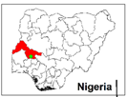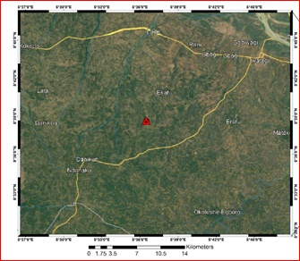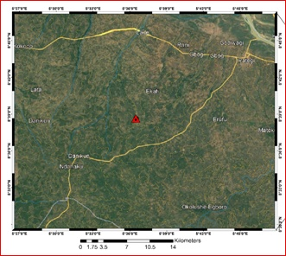
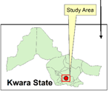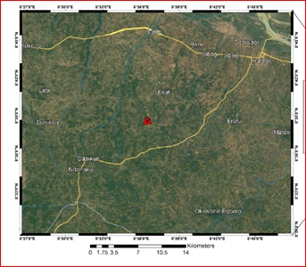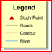
Fig 3.3a: Show the map Nigeria (Kwara State) showing the study area

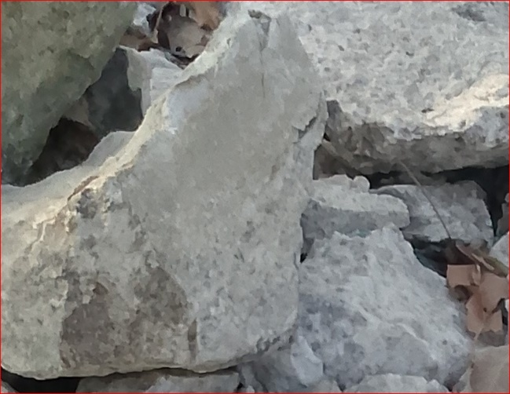
Fig 3.3b: shows the photograph of the study area

3.4 Sample collection
Fresh representative samples of lepidolite from location1, location 2 and location 3, were collected from three different points on the field using hammer, chisel, sample bags and GPS. The samples were labeled accordingly and were sent for analysis for petrographical analysis which was carried out at University of Ilorin Department of Geology and Mineral Science laboratory.
3.5 Sample preparation
Thin section was prepared by cutting an individual grab samples with a diamond saw, where by the slab cut is labeled on one side and the other side is lapped flat and smooth and grinding on a cast iron lap with 400 grit carborundum. The grinding sample is then finished on a glass plate with 600 grit carbonrundum, allow to dry on a hot plate, then glue the sample to a glass slide with epoxy to the lapped face. The thickness is further reduced on thin section grinder to a 30 microns. After this thickness is achieved then the section is placed in a holder for petrographical or microscopic analysis.
3.5.1 Petrographical Analysis (Thin Section)
This analysis examine the microscopic structure of the samples in thin sections of rocks, minerals and other materials by identifying their textures, mineral composition and others critical properties which give information of origin, formation and characteristics of rocks and minerals.

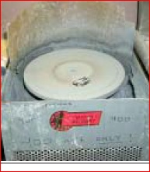
Figure 3.5a: 600 grit carborundom grinding machine

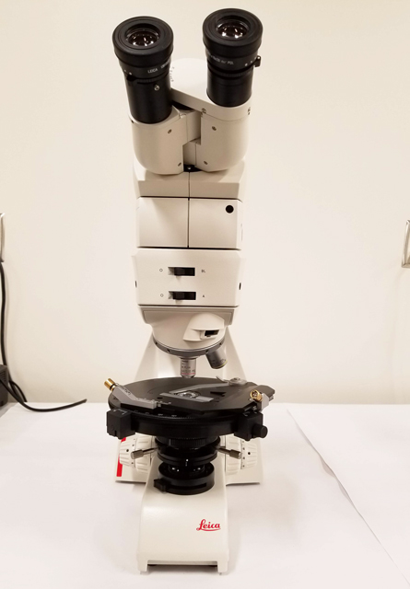
Figure 3.5b: Photograph of petrograhical microscope

CHAPTER FOUR
4.1 Microscopic description (Thin section)
The prepared thin section was examined and studied under plane polarized light (PPL) and cross polarized light (XPL). Photomicrographs of important sections (D&E) were analyzed from the thin section (Table 3). The minerals are recognized in plane polarized light view by lack of alteration and in cross polarized light view by their interference colour (Mackenzie et al., 1982).
4.2.1 Plane Polarized Light (PPL) Description
In the thin section (figure 4.3-4.5), quartz, muscovite mica, and biotite mica and plagioclase feldspar were the major rock forming minerals based on their characteristics. The quartz is colorless under plane polarized light (PPL) with low relief and no cleavage with absent pleochroism and its grain shape is anhedral. Plagioclase is gray in color with no pleochroism and low relief with anhedral grain shape. The biotite in L1 is light brown in color which standout with a moderate relief and strong pleochroism with a platy grain shape and one directional cleavage. The muscovite is brownish-red to red in color with moderate to strong pleochroism and one directional cleavage with low to moderate relief. The opaque mineral appears to be black in color with no cleavage and has subhedral grain shape.
4.3.2 Cross Polarized Light (XPL) Description
The samples was examine under crossed polarized light show properties such as birefringence and extinction (figure 4.4-4.6) The quartz displays low interference color, it is uniaxial, and it has undulose extinction which indicates dislocation walls in mineral grains, the plagioclase is anisotropic and it is identified by albite twinning which gives a series of fine lamellae and low birefringence. The muscovite is anisotropic with low to moderate birefringence

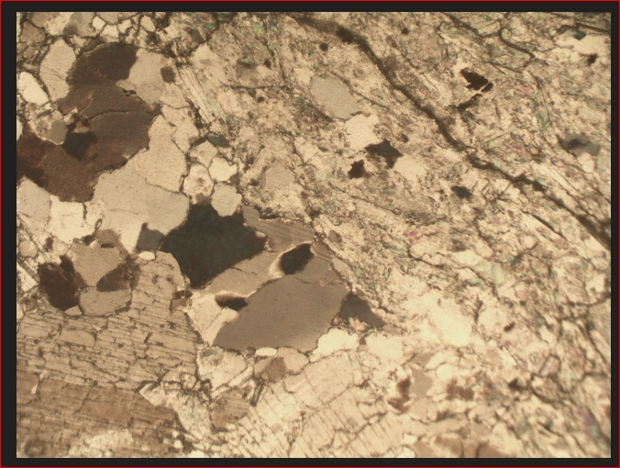
Figure 4.3: Photomicrograph of sample D under plane polarized light

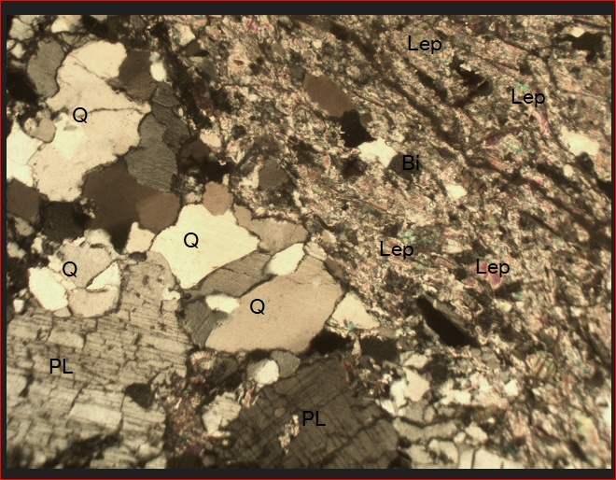
Figure 4.4 photomicrograph of sample D under crossed polarized light
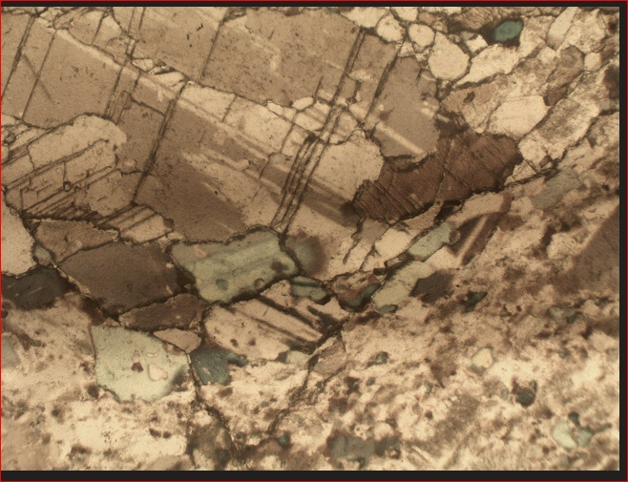
Figure 4.5 Photomicrograph of sample E under plane polarized light

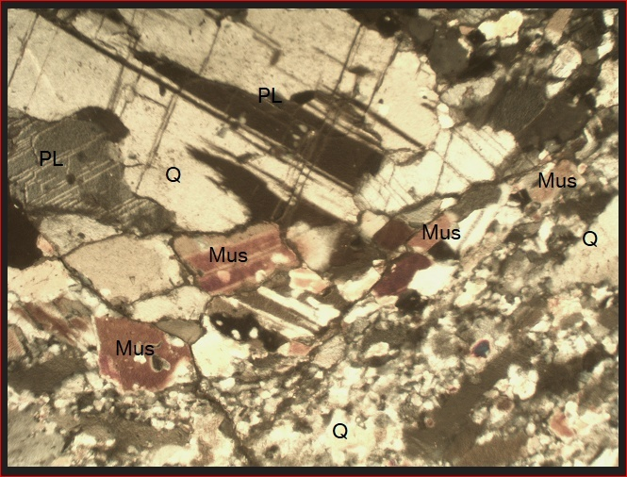
Figure 4.6 photomicrograph of sample E under crossed polarized light

Table3: Estimated modal composition of lepidolite in the study samples photomicrograph
Sample Name | % Composition of the Minerals Present in the Studied Samples |  |  |  | Grand Total (%)
Sample Name | Quartz | Mica | Feldspar | Lepidolite | Grand Total (%)
D | 27 | 3 | 20 | 50 | 100
E | 30 | 55 | 15 | -- | 100

Figure 4.7 Pie chart representation of modal composition of sample D

Figure 4.8 Pie chart representation of modal composition of sample E

4.4 Discussion
The result as shown from the table 3 and fig. 4.7 and 4.8 indicate that there is lithium ore with lepidolite ore in sample D while the other sample contain only appropriate minerals. The photomicrograph for both cross and plane polarized light revealed that there are some properties like twining, cleaverages, bireference and colours with opeone minerals. Mica has higher percentage sample E and lower percentage in sample D. The lepidolite dominate the sample D disappear in sample E.

CHAPTER FIVE
CONCLUSION AND RECOMMENDATIONS
5.1 Conclusion
5.1 Summary of Findings
This study investigated the petrographical characteristics of lepidolite-bearing rocks in Kakafu, Kwara State, with the aim of evaluating their mineralogical composition, textural relationships, and economic potential. The research employed both field-based observations and laboratory petrographic techniques to analyze collected
rock samples.
Key findings include:
- Occurrence and Geological Setting: Lepidolite in the Kakafu area is hosted in granitic pegmatites, consistent with global lithium-cesium-tantalum (LCT) pegmatite systems. The pegmatites are emplaced within the Nigerian Basement Complex, particularly within migmatite-gneiss terrain, and are associated with tectonic structures that favor mineral emplacement.
- Mineralogical Composition: Petrographic analysis revealed that lepidolite commonly coexists with quartz, muscovite, albite, and tourmaline. The lepidolite crystals are typically platy with lavender to pink coloration, perfect basal cleavage, and low birefringence under polarized light. Its chemical composition, inferred from literature, suggests high Li2O content with notable rubidium and cesium concentrations.
- Textural Features: Thin section analysis indicated that lepidolite occurs both as individual flakes and intergrowths with other minerals, often along grain boundaries and in late-stage crystallization zones. Zoning and replacement textures were observed, indicative of fluid interaction and post-crystallization alteration.
- Petrogenesis: The study supports the conclusion that the lepidolite formed during the late stages of pegmatite crystallization under low-temperature and high volatile conditions, with fluid enrichment in lithium, fluorine, and boron. These conditions are consistent with evolved magmatic systems typical of LCT pegmatites.
- Economic Implication: The mineralogical and petrographic evidence suggests that the lepidolite in Kakafu has significant lithium-bearing potential. However, further geochemical and beneficiation studies are necessary to evaluate its commercial viability.
5.2 Conclusion
Lepidolite occurrences in Kakafu, Kwara State, represent part of a broader network of rare-metal pegmatites within the Nigerian Basement Complex. This research has successfully demonstrated that the lepidolite-bearing rocks in this area are mineralogically and texturally comparable to economically viable global lithium deposits.
The integration of petrographic data with geological context supports the view that the Kakafu pegmatites were emplaced during post-orogenic stages and experienced fluid evolution conducive to lepidolite formation.
These findings provide a foundational framework for further mineral exploration and resource assessment in the region.
5.3 Recommendations
- Conduct detailed geochemical assays, including lithium content quantification using methods such as ICP-MS, to better assess the economic potential of the lepidolite.
- Employ electrical resistivity and ground magnetic surveys to delineate subsurface pegmatite bodies and assess their lateral extent.
- Investigate appropriate beneficiation techniques such as froth flotation or leaching to determine the efficiency of lithium recovery from lepidolite in the area.
- A techno-economic evaluation should be undertaken to determine the commercial viability of exploiting lepidolite in Kakafu.
- Any future mining activities should be preceded by an environmental impact assessment (EIA) to ensure sustainable and responsible resource development.
- Governmental agencies, local communities, and private investors should collaborate to explore, develop, and regulate lithium-bearing resources in Kwara State.

References
Adekeye, D. O., Ogunleye, A. A., & Alaba, F. A. (2019). Geology of the mineral resources in Kwara State, Nigeria: An overview. Journal of Applied Geology, 15(3), 45-56.
Adekeye, D. O., Ogunleye, A. A., & Alaba, F. A. (2019). Geology of the mineral resources in Kwara State, Nigeria: An overview. Journal of Applied Geology, 15(3), 45-56.
Adekeye, D. O., Ogunleye, A. A., & Alaba, F. A. (2019). Geology of the mineral resources in Kwara State, Nigeria: An overview. Journal of Applied Geology, 15(3), 45-56.
Hardy, L., & Vardon, P. (2021). Lithium extraction from Lepidolite: A critical review of current techniques. Minerals, 11(2), 112-130. https://doi.org/10.3390/min11020112
Hardy, L., & Vardon, P. (2021). Lithium extraction from Lepidolite: A critical review of current techniques. Minerals, 11(2), 112-130. https://doi.org/10.3390/min11020112
Hardy, L., & Vardon, P. (2021). Lithium extraction from Lepidolite: A critical review of current techniques. Minerals, 11(2), 112-130. https://doi.org/10.3390/min11020112
Hardy, L., & Vardon, P. (2021). Lithium extraction from Lepidolite: A critical review of current techniques. Minerals, 11(2), 112-130. https://doi.org/10.3390/min11020112
Hawthorne, F. C., Abraitis, P. V., & Liu, Z. (2018). Lithium-bearing minerals: Lepidolite. Mineralogical Magazine, 82(6), 1665-1683. https://doi.org/10.1180/minmag.2018.002
Hawthorne, F. C., Abraitis, P. V., & Liu, Z. (2018). Lithium-bearing minerals: Lepidolite. Mineralogical Magazine, 82(6), 1665-1683. https://doi.org/10.1180/minmag.2018.002
Hawthorne, F. C., Abraitis, P. V., & Liu, Z. (2018). Lithium-bearing minerals: Lepidolite. Mineralogical Magazine, 82(6), 1665-1683. https://doi.org/10.1180/minmag.2018.002
Meyer, G., & Schmidt, M. (2020). Geochemical analysis of Lepidolite: Advances in mineral identification. Geochemistry, 45(1), 22-38. https://doi.org/10.1016/j.geoche.2019.10.012
Meyer, G., & Schmidt, M. (2020). Geochemical analysis of Lepidolite: Advances in mineral identification. Geochemistry, 45(1), 22-38. https://doi.org/10.1016/j.geoche.2019.10.012
Meyer, G., & Schmidt, M. (2020). Geochemical analysis of Lepidolite: Advances in mineral identification. Geochemistry, 45(1), 22-38. https://doi.org/10.1016/j.geoche.2019.10.012
Meyer, G., & Schmidt, M. (2020). Geochemical analysis of Lepidolite: Advances in mineral identification. Geochemistry, 45(1), 22-38. https://doi.org/10.1016/j.geoche.2019.10.012
Schneider, L., & Lee, R. (2021). The role of PPL and XPL microscopy in mineralogical analysis. Journal of Microscopy and Spectroscopy, 35(4), 91-102. https://doi.org/10.1080/002227202013482
Schneider, L., & Lee, R. (2021). The role of PPL and XPL microscopy in mineralogical analysis. Journal of Microscopy and Spectroscopy, 35(4), 91-102. https://doi.org/10.1080/002227202013482
Schneider, L., & Lee, R. (2021). The role of PPL and XPL microscopy in mineralogical analysis. Journal of Microscopy and Spectroscopy, 35(4), 91-102. https://doi.org/10.1080/002227202013482
Schneider, L., & Lee, R. (2021). The role of PPL and XPL microscopy in mineralogical analysis. Journal of Microscopy and Spectroscopy, 35(4), 91-102. https://doi.org/10.1080/002227202013482
Zhao, Y., Liu, H., & Wang, X. (2022). Global lithium demand and the role of Lepidolite: A sustainable approach. Energy and Environmental Science, 15(3), 634-648. https://doi.org/10.1039/d2ee01483b
Zhao, Y., Liu, H., & Wang, X. (2022). Global lithium demand and the role of Lepidolite: A sustainable approach. Energy and Environmental Science, 15(3), 634-648. https://doi.org/10.1039/d2ee01483b
Zhao, Y., Liu, H., & Wang, X. (2022). Global lithium demand and the role of Lepidolite: A sustainable approach. Energy and Environmental Science, 15(3), 634-648. https://doi.org/10.1039/d2ee01483b
Zhao, Y., Liu, H., & Wang, X. (2022). Global lithium demand and the role of Lepidolite: A sustainable approach. Energy and Environmental Science, 15(3), 634-648. https://doi.org/10.1039/d2ee01483
APPENDICES
Appendix A: Glossary of Terms
- Lepidolite: A lithium – rich mica mineral that is an important sources of lithium.
- Pegmatite: A type of igneous rock that is characterized by a coarse-grained texture and is often host to economic minerals.
- Petrography: The study of the mineralogical composition and structure of rocks.
Appendix B: Tables and figures
- Table 1: Mineralogical and composition of lepidolite samples from the Kakafu Area
- Figure 1: Location map of the Kakafu area, Kwara State, Nigeria
- Figure 2: Photomicrograph of lepidolite sample from the Kakafu area
Appendix C: References
- List of references cited in the study
Appendix D: Fieldwork Data
- Field notes and observations from the study area
- Photographs of the study area and samples collected.
Appendix E: Laboratory Data
- Results of laboratory analysis of lepidolite samples
- X-ray diffraction patterns and scanning electron microscopy images of lepidolite samples.

These appendices provide additional information and data that support the findings of the study. They can be useful for researchers and readers who want to learn more about the study and it’s results.

