DESIGN AND IMPLEMENTATION OF A SOLAR POWERED SMART LAMP WITH USB CHARGING PORT

By:
AGBANA, SUNDAY EMANNUEL
HND/23/COM/FT/0225

Submitted to the
DEPARTMENT OF COMPUTER SCIENCE,
INSTITUTE OF INFORMATION AND COMMUNICATION TECHNOLOGY (IICT), KWARA STATE POLYTECHNIC, ILORIN

IN PARTIAL FULFILMENT OF THE REQUIREMENTS FOR THE AWARD OF HIGHER NATIONAL DIPLOMA (HND) IN COMPUTER SCIENCE

JUNE, 2025
APPROVAL PAGE
This is to certify that this project was carried out by AGBANA, SUNDAY EMMANUEL with Matric Number: HND/22/COM/FT/0225 has been read and approved by the Department of Computer Science, Kwara State Polytechnic, Ilorin in partial fulfillment of the requirements for the award of Higher National Diploma (HND) in Computer Science.

___________________ __________________
Dr. Ayeni, J.K.
Project Supervisor Date

______________________ _________________
Mr. Oyedepo, F.S.
Head of Department Date

______________________ _________________
External Examiner Date

DEDICATION
This research project is dedicated to the Almighty God, the giver of life and taker of life, who guided me throughout my program.

ACKNOWLEDGEMENTS
All glory and adoration belong to him alone (God), Omniscience, and Omnipresent for his mercy over me throughout my undergraduate journey. Which of your favour I will deny? Absolutely none.
First and foremost, I would like to express my deepest gratitude to my project supervisor, in person of Dr. Ayeni, J.K. for his unwavering support, insightful advice, and constructive feedback throughout the development of this project.
Also, to my lovely parents, indeed I am speechless to thank you today, I pray to the Almighty Allah to grant you both all your heart desires. May you both live long to eat the fruit of your labour.
Also, to the school management (Kwara State Polytechnic, Ilorin) and entire Staff of Computer Science Department, starting from the Head of Department in person of Mr. Oyedepo. I appreciate you all.
To all my friend and family, I can’t be mention all of you, we shall all meet in the field of success.
Thank you all.

TABLE OF CONTENTS
Title page i
Approval Page ii
Dedication iii
Acknowledgements iv
Table of Contents v-vii
List of Figures viii
Abstract ix
CHAPTER ONE: Introduction 1
1.1 Background to the Study 1-4
1.2 Statement of the Problem 4
1.3 Aim and Objectives 4-5
1.4 Methodology 5
1.5 Scope of the Study 5-6
1.6 Limitation of the Study 6
1.7 Operational Definition of Terms 6-7
1.8 Organization of the Report 8

CHAPTER TWO: LITERATURE REVIEW 8
2.1 Review of Related Works 9-11
2.2. Review of Related Concepts 11
2.2.1 Overview of Solar Energy Conversion and Photovoltaic Technology 11-12
2.2.2 Overview of Battery Storage Systems in Solar Lanterns 12-14
2.2.3 LED Technology in Solar Lanterns 14-16
2.3.4 Smart Technology Integration in Solar Lanterns 16-18
2.2.5 Overview of USB Charging Ports in Solar Lanterns 10-20
CHAPTER THREE: RESEARCH METHODOLOGY 21
3.1 Description of the Existing System 21
3.2 Problems of the Existing System 22
3.3 Description of the Proposed System 23-24
3.3.1 Advantages of the Proposed System 24-25
3.4 System Architecture 25
3.5 Circuit Diagram 26-28
CHAPTER FOUR: System Design and Implementation 29
4.1 Schematic Design 29
4.2 System Design 29-30
4.3 System Documentation 31-32
4.3.1 System Flowchart 32
4.4 System Implementation 33-37
CHAPTER FIVE: SUMMARY, CONCLUSION
AND RECOMMENDATIONS 38
5.1 Summary 38-39
5.2 Conclusion 39
5.3 Recommendations 40
References 41-42

LIST OF FIGURES
Fig: 3.4: System Architecture Diagram 25
Fig. 3.5: Circuit Diagram of the proposed System 26
Fig. 4.3:1 System Flow Chart 32
Fig. 4.1 Relay and Node MCU 34
Fig. 4.2: Mini Micro-controller unit 35
Fig. 4.3: Control Card 35
Fig. 4.4: Ion Lithium Battery 36
Fig. 4.5: Dc Bulb 36
Fig. 4.6: App Interface to control the System 37

ABSTRACT
The growing demand for sustainable energy solutions has led to the development of solar-powered smart lanterns with added functionalities such as USB charging ports. This research focuses on the design and construction of a solar-powered smart lantern equipped with energy-efficient LED lighting and a USB charging port for small electronic devices. The system harnesses solar energy through photovoltaic panels, which convert sunlight into electricity and store it in a rechargeable lithium-ion battery. A smart power management unit ensures efficient energy distribution between the LED light and the USB charging output, thereby enhancing the overall performance and functionality. The integration of modern technologies such as pulse-width modulation (PWM) for brightness control and protective circuitry for overcharge and short-circuit protection improves system durability and user safety. The project addresses common limitations of traditional lighting systems, such as inconsistent power supply and lack of portability. This solar-powered solution provides an eco-friendly, cost-effective, and reliable alternative for rural and urban areas with unstable grid connections. By merging energy independence with smart technology, the proposed system demonstrates a significant step forward in promoting sustainable living, especially in underserved communities where energy access remains a challenge.

Keywords: Solar Energy, Smart Lantern, USB Charging, Photovoltaic, Lithium-Ion Battery,
LED Lighting, Power Management, Sustainable Technology.
CHAPTER ONE
INTRODUCTION
1.1 BACKGROUND TO THE STUDY
The increasing global demand for sustainable and efficient energy solutions has led to a significant shift towards renewable energy sources. Among these, solar energy has gained prominence due to its abundance and environmental benefits. Solar-powered devices offer a viable alternative to conventional energy sources, reducing dependence on fossil fuels and minimizing greenhouse gas emissions (Smith, 2020). In regions where electricity access is limited, solar-powered lighting solutions provide an essential means of illumination, thereby enhancing productivity and quality of life (Johnson & Patel, 2021). Lighting is a fundamental necessity in human life, playing a crucial role in both domestic and industrial settings. However, millions of people worldwide still lack access to reliable electricity, particularly in rural and underdeveloped areas. The adoption of solar-powered lanterns addresses this challenge by offering an independent and renewable source of lighting. Unlike traditional kerosene lamps, which pose health hazards due to toxic emissions, solar lanterns provide888u7 a safer, cleaner, and more sustainable alternative (Anderson et al., 2019). Additionally, these lanterns contribute to economic savings by eliminating the recurring costs associated with fuel-based lighting solutions (Williams, 2022).
The integration of smart technology in solar lanterns further enhances their functionality, making them more efficient and user-friendly. A smart solar lantern is equipped with advanced features such as automated brightness control, battery management systems, and USB charging ports, allowing users to charge their mobile devices and other small electronic gadgets (Kumar & Zhang, 2021). This multi-functionality not only improves convenience but also supports digital connectivity in remote locations, where access to power sources is often scarce. Furthermore, incorporating smart control mechanisms optimizes energy usage, thereby prolonging battery life and improving overall performance (Lee & Thompson, 2020).
The design and construction of a solar-powered smart lantern with a USB charging port require a comprehensive understanding of photovoltaic (PV) technology, energy storage systems, and electronic control mechanisms. Solar panels convert sunlight into electrical energy, which is then stored in rechargeable batteries for later use. The efficiency of this process depends on factors such as solar irradiance, panel orientation, and battery capacity (Chowdhury et al., 2021). The implementation of a charge controller ensures that the battery is neither overcharged nor excessively discharged, thereby enhancing durability and efficiency (Garcia & Lewis, 2018). One of the major challenges in designing a solar-powered lantern is optimizing energy conversion and storage. The choice of photovoltaic cells, battery type, and charging circuit configuration significantly influences the overall performance of the device. Lithium-ion batteries are commonly preferred due to their high energy density, long lifespan, and low self-discharge rate (Hassan & Wong, 2019). Additionally, the inclusion of energy-efficient LED bulbs enhances light output while minimizing power consumption, making the lantern an ideal solution for off-grid applications (Fernandez et al., 2022).
The integration of a USB charging port adds further value to the solar lantern, addressing the growing need for portable power sources. With the proliferation of mobile devices, access to charging facilities has become a necessity, especially in rural and emergency situations. A well-designed power management system ensures that energy is efficiently distributed between lighting and charging functions without compromising performance (Okoro & Adams, 2021). Furthermore, incorporating a microcontroller-based control system can enhance automation, enabling users to customize brightness levels and monitor battery status in real-time (Nelson et al., 2023). Environmental sustainability is a key consideration in the development of solar-powered lighting solutions. Unlike conventional energy sources, which contribute to environmental degradation through carbon emissions and resource depletion, solar lanterns harness clean energy, promoting eco-friendly practices (Green & Lopez, 2020). The reduction in reliance on non-renewable energy sources aligns with global efforts to mitigate climate change and transition towards a more sustainable energy future (Martin et al., 2021). Additionally, the use of recyclable materials in the construction of solar lanterns further enhances their environmental benefits (Clark & Evans, 2019).
The design and construction of a solar-powered smart lantern with a USB charging port offer a practical and sustainable solution to the challenges of limited electricity access. By leveraging solar energy and smart technology, this innovation not only provides reliable illumination but also supports digital connectivity, economic savings, and environmental conservation. The increasing demand for renewable energy solutions highlights the significance of such projects in addressing global energy challenges. Through continuous research and technological advancements, solar-powered lighting systems can be further optimized to enhance efficiency, affordability, and accessibility, ultimately contributing to a more sustainable and energy-secure world (Jackson & Roberts, 2023).
1.2 STATEMENT OF THE PROBLEM
Access to reliable electricity remains a major challenge in many parts of the world, particularly in rural and remote communities. Millions of people depend on hazardous and inefficient lighting sources such as kerosene lamps and candles, which pose serious health and environmental risks (Brown & Miller, 2021).
The high cost of electricity and frequent power outages further exacerbate the need for alternative energy solutions. While solar lanterns have emerged as a viable option, many existing models lack essential features such as energy efficiency, smart control mechanisms, and device charging capabilities (Nguyen et al., 2020).
1.3 AIM AND OBJECTIVES OF THE STUDY
The aim of this research work is to design and construct a solar-powered smart lantern with a USB charging port that provides an efficient, reliable, and sustainable lighting solution for off-grid and rural communities. The specific objectives of this study are to:
- Design a compact and energy-efficient solar-powered lantern using photovoltaic technology;
- Integrate a smart control mechanism for optimizing energy consumption and battery management;
- Incorporate a USB charging port for powering small electronic devices such as mobile phones;
- Ensure the lantern is designed with durable and cost-effective components for long-term usability;
- Evaluate the performance of the constructed solar lantern in terms of energy efficiency, charging capabilities, and lighting output.
1.4 METHODOLOGY
The methodology for this research involves a systematic approach to the design and construction of a solar-powered smart lantern with a USB charging port. The first phase includes a comprehensive literature review to understand existing solar lantern technologies and identify key limitations. The second phase focuses on system design, where appropriate photovoltaic panels, energy storage batteries, LED lighting, and a USB charging module are selected.
The construction phase involves assembling the components, integrating a charge controller, and implementing a smart control mechanism to optimize energy consumption. After construction, the system undergoes performance testing to evaluate its energy efficiency, battery life, charging capability, and illumination output under different conditions. Data obtained from testing is analyzed to determine the effectiveness and reliability of the lantern.
1.5 SCOPE OF THE STUDY
This research focuses on the design and construction of a solar-powered smart lantern with a USB charging port, aimed at providing an efficient and sustainable lighting solution for off-grid and rural areas. The study covers the selection of appropriate photovoltaic panels, rechargeable battery systems, LED lighting, and smart energy management mechanisms to ensure optimal performance. The integration of a USB charging port is also examined to provide additional functionality for powering small electronic devices such as mobile phones.
The research is limited to small-scale applications, specifically for household and personal use, rather than large-scale commercial lighting systems. Performance evaluation is conducted under controlled conditions to analyze the lantern’s efficiency, charging capability, and durability. The study does not include grid-tied solar systems or large solar panel installations. Instead, it focuses on developing a cost-effective, portable, and energy-efficient lighting solution that can serve communities with limited or no access to electricity.

1.6 LIMITATION OF THE STUDY
This study is limited to the design and construction of a solar-powered smart lantern with a USB charging port for small-scale, off-grid applications. The research does not cover large-scale solar power systems or grid-connected lighting solutions. The efficiency of the lantern is dependent on solar irradiance, meaning its performance may vary based on weather conditions and geographic location.
The study is also constrained by the selection of available components, such as photovoltaic panels, battery capacity, and LED efficiency, which may impact the overall performance and durability of the lantern. Additionally, the testing phase is conducted under controlled conditions, which may not fully replicate real-world usage scenarios. Financial and time constraints further limit extensive testing and long-term field evaluation. Despite these limitations, the study aims to develop a functional and sustainable lighting solution that addresses the challenges of electricity access in remote and underdeveloped areas.
1.7 DEFINITION OF TERMS
- Solar Energy – Energy harnessed from the sun using photovoltaic cells to generate electricity for various applications.
- Photovoltaic (PV) Panel – A device that converts sunlight into electrical energy through the photovoltaic effect.
- Smart Lantern – A lighting device equipped with intelligent features such as automated brightness control and battery management.
- USB Charging Port – A power output interface that allows small electronic devices, such as mobile phones, to be charged using the stored energy in the lantern.
- Battery Storage – A rechargeable unit that stores electrical energy generated from solar panels for later use.
- Charge Controller – A device that regulates the voltage and current from solar panels to prevent overcharging or deep discharge of the battery.
- LED (Light Emitting Diode) – A highly efficient lighting source used in solar lanterns for optimal brightness and low power consumption.
- Energy Efficiency – The ability of a system to perform effectively while consuming minimal energy.
- Off-Grid System – A standalone power system that operates independently of the main electricity grid.
- Sustainability – The use of renewable resources in a way that meets present needs without compromising future availability.
1.8 ORGANIZATION OF THE REPORT
This researched work is divided into five chapter and a short description of what each chapter entails is given here.
Chapter one discusses the Background to the study, Statement of the problem, aim and Objectives of the study, Methodology, Scope of the Study, Limitation of the Study, Operational Definition of terms and Organization of the report. Chapter two focuses on past researches (Review of related literature), Overview of Construction and Implementation of Design and Construction of a solar Powered Smart lantern with USB Charging Port. Chapter three evaluates the description of existing system, problem of traditional system, description of proposed system, circuit diagram and architectural design of proposed system. Chapter four emphasizes on the overall design of the research work (Design and Construction of a solar Powered Smart lantern with USB Charging Port). The last chapter discuss the summary, conclusion of the research work and recommendations.

CHAPTER TWO
LITERATURE REVIEW
2.1 REVIEW OF RELATED WORKS
The use of solar energy as an alternative to conventional fossil fuels has garnered significant attention in recent years due to its sustainability and environmental benefits. Solar-powered lighting systems, in particular, have become an important solution for communities that lack access to reliable electricity. These systems harness the sun’s energy through photovoltaic (PV) technology, converting sunlight into electrical energy to power lights and other devices (Smith, 2020). Over the years, solar lanterns have emerged as one of the most efficient and affordable solutions for off-grid lighting. However, while solar lanterns have been widely adopted, many existing models still face challenges in terms of efficiency, functionality, and user convenience (Kumar & Zhang, 2021).
The basic concept of solar-powered lighting is not new. Early designs primarily focused on providing basic illumination through simple PV panels and rechargeable batteries. These designs, however, often lacked the ability to address diverse user needs, particularly in areas where access to mobile phone charging is essential. Recent studies have pointed out the need for solar-powered systems that not only provide lighting but also offer additional functionalities such as mobile device charging. The integration of a USB charging port in solar lanterns is a key advancement in addressing this need (Williams, 2022). By enabling users to charge their mobile devices, solar lanterns can serve as multi-functional tools in rural and off-grid settings, where electricity access is scarce (Nguyen et al., 2020).
In their review, Anderson et al. (2019) noted that solar lanterns have significantly reduced the dependence on kerosene lamps, which are not only expensive but also pose significant health risks due to harmful emissions. Solar lanterns, on the other hand, are seen as safer, more efficient, and environmentally friendly alternatives. The advent of energy-efficient LED technology has further improved the performance of solar lanterns, reducing energy consumption while maximizing light output (Fernandez et al., 2022). However, despite the advantages, many solar lanterns still struggle with issues related to energy management, particularly in terms of optimizing battery use and extending the overall lifespan of the lantern.
Energy storage is another critical aspect of solar lanterns. Rechargeable batteries, commonly used in these systems, store the energy generated by PV panels for later use. The choice of battery type plays a significant role in the performance of the lantern. Lithium-ion batteries are often preferred due to their high energy density, longer lifespan, and efficiency (Hassan & Wong, 2019). However, these batteries also present challenges in terms of cost and the need for careful charging and discharging management. A well-designed charge controller is necessary to prevent overcharging or excessive discharging, which can reduce the lifespan of the battery and affect the performance of the lantern (Garcia & Lewis, 2018).
Smart technology has recently been integrated into solar-powered lighting systems, offering a new layer of functionality. The integration of smart control systems, such as automated brightness adjustment and real-time battery status monitoring, has improved the overall user experience (Lee & Thompson, 2020). These systems help ensure that energy is used efficiently, prolonging battery life and enhancing performance. Moreover, the inclusion of a microcontroller-based system enables more precise control of the lantern’s features, providing users with greater flexibility and convenience (Nelson et al., 2023). As digital connectivity continues to play a central role in everyday life, providing mobile charging capabilities alongside lighting has become a major consideration in the design of solar lanterns.
A key feature that differentiates many modern solar lanterns is the inclusion of a USB charging port. This feature allows users to power small electronic devices such as mobile phones, which are increasingly vital for communication, education, and business in remote areas. The provision of a USB charging port in solar lanterns addresses a significant need, especially in rural communities where access to electrical outlets is limited (Okoro & Adams, 2021). By incorporating a USB charging port, solar lanterns are transforming from simple lighting devices to multifunctional tools, thereby expanding their utility and appeal.
Despite the progress made in solar lantern technology, several challenges remain. One of the primary issues is the efficiency of energy conversion and storage. While solar panels have become more efficient, their performance is still influenced by factors such as weather conditions, geographic location, and the amount of sunlight available (Chowdhury et al., 2021). Furthermore, the effectiveness of energy storage is highly dependent on the quality and size of the battery used, which in turn affects the lantern’s overall performance and reliability. These limitations highlight the need for continuous innovation in the design and construction of solar-powered lighting systems.
In recent years, researchers have explored various ways to improve the efficiency and sustainability of solar-powered lanterns. This includes the development of new materials for PV panels and batteries, the introduction of more energy-efficient LEDs, and the implementation of advanced charge controllers (Green & Lopez, 2020). Moreover, the integration of advanced features such as mobile app control and real-time monitoring systems offers a promising direction for future development. These innovations aim to optimize energy usage, improve user convenience, and extend the lifespan of solar lanterns, making them a more reliable and affordable solution for off-grid lighting (Martin et al., 2021).
The solar-powered lanterns have proven to be an effective solution for providing lighting and addressing energy needs in remote and off-grid communities. However, there are still opportunities for improvement, particularly in terms of energy efficiency, battery management, and the integration of additional features such as USB charging ports. As technology continues to evolve, solar lanterns are expected to become more efficient, affordable, and versatile, offering a sustainable solution to the challenges of electricity access in underserved areas (Jackson & Roberts, 2023).
2.2 REVIEW OF RELATED CONCEPTS
2.2.1 Overview of Solar Energy Conversion and Photovoltaic Technology
Solar energy conversion refers to the process of transforming sunlight into usable electrical energy, typically through the use of photovoltaic (PV) technology. Photovoltaic cells, commonly referred to as solar cells, are the core component of solar panels, and they operate based on the photovoltaic effect. When sunlight strikes the surface of a solar cell, photons from the light excite electrons in the material, creating an electric current. This current is then captured and used as electrical power to run various devices, such as solar lanterns, homes, and commercial buildings (Smith, 2020).
The primary advantage of solar energy conversion is its ability to generate clean, renewable electricity without producing harmful emissions or depleting natural resources. Unlike fossil fuels, solar power is an inexhaustible resource, making it an ideal energy source for off-grid areas and regions with limited access to conventional electricity (Brown & Miller, 2021). The efficiency of a solar cell is largely determined by the materials used, with silicon being the most common. Monocrystalline and polycrystalline silicon cells are widely used in solar panels due to their relatively high efficiency and cost-effectiveness (Chowdhury et al., 2021). Additionally, newer technologies, such as thin-film and perovskite solar cells, are emerging, offering potential benefits in terms of flexibility, cost reduction, and improved energy conversion rates (Kumar & Zhang, 2021).
The efficiency of solar panels has significantly improved over the years. Modern PV cells can convert about 15% to 22% of the sunlight they receive into usable energy, with some high-performance cells reaching over 40% efficiency in controlled laboratory conditions (Jackson & Roberts, 2023). However, the efficiency of solar energy conversion is influenced by several factors, including the angle of the panel, geographic location, and seasonal variations in sunlight availability. Despite these limitations, advancements in PV technology continue to improve solar energy conversion, making it a more viable solution for sustainable energy generation in off-grid communities (Garcia & Lewis, 2018).
2.2.2 Overview of Battery Storage Systems in Solar Lanterns
Battery storage systems are essential components of solar-powered lanterns, as they store the electrical energy generated by photovoltaic (PV) panels for later use. Since solar energy is intermittent and dependent on sunlight, having an efficient and reliable battery storage system ensures that solar lanterns can provide consistent lighting and power for mobile devices, even during the night or on cloudy days.
The most commonly used battery types in solar lanterns are lithium-ion (Li-ion) and lead-acid batteries. However, the growing preference in modern solar lanterns is for lithium-ion batteries due to their superior performance characteristics. Lithium-ion batteries offer higher energy density, meaning they can store more energy in a smaller and lighter form compared to traditional lead-acid batteries (Hassan & Wong, 2019). These batteries also have a longer lifespan and can withstand more charge cycles, making them more cost-effective in the long run. Additionally, they are more environmentally friendly because they contain fewer toxic materials compared to lead-acid batteries, which can pose disposal challenges (Nguyen et al., 2020).
Battery capacity plays a significant role in determining how long the solar lantern will function before needing to recharge. A higher-capacity battery can store more energy, allowing the lantern to provide light for extended periods. However, battery size and capacity must be balanced with the space available in the lantern’s design and the overall cost of the system. The capacity of a battery is typically measured in ampere-hours (Ah), and the choice of capacity depends on the intended use of the lantern, such as whether it will be used for general lighting or as a mobile phone charger.
To optimize the performance of the battery storage system, a charge controller is used to regulate the charging and discharging process. The charge controller ensures that the battery is not overcharged, which can reduce its lifespan, or undercharged, which can lead to insufficient energy storage. This regulation is critical in maintaining the longevity and efficiency of both the battery and the solar lantern itself (Garcia & Lewis, 2018). By implementing a charge controller, solar lanterns can provide more reliable and sustainable lighting solutions to users in off-grid areas.
Overall, battery storage systems are fundamental to the success of solar lanterns. Advances in battery technology, especially lithium-ion batteries, continue to enhance the performance and durability of solar-powered lanterns, making them a viable option for off-grid communities. Proper energy management and optimization through charge controllers are also crucial in ensuring the efficiency and longevity of the lanterns, enabling them to serve as reliable and sustainable lighting and charging solutions.
2.2.3 LED Technology in Solar Lanterns
Light Emitting Diode (LED) technology plays a crucial role in the performance and efficiency of solar-powered lanterns. LEDs have revolutionized the lighting industry due to their energy efficiency, long lifespan, and minimal environmental impact compared to traditional incandescent bulbs. In solar lanterns, the use of LED technology is particularly beneficial because it allows for optimal energy use, ensuring that the energy stored in the battery is utilized efficiently for maximum illumination.
One of the primary advantages of LED technology in solar lanterns is its energy efficiency. Unlike incandescent bulbs, which convert a significant portion of energy into heat, LEDs convert nearly all of the energy into light, resulting in minimal wasted energy (Fernandez et al., 2022). This is essential in solar-powered systems, where energy conservation is key to ensuring the lantern operates effectively during extended periods, such as throughout the night. LEDs use approximately 75% less energy than traditional lighting sources while providing the same level of brightness, making them ideal for off-grid solar lanterns, where the available power is limited and must be used sparingly.
In addition to energy efficiency, LEDs also provide high-quality illumination. They offer superior brightness compared to traditional light sources, such as incandescent or fluorescent bulbs, without consuming excessive amounts of power. Solar lanterns equipped with LEDs can produce bright, clear light that is suitable for a variety of tasks, such as reading, cooking, and general household activities. Furthermore, LEDs are capable of being dimmed or adjusted, providing flexibility in light intensity based on the user’s needs (Lee & Thompson, 2020). This ability to control brightness is particularly beneficial for extending battery life, as users can adjust the light level to conserve energy when full brightness is not necessary.
Another key advantage of LEDs in solar lanterns is their long lifespan. LEDs are designed to last much longer than conventional bulbs, with lifespans typically ranging from 25,000 to 50,000 hours, depending on the quality of the LED and the operating conditions (Green & Lopez, 2020). This longevity reduces the need for frequent replacements, which is particularly important in remote or off-grid areas where access to spare parts may be limited. The durability of LEDs also means that the lanterns are more robust, withstanding external environmental conditions such as high humidity or dust, which could affect the performance of other light sources.
Additionally, LED technology is environmentally friendly. LEDs are free from toxic materials such as mercury, which is commonly found in fluorescent and incandescent lighting. The absence of such hazardous substances makes LEDs safer to handle, dispose of, and recycle, contributing to the overall sustainability of solar lanterns (Martin et al., 2021). This aligns with the core goal of solar lanterns, which is to provide a clean, renewable source of light while minimizing the environmental impact.
The compact size of LEDs also allows for more flexible designs in solar lanterns. LEDs are small and lightweight, making it easier to create portable, sleek, and efficient lanterns. This is particularly important for solar-powered devices, where space and weight considerations are essential for maximizing the solar panel and battery storage without compromising performance.
In conclusion, LED technology is a key component in the effectiveness of solar-powered lanterns. By offering energy efficiency, high-quality illumination, long lifespan, environmental friendliness, and design flexibility, LEDs significantly enhance the performance and sustainability of solar lighting systems. As solar-powered lanterns continue to evolve, LED technology remains integral to their development, making them a reliable and efficient solution for off-grid lighting and mobile charging needs.
2.3.4 Smart Technology Integration in Solar Lanterns
The integration of smart technology into solar lanterns represents a significant advancement in both functionality and user experience. By incorporating smart features such as automated brightness control, real-time battery monitoring, and energy management systems, solar lanterns have become more efficient, user-friendly, and versatile. These innovations are designed to enhance the performance of solar-powered lighting systems, making them even more practical and appealing for users in off-grid areas.
One of the most impactful aspects of smart technology in solar lanterns is automated brightness control. Solar lanterns equipped with smart sensors can automatically adjust the light intensity based on environmental conditions, such as the available sunlight or the amount of ambient light in the surroundings. For example, the lantern might increase its brightness when it detects low light levels, such as during the evening, and reduce it when there is enough natural light during the day. This feature helps to conserve battery power and ensure that energy is used efficiently, prolonging the overall lifespan of the battery and ensuring the lantern functions optimally (Lee & Thompson, 2020).
Another important integration is real-time battery monitoring. Smart solar lanterns can come with embedded sensors and microcontrollers that allow users to monitor the battery’s status, including the level of charge, health, and voltage. This feature is valuable because it enables users to track the lantern’s energy consumption and recharge patterns, ensuring that the battery is not overused or damaged (Nguyen et al., 2020). For example, if the battery charge drops below a certain threshold, the system can send an alert to the user, prompting them to charge the lantern before it runs out of power. Real-time monitoring also allows the system to adjust the charging process, preventing overcharging and enhancing battery longevity. The integration of energy management systems in solar lanterns optimizes the usage of stored solar energy. These systems include features such as automatic on/off switches that turn the lantern on when needed and off when not, as well as the ability to limit the total energy consumption based on available resources. For instance, the lantern may adjust its operation based on the current battery charge or prioritize lighting over USB charging when the battery is low. Energy management features also help to maximize solar power usage, ensuring that the lantern remains functional for longer periods without frequent recharging (Garcia & Lewis, 2018).
Smart features also contribute to user convenience and personalization. Some solar lanterns are equipped with mobile applications that allow users to control settings remotely, such as adjusting the brightness or checking battery status via their smartphones. This added layer of convenience enables users to monitor and manage their solar lanterns more effectively, even from a distance. Additionally, some smart lanterns allow users to set customized preferences for brightness, light duration, and power consumption, enabling them to optimize the lantern’s performance according to their individual needs (Williams, 2022).
Moreover, the incorporation of wireless charging capabilities and Internet of Things (IoT) integration into solar lanterns is an emerging trend. IoT-enabled solar lanterns can communicate with other smart devices, creating a more connected and responsive system. For example, these lanterns could interact with other IoT-enabled systems in the home, such as smart appliances or energy storage units, to enhance energy management on a larger scale. Through wireless communication, users can receive updates on energy production and consumption patterns, further improving the lantern’s efficiency and integration within smart home ecosystems.
Finally, security and safety features are increasingly being integrated into smart solar lanterns. Features such as motion sensors or security alert systems are designed to provide additional functionality, such as lighting up a pathway when motion is detected or alerting the user to potential intruders in the area. These added features not only enhance the utility of solar lanterns but also increase their value in outdoor and security applications, making them more versatile and appealing to users in both urban and rural settings.
In conclusion, the integration of smart technology in solar lanterns significantly enhances their functionality, efficiency, and user convenience. Automated brightness control, real-time battery monitoring, energy management systems, and IoT connectivity all contribute to creating a more sustainable, reliable, and user-friendly lighting solution. As technology continues to evolve, smart solar lanterns are likely to become even more sophisticated, offering users greater control, flexibility, and enhanced performance, ultimately contributing to the broader adoption of solar energy solutions in off-grid and remote areas.
2.2.5 Overview of USB Charging Ports in Solar Lanterns
The inclusion of USB charging ports in solar lanterns has become a transformative feature, enhancing their functionality beyond just providing illumination. With mobile devices becoming increasingly essential in everyday life, especially in off-grid and remote areas where access to electricity is limited, the ability to charge phones and other small electronics using solar-powered lanterns provides added convenience and utility. This integration has significantly improved the appeal and value of solar lanterns as multi-functional devices. The primary benefit of USB charging ports in solar lanterns is the ability to charge mobile phones, tablets, and other small electronic devices. In regions with limited or no access to electricity, solar lanterns equipped with USB ports enable users to stay connected, access emergency communication services, or use their devices for educational or work-related purposes (Williams, 2022). This capability is especially vital in remote or rural areas where access to traditional power sources is either unreliable or non-existent, and it offers a degree of independence from grid-based energy systems.
One of the advantages of integrating USB ports into solar lanterns is the dual functionality that these devices offer. Users can simultaneously use the lantern for lighting while charging their mobile devices, making it an efficient solution for those who need both light and power. For instance, a user might use the lantern as a light source for reading or cooking at night, while charging their phone or a small electronic gadget via the USB port. This capability makes solar lanterns incredibly useful for a range of daily tasks, further enhancing their value proposition in off-grid communities (Garcia & Lewis, 2018).
The energy efficiency of solar lanterns with USB charging ports is also worth noting. These lanterns typically have efficient solar energy conversion systems, where the power generated by the photovoltaic panel is first used to charge the internal battery and then distributed to power the LED lights and USB port. The efficiency of this energy distribution is essential because it ensures that the solar lantern is able to provide adequate lighting while also offering charging capacity without excessive energy waste (Green & Lopez, 2020). Many solar lanterns are designed with energy management systems that prioritize light or charging depending on the battery level, which helps to extend battery life and optimize the use of solar energy.
Moreover, USB charging in solar lanterns is particularly beneficial in emergencies, as it allows users to maintain the charge of critical devices such as mobile phones during power outages or when access to grid electricity is unavailable (Fernandez et al., 2022). In situations where electricity supply is inconsistent or during natural disasters, solar lanterns with USB charging ports provide a reliable and portable source of power. This makes them indispensable for people living in areas prone to power disruptions, as well as for adventurers, travelers, and those in disaster relief settings.
The compact and portable nature of solar lanterns with USB charging ports also adds to their attractiveness. These devices are designed to be lightweight and easy to transport, making them suitable for outdoor activities like camping, hiking, or any situation where access to electricity is limited. Their portability ensures that users can carry a reliable source of both light and power wherever they go, offering flexibility for various uses. The integration of USB charging ports in solar lanterns has greatly expanded the functionality of these devices, making them essential tools for modern living, particularly in off-grid areas. By offering the ability to charge mobile phones and small electronics while providing light, these lanterns offer practical solutions for users in remote regions or emergency situations. Their dual functionality, energy efficiency, and portability make them invaluable devices for enhancing connectivity and improving quality of life in areas where conventional electricity is scarce or unreliable. The growing demand for multi-functional, sustainable products ensures that solar lanterns with USB charging ports will continue to be a key feature in the future of off-grid lighting solutions.

CHAPTER THREE
RESEARCH METHODOLOGY
3.1 DESCRIPTION OF THE EXISTING SYSTEM
The existing system of solar-powered lanterns primarily focuses on providing illumination in off-grid areas, using solar energy as a sustainable power source. These lanterns typically consist of a photovoltaic (PV) panel, which captures sunlight and converts it into electrical energy to charge an internal battery. The energy stored in the battery is then used to power an LED light, which offers long-lasting and energy-efficient illumination. Traditional solar lanterns often focus solely on lighting, with simple on/off switches and limited energy management capabilities.
In recent years, some solar lanterns have integrated USB charging ports to allow users to charge mobile phones and other small electronic devices. This addition addresses the need for power in areas where grid electricity is either unavailable or unreliable. The battery capacity in these lanterns is designed to support both the LED light and the USB charging function, though the energy distribution is often basic and may not always optimize power consumption.
While the current systems are effective in providing light and basic mobile charging, they lack advanced features such as energy management, real-time battery monitoring, or automated brightness control. Additionally, they may have limitations in terms of battery life, charging efficiency, and user control. These gaps indicate the need for a more sophisticated system that offers enhanced energy optimization and user-friendly features.

3.2 PROBLEMS OF THE EXISTING SYSTEMS
The existing solar-powered lantern systems, while effective in providing basic lighting and mobile device charging in off-grid areas, face several challenges that limit their overall performance and user experience. below are the key problems of the existing solar-powered lantern systems:
- Inefficient Energy Management: Energy is not always optimized for both lighting and charging, leading to rapid depletion of battery power when both functions are used simultaneously.
- Lack of Real-Time Battery Monitoring: Users cannot track the battery charge level or health, which may lead to overuse or undercharging, potentially damaging the battery.
- Absence of Automated Brightness Control: The light remains at a constant brightness level, leading to unnecessary power consumption when full brightness is not needed.
- Limited Battery Life and Lifespan: The batteries, especially lead-acid types, degrade over time, reducing the lantern’s efficiency and requiring frequent replacements.
- Lack of Smart Features: There is no integration of smart technology like remote control, mobile app integration, or connectivity with other devices, limiting the lantern's functionality.
- Limited Charging Capacity: The USB charging function may not be optimized, potentially leading to slower charging times or insufficient power for multiple devices.
- Poor Durability in Harsh Conditions: Some existing solar lanterns may not be durable enough to withstand harsh environmental conditions such as extreme temperatures, humidity, or dust.
3.3 DESCRIPTION OF THE PROPOSED SYSTEM
The proposed system aims to address the limitations of existing solar-powered lanterns by integrating advanced features to improve energy efficiency, functionality, and user experience. The proposed solar lantern will consist of a high-efficiency photovoltaic (PV) panel that captures solar energy and converts it into electrical power to charge an internal battery. This system will utilize lithium-ion batteries, which offer a longer lifespan, higher energy density, and faster charging compared to traditional lead-acid batteries.
One of the key features of the proposed system is the smart energy management system, which will optimize energy distribution between the LED light and the USB charging port. The system will prioritize power to the light or charging port based on the battery level, ensuring that the lantern operates efficiently and maximizes usage time. Additionally, the lantern will be equipped with real-time battery monitoring that allows users to check the battery status via a mobile app or a display on the lantern. This feature will help users manage power usage and avoid overuse or undercharging of the battery.
The proposed system will also incorporate automated brightness control, where the light intensity adjusts automatically based on the surrounding environment, conserving battery power when full brightness is not necessary. The USB charging port will be optimized to ensure faster and more reliable charging of mobile phones and small electronics, with the ability to charge multiple devices simultaneously without compromising the lantern’s performance.
Further, the proposed solar lantern will feature durability improvements, with a rugged, weather-resistant design capable of withstanding harsh environmental conditions such as extreme temperatures and humidity. The system will also be designed for user-friendly operation, with remote control or mobile app integration to allow users to control settings, adjust brightness, and monitor battery health from a distance.
the proposed system will combine smart technology, energy efficiency, and advanced battery storage to create a highly reliable, sustainable, and user-friendly solar lantern solution. It will meet the needs of off-grid communities, providing not only light but also a portable power source for mobile devices.
3.3.1 Advantages of the proposed Systems
- Improved Energy Efficiency: Smart energy management optimizes power distribution between lighting and USB charging, maximizing battery life.
- Longer Battery Lifespan: Use of lithium-ion batteries provides higher energy density, faster charging, and a longer lifespan compared to traditional lead-acid batteries.
- Real-Time Battery Monitoring: Users can track battery charge status via a mobile app or display, ensuring better power management and preventing overuse or undercharging.
- Automated Brightness Control: The lantern adjusts its light intensity automatically based on ambient light conditions, conserving battery power when full brightness is not necessary.
- Faster and More Reliable Charging: The optimized USB charging port enables faster charging of mobile phones and small electronics, allowing multiple devices to be charged simultaneously.
- Durability in Harsh Environments: The rugged, weather-resistant design ensures the lantern can withstand extreme temperatures, humidity, and outdoor conditions.
- User-Friendly Operation: Mobile app or remote control integration allows users to control settings, adjust brightness, and monitor battery health from a distance.
- Sustainable and Eco-Friendly: The system uses renewable solar energy, reducing reliance on non-renewable power sources and minimizing the environmental impact.
- Multi-Functional Use: Provides both lighting and USB charging capabilities, offering greater versatility for users in off-grid and emergency situations.
- Portable and Convenient: The lantern's lightweight and compact design makes it easy to carry and use in various outdoor or off-grid scenarios.
3.4 SYSTEM ARCHITECTURE
The proposed system architecture for the solar-powered smart lantern with USB charging port is designed to integrate various components that work together efficiently to provide illumination and charging functionalities. The architecture is divided into key functional blocks, each responsible for specific tasks to ensure smooth operation. Below is a breakdown of the architecture
Solar Panel (Photovoltaic Panel)
Charge Controller
Battery (Lithium-Ion)
LED Light (Lighting System)
Energy Management System
USB Charging Port
Real-Time Battery Monitoring
Real-Time Battery Monitoring
Control Interface
Processor
Sensor

Fig. 3.4 System Architecture
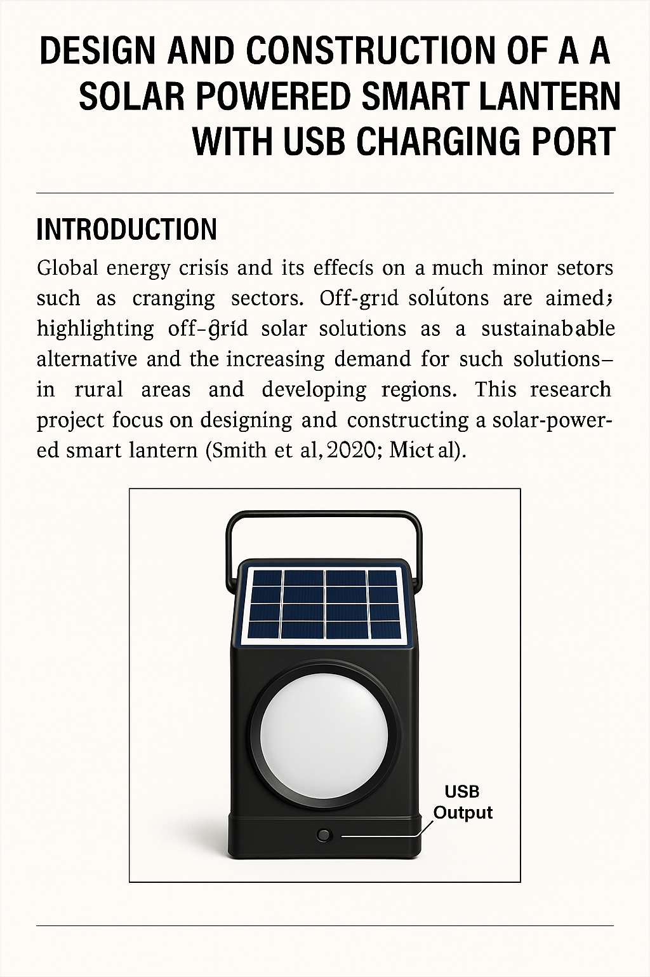
3.5 CIRCUIT DIAGARAM OF THE PROPOSED SYSTEM

Fig. 3.5: Circuit Diagram of the proposed System
Solar Panel (Photovoltaic Panel): The solar panel is responsible for capturing solar energy and converting it into electrical energy. It is connected to the charge controller and the battery. The panel will be optimized for maximum energy conversion to ensure the system charges efficiently during daylight hours.
Charge Controller: The charge controller regulates the flow of energy from the solar panel to the battery. It prevents overcharging and undercharging, thereby prolonging the battery's lifespan. It ensures that energy is distributed correctly between the battery and the LED light, and can also manage power distribution to the USB port for device charging.
Battery (Lithium-Ion): The battery stores the energy collected by the solar panel. Lithium-ion batteries are used due to their higher energy density, faster charging, and longer lifespan compared to traditional lead-acid batteries. The battery is connected to both the LED light and USB charging port, providing power when needed.
Energy Management System (EMS): The EMS monitors the battery charge level and controls the flow of energy to the lantern and the USB charging port. It ensures efficient power usage by prioritizing either the LED light or USB charging, depending on the battery status. The EMS adjusts power consumption to extend battery life, especially when the charge is low.
LED Light (Lighting System): The LED light provides illumination and is connected to the battery. It is energy-efficient, providing bright light while consuming minimal power. The light intensity is adjustable through automated brightness control, which allows the lantern to adjust based on environmental conditions (e.g., daylight vs. night).
USB Charging Port: The USB port allows users to charge mobile phones and small electronics. The charging circuit is optimized for fast, safe charging and can charge multiple devices simultaneously without affecting the lantern’s illumination function. The EMS also manages power distribution to this port.
Real-Time Battery Monitoring: A monitoring system tracks the battery’s charge level, health, and voltage in real-time. Users can access this data through a display on the lantern or via a mobile app. This feature helps users understand when the lantern needs recharging, preventing overuse or undercharging.
Control Interface (Mobile App/Remote Control): The control interface allows users to interact with the lantern remotely. Users can adjust the brightness, check battery status, and control other features via a mobile app or remote control. The app could provide notifications regarding battery health, charge status, and system performance.
Microcontroller/Processor: The microcontroller serves as the brain of the system, coordinating the operations of all components. It manages the energy distribution, brightness control, USB charging, battery monitoring, and communication with the control interface. It processes input from sensors and executes commands accordingly.
Sensors
- Light Sensors: Used for automated brightness control, these sensors detect the surrounding light level and adjust the LED brightness to conserve energy when full brightness is unnecessary.
- Motion Sensors: Optional feature for security, where the lantern automatically turns on or adjusts brightness when motion is detected in the vicinity.
Enclosure/Body
The lantern's body is designed to be durable and weather-resistant, ensuring protection of internal components from environmental conditions such as rain, dust, and high temperatures. The enclosure also houses the solar panel and all other components.
System Workflow:
- Daytime: The solar panel captures sunlight and converts it into electrical energy, which is stored in the lithium-ion battery. The energy management system ensures that the battery is charged without overloading.
- Nighttime: The system uses the stored energy to power the LED light and charge devices via the USB port. The EMS prioritizes lighting or charging based on the battery level, while the brightness control adjusts the light level according to environmental conditions.
- Real-Time Monitoring: Users can monitor the battery level through the display or mobile app, making it easier to manage power consumption. The system can notify the user when the battery is low and needs recharging.

CHAPTER FOUR
DESIGN AND IMPLEMENTATION OF THE SYSTEM
4.1 SCHEMATIC DESIGN
The schematic design of the solar-powered smart lantern with a USB charging port outlines the functional interconnection of all components in the system. At the core of the design is the photovoltaic (PV) panel, which converts sunlight into direct current (DC) electricity. This DC power is routed through a charge controller that regulates the voltage and current, protecting the rechargeable lithium-ion battery from overcharging or deep discharging. The battery stores the generated energy and supplies power when sunlight is not available, especially during nighttime or cloudy conditions.
Connected to the battery is a smart power distribution module that directs energy to both the LED lighting unit and the USB charging port. The LED light is powered through a current-limiting resistor or a driver circuit to ensure consistent illumination with low energy consumption. The USB port is regulated using a 5V step-down voltage converter, ensuring that mobile phones and similar devices can be safely charged. Safety features such as fuses, over-current protection, and short-circuit protection are also included in the schema to enhance system reliability. All these components are integrated on a well-laid-out circuit board and enclosed in a durable casing, making the system portable, efficient, and safe for various applications.
4.2 SYSTEM DESIGN
The system design of the solar-powered smart lantern with a USB charging port integrates renewable energy technology, efficient lighting, and smart charging functionality into a compact and portable device. The primary source of power for the system is a photovoltaic (PV) solar panel, which is responsible for harvesting solar energy during daylight hours. The panel is selected based on output rating sufficient to charge the battery within a reasonable time, depending on sunlight availability. The energy generated by the solar panel is direct current (DC), which is passed through a charge controller. The controller regulates the voltage and current coming from the solar panel to ensure that the battery receives safe and optimal charging, thereby prolonging its lifespan.
A rechargeable lithium-ion battery is incorporated to store the regulated energy. The choice of this battery is influenced by its lightweight, high energy density, and durability. From the battery, power is distributed to two main outputs: the LED lighting system and the USB charging interface. The LED system is chosen for its low power consumption, long life, and high brightness, making it ideal for use in rural and urban environments alike. A voltage regulator or driver circuit ensures stable operation of the LED even when battery voltage fluctuates.
The USB charging port is connected to a 5V voltage regulation circuit, which allows users to charge mobile phones and small electronic devices directly from the stored energy. Additional safety features such as short circuit protection, over-voltage protection, and indicators for battery status are incorporated into the design to ensure reliability and user awareness. All components are mounted within a weather-resistant and heat-dissipative enclosure, ensuring the system's durability and functionality in various environmental conditions. The complete design ensures sustainability, efficiency, and multi-purpose utility.

4.3 SYSTEM DOCUMENTATION
The system documentation for the solar-powered smart lantern with USB charging port provides a comprehensive overview of the components, operation, and assembly process involved in the development of the device. This documentation serves as a guide for understanding how each component interacts within the system, from solar energy captured to power distribution and output functionalities. The system is composed of a solar panel, a charge controller, a lithium-ion battery, an LED lighting unit, a USB charging port, and various safety circuits.
The solar panel is mounted externally to absorb sunlight and convert it into electrical energy, which is then routed to the charge controller. The controller is programmed to manage the charging process of the battery, protecting it from overcharging, deep discharge, and ensuring efficient energy utilization. The energy is stored in a lithium-ion battery, which acts as the main power reservoir for the system. From the battery, two branches of power supply are created one directed to the high-efficiency LED for illumination, and the other directed to a 5V voltage regulator circuit for the USB charging port.
LEDs are selected based on low power consumption and high brightness, providing adequate lighting during night hours. The USB port allows for mobile devices to be charged conveniently, making the lantern multifunctional. Indicators such as charging status LEDs and battery level indicators are also integrated for user guidance. All components are arranged on a printed circuit board (PCB) and enclosed within a durable casing that protects the internal parts from moisture, dust, and mechanical damage.
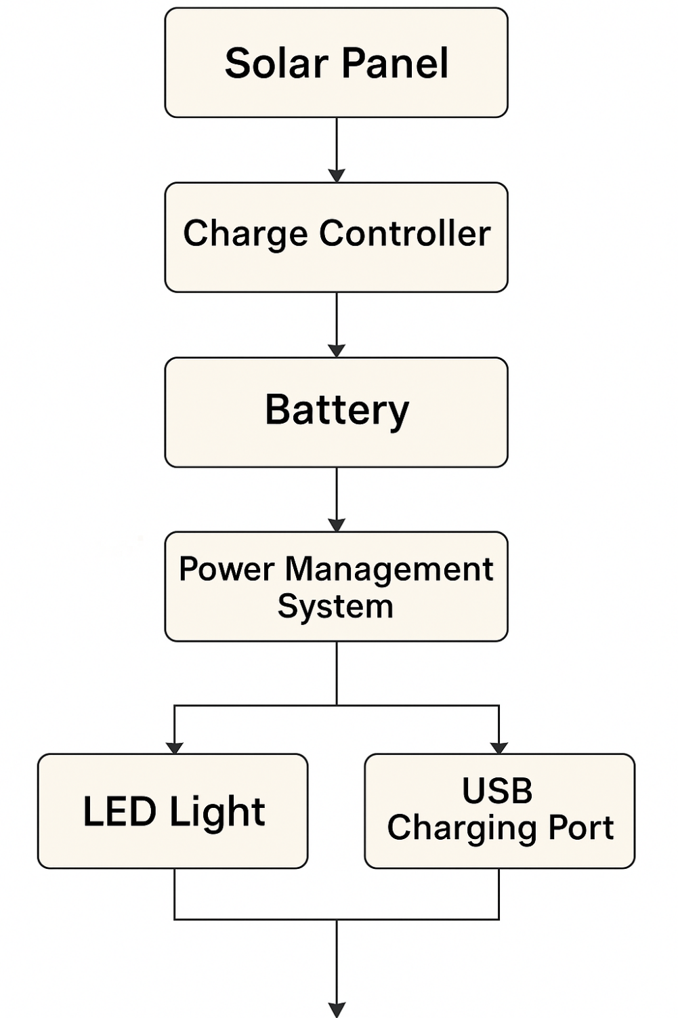
The documentation includes circuit diagrams, flowcharts, schematic layouts, and test results to demonstrate the functionality and reliability of the system. It also covers maintenance procedures, troubleshooting tips, and safety instructions. This ensures the system is user-friendly, easy to replicate, and scalable for broader applications.
4.3.1. SYSTEM FLOWCHART

4.4 SYSTEM IMPLEMENTATION
The system implementation of the solar-powered smart lantern with USB charging port involves the practical integration of hardware components based on the design specifications and schematic diagrams developed during the planning phase. The process begins with the procurement of essential components such as the photovoltaic (PV) solar panel, lithium-ion battery, charge controller, LED light, USB port module, voltage regulators, resistors, diodes, capacitors, switches, and a durable casing. Each component is carefully selected based on power ratings, durability, and compatibility with other units in the system.
The photovoltaic panel is installed on the external surface of the casing to maximize exposure to sunlight. Wires from the panel are connected to the charge controller, which manages the voltage and current to safely charge the lithium-ion battery. From the battery, two output lines are created: one directed to the LED lighting circuit and the other to the USB charging module. The LED is connected through a current-limiting resistor or driver to maintain stable illumination and protect the light from voltage fluctuations. The USB output is linked to a 5V step-down voltage regulator, ensuring safe charging of mobile devices and other electronics.
A PCB (Printed Circuit Board) is used to neatly organize the internal connections and improve system reliability. Proper soldering techniques are applied to ensure secure and durable joints. Safety features such as fuses and protection circuits are incorporated to prevent overvoltage, short circuits, or thermal damage. A user-friendly switch is included for controlling the LED, and indicator lights display charging and battery status.
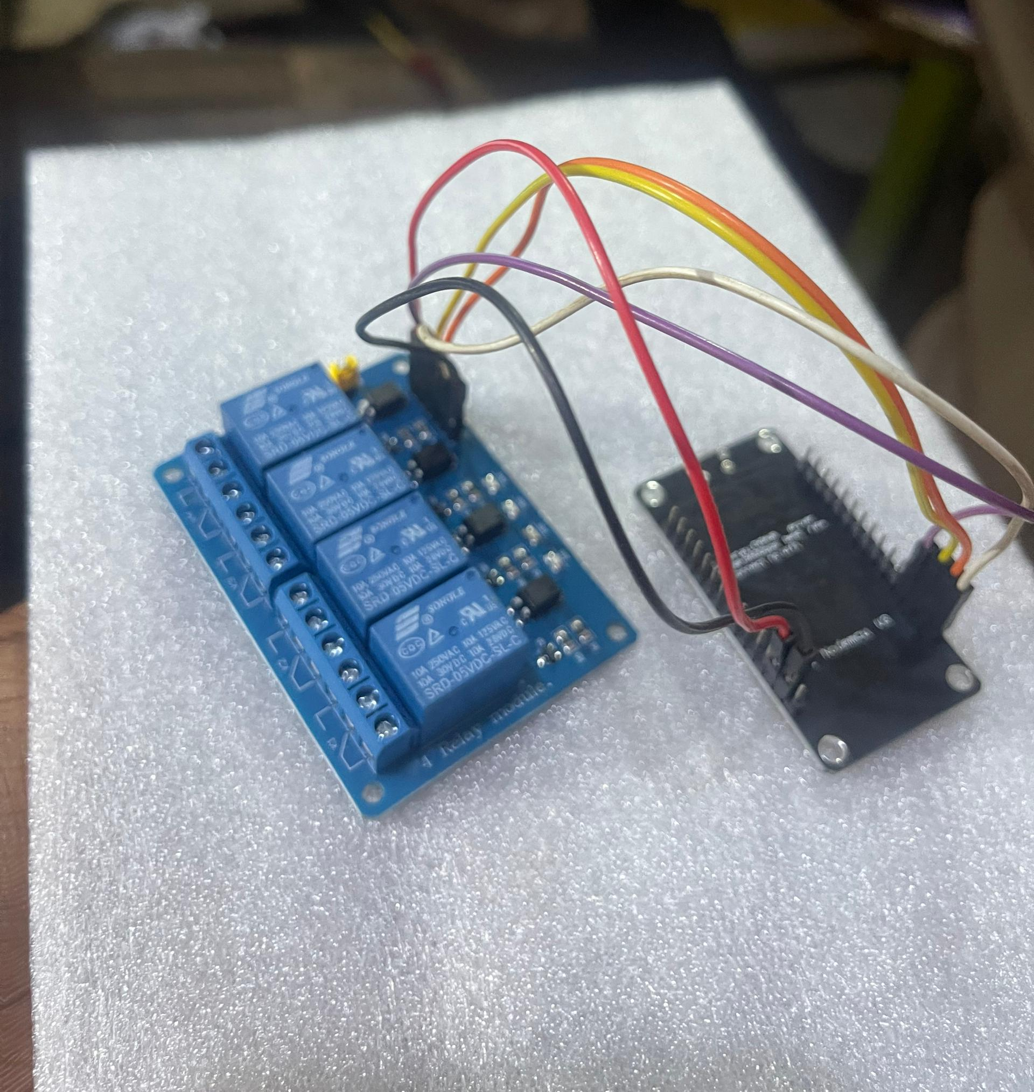
Finally, all the components are enclosed in a rugged, weather-resistant casing that protects the device from dust, moisture, and impact. Testing is conducted to ensure the lantern operates effectively under various conditions, verifying the efficiency of the solar charging, lighting duration, and USB charging capacity.

Fig. 4.1: Relay and Node MCU

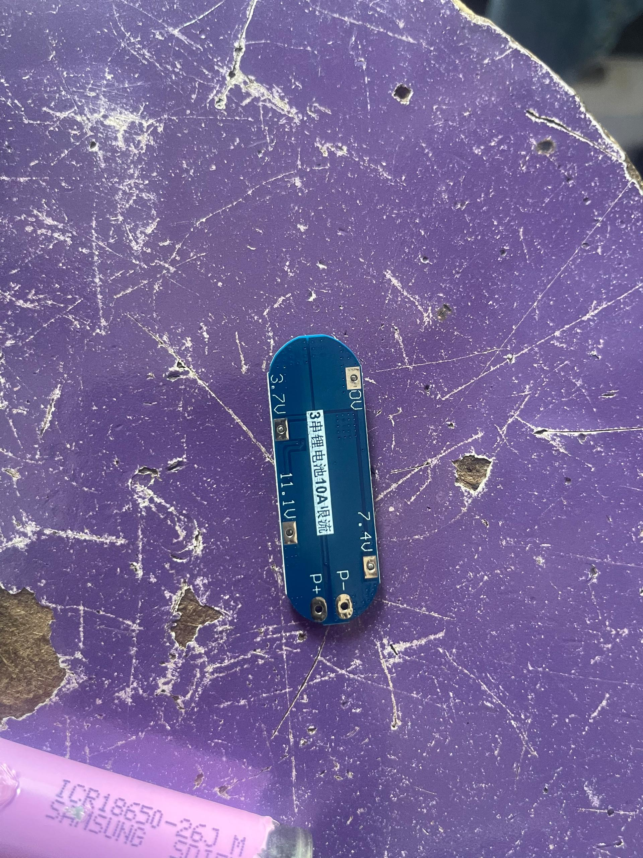

Fig. 4.2: Mini Micro-controller unit
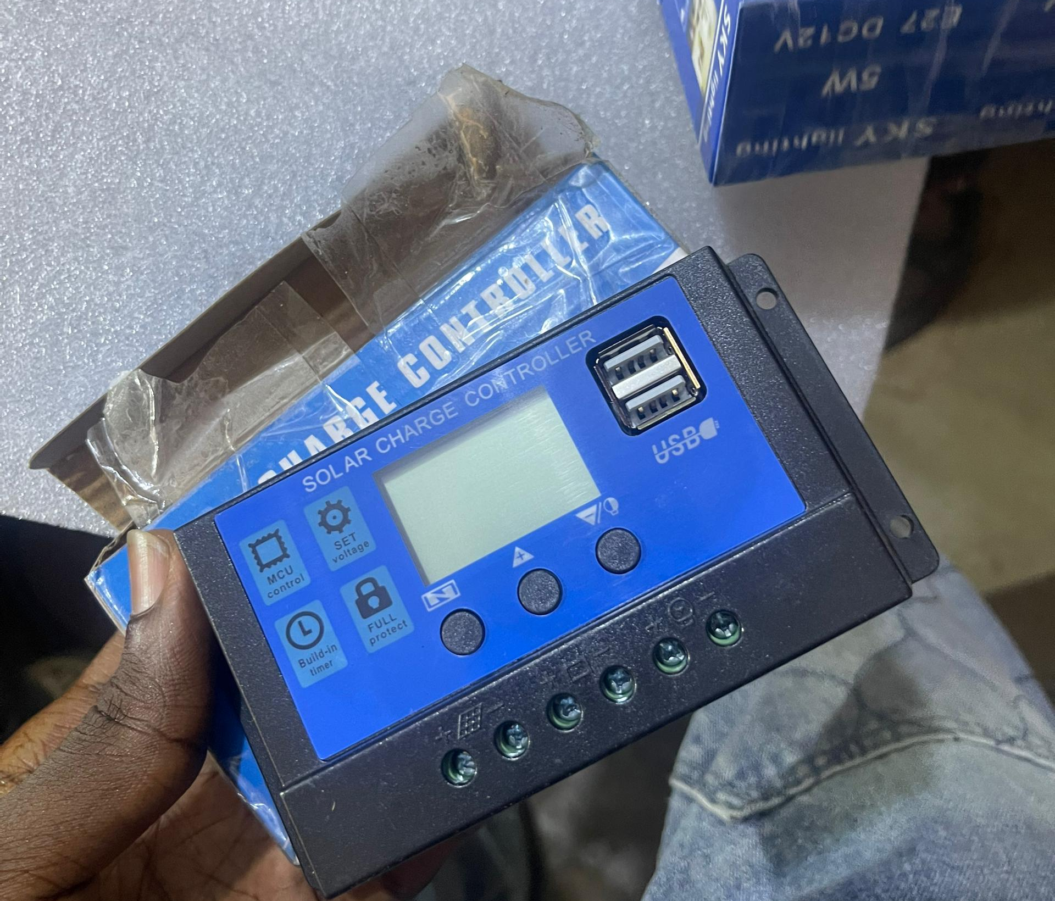

Fig. 4.3: Control Card

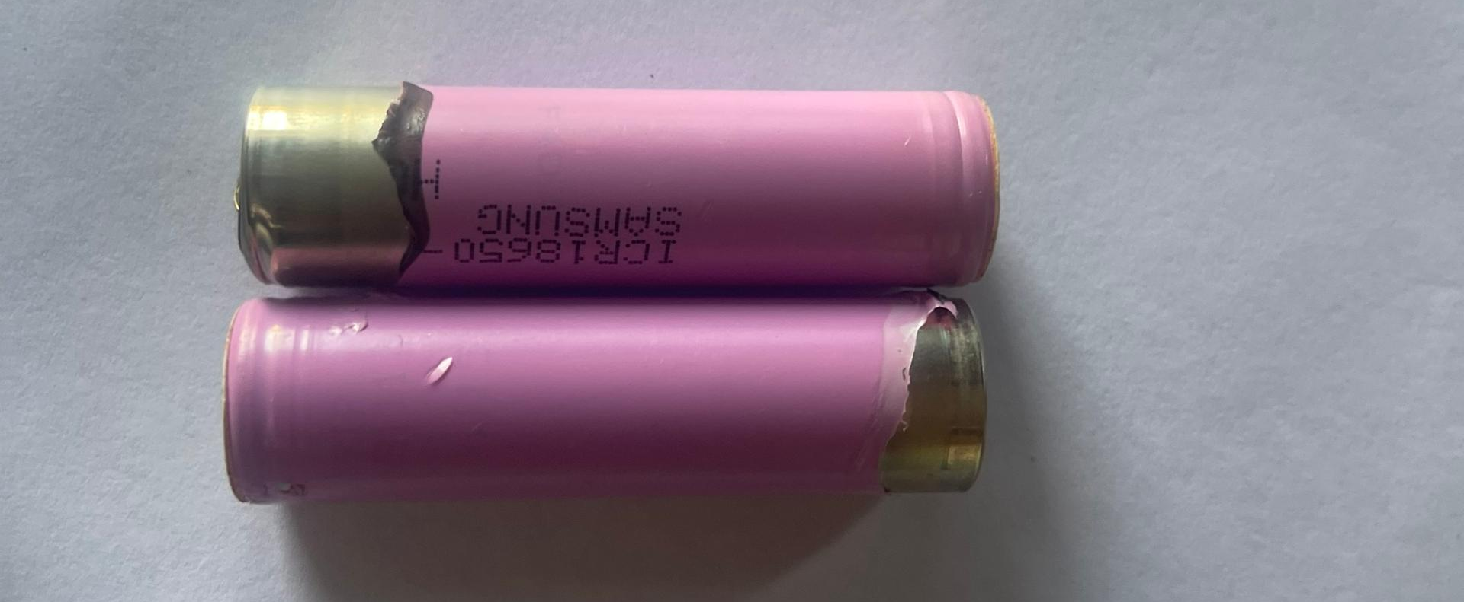

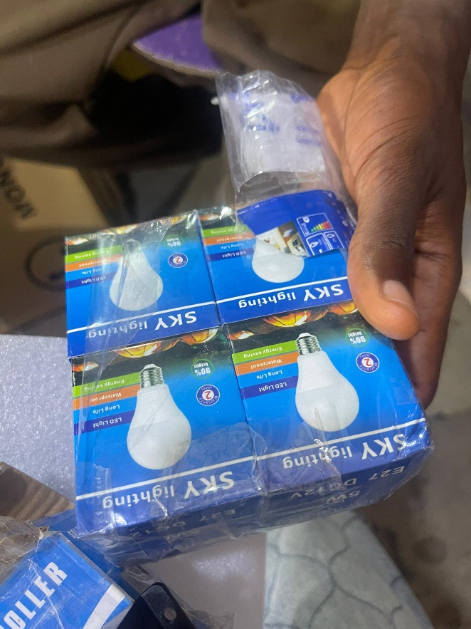
Fig. 4. 4: Ion Lithium Battery

Fig. 4.5: DC Bulb

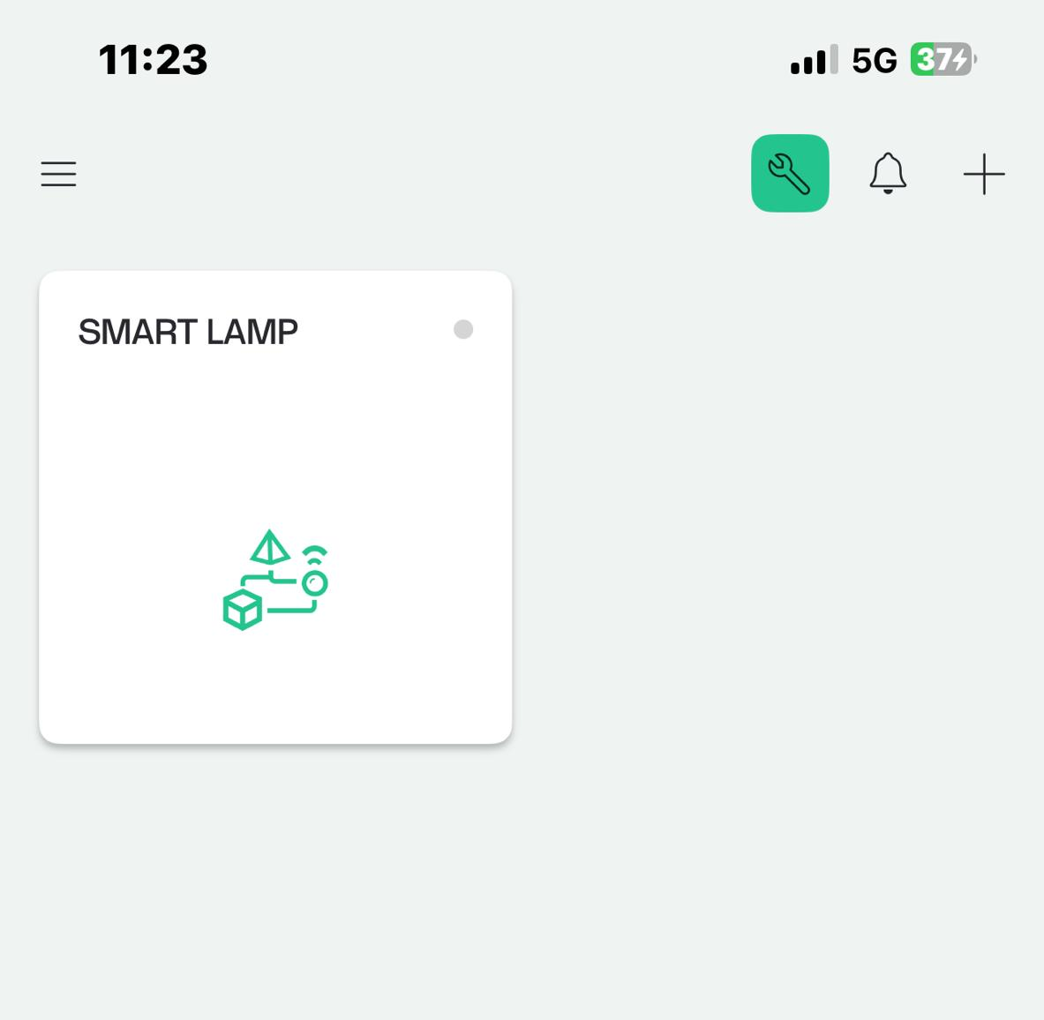

Fig. 6: App Interface to control the System

CHAPTER FIVE
SUMMARY, CONCLUSION AND RECOMMENDATIONS
5.1 SUMMARY
This research work has focused on the design and construction of a solar-powered smart lantern integrated with a USB charging port to address the growing need for sustainable and portable lighting solutions, especially in areas with limited access to electricity. The project aimed to harness renewable solar energy, store it efficiently, and distribute it for lighting and device charging using modern technological components. The system consists of a photovoltaic (PV) solar panel, a charge controller, a lithium-ion battery, a bright LED light, and a USB port with a 5V voltage regulator.
The PV panel collects sunlight and converts it into electrical energy, which is regulated by the charge controller to charge the battery safely. The stored energy is then used to power the LED for illumination and provide a stable voltage output to the USB charging port for mobile devices. Key advantages of this system include portability, energy efficiency, environmental friendliness, and multifunctional use. The lantern can be deployed in rural households, during emergencies, or in outdoor activities where grid power is unavailable.
The design process involved selecting appropriate components based on power ratings, integrating them using a well-laid-out circuit schematic, and constructing the final device with protective casing. The project also addressed limitations of existing systems such as poor battery life, inefficient lighting, and lack of multifunctionality.
Testing of the prototype confirmed its functionality, efficiency, and reliability. In conclusion, this research successfully developed a cost-effective and sustainable smart lantern that contributes to the advancement of renewable energy applications and improves the quality of life in energy-deficient areas.
5.2 CONCLUSION
In conclusion, this research work has successfully demonstrated the design and construction of a solar-powered smart lantern equipped with a USB charging port. The project effectively combines renewable energy utilization, energy storage, efficient LED lighting, and mobile device charging into a compact and affordable system. By employing a photovoltaic panel, charge controller, lithium-ion battery, LED technology, and USB charging interface, the system addresses the pressing need for sustainable and portable lighting solutions in both rural and urban areas where access to reliable electricity is limited. The developed lantern not only serves the purpose of providing illumination during power outages or in remote environments but also adds value through its ability to charge mobile phones and other low-power USB devices. The use of a rechargeable battery ensures energy can be stored for nighttime use, while the charge controller safeguards the system against power surges and overcharging. This improves safety, durability, and user confidence. Through proper system implementation and testing, the lantern has proven to be reliable, user-friendly, and cost-effective. It holds potential for wider application in educational, domestic, and outdoor settings. Ultimately, the project contributes to environmental conservation and energy efficiency while offering a practical solution to energy access challenges in underserved communities.

RECOMMENDATIONS
Based on the outcomes and observations of this research work, the following recommendations are made to improve the performance and application of the solar-powered smart lantern with USB charging port:
- Future designs should consider incorporating a Maximum Power Point Tracking (MPPT) charge controller to enhance solar energy conversion efficiency.
- A higher-capacity lithium-ion or lithium-iron phosphate battery can be used to increase energy storage and prolong lighting and charging time.
- Integrating smart features such as Bluetooth control, battery level notifications, and mobile app connectivity can enhance user experience and functionality.
- To make the lantern suitable for all environments, especially outdoor use, the casing should be waterproof, dustproof, and impact-resistant.
- Adding multiple USB ports can allow for simultaneous charging of more than one device, increasing user convenience.
- Future models should allow for adjustable solar panel positioning to maximize sun exposure regardless of the lantern’s placement.
- Government and NGOs should consider supporting the mass production and distribution of the lanterns in rural or disaster-prone areas to improve energy access.
- To reduce cost and increase accessibility, local assembly and maintenance training should be encouraged in communities where the lantern will be deployed.

REFERENCES
Ahmed, & M. A. Cruz, R.A (2020). Telecommunication Technologies for Smart Grids: Total Cost Optimization, Adv. Renew. Energies Power Technol., vol. 2, pp. 451–478, DOI: https://doi.org/10.1016/B978-0-12-813185-5.00007-3.
Atiqur, I. & Rotunno, J.Z, (2019). Energy management maturity model: An organizational tool to foster the continuous reduction of energy consumption in companies, Int. J. Clean. Prod, vol. 83, pp. 108– 117.
Atiqur W.E & Li Yu (2019). Security in building automation systems,” IEEE Trans. Ind. Electron., vol/issue: 57(11), pp. 3622-3630.
Desain Sistem Monitoring Sistem Photovoltaic Berbasis Internet of Things (IoT),” JNTETI, vol. 5, no. 4, pp. 328–333, 2016.
Dincer, I., & Rosen, M. A. (2018). A review on energy-saving strategies in the industrial sector,” Renew. Sustain. Energy Rev., vol. 15, pp. 150–168.
Han D.M., & Lim, J.H. (2010). Smart home energy management system using IEEE 802.15.4 and Zigbee, IEEE Transactions on Consumer Electronics, vol/issue: 56(3), pp. 1403-1410,
Hualei W.E. (2019). for Standardization, “ISO 50001 Energy Management System Haier Group Company,” 2013.
Hualei Z & Yanine, A.F. (2019). A survey on Internet of Things architectures,’’ J. King Saud Univ. Comput. Inf. Sci., vol. 30, no. 3, pp. 291 319, Jul. 2018, doi: 10.1016/j.jksuci.2016.10.003.
Indragandhi C.W, & Gellings K. E. (2018): Parmenter, ‘‘Demand-side management,’’ in Energy Ef ciency and Renewable Energy: Handbook, 2nd ed. Boca Raton, FL, USA: CRC
Kent R, (2019). Introduction to energy management,” Energy Manag. Plast. Process. (Third Ed., pp. 3–32, DOI: https://doi.org/10.1016/B978-0-08-102507-9.50001-5.
Liu XP (2015). Guest Editorial introduction to the Focused Section on Wireless Mechatronics, IEEE/ASME Transactions on mechatronics, vol/issue: 17(3), pp. 397-403.
Masud Md Rana & Li Li,, (2017). Industrial Energy Management: Principles and Applications. New York, NY, USA: Springer Science & Business Media.
Masud Md Rana & Li Li,, (2017). WSN- Based Smart sensors and Actuator for Power Management in Intelligent Buildings, IEEE/ASME transactions on Mechatronics, vol. 2, pp. 564-571.
Megha, Joshi, & Kavya, (2017). Fundamentals of Energy Management and Energy Managers, DOI: 10.13140/RG.2.2.20027.31524.
Natural Resources Canada (2010). Energy Management Information System S. Canada: Efficiency New Brunswick.
Ningana C, Wang, M. Daneshmand, M. Dohler, X. Mao, R. Q. Hu, & H. Wang (2017). Guest Editorial - Special issue on the internet of things (IoT): Architecture, protocols, and services, IEEE Sens. J., vol. 13, no. 10, pp. 3505–3508, 2.

