ASSESSMENT OF SOIL PHYSICO-CHEMICAL PROPERTIES OF PHASE II OF THE KWARA STATE POLYTECHNIC COMMERCIAL FARM LAND

BY

AGBOOLA SAMUEL OLUWAFERANMI ND/23/ABE/FT/0007

BEING A RESEARCH PROJECT SUBMITTED TO THE DEPARTMENT OF AGRICULTURAL AND BIO-ENVIRONMENTAL ENGINEERING TECHNOLOGY, INSTITUTE OF TECHNOLOGY, KWARA STATE POLYTECHNIC, ILORIN.
IN PARTIAL FULFILLMENT OF THE REQUIREMENTS FOR THE AWARD OF NATIONAL DIPLOMA (ND) IN AGRICULTURAL AND BIO-ENVIRONMENTAL ENGINEERING TECHNOLOGY

2024/2025 SESSION

DECLARATION

I hereby declare that this project titled "Assessment of Soil Physico-Chemical Properties of Phase II of The Kwara State Polytechnic Commercial Farm Land” is my original work carried out under the supervision of (ENGR. DAUDA K.A).
I also declare that to the best of my knowledge, all sources of information used in the course of this work have been duly acknowledged.

AGBOOLA SAMUEL OLUWAFERANMI
ND/23/ABE/FT/0007



DEDICATION

This project is dedicated to Almighty the most Beneficient, the Most merciful and to the Institute of Technology.

ACKNOWLEDGEMENT

All adoration and glory are due to the Almighty for His Love, guidance and protection. I thank him for the perfect health, wisdom, knowledge, strength and opportunity to complete this stage of Academic (National Diploma) in peace.
My Profound gratitude goes to my amiable supervisor ENGR. DAUDA KOLA ABDULKADIR., thanks so much for your support and care throughout the supervision of this research work, also to my good Project coordinator and to all the entire staff of the Institute of Finance and Management Studies.
Finally, I express my gratitude to my parents Mr. and Mrs. Agboola, friends and loved ones who supported me in one way or the other.

ABSTRACT
Continuous agricultural practices have impacts on soil properties and these impacts may be negative on soil, crop and groundwater quality. This could be as a result of the quality of water used, method of application and the nature of the soil viz the physical and chemical composition of the soil. The physical and chemical characteristics of soil at phase 1I of the Kwara State Polytechnic Commercial farm land were evaluated to assess the fertility and productivity status of the soils. Three soil samples were collected from different locations at soil depths of 0-20cm, 20- 60cm and 60-100cm in the study area using soil auger. A random sampling method was used to sample soil and the soil samples were taken to the laboratory for chemical and physical analysis. Physical analysis results showed that the soil of the study area was sandy loam; the available soil moisture contents obtained is low for 0-10cm, 10-20cm and 20-30cm crop rooting depths. The low percent of soil moisture ranged from 1.05 to 1.12%. The particle density, soil bulk density and porosity were 2.63g/cm³, 1.62 g/ cm³, and 38.4% respectively. Chemical analysis results revealed that the value of soil pH lies in the alkaline side and it ranged from 7.80 to 8.81. The organic carbon ranges from 0.52 to 0.72 % of the entire soil nutrients relating to soil fertility and is available in medium proportion of organic carbon. Electrical Conductivity (EC) values ranges from 0.50 to 0.73 dSm⁻¹ and all the soil samples have lower EC values. Available potassium content ranges from 125.31 to 630.15 kg/ha with the majority of the soil samples in the study show high available potassium. Nitrogen which is an essential plant nutrient for growth of plant canopy is low in all soil samples. The available phosphorous content of the soil is high which ranged from
15.11 to 54.13 kg/ha Therefore, it is essential to give attention to proper monitoring of the soil condition of the farm land in order to prevent soil deterioration.

 | TABLES OF CONTENTS
Title Page |  | i
Certification Dedication Acknowledgement Table of Content  Abstract |  | ii iii iv v  vi
CHAPTER ONE
INTRODUCTION
1.1 Background to the Study |  | 1
1.2 Statement of the Problem |  | 3
1.3 Aim of the Study |  | 3
1.4 Objectives of the Study |  | 4
1.5 Justification of the Study |  | 4

CHAPTER TWO LITERATURE REVIEW

  - Crop Type, Growth and Yield 5
  - Crop Yield and Growth As Affected by Environmental and
Climatic Factors 6
  - Effect of Soil Physical Properties on Crop Growth and Development 7
    - Soil Physical Properties 8
      - Soil Moisture Content 8
      - Water Holding Capacity 8
      - Particle Size Distribution 8
      - Soil Structure 10
      - Soil Bulk Density 11
      - Particle Density 11
      - Total Pore Space and Porosity 12
      - Infiltration Rate 13
    - Implication of Chemical Properties on Agricultural Soil
    - Exchangeable Sodium Percentage (ESP) 13
    - Cation Exchange Capacity (CEC) 13
    - Soil pH 14
    - Magnesium (Mg²⁺) 15
    - Calcium (Ca²⁺) 15
    - Sodium (Na²⁺) 15
    - Soil Organic Carbon (SOC) 15
    - Soil Organic Matter (SOM) 15
    - Soil Organic Matter (SOM) 16
CHAPTER THREE MATERIALS AND METHOD
  - Description of the Study Area 17
  - Soil Sampling Method 20
  - Soil Analysis Method 22
    - Soil Chemical Analysis 22
    - Physical Analysis 22
CHAPTER FOUR
RESULTS AND DISCUSSION
  - Results of Physical Analysis 23
  - Results of Chemical Analysis 25
CHAPTER FIVE
CONCLUSIONS AND RECOMMENDATIONS
  - Conclusions 34
  - Recommendations 34
REFERENCES 35

CHAPTER ONE INTRODUCTION

Background to the Study
The continuous use of soil for agricultural activity without careful quality assessment and monitoring will rise to accumulation of salts on the soil and consequently affects the crops potential yield. A salinity problem exists if salt accumulation in the crop root zone to a concentration that causes a loss in yield. Salts in soil reduce water availability to the crop to such an extent that yield is affected. A relatively high sodium or low calcium content of soil reduces the rate at which irrigation water enters soil to such an extent that sufficient water cannot be infiltrated to supply the crop adequately from one irrigation event to the next or infiltrates too slowly to supply the crop with sufficient water to maintain acceptable yields. Certain ions such as sodium, chloride and boron from the soil accumulate in a sensitive crop to concentrations high enough to cause crop damage and reduce yields (FAO, 1994).
Soil salinity is a major environmental factor limiting the productivity of agricultural lands. It causes land degradation and affects food production (Sharma and Rao, 1998). This problem is reducing agricultural productivity, and also putting far reaching impacts on the livelihood strategies of small scale farmers (Tanwir et al., 2003).
In addition to its direct impact on plants, salinity creates a sodic soil whose structure is much less stable than before and is quite vulnerable to structural decline. Excessive nutrients reduce yield and unsightly deposits on fruit or leaves due to overhead sprinkler irrigation with high bicarbonate water, water containing gypsum or high in iron; and various abnormalities often associated with an unusual pH of the water (FAO, 1994).

Some soil properties are good indicators of soil quality as they contribute to biological, physical and chemical properties of the soil. These include cation exchange capacity(CEC), soil organic matter (OM) and organic carbon (OC), exchangeable sodium percentage (ESP), electrical conductivity (EC), salinity and sodicity status, calcium (Ca), and magnesium (Mg) mineral nutrients (Adejumobi et al., 2014). However, soil physical properties include; Particle size distribution (soil texture), available soil moisture content, soil bulk density, particle density and soil porosity.
Soils in the tropics have been reported to be low in nutrients. Nitrogen is an important and commonly deficient nutrient element in tropical soils and it is the primary element of concern in vegetable production. In order to ameliorate nutrient depleted soils, inorganic fertilizer has been used by farmers (Ojo et al., 2015).
Global drive for sustainable agriculture systems involves optimizing agricultural resources to satisfy human needs and at the same time maintaining the quality of the environment and conserving natural resources (FAO, 1998). The success of soil management to achieve productivity and maintain soil fertility depends on the understanding of how the soil responds to agricultural use and practices (Negassa and Gebrekidan, 2004).
It is therefore necessary to carry out soil sampling and analysis of physical and chemical properties of soil at the phase II of the Kwara State Polytechnic commercial farm land to ascertain the quality status of the soil for sustainable agricultural production and for proper monitoring and dealing with fluctuation of the scheme soil quality.

Statement of the Problem
The establishment of agriculture production at phase II of the Kwara State Polytechnic commercial farm land is vital to enhance crop productivity to attain food sufficiency in Kwara State and Nigeria at large. Being the virgin land, its quality status for sustainable agricultural production has not been ascertained at the commencement of 2024 farming activity. Hence, the need to carry out soil sampling and analysis of physico-chemical properties of this farm land before land clearing, tillage and planting of seeds commence and for proper monitoring and dealing with fluctuation of the scheme soil quality.
Various soil and cropping problems develop as the total salt content increases, and special management practices may be required to maintain acceptable crop yields. The soil problems most commonly encountered in agricultural soils are those related to salinity, water infiltration rate, toxicity and a group of other miscellaneous problems (FAO, 1994).
In addition to its direct impact on plants, salinity creates a sodic soil whose structure is much less stable than before and is quite vulnerable to structural decline. Excessive nutrients reduce yield and unsightly deposits on fruit or leaves due to overhead sprinkler irrigation with high bicarbonate water, water containing gypsum or high in iron; and various abnormalities often associated with an unusual pH of the water (FAO, 1994).

Aim of the Study
The aim of the study was to monitor the soil conditions at phase II of the Kwara State Polytechnic commercial farm land with particular emphasis on some physico-chemical properties to guide against soil deterioration and ensure a sustainable agricultural production.

Objectives of the Study
The specific objectives of the study were to:

- collect soil samples randomly in different points on the field at 0-20cm, 20-60cm and 60-100 cm soil depths.
- determine some physico-chemical properties of soil through laboratory analysis; and

- make recommendations on the effects of soil properties as compare to some acceptable standards.

Justification of the Study
The establishment of agriculture production in the study area is vital to enhance crop productivity to attain food sufficiency but, in a long run, it might create adverse effect on the soil physical and chemical properties, fertility and sustainable productivity if it is not well monitored. Apart from the direct effects of water alone, soil structure can be dramatically and rapidly degraded in other ways by farming activities on the farm land.

CHAPTER TWO LITERATURE REVIEW

Crop Type, Growth and Yield
Three different arable crops such as Maize and Cassava were cultivated in the study area. Maize (Zea mays L.) is a member of grass family, Gramineae with basic structure of conspicuous nodes and internodes on the stem. The leaves grow on two opposite sides; one leaf per node. It is botanically unique among cereal crops and it is monoecious (separate male and female inflorescences on the same plant); produces grains on lateral rather than terminal branches and a cross pollinating (allogamous) species. Therefore, a natural population is usually heterogeneous (Jennifer, 1996).
Maize will do well on soils with good fertility, abundant soil structure, good drainage and a pH above 5.5, particularly in tropical region. Expected yield for open pollinated maize is between 2.5-3.5 tons/ha, while that of hybrid maize can be between 3.5-5.5 tons/ha. New improved maize varieties are constantly being released into the market, and can produce more than 5 tons/ha. However, these higher yields require at least 60,000 plants/ha and a higher rate of fertilisation (up to 150 kg of pure nitrogen/ha) (LFNL, 2003).
According to LFNL (2003), Cassava (Manihot esculenta) is a hardy and durable crop that can survive in many marginal soils. For good growth and yield, cassava requires friable, light textured and well-drained soils containing sufficient moisture and a balanced amount of nutrients. Depending on soil type and drainage, the soil may be prepared as moulds, ridges, flat or zero-tilled.

Multiple cropping with cassava is common in the humid tropics especially under rainfall conditions.
It is propagated vegetatively using the stem and identifying the polar orientation of the node during planting is very essential. Planting can be done vertically, at an angle or horizontally. 9-18 months are required depending on the variety and the need of the cultivator. They can be harvested by hand or by using a cassava lifter. The yield of cassava varieties can range from 15 to 30 t/ha. However, new triploids can reach a yield of up to 40 t/ha. These triploids varieties are increasingly becoming available.

Crop Yield and Growth As Affected by Environmental and Climatic Factors
In humid tropical regions, the high energy input, the high humidity of the air will reduce the evapotranspiration demand. In such an environment, the air is already close to saturation, so that less additional water can be stored by crop. Variations in wind alter the aerodynamic resistance of the crops and hence their crop coefficients and developmental stages which in turns affect their growth.
Too much water will result in water logging which might damage the root and limit root water uptake by inhibiting respiration. Cultivation practices and the type of irrigation method can alter the microclimate, affect the crop characteristics or affect the wetting of the soil, crop surface and yield. A ruminant animal can injure a crop plant and reduce fruit yield by feeding on the foliage or emerging fruit stalks (FAO, 1998).
Environmental factors such as soil salinity, poor land fertility, limited application of fertilizers, the presence of hard or impenetrable soil horizons, the absence of control of diseases and pests, animals, weeds, soil water content and poor soil management may limit the crop development and reduce crop yield. The evapotranspiration and photosynthesis process which are

essentially important for crop growth and development are determined by the amount of energy available to vaporize and remove water vapour from the evaporating surface.
Solar radiation is the largest energy source and is able to change large quantities of liquid water into water vapour. Part of the solar energy is used to heat up the atmosphere and the soil profile. The solar radiation absorbed by the atmosphere and the heat emitted by the earth increase the air temperature. The sensible heat of the surrounding air transfers energy to the crop and exerts as such a controlling influence on plant growth and development. In sunny, warm weather the loss of water by crop is greater than in cloudy and cooler weather (FAO, 1998).
In addition, the principal factors affecting crop growth and yield are climatic parameters (radiation, air temperature, humidity and wind speed) which provide energy for crop development. The favorable climatic environment can ensure high crop yields. Conversely, unfavorable conditions can negate or diminish the full growth (FAO, 1998). They are the components of all factors which influence plant growth and yield to the exclusion of the genetic factors.

Effect of Soil Physical Properties on Crop Growth and Development
Apart from the direct effects of water alone, soil structure can be dramatically and rapidly degraded in other ways by deforestation. The depth of the local water table represents a hydrological steady-state or balance between the addition to, and removal of water from the landscape. This balance is disturbed by vegetation removal, often leading to a shallower water table. Losses of water from this soil by evapotranspiration then allow the salt to accumulate near the soil surface and are quite vulnerable to structural decline.

Soil Physical Properties

Soil Moisture Content
As water is the most limiting factor in the arid to semi-arid areas, soil moisture determination is of major significance. Soil moisture influences crop growth not only by affecting nutrient availability, but also nutrient transformations and soil biological behavior. Therefore, soil moisture is routinely measured in most field trials. While it can be assessed in the field by the neutron probe, the gravimetric approach is more flexible, as samples can be readily taken from any soil situation. All analyses in the laboratory are related to an air- or oven-dry basis, and therefore must consider the actual soil moisture content (Sparks et al., 1966).

Water Holding Capacity
The water-holding capacity (WHC) is defined as the amount of water held in the soil after the excess gravitational water has drained away and after the rate of downward movement of water has materially ceased. Stage of field capacity is attained in the field after 24 to 72 hours of saturation; this is the upper limit of plant-available soil moisture. There is a distinction between soil water content, (the percent water on an oven-dry weight basis), and the soil water potential (the energy status of water in the soil), which is usually expressed in pressure units (Pascal or bar).

Particle Size Distribution
Individual soil particles vary widely in any soil type. Similarly, as these particles are cemented together, a variety of aggregate shapes and sizes occur. For standard particle size measurement, the soil fraction that passes a 2-mm sieve is considered. Laboratory procedures normally estimate percentage of sand (0.05 – 2.0 mm), silt (0.002 – 0.05 mm), and clay (<0.002 mm) fractions in soils.

Particle size distribution is an important parameter in soil classification and has implications for soil water, aeration, and nutrient availability to plants. Also, soil texture is an important property for agricultural soil, road beds, septic disposal systems, influences fertility, drainage, water-holding capacity, aeration, tillage, and bearing strength of soils. Because texture is so important, it is a standard physical soil test.
Once the percentage of sand, silt, and clay is measured, the soil may be assigned a textural class using the USDA textural triangle as shown in Figure 2.1. Within the textural triangle are various soil textures which depend on the relative proportions of the soil fractions. Twelve soil textural classes are recognized and their compositions are designed on a textural triangle. The class name can be determined by plotting these values on a textural triangle using the following technique:
- Clay; extend line horizontal from the percent clay (parallel with base of triangle, sand).

- Silt; extend line downward from percent silt at 60° (parallel with right side of triangle, clay).

- Sand; extend line upward from percent sand at 120° (parallel with left site of triangle, silt).

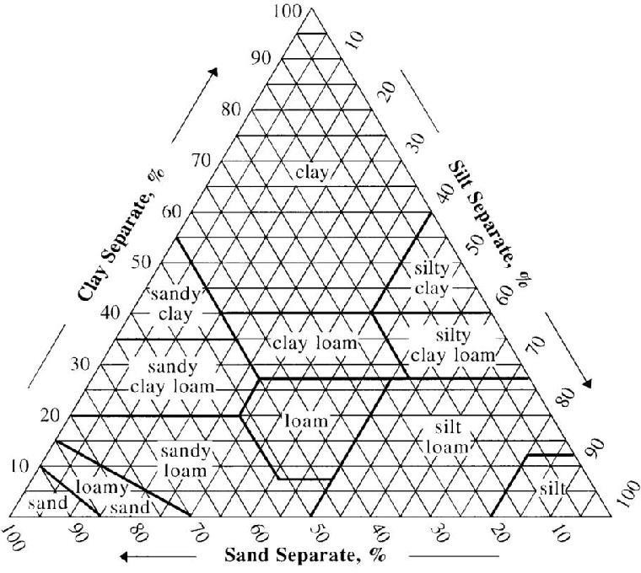

Figure 2.1: USDA soil textural triangle

Soil Structure
Soil structure is defined as the arrangement of the soil particles. With regard to structure, soil particles refer not only to sand, silt and clay but also to the aggregate or structural elements, which have been formed by the aggregation of smaller mechanical fractions. The size, shape and character of the soil structure varies, which could be cube, prism and platter likes. On the basis of size, the soil structure is classified as: very coarse (>10 mm), coarse (5-10 mm); medium (2-5 mm); fine (1-2 mm); and very fine (<1 mm). Depending upon the stability of the aggregate and the ease of separation, the structure is characterized as: Poorly developed, weekly developed, moderately developed, well developed, and highly developed.

Soil Bulk Density
Soil bulk density (BD) is ratio of the mass (oven-dry weight) of the soil to the bulk volume expressed in grams per cubic cm (g/cm³) or tons per cubic meter (t/m³), which includes the volume of both solids and pore space at a specified soil water content (usually the moisture content at sampling). The BD may be dependent on soil conditions at sampling time. Changes in soil swelling due to changes in water content can alter BD. Soil mass remains fixed, but the volume of soil may change as water content changes.
Bulk density is a parameter that indicates soil structure and void space. The BD is required to calculate porosity when particle density is known, to convert weights to volume, and to estimate weights of soil volumes too large to weigh. It is also required to convert data from a weight to a volume basis, to estimate saturated hydraulic conductivity (Ks), and to identify compacted horizons. For example, the volumetric content of water in a soil layer is obtained by multiplying the gravimetric water content by the product of the BD and the volume of the soil layer.
Soil BD is an indirect measure of the total pore space which is also affected by texture and structure. The BD of fine textured mineral soils usually ranges from about 1.0 to 1.5 g/cm³, and that of sandy soils from 1.3 to 1.7 g/cm³. The bulk density of organic soils is usually much less than that of mineral soils and may be as low as 0.4 g/cm³. Bulk density and total pore space are readily altered by tillage operations.

Particle Density
Soil particle density (PD) is defined as the ratio of the mass (oven dry weight) of the soil particles to the particle volume expressed in grams per cubic centimeter (only solid no pore space). The volume of soil is determined by measuring the volume of water displaced by the particles. The magnitude of PD depends on the type of minerals in the particles, and the content of organic matter

(OM) in the soil. The particle density of most soils varies from 2.60 to 2.75 g/cm³. When the average PD is not known, a value of 2.65 g/cm³ is generally assumed. Organic soils have a lower PD since OM has a density of 1.2 – 1.5 g/cm³. However, PD is used with BD to calculate soil porosity. Two methods for PD determination are common.

Total Pore Space and Porosity
The total pore space (TPS) consists of the PS between adjacent sand, silt and clay particles and those between aggregates. Percent pore space (PS) is the ratio of the volume of voids in a soil to the total volume (bulk volume) of the soil times 100. Texture and structure are the main factors governing the amount of PS in soil. The organic matter (OM) affects pore space indirectly by improving structure. If the aggregation of a particular soil is increased, the TPS increases, and the weight per unit volume or BD of the soil decreases. A medium textured mineral soil that is in good structural condition for plant growth has a PS of about 50 %. This PS is important for gas exchange (O2 and CO2) between the soil and the atmosphere, and water storage and movement. The PS is filled with air and water. Depending on pore size, pore spaces are given the name macro-pores (large) or micro-pores (small). There is no sharp line of demarcation between the two pore sizes. Pore space can be calculated using Equation 1.

Pore space (%) = (PD-BD) /PD x 100 (1)

Where:

PD = Particle density (g/cm³) BD= Bulk density (g/cm³)

Infiltration Rate
The infiltration rate is the velocity or speed at which water enters into the soil. It is usually measured by the depth (in mm) of the water layer that can enter the soil in one hour. An infiltration rate of 15 mm/hour means that a water layer of 15 mm on the soil surface will take one hour to infiltrate (FAO, 1994)
In dry soil, water infiltrates rapidly. This is called the initial infiltration rate. As more water replaces the air in the pores, the water from the soil surface infiltrates more slowly and eventually reaches a steady rate. This is called the basic infiltration rate. The infiltration rate depends on soil texture (the size of the soil particles) and soil structure (the arrangement of the soil particles) and is a useful way of categorizing soils from an irrigation point of view (FAO, 1994).

Implication of Chemical Properties on Agricultural Soil

Exchangeable Sodium Percentage (ESP)
Exchangeable Sodium Percentage (ESP) gives a measure of the percentage of sodium ions out of the total base cations. It is recognised as one of the indices of salinity with a reported threshold of 15%. Exchangeable Na or that held on the exchange sites or surfaces of clay minerals, is normally the dominant portion of total extractable Na. When ESP = 15 a critical values of ESP above which most crops are affected, causing changes in soil slow infiltration which is negative to crop growth (Lebron et al., 2002).

Cation Exchange Capacity (CEC)
Cation Exchange Capacity (CEC) is an estimate of the capacity of a soil to hold or absolve positively charged nutrients known as cations. The major soil cations include; calcium (Ca⁺²), potassium (K⁺²), sodium (Na⁺) and magnesium (Mg⁺²), hydrogen (H⁺) and aluminium (Al⁺³). It is

primarily influenced by soil type, pH level and amount of organic matter, hence, the higher the CEC, the more the clay and organic matter content present in the soil. The significance of pH lies in its influence on availability of soil nutrients, solubility of toxic nutrient elements in the soil, physical breakdown of root cells, and CEC in soils whose colloids (clay/humus) are pH-dependent and biological activity (ICARDA, 2013).
Several methods are available for CEC determination (Rhoades, 1982). Most methods involve saturation of the soil with an index cation (NH4), removal by washing of excess cation, and subsequent replacement of the adsorbed index cation by another cation (Na) and measurement of the index cation in the final extract (Richards, 1954). Modified procedures have been introduced because of high Ca solubility in calcareous and gypsiferous soils (FAO, 1990; Rhoades and Polemio, 1977).

Soil pH
Soil pH which is probably the most commonly measured soil chemical properties indicates alkalinity or acidity of the soil. It is also an excellent indicator of a soil’s suitability for plant growth which in turns affects the suitability of soil nutrients to the crop. However, crops vary in their acidity tolerance, growing best in a narrow pH range, while the desirable pH range for optimum plant growth also varies among crops. Soil pH is a crucial soil indicator, and is defined as the negative log of the hydrogen ion activity. Since pH is logarithmic, the H-ion concentration in solution increases ten times when its pH is lowered by one unit. The pH range normally found in soils varies from 3 to 9. Various categories of soil pH may be arbitrarily described as follows: Strongly acid (pH < 5.0); moderately to slightly acid (5.0-6.5); Neutral (6.5-7.5); moderately alkaline (7.5-8.5), and Strongly alkaline (> 8.5) (ICARDA, 2013).

Magnesium (Mg²⁺)

Magnesium (Mg²⁺) is another secondary macronutrient required by plants, vital for chlorophyll production or plant photosynthesis. It helps legume nodules fix nitrogen; mores phosphorus within the plant and in important for enzyme reactions. Magnesium deficiencies in different plants are shown by different symptoms (Tesfai et al., 2002).

Calcium (Ca²⁺)
Calcium (Ca²⁺) is a secondary macronutrient required by plants, important for cell nutrition, improving plant absorption of other nutrients and making plants respond better to environmental and disease stresses. It was stated the beneficial use of calcium in the soil; soil structure stabilization and combating of soil acidity. It is also observed that soils that are acidic are usually deficient in calcium. Calcium availability is closely related to soil pH (Tesfai et al., 2002).

Sodium (Na²⁺)
Sodium (Na) can be extracted with ammonium acetate solution in the same way as K, while soluble-Na can be obtained in a water extract obtained from a saturated paste as for EC. Subsequently, Na in the extract can be determined by flame photometry, where Na emits a sparkling yellowish-red color (ICARDA, 2013).

Soil Organic Carbon (SOC)
Soil organic carbon (SOC) is the carbon associated with soil organic matter. It promotes soil structure by holding the soil particles together as stable aggregates and improves soil physical properties such as water holding capacity, water infiltration, gaseous exchange, root growth and ease of cultivation. The actual amount of OC present in the soil is a function of a number of factors; rainfall, temperature, vegetation and soil type. Soil Organic Carbon (SOC) ranges from being the

dominant constituent of peat or muck soils in colder regions of the world to being virtually absent in some desert soils. Cultivated, temperate-region soils normally have often than 3 – 4 % SOM, while soils of semi-arid rainfed areas, such as in the WANA region, have normally less than 1.5
% SOM (ICARDA, 2013).

Soil Organic Matter (SOM)
Soil organic matter (SOM) represents the remains of roots, plant material, and soil organisms in various stages of decomposition and synthesis, and is variable in composition. Though occurring in relatively small amounts in soils, organic matter (OM) has a major influence on soil aggregation, nutrient reserve and its availability, moisture retention, and biological activity (ICARDA, 2013). Soil Organic Matter (OM) is the organic fraction of the soil that is made up of decomposed animal and plant materials as well as microbial organisms, without involving fresh and un-decomposed plant materials, such as straw and litter, lying on the soil surface. The decomposition makes certain nutrients such as nitrogen, phosphorus and a range of other nutrients available for plant growth. Organic Matter also acts as buffer against toxic and harmful substances (i.e.) lessen their effects (Yin, 2008).
Organic matter/organic carbon can be estimated by volumetric and colorimetric methods. However, the most common procedure involves reduction of potassium dichromate (K2Cr2O7) by organic compounds and subsequent determination of the unreduced dichromate by oxidation- reduction titration with ferrous ammonium sulfate. This method is referred to as the Walkley-Black method (Walkley, 1947; FAO, 1974).

CHAPTER THREE MATERIALS AND METHOD

Description of the Study Area
The study area is located at the South East Wing of Kwara State Polytechnic Ilorin main campus, in Moro Local Government Area of Kwara State. It is approximately located between latitude 08⁰ 33′ 16.4″ N, longitude 04⁰ 38′ 04.2″ E and latitude 08⁰ 33′ 38.4″ N and longitude 04⁰ 38′ 20.6″ E of Greenwich Meridian. The study area is at kilometer 10 off old Ilorin- Jebba road. The Polytechnic entrance is between Elekoyangan and Oke-Ose village along the road. The Polytechnic land was carved out of the present Moro Local Government area of Kwara State. The Polytechnic is having boundary with Ilorin East Local Government. Figure 3.1 is the map of the study area. Figure 3.2 is the perimeter map of the Kwara State Polytechnic commercial farm land.

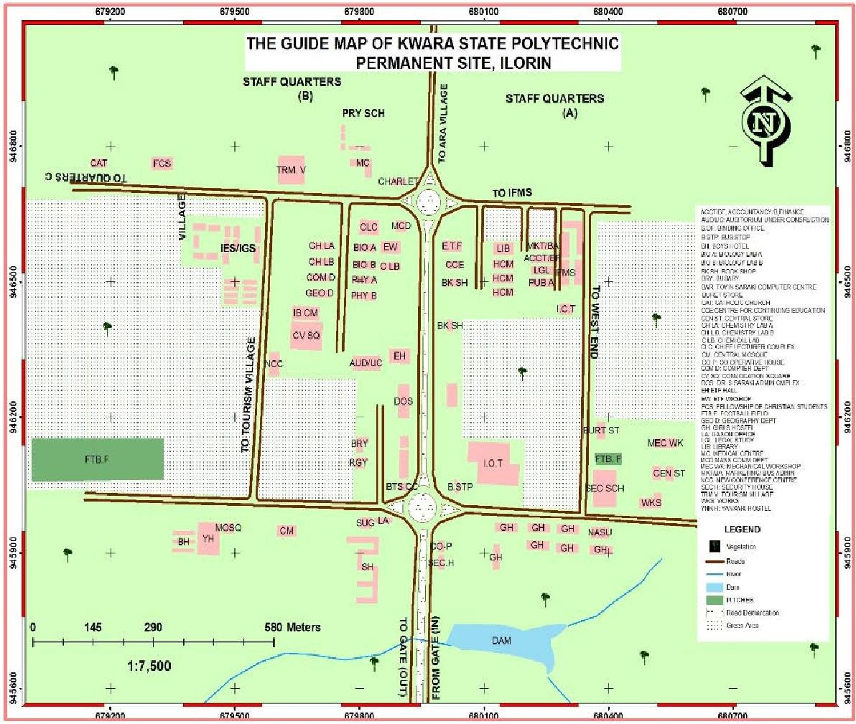

Figure 3.1: Map of the study area

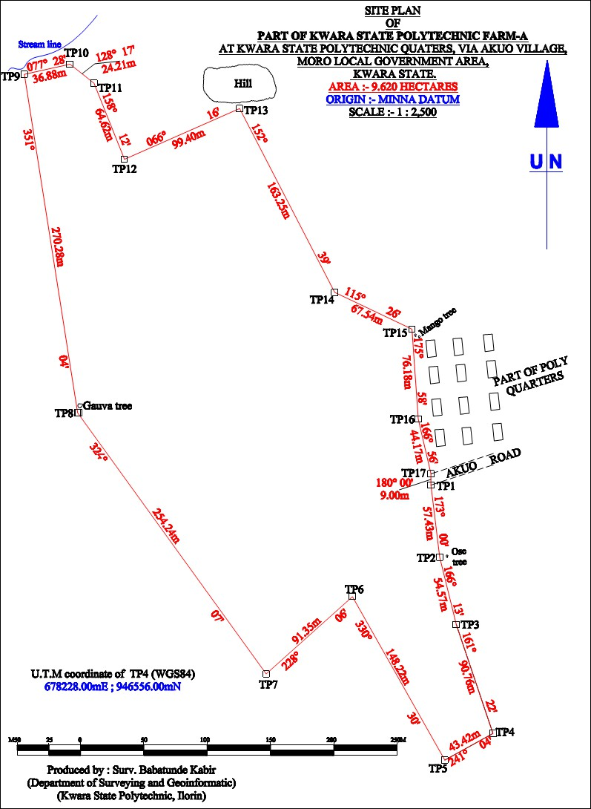

Figure 3.2: Perimeter map of the Kwara State Polytechnic commercial farm land Source: www.Googlemap.com

Soil Sampling Method
Three soil samples were collected randomly from different locations at soil depths of 0-20 cm, 20-60 cm and 60-100cm in the study area using soil auger. The soil samples were taken into polythene bags and labeled accordingly. The collected soil samples were air dried, gently crushed and sieved through 2 mm mesh for laboratory analysis. The undisturbed soil samples were collected using core cutters and sealed immediately on both edges with candle wax melted on the field to prevent loss of moisture. Soil sampling operation is shown in Plate 3.1.


Plate 3.1: Soil Sampling Operation using Soil Auger

Soil Analysis Method

Soil Chemical Analysis
The following methods were employed by the scientist in the laboratory for soil chemical analysis:
- Soil pH was determined by pH meter in soil-water and soil-KCL filtrates.

- CEC was determined titrimetrically, following sequential leaching with ammonium acetate, 95% ethanol, potassium chloride; and distillate collected over 2%.
- Exchangeable sodium percentage (ESP) was observed by dividing total exchangeable sodium by the cation exchange capacity multiplied by 100.
- Organic carbon (OC) expressed in percentage was determined using Walkley-Black wet digestion method.
- Organic Matter (OM) in percentage was done by calculation: OM = OC x 1.723

- Calcium and Magnesium were determined using Atomic Absorption Spectrophotometer.

Physical Analysis

The following methods were employed for soil physical analysis:

      - The particle size analysis was done by hydrometer method, employing sodium hexametaphosphate [Na (HPO4)6] calgon as the dispersing agent.
      - The available soil moisture content was determined using a digital moisture Analyser.

      - Soil bulk density was determined by employed a core method.

      - Particle density was used with bulk density to calculate soil porosity.

CHAPTER FOUR RESULTS AND DISCUSSION

Results of Physical Analysis
The parameters evaluated for soil physical properties include soil texture, moisture content, porosity and bulk density. Results of the soil particle size analysis revealed that soil in the study area is sandy loam, using USDA textural classification triangle chart. This indicates that the soil is generally very light-textured with sand percentage averaging more than 75% and loam is 25%. The particle size distribution of the soils is shown in Table 4.1. Therefore, the soils appear moderately suitable for agricultural production, but may be drought prone.
Table 4.1: Average particle size distribution of the soil

S/N | Depth (cm) | Sand (%) | Silt (%) | Clay (%) | Textural class (USDA)
1  2  3 | 0-10  10-20  20-30 | 71  69  76 | 12  16  12 | 17  15  12 | Sandy Loam  Sandy Loam Sandy Loam

The available soil moisture contents obtained is low for 0-10cm, 10-20cm and 20-30cm crop rooting depths. The low percent of soil moisture ranged from 1.05 to 1.12% and it is an indication that enough moisture is not readily available to support plant growth which may reduce crop yield. The field capacity, permanent wilting point and available water content are called the soil moisture characteristics. Soil moisture content is a portion of water which is easily extracted by the plant and it is about 75% of available water in the soil (FAO, 1985).

Bulk density was determined by measuring the mass of soil in a cylinder of known volume. Cylinder’s inside volume is equal to soil volume. After pushing the soil out of cylinder, it was dried in oven at 105⁰C until it reaches a constant weight. The bulk density was calculated by dividing the oven-dry mass by cylinder volume. Soil porosity in a soil consists of that portion of the soil volume not occupied by solid particles, either mineral or organic. It was calculated by dividing the volume of voids (pore space), by the volume of solids (soil particles). Thus;
- Cylinder volume (Vc) = Πr ²h

= (3.142) (2.06 cm²) (10.16)

= 135.45 cm³
- Volume of water displaced by soil (Vws) = 9.5 cm³

- Particle density (ρs) = Massofsoilsamplepassedthroughsieve(Ms)
Volumeofwaterdisplacedbysoil (Vws)

= 25
9.5

= 2.63g/cm³

- Bulk density (ρb) = Massofoven − driedsoil (Mds)
VolumeofCylinder (Vc)

= 218.9
135.45

= 1.62 g/ cm³

- Soil Porosity (ℓs) = 1 −
Bulkdensity Particledensity
x100

= 1 − 1.62 x100 2.63

= 38.4%

Results of Chemical Analysis
The results of the chemical analysis are presented in Table 4.2 and in Figure 4.1 to 4.9.
T able 4.2: Results of the selected average soil chemical properties
S/N | Parameter | 0-20cm | 20-60cm | 60-100cm
1  2  3  4  5  6  7  8  9  10 | pH  Mg⁺⁺ (me/l) Ca⁺⁺ (me/l) Na⁺ (me/l) OC (%)  OM (%)  P (mg/l) ESP (%)  CEC (me/l)  SAR (meg/l) | 6.52  1.36  5.25  0.25  0.23  0.17  28.34  10.00  5.34  0.14 | 5.30  1.16  4.36  0.16  0.14  0.16  26.06  9.11  4.76  0.10 | 6.87  2.26  6.22  0.65  0.27  0.13  20.28  5.90  5.52  0.32

Soil pH is a measure of soil acidity and alkalinity. The minimum and maximum soil pH values are 5.30 and 6.87. Soil pH on the field was moderately to slightly acidic, as given by Hert et al., 1999 in Table 4.3 and indicates a decrease from 0-20cm to 20-60cm soil depth and subsequently tending towards neutral as shown Figure 4.1. According to United State Department of Agriculture (USDA), too high or too low soil pH leads to deficiency of many nutrients, decline in microbial activities, decrease in crop yield, and deterioration of soil health. Therefore, the soil is thus suitable for crop growth.

Table 4.3: Soil pH ranges

S/N | Ranges | pH
1  2  3  4  5  6 | Strongly acidic Moderately acidic Slightly acidic Neutral  Moderately alkaline  Strongly alkaline | Below 5.1  5.2-6.0  6.1-6.5  6.6-7.3  7.4-8.4  Above 8.5
Source: Hart et al., 1999

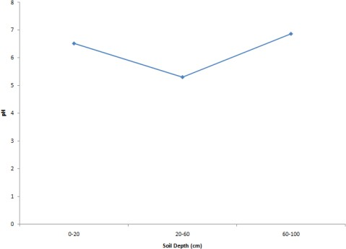

Figure 4.1: The soil available pH at three depths

The average organic carbon ranged from 0.142-0.267% of the entire soil nutrients relating to soil fertility. According to Velayutham, 2006 the organic carbon for the soil is considered high if it is within the range of 0.96-1.08%. It is observed from Figure 4.2 that the level of organic carbon has decreased from surface depth (0-20cm) to the second depth (20-60cm) and sharply increased from second depth (20-60cm) to third depth (60-100cm) of the soil depths.

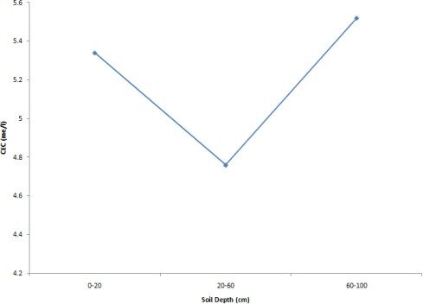

Figure 4.2: The average organic carbon at three depths

Phosphorus is an essential macro-nutrient which is relatively needed by crops in large quantity for proper growth and development. The different level of the soil phosphorous on the soil at three depths is shown in Figure 4.3. Available phosphorous content of the soil is high and larger from 20.276 to 28.342mg/kg. However, the soil will be good for crop that required much phosphorus.

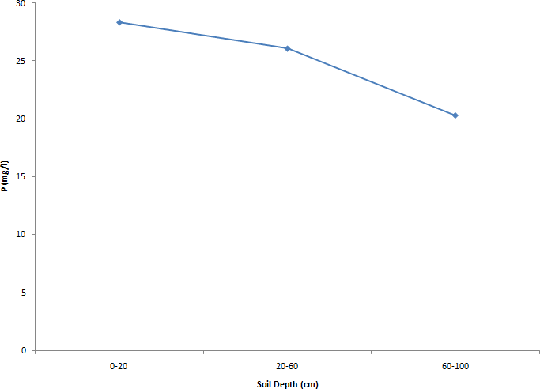

Figure 4.3: The soil phosphorous at three depths

Sodium, which determines the sodicity status of a soil is generally low and ranged from

0.156 to 0.653me/l. It is observed from Figure 4.4 that the level of sodium slightly decreased from soil surface depth (0-20cm) downward to the second depth (20-60cm) and also slightly increased to the third depth (60-100cm). The low sodium level in the soils indicates a non-sodic status of the soils and thus good for irrigation (Joseph et al., 2014). Excessive sodium level that occurred in the study area was resulted from irrigation water with high sodium content.

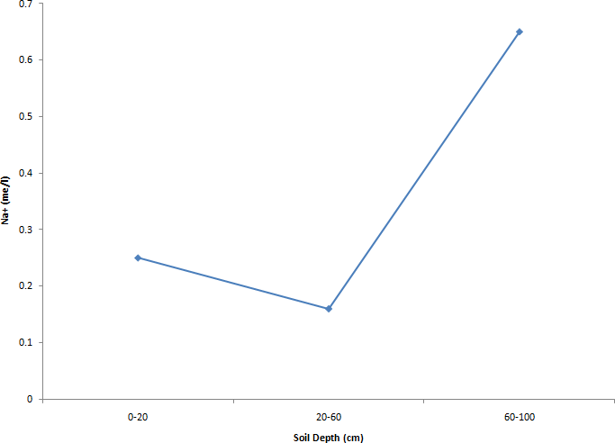

Figure 4.4: The soil sodium at three depths

Exchangeable sodium percentage (ESP) gives the measure of the potential sodium problem and is the percentage of sodium ions out of the total base cations (Ca²⁺, Mg²⁺, K⁺ and Na⁺) Marx et al., 1997. ESP value of the soil ranged from 5.90 to 10.0%. It slightly decreased from soil surface depth (0-20cm) to the second depth (20-60cm) and decreased sharply to the third depth (60-100cm) as shown in Figure 4.5. However, the ESP value has not exceeded 10% which could result to problem on the soil. The implication of a high ESP value on the soil is soil deterioration or damage and unhealthy soil condition as stated by Marx et al., 1997.

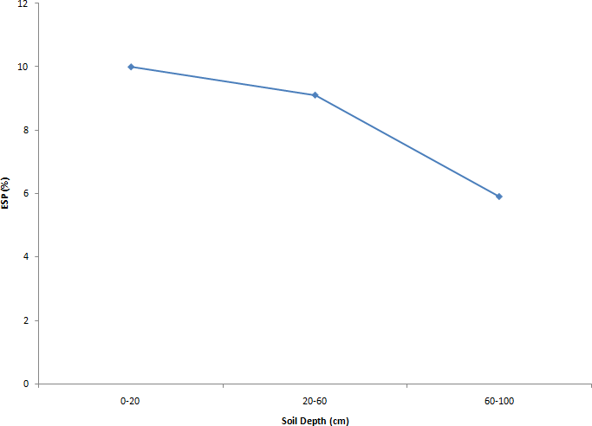
Figure 4.5: The soil ESP at three depths

The calcium in the soil of the study area is generally moderate and ranged from 4.36 – 6.22 me/l. It can be deduced from Figure 4.6 that there is a decrease in the calcium level from the soil surface depth to the second depth (20-60cm) and subsequently increased to the third depth (60- 100cm). The decrease may be resulted from leaching of this element during irrigation. This increase could be related to the increase in pH observed which in tending towards moderate to slightly acidic. It indicates that irrigation has led to increase in calcium level of the soil.

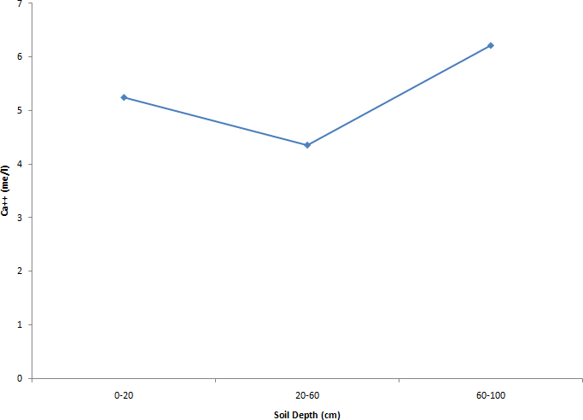

Figure 4.6: The soil calcium at three depths
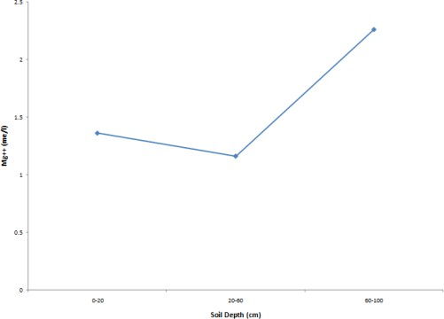
Magnesium ranged from 1.16 – 2.26 me/l and been the dominant cation. In Figure 4.7, magnesium level slightly decreases from soil surface depth (0-20cm) to the second depth (20- 60cm) and increased sharply from the second depth to the third depth (60-100cm). Magnesium is one of the secondary macronutrient required by plant, it deficiency causes leaf yellowing with brilliant tints (Yin, 2008).The organic matter of the soil is moderate ranging from 0.133 - 0.165% due to rapid rate of organic matter decomposition as a result of available moisture during irrigation.
Figure 4.7: The soil magnesium at three depths

Figure 4.8 shows a decline in organic matter level of the soil at the soil surface depth. The soil is considered moderately suitable for irrigation due to moderate organic matter contents of the soil.
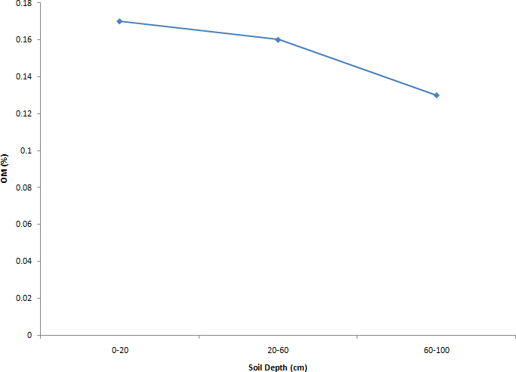
Figure 4.8: The soil organic matter at three depths

Cation exchange capacity (CEC) is a measure of soil capacity to retain and release element such as Ca, K, Mg, and Na (Marx et al., 1997). It is used as one way of estimating soil fertility and a good indicator of soil quality and productivity. It is observed that the CEC value has increased from the soil surface depth (0-20cm) to the second depth (20-60cm) and a rapid decrease occurred from second depth to the third depth (60-100cm) as shown in Figure 4.9. It ranged from 4.76 to
5.52me/l. Soils with higher value of CEC are considered fertile while soils with lower value of CEC are considered as non-fertile. The marked increase from the second depth (20-60cm) to the third depth indicates that irrigation has contributed to increased level of CEC. Thus the soil is currently falls within low to medium level as given by Edmeades et al., 1998.

Figure 4.9: The soil CEC at three depths

CHAPTER FIVE CONCLUSIONS AND RECOMMENDATIONS

Conclusions
The following conclusions were drawn from the study:

    - The soil of the study area is predominantly sandy loam and the soil has high value of low soil moisture content.
    - In this study, the soil bulk density, soil porosity and particle density are 1.62g/ cm³, 38.4% and 2.63g/cm³ respectively.
    - Conclusively from study area, the soil sample show medium proportion of organic carbon.

    - The higher nutrient fertility status in irrigation fields might be associated with intensive cultivation of crops.
- Classification criteria in the study area showed normal soil pH.

- The majority of soil samples low status of available phosphorous was found in all soil samples the generated nutrient status information can serve as an effective tool for farmers and policy makers in adoption of site specific nutrient management practices.

Recommendations
The following recommendations were drawn from conclusions:
    - For efficient production output, manure or compost should be applied in appropriate proportion to stabilize and correct nutrient deficiency in the soil.
    - Periodical test has to be conducted to ascertain any changes in values obtained.

    - Careful selection of crop and management alternatives is required if full yield potential is to be achieved.

REFERENCES

Adejumobi, M. A., Ojediran, J. O. and Olabiyi, O. O. (2014): Effects of Irrigation Practices on Some Soil Chemical Properties on Omi Irrigation Scheme. International Journal of Engineering Research and applications. Vol. 4 (10:2).
Edmeades, D. C., Wheeler, D. M. and Waller, J. E. (1998). Comparison of Methods for Determining Lime Requirements of New Zealand Soils. New Zealand Journal of Agriculture Research 28:93-100.
FAO (1998): Irrigation Water Management - Irrigation Scheduling. Training Manual No. 4. Food and Agriculture Organisation of United Nations, Rome, Italy.
FAO (1994): Water Quality for Agriculture. Irrigation and Drainage Paper 29.Rev. 1, Food and Agriculture Organisation of United Nations, Rome, Italy.
FAO (1990): Management of gypsiferous soils. Soils Bull. No. 62, Food and Agriculture Organization, Rome, Italy.
FAO (1985): Irrigation Water Management – Introduction to Irrigation. Training Manual No. 1.

Food and Agriculture Organisation of United Nations, Rome, Italy.

FAO (1974): The Euphrates Pilot Irrigation Project. Methods of soil analysis, Gadeb Soil Laboratory (A laboratory manual). Food and Agriculture Organization, Rome, Italy.
Hert, J., Marx E. S., and Stevens, R. G. (1999): Soil Test Interpretation Guide. Oregon State University, Corvallis.
ICARDA (2013): Methods of Soil, Plant, and Water Analysis: A Manual for the West Asia and North Africa region. 3rd Edition. International Center for Agricultural Research in the Dry Areas. Beirut, Lebanon.

Jennifer, G. K. (1996): Morphology and Growth of Maize. International Institute of Tropical Agriculture (IITA), Ibadan, Nigeria.
Johnston, A., Poulton, P. and Coleman, K. (2008): Soil organic matter: Its importance in sustainable agriculture and carbon dioxide fluxes. Advances in Agronomy 101 (November 30, 2008),1–57
Joseph, T. U., Abraham, T. A., and Terry, I. U. (2014). Irrigation Soil Analysis in River Katsina- Ala Catchment areas of North-Central Nigeria. Department of Civil Engineering, University of Agriculture, Markurdi, Nigeria.
Kachhave, K. G. and More. S. D. (1982): Research notes available potassium status in relation to physico–chemical properties of Maharashtra soils. J. Maharashtra agrci. Univ, 7(2), 1- 178. Lebron, I., Suarez, D. L. and Yoshida, T. (2002): Gypsum effect on the aggregate size and
Geometry of Three Sodic Soils Under Reclamation. Soil Sci. Soc. Am. J. 66: 92-98.

LFNL (2003): Manual: Small-Scale farming in West-Africa for improved production and better family living (Revised Edition). Leventis Foundation (Nigeria) Limited/ GTE, Marina, Lagos, Nigeria.
Marx, E. S., Christiensen, N. W., Hart, J., Gangwer, M., Gogger, C. G. and Barry, A. I. (1997) The Pre-side Dress Nitrate Test = (PSNT) for Wester Oregon and Western Washington, E.M8650. Oregon State University, Corvallis.Reprinted 1997.
Negassa, W. and Gebrelaidem, H. (2004): Impact of Different Land Use Systems on Soil Quality of Western Ezhiopian Aifisoil. A Paper Presented at Resource Management and Rural Poverty Reduction Through Research for Development and Rural Transformation. Tropentag 2004, Berlin Germany.

Ojo, A. O., Sokalu, A. O. and Faramade, A. K. (2015): Soil Chemical Properties, Growth Parameters and Yield as Affected by Poultry Manure Tea for Okra Production. Institute of Agricultural Research and Training Moor Plantation, Apata. Ibadan, Nigeria.
Rhoades, J. D., and Polemio, M. 1977. Determining cation exchange capacity: A new procedure for calcareous and gypsiferous soils. Soil Sci. Soc. Am. J. 41: 524 – 300.
Somwanshi, R. B., Kadu, P. P., Tamboli, B. D., Patil, Y. M. and Bhakare, B. D. (1999): Analysis of plants, irrigation water and soils MPKV. Extn. Publ. No. 284. Rahuri (Maharashtra)
Sparks, D. L., A. l. Page, P.A. Helmke, R.H. Loeppert, P.N.. Soltanpour, M.A. Tabatabai, C.T. Johnson, and M. Sumner (Eds) (1996): Methods of soil analysis: Part 3—chemical methods. Book Series Number 5. Soil Sci. Soc. of Am., Am. Soc. of Agron; Madison, WI, USA.
Tanwir, F., Saboor, A. and Nawaz, N. (2003): Soil Salinity and the Livelihood Strategies of Small Farmers: A Case Study in Faisalabad District, Punjab, Pakistan. Int. Journal of. Agric. Biol., 5:440-1
Tesfai, M., Dawod, V. and Kiflemariam, A. (2002): Management of Salts Affected Soils in the NCEW. Dry land Coordinator Group. Eritrea.
Velayutham, S. (2006). Political Economy of the Recognition of Forest Right, India.
Walkley, A. (1947): A critical examination of a rapid method for determining organic carbon in soils: Effect of variations in digestion conditions and of organic soil constituents. Soil Sci. 63: 251 – 263.
Yin, C. (2008): Increasing Soil Organic Carbon of Agricultural Land. NSW Dept. of Primary Industries. State of South Wales, England.

