DEVELOPMENT OF SMART IoT WEATHER STATION
BY

GBADERO OABDULAFEEZ OPEYEMI
ND/23/COM/FT/0124

SUBMITTED TO THE DEPARTMENT OF COMPUTER SCIENCE, INSTITUTE OF INFORMATION AND COMMUNICATION TECHNOLOGY
KWARA STATE POLYTECHNIC, ILORIN

IN PARTIAL FULFILLMENT OF THE REQUIREMENTS FOR THE AWARD OF NATIONAL DIPLOMA (ND) IN
COMPUTER SCIENCE

JUNE, 2025.

CERTIFICATION
This is to certify that this project was carried out by GBADERO ABDULAFEEZ OPEYEMI with matriculation number ND/23/COM/FT/0124 in the Department of Computer Science, Institute of Information Communication Technology, Kwara State Polytechnic, Ilorin, Kwara State.

…………………………………. ….………………………

MR. SADIQ, K. A. Date
Project Supervisor

…………………………………. ….………………………

MR. OYEDEPO, F. S. Date
Head of Department

…………………………………. ….………………………
External Examiner Date

DEDICATION
I dedicate this project work to Almighty God who inspired me and directed my ways during my academic stay in the polytechnic.

ACKNOWLEDGEMENT

All praise is due to Almighty God the Lord of the universe. I praise him and thank him for giving me the strength and knowledge to complete my ND program and also for our continued existence on Earth.
I appreciate the utmost effort of my supervisor, Mr. Sadiq, K. A. whose patience, support, and encouragement have been the driving force behind the success of this research work. He gave useful corrections, constructive criticisms, comments, recommendations, and advice and always ensures that excellent research is done. My sincere gratitude goes to the Head of the Department Mr. Oyedepo F. S., and other members of staff of the Department of Computer Science, Kwara State Polytechnic, Ilorin, for their constant cooperation, constructive criticisms, and encouragement throughout the program.
Special gratitude to my parents, who exhibited immeasurable financial, patience, support, prayers, and understanding during the period in which I was busy tirelessly with my studies, special thanks go to my lovely siblings
My sincere appreciation goes to my friends and classmates.
TABLE OF CONTENTS
Title page i
Certification ii
Dedication iii
Acknowledgments iv
Table of Contents v
Abstract vi
CHAPTER ONE: GENERAL INTRODUCTION
  - Background to the Study 1
  - Statement of the Problem 2
  - Aim and Objectives 3
  - Significance of Study 3
  - Scope of Study 4
  - Organization of the Report 4
CHAPTER TWO: LITERATURE REVIEW
  - Review of Related Pastworks 6
  - Review of General Studies 11
CHAPTER THREE: RESEARCH METHODOLOGY AND ANALYSIS OF THE SYSTEM
  - Research Methodology 15
  - Analysis of the Existing System 17
  - Problem of the Existing System 19
  - Analysis of the Proposed System 19
  - Advantages of the Propose System 21

CHAPTER FOUR: DESIGN, IMPLEMENTATION AND DOCUMENTATION OF THE SYSTEM
4.1 | Design of the System | 23
 | 4.1.1 Output Design | 23
 | 4.1.2 Input Design | 26
 | 4.1.3 Database Design | 30
 | 4.1.4 Procedure Design | 30
4.2 | Implementation of the System | 31
 | 4.2.1 Choice of programming language | 31
 | 4.2.2 Hardware support | 31
 | 4.2.3 Software Support | 32
 | 4.2.4 Changeover Techniques | 32
4.3 | System Documentation | 32
 | 4.3.1 Operating the System | 33
 | 4.3.2 Maintaining of the System | 34
CHAPTER FIVE: SUMMARY CONCLUSION AND RECOMMENDATION
  - Summary 34
  - Conclusion 35
5.4 Recommendations 36
References 38

ABSTRACT
Weather monitoring is crucial for various applications, including agriculture, disaster management, transportation, and environmental research. Traditional weather stations, which rely on manual data collection methods, often face challenges such as delays in data availability, human error, and high operational costs. This project aims to develop a Smart IoT Weather Station to address these limitations by leveraging modern Internet of Things (IoT) technology. The Smart IoT Weather Station integrates advanced digital sensors with a microcontroller, wireless communication modules, and a cloud-based platform. This integration allows for real-time data collection, processing, and transmission, providing continuous and accurate weather data. Users can access this data remotely through a web-based dashboard and a mobile application, which offer intuitive and user-friendly interfaces for monitoring and analysis. The system's design includes a comprehensive output design for effective data presentation, an input design for efficient data collection, a robust database structure for secure data storage, and well-defined procedures for data handling and system maintenance. The implementation utilizes suitable programming languages and technologies to ensure reliability, scalability, and cost-effectiveness. The project demonstrates significant advantages over traditional weather monitoring systems, including real-time data availability, reduced human error, lower operational costs, and enhanced accessibility. By automating data collection and integrating IoT technology, the Smart IoT Weather Station provides a modern solution for weather monitoring, with potential applications across various sectors. In conclusion, the development and implementation of the Smart IoT Weather Station represent a substantial improvement in weather monitoring capabilities. The system's real-time, accurate, and accessible data can significantly enhance decision-making processes in agriculture, disaster management, and other critical fields. Future enhancements, such as expanding the sensor network and integrating advanced data analytics, can further increase the system's value and impact.

CHAPTER ONE INTRODUCTION
  - BACKGROUND OF THE STUDY

The evolution of technology has dramatically transformed the way we live, work, and interact with the world. One of the most significant technological advancements in recent years is the development of the Internet of Things (IoT). IoT refers to a network of interconnected devices that communicate and exchange data with each other over the internet. This technology has enabled the creation of smart systems and applications that improve efficiency, automation, and decision-making across various domains, including home automation, healthcare, transportation, and environmental monitoring (Balakrishnan & Chikkamadaiah, 2021).

Weather monitoring is a crucial aspect of environmental science that involves the observation and analysis of atmospheric conditions to understand and predict weather patterns. Accurate and timely weather information is essential for various sectors, including agriculture, disaster management, aviation, maritime, and everyday activities. Traditional weather stations have been used for decades to collect weather data, but they often face limitations such as manual data collection, limited accessibility, and high maintenance costs (Shahadat et al, 2020).

The integration of IoT technology with weather monitoring systems has led to the development of Smart IoT Weather Stations. These advanced systems use a combination of sensors, data transmission modules, and cloud-based platforms to provide real-time, accurate, and remotely accessible weather data. IoT-enabled weather stations continuously collect and transmit weather data in real time, providing up-to-date information for analysis and decision-making. Users can access weather data from anywhere in the world using internet-connected devices, enabling remote
monitoring and control. The automated collection and transmission of data reduce the need for manual intervention, minimizing human error and labor costs. IoT Weather Stations can be integrated with other smart systems and applications, providing a comprehensive view of environmental conditions. The modular nature of IoT systems allows for easy expansion and customization, enabling the addition of new sensors and functionalities as needed (Kodali, and Mandal, 2023).

The development of Smart IoT Weather Stations involves the integration of various components, including sensors, microcontrollers, data transmission modules, and cloud-based platforms. Sensors are used to measure atmospheric parameters such as temperature, humidity, atmospheric pressure, wind speed, and rainfall. Microcontrollers process the sensor data and transmit it to a central server or cloud platform via wireless communication protocols such as Wi-Fi, Bluetooth, or cellular networks. Once the data reaches the cloud platform, it can be stored, analyzed, and visualized using web-based interfaces or mobile applications. Users can access real-time weather data, historical trends, and predictive analytics, enabling them to make informed decisions based on accurate and timely information (Mehta, 2017). Extreme weather events, such as hurricanes, floods, and heatwaves, are becoming more frequent and severe, posing significant risks to human life, infrastructure, and ecosystems. Accurate weather data is essential for early warning systems, disaster preparedness, and climate research, helping communities and governments to mitigate the effects of climate change and adapt to changing environmental conditions (Shahadat 2020).

Our main concern for this project was to implement a cost effective IoT automatic weather station which can measure weather data like temperature, humidity, pressure, wind speed and precipitation, which will be small in size to be installed in building top or harvesting field with self-powered from solar panel without need to go to station to get data with the possibility of accessing to data from anywhere in the world through the web page.

STATEMENT OF THE PROBLEM

Traditional weather stations face significant limitations that hinder their effectiveness and accessibility. These systems often rely on manual data collection, which is time-consuming and susceptible to human error, leading to inaccuracies and delays in data reporting. Additionally, the lack of remote accessibility restricts the real-time monitoring capabilities essential for timely decision-making in critical sectors such as agriculture, disaster management, and transportation. High maintenance costs and labor-intensive operations further exacerbate these challenges, making it difficult to ensure continuous and reliable weather monitoring. Moreover, the inability of traditional systems to integrate seamlessly with other technologies limits their functionality and scalability. Therefore, there is a pressing need for an advanced weather monitoring solution that leverages IoT technology to provide real-time, accurate, and remotely accessible weather data, overcoming the inherent limitations of traditional weather stations.

AIM AND OBJECTIVES

The primary aim of this project is to develop a Smart IoT Weather Station that provides real-time, accurate weather data accessible remotely via the internet and the objectives are to;

    - To design and implement a weather station with IoT capabilities.
    - To integrate various sensors for measuring temperature, humidity, atmospheric pressure, wind speed, and rainfall.
    - To develop a data transmission system that sends sensor data to a central server in real-time.
    - To create a web-based interface for remote monitoring and analysis of weather data.

SIGNIFICANCE OF THE STUDY
The significance of this study lies in its potential to revolutionize weather monitoring by developing a Smart IoT Weather Station that addresses the limitations of traditional systems. By providing real-time, accurate, and remotely accessible weather data, the Smart IoT Weather Station enhances decision-making in critical areas such as agriculture, disaster preparedness, and climate research. This system reduces the need for manual data collection, minimizes human error, and lowers maintenance costs, making weather monitoring more efficient and cost-effective. Furthermore, the integration capabilities of IoT technology allow for seamless expansion and connectivity with other smart systems, fostering a more comprehensive approach to environmental monitoring. Ultimately, this study contributes to better-informed strategies for managing weather-related challenges, thereby improving safety, productivity, and sustainability across various sectors.

SCOPE OF THE STUDY
The scope of this study encompasses the design, development, and implementation of a Smart IoT Weather Station, focusing on several key components and processes. This includes selecting and integrating various sensors to measure temperature, humidity, atmospheric pressure, wind speed, and rainfall. The study will also cover the development of a real-time data transmission system that sends sensor data to a central server. Additionally, it involves creating a web-based interface for remote monitoring and analysis of weather data.

ORGANIZATION OF THE STUDY

For easy study and proper understanding of this project write-up, It is planned and organized into five chapters. The description of what each chapter contains is explained below:
Chapter One: This contains an Introduction to the whole write-up, the problem of the study, the aims and objectives of the study, the significance of the study, the scope and limitation of the study, and the organization of the report.
Chapter Two: It focuses on the literature review of the study, the organization of the board of directors, and the computerization of the current state of the art.
Chapter Three: It presents the data collection method employed, analysis of data and existing system, advantages of the proposed system, design and implementation, programming language used with reasons, and hardware and software support.
Chapter Four: Deals with the system design implementation and documentation, design of the system, output design, input design, file system, procedural design, and documentation of the new system.
Chapter Five: This centres the summary, experienced gained, recommendation and conclusion.

CHAPTER TWO LITERATURE REVIEW
  - REVIEW OF RELATED WORKS

In today’s world many pollution monitoring systems are designed by different environmental parameters. Existing system model is presented IOT based Weather monitoring and reporting system where you can collect, process, analyses, and present your measured data on web server. Wireless sensor network management model consists of and device, router, gateway node and management monitoring center. End device is responsible for collecting wireless sensor network data, and sending them to parent node, the data are sent to gateway node from parent node directly or by router. After receiving the data from wireless sensor network, gateway node extracts data after analysing and packaging them into Ethernet format data, sends them to the server. Less formally, any device that runs server software could be considered a server as well. Servers are used to manage network resources. The services or information provided through the Internet that are connected through LAN and made available for users via smart phones, web browser or other web browser devices to make the system more intelligent, adaptable and efficient (Verma, 2022).
Oussama (2020) made a master thesis on Internet of Things (IoT) Automatic Weather Station, the work provides the development of a low-cost automatic weather station capable of measuring meteorological data in a specific region. Self-feeding by using LiPo batteries and solar panels to fully operate the system. The weather station and the gateway communicate via RF and Wi-Fi to spread data over the Internet allowing the user access to data remotely via the internet. This project consists of two parts: the first part is the design and creation of control units connected by radio waves between them, and the second part designing website to monitor climate information via the Internet Unit One: Its role is to collect climate information in the area to be studied and to send data to the Gateway. The second unit (the Gateway): its role is to collect information about the
climate sent from the first unit and store data in a database via the Internet. As for the second part: a website has been designed for monitoring climate information via the Internet anywhere in the world.

Verma et al (2020) wrote a journal on titled IOT Application of a Remote Weather Monitoring & Surveillance Station. They concluded that Numerous critical weather occasions have influenced humanity throughout the years. For quite a while climate checking was to a great extent a leisure activity of eager beginners. Yet in the course of the most recent century, it has advanced into an efficient and expert worldwide action that mirrors its vital significance for an extensive variety of economic, natural, civil assurance and farming exercises. Present day climate observing frameworks and systems are intended to be developed in a financially savvy way. This requires the aggregate life-cycle cost of an observing framework is minimized, and one approach to do this is to minimize the maintenance of the weather monitoring framework. Utilizing a solid-state system to quantify the weather, including the wind speed and bearing, is principal to minimize hardware adjusting and costs. The conventional weather monitoring framework comprised of individual sensors to quantify one meteorological variable, each associated with an data collection gadget or recorder. Modern day innovation has permitted the combination of a few sensors into one coordinated weather station that can be for all time situated at one site, or transported to a site where localized climate is required. The fundamental aim of this paper is to design a remote weather monitoring system which allows the monitoring of weather parameters and provides continuous surveillance at the same time. IOT based Remote Weather Monitoring Station is a fully-fledged open source weather station which is effective in measuring temperature, humidity, and light intensity with high precision and the values of measured parameters are plotted on open cloud "ThingSpeak". The system is also equipped with a camera to provide the live streaming of the area to be monitored. The controlling action is accomplished using an Embedded- PC
(Raspberry Pi) or Arduino board with WIFI extension interface. In this paper the weather station is currently controlled using Raspberry Pi board and programming is done in python language.

Olanrele et al (2022) developed an IOT Based Weather Station using an Embedded System. The paper is about the development of an internet-based weather station system to monitor temperature, humidity, light intensity and predict the possibility of whether it will rain or not. The real-time monitoring system was connected to a microcontroller embedded with a Wi-Fi module (NodeMCU/ESP8266), a temperature and humidity sensor (DHT 11), and a light-dependent resistor (LDR). This device is designed as a platform to provide adequate information for immediate and future weather forecasts. The measured parameters are sent to an open-source IoT analytics platform (ThingSpeak), recorded in the channel, and were downloaded for analysis purposes. The temperature and humidity level was monitored using the Things View Android application and can be accessed by anybody once given the Thing Speak channel ID. Weather data was easily viewed and it can aid in appropriate planning. This IoT-based system will help keep up with the demand of the ravaging global warming with the provision of real-time data for planning towards land preparation and crop planting and for other purposes that are weather dependent.
Girija et al (2023) developed a system for Weather Monitoring System using Internet of Things (IOT). The system proposed in this paper is an advanced solution for monitoring the weather conditions at a particular place and make the information visible anywhere in the world. The technology behind this is Internet of Things (IoT), which is an advanced and efficient solution for connecting the things to the internet and to connect the entire world of things in a network. Here things might be whatever like electronic gadgets, sensors and automotive electronic equipment. The system deals with monitoring and controlling the environmental conditions like temperature, relative humidity and CO level with sensors and sends the information to the web page and then plot the sensor data as graphical statistics. The data updated from the implemented system can be accessible in the internet from anywhere in the world.
Bhagat et al (2019) made a review on IOT Based Weather Monitoring and Reporting System Project. The IOT based Weather Monitoring and Reporting System project is used to get Live reporting of weather conditions. It will monitor temperature, humidity, moisture and rain level. Suppose Scientists/nature analysts want to monitor changes in a particular environment like volcano or a rain-forest. And these people are from different places in the world. In this case, SMS based weather monitoring system has some limitations. Since it sends SMS to few numbers. And time for sending SMS increases as the number of mobile numbers increases. In order to know the information about weather of a perticular place then they have to visit that particular sites. Where everyone can see it.

Kodali and Mandal (2021) developed an IoT based weather station. A weather station can be described as an instrument or device, which provides us with the information of the weather in our neighbouring environment. For example it can provide us with details about the surrounding temperature, barometric pressure, humidity, etc. Hence, this device basically senses the temperature, pressure, humidity, light intensity, rain value. There are various types of sensors present in the prototype, using which all the aforementioned parameters can be measured. It can be used to monitor the temperature or humidity of a particular room/place. With the help of temperature and humidity we can calculate other data parameters, such as the dew point. In addition to the above mentioned functionalities, we can monitor the light intensity of the place as well. We have also enabled to monitor the atmospheric pressure of the room. We can also monitor the rain value. The brain of the prototype is the ESP8266 based Wi-fi module Nodemcu (12E). Four sensors are connected to the NodeMCU namely temperature and humidity sensor (DHT11), pressure sensor(BMP180), raindrop module, and light dependent resistor(LDR). Whenever these values exceed a chosen threshold limit for each an SMS, an E-mail and a Tweet post is published alerting the owner of the appliance to take necessary measures.
Satyanarayana et al (2021) developed a mobile app & IOT based smart weather station. Nowadays weather conditions are changing day to day, hence some sort of system has to be designed to measure the weather parameters in an effective way at the place of interest. This paper projects an easy way to measure the dynamic parameters of weather without human interpretation. As this proposed method employs mobile app and IoT technology, collected weather parameters in a remote area can be uploaded to cloud as well as particular mobile app. The uploaded data can be verified and used, at anytime and anywhere in the world. The proposed system uses Raspberry-pi embedded with weather sensors to collect weather conditions. Hence, it provides better support for the weather monitoring and controlling centers, and weather reports for TV and radio stations.

Shahadat et al (2020) review a paper titled aEfficient IoT based Weather Station. In this paper, a new approach to practical and meaningful utilization of technology within a smart weather station system is presented. Weather station gives efficiency with instruments as well as equipment for measuring atmospheric data about the weather forecast conditions. Weather checking of the environment is essential because weather changes uncertainly every day. From weather updates, first understand the outside condition. So, we can take preparation according to weather. Weather also plays a vital role in human physical and psychological health. For these reasons, we always need to know about the current weather information. In this case, a weather station makes our life way easier by updating us about current weather states. We can easily see weather updates and information from weather stations by using apps. This paper has developed and tested a weather station based on NodeMCU Board and Blynk – IoT technology, which measures the meteorological data, including temperature, pressure, humidity, and rainfall.
Sivakumar and Nanjundaswamy (2021) Weather monitoring and forecasting system using IoT. The system proposed is an advanced solution for weather monitoring that uses IoT to make its real time data easily accessible over a very wide range. The system deals with monitoring weather and climate changes like temperature, humidity, wind speed, moisture, light intensity, UV radiation
and even carbon monoxide levels in the air; using multiple sensors. These sensors send the data to the web page and the sensor data is plotted as graphical statistics. The data uploaded to the web page can easily be accessible from anywhere in the world. The data gathered in these web pages can also be used for future references. The project even consists of an app that sends notifications as an effective alert system to warn people about sudden and drastic weather changes. For predicting more complex weather forecast that can’t be done by sensors alone we use an API that analyses the data collected by the sensors and predicts an accurate outcome. This API can be used to access the data anywhere and at any time with relative ease and can also be used to store data for future use. Due to the compact design and fewer moving parts this design requires less maintenance. The components in this project don’t consume much power and can even be powered by solar panels. Compared to other devices that are available in the market the Smart weather monitoring system is cheaper and cost effective. This project can be of great use to meteorological departments, weather stations, aviation and marine industries and even the agricultural industry.

REVIEW OF GENERAL STUDY
The review of general studies provides an overview of the existing literature related to the development and application of Smart IoT Weather Stations. It explores various aspects, including the evolution of weather monitoring technologies, the integration of IoT in environmental monitoring, and the benefits and challenges associated with IoT-based weather stations. This section synthesizes findings from previous studies to establish a foundation for understanding the current state of technology and its potential advancements.

Evolution of Weather Monitoring Technologies

Weather monitoring has a long history, evolving from rudimentary methods to sophisticated modern systems. Early weather monitoring relied on basic instruments such as thermometers, barometers, and anemometers, often requiring manual readings and record-keeping. As technology
advanced, automated weather stations (AWS) emerged, providing automated data collection and improved accuracy. These systems used electronic sensors and data loggers, enabling continuous monitoring and digital data storage.

Despite the advancements in AWS, traditional weather stations still faced limitations in terms of real-time data access, remote monitoring, and integration with other systems. These challenges paved the way for the incorporation of IoT technology into weather monitoring, leading to the development of Smart IoT Weather Stations.

Integration of IoT in Environmental Monitoring

The Internet of Things (IoT) has transformed various industries by enabling the interconnection of devices and systems through the internet. In environmental monitoring, IoT facilitates the collection, transmission, and analysis of data from multiple sensors distributed across different locations. IoT-based systems offer several advantages over traditional monitoring methods, including real-time data access, remote monitoring, automation, and scalability.

In the context of weather monitoring, IoT-enabled weather stations utilize a network of sensors to measure atmospheric parameters such as temperature, humidity, pressure, wind speed, and precipitation. These sensors are connected to microcontrollers or microprocessors that process the data and transmit it to cloud-based platforms via wireless communication protocols such as Wi-Fi, Bluetooth, or cellular networks.
The integration of IoT technology in weather monitoring represents a significant advancement in environmental science. Smart IoT Weather Stations provide real-time, accurate, and remotely accessible weather data, addressing many of the limitations of traditional weather stations. While there are challenges to overcome, the benefits of IoT-based systems in terms of real-time data access, remote monitoring, automation, and scalability make them a valuable tool for modern
weather monitoring and decision-making. This review highlights the importance of continued research and development in this field to further enhance the capabilities and applications of Smart IoT Weather Stations.

Internet of Things (IoT)

The Internet of Things (IoT) refers to the network of physical objects—devices, vehicles, buildings, and other items embedded with sensors, software, and network connectivity that enable them to collect and exchange data. IoT allows these objects to be sensed and controlled remotely across existing network infrastructure, creating opportunities for more direct integration of the physical world into computer-based systems. This results in improved efficiency, accuracy, and economic benefit in various applications, including environmental monitoring, healthcare, home automation, and smart cities.

Sensors and Actuators

Sensors are critical components in IoT systems, responsible for detecting changes in the environment and converting them into data that can be analyzed. In the context of a Smart IoT Weather Station, various sensors are used to measure different weather parameters:

      - Temperature Sensors: Measure ambient temperature.
      - Humidity Sensors: Measure the amount of moisture in the air.
      - Barometric Pressure Sensors: Measure atmospheric pressure.
      - Anemometers: Measure wind speed.
      - Rain Gauges: Measure the amount of rainfall.
Actuators, on the other hand, are devices that can influence the physical environment based on data received. While not commonly used in weather stations, they play a role in other IoT applications.
CHAPTER THREE

RESEARCH METHODOLOGY AND ANALYSIS OF THE NEW SYSTEM

RESEARCH METHODOLOGY

The research design for this project is an applied research approach aimed at developing a practical solution to enhance weather monitoring systems using IoT technology. The study involves both qualitative and quantitative methods to design, develop, and evaluate the Smart IoT Weather Station.

Data Collection

Data collection involves two main components: primary and secondary data. Primary data is collected through the design and implementation of the IoT weather station prototype, including sensor readings and system performance metrics. Secondary data is gathered from existing literature, scholarly articles, and case studies on IoT-based weather monitoring systems.

System Development Life Cycle (SDLC)

The project follows the System Development Life Cycle (SDLC) methodology, which includes the following phases:

    - Requirement Analysis: Identifying the requirements and specifications for the IoT weather station.
    - System Design: Designing the hardware and software components of the system.
    - Implementation: Building the system, integrating sensors, microcontrollers, and communication modules.
    - Testing: Validating the system's functionality, accuracy, and reliability through rigorous testing.
    - Deployment: Deploying the system in a real-world environment for further evaluation.
    - Maintenance: Ongoing maintenance and updates to ensure optimal performance.

Tools and Technologies

- Hardware: Sensors (temperature, humidity, pressure, wind speed, rainfall), microcontrollers (e.g., Arduino, Raspberry Pi), communication modules (Wi-Fi, LoRa).
- Software: Programming languages (Python, C++), cloud platforms (AWS, Google Cloud), data visualization tools (MATLAB, Grafana).
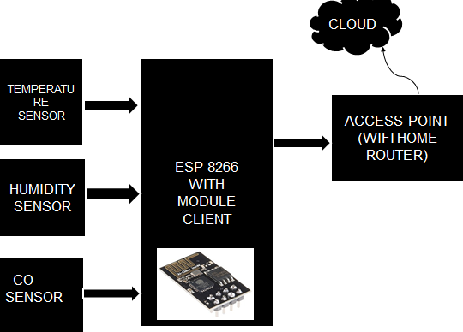

Figure 3.1. Block Diagram of the System

ANALYSIS OF THE EXISTING SYSTEM

Traditional weather stations have long been the cornerstone of meteorological data collection, relying primarily on analog instruments to measure atmospheric parameters such as temperature, humidity, pressure, wind speed, and rainfall. These stations often employ standalone devices like thermometers, barometers, hygrometers, anemometers, and rain gauges, each dedicated to a specific type of measurement. Data collected from these instruments are typically recorded manually at regular intervals by personnel on-site. This manual approach, while historically effective, is increasingly seen as outdated given the advancements in digital and IoT technologies.
The existing manual weather monitoring system comprises basic sensors for various weather parameters, each requiring periodic maintenance and calibration to ensure accuracy. The process of data collection involves personnel visiting the weather station to manually read and record measurements from each instrument. This data is then transferred to logbooks or local digital storage for further analysis. In some cases, semi-automated systems may use data loggers that automatically record readings but still require manual data retrieval and entry into central databases. The data transmission in these systems is often limited or non-existent, with information typically being stored locally and manually reported at intervals, rather than in real-time.

The primary limitations of the existing manual system include the time-consuming and labor-intensive nature of data collection and the susceptibility to human error, which can lead to inaccuracies and data gaps. The lack of real-time data transmission and remote accessibility means that data is often outdated by the time it is analyzed, reducing its utility for immediate decision-making. This delay can be particularly detrimental in applications where timely information is critical, such as disaster management and agricultural planning. Additionally, the high maintenance costs associated with frequent calibration and the labor required for manual data collection further exacerbate the challenges, making traditional weather stations less efficient and more costly to operate in the long term. These issues highlight the need for more advanced, automated, and interconnected systems to improve the accuracy, accessibility, and efficiency of weather monitoring.

PROBLEMS OF THE EXISTING SYSTEM
    - Existing weather monitoring systems that are used in the field generally consist of unconventional and heavy machinery that consists of numerous moving parts that require constant maintenance and need to be manually monitored and changed frequently.
    - Power requirements are one of many major constraints as these instruments are generally sited far from main power supply. This adds to the cost of using such instruments.
    - The use of thermometers to measure external temperature; however accurate is still outdated and constantly needs to be manually checked for any change in temperature.
    - Data that is collected by the instruments needs to be manually transferred from the logger to a laptop or computer via a cable.
    - Existing systems consist of large and heavy instruments that occupy a lot of space hence making it difficult to install them in remote location and places which have limited space.
    - The instruments used in the existing systems are expensive and add up to the already high cost of installation and maintenance

ANALYSIS OF THE PROPOSED SYSTEM

The proposed Smart IoT Weather Station aims to address the limitations of traditional weather stations by integrating modern IoT technology. The system architecture comprises advanced digital sensors for measuring temperature, humidity, atmospheric pressure, wind speed, and rainfall. These sensors are connected to a central microcontroller, such as an Arduino or Raspberry Pi, which processes the sensor data. The microcontroller is equipped with wireless communication modules, like Wi-Fi, LoRa, or cellular networks, to transmit data to a cloud-based platform. This platform serves as a central repository for storing, processing, and analyzing the collected data, making it accessible in real-time through web and mobile interfaces.

The functional requirements of the proposed system focus on real-time data collection, transmission, and remote accessibility. The system automates data collection and processing,
reducing the need for manual intervention and minimizing human error. Real-time data transmission ensures that weather information is always up-to-date, facilitating timely decision-making. The system's non-functional requirements emphasize reliability, security, and scalability. Reliability is ensured through robust sensor calibration and maintenance protocols, while security measures protect data integrity and privacy. Scalability allows the system to expand with additional sensors and functionalities as needed, ensuring long-term adaptability and relevance. The proposed Smart IoT Weather Station offers several advantages over traditional systems, including enhanced accuracy, efficiency, and cost-effectiveness. Real-time monitoring and remote access enable users to make informed decisions quickly, improving responsiveness in critical situations such as disaster management and agricultural planning. The automation of data collection and transmission reduces labor costs and the risk of human error, leading to more reliable data. Additionally, the system's integration with other smart applications and its scalability make it a versatile tool for comprehensive environmental monitoring. By leveraging IoT technology, the proposed system not only addresses the shortcomings of traditional weather stations but also provides a foundation for future advancements in weather monitoring and analysis.

ADVANTAGES OF THE NEW SYSTEM OVER THE EXISTING SYSTEM
    - Real-Time Data Collection and Transmission: One of the primary advantages of the new Smart IoT Weather Station over traditional weather stations is its ability to collect and transmit data in real time. Unlike the manual data collection methods of traditional systems, which often result in delays and outdated information, the IoT-based system continuously monitors weather parameters and updates the data in real time. This immediate availability of up-to-date information is crucial for timely decision-making in areas such as disaster management, agricultural planning, and transportation.
    - Remote Accessibility: The new system provides remote access to weather data through web and mobile interfaces, offering significant convenience and flexibility compared to traditional systems. Users can monitor weather conditions from anywhere, without needing to be physically present at the weather station. This capability is particularly beneficial for users in remote or inaccessible areas, as well as for centralized monitoring centers that oversee multiple weather stations. Remote accessibility ensures that critical weather data is always within reach, enhancing situational awareness and response times.
    - Automation and Reduced Human Error: The automation of data collection, processing, and transmission in the IoT-based weather station minimizes the need for manual intervention, significantly reducing the risk of human error. Traditional weather stations require personnel to manually record and transmit data, which can lead to inaccuracies and inconsistencies. The automated system ensures consistent and precise data collection, improving the overall reliability and accuracy of the weather information. This automation also reduces labor costs and the time required for data management.
    - Integration and Scalability: The IoT-based weather station is designed for easy integration with other smart systems and applications, providing a more comprehensive approach to environmental monitoring. This integration capability allows weather data to be combined with other data sources, such as agricultural sensors or urban infrastructure, for more holistic analysis and decision-making. Additionally, the system's scalability
means that it can be easily expanded with additional sensors and functionalities as needed, ensuring that it can adapt to changing requirements and technological advancements.
    - Cost-Effectiveness: While the initial setup costs of the Smart IoT Weather Station may be higher than traditional systems, the long-term benefits and cost savings make it a more economical choice. The reduction in manual labor and maintenance costs, coupled with the increased accuracy and reliability of automated data collection, leads to significant operational efficiencies. Moreover, the ability to access real-time data remotely reduces the need for frequent on-site visits, further lowering costs. Overall, the new system offers a more sustainable and cost-effective solution for weather monitoring.
CHAPTER FOUR

IMPLEMENTATION AND DOCUMENTATION OF THE SYSTEM

  - DESIGN OF THE SYSTEM

The design of the Smart IoT Weather Station involves a comprehensive approach to ensure that the system is efficient, reliable, and user-friendly. The design process encompasses output design, input design, database structure, and procedure design. Each of these components is critical to the overall functionality and effectiveness of the system.

OUTPUT DESIGN

The output design focuses on how the weather data will be presented to the users. The system will generate various types of outputs, including:

Real-Time Weather Dashboard: A web-based dashboard displaying real-time data for temperature, humidity, pressure, wind speed, and rainfall. The dashboard will use graphs, charts, and gauges for visual representation, making it easy for users to interpret the data.
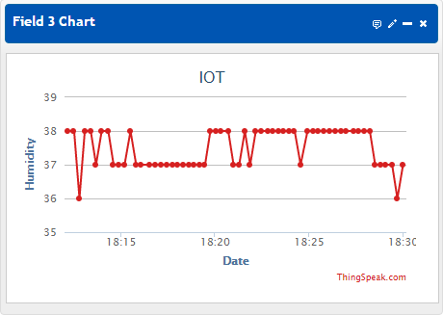

Figure 4.1: Humidity Data Plot
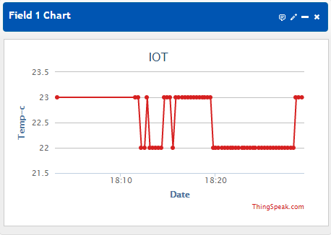

Figure 4.2: Temperature Data Plot
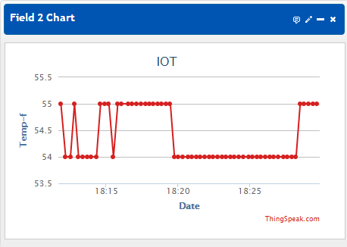

Figure 4.3: Temperature Data Plot

INPUT DESIGN

The input design outlines how data will be collected and fed into the system:
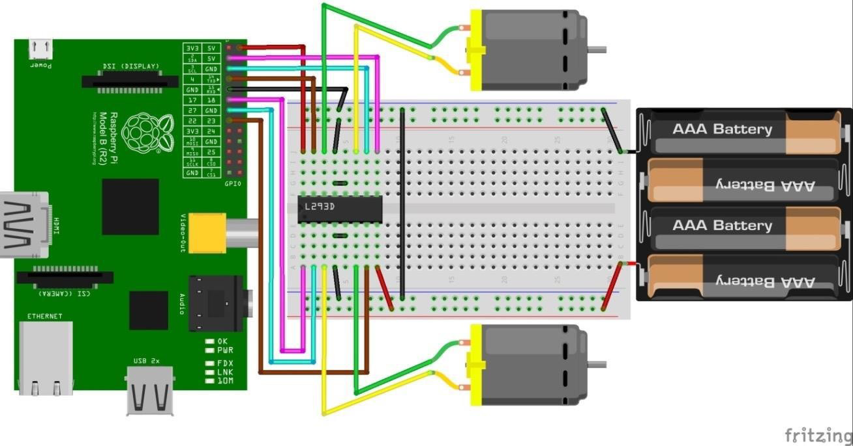

Figure 4.4. L293D Interfacing with Pi

There are 4 input pins for l293d, stick 2, 7 on the left and stick 15, 10 as shown in the pin diagram. Left input pins will control the turn of engine associated crosswise over left side and right input for engine on the right hand side. The engines are pivoted on the basis of the sources of input given over the pins as LOGIC 0 or LOGIC 1. VCC is the voltage that it requirements for its own particular internal operation 5v; L293D won't utilize this voltage for driving the engine. For driving the engines it has a different arrangement to give engine supply VSS (V supply). L293D will utilize this to drive the engine. It implies in the event that we need to work an engine at 9V then you have to give a Supply of 9V crosswise over VSS Motor supply.
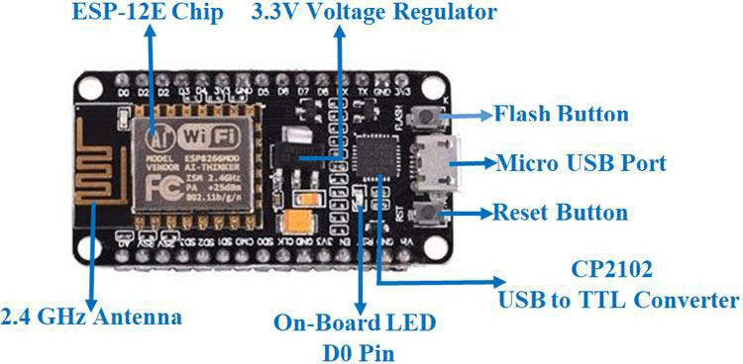

Figure 4.5: ESP8266/NodeMCU

This weather monitoring system uses Temperature and Humidity sensors (DHT11) and a LDR. LDR is a resistor whose resistance increases or decreases based on the light intensity and its value can be used in conjunction with temperature and humidity to predict the possibility that it will rain or not. NodeMCU stands as the link between the system and the environment, data will be forwarded to the ThingSpeak channel, where it is displayed and downloaded as an Excel CSV file for further analysis. NodeMCU is shown in Figure 1 below, and the system is connected to a lithium battery as its source of power, enough to supply the required 3.3V to power the microcontroller. Arduino IDE platform was used for the programming of the setup.
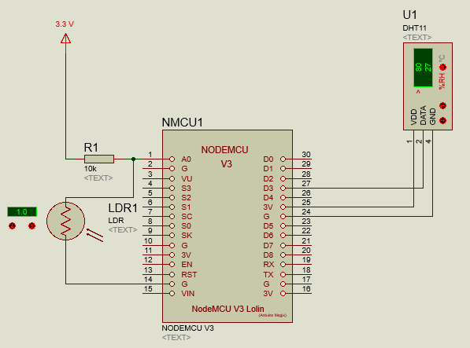

Figure 4.6: System circuit operation

The system’s circuit consists of a weather station that displays all the values of weather parameters and a control unit for controlling all the sensor data and sending it to the ThingSpeak platform. The weather station will communicate with the control unit via a client-server communication channel, where all the data collected by the sensor will be forwarded to ThingSpeak and the serial monitor. Figure 3 shows the circuit diagram of the system.
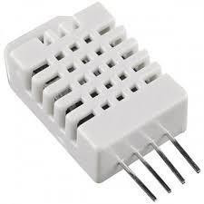

Figure 4.7: Temperature and Humidity Sensor DHT 11
It utilizes a capacitive humidity sensor and a thermistor to gauge the surrounding air, and releases a digital data on the data pin (no analog information pins required). The main genuine drawback of this sensor is you can just get new information from it once every 2 seconds, so when utilizing our library, sensor readings can be up to 2 seconds old. It works on 3 to 5V power supply. Good for 20- 80% humidity readings with 5% accuracy and for 0-50°C temperature readings ±2°C accuracy
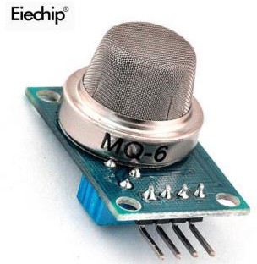

E.CARBON MONOXIDE (CO) SENSOR
Carbon Monoxide (CO) sensor, suitable for sensing CO concentrations in the air. Carbon monoxide sensor, suitable for sensing CO concentration in air. The MQ-6 can sense CO-gas concentration somewhere in the range of 20 to 2000ppm. This sensor has a high affectability and quick reaction time. The sensor's yield is an analog resistance.

DATABASE

The database design is crucial for storing and managing the collected weather data efficiently:

      - Cloud Database: The system will utilize a cloud-based database (e.g., Amazon RDS, Google Cloud Firestore) to store large volumes of data securely and reliably.
      - Data Tables: Key tables will include Sensor Data (storing raw sensor readings), User Settings (storing user preferences and alert thresholds), and System Logs (tracking system performance and errors).
      - Data Integrity: Ensuring data integrity through validation checks and periodic backups will be a priority to maintain reliable historical data.

PROCEDURE DESIGN

Procedure design involves outlining the steps and processes for system operations:

      - Data Collection Procedure: Sensors will continuously collect data and send it to the microcontroller, which processes the data and transmits it to the cloud database.
      - Data Processing Procedure: The cloud server will process incoming data, perform necessary calculations, and update the real-time dashboard and mobile app.
      - Alert and Notification Procedure: The system will monitor user-defined thresholds and send alerts via email, SMS, or push notifications when these thresholds are met.
      - Maintenance Procedure: Regular calibration of sensors, software updates, and system health checks will be conducted to ensure ongoing accuracy and reliability.

IMPLEMENTATION OF THE SYSTEM

    - CHOICE OF PROGRAMMING LANGUAGE

The programming languages chosen for this project are based on their suitability for different components of the system:

      - Microcontroller Programming: C++ (for Arduino) or Python (for Raspberry Pi) will be used to program the microcontroller and interface with the sensors.
      - Backend Development: Python with frameworks like Flask or Django for the server-side logic and data processing.
      - Frontend Development: HTML, CSS, and JavaScript for developing the web dashboard, with libraries like React or Vue.js for dynamic content.
      - Mobile Development: Kotlin or Swift for native Android and iOS app development, or a cross-platform framework like Flutter or React Native.

HARDWARE SUPPORT

The hardware components required for the system include:

      - Sensors: Digital sensors for temperature, humidity, atmospheric pressure, wind speed, and rainfall.
      - Microcontroller: Arduino or Raspberry Pi for processing sensor data.
      - Communication Modules: Wi-Fi or LoRa modules for data transmission to the cloud.
      - Power Supply: Reliable power sources, including batteries or solar panels for energy harvesting in remote locations.

SOFTWARE

The software components include:

      - Microcontroller Firmware: Software running on the microcontroller to collect and transmit sensor data.
      - Backend Software: Server-side software for data processing, storage, and API management.
      - Frontend Software: Web and mobile applications for data visualization and user interaction.
      - Cloud Services: Cloud database and storage solutions for handling large volumes of weather data.

IMPLEMENTATION TECHNIQUE USED

The implementation technique involves:

      - Incremental Development: Building the system in small, manageable increments, allowing for continuous testing and validation of each component before moving on to the next.
      - Agile Methodology: Using agile practices to ensure flexibility and responsiveness to changes and new requirements during the development process.
      - Prototyping: Creating prototypes for early user feedback and iterative refinement of the system.

SYSTEM DOCUMENTATION

    - PROGRAM DOCUMENTATION

Program documentation will include:

      - Source Code Documentation: Inline comments and external documentation explaining the code structure, logic, and functions.
      - API Documentation: Detailed descriptions of the APIs used for data communication between the microcontroller, server, and frontend applications.
      - User Guides: Manuals and tutorials for developers and users on how to install, configure, and use the system.

OPERATING THE SYSTEM

Operating the system involves:

      - Installation: Step-by-step instructions for setting up the hardware components, configuring the microcontroller, and deploying the backend and frontend applications.
      - Configuration: Guidelines for calibrating sensors, setting up user preferences, and configuring communication modules.
      - Usage: Instructions on how to access real-time data, generate reports, and receive alerts through the web dashboard and mobile app.

SYSTEM MAINTENANCE

System maintenance procedures will cover:

      - Regular Updates: Periodic software updates to add new features, fix bugs, and improve system performance.
      - Sensor Calibration: Routine calibration of sensors to ensure accurate data collection.
      - System Health Checks: Regular checks to monitor system performance, detect and address issues, and ensure the overall reliability of the system.
      - Backup and Recovery: Procedures for backing up data and recovering the system in case of hardware failures or data corruption.
CHAPTER FIVE

SUMMARY, CONCLUSION, AND RECOMMENDATION

  - SUMMARY

This project aimed to develop a Smart IoT Weather Station to overcome the limitations of traditional weather monitoring systems. The traditional systems, characterized by manual data collection and limited real-time access, often result in delayed information and higher operational costs. In response, the Smart IoT Weather Station leverages modern IoT technology to provide continuous, real-time weather data collection and transmission. The system architecture integrates advanced digital sensors, a central microcontroller, and a cloud-based platform to ensure accurate and reliable data. The implementation involved careful selection of programming languages, hardware, and software components, along with a detailed procedural design to streamline operations. The benefits of the new system include real-time monitoring, remote accessibility, automation, integration, scalability, and cost-effectiveness, addressing the critical shortcomings of existing systems.

CONCLUSION
The development of the Smart IoT Weather Station represents a significant advancement in weather monitoring technology. By incorporating IoT technology, the system provides real-time, accurate, and accessible weather data, enabling timely decision-making and efficient resource management. The automation of data collection and transmission reduces human error and operational costs, while the scalability and integration capabilities allow for future enhancements and broader applications. The successful implementation and documentation of this system demonstrate its potential to revolutionize weather monitoring and offer a reliable solution for various sectors, including agriculture, disaster management, and environmental research.

RECOMMENDATIONS

Expand Sensor Network

To enhance the coverage and reliability of the weather station, it is recommended to expand the sensor network by deploying additional weather stations in different geographical locations. This will provide more comprehensive data and enable better analysis of regional weather patterns.

Integration with Other Systems

Integrate the Smart IoT Weather Station with other environmental monitoring systems, such as air quality sensors and water quality monitors, to create a more holistic approach to environmental management and research.

Enhance User Interfaces

Continuously improve the web and mobile interfaces to ensure they remain user-friendly and intuitive. Incorporating advanced data visualization techniques and interactive features can help users better interpret and utilize the weather data.

Implement Advanced Data Analytics

Utilize advanced data analytics and machine learning algorithms to analyze the collected weather data. This can provide valuable insights, such as weather predictions and anomaly detection, further enhancing the utility of the weather station.

Regular System Updates and Maintenance
Ensure regular updates and maintenance of both hardware and software components to keep the system running efficiently. This includes periodic calibration of sensors, software updates for bug fixes and new features, and routine health checks to monitor system performance.

REFERENCES
Balakrishnan Sivakumar, & Chikkamadaiah Nanjundaswamy. (2021). Weather monitoring and forecasting system using IoT. Global Journal of Engineering and Technology Advances, 8(2), 008–016. https://doi.org/10.30574/gjeta.2021.8.2.0109
Bhagat, A. M., Thakare, A. G., Molke, K. A., Muneshwar, N. S., & Choudhary, V. (2019). In International Journal of Trend in Scientific Research and Development (ijtsrd) (Issue 3). http://creativecommons.org/licenses/by/4.0
Shahadat, A. S., Ayon, S. I., & Khatun, M. R. (2020). Efficient IoT based Weather Station. Proceedings of 2020 IEEE International Women in Engineering (WIE) Conference on Electrical and Computer Engineering, WIECON-ECE 2020, 227–230. https://doi.org/10.1109/WIECON-ECE52138.2020.9398041
Hamaizia, Z. (n.d.). Internet of Things (IoT)Automatic Weather Station. https://doi.org/10.13140/RG.2.2.25803.41760
Kodali, R. K., & Mandal, S. (2017). IoT based weather station. 2016 International Conference on Control Instrumentation Communication and Computational Technologies, ICCICCT 2016, 680–683. https://doi.org/10.1109/ICCICCT.2016.7988038
Olanrele, O. O., Adeyemi, O. A., & Ajayi, O. K. (n.d.). AN IOT BASED WEATHER STATION
USING AN EMBEDDED SYSTEM. www.qjoest.com
Satyanarayana, K. N. v, Reddy, S. R. N., Suresh Varma, K. N. v, & Kanaka Raju, & P. (n.d.).
MOBILE APP & IoT BASED SMART WEATHER STATION. www.tjprc.org
Verma, G., Gautam, A., Singh, A., Kaur, R., Garg, A., & Mehta, M. (2017). IOT Application of a Remote Weather Monitoring & Surveillance Station. International Journal of Smart Home, 11(1), 131–140. https://doi.org/10.14257/ijsh/2017.11.1.09

