EVALUATION OF PHYSICAL AND CHEMICAL PROPERTY OF KWARA STATE POLYTECHNIC UNDERGROUND WATER

BY

AKEEM ASIMIYU
ND/23/WRE/PT/0008

A RESEARCH PROJECT SUBMITTED
TO THE DEPARTMENT OF WATER RESOURCES ENGINEERING, INSTITUTE OF TECHNOLOGY (IOT)
KWARA STATE POLYTECHNIC, ILORIN

IN PARTIAL FULFILLMENT OF THE REQUIREMENTS FOR THE AWARD OF
NATIONAL DIPLOMA
IN OFFICE WATER RESOURCES ENGINEERING

AUGUST, 2025
CERTIFICATION
This is to certify that this project was carried out by Akeem Asimiyu with Matriculation Number nd/23/wre/pt/0008 to the Department Of Water Resources Engineering Technology, Kwara State Polytechnic Ilorin, In Partial Fulfillment of The Award Of National Diploma in Water Resources Technology.

_______________________ _______________
Engr. Mr abdullahi S.K DATE
Project Supervisor

_______________________ _______________
Engr. Mrs. Feruke , A.R DATE
Project Coordinator

_____________________________ _______________
Engr. Mrs. Shuaib-na’ Allah B.O DATE
Head Of Department

_______________________________ _______________
Engr. Isaac Olufunso Ogunwemimo DATE
External Examiner

DEDICATION
I dedicate this project to Almighty Allah, whose infinite wisdom, mercy, and guidance have been my anchor throughout this academic journey. His strength has inspired me to continue even when faced with challenges
This work is also dedicated to my parents, MR. & MRS. AKEEM whose unwavering Love, sacrifice and constant encouragement have shaped my path to success. Their belief in me has been my greatest source of strength and motivation.

ACKNOWLEDGEMENTS
All praise and thanks be to God, whose mercy, wisdom, and unchanging favor have sustained me throughout this academic pursuit. I am truly grateful for His divine support.
My heartfelt appreciation goes to my supervisor, Engr. Mr abdullahi S.K , for his
constant support, kind patience, and insightful guidance during the course of this project. May God bless you richly, ma.
To my parents and family, I am deeply thankful for your continuous prayers, emotional support, and encouragement, which gave me strength along the way.
I also express my sincere gratitude to my friends and classmates for their support,
kindness, and motivation throughout this period. May God reward you all.

ABSTRACT
Access to safe and potable water is essential for sustaining health, particularly in academic institutions where population density and human activities increase the risk of groundwater contamination. This study evaluated the physical and chemical properties of underground water sources within Kwara State Polytechnic, Ilorin, with a view to assessing their suitability for domestic use. The research adopted a quantitative design using stratified random sampling to collect groundwater samples from selected boreholes across the campus. The samples were analyzed for parameters including pH, temperature, turbidity, total dissolved solids (TDS), electrical conductivity (EC), iron, nitrate, and lead using standard laboratory techniques.The study employed descriptive statistics and Chi-square tests to compare observed values against WHO and NSDWQ permissible limits. Findings revealed that while most physical parameters such as temperature and pH were within acceptable ranges, certain chemical indicators—particularly iron and lead—exceeded recommended thresholds in some locations. The results indicated spatial variation in contamination levels, largely influenced by proximity to refuse dumps, oil spill-prone zones, and old plumbing infrastructure.The theoretical underpinning combined Hydrogeological Theory, which explains the natural vulnerability of aquifers due to local geology and recharge conditions, with Human Ecology Theory, which emphasizes the role of human activity and institutional behavior in environmental degradation.
Keywords: Groundwater, Physical and Chemical Properties, Water Quality, Kwara State Polytechnic, Chi-square, Hydrogeology, Heavy Metals

TABLE OF CONTENT
Title Page
Certification
Dedication
Acknowledgement
Abstract
Table of Content

CHAPTER ONE: INTRODUCTION
1.1 Background of the Study
1.2 Statement of the Problem
1.3 Research Questions
1.4 Objectives of the Study
1.5 Research Hypotheses
1.6 Significance of the Study
1.7 Scope and Limitation of the Study
1.8 Definition of Terms
1.9 Plan and Organization of the Study

CHAPTER TWO: LITERATURE REVIEW
2.0 Introduction
2.1 Conceptual Review
2.1.1 Groundwater and Its Importance
2.1.2 Water Quality Indicators
2.1.3 Heavy Metals in Groundwater
2.1.4 Contamination Sources
2.1.5 WHO and NSDWQ Standards
2.1.6 Health and Environmental Implications
2.2 Theoretical Review
2.2.1 Hydrogeological Theory
2.2.2 Human Ecology Theory
2.2.3 Theoretical Synthesis and Relevance
2.3 Empirical Review
2.4 Gaps in Literature

CHAPTER THREE: METHODOLOGY
3.1 Introduction
3.2 Research Design
3.3 Population of Study
3.4 Sample and Sampling Techniques
3.5 Method of Data Collection
3.6 Methods of Data Analysis
3.7 Instrument of Data Collection
3.8 Historical Background of the Case Study

CHAPTER FOUR: DATA PRESENTATION AND ANALYSIS
4.0 Data Presentation
4.1 Data Analysis
4.2 Data Analysis According to the Research Questions
4.3 Test of Hypotheses

CHAPTER FIVE: SUMMARY, CONCLUSION AND RECOMMENDATIONS
5.1 Introduction
5.2 Summary of Findings
5.3 Conclusion
5.4 Recommendations
References

CHAPTER ONE

INTRODUCTION

1.1 BACKGROUND OF THE STUDY
Water is universally acknowledged as one of the most essential natural resources for life and human development. Groundwater, a critical component of the hydrological cycle, serves as a primary source of drinking water for a significant portion of the global population, especially in developing countries. In Nigeria, the reliance on underground water has increased due to the inadequacies of public water supply systems, especially in semi-urban and rural areas (Adebayo, et al 2022). Institutions like Kwara State Polytechnic depend heavily on underground water sources, particularly boreholes and hand-dug wells, to meet their domestic and academic water needs.
The chemical and physical properties of groundwater are essential indicators of its suitability for various uses, including drinking, irrigation, and industrial applications. Parameters such as pH, temperature, electrical conductivity, turbidity, total dissolved solids (TDS), and presence of heavy metals play a crucial role in determining water quality (Dauda and Shuaib-Na’Allah, 2023). Deviations from established water quality standards, as defined by the World Health Organization (WHO) and Nigeria’s Standard for Drinking Water Quality, may result in adverse health and environmental outcomes (Awe and Oyinade, 2020).
Several studies have shown that anthropogenic activities significantly affect groundwater quality. Uncontrolled waste disposal, proximity to petrol stations, leaky underground storage tanks, and poorly sited soak-away pits contribute to the deterioration of underground water sources (Agboola, Sunmonu, & Suleman, 2021; Emmanuel, 2022). In the context of Kwara State Polytechnic, these concerns are pertinent. The institution, located in the heart of Ilorin metropolis, is surrounded by residential communities, commercial activities, filling stations, and waste disposal sites—all of which can potentially influence the quality of its groundwater resources (Lawal, Abayomi, & Fawale, 2023).
The geophysical characteristics of aquifers in the Ilorin region further complicate groundwater safety. According to Olatunji (2020), the region lies within the basement complex terrain of southwestern Nigeria, where the depth, lithology, and permeability of aquifer units determine groundwater vulnerability. Shallow aquifers are more susceptible to contamination from surface activities, especially when natural filtration barriers are absent or compromised. This vulnerability necessitates routine monitoring of groundwater to safeguard public health and ensure sustainability.
Physical parameters such as turbidity, color, odor, and temperature are direct indicators of contamination or poor water handling practices. High turbidity levels may suggest the presence of suspended particles, which could harbor microbial contaminants (Jimoh et al., 2025). Likewise, elevated temperatures may enhance microbial growth, while foul odor and discoloration may indicate chemical pollution or organic decomposition. Chemical characteristics, including pH, electrical conductivity, nitrate concentration, and presence of heavy metals such as lead, iron, and manganese, are equally critical. Chronic exposure to these elements can lead to health complications such as methemoglobinemia, organ toxicity, and carcinogenic effects (Ajenikoko, 2022; Awoyemi et al., 2025).
Moreover, environmental and climatic factors play a role in seasonal variability of water quality. Dauda and Shuaib-Na’Allah (2023) noted that water parameters fluctuate with seasons due to changes in surface runoff, leaching patterns, and evapotranspiration rates. Such fluctuations may render water unsafe during certain periods, even if deemed potable at other times.
Beyond environmental concerns, institutional awareness and proactive water quality management are necessary. There is evidence that many institutions lack structured monitoring systems for assessing the quality of their water supply (Eniola et al., 2022). This gap often leads to delayed response to contamination events, putting users at risk. Hence, assessing the physical and chemical properties of Kwara State Polytechnic’s underground water is timely and essential to identify potential risks and recommend sustainable management solutions.
Furthermore, the presence of fuel stations around Ilorin metropolis has raised concerns about petroleum hydrocarbon contamination of groundwater. These contaminants, which include polycyclic aromatic hydrocarbons (PAHs), are persistent and pose serious health risks even at low concentrations (Lele, Olarewaju, & Adeyemi, 2023). Such compounds often enter underground water systems through leaky tanks or improper waste disposal practices associated with vehicle maintenance activities.
Another emerging concern is the radioactive contamination of groundwater, which has been detected in some areas of Kwara State Polytechnic and its environs (Lawal et al., 2023). Although the concentrations recorded are generally within safe limits, the long-term exposure risks warrant continuous monitoring.
This study, therefore, evaluates the physical and chemical parameters of underground water sources within Kwara State Polytechnic to establish baseline data, identify potential contamination sources, and contribute to informed decision-making in water management. The findings will be vital not only for campus health and environmental safety but also for the wider Ilorin community that may share similar hydrogeological characteristics and anthropogenic pressures.

1.2 Statement Of The Problem
The quality of groundwater within the Kwara State Polytechnic environment has become a growing concern due to rapid urbanization, increasing anthropogenic activities, and insufficient water quality monitoring protocols. As the polytechnic and its surrounding areas expand, there is a heightened risk of groundwater contamination through various channels such as improper waste disposal, oil leakage from nearby petrol stations, leaky soak-away pits, and surface runoff during rainfall (Agboola et al., 2021; Adebayo et al., 2022).
Despite the critical reliance on underground water as the primary source of drinking and domestic water for students and staff, there is limited empirical data assessing its physicochemical status. Prior studies in nearby areas such as Ganmo and Ilorin metropolis have revealed alarming levels of contaminants including heavy metals, nitrates, hydrocarbons, and pathogenic microorganisms in underground water (Emmanuel, 2022; Ologun, 2024). Yet, a comprehensive investigation focusing specifically on Kwara State Polytechnic’s underground water remains scarce.
Additionally, environmental health incidents such as gastrointestinal diseases and skin irritations among residents and students have been loosely attributed to water consumption, but these claims are rarely investigated or verified with laboratory evidence (Awe & Oyinade, 2020). This lack of evidence-based assessment not only hampers public health responsiveness but also limits institutional planning in water management and sanitation services.
Given the health, environmental, and policy implications of water quality, there is a pressing need to evaluate the physical and chemical parameters of groundwater within the institution. This study seeks to address this gap and provide scientific data that can support policy, enhance water safety, and contribute to public awareness on water-related health risks.

1.4 OBJECTIVES OF THE STUDY
Aims And Objective:
To evaluate the physical and chemical properties of underground water in Kwara State Polytechnic, Ilorin, Kwara State.
Specific Objectives:
- To assess the physical parameters of underground water in the study area.
- To determine the chemical properties of the water samples.
- To compare the measured values with WHO and NSDWQ standards.
- To identify potential contamination sources and associated health risks.

1.5 Research Hypotheses
H₀₁: There is no significant deviation between the physical parameters of groundwater in the study area and WHO standard values.
H₀₂: There is no significant difference between the chemical characteristics of the water samples and standard permissible limits.
H₀₃: Underground water in Kwara State Polytechnic is free from contamination.

1.6 Significance Of The Study
This study is significant for several reasons. First, it provides essential baseline data on the physical and chemical quality of groundwater in Kwara State Polytechnic, enabling stakeholders to identify pollution trends and take preventive actions (Dauda & Shuaib-Na’Allah, 2023). Second, the findings will help policymakers, including environmental protection agencies and health departments, in formulating targeted water safety regulations. Furthermore, it will aid institutional planning in infrastructure development, particularly in areas related to water treatment and sanitation.
Additionally, the study contributes to academic literature by filling the current knowledge gap in localized groundwater quality assessments in educational institutions in Nigeria (Eniola et al., 2022; Lele et al., 2023). It also raises public awareness on the importance of regular water testing and environmental sanitation practices.

CHAPTER TWO

LITERATURE REVIEW

Preamble
Groundwater is a critical source of drinking water globally, particularly in developing countries where surface water sources are often unreliable or contaminated. The increasing reliance on underground water in densely populated academic institutions such as Kwara State Polytechnic underscores the importance of constant evaluation of its quality. This chapter presents a comprehensive literature review focusing on the conceptual framework surrounding groundwater quality, major contaminants, physical and chemical properties, water quality standards, and the health implications of contaminated groundwater. It also evaluates the influence of local environmental factors and anthropogenic activities that affect water quality in Ilorin and similar environments.

2.1 Conceptual Review

2.1.1 Concept of Groundwater and Aquifer Systems
Groundwater is defined as water located beneath the earth's surface in soil pore spaces and in the fractures of rock formations. The movement and availability of groundwater are controlled by the permeability and porosity of the aquifer materials (Olatunji, 2020). Aquifers are geological formations that store and transmit water and are typically categorized into confined and unconfined types. In Kwara State, the dominant aquifer system is the fractured basement complex, which is known for its shallow depth and high vulnerability to contamination (Lawal, et al; 2023).
In urbanizing environments like Ilorin, groundwater serves as a primary source of potable water due to inadequate municipal supply. However, its reliability is compromised by contamination from waste dumps, petrol stations, and other anthropogenic activities (Agboola, et al 2021). Scholars have highlighted the geological composition of Ilorin and its environs as a major determinant in the vulnerability of groundwater sources to pollution, particularly in regions where the aquifer is unconfined and close to the surface (Abdulrahman, 2020).
The hydrogeological characteristics of the Kwara State Polytechnic area make it susceptible to pollution, especially in places where groundwater recharge is rapid due to fissured bedrock. Studies have indicated that aquifers in the Ilorin metropolis often lack protective clay layers that naturally prevent contaminants from infiltrating groundwater zones (Olatunji, 2020). Therefore, understanding the composition and structure of local aquifer systems is crucial for evaluating and managing groundwater quality.

2.1.2 Physical Parameters of Groundwater Quality
Physical water quality parameters are non-chemical characteristics that affect the aesthetics and usability of water. These include color, turbidity, temperature, odor, and taste. While they may not directly affect human health, they significantly influence consumer perception and the potential for microbial growth (Awe et al, 2020).
Turbidity, which refers to the cloudiness of water due to suspended solids, is particularly significant in evaluating water for domestic use. Studies conducted in Ganmo and other areas near Ilorin have shown that water sources close to waste dumps often exhibit turbidity values that exceed WHO standards, suggesting particulate infiltration due to poor waste management (Agboola et al., 2021). Elevated turbidity can also interfere with the effectiveness of disinfection processes by shielding pathogens.
Temperature plays a vital role in the biological activity within water systems. Water temperatures above 25°C, which are common in tropical environments such as Ilorin, have been associated with accelerated microbial activity and chemical reactions (Dauda et al, 2023). These reactions may increase the breakdown of organic matter and the release of dissolved substances into the water, indirectly affecting its chemical composition.
Color and odor, though more aesthetic in nature, are often early indicators of pollution. For example, a metallic taste or reddish tint may indicate the presence of dissolved iron or manganese. The WHO and NSDWQ recommend that potable water be free from any objectionable taste or odor. Field surveys by Emmanuel (2022) in Ilorin indicated that 20% of sampled boreholes exhibited slight discoloration, which was linked to rusted pipelines and nearby industrial activities.

2.1.3 Chemical Parameters and Their Health Implications
Chemical water quality parameters include substances that may be naturally occurring or introduced through human activities. These include pH, Total Dissolved Solids (TDS), Electrical Conductivity (EC), nitrates, sulphates, chlorides, heavy metals, and trace elements. The concentration of these parameters must be monitored, as several have been linked to adverse health outcomes.
pH is a measure of hydrogen ion concentration and indicates the acidity or alkalinity of water. Water with a pH lower than 6.5 is considered corrosive and may leach metals from pipes, while a pH above 8.5 may affect taste and reduce the efficiency of chlorination (Ajenikoko, 2022). Groundwater in parts of Ilorin has been found to exhibit slightly acidic pH values, possibly due to the dissolution of acidic minerals or infiltration of organic matter (Adedeji et al., 2020).
Heavy metals such as lead, iron, and manganese are of particular concern. Exposure to lead, even in small concentrations, can cause neurological and developmental disorders, especially in children. Studies by Lawal et al. (2023) found trace concentrations of radioactive and metallic elements in groundwater samples from Kwara State Polytechnic, which may be linked to surrounding vehicular and industrial activities.
Nitrates and sulphates often originate from agricultural runoff, sewage infiltration, or the improper disposal of animal waste. High nitrate levels can cause methemoglobinemia (blue baby syndrome) in infants, while sulphate ingestion in high concentrations may cause diarrhea and dehydration (Alao et al., 2025).
Therefore, the regular evaluation of these chemical parameters is essential in determining the suitability of groundwater for human consumption and other domestic uses.

2.1.4 Anthropogenic Influences on Groundwater Quality
Human activities significantly affect groundwater quality, particularly in developing regions where environmental regulations are poorly enforced. Improper waste disposal, leakages from underground storage tanks, and poor urban planning are major contributors to groundwater pollution in Kwara State (Emmanuel, 2022; Adebayo, Adesina, and Adeniji, 2022).
Petrol stations and auto-mechanic workshops, often located near residential areas in Ilorin, are frequent culprits of hydrocarbon and heavy metal contamination. Petroleum-derived pollutants such as benzene, toluene, and lead have been detected in borehole samples near these facilities (Adedeji et al., 2020). Moreover, unlined waste pits and soak-away systems allow leachates containing pathogens, heavy metals, and nitrates to seep into aquifers.
Research by Agboola et al. (2021) shows a correlation between proximity to open dumpsites and the degradation of groundwater quality, particularly in areas with shallow aquifers. Similar observations were made by Abdulrahman (2020), who found elevated iron and sulphate levels in groundwater samples near densely populated settlements.

2.1.5 Regulatory Standards for Groundwater Quality
The regulation of drinking water quality is anchored on benchmarks set by international and national agencies such as the World Health Organization (WHO) and the Nigerian Standard for Drinking Water Quality (NSDWQ). These standards define the permissible limits for physical, chemical, and biological parameters in potable water.
According to WHO guidelines, parameters such as pH should fall within the range of 6.5–8.5, turbidity should not exceed 5 NTU, and TDS should be less than 500 mg/L. For heavy metals, lead should not exceed 0.01 mg/L, iron 0.3 mg/L, and manganese 0.4 mg/L (WHO, 2017). The NSDWQ mirrors these thresholds and provides additional recommendations relevant to local environmental conditions.
Studies in Ilorin have revealed varying degrees of compliance with these standards. For instance, Ologun (2024) found that while bottled water samples in Offa met WHO standards, hand-dug well samples often failed to meet basic chemical and microbial requirements. Similarly, Musa et al. (2020) observed that deep well water in some parts of Kaduna met regulatory standards better than shallow wells in Kwara State.
The challenge in Nigeria, however, is not the lack of standards but the lack of enforcement and routine monitoring. Most water quality assessments are project-based and do not benefit from continuous institutional oversight. This creates significant risks, especially in densely populated environments like educational institutions, where the water demand is high and contamination can spread rapidly.

2.1.6 Implications for Public Health and Water Resource Management
The implications of poor groundwater quality for public health are profound. Contaminated water can lead to acute and chronic health conditions, including gastrointestinal infections, developmental disorders, reproductive complications, and cancer (Eniola et al., 2022). In Nigeria, diseases such as typhoid, cholera, and dysentery are often linked to the consumption of unsafe water.
Hand-dug wells, in particular, are known to be more vulnerable to contamination due to their shallow depth and exposure to surface runoff. Awe and Oyinade (2020) documented bacteriological contamination in Malete environs, highlighting the risk of waterborne disease outbreaks. Furthermore, chemical contaminants like lead and nitrate are not detectable by taste or smell, making their presence especially dangerous without regular testing.
For Kwara State Polytechnic, the risks are magnified by the increasing population and the lack of centralized water treatment facilities. Water resource management must therefore prioritize source protection, periodic testing, and user education. Institutions must also collaborate with local and state regulatory bodies to implement long-term strategies for sustainable groundwater use and quality assurance.

2.2 Theoretical Review
Theoretical frameworks serve as lenses through which the dynamics of groundwater contamination and water quality assessment can be better understood. In environmental and public health studies, especially those related to water resources, theories help conceptualize the interaction between natural systems and human activities. For this study, two theories are particularly relevant: the Hydrogeological Theory and the Human Ecology Theory. These theories collectively offer insights into both the physical behavior of groundwater systems and the socio-environmental factors contributing to their contamination.

2.2.1 Hydrogeological Theory
Hydrogeological theory centers on the scientific principles that govern the movement, distribution, and quality of groundwater within the earth's subsurface. This theory postulates that groundwater systems are influenced by various physical factors including the geological structure of the subsurface, soil permeability, aquifer properties, recharge and discharge dynamics, and the physicochemical interactions between water and geological materials (Olatunji, 2020). It is grounded in the laws of fluid mechanics and geochemistry, particularly Darcy’s Law, which explains the rate of water flow through porous media.
In the context of Kwara State Polytechnic, the groundwater system lies within the Precambrian basement complex terrain characterized by fractured crystalline rocks. These fractures serve as conduits for groundwater flow but also create vulnerabilities, especially when the overburden is thin and lacks protective clay layers. The Hydrogeological Theory explains that such aquifers are easily recharged by rainfall and surface runoff, but this same feature makes them susceptible to contamination from surface pollutants (Abdulrahman, 2020; Lawal et al., 2023).
One of the key propositions of this theory is that the quality of groundwater is heavily influenced by the residence time of water in the subsurface. Water that remains in the ground for extended periods undergoes geochemical interactions that may naturally purify it. Conversely, rapid recharge through permeable soils or fractures allows for the direct transport of contaminants from the surface, especially in areas with poor waste disposal practices, such as open dumpsites and petrol stations, which are common around Ilorin (Agboola et al., 2021; Adebayo et al., 2022).
Hydrogeological theory also considers the spatial variability of groundwater quality. Factors such as topography, land use, and hydraulic gradient influence not only where water flows but also how contaminants migrate. For instance, in regions where the slope is steep, surface runoff can quickly infiltrate aquifers through cracks or faults. This theory provides a strong explanatory model for understanding the variability of water quality results from different sampling points within Kwara State Polytechnic.
Furthermore, the theory highlights the role of aquifer vulnerability assessment—a methodological application of hydrogeological principles that can be used to map areas at high risk of contamination. Tools such as the DRASTIC model and GIS-based mapping have been applied in other Nigerian cities to identify susceptible zones (Olasehinde et al., 2020), and these tools could be useful in institutional settings like Kwara State Polytechnic.
Critics of hydrogeological theory, however, argue that it does not fully account for human behavioral factors that influence water quality. While it excels at explaining the natural dynamics of water movement and contamination, it is limited in addressing socio-cultural and infrastructural dimensions such as user practices, institutional maintenance, or policy enforcement.
Nonetheless, hydrogeological theory remains indispensable in understanding the physical mechanisms and natural susceptibility of groundwater systems. It justifies the need for regular testing of parameters like pH, electrical conductivity, turbidity, TDS, heavy metals, and nitrate, which are indicators of both natural and anthropogenic influences.

2.2.2 Human Ecology Theory
Human Ecology Theory offers a broader sociological and environmental lens for interpreting the relationship between humans and their natural environment. It emphasizes that the environment and human activities are deeply interconnected, and that environmental problems, including water contamination, are not solely scientific or technical in nature but are also rooted in social behavior, policy decisions, population dynamics, and economic activities (Eniola et al., 2022).
Originating from the Chicago School of Sociology, this theory postulates that human populations adapt to and transform their environment based on cultural, technological, and institutional structures. Applied to groundwater studies, the theory suggests that contamination is not just a matter of geological vulnerability but also a function of how people interact with the environment—including how they dispose of waste, extract resources, or manage urban infrastructure.
In Ilorin, for example, improper siting of soak-away pits, oil spills from mechanic workshops, and informal waste disposal practices are rampant and often occur near institutional premises such as Kwara State Polytechnic. These practices are influenced by socio-economic realities, limited enforcement of environmental regulations, and public unawareness about safe water practices (Awe & Oyinade, 2020; Adedeji et al., 2020). Human Ecology Theory helps to explain why such practices persist and how they contribute to water pollution.
Another contribution of this theory is its systems thinking approach, which views the institution, the environment, and the community as parts of an interconnected web. For example, the growing student population at Kwara State Polytechnic increases water demand, which leads to the drilling of more boreholes and greater pressure on groundwater resources. If waste management does not keep pace with this growth, the risk of contaminating aquifers increases. Human Ecology Theory, therefore, emphasizes the importance of integrated environmental management, involving all stakeholders.
This theory also aligns with studies that identify population density, land-use practices, and infrastructure quality as key predictors of groundwater contamination (Emmanuel, 2022; Musa et al., 2021). For instance, Lele et al. (2023) noted that borehole water in Onne, Nigeria, was contaminated by polycyclic aromatic hydrocarbons due to oil-related activities. These findings illustrate the need for behavioral change and institutional policies in addressing groundwater quality issues.
While Human Ecology Theory offers a holistic framework, its main criticism is its broadness and limited predictive capacity. It does not provide specific mechanisms for water movement or contaminant transport as hydrogeological models do. Also, it often requires qualitative data—interviews, surveys, and ethnographic observations—which may not align with purely quantitative designs like this study. However, it remains valuable for interpreting the socio-environmental context of groundwater contamination.
Importantly, this theory underscores that technical solutions alone are insufficient to ensure water quality. Even where boreholes are properly constructed, contamination can still occur if there are no regulations on land use or waste disposal. This view supports the call for participatory environmental governance involving academic institutions, state agencies, and local communities.

2.2.3 THEORETICAL SYNTHESIS AND RELEVANCE TO THE STUDY
Both Hydrogeological Theory and Human Ecology Theory provide complementary perspectives for evaluating groundwater quality. The former offers ascientific and mechanistic explanation of how water behaves underground and how contaminants migrate, while the latter addresses the human dimensions—how social behavior, population growth, and environmental management affect water resources.
By integrating these theories, this study adopts a multi-dimensional frameworkfor evaluating the physical and chemical properties of Kwara State Polytechnic underground water. Hydrogeological theory justifies the sampling of physical and chemical parameters and helps interpret spatial variations in water quality. Human Ecology Theory explains how land use and institutional practices contribute to observed contamination.
For instance, the presence of heavy metals like lead and iron in certain samples may be attributable not only to natural geological formations but also to leakages from nearby infrastructure or human activities. Likewise, observed variations in turbidity and pH can be linked to both natural recharge mechanisms and human-induced pollution.
The integration of these theories also supports the formulation of evidence-based recommendations. While hydrogeological analysis can inform technical interventions such as borehole design and aquifer mapping, the human ecology perspective emphasizes the need for public education, waste management, and policy enforcement.

2.3 Empirical Review
Empirical studies play a critical role in understanding the real-world implications of theoretical postulations on groundwater quality. They offer data-driven insights into the occurrence, causes, patterns, and health implications of contaminants in underground water across Nigeria and beyond. This section reviews a variety of empirical works focused on the evaluation of physical and chemical properties of groundwater, particularly within Kwara State and other parts of Southwestern Nigeria, with a few comparative perspectives from other regions. The review is categorized based on relevance to the research objectives: water quality assessments in educational institutions, pollutant-specific studies, sources of contamination, seasonal and spatial variations, and water treatment practices.

2.3.1 Water Quality Assessments In Academic And Urban Areas
Several studies have evaluated groundwater quality within academic institutions and densely populated urban areas. These studies are particularly relevant to the current research because they mirror the demographic and infrastructural setting of Kwara State Polytechnic.
Lawal, et al (2023) conducted an assessment of radioactive elements and heavy metal concentrations in groundwater around Kwara State Polytechnic. Using field and laboratory analysis, the study found elevated levels of uranium and iron, which exceeded WHO guidelines. This research emphasized the vulnerability of groundwater sources near institutions with poor waste management infrastructure.
Similarly, Awe and Oyinade (2020) assessed boreholes in Malete, another academic community in Kwara State. Their study revealed that several water sources had turbidity and iron levels above permissible limits, and some samples also tested positive for bacterial contamination. The authors attributed these findings to the proximity of wells to refuse dumps and unlined soak-away pits, conditions similar to those found around Kwara State Polytechnic.
Abdulrahman (2020) conducted a geophysical and geochemical investigation of water sources in Ilorin, discovering that physical parameters such as turbidity and temperature, as well as chemical indicators like lead and iron, showed spatial variation depending on surrounding land use. The results of this study underscore the need for context-specific water monitoring strategies.
These findings demonstrate the broader issue of groundwater vulnerability in peri-urban and institutional environments where informal settlements, poor waste disposal systems, and lack of monitoring infrastructure expose aquifers to contamination.

CHAPTER THREE

METHODOLOGY
2.1 Location of the Study Area

Kwara state polytechnic ilorin is located in Kwara State, Nigeria. It

lies between latitude 08º 33' 16.4" N and longitude 04 º 38' 04.2"E and latitude

08º 33' 38.4"N and 04º 38' 20.6" E of the Greenwich meridian. It lies on altitude

of approximately 372m which is about 1,220 feet. Figure 1 is the satellite

imagery Kwara state polytechnic ilorin

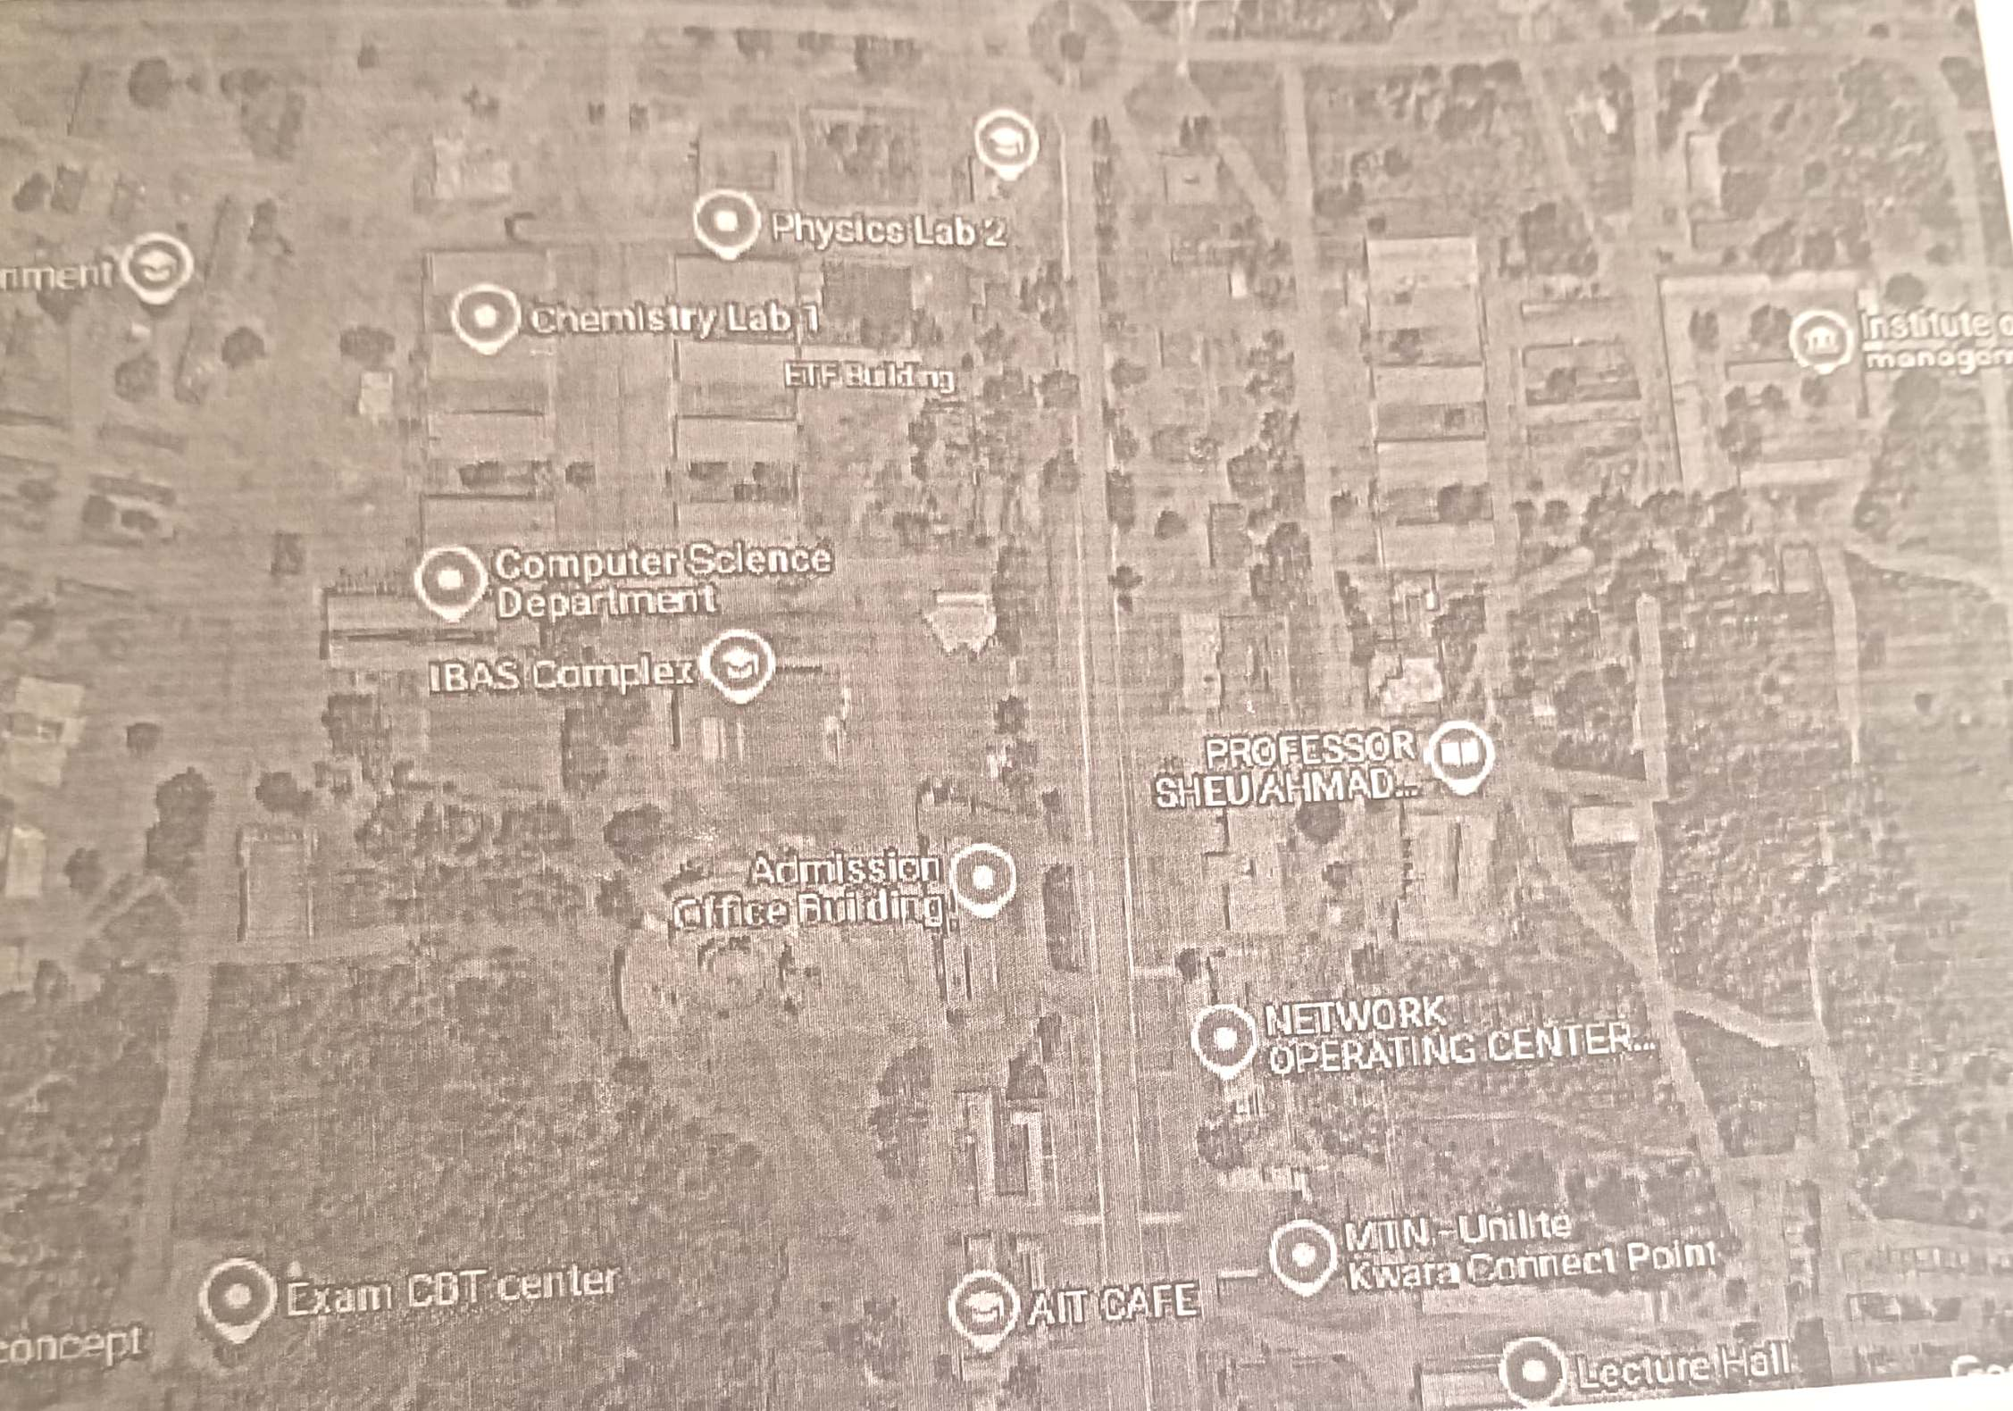

Figure 1: Satellite imagery of the study area
Source: www.goggle,com

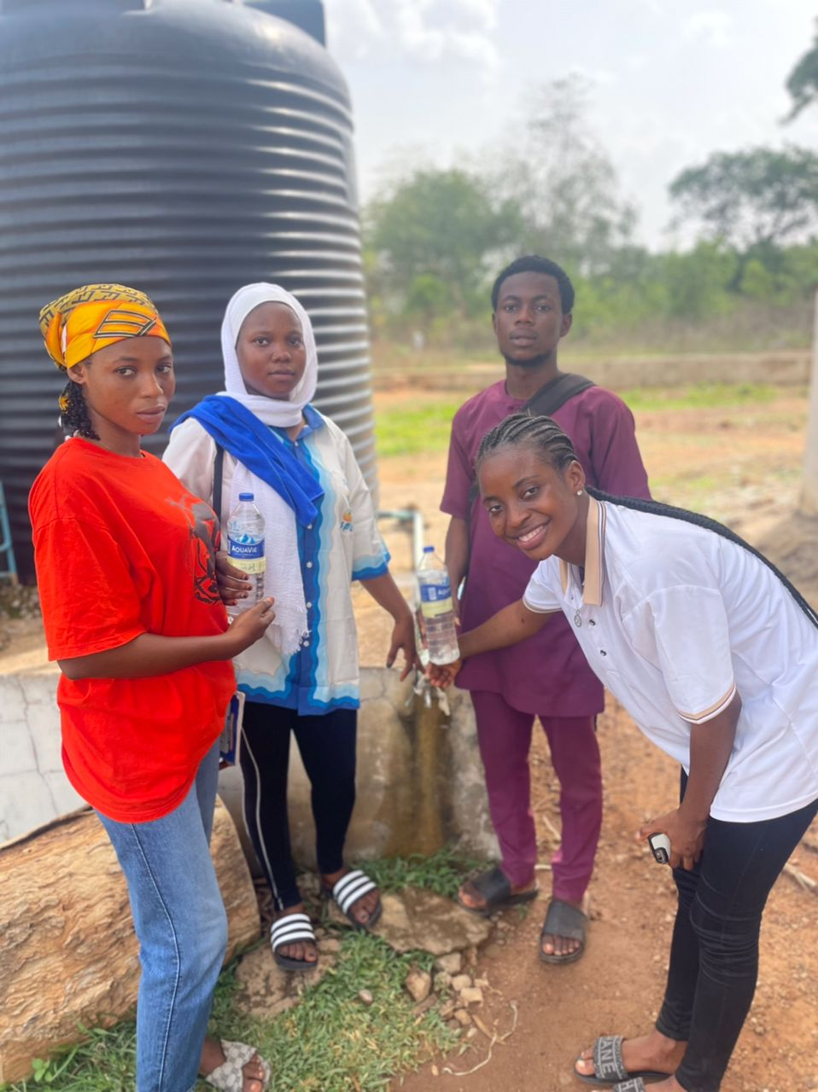
Fig 3.1: well sample collection

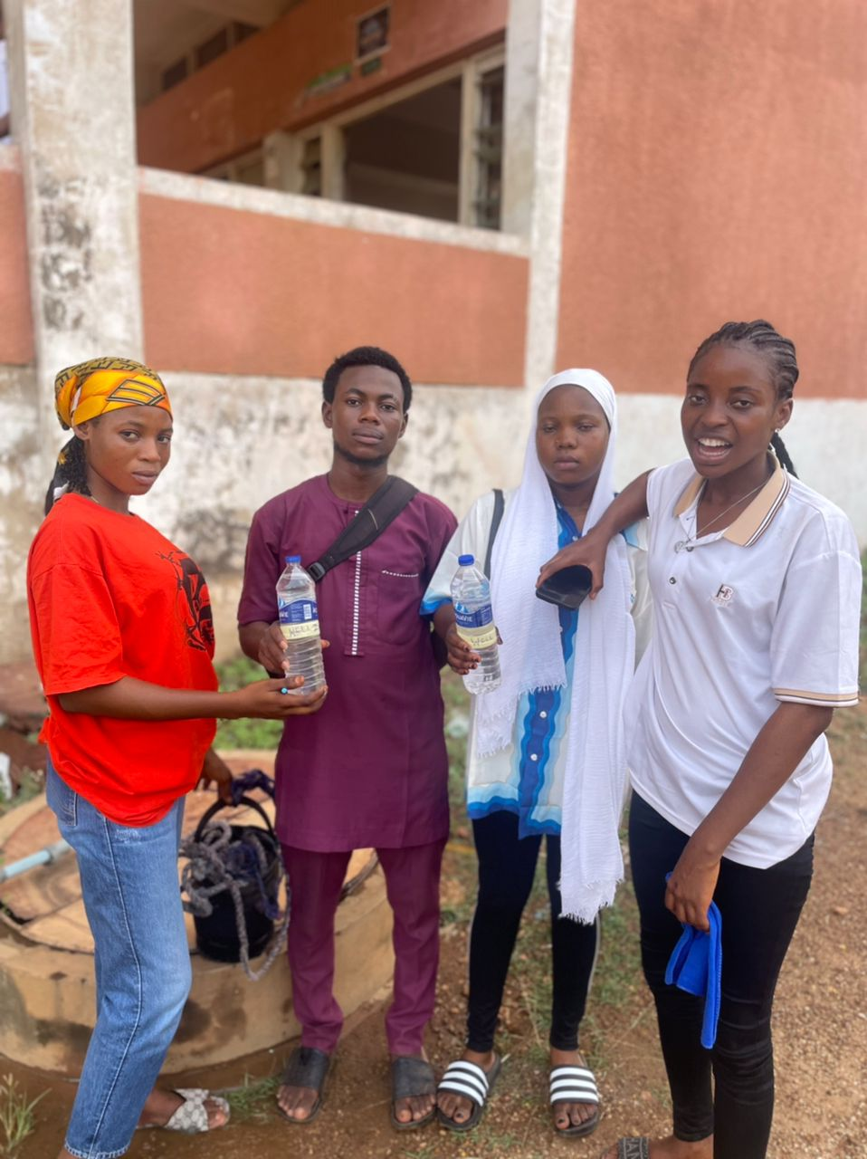

Fig 3.2: Well Water Sample Collection

2.2 Water Sampling Procedure

Selection of water sources was done by random sampling procedure. A

total number of five groundwater samples were collected within Akuo

community: Two wells

and three boreholes. The samples were collected separately in a sterilized

bottle for rain season and dry season respectively. Before collecting the water

samples, the bottle container was washed and rinsed thoroughly with water.

The water samples collected were taken to the laboratory for analysis using

standard methods. The Global Position

System (GPS) was used to determine the coordinates of the sampled points.

3.3 Laboratory Analysis of the Water Samples
The Laboratory analysis of the water samples was carried out at Fisbol Geosciences and analytical service sabookeilorin, kwara state. The water samples were tested for selected physical, chemical and biological.
The laboratory analysis was carried out using standard analytical methods and physical procedures for water quantity analysis.
3.4 Analysis of parameters
3.4.1 Physical parameters
A number of tests were carried out to determine physically parameters and there quantities in each ground water samples
3.4.2.1 Temperature
The temperature of each sample was measured directly at the collection site from the boreholes and wells using a thermometer.
3.4.2.2 Color / Odor
The Equipment use in determine color is colorimeter and odor is odor panel
3.4.2.3 P^{H}
The Equipment for the P^{H} is pH meter.
3.4.2.4 Filterable solids
Determined by filtering the sample through a filter and then measuring the solids
present in the filtrate.
3.4.3 Chemical Analysis
Tests varying in equipment and reagent used were carried out to analyze samples for chemical parameters

3.4.3.1 Total hardness
The total hardness, which includes both temporary and permanent hardness, was determined using the EDTA titrimetric method.
3.4.3.2 Chloride
Chloride concentration was determined using the Mohr titration method. Silver nitrate was titrated against the water sample, with potassium chromate (K,CrO4) used as the indicator.
3.4.3.3 Sulphate
Sulphate levels in water samples were determined using the turbidimetric method. The results were measured with a SpectroMec 20 Atomic Absorption Spectrophotometer and subsequently converted to mg/L.

3.4.3.4 Nitrate
Sulphate levels in water samples were determined using the turbidimetric method. The results were measured with a SpectroMec 20 Atomic Absorption Spectrophotometer and subsequently converted to mg/L.
3.4.3.5 Trace Elements
Zinc, Iron, copper, manganese, The results were directly obtained from the Atomic Absorption Spectrophotometer, Spectronic 20 model.
3.4.4 Biological Analysis
3.4.4.1 Total Viable Counts
Total Viable Plate Counts (TVPC) is a microbiological technique used to estimate the number of viable microorganisms present in a sample. It provides an indication of the overall microbial population and can be used to assess the quality and safety of various products, including food and water.
3.4.4.2 Coliform Counts
Coliform counts are used to evaluate the microbial quality of water, food, and other products by detecting the presence and concentration of coliform bacteria. Coliforms are a group of bacteria commonly found in the environment, including soil and vegetation, as well as in the feces of warmblooded animals. Their presence indicates potential contamination with fecal material.
3.4.4.3 E. Coli
Escherichia coli (E. coli) is a type of bacterium commonly found in the intestines of warm-blooded animals, including humans. It is a versatile organism used in research, biotechnology, and medicine.
3.4.4.4 Streptococcus Feacalis
Streptococcus faecalis (now more commonly known as Enterococcus faecalis) is a type of bacterium that is part of the normal flora of the gastrointestinal tract in humans and animals. It is also known for its role in both health and disease.

3.4.4.5 COPPER
Copper is a chemical element; it has symbol Cu (from Latin cuprum) and atomic number 29. It is a soft, malleable, and ductile metal with very high thermal and electrical conductivity. A freshly exposed surface of pure copper has a pinkish-orange color.
3.5 METHODS OF DATA ANALYSIS
The data that were collected from the laboratory analysis of the water samples were further analyzed using statistical tools and the results obtained were presented in tables .

CHAPTER FOUR

DATA PRESENTATION AND ANALYSIS
___________________________________________________________________________________S/N Parameter A B C D E MIN MAX Mean STD
1 Temperature 30.2 30.4 30.6 31.8 30.9 30.2 30.9 30.78 0.626099
˚C
2 Colour units 42 17 12 49 61 12 61 36.2 21.01666
3 Turbidity 25 9 8.5 21 20 9 25 16.7 0.403733
N.T.U
4 Ph 7.7 9 8.5 21 20 9 25 16.7 7.496666
5 Total D 680 980 790 879 710.5 680 980 807.9 123.328
issolvedSolids
(TDS)
6 Electrical 1176 1850 1568 1758 1419 1176 1850 1554.2 269.5073
Cond.
7 Chloride 22 38 64 45 30.7 22 64 39.94 15.93324
mg/l
8 Nitrate mg/l ND ND 24.1 23.43 18.6 18.6 24.1 22.04333 3.000772
9 Total hardness 28 42 54 78 98.9 28 98.9 60.18 28.37714
mg/l
10 Manganese ND 0.1 0.1 0 0.3 0 0.3 0.125 0.125831
Mn²⁺ mg/l
11 Iron Fe³⁺ mg/l 0.05 0.05 0.02 0 0.36 0 0.36 0.096 0.149097
12 Copper ND ND 0.05 0.08 0.04 0.04 0.08 0.056667 0.020817
13 Zinc ND ND ND ND ND ND ND ND ND
_____________________________________________________________________

A | BoreHore
B | BoreHore
C | wellWater
D | wellWater
Temperature
Table 4.1 shows the temperature mean (30.78ºc) is higher than the WHO’s recommended value (25ºc) which may affect taste and could encourage microbial growth, but it does not violate any health-based standard. Regular monitoring and, if possible, cooling of water before consumption is recommended for better acceptability and safety.
colour
Table 4.1 shows the colour (A,B,D and E) exceed the WHO recommended colour limit (15units) for drinking water, except for sample C. While this does not pose a direct health risk, it suggests the presence of dissolved substances or metals and may affect taste, appearance, and consumer trust. Treatment and regular monitoring are advised to improve water quality.
Turbidity
All the parameters exceed WHO standard for drinking water, which may affect taste, appearance, and indicate possible contamination
pH
The pH values of all the samples fall between 7.1–8.1 the mean is 7.54 as shown in table 4.1 are all within the WHO recommended range for drinking water (6.5–8.5). This suggests the water is safe regarding pH, with no risk of corrosion or taste issues related to pH. For further information on pH standards and measurement, consult research on pH sensing and standardization
Total Dissolve Solid
Table 4.1 shows TDS values rangefrom 680–980 mg/L, mean is 807.9 mg/Lare below the WHO recommended maximum of 1000 mg/L, indicating the water is within acceptable limits for drinking .The samples meet the WHO standard for TDS in drinking water, indicating they are safe and acceptable for consumption in terms of dissolved solids
Electrical Conductivity
Samples B, C, and D, as well as the mean value, exceed the commonly referenced WHO standard of 1500 µS/cm, while A and E are within the acceptable range as shown in table 4.1.Samples B, C, and D which may affect palatability and signal the need for further investigation into specific dissolved ions. While not a direct health risk, consistently high EC warrants attention to overall water quality and potential sources of contamination.
Chloride and Nitrate
Chloride: All your samples (22–64 mg/L) are well below the WHO guideline, indicating no taste or health concerns.Nitrate: All detected values (18.6–24.1 mg/L) are also below the WHO limit, suggesting no immediate health risk. “ND” (not detected) in some samples further supports safety, as shown in table 4.1. Both chloride and nitrate levels in the samples are well within WHO standards for drinking water, indicating the water is safe and acceptable for consumption regarding these parameters. Regular monitoring is still recommended to ensure ongoing safety.
Hardness and Manganese
Table 4.1 shoes all the watersample are soft, which is generally preferred for taste and household use .Manganese is levels are safe, but ongoing monitoring is wise, as high manganese can cause staining and health issues if above recommended levels, indicating the samples are safe and acceptable for drinking regarding these parameters. Regular monitoring remains important to ensure continued compliance.
Iron (Fe³⁺)
Table 4.1 shows samples (A–D) meet WHO standards and are health-wise acceptable Iron is not toxic at these levels and poses no direct health risk based on WHO criteria, Sample E (0.36 mg/L) exceeds the WHO guideline of 0.3 mg/L. This could lead to metallic taste, staining, or cloudiness in the water. Mean is 0.096 mg/L well below the WHO aesthetic limit and standard deviation is 0.149 indicates some variation among samples, mainly due to Sample E. further investigation or routine monitoring is recommended.
Discussion on Water Temperature Samples Compared to WHO Standards
According to WHO, drinking water should ideally be between 15°C and 25°C. All five samples exceed this range, making them less ideal for consumption without proper treatment and storage. Among them, Sample A (30.2°C) is the most acceptable, though still slightly above the recommended standard. Measures should be taken to reduce water temperature for better safety, taste, and quality.
Discussion on Electrical Conductivity (EC) of Water Samples Compared to WHO Standards.
While the World Health Organization (WHO) does not set a strict health-based limit for EC, it gives guidance based on aesthetic acceptability:

EC values should generally be below 1500 µS/cm.

Above 1500 µS/cm, water may taste salty, metallic, or unpleasant.
Based on WHO guidelines, water with EC below 1500 µS/cm is considered acceptable for taste and safety. Only Samples A (1176 µS/cm) and E (1419 µS/cm) meet this standard. Sample A is the most desirable, indicating the cleanest water with the lowest mineral content. Samples with higher EC (like B and D) may require treatment or alternative sources to ensure water quality and user satisfaction.
Discussion on Chloride Concentration in Water Samples Compared to WHO Standards.
The acceptable limit for chloride in drinking water is 250 mg/L.

CHAPTER FIVE

SUMMARY, CONCLUSION AND RECOMMENDATION

Conclusion
The analysis of water quality parameters in Table 4.1 reveals that most values fall within the acceptable limits set by the World Health Organization (WHO), indicating that the water is generally safe for consumption. Parameters such as pH, Total Dissolved Solids (TDS), chloride, nitrate, hardness, and manganese comply with WHO standards, ensuring no immediate health concerns. However, elevated values were observed in temperature, colour, turbidity, electrical conductivity, and iron (in Sample E), which may not pose direct health risks but can affect water palatability, appearance, and consumer perception.

Recommendations
- Temperature exceeds WHO's recommended value, consider cooling the water before consumption to enhance taste and limit microbial growth.
- Filtration or chemical treatment should be employ to reduce colour and turbidity levels, which can improve clarity and restore consumer confidence.
- For samples with high EC, further analysis should be carried out to identify specific dissolved ions and address any underlying contamination sources.
- Investigate and treat sample E to reduce iron content and prevent staining, taste issues, and water discoloration.
- Maintain routine water quality testing to ensure compliance with WHO guidelines and to detect any emerging contamination issues early

REFERENCES
Abdulrahman, H. M. (2020). Geophysical and Geochemical Assessment of the Impact of Domestic Waste Dumps on Groundwater in Parts of Ilorin, Southwestern Nigeria (Master's thesis, Kwara State University (Nigeria)).
Abdulrasaq, K. T. (2022). Assessment of Heavy Metals, Poly Cyclic Aromatic Hydrocarbons (PAHs), Persistent Organic Pollutant (POPs) in Soil and Water in Selected Markets in Nigeria (Master's thesis, Kwara State University (Nigeria)).
Aborisade, W. T., Ajao, A. T., & Sadiq, A. I. (2024). Assessment of surface water quality using phytoplankton as base-line indicator organisms in Ilorin, Kwara state, Nigeria. UMYU Journal of Microbiology Research, 9(1), 26-33.
Adebayo, K. R., Adesina, I. K., & Adeniji, F. A. (2022). Investigation of water qualities of open wells located at fuel stations within Ilorin metropolitan communities, Nigeria. Journal of Research in Forestry, Wildlife and Environment, 14(2), 31-38.
Adedeji, M. A., Adesina, I. K., Adeniji, F. A., & Chikezie, A. O. (2020). Around Auto-mechanic Workshops in Some Ilorin Metropolitan Areas.
Adeyinka, G. C., Afolabi, F., & Bakare, B. F. (2023). Evaluating the fate and potential health risks of organochlorine pesticides and triclosan in soil, sediment, and water from Asa Dam River, Ilorin Kwara State, Nigeria. Environmental Monitoring and Assessment, 195(1), 189.
Agboola, R. O., Sunmonu, L. A., & Suleman, K. O. (2021). Effect of Open Dumpsite on Underground Water Quality in Ganmo, Kwara State. The Nexus (Science Edition), 1(1), 17-23.
Ajenikoko, S. J. (2022). Comparative Study of Ground Water Quality Around Selected Petrol Stations in Ogbomoso North and South Metropolis, Nigeria (Master's thesis, Kwara State University (Nigeria)).
Akpan Emmanuel, F., Akpan Veronica, M., & Inyang Udeme, U. (2020). Geoelectrical investigation of groundwater quality through estimates of total dissolved solids and electrical conductivity in parts of Akwa Ibom state, southern Nigeria. Malaysian JG, 4(1), 32-37.
Alao, K. N., Oladejo, O. P., Ogunkoya, C. O., Adedokun, O. M., Adeniyi, E. O., & Sunmonu, L. A. (2025). Delineation of depth to some aquifers of Ogbomoso, Southwestern Nigeria. Dutse Journal of Pure and Applied Sciences, 11(1d), 343-354.
Awe, S., & Oyinade, F. (2020). Bacteriological Assessment of Selected Hand-Pumped Boreholes Water Sources in Malete Environs, Kwara State Nigeria. Natural and Applied Sciences Journal, 3(1), 47-58.
Awoyemi, A. R., Opasola, O. A., Adiama, B. Y., Agboola, O. E., Awoyemi, A. G., Ekundayo, D. E., & Atimiwoaye, A. D. (2025). Heavy metal pollution of water around waste dumpsite in Ado-Ekiti, Southwest Nigeria. Dutse Journal of Pure and Applied Sciences, 11(1d), 296-302.
Benson, O., & Adewunmi, T. (2023). Assessment of the Impact of Solid Waste on Groundwater Quality in Ikole Town, Ekiti State, Nigeria: A Case Study of Otunja and Asin Dumpsites. Int. J. Sci. Res. in Multidisciplinary Studies Vol, 9(11).
Daniel, M., Sawyerr, H. O., Opasola, O. A., Ekundayo, D. E., Atimiwoaye, A. D., Musa, O., & Sule, R. (2023). Water quality assessment of the man-made jabi lake, federal capital territory, Abuja, Nigeria. Journal of Applied Sciences and Environmental Management, 27(6), 1141-1146.
Dauda, A. K., & Shuaib-Na'Allah, B. O. (2023). SEASONAL VARIATION IN RELATION TO PHYSICO-CHEMICAL PROPERTIES OF GROUNDWATER QUALITY FOR DOMESTIC USES. International Journal of Novel Research in Science, Technology and Engineering, 6(1).
Durumba-obi, F. M., Njoku, F. I., Akande, O. S., & Ogbuji, S. I. (2023). Assessment of Soak Away Distance and Infiltration Layer on Bore-Hole Water Quality in Densely Residential Areas of Owerri Municipal, IMO State. International Journal of Agriculture and Environmental Research, 9(4), 612-633.
Emmanuel, O. O. (2022). Assessment of Groundwater Pollution from Leakages of Underground Storage Tanks of Filling Stations in Ilorin Metropolis, Nigeria (Doctoral dissertation, Kwara State University (Nigeria)).
Eniola, K. I. T., Awe, S., Olawale, K. A., & Kayode-Isola, T. M. (2022). Disease Risk Levels of Drinking Water Sources in Some Rural Communities in Kwara State, Nigeria. Journal of Biochemistry, Microbiology and Biotechnology, 10(2), 10-14.
Fawale, O., Lawal, T. O., & Abayomi, J. S. (2023). A Geo-Electrical Survey for Groundwater Exploration in a Part of the Basement Complex Terrain, Ilorin Metropolis Northcentral Nigeria. Nigerian Journal of Physics, 32(2), 55-65.
Isimikalu, T. O., Olaniyan, J. O., Alasinrin, S. Y., Wahab, A. A., & Salifu, U. M. (2022). Influence of environmental variables on carbon mineralization in diverse soil management systems under maize cropping in Kwara State, Nigeria.
Jimoh, F. A., Ajao, A. T., Aborisade, W. T., Abdulsalam, Z. B., & Kolawole, M. O. (2025). Bacteriological Evaluation And Physicochemical Compliance Of Packaged Water Sold In Ilorin, Nigeria. Fudma Journal Of Sciences, 9(1), 180-185.
Lawal, T. O., Abayomi, S. J., & Fawale, O. (2023). Assessment of activity concentrations of radioactive elements in selected groundwater samples of Kwara State Polytechnic and its environs, North Central Nigeria. Recent Advances in Natural Sciences, 6-6.
Lele, C. K., Olarewaju, M. O., & Adeyemi, O. S. (2023). Concentrations of Polycyclic Aromatic Hydrocarbons and Potability of Borehole Water in Onne, Nigeria. Polycyclic Aromatic Compounds, 43(7), 6502-6515.
Mohammed, K. A., Balogun, O. S., & Adebayo, K. R. (2023). Evaluation of Natural Fertilizer Potential of Neem Leaves Aqueous Extract for Irrigation Practices. Journal of Applied Sciences and Environmental Management, 27(8), 1713-1717.
Musa, J. J., Otuaro, E. A., Musa, M. T., Dada, P. O. O., & Musa, E. T. (2020). Evaluation of Temporal Changes in Deep Well Water Quality in Igabi Local Government Area of Kaduna State.
Musa, S. T. (2021). Geology and Hydrogeology of Part of Makurdi Sheet 251 SW, North Central Nigeria (Doctoral dissertation).
Obaro, R., &Obaro, N. (2022). Geological And Engineering Evaluation Of Gravel Deposits Around Amoyo Area, Kwara State.
Olasehinde, D. A., Adeniran, K. A., Olasehinde, D. O., Bayeiri, M. R., & Adewara, S. O. (2020, February). Mapping groundwater suitability for irrigation using GIS: A Case study of Ilorin, Kwara State, Southwestern Nigeria. In IOP Conference Series: Earth and Environmental Science (Vol. 445, No. 1, p. 012021). IOP Publishing.
Olatunji, J. A. (2020). Hydrogeological and Geophysical Characteristics of Aquifers in Parts of Ilorin, Southwestern Nigeria (Doctoral dissertation, Kwara State University (Nigeria)).
Ologun, A. A. (2024). Water Quality Index and Health Risk Assessment of Commonly Soldbottled Water in Ilorin and Offa Metropolises, Kwara State, Nigeria (Master's thesis, Kwara State University (Nigeria)).
Olosunde, O. O., & Amanyunose, A. A. (2023). Quality Assessment of Well Water in Some Selected Iree Community. Adeleke University Journal of Engineering and Technology, 6(1), 107-112.
Oluwagbayide, S. D., & Abulude, F. O. (2021). Assessment of the Quality of Well Dug Water Samples in Nigeria and Their Suitability for Drinking and Irrigation Purposes.
Oluwagbayide, S. D., & Abulude, F. O. (2022). Assessment of the quality of dug well water samples in Nigeria and their suitability for drinking and irrigation purposes. Sustainable Water Resources Management, 8(5), 149.
Ore, A. A. (2023). Effects of Magnetized Fish Pond Wastewater on the Height, Leave and Stem Diameter of Okra (Abelmoschus esculentus Moench) Using Drip Irrigation System (Master's thesis, Kwara State University (Nigeria)).
Scholar, A. (2020). Water Qualities of Open Wells Located at Fuel Stations in Ilorin Metropolitan 1I. K. Adesina, MA Adedeji,. A Adeniji and OA Oyedele3.
Umoren, O. D., Salaudeen, G., Olowo, S. T., Mohammed, M. A., Akpowu, A. G., Ayanleke, T. A., ... & Afolabi, T. (2024). Physicochemical Parameters of Selected Ground and Surface Water Sources in Ijeun-Titun and Kuto Community, Abeokuta, Ogun State, South-western Nigeria. Nigerian Journal of Hydrological Sciences, 11(1), 87-95.

