EFFECT OF EXTRACTION CONDITIONS ON THE PROXIMATE COMPOSITION OF SUGARCANE JUICE

BY:
AKANDE TOPE
HND/23/ABE/FT/0094

DEPARTMENT OF AGRICULTURAL AND BIO – ENVIRONMENTAL
ENGINEERING, INSTITUTE OF TECHNOLOGY, KWARA STATE
POLYTECHNIC, ILORIN
INPARITAL FULFILLMENT OF REQUIREMENT FOR THE AWARD OF
HIGHER NATIONAL DIPLOMA (HND) IN AGRICULTURAL AND BIO-
ENVIRONMENTAL ENGINEERING TECHNOLOGY
AUGUST,2025

CERTIFICATION
This is to certify that this project title, effect of extraction conditions on the proximate composition of sugarcane juice by Akande Tope with Matric number HND/23/ABE/FT/0094 was carried out under my Supervision at the Department of Agricultural and Bio-environmental Engineering Technology, Institute of Technology, Kwara State Polytechnic, Ilorin. This Project report has been read and approved having met the requirement for the award of Higher National Diploma (HND) in Agricultural and Bio-environmental Engineering Technology.


______________________ _________________
ENGR. (MRS) Shuaib-Na allah B.O DATE
Project Supervisor


______________________ _________________
ENGR. OYEBANRE, O.D DATE


Project Coordinator
______________________ ___________________
ENGR. DR. DAUDA, K.A DATE


Head of Department
______________________ ___________________
EXTERNAL EXAMINER DATE
ENG.DR. ADEJUMO AKINFOYE .D.

DEDICATION
This project is dedicated to Almighty God, the most Beneficent and Merciful
ACKNOWLEDGEMENT
All praise and gratitude belong to Almighty Allah, the Most Gracious, the Most Merciful, for granting me life, strength, wisdom, and perseverance throughout the period of this project and my academic journey. His mercy and guidance have been my anchor, and without His favor, this achievement would not have been possible.
I am deeply indebted to my wonderful mum, Mr. & Mrs. Akande and my beloved siblings whose love, sacrifice, and encouragement have been the bedrock of my life. Your constant prayers, moral support, and financial backing gave me the strength to keep going even during the most difficult times. Words alone cannot express how thankful I am for everything you have done for me.
My sincere appreciation goes to my project supervisor, Engr. Mrs. Shuaib Na’allah B.O, whose guidance, feedback, and dedication helped shape this research work. Your patience, constructive criticism, and academic mentorship greatly enhanced the quality of this project.
I also extend my gratitude to the Head of Department Engr. Dr. Dauda K.A and all the lecturers in the Department of Agricultural and Bio-Environmental Engineering for the knowledge and inspiration they have imparted to me throughout my studies. Your collective impact has been monumental in shaping my academic foundation.
To my friends who have walked this journey with me — Wizstar, Teslim and others — thank you for your companionship, moral support, words of encouragement, and the memorable times we shared. Your presence made this academic journey worthwhile and bearable.
Special thanks to my course mates and colleagues who directly or indirectly contributed to the success of this project. The discussions, shared resources, and teamwork during practicals and lectures were invaluable

TABLE OF CONTENT
Title Page i
Certification ii
Dedication iii
Acknowledgement iv
Table of Contents v
Abstract vii
List of Figure viii
List of Plates ix
List of Tables x
CHAPTER ONE: INTRODUCTION
1.1 Background to the Study
1.2 Problem statement of the Study
1.3 Aim and Objectives of the Study
1.4 Scope of the Study
1.5 Justification of the Study
CHAPTER TWO
2.1 Introduction to Automated Solar Cocoa Seed Dryers 3
2.1.1 Importance of Efficient Drying 3
2.1.2 Benefits of Automated Solar Dryers 3
2.1.3 Challenges in Cocoa Drying 3
2.1.4 Future Directions 4
2.2 Design Considerations for Automated Solar Cocoa Seed Dryers 4
2.2.1 Solar Collector Design 4
2.2.2 Drying Chamber Design 4
2.2.3 Automation and Control Systems 5
2.2.4 Energy Storage Options 5
2.3 System Components of Automated Solar Cocoa Seed Dryers 5
2.3.1 Design Considerations 6
2.3.2 Benefits of Automated Solar Cocoa Seed Dryers 7
2.4 Automation and Control Strategies in Solar Dryers 7
2.4.1 Types of Automation and Control Strategies 7
2.4.2 Benefits of Automation and Control Strategies
2.4.3 Examples of Automation and Control Systems
2.5 Implementation and Testing of Automated Solar Cocoa Seed Dryers
2.5.1 Prototype Development 8
2.5.2 Performance Testing 9
2.5.3 Optimization 9
2.5.4 Benefits of Automated Solar Dryers 9
2.5.6 Challenges and Limitations 9
CHAPTER THREE: Materials and Methods
3.1 Design Considerations 10
3.2 Description of the Hybrid Dryer 10
3.2.1 Collector 11
3.2.2 Drying Chamber 11
3.2.3 Trays 12
3.2.4 Fans 13
3.2.5 Frame 13
3.2.6 Monitoring equipment 14
3.2.7 Hinges and lock 15
3.2.8 Solar Battery 15
3.2.9 Solar Panel 15
3.2.10 Charge controller 16
3.3 Hybrid Dryer Parts Design 16
3.4 Moisture Content 19
3.5 The Mass of water evaporated or moisture loss 19
3.6 Average Drying Rate 20 vii
3.7 Principle of Operation of the Hybrid Dryer 21
3.8 Experimental procedure 21
3.9 Material used for construction of Solar Dryer 23
3.10 Tools and Equipment 26
3.11 Design Layout 29
CHAPTER FOUR: Results and Discussion
4.1 Result 32
4.2 Discussion 33
CHAPTER FIVE: Conclusion and Recommendation
5.1 Conclusion 37
5.2 Recommendation 37
References 38
CHAPTER ONE
INTRODUCTION
1.1 Background of the Study
Sugarcane (Saccharum spp.) is one of the most economically important grasses in the world, showing a high bioenergy potential due to its C4 nature and high biomass yield. The main product is sugar, but it is also an important bioenergy feedstock exemplified by bioethanol and bioelectricity; more recently, interest has also relied on bioplastics (Furlan et al., 2013; Hoang et al., 2015; Saini et al., 2015; Hiloidhari et al., 2018; Silveira et al., 2018). Genetically, sugarcane has a complex genome with a size of approximately 10 Gb due to a high and variable ploidy level, with frequent aneuploidy (D’Hont, 2005; Piperidis et al., 2020; Thirugnanasambandam et al., 2018). Currently, sugarcane breeding aims to obtain new varieties with tolerance to abiotic stress (e.g., drought), resistance to pests and diseases, mechanical harvesting features (e.g., sprout, tillering), and mainly high sucrose content (with high quality) per hectare; the last can be achieved either from increasing biomass productivity or sugar content (de Morais et al., 2015). The sugarcane pipeline breeding can vary between different programs. However, a similar structure can be defined, i.e., the procedure starts with several crosses among superior genotypes (frequently commercial cultivars) to obtain a population with genetic variability, followed by several selection stages until the target genotype is identified. The selection stages explore sugarcane clonal propagation ability; for this, two major consequences are observed: the hole genetic variation can be exploited by either additive and non-additive effects over stages; and, historically, a few recombination events are observed from the ancestors to the modern varieties (Yadav et al., 2020). According to each breeding program, obtaining a new cultivar can vary from 11 to 12 years (Cheavegatti-Gianotto et al., 2011; Cursi et al., 2021). Sugarcane history has indicated that the breeding program follows a recurrent selection process (Jackson, 2005), in which the newly selected genotypes are included as new parents for another cycle. This approach is a successful example of breeding, worldwide data indicate that sugarcane yield increasing41% during the last 50 years, and sugar production increasing by 1–1.5% per year (Gouy et al., 2013, 2015). On the other hand, yield gains rate are decreasing over time, suggesting a possible plateau in sugar accumulation (Dal-Bianco et al., 2012). New sugarcane breeding strategies are essential to overcome this limitation and reduce the demanding time to obtain a new cultivar. In this aim, Biotechnology is a highlighted strategy, integrating new tools for breeding (Dal-Bianco et al., 2012), such as ‘omics’ data, molecular markers, and Genetic Engineering. The development of sugarcane genetically modified (GM) cultivars has received special attention as a possible alternative to increase genetic gain. In 2017, the National Technical Biosafety Commission (CTNBio), responsible for the evaluation and commercial approval of genetically modified cultivars in Brazil, approved the cultivation of the first GM sugarcane developed to control the sugarcane borer in Brazilian fields (Gianotto et al., 2019). Approval for commercial planting of GM cultivars depends on a rigorous interdisciplinary risk assessment process in which the potential environmental impact and the food and feed safety are evaluated (Kennedy et al., 2018). A critical aspect of biosafety analysis of GM cultivars is the risk assessment for human and animal health. Normative Resolution No. 05 of CTNBio states that GM organisms used as food must be evaluated for substantial equivalence to the non-modified cultivar. The Organization for Economic Co-operation and Development (OECD) developed the concept of substantial equivalence to ensure that new biotechnologyderived foods are safe as their conventional counterparts. Specifically, for sugarcane, the OECD recommends that the new cultivar be analyzed for its main component contents (moisture, crude protein, lipids, ashes, fibers, and sucrose) (OECD, 2011). There is national scientific literature on the topic (Azevedo et al., 2003; de Souza França et al., 2004; Santos et al., 2006), but most studies have focused on the use of sugarcane as silage. As required by CTNBio and recommended by the OECD, there is currently no database containing the nutritional information of national sugarcane cultivars. In this context, the lack of information about the nutritional characteristics of conventional sugarcane cultivars creates a challenging scenario to assess substantial equivalence with GM sugarcane. For this, we aim to obtain a reference database of substantial equivalence of future genetically modified cultivars, as recommended by the OECD report, for the sugarcane Nutritional Composition traits and Technological Composition. These data are collected based on Brazilian cultivated germplasm evaluated under multi-environmental trials.
Despite these increases, Nepal ranks 34th globally among sugarcane-producing countries (FAOSTAT, 2018), with national productivity averaging 49.59 tons per hectare (MoAD, 2020). This relatively low productivity highlights the need for improved agricultural practices, particularly in weed management, which is a key factor influencing sugarcane yield and quality. Weeds compete with sugarcane for essential resources such as water, nutrients, light, and space, leading to significant yield reductions if not effectively controlled. Research across various regions has documented substantial yield losses due to weeds, with typical reductions ranging from 28-38% (Singh & Tamor, 2005). In extreme cases, such as in Thailand and Ethiopia, yield losses due to weeds have reached as high as 70-80% (Suwanarak, 1990; Yirefu et al., 2013). In India, cane yield losses have been reported to range from 12-72%, depending on the region and weed species present (Rana & Rana, 2016). Similarly, the Australian sugarcane industry faces annual losses estimated at $70 million due to weeds (Eppe, 2018).
However, these traditional methods are less viable under current conditions, underscoring the need for more efficient and sustainable weed management approaches, such as Integrated Weed Management (IWM). IWM is a comprehensive strategy that combines chemical, mechanical, biological, and cultural practices to manage weed populations effectively and sustainably. This approach is particularly well-suited to Nepal's diverse agricultural conditions, offering a flexible framework that can be tailored to the specific needs of different sugarcane-growing regions. IWM reduces reliance on chemical herbicides, minimizing environmental risks and the development of herbicide-resistant weeds. It also integrates cultural practices like mulching and intercropping, which suppress weed growth and improve soil health, further enhancing the sustainability of sugarcane farming. Economically, IWM reduces production costs by optimizing herbicide use and lowering labor requirements, making sugarcane farming more cost-effective. Improved weed control through IWM leads to higher yields, increasing the economic viability of sugarcane farming and contributing to the agricultural sector's overall productivity and profitability in Nepal. Therefore, adopting IWM is crucial for addressing the persistent challenges of weed management in sugarcane cultivation, improving productivity, ensuring environmental sustainability, and securing the future of sugarcane farming in Nepal. Thus, an experiment was conducted at NSRP, Jeetpur to evaluate the effectiveness of Integrated Weed Management (IWM) strategies in enhancing sugarcane yield and productivity in Nepal.
1.2 Problem Statement
Sugarcane (Saccharum officinarum) is a tropical crop widely cultivated for its sweet juice, which is rich in natural sugars, minerals, and other nutrients. Sugarcane juice serves as a popular refreshment in many parts of the world, particularly in tropical regions like Nigeria, where it is consumed for its energy-boosting properties, affordability, and natural flavor. Beyond its immediate use as a beverage, sugarcane juice also holds potential in the production of fermented drinks, syrups, and other value-added products.
Despite its popularity, one major challenge facing processors and food scientists is the variation in the nutritional quality of sugarcane juice resulting from different processing conditions. Parameters such as roller speed, feed rate, and the number of extraction passes play a crucial role in determining not only the yield of juice but also its nutritional composition. These extraction conditions can influence the extent of cell rupture, juice purity, and the inclusion or loss of vital nutritional components such as protein, fiber, and mineral content. Improper extraction methods may lead to excessive dilution, oxidation, or nutrient loss, thereby reducing the nutritional and commercial value of the juice.
While several studies have focused on improving sugarcane yield and juice preservation, there is a noticeable gap in literature regarding the direct relationship between extraction conditions and the proximate composition of the juice. Understanding how these mechanical and operational variables affect the nutritional makeup of sugarcane juice is essential for optimizing processing techniques, improving product consistency, and ensuring that consumers receive a nutritionally beneficial product.
1.3 Aim and Objectives The aim of the project is to extract quality uice from sugar cane and examing the effect on the proximate composition of the sugar cane juice. While the specific objectives are:
- To extract sugarcane juice under varying extraction conditions (machine roller speed, feed rate and number of passes).
- To determine the proximate composition of the sugar cane juice (moisture, ash, crude protein, crude fiber, calorific value, crude fat and carbohydrates) obtained under different conditions.
- To evaluate the influence of each extraction condition on the proximate composition of the sugar cane juice.
- iv. Identify the optimal extraction condition that yields juice with the most desirable nutritional characteristics (highest sugar content and lower fiber residue).

1.4 Justification of the Study
The study aims to establish scientifically-based guidelines for optimal juice extraction. The findings will provide valuable insights for small- and large-scale sugarcane juice processors, contributing to improved product quality, better nutrient retention, and overall consumer satisfaction.
1.5 Scope of the Study
This study is limited to evaluating the nutritional composition of sugarcane juice through proximate analysis. It specifically examines how variations in machine roller speed, feed rate and number of passes duringextraction affects the proximate composition of the juice..

CHAPTER TWO
LITERATURE REVIEW
2.1 Overview of Sugarcane (Saccharum officinarum)
Sugarcane juice is extracted by mechanically crushing the stalks, resulting in a naturally sweet, nutrient-rich liquid. The extract contains essential nutrients such as carbohydrates, proteins, minerals, vitamins, and antioxidants that contribute to its nutritional and therapeutic value (Kumar et al., 2021).
Sugarcane (Saccharum officinarum) is a tall perennial grass belonging to the family Poaceae, extensively cultivated in tropical and subtropical regions. It is the world’s largest crop by production quantity and serves as a key raw material in the sugar, ethanol, and beverage industries. Apart from its use in sugar production, sugarcane is widely consumed in its raw juice form due to its refreshing taste and health-promoting properties (Patel et al., 2020).
2.1.1 Plant material and experimental conditions in the fields
A collection of twenty relevant commercial sugarcane cultivars was used in this study. The criteria for choosing the evaluated varieties were proportion of the planted area that they occupy 63.2%, maturation with respect to sucrose accumulation and adaptability to different production environments. Varieties from the main Brazilian breeding programs were also chosen, such as RIDESA public program (Inter-university Network for the Development of the Sugarcane Industry), which develop varieties with the acronym RB; COPERSUCAR’s private program (produced SP varieties) that ended its activities in 2003, and since 2004, it has been managed by the Sugarcane Technology Center (CTC), which has been developing CTC varieties; CanaVialis, whose varieties are named CV; and IAC program (Agronomic Institute of Campinas) that produced varieties with the acronyms IACSP and IAC (Cursi et al., 2021). According to the maturation period of the cultivars, they can be classified as early (RB855156, RB855453, RB965917, RB966928, CV7231, CTC9, CTC17 and CTC21) or late cultivars (encompasses the medium/late cultivars: RB92579, RB835054, RB867515, RB965902, IACSP955000, IACSP955094, CV7870, SP81–3250, SP83–2847, CTC4, CTC15 and CTC20), thus this study encompassed materials from the main Brazilian breeding programs for sugarcane. Still, twelve of them were cited as the most cultivated in Brazil in 2019, in which the Brazilian sugarcane census was based on 6.8 mi hectares (Braga Jr et al., 2021). These cultivars were already present in the national census since 2011, except for CV7870, which appeared in the census in 2014. Regarding the regional censuses, 18 of them were present in at least one regional area, an indication that the cultivar sample also includes several environmental production areas. The locations chosen in this research represent the main growing areas of sugarcane in Brazil. The States of S˜ ao Paulo, Parana, ´ Pernambuco, and Goias ´ together represent 71.5% of the sugarcane growing area in Brazil. The trials were conducted in six environments: Conchal (lat 22◦24’S, long 47◦06’W and alt 591 m asl, in the state of Sao ˜ Paulo), Jaboticabal (lat 21◦16’S, long 48◦23’W and alt 615 m asl, in the state of Sao ˜ Paulo), Taciba (lat 22◦ 23’S, long 51◦17’W and alt 416 m asl, in the state of Sao ˜ Paulo), Rolandia ˆ (lat 23◦18’S, long 51◦22’W and alt 730 m asl, in the state of Parana), Montividiu (lat 17◦26’S, long 51◦10’W and alt 821 m asl, in the state of Goias), and Carpina (lat 07◦35’S, long 34◦15’W and alt 184 m asl, in the state of Pernambuco). The climates were Cwa (Jaboticabal and Conchal), Aw Montividiu, As (Carpina), Cfa (Rolandia ˆ and Taciba), according to Koppen ¨ (Fig. 1) (Supplementary Table 4). At each location, the experimental design consisted of a randomized block design, which was fully replicated three times. Trial plots consisted of two 3 m-long rows spaced 1.4 m apart. Weed, fertilizer and pest and disease management proceeded per commercial farm practice. The experimental plots were installed in 2014, and harvesting, according to maturation period, was carried out in 2015 (plant cane) and 2016 (first ratoon). A 10-stalk sample was taken for analysis of the nutritional composition, and three replicates at each location were evaluated.

2.2 Nutritional Composition of Sugarcane Extract
Sugarcane extract, often referred to as sugarcane juice, is a natural beverage obtained by crushing the stalks of the Saccharum officinarum plant. It is widely consumed in tropical and subtropical regions and is valued not only for its sweet flavor but also for its nutritional content. The extract is composed of water, sugars, vitamins, minerals, and phytonutrients, offering both energy and health benefits. difference between FDN and FDA.

2.2.1 Carbohydrates and Sugars
The primary component of sugarcane extract is carbohydrate, particularly sucrose, which makes up about 10–15% of the juice. In addition to sucrose, sugarcane extract contains glucose and fructose in smaller quantities (Jaganath & Ng, 2010). These simple sugars make it an excellent source of quick energy.

2.2.2 Vitamins: Sugarcane extract contains small amounts of water-soluble vitamins such as:
Vitamin C (ascorbic acid): functions as an antioxidant which supports immune health.
B-complex vitamins, including riboflavin (B2), niacin (B3), and pantothenic acid (B5), which are involved in metabolic energy production (Sundar & Ramesh, 2012)

2.2.3 Minerals: It is also a source of several essential minerals:
Potassium: Important for maintaining electrolyte balance and blood pressure regulation.
Calcium and Magnesium: Support bone health and enzymatic activities.
Iron: Helps in the formation of hemoglobin (Chaturvedi & Upreti, 2020).

2.2.4 Phytochemicals and Antioxidants
Sugarcane juice contains phenolic compounds, flavonoids, and other antioxidants, which contribute to its potential anti-inflammatory and hepatoprotective properties (Banerjee et al., 2013). These antioxidants help combat oxidative stress and may offer protective effects against certain chronic diseases.

cidity and supports digestion (Patel et al., 2020).
2.4.3 Detoxification: The diuretic properties assist in kidney function by promoting urine production and toxin elimination (Kumar et al., 2021).
2.4.4 Immune Support: The presence of vitamin C and antioxidants strengthens the immune system and reduces the risk of infections.

2.6 Past Review on the Project Topic
Several studies have explored the nutritional composition and potential health benefits of sugarcane (Saccharum officinarum L.) extract, highlighting its importance beyond being a source of sucrose. Below are three key reviews and research works that contribute to the understanding of its nutritional profile.

2.6.1 Nutritional and Phytochemical Composition of Sugarcane Juice
According to the study by Rao and Rao (2013), sugarcane juice contains essential nutrients such as carbohydrates (primarily sucrose), small amounts of proteins, vitamins (notably B-complex), and minerals like calcium, potassium, magnesium, and iron. The authors emphasized the presence of phenolic compounds and flavonoids, which confer antioxidant properties to sugarcane juice. These phytochemicals have been linked to anti-inflammatory, hepatoprotective, and antimicrobial activities, which broaden the scope of sugarcane as more than a sugary beverage.

2.6.2 Bioactive Components and Health Potential of Sugarcane Extract
Patel et al. (2015), sugarcane extract was reported to contain diverse bioactive molecules including polyphenols, flavonoids, and terpenoids. The study emphasized sugarcane’s antioxidant potential due to its polyphenol content, which helps combat oxidative stress. Furthermore, the authors detailed the antibacterial effects of the extract and suggested potential in the management of lifestyle-related diseases such as diabetes and cardiovascular disorders when used in moderation.

2.6.3 Analysis of Nutritional Properties and Industrial Uses of Sugarcane Juice
Choudhary et al. (2020) analyzed the macro and micronutrient composition of sugarcane juice and noted its industrial relevance in food processing and health supplements. They highlighted sugarcane as a natural energy drink due to its high carbohydrate content and presence of electrolytes, particularly potassium. Moreover, they mentioned the role of sugarcane extract in traditional medicine systems such as Ayurveda and Unani, where it is used for its diuretic and liver-tonic properties.

CHAPTER THREE
MATERIALS AND METHODS
3.1 Materials
The following materials and instruments were used in the course of this study.
- Digital weighing scale: A digital weighing scale plate A1 with model no NBL-2602e with an accuracy ±0/01g was used to measure the samples for the experiment as shown in plate 3.1
- Digital tachometer: A contact/non contact digital tachometer plate A2 with accuracy ± (0.05% + 1 digits) was used to measure the speed of the machine during operation.
- Bowl: Three bowls of equal size was used to prepare the sample and also to collect the baggase from the machine.
- Sugar cane
- Stopwatch: A digital stopwatch was used to measure the time taken to complete each experiment.
- Hot Air Oven: Temperature range up to 250°C; accuracy ±1°C; timer 0–99 hours
- Muffle Furnace: Maximum temperature 1000°C; operating temperature 550–600°C; digital controller.
- Analytical Balance: Readability 0.1 mg (±0.0001 g); capacity 200–300 g; internal or external calibration.
- Desiccator: Vacuum or non-vacuum type; diameter 150–300 mm; includes ceramic plate and silicone seal.
- Aluminium/Platinum Crucible: Capacity 30–50 mL; made of high-purity aluminum or platinum.
- Soxhlet Extractor: Volume 100–500 mL; borosilicate glass; compatible with cellulose thimbles.
- Fat-Free Thimble: Made of cellulose; standard size 33 x 80 mm or as required by extractor.
- Heating Mantle: Temperature range ambient to 450°C; accommodates 250–500 mL flasks.
- Rotary Vacuum Evaporator: Temperature up to 180°C; rotation speed 20–280 rpm; vacuum control system.
- Digestion Block/Heater: Temperature up to 450°C; accommodates 6–20 digestion tubes; timer with exhaust.
- Distillation Unit: Includes condenser and ammonia trap; heater with adjustable temperature.
- Titration Setup: 50 mL burette (Class A); stand and clamp; 250 mL conical flask.
- Glassware (Flasks, Beakers, Pipettes): Made of borosilicate glass; capacity ranges from 10–500 mL.
- Reflux Apparatus: Includes condenser and heat source; round-bottom flask capacity 250–500 mL.
- Filter Setup (Funnels, Cheesecloth, Filter Paper): Medium to coarse porosity; diameter 90–150 mm.
- Couch/Porcelain Crucible: Capacity 20–50 mL; heat resistant up to 1000°C
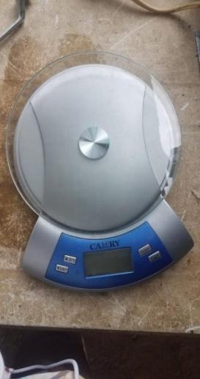
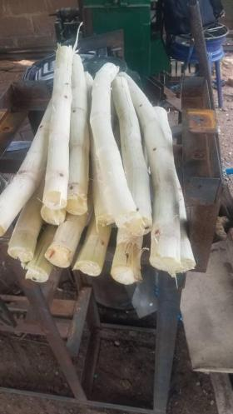

Plate 3.1: Sugar cane Plate 3.2: Digital weighing scale

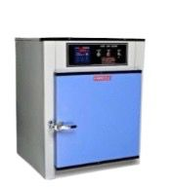
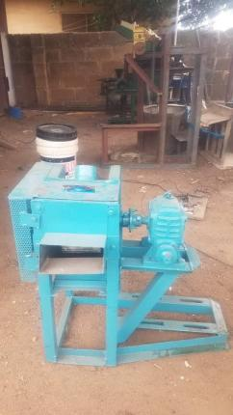

Plate 3.3: Soxhlet extractor Plate 3.4: Hot air oven

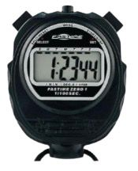

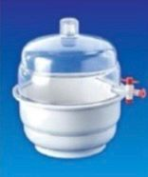

Plate 3.5: Desiccator vaccum 150mm Plate 3.6: Stop watch

3.2 Methods
3.2.1 Sourcing of Experimental Materials
Sugarcane was purchased from a local market in Ilorin South Local Government Area, Kwara State, Nigeria.
3.2.2 Sample Preparation
The sugar cane was peeled and washed thoroughly with water. The sugar cane was cut to medium sizes for easy measurement. The sugar cane was then measured into the various samples using a digital weighing scale according to the design layout.
3.2.3 Experimental Design and Layout
Three independent variables (feed rate, machine roller speed and no of pass) were selected while seven dependent variables: output parameters (moisture, ash, crude protein, crude fiber, calorific value, crude fat and carbohydrates) were considered for this study. A computer software Central Composite Design Expert Software version 6.08 with three factors and three levels (Box-Behnken experimental design) which generated 17 experimental runs was applied. The independent variables for this study were selected based on preliminary experiments and literature search. Three levels of feed rate (500g, 1000g and 1500g), machine speed (50 rpm, 100 rpm and 150 rpm) and number of pass (1, 2, 3). Table 3.1 shows the experimental factors and their levels while Table 3.2 shows the experimental matrix used for the experiment.
Table 3.1: Experimental Factors and levels for Box-Behnken design
Factors | Symbol |  | Level
 | Original | Coded | -1 | 0 | +1
Feed rate (Kg) | Fr | A | 500 | 1000 | 1500
Machine Roller Speed (rpm) | Sp | B | 50 | 100 | 150
No of Pass | N | C | 1 | 2 | 3

Table 3.2: Experimental matrix by Box-Behnken Design
Std | Run | A:Machine Roller Speed | B:Feed Rate | C:No of Passes | Moisture | Calorific Value | Ash | Crude Protein | Crude Fiber | Crude Fat | Carbohydrate
 |  | rpm | g |  | % | kj/100g | % | % | % | % | %
14 | 1 | 100 | 1000 | 2
13 | 2 | 100 | 1000 | 2
4 | 3 | 150 | 1500 | 2
5 | 4 | 50 | 1000 | 1
6 | 5 | 150 | 1000 | 1
15 | 6 | 100 | 1000 | 2
12 | 7 | 100 | 1500 | 3
7 | 8 | 50 | 1000 | 3
9 | 9 | 100 | 500 | 1
10 | 10 | 100 | 1500 | 1
16 | 11 | 100 | 1000 | 2
11 | 12 | 100 | 500 | 3
2 | 13 | 150 | 500 | 2
3 | 14 | 50 | 1500 | 2
8 | 15 | 150 | 1000 | 3
17 | 16 | 100 | 1000 | 2
1 | 17 | 50 | 500 | 2

Experimental Procedure
The sample prepared was fed into the machine via the feeding hopper while the electric motor was used to power the machine. The operation of the sugar cane juice extracting machine assisted in obtaining a sugar cane juice from the juice outlet while the baggase were collected from the baggase outlet. The juice and the baggase were measured with a digital weighing scale and recorded while the time taken for each experiment was taken with a stopwatch and recorded. The juices were then taken to the lab for further analysis.
Output Parameters
The output parameters were determined using the procedure given by Association of Official Analytical Chemist (AOAC), 2019.

Determination of Moisture Content
This method is based on moisture evaporation. Here the aluminium dishes were washed dried in oven and in desiccators for cooling. The weight of each dish was taken. 5.0 g of ground samples of were weighed into a sterile aluminium dish, weight of the dish and weight of un-dried sample (in duplicate) were taken. This was transferred into an oven set at 80°C for 2 h and at 100°C for 3 h respectively. This was removed and cooled in desiccators. Then the weight was measured using a measuring scale balance. It was transferred back into the oven for another one hour and then reweighed. The process continued until a constant weight was obtained. The difference in weight between the initial weight and the constant weight gained represents the moisture content.
Calculation: The loss in weight multiplied by 100 over the original weight is percentage moisture content.
Moisture Content (g/100 g)
= loss in weight ((W2-W3)/ (W2-W1)) x 100
Where W1= initial weight of empty crucible, W2= weight of crucible + sample before drying, W3 = final weight of crucible + sample after drying.
% Total solid (Dry matter) (%) = 100- moisture (%)
Ash Content
The ash represents the inorganic component (minerals) of the sample after all moisture has been removed as well as the organic material. The method is a destructive approach based on the decomposition of all organic matter such that the mineral elements may be lost in the process. Twenty grams (20 g) of each of the samples were weighed into a clean dried and cooled platinum crucible. It was put into a furnace set at 550 °C and allowed to blast for 3 h. It was then brought out and allowed to cool in desiccators and weighed again.
Calculation: Percentage weight is calculated as weight of ash multiplied by 100 over original weight of the samples used.
Ash content = (weight of ash/ weight of original sample used) x100.
Loss in weight ((W3-W1)/(W2-W1)) x 100
Where W1 = weight of empty crucible, W2 = weight of crucible + sample before drying and or ashing, W3 = weight of crucible + ash.
Determination of Lipid Content
The method employed was the soxhlet extraction technique. 15 g of the samples were weighed and carefully placed inside a fat free thimble. This was covered with cotton wool to avoid the loss of sample. Loaded thimble was put in the Soxhlet extractor, about 200 ml of petroleum ether was poured into a weighed fat free soxhlet flask and the flask was attached to the extractor. The flask was placed on a heating mantle so the petroleum ether in the flask refluxed. Cooling was achieved by a running tap connected to the extractor for at least 6hrs after which the solvent was completely siphoned into the flask. Rotary vacuum evaporator was used to evaporate the solvent leaving behind the extracted lipids in the soxhlet. The flask was removed from the evaporator and dried to a constant weight in the oven at 60°C. The flask was then cooled in a desiccator and weighed. Each determination was done in triplicate. The amount of fat extracted was calculated by difference. Ether extracts (100g) dry matter = (weight of extracted lipids/ weight of dry sample) x100
Determination of Protein
1.0g of the sample was weighed and transferred to the digestion flask. 3.4g of potassium sulphate and 0.4g of copper sulphate was added alongside 5ml concentrated sulfuric acid. The flask was placed in an inclined position and heated until frothing ceased. The mixture in the flask was cooled and 45ml of distilled water added and mixed. Thereafter, anti-bumping material was added and the content of the flask carefully poured into a distillation flask. 5M NaOH was added to the content and this was immediately distilled and the distillates collected into 10ml of 1M HCl containing 5 drops of mixed indicator solution. The excess acid was titrated with 1M NaOH solution until a color change is observed. Percentage N= (ml of standard acid*molarity-ml of NaOH*M) *1.4007/g test portion CrudeProtein General Factor=6.25 e.g meat=N*6.25, Milk=N*6.38
Crude Fiber
The bulk of roughages in sample is referred to as fiber and is estimated as crude fiber. Twenty grams (20 g) of the different samples were defatted with diethyl ether for 8 h and boiled under reflux for exactly 30 min with 200 mL of 1.25% H2SO4. It was then filtered through cheese cloth on a flutter funnel. This was later washed with boiling water to completely remove the acid. The residue was then boiled in a round bottomed flask with 200 mL of 1.25% sodium hydroxide (NaOH) for another 30 min and filtered through previously weighed couch crucible. The crucible was then dried with samples in an oven at 100°C, left to cool in a desiccator and later weighed. This was later incinerated in a muffle furnace at 600°C for 2 to 3 h and later allowed to cool in a desiccator and weighed.
Calculation = Weight of fiber = (C2-C3)
% Fiber = C2-C3 x 100 /Wt. of original sample
Carbohydrate Determination
Available carbohydrate (%) = 100- (protein (%) + Moisture (%) + Ash (%) + Fibre (%) + Fat (%)).
Energy or Caloric Value (KJ/100g) = (Protein X 16.7) + (Lipids X 37.7) + (Carbohydrate X 16.7)
Statistical Analysis
The statistical analysis used for this study is analysis of variance (ANOVA) using Design Expert Software version 6.08. A 3D plot is also used to describe the dependent variables with respect to the independent variables.

CHAPTER FOUR
RESULTS AND DISCUSSIONS
Results
The results obtained from the test conducted on the extracted sugar cane juice is presented in table 4.1 below.
Table 4.1: Summary of Result Obtained from the Test conducted on Sugar Cane Juice
Run | A:Machine Roller Speed | B:Feed Rate | C:No of Passes | Moisture | Calorific Value | Ash | Crude Protein | Crude Fiber | Crude Fat | Carbohydrate
 | rpm | g |  | % | kj/100g | % | % | % | % | %
1 | 100 | 1000 | 2 | 87.2117 | 212.25 | 0.3343 | 0.8607 | 0.1269 | 0.3042 | 11.1622
2 | 100 | 1000 | 2 | 87.2117 | 212.25 | 0.3343 | 0.8607 | 0.1269 | 0.3042 | 11.1622
3 | 150 | 1500 | 2 | 85.4978 | 237.844 | 0.3674 | 0.8371 | 0.1274 | 0.1867 | 12.9836
4 | 50 | 1000 | 1 | 88.0908 | 198.899 | 0.3166 | 0.8701 | 0.1202 | 0.3481 | 10.2544
5 | 150 | 1000 | 1 | 86.3334 | 225.589 | 0.352 | 0.8514 | 0.1336 | 0.2603 | 12.0692
6 | 100 | 1000 | 2 | 87.2117 | 212.25 | 0.3343 | 0.8607 | 0.1269 | 0.3042 | 11.1622
7 | 100 | 1500 | 3 | 86.3761 | 224.504 | 0.3497 | 0.8464 | 0.1207 | 0.2305 | 12.0765
8 | 50 | 1000 | 3 | 88.0901 | 198.911 | 0.3166 | 0.8701 | 0.1202 | 0.348 | 10.2551
9 | 100 | 500 | 1 | 88.0473 | 199.996 | 0.3189 | 0.875 | 0.1331 | 0.3779 | 10.2478
10 | 100 | 1500 | 1 | 86.3768 | 224.494 | 0.3497 | 0.8464 | 0.1207 | 0.2306 | 12.0758
11 | 100 | 1000 | 2 | 87.2117 | 212.25 | 0.3343 | 0.8607 | 0.1269 | 0.3042 | 11.1622
12 | 100 | 500 | 3 | 88.0466 | 200.006 | 0.319 | 0.875 | 0.1331 | 0.3778 | 10.2485
13 | 150 | 500 | 2 | 87.1683 | 213.345 | 0.3367 | 0.8657 | 0.1398 | 0.334 | 11.1556
14 | 50 | 1500 | 2 | 87.2551 | 211.154 | 0.332 | 0.8558 | 0.1139 | 0.2744 | 11.1687
15 | 150 | 1000 | 3 | 86.3327 | 225.6 | 0.3521 | 0.8514 | 0.1336 | 0.2603 | 12.07
16 | 100 | 1000 | 2 | 87.2117 | 212.25 | 0.3343 | 0.8607 | 0.1269 | 0.3042 | 11.1622
17 | 50 | 500 | 2 | 88.9257 | 186.656 | 0.3012 | 0.8844 | 0.1264 | 0.4217 | 9.3407

Table 4.2: Analysis of Variance (ANOVA) for Moisture of Sugar Cane Juice
Source | Sum of Squares | df | Mean Square | F-value | p-value
Model | 11.76 | 3 | 3.92 | 4.174E+09 | < 0.0001 | significant
A-Machine Roller Speed | .18 | 1 | 6.18 | 6.579E+09 | < 0.0001
B-Feed Rate | 5.58 | 1 | 5.58 | 5.944E+09 | < 0.0001
C-No of Passes | 9.800E-07 | 1 | 9.800E-07 | 1043.76 | < 0.0001
Residual | 1.221E-0  8 | 13 | 9.389E-10
Lack of Fit | 1.221E-08 | 9 | 1.356E-09
Pure Error | 0.0000 | 4 | 0.0000
Cor Total | 11.76 | 16

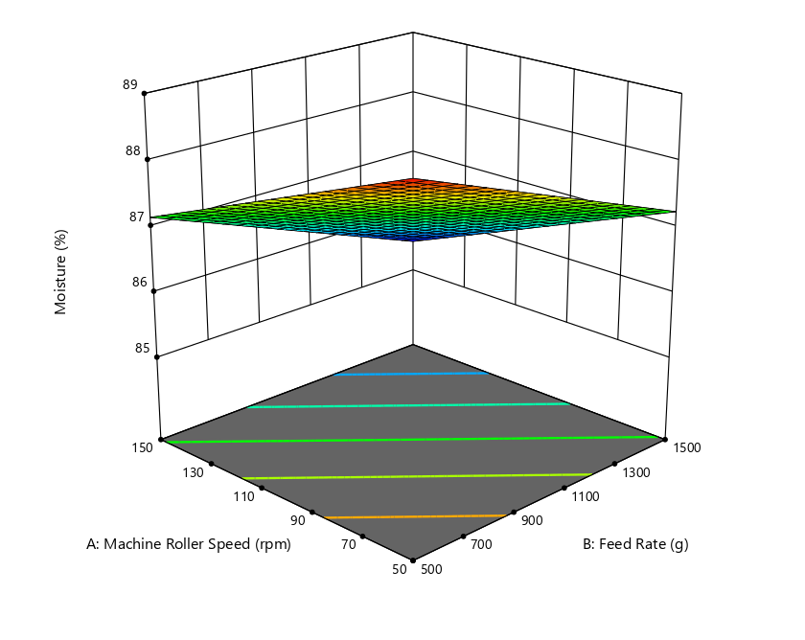
Figure 4.1: Effect of Machine Roller Speed and Feed Rate on the Moisture of Sugar Cane Juice
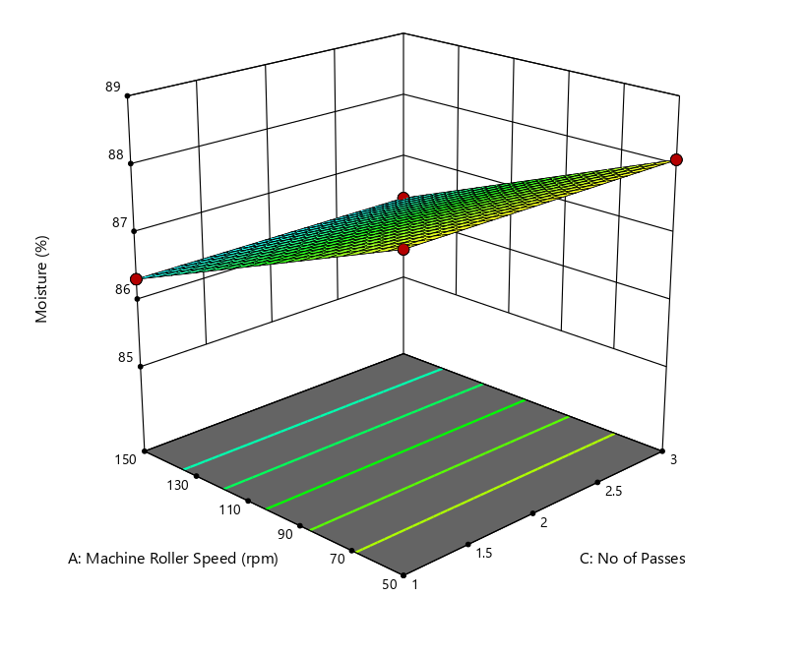
Figure 4.2: Effect of Machine Roller Speed and No of Passes on the Moisture of Sugar Cane Juice

ANOVA for Linear model
Table 4.3 Response 2: Calorific Value
Source | Sum of Squares | df | Mean Square | F-value | p-value
Model | 2624.97 | 3 | 874.99 | 1.833E+10 | < 0.0001 | significant
A-Machine Roller Speed | 1424.66 | 1 | 1424.66 | 2.984E+10 | < 0.0001
B-Feed Rate | 1200.31 | 1 | 1200.31 | 2.514E+10 | < 0.0001
C-No of Passes | 0.0002 | 1 | 0.0002 | 4886.72 | < 0.0001
Residual | 6.206E-07 | 13 | 4.774E-08
Lack of Fit | 6.206E-07 | 9 | 6.895E-08
Pure Error | 0.0000 | 4 | 0.0000
Cor Total | 2624.97 | 16
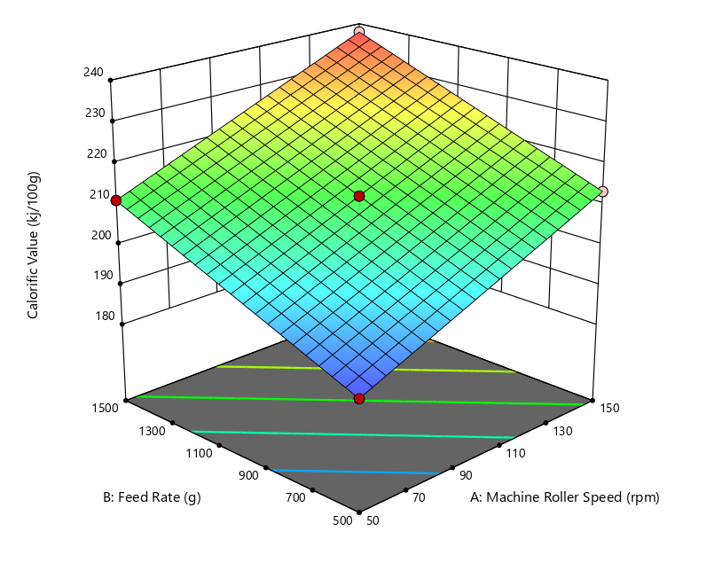
Figure 4.3: Effect of Machine Roller Speed and Feed rate on the Calorific value of Sugar Cane Juice

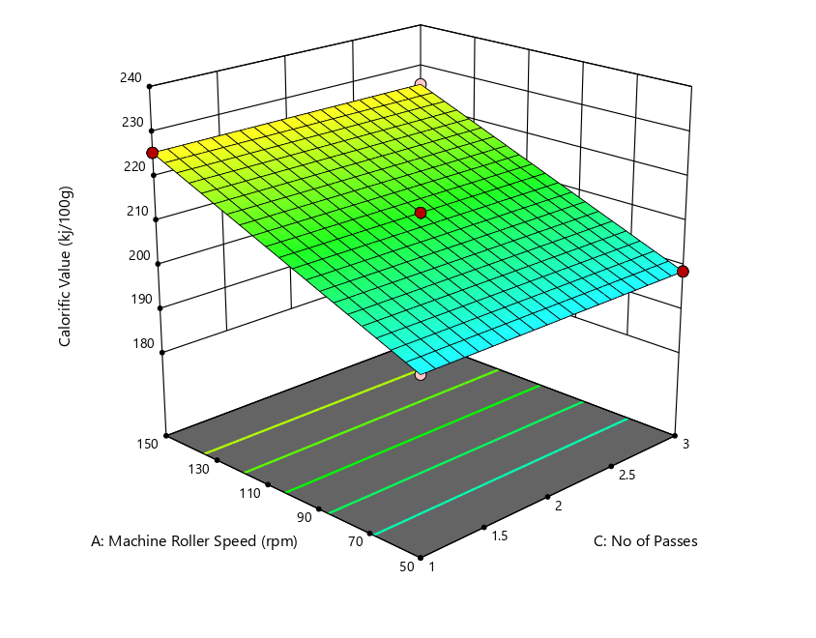
Figure 4.4.: Effect of Machine Roller Speed and No of passes on the Calorific value of Sugar Cane Juice

ANOVA for 2FI model
4.4 Response 3: Ash
Source | Sum of Squares | df | Mean Square | F-value | p-value
Model | 0.0044 | 6 | 0.0007 | 3.328E+06 | < 0.0001 | significant
A-Machine Roller Speed | 0.0025 | 1 | 0.0025 | 1.139E+07 | < 0.0001
B-Feed Rate | 0.0019 | 1 | 0.0019 | 8.573E+06 | < 0.0001
C-No of Passes | 5.000E-09 | 1 | 5.000E-09 | 22.67 | 0.0008
AB | 2.500E-09 | 1 | 2.500E-09 | 11.33 | 0.0072
AC | 2.500E-09 | 1 | 2.500E-09 | 11.33 | 0.0072
BC | 2.500E-09 | 1 | 2.500E-09 | 11.33 | 0.0072
Residual | 2.206E-09 | 10 | 2.206E-10
Lack of Fit | 2.206E-09 | 6 | 3.676E-10
Pure Error | 0.0000 | 4 | 0.0000
Cor Total | 0.0044 | 16
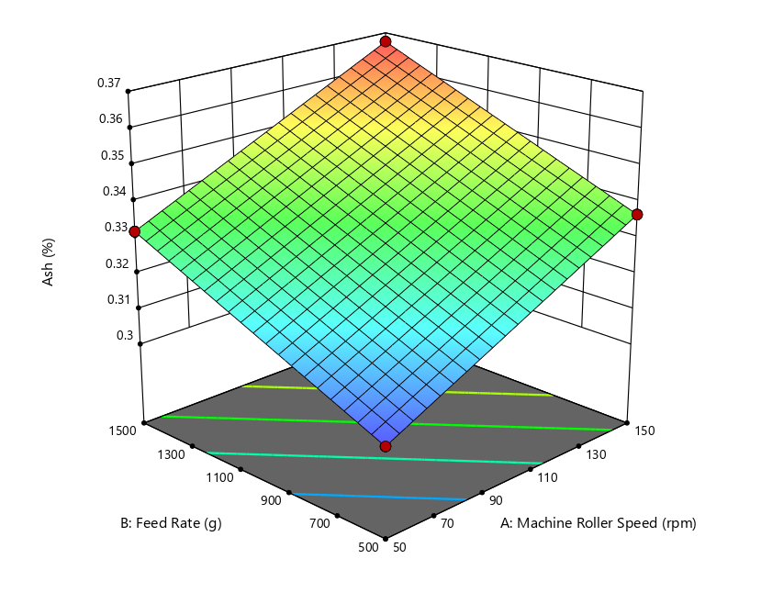
Figure 4.5: Effect of Machine Roller Speed and Feed rate on the Ash value of Sugar Cane Juice

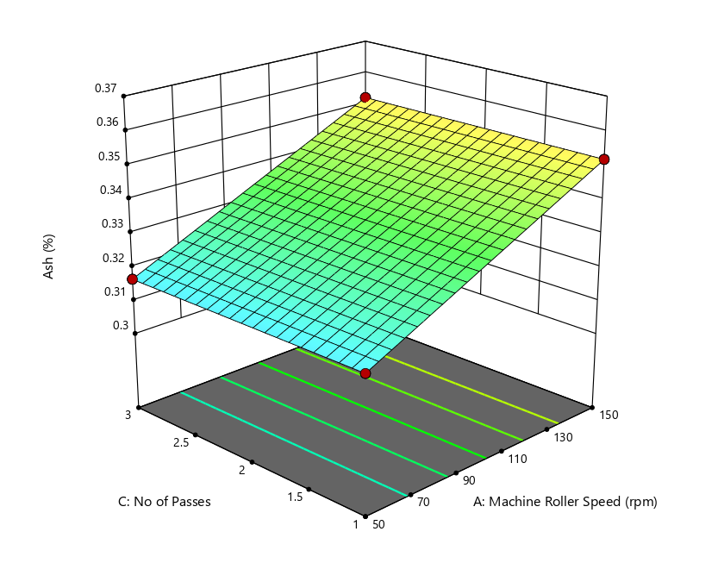
Figure 4.6: Effect of Machine Roller Speed and No of Passes on the Ash value of Sugar Cane Juice

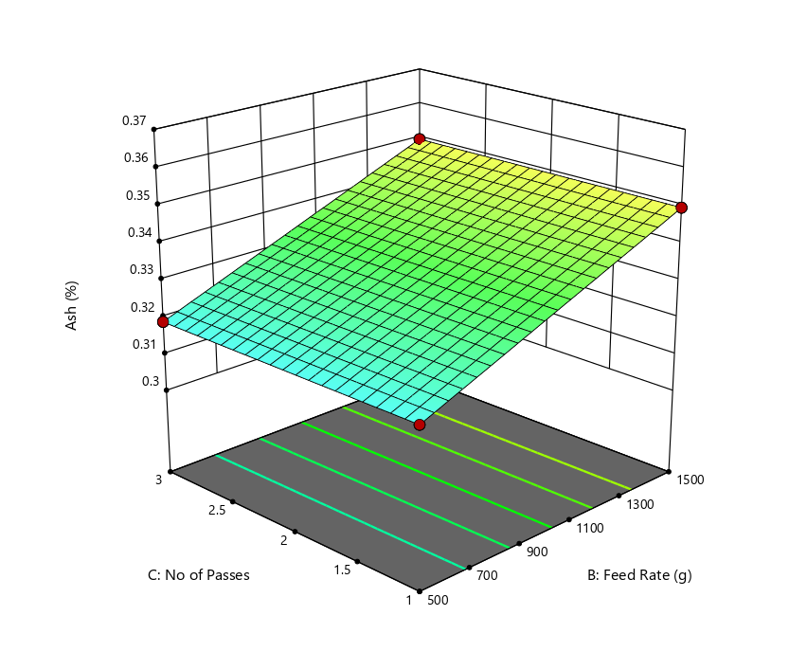
Figure 4.7: Effect of Feed rate and No of Passes on the Ash value of Sugar Cane Juice

ANOVA for Linear model
4.6 Response 4: Crude Protein
Source | Sum of Squares | df | Mean Square | F-value | p-value
Model | 0.0023 | 3 | 0.0008 | 9.557E+05 | < 0.0001 | significant
A-Machine Roller Speed | 0.0007 | 1 | 0.0007 | 8.587E+05 | < 0.0001
B-Feed Rate | 0.0016 | 1 | 0.0016 | 2.009E+06 | < 0.0001
C-No of Passes | 0.0000 | 1 | 0.0000 | 0.0000 | 1.0000
Residual | 1.059E-08 | 13 | 8.145E-10
Lack of Fit | 1.059E-08 | 9 | 1.176E-09
Pure Error | 0.0000 | 4 | 0.0000
Cor Total | 0.0023 | 16
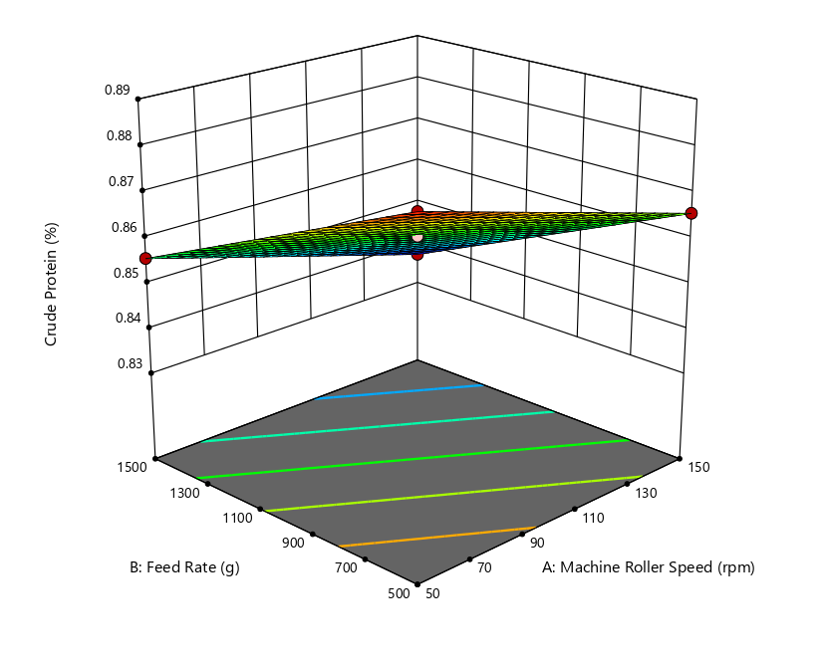
Figure 4.8: Effect of Machine Roller Speed and Feed Rate on the crude protein of Sugar Cane Juice

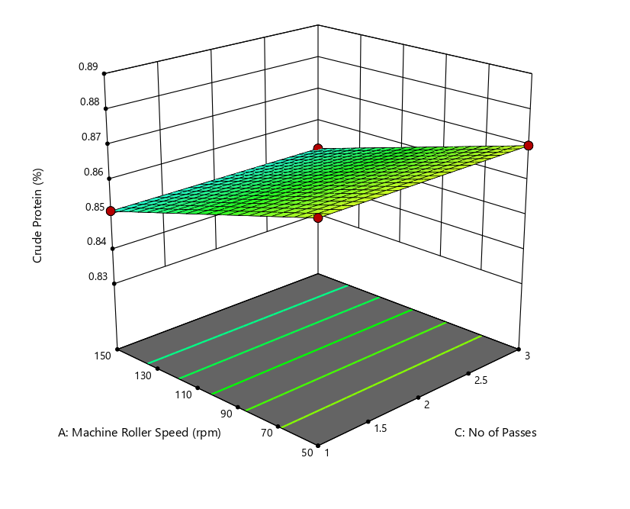
Figure 4.9: Effect of Machine Roller Speed and No of Passes on the crude protein of Sugar Cane Juice

ANOVA for Linear model
4.7 Response 5: Crude Fiber
Source | Sum of Squares | df | Mean Square | F-value | p-value
Model | 0.0007 | 3 | 0.0002 | 4.196E+05 | < 0.0001 | significant
A-Machine Roller Speed | 0.0004 | 1 | 0.0004 | 6.780E+05 | < 0.0001
B-Feed Rate | 0.0003 | 1 | 0.0003 | 5.807E+05 | < 0.0001
C-No of Passes | 0.0000 | 1 | 0.0000 | 0.0000 | 1.0000
Residual | 6.912E-09 | 13 | 5.317E-10
Lack of Fit | 6.912E-09 | 9 | 7.680E-10
Pure Error | 0.0000 | 4 | 0.0000
Cor Total | 0.0007 | 16
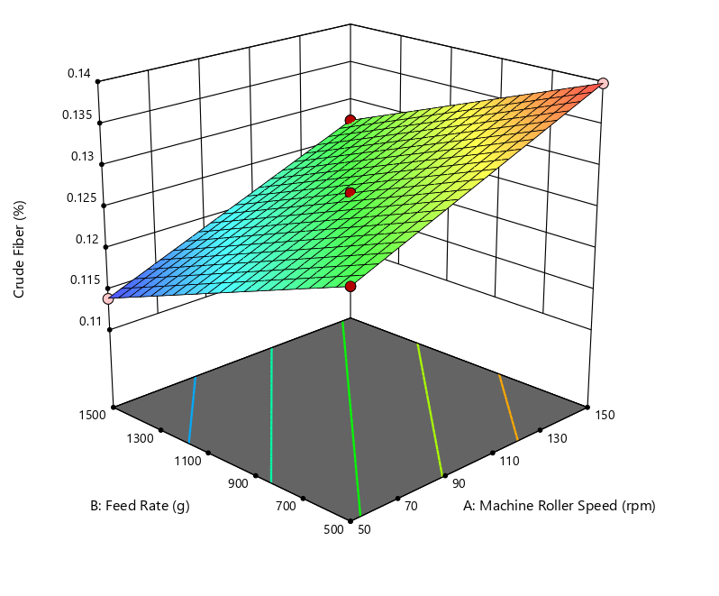
Figure 4.10: Effect of Machine Roller Speed and Feed Rate on the Crude Fiber of Sugar Cane Juice

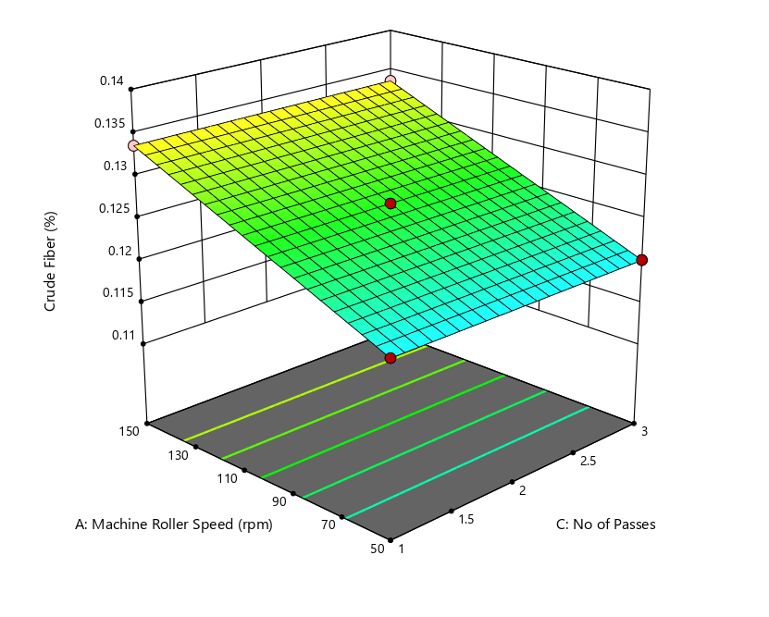
Figure 4.11: Effect of Machine Roller Speed and No of Passes on the Crude Fiber of Sugar Cane Juice

ANOVA for Linear model
4.8 Response 6: Crude Fat
Source | Sum of Squares | df | Mean Square | F-value | p-value
Model | 0.0588 | 3 | 0.0196 | 3.686E+07 | < 0.0001 | significant
A-Machine Roller Speed | 0.0154 | 1 | 0.0154 | 2.895E+07 | < 0.0001
B-Feed Rate | 0.0434 | 1 | 0.0434 | 8.162E+07 | < 0.0001
C-No of Passes | 1.125E-08 | 1 | 1.125E-08 | 21.16 | 0.0005
Residual | 6.912E-09 | 13 | 5.317E-10
Lack of Fit | 6.912E-09 | 9 | 7.680E-10
Pure Error | 0.0000 | 4 | 0.0000
Cor Total | 0.0588 | 16

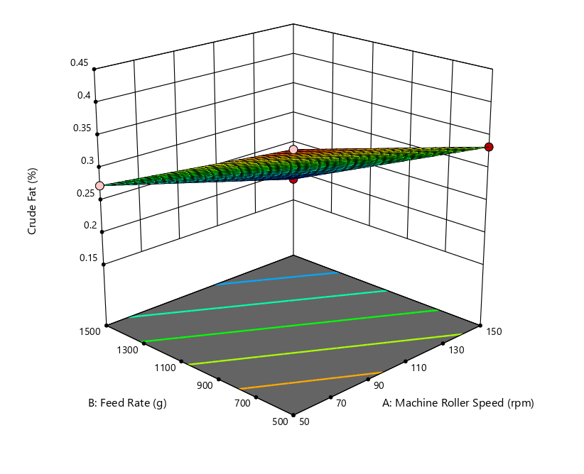
Figure 4.12: Effect of Machine Roller Speed and Feed Rate on the Crude Fat of Sugar Cane Juice

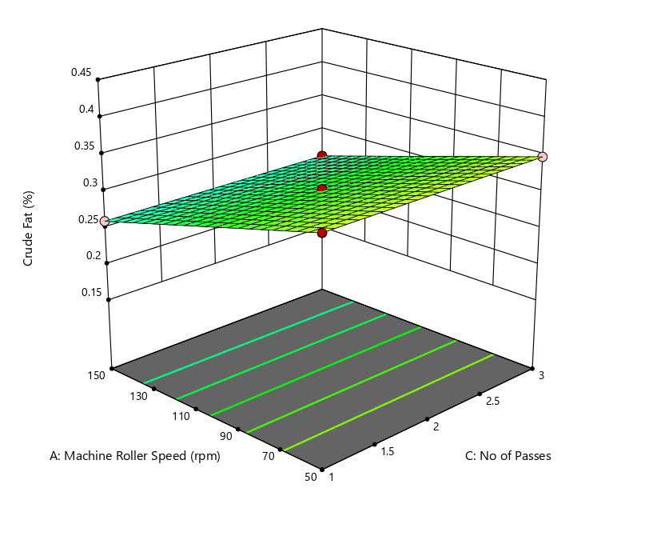
Figure 4.13: Effect of Machine Roller Speed and No of Passes on the Crude Fat of Sugar Cane Juice.

ANOVA for Quadratic model
4.9 Response 7: Carbohydrate
Source | Sum of Squares | df | Mean Square | F-value | p-value
Model | 13.27 | 9 | 1.47 | 4.129E+09 | < 0.0001 | significant
A-Machine Roller Speed | 6.59 | 1 | 6.59 | 1.845E+10 | < 0.0001
B-Feed Rate | 6.68 | 1 | 6.68 | 1.871E+10 | < 0.0001
C-No of Passes | 1.051E-06 | 1 | 1.051E-06 | 2943.50 | < 0.0001
AB | 0.0000 | 1 | 0.0000 | 0.0000 | 1.0000
AC | 2.500E-09 | 1 | 2.500E-09 | 7.00 | 0.0331
BC | 0.0000 | 1 | 0.0000 | 0.0000 | 1.0000
A² | 6.579E-10 | 1 | 6.579E-10 | 1.84 | 0.2168
B² | 5.921E-09 | 1 | 5.921E-09 | 16.58 | 0.0047
C² | 6.579E-10 | 1 | 6.579E-10 | 1.84 | 0.2168
Residual | 2.500E-09 | 7 | 3.571E-10
Lack of Fit | 2.500E-09 | 3 | 8.333E-10
Pure Error | 0.0000 | 4 | 0.0000
Cor Total | 13.27 | 16
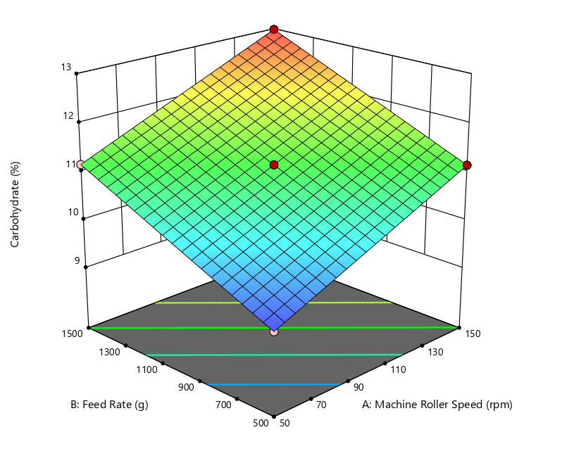
Figure 4.14: Effect of Machine Roller Speed and Feed Rate on the Carbohydrate of Sugar Cane Juice

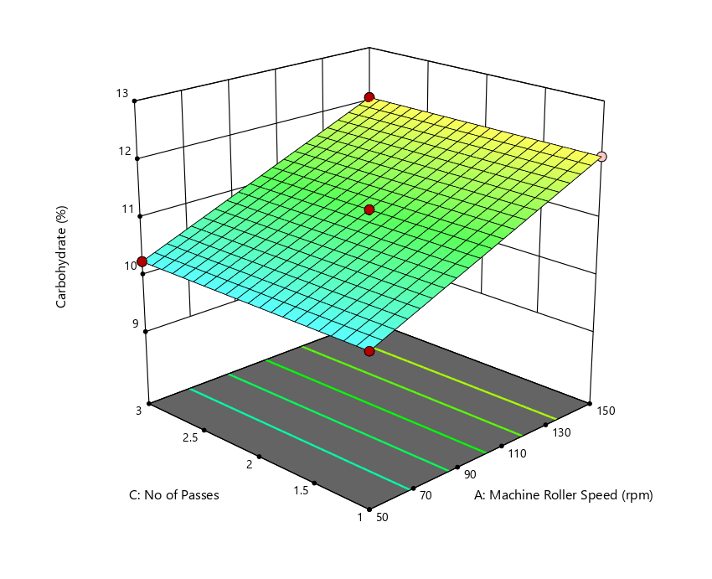
Figure 4.15: Effect of Machine Roller Speed and No of Passes on the Carbohydrate of Sugar Cane Juice

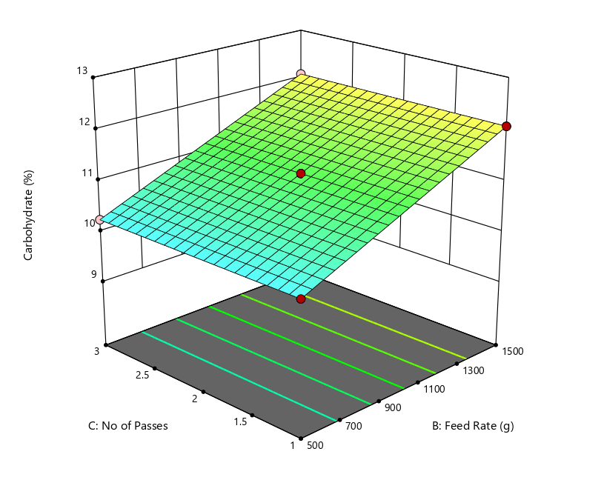
Figure 4.16: Effect of Feed Rate and No Passes on the Carbohydrate of Sugar Cane Juice
4.2 Discussion
Effect of Machine Roller Speed and Feed Rate on the Moisture of Sugar Cane Juice
Table 4.2 shows that both machine roller speed and feed rate have highly significant effects on the moisture content of sugarcane juice (p < 0.0001), while the number of passes, though statistically significant, has a much smaller effect size. The model is highly significant , the very low residual mean square and pure error suggest high precision in the experimental setup.
figure 4.1 also shows that roller speed significantly influences juice extraction efficiency and output. Optimal speeds (30 rpm) yield the highest extraction efficiency and output capacity, while excessively high speeds increase extraction losses and reduce efficiency(Oji et al., 2021). Lower feed rates (e.g., one cane stalk at a time) result in higher extraction efficiency and lower juice loss, while higher feed rates can increase losses and reduce extraction quality(Oji et al., 2021; Zhou et al., 2024). Adjusting feed rate is thus essential for optimizing both yield and nutritional quality. Optimizing roller speed and feed rate not only increases juice yield but also helps retain more nutrients by reducing extraction losses and preventing excessive mechanical damage to the cane(Oji et al., 2021; Zhou et al., 2024).

Effect of Machine Roller Speed and No of Passes on the Moisture of Sugar Cane Juice
The ANOVA table 4.2 and figure 4.2 shows that machine roller speed has a highly significant effect on the moisture content of sugarcane juice (F = 6.579E+09, p < 0.0001). Indicating that optimal roller speeds (30 rpm) maximize extraction efficiency and output, while higher speeds can increase extraction losses and reduce efficiency (Oji et al., 2021). The number of passes also shows a statistically significant effect on moisture content (F = 1043.76, p < 0.0001), though the effect size is much smaller than that of roller speed. Both machine roller speed and number of passes are important for maximizing the moisture content of sugarcane juice. The most effective strategy is to use slower roller speeds combined with multiple passes, which increases juice extraction and moisture yield without negatively affecting juice quality (Oji et al., 2021; Crépeau et al., 2015). This approach aligns with the goal of optimizing processing parameters for enhanced nutritional quality.
Effect of Machine Roller Speed and Feed Rate on Calorific Value
Table 4.3 shows that machine roller speed significantly impacts juice extraction efficiency and output capacity. Optimal speeds ( 30 rpm) yield the highest extraction efficiency and output, while excessively high speeds can increase extraction losses, potentially affecting the calorific value by reducing juice yield and possibly altering its composition(Oji et al., 2021). Lower feed rates are associated with higher extraction efficiency and output capacity. Higher feed rates can reduce efficiency, likely due to incomplete crushing, which may lower the calorific value of the extracted juice as shown in figure 4.3 (Oji et al., 2021).

Effect of Machine Roller Speed and Number of Passes
Number of Passes has direct data on calorific value is limited, more passes generally increase juice extraction, which could enhance calorific value by maximizing sugar and nutrient recovery. However, the effect is less pronounced than roller speed or feed rate (Oji et al., 2021). The ANOVA table 4.3 indicates both roller speed and number of passes are statistically significant, but roller speed has a much larger effect size compared to the number of passes.

Effect of Machine Roller Speed and Feed Rate on Ash Value
Both machine roller speed and feed rate have highly significant effects on the ash value of sugarcane juice, as shown in table 4.2 and figure 4.5 by their large F-values and very low p-values (<0.0001). This means changes in either parameter can substantially alter the mineral content in the juice.
The interaction between roller speed and feed rate (AB) is also significant (p = 0.0072), indicating that the combined effect of these two factors on ash value is not simply additive.
Effect of Machine Roller Speed and Number of Passes
Figure 4.6 shows the number of passes has a statistically significant but much smaller effect on ash value (F = 22.67, p = 0.0008) compared to roller speed and feed rate and the Interactions between roller speed and number of passes (AC), and between feed rate and number of passes (BC), are also significant (p = 0.0072 each), as shown in table 4.5 though their effect sizes are small. This suggests that optimizing both roller speed and number of passes together can fine-tune ash content, but the impact is less pronounced than the main effects.
Effect of Machine Roller Speed and Feed Rate on Crude Protein
Both machine roller speed and feed rate have a highly significant impact on crude protein content, as indicated by very high F-values (8.587E+05 for roller speed, 2.009E+06 for feed rate) and extremely low p-values (<0.0001) as shown in table 4.2 and figure 4.8. This means that adjusting either parameter can substantially change the amount of crude protein extracted into the juice.
The feed rate has a larger effect size than roller speed, suggesting that how quickly cane is fed into the machine is even more critical for crude protein extraction than the speed of the rollers.
Effect of Machine Roller Speed and Number of Passes
Tables 4.6 shows the number of passes has no significant effect on crude protein content (F = 0, p = 1.0000). This means increasing or decreasing the number of times cane passes through the rollers does not alter the crude protein level in the juice. Since the number of passes is not significant, its interaction with roller speed is also not expected to meaningfully affect crude protein content.
Effect of Machine Roller Speed and Feed Rate on Crude Fiber
Both machine roller speed and feed rate have a highly significant impact on crude fiber content, as shown by very high F-values (6.78E+05 for roller speed, 5.81E+05 for feed rate) and extremely low p-values (<0.0001). This means that adjusting either parameter can substantially change the amount of crude fiber in the juice. Table 4.7 and figure 4.10
Research shows that optimal roller speeds ( 30 rpm) and lower feed rates (one cane stalk at a time) maximize extraction efficiency and output, which likely helps control crude fiber content by reducing excessive fiber breakage and inclusion in the juice (Oji et al., 2021).

Effect of Machine Roller Speed and Feed Rate on Crude Fat
Machine Roller Speed (A), has a very strong effect on crude fat (F = 2.895E+07, p < 0.0001).
It contributes a large portion to the variation in crude fat (Sum of Squares = 0.0154).
Feed Rate (B), stronger effect than roller speed (F = 8.162E+07, p < 0.0001) as shown in table 4.8 and figure 4.12 . Both Machine Roller Speed and Feed Rate significantly affect crude fat content, with Feed Rate being more influential in the process.
Effect of Machine Roller Speed and Number of Passes on Crude Fat
Table 4.8 shows the number of Passes (C) is statistically significant (F = 21.16, p = 0.0005), but the effect is much smaller compared to A and B. This is seen in the very small Sum of Squares (1.125E-08), suggesting a minor but significant impact. Machine Roller Speed (A), shows a very significant effect, supporting that it plays a consistent role in influencing crude fat regardless of the second variable considered (Feed Rate or Number of Passes).
Therefore, Machine Roller Speed and Number of Passes both affect crude fat, but the effect of Number of Passes is minimal compared to Machine Roller Speed. as shown in figure 4.13.

Effect of Machine Roller Speed and Feed Rate on Carbohydrate
Table 4.9 shows that Machine Roller Speed (A) is highly significant (F = 1.845E+10, p < 0.0001) and Contributes 49.7% of the total variation in carbohydrate (6.59 out of 13.27). Feed Rate (B) is also highly significant (F = 1.871E+10, p < 0.0001) has 50.3% of the variation (6.68 out of 13.27). Machine Roller Speed and Feed Rate act independently their combined influence doesn’t have an added or interactive effect. As indicated in figure 4.14.

Effect of Machine Roller Speed and Number of Passes on Carbohydrate
Machine Roller Speed (A) is Strong and significant . The Number of Passes (C) is also Statistically significant (F = 2943.5, p < 0.0001) but with negligible practical effect (SS = 1.051E-06 compared to 6.59 and 6.68). This means Number of Passes has a tiny but statistically clear influence on carbohydrates. Their combination (interaction) also plays a minor but significant role in shaping carbohydrate content. As shown in table 4.9 and figure 4.15.

Effect of Feed Rate and Number of Passes on Carbohydrate
Table 4.9 and figure 4.15 shows Feed Rate (B) has very strong effect. And Number of Passes (C) with a Tiny effect as shown in table 4.9
B and C are Not significant at F = 0.000, p = 1.0000 . Means the effect of Feed Rate on carbohydrate does not depend on the Number of Passes.

Feed Rate and Machine Roller Speed are the primary drivers of carbohydrate content in sugarcane juice.
The Number of Passes has a statistically significant but very small impact.
The interaction between Roller Speed and Number of Passes is meaningful, suggesting operational adjustments can fine-tune carbohydrate levels.
The model is extremely robust (very small residual error, perfect significance), so results are reliable.

CHAPTER FIVE
CONCLUSIONS AND RECOMMENDATIONS
Conclusion

This study investigated the effect of varying extraction conditions machine roller speed, feed rate, and number of passes on the proximate composition of sugarcane juice. The findings demonstrate that extraction parameters significantly influence nutritional and physical properties of the juice, validating the importance of process optimization in juice production. The following Conclusions were made:

1. Machine Roller Speed had a strong and consistent effect on nearly all proximate parameters (moisture, ash, crude fat, carbohydrate, crude fiber, and crude protein) and Optimal speed (30 rpm) significantly improved juice yield, extraction efficiency, and nutrient retention.

2. Feed Rate Was the most influential factor for many nutrients, especially crude fat, crude protein, and crude fiber. Lower feed rates (feeding one cane stalk at a time) resulted in higher extraction efficiency and better nutrient retention.

3. Number of Passes had a statistically significant but smaller effect on most components. Its influence was more relevant when combined with roller speed, especially for moisture and ash content, but not significant for crude protein.

4. Roller speed × feed rate, and roller speed × number of passes showed statistical significance, particularly for ash and carbohydrate content, indicating that combined tuning of parameters may fine-tune juice quality.

5. The overall model accuracy was high, as indicated by low residuals and pure error values, which confirms reliable experimental design and precision.
Recommendation

Based on the findings, the following recommendations are proposed to optimize sugarcane juice extraction for enhanced nutritional quality.

1. Adopt Moderate Roller Speeds 30 rpm it offers a balance between yield and nutrient retention, minimizing mechanical damage and extraction losses.

2. Feeding one cane stalk at a time improves juice quality, especially increasing protein and fat content while minimizing fiber residue and loss of moisture.

3. While more passes can slightly increase moisture and ash content, they do not significantly affect protein content and may increase operational time. Thus, limit to *2–3 passes for best efficiency without compromising quality.

4. Parameter Optimization Should Be Goal-Driven
5. Combined effects of parameters influence qualities of ash and carbohydrates, future designs or machines should allow fine control over multiple variables simultaneously.

6. These findings can inform the design of automated sugarcane pressing machines with adjustable rollers and controlled feed mechanisms for nutrient-optimized juice processing.

REFERENCES
Akhtar, M., & Ahmad, A. (1999). Herbicides in sugarcane agriculture. Journal of Agronomy, 88(5), 439–446.
Bharati, M. P., Khatri, N. B., & Sharma, S. R. (2018). Weed management practices in sugarcane cultivation in Nawalparasi district. Nepal Journal of Agricultural Research, 5(3), 112–120.
Chauhan, B. S., & Abugho, S. B. (2013). Integrated weed management in sugarcane: Enhancing productivity and profitability. Crop Protection, 52, 58–63.
Chauhan, B. S., Singh, R. G., & Mahajan, G. (2014). Ecology and management of weeds under conservation agriculture: A review. Crop Protection, 65, 105–118.
Eppe, M. (2018). Economic impact of weed management in Australian sugarcane. Agricultural Economics Review, 24(2), 201–210.
Heap, I. (2020). Herbicide resistance: The state of the art. Pest Management Science, 76(1), 16–27.
Jat, R. S., et al. (2021). Advances in weed management for sustainable sugarcane production. Sugar Tech, 23(1), 23–34.
Kumar, V., Yadav, A., Singh, S. S., & Chauhan, B. S. (2017). Weed management strategies to reduce herbicide use in zero till rice–wheat cropping systems of the Indo Gangetic Plains. Weed Technology, 31(3), 503–513.
Kumar, V., et al. (2020). Benefits of intercropping and its role in sustainable agriculture. Agricultural Reviews, 41(2), 120–127.
Mahajan, G., et al. (2020). Weed dynamics and management in sugarcane. Indian Journal of Weed Science, 52(3), 240–247.
MoAD (Ministry of Agriculture and Development). (2020). Statistical information on Nepalese agriculture 2019/20. Kathmandu, Nepal.
NSRP (National Sugar Research Program). (2015). Annual report on sugarcane weed management trials. NSRP Publications.
Pandey, S., & Devkota, D. (2020). The effect of weeding frequency on sugarcane yield in Nepal. Journal of Crop Science and Technology, 34(1), 78–85.
Patel, R. B., et al. (2019). Post emergent herbicide use in sugarcane: Pros and cons. Sugarcane Research, 37(1), 33–40.
Rana, S. S., & Rana, R. S. (2016). Impact of weed infestation on sugarcane yield. International Journal of Agricultural Science, 10(4), 289–295.
Singh, M., & Kumar, A. (2013). Weed management in sugarcane: Challenges and solutions. Journal of Weed Science, 61(2), 145–150.
Singh, R. P., et al. (2016). Influence of mulching on crop performance and weed dynamics. Indian Journal of Agronomy, 61(1), 45–50.
Singh, S., et al. (2018). Evaluation of weed control methods in sugarcane. Journal of Agricultural Research, 56(4), 298–306.
Singh, S. P., & Tamor, M. (2005). Weed competition in sugarcane: A critical review. Indian Journal of Weed Science, 37(1), 1–8.
Srivastava, S. K., Singh, R. K., & Shukla, A. K. (2002). Weed management in sugarcane: Current trends and future prospects. Sugarcane Research, 21(4), 304–312.
Suwanarak, P. (1990). Weed management in Thailand's sugarcane fields. Tropical Agriculture Journal, 67(3), 212–219.
Thapa, R. B., Shrestha, B. K., & Ghimire, K. H. (2016). Integrated Weed Management in Sugarcane in Nepal. Journal of Nepal Agricultural Research Council, 2, 45–54.

