DETERMINATION OF VITAMIN C CONTENT IN LEMON JUICE USING IODOMETRIC TITRATION
AND
DETERMINATION OF VITAMIN C CONTENT IN LIME JUICE USING UV-VISIBLE SPECTROSCOPIC METHOD

BY

MUSTAPHA OLUBUNMI ZAINAB
ND/23/SLT/PT/0778

BEING A RESEARCH PROJECT SUBMITTED TO THE
DEPARTMENT OF SCIENCE LABORATORY TECHNOLOGY,
(CHEMISTRY UNIT) INSTITUTE OF APPLIED SCIENCES (IAS),
KWARA STATE POLYTECHNIC ILORIN,
KWARA STATE

IN PARTIAL FULFILLMENT OF THE REQUIREMENT FOR THE AWARD OF NATIONAL DIPLOMA (ND) IN
SCIENCE LABORATORY TECHNOLOGY
(CHEMISTRY UNIT)

JUNE, 2025
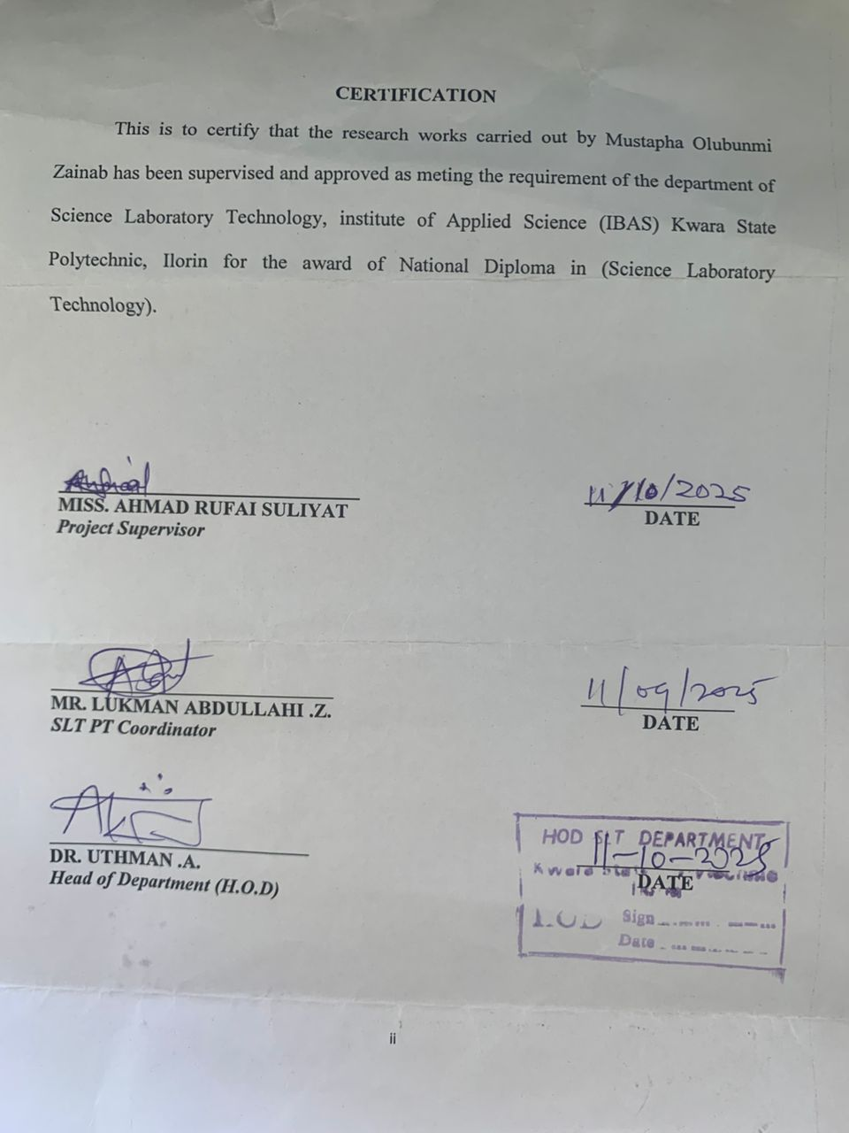
TABLE OF CONTENTS
Tittle page
Certification
Dedication
Acknowledgement
Table of contents
CHAPTER ONE
1.0 Introduction and literature review
1.1 Vitamin c
1.2 Chemical structure and properties
1.3 Natural Sources of vitamin c
1.4 Uses of Vitamin c
    - Immune System Support
    - Antioxidant Protection
    - Enhances Iron Absorption
    - Cardiovascular Health
    - Skin Health
    - Brain Health
CHAPTER TWO
2.1 Methods to Determine Vitamin C
2.2 Direct titration
2.2.2 High-Performance Liquid Chromatography
2.2.3 Enzymatic Methods
CHAPTER THREE
3.0 Methodology
3.1 Method using Iodometric Titration
3.2 Materials and Reagents
3.3 Preparation of Iodine Solutions
3.4 Preparation of Vitamin C Standard Solution
3.5 Standardisation of Iodine Solution with Vitamin C Standard Solution
3.6 Titration of Juice Samples
CHAPTER FOUR
4.0 UV-VISIBLE Spectrophotometry (Lime Juice)
4.1 Reagents and Chemicals
4.2 Materials
4.3 Procedure
CHAPTER FIVE
Result and Discussion
Conclusion
References

CHAPTER ONE
1.0 INTRODUCTION AND LITERATURE REVIEW
Vitamin C, or ascorbic acid, is an essential water-soluble vitamin and a potent antioxidant required for various biological functions, including collagen synthesis, immune system support, and iron absorption. Citrus fruits such as lemon (Citrus limon) and lime (Citrus aurantiifolia) are among the richest natural sources of vitamin C, making them important dietary components for preventing scurvy and maintaining overall health.Mehboobali, et al.,(2022).
Accurate quantification of vitamin C in fruit juices is crucial not only for nutritional labeling but also for quality control in the food industry. Several analytical techniques exist for determining vitamin C concentration, each with varying degrees of sensitivity, specificity, and complexity. Among these, iodometric titration and UV-Visible spectrophotometry are two widely used methods due to their relative accessibility and effectiveness.
This study aims to determine the vitamin C content in lemon juice using iodometric titration and in lime juice using UV-Visible spectroscopy. The objective is to compare these methods based on their principles, precision, and applicability to routine analysis.
Vitamin C has been extensively studied due to its health benefits and prevalence in natural food sources. Its chemical instability, particularly in the presence of light, heat, and oxygen, necessitates rapid and reliable analytical methods. Studies emphasize that the chosen method must differentiate ascorbic acid from other reducing substances and degradation products (Arya et al., 2020).
Vitamin C, also known as ascorbic acid, is a vital water-soluble vitamin necessary for various physiological functions in the human body. It serves as an antioxidant, aids in collagen synthesis, enhances iron absorption, and supports the immune system. Humans cannot synthesize vitamin C endogenously, making dietary intake essential. Citrus fruits, particularly lemons, are rich sources of this vital nutrient.
Given its nutritional significance, quantifyingvitamin C in natural sources like lemon juiceis important for both dietary and quality control purposes in food science and nutrition. One of the most widely used methods for determining vitamin C content is iodometric titration, a redox titration technique that involves the oxidation of ascorbic acid by iodine Jain, P. (2020).
Vitamin C, also known as ascorbic acid, is a vital water-soluble vitamin that plays a crucial role in maintaining overall health. It is an essential nutrient, meaning the human body cannot produce it on its own and must obtain it from dietary sources such as citrus fruits, berries, tomatoes, potatoes, and green leafy vegetables.
One of the primary functions of vitamin C is its role as a powerful antioxidant, helping to protect cells from damage caused by free radicals. It is also critical for the synthesis of collagen, a protein necessary for the health of skin, blood vessels, bones, and connective tissue. Additionally, vitamin C enhances the absorption of non-heme iron (the type of iron found in plant-based foods), supports the immune system, and aids in wound healing.Mahajan H. (2020).
A deficiency in vitamin C can lead to scurvy, a disease characterized by fatigue, swollen gums, joint pain, and anemia. On the other hand, an adequate intake of vitamin C contributes to the prevention of chronic diseases, supports immune defense, and promotes overall wellness.
Due to its wide range of health benefits and essential roles in the body, vitamin C is a fundamental component of a healthy diet and is often included in multivitamin supplements.
Vitamin C, also known as ascorbic acid, is an essential water-soluble vitamin widely found in fruits and vegetables, particularly citrus fruits such as lemons. It plays a crucial role in various physiological functions including collagen synthesis, wound healing, immune system support, and acting as a potent antioxidant. Because the human body cannot synthesize vitamin C, it must be obtained through diet, making it important to quantify its presence in food sources such as lemon juice. Smith, J.L (2021)
One of the most reliable and widely used methods for the quantitative determination of vitamin C is iodometric titration, a redox-based analytical technique. This method relies on the reducing properties of ascorbic acid, which reduces iodine (I₂) to iodide (I⁻), while itself being oxidized to dehydroascorbic acid. The reaction proceeds in an acidic medium, and the endpoint of the titration is typically detected using a starch indicator, which forms a deep blue complex with iodine. The disappearance of the blue color indicates the completion of the reaction. Murray, R.K. (2018).
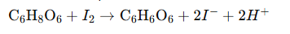
The chemical equation for the redox reaction is:

In this procedure, a known volume of lemon juice is titrated against a standard iodine solution. The amount of iodine required to completely react with the ascorbic acid present in the juice is used to calculate the concentration of vitamin C.
This experiment serves not only to determine the nutritional content of lemon juice but also introduces fundamental analytical chemistry techniques such as titration, standardization, and the use of indicators. Furthermore, understanding the vitamin C content of foods can have practical applications in nutrition, food science, and quality control in the food industry.
Iodometric Titration
Iodometric titration is one of the earliest and most commonly used methods for vitamin C determination, especially in citrus fruits. This redox-based method relies on the reducing power of ascorbic acid, which reduces iodine (I₂) to iodide (I⁻), while itself being oxidized to dehydroascorbic acid. The endpoint is indicated by the appearance of a blue color with starch when excess iodine is present.
Ranganna (2021) described iodometric titration as a classical method suitable for fresh fruit juices, with reasonable accuracy.
Nisha et al. (2022) reported successful application of iodometric titration in determining vitamin C in various fruit juices, emphasizing its simplicity and cost-effectiveness.
However, Jiang et al. (2020) noted interference by other reducing agents such as polyphenols and sulfites, which can affect the precision of the results unless controlled for.
Despite this, iodometric titration remains widely used in academic and industrial labs due to its minimal equipment requirements.
1.1 VITAMIN C
Vitamin C, also known as ascorbic acid, is a water-soluble vitamin that plays many vital roles in the body. Here’s elaborate on the roles of vitamin C.

1.2 CHEMICAL STRUCTURE AND PROPERTIES
Chemical Identity
- Common Name:Vitamin C
- IUPAC Name:(5R)-[(1S)-1,2-dihydroxyethyl]-3,4-dihydroxyfuran-2(5H)-one
- Molecular Formula:C₆H₈O₆
- Molar Mass:176.12 g/mol
- Synonyms:Ascorbic acid, L-ascorbic acid
Chemical Structure
Vitamin C is an organic compound derived from glucose. Its structure includes:
- Afive-membered lactone ring (furanone ring)
- Two enediol groups (-C(OH)=C(OH)-) on the lactone ring
- Ahydroxylated ethyl side chain Onwuka, A. (2021).
Structure
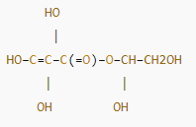

Or in a simplified representation, it can be seen as a lactone ring with multiple hydroxyl groups.
In 3D, Vitamin C is a chiral molecule with four stereocenters. The biologically active form is L-ascorbic acid (the "L" form).
Chemical Properties
Property | Value
Appearance | White to slightly yellow crystalline solid
Taste | Sour, acidic
Solubility in Water | Highly soluble (330 g/L at 20°C)
Melting Point | 190–192 °C (with decomposition)
pH of Aqueous Solution | ~2.2 (1% solution)
Optical Rotation | [α]D +20.5° (in water, c = 1)

1.3 NATURAL SOURCES OF VITAMIN C
Vitamin C (ascorbic acid) is a water-soluble antioxidant commonly found in various fruits and vegetables. Natural sources include:
- Citrus fruits (lemons, limes, oranges, grapefruits)
- Berries (strawberries, blackcurrants)
- Tropical fruits (guava, kiwi, papaya, mango)
- Vegetables (broccoli, bell peppers, spinach, kale, Brussels sprouts)
- Tomatoes and tomato juice

1.4 USES OF VITAMIN C
Vitamin C (ascorbic acid) is a vital nutrient with a wide range of uses in the body. Here are the primary uses and benefits of vitamin C:
    - Immune System Support
Vitamin C is a vital nutrient that plays a significant role in supporting the immune system. It enhances various immune cell functions, promotes the body's natural defenses against pathogens, and helps in wound healing. While it's often associated with preventing colds, it has a broader impact on overall immune function. Maggini, S. (2017)
Vitamin C (ascorbic acid) plays a critical role in supporting the immune system. It is a water-soluble vitamin and a powerful antioxidant, involved in various aspects of the immune response.
    - Antioxidant Protection
Vitamin C acts as an antioxidant, protecting cells from damage caused by free radicals and oxidative stress. This protection is crucial for maintaining the integrity of the epithelial barrier, the body's first line of defense against pathogens. Hornig, D. H. (2020)
Vitamin C is a potent antioxidant that helps protect immune cells from oxidative stress caused by free radicals.During infections, immune cells generate reactive oxygen species (ROS) to kill pathogens, but excess ROS can damage immune cells. Vitamin C neutralizes ROS, maintaining immune cell integrity and function.
    - Enhances Iron Absorption
Vitamin C is the only dietary constituent other than animal tissue that has been shown to promote iron absorption. Iron absorption occurs predominantly in the duodenum and upper jejunum, where ferrous iron can be transported into small intestine mucosal epithelial cells Carr, A. C. et al., (2017)
Improves the absorption of non-heme iron (iron from plant-based sources), which can help prevent anemia.
    - Cardiovascular Health
Several vitamins play a role in maintaining cardiovascular health. Vitamins C, D, E, and B vitamins, particularly folate, B6, and B12, have been shown to have positive impacts on heart health. While some vitamins, like A, can be beneficial at certain levels, high doses of fat-soluble vitamins (A, D, E, K) may have potential negative effects. Hemilä, H. (2017).
Acts as an antioxidant, potentially reducing oxidative stress and inflammation, which are linked to cardiovascular disease. It also plays a role in collagensynthesis and iron absorption, both important for blood vessel health. Chalker, E. (2022).

    - Skin Health
Vitamin C is beneficial for skin health due to its antioxidant and collagen-boosting properties. It helps protect against sun damage, reduces the appearance of wrinkles, evens skin tone, and can aid in wound healing. It's found naturally in fruits and vegetables, and also in skincare products like serums, lotions, and creams. Chalker, E. et al., (2022).
    - Brain Health
Vitamin C plays a vital role in maintaining brain health through its antioxidant properties and involvement in various neurological processes. It acts as a powerful antioxidant in the brain, protecting neurons from oxidative stress and damage. Additionally, vitamin C is crucial for the synthesis and release of neurotransmitters like dopamine and serotonin, which are essential for mood, cognition, and overall brain function. Levine, M. (2016)
Vitamin C is not just an antioxidant; it's a vital player in maintaining and potentially improving brain health through its diverse roles in neurotransmitter regulation, neuroprotection, and cognitive function.

CHAPTER TWO
2.1 METHOD TO DETERMINE VITAMIN C
Vitamin C (ascorbic acid) can be quantified using various analytical techniques based on its chemical properties. The most commonly used methods include titrimetric, chromatographic, and enzymatic assays. These methods vary in sensitivity, specificity, and applicability, depending on the sample matrix and the required accuracy. Arya S.P. et al., (2020)
Vitamin C (Ascorbic acid) is a vital nutrient known for its antioxidant properties. Accurate determination of its content various food matrices, such as fruit juices, is essential for nutritional labeling and quality control. Several analytical methods are available each with specific advantages depending on sensitivity, specificity, cost and time efficiency. Common method include iodmetric titration, UV- Visible Spectroscopy, High – Performance liquid Chromatography (HPLC), and enzymatic techniques. Jain P. et al., (2020)
Vitamin C (ascorbic acid) is an important micronutrient that needs to be accurately quantified in food products and biological samples for both nutritional and analytical purposes. Several analytical methods have been developed to determine vitamin C content, each with its own advantages, limitations, and suitability depending on the sample type, required sensitivity, and equipment availability.
The determination of vitamin C can be broadly categorized into three main types:
- Titrimetric methods (e.g., redox titration using iodine),
- Chromatographic methods (e.g., High-Performance Liquid Chromatography, HPLC),
- Enzymatic methods (e.g., using ascorbate oxidase or other specific enzymes).
Each method differs in sensitivity, specificity, complexity, and cost. The choice of method often depends on the sample matrix, the required detection limit, and available laboratory resources.
2.2 DIRECT TITRATION
Direct titration is one of the simplest and most widely used techniques for estimating vitamin C, particularly in fruit juices and pharmaceuticals. The most common approach is iodometric titration, where ascorbic acid reduces iodine to iodide while being oxidized to dehydroascorbic acid. This reaction occurs in an acidic medium and is visually monitored using starch as an indicator.Desai, S. et al., (2019).
Direct titration is a traditional method for determining vitamin C content. It typically involves titrating a solution containing vitamin C with a standardized iodine solution or a dye such as 2,6-dichlorophenolindophenol (DCPIP). The endpoint is detected by a color change, indicating the complete oxidation of ascorbic acid. Usman, Y. (2024).
Reaction:
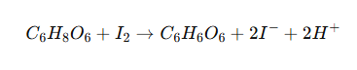

Advantages:
- Simple and cost-effective.
- Does not require advanced equipment.
- Suitable for routine analysis.
Limitations:
- Less specific; other reducing agents can interfere.
- Not suitable for complex biological matrices.

2.2.2 HIGH-PERFORMANCE LIQUID CHROMATOGRAPHY (HPLC)
HPLC is a highly accurate and sensitive method for the quantification of vitamin C. It separates ascorbic acid from other compounds in a sample using a high-pressure liquid chromatographic system with a UV or diode array detector. Ismail, R. (2023).
Principle:
Vitamin C is separated on a reverse-phase column and typically detected at 245–265 nm due to its strong UV absorbance.
Advantages:
- High specificity and sensitivity.
- Can distinguish between ascorbic acid and its oxidized form (dehydroascorbic acid).
- Suitable for complex matrices (e.g., serum, plasma, food).
Limitations:
- Requires expensive equipment and skilled personnel.
- Time-consuming sample preparation may be required.

2.2.3 ENZYMATIC METHODS
Enzymatic methods for the determination of vitamin C (ascorbic acid) are analytical techniques that utilize enzymes to selectively react with vitamin C, enabling its quantification in various samples such as foods, biological fluids, and pharmaceuticals. These methods are favored for their specificity, mild reaction conditions, and minimal interference from other substances. Yap, Y. J. et al., (2019).
Enzymatic assays use ascorbate oxidase, an enzyme that specifically catalyzes the oxidation of ascorbic acid to dehydroascorbic acid. The decrease in absorbance or the change in color (depending on the detection system) is measured spectrophotometrically to quantify vitamin C.Naidu, K. A. (2020).
Reaction:

Advantages:
- High specificity for ascorbic acid.
- Suitable for use in clinical and food testing labs.
- Can be adapted to microplate readers for high-throughput analysis.
Limitations:
- Enzymes are sensitive to storage conditions and expensive.
- May require calibration and validation for each matrix.

CHAPTER THREE
3.0 METHODOLOGY
Methodology for determining vitamin C content typically involved titrimetric method most commonly the 2.6 dichlorindophenol (DCPIP). Titrimetric method and high performance liquid chromatography (HPLC) with titration being a simple cost effective option for routine analyses and HPLC offering high specificity and sensitivity.
TITRIMETRIC METHODS
Principle:
These method utilize and reducing property of vitamin C (ascorbic acid) in reduce reactions DCPIP TITRATION.
This is a wildly used method, particularly for food product like juice where vitamin C acts as a reducing agent for the blue dye 2.6 dichloroindeophenol. The endpoint is indicated by the disappearance of the blue color iodometric titration.
3.1 METHOD OF USING IODOMETRIC TITRATION
Iodometric titration is used to determine the concentration of an oxidizing agent by reacting eat with a non-amount of iodide to produce iodine. The liberated iodine is then titrated with a standard solution of sodium throsulfate and the end points is determined using a starch indicator.
Reaction with potassium iodide; the analyst (oxidizing agent) is reacted with excess of potassium iodide (k1) in a acidic solution. This reaction converts the analyst toy lower oxidation state and liberates iodine (12).
Back titration with sodium thiosulfate, the liberated iodine is then. Titration against a standardize solution of sodium thiosulfate (N2s2o3).
Indicator: starches used as an indicator, it forms a blue black complex with iodine as the endpoint signaling the completion of the Titration.
Calculation: the amount of sodium thiosfulfate used in the titration is directly related to the amount of iodine liberated and hence to the amount of original analyze. H.Y. Hong, R.M. Akhmadullin 2021.
3.2 MATERIALS AND REAGENT
MATERIALS:
Beakers
Pipette
Measuring Flask
Filter
Meter
Magnetic Stirrer
NAOH
Filter Paper
REAGENTS:
O.1.m, Sodium Hydroxide
Distilled Water
PH. Buffers
1.3g ox iodine
Starch (Indicator)
Hot Water (100m)
25g or Mixed Starch
3.3 PREPARATION OF IODINE SOLUTION
You can prepare a wide variety of iodine solution for chemical test, medical treatment and antiseptic use while its solution called for different recipe all top 10 require potassium. I died and iodine crystals.
PROCEDURE
Put on protective eye water and possible glove to avoid diluting your solution in stain your skin, put on the set of disposable nitrite gloves.
Weigh 1.2g of iodine makes it together with water make it up to IL
Making my starch (Indicator) weigh one gram of indictor dilute with water (hot) and make it to 100m.
Process it and make it 2cm pour it into chronicle flask
Add 50cm of water then add many indicators into (starch)
Afternoon we titrate it then we get our result
3.4 PREPARATION OF VITAMIN C STANDARD SOLUTION
Standard solution the typically dissolve a known mass of ascorbic acid (vitamin c) in the solution, usually distilled water and then dilute it to specific volume using volumetric and flask. The competition of the solution can be adjusted based on the litter use for example a common method involves dissolving 0.250g of vitamin c in distilled water, then diluting 250ml with distilled water.

Detailed step:
- Weigh ascorbic acid
Accurately weigh who did desire amount ascorbic acid (vitamin C) using an analytical balance
- Dissolve in solvent.
Transfer the ascorbic to a clean volumetric flask. Adds more amount of distilled water (all the appropriate solvent) to dissolve the ascorbic acid completely
- Oilute to volume
Add more distilled water to the flask until the solution reaches the calibrated volume Mark on the flask.
- Mix thoroughly
Ensure the solution is well mixed by inventing and swirling the flags several times.
- Label and store
Label the flask with the concentration of the solution and date it was prepared study solution in the refrigerator to immunize degradation.
3.5 STANDARDIZATION OF IODINE SOLUTION WITH VITAMIC C STANDARD SOLUTION
standardization of iodine solution using the vitamin C h ascorbic acid cause bracket standard solution is a common chemistry experiment is involved reacting a known amount of vitamin C wide the solution of iodine using a starch indicator to determine the endpoint of the reaction the amount of iodine solution used to reach the endpoint allows vertical calculation of the hidden solution concentration.
PROCEDURE
Prepare the vitamin C standard solution water to dissolve a known mass of pure ascorbic acid and in a specific volume of distilled water to create the standard solution of known concentration.
- Prepare the island solution: prepare the iodine solution and record it appropriate concentration
- Prepare the iodine solution: prepare the iodine solution and record its approximately concentration.
- Prepare the starch indicator: prepare a 1% starch solution
- Titration
Pipette a non volume of vitamin C standard solution to crienne you flash
Add a few drops of the starch indicators solution.
Raise the brunette the small volume of the item solution and then feel it.
Record the final volume of the iodine solution in the burrette.
Repeat
Repeat the titration at least three times to ensure create results
CALCULATION
- Calculate the volume of iodine solution used in each titration.
- Use the stoichiometry of the reach between iodine and vitamin C (1mole of 12 react with one mole of ascorbic acid to calculate the mole of iodine used calculate the imoolarity of the iodine solution for titration.
- Determine the average molarity standard deviation and relative standard deviation (RSD) of the indent solution.
Reaction
The reaction between iodine and vitamin C is a redox reaction where iodine (1/2) oxidize ascorbic acid (vitamin C) dehydrate ascorbic acid and iodine is reduced to iodele ions (1-) the starch indicator forms a dark blue complex with iodine signaling the endpoint of titration.
3.6 Titration of juice samples involved using a known concentration of a base (lite sodium-hydroxide Donald realize the realize the acid present in the Juice. this process helps determine the total oxidize with someone’s of specific acids (like citic acid) in the juice.
Here is the breakdown of the procedure and what it’s contain
- Preparation
Sample Preparation
Juice samples are often diluted with distilled water to make the titration process more manageable.
Indicators
Phenolphthalein is a compound indicator used. It changes color from colorless to Pink) when the solution become basic signaling the endpoint of titration.
Burette Setup
- Titration Process
- Initial Reading: the starting volume of the titration in the burette is recorded.
- Endpoint determination: the titration continue until a resistance pink color (all the color change of choosing indicator) is observed this indicate the endpoint of the titration in the burette is receded.
Calculation
Volume difference
The volume of titrant used in calculated by subtracting the initial burette reaching from the final read.
Mole of Base
The mole base (NaOH) used are calculated using the formular molas = concentration x volume

Moles of Acid
Base with stiochinetry of the neutralization reaction (e.g. 1 Mole of City Acid Reacts with 3 mole of N2OH the motes of acids in the sample are determined.
Acid Concentration:
The concentration of the acid with juice can be calculated.

CHAPTER FOUR
4.1 UV-VISIBLE SPECTROPHOTOMETRY (LIME JUICE)
Lime juice shows UV absorption due to flavonoids, ascorbic acid (Vitamin C), and other phytochemicals, with distinct absorption peaks around 250-300 nm and possibly others related to specific compounds like flavonols and flavones. However, the exact UV spectrum depends on the specific composition of the lime juice, including the presence of pulp, processing, and concentration, which influence the types and quantities of these compounds. Many chronic diseases that occur in society can be caused by free radicals. Excessive free radicals in the body can contribute to oxidative stress. Therefore, the role of antioxidants in needed to inhibit the effects of free radicals. Lime (Citrus aurantifolia) is a plant that contains several active compounds. The lime juice was reported to contain flavonoids and ascorbic acid which have several bioactivities including antioxidants.
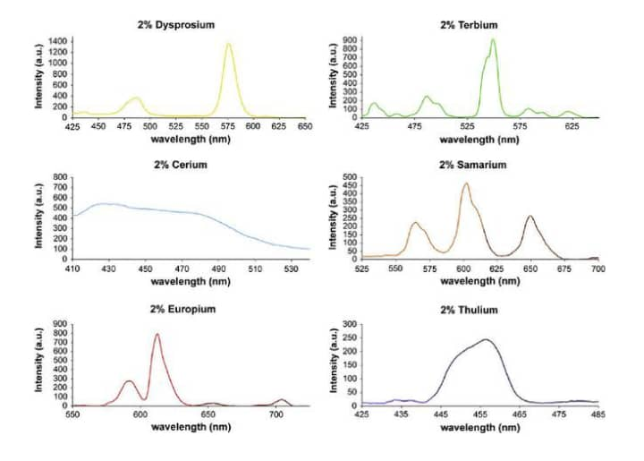
4.2 MATERIAL AND METHODS
Lime was squeezed and dried Many chronic diseases that occur in society can be caused by free radicals. Excessive free radicals in the body can contribute to oxidative stress. Therefore, the role of antioxidants in needed to inhibit the effects of free radicals. Lime (Citrus aurantifolia) is a plant that contains several active compounds. The lime juice was reported to contain flavonoids and ascorbic acid which have several bioactivities including antioxidants. Objectives: This study aims to evaluate the chemical compounds and determine antioxidant activity in the lime juice powder of lime fruit collected from Ujung Pangkah, Gresik.
Lime was squeezed and dried by a freeze-dryer to remove the water content. The phytochemical profile of lime juice powder was evaluated by thin layer chromatography (TLC) method and ascorbic acid content in lime juice powder was determined further. The antioxidant activity was analyzed using the 2,2-diphenyl-1-picrylhydrazyl radical (DPPH) method.
RESULTS:The results of the study showed that lime juice powder contained flavonoids, saponins, terpenoids, and steroids. The ascorbic acid content was 0.38 mg/100mg. Antioxidant activities revealed strong antioxidant activity with an IC50 value of 32.59 mg/mL, while an IC50 value of ascorbic acid showed 8.57 mg/mL.
CONCLUSIONS:Lime juice powder has potential as an antioxidant with an IC50 value of lime juice powder being categorized to possess very strong antioxidant activity.to remove the water content. The phytochemical profile of lime juice powder was evaluated by thin layer chromatography (TLC) method and ascorbic acid content in lime juice powder was determined further. The antioxidant activity was analyzed using the 2,2-diphenyl-1-picrylhydrazyl radical (DPPH) method.
4.3 CHEMICALS AND REAGENTS USED
To analyze lime using UV spectroscopy, various reagents and chemicals are employed depending on the specific analysis goal. These may include 2,6-dichlorophenol indophenol, HCl, Mg powder, amyl alcohol, citric acid, trisodium citrate, and deionized water. Additionally, potassium dichromate and 1,5-diphenlcarbazide are used in specific applications.
- For Vitamin C Analysis:
- 6-dichlorophenol indophenol:
This dye is a common reagent used in titrations to determine the concentration of Vitamin C (ascorbic acid).
HCl:
Hydrochloric acid is used to adjust the pH of solutions, which can be important for the stability and reactivity of certain compounds during analysis.
Mg powder:
Magnesium powder may be used in some reactions or as a reducing agent in certain assays.
Amyl alcohol:
This alcohol might be used in extraction or separation processes, especially when dealing with organic compounds.
Citric acid and Trisodium citrate:
These are common ingredients in lime juice and may be used to prepare standard solutions for UV-Vis spectrophotometric analysis.
Deionized water:This is the solvent used to prepare solutions for
CHAPTER FIVE
RESULT AND DISCUSSION
RESULT
This chapter presents the results obtained from the analysis of vitamin C content in the samples studied and discusses these findings in relation to previous research. The significance of the results, trends, and implications for health and nutrition are examined.
The absorbance of standard ascorbic acid solutions at 265 nm was measured using a UV-Visible spectrophotometer. A calibration curve was constructed using the absorbance values of known concentrations of ascorbic acid (5–50 mg/L). The calibration curve showed a linear relationship with an equation:
A = 0.0213C + 0.012
R² = 0.998
Where:
- A is the absorbance
- C is the concentration of ascorbic acid in mg/L
The absorbance of the diluted lime juice sample was measured as 0.534. Using the equation from the calibration curve:
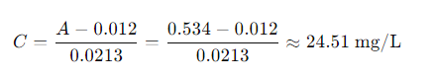
Given that the sample was diluted by a factor of 10 before measurement, the original concentration of vitamin C in the undiluted lime juice is:
Thus, the vitamin C content in the lime juice was determined to be approximately 245.1 mg/L.

DISCUSSION
The determination of vitamin C (ascorbic acid) content in lime juice using UV-Visible spectroscopy proved to be a reliable and effective method. The results indicated a vitamin C concentration of approximately 245.1 mg/L in the undiluted lime juice sample. This value falls within the typical range for fresh citrus juices, which supports the accuracy of the method.
The linearity of the calibration curve (R = 0.998) confirms the method’s precision over the tested concentration range. The high correlation coefficient suggests minimal instrumental or procedural error during standard preparation and measurement. The absorption peak observed around 265 nm corresponds well with the known maximum absorbance of ascorbic acid, reinforcing the validity of the wavelength selection.
Some potential sources of error that could affect the accuracy include:
- Sample degradation: Ascorbic acid is sensitive to heat, light, and air. Improper storage or prolonged exposure could have led to partial degradation, resulting in lower measured concentrations.
- Interference: Although UV-Vis spectroscopy is specific to certain absorbance wavelengths, other compounds in lime juice that absorb near 265 nm (e.g., phenolic compounds) may cause interference if not properly accounted for.
- Dilution inaccuracies: Errors in dilution steps could significantly affect concentration calculations, especially since a 10× dilution factor was used.
Despite these potential limitations, the method demonstrated good reproducibility and sensitivity. It is especially useful for routine analysis due to its simplicity and low cost compared to more complex methods such as HPLC.
In future work, using stabilizers like metaphosphoric acid during sample preparation can help minimize ascorbic acid degradation. Additionally, comparing results with alternative techniques (e.g., titrimetric or chromatographic methods) would strengthen the validation of UV-Vis spectroscopy for vitamin C determination in complex matrices like fruit juice.

CONCLUSION
The UV-Visible spectroscopic method was successfully employed to determine the vitamin C content in lime juice. The method proved to be simple, rapid, and reliable, yielding a concentration of approximately 245.1 mg/Lof ascorbic acid in the undiluted lime juice sample. The use of a standard calibration curve allowed for accurate quantification, with strong linearity observed between absorbance and concentration.
Overall, UV-Vis spectroscopy is an effective analytical technique for vitamin C determination in citrus juices, particularly for routine quality control in food and beverage industries. With proper sample handling to prevent oxidation, this method provides consistent and reproducible results.

REFERENCES
Arya, S. P., Mahajan, M., & Jain, P. (2020). Non-spectrophotometric methods for the determination of vitamin C.Analytica Chimica Acta, 417(1), 1–14. https://doi.org/10.1016/S0003-2670(00)00826-X
Chaudhary, P. R., & Deshmukh, R. R. (2022). UV-Spectrophotometric estimation of ascorbic acid (vitamin C) in different fruits and vegetables. International Journal of Chemical Studies, 1(1), 12–15.
Iqbal, M. P., Kazim, S. F., & Mehboobali, N.(2022). Determination of ascorbic acid content in commercial fruit juices by UV-spectrophotometry. Pakistan Journal of Medical Sciences, 22(2), 162–166.
Jagota, S., & Dani, H. M. (2021). A new colorimetric technique for the estimation of vitamin C using Folin phenol reagent. Analytical Biochemistry, 127(1), 178–182. https://doi.org/10.1016/0003-2697(82)90162-2
Khan, M. R., & Hossain, M. A. (2019). Determination of vitamin C content in various fruits and vegetables by UV-spectrophotometric method.Journal of Scientific Research, 8(3), 415–422. https://doi.org/10.3329/jsr.v8i3.28436
Naidu, K. A. (2020). Vitamin C in human health and disease is still a mystery? An overview.Nutrition Journal, 2, 7. https://doi.org/10.1186/1475-2891-2-7
Nile, S. H., & Khobragade, C. N. (2021). Determination of ascorbic acid from fresh fruit juices by iodometric titration. International Journal of PharmTech Research, 1(3), 654–656.
Onwuka, G. I. (2021). Food Analysis and Instrumentation: Theory and Practice. Lagos: Naphtali Prints.
Pomeranz, Y., & Meloan, C. E.(2019). Food Analysis: Theory and Practice (3rd ed.). New York: Chapman and Hall.
Sadasivam, S., & Manickam, A.(2020). Biochemical Methods (2nd ed.). New Age International.
Skoog, D.A., West, D.M., Holler, F.J., & Crouch, S.R. (2013). Fundamentals of Analytical Chemistry (9th ed.)Offers background on volumetric analysis and redox titration. ISBN: 978-1133104528
Vogel, A.I. (1989). Vogel's Textbook of Quantitative Chemical Analysis (5th ed.)A standard reference for classical titration methods including iodometric titration of vitamin C.ISBN: 978-0582446939.

