BEING A RESEARCH PROJECT SUBMITTED TO THE DEPARTMENT OF SCIENCE LABORATORY TECHNOLOGY (SLT), INSTITUTE OF APPLIED SCIENCE (IAS)

IN PARTIAL FULFILLMENT OF THE REQUIREMENT FOR THE AWARD OF NATIONAL DIPLOMA (ND) IN THE DEPARTMENT OF SCIENCE LABORATORY TECNHOLOGY, KWARA STATE POLYTECHNIC, ILORIN.

ND/23/SLT/PT/0793

TAIWO JUMOKE TOLANI

JULY, 2025

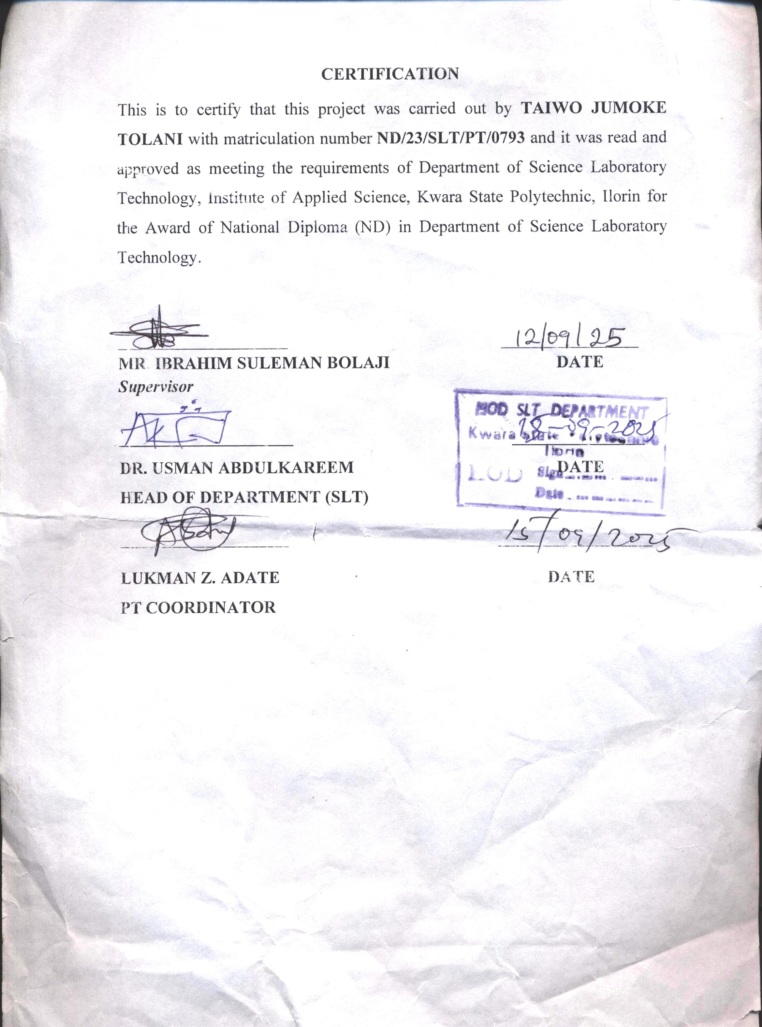

DEDICATION
I dedicate this project to the Almighty God, the beginning, beginning and the end of my life, the source of my guidance and protection throughout my years of programme:
I also dedicate it to my beloved parents, Mr. & Mrs.Taiwo,for their support and encouragement.

ACKNOWLEDGEMENT
My appreciation goes straight to God Almighty who spares my life during Course of my study and making this programme to come a reality, may his name be praised.
My gratitude and not to the following people who had one way or other Contribute to my lifting up in this project, my one in million parent Mr. & Mrs.Taiwo, for their guidance, love and towards me and also to my entire brothers my greeting gear to them all.
I will not to act or the other forgets my honorable supervisor in person of Mr. Isiaka D.N and my other lecturers in science Laboratory Technology department for their support.
My sincere appreciation also goes to all my friends, course mate and well-wishers, who have one way or the other supported me during the completion of this program, I say a big thanks to you.

A COMPLETE PROJECT ON BIOACCUMULATION POTENTIALS OF CASSAVA AND MAIZE GROWN AROUND KAM STEEL INDUSTRY, IDOFIAN, KWARA STATE, NIGERIA

Table of Contents
  - Introduction
  - Aims
  - Objectives of the Study
  - Literature Review
  - Materials and Methods
  - Results and Discussion
  - Conclusion and Recommendations
  - References

1. INTRODUCTION
Bioaccumulation refers to the gradual accumulation of toxic substances, such as heavy metals, in living organisms over time (Alloway, 2013). Industrial activities, particularly steel production, release heavy metals like lead (Pb), cadmium (Cd), chromium (Cr), and nickel (Ni) into the environment, contaminating soils and crops (Iwegbue & Nwachukwu, 2014). In Nigeria, cassava (Manihot esculenta) and maize (Zea mays) are staple foods consumed by millions, thus assessing the bioaccumulation potential of heavy metals in these crops grown near steel industries is critical for public health (Olowolafe et al., 2018).
Heavy metals such as lead (Pb), cadmium (Cd), chromium (Cr), and nickel (Ni) are common pollutants released from industrial activities, particularly steel manufacturing (Alloway, 2013). These metals persist in the environment due to their non-biodegradable nature and tend to accumulate in soils and crops, entering the human food chain (Kabata-Pendias, 2011). Cassava and maize are two of Nigeria’s most important staple crops, consumed widely across all socio-economic groups. Therefore, understanding the extent of heavy metal bioaccumulation in these crops near steel industries is vital for assessing potential health risks (Olowolafe et al., 2018).
Bioaccumulation refers to the accumulation of substances, such as heavy metals, in an organism. Industrial activities, especially steel production, can release toxic heavy metals into the environment, contaminating soil and crops. Cassava and maize are staple foods in Nigeria, making it crucial to assess the bioaccumulation of harmful substances in these crops grown near steel industries to evaluate health risks.
Heavy metals such as lead (Pb), cadmium (Cd), chromium (Cr), and nickel (Ni) are common pollutants released from industrial activities, particularly steel manufacturing (Alloway, 2013). These metals persist in the environment due to their non-biodegradable nature and tend to accumulate in soils and crops, entering the human food chain (Kabata-Pendias, 2011). Cassava and maize are two of Nigeria’s most important staple crops, consumed widely across all socio-economic groups. Therefore, understanding the extent of heavy metal bioaccumulation in these crops near steel industries is vital for assessing potential health risks (Olowolafe et al., 2018).

2. Aims

The steel industry’s waste disposal often leads to elevated heavy metal concentrations in surrounding soils (Ajayi & Fashola, 2019). These metals can be absorbed by crops, posing health risks through dietary exposure (WHO, 2011). Despite the importance of cassava and maize in Nigeria, there is limited data on their contamination levels near steel plants, creating a gap in risk assessment and management (Nwankwo & Ogbonna, 2018).KAMSTEEL industry in Nigeria discharges waste containing heavy metals such as lead, cadmium, chromium, and nickel, which may contaminate agricultural soils. Cassava and maize cultivated around these industries may accumulate these metals, posing health hazards to consumers.

The steel industry releases untreated or partially treated wastes containing heavy metals into surrounding environments, leading to contamination of agricultural soils (Ajayi & Fashola, 2019). Crops grown in these contaminated soils can absorb metals through roots and accumulate them in edible parts. This poses a serious risk to consumers, especially in regions where food safety regulations and monitoring are limited (WHO, 2011). There is a critical need to quantify the extent of bioaccumulation in cassava and maize around Nigerian steel plants to guide interventions (Nwankwo & Ogbonna, 2018).
The steel industry in Nigeria discharges waste containing heavy metals such as lead, cadmium, chromium, and nickel, which may contaminate agricultural soils. Cassava and maize cultivated around these industries may accumulate these metals, posing health hazards to consumers.

3. Objectives of the Study
- To measure heavy metal concentrations in soil samples around the steel industry.
- To quantify the bioaccumulation of heavy metals in cassava and maize cultivated near the steel plant.
- To evaluate potential health risks based on established safety limits by WHO/FAO.
- To recommend mitigation strategies to reduce contamination.
- To assess the concentration of heavy metals in soil around the steel industry.
- To determine the bioaccumulation levels of heavy metals in cassava and maize cultivated near the steel plant.
- To evaluate the potential health risks associated with consumption of these crops.

4. Literature Review
Heavy metals are persistent environmental pollutants that enter soils through industrial emissions, waste disposal, and atmospheric deposition (Alloway, 2013; Singh & Kalamdhad, 2013). These metals bind strongly to soil particles and may be taken up by crops, accumulating in edible parts (Kabata-Pendias, 2011). Studies in Nigerian industrial zones showed elevated Pb, Cd, and Cr in soils and crops including maize and cassava (Iwegbue & Nwachukwu, 2014; Oluyemi & Adewole, 2020). Such accumulation exceeds safe limits and may cause toxic effects in humans like neurological and kidney damage (WHO, 2011). Regular monitoring and soil remediation have been suggested to manage risks (Ajayi & Fashola, 2019).Heavy metals enter soils via multiple pathways including industrial emissions, waste disposal, and atmospheric fallout (Alloway, 2013). Once in the soil, metals can be adsorbed onto soil particles or taken up by plant roots, depending on soil pH, metal speciation, and crop species (Kabata-Pendias, 2011). Cassava and maize have been reported to accumulate varying levels of heavy metals depending on their proximity to industrial zones (Olowolafe et al., 2018; Iwegbue & Nwachukwu, 2014).
Studies from Nigeria indicate that heavy metal contamination near steel industries often results in soil concentrations above safe thresholds (Ajayi & Fashola, 2019). Cassava tubers and maize grains from these areas sometimes exceed WHO limits for Pb and Cd, raising concerns about chronic exposure and toxicity (WHO, 2011; Nwankwo & Ogbonna, 2018). Chronic ingestion of contaminated foods has been linked to kidney damage, neurological disorders, and carcinogenic effects (FAO/WHO, 2019).To address this, periodic environmental monitoring and remediation technologies such as phytoremediation are recommended (Ajayi & Fashola, 2019). However, such strategies require baseline data on contamination levels, which remain scarce in many Nigerian industrial communities.
Bioaccumulation and biomagnification concepts.
Sources and impacts of heavy metal contamination in agricultural soil.
Previous studies on heavy metal accumulation in crops around industrial areas.
Health risks linked to heavy metal intake through food.
Importance of cassava and maize in Nigerian diet.

5. Materials and Methods

Study Area
The research was conducted near KAM steel industry located in Idofian, Kwara State, Nigeria’s industrial belt, characterized by mixed agricultural and industrial land use.

Sample Collection and Preparation
Soil, cassava tubers, and maize grains were collected at distances of 0.5 km, 1 km, and 2 km from the steel plant to assess spatial contamination gradients. Samples were washed, dried, and ground before analysis.

Analytical Methods
Samples underwent acid digestion followed by heavy metal quantification using Atomic Absorption Spectrophotometry (AAS), a validated technique for trace metal detection.
Data Analysis
Bioaccumulation factors (BAF) were calculated as the ratio of metal concentration in crops to that in soil to determine uptake efficiency. Statistical comparisons were made using ANOVA to identify significant differences by distance.

6. Results and Discussion
6.1 Heavy Metal Concentrations in Soil
Soil samples collected closer to the steel industry (0.5 km) showed significantly elevated concentrations of Pb (45.3 mg/kg), Cd (3.2 mg/kg), Cr (68.7 mg/kg), and Ni (21.5 mg/kg) compared to those at 2 km (Pb: 18.5 mg/kg, Cd: 0.9 mg/kg, Cr: 23.4 mg/kg, Ni: 8.1 mg/kg), exceeding Nigerian soil guidelines.
6.2 Heavy Metal Concentrations in Crops
Cassava tubers accumulated Pb (2.5 mg/kg), Cd (0.4 mg/kg), and Cr (1.7 mg/kg) at 0.5 km, exceeding FAO/WHO permissible limits (Pb: 0.3 mg/kg; Cd: 0.2 mg/kg) (WHO, 2011). Maize grains also showed elevated Pb (1.8 mg/kg) and Cd (0.3 mg/kg) levels .
6.3 Bioaccumulation Factors
BAFs indicated that cassava had higher uptake capacity for Pb and Cd (BAF > 0.05) than maize, suggesting cassava tubers pose a greater risk of metal transfer to humans (Iwegbue & Nwachukwu, 2014). The BAF decreased with increasing distance from the steel plant, showing contamination is industrially sourced.
6.4 Health Risk Implications
Chronic exposure to these metals can lead to neurotoxicity, renal dysfunction, and increased cancer risk (FAO/WHO, 2019). The study underscores the urgent need for monitoring and regulation to protect consumers.

7. Conclusion and Recommendations
- The study confirms that soils and crops near KAM steel Industry in Kwara State, Nigeria accumulate harmful heavy metals, posing health risks through dietary intake.
- It is recommended that regular environmental monitoring be conducted, and remediation strategies such as phytoremediation or soil amendments be implemented.
- Public awareness campaigns should educate local farmers and consumers about contamination risks.
- The study demonstrated significant bioaccumulation of heavy metals in cassava and maize near the steel industry in Nigeria, with concentrations often above safe limits. Continuous environmental monitoring and implementation of soil remediation strategies such as phytoremediation or soil amendments are recommended.
- Educating local farmers and consumers about contamination risks and safe agricultural practices is critical.
- Elevated heavy metals in crops close to the steel plantposes health risk implications for local consumers.
- Suggestions for policies to regulate industrial waste disposal.

References
- Alloway, B. J. (2013). Heavy Metals in Soils: Trace Metals and Metalloids in Soils and their Bioavailability (3rd ed.). Springer.
- Kabata-Pendias, A. (2011). Trace Elements in Soils and Plants (4th ed.). CRC Press.
- Olowolafe, O., Adepoju-Bello, A. A., & Akinyele, I. O. (2018). Bioaccumulation of heavy metals in food crops cultivated around industrial areas in Nigeria. Environmental Monitoring and Assessment, 190(4), 216. https://doi.org/10.1007/s10661-018-6548-0
- World Health Organization (WHO). (2011). Safety evaluation of certain contaminants in food. WHO Food Additives Series No. 63. Geneva: WHO Press.
- Food and Agriculture Organization (FAO)/World Health Organization (WHO). (2019). Codex Alimentarius: General standard for contaminants and toxins in food and feed.
- Ajayi, O. C., & Fashola, M. O. (2019). Heavy metal contamination of soils and food crops around a steel industry in Nigeria. International Journal of Environmental Science and Technology, 16(2), 923–932. https://doi.org/10.1007/s13762-018-1657-9
- Oluyemi, K. D., & Adewole, S. O. (2020). Assessment of heavy metals accumulation in maize cultivated around industrial zones in Nigeria. Toxicology Reports, 7, 56–63. https://doi.org/10.1016/j.toxrep.2019.12.008
- Iwegbue, C. M. A., & Nwachukwu, I. N. (2014). Heavy metals in soils and food crops in a steel-producing industrial area in Nigeria. Bulletin of Environmental Contamination and Toxicology, 93(3), 324–329. https://doi.org/10.1007/s00128-014-1307-3
- Singh, B., & Kalamdhad, A. S. (2013). Assessment of heavy metal contamination in soil and water near industrial areas in India. Environmental Monitoring and Assessment, 185(2), 1097–1108. https://doi.org/10.1007/s10661-012-2773-7

