CORPORATE GOVERNANCE AND FIRM PERFORMANCE: EMPIRICAL EVIDENCE FROM SELECTED LISTED COMPANIES IN NIGERIA
(Case Study of Quoted Company in Nigeria Stock Exchange)

BY
AJAO FATHIA APEKE
ND/23/ACC/PT/0062

BEING A PROJECT SUBMITTED TO THE DEPARTMENT OF ACCOUNTANCY, INSTITUTE OF FINANCE AND MANAGEMENT STUDIES, KWARA STATE POLYTECHNIC ILORIN

IN PARTIAL FULFILMENT OF THE REQUIREMENT FOR THE AWARD OF NATIONAL DIPLOMA (ND) IN ACCOUNTANCY

JULY, 2025

CERTIFICATION
This is to certify that this research work has been written by Ajao Fathia Apeke with matriculation number ND/23/ACC/PT/0062 and approved as meeting part of the requirements for the award of National Diploma (ND) Department of Accountancy, Institute of Finance and Management Studies, Kwara State Polytechnic, Ilorin.

MR. RASHEED. B. DATE
(Project Supervisor)

MR. HASSAN O. A DATE
(Project Coordinator)

MR. ELELU M. O DATE
Head of Department

External Examiner DATE

DEDICATION
This project work is dedicated to Almighty Allah, the source of all wisdom and understanding for counting me among today’s graduates.

ACKOWLEDGEMENT
I give all glory, honor, praise and adoration to ALLAH in the highest, the most merciful, most beneficent for His love, kindness and faithfulness in my life right from my primary school days to the time I am now leaving Kwara State Polytechnic, Ilorin, He's always been by my side. And in Him I am rest assured he will be with me till the end of my life. All glory to him.
My profound gratitude goes to my able supervisor MR Rasheed who took time to make correction on my project and also my Head of Department (H.O.D), Project Coordinator, you shall all live to witness the fruit of your labour, and may Almighty ALLAH continue to bless you (Amin).
I further My Appreciation to My Beloved and Able Parents, MR. and Mrs. Ajao for their parental support both financial and morally toward my success in life, you shall live to witness the fruit of your labour, and may Almighty Allah continue to bless you (Amin).
To all those I don't remember to mention your names, may Almighty ALLAH bless you all.

TABLE OF CONTENTS
Title page i
Certification ii
Declaration iii
Dedication iv
Acknowledgment v
Table of Contents vi
CHAPTER ONE:
INTRODUCTION
1.1 Background to the Study 1
1.2. Statement of the Research Problem 3
1.3. Research Questions 4
1.4. Objective of the Study 4
1.5. Research Hypotheses 5
1.6. Significance of the study 5
1.7. Scope of the study 5
1.8. Limitations of the study 6
1.9. Definition of key terms 6
CHAPTER TWO
LITERATURE REVIEW
2.0. Literature review 7
2.1. Introduction 7
2.2. Conceptual Framework 7
2.3. Theoretical Framework 11
2.4. Empirical Review 12
CHAPTER THREE:
RESEARCH METHODOLOGY
3.0. Research methodology 14
3.1. Introduction 14
3.2 Research design 14
3.3 Sources of Data 14
3.4. Population of the study 14
3.5. Sampling Size and Sampling Techniques 14
3.6. Data Analysis Method 14
3.7 Instrument of data collection 14
3.8 Validity and reliability of instrument 15
3.9 Methods of Data Analysis 15
CHAPTER FOUR: PRESENTATION AND ANALYSIS OF DATA

4.1. Data presentation 17
4.2. Data Analysis 18
4.3. Discussion of finding 18
CHAPTER FIVE: SUMMARY, CONCLUSION AND RECOMMENDATIONS
5.0. Summary, conclusion and recommendation 24
5.1. Summary 24
5.2. Conclusion 25
5.3. Recommendations 25
References 26

CHAPTER ONE
INTRODUCTION
  - Background To The Study
The subject of corporate governance has spurred research interests with respect to principal-agent relationship expropriation in recent times especially with the existence of publicly quoted companies. This is in corroboration with Claessens & Fan (2012) who opined that corporate governance has received much attention in recent years. Abor & Biekpe (2015) intricately define corporate governance as the process and structure used to enhance business prosperity and corporate accountability with the ultimate objective of realizing long- term shareholder value, whilst taking into account the interest of other stakeholders. Kyereboah-Coleman (2017) argues that corporate governance is represented by the structures and processes lay down by a corporate entity to minimize the extent of agency problems as a result of separation between ownership and control. Simply put, corporate governance in an organizational context is the totality of the control, monitoring and directing mechanism utilized by strategic management in the best interests of its stakeholders.
Corporate governance refers to a situation in which all the interests of stakeholders in a firm are taken care by the managers and other insiders by adopting mechanisms that guarantee and protect the interests of the stakeholders. Dabor, Isiavwe, Ajagbe and Oke (2015) explains that corporate governance codes are developed with the primary goal of promoting a transparent and efficient system that will promotes the rule of law and facilitates division of responsibilities among the various managers of firms in a professional and objective manner. However, the increasing incidence of corporate fraud relating to exaggerated and fleeting reports have reinforced the renewed global emphasis on the need for effective corporate governance practices (Adebayo, Ibrahim & Yusuf, 2024). The framework of corporate governance encourages efficient use of resources and also requires accountability for the stewardship of those resources (Aggarwal, 2013). In the present era, the strengths, weakness and performances of firms are usually measured by the extent to which a firm upholds the codes of corporate governance (Ndum & Oranefo, 2021). Notable among the most important roles played by corporate governance is in ensuring and encouraging quality financial reporting process (Cohen, Krishnamurthy & Wright, 2024).
Consequently, abuse of corporate governance is a global thing that has no territorial definition or coloration. thus, as they have been reported in the international scenes, many scandals have equally been reported in Nigeria; this is why Ndum and Oranefo (2021) averred that the cases of abuse of corporate governance encompasses the recent gross financial misconduct in which the former managing directors of the Oceanic Bank of Nigeria Plc, Union Bank of Nigeria Plc and the Intercontinental Bank of Nigeria Plc, and other banks in Nigeria were found wanting, and which were widely reported in the press. In addition, they pointed out that another case of corporate governance breaches involved the Directors of the Nigeria Stock Exchange, especially the Director General, who in the conduct of the Board affairs committed fatal breaches of corporate governance codes in relation to the institution they managed.
Firm performance is a concept that supports the effective and efficient use of financial resources to achieve overall company objectives which include both shareholders wealth maximization and profit maximization objectives. It can be measured using long term market performance measures and other performance measures that are non-market-oriented measures or short term measures (Zubaidah et al, 2019). The measure of firm performance employed in this study is from a non-market oriented perspective which is most common and requires the use of accounting ratios which are the profitability and investor ratios. This study intends to contribute to the few researches on the Nigerian environment as most of the researches on firm performance and corporate governance which resulted in mixed outcomes were conducted in the United States of America, the United Kingdom, Pakistan and Malaysia (Ertugrul & Hegde, 2019; Jong, Gisper. Kabir, & Renneboog, 2012; Javid & Igbal, 2019; Zubaidah, Nurmala, & Kamaruzaman, 2019).
Generally, well-governed firms are expected to have higher profits, less bankruptcy risk, higher valuations and pay out more cash to their shareholders, while reverse holds for poorly-governed firms (Kyereboah-Coleman and Biekpe, 2016). Several studies have established the importance of good corporate governance to enhanced firm performance (Sanda et al, 2015; Adenikinju and Ayonrinde, 2011, Adelegan, 2017; Magbagbeola, 2016; Brown and Caylor, 2015; Core and Rusticus, 2015, etc). Conversely, several others have established the impotency of some corporate governance precepts (Demsetz and Lehn, 1985, Core et al, 2015; Adenikinju, 2015 and Chidambaran et al., 2017), hence yielding conflicting observations. This notwithstanding, works on corporate governance are still few in Nigeria. It would also provide credible findings to support deliberations on this topical issue.
1.2 Statement of the Research Problem
The problem areas that spurred the interest in researching on this topic are specifically the loss of confidence by the investors on the capital market, the persistent agency problem and the insolvency of large companies as a result of financial improprieties. These issues are discussed more explicitly below.
Kajola (2018) asserts that financial scandals around the world and the recent collapse of major corporate institutions in the USA, South East Asia, Europe and Nigeria have shaken investors' faith in the capital markets and the efficacy of existing corporate governance practices in promoting transparency and accountability. Good corporate governance is an important step in building market confidence and encouraging more stable, long-term international investment flows (Bocean & Barbu, 2017). The loss of confidence by investors in the capital market is therefore an indicator of poor corporate governance practice in quoted companies (Oyebode, 2019). The shares of the listed companies on the Nigerian stock exchange are gradually declining from a bullish state to a bearish status. Shareholders have lost interest in trading on the stock exchange because of the crash in share prices just as in the Cadbury Nigeria Plc case when it overstated its earnings and its shares were dealt a heavy blow on the Nigerian Stock Exchange Market.
Also, the existence of the agency problem which arises in a bid to intermediate between the interests of the managers and that of the shareholders typically influences firm performance. It is for this reason that Sanda, Mikailu, & Garba (2015) posits that for example, the managers might take steps to increase the size of the company and. often, their pay, although they may not necessarily raise the company's profit, the major concern of the shareholder.
The insolvency of large companies as a result of financial improprieties has awakened discuss on the effect of corporate governance on firm performance (Claessens, 2013; MENA-OECD Investment Programme- Working Group 5, n.d). In the same vein, the predominance of sharp practices by management and insider trading for the purpose of defrauding such companies as a result of the need to satisfy some personal interest may also a contributory factor to poor firm performance.
It is therefore believed that examining the relationship between corporate governance mechanisms and firm performance would attempt to address the problems as stated.
1.3 Research Questions
The following research questions were raised:
i. What is the relationship between board size and firm performance?
ii. To what extent does the combination of the posts of the CEO and Chairman of the Board affect performance?
iii. How does concentration of ownership affect firm performance?
1.4 Objectives of Study
The objective of this study in a broad sense is to measure the relationship between firm performance and corporate governance mechanisms. The specific objectives of this study are thus as follows:
i. Examine the effect of board size and firm performance.
ii. Investigate the combination of the posts of the CEO and Chairman of the board on firm performance.
iii. Examine the relationship between ownership concentration and firm performance.
1.5 Research Hypotheses
This study is guided by the following statement of testable hypotheses:
H01. Board size has no significant relationship with firm performance
H02. CEO duality does not have significant increase on firm performance
H03. Ownership concentration has no effect to firm performance
1.6 Significance of Study
The indispensability of this study lies in its ability to fill an identified gap and contribute to existing researches in the subject area. The previous empirical studies conducted on the Nigerian environment do not cover information elicited from the most recent periods.
Top executives: this includes the CEO, Chairman and members of the board. It would aid them in managing the issues arising from agency relationships. It would also broaden their perspective on the aspects of corporate governance that need to be enhanced that will result in improved firm performance.
Shareholders/ Investors: it would assist existing shareholders and potential investors to make appropriate judgments as regards their investments and performance of the companies in which they are stakeholders.
Regulators: it would assist the regulators in promulgating better corporate governance regulations that will be more encompassing and contribute effectively to enhancing firm performance and resolving agency conflict.
Future Researchers: they will be able to apply this research to carry out further studies in the same area or related area by serving as a theoretical base for the research to be carried out.
1.7 Scope of Study
The focus of this study is to employ panel data methodology to provide evidence on the relationship between firm performance measures and corporate governance in Nigeria Stock Exchange. The study observes the most recent financial periods of some of the non-financial companies listed on the Nigerian Stock Exchange. This includes fifty two (52) selected listed non-financial companies. Information is elicited from Annual Reports and Accounts for a period of 6 years from 2015 to 2021. The list of selected companies is contained in the appendix.
1.8 Limitations of Study:
The constraints experienced in carrying out this research are
1. Availability of data: the inability to obtain data from a very large sample of the population impairs the generalization of the findings to a certain extent.
2. Time constraint: based on the fact that the researcher has to cope with other academic activities and official assignments, there is insufficient time for project work.
1.9 Definition of Terms
Accounting scandals: an event of an accounting nature that causes public outrage or censure such as the understatement of profit, overstatement of assets.
Agency: fiduciary relationship between two parties in which one (the "agent") is obligated to the other (the "principal").
Audit Committee: it is a body formed by a company's board of directors to oversee audit operations and circumstances. Besides evaluating external audit reports, the Committee may evaluate internal audit reports as well.
Bearish: a stock market situation characterized by falling stock-market prices.
Board of Directors: A board of directors is a body of elected or appointed members who jointly oversee the activities of a company or organization. The body sometimes has a different name, such as board of trustees, board of governors, board of managers, or executive board.
Bullish: a stock market situation characterized by rising stock market prices.
Corporate Governance: Corporate governance is the set of processes, customs, policies, laws, and institutions affecting the way a company is directed, administered or controlled.

CHAPTER TWO
LITERATURE REVIEW
2.1 Introduction
Ndum and Oranefo (2021) explain that corporate governance is concerned with accountability, boards, disclosure, investor involvement, and other related concerns, implying that the composition of a board determines the performance of a business to a great extent. As a result, corporate governance is concerned with finding a balance between economic and social aims, as well as between individual and communal interests.
In understanding the theoretical perspectives of corporate governance, it is necessary to evaluate the accounting models adopted by various countries. Gernon & Meek (2010) classified accounting models into the Fair Presentation/Full Disclosure Model; the Legal Compliance Model, and the Inflation Adjusted Model. This section therefore discusses the conceptual framework, theoretical framework, corporate governance mechanisms, and firm performance.
2.2 Conceptual Framework
The conceptual framework of corporate governance pertains to the theoretical configurations, underlying postulations, and principles adopted by companies. A study of literature has shown that the conceptual framework of corporate governance is the agency theory, institutional theory and mechanisms of reducing agency costs. The conceptual framework for this study focuses on the agency relationship and the corporate governance mechanisms to reduce the cost of agency.
2.2.2 Corporate Governance Mechanisms for Reducing Agency Costs
The Organization for Economic Cooperation and Development (2016) suggests that corporate governance systems should encompass the roles, duties and powers of shareholders, the board of directors and company management, and should also include transparency and disclosure as well as the place of the corporation in society at large. International Finance Corporation (2014) argues that there is no single definition of corporate governance that can be applied to all situations and jurisdictions.
The bottom line remains that corporate governance borders on the ethos that support directing and controlling companies in such a way that the stakeholders utility is maximized. The extent of corporate governance can be measured by certain indices that are either internal or external to the company. The internal governance mechanisms relate to the structures existing within the companies while the external mechanisms are determined by influences outside the company. The internal governance mechanisms that would reduce agency cost are discussed as follows:
2.2.2.1 Board Size
The board is an important internal mechanism for resolving the agency problems, since it is primarily responsible for recruiting and monitoring the executive management to protect the interests of the shareholders (Haque, Arun, & Colin, 2018). The structure and size of corporate boards have received much attention in the media and in the business community recently, fuelled by the prominent business failures of large companies such as Enron, WorldCom and Parmalat (Bennedsen, Kongsted, & Nielsen, 2018).
Many researchers have studied the effect of board size as a measure of the quality of corporate governance on firm performance. The empirical results thus far reflect mixed outcomes in the sense that some scholars (Kashif, 2018; Zubaidah, Nurmala, & Kamaruzaman, 2019) conclude that board size have a positive impact on firm performance. Mak & Kusnadi (2015); Randoy, Thomsen, & Oxelheim, (2016); Mashayekhi & Bazaz (2018); Ning, Davidson, & Wang, (2010); Connell & Cramer (2010), conclude that a negative relationship exists. Li & Niu, 2016; Frick & Andreas, (2010); results report a non-consistent relationship between board size and firm performance.
Though the Securities and Exchange Commission Code of Corporate Governance in Nigeria (2013) stipulates that the size of a board should not exceed fifteen (15) persons or be less than (5) persons in total, the question still remains on what the optimal size of a board should be. Among other scholars, Kashif (2018) suggest that the board size be chosen with the optimal combination of both inside and outside directors for the value creation of the company.
Ning, Davidson, & Wang (2010) assert that when board size increases, agency problems in the boardroom increase simultaneously, therefore leading to more director free-riding problems and internal conflicts among directors. Drawing from this pattern of thought, agency theory encourages smaller boards because of the ease of decision making and reduced tendency of conflict of interest. In the U.S., it has been observed that the board size in publicly traded companies range from 8 to 11 directors and overtime, small boards with 7 or fewer directors tend to increase their size but large boards with 12 or more directors tend to shrink their size (Ning. Davidson, & Wang, 2010). Kajola (2018) in his study on the Nigerian environment advocates that board size be limited to a sizeable level.
Smaller boards preferably reduce agency cost and inferably increase performance. Hence, the study suffices to hypothesis as follows
2.2.2.2 CEO Duality
The concept of CEO duality borders on a combination of the leadership roles of both the Chairman and the Chief Executive Officer (CEO) in a singular position. This translates into the Chairman of the Board being the same individual as the CEO.
An impartial monitoring of managerial actions of shareholders will occur more fully where the Chief Executive Officer is separate from the chairman of the board (Donaldson & Davies, 1991) Ponnu (2018) explains that the chairman of the board is responsible for managing the board while the Chief Executive Officer is responsible for the day to day management of the company, including the implementation of board decisions. He further asserts that interest in duality of roles has emerged primarily because it is assumed to have significant implications for firm performance and corporate governance.
It follows that in the Nigeria Securities and Exchange Commission Code of Corporate Governance (2013) supports that where there be CEO duality, there should be a strong non-executive Vice Chairman. Benz & Frey (2017) therefore opines that the most important area where corporate governance violates the principle of division of power is CEO duality- that is, when the CEO of the company is at the same time the chairperson of the board.
2.2.2.2 Ownership Concentration
The initial view of the advantages of ownership concentration in joint stock was determined by the concern about the opportunistic managerial (Grosfield, 2018). In a bid to forestall agency conflicts ideas on the d shareholders ownership such that there are different groups of owners.
Corporate governance systems can be distinguished according to the degree of ownership concentration and the identity of controlling shareholders (Bocean & Barbu, 2018). It is for this reason that Farooque (2018) reports that the determinants of company ownership structure are classifyable into shareholder ownership concentration and board ownership. Bocean & Barbu (2016) describe ownership structure as wide dispersed ownership (outsider systems), and concentrated ownership (insider systems). The shareholder ownership concentration of companies is usually characterized by the majority or controlling shareholder who exerts control and significant influénce over the company's operating and financial policies. The controlling shareholder is either an individual, family holding, bloc alliance, financial institution or other corporations acting through a holding company or via cross shareholdings (Bocean & Barbu, 2017). Board ownership suggests that board members own shares in the companies where they function.
Ownership position with the company aligns directors' economic wealth to the value of the company, thus encouraging directors to be more active in monitoring and controlling the managerial initiatives that could lower the company's value (Kim, Al-shammari, Kim, & Lee, 2019).
2.2.2.3 Audit Committee Independence
The audit committee is a critical link between a company's financial reporting function and its external shareholders (Bolton, 2010). They act as representatives of the shareholders by monitoring internal control, overseeing the external auditing process. Accounting'scandals and concerns about the quality of financial statements have led to many calls for improved audit committee effectiveness (Bronson,Carcellor, Hollingsworth, & Neal, 2019). Audit committee effectiveness can be achieved by growing independence of the committee in terms of more independent outside directors on the committee. The audit committee serves as the eyes of the shareholders because their duty is to ensure transparency and accountability in the financial reporting process. A strong audit committee is expected to remedy poor governance systems (e.g., agency problems) that seem to prevail in emerging markets (Choi, Han, & Lee, 2011). This depicts that an independent audit committee can reduce the opportunistic tendencies of managers.
Form Performance Akintonde (2013) opines that depending on whether the measuring goal is to analyze performance results or behavior, performance is a multi-dimensional construct. Also, Nnabuife (2019) felt that performance encompasses not only teamwork but also individual efforts that result in a specified end result that will be rewarded by managers. Armstrong as cited in Akintonde (2013) says because they have the strongest linkage to the organization's strategic goals, customer happiness, and economic contributions, performance is described as work outcomes. The quantity of utility or benefits gained by shareholders from the firm's shares can be viewed as the firm's performance or worth.
Firms that generate a substantial amount of value from the selling of their shares are said to be financially successful. Such highvalue companies attract a lot of investors, which increases the company's chances of continued expansion. A company can be valued in a variety of ways. Discounted cash flow, present value, equity cash flow, and weighted average cost of capital methods are some of the most commonly used measures. Profit After Tax (PAT) was used to measure firm performance for this study. This ratio measures a company's ability to generate earnings or returns from its assets. After deducting all expenses and taxes related to the returns, profit is computed. According to Drucker (1999), a company must make money in order to stay in business.
2.3 Theoretical Framework of Corporate Governance
The basic theoretical structures of corporate governance include the agency theory, stakeholder theory, stewardship theory, and resource dependency theory. However the agency theory is the focal point.
The theory of agency forms the theoretical core for this study because it is a foundational theory of corporate governance. It also relates to internal mechanisms of corporate governance. These theoretical perspectives are discussed herewith with emphasis on agency theory.
2.3.1 Agency theory
The agency theory stems from the existence of agency relationships in corporate environments where there exists a fiduciary relationship between two individuals described as the principal and agent. The Institute of Chartered Accountants of England and Wales (2015), explains that an agency relationship arises when one or more principals (e.g. an owner) engage another person as their agent (or steward) to perform a service on their behalf. Drawing from the above assertions, it is expedient that a principal engages in a contract with an agent based on trust and interest in achievement of overall organizational goals and objectives. This suggests that though the principal may have personal goals, loyalty and dedication lies in the ability to place corporate goals ahead of personal goals.
In corporate governance debates, the agency theory appears to be the foremost and the most emphasised because it borders on the cost of agency. Agency costs include monitoring expenditures by the principal such as auditing, budgeting, control and compensation systems, bonding expenditures by the agent and residual loss due to divergence of interests between the principal and the agent (Kyereboah Coleman, 2017).
In the deliberations on agency theory, relationships and cost, a scholarly literature that is most prevalent is Theory of the Company, Agency Costs and Ownership Structure - Jensen and Meckling (1976) because it presents a theoretical framework for other researchers to build up the theory. Jensen and Meckling (1976) focus almost exclusively on the normative aspects of agency relationships: that is how to structure the contractual relation including compensation incentives between the principal and agent to provide appropriate incentives for the agent to make choices which will maximise the principal's welfare given that uncertainty and imperfect monitoring exists.In addition to the key issues towards addressing opportunistic behaviour from managers within the agency theory which are the composition of the board of directors and CEO duality as posited by Kyereboah Coleman (2017), this study suggest two others which is the independence of the audit committee and ownership concentration.
2.3.2 Stewardship Theory
Stewardship theory focuses on psychological and sociological methods of oversight, rather than the economic (pecuniary) tools of agency theory. The former holds that organisational members have some form of positive collective identity that engenders trustworthy behaviour (Davis and Donaldson, 1997). Muth and Donaldson (1998) concur in that financial gain is not necessarily the sole driver of managerial behaviour, and in addition managers require some discretion to effectively manage business for shareholders. Consequently, separate ownership is not viewed as a weakness in stewardship theory as cooperative behaviours are held to be the latent/intrinsic behaviour of managers (Davis et al., 1997; Donaldson and Davis, 1991), and they are subject to an array of motives in addition to financial gain (Muth and Donaldson, 1998). Fama and Jensen (1983a) observed that inside board member managers are more likely that outside directors in large organisations due to the deep insight into organisational activities enjoyed by the former. Stewardship theory posits that concern for their own reputations and career progression inhibits agents from acting against the interests of shareholders, thus agency costs should be inherently minimised (Donaldson and Davis, 1994). The contribution to firm performance of stewards relates to the context in terms of socio-cultural and psychological factors (Clarke, 2014).
2.3.3 Resource Dependence Theory
The perspective of the resource dependence theory is more materialist and less organization-centred. It is primarily concerned with firms‘ access to resources, such as expertise and capital. According to resource dependence theory, structures of corporate governance such as the board of directors affect firms‘ access to resources essential for firm performance (Pfeffer, 1973). Resource dependence theory particularly favours boards with a high composition of NEDs, due to the wider expertise and knowledge they can provide, as well as improved networking with the external environment and a generally improved reputation (Haniffa and Cooke, 2012; Haniffa and Hudaib, 2016). Thus NEDs can facilitate access to the political and business contacts, capital and information (Nicholson and Kiel, 2013), by enhancing networking with external stakeholders, including customers, governments and other companies (e.g. creditors, suppliers and buyers); thus NEDs improve access to resources (Nicholson and Kiel, 2013), which put simply enables cheaper access to inputs and thus positively affects firm performance.
2.3. Empirical Review
Kyereboah (2017) in his study on the effect of CG on the performance of firms in Africa by using both market and accounting based performance measures found out that the direction and the extent of impact of governance is dependent on the performance measure being examined, He found out that large and independent boards enhance firm value and that combining the positions of CEO and board chair has a negative impact on corporate. Performance, CEO's tenure in office enhances a firm's profitability whiles board activity intensity affects profitability negatively. The size of audit committees and the frequency of their meetings have positive influence on market based performance measures and that institutional shareholding enhances market valuation of firms.
Heenetigala (2017) using descriptive statistics he discovered a significant increase in corporate governance practices between the board composition, board committees and corporate social responsibility reporting. As a result of the increased governance practices the study provided evidence in support of a positive relationship for separate leadership, board composition, board committees and firm performance based on return on equity in Sri-Lanka. Both board composition and board committees also had a significant relationship with performance measured by Tobin's Q However, corporate social responsibility reporting practices by the firms in Sri Lanka did not report any relationship to firm performance. In the study, the positive relationship between corporate governance structures, separate leadership, board composition, board committees and firm.
Gupta (2016) studied various Corporate Governance practices followed by companies in India, Japan and South Korea. A sample of five multinational companies from each country was studied based on the Corporate Governance practices that are followed by them. This included parameters like Board Constitution, Board Structure, Different Committees, Independent Directors and their roles, Conflict of interest and Disclosure of information. The study found that corporate governance practices have limited impact on both the share prices of the companies as well as on their financial performance.
`Aggarwal et al. (2015) attempted to investigate the impact of corporate governance on corporate financial performance in an Indian context, using a sample of 20 companies listed on S&P CNX Nifty 50 Index. They carried out various tests like regression, correlation, and t-test and F-test using secondary data over a period of two years from 2010 2012 they found out that the governance ratings have positive and significant impact on corporate financial performance.

CHAPTER THREE
RESEARCH METHODLOGY
3.1 Introduction
This section essentially describes the principles underlying the execution of this research. It contains the research design, population of study, sample size, sampling technique, data gathering method, actual field work, data analysis method, instruments of data collection.
3.2 Research Design
This study employs the technique of panel data analysis. It involves an empirical analysis of the annual financial reports and accounts of selected companies on the Nigerian stock exchange. It requires the use of descriptive and inferential statistics for data analysis as a result of the need to test hypothesis. The main reason for embarking on a panel study is that it allows for the measuring of the pattern of change and obtaining of factual information requiring collection on a regular basis.
3.3 Population of Study
The population for this study is defined as all the companies listed on the Nigerian Stock Exchange (NSE) at 2018. The total number of listed companies as at 2018 from which the sample is drawn is 213 (Okereke-Onyuike, 2019).
3.4 Sample size and Sampling Technique
The sample size for this study is 52 companies listed on the Nigerian Stock Exchange Market (NSEM). The technique of sampling used is the random sampling technique. The random sampling is applied because of the need to select a sample based on the availability of the required information to achieve the objective of the study. Therefore, only companies with financial statements covering the time period of 2013 to 2018 were selected based on access to their annual reports and accounts. This excludes the companies in the financial industry.
3.5 Sources and Method of Data
The research employs both primary and secondary data. The major source of data is the secondary source which is the data collected from the annual financial reports and accounts of companies, the Nigerian Stock Exchange fact book. The annual reports and accounts are sourced from an internet database addressed as www.sbainteractive .com.

3.6 Instruments of Data Collection
This research employs quantitative data. The instrument used to gather this quantitative data is the annual reports and accounts of the selected companies.
3.7 Techniques for Data Analysis
The data collected for the research representing corporate governance mechanisms and performance measures is analysed with statistical methods. Charts and tables are initially used to display data gathered. The data is further analysed using descriptive statistics which describes the mode, median and standard deviation. The hypotheses are tested using inferential statistics which include the regression tests and the test of correlation. A multiple regression analysis which is estimated with the Ordinary Least Square (OLS) is done to explain the impact of corporate governance on firm performance while the test of correlation measures the degree of association of the corporate governance mechanisms with the performance measures. For the purpose of obtaining stronger empirical evidence to support this study, further tests-the fixed effects model and random effects test are conducted to reduce the effect of a bias in the result. The fixed and random effects model is tested for its appropriateness using the Hausman Specification test which is performed using STATA statistics package spetial edition 10.

CHAPTER FOUR
DATA PRESENTATION AND ANALYSIS
4.1 Introduction
The data collected is analysed and presented in this section using panel data methodology. The analysis comprises of descriptive analysis, correlation analysis and econometric analysis. The instruments for the data analysis are the EViews 6 and STATA SE 10. The model specified is also tested to inquire into the nature of relationship that exists between corporate governance and firm performance for a period of six years.
Therefore, this chapter commences with a industrial presentation of sample companies, a descriptive analyses followed by a test for multicollinearity. The ordinary least square regression and the Generalised least square regression are applied to examine the relationship between corporate governance and firm performance while controlling for company size and leverage. The hypotheses are also tested using the regression analysis which aids in achieving the objectives of the study. The data for this study is sourced from the annual reports and accounts of some selected listed companies in Nigeria and the Nigerian Stock Exchange (NSE) fact book.
4.2 Data Presentation
4.2.0 Industry Based Presentation
The fifty two (52) companies studied are classified on industry basis (see appendix 1). A column chart is also used to for a pictorial presentation of the percentage of companies contained in each industry. The industries as contained in the chart above are randomly selected from the Nigerian Stock Exchange based on availability of data excluding the financial industry (banking, insurance, leasing and other financial institutions). These companies are listed on the first tier market of the Nigerian Stock Exchange implying that they are open to other sources of funds apart from debt because of their size and large capital base.
The chart reveals that the industry with the highest number of sample companies in Petroleum (marketing) with 7 out of the 52 companies studied representing 13%. The other industries are represented as follows- Food/Beverages and Tobacco( companies representing 12%: Building materials and Conglomerates (5 companies each representing 10%): Chemical & Paints and Industrial & Domestic Products (4 companies each representing 8%); Healthcare, Packaging, Printing & Publishing (3 companies each representing 6%): Breweries, Construction, Computer and Office Equipment (2 companies each representing 4%: Agriculture & Allied, Automobile & Tyre, Maritime, Textile (1 company each representing 2 %). Data is collected for the 52 sample companies of each industry from a period of 2013 to 2018 representing 6 years.
4.3 Data Analysis
4.3.1 Summary Statistics
The table 2 below shows that the extent of audit committee independence is 49 %. This implies that the audit committee of the sample companies is on the average dependent because the structure comprises more shareholders than independent directors. This has the tendency to hamper the objectivity of the audit committee.
The average board size is 9 which depict a level of compliance of the sample companies with the Securities and Exchange Commission Code of Corporate Governance (2013). The code of corporate governance recommends that the board size should not exceed 15 with a minimum of 5 board members. Also, the agency theory supports smaller boards relative to larger boards to enhancing corporate governance and improving firm performance Ning, Davidson, & Wang (2010). Suffice to deduce that a mean board size of 9 is sufficient to reduce agency costs. The mean value of the size of the company is 16.72 billion naira. It shows that on the average, the companies are large which typifies the features of companies in the first tier market. The large size of the companies also suggests accessibility to wide range of finance and information in the market.
The extent of CEO duality on the average is 11% explaining that most of the sample companies separate the positions and the persons of the Chief Executive Officer and the Chairman. Also, it is apparent that an average of 89% of the sample companies comply more with the code of corporate governance. It is expected that since CEO duality is bad for performance based on the agency theory (Peng, Zhang, & Li, 2017), 89% of the companies are likely to experience better performance than others belonging to the 11%.

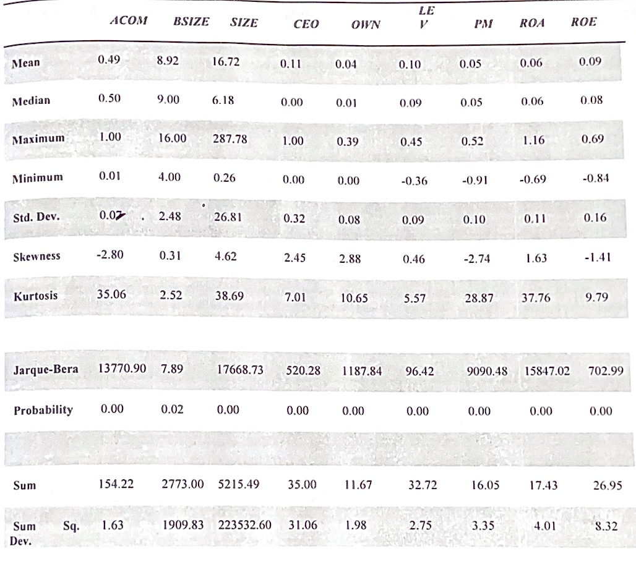
Table 2: Summary Statistics of Variables



Note: the values of company size are in billions. All the values in the table are in 2 decimal points so as to maximize space.
Also from the table, the concentration of ownership measured by directors' ownership reflects a mean value of 4%. This suggests that 96% of the ownership is concentrated on other forms including shareholders, institutional, and foreign ownership. The concentration of directors' ownership is perceived to reduce the shirking and opportunistic attitude of directors because of their stakes. The low level of ownership concentration then places the sample companies at a risk of incurring agency costs which can slow down firm performance.
The sample companies are on the average are 10% levered whereas 90% are sustained by equity financing. This suggests that 90% of the companies are not indebted and are prone to less risk. However, Berger & Patti (2013) opine that highly levered company reduce agency costs and vice versa. Inferably, the sample companies are more likely to have increased agency costs because they are less levered.
The average profit margin is 5% implying that the ratio of the profit to turnover is low. This is as a result of the low profits and losses made by the sample companies while the value of sales keeps increasing.
The return on assets shows an average of 6%. This measure of performance is low for the sample firms because of constant increase in total assets without a corresponding increase in profit.
The return on equity exhibits a mean value of 9% which is as a result of fluctuations in profit and increasing levels of equity.
Table 3 and 4 contains a summary descriptive statistics of the industries alongside the variables. Table 3 shows that the industry with the largest mean board size is the Textiles industry with 15 board members while the industry with smallest mean board size is the Maritime industry with 6 members. CEO duality is highest in the agriculture industry (67%) and lowest (0%) in the Automobile & Tyre, Breweries, Building & Materials, Chemicals & Paints, Conglomerates, Construction, Engineering Technology, Foods/ Beverages, Industrial /Domestic Products, Real Estate And Textiles industry. The industry with the highest concentration of directors' ownership is Printing and Publishing with a mean value of 21% while Agriculture and Allied, Breweries and Real estate have a 0% mean value. Audit committee independence is highest in the Chemical & Paints and Industrial /Domestic products industry at an average of 51% and lowest in the Agriculture and Allied industry at an average of 45%. Breweries have the highest average company size of 67.18 billion while Engineering Technology has the lowest at 470 million. Leverage is highest on the average in the Breweries industry at 23% but lowest in the Automobile and tyre industry at 3%.
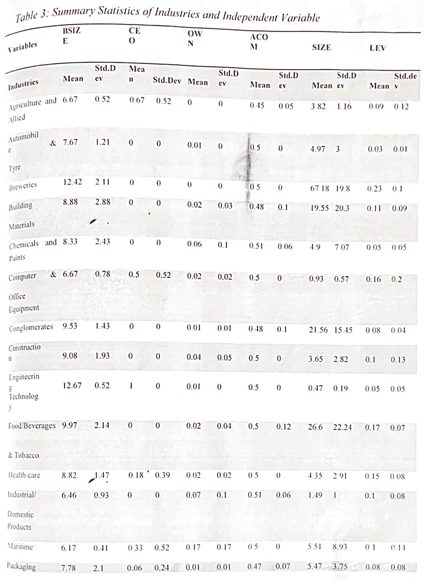
Table 3: Summary of Industries and Independent Variable

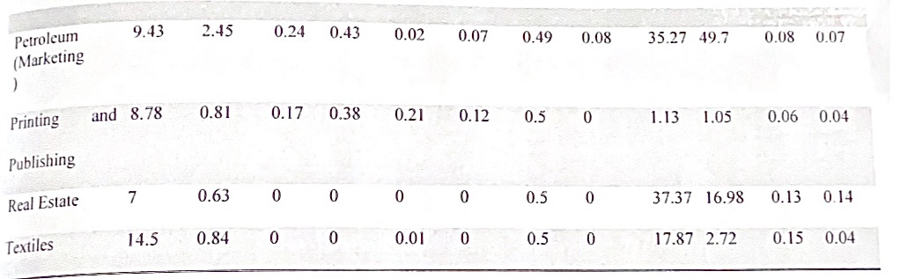

Note: the values of company size are in billions. All the values in the to in 2 decimal points so as to maximize space.
4.3.2 Correlation Analysis
The test for multicollinearity is executed using the correlation analysis, in order to examine the existence of correlation between the independent variables. The applicability of this test is that if such exist, it may lead to a phony regression result.
Also, the result of the correlation between the dependent and the in variables are discussed in this section.
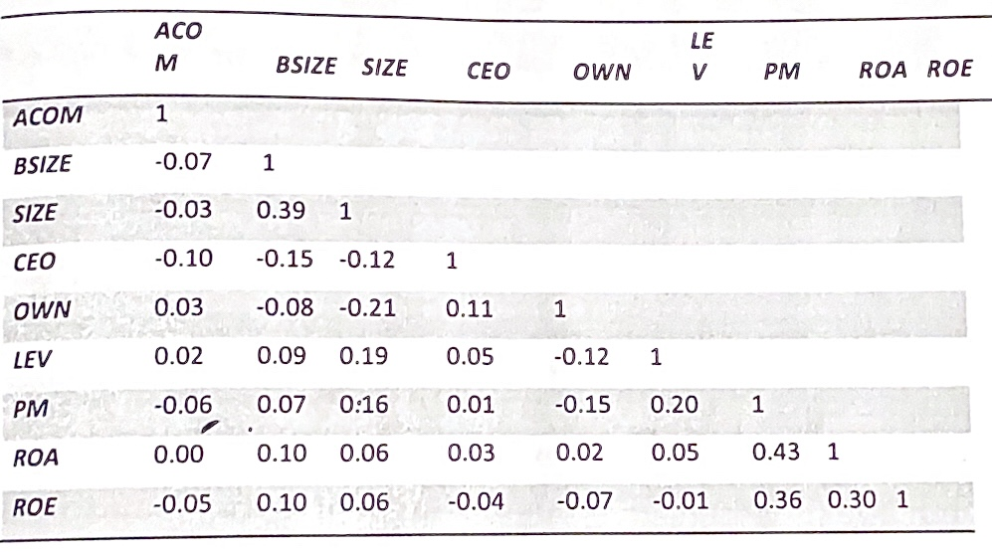
Table 5: Test for Multicollinearity

From table 5 above, there appears to be no incidence of multicollinearity among the independent variables. This certifies the independent variables as fit to be estimated together on the same regression model. The correlation result also shows the bivariate relationship between the performance and corporate governance proxies. Audit committee independence, profit margin, and return on equity are negatively and weakly associated but positive and weakly associated with return on assets. This implies that an increase in audit committee independence, results in lesser profit margin and return on equity but greater return on assets.
Board size is positively associated with the performance surrogates (profit margin, retur on assets, and return on equity). This suggests that larger board size result in better firm performance. The result is in cognisance with the resource dependency theory that supports larger board size because of the benefits of harnessing several human resource skills and input. This result is consistent with the findings of Kashif (2018): Zubaidab, Nurmala, & Kamaruzaman (2019) who also observe a positive relationship.
The CEO duality proxy is positively associated with profit margin and return on assets but negatively associated with return on equity. Therefore the more the CEO duality, the higher the profit margin and return on assets which is in line with the stewardship theory of corporate governance. Agency theory supports that the more the CEO duality the lesser the return on equity. The concentration of ownership depicts a negative relationship with profit margin and return on equity but a positive relationship with return on assets. The higher the concentration of director ownership, the lesser the profit margin and return on equity but the greater the return on assets. Leverage is positively associated with profit margin and return on assets but negatively associated with return on equity. Hence, the higher the debt, the higher the profit margin and return on assets which agrees with the agency theory on agency cost reduction. This is usually the case when the company has debt pacts to uphold and would do their best to present a financial position that is good to their stakeholders. The negative relationship between debt and return on equity may be as a result of the fact that debt and equity are alternate sources of finances in that they can either be combined (debt and equity) or used singularly (debt or equity). Therefore the higher the debt, the lower the equity and correspondingly the lower the return on equity.
Company size is found to be positively associated with profit margin, return on assets, return on equity. This suggests that the greater the company size, the greater the firm performance. Therefore larger firms are most likely to perform better than their smaller counterparts because they are open to greater windows of opportunity.
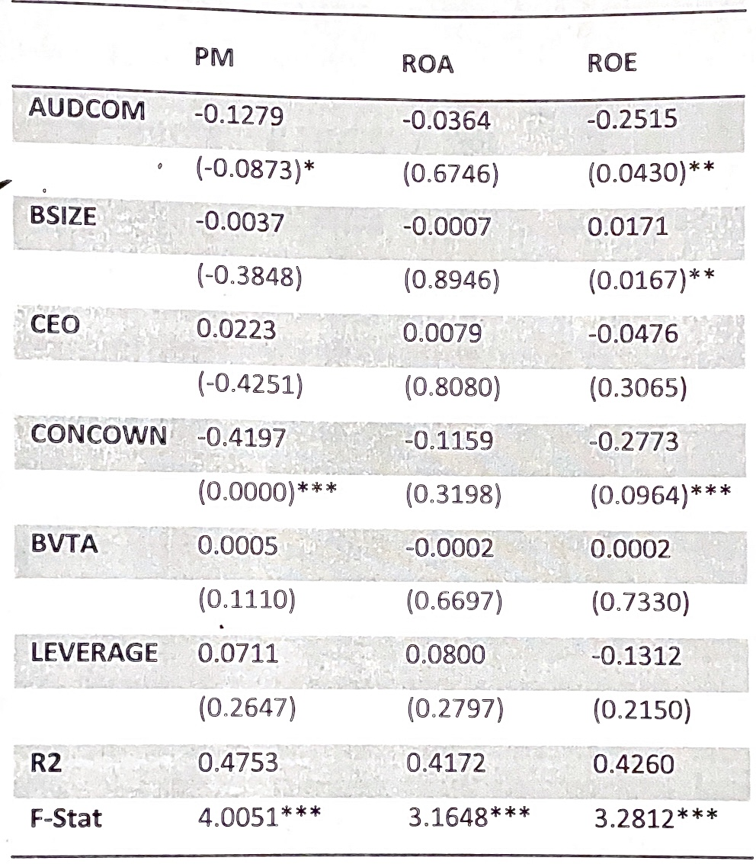
Table 6: Generalised Least Square Regression Result of Estimated Model (Fixed effects)

Note. ***, **, * significant at 1%, 5% and 10% respectively
The relationship between leverage and firm performance is observed to be insignificant. This is not in line with the proposition of agency theory that a company that is indebted would do its best to reduce agency costs because the company is a risk taker. The empirical outcome is not surprising because the summary statistics reveals that on the average, the sample companies are levered only up to 10% of their total assets. Since the lion's share of their total assets (90%) is financed by shareholders' equity and possibly retained earnings, it is only expedient that leverage would have no impact on firm performance.
The r-squared for profit margin, return on assets and return on equity is 48%, 42%, and 43% respectively. Deductively, the corporate governance surrogates are responsible for 48% of the variations in profit margin, 42% variations in return on assets and 43% variations in return on equity.
The F- statistic for the entire model is significant at 1%. Therefore, the empirical model adopted in the study for describing the relationship between corporate governance and firm performance is statistically significant.
CHAPTER FIVE
SUMMARY, FINDINGS, CONCLUSION AND RECOMMENDATION
5.1 Introduction
This research work is structured and brings to the fore the relationship between corporate governance and firm performance in selected listed companies in Nigeria. This chapter includes the summary of the focal point of the study, research findings, conclusions recommendation, and suggestions for further studies.
5.2 Summary of Work Done
Corporate governance discuss has spurred research interests with respect to principal-agent relationship expropriation in recent times especially with the existence of publicly quoted companies. There has been contemporary argument (Chen, Chen, & Wei, 2014; Sanda, Mikailu, & Garba 2015; Biswas & Bhuiyan, 2018; Darren 2010) that restricting agency conflicts and resulting agency costs is a potential channel through which corporate governance may impact on firm performance. It follows that internal corporate governance mechanisms are a means to curb agency costs and reduced agency cost would increase firm performance.
The study lends its solutions and methodologies to resolving the lasting conflict interest between managers and shareholders which has been tagged as the age problem by measuring the relationship between corporate governance and f performance. A conceptual model is developed based on a review of theoretical empirical literature. Four hypotheses are formulated to provide better insight into the research. hypotheses are tested using Generalised Least Square Regression testing for Fi Effects. Other preliminary analysis including descriptive statistics and correlation contained in the study to aid the robustness of findings.
The research findings are categorised into both theoretical and empirical findings which forms the basis for recommendations and suggestions for further studies.
5.4 Conclusion
Corporate governance is a pertinent contemporary issue because of the prominence of corporate scandals mostly arising from creative accounting, and other financial misappropriations. The companies listed on the Nigerian Stock Exchange are guided by the Securities and Exchange Commission Code of Corporate Governance developed in October 2013. The corporate governance mechanisms complied with by companies is specified in this code of best practices. In order to curb agency cost which could be monetary and non- monetary and increase firm performance, corporate governance indices are identified. The effect of these corporate governance mechanisms on accounting based measures of firm performance is observed. The concentration of director ownership is quite low at an average of 4% and has an
Inverse relationship with the performance measures. The average board size is found to be 9 which is in concordance with the Securities and Exchange Commission Code of Corporate Code of Corporate governance. The audit committee is on the average 49% independent which results in an impact on performance based on return on equity and profit margin of Corporate Code of Corporate governance. The audit com 49% independent which results in an impact on performance and profit margin.
5.5 Recommendations
In attaining deeper insight into the relationship between c firm performance and also into the research findings, propositions to that effect. Importantly, industry specific effects should be taken into consideration before formulating codes of corporate governance that determine the characteristics of the audit committee or the board structure. The Securities and Exchange Commission should take into cognisance this condition in formulating corporate governance.
In addition, the Corporate Governance Committee of companies should endeavor to do a regular appraisal of their corporate governance compliance status as it affects performance. This is because the study is able to identify that corporate governance has an impact on firm performance.
Conclusively, diminishing profits should be investigated because it is apparent that there are scenarios were profits keep reducing till they eventually turn to losses. The performance indicators used in the study, measure below 10 % on the average which indicates poor performance and increasing agency costs.

REFERENCES
Adebayo, M. Ibrahim, A.O.B., Yusuf, B., & Omah, I., (2014). Good Corporate Governance and Organizational Performance: An Empirical Analysis. International Journal of Humanities Social Science, 4(7), 170-178. 2.
Abdullahi, H., & Valentine, B. (2019). Fundamental and ethics theories of corporate governance. Middle Eastern Finance and Economics, 88-96.
Abor, P. K, & Biekpe T. Y (2015). Corporate governance research in Nigeria: a review. Munich Personal RePEc Archive
Beaudoin, C. (2018). Earnings management: The role of the agency problem and corporate social responsibility (Doctoral Thesis, Drexel University). Retrieved
http://idea.l/brary.drexel.cdu/bitstream/1860/2805/1/Beaudoin_Cathy.pdf
Bennedsen, M., Kongsted, H. C.. & Nielsen, K. M. (2018). The causal effect of board size in the performance of small and medium-sized firms. Journal of Banking and Finance, 32, 1098-1109.
Benz, M., & Frey, B. (2017). Corporate governance: What can we learn from public goveranance. Academy of Management Review, 92-104.
Bhagat, S., & Bolton, B. (2018). Corporate governance and firm performance. Journal of Corporate Finance, 14, 257-273.
Biswas, P. K. & Bhuiyan, M. U. (2018, October 20). Agency problem and the role of corporate governance revisited. Retrieved from A Social Science Research Network Web site: http://ssr.com/abstract=1287185
Bocean, C., & Barbu, C. (2017). Corporate governance and firm performance. Marketing and Management Journal, 125-131.
Farooque, O. A. (2018). Factors influencing corporate ownership structure in an emerging market. Some Issues on entrepreneurship. Seoul Korea: International Conference on Business and Information.
Frick, B. & Andreas, B. (2010, June 10). Board size, board composition and firm performance: Empirical evidence from Germany. Retrieved from A Social Science Research Network Web site: http://ssrn.com/abstract-1623103
Garcia-Meca, E. & Sanchez-Ballesta, J. P. (2019). Corporate governance and earnings management: A meta- analysis. Corporate Governance: A International Review, 17(5), 594-610
Grosfield, I. (2016). Ownership concentration and firm performance: Evidence from an emerging marker. Retrieved from A Pari-Jourdan Sciences Economiques Web Site: http://www.pse.ens.fr/document/wp201618.pdf
Haque, F., Arun, T.. & Colin, K. (2018). Corporate governance and capital markets: A conceptual framework. Journal of Corporate Ownership and Control. 5(2). Heath, J., & Norman, W. (2014). Stakeholder theory, corporate governance and public management:. Journal of Business Ethics, 53, 247-265.
Kajola, S. O. (2018). Corporate governance and firm performance: The case of Nigerian listed firms. European Journal of Economies, Finance and Administrative Sciences, 16-28.
Kanellos, T., & Karathannassis, G. (2017, December 20). Corporate governance and firm performance: Results from Greek firms. Retrieved from A Munich Personal RePc Archive Website: http://mpra.ub.uni-muenchen.de/6414/
Kashif, R. (2018). A comparison of corporate governance and firm performance in developing (Malaysia) and developed (Australian) financial market Melbourne: Centre for Strategic Economic Studies.
Tsifora, E., & Eleftheriadou, P. (2017). Management of International Business and Economic Systems- Transactions on Line, /(1), 181-211.
Zheka, V. (2016, May). Corporate governance and firm performance in Ukraine. Retrieved from Centre for Economic Reform and Transformation: http://www.sml.hw.ac.uk/cert
Zubaidah, A. Z., Nurmala, K. M., & Kamaruzaman, J. (2019). Board corporate performance and corporate performance in Malaysia. International Journal of Economic Finance, 150-164.

