INFLUENCE OF FOREIGN TELEVISION PROGRAMMES ON DRESSING HABIT OF NIGERIA YOUTH
(A CASE STUDY OF KWARA STATE POLYTECHNIC)

PREPARED BY:

OLAIDE ARAFAT OYINKANSOLA
ND/23/MAC/PT/1167

SUBMITTED TO:
DEPARTMENT OF MASS COMMUNICATION
INSTITUTE OF INFORMATION AND COMMUNICATION TECHNOLOGY, KWARA STATE POLYTECHNIC, ILORIN.

IN PARTIAL FULFILLMENT OF THE REQUIREMENT FOR THE AWARD OF NATIONAL DIPLOMA (ND) IN MASS COMMUNICATION

JULY, 2025

CERTIFICATION
This is to certify this project has been read and approved having satisfied the requirement for award of National Diploma in Mass communication, in the department of mass communication, institute of information communication technology (IICT), Kwara State Polytechnic, Ilorin.

_______________________ ______________________
MRS. AMINAT SULYMAN DATE
(Project supervisor)

_______________________ ______________________
MRS. OPALEKE G.T DATE
(Project coordinator)

_______________________ ______________________
MRS. OPALEKE G.T DATE
(Head of Department)

_______________________ ______________________
EXTERNAL EXAMINER DATE

DEDICATION
This project is dedicated to God Almighty and to our family, for their unwavering support and for driving us to succeed and also to the pursuit of knowledge and understanding.

ACKNOWLEDGEMENTS
Our sincere gratitude goes to my supervisor mrs. Aminat sulyman for the time and effort she dedicated to make this project possible Thanks very much ma. We pray that your children will as well experience favour on their to success.
And also to the HOD of the Department of Mass Communication Kwara state polytechnic, and The Coordinator of Part Time program in the Department of Mass communication, We say a big thank you. To our lecturers which can’t start mentioning name, we say thank you for your advice and counseling during the course of my study in the institution. More blessings to you all, Inshallah. (Amin)

TABLE OF CONTENTS
Title page i
Certification ii
Dedication iii
Acknowledgement iv
Table of contents v
CHAPTER ONE
  - Introduction 1
  - Background of the Study 1
  - Statement of the Problem 3
  - Purpose of the Study 4
  - Objectives of the Study 5
  - Research Questions 6
  - Significance of the Study 7
  - Scope and Limitation 8
  - Definition of Terms 9
CHAPTER TWO
- Literature Review
  - Conceptual Framework 11
  - Theoretical Framework 12
  - Empirical Review 14
  - Summary of Literature Review 18
CHAPTER THREE
- Methodology
  - Research Design 30
  - Population of the Study 30
  - Sample and Sampling Technique 30
  - Data Collection Instruments 31
  - Validity and Reliability of Instruments 31
  - Data Collection Procedure 31
  - Data Analysis Techniques 31
CHAPTER FOUR
- Data Analysis and Presentation 33
  - Introduction 33
  - Demographic Characteristics of Respondents 33
  - Analysis of Research Questions 43
  - Discussion of Findings 44
- Summary, Conclusion, and Recommendations
  - Summary of Findings 46
  - Conclusion 47
  - Recommendations 48
References 51-53

CHAPTER ONE
1.1 Background of the Study
The media has a very powerful position in today’s world. It has tremendous influence on people as it encourages them to make choices and take different decisions on several issues one of which is their dressing habit. Not only does it influence the way people interpret different aspects of their lives but it has also served as a guide on several issues including the nature and pattern of dress that they use. This is most obvious when viewed from the perspective of the foreign films which people view for their leisure and entertainment.
Films also known as motion pictures encompass the projection of a series of images into the screen to create an illusion of motion. It is one of the widely known forms of entertainment, allowing people to be in an imaginary world for a short period of time (Olaleye, 2007).
Film as a medium of mass communication is assuming a highly important place in the society that is globalised. Since there are subtitles that translate different languages, the appeal of films has increased among people generally, especially those from foreign cultures. Subtitles afford the audience the chance to watch films that were not produced in their original language. This development creates room for rapid flow of films from their country of origin to other countries Nigeria inclusive.
In Nigeria today, films produced in USA, France, India, China, Japan, Mexico, Philippines, among others are commonly available.
Because of the explosion of films into the society, students now tend to talk, walk, behave, eat, and dress exactly like the characters they have watched in films.
Furthermore, foreign films (especially fashion films) are primarily directed at students based on the fact that it will open up market for foreign dresses to be easily sold locally and adopted by students.
Because of this idea, Western films have found a place in the heart of students to the extent that our local dresses are rarely seen on campus.
Additionally, Vasudev (1986) in his study on Foreign Films and their influence on cultural values - the Indian experience, opines that the invention of cinema in the West has led to a long Western domination over the means of production and most importantly, of distribution. For this reason, the impact of such films as a social force was as important as the birth of a new art. The captive markets of the rest of the world were flooded with images that reflected the culture of the countries of Europe and America from where they originated. With no challenge to the cultural imperialism these countries enjoyed, allowing no opportunities for any kind of equal cultural exchange, their cinemas filled our minds and imagination to the exclusion of our own visions, hopes, and ideals. We also borrowed their ideologies and norms thereby aligning ourselves to their cultures.
In the same vein Semiu (2011) cited by Oketumbi, E.O.O (2014) in his PhD Pre-Field Presentation entitled, "Influence of Foreign Movies on Cultural Practices among Undergraduates in Selected Universities in Nigeria” opines that, “Western movies enable teenagers to experience other parts of the world (and) film…is one of the major contributors to blind acceptance and practice of Western cultures by the young ones in Nigeria and Africa. In Nigerian society, the situation is quite alarming in (the sense) that, teenagers’ attitudes, thoughts and general behaviours are considerably influenced by Western films and worse still, Nollywood films which are mostly anchored on Western models consolidate Western Films thereby promoting Western values in Nigeria.”
It is based on the tremendous influence of foreign films on Nigerian students in general and their dressing habit in particular that has informed the idea of this research project which is geared towards taking a close and panoramic view at how far the influence is within the purview of dressing habit of Taraba State University Students.
1.2 Statement of the Problem
Social scientists and policy makers have for long been concerned about the effects of films and television especially on the youths and students in particular. The point is that such exposure is leading young people to risk-taking behaviours, including unsafe sex, alcohol use, transposition and adaptation of foreign values and norms, violence among others.
Vasan, A. (2010) posits that a considerable body of research from developed countries, particularly the US, suggests that the visual media influence a broad range of attitudes and behaviours among young people and may exacerbate risky practices. Furthermore, it is obvious that students are exposed to foreign films. This exposure is premised on the fact that students want to learn about other cultures. As a result, film being a powerful medium of mass communication has influenced several aspects of people’s attitude and behavior including choice and taste of dress.
Daine (2006) cited by Oketumbi, E.O.O (2014) in his PhD Pre-Field Presentation entitled, “Influence of Foreign Movies on Cultural Practices among Undergraduates in Selected Universities in Nigeria”, asserts that, “Student’s exposure or lack of exposure to foreign films influences their beliefs about other cultures”. This culture includes the dress mode depicted in foreign movies. As the clothes we wear is equally part of culture.
In agreement with the above, Wok, S. and Mohd, S. (2007) remarked that, “The influence of TV and magazine on teenagers, adolescents and youth are widespread. The influence is mainly on their dressing and their attires…” more so, importation of foreign dress code and its adoption by students of tertiary institutions has been a perpetual source of concern.
From the above scholarly points, it is obvious that foreign films have been implicated and indicted in several instances which breed enculturation of the passive viewers with foreign dresses at the detriment of their original pattern of dressing. Their claim stems from the fact that foreign films often tend to cause people to accept an alien culture thereby relegating their own to the background. A very important part of that culture is the attire they wear.
It is against this backdrop that this work seeks to investigate the Influence of Foreign Films on the Dressing Habit of Taraba State University Students. The study seeks to validate or invalidate the several opinions proposed and to determine whether the influence is positive or negative among the students.
1.3 Objective of the Study
- To find out whether Taraba State University students watch foreign films
- To find out if foreign films influence the dressing habit of Taraba State University students
- To find out the dressing pattern and mode which Taraba State University students adopt and use as depicted in foreign films.
1.4 Research Questions
- To what extent do students of Taraba State University watch Foreign Films?
- To what extent are Taraba State University students influenced by foreign films in their form of dressing?
- To what extent does the dressing pattern and mode depicted in Foreign Films become adopted by Taraba State University Students?
1.5 Hypothesis
Ho1: Foreign Films do not influence the dressing habit of Taraba State University Students.
1.6 Significance of the Study
This study has significance both socially and theoretically. The social significance of this study lies in the fact that it will expose the society to the knowledge of how indigenous culture is gradually being wiped away because of excessive consumption of western contents. This will serve as a guide in making concerted effort in promoting the usage of local and locally made dresses. So that students of tertiary institutions of learning will be at the forefront of championing the cause of wearing local dresses, thereby help in the area of doing something to revive the decaying culture.
In the same vein, it will serve as motivation to policy makers and movie makers to make serious effort that will lead to the upholding of salient areas in indigenous culture through the locally made movies. This is based on the reason that, obviously Nollywood and Kannywood-the Nigerian movie industries are not helping matters as they serve as proxy to foreign films especially from Hollywood and Bollywood through the way they package and produce movies.
Furthermore, it will equally open up way to the knowledge of the fact that foreign films are also the motivating factor of certain behaviors that are found in tertiary institutions in Nigeria.
In the end, it will theoretically serve as a contribution to knowledge on the effect of the mass media by building on the already existing body of literature as research in this area is still not conducted by many especially in Nigeria. This will inspire subsequent researchers to replicate or embark on similar work.
1.7 Scope and Limitation of the Study
The scope of the study will be the influence of foreign films on dressing habit of Taraba State University Students. This therefore implies that any other area that foreign films have influenced on students such as: moral values, language preference, conduct towards elders and manners of speaking among others will not be focused on this study.
The study will be limited to the regular students of Taraba State University, Jalingo, More so, time will be a great limiting factor to the expanding of the work seeing that the research would be combined with other academic activities. Apparently, there is still a lot to be done because there is limited literature on this work as well as financial constraint.
1.8 Definition of Key Terms
The key concepts guiding this study that need to be operationally defined in a view to align them with the work’s context are:
- Influence
- Foreign Films
- Enculturation
- Transposition and Adaptation
Influence: The term influence means doing the things that you see other people do. Sometimes, people can like a particular person or thing and are thus spurred to think and act in the way that will align with that person or thing. It can also be in the form of mimicry of what we see other people do by trying to make sure that we do it exactly or the same way that they are doing it. The idea is to establish the fact that the concept influence as used here entails the copying or adoption of the dress mode depicted in foreign films. In summary, it means the effect of foreign films on students.
Foreign Films: These are series of images that are projected into the screen to create an illusion of reality which depicts alien cultures. Such series of images could either come from the Americas, Philippines, China and India among others. They are called foreign films because they are not films that are made here with our cultural predispositions in mind rather, they serve to depict or project culture (dressing style) that does not originate from us.
Enculturation: This is the gradual acquisition of the norms, dressing pattern, and ideologies of a culture or group.
Transposition and Adaptation: Similar to enculturation, transposition and adaptation entails the transfer of something done elsewhere and fitting it to the context of your environment. This goes to tell how dress patterns of other cultures become transposed and adapted by students of tertiary institutions in Nigeria.

CHAPTER TWO
2.1 Introduction
This chapter deals with the review of literature in this field of study. It dwelled on the following: Film as medium of communication; Dressing/Costume in film; The Effect/Influence of film on an Audience; Empirical Studies on film Costumes on Audience; Taraba State University and her students; Theoretical Framework, and summary of literature. 2.2 Film as a Medium of Communication
According to Umar (2000) film is a very powerful medium of mass communication. Through this medium, different people like producer, director, story or scriptwriter, songwriter etc. want to communicate with the masses. It is a collaborative medium. It has the potential to reach the heterogeneous audience. Filmmakers produce films for masses not for individuals. The essence is to package something that will communicate messages to the audience shodhganga (n.d).
Furthermore, Wok and Mohd (2007) opine that film is one of the most popular medium of communication. Through film, the director communicates with the audience. Audience is equally important in this process of communication. The action on the screen does not take place between actors of a film; rather the action takes place among the actors and the audience. In the same vein, film is also a medium of non-verbal communication. In other words, film speaks through silence, facial expression; body language etc Shodhanga (n.d). film shows the mode of dressing of the characters and what those dressings depict. When it comes to the communicative power of films, language is not a barrier because it has the ability of visual grammar which transcends linguistic barriers. Films are more than entertainment. They inspire, inform, and may even become part of people’s culture Royster and Dennis (2013).
2.3 Dressing/Costumes in Film
In films, costumes are worn. The reason for wearing costumes is to project the environment, time, place and personality of the character. It also projects the social standing of the characters. Landis (2014) opines that Costumes communicate the details of a character’s personality to the audience, and help actors transform into new and believable people on screen. He says that every garment worn in a movie/film is considered a costume. Costumes are one of many tools the director has to tell the story. Further, Costume is the distinctive style of dress of an individual or group that reflects their class, gender, profession, ethnicity, nationality, activity or epoch Landis (2014).
The above point makes us to understand that each garment in the film has been chosen, altered and aged specifically for the character and the socio-cultural milieu of the story (Wikipedia 2016). Our dressing habits define our taste and are an expression of our personality just like the characters who are dressed in reflection of their personality and style. Further, the way one dresses shows his/culture and how it influences him. That is why in our society today, costumes of characters in films have greatly swept the academic environment. This is because students are seen depicting the dress modes of the characters in foreign movies.
2.4 The Effect/Influence of Films on an Audience
There is no doubt that films influence its audience. This is because every film is packaged to convey a particular message. The message could be that of dissatisfaction about a given social phenomenon, Falling in love, Emotions and Feelings, Parents and Adult Children, Child Abuse, Change of attitude, Adolescence, Guilt, Friendship, Dreams and ambitions, Hope, Challenging Realities, Secrets, Living With Danger, Childhood, Family ties, Loss and Matters of Trust among others. Films like “Sometimes in April”, “Hotel Rwanda” among other films show the effect of social phenomena.
This point has been stressed by Wood (1994) when she averred that …media (film inclusive) insinuate their messages into the consciousness of people at every turn. And this messages cause the audience to pick on behaviours, habits and attitudes that are not originally theirs. The influence of films on its audience according to Wok and Mohd (2007) is primarily based on the dressing and the attires that people use to adorn themselves.
In similar vein, film audiences’ attitudes, perceptions and beliefs can be shaped through the characters on film and the adverts of clothes shown on films can make the audience to develop interest in the advertised product and even buy it. More so, the clothes worn on films can equally attract the interest of the audience. An example is seen in “The Devil Wears Prada (a fashion-based movie)” where clothes of varied designs were showcased thus making the audience to like it and go for such wears. Film can equally have influence on the behaviour of the audience.
4.5 Empirical Studies of Film Costume on Audience
There have a number of studies conducted to examine the influence that the costumes used in films have on its audience. These researches have shown that the dresses displayed on television usually influences it audience to the extent that they end up adopting same in their dressing mode.
Drawing from the above prelude, Saima, Arshad and Saira (2014) Conducted a research at the University of Gujarat in Pakistan entitled, “Effects of fashion shows of TV channels on the dressing style of female students at the University of Gujarat”. Survey Design was used for the study and a Total of 150 female students was selected as a sample from the whole population for investigating whether it is really true that female students of University of Gujarat are involved in fashion from TV fashion shows and become fashion conscious. The Researchers adopted quantitative method for investigating the said problem and conducted survey through questionnaires for measuring results and the theory applied to the study is cultivation theory. At the end of the research, results and conclusion revealed that the female students of University of Gujarat like to wear indo western dresses, combination of western and Pakistani dress and thus are influenced by foreign films and or content on television.
From the foregoing conclusion by the above researchers, it is clear that female students of the University of Gujarat wear foreign dresses as a result of their exposures to fashion shows. This means that, had it not been for fashion shows, they may not fancy foreign dresses but because of how they are displayed on television it impress in them the idea to try to look like the models they see on television unmindful of the fact that these models don’t showcase indigenous attires.
Furthermore, Odinma (2013) conducted a study on, “influence of Hollywood films on the moral values of youths”. The study was poised at finding out whether Hollywood films have either positive or negative influence. Survey research method was used and 115 questionnaires were administered to respondents. The theories applied include: Cultural norms theory, social learning theory and mainstreaming/synchronization theory. Findings from the research revealed that 99% of the students watch Hollywood films, and 54% of the students watch it regularly. More so, Covenant University students according to this research affirm that Hollywood films affect the way they dress and behave, encourage them to fantasize about sex, dress indecently, learn about new cultures and accept and practice the American way of doing things. The study shows that Hollywood films have negative influence on the moral values of Nigerian youths and they have little or no ability to control it.
From the findings of the above research, the influence of foreign films is negative. The point is that, when an influence is positive even when not desired, it possibility to breed concern is minimal, but when such influence is negative, questions arise from every side because it has the capacity to make the person influenced exhibit negative results and even go hyper. And because Nigerian youths expose themselves to Hollywood films, they tend to lose moral values that are peculiar to their environment which is a precondition for proper incorporation in the society and will serve as a guide on how to relate well with people especially with the elders.
In addition to the above, another study by Wok and Mohd (2007) was conducted on, “The Impact of TV and Magazine on Fashion and Dressing of Urban Women of Different Ages”. The study was poised at investigating the level of influence of western dress on the dressing pattern of urban Malaysian women. The study was conducted among 639 urban Malaysian women employing Survey methodology. Data were collected with the use of questionnaire. Both descriptive statistics and inferential statistics were employed in the study and the theory adopted for the study is the Social Learning Theory. Results revealed that TV influence has an impact on urban Malaysian women’s fashion and dressing. Magazine use is associated with young adults’ fashion and dressing while magazine influence is associated with adolescent’s fashion and dressing. This result made these researchers to remark thus: …present day dressing of some of the urban women particularly the younger groups are very much influenced by the Western fads and fashion trends.
The point here is that Malaysian women in the urban areas want to look trendy. The question is how do women know about a fashion trend which spurs them to want to hook up with the times in terms of dressing? The fact is this knowledge comes from fashion television stations and fashion magazines. It therefore means that when dresses are glamorously and elegantly displayed using a carefully selected group of ladies to wear and display them either on magazine or television. They ladies look so beautiful in those trendy outfits and the audience assumes that if she tries that dress on her, it will equally look beautiful unmindful of the fact that those ladies showcasing the clothes are strategically and tactically devising the means of marketing the product of the fashion designer that is lurking somewhere in America, England or Italy. Another point is that if the influence of western fads and fashion trends permeates the younger groups of women most. In effect it means that the future of indigenous dress is bleak and also, through films, powerful advertisement, fashion and Musical shows, the west has tried to sell to the developing world the notion that their goods, cultures and dresses are better than those in developing countries.
On her part, Eziechi (2010) investigated, “The Influence of Western Television Programmes on the Cultural Values of Nigerian Youths (A Case Study of Caritas Students, Enugu)”. The study sought to examine the impact of TV on the cultural values of the Nigeria youths, with particularly attention on the impact of western TV programmes on Nigeria University students. Survey research was adopted by the researcher through the administration of questionnaire as well as interview and observation. The researcher after her findings discovered that the trend prevalent in cultural behaviour of youths in Nigeria as observed among Caritas students, Enugu is to a large extent linked to their perception of western culture and exposure to Western TV programmes. The research made use of the theory of acculturation along with the cultivation hypothesis which means that acculturation of Nigeria youths take place as a result of exposure to western TV which influence the perception of TV reality and alters self-image.
Going by the findings of the above work, there is no gainsaying the fact that culture (dresses inclusive) being a reflection of the life of the Nigerian people is gradually going extinct among Caritas students. This extinction is as a result of exposure to western television programmes which has the capacity to alter self-image. The more exposed students are to western television programmes, the more they are influenced by contents in them and lose touch with the rich cultural heritage that has been bequeath from time immemorial to them. This in effect spells doom for the Nigerian culture.
Additionally, Vasudev (1986) in his study of foreign films and their influence on cultural values based on the Indian experience revealed that because of the over bombardment of western films in India, it led to an unequal opportunities for cultural exchange which in effect means that the culture of the west through its movies dominates that of India and the likelihood of Indians practising it was inevitable. This according to him is based on the fact that western cinemas filled the minds and imagination of the audience in India to the exclusion of their own visions, hopes, ideals and sensitivities. He went further to say that the single most pervasive influence on behaviour, ideas and attitudes was as a result of the western cinema especially from America which depicted mainly the American way of life. This author further said, “It was inevitable that a disoriented urban elite cut off from his own cultural roots through the years of colonial rule, disdainful of the popular Indian film should fall an easy prey to such seductive images and take them as norms for both behaviour and morality”. Because young Indians wanted to be initiated to what was in vogue then, they turned to western films in order to hook up with the emerging times. On how those films influence the other aspects of social life in India, the researcher remarked thus:
Apart from superficial modes of dressing and eating, even relationships tended to pattern themselves on what was seen in these films. For the affluent young, it was the music, the dances, and the jeans, the ideas of love and marriage that were acquired from Hollywood films. These, they thought, were the signs of modernity.
This idea was also stressed by Zhang and Harwood (2002) cited in Oketumbi (2014) that “television is not simply an entertainment medium; it has the ability to communicate norms, rules, and values of a society (and) when substantial time is devoted to programmes from another culture, these effects become more salient.”
Obviously, the Nigerian media audience especially the youth is stuck in a confusing dilemma of values. This is shown in their mode of dressing, speech, Mannerism, socio-cultural Life among others. It has also impressed on the youth a false perception and behavior towards the indigenous culture in a manner that creates the impression of damage to local culture and environment. Violent behaviours are on the increase, the society has been plagued by diseases including HIV infection, immoral acts and such other vices by the youths all traceable to exposure to pornography in the foreign media.
In the same vein, Ekwazi (1991) in his, “Towards the Decolonization of the African Film” opines that, “the more foreign films pumped into African landscape, the more the cultural enslavement and the more dire consequences”. This according to him was as a result of a random sampling of cinema houses in Ghana, Burkina Faso and Nigeria which revealed that the distribution/exhibition circuit in Africa exists primarily to service foreign films: notably American and Indian films. More so, where a country happens to be heavily dependent on another for the supply of film, certain implications like the transposition and adaptation of foreign dresses are unavoidable. He went further to say that the intimidating stature of America in the international movie marketplace as a result of its economic strength and other related factors puts the African society in a risky and dangerous position of recycling the noxious clichés of Hollywood cinema.
In the same vein, Umar (2000) conducted a study on the topic, “Influence of foreign Films on Dressing Habit of Kaduna Polytechnic Students.” the study was poised at finding out the extent to which foreign films influence Kaduna Polytechnic students’ dressing pattern and to also know their preference of movie-either local or foreign ones. Survey research methodology was adopted by the researcher to investigate the research problem. And questionnaires were administered to 10% of the total population of study amounting to 300 students of the College of Environmental Studies-Kaduna Polytechnic. The theories used in the study are The Uses and Gratification Theory and The Hypodermic Needle Theory. Findings from the study show that 53% of the students are influenced in the choice of what they wear as a result of the foreign films they watch. More so, it revealed that not only are Kaduna Polytechnic students influenced by foreign movies in their dressing pattern, but would prefer western movies to locally made ones.
A study by Aliu (1982) cited in Umar (2000) and Eziechi (2010) bear witness to the findings in the above study when findings revealed that, Lagos university students will tend to prefer foreign films to Nigerian movies. Such preference are based on the entertainment aspect of films but the films on the other hand play an important role in influencing the youths in the way they behave, their dressing style, speaking and thinking etc. This study led him to conclude that Nigerian university students have become a brainwashed set of youths who think more of the transient and banal ideals of foreign cultures rather their own.
In similar vein, Ikwuba (2012) conducted a study on the topic, “An Assessment of Impact of Globalization on Dressing Style of Undergraduate Students of Benue State”. The study was geared towards assessing the impact of globalization on dressing style of undergraduate students of Benue State University. Questionnaire and interview were used as methods of data collection. Findings from this study revealed that the dressing style of majority of the students was indecent and completely unacceptable to the school community. Further, this research show that Majority of the female students were said to dress most times with very tight, transparent, clothes that expose their thighs, breast, chest, pants and belly in the name of new innovation or western form of dressing. The situation was similar with their male counterparts.
According to the above research, the sources of their dressing knowledge were mainly from the internet, Television, magazines and imitation from fellow students. This is a clear pointer that the source of the current culture of dressing is foreign and not indigenous. Students have tremendously increased access to these sources of dressing information through globalization activities. The impacts of these forms of dressing as mentioned by the researcher are: sexual harassments, contribution to the spread of sexually Transmitted Disease, (STDs), lack of concentration by both students and staff, waste of money, Seduction of male staff by such female students, stealing by some of them to buy such clothes, worry by the school authority, and negative image of the school. Additionally, the study shows that it is difficult to identify the ethnic groups or tribe of an individual based on dressing style contrary to those days when it was easy to do so because people were making use of their traditional/local dresses. This made the researcher to lament thus:
It was very easy in the olden days to identify for instance a Tiv person or Idoma through dressing style. This was because every tribe in Benue State has its own cultural wears and style of dressing. Instead of this now, it is rather easier to imagine a student’s level of insanity based on the dressing style.
From these findings, instead of promoting indigenous attires, University students in Nigeria are busy promoting that of the west and even over doing it. This is further giving the impression that the west has better attires than Africa and Nigeria in particular. The influence is depicting students as insane with the potential of projecting a bad image of the academic realm. More so, this kind of negative influence destroys the individual’s personality and shows the level of decadence in the society.
Mangwere, Wadesango and Kurebwa (2013) in their study on, “Influence of the Electronic Media on the Behaviour of Children/ Teenagers in Zimbabwe” were poised to investigate the positive and negative influence that the media (particularly television) has on the behaviour of children and teenagers in Gweru Urban in Zimbabwe. The theories applied to the study includes: Hypodermic Theory, Cultivation Theory and Modelling Theory. Three instruments, the questionnaire, interview and the observation technique were used. The main findings of the research pointed out that the electronic media has enormous influence on the way children and teenagers behave because some of the children who are not exposed to the media that live predominantly in the rural areas behave differently from those in the urban areas. Some of the positive influence of television as contained in the study is that it informs, entertains and educates through the variety of programmes that are broadcast, citing documentary programmes on health, farming, education, mining, etc. as typical examples. According to these authors T.V. viewing also broadens the outlook of the younger generation making them aware of not only of their family circle, neighborhood or school but also of the wider community and other societies. It also affords them the chance to learn the use of English. However, the disheartening part of it according to these authors is that teenagers after watching how abortion is carried out and legalised in the western world, they will see nothing wrong with it. Furthermore, it says that film can equally produce the “drip effect” which by implication means that constant repetition of contents on television will make viewers lose touch with the reality of its gravity and will view it as a normal thing for example, sex, violence, promiscuity among others. Almost all the teenagers who responded preferred the foreign films as compared to the African films. The majority of them stated that the programs were stupid and childish. They rated foreign programs as more organized, professional, advanced, full of action and interesting to watch. Over 72% of them pointed out that they prefer DSTV to the local channels just to run away from local things. The authors lament that, “The teenagers are not proud of their mother tongue. Even the way they dress is mostly Western and American”. This goes to tell us that some African cultures have lost their originality. As a result, the study recommends that teenagers be educated on the role of the media and their effects.
Furthermore, Vasan, (2010) in her study on, “Films and TV: Viewing Patterns and Influence on Behaviours of College Students” examined the influence of media use among young people, with particular attention on films and television which according to the researcher are the most popular and accessible forms of media. Findings show that both men and women learnt how to tease those from the opposite sex, be in love, and engage in sexual intercourse; young men were also more likely than young women to smoke, drink alcohol, and engage in violence. Additionally, films taught the men folks how to woo the female folks and on the part of the women films stars influenced their mode of hairstyles, dresses and speech, dance and how to wear make-up and laugh like film stars.
In consensus with the above findings, an FGD study by W.H.O in 2003 in India cited in Vasan (2010) has this to say on the influence of films:
“Films do influence us… we try to act like them… try to win a girl using methods we have seen heroes use. Try to be good like the hero…. Try to copy his dress style”, and further;” in college it is necessary to have a girlfriend. It’s a fashion” and “if a guy does not have a girlfriend, he is jealous of others who do… and he gets teased. (WHO, 2003).
The idea here is that films bring about behavioural change which could either be in the form of speech, lifestyle, dress mode, how to interact with the opposite sex, how to learn immorality and a high possibility of wanting to by all means imitate the film stars and their mannerisms as displayed on TV.
2.6 Taraba State University and her students
This is the area of study. According to the Mass Communication Students Handbook, the University was established in 2008 by Law No 4 of 2008, passed by the Taraba State House of Assembly. The then Executive Governor of Taraba state, Pharmacist Danbaba Danfulani Suntai accented the above law on 28th day of January 2008.
The university started academic activities in the 2008/2009 academic session with Pre-degree programmes and in 2009/2010 academic session, full-time undergraduate programmes in eighteen courses commenced with over 40 academic staff and 500 students. In terms of academic and structural growth, the university is ranked one of the fastest growing in the North-East and students all over the country are coming from different states of the federation to study. And courses are undertaken by the school in Sciences, Humanities, Social Sciences and Agriculture.
2.7 Theoretical Framework of the Study
A number of theories can be applied in explaining the communication situation being questioned by this study. However, Cultivation Theory as propounded by George Gerbner, is considered suitable for the problem under investigation.
In the light of the above, Cultivation theory also referred to as cultivation hypothesis or cultivation analysis is a theory that examines the cumulative effect of television viewing on human attitude and behaviour. More so, it studies the independent contribution of television to viewers’ conception of social reality.
Developed by George Gerbner and Larry Gross of the University of Pennsylvania in 1976, the basic assumption guiding cultivation states that "The more time people spend 'living' in the television world, the more likely they are to believe social reality portrayed on television" (Wikipedia 2016). More so, Heavy viewers of TV are thought to be ‘cultivating’ attitudes that seem to believe that the world created by television is an accurate depiction of the real world. The theory suggests that prolonged watching of television can tend to induce a certain paradigm about violence in the world. For example, a person who watches a lot of crime shows on television will eventually believe that there is a lot of violent crime in the environment in which he lives.
In addition to the above, Cultivation theorists distinguish between first order effect – which means learning facts from the media, and second order effect – which are specific attitudes, such as a hatred or reverence for law and order among others.There is also a distinction between two groups of television viewers: the heavy viewers and the light viewers. The focus is on ‘heavy viewers’. The delta between those considered to be light viewers and heavy viewers is called the ´cultivation differential’. This describes the extent to which an attitude on a particular topic is shaped by exposure to television. People who watch a lot of television are likely to be more influenced by the ways in which the world is framed by television programs than are individuals who watch less, especially regarding topics of which the viewer has little first-hand experience. Light viewers may have more sources of information than heavy viewers. ‘Resonance’ describes the intensified effect on the audience when what people see on television is what they have experienced in life. This double dose of the televised message tends to amplify the cultivation effect.
Application of Theoretical Framework to the Study
Against the above backdrop, exposure to foreign films, which are mostly viewed on television by Nigerian university students, will acculturate them into western mode of dressing as depicted on screen (TV, Computer, phone and IPod among others). This is based on the reason that (according to observation) the local stations in Nigeria are dominated by media contents from foreign sources and another point is that the local contents are produced based on western patterns or models, further, cable television is not left out as every student wants to own StarTimes and other digital Satellites which are affordable and contains mostly foreign contents. Consequent on this is the fact that the high tendency of Nigerian university students viewing films from foreign sources so will they be absorbed or immersed into foreign cultures due to the excessive exposure to foreign films. And such over exposure will make them take or believe the dresses projected on television as the real dresses. This idea concurs with the “drip effect” idea which talks about the effect that constant repetition of contents on television will have on students making them lose touch with the reality of its gravity and will view it as a normal thing.
2.8 Summary of Literature/Gap in Literature
Inferring from the literature reviewed, it is obvious that the influence of foreign films is tremendous on the Nigerian University students which can be seen in their behaviours, attitudes, belief and patterns of dressing which are obviously in agreement with foreign culture. To the extent that foreign cultures have been transposed and adapted in the academic realm by students. There is no gainsaying the fact that foreign contents have positive impact and or influence, but the negative impact particularly in the literatures reviewed is far more than the positive ones which can be equated to “from flying palm to fire” experience. And so the students in Nigeria now become the promoters of foreign dresses.
Be it as it may, all the literatures reviewed have viewed media effect and or influence in different perspectives. But the point still remains that most of the research conducted on the influence of western/foreign media on University students especially in Nigeria are mostly confined within the purview of culture and moral values. And because culture is all-embracing, it will not afford a researcher the chance to do an in-depth examination of a single research problem within a subset of culture. Therefore the attire that students wear being a single part of culture would be examined in this work with regard to the extent in which foreign wears as depicted in foreign films influence the way Taraba State University students dress.

CHAPTER THREE
METHODOLOGY
3.1 Introduction
This chapter describes the research methodology that was used to investigate the influence of foreign films on the dressing habit of Taraba State University Students. It included details of the research design, the methods, the description of the population, the sample, the data collection tools, content of the instruments, validations of the instruments and information about the data analysis procedures.
3.2 Research Design
Survey Design was used in this study. A survey encompasses scanning and examining opinions, beliefs, attitudes, values, characters, demographics, habits, desires, ideas, and other types of information (McMillan & Schumacher 2001, Gay et al 2006). The intention of surveys as further propounded by Bell (2005) and Robson (2007) is to describe the incidence, frequency or distribution of characteristics of an identified population. The researcher used survey based on the fact that it aids in investigating the cause and effect relationship between variables or current status by collecting data from members of the population of study thereby make known the causal relationship between foreign films and the dressing habit of the students of Taraba State University.
3.2 Population of the Study
Population may be described as the entire group of individuals having the characteristics that interest the researcher (McMillan & Schumacher 2001, Johnson & Christensen 2008). According to the data obtained, the population of this study comprised the regular students of Taraba State University, Jalingo.
3.4 Sample of the Study
Sample of the study is the selection of a limited number from the population of study for the actual study. The sample of this study comprised 100 respondents.
3.5 Sampling Technique
The technique adopted for this study was purposive sampling. The reason for this technique is to get the required information from the right people. This means that the researcher only reached those who admitted that they watch foreign films and that it influences their dressing habit.
3.6 Method of Data Collection
Data was collected through face to face administration of questionnaire to respondents in the University community. The questionnaire was designed to elicit demographic data as well as supply answer to the specific questions of the study.
3.7 Instrument for Data Collection
Research instruments are described as tools used for collecting data needed to find solutions to the problem under investigation (McMillan & Schumacher 2001). Therefore, the main or central data-collection instrument used in this study was by means of questionnaire.
3.8 Validations of Instrument
According to Johnson and Christensen (2008) and McMillan and Schumacher (2001) validity can be described as whether or not something actually measures what it claims to measure for particular people in a particular context and that the interpretations made on the basis of the test scores are correct. To guard against validity, after drafting the measuring instruments they were given to the supervisor to check the validity of the instrument (questionnaires) before administering them.
The supervisor assessed the inclusiveness, content and relevancy of the questions to the subject under study. This helped to reveal any ambiguities and ensured that validity assisted the questionnaires to achieve the degree of precision necessary for respondents to understand exactly what would be asked.
3.9 Methods of Data Presentation/Analysis
Data analysis is described by Gay et al (2006) as a systematic organization and synthesis of data that involves application of one or more statistical techniques. It therefore gives meaning to data collected during research in a way that permits the researcher to answer the research question.
Descriptive statistics that involves frequencies and percentages derived from mathematical formulas was used to analyse and organise data and to represent all observations (McMillan and Schumacher 2001).
3.10 Instrument(S) of Data Analysis
The instrument employed for data analysis of the study was the Statistical Package for Social Sciences (SPSS).

CHAPTER FOUR
DATA PRESENTATION AND ANALYSIS
4.0 Introduction
This chapter deals with the analysis and presentation of data derived from the survey conducted in the field. The researcher administered 100 questionnaires in all and all the administered questionnaires properly completed by respondents and retrieved. Hence, there was 100% retrieval of administered questionnaires. The first aspect of the data presentation and analysis deals with demographic data. The other aspect deals with analysis of the questions that are developed on the research questions. Based on the above point, all the 100 responses given were analysed and presented below.
4.1 Demographic Data:
Table 4.1.1 Gender of Respondents
Gender |  | Frequency | Percent | Valid Percent | Cumulative Percent
 | Male | 48 | 48.0 | 48.0 | 48.0
 | Female | 52 | 52.0 | 52.0 | 100.0
 | Total | 100 | 100.0 | 100.0
Source: Field Survey 2016
Table 4.1.1 above represents the gender of the respondents. 48 (48%) respondents are male while 52 (52%) are females. This tells us that majority of the respondents come from the female sex.

Table 4.1.2 Age of Respondents
Age-Bracket |  | Frequency | Percent | Valid Percent | Cumulative Percent
 | 16-20 | 8 | 8.0 | 8.0 | 8.0
 | 21-25 | 44 | 44.0 | 44.0 | 52.0
 | 26-30 | 28 | 28.0 | 28.0 | 80.0
 | 31-35 | 12 | 12.0 | 12.0 | 92.0
 | 36-40 | 8 | 8.0 | 8.0 | 100.0
 | Total | 100 | 100.0 | 100.0
Source: Field Survey 2016
Table 4.1.2 above indicates that 8 (8%) respondents are between the ages of 16-20; 44 (44%) respondents are between the ages of 21-25; 28 (28%) respondents are between the ages of 26-30; 12 (12%) respondents are between the ages of 31-35 and another 8 (8%) respondents are between the ages of 36-40. This entails that majority of the respondents fall within the age range of 21-25. The pie chart below gives further illustration.
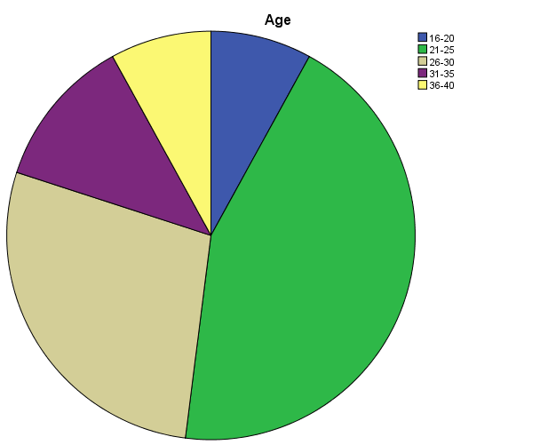
Table 4.1.3 Marital Status of Respondents
Marital Status |  | Frequency | Percent | Valid Percent | Cumulative Percent
Valid | Single | 71 | 71.0 | 71.0 | 71.0
Valid | Married | 29 | 29.0 | 29.0 | 100.0
Valid | Total | 100 | 100.0 | 100.0
Source: Field Survey 2016
Table 4.1.3 above indicates that 71(71%) respondents are single while 29 (29%) are married. This shows that majority of the respondents are single. The illustration is shown in the bar chart below.
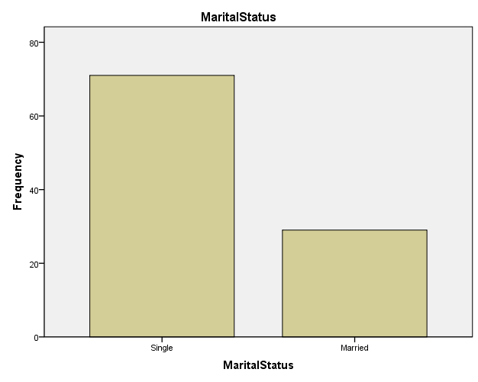
Table 4.1.4 Educational Qualification
Educational Qualification |  | Frequency | Percent | Valid Percent | Cumulative Percent
Valid | WAEC/NECO | 47 | 47.0 | 47.0 | 47.0
Valid | ND/NCE/HND | 41 | 41.0 | 41.0 | 88.0
Valid | B.Sc | 12 | 12.0 | 12.0 | 100.0
Valid | Total | 100 | 100.0 | 100.0
Source: Field Survey 2016
Table 4.1.4 above indicates that 47 (47%) respondents are holders of WAEC/NECO; 41 (41%) respondents hold ND/NCE/HND and the remaining 12 (12%) respondents are holders of B.Sc. This means that most of the respondents are SSCE holders. The expression above is further illustrated in the bar chart below.
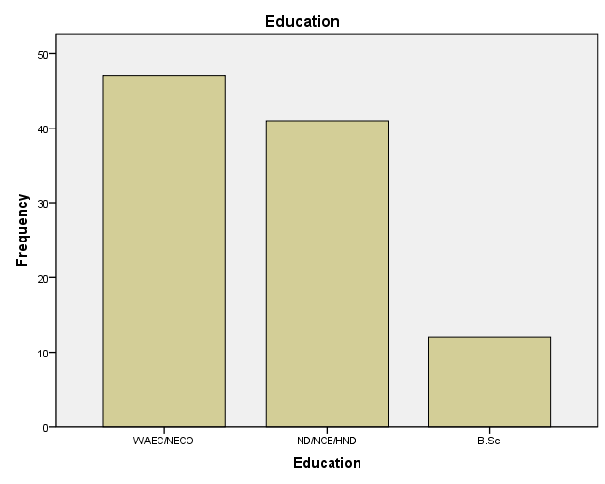
Table 4.1.5 Level of Respondents
Level |  | Frequency | Percent | Valid Percent | Cumulative Percent
Valid | 100 | 4 | 4.0 | 4.0 | 4.0
Valid | 200 | 17 | 17.0 | 17.0 | 21.0
Valid | 300 | 32 | 32.0 | 32.0 | 53.0
Valid | 400 | 47 | 47.0 | 47.0 | 100.0
Valid | Total | 100 | 100.0 | 100.0
Source: Field Survey 2016
Table 4.1.5 above indicates that 4 (4%) respondents are from 100 level; 17 (17%) respondents come from 200 level; 32 (32%) respondents are in 300 level and 47 (47%) respondents are in 400 level. This means most of the respondents are in 400 level.

4.2 The extent to which Taraba State University students watch Foreign Films.
Foreign films have found a place in the homes of many students and it has become virtually part of their daily lives. This point is not a deviation from the study as the field work revealed that all the respondents reached attest to the fact that they watch foreign films. The above research question has been addressed by questionnaire questions 6, 7 and 8. See table 4.2.6 below for details.
Table 4.2.6 Do you watch foreign films?
Response |  | Frequency | Percent | Valid Percent | Cumulative Percent
Valid | Yes | 100 | 100.0 | 100.0 | 100.0
Source: Field survey 2016
Table 4.2.6 above indicates that 100 (100%) respondents watch foreign films. This means that all the respondents watch foreign films.
In further examining this issue of foreign film viewership among students, the research investigated film preference among students of TSU and the result was alarming as most of the students would prefer foreign films to locally made ones. See table 4.2.7 with the details.
Table 4.2.7 Which of these categories of films do you prefer watching?
Response |  | Frequency | Percent | Valid Percent | Cumulative Percent
Valid | Foreign | 70 | 70.0 | 70.0 | 70.0
Valid | Local | 17 | 17.0 | 17.0 | 87.0
Valid | Both | 13 | 13.0 | 13.0 | 100.0
Valid | Total | 100 | 100.0 | 100.0
Source: Field Survey 2016
Table 4.2.7 above indicates that 70 (70%) respondents prefer watching foreign films while 17 (17%) prefer watching local films and 13 (13%) prefer watching both foreign and local films. This entails that most of the respondents prefer to watch foreign films. See pie chart below for further details.
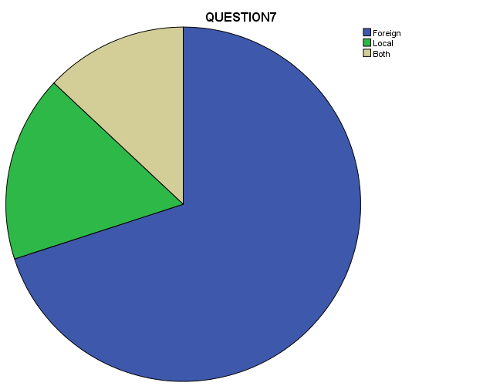
Aside the issue of measuring preference of films by students of TSU, the point that the research sought to establish was the frequency of such viewership. This is because, as good as it is to discover that most of the students would prefer foreign films, so is it with how often they devote their time to watching such films. In investigating such frequency, results from the field survey showed that most of the respondents are constant viewers of foreign films. See table 4.2.8 below for details.

Table 4.2. 8 How often do you watch foreign films?
Response |  | Frequency | Percent | Valid Percent | Cumulative Percent
Valid | Very often | 68 | 68.0 | 68.0 | 68.0
Valid | Often | 21 | 21.0 | 21.0 | 89.0
Valid | Rarely | 11 | 11.0 | 11.0 | 100.0
Valid | Total | 100 | 100.0 | 100.0
Source: Field Survey 2016
Table 4.2.8 indicates that 68 (68%) respondents watch foreign films very often and 21 (21%) respondents often watch foreign films whereas 11 (11%) rarely watch foreign films. See level of representation in the pie chart below.
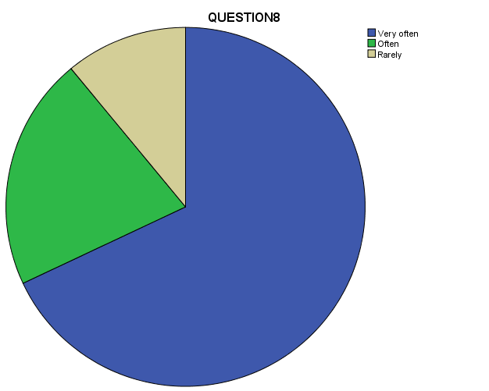

4.3 The extent to which foreign films influence the form of dressing of TSU students.
In looking at whether the students of TSU get influenced by the costumes worn in foreign films. The above research question has been addressed by questionnaire questions 9, 10 and 11. An issue that is of pertinence in terms of influence is that of attraction. This is because anything that is physical (e.g. clothe), before it can influence it must first attract. See table 4.3.9 below for details.
Table 4.3.9 Do you get attracted to the dressing pattern on foreign films?
Response |  | Frequency | Percent | Valid Percent | Cumulative Percent
Valid | Yes | 66 | 66.0 | 66.0 | 66.0
Valid | No | 34 | 34.0 | 34.0 | 100.0
Valid | Total | 100 | 100.0 | 100.0
Source: Field Survey 2016
The table above shows that 66 (66%) respondents agree that they get attracted to the dressing pattern depicted in foreign films whereas, 34 (34%) respondents disagree to it.
As to whether the costumes used in foreign films influence the dressing pattern of TSU students, the results gotten show a large proportion of respondent acceding to the claim stating that they get influenced. See table 4.3.10 below for details.

Table 4. 3.10 Does the dressing style on foreign films influence you?
Response |  | Frequency | Percent | Valid Percent | Cumulative Percent
Valid | To a large extent | 46 | 46.0 | 46.0 | 46.0
Valid | To some extent | 28 | 28.0 | 28.0 | 74.0
Valid | Not much | 26 | 26.0 | 26.0 | 100.0
Valid | Total | 100 | 100.0 | 100.0
Source: Field Survey 2016
Table 4.3.10 above indicates that 46 (46%) respondents get influenced by the dressing style in foreign films to a large extent; whereas 28 (28%) respondents get influenced to some extent and 26 (26%) fall within those not influenced much.
Coming to the preference of dresses, the outcome of the study is clear as most of the respondents prefer foreign to local dresses. More so, the reason behind such preference is traceable to their level of the viewership of foreign films which influences their choice of dressing. Besides, one can only prefer what influences him/her. This is illustrated in table 4.3.11 below.
Table 4.3.11 Would you prefer foreign or local dresses?
Response |  | Frequency | Percent | Valid Percent | Cumulative Percent
Valid | Foreign | 83 | 83.0 | 83.0 | 83.0
Valid | Local | 17 | 17.0 | 17.0 | 100.0
Valid | Total | 100 | 100.0 | 100.0
Source: Field Survey 2016
The table above indicates that 83 (83%) of the respondents prefer foreign dresses whereas 17 (17%) respondents prefer local dresses. This means that most of the respondents prefer foreign wears. This point is graphically presented below.
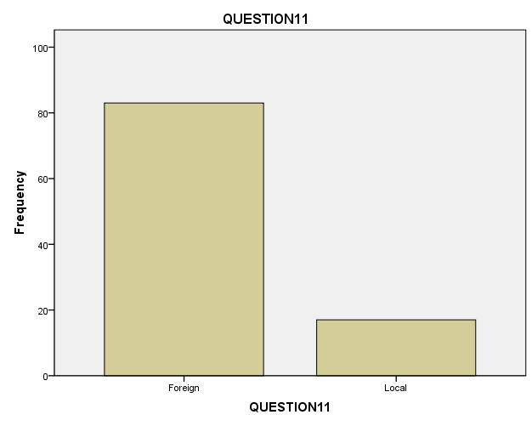
4.3 The extent to which Taraba State University Students adopt the dressing pattern and mode depicted in Foreign Films.
The above research question has been addressed by questionnaire questions 12 and 13. Therefore, in assessing the level of the influence of foreign films among TSU students as to whether they copy the mode of dressing depicted in foreign films. The study got an alarming result of the fact that most of the responses elicited demonstrate that the students of TSU copy the style of dressing depicted in foreign films. Table 4.4.12 below gives a clear detail.

Table 4.4.12 Do you copy the mode of dressing in foreign films?
Response |  | Frequency | Percent | Valid Percent | Cumulative Percent
Valid | Yes | 92 | 92.0 | 92.0 | 92.0
Valid | No | 8 | 8.0 | 8.0 | 100.0
Valid | Total | 100 | 100.0 | 100.0
Source: Field Survey 2016
The above table indicates that 92 (92%) respondents affirm that they copy the mode of dressing depicted in foreign films while 8 (8%) of the respondents do not affirm to it. This point is further illustrated below.
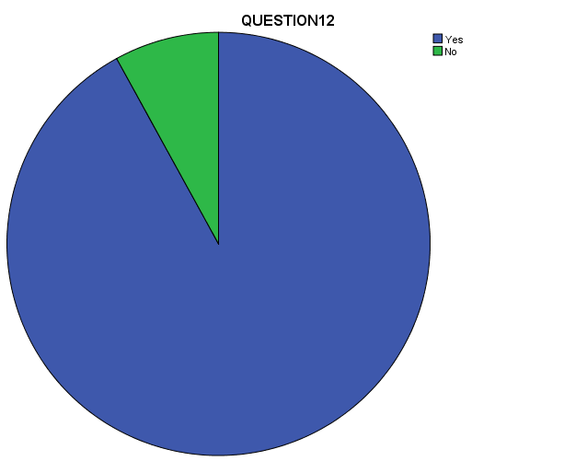
The study went ahead to know why the students copy the mode of dressing depicted in foreign films and the results showed variations of options. But most of them claim that the reason why they wear foreign dresses is because they look good on them. See table 4.4.13 below for details.
Table 4.13 Why do you copy the mode of dressing on foreign films?
Response |  | Frequency | Percent | Valid Percent | Cumulative Percent
Valid | I look good on them | 82 | 82.0 | 82.0 | 82.0
Valid | They are readily available | 8 | 8.0 | 8.0 | 90.0
Valid | I just feel like using them | 10 | 10.0 | 10.0 | 100.0
Valid | Total | 100 | 100.0 | 100.0
Source: Field Survey 2016
Table 4.4.13 indicates that 82 (82%) of the respondents give their reason for wearing foreign dresses because they look good on them; 8 (8%) say that they use them because they are readily available and 10 (10%) pointed out that they just feel like using them. More illustration is given in the pie chart below.
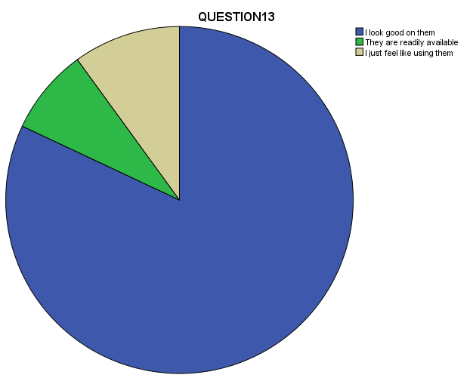
DISCUSSION OF FINDINGS
It is highly lamentable to notice from the study that foreign films have a lot of influence on the students of Taraba State University. Little wonder that Tobrise (1998) averred that, “film can actually mold a person’s life as people tend to be influenced by what they see in films that appeal to them”. The point that is so disturbing is the costumes that film stars use in depicting their character. These costumes were built for characters to project what their role purports to project but students view it as something they can use that will fit them.
In the light of the above, findings from the study revealed that students of Taraba State University watch foreign films. This is evidenced by the large proportion of responses elicited from the respondents on their viewership of foreign films (see table 4.2.6). Further investigation into foreign films among TSU students show that 70% of the respondents prefer foreign films to other films and 13% would like both foreign and local films leaving the remaining 17% respondents to local films. This means that virtually all the respondents are for foreign films. The problem here is that the preference one gives to something will determine the extent to which that thing will influence him. Little wonder that 89% of the respondents are frequent viewers of foreign films. For them to be frequently viewing such films, they are bound to cultivate the world depicted in films as the real world.
Furthermore, because students of TSU often watch foreign films, 66% of the responses show that they get attracted to the mode of dressing depicted in those films. This point takes us to the cultivation hypothesis which was earlier cited in the previous paragraph that deals with how students perceive the costumes depicted in films as the actual dressing in the real world. As a result, students of TSU get influenced by the dresses in foreign films (see table 4.3.10).
Additionally, because of the influence that costumes in foreign films have on the students, they tend to prefer foreign dresses to locally made ones. You can see the extent to which foreign films is taking students. They have little regard for locally made attires because they see them as not meeting the time and so would prefer the trends that are shown in foreign films. This point agrees with the findings from the field as results show that 83% of the respondents would prefer foreign dresses to locally made ones (see table 4.3.11). Because of such preference, they tend to dress in similar manner with the ones shown in those films (see table 4.4.12). This point compelled Ver (2012) to lament that students try to copy from the stars in films and are not mindful of the fact that some of the dresses they copy may be conveying messages of indecency. Stressing further, this scholar says that because indecent modes of dressings are heralded and embraced, and since it is not despised in the course of the film, it is accepted by the viewer and such depiction is encouraging students to copy same. Another issue raised is that of the reason behind the wearing of foreign dresses by the students of TSU. Findings show that 82% of the respondents wear foreign dresses because they look good on them, leaving the remaining 18% on the availability of the wears and those who just feel like using them (see table 4.4.13). Looking good on most of those foreign attires have been indicted by social scientists seeing that it leaves especially the female students almost have naked thus exposing them to rape and other societal vices. This goes to tell that students get influenced by their viewership of foreign films and such influence does not augur well for the society at large.
Test of Hypothesis
The hypothesis coined for the study stating that “Foreign Films do not influence the dressing habit of Taraba State University Students” has been rejected. This is based on the findings of the study which has clearly established that foreign films influence the dressing habit of Taraba State University students.

CHAPTER FIVE
5.0 SUMMARY, CONCLUSION AND RECOMMENDATION
5.1 Summary of Findings
This work represents an attempt to investigate the Influence of Foreign Films on the Dressing Habit of Taraba State University Students. Findings from the study show that:
- Students of Taraba State University watch foreign films and they prefer foreign films to locally made ones.
- They are frequent viewers of foreign films.
- They get attracted to the pattern of dressing depicted in foreign films and are influenced by it.
- They tend to adopt the mode and pattern of dressing that characters use in foreign films.
- As a result of their adoption of foreign dresses, they tend to prefer foreign to locally made wears.
- Students of TSU prefer foreign dresses because they are readily available and because they look good on them.
- Therefore, findings from the study in a general note show that foreign films influence the dressing habit of Taraba State University students.
2.1 Conclusion
The study conducted shows that the students of Taraba State University are influenced by the dressing pattern depicted in foreign films. This goes to tell that through their modes of dressing, they’ve not been able to promote local dresses but are rather promoting those from foreign sources. This study is in agreement with Umar (2000) who revealed in his study in Kaduna Polytechnic that students of Kaduna Polytechnic aside being influenced by foreign films would prefer foreign wears to locally-made ones. This point received the blessings of Aliu (1980) cited in Umar (2000) who lamented that Nigerian university students have become a brainwashed set of youths who think more of the transient and banal ideals of foreign cultures rather their own.
2.3 Recommendation
Based on the findings and the conclusion of this study, the researcher puts forth the following recommendations:
- Local movie-makers should intensify effort in making movies that will reflect indigenous culture especially in terms of dressing. This will go a long way in making students to learn to appreciate locally-made attires especially if they are depicted in movies.
- Nigerian Censors Board should devise measures that will curb the influx of too many foreign films and or contents that have the capacity to negatively influence students pattern of dressing.
- Since another reason given by students for using foreign wears is because of their availability, it is important for the textile factories in the country to manufacture fabrics that can compete favourably with foreign ones so as to encourage student to buy and use them.
- Educational institutions should do more in the area of imposing dress codes as that will help in reducing the extent to which students of tertiary institutions adopt the usage of foreign dresses.
- Finally, indigenous movie industries have being seen to be using foreign wears as costumes and that has to some extent promoted foreign dresses. Therefore, costumes of both Nollywood and Kannywood movies should reflect ingenious culture and not otherwise.

References
Gay, LR, Mills, GE & Airasian, P. (2006) Educational research: Competencies for analysis and applications. Eighth edition. New Jersey: Pearson Merrill Prentice Hall.
Bell, J. (2005). Doing your Research Project: A guide for first-time researchers in education, health and Social Sciences. 4th edition. New York: McGraw-Hill.
Chandler, D. (1995) Cultivation Theory. Retrieved 07:45, December 29, 2015. From: http://visual-memory.co.uk/daniel/Documents/short/cultiv.html
Cultivation Theory. (2015, December 8). In Wikipedia, The Free Encyclopedia. Retrieved 19:34, December 28, 2015, from https://en.wikipedia.org/w/index.php?title=Cultivation_theory&oldid=694360567
Davie, G. (2010, March 12). Cultivation Theory: How Violence Might Affect Us [Web log post]. Retrieved from 18:00, December 28, 2015 from http://masscommtheory.com/2010/03/12/cultivation-theory-how-violence-might affect-us/
Ekwazi, H. (1991). Towards the Decolonization of the African Film: Africa Media Review Vol. 5 No. 2.1991. African Council for Communication Education.
Eziechi, I. S (2010) The Influence of Western Television Programmes on the Cultural Values of Nigerian Youths (A Case Study of Caritas Students, Enugu). The Project Research Submitted in Partial Fulfilment of the award of Bachelor of Science (B.sc) degree in mass communication faculty of management and social science. Caritas university Amorji-Nike Enugu State. August, 2010 (Unpublished).
Gerbner, G., Gross, L., Morgan, M., Signorielli N.,& Shanahan, J. (1986). Living with television: the dynamics of the cultivation process. In Bryant J. & Zillmam D. (eds).
Ikwuba, A. (2012). An Assessment of Impact of Globalization on Dressing Style of Undergraduate Students of Benue State. Journal of Social Science and Policy Review Volume 4, September 2012: 2012 Cenresin Publications.
Jen, S. (2004). Fundamentals of Research Methodology. Yola Paraclete publishers.
Johnson, B & Christensen, L. (2008). Educational research: Quantitative, qualitative and mixed approaches. Third edition. United Kingdom: SAGE Publications.
Mangwere, A. Wadesango N. and Kurebwa M. (2013) Influence of the Electronic Media on the Behaviour of Children/ Teenagers in Zimbabwe. J Communication, 4(2): 101-109 (2013) Kamla-Raj 2013. Walter Sisulu University, East London Campus, RSA.
McMillan, J.H. & Schumacher, S. (2001) Research in Education: A Conceptual Introduction. United States: Longman.
McQuail, D. (1979) The Influence and Effects of the Media. From Mass Communication and Society. 70-79, Sage Publications.
Odinma C. (2013) Influence of Hollywood films on the moral values of youths. (Unpublished).
Oketumbi, E.O.O (2014) Influence of Foreign Movies on Cultural Practices among Undergraduates in Selected Universities in Nigeria. PhD Pre-Field Presentation: PDF.
Olaleye V. (2007) Perception of Nigerian youths on the influence of western films. Unpublished undergraduate long essay of the Department of Mass Communication, College of Development Studies, Covenant University.
Oyero, O. S. and Oyesomi, K. O. (2014) Perceived Influence of Television Cartoons on Nigerian Children’s Social Behaviour. Estudos em Comunicação No: 17. 93-116. Center Cir, Ota, Nigéria
Robson, C. (2007) How to do a Research Project: A Guide for Undergraduate Students. USA: Blackwell Publishing Ltd.
Royster, S and Dennis, V (2013) From script to screen: Careers in film production. Retrieved from www.bls.gov/ooq • Summer 2013 (PDF)
Saima, Z., Arshad, A. and Saira S. (2014) Effects of fashion shows of TV channels on the dressing style of female students at the University of Gujarat. Journal of Humanities and Social Science (IOSR-JHSS) Volume 19, Issue 4, Ver. VII (Apr. 2014), PP 79-97
Semiu, B. (2011) Impact Assessment of Western Films on Teenagers and the Question of Cultural Promotion in African Society.
Shanahan, J. and Morgan, M. (1999) Cultivation Theory and Research. Cambridge University Press, United Kingdom.
Shodhanga (n.d) Cinema as a Medium of Communication and Mass Communication (PDF).
Student Handbook of Undergraduate Programmes of Mass Communication, Taraba State University, Jalingo. 2012-2017
Umar, C.G (2000) Influence of Foreign Films on the Dressing Habit of Kaduna Polytechnic Students. A project submitted to the Department of Mass Communication and Languages in partial fulfilment of the Award of Higher National Diploma in Mass Communication. Kaduna Polytechnic, Kaduna (Unpublished).
UNESCO (1961) Reports and Papers on Mass Communication: The Influence of the Cinema on Children and adolescents-An Annotated International Bibliography. No 13. UNESCO, Paris.
Vasan, A. (2010) Films and TV: Viewing Patterns and Influence on Behaviours of College Students Health and Population Innovation Fellowship Programme Working Paper, No 13, New Delhi: Population Council.
Vasudev, A. (1986). Foreign Films and their Influence on Cultural Values - the Indian Experience. In AMIC-CSDWACC Seminar on the Communication Revolution in Asia : New Delhi, Aug 21 23, 1986. Singapore: Asian Mass Communication Research & Information Centre.

Ver, W.Z (2012 ) Hollywood Dress Habits and its effect on University Students. A paper presented at the International Conference themed Nollywood, Women and Cultural Identity, held at the Benue State University, Makurdi- Nigeria. 8th-11th May, 2012.
White, L.A. (2000) Reconsidering cultural imperialism theory. Peer Reviewed Paper Competition Winner: Global Fusion. Florida State University.
Wok, S. and Mohd, S. (2007) The Impact of TV and Magazine on Fashion and Dressing of Urban Women of Different Ages. Jurnal Pengajian Media Malaysia/ Malaysian Journal of Media Studies.
Wood, J.T (1994) Gendered Media: The Influence of Media on Views of Gender. From Gendered Lives: Communication, Gender, and Culture by Julie T. Wood, Chapter 9, pp. 231-244. 0 1994. Reprinted with permission of Wadsworth Publishing, a division of Thomson Learning. Fax 800-730-2215 (PDF).

Appendix I
Questionnaire

Faculty of Arts and Social Sciences
Department of Mass Communication
Taraba State University
P.M.B 1167, Jalingo
Taraba State.
Dear Respondents,
I am a final year student of the above institution in the address, who is currently carrying out a research on the topic ―Influence of Foreign Films on the Dressing Habit of Taraba State University Students. This study is in partial fulfilment of the requirements for the award of a Bachelor of Science (B.sc) degree in mass communication at Taraba State University, Jalingo Taraba state.
To accomplish this research work, you are expected to help the researcher by responding to these questions. This is purely an academic exercise and the confidentiality of information you give is assured. Thanks for your co-operation.
Yours Faithfully
Shitta Bweseh Habila

Appendix II
Please tick appropriately in the space provided. The questionnaire is divided into two parts namely part A which contain demographic data and part B.
Part A:
(1) Gender:
(a) Male [ ] (b) Female [ ].
(2) Age:
(a) 16-20 [ ] (b) 21-25 [ ] (c) 26-30 [ ] (d) 31-35 [ ] (e) 36-40 [ ] (f) 41 and above [ ].
(3) Marital Status:
(a) Single [ ] (b) Married [ ] (c) Divorced [ ] (d) widows/ widowers [ ].
(4) Educational Qualification:
(a) WAEC/NECO [ ] (b) ND/NCE/HND [ ] (c) B.sc [ ] (d) Masters [ ] (e) Ph.D. [ ].
(5) Level
(a) 100 [ ] (b) 200 [ ] (c) 300 [ ] (d) 400 [ ] (e) 500 [ ].
Part B:
(6) Do you watch foreign films?
(a) Yes [ ] (b) No [ ].
(7) Which of these categories of films do you prefer watching?
(a) Foreign [ ] (b) Local [ ] (c) Both [ ].
(8) How often do you watch foreign films?
(a) Very often [ ] (b) Often [ ] (c) Rarely [ ] (d) Never
(9)Do you get attracted to the dressing pattern on foreign films?
(a) Yes [ ] (b) No [ ].
(10) Does the dressing style on foreign films influence you?
(a) To a large extent [ ] (b) To some extent [ ] (c) Not much [ ] (d) No
(11) Would you prefer foreign or local dresses?
(a) Foreign [ ] (b) Local [ ].
(12) Do you copy the mode of dressing on foreign films?
(a) Yes [ ] (b) No [ ].
(13) Why do you copy the mode of dressing on foreign films?
(a) I look good on them [ ] (b) They are readily available [ ] (c) I just feel like using them [ ].
(d) State other reason (s) [ ]

