DESIGN AND IMPLEMENTATION OF AN AUTOMATIC SMART WATER TAP

BY:
JIMOH WASIU KAYODE

ND/22/COM/PT/307

A Project Submitted to the Department of Computer Science, Institute of Information and Communication Technology, Kwara State Polytechnic, Ilorin

In Partial Fulfillment of the Requirements for the Award of National Diploma (ND) in Computer Science

July, 2025
CERTIFICATION
This is to certify that this project was carried out by JIMOH WASIU KAYODE, with matriculation number ND/22/COM/PT/302, has been read and approved as meeting part of the requirements for the award of National Diploma (ND) in Computer Science.

………………………………. ……………………………….
Dr. (Mrs.) OLUSI, T. Date
(Project Supervisor)

………………………………. ……………………………….
Mr. Oyedepo, F. S. Date
(Head of Department)

………………………………. ……………………………….
External Examiner Date

DEDICATION
This project is dedicated to the creator of the earth and universe, the Almighty God. It is also dedicated to my parents for their moral and financial support.

ACKNOWLEDGEMENT
All praise is due to the Almighty God the Lord of the universe. I praise Him and thank Him for giving me the strength and knowledge to complete my ND program and also for my continue existence on the earth.
I appreciate the utmost effort of my supervisor, Dr. (Mrs.) Olusi, T. whose patience support and encouragement have been the driving force behind the success of this research work. She gave useful corrections, constructive criticisms, comments, recommendations, advice and always ensures that an excellent research is done. My sincere gratitude goes to the Head of the Department and other members of staff of the Department of Computer Science, Kwara State Polytechnic, Ilorin, for their constant cooperation, constructive criticisms and encouragements throughout the program.
Special gratitude to my parents who exhibited immeasurable financial, patience, support, prayers and understanding during the periods in which I was busy tirelessly in my studies. Special thanks go to all my lovely siblings.
My sincere appreciation goes to my friends and classmates.

TABLE OF CONTENTS
Title Page i
Certification ii
Dedication iii
Acknowledgements iv
Abstract v
Table of Contents vi
CHAPTER ONE: GENERAL INTRODUCTION
  - Background to the Study 1
  - Statement of the Problem 3
  - Aim and Objectives of the Study 3
  - Significance of the Study 4
  - Scope of the Study 4
  - Organization of the Report 5
CHAPTER TWO: LITERATURE REVIEW
2.1 Review of Related Works 6
  - Review of Related Concepts 10
2.2.1 Infrared Sensor Technology 10
2.2.2 Overview of Microcontroller Applications 12
2.2.3 Overview of Artificial Intelligence 12
2.2.4 Artificial Intelligence in Water Sensor Tap 14
2.2.5 Automatic Water Sensor Tap 14
CHAPTER THREE: RESEARCH METHODOLOGY AND ANALYSIS OF THE EXISTING SYSTEM
  - Research Methodology 16
  - Analysis of the Existing System 16
  - Problems of the Existing System 17
  - Description of the Proposed System 17
  - Advantages of the proposed system 18
CHAPTER FOUR: DESIGN, IMPLEMENTATION AND DOCUMENTATION OF THE SYSTEM
  - Design of the System 19
    - Output Design 19
    - Input Design 23
4.1.3 Procedure Design 25
  - Implementation of the System 25
    - Choice of Programming Language 26
    - Hardware Support 26
    - Software Support 26
  - Documentation of the System 27
    - Program Documentation 27
    - Maintaining the System 27
CHAPTER FIVE: SUMMARY, CONCLUSION AND RECOMMENDATION
  - Summary 29
  - Conclusion 29
  - Recommendation 30
References
Appendices

ABSTRACT
This project explores the design and implementation of an automatic water sensor tap aimed at addressing issues of water wastage and promoting efficient water management. The work aimed to switch ON and OFF a water tap automatically without the need of turning it manually. It employs a passive Infrared (PIR) Sensor which has a maximum sensitivity of about 3m. The sensor detects the presence of a user within its viewing range and responds by giving a high at its output. The automatic sensor water tap incorporates a microcontroller (PIC16F628A) which was programmed using the ‘C’ programming language and turns ON the tap automatically whenever the sensor senses a user, and turns OFF when the user moves back. This research has successfully provided the improvement on existing water condition by which human beings get the good quality of water.

CHAPTER ONE
GENERAL INTRODUCTION
  - BACKGROUND TO THE STUDY
Water is the available natural resources on earth, which has to be utilized efficiently. Also it has to be provided without wastage to face the problem of scarcity with appropriate quantity and quality. Water bodies cover 70% of earth surface out of this only 3% of water is portable and drinkable. Water conservation is a critical global concern, with increasing demand and dwindling resources exacerbating the issue (Karthikeyan et al., 2022).
Traditional taps often lead to significant water wastage due to user negligence or improper closure. The advent of sensor-based technology provides an innovative approach to mitigate these challenges. The problem to find a new water source, need to pay a high-water bill and the difficulty that been facing by disabled people to used water tap becomes the reason why systems like this are needed to be built (Khulal & Ranganayakulu, 2024)
Mohammed and Mohammed (2020) explained that water scarcity affects billions globally, necessitating efficient management practices. Traditional water dispensing systems are prone to wastage, particularly in public facilities where taps are often left running. Automatic water taps, equipped with sensors, offer a practical solution by activating water flow only when a user is detected, thus minimizing waste. However, challenges such as inconsistent detection accuracy and power dependency have limited their widespread adoption.
The concept of an automatic water tap was first introduced by the Australian inventor Norman Wareham. Norman Wareham initiated electronic controls of water flow for domestic, commercial, medical and industrial sector. The automatic faucet is equipped with a proximity sensor. The working mechanism helps to opens its valve to flow water in response to the presence of a user’s hands in close proximity. The water tap closes its solenoid valve, after a few seconds when it no longer detects the presence of a user’s hands. The developed system is able to control the water tap to protect the wastage of water (Pahalson & Dayer, 2019). This device developed is very-cost if compared to this proposed system.
Automatic sensor taps offer the benefit of improved hygiene, by eliminating the need to physically turn the knob of the tap ON or OFF. This eliminates the chance of re-contaminating one’s hand by touching the same handle that was previously touched by not only your unwashed hands, but by that of those before you. This tap greatly reduces the chances of water wastage which may arise if one forgets to turn off the tap after use or turned it only partially off out of haste. By implication, when installed in home, sensor taps alleviate the need for parents to ensure that their children have turned off taps. Economically, sensor taps use less water, resulting in direct savings on water bills (Sinaga et al, 2023).
Additionally, the integration of advanced microcontroller technology and infrared sensors presents an opportunity to enhance the efficiency of automatic taps. These innovations aim to address the shortcomings of existing systems while ensuring affordability and environmental sustainability (Wanga et al., 2020).
This project emphasizes bridging the gap between technological advancements and practical implementation to promote global water conservation. Automatic water tap or faucet is a tap equipped with an IR sensor and mechanism that opens its valve to allow water to flow in response to the presence of an object nearby to the sensor. The advantage of this system is, it will work very accurate because the system will let the water flow out only when the sensor sense the present of human and it automatically stop the water flow when the sensor do not detect any motion of human. It will minimize the water waste because water only flow out when someone used the water tap.
This study seeks to address the existing system barriers by developing a cost-effective, user-friendly, and reliable system.
  - STATEMENT OF THE PROBLEM
Usually, most of the water taps available today used the old system where it uses manual control to turn ON or OFF the system. The water tap is easy to be spoiled due to frequent turning as some people do not know how to carefully handle it. The manual operation of traditional taps often results in excessive water wastage due to human error or negligence. This inefficiency not only exacerbates water scarcity but also increases utility costs and environmental impact. Another disadvantage of the older system is that, when users wash their hands, their hands are not always clean because they still have a direct contact with the messy tap which is exposed to germs. Existing automatic taps are frequently cost-prohibitive and require significant maintenance, limiting their accessibility and usability. There is a need for a more affordable, efficient, and reliable solution to tackle these issues.
  - AIM AND OBJECTIVES OF THE STUDY
The aim of this project is to design and implement a cost-effective and efficient automatic water sensor tap to promote water conservation and reduce wastage. The objectives are to:
- Design a sensor-based tap system capable of detecting user presence;
- Implement and test the designed system for effectiveness and efficiency; and
- Evaluate the economic and environmental benefits of the proposed system.
  - SIGNIFICANCE OF THE STUDY
This project contributes to global water conservation efforts by addressing inefficiencies in traditional water dispensing systems. The proposed solution offers practical applications in residential, commercial, and industrial settings. By reducing water wastage and operational costs, it supports sustainable resource management and environmental protection. Also, the system will reduce the need to pay a high-water bill and the difficulty that has been facing by disabled people to used water tap becomes the reason why this system is built
  - SCOPE OF THE STUDY
The study focuses on the design, development, and testing of an automatic water sensor tap. It examines the system's functionality, efficiency, and cost-effectiveness. The implementation scope is limited to small-scale applications, such as households and public restrooms, with potential scalability for broader applications.
1.6 ORGANIZATION OF THE REPORT
The project write-up is organized into five distinct chapters. Chapter one covers general introduction, which contains introduction to the project topic, statement of the problem, aim and objectives of the study, significance of the study, scope of the study and organization of the report. Chapter two covers the literature review, which contains review of related past works, overview of artificial intelligence, description infrared sensor, automatic water sensor tap and other related concepts. Chapter three explains the project methodology which includes analysis of existing system, problems of the existing system, the description of the proposed system and advantages of proposed system. Chapter four explains the design, implementation and documentation of the system which contain system designed output design, input design, procedure design, implementation of the system hardware and software support and documentation of the new system installation procedure, operating the system and system maintenance. Lastly, chapter five explains the summary of the research, recommendations, and conclusion.

CHAPTER TWO
LITERATURE REVIEW
2.1 REVIEW OF RELATED LITERATURE
Muhammad and Mohammad (2020) developed an automatic water tap system. The aim of the paper is to develop an automatic water tap system that can reduce the water wasting in our daily life and save water bill so it can reduce life cost. It's also can help disabled people to used water tap in easy way. This system can be used at residence, school, mall and mosque. In the system, Arduino Uno was used as microcontroller and LDR sensor also been used to detected a user. When the sensor detects the user, the system will let the water flow out. The microcontroller receives the signal from sensor and will send the signal to L239B (motor driver) to control the motor rotation. It will control the motor to rotate clock wise or anti-clock wise for open and close the water tap. The LED also been used in this system. The water flows out accurately because it only flows when the sensor senses the user hand and it automatically stop the water flow when there is nobody uses the water tap. The result shows that the system is able to save water and automatically detect a hand when placed under the tap.
Khulal and Ranganayakulu (2024) implemented an automatic water tap. The paper presented the development of an automatic water tap based on an industrial grade adjustable infrared sensor. A typical Automatic water tap can switch the device on and off continuously and mitigate the usage of water from wastage. The industrial grade adjustable sensor is used which can sense transparent or opaque with maximum sensitivity of about 80 cm. Active infrared sensor emits and receives infrared radiation, which detects the presence of objects nearby and bounces back to the receiver of the device. The high or low signal generated by the IC is used to control the water flow by switching the solenoid valve and vice versa. The overall design and unique feature an automatic water tap makes the product user-friendly. It is comfort and easy to plug in a regular water pipe socket for standard hand-washing. The extensively tested of device results to achieve the high levels of reliability. By considering the hygienic to avoid cross contamination, automatic water taps make significant on saving water.
Pahalson and Daya (2019) worked on the design and implementation of an automatic sensor water tap for hand washing. The research is a design and implementation of an automatic sensor water tap for hand washing. The work aimed to switch ON and OFF a water tap automatically without the need of turning it manually. It employs a passive Infrared (PIR) Sensor which has a maximum sensitivity of about 3m. The sensor detects the presence of a user within its viewing range and responds by giving a high at its output. The automatic sensor water tap incorporates a microcontroller (PIC16F628A) which was programmed using the ‘C’ programming language and turns ON the tap automatically whenever the sensor senses the user’s hand, and turns OFF when the hand is withdrawn.

Sinaga et al., (2023) proposed an automatic water faucet system using the IOT based HC-SR04 sensor. In the system, the concept of the Internet of Things (IoT) emerges as a potential solution by connecting physical objects via the internet. This research designs and builds an IoT-based automatic water faucet system using the HC-SR04 sensor to measure the water level in a container. Hardware components such as Node mcu Esp8266, Infrared Sensor, 2 channel 5v Relay, and others are used to control the system automatically. The software used includes the Arduino IDE. This system aims to intelligently monitor and control water flow, prevent water wastage, and incorporate the advantages of IoT technology to create an automatic water faucet system that is responsive to water levels and the presence of objects in front of it.
Karthikeyan et al., (2022) designed an automatic water tap. The aim of the project is to build and to test a smart tap system. The Smart tap system is more advanced than the conventional method and it is designed to improve life by having a more convenient drinking water filling in containers. The project was created and implemented as a prototype of automatic water tap. The aim of this project is to build and test a smart tap system using IR sensor. The smart tap system is used to turn over water from source point to usage point in an efficient way and avoids human error. This involves Arduino Nano, IR Sensor, Solenoid Valve and 7805 IC. Automated water supply can be done through embedded system in cost effective way. The smart tap system is actually a smart system as the people who wish to drink water without turning on the water tap. This project works on automated on/off tap when sensed by a sensor. This research has successfully provided the improvement on existing water condition by which human beings get the good quality of water.
Wanga (2020) proposed a war against coronavirus (COVID – 19) in Tanzania: designing a low-cost automatic water tap. In the paper, an attempt has been made
to design a low-cost automatic water tap as a measure to fight the spread of Coronavirus (Covid-19). The designed system uses simple, easy to get and low-cost instruments. The system does not require a user to touch the water tap. It uses microcontroller to implement intelligence. The solar panel is used as a source of power. The system design uses green solution based automatic water tap. The system will be used in gatherings to avoid Coronavirus spreading. Such gathering places include hospitals, markets, bus stops, public transports, churches, mosques, and restaurants.

2.2 REVIEW OF RELATED CONCEPTS
2.2.1 Infrared Sensor Technology
Infrared (IR) sensor technology involves the use of infrared light to detect objects, measure distances, or sense heat. Infrared sensors operate by emitting infrared radiation and detecting the changes in the reflected or transmitted signals. This technology finds widespread use in proximity sensing, motion detection, temperature measurement, and environmental monitoring. The versatility of infrared light, which is invisible to the human eye, makes these sensors ideal for non-intrusive and non-contact applications, ensuring minimal interference with the observed object or environment (Prima et al., 2017).
One common application of infrared sensors is in remote control devices. They transmit infrared signals to control various appliances such as televisions and air conditioners. These sensors are also critical in industrial automation, where they detect object presence, position, or motion in manufacturing lines. Similarly, IR sensors are employed in security systems for intrusion detection, as they can effectively sense motion and heat from humans or animals.
Infrared sensors come in two main types: active and passive. Active infrared sensors emit infrared light and measure the reflections to determine distance or motion. In contrast, passive infrared (PIR) sensors detect infrared radiation emitted naturally by objects, such as human body heat. This makes PIR sensors a popular choice for energy-efficient lighting systems and security cameras, as they can trigger actions like turning on lights when movement is detected.
As technology advances, IR sensors are becoming more sensitive, compact, and affordable. They are integral in applications like health monitoring, where they measure heart rate and oxygen levels through infrared light absorption. With the rise of smart devices and IoT systems, infrared sensor technology is poised to play an even more significant role in creating intelligent, connected solutions for everyday challenges (Zhang & Liu, 2020).
2.2.2 Overview of Microcontroller Applications
Microcontrollers are compact computing devices that integrate a processor, memory, and input/output peripherals onto a single chip. They are the brains behind many electronic devices, enabling automation, control, and communication in a vast array of applications. Microcontrollers are specifically designed for embedded systems, where they execute dedicated tasks efficiently, making them an essential component of modern technology (Amin, 2020).
One of the most common applications of microcontrollers is in consumer electronics. They are found in appliances like washing machines, refrigerators, and microwaves, where they control operations and user interfaces. In automotive systems, microcontrollers are crucial for functions such as engine control, anti-lock braking systems, and infotainment. Similarly, in healthcare devices like glucose monitors and pacemakers, microcontrollers ensure precise control and reliability.
In industrial environments, microcontrollers enable process automation and monitoring. They are at the heart of robotic systems, controlling movements, sensors, and actuators. They also manage energy-efficient lighting systems and HVAC (heating, ventilation, and air conditioning) units in buildings. The rise of IoT has further expanded their utility, allowing devices to communicate and share data for intelligent decision-making.
Advancements in microcontroller technology are leading to greater computational power, lower energy consumption, and enhanced connectivity. Modern microcontrollers often feature wireless communication capabilities, such as Bluetooth and Wi-Fi, enabling seamless integration into smart ecosystems. As industries continue to innovate, microcontrollers will remain a pivotal technology for enabling smarter, more efficient systems (Ihsan et al., 2021).
2.2.3 Overview of Artificial Intelligence

Artificial Intelligence (AI) refers to the development of computer systems that can perform tasks typically requiring human intelligence. These tasks include learning from experience, reasoning, problem-solving, understanding natural language, and visual perception. AI leverages algorithms, data processing, and computational power to mimic cognitive functions, enabling machines to make decisions or predictions.
AI can be broadly categorized into narrow AI and general AI. Narrow AI, which focuses on specific tasks, is prevalent in applications like virtual assistants, recommendation systems, and autonomous vehicles. General AI, on the other hand, aims to replicate human-level intelligence across a wide range of tasks, though it remains a theoretical concept in current research. Machine learning, a subset of AI, is a pivotal technique where systems learn from data to improve their performance over time (Kumar, 2022).
Industries across the board are adopting AI to enhance efficiency and innovation. In healthcare, AI algorithms assist in diagnosing diseases, predicting patient outcomes, and personalizing treatment plans. In finance, AI-powered systems analyze market trends, detect fraudulent transactions, and optimize investment strategies. Additionally, AI is revolutionizing education, agriculture, and entertainment by automating processes and enabling new experiences.
Despite its immense potential, AI also presents ethical and technical challenges. Issues such as bias in algorithms, privacy concerns, and job displacement must be addressed as the technology evolves. Responsible development and regulation are critical to ensuring that AI serves humanity effectively while minimizing risks and inequities (Mashilkar et al., 2018).
2.2.4 Artificial Intelligence in Water Sensor Tap

Artificial Intelligence in Water Sensor Tap
Integrating Artificial Intelligence (AI) into water sensor taps transforms these devices into intelligent systems that optimize water usage and enhance user convenience. AI enables the tap to analyze patterns of water consumption and adapt its operation to minimize wastage. For instance, it can adjust the water flow rate based on the detected level of dirt on hands or the type of activity being performed.
AI-powered water sensor taps use advanced machine learning models to process data from various sensors, such as proximity, pressure, and flow sensors. This allows the system to detect not only hand movements but also contextual cues like water temperature preferences. By learning user habits, the tap can provide personalized settings, improving the overall user experience while conserving resources (Tibe et al., 2021).
These systems can also be connected to IoT networks for remote monitoring and control. Facility managers can access real-time data on water usage through dashboards and receive alerts in case of anomalies, such as leaks or unusually high consumption. AI algorithms can analyze this data to predict maintenance needs, ensuring the taps operate efficiently and reducing downtime.
The combination of AI and water sensor taps is a significant step toward sustainable technology. By reducing water waste and providing data-driven insights, these systems align with global efforts to address water scarcity and promote environmental conservation. As the technology evolves, it has the potential to be widely adopted in homes, businesses, and public spaces (Tibe et al., 2021).
2.2.5 Automatic Water Sensor Tap
Automatic water sensor taps are a modern solution for minimizing water waste and enhancing hygiene. These taps operate using sensors that detect the presence of hands or objects, automatically activating water flow without the need for physical contact. This touchless functionality not only conserves water but also reduces the spread of germs and bacteria, making them ideal for public restrooms and healthcare facilities.
The core technology behind automatic water sensor taps includes infrared sensors or ultrasonic sensors, which detect proximity or motion. When an object is detected, the sensor sends a signal to a control unit that activates the solenoid valve, allowing water to flow. Once the object is removed, the valve closes, ensuring water is used only when needed.
In addition to basic functionality, advanced models incorporate features like adjustable flow rates, temperature controls, and timers. Some taps are equipped with smart capabilities, enabling integration with IoT systems for remote control and monitoring. This makes them especially useful in commercial settings, where optimizing resource usage and maintenance is a priority.
The widespread adoption of automatic water sensor taps reflects a growing emphasis on sustainability and convenience. These taps significantly reduce water wastage by preventing accidental overflows or continuous flow when the tap is left running. As awareness of environmental conservation increases, automatic water sensor taps are becoming a standard fixture in modern infrastructure (Vedula et al., 2020).

CHAPTER THREE
RESEARCH METHODOLOGY AND ANALYSIS OF THE EXISTING SYSTEM
3.1 RESEARCH METHODOLOGY
In this system, Arduino Uno will be used as microcontroller and IR sensor also will be used to detected a user. When the sensor detects the user, the system will let the water flow out. The microcontroller receives the signal from sensor and will send the signal to L239B (motor driver) to control the motor rotation. It will control the motor to rotate clock wise or anti-clock wise for open and close the water tap. The LED also been used in this system. The water flows out accurately because it only flows when the sensor senses the user hand and it automatically stop the water flow when there is nobody using the water tap. Below is the block diagram of the proposed automatic water sensor tap.
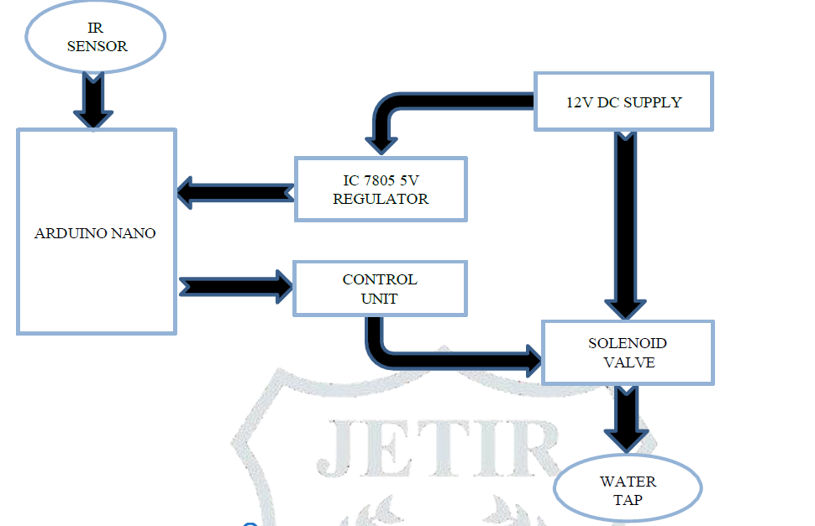
Figure 3.1: The Block Diagram of Automatic Water Tap
3.1.1 Materials Needed
i. IR Sensor
An infrared sensor is an electronic module which is used to sense certain physical appearance of its surroundings by either emitting and/or detecting infrared radiation. IR sensors are also capable of determining the heat being emitted by an object and detecting motion.
ii. Microcontroller
Microcontroller is a complete microprocessor system contained on a chip. Microcontrollers are different from multipurpose microprocessors used in a PC, because a microcontroller generally contains components that support a minimal microprocessor system, namely memory and Input-Output programming. Microcontrollers can be programmed to perform calculations, receive input and produce output. Microcontrollers are used in automatically controlled products and devices, such as machine control systems, remote controls, office machines, household appliances, heavy equipment, and toys.
iii. TPN122 NPN Transistor
It is a Darlington braces NPN transistor. It works like an ordinary NPN Transistor but as it consists of a Darlington pair it has a decent collector current assessment of nearby 5 amperes and its gain is around 1000. This transistor is famous for its higher gain of current which 1000 and it uses higher current at collector which is 5 amperes. Due to its higher gain of current and huge collector current (IC), it is used in such loads which use higher current and its uses for such submissions which required higher amplification.
iv. IC 7805 (Voltage Regulator)
7805 is an IC used for voltage regulation and comes in TO-220 version. This component belongs to 78xx series where xx defines the output voltage it generates. It is a compact IC that comes with a built-in protection circuit that avoids the circuits from too much heating, making it suitable for circuits drawing high current. The input voltage range applied to the input terminals of this IC varies from 7 V to 18 V (in some cases 7 to 35 V), resulting in the generation of constant output voltage around 5 V.
v. Solenoid Valve
Solenoid valve function involves either opening or closing an orifice in a valve body, which either allows or prevents flow through the valve. The solenoid valve consists of coil and plunger attached to spring. In our project we have used Normally Closed solenoid valve. In Normally Closed type solenoid valve, the water flow is restricted by the plunger. When the coil gets energized, the spring moves up along with plunger. So, the water flows through the valve.
vi. Arduino IDE
Arduino uno can be programmed with Arduino software. The Arduino IDE was developed from Processing software which was overhauled into an Arduino IDE specifically for programming with Arduino. Programs written using Arduino Software (IDE) are called sketches. Sketches are written in a text editor and saved in files with the extension IDE stands for Integrated Development Environment or in simple language is an integrated environment used for development. It is called an environment because it is through this software that Arduino is programmed as a built-in function with programming syntax. Arduino uses its own programming language, which is similar to C language.
3.2 ANALYSIS OF THE EXISTING SYSTEM
Existing water dispensing systems, both manual and automatic, exhibit several limitations. Manual systems are prone to user negligence, leading to wastage. Current automatic systems often require substantial investment and maintenance, limiting their adoption. Additionally, these systems may lack adaptability for diverse use cases.
3.3 PROBLEMS OF THE EXISTING SYSTEM
The existing water tap systems primarily rely on human intervention by manually turning it on or off. Studies have highlighted the need for systems that can operate autonomously. Problems of the existing system are:
- High water wastage in manual systems.
- High cost and complexity of existing automatic systems.
- Limited accessibility and usability for diverse environments.
3.4 DESCRIPTION OF THE PROPOSED SYSTEM
The proposed system incorporates an infrared sensor to detect user presence and control water flow. A microcontroller processes sensor signals to open or close a solenoid valve, ensuring precise operation. The system is designed for minimal energy consumption and easy installation, making it suitable for various applications. The proposed system’s design also prioritizes user convenience by employing a compact and modular structure, allowing for seamless integration into existing plumbing setups. This adaptability ensures minimal disruption during installation and promotes faster adoption in various settings, including residential and commercial facilities. By focusing on a user-centric approach, the system caters to a wide range of needs while maintaining high standards of efficiency and reliability.
3.5 ADVANTAGES OF THE PROPOSED SYSTEM
Advantages of the proposed system are:
- Significant reduction in water wastage.
- Cost-effective and accessible design.
- Low maintenance requirements.
- Environmental and economic benefits.

CHAPTER FOUR
DESIGN, IMPLEMENTATION AND DOCUMENTATION OF THE SYSTEM
4.1 DESIGN OF THE SYSTEM
The design of the automatic water tap integrates sensors, Arduino microcontroller, and solenoid valve to open and close the water faucet. It features transistor and voltage regulator for voltage regulation, a microcontroller for processing data and executing control algorithms, and sensors, for detecting bodies. The system can be implemented in a house, an office or for an industry.
4.1.1 OUTPUT DESIGN
The output design of the automatic water sensor tap is discussed in this section. Plastic was used for casing, the electronic circuit and its circuitry. The casing is made up of a plastic sheet of the following dimensions; length 18cm, breadth 15cm and height 8cm. A space was created on the top of the box to accommodate the LCD. The system uses a plastic tank of volume 30 litres. The solenoid valve used has a diameter of 0.5 inch. Things taken into consideration in determining the output are represented below:
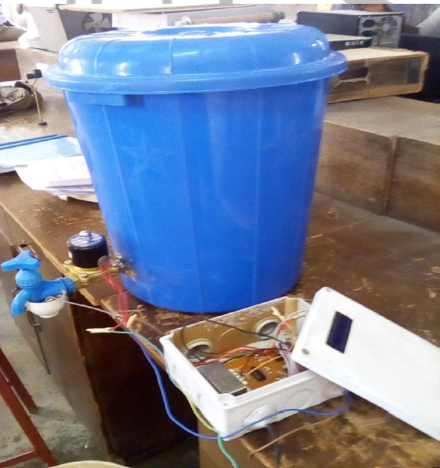
Figure 4.1: The Automatic Water Sensor Tap
The picture above is the automatic water sensor tap. If the IR sensor of the water tap a hand or human very close, it will start rushing out water with the help of the valve and stop when no hand is detected.
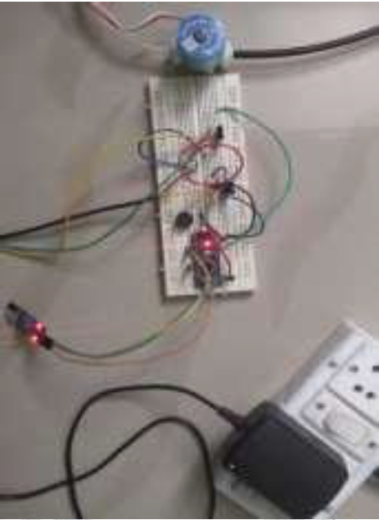
Figure 4.2: The Hardware Connections
This image above shows the hardware connections of the developed system.
4.1.2 INPUT DESIGN
In this section, the input design of the automatic water sensor tap system is presented in which it consists of IR sensors, solenoid valve, water pump, transistors, microcontroller, processor, and voltage regulator for voltage regulation. Below are the inputs of the developed system.
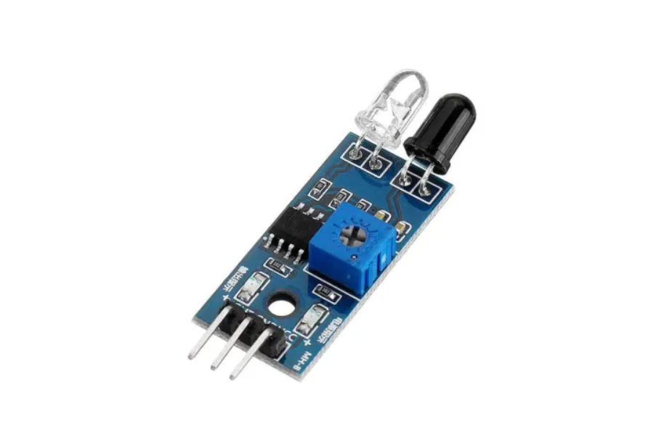
Figure 4.3: IR Sensor Module
As you can see this sensor have an IR Receiver (Photodiode) which is used to detect the object. How is this possible? When an object moves close to the sensor it detect motion. Passive IR sensors, unlike active ones, solely measure infrared radiation without emitting it. Typically, all objects emit some degree of thermal radiation within the infrared spectrum.

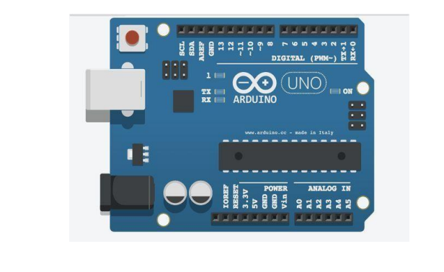
Figure 4.4: Arduino Uno Microcontroller based development Board
A Microcontroller is a compact device with a processor, storage and configurable input/output devices on a single integrated circuit. The researchers used the Arduino UNO board, which combines a microcontroller with all of the extras needed to quickly create and debug projects. The ATmega3288based UNO is a microcontroller board.
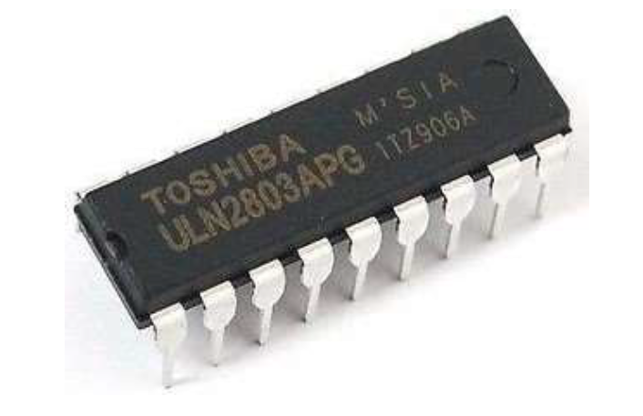
Figure 4.5: ULN2803 transistor
The Transistor is used in interfacing with high-current devices such as relays, motors, and solenoids in various electronic and control applications.
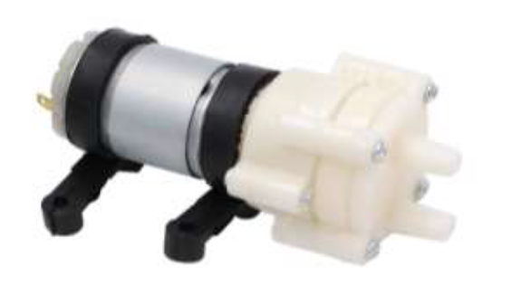
Figure 4.6: Water Pump
Figure 4.6 above shows the submersible water pump. DC6-12V MINI Aquarium Water Pump is selected for this design. The pump can push even hot water less than 60 Celsius. Its advantages include; relatively cheaper than mini servo motors, and you do not have to worry for positive and negative pole of connections.
4.1.3 PROCEDURE DESIGN
In the context of automation and control systems, sensors are essential components responsible for detecting movement or sensing objects and controlling the movement of mechanisms, systems, or processes. They receive signals from a control system or microcontroller and translate these signals into physical action, such as opening or closing a valve, moving an object, or adjusting the position of a system.
4.2 IMPLEMENTATION OF THE SYSTEM
The implementation of the system involves assembling the hardware components, developing and integrating software for control algorithms, calibrating sensors, connecting microcontrollers, and thoroughly testing the system to ensure it meets the desired specifications for efficient and reliable automatic tap system.
4.2.1 CHOICE OF PROGRAMMING LANGUAGE
The choice of programming language for the system depends on the microcontroller used. For Arduino Microcontroller, C is chosen; for Raspberry Pi, Python is preferred; and for ESP32, both C and MicroPython are suitable. These languages are selected for their compatibility with hardware, ease of use, and availability of necessary libraries.
4.2.2 HARDWARE REQUIREMENT
- Microcontroller: Arduino Uno
- Sensors: IR Sensor
- Transistor
- Solenoid Valve
- Power Supply: 18650 Battery
- Additional Components: Wires, connectors, and other necessary electronic components for interfacing sensors and actuators.
4.2.3 SOFTWARE REQUIREMENT
- Integrated Development Environment (IDE):
  - Arduino IDE for Arduino
- Programming Languages:
  - C for Arduino
- Libraries:
  - Sensor libraries (e.g., Adafruit DHT, One Wire for IR sensors)
  - Display libraries (e.g., Liquid Crystal for LCDs)
  - Control libraries for handling actuators
- Communication Protocols:
  - MQTT for remote control and monitoring, if needed
4.3 DOCUMENTATION OF THE SYSTEM
4.3.1 Program Documentation
The program documentation for the automatic water tap system provides a comprehensive guide to understanding, configuring, and utilizing the software developed for the Arduino Uno. It includes setup instructions for the development environment, details on hardware configuration, an overview of the software structure, explanations of functionality, definitions of configuration parameters, usage instructions, and troubleshooting guidance. This documentation serves as a valuable resource for developers and users, ensuring smooth implementation, operation, and maintenance of the automatic water tap system.
4.3.2 MAINTAINING OF THE SYSTEM
Maintaining the automatic water tap system involves regular checks, updates, and occasional troubleshooting to ensure its continued functionality and efficiency. This entails inspecting hardware components for wear or damage, updating software to the latest versions, monitoring sensor data for irregularities, and conducting scheduled calibrations and battery replacements as needed. Troubleshooting efforts include diagnostic checks, component replacements, and meticulous documentation of maintenance activities to facilitate seamless operation and timely interventions.

CHAPTER FIVE
SUMMARY, CONCLUSION AND RECOMMENDATIONS
5.1 SUMMARY
This project addresses the pressing issue of water wastage through the design and implementation of an Automatic Water Sensor Tap. By leveraging sensor and microcontroller technology, the system ensures efficient water usage while maintaining affordability and ease of use. This developed system also underscores the environmental and economic significance of implementing innovative solutions like automatic sensor taps. These systems not only conserve water but also align with sustainable development goals, encouraging a paradigm shift towards resource-efficient practices.
By focusing on cost-effectiveness and user convenience, the research highlights the potential for widespread adoption in various settings, paving the way for enhanced water management practices globally.
5.2 CONCLUSION
The overall design and implementation of an automatic water sensor tap makes the device unique for hand wash and other necessary things. The tap turns ON automatically whenever it detects the user’s hand and turns OFF whenever the user’s hand is removed from the tap. Automatic water tap devices are cost-effective and can be fabricated with low cost comparatively less than the market price. These devices can be used in various sectors, even these days the whole world is suffering from COVID 19, so these types of innovations can help the human being not to spread the viruses from one to another. The main objective of the researcher, is to fabricate quality products with a low range of cost and also to promote the local made. The quality of product with average cost helps the people to purchase these devices easily without thinking twice. In the age of globalization with the rapid growth of technologies, where everyone wants to own luxury but with an affordable price.
  - RECOMMENDATIONS
Based on the findings of this research, the following were recommended:
- People should consider wider adoption of sensor-based systems in public and private facilities.
- Continuous research and development should be conducted to enhance system performance and reduce costs.
- Public awareness campaigns should be made to promote water conservation and technology adoption.
- Collaboration with policymakers to support sustainable water management initiatives.

REFERENCES
Arduino. Retrieved on March, 18, 2025 From: http://electronicsforu.com/electronics-projects/hardware-diy/arduino-ir-water sensor tap.
Ihsan, K. (2021). Water Level Design as a Control System in a Miniature Dam Based on NodeMCU ESP8266, International Research Journal of Modernization in Engineering Technology and Science. Vol. 5, Issue: 6. Pp. 97–103. DOI: https://www.doi.org/10.56726/IRJMETS42309
Karthikeyan, G, Barath, V. C., Dhanasekar, M., Bhuvanesh, M. & Jai-Suheen, S. (2022). Automatic Water Tap, Journal of Emerging Technologies and Innovative Research (JETIR). Vol. 11, Issue: 5. Pp. 2281-2282. https://doi.org/10.15866/irea.v11i5.24007 346 Alaa
Khulal, N. & Ranganayakulu, S. (2024). 1 Automatic Water Tap, Futuristic Trends in Electronics & Instrumentation Engineering. Vol. 3, Book: 1. Pp. 57-58. e-ISBN: 978-93-6252-491-1 IIP Series.
Kumar, N. Mounika, P., Ramani, D. Saketh, M. & Sujith, M. (2024). Automatic Water Tap System. International Journal of Progressive Research in Engineering Management and Science (IJPREMS). Vol. 4, Issue: 4. Pp. 34-35. doi: 10.1109/ECAI58194.2023.10193962.
Muhammad, S. A., & Mohammad, S. R. (2020). Automatic Water Tap System, International Journal of Advanced Research in Computer and Communication Engineering, Vol. 5, Issue:12. Pp. 121-123. https://doi.org/ 10.3390/drones7120694
Pahalson, C. A. and Dayer, I. (2019). Design and Implementation of an Automatic Sensor Water Tap for Hand Washing, Global Scientific Journals. Vol. 7, Issue: 7. Pp. 67-69. Doi https://doi.org/10.30780/
Prima, E. C., Munifaha, S. S., Salam, M., Aziz, H. & Suryani, A. (2017). Automatic Water Tank Filling System controlled using Arduino TM Based Sensor for Home Application, Proceeding of Elsevier Engineering Physics International Conference. Vol. 17, Issue: 8. Pp. 373 – 377. Procedia Engineering
Tibe, D. P., Ghodke, I. J., Pawara, A. U., Gupte, P. C. & Mahindrakar, K. (2018). Automatic Public Tap Control Using IR Sensor and Water Level Indication Using GSM, International Journal of Advance Engineering and Research Development (IJAERD). Vol. 3, Issue 5. Pp. 2348-6406. Doi. www.jetir.org b508
Sinaga, R. J., Novriyenni, M. & Siswan, S. (2023). Design of an Automatic Water Faucet System using the IOT Based HC-SR04 Sensor, International Journal of Progressive Research in Engineering Management and Science (IJPREMS). Vol. 4, Issue: 12. Pp. 46-47.
Ugochukwu, N. A., Goyal, S. B., Rajawat, A. S., Verma, C. & Illés, Z. (2024). Enhancing Logistics with the Internet of Things: A Secured and Efficient Distribution and Storage Model Utilizing Blockchain Innovations and Interplanetary File System, in IEEE Access. Vol. 12. Pp. 4139-4152. doi: 10.1109/ACCESS.2023.3339754
Wanga, H., Thobius, J. & Mauna, B. (2020). War against Coronavirus (COVID – 19) in Tanzania: Designing a Low Cost Automatic Water Tap, International Journal of Computer Applications Technology and Research. Vol. 9, Issue: 4. Pp. 150-154. Taichung, Tanzania.

Zhang, S. & Liu, L. (2020). Design and Implementation of an Automatic Sensor Water Tap for Hand Washing, In Journal of Physics: Conference Series. Vol. 17, Issue: 6. Pp. 167-168.

