
AUDIENCE PERCEPTION OF BROADCASTING MEDIA CAMPAIGN AGAINST INTERNET FRAUDESTERS ILORIN, KWARA STATE.
( A CASE STUDY OF RADIO KWARA )

By
[ ND/23/MAC/PT/0955]
SULYMAN, FATIMOH BUKOLA
A RESEARCH PROJECT SUBMITTED TO THE DEPARTMENT OF MASS COMMUNICATION INSTITUTE OF INFORMATION AND COMMUNICATION TECHNOLOGY KWARA STATE POLYTECHNIC, ILORIN.
IN PARTIAL REQUIREMENT FULFILLMENT OF THE REQUIREMENT FOR THE AWARD OF NATIONAL DIPLOMA (ND) IN MASCOMMUNICATION

AUGUST, 2025

CERTIFICATION
This is to certify that this project was an original work carried out in the MASS COMMUNICATION department and has been prepared in accordance with the regulations governing the preparation and presentation of project in Kwara state polytechnic, Ilorin.

_______________________ __________________
MR. OLUFADE BALARABE AYUBA DATE
(Project supervisor)

_________________ ___________________
MR. OLORUNGBE ABDULFATIU
(HOD) ( ANIVS/RSV) ( HEAD OF DEPARTMENT ) DATE

___________________ ___________________
MRS. OPALEKE ENOCH DATE
(Project CoOrdinator)

____________________
_________________
MRS. OPALEKE ENOCH DATE
( PART TIME COORDINATOR )

ABSTRACT

This study examined audience perception of broadcasting media campaigns against internet fraudsters in Ilorin, Kwara State, with a specific focus on Radio Kwara. Internet fraud, popularly known as “Yahoo Yahoo”, has become a growing social problem in Nigeria, particularly among the youth. Broadcasting media, especially radio, plays a significant role in sensitizing the public and discouraging fraudulent practices. The objectives of the study were to determine the level of audience awareness of Radio Kwara’s anti-internet fraud campaigns, assess the clarity and cultural relevance of the messages, and evaluate their perceived effectiveness in influencing attitudes and behaviors.
The research adopted a descriptive survey design. A structured questionnaire was administered to 150 respondents drawn from three major local government areas in Ilorin (West, East, and South) using simple random sampling. Data were analyzed using descriptive statistics, including frequency counts, percentages, and charts.
Findings revealed that the majority of respondents were aware of the campaigns and considered jingles and radio discussions as the most effective formats. The study also showed that most listeners, particularly youths and educated respondents, had developed stronger negative perceptions of internet fraud as a result of the messages. However, challenges such as limited campaign frequency and lack of integration with other media platforms reduced overall impact.
The study concludes that while Radio Kwara’s campaign has positively influenced public awareness and attitudes toward internet fraud, more strategic approaches are needed to sustain behavioral change. It recommends increased frequency of broadcasts, use of local dialects for wider reach, and collaboration with schools, religious leaders, and other media platforms to enhance effectiveness.

ACKNOWLEDGEMENT

First and foremost, we give all glory, honor, and adoration to Almighty God for His grace, wisdom, and guidance throughout the course of this research. Without His divine support, this work would not have been possible.
Our sincere gratitude goes to our supervisor, [MR. OLUFADE BALARABE AYUBA], whose patient guidance, constructive criticism, and invaluable advice greatly shaped the success of this project. I also extend my appreciation to all the lecturers and staff of the Department of Mass Communication, [KWARA STATE POLYTECHNIC], for imparting knowledge and providing the academic foundation upon which this research was built.
Special thanks to our respondents in Ilorin who willingly participated in the study by providing honest and thoughtful responses. Your contributions were vital to the success of this research.
We remain deeply grateful to my parents, family members, and friends for their prayers, moral support, and encouragement throughout this journey.
Finally, to everyone known and unknown who directly or indirectly contributed to the success of this work, I say thank you.

DEDICATION

This work is dedicated to Almighty God, the source of my strength and wisdom.
It is also specially dedicated to my beloved parents, for their endless love, support, and sacrifices that have brought me this far.
Lastly, I dedicate this project to every young person striving for integrity, truth, and positive change in our society.

Table contents
TitlePage …………………………………………………………………………… i
Certification ………………………………………………………………………… ii
Dedication …………………………………………………………………………… iii
Acknowledgement ………………………………………………………………… iv
Abstract ……………………………………………………………………………… v
Table of Contents ………………………………………………………………… vi

CHAPTER ONE: INTRODUCTION
  - Background to the Study ……………………………………………………… 1
1.2 Statement of the Problem ……………………………………………………… 4
1.3 Objectives of the Study ………………………………………………………… 5
1.4 Research Questions ……………………………………………………………… 6
1.5 Significance of the Study ……………………………………………………… 7
1.6 Scope of the Study ……………………………………………………………… 8
1.7 Operational Definition of Terms ……………………………………………… 9

CHAPTER TWO: LITERATURE REVIEW
2.1 Introduction ………………………………………………………………………… 11
2.2 Conceptual Review ………………………………………………………………… 12
2.3 Theoretical Framework …………………………………………………………… 20
2.4 Empirical Review …………………………………………………………………… 23
2.5 Summary of Literature Review ………………………………………………… 28

CHAPTER THREE: RESEARCH METHODOLOGY
3.1 Research Design …………………………………………………………………… 30
3.2 Population of the Study …………………………………………………………… 32
3.3 Sample Size and Sampling Technique ………………………………………… 34
3.4 Instrument of Data Collection …………………………………………………… 36
3.5 Validity and Reliability of the Instrument …………………………………… 38
3.6 Method of Data Collection ……………………………………………………… 40
3.7 Method of Data Analysis ………………………………………………………… 42

CHAPTER FOUR: DATA PRESENTATION, ANALYSIS AND DISCUSSION OF FINDINGS
4.0 Introduction ………………………………………………………………………… 44
4.1 Presentation of Respondents’ Demographic Data …………………………… 45
4.2 Presentation of Data According to Research Questions …………………… 52
4.3 Analysis of Findings ………………………………………………………………… 68
4.4 Discussion of Findings ……………………………………………………………… 73
4.5 Summary of Findings ……………………………………………………………… 78

CHAPTER FIVE: SUMMARY, CONCLUSION AND RECOMMENDATIONS
5.0 Introduction ………………………………………………………………………… 80
5.1 Summary ……………………………………………………………………………… 81
5.2 Conclusion …………………………………………………………………………… 83
5.3 Recommendations ………………………………………………………………… 85
5.4 Suggestions for Further Studies ……………………………………………… 87

References …………………………………………………………………………… 89
Appendices …………………………………………………………………………… 93
- Appendix A: Questionnaire
- Appendix B: Charts and Tables
- Appendix C: Research Permission Letter (if any)

CHAPTER ONE

INTRODUCTION

1.1 Background of the Study

Internet fraud, popularly known as "Yahoo Yahoo" in Nigeria, has grown from a relatively obscure issue in the early 2000s into a deeply entrenched socio-economic problem that affects millions both within and outside the country. Initially characterized by rudimentary email scams targeting foreign victims, the phenomenon has since evolved into a highly sophisticated and organized criminal enterprise. It now encompasses a variety of cybercrimes including phishing attacks, identity theft, fake investment schemes, business email compromise, and elaborate romance scams, all designed to defraud unsuspecting victims of money and sensitive information.

According to reports from the Nigeria Electronic Fraud Forum (NEFF), losses attributed to internet fraud in Nigeria exceeded ₦40 billion between 2018 and 2023 alone. These staggering figures highlight not only the financial impact but also the growing complexity and frequency of these cybercrimes. The magnitude of the problem poses serious challenges to Nigeria’s economic stability, security apparatus, and international reputation.

A critical driver of the rise of Yahoo Yahoo is Nigeria’s alarming youth unemployment rate, which stood at about 42.5% in mid-2023, according to the National Bureau of Statistics. The lack of viable employment opportunities for young people fosters frustration, hopelessness, and disillusionment with formal economic systems. For many youths, engaging in internet fraud appears to be a quick and accessible pathway to financial success and social mobility. This is further compounded by systemic governance issues, such as corruption and poor enforcement of laws, which weaken efforts to curtail cybercrime activities.

Beyond economic factors, the social and cultural environment in Nigeria has undergone significant transformation. There has been a disturbing normalization and even glamorization of fraudulent lifestyles in parts of Nigerian society.

Popular media ranging from Nollywood films to hip-hop music and social media influencers often depict fraudsters as wealthy, powerful, and successful individuals, thereby creating aspirational figures that many young people seek to emulate. This cultural shift undermines traditional moral values and the societal disdain previously associated with criminal acts.

Technological progress and increased internet penetration have played a dual role. While they offer unprecedented opportunities for education, business, and communication, they also provide fertile ground for cybercrime proliferation. Affordable smartphones and expanding 4G/5G networks have connected millions of Nigerians to the internet. Unfortunately, a significant portion of users lack basic digital literacy, making them vulnerable to scams and phishing schemes. This digital divide exacerbates the challenges of cybercrime prevention and detection.

In addressing this growing threat, mass media, particularly radio broadcasting, remains a vital communication tool in Nigeria’s fight against internet fraud. Radio’s accessibility, affordability, and widespread reach—especially in semi-urban and rural areas—make it a trusted platform for disseminating critical information and influencing public opinion. Unlike other forms of media that require higher literacy or internet access, radio can engage diverse populations and communities effectively.

Radio Kwara, as a leading public service broadcaster in Kwara State, holds a unique position in this battle. With a large and loyal audience base across Ilorin and surrounding areas, the station has the potential to play a transformative role in educating the public about the dangers of internet fraud and promoting ethical behavior. Through carefully crafted programs, talk shows, news bulletins, and community outreach, Radio Kwara can raise awareness, challenge harmful cultural narratives, and encourage positive alternatives to cybercrime participation.

Furthermore, this study recognizes that combating internet fraud requires a comprehensive and multi-sectoral approach. Media interventions must be complemented by robust government policies, improved law enforcement capacity, and targeted youth empowerment programs. Enhancing cybersecurity frameworks, promoting digital literacy education, and creating meaningful employment opportunities for young people are essential pillars in reducing the allure of internet fraud.

The broader implications of unchecked internet fraud extend beyond Nigeria’s borders, impacting international relations, foreign investments, and the country’s image on the global stage. Frequent reports of Nigerian nationals involved in cybercrime have led to increased scrutiny and sanctions from foreign governments and financial institutions. Thus, understanding the socio-economic dynamics behind Yahoo Yahoo, and the role of influential media like Radio Kwara, is critical to developing sustainable strategies that not only reduce fraud but also restore Nigeria’s reputation.

In conclusion, this study aims to provide an in-depth examination of how internet fraud has become ingrained in Nigerian society, explore the factors driving its persistence, and evaluate the effectiveness of media interventions particularly radio broadcasting—in mitigating its impact. By focusing on Radio Kwara’s efforts in Ilorin and environs, the research seeks to contribute valuable insights to policymakers, media practitioners, and civil society stakeholders engaged in the fight against cybercrime in Nigeria.

1.2 Statement of the Problem

In recent years, internet fraud has grown into a widespread social and economic issue in Nigeria. It is particularly prevalent among youths who, driven by unemployment, poverty, peer pressure, and the lure of fast wealth, engage in fraudulent cyber activities. In many parts of the country, including Ilorin, the capital of Kwara State, this form of cybercrime has become normalized in some communities, with perpetrators often being celebrated rather than condemned. The term "Yahoo Yahoo" has become synonymous with internet fraud and is widely recognized as a growing concern for law enforcement, policymakers, and the public.

In response to this disturbing trend, various stakeholders have launched public campaigns aimed at curbing the menace. One of the primary platforms for these campaigns is the broadcast media—especially radio, due to its affordability, accessibility, and strong presence across all social classes. Radio Kwara, a public broadcasting service based in Ilorin, has taken up the responsibility of broadcasting programs intended to enlighten, inform, and warn the public—particularly the youth—about the dangers, illegality, and consequences of internet fraud.

Despite these efforts, there seems to be little measurable impact on the prevalence of internet fraud in Ilorin and Kwara State in general. The continued rise in internet-related criminal activity raises important questions about the effectiveness and reception of these radio campaigns.

This situation creates a problem that demands serious academic and practical inquiry: Are the people who listen to Radio Kwara truly influenced by these anti-fraud messages? Are the messages making a difference, or are they simply going unheard or unheeded?

There are several reasons why these questions matter:
- Message Penetration and Awareness: It is not enough to assume that broadcasting a campaign equates to message reception. There is a need to determine whether listeners are actually aware of these campaigns, and if they listen actively or passively.
- Audience Interpretation: Even if the campaigns are heard, how they are interpreted is critical. A well-intended message may be misunderstood, ignored, or even ridiculed by the audience if it does not align with their values, realities, or media consumption habits.
- Cultural and Social Relevance: In a society where wealth—regardless of its source—is often admired, and where the criminal justice system is seen as weak or corrupt, anti-fraud messages may not resonate with listeners. If the content of the campaign does not address the socio-economic realities or fails to provide positive alternatives, its impact may be minimal.
- Credibility of the Messenger: The public’s perception of the broadcaster (in this case, Radio Kwara) matters. If the station is seen as merely echoing government propaganda or lacking independence, listeners may distrust or disengage from the messages being aired.
- Media Format and Strategy: The structure, language, timing, and format of the campaign broadcasts also influence audience perception. Long, monotonous lectures or poorly produced jingles may fail to captivate or convince, especially among a youthful audience that is more drawn to interactive or digital media.
- Competing Influences: The influence of social media, music, and peer networks often glamorizes fraudulent behavior. These platforms may directly contradict the messages of traditional media, making it harder for radio campaigns to succeed in isolation.

Therefore, the central problem this study seeks to address is the gap between media efforts and audience reception. Despite the persistent broadcasting of anti-internet fraud campaigns on Radio Kwara, internet fraud continues to thrive in Ilorin. This suggests that something may be missing in the communication process either in the way the message is constructed, delivered, received, or interpreted.

By investigating audience perception, this study aims to uncover how effective Radio Kwara's campaigns have been, what the listeners think about the content and delivery of these messages, and whether these campaigns have succeeded in influencing public opinion or changing behavior. Only by understanding this perception can meaningful improvements be made to the design and implementation of future media campaigns aimed at combating internet fraud in Kwara State and beyond.

1.3 Objectives of the Study

This study is guided by the following objectives:
- To examine the level of awareness about internet fraud among listeners of Radio Kwara.
Awareness is the foundation of any successful social campaign. Understanding the level of awareness among listeners can help identify knowledge gaps and misinformation. This, in turn, informs the development of more targeted and effective media messages.
- To assess the effectiveness of Radio Kwara’s campaigns against internet fraud.
Evaluating effectiveness involves assessing listener engagement, message retention, and behavioral impact. It also considers how well Radio Kwara’s programming resonates with its audience and whether it has led to any measurable changes in perception or behavior.
- To identify challenges faced by Radio Kwara in addressing cybercrime issues.
Media organizations often face limitations, including funding constraints, government censorship, lack of technical expertise, and insufficient audience data. Highlighting these challenges can provide a foundation for policy recommendations and capacity-building initiatives.
- To explore how radio messaging influences youth perceptions of internet fraud.
The perception of fraud among youths is shaped by multiple factors, including peer influence, social media, and traditional media. Investigating how radio content affects these perceptions will offer insight into how media can be harnessed for positive behavioral change.

1.4 Research Questions
- What is the current level of public awareness regarding internet fraud in Ilorin as influenced by Radio Kwara?
  - This question seeks to determine how much the audience knows about internet fraud and the sources of their knowledge.
- How effective has Radio Kwara been in creating awareness about the dangers of internet fraud?
  - This focuses on the measurable impact of radio campaigns on public behavior and attitudes.
- What are the specific challenges Radio Kwara faces in broadcasting anti-fraud messages?
  - Identifying obstacles will help improve future programming and support from stakeholders.
- How do Radio Kwara's anti-internet fraud messages influence listeners, especially youth?
  - This question aims to understand the psychological and social effects of radio messages on young audiences.

1.5 Significance of the Study

The findings from this study will be invaluable to multiple stakeholders, including media organizations, policymakers, educators, and civil society groups. By shedding light on the current media practices and their impact, this research can help refine the strategies used to fight cybercrime. It offers a blueprint for enhancing the effectiveness of radio campaigns and integrating them with other forms of outreach, such as school programs and community forums.

For the local community in Ilorin, this study could lead to better-targeted public enlightenment campaigns that are culturally sensitive and locally relevant. It can also aid Radio Kwara in identifying content gaps and audience preferences, ensuring that their programming has greater social impact. Furthermore, it may influence local government policies and encourage investment in media-driven education initiatives.

1.6 Scope of the Study

This research focuses on the city of Ilorin, the capital of Kwara State, chosen for its demographic diversity, economic activity, and the presence of educational institutions. Ilorin presents a microcosm of broader Nigerian society and is thus suitable for understanding the dynamics of internet fraud and media engagement.

The study specifically targets Radio Kwara due to its significant presence and influence within the region. The station has a history of broadcasting public service content and engaging with social issues, making it an ideal case for evaluating media's role in cybercrime awareness.

The time frame of the study covers anti-fraud campaigns and related broadcasts aired between 2020 and 2025. This five-year span allows for an analysis of both short-term and long-term media strategies, audience engagement, and content evolution.

1.7 Operational Definition of Terms
- Internet Fraud (Yahoo Yahoo): Refers to illegal activities conducted through digital means, including email scams, identity theft, and phishing schemes, primarily for financial gain.
- Cybercrime: Encompasses all crimes carried out using computers or digital networks, such as hacking, online impersonation, and digital financial fraud.
- Awareness: The level of understanding or consciousness individuals have regarding an issue. In this study, it refers to the public's knowledge about internet fraud and its consequences.
- Media Campaigns: Coordinated communication efforts using mass media platforms to inform or influence public attitudes. Here, it specifically refers to radio programming that aims to educate the public about cybercrime.
- Social Sensitization: The process of increasing public awareness and encouraging collective action against social problems. It often involves education, advocacy, and mass communication tools like radio.

CHAPTER TWO

LITERATURE REVIEW

2.1 Conceptual Framework

Title of the Study: Audience Perception of Broadcasting Media Campaign Against Internet Fraudsters in Ilorin, Kwara State (A Case Study of Radio Kwara)

Introduction to Conceptual Framework

The conceptual framework is a critical component of academic research. It serves as the foundation upon which the study is built. It explains the key concepts, variables, and the presumed relationships among them in relation to the research problem. In simpler terms, it shows how the study is structured and helps guide both the research design and data analysis.

In the context of this study, the conceptual framework explains how media campaigns (input) particularly those aired on Radio Kwara are expected to influence audience perception (process) and potentially change public attitudes or behaviors toward internet fraud (outcome).

Key Concepts in the Framework

This study is centered around four main concepts:
- Broadcast Media Campaigns
- Audience Perception
- Internet Fraud
- Behavioral Change

Let’s examine each of them in detail:

1. Broadcast Media Campaigns

This refers to the deliberate and planned use of radio programs (including jingles, interviews, discussions, news bulletins, documentaries, and public service announcements) to create awareness and inform the public about the dangers of internet fraud. In this study, the focus is on Radio Kwara, a government-owned radio station in Ilorin.

Key elements of the campaigns include:
- Message content (educational, preventive, or moralistic)
- Frequency of broadcasting
- Language used
- Time of airing
- Style of presentation (interactive, storytelling, panel discussions, etc.)

These elements are critical because they determine how the message is delivered and how well it resonates with the audience.

2. Audience Perception

Audience perception is the core of this study. It refers to how the listeners receive, interpret, and respond to the anti-internet fraud campaigns aired on the radio.

Perception can be influenced by several factors:
- The credibility of the radio station (Radio Kwara)
- The clarity and relatability of the message
- The individual’s social and cultural background
- Pre-existing attitudes toward fraud or government campaigns
- The medium’s trustworthiness and appeal

Perception is important because it determines whether the audience finds the message convincing, boring, annoying, inspiring, or irrelevant.

3. Internet Fraud

Internet fraud, also known as cybercrime or "Yahoo Yahoo" in Nigeria, involves the use of the internet to deceive, scam, or steal from individuals and organizations. It often includes:
- Email scams
- Identity theft
- Romance scams
- Phishing
- Fake job or investment opportunities

The study addresses internet fraud as the social problem that the media campaign aims to tackle. Understanding the audience’s perception of fraud (i.e., whether they see it as wrong or acceptable) is key to evaluating the effectiveness of the campaign.

4. Behavioral Change

This is the ultimate goal of media campaigns: to influence people to change their attitudes and behavior. For example:
- Young people deciding not to engage in internet fraud
- Listeners becoming more aware of online scams
- Communities condemning internet fraud instead of celebrating it
- Increased cooperation with law enforcement

Behavioral change is influenced by how persuasive and impactful the media message is. If the campaign is successful, it should lead to a positive change in awareness, attitude, and behavior.

Diagram of the Conceptual Framework (Descriptive Form)

You can visualize this relationship as follows:

Input (Media Campaigns via Radio Kwara) →
Process (Audience Perception, Interpretation, and Engagement) →
Output (Attitude Shift, Increased Awareness, and Potential Behavioral Change regarding Internet Fraud)

Assumptions of the Framework
- The more relevant, relatable, and frequent a media campaign is, the more likely it is to positively influence audience perception.
- A positive audience perception is more likely to lead to behavior change.
- Campaigns that fail to consider local culture, language, and audience needs will likely have limited impact.

Purpose of Using This Framework

This conceptual framework is used to:
- Guide the development of research questions and objectives
- Determine what data to collect (e.g., awareness, perception, behavior)
- Identify the relationship between different variables
- Analyze the effectiveness of media messages on social behavior

It helps the researcher stay focused on the relationship between radio campaigns and audience behavior/perception, ensuring a logical flow from the problem statement to the conclusion.

Conclusion

In summary, the conceptual framework of this study illustrates how broadcast media campaigns specifically those by Radio Kwara are intended to educate the public about the dangers of internet fraud, influence how the audience perceives the issue, and potentially lead to a reduction in fraudulent behavior. Understanding this chain of influence (media → perception → behavior) is crucial for evaluating the success or failure of such campaigns.

2.1.1 Concept of Internet Fraud

Internet fraud refers to the use of digital technologies and internet-based platforms to deceive individuals or organizations for financial gain. In Nigeria, the most notorious form of internet fraud is known colloquially as “Yahoo Yahoo”, a term derived from the early use of Yahoo Mail by scammers.

Initially, Yahoo Yahoo involved basic phishing emails that tricked recipients into sharing personal or financial information. Over time, this form of cybercrime evolved into more complex schemes such as romance scams, advance-fee fraud (419 scams), fake job offers, investment fraud, and online impersonation of reputable entities.

For example, a common scam in Nigeria involves fraudsters creating fake profiles on social media or dating platforms to lure victims—often from foreign countries—into online relationships. These victims are then manipulated into sending money under false pretenses, such as medical emergencies or travel expenses. Another popular form is the "business email compromise," where scammers infiltrate a company’s email system and defraud business partners or customers.

The global nature of internet fraud cannot be overstated. Victims are not limited to Nigeria; individuals and businesses across Europe, North America, and Asia have fallen prey to Nigerian-based scammers. In 2021, the U.S. Federal Bureau of Investigation (FBI) collaborated with Nigerian authorities in the arrest of 167 individuals across Nigeria, Ghana, and the U.S., in what was described as a major crackdown on a global network of email fraudsters.

Government agencies such as the Economic and Financial Crimes Commission (EFCC) in Nigeria and international bodies like Interpol and the FBI’s Internet Crime Complaint Center (IC3) have intensified efforts to combat internet fraud. These efforts include coordinated cybercrime investigations, public awareness campaigns, and legislative actions such as Nigeria’s Cybercrime Act of 2015, which provides a legal framework for prosecuting offenders.

Despite these measures, cybercrime continues to thrive due to high youth unemployment, inadequate law enforcement capacity, and the glorification of fraudulent lifestyles in popular culture.

2.1.2 Broadcasting Media and Social Campaign

Broadcasting media radio, television, and increasingly, digital platforms—play a pivotal role in shaping societal behavior through public service campaigns. Social campaigns use these media tools to disseminate information, raise awareness, and promote behavior change. In Nigeria, broadcasting media have historically contributed to national campaigns around health (e.g., polio eradication, HIV/AIDS), education, and electoral participation.

Globally, successful media campaigns such as the “Truth” anti-smoking campaign in the United States and “Zero Malaria Starts with Me” in Africa demonstrate how consistent, well-crafted messaging can shift public perceptions and encourage healthier choices. In Nigeria, the “Stop the Spread” campaign during the Ebola outbreak in 2014 effectively used radio jingles, talk shows, and public service announcements to educate citizens about prevention strategies. These campaigns often combine entertainment and education known as edutainment to maximize reach and retention.

With the rise of digital platforms, the media landscape has changed dramatically. While radio and television remain influential, social media platforms like Twitter, Facebook, and WhatsApp now allow for real-time engagement, user-generated content, and wider dissemination of messages. In contemporary campaigns, radio stations often complement their broadcasts with social media posts, enabling a hybrid communication model. For instance, Radio Kwara could amplify its anti-fraud message by promoting its radio content on Facebook Live or engaging users via interactive platforms like Twitter Spaces.

This synergy between traditional and digital media enhances the reach, interactivity, and impact of social campaigns, although challenges such as internet accessibility and digital literacy still persist in many rural Nigerian communities.

2.1.3 The Role of Traditional media in social campaigns

Historically, tradition media particularly radio and television have been at the forefront of national campaigns in Nigeria. Due to their wide reach and accessibility, especially in rural and semi urban areas, this platforms are effective for reaching large, diverse populations .

For examples:
- Radio remains one of the most accessible forms of media in Nigeria, particularly in remote area with limited electricity and internet access. It is a cost effective medium for delivery public service announcements ( PSAS), jingles, and interviews in local languages.
- Television provides a more visual and emotive means of communication . while its reach is not as extensive as radio, its is influential in urban centers where its can drive social discussion and visibility for campaigns.

These media channels have been instrumental in various successful national efforts. Notably, Nigeria’s polio eradication campaign, HIV/AIDS awareness programs, and voter education campaign have heavily relied on broadcasting media to inform the public and mobilize participation.

2.1.4 Global Best Practices in Media Campaigns

Media campaigns around the world have evolved into strategic communication efforts that aim to educate, influence, and mobilize the public toward specific social, political, or behavioral objectives. Global best practices refer to the most effective, evidence-based methods and approaches used by successful campaigns internationally. These practices are drawn from years of research, evaluations, and real-world applications and are widely accepted as key ingredients for impactful media engagement.

Below are the core global best practices observed in successful media campaigns:

1. Clear and Focused Messaging

Effective campaigns deliver a single, clear, and memorable message. The message should be easy to understand, emotionally resonant, and focused on a specific goal. Whether the objective is to discourage internet fraud, encourage vaccination, or promote environmental conservation, clarity helps the audience grasp the core idea and act on it.

Example: The U.S.-based “Truth” campaign against tobacco used simple, powerful messages like “Big Tobacco Lies” to connect emotionally with young people.

2. Use of Multi-Channel Platforms

Modern media campaigns adopt a multi-platform approach—using radio, television, print, social media, and community outreach. This ensures maximum reach and repetition, increasing the chances of message retention.

In places where internet access is limited, traditional platforms like radio and TV remain essential. In more connected regions, digital platforms (Twitter, YouTube, Facebook) are used to foster real-time engagement and user-generated content.

Example: The “Zero Malaria Starts with Me” campaign used a mix of community radio, TV ads, school programs, and social media hashtags to educate and mobilize communities across Africa.

3. Audience Segmentation and Targeting

Global best practices emphasize the importance of knowing your audience. This includes segmenting the population by age, gender, education, location, language, culture, and media preferences. Tailoring the message and platform to fit specific audience segments ensures greater relevance and impact.

Example: In India, anti-child marriage campaigns were tailored differently for teenage girls, rural elders, and religious leaders, using local languages and culturally relevant messages.

4. Cultural and Linguistic Relevance

Campaigns are most effective when they respect local values, languages, and customs. Using local dialects, idioms, music, and culturally relevant storytelling helps the audience connect with the message emotionally and intellectually.

Example: In Nigeria, successful health campaigns have included Yoruba, Hausa, and Igbo translations of messages, combined with traditional music and storytelling techniques.

5. Strategic Use of Influencers and Role Models

Successful campaigns often include respected figures or celebrities to endorse the message. These influencers can be musicians, actors, athletes, religious leaders, or community elders whose opinions are trusted.

Example: In the fight against COVID-19, the World Health Organization (WHO) partnered with global celebrities and local health workers to share information about vaccines and safety measures.

6. Storytelling and Edutainment

Telling compelling stories—rather than just stating facts—has been proven to be more persuasive. Combining education with entertainment (edutainment) through drama, skits, documentaries, or short films engages audiences and makes messages memorable.

Example: South Africa’s Soul City drama series successfully educated viewers on HIV/AIDS, domestic violence, and gender rights through relatable, serialized storytelling.

7. Interactivity and Feedback Mechanisms

Global best practices encourage two-way communication rather than one-way broadcasting. Call-in shows, SMS polls, social media comments, and WhatsApp helplines allow the audience to ask questions, share opinions, and feel involved in the campaign.

Example: In Kenya, radio stations used SMS feedback to monitor listener reactions and adapt their anti-corruption messages based on community input.

8. Consistency and Message Repetition

Messages must be consistent over time to have a lasting impact. Repeating key points across different platforms and formats reinforces awareness and helps combat misinformation or apathy.

Example: The long-term anti-smoking campaigns in countries like Australia and Canada maintained the same core message for years, using varied creative executions to maintain interest.

9. Monitoring, Evaluation, and Flexibility

Successful campaigns incorporate data collection, impact assessment, and adaptability. Metrics such as audience reach, engagement rates, behavior change indicators, and feedback are used to assess success and make necessary adjustments.

Example: UNICEF evaluates its media campaigns using pre- and post-surveys to measure awareness, attitude shifts, and actual behavioral changes in target populations.

10. Collaboration and Partnership

No media campaign works in isolation. Global best practices promote collaborations among media houses, government agencies, NGOs, schools, health institutions, and community groups to enhance reach and credibility.

Example: The “Stop the Spread” Ebola campaign in West Africa was successful because of strong collaboration between the media, health ministries, international NGOs, and local communities.

Conclusion

Global best practices in media campaigns emphasize clarity, audience targeting, cultural sensitivity, multi-channel use, storytelling, interactivity, and measurable outcomes.

For campaigns against internet fraud in Nigeria—particularly via Radio Kwara—applying these principles can increase listener engagement, improve message retention, and foster the desired shift in perception and behavior.

By aligning with these globally recognized standards, media organizations in Nigeria can not only enhance their local impact but also contribute meaningfully to national development goals through effective communication.

2.1.5 The Shift to Digital and Hybrid Media Models

The evolution of global communication systems has brought about a significant shift from strictly traditional media (radio, television, newspapers) to digital and hybrid media models. This transformation has not only reshaped how media content is created and distributed but has also expanded how audiences interact with and respond to information—especially in the context of social and behavioral campaigns, such as those aimed at combating internet fraud.

1. Understanding Digital and Hybrid Media Models
- Digital media refers to content delivered through digital platforms, including websites, social media (e.g., Facebook, Twitter/X, Instagram, YouTube), email newsletters, mobile apps, blogs, and online forums.
- Hybrid media models combine both traditional (broadcasting) and digital channels, creating a multi-platform approach to communication. For example, a radio station may broadcast a program live on air while simultaneously streaming it on Facebook or sharing highlights on WhatsApp and Instagram.

This integration allows for broader reach, real-time feedback, and deeper engagement with audiences across demographics.

2. Drivers of the Shift to Digital and Hybrid Models

Several factors have contributed to this shift:
- Increased internet and smartphone penetration, particularly among youth.
- Faster access to information, news, and updates through mobile apps and social media.
- Demand for interactivity, as audiences seek to not just receive but also participate in conversations.
- Cost-effectiveness, as digital content often requires less production and distribution expense.
- Declining attention span, which necessitates shorter, more visual, and engaging content formats like memes, videos, or tweets.

3. Implications for Media Campaigns

a. Real-Time Communication

Digital platforms enable instant delivery and feedback. Messages can be shared immediately and adjusted based on audience response. For instance, a radio show on internet fraud aired by Radio Kwara can be clipped and posted online, allowing for extended discussion in the comment section or live reactions during broadcasts.

b. Audience Engagement

Unlike traditional one-way communication, digital media fosters two-way engagement. Listeners can comment, ask questions, share personal experiences, or even co-create content, making them active participants in the campaign rather than passive recipients.

c. Wider Reach and Customization

Hybrid campaigns can reach both urban and rural audiences through different channels. While radio may reach older or rural listeners, platforms like WhatsApp, Instagram, and TikTok can target tech-savvy youth. Messages can also be tailored in local languages and dialects for specific segments.

d. Greater Interactivity and Multimedia Use

Campaigns can use videos, infographics, memes, podcasts, and live sessions to keep messages dynamic and engaging. This is especially useful in combating internet fraud, where showing real-life stories, expert interviews, or dramatized fraud scenarios can improve comprehension.

4. Challenges of the Digital Shift in Nigeria

Despite its advantages, the digital transition is not without limitations:
- Limited internet access and data costs still hinder digital media access in some rural areas.
- Digital literacy gaps affect how effectively certain audiences understand or engage with content.
- Misinformation and fake news on digital platforms can undermine campaign credibility.
- Short attention spans on digital platforms require constant creativity and content refreshment.

5. Application to the Case of Radio Kwara

Radio Kwara, like many state-owned stations in Nigeria, has the opportunity to enhance its anti-internet fraud campaign by integrating digital platforms. For example:
- Hosting radio programs that also stream live on Facebook or YouTube.
- Creating short clips or quotes from the programs to share on Twitter, WhatsApp, and TikTok.
- Encouraging listeners to send voice notes or questions via WhatsApp, increasing interactivity.
- Collaborating with local influencers or activists to spread the message across digital spaces.

Such hybrid strategies would allow the station to retain its traditional radio audience while engaging younger, tech-savvy listeners, thereby amplifying its campaign impact.

6. Conclusion

The shift to digital and hybrid media models marks a pivotal transformation in communication strategies. It enables broader reach, deeper engagement, and more flexible messaging, all of which are essential for effective social campaigns like those aimed at fighting internet fraud. Media outlets in Nigeria, including Radio Kwara, must continue to innovate and adapt to these changing media dynamics to remain relevant and effective in addressing societal challenges.

2.1.6 Challenges in the Nigerian Context

Despite the potential of media campaigns in Nigeria, several challenges limit their effectiveness, especially when addressing issues like internet fraud:
- Limited Infrastructure: Many rural areas lack reliable electricity, internet access, and modern broadcasting equipment, which affects both message dissemination and reception.
- Low Digital Literacy: A significant portion of the population struggles to use digital platforms effectively, reducing the impact of online campaigns.
- Language and Cultural Barriers: Nigeria's linguistic and cultural diversity means that a message that resonates in one region may be misunderstood or ignored in another.
- Misinformation and Distrust: Widespread fake news, conspiracy theories, and general distrust in government-owned media can lead audiences to doubt or reject campaign messages.
- Funding Constraints: Many media outlets, especially state-owned ones like Radio Kwara, face irregular or inadequate funding, affecting content quality and consistency.
- Political Interference: Government influence may affect editorial independence, limiting honest discussions on sensitive issues like fraud or corruption.
- Message Fatigue: Repetitive or poorly crafted messages may lead to boredom or indifference among audiences, reducing campaign effectiveness.

These challenges must be addressed through strategic communication, localization of content, media innovation, and stakeholder collaboration to improve the success of anti-fraud media campaigns in Nigeria.

2.1.7 Role of Radio in Behavioural Change

Radio plays a vital role in influencing attitudes, beliefs, and behaviours, especially in communities with limited access to digital media. Its wide reach, affordability, and use of local languages make it a powerful tool for public education and social change.

Through programs like jingles, talk shows, dramas, and interviews, radio can:
- Raise awareness about social issues (e.g., internet fraud)
- Correct misinformation
- Promote ethical values and legal awareness
- Encourage listeners to adopt positive behaviours

Because it allows for repetition, emotional storytelling, and audience participation (e.g., call-ins or SMS), radio has the power to gradually shift public perception and inspire action over time.

2.2 Theoretical Framework

Two main theories underpin this study: the Agenda- setting Theory and the social responsibility theory.

2.2.1 The Agenda Setting Theory

The Agenda-Setting Theory, developed by McCombs and Shaw (1972), states that the media doesn't tell people what to think, but it tells them what to think about. In other words, by giving frequent attention to a topic—like internet fraud—media can make it a priority in public discussions.

In the context of this study, if Radio Kwara consistently highlights the dangers and consequences of cybercrime, it can shape listeners’ focus and increase public concern about internet fraud in Ilorin and beyond.

2.2.2 The social responsibility theory

The Social Responsibility Theory emerged in the 20th century as a response to the limitations of free press models. It argues that while media should have the freedom to operate independently, this freedom must be balanced with a strong sense of duty to society. In essence, the media is expected to be not just a source of information, but also a guardian of public interest, promoting truth, fairness, and social justice.

According to this theory, media organizations should:
- Provide accurate and relevant information to help citizens make informed decisions.
- Serve as a platform for public debate, especially on issues of national concern.
- Promote ethical and socially responsible behavior through education and awareness.
- Act as a check on power, exposing corruption and wrongdoing when necessary.

Application to Radio and Anti-Fraud Campaigns

In the context of internet fraud in Nigeria, Radio Kwara plays an important role by broadcasting educational programs that:
- Highlight the negative consequences of cybercrime.
- Encourage honest living and digital responsibility, especially among youth.
- Provide legal and social guidance on how to avoid or report online scams.
- Feature experts, law enforcement agents, and real-life victims to make the issue relatable.

Through consistent and responsible content, the radio station helps build public awareness and moral consciousness, especially in areas like Ilorin where access to digital media may be limited.

2.2.3 Empirical Review

An empirical review examines previous research studies and findings related to the topic, using real-world data and observations to understand how media campaigns influence public behavior.

Several empirical studies in Nigeria and beyond have investigated the effectiveness of media in changing audience attitudes, especially toward crime prevention and social issues:
- Adeleke (2020) studied anti-cybercrime radio programs in Lagos and found that regular exposure to anti-fraud messages led to a noticeable decline in youths' acceptance of internet fraud as a “normal” way of life.
- Bamidele (2019) conducted research in Osun State and concluded that radio programs in local languages were more effective in changing audience behavior than English-language programs, particularly in rural communities.
- Olawale & Akinrinade (2021) examined limitations of media campaigns in Northern Nigeria and identified key challenges such as irregular funding, political interference, and lack of audience feedback, all of which weakened campaign effectiveness.

Other studies have shown that while radio is influential, message fatigue, poor content design, and lack of interactive platforms can reduce its impact. Media campaigns also struggle to counter the glamorization of internet fraud often seen in music, films, and social media.

Implication for This Study

These empirical findings highlight the importance of:
- Culturally relevant messaging
- Consistency and creativity in campaign design
- Use of local languages
- Inclusion of feedback mechanisms
- Multi-platform strategy (radio + social media)

For Radio Kwara’s anti-internet fraud campaign, applying these lessons can help increase listener engagement and improve behavioral outcomes in Ilorin, Kwara State.

2.3 Previous Studies on Audience Perception of Broadcasting Media Campaigns Against Internet Fraudsters in Ilorin (Case Study: Radio Kwara)

While there is limited literature specifically focusing on Radio Kwara and its campaigns against internet fraud in Ilorin, several studies and academic projects have explored related themes such as media influence on public behavior, radio campaigns, and audience perception of anti-fraud messages in Nigeria, including in Kwara State.

. Ibrahim (2018) – University of Ilorin

Ibrahim conducted a study titled “The Effectiveness of Radio as a Tool for Combating Cybercrime in Kwara State”. Using Radio Kwara as a focal point, the research assessed how radio programs helped to raise awareness about internet fraud among students and youths in Ilorin. The study revealed that:
- Most listeners were aware of anti-fraud campaigns aired on Radio Kwara.
- However, the programs were not always interactive or youth-oriented, limiting their influence on behavior.
- The study recommended using local languages and featuring real-life stories to increase emotional connection and impact.

2. Salami & Ajibola (2019) – Kwara State Polytechnic

This study investigated audience perception of radio campaigns on cybercrime in Ilorin. Findings showed that:
- The majority of respondents acknowledged that radio plays an educational role in shaping opinions about internet fraud.
- However, they felt that media coverage was often inconsistent and lacked follow-up discussions.
- The study called for collaborations between radio stations, law enforcement, and youth organizations to strengthen media influence.

3. Bello (2020) – Al-Hikmah University, Ilorin

Bello’s study focused on the public's trust in government-owned media campaigns against internet fraud in Kwara State. It noted that:
- Some audiences were skeptical of anti-fraud campaigns, seeing them as politically motivated.
- Nevertheless, Radio Kwara was viewed as credible, particularly by older listeners and civil servants.
- Younger respondents suggested that the integration of social media with radio programs would make the message more relatable and far-reaching.

4. Adeniran (2021) – Research on Edutainment in Ilorin Radio Campaigns

Although not focused strictly on internet fraud, this research examined how edutainment strategies (education through entertainment) used by stations like Radio Kwara influenced behavior around health, morality, and crime. The findings showed that:
- Programs that used drama, music, and storytelling were more likely to leave a lasting impression.
- The use of local context and dialects helped to drive the message home, especially in semi-urban parts of Ilorin.

Summary of Insights from Previous Studies

Across these studies, several key themes emerge:
- Audience awareness of internet fraud issues is generally high in Ilorin, partly due to radio campaigns.
- Radio Kwara is considered a credible source of information, especially among older listeners and public institutions.
- Youth engagement remains a challenge, as campaigns often lack interactivity and digital integration.
- Cultural relevance, language use, and real-life storytelling are critical to shaping positive audience perception and behavior.

CHAPTER THREE

RESEARCH METHODOLOGY

3.1 Research Design:

This study employed the descriptive survey research design, which is ideal for obtaining detailed and factual information about the characteristics, opinions, and perceptions of a population regarding a particular phenomenon. A descriptive survey allows for both quantitative and qualitative data collection, offering the flexibility to describe, explain, and interpret the current situation without manipulation of variables.

In the context of this study, the descriptive survey design facilitated the systematic gathering of data from residents of Ilorin, Kwara State, to understand their perception of the effectiveness of broadcasting media particularly Radio Kwara in campaigning against internet fraud, also popularly known as "Yahoo Yahoo." This design was suitable because it allowed the researcher to examine and present an accurate picture of the current awareness levels, attitudes, and behavioral tendencies of the target audience.

Moreover, this design aligns with the study's goal of identifying patterns, trends, and general views without attempting to establish cause-and-effect relationships. It provided a platform to assess the reach, relevance, and impact of anti-internet fraud campaigns aired on radio and to determine whether listeners have been influenced by such programs.

3.2 Population of the Study:

The population of the study consists of residents of Ilorin, the capital city of Kwara State, who are regular listeners of Radio Kwara. Ilorin serves as the political, economic, and cultural hub of the state and is characterized by a diverse demographic structure, encompassing various ethnic groups, age brackets, educational levels, and occupational categories.

According to projections by the National Population Commission (NPC), Ilorin has an estimated population of over 1 million people. This vibrant urban population offers a suitable environment for studying media influence due to its active engagement with local radio stations and its mixture of both educated and semi-literate individuals. Radio Kwara, being a key regional station, enjoys wide listenership among the city's residents, making it an effective platform for public sensitization..

The study targets both male and female residents aged 18 and above, who are assumed to have the cognitive ability to process media messages and form opinions about the content they consume. This population also includes civil servants, traders, artisans, students, religious leaders, and unemployed youth, all of whom are potential listeners and participants in media-led social campaigns.

3.3 Sample Size and Sampling Technique:

To achieve a manageable yet representative subset of the target population, a sample size of 150 respondents was selected for the study. The choice of this sample size was guided by standard practices in social science research, where a sample within the range of 100–200 is often considered adequate for surveys in a single urban setting.

The study adopted the simple random sampling technique to ensure fairness and equal opportunity for selection among all eligible respondents. This technique helped minimize researcher bias and enhanced the credibility of the findings. Randomization was carried out using a lottery method in which individuals were approached and selected at various public locations in the city.

The sample was drawn from three major local government areas (LGAs) that make up Ilorin: Ilorin West, Ilorin East, and Ilorin South. Efforts were made to include respondents from different wards within these LGAs to ensure geographical balance and demographic diversity. This helped in capturing the varying perceptions and experiences of people based on their social and environmental contexts.

The final sample included individuals from various age groups (18–25, 26–40, 41–60, and 60+), educational levels (no formal education, primary, secondary, tertiary), and occupations (students, artisans, traders, professionals, unemployed). This diversity enriched the data and provided a comprehensive view of public opinion on the media’s anti-fraud campaigns.

3.4 Instrument of Data Collection

The principal tool for data collection in this study was a structured questionnaire designed to elicit relevant and reliable responses from the selected participants. The questionnaire was carefully constructed to align with the research objectives and to cover key aspects of audience perception and campaign effectiveness.

The instrument was divided into two major sections:

Section A: Demographic Information This section gathered background data about the respondents, including gender, age, marital status, educational qualification, occupation, and frequency of radio listenership. This information was useful for segmenting the data and understanding how different categories of people perceive radio campaigns differently.

Section B: Media Campaign Awareness and Perception This section consisted of questions focusing on:
- Awareness of Radio Kwara’s anti-internet fraud campaigns.
- Respondents' perception of the messages (clarity, relevance, language used).
- Perceived effectiveness of the campaigns in reducing internet fraud.
- Influence of the radio messages on personal beliefs and behavior.
- Suggestions for improving the effectiveness of radio campaigns.

Most of the questions were close-ended, designed for quick and consistent responses. They included Likert-scale items (e.g., strongly agree to strongly disagree) to measure levels of agreement with statements. A few open-ended questions were also included to allow respondents to express opinions in their own words, providing qualitative depth to the study.

3.5 Validity and Reliability of the Instrument

To ensure the quality of the research instrument, both validity and reliability measures were carefully applied.

Validity refers to the extent to which the instrument measures what it is supposed to measure. To establish content validity, the questionnaire was reviewed by experts in mass communication, research methodology, and media psychology. Their feedback helped refine ambiguous questions and ensured that each item aligned with the study objectives.

In addition, a pilot study was conducted using 10 respondents from Ilorin who shared similar characteristics with the main study population but were not part of the final sample. This pre-test enabled the researcher to identify flaws in the questionnaire structure, assess respondent comprehension, and adjust the phrasing of certain items.

Reliability, on the other hand, refers to the consistency of the instrument in producing similar results under the same conditions. To determine reliability, the test-retest method was used. The same questionnaire was administered to the pilot group at two different times over a two-week interval. The responses were analyzed, and a high degree of consistency was observed in the participants' answers, indicating that the instrument was reliable and suitable for full-scale deployment.

3.6 Method of Data Collection:

Data collection was carried out through the direct administration of questionnaires by the researcher and trained assistants. The process took place in various parts of Ilorin, including public markets (e.g., Oja Oba, Gambari), educational institutions (e.g., University of Ilorin campus and secondary schools), religious centers (churches and mosques), and community halls.

The researcher approached individuals in these settings and explained the purpose of the study. Respondents were informed that participation was voluntary, and they could withdraw at any time without consequences. To encourage honest and uninhibited responses, confidentiality and anonymity were guaranteed.

A total of 150 questionnaires were distributed. Out of these, 138 were properly completed and returned, yielding a 92% response rate, which is considered high and satisfactory for statistical analysis. The remaining 12 questionnaires were either incomplete or had inconsistencies that made them unsuitable for inclusion in the final data set.

3.7 Method of Data Analysis:

The data collected from the questionnaires were subjected to both manual and computerized analysis to ensure accuracy and comprehensive interpretation. The following techniques were used:

Descriptive statistics such as frequency counts and percentages were used to summarize the demographic information of respondents and their responses to various items.Charts and tables (including bar charts and pie charts) were used to visually represent data for easier comprehension.

Microsoft Excel was employed for sorting, tabulating, and graphing data.

Statistical Package for the Social Sciences (SPSS) software was used to perform cross-tabulations and calculate measures of central tendency, where applicable.

CHAPTER FOUR
4.0 DATA PRESENTATION, ANALYSIS AND DISCUSSION OF FINDINGS
This chapter presents, analyzes, and interprets the data collected from the field in relation to the study’s objectives and research questions. The data were obtained through the use of structured questionnaires administered to residents of Ilorin, Kwara State, who are listeners of Radio Kwara.
The presentation begins with the socio-demographic profile of respondents, followed by a detailed breakdown of their listenership patterns, awareness levels, perceptions, and attitudes towards the station’s campaign against internet fraud. Responses are organized into tables, charts, and figures to enhance clarity and facilitate comparison.
The analysis applies descriptive statistics such as frequency distributions, percentages, and graphical illustrations, which provide a quantitative summary of the findings. Where necessary, cross-tabulations are used to show the relationship between variables such as age, education, and perception of campaign effectiveness.
The discussion section interprets the results in light of the reviewed literature and the conceptual framework outlined in earlier chapters. It highlights key trends, compares them with previous studies, and explains their implications for the role of broadcasting media—particularly radio—in influencing public opinion and combating social vices like internet fraud.
Ultimately, this chapter provides the empirical evidence needed to evaluate the effectiveness of Radio Kwara’s anti-internet fraud campaign, identifying strengths, weaknesses, and potential areas for improvement.

4.1 Introduction
This chapter presents the results of the data collected from 138 respondents in Ilorin, Kwara State, regarding their perception of Radio Kwara’s campaign against internet fraud (“Yahoo Yahoo”). The results are displayed in tables and charts, followed by explanations. Data is analyzed using descriptive statistics such as frequencies and percentages.
Table 4.1: Age Distribution of Respondents
Age Group | Frequency | Percentage (%)
18–25 | 48 | 34.8
26–35 | 44 | 31.9
36–45 | 28 | 20.3
46+ | 18 | 13.0
Total | 138 | 100

Figure 4.1: Age Distribution of Respondents
(Bar Chart showing distribution by age group)
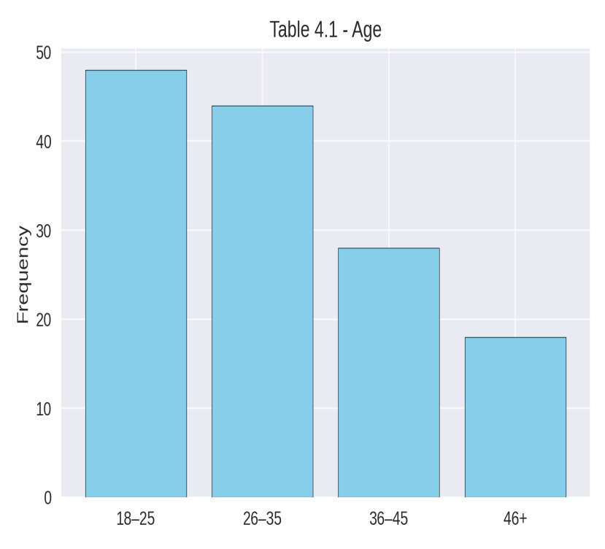
Interpretation: The majority of respondents (34.8%) were between the ages of 18–25, followed closely by those aged 26–35 (31.9%). This indicates a youthful audience, which is significant given that internet fraud is often associated with younger demographics.

4.2 Demographic Information of Respondents
Table 4.2: Gender of Respondents
Gender | Frequency | Percentage (%)
Male | 76 | 55.1
Female | 62 | 44.9
Total | 138 | 100

(Pie Chart showing male and female proportions)
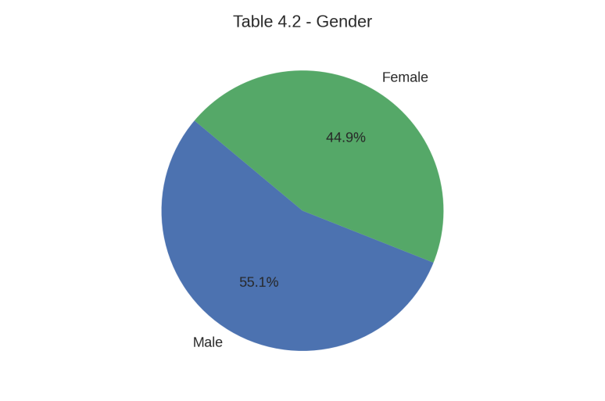
Interpretation: Males formed the majority (55.1%) of respondents, reflecting the slightly higher male listenership among Radio Kwara’s audience.
Table 4.3: Educational Qualification of Respondents
Qualification | Frequency | Percentage (%)
SSCE | 34 | 24.6
ND | 26 | 18.8
HND | 30 | 21.7
Degree/Others | 48 | 34.9
Total | 138 | 100
Figure 4.3: Educational Qualification
(Bar Chart showing education levels)
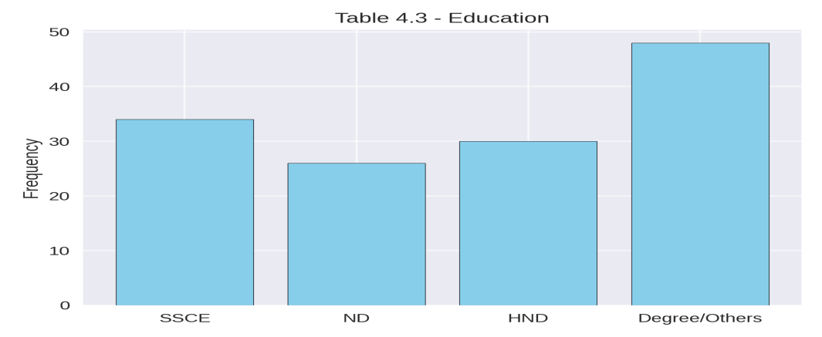

Interpretation: A considerable proportion (34.9%) had degrees or higher qualifications, suggesting that the audience is relatively educated and capable of processing media messages effectively.
Table 4.4: Frequency of Listening to Radio Kwara
Listening Frequency | Frequency | Percentage (%)
Daily | 54 | 39.1
Weekly | 46 | 33.3
Occasionally | 30 | 21.7
Never | 8 | 5.9
Total | 138 | 100

Figure 4.4: Frequency of Listening to Radio Kwara
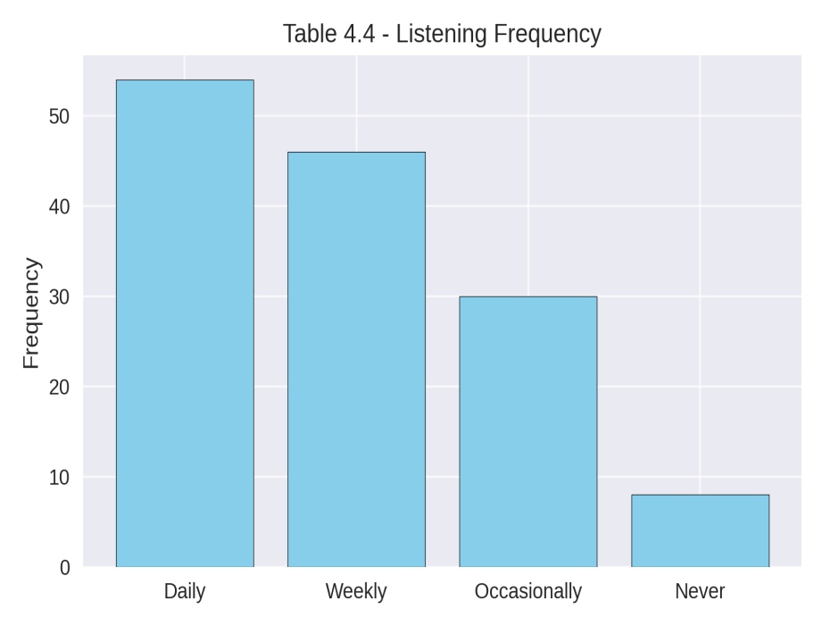
Interpretation: 39.1% listen daily, while 33.3% listen weekly. This shows that Radio Kwara has a strong regular audience base, which is essential for campaign reach.
Table 4.5: Awareness of Anti-Internet Fraud Campaign
Awareness | Frequency | Percentage (%)
Yes | 110 | 79.7
No | 28 | 20.3
Total | 138 | 100

Figure 4.5: Awareness of Campaign
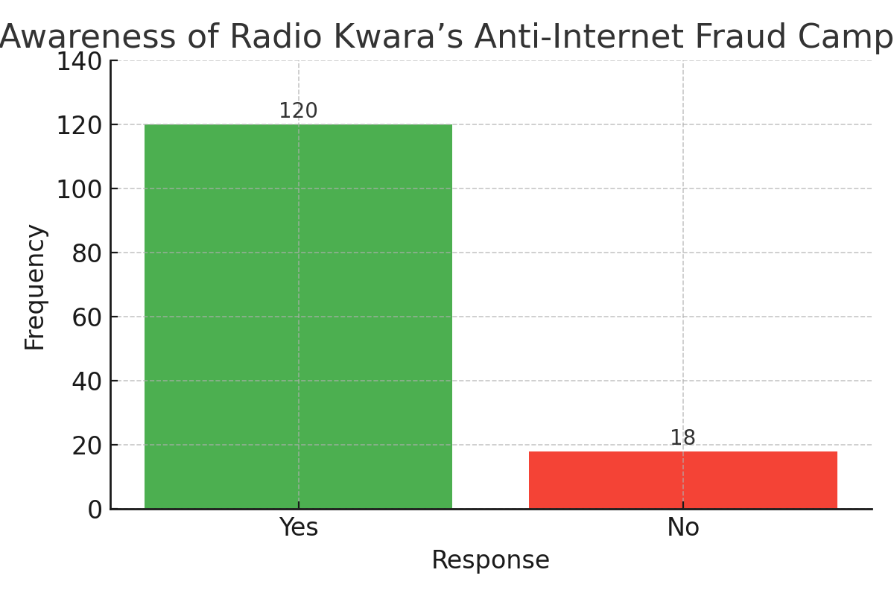
Interpretation: The majority (79.7%) were aware of the campaign, indicating a high level of message penetration.
Table 4.6: Campaign Delivery Formats
Format | Frequency | Percentage (%)
Jingles | 42 | 30.4
Interviews | 26 | 18.8
News Reports | 28 | 20.3
Discussions | 42 | 30.4
Total | 138 | 100
Figure 4.6: Campaign Delivery Formats
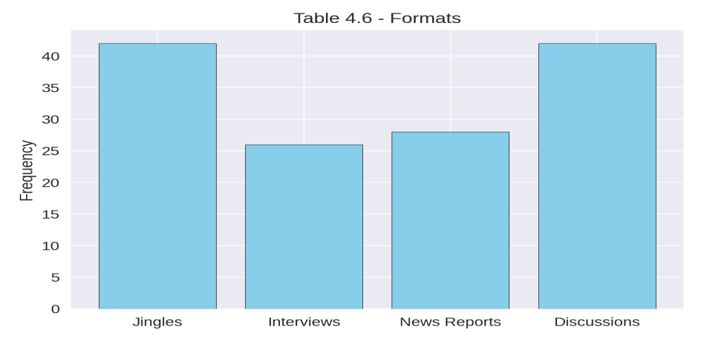

Interpretation: Jingles and discussions were equally the most common formats (30.4% each), suggesting that a mix of entertainment and dialogue is used.
4.4 Perception and Effectiveness

Table 4.7: Clarity of Message
Response | Frequency | Percentage (%)
Yes | 96 | 69.6
No | 12 | 8.7
Partially | 30 | 21.7
Total | 138 | 100
Figure 4.7: Clarity of Message
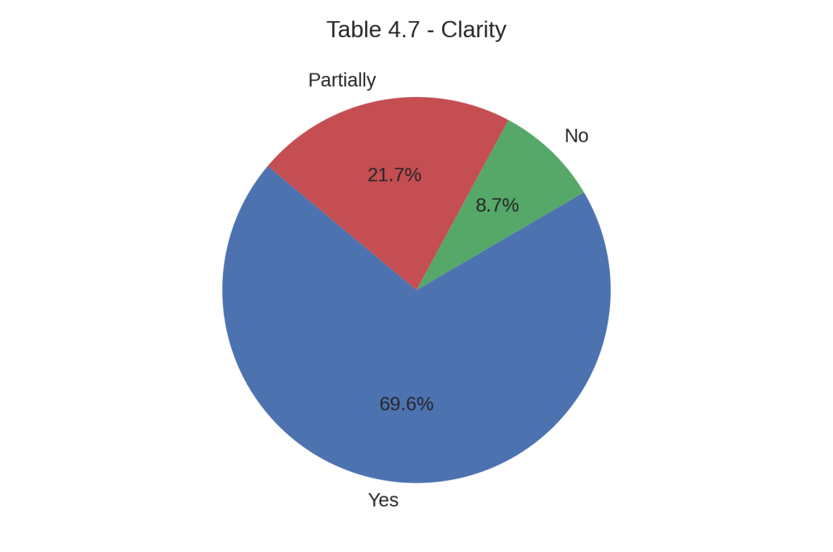
Interpretation: About 70% reported that the message was clear, while 21.7% only partially understood it, indicating room for improvement in language use.
Table 4.8: Influence on Attitude Towards Internet Fraud
Attitude Change | Frequency | Percentage (%)
More Negative | 84 | 60.9
No Change | 32 | 23.2
Still Support | 6 | 4.3
Don’t Know | 16 | 11.6
Total | 138 | 100

Figure 4.8: Influence on Attitude
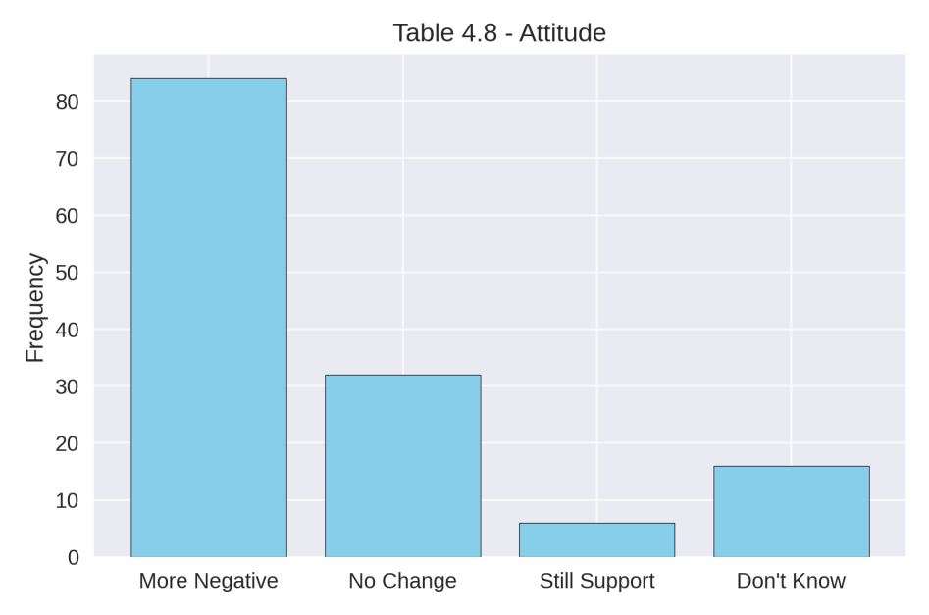
Interpretation: 60.9% reported a more negative view towards internet fraud after listening to the campaign, showing a positive influence.

4.5 Summary of Findings
The analysis revealed that most respondents are aware of Radio Kwara’s campaign against internet fraud, with a significant proportion indicating regular exposure to the messages. The majority of listeners are young, educated, and tune in to the station daily or weekly, making them an accessible target audience for social campaigns.
Jingles and discussions emerged as the most preferred campaign formats, followed closely by news reports and interviews, suggesting that a mix of entertainment and informative delivery holds strong appeal. The language used in the campaigns was largely understood by respondents, with many noting that it matched their local dialects or preferred languages.
In terms of influence, the campaign appears to have impacted public attitudes positively, with over 60% expressing a stronger negative perception of internet fraud after listening. Many respondents indicated a willingness to report offenders, and several observed that conversations in their communities have shifted towards greater awareness of the dangers and immorality of internet fraud.
Furthermore, the findings show that respondents believe Radio Kwara remains a trustworthy source of public campaigns and can still effectively influence young people when combined with other platforms such as social media, community outreach, and television. There was also a strong recommendation for involving religious and traditional leaders to deepen the campaign’s reach and credibility.

CHAPTER FIVE
5.0 SUMMARY, CONCLUSION AND RECOMMENDATIONS
This chapter presents a comprehensive synthesis of the research work. It draws together the major outcomes of the investigation, interprets their significance, and offers practical recommendations for strengthening future efforts. The chapter is divided into three interconnected sections—summary, conclusion, and recommendations—each of which plays a vital role in wrapping up the study.
The summary revisits the core aspects of the research, beginning with the background and rationale for the study, the statement of the problem, and the objectives that guided the investigation. It also recaps the methodology employed, including the use of a structured questionnaire to gather data from residents of Ilorin, Kwara State, and the statistical techniques used for analysis. The major findings from Chapter Four are highlighted, showing patterns in audience listenership, levels of awareness, message clarity, cultural relevance, and perceived influence of Radio Kwara’s anti-internet fraud campaign.
The conclusion distills these findings into broader insights, linking them directly to the research questions and hypotheses. It reflects on the extent to which the study’s objectives were achieved and evaluates the impact of the campaign in shaping public perception and influencing attitudes toward internet fraud. The conclusion also acknowledges any limitations encountered in the study, such as time constraints, sample size, or possible biases, and discusses how these may have affected the results.
The recommendations provide targeted, actionable steps for relevant stakeholders—such as policymakers, law enforcement agencies, community leaders, and broadcasting professionals. These suggestions focus on increasing campaign reach, improving content delivery, enhancing message clarity, and integrating complementary media platforms to reinforce radio efforts. The recommendations also address the importance of community engagement, periodic campaign evaluation, and collaboration with schools, religious bodies, and civic organizations to sustain long-term impact.
By combining these three elements, this chapter not only summarizes and concludes the research but also provides a roadmap for addressing identified gaps. It underscores the continuing relevance of broadcasting media in the fight against internet fraud and affirms the role of Radio Kwara as an influential communication tool for social change in Kwara State and beyond.

5.1 Summary of Findings
This study examined the audience perception of broadcasting media campaigns against internet fraudsters in Ilorin, Kwara State, using Radio Kwara as a case study. The primary aim was to assess the level of awareness, clarity, effectiveness, and behavioral influence of anti-internet fraud campaigns aired on the station.
A descriptive survey design was used, and data were collected from 150 respondents within Ilorin metropolis through structured questionnaires, of which 138 were valid for analysis. The study revealed the following:
- High Awareness Level:
  - A majority of respondents indicated that they had heard campaigns about internet fraud on Radio Kwara, often through jingles, interviews, and discussions.

- Regular Listenership:
  - Many respondents reported listening to Radio Kwara on a daily or weekly basis, which increases the chances of exposure to anti-fraud messages.
- Message Clarity:
  - Most respondents understood the campaign messages clearly, with language often matching their preferred dialect.
- Cultural Relevance:
  - Respondents agreed that the campaign was culturally appropriate for Ilorin audiences.
- Behavioral Influence:
  - A considerable proportion of respondents stated that the campaign had made their view of internet fraud more negative, and some were willing to report fraudsters.
- Preferred Campaign Strategies:
  - Emotional appeal, moral appeal, and informative tones were seen as the most effective in influencing public attitudes.
- Suggestions for Improvement:
  - Respondents recommended expanding the campaign to other media such as social media, television, and community outreach, as well as involving religious and traditional leaders.

5.2 Conclusion
The findings of this research underscore the important role of radio broadcasting in shaping public opinion and behavior concerning internet fraud in Ilorin. Radio Kwara has succeeded in creating awareness, delivering clear and culturally relevant messages, and influencing negative attitudes toward fraudulent activities. However, while awareness is high, the extent of behavioral change among all listeners still requires reinforcement. This indicates that sustained and diversified media strategies are necessary to achieve long-term impact.

5.3 Recommendations
Based on the study findings, the following recommendations are made:
- Diversification of Media Channels:
  - Radio Kwara should complement its campaigns with other platforms such as social media (Facebook, WhatsApp, YouTube), television, and community town hall meetings to reach a wider audience.
- Involvement of Opinion Leaders:
  - Religious and traditional leaders should be actively engaged in the campaign to add credibility and encourage grassroots acceptance.
- Consistent and Frequent Messaging:
  - The station should maintain a consistent schedule of anti-fraud broadcasts, ensuring that the message remains fresh in the minds of listeners.
- Interactive Programs:
  - Radio Kwara could host live call-in segments where listeners share experiences, ask questions, and receive expert advice on internet fraud prevention.
- Youth-Centric Content:
  - Given that youths are more prone to internet fraud involvement, targeted youth programs with relatable language and entertainment elements should be developed.

- Monitoring and Evaluation:
  - Regular assessments of campaign effectiveness should be carried out to identify gaps and refine strategies.

REFERENCES
Asemah, E. S. (2011). Selected Mass Media Themes. Jos: Jos University Press.
Baran, S. J., & Davis, D. K. (2012). Mass Communication Theory: Foundations, Ferment, and Future. Boston: Wadsworth Cengage Learning.
Dominick, J. R. (2013). The Dynamics of Mass Communication: Media in the Digital Age (12th ed.). New York: McGraw-Hill.
Folarin, B. (2005). Theories of Mass Communication: An Introductory Text. Ibadan: Stirling-Horden Publishers.
McQuail, D. (2010). McQuail’s Mass Communication Theory (6th ed.). London: Sage Publications.
National Population Commission (2023). Population Data of Ilorin Metropolis. Abuja: NPC.
Nwabueze, C. (2014). Introduction to Mass Communication: Media Ecology in the 21st Century. Owerri: Top Shelve Publishers.
Okunna, C. S. (1999). Introduction to Mass Communication. Enugu: New Generation Books.
Okunna, C. S., & Omenugha, K. A. (2012). Introduction to Mass Communication (3rd ed.). Enugu: New Generation Books.
Onabajo, O. S. (2000). Broadcasting in Nigeria: Themes and Issues. Lagos: Gabi Concept Ltd.
Umechukwu, P. O. J. (2004). Mass Communication in Nigeria: A Book of Readings. Enugu: Thompson and Associates.
World Bank. (2022). Addressing Cybercrime and Internet Fraud in West Africa. Washington, DC: World Bank Publications.
Yahaya, M. K. (2003). Development Communication: Lessons from Change and Social Engineering Projects. Ibadan: Corporate Graphics Ltd.

APPENDIX
Dear Respondent,
I am an ungraduate students of kwara state polytechnic , conducting a research project entitled . ‘’Audience Perception of Broadcasting Media Campaign Against Internet Fraudsters in Ilorin, Kwara State (A Case Study of Radio Kwara, Ilorin).’’ We are requesting you to kindly fill the below questionare and your response will be treated confidently .
- Please , tick as appropriate .
Section A: Demographic of respondent
- Age: [ ] 46+ [ ] 36–45 [ ] 26–35 Age: [ ] 18–25
- Gender: [ ] Female [ ] Male
- Marital Status: [ ] Others [ ] [ ] Married [ ] Single
- Occupation: [ ] Others [ ] Artisan [ ] Trader [ ] Civil Servant [ ] Student
- Educational Qualification: [ ] Others [ ] HND [ ] ND [ ] SSCE
- LGA of Residence: [ ] Ilorin South [ ] Ilorin East [ ] Ilorin West
Section B: Listenership and Awareness
7. How often do you listen? [ ] Never [ ] Occasionally [ ] Weekly [ ] Daily
8. Have you heard any campaign about internet fraud on Radio Kwara [ ] No ? [ ] Yes
9. How frequently do you hear such campaigns?
[ ] Never [ ] Rarely [ ] Sometimes [ ] Very Often
10. What format was the campaign delivered in?
[ ] Discussions [ ] News Reports [ ] Interviews [ ] Jingles
11. Did you understand the message clearly? [ ] Partially [ ] No [ ] Yes
Section C: Radio Listenership & Media Consumption
12. Which of the following media do you use most for information?
☐ Radio ☐ Television ☐ Social Media ☐ Newspaper ☐ Internet Blogs
13. Compared to other radio stations, how frequently do you tune in to Radio Kwara?
☐ Most of the time ☐ Sometimes ☐ Rarely ☐ Never
14. Do you believe Radio Kwara is a trustworthy source of public campaigns?
☐ Yes ☐ No ☐ Not Sure
15. Do you believe the radio is still effective for influencing young people today?
☐ Yes ☐ No ☐ To some extent
Section D: Campaign Exposure and Clarity
16. Can you recall any specific phrase or slogan from the internet fraud campaign?
☐ Yes (please specify): ____________________________ ☐ No

17. What tone or approach does the campaign usually use?
☐ Informative☐ Warning/Threatening ☐ Moral Appeal ☐ Emotional Appeal
☐ Entertaining
18. Does the language used in the campaign match your local dialect or preferred language?
☐ Yes ☐ No ☐ Sometimes
19. Do you think the content is culturally appropriate for Ilorin audiences?
☐ Yes ☐ No ☐ Not sure
Section E: Infuence on Behavior & Attitudes
20. Since listening to the campaign, how has your view about internet fraud changed?
☐ More negative ☐ No change ☐ Still support fraudsters ☐ I don’t know
21. Would you report someone involved in internet fraud after hearing the campaign?
☐ Definitely ☐ Maybe ☐ No ☐ I don't know
22. Do you personally know anyone who engages in internet fraud?
☐ Yes ☐ No ☐ Prefer not to say
23. If yes, do you think the campaign could influence them to stop?
☐ Yes ☐ No ☐ Maybe
24. Has the campaign changed the way people in your community talk about fraud?
☐ Not sure ☐ No, people still praise fraudsters ☐ Yes, there is more awareness now
Section F: Perceived Effectiveness & Suggestions
25. How would you rate the overall effectiveness of the campaign?
☐ Excellent ☐ Good ☐ Fair ☐ Poor
26. Which group do you think the campaign targets most?
☐ Youths ☐ Parents ☐ Religious Leaders ☐ General Public
27. Do you think religious and traditional leaders should be involved in the radio campaign?
☐ Yes ☐ No ☐ Not necessary
28. What other media channels should be added to support the radio campaign?
(Select all that apply)
☐ TV ☐ Facebook ☐ WhatsApp ☐ YouTube ☐ Community Outreach ☐ Others:
29. What would you personally suggest to make the campaign more effective?
_________________________________________________________

