GREEN SYNTHESIS OF SILVER NANOPARTICLE USING CALOTROPIS PROCERA LEAVES AND ITS ANTIMICROBIAL EFFECT ON SOME BACTERIAL AND FUNGAL ISOLATES.

BY
AKINYEMI TEMITOPE ELIJAH
ND/23/SLT/PT/0330
A PROJECT SUBMITTED TO THE DEPARTMENT OF SCIENCE
LABORATORY TECHNOLOGY, INSTITUTE OF APPLIED
SCIENCES (IAS), KWARA STATEPOLYTECHNIC, ILORIN

IN PARTIAL FULFILMENT OF THE REQUIREMENT FOR THE
AWARD OF NATIONAL DIPLOMA (ND) DEGREE IN
SCIENCE LABORATORY TECHNOLOGY, INSTITUTION OF
APPLIED SCIENCES (IAS), MICROBIOLOGY UNIT
KWARA STATE POLYTECHNIC ILORIN

JULY, 2025

i

CERTIFICATION
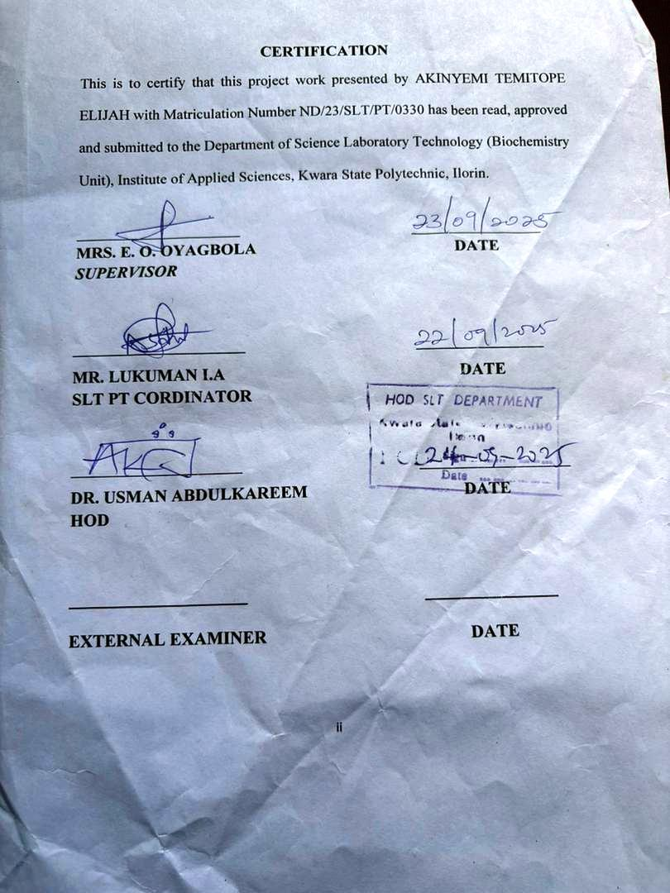

DEDICATION
I dedicated this project work to the Almighty God, who has been my source of strength, wisdom and guidance throughout this journey.
I also dedicate this seminar work to my beloved late father (Ibironke Kayode Emmanuel), your memory continues to inspire me to strive for excellence, and I hope that this achievement would have made you proud.

ACKNOWLEDGEMENT

I would like to express my deepest gratitude to the Almighty God, who has been my rock, my guiding light and my source of strength throughout this journey. Your divine providence, love and care have enabled me to persevere and complete this project.

To my family, especially my mother and step father, I am forever grateful for your unwavering support, love, and encouragement. Your sacrifices, prayers and words of encouragement have been a constant source of motivation for me. Thank you for being my pillar of strength and for believing in me.

My supervisor, Mrs. E.O Oyagbola, for her exceptional guidance, mentorship and support, your expertise, patience, and encouragement have been invaluable and I appreciate the time and efforts you invested in me.

I will also acknowledge my benefactor of knowledge for his fatherly roles and words of encouragement and to other viable lecturers in the department (microbiology unit), who has contributed in one way or the other and positively in planting me qualities, and moral values. May God reward you all!

To my big sister and her family, I appreciate your kindness, generosity and support. Your contributions, whether financial, emotional, or spiritual have made a significant impact on my Journey.

Special thanks to my best friend, Mohammed, for being a constant source of motivation, encouragement and support, your friendship has been a blessing and I am grateful for your presence in my life.

I am grateful to everyone who has contributed to my journey in one way or another. Your support, encouragement and prayers have made a significant impact on my life and I appreciate your presence in my life.

To crown it all, I congratulate myself on my successful completion of my programme in Kwara State Polytechnic.

TABLE OF CONTENT

Title page i
Certification ii
Dedication iii
Table of content iv
Abstract vi
CHAPTER ONE
1.0 Introduction 1
1.1 Literature Review 3
1.1.1 Overview of Silver nanoparticles and their antimicrobial properties. 6
1.1.2 Protocols for the Biosynthesis of Silver Nanoparticles (AgNPs). 13
1.1.3 Plant-mediated Biogenic Synthesis of AgNPs and their Antimicrobial Activity. 16
1.1.4 Calotropis procera’s medicinal properties and Potential Application. 26
1.2 Research Aim and Objectives. 33
1.3 Research Problems. 34
CHAPTER TWO
2.0 Materials and Methods. 35
2.1 Collection of Plant Extract and Bacterial and Fungal Isolates. 35
2.2 Preparation of Calotropis procera extract and Silver nitrate. 36
2.3 Synthesis of Silver nanoparticles using leaf extracts (Phytochemical properties) 37
2.4 Characterization of Silver nanoparticles. 40
2.5 Antimicrobial activity Assays. 47
CHAPTER THREE
3.0 Result 50
3.1 Phytochemical analysis. 50
3.2 Green synthesis of silver nanoparticle using leaf extract. 51
3.3 Characterization of synthesized nanoparticles. 52
3.4 Antimicrobial activity evaluation. 55

CHAPTER FOUR
4.1 Discussion. 58
4.2 Conclusion. 62
REFERENCES 65-73

V

ABSTRACT
In this study, Silver nanoparticles were successfully synthesized using Calotropis procera aqueous leaf extract. The effect of the whole extract and some of its phytochemicals on the particle distribution was determined while other characterizations such as UV-VIS spectrophotometer, Fourier transform infrared (FTIR) spectroscopy, Scanning electron microscopy (SEM) were carried out. The antimicrobial activity against selected microorganism was also studied using the agar diffusion method. The leaf extract showed the presence of phenols, flavonoids, saponins, steroid, terpenoids, alkaloids, and tannins. The UV-vis spectra displayed the characteristics Plasmon resonance at 400nm, The FTIR plots highlighted important functional groups including peaks between 3430.17 cm⁻¹, 2966.00 cm⁻¹, and 1753.00cm⁻¹ respectively confirming the formation of Silver oxide. Calotropis procera/AgNo₃ displayed significant antimicrobial activity against Klebsiella pneumoniae , Pseudomonas spp, Penicillum spp., Aspergillus spp,. Trichoderma spp., while no activity was recorded Escherichia coli ,Staphyloccus aureus, Salmonella typhi, Rhizopus spp. This study indicated that Calotropis procera was suitable for the synthesis of silver with properties that suggested that it could be potentially applied as antimicrobial nanofillers.

vi

