GENERATION OF AN AUTOMATIC TELLER MACHINE’S ONE-TIME PASSWORD USING TIME SYNCHRONIZATION
(A CASE STUDY OF FIRST BANK OF NIGERIA)

BY

ONIPEDE NANAHAWAU AYOMIDE
ND/23/COM/PT/0103

A PROJECT REPORT SUBMITTED TO THE

DEPARTMENT OF COMPUTER SCIENCE,
INSTITUTE OF INFORMATION AND COMMUNICATION TECHNOLOGY,
KWARA STATE POLYTECHNIC ILORIN

IN PARTIAL FULFILLMENT OF THE REQUIREMENT FOR THE AWARD OF NATIONAL DIPLOMA (ND) IN COMPUTER SCIENCE

2025
CERTIFICATION
This is to certify that this project was carried out by Onipede Nanahawau Ayomide of Matriculation Number ND/23/COM/PT/0103 in the department of Computer Science, Institute of Information and Communication Technology, Kwara State Polytechnic, Ilorin, Kwara State.

------------------------------------- ----------------------
MR. ISIAKA, O.S. Date
(Project Supervisor)

--------------------------------- ----------------------
MR. OYEDEPO, F.S. Date
(Head of Department)

----------------------------------- ---------------------
External Supervisor Date

DEDICATION
This project is dedicated to Almighty God for His guidance over my life.

ACKNOWLEDGEMENT

TABLE OF CONTENTS
PAGE
TITLE PAGE i
CERTIFICATION ii
DEDICATION iii
ACKNOWLEDGEMENT iv
TABLE OF CONTENTS v
ABSTRACT vii
CHAPTER ONE: GENERAL INTRODUCTION
  - INTRODUCTION 1
  - STATEMENT OF THE PROBLEM 2
  - AIM AND OBJECTIVES 3
  - SIGNIFICANT OF THE STUDY 3
  - SCOPE AND LIMITATION 3
  - ORGANIZATION OF REPORT 3
CHAPTER TWO: LITERATURE REVIEW
  - REVIEW OF RELATED PAST WORKS 5
  - ATM AUTHENTICATION FACTORS 6
2.2.1 SINGLE FACTOR AUTHENTICATION 6
    - TWO FACTOR AUTHENTICATION 7
2.3 OVERVIEW OF ONE TIME PASSWORD (OTP) 9
2.5.1 APPROACHES FOR OTP GENERATION 10
CHAPTER THREE: METHODOLOGY AND ANALYSIS OF THE EXISTING SYSTEM
3.1 RESEARCH METHODOLOGY 12
3.2 ANALYSIS OF THE EXISTING SYSTEM 13
3.3 PROBLEMS OF THE EXISTING SYSTEM 13
3.4 DESCRIPTION OF THE PROPOSED SYSTEM 14
3.5 ADVANTAGES OF THE PROPOSED SYSTEM 15

CHAPTER FOUR: DESIGN, IMPLEMENTATION AND DOCUMENTATION
4.1 DESIGN OF THE SYSTEM 16
4.1.1 OUTPUT DESIGN 16
4.1.2 INPUT DESIGN 19
4.1.3 PROCEDURE DESIGN 20
4.2 SYSTEM IMPLEMENTATION 20
4.2.1 CHOICE OF PROGRAMMING LANGUAGE 20
4.2.2 HARDWARE SUPPORT 20
4.2.3 SOFTWARE SUPPORT 21
4.2.4 IMPLEMENTATION TECHNIQUE USED 21
4.3 SYSTEM DOCUMENTATION 21
4.3.1 PROGRAM DOCUMENTATION 21
4.3.2 OPERATING THE SYSTEM 21
4.3.3 MAINTAINING THE SYSTEM 21
CHAPTER FIVE: SUMMARY, CONCLUSION AND RECOMMENDATION
5.1 SUMMARY 22
5.2 CONCLUSION 22
5.3 RECOMMENDATION 23
REFERENCES 24
FLOWCHARTS 26
SOURCE CODE LISTING 29

ABSTRACT
The most important information in this study is that one-time passwords (OTPs) generated and sent via short message service (SMS) to mobile phones are suggested by security experts as a way to get rid of some hacking techniques like phishing, man in the middle, key-loggers, and social engineering. By merely requiring an additional security code that is sent from the server to their mobile phone whenever they want to log in to their account from the internet, the project aims to create a second layer of security to protect users from those threads. The concept of this security method is very good because it can be used to solve many social networking problems. C-Sharp (C#) was the programming language employed to develop the software, and SQL server was the database server.

CHAPTER ONE
GENERAL INTRODUCTION
1.1 INTRODUCTION
The most important details in this text are that an ATM card and a Personal Identification Number (PIN) are needed to use an ATM. The PIN is a four-digit number that is used to verify the card holder's identity and presence, eliminating the need for a signature to authorize a financial transaction. When approaching an ATM, the card is inserted and the PIN is entered (Jyotsna & Shashikala, 2016). A list of options is given, and the keypad can be used to indicate the choice and amount of money desired.
SMS-based OTP is one of the most user-friendly multi-factor authentication mechanisms available today, as it does not require the use of a separate device. OTPs sent via SMS are now commonly used for authentication and authorization in a wide range of applications. One time passwords, or OTPs, are used for a single session or transaction and provide two levels of security. OTP-generated passwords are one-time passwords, meaning the OTP password you used for one of your transactions cannot be used again. OTP via SMS is a type of multi-factor authentication, as the user must meet (1) Something you know (i.e. a PIN) and (2) Something you have (the ATM card). Multi-factor authentication is considered stronger than simple PIN authentication, while OTP serves as a third authenticating factor.
There are three different categories for one-time passwords. In the first, a new password is generated based on the old one using a mathematical algorithm. The second relies on the time being synchronised between the authentication server and the user who provides the password. In the third method, a mathematical algorithm is used, but a challenge and a counter are used to choose the new password. In OTP generation algorithms, pseudo-randomness or randomness are frequently used. Additionally, there are several ways to let the user know what OTP to use next. Some systems use special electronic security tokens that users carry around that generate OTPs and show them on a small display. Other systems are made up of software that runs on the user's smartphone. Other systems, on the other hand, generate OTPs on the server and send them to the user via an out-of-band channel, such as SMS messaging. Finally, in some systems, OTPs are printed on paper and given to the user.
The purpose of this study is to secure ATM operations by creating a one-time password that will be generated each time a transaction on an ATM machine is required and sent to the user's mobile phone via SMS. Two organisations manage the OTP one-time password system. The one-time password (OTP) is created in the first step, and it is then verified and, if accurate, used to authenticate the user for the transaction in the second step. The user's secret password and the data entered on the account opening form will be used by the server to generate the proper one-time password (OTP) using the Sha-256 algorithm. After that, the server sends the generated OTP to the user's mobile device while encrypting the SMS with Base 64 over the network (Isiaka, 2013). The static password (PIN) is then followed by the OTP as the second password, which is entered by the user. After that, the server contrasts the received OTP with the one kept in the database. The user will be verified for the transaction if they match; otherwise, it will be cancelled. The secure hash function creates a different OTP for every transaction, so after every successful transaction, the OTP will no longer be valid.
1.2 STATEMENT OF THE PROBLEM
There are numerous issues associated with the use of ATMs around the world. Card theft, phishing, PIN interception, and shoulder surfing are just a few of the issues. In order to solve all of the aforementioned problems and provide more security to ATM transactions, this project attempts to generate OTP that will be sent to the user via SMS and used once in addition to the static password.
1.3 AIM AND OBJECTIVES
The aim of this project is to create a one-time password (OTP) for ATM operations using time synchronization. The following are the objectives:
- To design an interactive and user-friendly platform for demonstrating ATM operations.
- To generate an OTP using time synchronization and send it to a mobile phone via SMS for second factor authentication.
1.4 SIGNIFICANCE OF THE STUDY
The purpose of this research is to authenticate the user for ATM transactions by using a non-reversible second password generated by the server and sent to the user's mobile phone via SMS. This second non-reversible one-time password will go a long way toward reducing alarming ATM fraud and the man-in-the-middle effect that is common with ATM transactions.
1.5 SCOPE OF THE STUDY
The scope of this study is limited to the condition in which all necessary networks, particularly those of mobile service providers and internet services, are fully operational. As a result, the following conditions are not covered by the scope of this study.
- Even if a user is a genuine user, he cannot login to the system if the GSM gateway service provider's servers are down and he cannot receive the OTP.
- The system cannot be used if a user disconnects from the network due to a delay in bill payments or a poor network signal.
1.6 ORGANIZATION OF REPORT
This report is divided into five chapters, which are listed below. The first chapter provides a general introduction and overview of the entire research. It also discusses the problem statement, the aim and objectives of the proposed system, the significance of the study, the scope and limitations of the project, and the report's organization. The second chapter deals with the literature review, which includes a review of related topics to the project as well as a discussion of related aspects of the project topic related to computer technology. The third chapter deals with system analysis, which includes the data collection method used, a description of the existing system and its problems, and a description of the proposed system and the potential benefits it will provide to solve problems encountered in the existing manual system. The fourth chapter focuses on the proposed system's design, implementation, and description. It also describes the output design, the input design, and the procedure design. The implementation techniques used, the programming language used in developing the new system, and the system requirements for running the system. Also discusses program documentation as well as user documentation. Finally, the fifth chapter provides a brief summary of the work completed, experience gained, and problems encountered during the course of the project, as well as a conclusion and recommendations. Other appendices included after the references are a system flowchart, a program flowchart, and a program source listing.

CHAPTER TWO
LITERATURE REVIEW
2.1 REVIEW OF RELATED PAST WORKS
According to More and Markande (2016), the number of ATM-related crimes has increased, necessitating the need for improved ATM security. There are various technologies used to provide security to ATM machines, such as biometric technology, RFID technology, and so on. Fingerprint and face recognition systems are examples of biometric technology. This paper presents a survey of various ATM security technologies. There are some limitations to these technologies. When comparing various ATM security technologies, it is discovered that fingerprint technology appears to be better and more secure than other technologies.
Frimpong et al. (2016) discovered that a wide range of systems require a dependable personal recognition system to either authorize or determine the identity of a person requesting their services. The goal of such a system is to ensure that the rendered services are only accessed by the intended user and no one else. These systems are vulnerable to imposter deception in the absence of robust personal recognition schemes. Due to its traditional authentication mode, the ATM has suffered greatly over the years from PIN theft and other ATM frauds (PIN). In their paper, they proposed a multifactor (PIN and fingerprint) based authentication security arrangement to improve the ATM's and its users' security and safety. The proposed system has a three-tiered design structure. The verification module is the first tier, and it focuses on the enrollment phase, enhancement phase, feature extraction, and fingerprint matching. The second tier is the database end, which serves as a repository for all ATM users' preregistered fingerprints as templates and PIN as text.
Himika et al. (2012) proposed an image-based authentication service that eliminates the need for text passwords. After image authentication, the user will obtain the One Time Password (OTP) via the internet's instant messaging service. This OTP is then used by the user to gain access to their personal accounts. The image-based authentication method is based on the user's ability to identify pre-selected categories from a grid of images. This paper combines image-based authentication and HMAC-based one-time passwords to achieve a high level of security in internet authentication. If the algorithms are time synchronized with the user, they are very cheap to implement.
2.2 ATM AUTHENTICATION FACTORS
Authentication is the use of one or more mechanisms to prove that you are who you say you are. Access is granted once the human or machine's identity is validated. Today, three universally recognized authentication factors exist: what you know (e.g., passwords), what you have (e.g., ATM card or tokens), and what you are (e.g. biometrics). Recent work has been done in attempting alternative factors such as a fourth factor, e.g. someone you know, which is based on the concept of vouching (Mallat et al., 2004).
    - SINGLE FACTOR AUTHENTICATION
A password is typically used as a single factor of authentication. However, these may be vulnerable to attacks that jeopardize the application's security in general. Some of the more common attacks can be carried out with little or no cost to the perpetrator and remain undetected. Traditionally, one of these elements has been responsible for single factor authentication.
- Something you have − including keys or token cards
- Something you know − including passwords
- Something you are − including fingerprints, voiceprints or retinal scans (iris)
The user must prove knowledge or possession of something in a single factor authentication solution; additional authentication is not required. Figure 2.1 depicts the most basic and widely used method of single factor authentication: passwords.
Figure 2.1: Static username ID and password

Meanwhile, according to AbdulRahaman and Vemuri (2016), the disadvantages of single factor authentication are that "something you have" can be stolen, "something you know" can be guessed, shared, or lost to other methods, and "something you are" can be cloned and imitated.
2.2.2 TWO FACTOR AUTHENTICATION
According to Agoyi & Seral (2010), two factor authentication is a mechanism that implements two of the aforementioned factors and is thus considered stronger and more secure than the traditionally implemented one factor authentication system. Withdrawing money from an ATM machine requires two factor authentication; the user must have the ATM card, i.e. what you have, and know a unique personal identification number (PIN), i.e. what you know. Passwords are one of the most common targets for hackers. As a result, most businesses are looking for more secure ways to protect their customers and employees. Biometrics are known to be very secure and are used in specialized organizations, but they are not widely used in secure online transactions or ATM machines due to the expensive hardware required to identify the subject and the associated maintenance costs, etc. Instead, banks and businesses use tokens for two-factor authentication.
Given the limitations of single-factor authentication, the logical alternative is two-factor authentication, in which two methods, knowledge and possession, are used in tandem, i.e. something the entity knows and something the entity possesses. A perfect example is the system used to authenticate ATM users, which combines a magnetic-stripe card (what you have) with a multi-digit PIN (what you know). Figure 2.2 depicts a typical conventional ATM connection with a two-factor authentication system.
Figure 2.2: Basic Connection of Automated Teller Machine (ATM)

ATM
Host Computer
Bank Computer

Physical contact
Internet
User

Two-factor authentication is not a new concept; it has been used for centuries. When a bank customer visits a local automated teller machine (ATM), the physical ATM card that the customer inserts into the machine serves as one authentication factor ("something the user has"). The second factor is the PIN entered by the customer via the keypad ("something the user knows"). Authentication fails in the absence of corroborating verification from both of these factors. This scenario exemplifies the fundamental idea behind most two-factor authentication systems: the combination of a knowledge factor and a possession factor.
To make the implementation and use of a two factor authentication system more complex and difficult for an attacker to crack, an additional system generated password is proposed, and this password should be sent to the user via SMS. A user is authenticated in two steps, with the user providing the system with two passwords. One password (PIN) is the general password that the user must enter each time he or she wants to login. The second password is the One Time Password (OTP), which is generated by the system and sent to the user's mobile phone via SMS, which he must then enter into the machine in order to be granted transaction access. This password will become invalid immediately after access is granted (Roberto et al, 2005). Because the output of the Sha-256 algorithm is irreversible, it is used to generate this one time password (OTP). The output is then Base 64 encoded and decoded for easy network transport without interference (Isiaka, 2013).
Since both PIN and OTP are part of what the user knows, this proposed method is classified as a two factor authentication because it only uses two different types of authentication techniques; something the user has and something the user knows. This method is then considered "strong authentication" because it is difficult to break through due to the unpredictable second password OTP added to it.
A. BENEFIT OF TWO FACTOR AUTHENTICATION
- Double-criterion to verify the user's identity: The system verifies the user's identity by requesting two passwords. The first is the PIN, which is a static password that the system will use to generate the second password, which is a one-time password that is sent to the user via SMS.
- Protecting the existing authentication system: The OTP authentication method does not replace the existing authentication system; rather, it adds a layer of security that protects and enhances the existing authentication system, whether software or hardware (Mithun et al, 2017).
- Protecting against internal fraud: The system's core authentication and messaging engine is designed to provide a high level of security against reverse program transformation of software. A security platform is never secure if someone has access to parts of the application and its security algorithm, modifies the content of code to reveal security flaws, or even creates a backdoor entry.
B. LIMITATIONS ON TWO FACTOR AUTHENTICATION
- Two-factor authentication cannot solve the phishing problem ( phishing is defined as a process of gathering personal data such as credentials, information of the credit cards and other sensitive data by impersonating as a trusted party through electronic communication).
- Even if a user is a genuine user, he cannot login to the system if the GSM gateway service provider's servers are down and he cannot receive the OTP.
- This system cannot be used if a user disconnects from the network due to a delay in bill payments or a poor network signal.
This research attempted to solve the problem of phishing but was unable to address the other issues raised above because the scope did not include GSM services, bill payments, or network signal. All of this will be investigated in future research.
2.3 OVERVIEW OF ONE TIME PASSWORD (OTP)
Single static passwords or PINs are vulnerable to ATM operations, i.e., people asking for or correctly guessing PINs. Some surveys have revealed how simple it is to get people to reveal their PIN. They can also be detected by spyware. It provides many opportunities for others to gain access to their personal accounts; otherwise, we must change the PIN on a regular basis. To address these shortcomings, a new method known as "One Time Password" is introduced (OTP). After the user enters the PIN into the machine, the web server generates the OTP code using the Sha-256 algorithm and sends it to the user's mobile device (Mohsen & Satar, 2016). When prompted, the user must enter the OTP code into the machine. At the system level, the OTP is validated and access is granted for the transaction if it is correct, or the operation is aborted if the OTP supplied is incorrect. It prevents unauthorized logging.
A one-time password (OTP) is a password that is only valid for one login session or transaction at a time. OTPs avoid a number of flaws associated with traditional (static) passwords. The most significant flaw addressed by OTPs is that, unlike static passwords, they are not vulnerable to replay attacks. This means that a potential intruder who records an OTP that has already been used to log into a service or conduct a transaction will be unable to exploit it because it is no longer valid. On the negative side, OTPs are difficult for humans to remember. As a result, they require additional technology to function. Pseudo-randomness or randomness are commonly used in OTP generation algorithms. This is necessary because it would be too easy to predict future OTPs based on previous ones (Salem & Anastasios 2013). The specifics of concrete OTP algorithms vary greatly.
2.3.1 APPROACHES FOR OTP GENERATION
Nguyen (2014) has highlighted several approaches for the generation of OTPs, which are listed below:
a) Time-synchronized:
This scheme may also have issues with synchronization. In practice, however, dedicated devices are extremely reliable at staying synchronized. Cell phones, on the other hand, generally get their time from the cell phone network and are extremely accurate the vast majority of the time. When cell phones are incorrect, they benefit from the fact that time will correct itself. Time zones can be an issue depending on how the cell phone stores time and how the app is written. If the times are not synchronized to a universal time, traveling to a different time zone may cause your phone's clock to reset in a way that disrupts the synchronization.
b) Mathematical algorithm (Sha-256)
The mathematics used to implement Sha-256 hashing programs is quite complex.
Hash computation
• The first eight variables are set to their initial values, which are given by the first 32 bits of the fractional part of the square roots of the first eight prime numbers:
H₁⁽⁰⁾ = 0x6a09e667 H₂⁽⁰⁾ = 0xbb67ae85 H₃⁽⁰⁾ = 0x3c6ef372 H₄⁽⁰⁾ = 0xa54ff53a
H₅⁽⁰⁾ = 0x510e527f H₆⁽⁰⁾ = 0x9b05688c H₇⁽⁰⁾ = 0x1f83d9ab H₈⁽⁰⁾ = 0x5be0cd19
• Next, the blocks M(1), M(2), . . . , M(N) are processed one at a time:
• The hash of the message is the concatenation of the variables H_{j}^{(t)} after the last block has been processed
H = H₁^{(N)}║H₂^{(N)}║H₃^{(N)}║H₄^{(N)}║H₅^{(N)}║H₆^{(N)}║H₇^{(N)}║H₈^{(N)}.
Fortunately, there are free, open-source, and commercial hashing libraries available for use in one's program. However, rather than incorporating the algorithm, future research will delve deeper into it.
c) Mathematical algorithm (Base 64)

The generated OTP value is encoded and sent to users using the powerful Base 64 algorithm. Base64 encoding entails using four printable characters (in US-ASCII format) to encode any three bytes (3*8 bits = 24 bits). Base64 encoding employs a 64-character alphabet to represent 6 bits of data. The 64 symbols in this alphabet were chosen to be universally readable and to have no special meaning in the main email/SMS protocols (in particular SMTP).

CHAPTER THREE
RESEARCH METHODOLOGY
3.1 RESEARCH METHODOLOGY
To ensure the system's security, the generated OTP must be difficult for hackers to guess, retrieve, or trace. As a result, developing a secure OTP generating algorithm is critical. In the OTP computation, the following fields are chosen:
- Date: The actual system date, in the format DDMMYYYYY, on which the user uses the ATM.
- Time: The actual time of day, in the format HHMM (24 hour time), that the user uses the ATM.
- PIN: This is the four-digit password or lock that the user provides to his ATM for the first authentication in order for the server to generate OTP and prevent it from being executed by another person.
- IMEI number: This stands for International Mobile Equipment Identity and is unique to each mobile phone.
- SIM number: Subscriber Identity Module number.
- Attempt Number: The number of times the user has logged in with his/her PIN.
The server will keep track of the user's login attempt number after each successful login with the static password (PIN). The server then uses this attempt number, along with the user credentials stored in the database, to compute OTP.
STEPS OF OTP ALGORITHM
Step 1: The algorithm first concatenates all of the above-mentioned fields using the SHA-256 hash algorithm.
Step 2: A strong hash function (SHA-256) is applied to the concatenated string formed in step 1, yielding a 256 bit length string.
Step 3: The result is then divided into two halves and XORed.
Step 4: Step 3 is repeated until we get a small size result, which is our OTP.
Step 5: The attempt number is then updated by some unique logic at the server end so that it can be used in the next authentication process.
3.2 ANALYSIS OF EXISTING SYSTEM
To use an ATM, you will need an electronic account card (ATM card) and a Personal Identification Number (PIN). Your PIN is a four-digit number that will be assigned to you when you receive your electronic card. This number is used to verify the identity and presence of the card holder, eliminating the need for a signature to authorize the financial transaction. When you approach an ATM, you must insert your ATM card into the machine and then enter your four-digit PIN (Frimpong, Kofi & Michael, 2016).
ATMs today are more than just machines for accessing and dispensing cash; some ATMs also allow you to transfer funds between accounts, buy stocks, check account balances, and even make deposits into your account. All of these features are accessible with a single debit or credit card and a PIN number. Having access to an ATM is very convenient and makes life's little emergencies far less difficult if you take precautions to protect your PIN and account information.
3.3 PROBLEMS OF EXISTING SYSTEM
There are numerous issues associated with the use of ATMs around the world. Among the issues identified by Diebold (2002) and Michael (2009) are:
- Card Theft: In order to obtain actual cards, criminals have used a variety of card trapping devices, which are slim mechanical devices encased in a plastic transparent film and inserted into the card reader throat. Hooks are attached to the probes, preventing the card from being returned to the customer at the end of the transaction. After the customer leaves the area believing that their card has been captured by the ATM, the criminal will use a probe to extract the card. With the customer's PIN in hand and the card in hand, the customer can easily withdraw money from the unsuspecting customer's account.
- Phishing: This is the process of gathering personal data such as credentials, credit card information, and other sensitive data by impersonating a trusted party through electronic communication.
- PIN Interception: The information is captured in electronic format by an electronic data recorder after the PIN is entered by the card's owner. Capturing the PIN can be done within the terminal or while the PIN is being transmitted over the network to the host computer for verification. This is also referred to as a man-in-the-middle attack.
- Utilizing a fake PIN pad overlay: The original keypad is covered with a fake PIN pad. This overlay captures and stores the PIN data in its memory. After that, the phony PIN pad is removed, and the recorded PINs are downloaded. Fake PIN pads can look and feel almost identical to the real thing.
- Shoulder Surfing: This is an act in which the fraudster watches the number that the account owner taps on the keypad with style. Miniature video cameras may be installed discretely on the fascia or near the keypad to record PIN entry information.
3.4 DESCRIPTION OF THE PROPOSED SYSTEM
The OTP system is operated by two entities. The user's secret password and the server's specific password must be generated correctly so that it can be generated. The generator's appropriate generation parameters must receive a challenge from the server, as well as verifying the received one-time password, storing the received last valid one-time password, and finally storing the corresponding sequence number one-time password. There is a secure method in which the server must also facilitate the user's secret pass-changing. A hash function generates a one-time password through multiple iterations as part of the challenge, so that a received seed is passed to the user by a single one-time password system generator. The number of secure hash function iterations is reduced by one after each successful authentication. As a result, a unique password sequence will be generated. The server can validate the one-time password generated by the generator by computing the secure hash function, and the accepted OTP will be compared to the previous one.
Time one-time password (TOTP) truncates the output of the HMAC-SHA-1 calculation to produce user-friendly values:
HOTP (K, C) = Truncate (HMAC-SHA-256 (K,C)) where
An HMAC-SHA-256 value can be converted by the function in order to get HOTP value. While counter value and shared secret are represented by C and K;
T represents a time step that is derived from a time reference. TOTP is the time-based variant of this algorithm, and the counter C replaces the computation of HOTP. TOTP implementations employed the use of SHA-256 hash functions. The time step and an OTP are generated at the same time. When a validation system sends a generated OTP, it does not know the client's exact timestamp. The timestamp of the validation system is typically used for OTP comparison. Due to network latency, there is a time lag between when the OTP is generated and when it arrives. The result can be very high, denoted by the letter T. In order to receive time from the validated system, the time step window must not fall within the same actual OTP generation. When an OTP is generated, the receiving time is added to the end of the next step window.
3.5 ADVANTAGES OF THE PROPOSED SYSTEM
- Double-criterion to verify the user's identity: The system verifies the user's identity by requesting two passwords. The first is the PIN, which is a static password that the system will use to generate the second password, which is a one-time password that is sent to the user via SMS.
- Protecting the existing authentication system: The OTP authentication method does not replace the existing authentication system; rather, it adds a layer of security that protects and enhances the existing authentication system, whether software or hardware.
- Protecting against internal fraud: The system's core authentication and messaging engine is designed to provide a high level of security against reverse program transformation of software. A security platform is never secure if someone has access to parts of the application and its security algorithm, modifies the content of code to reveal security flaws, or even creates a backdoor entry.
CHAPTER FOUR
DESIGN AND IMPLEMENTATION OF THE SYSTEM
4.1 DESIGN OF THE SYSTEM
A system design is concerned with the analysis of a new system. Proper analysis and design of the available data will allow for the proposed system to be realized.
4.1.1 OUTPUT DESIGN
This section describes the design's output after the user has been authenticated with a PIN and an OTP. In terms of the various operations that can be performed on the application, operations can be performed after the authentic user has successfully logged in. Figures 4.1 to 4.5 show the message displayed when the user enters an incorrect PIN, the phone inbox showing the OTP code received, the displayed OTP digits on the phone, the message displayed when the user enters an incorrect OTP, and the successful login templates.
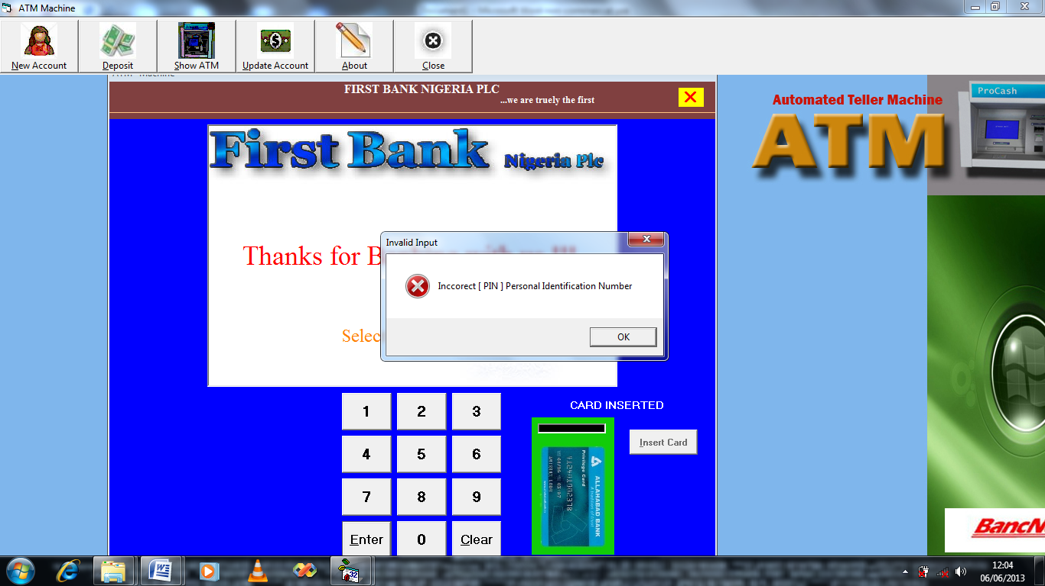
AUTHENTICATE ATM TRANSACTION
WITH SMS OTP
Figure 4.1: Screen shot showing error for wrong PIN entered

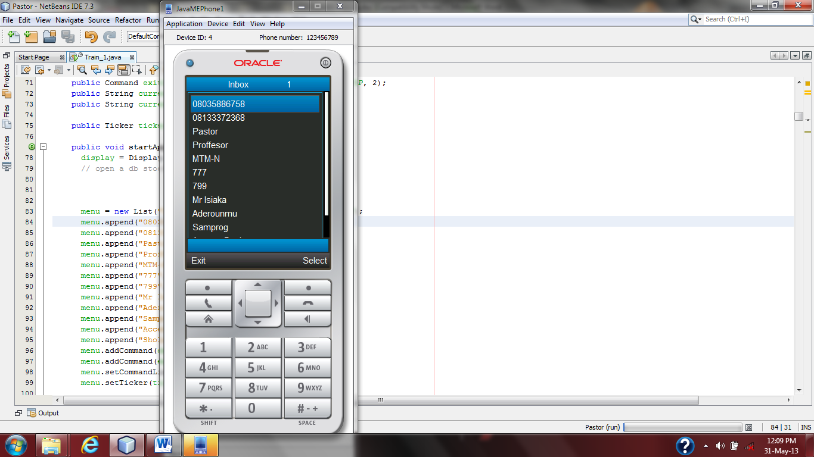

OTP Code
Figure 4.2: Inbox of the mobile phone showing OTP code message received.

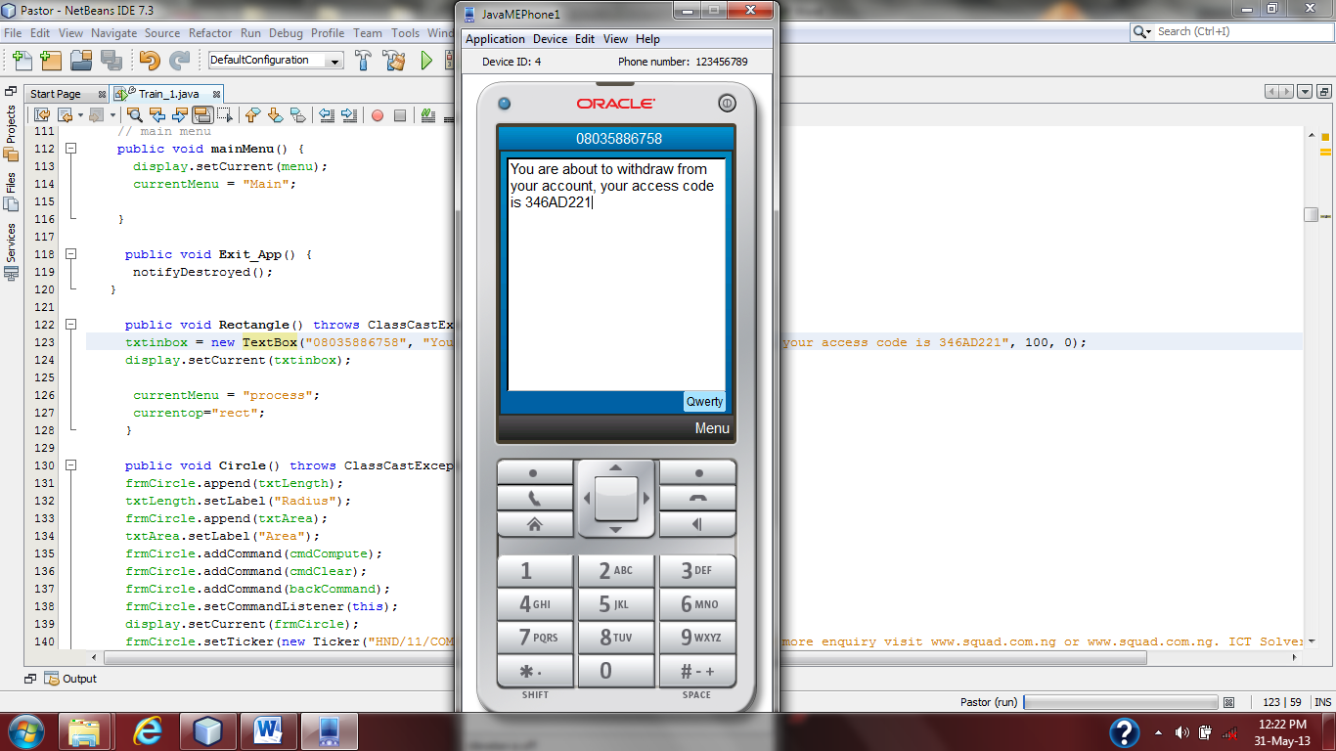
You are to perform transaction on your account using ATM. Your access code is 346221
OTP Code
Figure 4.3: The menu displaying OTP code to login.

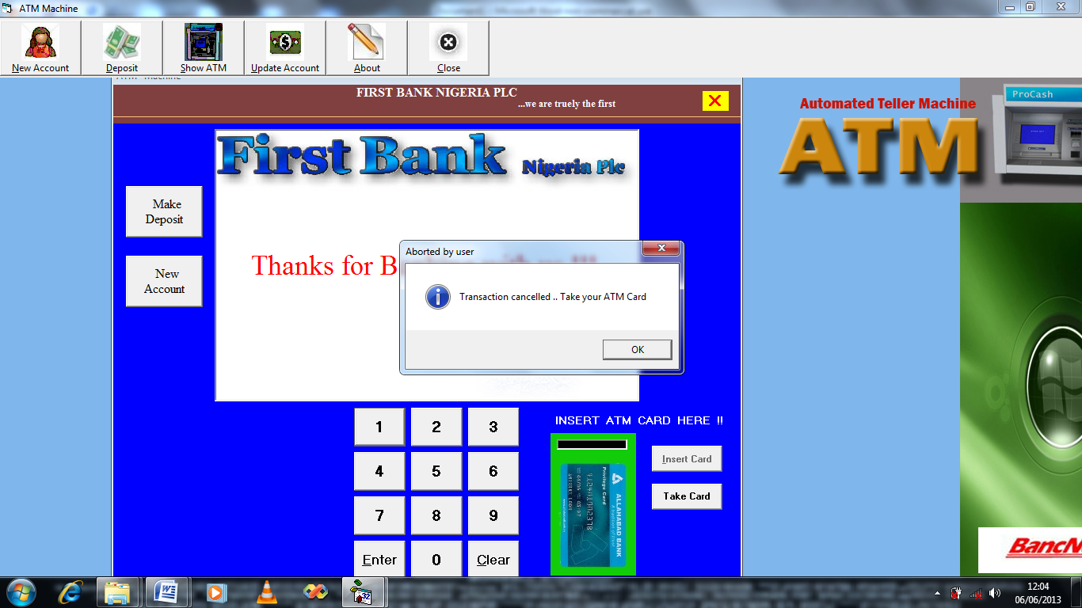
AUTHENTICATE ATM TRANSACTION
WITH SMS OTP
Figure 4.4: Snapshot showing error message for wrong OTP code entered

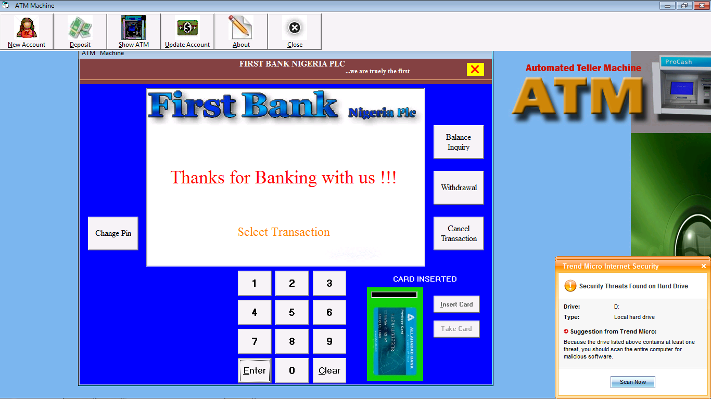
AUTHENTICATE ATM TRANSACTION
WITH SMS OTP
Figure 4.5: Snapshot showing Transaction environment after successful login with OTP

4.1.2 INPUT DESIGN
This is explained under the input design as how data are fed into the system or how data are to be organized so that the processing state can be successful. Figures 4.6–4.7 depict the input designs for this project work.
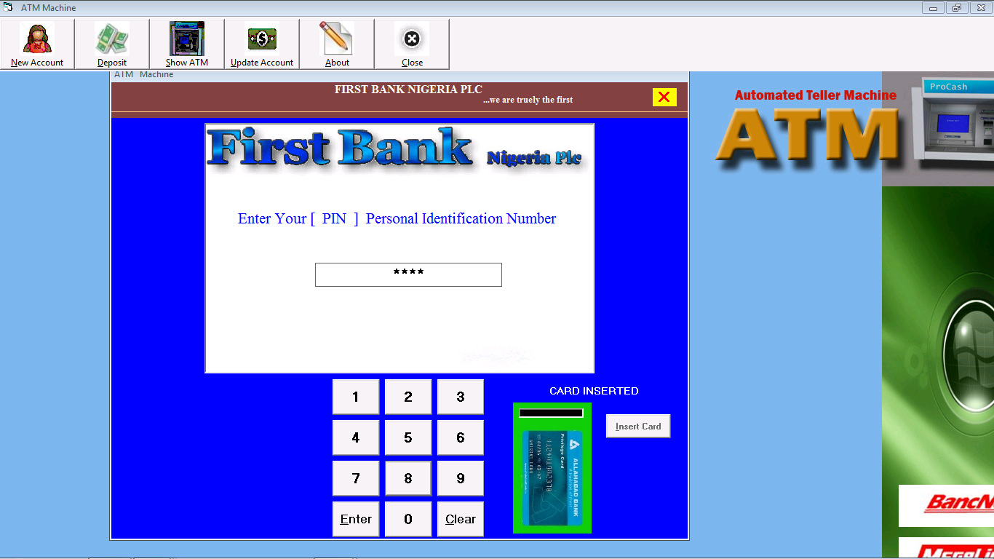
AUTHENTICATE ATM TRANSACTION
WITH SMS OTP
Figure 4.6: Screen shot for login with PIN

AUTHENTICATE ATM TRANSACTION
WITH SMS OTP

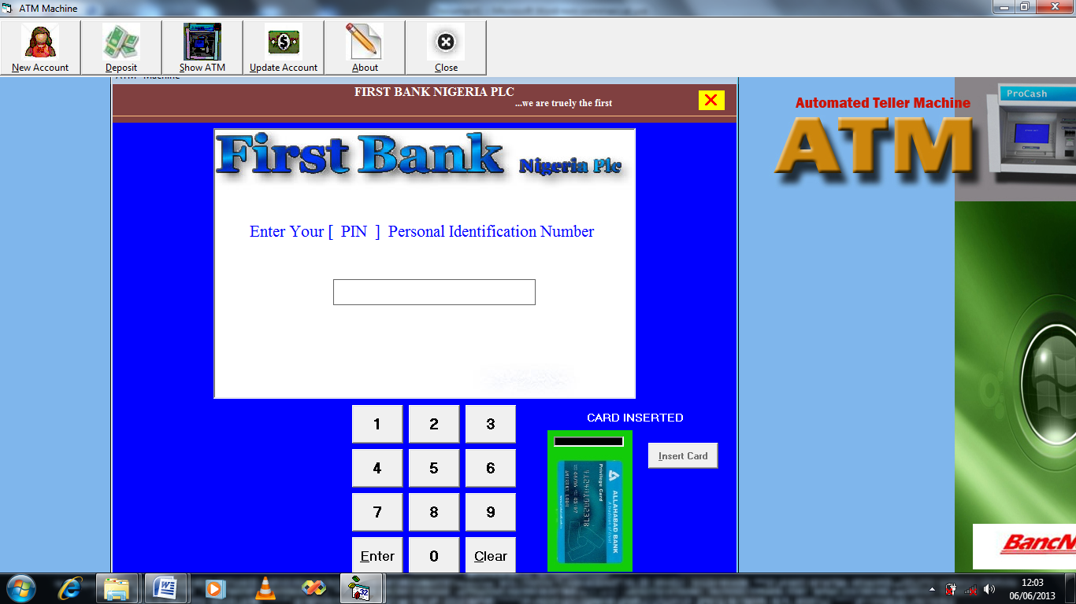
AUTHENTICATE ATM TRANSACTION
WITH SMS OTP
Enter your [ OTP ] one Time Password
******
Figure 4.7: Snapshot showing login environment for second password (OTP)

4.1.3 PROCEDURE DESIGN
The procedure is the arrangement, steps, and how the flow of a program with the program's arranging and structuring. Because the program is divided into modules, the methodology used is an event driven programming language, which makes the program much more efficient in terms of execution, program write time, storage utilization, and maintenance.
4.2 SYSTEM IMPLEMENTATION
4.2.1 CHOICE OF PROGRAMING LANGUAGE USED WITH REASONS
The programming language used for the design and implementation of OTP generation and ATM operation is C Sharp (C#), and SQL server was used as a database server. The following were the reasons for using the aforementioned program.
- It is compiled to an intermediate language (CIL) regardless of the language in which it was written or the target architecture or operating system.
- It is much more efficient and runs at a faster rate.
- The assembly concept effectively addresses the problem of versioning control.
- It provides good distributed system support.
4.2.2 HARDWARE REQUIREMENTS
To install and run the program, the user needs a
- PC (Pentium IV), dual-core, 2.66-GHz or faster processor,
- USB 2.0 bus dedicated to the Kinect,
- 40GB hard disk with 1GB of RAM,
- Graphics card that supports DirectX 9.0c
- 10-100 MBPS of Network card

4.2.3 SOFTWARE REQUIREMENTS
- Windows XP Professional or higher version
- SQL server 2007 with Visual studio.Net setup tools
- Microsoft word processor 2007
- HTML, Visual studio designer
4.2.4 IMPLEMENTATION TECHNIQUES USED
The pilot implementation technique was used in the development of the synchronous e-learning method because it is simple to control; the pilot can be stopped at any time. It is simple to evaluate because the new and old systems are running concurrently; it is also simple to train students and low risk.
4.3 SYSTEM DOCUMENTATION
4.3.1 PROGRAM DOCUMENTATION
The program is installed by selecting WAMP Server from the start menu, navigating to the set up folder where the modules are saved on the www, double-clicking, and then following the instructions on the screen. The program will be placed in the WAMP Server folder.
4.3.2 OPERATING THE PROGRAM
Click the start button on the Windows start bar, then move the mouse pointer to all programs, then click the WAMP Server to locate the application's folder, and then click it. The home page will be displayed, and the user will be able to click through to other pages one by one.
4.3.3 MAINTAINING THE SYSTEM
System maintenance entails system modification. It refers to the ease with which changes to the system can be made under certain conditions. It also refers to the correction, addition, or deletion of a portion or the entire program. A good program has structure and a feature of maintainability. This Program is designed in such a way that it allows for project modification and expansion.
CHAPTER FIVE
SUMMARY, CONCLUSION AND RECOMMENDATION
5.1 SUMMARY
Following a thorough examination of the security features in ATM transactions where a static password or PIN is used to secure the service, an additional security scheme of a second password that can be used only once is proposed. This proposal does not replace existing security technology; rather, it serves as an additional layer of security that protects the existing authentication system from fraud and crime. The goal of this research is to generate One Time Password (OTP) and provide secure end-to-end communication of OTP to customers by encoding the SMS message used to send the OTP from the bank server to the customer's mobile phone.
5.2 CONCLUSION
This study introduced the use of a second password known as One Time Password (OTP) that ATM users must enter for authentication before any transaction can take place after the system has verified the static password or Personal Identification Number (PIN). The host computer generates this OTP by concatenating the user's vital information and using the Sha-256 algorithm. Because an OTP generated for a user for a transaction is only valid for that transaction, it cannot be regenerated for the same or another user. To protect the OTP from fraudsters, Base 64 is used to easily encode it and save transmission over the network via Short Message Service (SMS) to the user's mobile phone. The study's findings revealed that a static password or PIN is ineffective at providing the necessary security for ATM users. Finally, banks can use this scheme to ensure the confidentiality and authenticity of bank-user communication via ATM. The scheme can also be used to secure communication between banks and customers for mobile and online banking.

5.3 RECOMMENDATION
Given the difficulties encountered during the course of this research, I have recommended the following for future research in order to eliminate any obstacles that may prevent the proposed work from running smoothly.
- The issue of network fluctuation in the mobile network must be addressed because delays in SMS delivery may result in time consuming, which may frustrate the user's confidence in the transaction.
- Frequent phone number verification in the event that the phone is lost or stolen. It is necessary to implement a security measure to track the authenticity of the phone number.
- Informing users about the importance of one-time passwords (OTPs) and the need for them to always have a functional mobile phone with them whenever they want to transact with an automated teller machine (ATM).

REFERENCES
AbdulRahaman S. & Vemuri K. P. (2016). A-ATM: AADHAAR Based Security in ATM. International Research Journal of Engineering and Technology, 3(12).
Agoyi M. & Seral D. (2010). The use of SMS encrypted message to secure automatic teller machine. Published by Elsevier Ltd. doi:10.1016/j.procs.2011.01.008, open access under CC BY-NC-ND license, www.elsevier.com/locate/procedia.
Chow Y., Susilo W., Au M. H. & Barmawi A. M. (2015). A visual one-time password authentication scheme using mobile devices. In L. C. K. Hui, S. H. Qing, E. Shi & S. M. Yiu (Eds.), Proceedings of the 16th International Conference on Information and Communications Security, 243-257.
Frimpong T., Kofi N. & Michael A. (2016). Improving security levels in Automatic Teller Machines (ATM) using multifactor authentication. International Journal of Science and Engineering Applications, Volume 5 Issue 3, ISSN-2319-7560.
Himika P., Nancy N. & Sumaiya T. (2012). Generation of secure one-time password based on image authentication. Computer Science & Information Technology.
Isiaka O. S. (2013). Secured Automated Teller Machine (ATM) authentication with One-Time Password (OTP) using Short Message Service (SMS) verification. An Unpublished Dissertation for the Award of Master of Science in Information Technology, School of Science and Technology, National Open University of Nigeria, Lagos, Nigeria
Jyotsna T. D. & Shashikala R. J. (2016). Secure ATM system with biometric fingerprints technology. International Journal of Current Trends in Engineering & Research, 2(6), 489-494.
Marimuthu K., Ganesh G. D., Harshita M. & Aditya-Rajan P. B. (2014). A novel way of integrating voice recognition and one time passwords to prevent password phishing attacks. International Journal of Distributed and Parallel Systems, 5(4).
Mithun D., Kangkhita K. P. & Shamima Y. (2017). ATM transaction security using fingerprint recognition. American Journal of Engineering Research (AJER), e-ISSN: 2320-0847 p-ISSN: 2320-0936 6(8), 41-45.
Mohsen G. & Satar G. (2016). One-time passwords via SMS. Bulletin de la Société Royale des Sciences de Liège, 8(5), 106-113.
More P. & Markande S. D. (2016). Survey of security of ATM machine. International Journal of Advanced Research in Computer and Communication Engineering 5(4).
Muhammad-Bello B. L., Alhassan M. E. & Ganiyu, S. O. (2015). “An Enhanced ATM Security System using Second-Level Authentication”. International Journal of Computer Applications, 111(5).
Nguyen M. P. (2014). SMS-OTP. Helsinki Metropolia University of Applied Sciences.
Okafor C. M. (2015). Design of two-factor authentication (PIN and SMS Password) for an automated teller machine (ATM). An unpublished thesis for the award of Master of Electronic Engineering (Digital Electronics and Computers option) in the Department of Electronic Engineering, University of Nigeria, Nsukka.
Paterson K.G. & Stebila D. (2010). One-time-password authenticated key exchange. In: information security and privacy: Proceedings of the 15th Australasian Conference, ACISP 2010, Macquarie Graduate School of Management, Sydney.
Salem A. & Anastasios K. (2013). Efficient time synchronized one-time password scheme to provide secure wake-up authentication on wireless sensor networks. International Journal of Advanced Smart Sensor Network Systems (IJASSN), 3(1).

PROGRAM FLOWCHART
START
ENTER PIN
GENERATE OTP
SEND OTP
STOP
PIN VERIFICATION
OTP VERIFICATION
SEND OTP
SEND OTP

PIN VERIFICATION FLOWCHART
START
INSERT CARD
OPEN DATABASE
CLOSE DATABASE
ENTER PIN
IS PIN MATCH WITH DATABASE?
NO
YES
GENERATE OTP
SAVE OTP TO DATABASE
SEND OTP TO USER MOBILE PHONE
OTP VERIFICATION
DISPLAY INCORRECT (PIN) PERSONAL IDENTIFICATION NUMBER
STOP

OTP VERIFICATION FLOWCHART
START
OPEN DATABASE
CLOSE DATABASE
ENTER OTP
IS OTP MATCH WITH DATABASE?
NO
YES
PERFORM TRANSACTION
DISPLAY TRANSACTION CANCELLED … TAKE YOUR ATM CARD
STOP

SOURCE CODE
Source for Connection
Sub Network()
Set con = New Connection
Set rec = New Recordset
con.Open "Provider=Microsoft.Jet.OLEDB.4.0;Data Source=" & App.Path & "\ATM.mdb;jet oledb:database password=admin"
End Sub

Source code for Account creation
using System;
using System.Collections.Generic;
using System.ComponentModel;
using System.Data;
using System.Drawing;
using System.Linq;
using System.Text;
using System.Threading.Tasks;
using System.Windows.Forms;
namespace WindowsFormsApplication1
{
public partial class CREATE : Form
{
public CREATE()
{
InitializeComponent();
Randomize Timer
accountnumber = Int((9999999999# - 1111111111 + 1) * Rnd) + 1111111111
Randomize Timer
atmnumber = Int((999999999999999# - 111111111111111# + 1) * Rnd) + 111111111111111#
Randomize Timer
atmpin = Int((9999 - 1111 + 1) * Rnd) + 1111
Network
rec.Open "New_Account", con, adOpenDynamic, adLockOptimistic
With rec
.AddNew
!Surname = txtsurname.Text
!Othernames = txtothernames.Text
!Sex = cmbsex.Text
!Date_Of_Birth = cmbday.Text & "-" & cmbmonth.Text & "-" & cmbyear.Text
!Address = txtaddress.Text
!Postal_Address = txtpostaladdress.Text
!Occupation = txtoccupation.Text
!Marital_Status = cmbmarital.Text
!Religion = cmbreligion.Text
!Initial_Deposit = txtinitialdepo.Text
!Mobile_Phone = txtphone.Text
!Account_Type = cmbaccounttype.Text
!Passport = accountnumber & ".jpg" 'txtsurname.Text & ".jpg"
!Kin_Surname = txtksurname.Text
!Kin_Othernames = txtkothernames.Text
!Kin_Sex = cmbksex.Text
!Relationship = cmbrelationship.Text
!Kin_Address = txtkaddress.Text
!Kin_Postal_Address = txtkpostaladdress.Text
!Kin_Occupation = txtkoccupation.Text
!Kin_Phone = txtkphone.Text
!Account_Number = Int(accountnumber)
!ATM_Number = Int(atmnumber)
!ATM_Pin = Int(atmpin)
!Last_Deposit = txtinitialdepo.Text
!balance = txtinitialdepo.Text
!Available_Balance = Val(txtinitialdepo.Text) - Val(1000)
.Save
}
private void button3_Click(object sender, EventArgs e)
{
this.Hide();
}
}
}

Source for SMS verification
'MSComm1.Settings = "460800,n,8,1" 'Change this with the Baud rate of your modem (The one you use with Hyper Terminal)
'MSComm1.CommPort = 10 ' Change this with the port your Modem is attached,(eg bluetooth)
'MSComm1.PortOpen = True
With MSComm1
.CommPort = 1
.Settings = "460800,N,8,1"
.Handshaking = comRTS
.RTSEnable = True
.DTREnable = True
.RThreshold = 1
.SThreshold = 1
.InputMode = comInputModeText
.InputLen = 0
.PortOpen = True 'must be the last
End With
Exit Sub
' Send an 'AT' command to the phone
MSComm1.Output = "AT" & vbCrLf
Sleep 500
MSComm1.Output = "AT+CMGF=1" + vbCrLf 'This line can be removed if your modem will always be in Text Mode...
Sleep 500
MSComm1.Output = "AT+CMGS=" + Chr(34) + Trim(txtPhone_No.Text) & Chr(34) & vbCrLf 'Replace this with your mobile Phone's No.
Sleep 200
MSComm1.Output = txtPin.text + Chr(26)
Sleep 2000

Source for Withdraw
using System;
using System.Collections.Generic;
using System.ComponentModel;
using System.Data;
using System.Drawing;
using System.Linq;
using System.Text;
using System.Threading.Tasks;
using System.Windows.Forms;
namespace WindowsFormsApplication1
{
public partial class WITHDRAW : Form
{
public WITHDRAW()
{
InitializeComponent();
}
private void button3_Click(object sender, EventArgs e)
{
this.Hide();
}
}
}

Source for Balance Enquiry
using System;
using System.Collections.Generic;
using System.ComponentModel;
using System.Data;
using System.Drawing;
using System.Linq;
using System.Text;
using System.Threading.Tasks;
using System.Windows.Forms;
namespace WindowsFormsApplication1
{
public partial class Balanceinq : Form
{
public Balanceinq()
{
InitializeComponent();
}
private void button2_Click(object sender, EventArgs e)
{
this.Hide();
}
private void button1_Click(object sender, EventArgs e)
{
}
}
}

