POTENCY OF FUSARIUM GRAMINEARUM TOXIN

BY

OLUGBEMI FISAYO GOLD
ND/23/SLT/PT/0414
A PROJECT SUBMITTED TO THE DEPARTMENT OF SCIENCE LABORATORY TECHNOLOGY, INSTITUTE OF APPLIED SCIENCES, KWARA STATE POLYTECHNIC, ILORIN

IN PARTIAL FULFILMENT OF THE REQUIREMENTS OF THE AWARD OF NATIONAL DIPLOMA (ND) IN SCIENCE LABORATORY TECHNOLOGY (SLT)

JULY, 2025

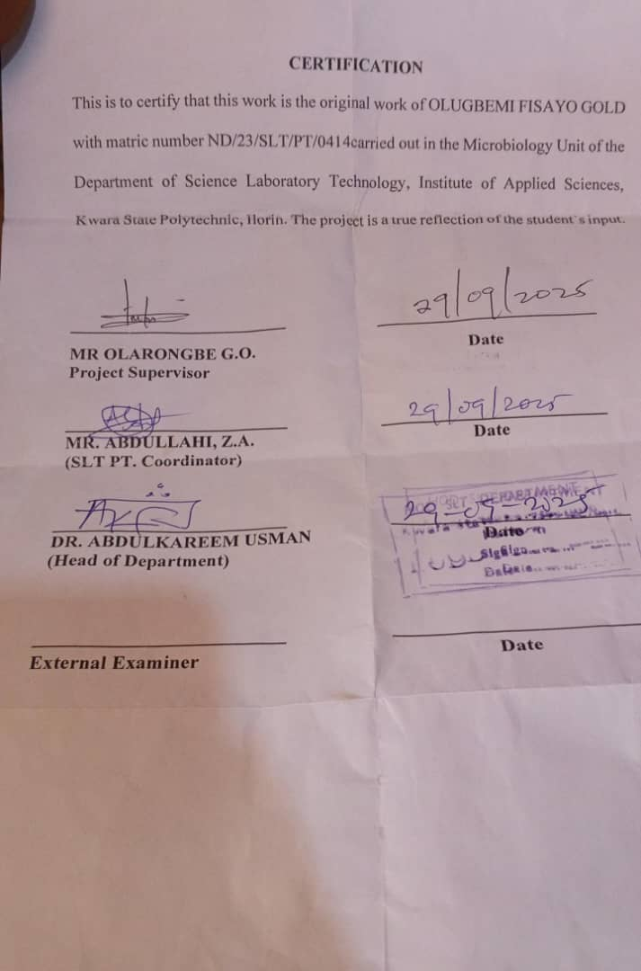
DEDICATION
This project is dedicated to almighty GOD for the success of this project who has seen me through this project work .the most merciful who has being with me throughout my journey

ACKNOWLEDGEMENTS
I would like to acknowledge the Almighty God for his strength and support over this project work, and for the privilege to complete this project work, may God be praised forever, Also to my parent who gave us the opportunity to be here and took care of our needs.
Am using this opportunity to acknowledge our supervisor MR OLARONGBE for his enthusiasm, Patience, helpful information, practical advice and unceasing ideas that have helped us tremendously at all times in writing this project. More so, our appreciation goes to our colleagues who had the pleasure to work with us during this project work, without their support and cooperation this wouldn't be successful, may God bless you all. Amen

TABLE OF CONTENTS

TITLE PAGE -------------------------------------------------------------------------- i
CERTIFICATION ---------------------------------------------------------------------ii
DEDICATION ------------------------------------------------------------------------iii
ACKNOWLEDGEMENTS ---------------------------------------------------------iv
TABLE OF CONTENTS ------------------------------------------------------------vii
LIST OF TABLES ---------------------------------------------------------------------viii
LIST OF FIGURES ---------------------------------------------------------------------viii
ABSTRACT ------------------------------------------------------------------------------ix
CHAPTER ONE
1.0 Introduction -------------------------------------------------------------------------6
1.1 Literature Review------------------------------------------------------------------8
1.2 Statement of Problem--------------------------------------------------------------9
1.3 Justification of Study--------------------------------------------------------------9
1.4 Aims and Objective----------------------------------------------------------------10

CHAPTER TWO
2.0 Materials and Methods -----------------------------------------------------------11
2.1 Material Used ---------------------------------------------------------------------11
2.2 Sterilization of Equipment and Environment ---------------------------------11
2.3 Samples Collection ----------------------------------------------------------------12
2.4 Media Preparation for fungal isolation -----------------------------------------12
2.4.1 Preparation of Potato Dextrose Agar -------------------------------------------12
2.4.2 Preparation of Potato Dextrose Broth-------------------------------------------13
25 Isolation of Fusarium gramenearium from maize------------------------------14
2.6 Characterization and Identification of Fusarium gramenearium --------------14
2.7 Sub-culturing and Extraction of Fusarium gramenearium----------------------15
2.8 Administration and Evaluation of the Potency of the Toxin in White Rats-15
CHAPTER THREE
3.0 Results
3.1 Characterization and Identification of Fungal Isolate ------------------------17
3.2 Weekly clinical Observation in Experimental rats -----------------------------19
3.3 Post-Mortem Gross Pathological Findings ------------------------------------- 20
CHAPTER FOUR
4.0 Discussion and Conclusion
4.1 Discussion -------------------------------------------------------------------- ---23
4.2 Conclusion ------------------------------------------------------------------------23
REFERENCES

LIST OF TABLES
Table 1: Characterization and Identification of Fusarium gramenarium Isolate after culturing
Table 2 Daily Observation for 100% Conc. Toxin Administration in Rats
Table 3 Daily Observation for 80% Conc. Toxin Administration in Rats
Table 4 Daily Observation for 60% Conc. Toxin Administration in Rats
Table 5 Daily Observation for 50% Conc. Toxin Administration in Rats
Table 6: Post-Mortem Findings in Experimental Rats

LIST OF FIGURES
Figure 1: Showing Microscopic view
Figure 2: Images of postmortem findings in experimental rats

ABSTRACT
Fusarium graminearum is a mycotoxigenic fungus that often infects cereal crops, generating strong toxins such deoxynivalenol (DON), zearalenone (ZEN), and fusarenon-X (FX). This study looked at how dangerous the F. graminearum toxin was when it was taken from infected maize samples and given to albino rats in controlled laboratory circumstances at different concentrations (100%, 80%, 60%, and 50%). Clinical investigations showed that the harmful effects got worse with higher doses. These symptoms included less movement, difficulty breathing, dullness of the eyes, and death at the greatest concentration. The investigation after death showed that important organs like the liver, kidney, and gut were getting worse, which confirmed systemic poisoning. Rats that were exposed to lesser amounts showed less severe but nonetheless noticeable physiological impairment. These results add to what we already know about the health consequences of F. graminearum toxins and show how important it is to keep an eye on and control mycotoxins in food systems to protect the health of people and animals.
Keyword: Fusarium graminearum, deoxynivalenol (DON), zearalenone (ZEN), mycotoxins, food safety, toxicology, organ damage.

