DESIGN OFA OFF-GRID CONNECTED PV SYSTEM FOR A 3- BEDROOM FLAT AT OSOGBO, OSUN STATE

BY:

OLAYIWOLA ROSELINE OLUWATOSIN
ND/23/SLT/PT/0078

BEING A PROJECT REPORT SUBMITTED TO THE DEPARTMENT OF SCIENCE LABORATORY TECHNOLOGY (PHYSICS/ELECTRONIC UNIT), INSTITUTE OF APPLIED SCIENCES, KWARA STATE POLYTECHNIC ILORIN

IN PARTIAL FULFILMENT OF THE REQUIREMENTS FOR THE AWARD OF NATIONAL DIPLOMA (ND) IN SCIENCE LABORATORY TECHNOLOGY (SLT), KWARA STATE POLYTECHNC, ILORIN, KWARA STATE

SUPERVISED BY:
Dr. Ibrahim B. B

JUNE, 2025

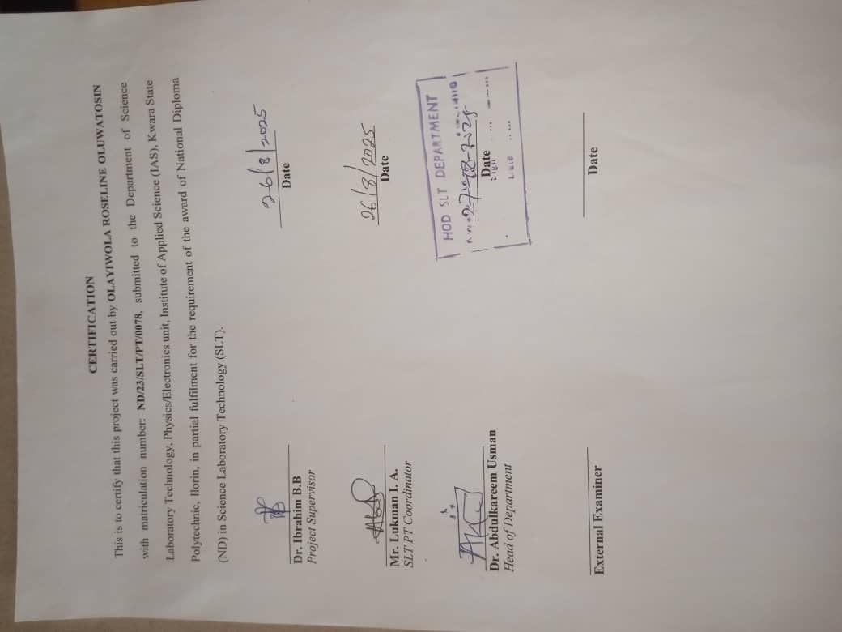

DEDICATION
I dedicate this research work to almighty God and my lovely parents.

ACKNOWLEDGEMENT
I give thanks to God the most beneficent and the most merciful, the Creator of the universe and all the knowing of everything hidden, both on earth and in heaven. He alone deserved to be praised for his mercies on mankind including but not limited to the strength he bestowed on us to put this project together.
I appreciate our precious parents for their moral and financial support, May Almighty God continue to shower his mercy and blessing on them (AMIN).
My profound gratitude goes to our amiable supervisor Dr.IBRAHIM B. B, who has always been there for us as a mentor despite his tight official schedules, we pray almighty God continue to bless you (AMIN).
I must not forget to give our vast and weighty gratitude to our father in the department, our Head of department Dr. Abdulkareem Usman and to all the lecturers in the department of Science Laboratory Technology.
My thanks go to my friends and relatives for their support throughout the period of my program and also to all our friends who stood by me during my program, we appreciate you all. May God bless you all.

TABLE OF CONTENTS
TITLE PAGE
CERTIFICATION
DEDICATION
ACKNOWLEDGMENT
TABLE CONTENTS
ABSTRACT
CHAPTER ONE
1.1 INTRODUCTION
1.2 STATEMENT OF PROBLREM
1.3 AIMS AND OBJECTIVES
1.4 SIGNIFICANT OF STUDY
CHAPTER TWO: LITERATURE REVIEW
2.1 PHOTOVOLTAIC CELL
2.2 TYPES OF PV SYSTEM
2.3 TILT ANGLE
2.4 LATITUDE
2.5 BATTERY
2.6 INVERTER
2.7 CHARGE CONTROLLER
CHAPTER THREE: RESEARCH METHODOLOGY
3.1 DESCRIPTION OF THE STUDY AREA
3.2 INSTRUMENTATION(DATA COLLECTION)
3.3 PVSYST SOFTWARE
CHAPTER FOUR: RESULT AND DISCUSSION
4.1 SUMMARY OF THE LOA
4.2 SYSTEM ENERGY YIELD
CHAPTER FIVE
5.1 RECOMMENDATIONS:
REFRENCES

ABSTRACT
This study investigates the analysis and feasibility of 31.2 kWp self-consumption photovoltaic system used for supplying the electrical load in 3 bedroom flat in Osogbo, Osun State. An Off-Grid connected photovoltaic system is simulated using the PVsyst software to design an off- grid connected PV system for 3 bed room flat in Osogbo Nigeria. Detailed system configuration, system output and system losses are determined in this study. From the simulation optimal size of the PV system is determined that is able to supply the electricity to the 3 bedroom flat throughout the year. It is founded that 31162 PV module and 24.0 grid connected inverter is the optimal solution for the load of 3 bed room flat. About 11,374.130MWh electricity will be available in a year.

..

CHAPTER ONE
1.1 INTRODUCTION
The time of coal based power generation has come to its end, thus it’s imperative to look for new and innovative ways to generate energy, Renewable energy is slowly but surely making its way into every household.(Changkakati et al., 2020). Renewable energy technologies are able to provide sustainable and clean energy from the sources such as sun, wind and bio-materials. Photovoltaic system is one of the most important and promising technology that are able to produce the electricity to meet the electricity demand of the whole world Srivastava & Giri, 2017).
Humankind has relied on energy for the past centuries. Our ancestors used energy in its primary forms; animal muscles, burning wood as a biomass form by the early 18th century, fossil fuels energized the first industrial revolution. Fossil fuels are oil, gas, and coal, formed from fossilized, remained organic materials (Alzahrani et al., 2021). Energy consumption is on a permanent rise and it is becoming increasingly concentrated in cities. Cities host about the 80 % of the European population and consequently represent the 75 % of the total energy demand and CO₂ emissions.(Amigó, 2016).
A photovoltaic (PV) system consists of a PV array, battery and elements for power conditioning. The PV system converts solar energy into dc power. If ac loads are used means, the system requires inverter to convert dc into ac. There are two types in PV system such as grid connected and standalone. Grid connected photovoltaic systems feed electricity directly to the electrical network, operating parallel to the conventional energy source. Grid-connected systems generate clean electricity near the point of use, without the transmission and distribution losses or the need for the batterie(Ramoliya, 2015). This can be realized through effective and sustained research and technological advancement which will help in boosting the harvesting and harnessing of the solar energy wherever there is sufficient sunlight. Study has recommended that the solar energy received at Earth's atmosphere is approximately 342 W m⁻², which about 30 % is scattered or reflected back to space, while about 70 % (239 W m⁻²) of the energy remains to be harvested. (Okon, 2020).
One of the most basic need of life is energy. It is critical for the development and improvement of a society. Electrical energy among the various types of energy, has a significant impact on how a society operates (Design, 2022). Solar energy is the most abundant form of energy available to us. It is approximated that 10000 TW worth of solar energy is incident on earth’s surface in a day (Bosshard, 2006). The installation of solar PV (SPV) is an environmentally friendly project. Solar energy is free and present in sufficient amounts in almost every part of the world. Moreover, the Maintenance cost of solar PV is very low as compared with other conventionalsources (Ul et al., 2021).
A Standalone PV system is widely used in present days. The design of the system, using simulation software, helps to get the best result from the available resources. Software results help to rectify problems of the desired needs of the system before field installation. Many software packages are available which give a platform to design the balance of system for solar photovoltaic standalone system (SPSS). The PVsyst software package and the process of designing system is so easy and comprehensive. The design process also includes explanation for each component by using graphs.(Teja et al., 2021).
1.2 STATEMENT OF PROBLREM
In many remote and rural areas, access to the traditional electrical grid is either non-existent or highly unreliable. These areas often rely on diesel generators or other fossil fuel-based sources for electricity, which are not only expensive but also environmentally detrimental. The lack of a stable power supply hampers the development of essential services such as healthcare, education, and commerce, exacerbating socio-economic inequalities. There is a pressing need to design and implement off-grid photovoltaic (PV) systems that can provide a sustainable, reliable, and cost-effective power solution to these underserved communities. However, the design and optimization of such systems pose several challenges:
Determining the exact energy requirements of the off-grid community or facility is challenging due to fluctuating usage patterns and the lack of historical consumption data. Selecting the appropriate size for PV arrays, batteries, and inverters is critical to ensure reliability without incurring unnecessary costs. Over-sizing leads to higher initial costs, while under-sizing results in insufficient power supply. PV systems are subject to variations in energy production due to changes in weather, shading, and seasonal differences. Accurately modeling these factors is essential for reliable system performance.
Ensuring the designed system is economically viable with a favorable return on investment (ROI) is essential for long-term sustainability. This includes considering initial costs, operational expenses, and potential savings. While PV systems are environmentally friendly, the design must consider the lifecycle impact of all components, including batteries, which may have significant disposal and recycling concerns.
1.3 AIMS AND OBJECTIVES
The aim of this project is to design an off Grid connected PV system using PVSyst software while the specific objectives are to:
(i) Conduct a detailed assessment of the energy load requirements to ensure the system is sized correctly.
(iii) Design a cost-effective PV system that minimizes initial investment and operational costs.
(iv) Determine the performance ratio to evaluate the overall efficiency and reliability of the system.
(v) Minimize environmental impact by reducing greenhouse gas emissions and promoting clean energy use.
(vi) Perform a detailed cost analysis, including initial capital expenditure, operational, and maintenance costs.
(vii) Design an efficient battery management system to optimize battery life and performance.

1.4 SIGNIFICANT OF STUDY
Studying the design and simulation of a standalone PV system using PVSyst play a pivotal role in reducing reliance on fossil fuels and mitigating climate change. It also enhancing the feasibility and efficiency of off-grid applications, enabling access to electricity in underserved regions and promoting economic development. Additionally, it promotes sustainability by harnessing clean energy resources and reducing greenhouse gas emissions associated with traditional energy generation. It helps in refining system performance predictions, optimizing component selection, and enhancing overall system reliability and durability. By accurately estimating the energy output and system performance, stakeholders can make informed decisions regarding investments in renewable energy infrastructure. Studying the design and simulation of standalone PV systems using tools like PVSyst contributes to educational initiatives and capacity building efforts in the renewable energy sector. It provides valuable insights and practical skills to students, researchers, engineers, and professionals involved in the field.

CHAPTER TWO
LITERATURE REVIEW
2.1 PHOTOVOLTAIC CELL
Photovoltaic (PV) cells, commonly known as solar cells, are devices that convert light energy directly into electrical energy through the photovoltaic effect.
WORKING PRINCIPLE OF SOLAR PANEL: The working principle of a solar panel is based on the photovoltaic effect, which is the generation of an electric current in a material upon exposure to light.
2.2 TYPES OF PV SYSTEM
-Off-Grid Systems
-Grid-Tied (On-Grid) Systems
2.2.1 Off-Grid Systems
Off-grid solar power system is an independent power system that generates electricity from solar panels and stores it for use without relying on the electrical grid. An off-grid solar system is a self-contained power solution that provides electricity independently from the main electrical grid, making it suitable for remote or environmentally conscious applications.
2.2.2 Grid-Tied (On-Grid) Systems
A grid-tied, or PV system, connects directly to the local utility grid, allowing for a seamless exchange of electricity between the solar panels and the grid. A grid-tied PV system is an efficient and cost-effective solution for integrating solar power into a home or business, providing significant energy savings and environmental benefits while relying on the utility grid for backup.

2.3 TILT ANGLE
The tilt angle of solar panels is crucial for maximizing their efficiency and energy production. The optimal tilt angle depends on several factors, including geographic location, the time of year, and the specific energy needs. The tilt angle of solar panels is a critical factor in maximizing energy production. While the latitude of the installation location provides a good starting point, seasonal adjustments can further optimize performance.
2.4 LATITUDE
Latitude is a geographic coordinate that specifies the north-south position of a point on the Earth's surface. It is expressed in degrees, ranging from 0° at the Equator to 90° at the poles (90° N for the North Pole and 90° S for the South Pole).
2.5 BATTERY
Batteries are a crucial component of solar energy systems, especially in off-grid and hybrid setups, as they store energy generated by solar panels for use when sunlight is not available. Batteries are vital for ensuring a continuous power supply in solar energy systems, especially in off-grid and hybrid configurations. Selecting the right type of battery, properly sizing the system, and implementing appropriate maintenance and safety measures are essential for optimal performance and longevity.
2.6 INVERTER
An inverter is a crucial component of a solar power system, responsible for converting the direct current (DC) electricity generated by solar panels into alternating current (AC) electricity, which is used by most household appliances and can be fed into the utility grid.
Inverters are essential for converting DC power from solar panels into usable AC power. Choosing the right type of inverter—whether string, micro-inverter, power optimizer, or hybrid—depends on specific system requirements, budget, and installation conditions. Proper sizing, installation, and maintenance are crucial for ensuring efficient and reliable operation of the solar power system.
2.7 CHARGE CONTROLLER
A charge controller, also known as a solar charge regulator, is a critical component in off-grid and hybrid solar power systems. Its primary function is to manage the flow of electricity from the solar panels to the batteries, ensuring that the batteries are charged efficiently and safely. A charge controller is essential for protecting batteries and ensuring efficient energy storage in solar power systems. Choosing between PWM and MPPT controllers depends on the specific needs, size, and complexity of the system. Proper sizing, installation, and maintenance are critical for the reliable and efficient operation of the charge controller and the overall solar power system.

CHAPTER THREE
RESEARCH METHODOLOGY
3.1 DESCRIPTION OF THE STUDY AREA
This study was carried out at Osogbo, the administrative headquarters of Osogbo and Olorunda Local Government Areas (LGAs) and the capital of Osun State, Nigeria. It has a total land area of 47 square kilometres and shares boundary with Ifelodun, Ede North, Atakunmosa West, Egbedore and Boripe Local Government Areas (Osun State Government, 2006). Osogbo is located between Latitudes 7°42’20” and 7°49’20” North and Longitudes 4°30’20” and 4°38’20” East (Ibrahim, 2019)

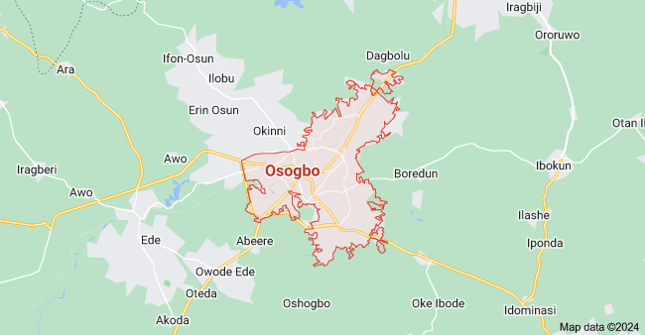
Fig. 1: The map showing Osogbo in Osun State.
Source: https://www.researchgate.net/publication/316612504

3.2 INSTRUMENTATION(DATA COLLECTION)
The monthly mean daily data were collected from the Nigeria meteorological agency, federal ministry of aviation, Osogbo, Osun, Nigeria. The data obtained covered a period of 11 years ( 2012-2023). This data was used for the simulation.
3.3 PVSYST SOFTWARE
PVsyst is simulation software that was first of all designed in Geneva and helps in calculating the working and operations of PV system. This software helps in designing and the configuration of the system and also enables to calculate the amount of energy generated by the PV module. The output is based on the simulation of the sizing system mainly depends on geographical site location of PV system. Results may include several simulation variables that can be displayed in hourly, daily or monthly values to calculate. The ‘‘Loss Diagram” emphasis the weaknesses and suggests the alternations in the system design (Teja et al., 2021). To obtain results, we have to provide some inputs to the software. Simulation variables in PVsyst are:
-Meteorological data
-Incident irradiance in collector plane
-Incident energy factors
-PV array (field) behaviour
-Inverter losses
-System operating conditions
-Energy use
-Efficiencies
-Normalized performance index

CHAPTER 4
4.0 RESULT AND DISCUSSION
The efficiency of the system has a great impact on power generation and as well as on the overall performance of power plants. Subsystem losses play a significant role in lowering system efficiency, resulting in low energy output.

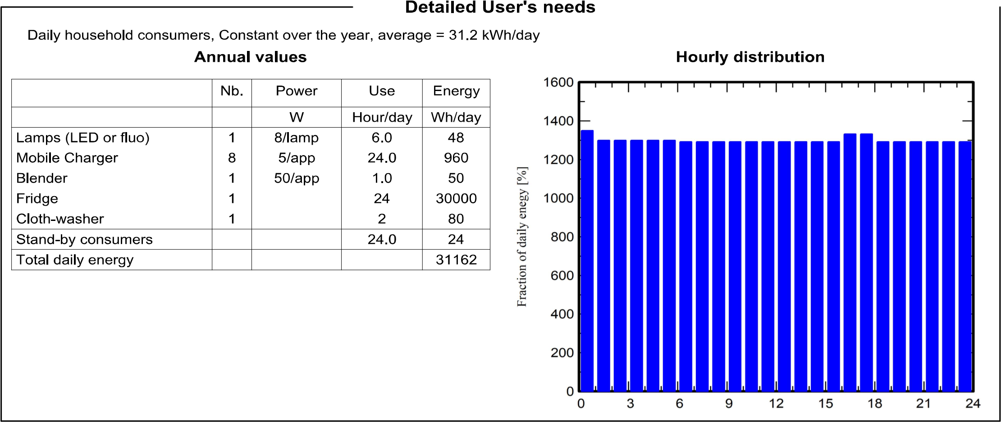
4.1 Summary of the Load
Table4.1 Summary of Load
From Table 4.1 above, the total loads of the 3 bedroom flat in Osogbo is 63kW and the required energy is 31162kWh/day. As a result of load forecast and for the purpose of selling the excess energy, 500kW load and its required energy of 31.2kWh/day is used for this work. This helps in determining the PV plant’s component sizes.
4.2System Energy Yield
The energy generated by the PV system as shown in table 4.2 below is 11374.1kWh and this is called DC energy. The output of the inverter is 11374.1kWh and is called the system yield. It is an alternating current energy that is fed to the grid. From this system yield, it is evident that the proposed plant can power the 3bed room flat in Osogbo, Osun State which has annual energy requirement of 556,175.32kWh and the excess energy which is 558,326.68kWh, is fed to the grid for profit making.
Table 4.2 Balances and Main Result
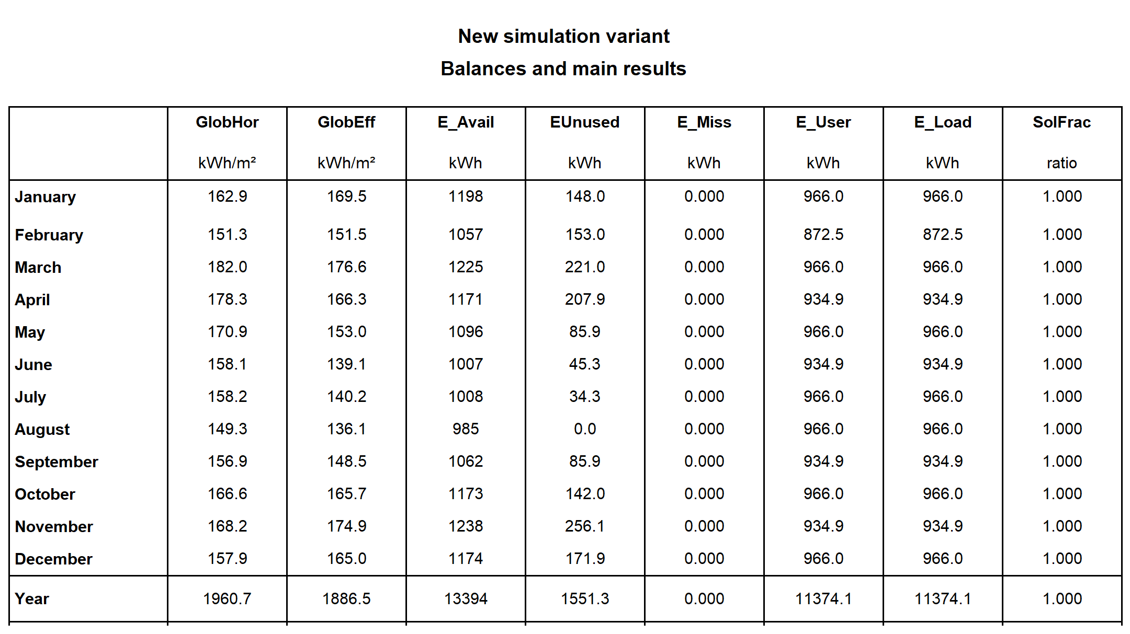

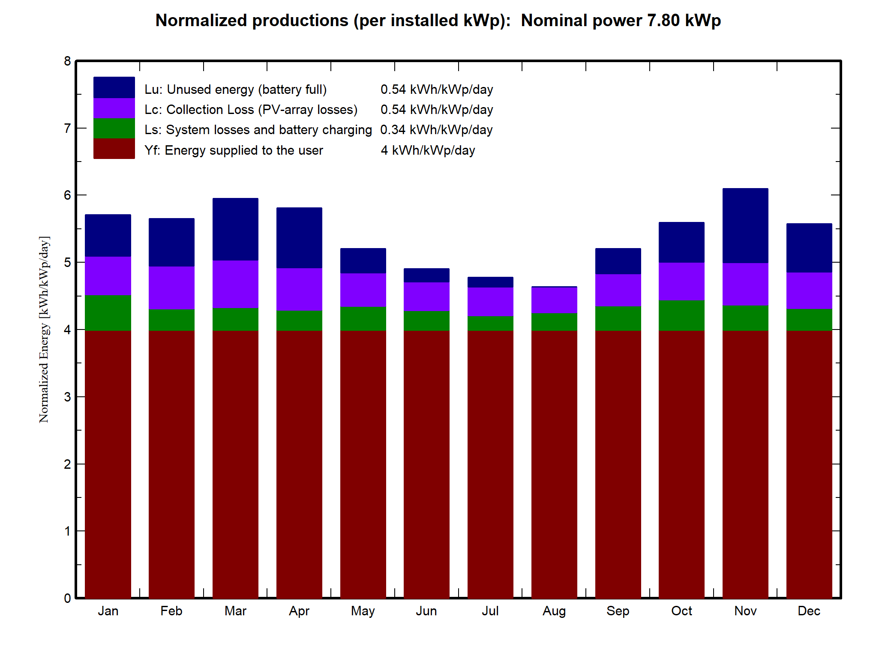
Figure 4.1 Normalized Production
Figure 4.1shows a bar chart describing electricity production in kWh/kWp. It gives the ratio of the mean daily electricity production in kWh to the rated power in kWp. The average energy loss is compared to the rated power. The figure presents that the collector losses (Lc) of the PV is 0.54 kWh/kWp/day, the systemic loss of the inverter (Ls) is 0.34 kWh/kWp/day. Finally, the mean daily capacity is 4kWh/kWp/day.
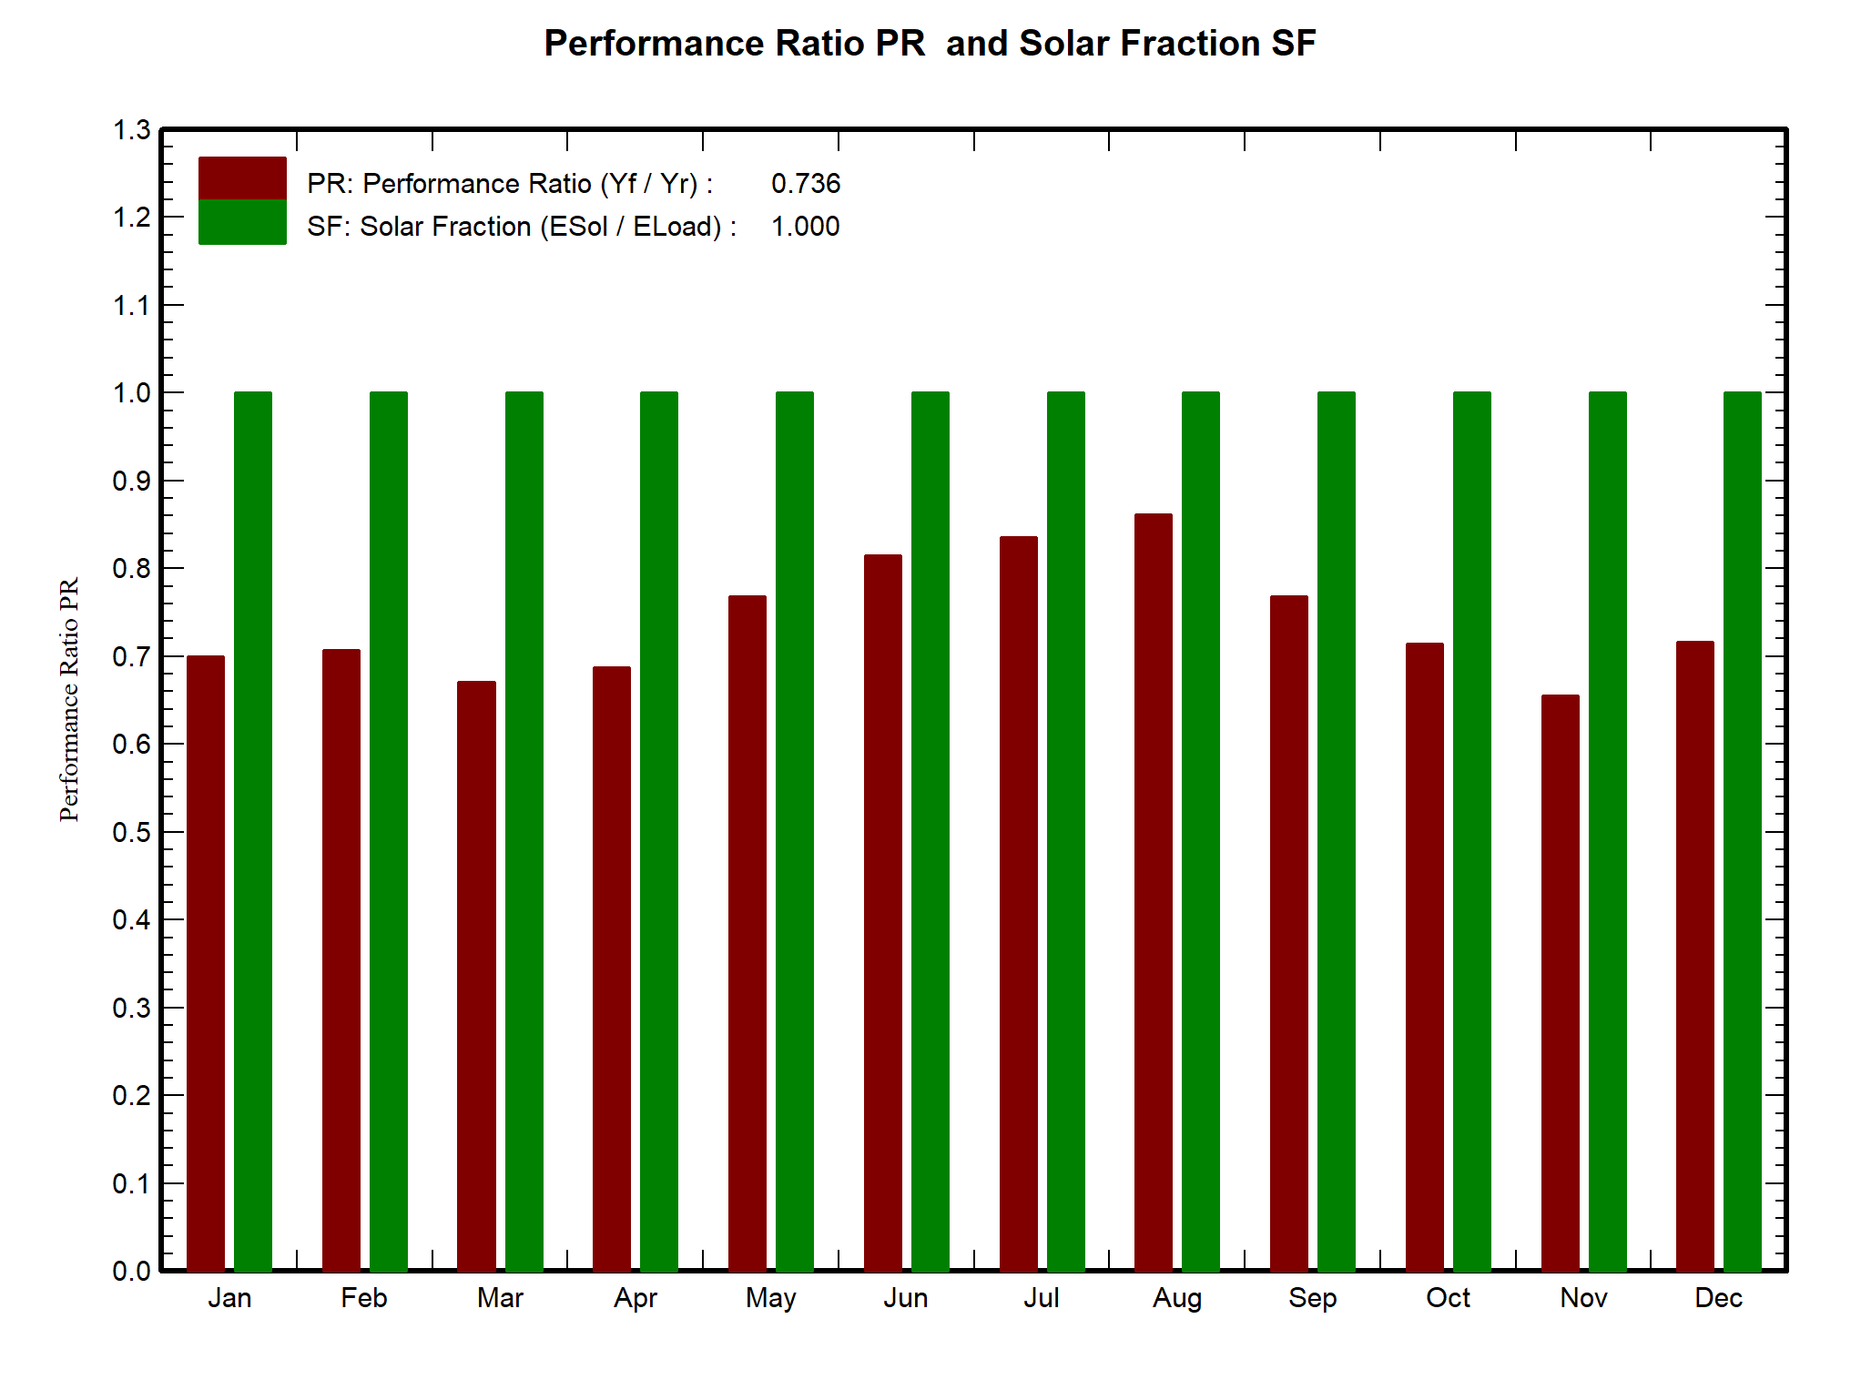
Figure 4.2 Performance Ratio
Figure 4.2 shows the performance ratio of an solar off- grid connection at Osogbo, Osun State. This measure is important and determines the plant's profitability performance ratio is 7.36%. This ratio shows that the loss is not up to 20.0% in the network.

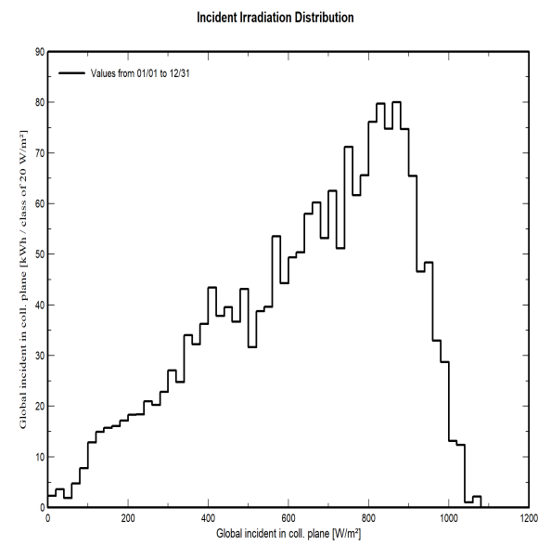
Figure 4.3: Incident irradiation Distribution

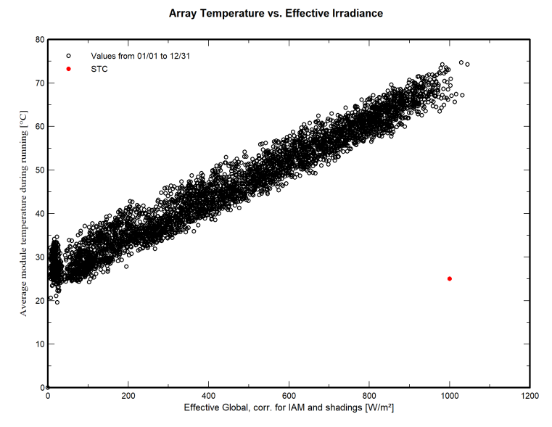
Figure 4.4: Array Temperature Vs. effective Irradiance

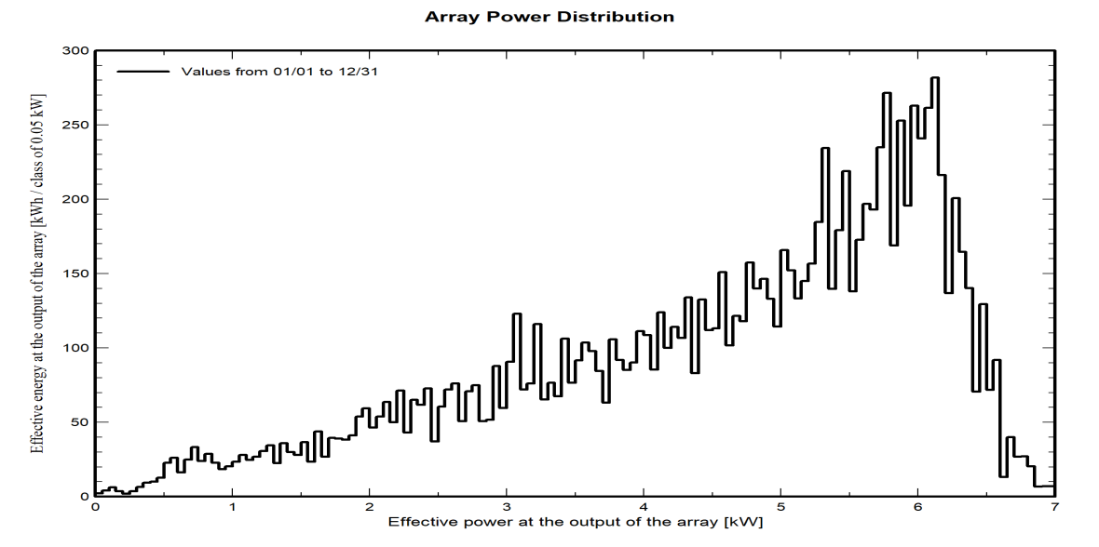
Figure 4.5: Array Power Distribution
Figure 4.3 shows the Incident irradiation distribution of Osogbo PV project, all data calculated from January to December. Figure 4.4 shows the Array temperature & Effective irradiation of Osogbo PV project. Figure 4.5 shows the Array Power distribution during running of Osogbo3 bedroom Flat project.
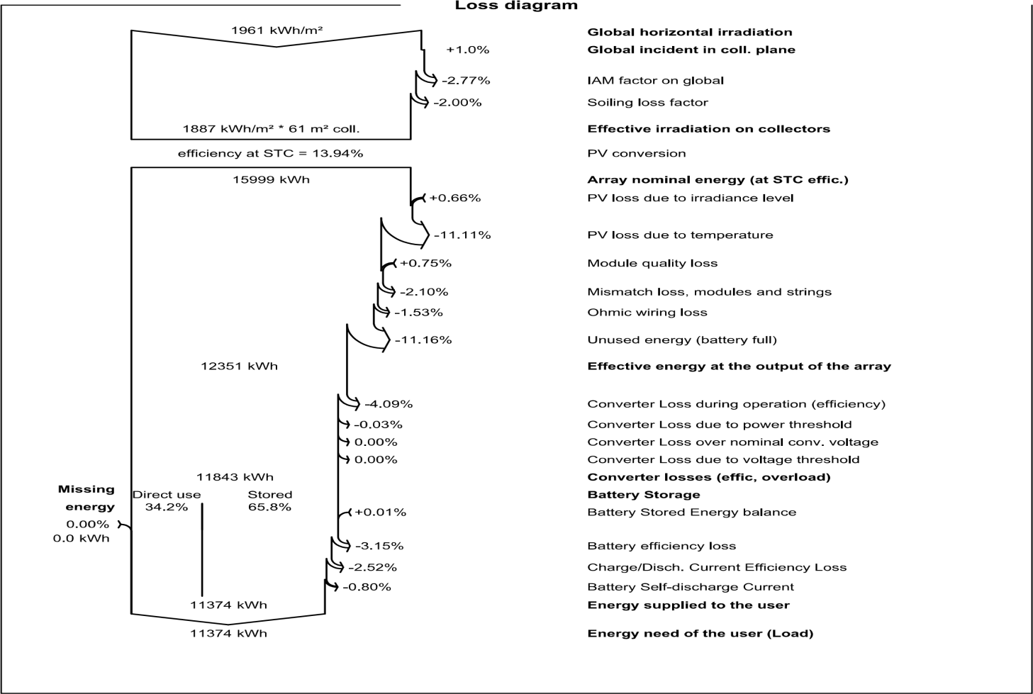

Figure 4.6: Loss Diagram
Figure 4.6 shows a diagram of the losses of the solar power system. The results show that the loss of heat and global incident irradiation are high (1.0% and 2.0% respectively). The heat loss is high because Osogbo City is located in the South of Osun where the temperature is high compared to the standard conditions. In addition, the loss of global incident irradiation is also high since the tilt angle of the panel is steeper than the optimal angle (11º-12º). However, the other losses are quite small, ranging from 0.1% to 3.15%.

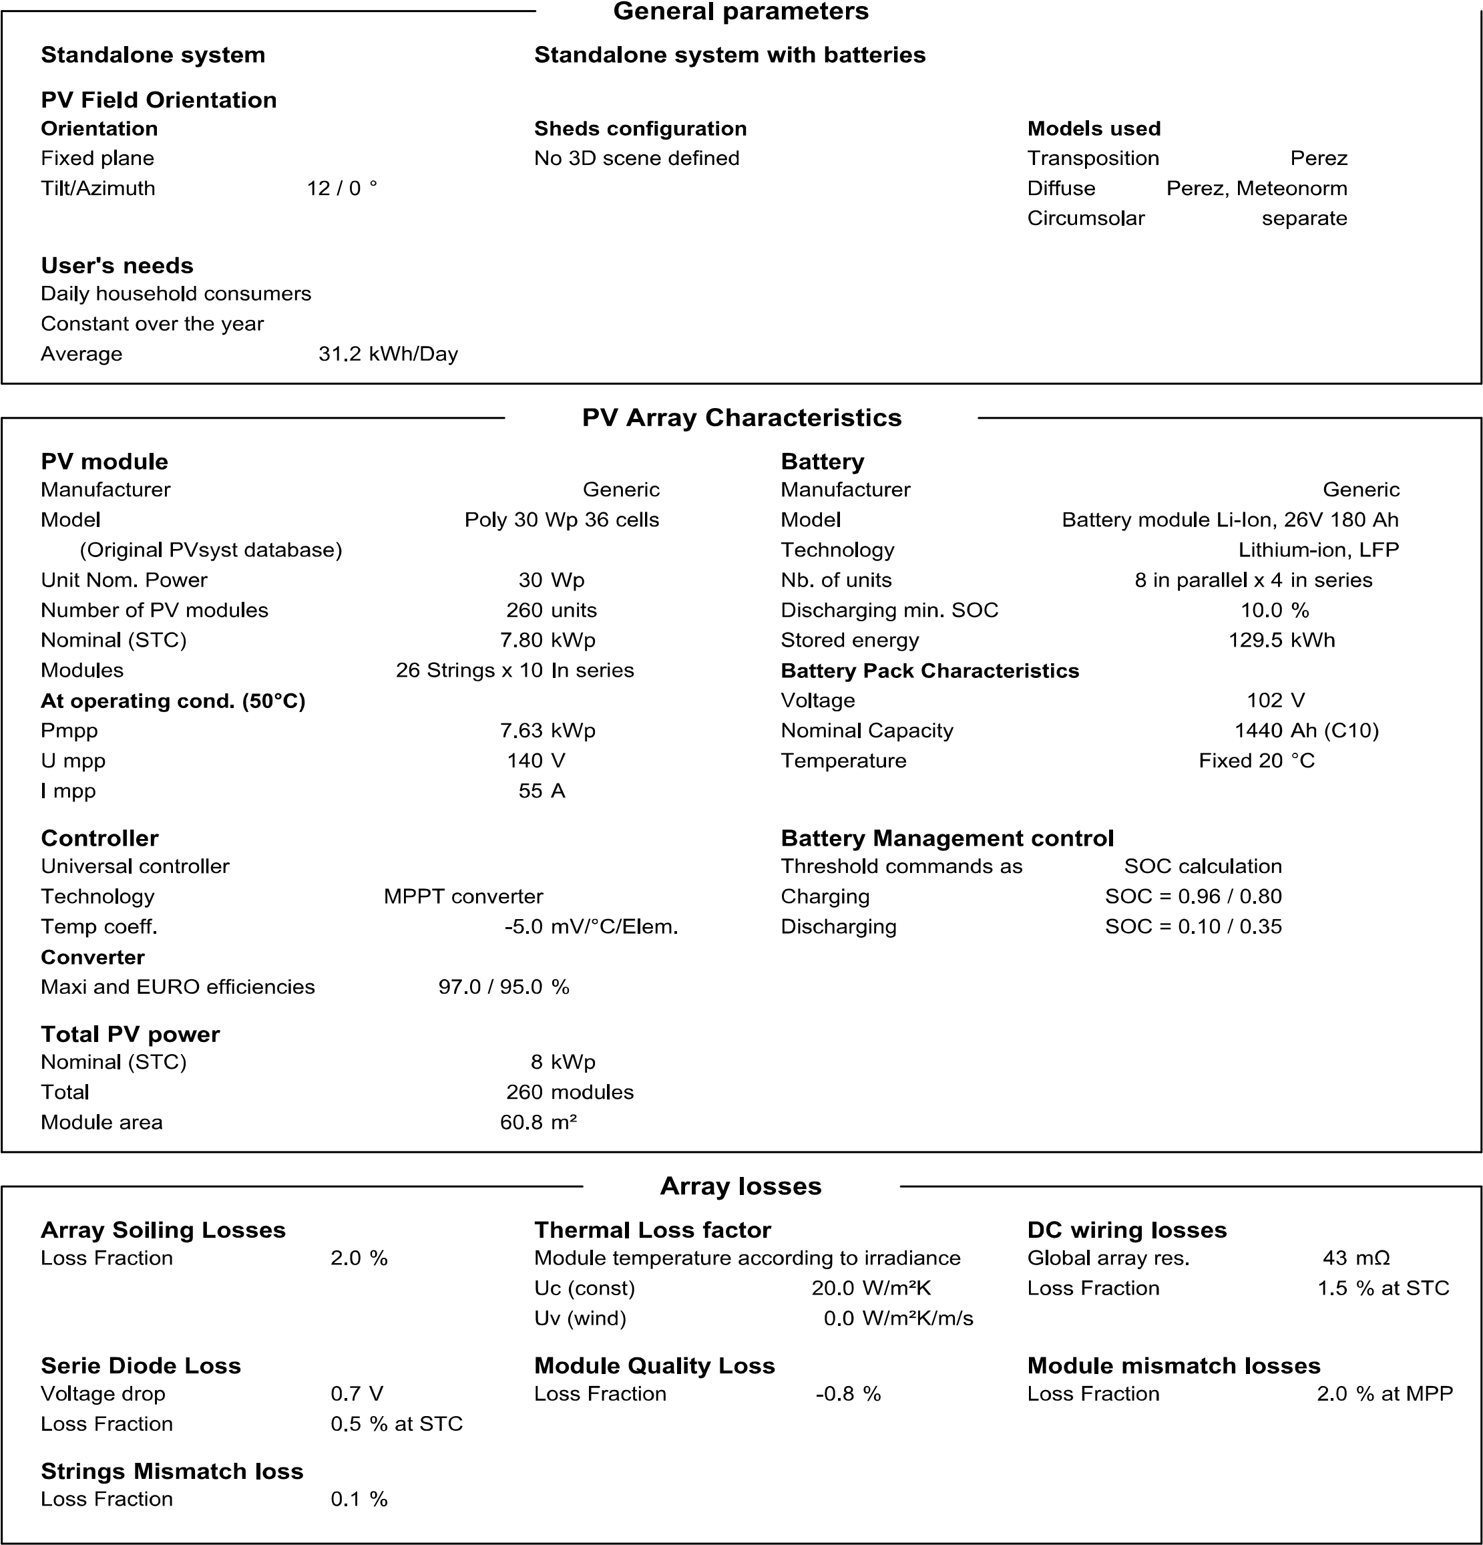
CHAPTER FIVE
5.1 Conclusion:
In this work, an analytical study of using PV system energy in Osun State was presented. The work discussed the possibility of installing a stand-alone PV system for a three bedroom flat. The design of an off-grid connected PV system requires careful consideration of various factors, including energy demand, solar resource, and system components. By following the recommendations outlined in this report, the system will provide reliable and sustainable energy to the off-grid location. The goal of this project is to design and simulate a PV system in order to provide a dependable, cost-effective, and clean solution for power supply shortfall at Osogbo Osun State and sell the excess energy for profit making.
5.2 Recommendations:
To help improve on grid connected PV systems, the following should be considered:
- Use high-efficiency solar panels (>20%) to maximize energy production.
- Select deep cycle batteries with a long lifespan (>10 years) for energy storage.
- Implement a grid-tie inverter with a built-in charge controller for efficient energy management.
- Install a monitoring system to track performance and detect potential issues.
- Consider adding a backup generator for extended periods of low solar irradiance.

REFRENCES
Alzahrani, A., Rajeh, M., & Banjar, S. (2021). Design and Simulation of a Standalone PV System for a Mosque in NEOM City. Design and Simulation of a Standalone PV System for a Mosque in NEOM City Amani, 634–649.
Amigó, L. P. (2016). Solar Potential Assessment : Comparison Using LiDAR Data and PVsyst. June.
Changkakati, S., Sahu, A. K., Syed, R., Kumar, S., & Kesari, J. P. (2020). Performance Evaluation of Grid-Connected Solar Photovoltic Plant using PVSYST Software. International Journal of Engineering Research & Technology (IJERT) ISSN:, 9(10), 71–97.
Design, I. T.-. (2022). Design And Simulation Of 500kw Grid Connected PV System for Faculty of Engineering , Rivers State University Using Pvsyst Software. IRE Journal, 5(8), 221–229.
Okon, E. (2020). Pvsyst Software-Based Comparative Techno- Economic Analysis Of PV Power Plant For Two Installation Sites With Different Climatic Conditions. 5(7), 2819–2829.
Ramoliya, J. V. (2015). Performance Evaluation of Grid-connected Solar Photovoltaic plant using PVSYST Software. 2(2), 372–378.
Srivastava, R., & Giri, V. K. (2017). Design of Grid Connected PV System Using Pvsyst. African Journal of Basic & Applied Sciences 9 (2): 92-96, 2017, 9(2), 92–96. https://doi.org/10.5829/idosi.ajbas.2017.92.96
Teja, G. D., Kumar, N. M., Teja, G. V. P., & Student, M. T. (2021). Experimental Investigation of Standalone PV System Using PVsyst Software. 6(1), 1249–1254.
Ul, F., Faiz, H., Shakoor, R., Raheem, A., Umer, F., Rasheed, N., & Farhan, M. (2021). Modeling and Analysis of 3MW Solar Photovoltaic Plant Using PVSyst at Islamia University of Bahawalpur , Pakistan. International Journal of Photoenergy, 2021.

