DESIGN AND CONSTRUCTION OF A BATTERY CAGE

BY

ABDULRAHEEM ORIRE QUADRI
ND/23/ABE/PT/0038

A RESEACH PROJECT SUBMITTED T THE DEPARTMENT OF AGRICULTURAL AND BIO-ENVIRONMENTAL ENGINEERING TECHNOLOGY, INSTITUTE OF TECHNOLOGY, KWARA STATE POLYTECHNIC, ILORIN.
IN PARTIAL FULFILMENT OF THE AWARD OF NATIONAL DIPLOMA (ND) IN AGRIULTURAL AND BIO-ENVIRONMENTAL ENGINEERING TECHNOLOGY

SEPTEMBER, 2025

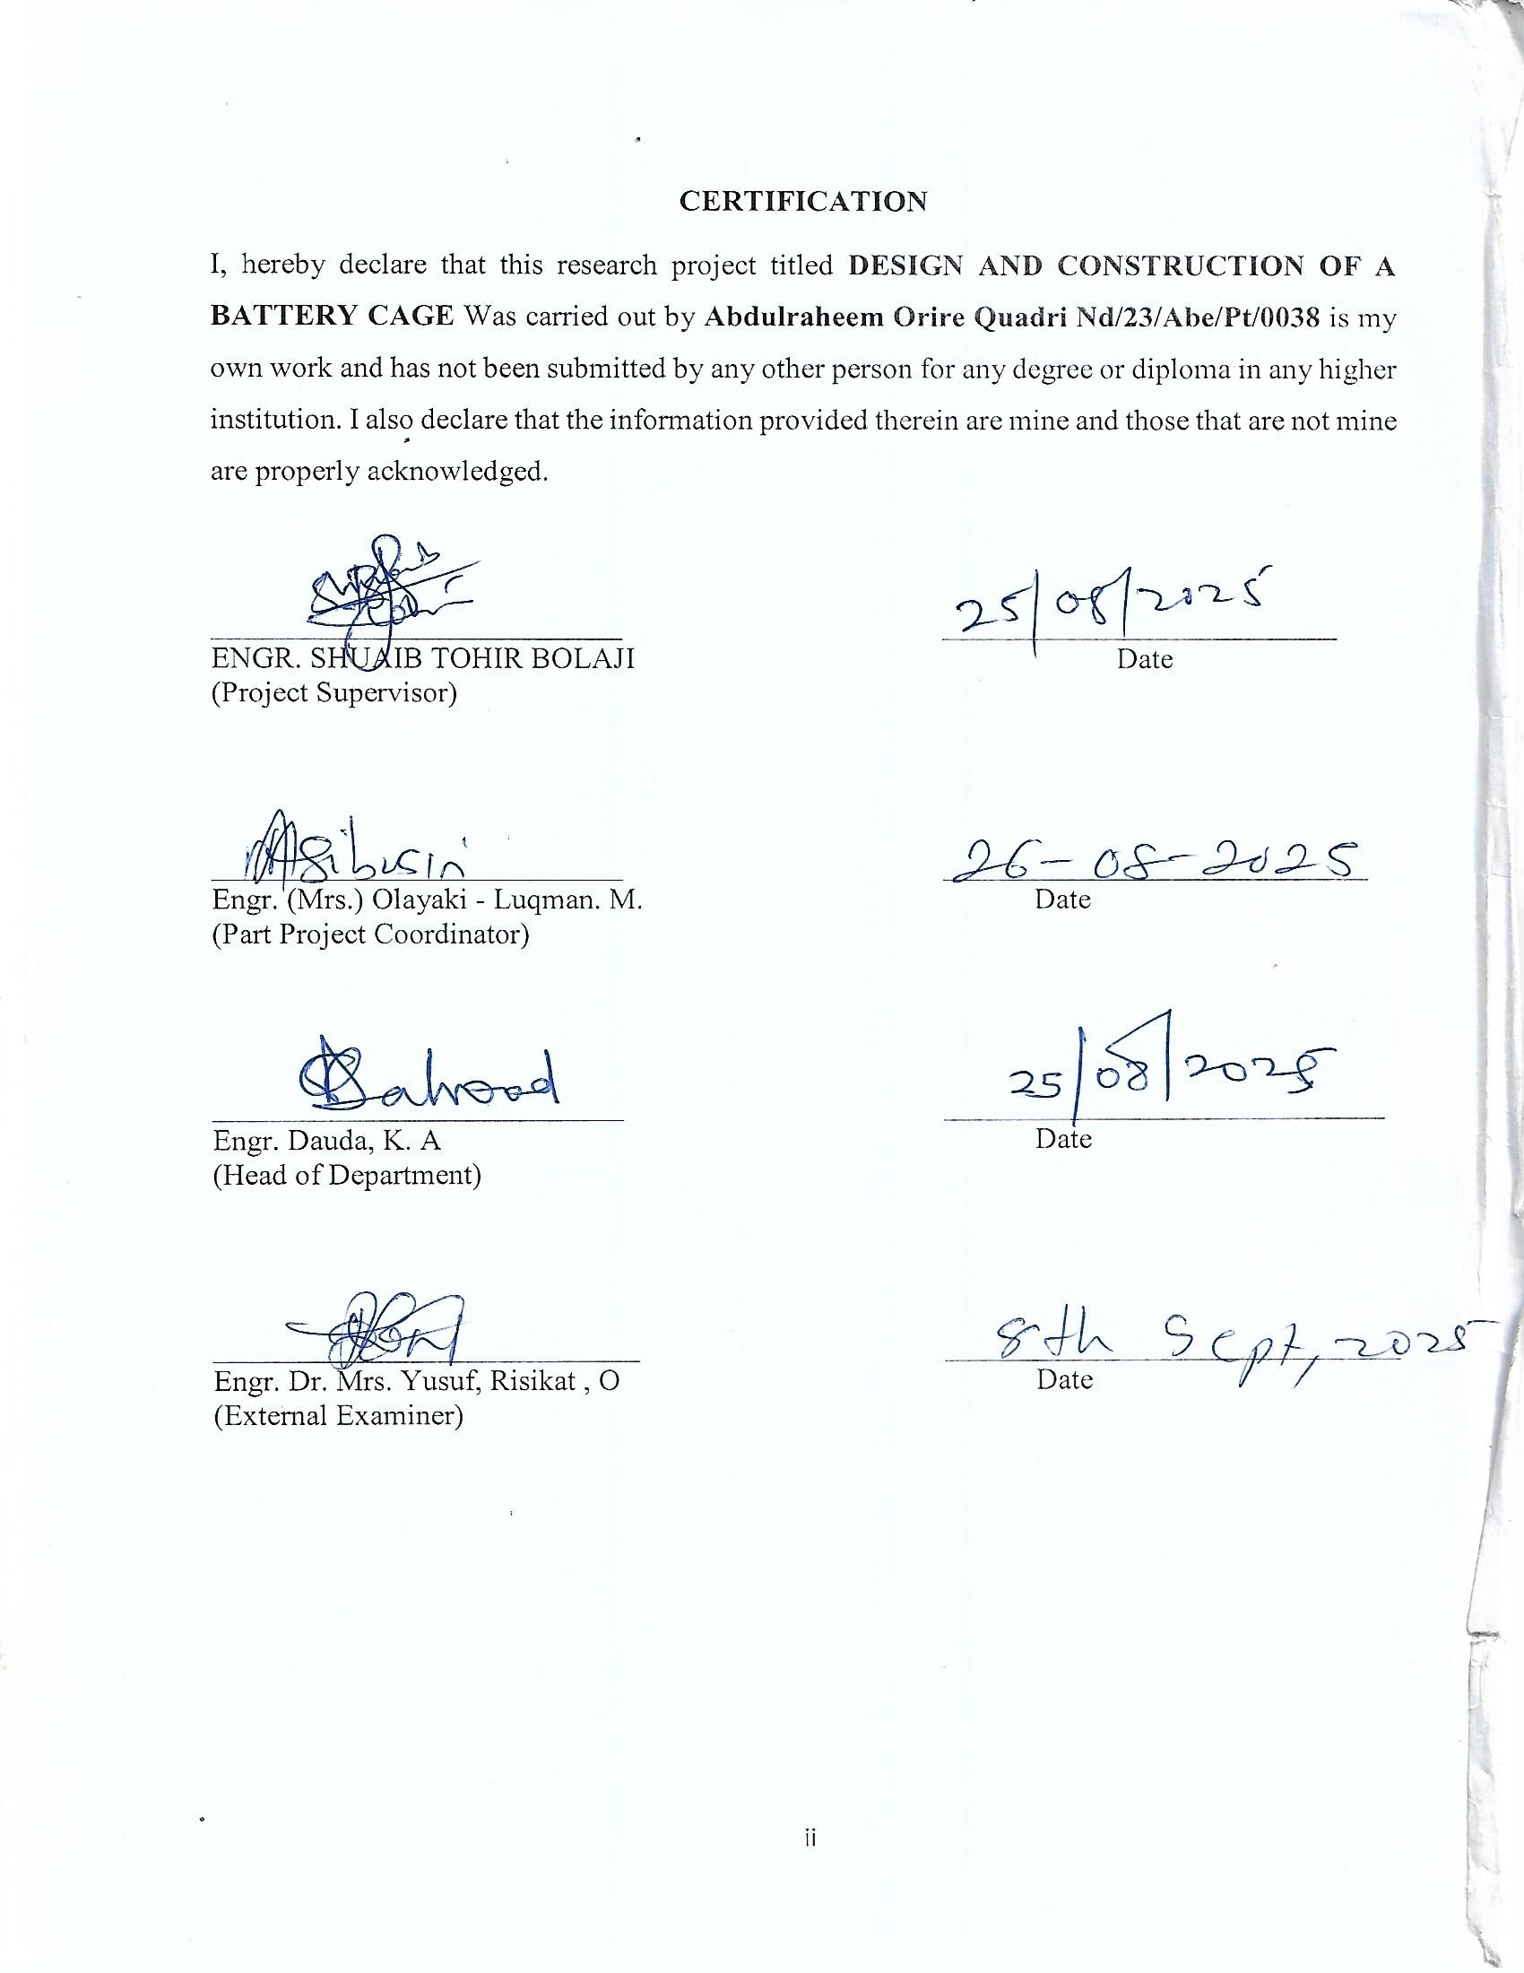
DEDICATION
This project is dedicated to Almighty Allah and to my parents, the author and finisher of our faith who has assisted me throughout the course of this project.

ACKNOWLEDGEMENTS
I acknowledge with gratitude to Almighty Allah for the successful completion of this project.
Most importantly, I am grateful to my supervisor Engr. Tohir Shuaib Bolaji for his support and encouragement on this work, his constant constructive feedback, and patience have been invaluable in helping us navigate through the challenges of this project.
My appreciation goes to all staff and lecturers in the department of (ABE) in person of Engr. (Mrs) Olayaki-Lukman, Engr. Mayaki R, Engr. Toheer, Engr. (Mrs) Abubakar A. and Engr. Babatunde S. O. may God bless you all (Amen).
I also appreciate the effort of my parent for their morality, spiritually and financially support I pray Almighty God should be with them.
Lastly, I extend and express our appreciation to our friends for their moral support during the write up we say thank you to our supervisor and all our lecturers may God continue to bless you all abundantly.

ABSTRACT

Battery or bird cages are homes for domesticated birds. Birds require a house in which they can fly and have some freedom but still ensure they do not fly away. Bird cages are constructed to be large enough to accommodate the motion and daily activities of domesticated birds. This work was carried out to build a bird cage using available materials.

TABLE OF CONTENTS
TITLE PAGE i
APPROVAL PAGE ii
DEDICATION iii
ACKNOWLEDGEMENT iv
ABSTRACT v
TABLE OF CONTENTS vi-vii
CHAPTER ONE
INTRODUCTION 1
  - BACKGROUND OF THE PROJECT 1
  - PROBLEM STATEMENT 2
  - OBJECTIVES OF THE PROJECT 3
  - SCOPE OF THE PROJECT 3
  - ADVANTAGES OF BATTERY CAGE 4
  - DISADVANTAGES OF THE BATTERY CAGE 4
CHAPTER TWO
LITERATURE REVIEW
  - OVERVIEW OF THE STUDY 6
  - HISTORICAL BACKGROUND OF BIRD CAGE 7
  - HISTORICAL BACKGROUND OF THE STUDY 7
  - TYPES OF CHICKEN BATTERY CAGE SYSTEM 9
  - BENEFITS OF USING POULTRY BATTERY CAGES FOR CHICKEN PRODUCTION 23
CHAPTER THREE
  - MATERIALS AND METHOD 29
  - MATERIALS USED 29
  - METHOD 30
CHAPTER FOUR
RESULT ANALYSIS
  - DISCUSSION 40
  - CHOOSING A BIRD CAGE 41
CHAPTER FIVE
  - CONCLUSION AND RECOMMENDATION 45
REFERENCES 46

CHAPTER ONE
1.0 INTRODUCTION
1.1 BACKGROUND OF THE STUDY
The production of eggs for human consumption is based on several technologies, based on the knowledge and experience gathered for more than a century. Until recently, the battery cage production system was believed to be the most intensive, most efficient and most appropriate for rearing laying hens (Kabakchiev, 2010). The development of this system has also gained many opponents, who denied it from the point of view of animal welfare.
The poultry egg industry in Nigeria has developed rapidly over the past few decades. Until 1960, laying chickens were reared in open barns located in the corners of farmyards. Production in closed barns began in the early 1960s, when poultry farming began to become a full-time operation. The battery cage system was introduced into Nigeria in the mid-1980s, and barns without open side curtain walls were first built in 1984 by several poultry farmers. Since then, commercial egg production systems have moved toward bigger farms and a large part of the egg production costs can be reduced through the automation of facilities. Since 1980, there has been a change from full-time poultry farms to poultry factories (Green et al, 2010). With the modernization of the egg production system, specialization in hatching, rearing, egg grading, and packing has taken place and vertically and horizontally integrated systems have been established (Green et al, 2010).
Housing system is an important factor that influences the production performance and some egg quality parameters.
Different production systems are available in laying hens’ husbandry such as conventional, enriched cage, and freerange systems.
1.2 PROBLEM STATEMENT
When chicks grow up, you may need to transfer them to a cage. Cage raising is better for a commercial farm because it saves space and feed. Moreover, the chickens are separated from the manure, cage raising reduces the spread of disease and the risk of infection.
Nowadays, more and more farms are choosing to buy battery cages to raise chickens. According to incomplete statistics of customer data, from 2018 to 2019 alone(Yousaf et al, 2019), thousands of buyers imported chicken battery cages from China. It also shows that the farmer’s demand for cage farming is gradually increasing, and cage farming has become a major trend in poultry breeding. Importing battery cage costs lots of money, this study was carryout to build a battery cage with locally made material(Green et al, 2010).
1.3 OBJECTIVES OF THE STUDY
The objectives of this study are:
- To build a type of intensive poultry housing system in which chickens are kept in compartment units.
- To provide a means of making eggs roll from the back to the front of the cage for easy collection
- To minimize waste from poultry birds
1.4 SCOPE OF THE STUDY
This scope of this work is on building system for poultry farming which involves the arrangement of similarly-looking cages in rows and columns.
Also, the rows and columns of the battery cage are closely knit together with the same dividing walls as the cells of a battery. Battery cage is associated with poultry farming, but one can also use it to keep other animals. What differentiates the chicken battery cage from most other cages is that its floors slope from back to front.
1.5 ADVANTAGES OF BATTERY CAGE
The following economic advantages to battery cages (Appleby et al., 2014):
- It is easier to care for the pullets; no birds are underfoot.
- Floor eggs are eliminated.
- Eggs are cleaner.
- Culling is expedited.
- In most instances, less feed is required to produce a dozen eggs.
- Broodiness is eliminated.
- More pullets may be housed in a given house floor space.
- Internal parasites are eliminated.
- Labor requirements are generally much reduced
1.6 DISADVANTAGES OF THE BATTERY CAGE
The disadvantages of battery cages are:
- The handling of manure may be a problem.
- Generally, flies become a greater nuisance.
- The investment per pullet may be higher than in the case of floor operations.
- There is a slightly higher percentage of blood spots in the eggs.

CHAPTER TWO
2.0 LITERATURE REVIEW
2.1 OVERVIEW OF THE STUDY
Battery cages are a housing system used for various animal production methods, but primarily for egg-laying hens. The name arises from the arrangement of rows and columns of identical cages connected together, in a unit, as in an artillery battery. Although the term is usually applied to poultry farming, similar cage systems are used for other animals. Battery cages have generated controversy between advocates for animal welfare and industrial producers (Yousaf et al, 2019).
Battery cages are the predominant form of housing for laying hens worldwide. They reduce aggression and cannibalism among hens, but are barren, restrict movement, prevent many natural behaviours, and increase rates of osteoporosis.As of 2014, approximately 95% of eggs in the US were produced in battery cages.

2.2 HISTORICAL BACKGROUND OF THE STUDY
An early reference to battery cages appears in Milton Arndt's 1931 book, Battery Brooding, where he reports that his cage flock was healthier and had higher egg production than his conventional flock.
At this early date, battery cages already had the sloped floor that allowed eggs to roll to the front of the cage, where they were easily collected by the farmer and out of the hens' reach. Arndt also mentions the use of conveyor belts under the cages to remove manure, which provides better air control quality and eliminates fly breeding. Original battery cages extended the technology used in battery brooders, which were cages with a wire mesh floor and integral heating elements for brooding chicks. The wire floor allowed the manure to pass through, removing it from the chicks' environment and reducing the risk of manure-borne diseases (Patwardhan et al., 2011).
Early battery cages were often used for selecting hens based on performance, since it is easy to track how many eggs each hen is laying if only one hen is placed in a cage. Later, this was combined with artificial insemination, giving a technique where each egg's parentage is known. This method is still used today (Patwardhan et al., 2011).
Early reports from Arndt about battery cages were enthusiastic. Arndt reported:
- "This form of battery is coming into widespread use throughout the country and apparently is solving a number of the troubles encountered with laying hens in the regular laying house on the floor.
- In the first edition of this book I spoke of my experimental work with 220 pullets which were retained for one year in individual cages. At the end of this year it was found that the birds confined in the batteries outlaid considerably the same size flock in the regular houses. The birds consume less feed than those on the floor and this coupled with the increased production made them more profitable than the same number of pullets in the laying house(Yousaf et al, 2019).
- A number of progressive poultrymen from all over the United States and some in foreign countries cooperated with me in carrying on experimental work with this type of battery and each and every one of them were very well satisfied with the results obtained. In fact, a number of them have since placed their entire laying flocks in individual hen batteries.

2.3 TYPES OF CHICKEN BATTERY CAGE SYSTEM
There are several types of chicken battery cages and you can easily categorize them according to different criteria;
The different types of poultry cages can be classified according to the following categories.
- It could be based on the carrying capacity or number of birds in the cage
- Number of rows or decks the battery cage has
- The arrangement of the cages is also a criterium
- Also, the type of bird being reared determines the type of cage to use.
Now, let’s see each of these categories of chicken cages in detail

Types of poultry cages based on the capacity or the number of birds in a cage
For this group of cage systems, there are major two types

The multiple chicken cages:
This type of poultry cage houses from 2 to 10 birds. In most cases, they are only about 3 or 4 birds per cage.

Colony cages:
As the name implies, this type of chicken cage holds more birds than the multiple birdcages.
The colony cages hold more than 11 chickens per cage.

Battery cage system based on the number of rows
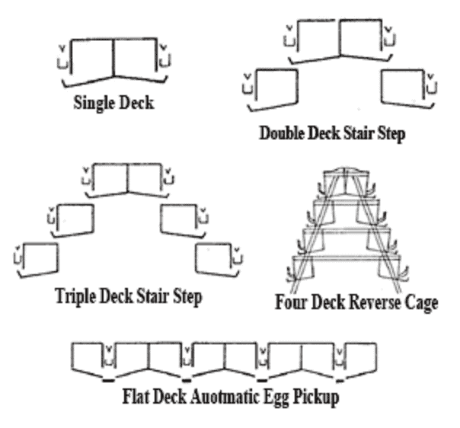
In this type of poultry cage system, the goal is to maximize the use of space.As a result, the grouping here is based on the number of layers or levels the cage has.
Four main types of chicken cage systems exist based on the number of layers the cages have.
They are;

1. The single-layer battery cage:
This type of cage has only one layer. At best, you can only connect another set of cages parallel to this one. So, what you will have are two cages facing opposite sides.

2. Double-deck poultry cage:
As the name implies, this has two decks. One at the top and the second row on the bottom of the cage. With this cage system, you can save more space.

3. Triple-layers cage system
The triple-layers cage system provides even more space for you to keep more birds. With this cage system, you can have about three times as many birds on your poultry farm.

4. Four-tier chicken cage
For ease of operation and management, the four-deck chicken cage system is the highest for this category.
At this height, workers can still easily pick up eggs and do other daily activities without stressing muscle.
With four layers available for your birds, you can produce more chickens and eggs in this system.
It is a good option if you want to keep a very large quantity of birds but lack enough space to keep them.

5. Flat-deck poultry cage system
The flat deck poultry cage system is just like the single-layer battery cage. The only difference this time is that the flat deck cage has more parallel lines of cages than the single layer.
Because of the arrangement of the battery cages in this system, workers cannot walk between cages to pick eggs.
As a result, the egg collection method for this system is automated.

Types of battery cage for chicken based on the type of chicken reared
If you are considering the type of chicken you want to rear on the farm then you should choose one of the following;

1. Brooder/chick battery cage
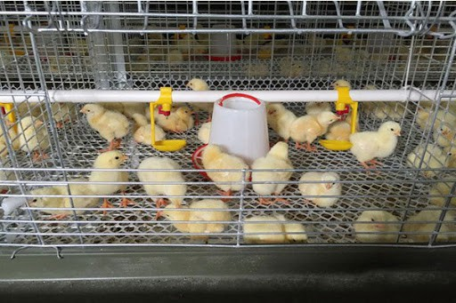
The chicken brooder cage, also called the baby chick cage system, is an important poultry farming equipment for raising baby chickens.
This type of cage is a kind of cage is suitable for raising chicks from 0-8 weeks.
It is easy to operate, suitable for large farmers poultry rearing, and leaves a clean raising environment.
The arrangement of the chick cages can either be as a single deck or double deck system.
This system has its feeders and waterers are outside the cage.
As a result of technologies in poultry farming, you can even have a nipple drinker for your birds from day-old.
This will provide the chicks with enough floor under their tiny feet.
In addition, you have to provide the chick feed inside the cage during the first week of age.
After the first week, they can pick their food from the feeding system attached to the outside body of the cage.

2. Grower poultry cages
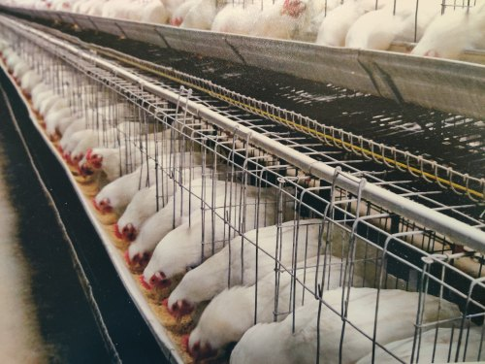
The grower poultry cage house is used to grow egg-type birds from 9 to 18 weeks of age.
So, after keeping your chicks in the brooder cage for 8 weeks, in the 9th week, you can transfer them to the grower cage.
It is in the grower battery cage that you will prepare the birds for when they will start laying eggs.
Whether you are rearing growers chicken for commercial egg production or for your hatchery, this blossoming period as a complete hen is very important.
You need to put the birds in a better pen that will conserve the health and growth of the hends in this phase of their life.
The way you keep the birds at this stage (9-17 weeks) will reflect in the laying stages.
Therefore, you need to give the birds very close monitoring because of their volatile immune systems in this stage.

Poultry cage for Layers
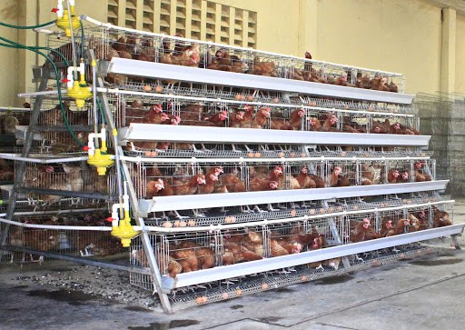
If you are in the business of egg production or hatching, then you will agree with me that a layer bird is the essence of poultry farming.
After going through the chick stage safeguarding your birds with chick cages.
Then, what followed was accomplishing a splendid grower stage of uniform growth in grower cages.
By now, the birds are ripe to start laying their golden eggs.
It is at this stage of your poultry farming that you will see the efforts you invested in your chicks and grower birds.
You will start making money from your poultry business as the birds mature and start laying eggs.
However, you need a layer battery cage for this purpose.
Its biggest advantage is increasing egg production to 98%.
Besides that, with the layer battery cage, it is very easy to handle chicken waste and reduce disease transmission.
There are two types of layers of poultry cage;
- A-type of layers poultry-cage: The A type of battery cages can be 3-4 tiers high.
- H-type of layers chicken battery-cage: This type of cage can have up to 3-8 tiers.

4. Breeder chicken cage
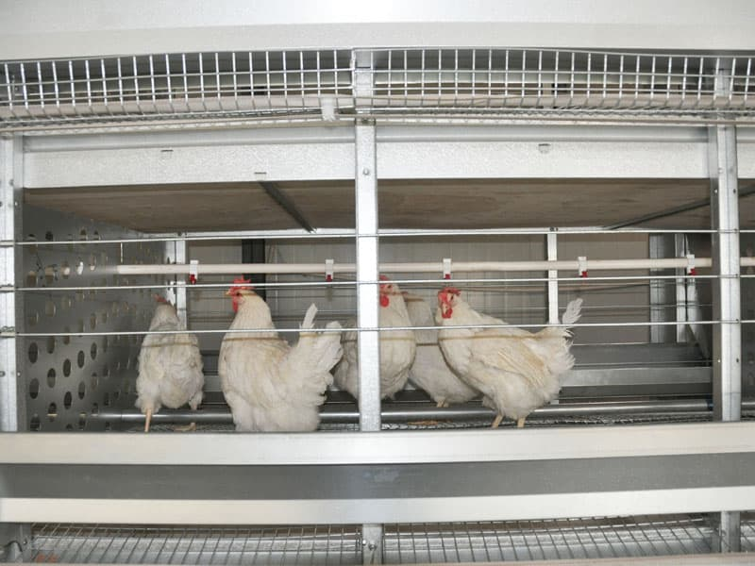
Layer breeder cages are designed especially for breeding birds in the production of eggs for hatching purposes.
The breeder cages allow for a high stocking density of birds and require minimum labour to ensure clean hatching eggs.
In the centre of the cages is a reinforced perch offering the birds an opportunity to exhibit their natural behaviours.
So, both the male and female breeders have the reinforcement to perch on while in the cage.
In addition, there is a separation between the individual cages which ensures that males in different groups remain separate.
The breeder chicken cage has a cost-effective poultry feeding system that carries feed to the layer breeders consistently and evenly.
Also, the feed trough is deep enough to avoid feed losses while the birds perk on their feed.
Additionally, the egg collection system in the layer breeder cages can convey eggs to the longitudinal belt safely.
This makes hatching eggs cleaner: without dust and feathers.
The installation of nipple drinkers in this cage is at a different height.
This is to adapt to the water supply of hens and male layer breeders and provide fresh and clean drinking water.
The high degree of automation in this breeder cage system, including water and feed supply, egg collection and manure removal, leads to the high effectiveness of layer breeder cages.

5. Poultry cage for broilers
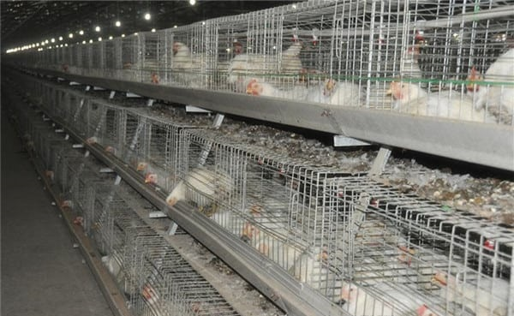
If you are thinking of growing broilers for meat production, then you should consider doing so with broiler chicken cages.
I advise starting with the battery cages for broilers since it provides a comfortable room for broilers.
In addition, broiler cages are a more economical and convenient way to grow chickens for meat.
With a broiler battery cage, you can provide a hygienic environment and reduce the death rate of broilers.
You can build your broiler battery cages in such a way that they have a perfect environment for the birds.
That way, you can ensure more cycles of broilers per year, which means more profits for you.
In addition, the high stocking density of broilers in the broiler chicken cages can save labour and resources significantly.

2.4 BENEFITS OF USING POULTRY BATTERY CAGES FOR CHICKEN PRODUCTION
In the modern day chicken rearing, battery systems have certain beneficial impact on poultry farming in the following seven ways discussed below (Green et al, 2010).

Battery Cages Boosts the Health of the Chickens
Many poultry farmers do not get healthy results from their chicken rearing because they have ignored the use of battery cages. Battery cages are very good means of accommodating your chickens in healthy conditions that will boost their reproduction.
Original battery cages are not mere cages with wire mesh floor and essential heating elements for brooding chickens. Quality and superior battery cages are designed to outweigh an ordinary wire mesh cage. The wire floor is designed to allow manure go through it, taking it away from the chickens surroundings and eventually minimizing the risks of manure-borne diseases. This will keep the chickens healthy and make chicken rearing a task worthwhile for the poultry farmer.

Increases Egg Production
A chicken that is healthy will significantly become more productive than chickens reared in environments that do not boost their health. Enriched battery cages increase the potential of egg production in chickens.
In fact, recent estimations reveal that sixty percent of eggs used in products such as mayonnaise, sandwiches and cakes are from chickens reared in battery cages. This reveals that chickens have more tendencies to produce eggs in battery cages compared to other rearing systems. It is more advisable to use battery cages to aid egg production.

Qualitative Feeding For the Chickens
The battery cage system makes feeding for chickens a habitual process which connotes more care for the chickens. This is because the chickens are fed through a long bisected metal or plastic pipe and water is served to them with overhead nipple systems which are set before the chickens. This makes it easy for the poultry farmer to care for the chickens with frequent and adequate food and water.
Chickens are well-catered for in battery cages and this makes them healthier and more productive.

Low Cost OfLabour
Battery cage reduces labour by the poultry farmer. This is because the chickens are well-organized and conducted to be in rows with several facilities for their feeding, carriers of their faeces droppings adequately positioned and the eggs rolling to the appropriate places designed in the battery cages.
Everything is organized already. The poultry farmer will simply do the job of pouring food and water in the designated areas, cleaning the faeces that drop and packing the eggs. This reduces stress for the farmer and the need to employ many workers for poultry farms will be minimized. In the long run, poultry farming will be more rewarding for the poultry workers.

Poultry Battery Cages Have Feeders that Minimize Feed Spillage
Battery cages make it easy for poultry farmers to care adequately for their chickens. Despite this dire need to take care of the chickens, battery cages help the poultry farmer to minimize feed spillage when feeding chickens.
It is easy to minimize feed spillage with battery cages because they are designed with standard accessories for holding food and water, especially the amount required for feeding the chickens daily. This disallows any form of feed spillage and wastage. Instead of feed spillage, the chickens keep feeding on the required amount of food specifically provided in front of them.

High Capacity for Accommodation
Modern battery cages have high capacity to accommodate a larger number of chickens within a limited space.
That means, battery cages will save you cost in construction and help you maximize the use of whatever space you have available. Many A-type poultry battery cages can accommodate between 60 and 128 chickens or more per unit, depending on the size and model you buy.
Therefore, it is rewarding to invest in poultry farming using poultry battery cages with high capacity for accommodation.

Affordable, Durable And Suitable For All Egg-Laying Chicken Types
Poultry battery cages are quite affordable for beginners and experienced poultry farmers who need to give this method of rearing chickens a trial. It costs less and is more effective and efficient.
Besides being affordable, poultry battery cages are durable because they have wire mesh made of galvanized iron which keeps them from rusting and makes them last for a lengthy period of time. It is not just durable but suitable for all egg-laying chicken types such as breeders, layers, point-of-lay and point-of-cage chickens.
It is therefore advisable for poultry farmers to consider using the modern poultry battery cages for sustainable and adequate productivity in chicken rearing.

CHAPTER THREE
3.0 MATERIALS AND METHOD
3.1 MATERIALS USED
- wire mesh
- 1 1/4″ deck screws
- 1 1/2″ deck screws
- 3″ deck screws
- 2 1/2″ pocket hole screws
- 18 gauge 3/4″ galvanized staples
- 1 1/2″ finishing nails
- exterior wood glue
- 8 – door hinges
- 4 – door latch

Cutting List
Right Side
- 2 – 2×2 – 11 3/4″
- 2 – 2×2 – 7 1/4″
Left Side
- 2 – 2×4 – 60″
- 3 – 2×4 – 30″
Back Side
- 11 – 1×6 – 48″
Front Side
- 2 – 2×2 – 45″
- 2 – 2×2 – 28 1/2″
Floor
- 6 – 1×6 – 48″
Roof
- 6 – 2×4 – 27 15/16″
3.2 METHOD USED
The cage panels were assembled according to their side – right, left, back, front, roof and floor side
Right Side
- 2 – 2×2 – 11 3/4″
- 2 – 2×2 – 7 1/4″
- wire mesh
Assemble the door as shown on drawing above using exterior wood glue and 2 1/2″ pocket hole screws. Cut the wire mesh to size and attach to the door frame using 18 gauge 3/4″ galvanized staples.
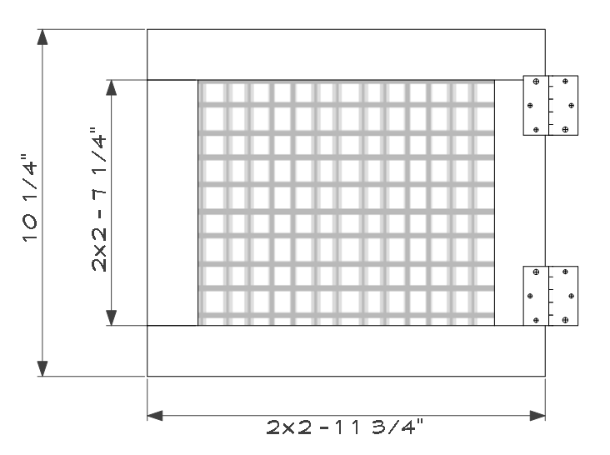

Left Side
- 2 – 2×4 – 60″
- 3 – 2×4 – 30″
Notch all 2×4 ends to 3 1/2″ x 3/4″ deep. Pre-drill all holes and assemble as shown on drawing using exterior wood glue and 1 1/4″ deck screws.
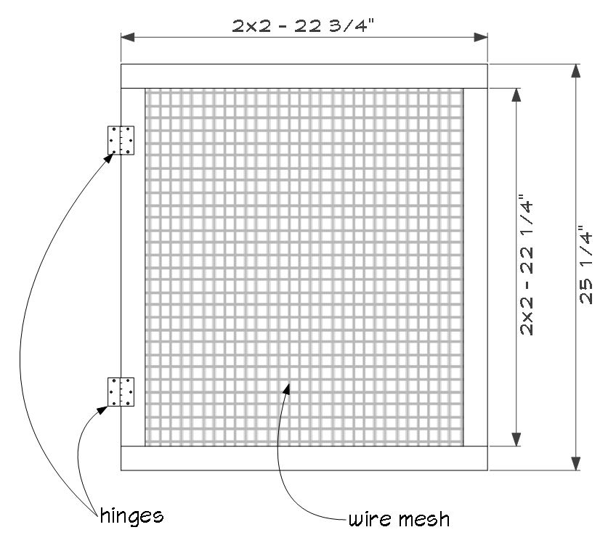
The door as shown was assembled using exterior wood glue and 2 1/2″ pocket hole screws. Cut the wire mesh to size and attach to the door frame using 18 gauge 3/4″ galvanized staples.
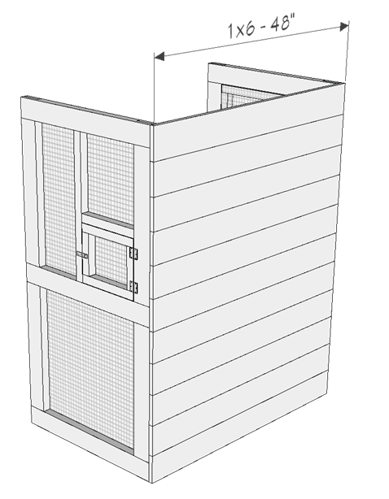
For the back side above
1×6 board was installed for the back wall. Use 1 1/2″ deck screws, pre-drill holes and screw through the 1×6 boards and into the side walls. Rip the last 1×6 board to size.
Front Side
- 2 – 2×2 – 45″
- 2 – 2×2 – 28 1/2″
- wire mesh
Assembling was carried out as shown below using exterior wood glue and 2 1/2″ pocket hole screws. Cut wire mesh to size and attach with staples.
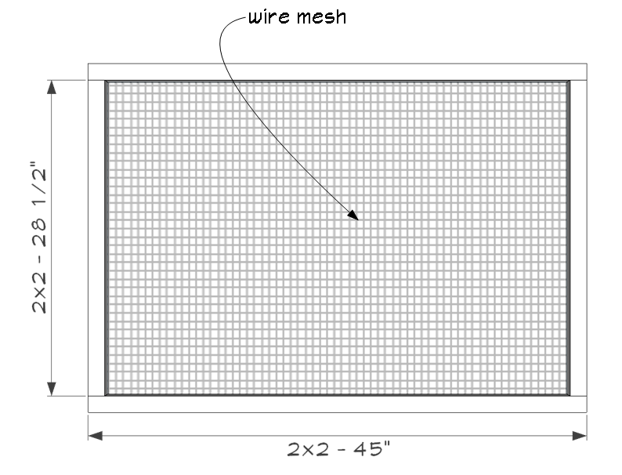

Floor
Floor was assembled using
- 6 – 1×6 – 48″ wood
Pre-drill holes and attach the 1×6’s to the bottom for the floor. Rip the last 1×6 to size. Use exterior wood glue and 1 1/2″ deck screws to assemble.

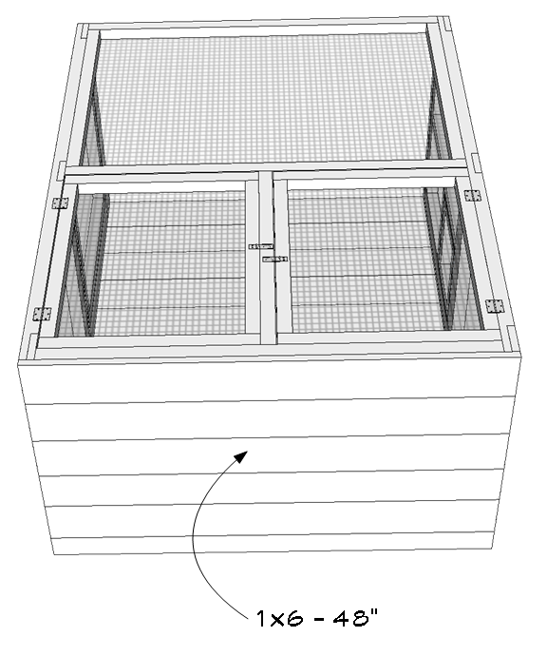
Roof
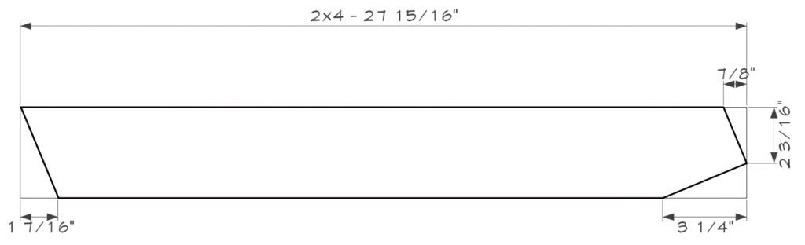
Roof Rafters
- 6 – 2×4 – 27 15/16″
Cut the 22.5-degree angle cuts to the 2×4 rafters as shown on drawing above.
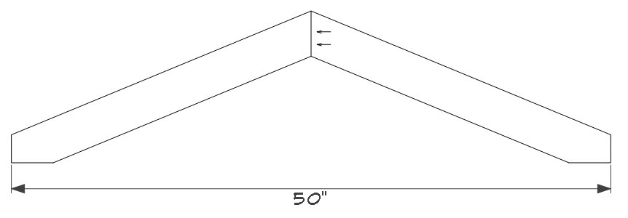
Roof Truss
The complete picture of the system is as shown below:

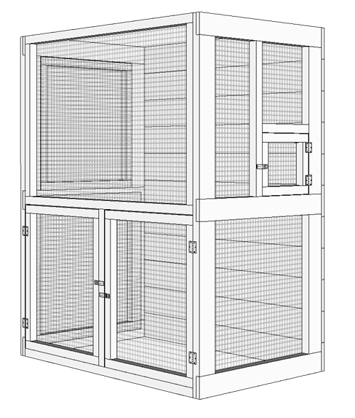

CHAPTER FOUR
4.1 DISCUSSION
Bird cage mesh was not built by used but was purchase from wire mesh or fencing manufacturers. The bird cage must be made from precisely configured mesh so that the cage will be stable or safe for the bird. As the panels and sides are cut directly from the mesh, it must be evenly spaced or the cut panels will not meet precisely at the edges. Larger birds can have a slightly larger mesh, but manufacturers are careful to keep the mesh fairly tight.
The panels which have been cut out of the wire mesh must be physically separated from the wire mesh. The mesh, with panels still intact, is fed automatically into another machine, and the machine uses a hydraulic punch to remove the panel from the mesh. This happens with all the components of the cage cut out of mesh.
The door panels of the cage must be reinforced with another brace or wire around them. Thus, the door panels are automatically soldered with another band of wire along the outside of the door. This strong wire addition leaves no rough edges of cut gauge, strengthens the door in order to provide a secure door for the bird, and provides a stable, consistent edge by which the door can be hinged to the cage body.
The components are now all cut. The door must be connected to the front panel. The door, a bit larger than the opening in the front panel, is attached to the panels with ferrules. An air gun is put up to the door and the side panel, and an open clip encircles the door panel and the front panel. At least two ferrules are attached to the door and the front panel and thus serve as hinges.
Additionally, the cage must be secure so that the bird does not slip out of any gaps in the cage should the panels not line up evenly. Poor registration of the sides and/or top is primarily the result of poorly-configured mesh wire. It is imperative that the raw material used in the construction of the bird cage be very carefully inspected upon receipt. Most manufacturers only use materials that are certified meaning they are guaranteed to be made to specifications.

4.2 CHOOSING A BATTERY CAGE
Although it seems there are endless choices when it comes to the types of battery cages available, there are a few simple guidelines one can remember that will make the process of choosing one much easier.

Location and Placement
The first of these rules is to decide where your bird's cage will be located, and shop based on what will work with the area you have set aside. The area should be away from windows and drafts, yet in an active part of your home to encourage your pet's social development.

Choosing the Right Size
Next is to keep the size of your bird in mind. While it is perfectly fine to keep a Finch or Canary in a small space, larger birds need larger cages, and it is always better to buy or build the largest cage you possibly can for your bird. Keeping a bird in a cage that's too small can lead to undesirable behaviors such as screaming, biting, psychological disorders, and feather plucking, to name a few. A good cage should be large enough for your bird to walk around comfortably, and fully extend and flap her wings. Don't forget to take into account the space that will be lost when you add your bird's perches, food bowls, and toys! Consult your avian veterinarian for recommended cage sizes for your particular species.

Bar Spacing
Another thing to look at when selecting a cage is the bar spacing. Smaller birds, such as parakeets and lovebirds, require cages with bars no more than a half inch apart, to prevent them from squeezing through or becoming stuck between the bars. Many bird owners have been surprised to find that their pets are quite the little escape artists! Those who own larger birds should look for bars that are placed horizontally rather than vertically, to give your bird a means of climbing and exercise.

Shape and Style
The style of the cage is also an important factor. According to some veterinarians, round cages have been found to be detrimental to birds' psychological health, so angled cages are preferable. Many of these cages can either be hung or placed on a stand and come in a variety of sizes and shapes to accommodate any species of pet bird.

Quality and Craftsmanship
Assess the overall quality of a birdcage before you buy it. Does the cage appear sturdy and solid? Are there any loose parts or sharp edges? The best cages are made of stainless steel, which is non-toxic, easy to clean, and will not chip. The primary function of a bird's cage is to protect it - make sure that your bird's home does not pose any hazards to his health and well-being.
A properly designed birdcage normally gives bird and owner many years of use and enjoyment. You should remember that your bird will spend a great deal of time in his cage, and much like a person will appreciate some decorations to look at! Fill your bird's cage with colorful toys, perches, and accessories to ensure that he is well entertained. With a little planning and careful decision making, you should be able to choose a cage that will meet all your expectations while providing your bird a safe, sturdy, and secure living space.

CHAPTER FIVE
5.1 CONCLUSION AND RECOMMMENDATION
At the end of this work a battery cage was constructed successfully. During the construction, one should be very careful not to purchase mesh that is full of drips resulting from the galvanizing process. These drips are heavy in zinc, used in the plating process. Some bird breeders and veterinarians believe that excessive zinc can lead to zinc toxosis in which the bird is poisoned by an overabundance of zinc ingested through nipping at the zinc galvanizing from the mesh cage.

REFERENCES
Appleby, M.C.; Mench, J.A.; Hughes, B.O. (2014). Poultry Behaviour and Welfare. Wallingford and Cambridge MA: CABI Publishing. ISBN 0-85199-667-1.
Prescott, N.B. and Wathes, C.M., (2002). Preference and motivation of laying hens to eat under different illuminances and the effect of illuminance on eating behaviour. British Poultry Science, 43: 190-195
Davis, N.J., Prescott, N.B., Savory, C.J. and Wathes, C.M., (2019).Preferences of growing fowls for different light intensities in relation to age, strain and behaviour. Animal Welfare, 8: 193-203
Green, L.E., Lewis, K., Kimpton, A. and Nicol, C.J., (2010). Cross-sectional study of the prevalence of feather pecking in laying hens in alternative systems and its association with management and disease. Veterinary Record, 147: 233-238
Against Animal Cruelty Tasmania (AACT) - Battery Hen Campaign Archived 20 September 2011 at the Wayback Machine
Prevent Cruelty to Chickens in the Egg Industry by Adopting a Vegan Diet | ChooseVeg.com Archived 25 November 2011 at the Wayback Machine
Scientific Veterinary Committee of the European Commission (1996). "Report on the Welfare of Layer Hens" (PDF). Archived from the original (PDF) on 26 September 2006.
Patwardhan, D. and King, A., (2011). Review: feed withdrawal and non feed withdrawal moult. World's Poultry Science Journal, 67: 253-268
Webster, A.B., (2003). Physiology and behavior of the hen during induced moult. Poultry Science, 82: 992-1002
Yousaf, M. and Chaudhry, A.S., (2019).History, changing scenarios and future strategies to induce moulting in laying hens. World's Poultry Science Journal, 64: 65-75
Morris, M.C. (2016). "The ethics and politics of the caged layer hen debate in New Zealand". Journal of Agricultural and Environmental Ethics. 19 (5): 495–514.

