CHAPTER ONE
INTRODUCTION
1.1Background of the Study
Insect are always present in field crops during cultivation and in storage of the produce, and can have a huge economic lose in production. Control of storage pests of agriculture products largely depend on synthetic pesticides, which has been widely since inception in 1950s (Stevenson, 2014).
Over time, many of these chemical have become extremely pervasive in the environment, in some cases, in consumed food as a result of their widespread repeated use (Allsopp et al., 2014, 2015).
Exploring the potential of utilize the pesticides properties of plant of plants has become a key focus of research in pest control.
Some plants are known to contain bioactive metabolites, which show antecedent, repellent and toxic effects on a wide range of insect pests (Mondal and Khalequzzaman, 2010; Anyanga et al., 2013; Stevenson, 2014).
The production of organic extracts of plant origin for pest control maybe easier and less expensive than the synthesis of some complex chemical formations (Shadia, 2011; Amoabeng et al., 2014; Grzywacz et al., 2014).
Examples of these important bioactive plants are catnip, basil, Artemisia, orage, dahlia, ginger, hyssop, chrysanthemum, lime, black pepper, clove, neem and the host of others. These plants are known to contain organic compounds which possess bio-pesticides properties in their bioactive components. pest control or repelling organic extracts of plant origin offer protection with minimal impacts on the ecosystem and repel the insect pests from the treated materials by stimulating receptors (such as olfactory receptor) of the insect. Repellent when effective because the target pest of make an oriented movement away from the source of stimulus, and in cases where escape is not possible, over stimulation of the receptors leads to death of the pest. Plant extracts in powder or essential oil form from different bioactive plants are known to be effective repellents against different economic storage pests of grains, even for stored c ereals (Owusu, 2001; Khan and Gumbs, 2003).
Cereals such as wheat, maize and rice, together comprise at least 75% of the world grain production and they are among the world’s most important staple foods (FAO, 2008). They constitute the major sources of food in the world and are usually seasonally cultivation with single harvesting per year in some regions. With the seasonality of cultivation, preserving is of high importance to ensure sustenance to their economic valve, continuous supply at stable price and maintain constraint their nutritional valve. Post-harvest losses are recognized as a major constraint in Africa, with storage damage sometimes as high as 40%. For example, nearly US$4 billion of the staple food, maize’ is lost annually in Africa to insects (Stevenson, 2014).
In spite of their efficacy, their repeated use for several decades have disrupted biological control systems, which have led to outbreaks of resistant insect pests, undesired effect on non-target organisms and environmental and human concerns.
Beans (Phaseolus valgaris) form an important food and cash crop in Africa, particular in eastern, southern, and great lakes regions of the continent, of all agricultural commodities produced in these parts of Africa, beans are considered the second most important source of human dietary protein and the third most important source of calories (Ampofo, 2009).
Neem (Azdiranchta indica) is a large tree with semi-strength to straight trunk and
spreading breaches. It has been widely regarded as a nature source of pesticides and other agro-chemical. Neem was reported to be the most effective the species that have shown pesticide activities (Girish and Shankara, 2008). The extracts of different parts o seeds and bark) were found to control a variety of arthropods, nematodes, fungi, viruses, snails and crustacean’s species (Girish and Shankara, 2008). The extract of its seeds was effectives larvicidal and indicated (Hashmat et al., 2012). Neem leave powder/Ash is also recommended as the most promising pesticide for effective control for beans weevil.

1.2 Problems Statement of the Project Work
There have been notable concerns on the persistent use of synthetic chemicals for pest control bearing direct adverse effects on humans, wildlife, aquatic life and the environment at large (Munoz-Quezada et al., 2013).
Apart from the negative effect of synthetic insecticides, in most remote rural area their availability in unreliable, and are frequently adulterated (diluted to ineffective concentrations by unscrupulous traders), outdated (owing to their toxicity to people and the environment), and ineffective owing to rapid evolution of pesticide resistance (Stevenson, 2014).
Many plants can protect themselves against insects by producing their own chemical defenses that can repellent (Stevenson, 2014). The consideration for the use of extracts of plants origin is that they are easily biodegradable, effective on some pests and considered safe in pest control operations as they minimize pesticide residues, ensure safety of consumers of the treated grains and the environment.
The infestations of weevil in beans compromise seeds viability, grains physiology, and its nutritional quality, as well as contaminate the product with excrement. Such problems cause qualitative and quantitative losses through, which reduces beans commercial value. Weevil causes annual losses between 30 and 50% and sometimes above 90%. In addition to the problems mentioned above, many producers, especially in family farms, neglect the control of weevil due to lack of financial resources.
Neem pesticides are generally water soluble and help in the growth of the plants. It acts as pest repellent and pest reproduction controller. The transition from use of synthetic products to natural ones is an evident I agricultural industry.
1.3 Aim and Objectives
The aim of the study is to evaluate the effectiveness of neem leaf powder as a natural preservative in controlling callosobruchus maculatus infestation and maintaining the quality of stored cowpea seeds.
Objectives
The specific objectives of this study are:-
- To determine the efficacy of neem leaf powder in controlling callosobruchus maculatus infestation in stored cowpea seeds
- To identify the optimal dosage of neem lead powder that minimize pest damage while maintaining seed quality.
- To assess the potential of neem leaf powder as sustainable and eco-friendly alternative to chemical insecticides in cowpea storage.
1.4 Justification of the Project Work
The increasing public concern over chemical pesticide safety and possible damage to the environment has resulted in increasing attention to natural products of mostly plant origin for the control of storage pest globally. The infestations of weevils in cowpea compromise seeds viability, grains physiology, and its nutritional quality, as well as contaminate the product with beans commercial value.
Cowpea weevils cause annual losses between 30 and 50% and sometimes above 90% (Ileke and Oni, 2011). Control of cowpea weevil has been carried out my fumigation or spraying with chemicals of different toxicological classes.
Synthetic insecticides are expensive for small farmers and require equipment and training for their use. (Owusu, 2001; Khan and Gumbs, 2003).
Beans are highly susceptible to insect (weevil) attach during storage and after for this, chemical preservatives are being applied to control the effect of the weevils.
However, a growing awareness among consumers towards health aspect has increased their interest on natural preservatives as an alternative to certain disadvantages associate with chemical preservatives; utilization of natural preservative has rendered foods with high nutritional values, free from chemical preservative and adequate microbial safety.
1.5 Scope of the study
The study is limited to use of neem powder as an organic preservative for the control of pest and diseases in legume using cowpea as a case study.
The neem powder was introduced to the infested and non-infested cowpea. Proximate composition would be carried out on the treated cowpea after eight weeks of storage.

CHAPTER TWO
LITERATURE REVIEW
2.1 Agronomy of Cowpea
Among the cultivated crop plants, cowpea is one of the most variable species in terms of its plant growth, morphology, maturity and grain1 types (Singh, 2014). The cowpea has a long taproot and adaptation mechanisms such as turning the leaves upwards to prevent them from becoming too hot and closing the stomata that help give it drought tolerance. As a legume crop, the cowpea fixes atmospheric nitrogen through symbiotic interactions with soil rhizobia (Sarr et al., 2015).
The present-day importance of the cowpea as an agricultural plant stems largely from its use as a short season protein-rich grain crop for human or animal consumption. In the African marketplace, harvested cowpea grain provides a cost-effective substitute for the less affordable foods from livestock and fish. Cowpea leaves can (Sarr et al., 2015).be harvested for direct use as needed during times of food scarcity while end of season collection of above-ground biomass after harvest provides valuable feedstock as fodder hay either for direct use or as a transportable commodity for sale or barter (Kristjanson et al., 2001; Hollinger and Staatz, 2015).
The cowpea is the most economically important indigenous African legume crop (Langyintuo et al., 2003). The majority of cowpea exports and imports occur within Africa for human consumption. It is actively traded from West to Central Africa because of the comparative advantage that drier areas of West Africa have in growing cowpea. Niger, Burkina Faso, Benin, Mali, Cameroon, Chad and Senegal are net exporters; Nigeria, Ghana, Togo, Côte d’Ivoire, Gabon, and Mauritania are net importers (Langyintuo et al., 2003). Since 2008, Brazil has exported the brown-eyed white commercial type to countries such as India, Israel, Pakistan, Turkey, the United Arab Emirates, Singapore, Indonesia, Nepal, Viet Nam, Portugal, and Italy (Aguiar, 2016; Freire Filho et al., 2017).
For human consumption, the cowpea is mainly grown for grain (dry and fresh) and sometimes for fresh pods in West Africa, India, and South America, while also grown for leaves in East Africa. It is an underused legume crop with a high potential for food and nutritional security in South Africa and produced for grain, immature green pods and fresh leaves due to its nutritional composition (Gerrano et al., 2015).
2.2 Economic importance of Cowpea
Cowpea is of major importance to livelihoods of relatively poor people in less developed countries of the tropics including South Sudan, especially where animal protein is not easily available for the family. According to (Ngalamu et al., 2014) cowpea is an important crop in the agriculture of African countries and south Sudan in particular for the following reasons:
- Provision of nutritious food: All the parts of cowpea used for food (fresh leaves, immature pods and the grains) are nutritious, providing protein, carbohydrate, vitamins and minerals. The grain contains 22-23 % protein (as opposed to 2 % in cassava and 10 % in maize) and good quantity of thiamine (vitamin B₁), riboflavin (vitamin B₂) and niacin (vitamin B3), and richer 3 than cereals in iron and calcium content. Cowpea leaves are a significant source of β-carotene and ascorbic acid (vitamin C). Cowpeas seed grain used as food, supplement very well the protein deficiency of the predominantly carbohydrate, cereal, root and plantain diet of African communities. A well-known problem of cowpea grain is its content of tannins, trypsin inhibitors and flatulent sugar, raffinose, which cause bloating of stomach when a meal containing cowpea is consumed. As a result, a meal of cowpea is repulsive to some people. This problem can easily be avoided by grain soaking before dehulling, heat treatment and breeding for cowpea varieties without or with low content of these factors.

- Provision of high quality feed for animals: Cowpea can be grown and above ground plant parts harvested and fed to animals (cattle, sheep and goats), providing proteins, vitamins and minerals.
- Cowpea as cover crop: The spreading indeterminate and semi-determinate bushy growth of cowpea provides ground cover, thus suppressing the growth of weeds and providing protection against soil erosion by running water during heavy rains. A complete ground cover also reduces the temperature of the soil.
- Provision of organic matter to the soil: The root, stem, and haulm residues decay after harvest, providing organic matter and the contained nutrients to the soil.
- Fixes atmospheric nitrogen and adds it to the soil: As a legume, cowpea roots fix atmospheric nitrogen thus, increasing or improving the nitrogen content of the soil in which it is growing. Thus, the nitrogen content of the soil increases following cowpea cultivation, a contribution of about 40–80 kg/ha. Growing cowpea in a mixture with cereals (maize, sorghum, or millets) will increase the yield of cereal crops. In rice farming, cowpea can be grown either before or after a crop to increase food production from a land area. It can also be grown in rotation with rice immediately after harvest of rice thereby replenishing the soil fertility for the next crop to be grown on the same piece of land.
- Suppression of growth of striges (ngava (Moru); loliyum (Bari), buda (Arabic): Some cowpea varieties will stimulate the germination of striges seeds, but the roots of the germinated seedling of the Striges cannot penetrate the roots of the cowpea to obtain nutrients for its subsequent growth. Failing to obtain a host, the striges seedling will starve to death. However, cowpea does not cause suicidal germination in all Striges species. Striges gesnerioides and Alectra vogelii cause substantial yield reduction in cowpea in the dry savannas of sub-Saharan Africa. It is possible that these two species could be available in South Sudan. Resistant/ tolerant varieties to S.gesnerioides and A.vogelii have been developed by the International Institute of Tropical Agriculture (IITA) in Nigeria.
- Drought tolerant or drought hardy: Many cowpea varieties can maintain some growth or at least survive and yield under dry conditions where other crop plants cannot grow. Some varieties of cowpea with deep rooting habit can grow under semi-arid conditions.
- Provision of cash (Money): Petty trading in fresh cowpea leaves (nyete), fresh produce and processed food provides both rural and urban communities opportunities for earning some money, particularly by women. Trading in cowpea haulms as food for large and small ruminants can be remunerative.
- Good growth and yield under irrigation in hot tropical dry season: Cowpea can grow well and attain good yields under irrigation when cultivated during the hot tropical dry season. Some varieties of cowpea can thrive well on the use of residual soil moisture in drier season.
- Seeds cook quickly: Dry cowpea seeds take comparatively less time to cook than any other food legumes, an important consideration in most developing countries where cooking fuel is scare.

2.3 Processing of Cowpea
Processing of cowpeas and legumes, in general, is essential to make them nutritious, nontoxic, palatable and acceptable. The cowpea is utilized either whole or decorticated or dehulled. It is decorticated by soaking in water (at room temperature) for about 30-60 min, and the seed coat removed by squeezing between the palms or by gentle abrasion using grinding stones. The seed coat is separated by subsequent filtration (Adebooye and Singh, 2007).
The constraints to maximum utilization of cowpeas can be overcome by appropriate processing technology. For example, these techniques include dehulling, grinding, soaking, germination, fermentation, addition of salts, wet and dry heat treatments, cooking and roasting (Uzogara and Ofuya, 1992; Adebooye and Singh, 2007). Irradiation by gamma rays can also be used to sterilize cowpea flours and pastes but high levels of irradiation can reduce food quality (Abu et al., 2005). The most commonly used processing methods for cowpea products are presented in Figure 2.1 by Modade et al., (2013).
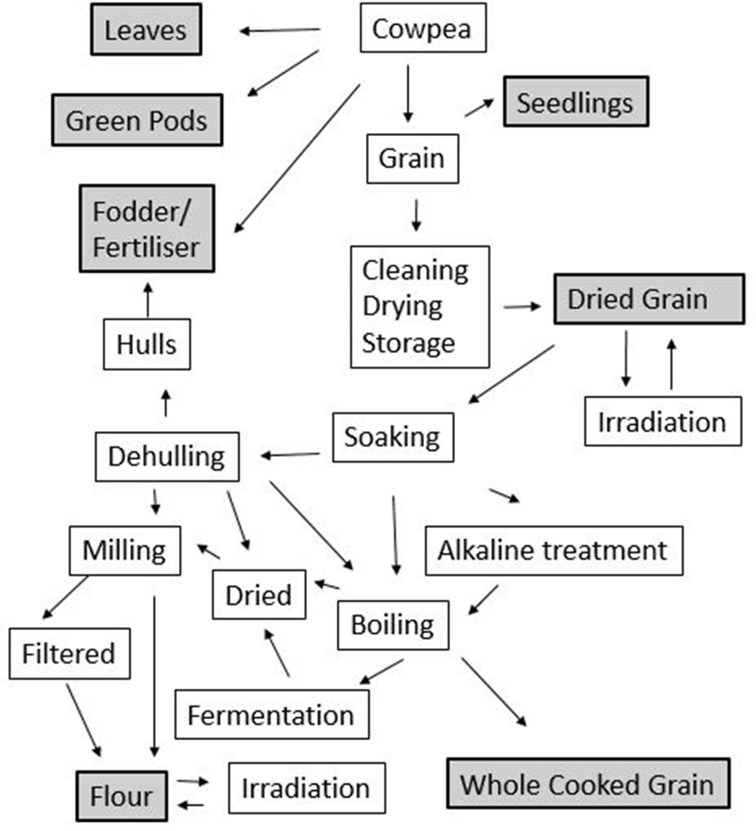
Figure 2.1 Method of processing for cowpea
Source: Modade et al (2013).

2.4 Nutritional Composition of Cowpea
Most of the nutrient composition data is based on cowpea whole grain, although there is a limited amount of data for dehulled grains, sprouted grains and leaves. Whole grains include the seed coat which represents 6% of grain dry matter (Aremu, 1990).
The cowpea is morphologically variable and adapted to different environments, resulting in a wide range of local varieties (OECD, 2015). The nutritional composition of cowpea is impacted by genetic characteristics, agro-climatic conditions, biotic stresses and postharvest management (Goncalves et al., 2016; Murdock et al., 2003; Oluwatosin, 1998; Silveira et al., 2001). The cowpea is highly nutritious and has potential health benefits because of its high protein, high fibre and low glycaemic index, (OECD, 2018).

2.4.1 Constituents of Cowpea
The proximate composition of a large number of cowpea varieties is listed in Tables 2.2 and 2.3 below as reviewed by different researchers.

Carbohydrates and Fibres
The cowpea contains a high proportion of carbohydrates, representing the majority of the dry weight of the grain, leaves, and sprouts (Goncalves et al., 2016). Eight sugars (simple carbohydrates) have been reported in the cowpea, namely, sucrose (11-19 g/kg), glucose (4-5 g/kg), fructose (1-2 g/kg), galactose (≤ 15 g/kg), maltose (≤ 11 g/kg); and three carbohydrates considered to be anti-nutrients, stachyose (17-60 g/kg), verbascose (6-13 g/kg), and raffinose (5-10 g/kg) The crude fibre (complex carbohydrates) content of whole cowpeas ranges from 2.5% to 32% of total dry matter. The crude fibre content decreases when the seed coat is removed. The means for total, insoluble and soluble dietary fibre of dehulled cowpeas reported by Khan et al. (2007) are 18.2%, 14.8%, and 3.3% of dry matter respectively. Total dietary fibre includes cellulose (6%), hemicellulose (3.9%), lignin (2%), and pectin (1.8%) (Khan et al., 2007).

Protein
The cowpea provides a source of protein (Boukar, Massawe and Muranaka, 2011) with the whole grain containing levels ranging from 16% to 31%. The seed coat contains 12% protein (Aremu, 1990). Most of the cowpea grain proteins consist of globulins with lower levels of albumins, glutens, and protamine (Goncalves et al., 2016; Vasconcelos et al., 2010).
The amino acid composition of the cowpea is rich in lysine, leucine, arginine and other essential amino acids and can largely fulfill the essential amino acid requirements of a human diet. However, cowpeas are low in the sulphur amino acids (methionine and cysteine) compared to cereals and animal products and thus, for a balanced diet, cowpeas need to be supplemented with cereals or vegetables, meat and/or dairy products (Iqbal et al., 2006; Uzogara and Ofuya, 1992; Hussain and Basahy, 1998; FAO, 2004).

Lipids/fatty acids
According to (Goncalves et al., 2016) the lipid content of cowpea whole grain ranges from 0.5% to 3.9%. The lipid profile of cowpea indicates a predominance of triglycerides (41.2% of total fat), followed by phospholipids (25.1% of total fat), monoglycerides (10.6% of total fat), free fatty acids (7.9% of total fat), diglycerides (7.8% of total fat), sterols (5.5% of total fat) and hydrocarbons and sterol esters (2.6% of total fat) With respect to fatty acids, linoleic acid and palmitic acid predominate followed by oleic acid, stearic acid and linolenic acid (Thangadurai, 2005; Goncalves et al., 2016).

Minerals
Cowpeas are a source of essential minerals, calcium, magnesium, potassium, iron, zinc and phosphorus. Low availability of soil phosphorus is a primary constraint to cowpea production in developing countries (Burbidgeet al., 2016). Levels of grain phosphorous, potassium and manganese vary widely due to environmental conditions (Adebooye and Singh, 2007). Most minerals are at higher concentrations in leaves (Gerrano et al., 2015) and immature green pods (Gerrano, Jansen van Rensburg and Adebola, 2017) compared to grain (Belane and Dakora, 2012; Madode et al., 2011). Some minerals are lost when the seed coats are removed, (Mamiro et al., 2011).

Vitamins
Cowpeas are a source of thiamin and niacin, and also contain reasonable amounts of other water-soluble vitamins such as riboflavin. Vegetative tissues including germinated grain tend to have higher levels of niacin, thiamin and riboflavin than grain (Nnanna and Phillips, 1989; Goncalves et al., 2016). Seed coat removal results in up to 30% loss in niacin content, while thiamin is reduced 41% by cooking (Nnanna and Phillips, 1989). Vitamin C values are higher in leaves than grains and increased by 4 to 38-fold after grains sprout (Devi, Kushwaha and Kumar, 2015. Cooking in an alkaline solution containing “kanwa” (naturally-occurring rock-salt) decreases thiamin, niacin and riboflavin levels compared to cooking without “kanwa” (Uzogara et al., 1991). Fermentation results in a significant increase in the levels of thiamin and niacin (Akinyele and Akinlosotu, 1991).
2.5 Agronomy of Neem Plant
Azadirachta indica A. Juss., commonly called ‘Neem by the English, it called dogonyaro in Hausa, Igbos calls it Akun shorop and Yorubas calls it Awe kasha, this has been used in traditional medicine since antiquity, is regarded as ‘holy tree’ ( Dharmendra et al.,2016) . Neem trees grow generally 15-20 m tall and have a life span of 150-300 years. Fruits are green that turns yellow on the time of ripening. It is sensitive to frost and restricted to warmer parts of the world (21-32ºC).
Neem (azadirachta indica) is native to the arid regions of the Indian subcontinent, where it grows to 12-24m high at attitude between 50 and 100m with 130mm of sufficient rainfall per annum for its growth. Indian, been is known for its use and is more utilized in beans cultivation. Neem is also called 'arista' sanskrit a word that means 'perfect' complete and 'imperishable’. The Sanskrit name 'nimbi' comes from the term 'nimbatisy-asthyamdadati' which means to give good health. The seeds bark and leaves contain compounds with proven antiseptic, antiviral, antipyretic, anti-inflammatory, anti-ulcer and antifungal uses (Adeyeba, 2014).
Azadirachta indica can be propagated easily by seeds, or 9 to 12 month -old neem seedlings can also be transplanted. Fresh fruit yield per neem tree ranges between 37 and 50kg per year. Forty kg fruit yield nearly 24kg of dry fruit (60%),which in turn gives 11.52kg of pulp(48%),1.1kg of seed coat (4.5%), 1kg of husk (25%)and 5.5kg of kernel (23%).the kernel gives about 2.5kg of neem oil(45%) and 3.0kg of neem cake(55%) neem is recognized today as a natural product which has much to offer in solving global agricultural environmental and public health problems. Researchers worldwide are now focusing on the importance of neem in the agricultural industry .the magical tree and hundreds of their active compounds are used manufacture a number of products natural properties of neem do not have any toxic reactions, so they are helpful in ant protection and management. All the parts of neem like seed flowers barky and leaf can be used to produce high quality product Adeyeba (2014).
2.6 Benefits of Neem
Some of the benefits of neem are highlighted below according to Subbalakshmi et al., (2012)
2.6.1 Neem used as Fertilizer:
The material left after oil is squeezed out from seeds and is popularly known as the seed cake. It acts as a bio fertilizer and helps in providing the required nutrients to plants. It is widely used to ensure a high yield of crops. Neem is used as a fertilizer both for food crops and cash crops, particularly rice and sugarcane crop.Neem seed cake performs the dual function of both fertilizer and pesticide, acts as a soil enricher, reduces the growth of soil pest and bacteria, provides macro nutrients essential for all plant growth, and helps to increase the yield of plants in the long run, bio degradable and Eco- friendly and excellent soil conditioner.
2.6.2 Neem used as Manure:
Manure is any animal or plant material used to fertilize land especially animal excreta for improving the soil fertility and thus promoting plant growth. Neem manure is gaining popularity because it is environmental friendly and also the compounds found in it help to increase the nitrogen and phosphorous content in the soil. It is rich in sulphur, potassium, calcium, nitrogen, etc. Neem cake is used to manufacture high quality organic or natural manure, which does not have any aftermaths on plants, soil and other living organisms. It can be obtained by using high technology extraction methods like cold pressing or other solvent extraction. It can be used directly by mixing with the soil or it can be blended with urea and other organic manure like farm yard manure and sea weed for best results. (Thompson, 2015). It is bio degradable and ecofriendly, nourishes the soil and plants by providing all the macro and micro-nutrients, helps to eliminate bacteria responsible for denitrifying the soil, ideal for cash crops and food crops, increases the yield of crops, helps to reduce the usage of fertilizer, thus reducing the cost of growing plants, antifeedant properties that help to reduce the number and growth of insects and pests.
2.6.3 Neem as Soil Conditioner:
Neem seed granules or powdered seeds are used to manufacture the soil conditioner. It can be applied during sowing of plants or can be sprinkled and raked into the soil. The process of sprinkling should be followed by proper irrigation so that the product reaches the roots. It is a natural soil conditioner that helps improve the quality of soil, thereby enhancing the growth of plants and fruits. Organic soil conditioner is gaining popularity in agricultural industry, not only in Asian countries like India but also in western counterparts such as USA, UK and Australia. (Wilson, 2014).
Neem is a natural soil conditioner that helps improve the quality of soil, thereby enhancing the growth of plants and fruits. It not only helps the plants grow, but also prevents them from being destroyed by certain pests and insects. Organic soil conditioner is gaining popularity in agricultural industry. Because they are organic, they have no harmful effects and are cheaper than the other soil conditioners. This natural soil conditioner is also multi-functional and in the sub-tropical regions. Neem soil conditioner application in plantation crops is known to be a soil enhancer that helps to increase its fertility.
2.6.4 Neem as Fumigant:
Neem tree has been used against household, storage pests and crop pests. Neem pest fumigant is available in gaseous state and is used as a pesticide and disinfectant. It is being used by a large number of countries on a commercial basis by farmers and agriculturists. This 100% natural product is being exported as it is nontoxic and does not affect the environment. It assumes more importance in developing countries where millions of deaths are reported every year due to the accidental intake of synthetic pest fumigants. This natural fumigant not only kills pests but also affects them negatively by acting as feeding and ovipositor deterrence, mating disruption, inhibition of growth etc. According to studies undertaken, neem fumigant helps to protect stored rice grains from pests. One of the major benefits of this organic fumigant is that pests do not develop resistance to it.
2.7 Economy Importance of Neem
According to (Balaji et al., 2018) reported on the other benefits or uses of neem. These include:
- Antibacterial activity recent research shows the isolation and identification of the antibacterial active compound from petroleum ether extract of neem.
- Sexually transmitted disease. Few researchers have focused on neem efficacy in treating sexually transmitted diseases. The reports that have been completed are overwhelmingly positive. Recent research.
- Parasitic diseases Neem quickly kill external and internal parasites. Neem extracts have hormone mimics that interfere with the life cycle of parasites, inhibit their ability to feed and prevent the eggs from hatching.
- Skin diseases Neem have a remarkable effect on chronic skin conditions. Acne, psoriasis, eczema, ringworm and even stubborn warts are among the conditions that can clear up easily when high quality, organic neem is used. Neem and leaves has been used in Siddha medicine for the treatment of skin diseases. In addition, neem can be used as an excellent component of cosmetics to help clear, beautify and rejuvenate the skin.
- Digestive disorders Neem is generally accepted in the Ayurveda medical tradition as a therapy for ulcers and other types of gastric discomfort. Neem promotes a healthy digestive system by protecting the stomach, aiding in elimination.
2.8 Postharvest Losses of Agricultural Crops
Cereals and legumes generally known as grains constitute the most vital diet component for the majority of people in the world (Duranti, 2006; Rajashekaret al., 2016) providing the calories and proteins consumed by the resource-poor and provide the rural folks with employment and sustainable source of income. Food grains are the most commonly stored durable food commodities in the tropic and subtropics usually stored to provide food and feed reserves as well as seed for planting (Mobolade et al., 2019). In Nigeria, the major grain crops cultivated are maize, rice, wheat, sorghum, cowpea, soybean, pigeon pea, kidney bean, mung bean, black gram, and lentil (Asif et al., 2013)
According to Biam and Okorie (2012), Nigeria produces 1.09% and 2.85% of world production of cereals and legumes respectively.
A substantial amount of food grains is being damaged after harvest due to lack of adequate storage and processing facilities. Moreover, significant agricultural production could be impacted due to variations in periodicity and intensity of climatic events like floods and droughts, temperature and rainfall patterns (Arun et al., 2017). FAO estimates of worldwide annual losses in stored produce have been given as 10% of all stored grain (Parfitt et al., 2010). In Sub-Saharan Africa, 25–40% of food grain losses occur during storage at the farm level.
Farmers usually keep such food grains in storage structures mainly for household consumption. The surplus grains, on the other hand, may be sold within two or three months of harvest. After harvest, the grains may be stored temporarily in bulk or in bags for a month or two before being transferred to a structure. It is observed that different localities in Nigeria has peculiar storage methods depending on the types of crop grown and farmers attain a varying degree of success in applying the basic principles involved in the safe storage of food grains (Mobolade et al., 2019).
Traditional methods of storage are a type of knowledge, which has evolved into the community and has been passed on from one generation to another generation (Natarajan and Santha, 2006). Certain traditional methods of grains storage practices are unique to the culture of society and vary among countries, villages, locals and even communities. These indigenous practices originate from the cultural connection with specific environmental conditions and are based on traditional societies having intimate consciousness of their environment. It is estimated that 60–70% of food grains produced in developing nations are stored at home level in traditional structures either in threshed or threshed forms. In order to reduce the losses incurred after harvesting, farmers take measures such as sufficiently drying maize before storage, using storage structures which are moisture proof and are adequately aired (Nduku et al., 2013). Most of the structures are constructed at the beginning of the harvesting season and harvesting time varies with the agro-climatologically zones. In Nigeria, the prominent structures found in the three different climatic zones are; granaries, mud rhombus, thatched rhombus, platforms, cribs, earthen pots or baskets, domestic or indoor storage such as plastic containers, gourds, earthen pots and metal containers. Other storage structures include bags, which could be made of jute, hessian, and polyethylene or plant fiber. In addition to the use of traditional storage structures, farmers use other coping strategies aimed at reducing these postharvest losses such as the use of traditional knowledge.

2.10 Purpose of Food Grains Storage
Food grain storage plays a crucial role in the economies of developed and developing countries. Quality food grains must be supplied to the consumers for making different products and marketing, as well as to the farmers for sowing and growing healthy cereals and pulse grains. These required regular availabilities of agricultural outputs which will stabilize the economy of any country. In order to satisfy the demand for a plentiful supply, the grains must be stored throughout the year and gradually released to the market during off-season periods, which also stabilizes seasonal prices (Adejumo and Raji, 2007)

CHAPTER THREE
3.0 MATERIALS AND METHODS
3.1 Materials Used in the Study
The following material, apparatus and equipment are used during the research work:
- Neem leaves
- Plastic container with lid
- Electronic weighing scale
- 10mm Sieve
- Thermometer
- Digital spoon scale
- Electric blender
- Neem powder
3.1.1 Neem Leaves and Neem Powder
The neem leaves also known as wonder leaves or holy leave was use to preserve the grain. It was pounded. Plate 3.1 shows the pictorial view of Neem Leave and neem powder. 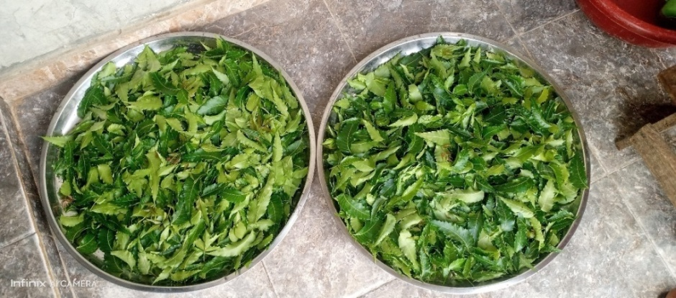
Plate 3.1 Neem leaves
3.1.2 Electronic weighing Scale
This is used to measure the neem powder extracted from the neem leaves. Plate 3.2 shows the pictorial view of the electronic weighing scale.
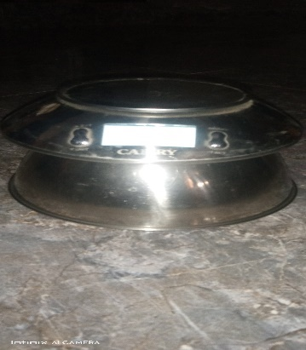
Plate 3.2 Electronic weighing Scale
3.1.3 Plastic container with lid
This was used for storing the grains (treated and un-treated) during the experiment. Plate 3.3 shows the pictorial view of the plastic container with lid.
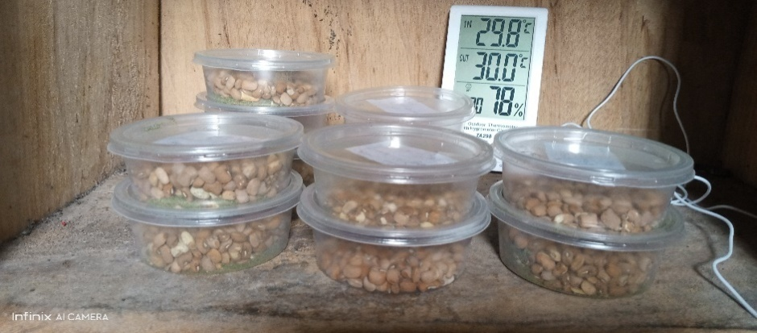
Plate 3.3: plastic container
3.1.4 Thermometer:
This is used to measure the amount of temperature in the room where the neem leaves were kept. Plate 3.5 shows the pictorial view of Thermometer
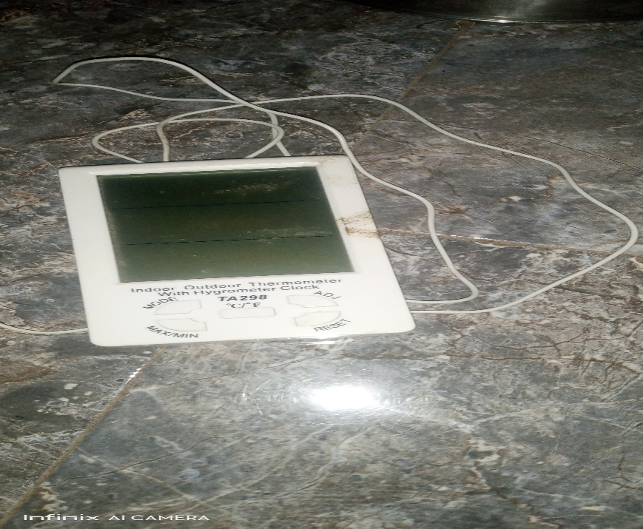
Plate 3.1.4: Thermometer
3.1.5 Digital spoon Scale
This was use to give us the correct amount of neem powder need in the jar as preservative
Plate 3.6 shows the pictorial view of Digital spoon scale
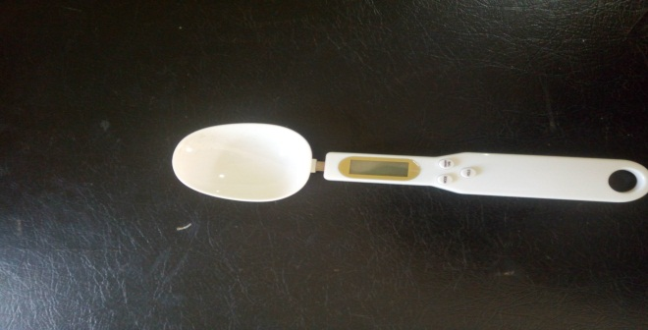
3.1.6 Electric Blender
This was use to blend the dry neem leaves into powder form. Plate 3.7 shows the pictorial view of the electric blender

3.2 Methodology
3.2.1 Sourcing of Experiment Materials
The cowpea was purchased from Mandate market in Ilorin West Local Government area of Kwara State. The neem leave was gotten from the back of Kwar State Polytechnic mini campus. The fresh neem leaves were dried under room temperature for nine days and the dried neem leaves were blended to neem powder.
3.2.2 Sample Preparation
The cowpeas were sorted to remove damage grains and unwanted particles. The wholesome grains were cleaned by manual winnowing. The grains were divided into potion by weighing them with electronic weighing scale into plastic containers. The neem was prepared in a room temperature (28ºC) and the dried neem leaves were blended into neem powder.
3.2.3 Experimental Procedure
The clean cowpea was divided into ten (10) portions of 100g for four samples each, 50g for four samples and two samples were used as control with the following descriptions into the plastic container.
- Two (2) containers of 50g each contains infected and non-infected cowpea with 5g neem powder
- Two (2) containers of 50g each contains infected and non-infected cowpea with 10g neem powder
- Two (2) containers of 100g each contains infected and non-infected cowpea with 5g neem powder
- Two (2) containers of 100g each contains infected and non-infected cowpea with 10g neem powder
- Two (2) jars of 100g each contain infected and non-infected cowpea with no preservation (no neem powder) which was used as control
3.2.4 Experimental Design
Proximate composition was done on the fresh cowpea before the addition of preservative and storage. The cowpea was preserved and stored for a period of twelve weeks. The proximate composition was conducted on the 4th and 6th , 8th, 10th and 12th weeks of storage in order to determine the effect of the preservatives on the stored cowpea
3.3 Proximate composition of Cowpea
This study aimed at determining the proximate composition, mineral constituents and tyrosine inhibitory activity of the cultivar. Cowpea presents (100g): 24.5 protein, 51.4 carbohydrates, 16.6 insoluble fibers and 2.7 soluble fibers, 2.6 ash; major mineral constituents.
3.3.1 Initial and Final Moisture Content Determination on Dry Basis (db)
Fresh beans sample of 100g were placed in pre-weighed electro weighing balances and mixed with neem powder, temperature of 70c for 6h at 26.1HG vacuum in a thelco 29 vacuum oven (precisions scientific, Chicago, IL) dishes were removed and placed immediately in desiccators to allow temperature to equilibrate before weighing.
The weighing used for the scale had an accuracy of 0.01g. All moisture measurement for each trial were replicated twice and moisture contents were calculated on dry basis using the following formula to obtain the initial moisture content of the samples.
MC (%db) = (W₁-W_{F}) x 100
W_{F}
W_{I} =initial weight of the sample 3.1
W_{F} =final weight of the sample
The final moisture of the dried samples was the determined using infrared moisture determination balance AD/4714A,(centurion scientist limited). Following manual recommendation, 5g of each sample was weighed into a cleaned dried dish. The sample was then placed in the infrared mixture determination balance. The temperature regulated to 105Oc. The mixture content was indicated automatically by the reading on the machine.
3.3.2 Determination of Fat Contents
About 5g of each of the sample weighted and wrapped in a filter paper and placed in an extraction thimble. The thimble weighed before the additional of the sample, (W₁), the thimble with sample (W₂) was then inserted in soxhlet apparatus. Extraction under reflux was carried out with petroleum ether (30-60⁰C boiling range) for 5hrs. At the end of the extraction thimble was dried in an oven for about 180s at 100⁰c for the evaporation of the solvent and the thimble was allowed to cool in a desiccators and later weighed (W₃) (AOAC,2005)
%Fat = (weight loss of a sample {extracted fat})– (original weight of sample) x 100 (W₂ – W₃) – (W₂ –W₁) x 100
3.3.3 Determination of Carbohydrate Contents
The carbohydrate contents were determined by the subtraction of the summation of crude protein, crude fiber, and ash, fat contents in percentage from 100 percent.
3.3.4 Determination of Ash Contents
The ash content was determined as described in association of official analytical chemists (AOAC) official standard and methods (2005). A know weigh of the beans was charred in a low flame. Thereafter, the sample was transferred to the furnace regulated at 600_{o}c for about 30min. the sample was then cooled and reweighed the procedure was respected until gray ash was resulted. The ash content was calculated as shown in equation developed by AOAC (2005).
C_{ASH} = W_{ASH} x 100
W_{AS}
Where,
C_{ash} = the ash content in %
_{ASH} = ash weigh, kg
W_{as} = sample weigh, kg
3.3.5 Determination of Crude Fibre Contents
The fibre content was determined by the method described in AOAC, (2005). Two grams of the samples were accurately weighed into fibre flask and 100 ml of 0.255 N H₂SO₄ was added. The mixture was then heated under reflux for one hour with the heating mantle and the hot mixture was filtered through fibre sleeve cloth. The filtrate was thrown of while the residue was returned to the fibre flask to which 100ml of 0.313 NNAOH was added and heated under reflux for another 1hr. The mixture was filtered through a fibre sleeve cloth and 100ml of acetone was added to dissolve ant organic constituent. The residue was washed with some hot water twice on the sleeve cloth before it was finally transferred into a crucible. The crucible containing the residue was cooled in the desiccators and later weighed to obtain weight W₂
The different W₁-W₂ gives the weight of fibre and the percentage fibre was obtained as
% Fibre = W₁-W₂ x 100
Weight of sample
3.3.6 Determination of Crude Protein Content
Protein content of the test sample was determined using micro kjedhel method as described by AOAC (2005). One gram of test sample was weighed into digestion tube, 15ml of concentrated H₂SO₄ and one tablet of selenium catalyst was added. The mixture was digested on an electro-thermal heater until clear solution is obtained. The flask was allowed to cool after which the solution was diluted with distilled water to 50ml, 5ml of this was transferred into the distillation apparatus, 5ml of 2% boric acid was pipette into a 100ml conical flask (the receiving flask) and 4 drop of screened methyl red indicator was added 50% N_{a}OH was continually added to the digested sample until the solution turned cloudy and this indicates the alkalinity of the solution. The distillation was carried out the acid solution in the receiving flask with the delivery tube below the acid level. As the distillation is going on, the pink color solution of the receiving flask turned blue. Distillation was continued was continued until the content of the round bottom flask is about 50ml. The resulting solution in the conical flask was titrated with 0.1 M HCI.
% Nitrogen = Titre value x 0.1 HCI x 0.014 x 100 x ⁵⁰/₅
Original weight of sample
% Protein = %Nitrogen x protein conversion factor.

CHAPTER FOUR
4.0 RESULTS AND DISCUSSION
4.1 Results
The average results of a proximate composition of the cowpea before storage and preservation is presented in table 4.1 while that of freshly prepared neem powder is presented in table 4.2.
Table 4.3-4.6 shows the average results of the proximate composition of the treatment applied to the cowpea after eight (6) weeks of the experiment for the different quantities of neem powder applied.
Table 4.7 shows the average result of the proximate composition of cowpea before storage and preservation, the freshly prepared neem powder and when different treatment were applied to the cowpea are present in the appendix A-L
Table 4.1 Average Proximate Composition of Cowpea before Storage

Proximate Composition (%)
SAMPLE MC ASH FAT FIBREPROTEIN CHO
COWPEA 14.02 3.3 3.2 3.1 5.1 71.3

Table 4.2 Average Proximate Composition of Neem Powder

Proximate Composition (%)
NEEM
POWDER MC ASH FAT FIBRE PROTEIN CHO
14.12 1.06 3.8 3.07 1.02 76.95

Table 4.3 Average Proximate Composition of Cowpea with Neem Treatment under Ambient Storage
Proximate Treatment Applied Preserved
Composition (%) Infested with Insect
MC 14.32 15.16
PROTEIN 5.71 5.10
CARBONHYDRATE 76.14 71.48

Table 4.4 Average Proximate Composition of Cowpea (50g) with Neem Powder (5g) under Ambient Storage
Proximate Composition (%)
SAMPLE MC PROTEIN CHO
COWPEA 14.21 5.90 76.23

Table 4.5 Average Proximate Composition of Cowpea (50g) with Neem Powder (10g) under Ambient Storage

Proximate Composition (%)
SAMPLE MC PROTEIN CHO
COWPEA 15.10 5.40 74.28

Table 4.6 Average Proximate Composition of Cowpea (100g) with Neem Powder (5g) under Ambient Storage
Proximate Composition (%)
SAMPLE MC PROTEIN CHO
COWPEA 15.03 5.62 75.06

Table 4.7 Average Proximate Composition of Cowpea with no Neem Powder
Proximate Composition (%)
Cleaned Cowpea Cowpea with Insect
MC 14.52 15.32
PROTEIN 5.94 5.42
CARBOHYDRATE 76.11 70.03

4.2 Discussions
4.2.1 Effect of Neem powder on cowpea
Tables 4.3-4.6 revealed the effect of different quantities of neem powder added to preserve the cowpea. In all the results presented the moisture content increases as well as the protein. It was also observed that there was no emergence of insects which are responsible for feeding on the carbohydrate. Therefore, the decrease on the carbohydrate was negligible when compared with the fresh cowpea before storage and preservation.
4.2.2 Effect of Carbohydrate on Cowpea
Table 4.3-4.6 show the result of the carbohydrate of the cowpea when neem powder was applied and when insect was introduced.
The carbohydrate ranged between 70.03 to 76.28% when neem powder was applied. The highest value recorded was when 10g neem powder was applied to the cowpea while the lowest carbohydrate was recorded when no treatment was applied to the cowpea with infested insects.
The value recorded for the cowpea which treated with 5g of neem powder is still higher with the value recommended for carbohydrate in cowpea by (Mainaet al., 2000) which ranged between 68-73%.
4.2.3 Effect of Moisture Content on Cowpea
The moisture content recorded in this study ranged between 14.08 to 15.32%. The highest recorded was when no treatment was applied to the cowpea (control). The lowest moisture content was when 5g of neem powder was added to the cowpea. This implies that increase in moisture content will reduce the storage life of cowpea. This will cause insect multiplication in the cowpea under study. The reverse is the case when there is decrease in the moisture content,
4.2.4 Effect of protein on Cowpea
The protein content on the non-infested cowpea ranged between 5.71 to 6.10% and the protein content in the infested cowpea ranged between 5.10 to 5.62%. The protein content with 5g of neem powder was the highest recorded and the least was when 2g of neem powder was applied. The infested cowpea when 2g of neem powder was the lowest and 5g of neem powder was the highest. The protein content when 5g of neem powder favors the infested and non-infested cowpea.
4.2.5. Effect of neem powder on Cowpea
It was also observed that the cowpea infested with insect and preserved with various quantity of neem powder were found dead and there were no multiplication of insect. Also the cleaned and healthy cowpea preserved with various quantity of neem powder remains clean and fresh without any emergency of insect. Thus, the neem powder had persevered the shelf life of the cowpea throughout the experiment thereby prohibiting insect multiplication and no detection of life insect during the period of study.
4.2.1 Effect of Neem powder on cowpea
Tables 4.3-4.6 revealed the effect of different quantities of neem powder added to preserve the cowpea. In all the results presented the moisture content increases as well as the protein. It was also observed that there was no emergence of insects which are responsible for feeding on the carbohydrate. Therefore, the decrease on the carbohydrate was negligible when compared with the fresh cowpea before storage and preservation.
4.2.2 Effect of Carbohydrate on Cowpea
Table 4.3-4.6 show the result of the carbohydrate of the cowpea when neem powder was applied and when insect was introduced.
The carbohydrate ranged between 70.03 to 76.28% when neem powder was applied. The highest value recorded was when 3g neem powder was applied to the cowpea while the lowest carbohydrate was recorded when no treatment was applied to the cowpea with infested insects.
The value recorded for the cowpea which treated with 5g of neem powder is still higher with the value recommended for carbohydrate in cowpea by (Maina et al., 2000) which ranged between 68-73%.
4.2.3 Effect of Moisture Content on Cowpea
The moisture content recorded in this study ranged between 14.08 to 15.32%. the highest recorded was when no treatment was applied to the cowpea (control). The lowest moisture content was when 5g of neem powder was added to the cowpea. This implies that increase in moisture content will reduce the storage life of cowpea. This will cause insect multiplication in the cowpea under study. The reverse is the case when there is decrease in the moisture content,
4.2.4 Effect of protein on Cowpea
The protein content on the non-infested cowpea ranged between 5.71 to 6.10% and the protein content in the infested cowpea ranged between 5.10 to 5.62%. The protein content with 5g of neem powder was the highest recorded and the least was when 2g of neem powder was applied. The infested cowpea when 2g of neem powder was the lowest and 5g of neem powder was the highest. The protein content when 5g of neem powder favors the infested and non-infested cowpea.
4.2.5. Effect of neem powder on Cowpea
It was also observed that the cowpea infested with insect and preserved with various quantity of neem powder were found dead and there were no multiplication of insect. Also the cleaned and healthy cowpea preserved with various quantity of neem powder remains clean and fresh without any emergency of insect. Thus, the neem powder had persevered the shelf life of the cowpea throughout the experiment thereby prohibiting insect multiplication and no detection of life insect during the period of study.

CHAPTER FIVE
5.0 CONCLUSIONS AND RECOMMENDATIONS
5.1 CONCLUSIONS
The effect of organic preservatives for the treatment of insects and pest in agricultural crops was investigated, based on the experiment conducted, the following conclusion was drawn:
- Neem powder in different quantity of 2g, 3g, 4g, and 5g were applied to cowpea under ambient storage of 28ºc using infested and non-infested cowpea.
- Neem powder favors the non-infested cowpea when 5g of neem powder is applied and also showed no emergence of life insect throughout the experiment.
- The infested cowpea showed no further emergence of insect and confirmed death of the entire insect introduced when 5g of neem powder was used.
- Neem powder can be used as an alternative preservative for cowpea.
5.2 RECOMMENDATIONS
The following recommendation were made at the end of the study for further work
- Famers should be encourage and educated on the effectiveness of use of neem powder.
- The awareness of the use of neem powder as an alternative to chemical should be advocated.
- Other agricultural crop can be tested and treated with the neem powder.

REFERENCE
Adebooye, o.c. And v. Singh (2007), “effect of cooking on the profile of phenolics, tannins, phytate, amino acid, fatty acid and mineral nutrients of whole-grain and decorticated vegetable cowpea (vigna unguiculata l. Walp)”, journal of food quality, vol. 30, pp. 1101-1120. Http://onlinelibrary.wiley.com/doi/10.1111/j.1745-4557.2007.00155.x/epdf.
Adeyeba, k.e. And e.f. Fabiyi (2014), “effect of processing methods on some antinutritional factors in legume seeds for poultry feeding”, international journal of poultry science, vol. 9, pp. 996-1001.
Akinyele, i.o. And a. Akinlosotu (1991), “effect of soaking, dehulling and fermentation on the oligosaccharides and nutrient content of cowpeas (vigna unguiculata)”, food chemistry, vol. 41, pp. 43-53, http://www.sciencedirect.com/science/article/pii/030881469190130g/pdf?md5=a0b6ac6a100e4acf26f75f2d5039a097&pid=1-s2.0-030881469190130g-main.pdf.
Allsopp, m., huxdorff, c., johnston, p., santillo, d., thompson, k., 2015.pesticides and our health; a growing concern. Greenpeace research laboratories. University of exeter. Exeter ex4 4rn. United kingdom. Www.greenpeace.org.
Allsopp, m., tirado, r., johnston, p., santillo, d., lemmens, p., 2014. Plan bee – living.
Amoabeng, b.w., gurr, g.m. Gitau, c.w., stevenson, p.c., 2014. Cost: benefit analysis of botanical insecticide use in cabbage: implications for smallholder farmers in developing countries. Crop protection 57, 71-76
Ampofo-nyarko, k., reddy, s. K. V. & saxena, k. N. (1994) reduction in insect pest attack on sorghum and cowpea by intercropping. Ent omol ogia exp. App l. 7 o7 9 -184.
Anyanga, o.m., muyinza, h., hall, d.r., porter, e., farman, d.i. Talwana, h., mwanga, r.o., stevenson, p.c., 2013. Resistance to the weevils cylas puncticollisand cylas brunneus conferred by sweetpotato root surface compounds. Journal of agricultural and food chemistry 61, 8141-8147.
Aremu, c.y. (1990), “proximate and amino-acid-composition of cowpea (vigna unguiculata, walp) protein-concentrate prepared by isoelectric point precipitation”, food chemistry, vol. 37, pp. 61- 68, http://www.sciencedirect.com/science/article/pii/0308814690900456/pdf?md5=079b319a1346fef268dee5b0ccf323a2&pid=1-s2.0-0308814690900456-main.pdf.
M. Asif, l.w. Rooney, r. Ali, m.n. Riaz application and opportunities of pulses in
Food system: a review riaz (2013), pp. 1168-1179,
Balaji (2008) siddha medicine—background and principles and the application for skin diseases. Clin dermatol 26(1): 62-78.
Belane, a.k. And f.d. Dakora (2012), “elevated concentrations of dietarily-important trace elements and macronutrients in edible leaves and grain of 27 cowpea (vigna unguiculata l. Walp.) Genotypes: implications for human nutrition and health”, food and nutrition sciences, vol. 3, pp. 377-386
Biam and okorie, 2012 c.k. Biam, a. Okorie (2012), accelerating grain legumes
Production in nigeria: prospects and challenges j. Agric. Sci. Technol. B., 2 pp. 627-641
Burridge, j. (2016), “legume shovelomics: high-throughput phenotyping of common bean (phaseolus vulgaris l.) And cowpea (vigna unguiculata subsp. Unguiculata) root architecture in the field”, field crops research, vol. 192, pp. 21-32.
C. Karthikeyan, d. Veeraragavathatham, d. Karpagam, s.a. Firdouse. (2009), traditional practices indian j. Tradit. Knowl., 8 pp. 564-568
Carvalho, a.f.u. Et al. (2012), “nutritional ranking of 30 brazilian genotypes of cowpeas including determination of antioxidant capacity and vitamins”, journal of food composition and analysis, vol. 26, pp. 81-88.
Devi, c.b., . Kushwaha and . Kumar (2015), “sprouting characteristics and associated in nutritional composition of cowpea (vigna unguiculata)”Journal of food science and technology, vol. 52, pp. 6821-6827.
Dharmendra, k. Y; , yogesh p. B; kasturi, c; monisankar, g, nirup, b. M and snehasikta, s. 2016. Importance of neem leaf: an insight into its role in combating diseases. Indian journal of experimental biology vol. 54, pp. 708-718
E.m. Kunkel and h.d. Barbara (2004). The gale group inc., macmillan reference usa, new york, gale nutrition and well-being a to z.
Food and agricultural organization, 2008. Post-harvest grain loss assessment methods-a manual of methods for the evaluation of post-harvest losses. Fao, rome.
G.a. Gilman, r.a. Boxall storage of food grains in traditional underground pits trop. Stor. Prod. Inf., 29 (1974), pp. 6-9
Gerrano, a.s. (2015), “genetic variability in cowpea vigna ung uiculata (l.) Walp. Genotypes”, south african journal of soil and plant, vol. 32(3), pp. 165-174.

Girish k. And shankara b.s. (2008)neem – a green treasure. Electronic journal of biology., 4(3), 102-111.
Goncalves, a. (2016), “cowpea (vigna unguiculata l. Walp), a renewed multipurpose crop for a more sustainable agri-food system: nutritional advantages and constraints”, journal of the science of food and agriculture, vol. 96, pp. 2941-2951.
Grzywacz, d., stevenson, p. C., belmain, s. R., wilson, k., 2014. The use of indigenous ecological resources for pest control in africa. Food security 6, 71–86
Heuzé, v. And g. Tran (2015), “cowpea (vigna unguiculata) seeds”, feedipedia: a programme by inra, cirad, afz and fao, http://www.feedipedia.org/node/232,
Hollinger, f. And j.m. Staatz (2015), agricultural growth in west africa. Market and policy drivers, food and agriculture organization of the united nations (fao) and african development bank, rome.
Hussain, m.a. And a.y. Basahy (1998), “nutrient-composition and amino acid pattern of cowpea (vigna unguiculata (l.) Walp, fabaceae) grown in the gizan area of saudi arabia”, international journal of food sciences and nutrition, vol. 49, pp. 117

Hussain, m.a. And a.y. Basahy (1998), “nutrient-composition and amino acid pattern of cowpea (vigna unguiculata (l.) Walp, fabaceae) grown in the gizan area of saudi arabia”, international journal of food sciences and nutrition, vol. 49, pp.
Ileke, k.d. And m.o. Oni, 2011. Toxicity of some plant powders to maize weevil, sitophilus zeamais (motschulsky) [coleopteran: curculiondae] on stored wheat grains (triticum aestivum). Afr. J. Agric. Res., 6: 3043-3048.
Ileke, k.d. And m.o. Oni, 2011. Toxicity of some plant powders to maize weevil, sitophilus zeamais (motschulsky) [coleopteran: curculiondae] on stored wheat grains (triticum aestivum). Afr. J. Agric. Res., 6: 3043-3048.
Imam hashmat, effects of neem on hepatic glycogen in rats. Indian j. Pharmacol., 25, 174-175 2000 indigenous agricultural practices among tribal women indian j. Tradit. Knowl., 5 (2006), pp. 114-117
Khan, a.r. (2007), “dietary fiber profile of food legumes”, sarhad journal of agriculture, vol. 23,pp. 763766, https://www.aup.edu.pk/sj_pdf/dietary%20fiber%20profile%20of%20food%20legumes.pdf.

