GROUNDWATER EXPLORATION AROUND KWARA STATE POLYTECHNIC ILORIN CENTRAL LIBRARY USING VES GEOPHYSICAL METHODS

BY:
JIMOH NOFISAT ODUNAYO

HND/23/SLT/FT/0698

BEING A PROJECT REPORT SUBMITTED TO THE DEPARTMENT OF SCIENCE LABORATORY TECHNOLOGY (PHYSICS/ELECTRONIC UNIT), INSTITUTE OF APPLIED SCIENCES, KWARA STATE POLYTECHNIC ILORIN

IN PARTIAL FULFILMENT OF THE REQUIREMENTS FOR THE AWARD OF HIGHER NATIONAL DIPLOMA (HND) IN SCIENCE LABORATORY TECHNOLOGY (SLT), KWARA STATE POLYTECHNC, ILORIN, KWARA STATE

July 2025
j
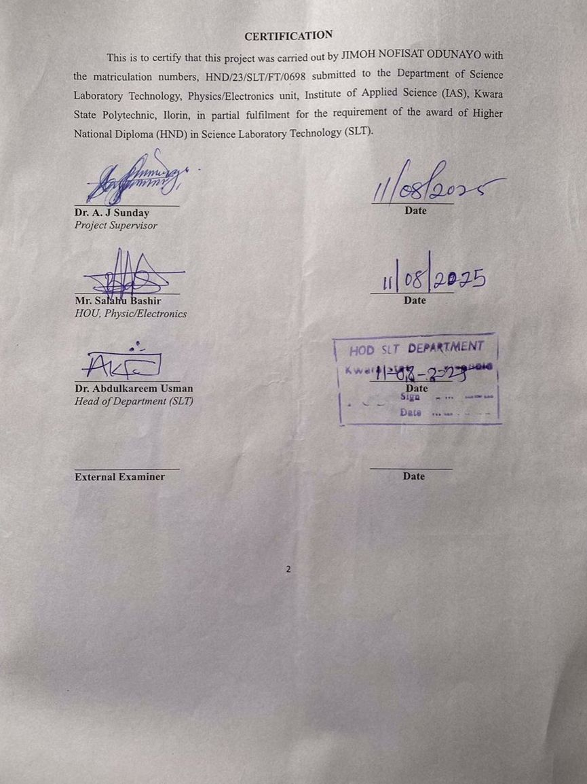

DEDICATION
This work is dedicated to Almighty God who made it possible for me. To everyone who believed in me especially my family and friends, this project is dedicated to you.
I also dedicate this project to my parent for their love,support and encouragement have been my guilding light throughout the journey.
I also dedicate this project to my siblimgs and also to my wonderful family(the ojelola’s family)for their love,support,advice and prayers. Thank you my wonderful family.

ACKNOWLEDGEMENT
First and foremost, I offer my sincerest gratitude to God for His guidance, strength, and unwavering support throughout this journey. This project would not have been possible without His blessings.

To my lovely and caring parents (Mr&mrs jimoh ) my success journey is incomplete without you, thank you for always windless love and support. God bless you abundantly, may you live long to reap the fruit of your labor.

With a heart full of gratitude, I acknowledge those who have been the wind beneath my wings. To my support system(my parents)who provided unwavering belief and encouragement.Thank you for being the guiding stars that illuminated my path.

My profound gratitude goes to my projects supervisor, Dr A J Sunday, who had taken his time to supervise and guide me in every stage of this project. May almighty God perfect everything that concerns you and your family (Amen)

I also appreciate my siblings ( jimoh idris and jimoh haleemah) for their love support and kindness towards me.

Also not to forget my favorite person ( kareem Victor Isreal)you’re real definition of a friend in need is a friend indeed. To my amazing corsemate turn friends (Oreoluwa, arike,oyin, Damilola,and olamide) I’m indebted to you all, I really appreciate you all.

Thank you all

TABLE OF CONTENTS
Title page
Certification
Dedication
Acknowledgment
Table of content
Abstract
CHAPTER ONE: INTRODUCTION
1.1 Introduction
1.2 Statement of Problem
1.3 Aim and Objectives
CHAPTER TWO: LITERATURE REVIEW
2.0 Introduction
2.2 Overview of Groundwater Occurrence
2.3 Geophysical Methods in Groundwater Exploration
2.5 Application of VES in Groundwater Exploration
CHAPTER THREE: METHODOLOGY
3.1 Introduction
3.2 Geophysical Investigation
3.3 Electromagnetic wave propagation theory, Helmholtz equation
3.4 Overview of the Instrument
3.5 Main Features
CHAPTER FOUR: RESULTS, DISCUSSION AND CONCLUSSION
4.1 Results
4.2 Data Presentation and Interpretation
4.3 Profile A – A’
4.4 Profile B – B’
4.5 Profile C – C’
4.6 Profile D – D’
4.7 Profile E – E’
Conclusion
References

ABSTRACT
This study investigates the groundwater potential around the Central Library of Kwara State Polytechnic, Ilorin, using the Vertical Electrical Sounding (VES) geophysical method. The research aims to address water scarcity issues by delineating subsurface hydrogeological features and identifying viable aquifer zones for sustainable groundwater development. Five VES profiles (A to E) were conducted using the ADMT Resistivity Meter, probing to a depth of 100 meters. The resistivity tomograms revealed three distinct lithological units: topsoil (0–20 m, 30–200 Ωm), weathered/fractured basement (21–1684 Ωm), and fresh crystalline basement (87–3623 Ωm). Low resistivity zones (30–130 Ωm) at depths of 25–100 meters were identified as potential aquifer zones, particularly within weathered and fractured basement rocks, suitable for groundwater recharge and storage. Specific stations along each profile were recommended for borehole drilling to a depth of approximately 90–100 meters based on the presence of thick, saturated aquifer layers. The study successfully delineates subsurface layers, identifies aquifer zones, and provides recommendations for borehole siting, demonstrating the efficacy of the VES method in basement complex terrains for groundwater exploration. These findings offer a scientific basis for improving water supply infrastructure at the study site.

CHAPTER ONE
1.1 INTRODUCTION
Groundwater is one of the most important natural resources. Its availability in Basement Complex rocks is commonly due to the development of secondary porosity and permeability resulting from weathering and fracturing. Aquifers are known to occur within the highly weathered overburden and the fractured zones of the basement rock. The discontinuous nature of the basement aquifer system makes detailed knowledge of the geology, hydrogeological and geophysical investigations inevitable. Electrical resistivity method is one of the most relevant geophysical methods applied in groundwater investigation in the basement terrains. The vertical electrical sounding (VES) technique using Schlumberger configuration has proved useful especially for the delineation of weathered and fractured zones in the basement rocks.
Olayinka et al., (2020) reported that the vertical electrical sounding (VES) curves from the crystalline basement rocks of south western Nigeria show a basic 3-layer geoelectrical succession, namely: a thin (0 to 2m) highly resistive topsoil (100 to 400 ohm-m), a highly conductive weathered basement (with resistivity between 10 to 200 ohm-m) and a highly resistive fresh crystalline basement whose resistivity exceeds 1000 ohm-m. The resistivity of fractured basement rocks is often less than 1500 ohm-m (David, 2021; Hazell et al., 2023) but can be as high as 3000 ohm-m (white et al., 2020). Any basement rock resistivity exceeding 3000 ohm-m can be thought of as representing fresh basement rock containing little or no water (Olayinka, 2019). Some hydrogeological and hydrogeophysical investigations including Adelusi and Folami (2020) reported that groundwater in such terrains occur in the weathered and fractured zones/columns. They stated that the groundwater yield from the weathered horizon is often supplemented by the accumulated groundwater in the fractured zones of the basement rocks. They also reported that the highest groundwater yield in such terrains is found in areas where thick overburden overlies fractured zones.
Groundwater is an essential natural resource that serves as a reliable source of potable water for domestic, agricultural, and industrial uses across the globe. In many developing regions, including Nigeria, groundwater often provides the most viable and accessible source of clean water due to the limitations of surface water resources, which are often seasonal and prone to pollution (Todd and Mays, 2022).
Vertical Electrical Sounding (VES), a widely used geophysical method under electrical resistivity surveying, has proven to be highly effective in groundwater exploration. It is non-invasive, relatively cost-effective, and can offer substantial insights into subsurface lithology and aquifer characteristics. The VES method operates on the principle of measuring variations in the earth’s electrical resistivity to delineate subsurface features, including water-bearing formations (Telford, Geldart, and Sheriff, 2018).
Groundwater occurrence in Precambrian basement terrain is hosted within zones of weathering and fracturing which often are not continuous in vertical and lateral extent (Jeff, 2008). Most groundwater projects recorded in basement complex aquifers have revealed geophysical survey as a compulsory perquisite to any successful water well drilling project (Dan Hassan and Olorunfemi 2019). The electrical resistivity method involving the vertical electrical sounding, (VES) technique is extensively gaining application in environmental, groundwater and engineering geophysical investigations (Bienibuor et al., 2016, Kumar et al., 2016, Nicholas et al., 2016). In the Institute of Technology campus, Ilorin, groundwater abstraction is mainly from shallow hand dug wells which are perched in nature and dry out during the dry season. Aside drying out during the dry season, the water supply from these shallow wells have not been able to meet the growing population of the institute community. Several deep wells (boreholes) drilled and development within the institute have failed because of poor siting of the boreholes emanating from poor understanding of the geology and groundwater occurrence in the area.
In many developed and developing countries there is not only a heavy reliance on ground water as a primary drinking supply but also as a supply of water for both agriculture and industrial use. The reliance on groundwater is such that it is necessary to ensure that there are significant quantities of water and that the water is of a high quality. The use of geophysics for both groundwater resource mapping and for water quality evaluations has increased dramatically over the last 10 years in large part due to the rapid advances in microprocessors and associated numerical modelling solutions. However despite its sometimes spectacular success, for the majority of groundwater studies, the use of geophysics is still often not considered. Why is this? In part it is poor publicity of the potential use of geophysics and poor dissemination of some of the more complex technical issues. It is also due in part to practical implementation difficulties and cost limitations. Unfortunately it is sometimes because geologists and engineers may have experienced an in-appropriate use of geophysics in the past or more unfortunately had some geophysics over-sold to them under false pretences of its possibilities thus leading to not just the poor use of the geophysics but to the delivery of misleading or wrong results.
The main use of geophysics in the geosciences is for hydrocarbon exploration typically at depths greater than 1000m. Significant technological advances have been made in this industry over the last thirty years especially with seismic reflection techniques. In contrast, near-surface geophysics for groundwater investigations is usually restricted to depths less than 250m below the surface and developments have not concentrated on one specific geophysical technique. Groundwater applications of near-surface geophysics include mapping the depth and thickness of aquifers, mapping aquitards or confining units, locating preferential fluid migration paths such as fractures and fault zones and mapping contamination to the groundwater such as that from saltwater intrusion.
Many geophysical techniques have been applied to groundwater investigations with some showing more success than others. In the past, geophysics has either been used as a tool for groundwater resource mapping or as tool for groundwater character discrimination. For groundwater resource mapping it is not the groundwater its self that is the target of the geophysics rather it is the geological situation in which the water exists. Potential field methods, gravity and magnetics, have been used to map regional aquifers and large scale basin features. Seismic methods have been used to delineate bedrock aquifers and fractured rock systems. Electrical and electromagnetic methods have proved particularly applicable to groundwater studies as many of the geological formation properties that are critical to hydrogeology such as the porosity and permeability of rocks can be correlated with electrical conductivity signatures. General methods of practice have been produced for geophysical techniques in groundwater exploration (Van Dongen and Woodhouse, 2017) but as MacDonald et al. (2020) point out, situations with complex geology and hydrogeology do not lend themselves to the generic approach and require specific targeting of methods for particular problems. Most geophysical techniques have been used for groundwater characterisation but once again it is with the electrical and electromagnetic methods that the greatest success has been shown in directly mapping and monitoring contaminated and clean groundwater.
According to Otutu and Oviri (2010) groundwater is the water found in the saturated layers of soils and rocks. This water is usually below the water table and is held in the sub-surface within the saturated zone under hydrostatic pressure. Such groundwater systems can be found in the sedimentary terrain or in the basement complex environment (Fadele et al, 2013).
1.2 STATEMENT OF PROBLEM
Despite the significance of groundwater resources, there is limited empirical exploration around the Central Library of Kwara State Polytechnic, Ilorin. The current water supply systems are often inadequate, leading to water scarcity in key facilities. This situation affects sanitation, learning, and working conditions. There is therefore a pressing need to assess the subsurface hydrogeological characteristics to determine the feasibility and potential for sustainable groundwater development..
1.3 AIM AND OBJECTIVES
The aim of this study is to explore the groundwater potential around the Kwara State Polytechnic Central Library using Vertical Electrical Sounding (VES) method.
The specific objectives include:
- To conduct vertical electrical soundings at selected points within the study area.
- To interpret the geoelectrical data for delineation of subsurface layers.
- To identify potential aquifer zones suitable for groundwater development.
- To make recommendations for potential borehole drilling locations based on geophysical analysis.

CHAPTER TWO
LITERATURE REVIEW
2.0 Introduction
Groundwater plays a crucial role in providing fresh water for domestic, agricultural, and industrial uses, particularly in arid and semi-arid regions. Due to increasing demand and the challenges associated with groundwater depletion, efficient and accurate exploration methods are vital. Geophysical methods, especially electrical resistivity techniques like Vertical Electrical Sounding (VES), have proven to be effective in groundwater investigations due to their ability to delineate subsurface layers and identify aquifer-bearing formations. This chapter reviews the theory, applications, and past studies on groundwater exploration using VES.
2.2 Overview of Groundwater Occurrence
Groundwater exists in the pore spaces and fractures of subsurface rocks. The occurrence and movement of groundwater are largely influenced by the porosity, permeability, and structure of the geologic formation (Fetter, 2010). Aquifers are broadly categorized into unconfined, confined, and semi-confined types, depending on the nature of the overlying and underlying geological formations.
The occurrence and movement of groundwater are related to physical forces acting in the subsurface and the geologic environment in which they occur. This chapter presents a general overview of basic concepts which explain and quantify these forces and environments as related to groundwater. For Corpsspecific applications, a section on estimating capture zones of pumping wells is included.
Hydrologic Cycle
a. The Earth's hydrologic cycle consists of many varied and interacting processes involving all three phases of water. A schematic diagram of the flow of water from the atmosphere, to the surface and subsurface, and eventually back to the atmosphere is shown in Figure 1.

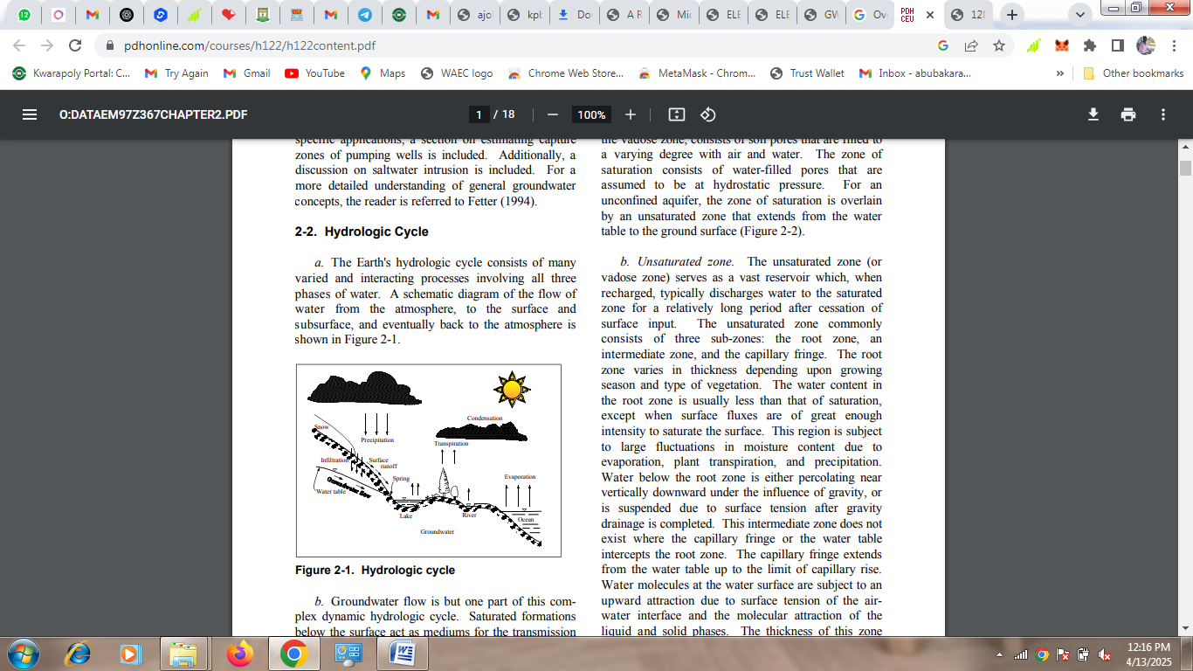
Figure 1. Hydrologic cycle (Todd 2015).
b. Groundwater flow is but one part of this complex dynamic hydrologic cycle. Saturated formations below the surface act as mediums for the transmission of groundwater, and as reservoirs for the storage of water. Water infiltrates to these formations from the surface and is transmitted slowly for varying distances until it returns to the surface by action of natural flow, vegetation, or man (Todd 2015). Groundwater is the largest source of available water within the United States, accounting for 97 percent of the available fresh water in the United States, and 23 percent of freshwater usage (Solley and Pierce 2013).
2.3 Geophysical Methods in Groundwater Exploration
Several geophysical techniques are employed in groundwater exploration, including seismic, magnetic, gravity, electromagnetic, and electrical methods. Among these, electrical resistivity methods are widely used due to their effectiveness in mapping subsurface variations and their cost-effectiveness (Telford et al., 2019). These methods are based on the principle that different geological materials exhibit varying degrees of electrical resistivity.

Designing a Successful Survey
Achieving a successful geophysical survey is reliant on three features: implementing the geophysical survey early in the project planning stages, designing the correct geophysical survey and choosing the appropriate geophysical contractor.
Planning the Survey
Ideally the use of geophysics should be discussed early in the planning stages of a survey in order to gain most benefit from the geophysics. Unfortunately this is not always the case and geophysics is only used when all other investigation techniques have failed. This has led to unjustified bad publicity for geophysics; if all else has failed then it is unlikely that the geophysics will be successful usually because the original survey objectives have not been clearly defined at the start of the project. Using geophysics to solve a problem in this manner is often expecting too much from the geophysics and will result in failure. Geophysics is only one tool that can be applied to a groundwater investigation and its success must rely on the careful interpretation and integration of the results with the other geologic and hydrogeologic data for the site. Only then will the geophysics be a success.
Geophysics is typically used in one of two ways. Either it is used to project an interpretation of the geology and hydrogeology from boreholes and surface exposure into a formation or the geophysics is used in an area of unknown geology and hydrogeology in order to better focus the direct sampling programme. For both of these types of use, if the geophysics is discussed early in the proceedings then the most appropriate techniques can be found and used in the most cost effective manner. A parallel for groundwater development can be found in the hydrocarbon world where the successful use of an integrated geophysical programme is seen at all stages of developing a hydrocarbon reservoir. First a geophysical regional recognisance study is conducted with potential field methods (gravity and magnetics). This is followed by regional seismic programmes and exploration wells. Based on these results, more detailed local 3D geophysical surveys are made and the surface geophysics is tied to the subsurface geology by borehole geophysics. Ultimately high frequency borehole geophysics is conducted for reservoir modelling purposes. This integrated use of geophysics is recommended in developing a groundwater resource however, due to cost limitations it is not always possible. It is therefore vital that the geophysics is used in the most appropriate manner at the most appropriate time in a project if it is to be successful in helping to develop a groundwater resource.
Designing the Geophysical Survey
Paramount to designing a successful geophysical survey is the definition of a clear set of objectives and the choice of appropriate methods. The objectives must be based on reasonable, geophysically achievable criteria. For this it is important that the geophysical target has physical properties that can be distinguished from background signatures (geological and hydrogeological features) and background noise (ambient cultural noise together with system induced noise). The next stage in defining a project is to be able to provide an adequate site description along with any previous data that has been collected, site maps or other data that would pertain to the project. This includes logistical features such as access to the site, noise sources and working restrictions. The client must specify early in the project what the ultimate results will be used for and what format they should be provided in. This will ensure that the geophysical results are fully integrated into the project as a whole. If the results are not presented in a manner that the client can fully understand and utilise then they are as good as useless results!
Choosing the appropriate geophysical methods and applying the methods in an appropriate manner is also critical to a successful survey. Only once the objectives have been clearly defined and agreed on by both the client and the contractor can the appropriate geophysical methods be chosen. The incorrect choice of technique and insufficiently experienced personnel conducting the investigation have been cited as primary reasons for the failure of many geophysical surveys (Darracott and McCann, 2017; MacDonald et al., 2019). In choosing the methods, the contractor should first conduct forward models based on the objectives and known site conditions to determine the likely success of each method.
Choosing a Contractor
A successful survey requires the choice of an appropriate contractor. This will be one who has the general knowledge to be able to suggest the most appropriate geophysical survey tools to meet the objectives. A good contractor should also possess the knowledge and professional integrity to admit the inadequacies of the geophysics if it is not likely to meet the survey objectives. The contractor should have sufficient specialist knowledge to be able to carry out the geophysics or to suggest an expert who has the necessary specialised knowledge. It may be that more than one contractor is needed with experts for field acquisition, for data processing and for data integration. It may often be beneficial to use more than one contractor on large investigations and have them conduct trial surveys to test various methods before a commitment is made to a full survey programme. This allows more precise models of the geology and geophysics to be constructed in order to maximise the results of the geophysics.
It is important throughout the process of choosing a contractor to be aware of who shall have responsibility for the different parts of work. Some guidelines to geophysical survey work have been provided in recent documents and recommendations by working parties for ASTM, for Brithish Standards Institute (BS 5930, 1981; referred to by Hawkins, 1986) and the Geological Society Engineering Group Working Party Report on Engineering Geophysics (1988), however, there is no worldwide organisation yet established for either setting out work practice documents of for regulating the geophysical industry. Furthermore, it is unlikely that there will be such arrangements for taking these responsibilities in the near future. In different countries, commissioning bodies and other organisations such as the Geological Society of London and the American Association of Petroleum Geology now offer some regulation of practising geophysicist by means of charter status but many still practice to high standards outside of the organisations. Careful scrutiny of the qualifications of individuals who will be working on the project is thus recommended.
Survey techniques
The range of geophysical techniques used in groundwater investigations is only briefly described here in order to provide an introduction to the methods and some useful literature references. The techniques, together with the physical parameters that they measure, are summarised in Table 1.
All geophysical techniques measure variations in a material's physical properties. For soils and rocks the properties can be divided into a framework or matrix component and the pore content component. Different materials exhibit different parameter signatures such as their resistivity or its inverse, conductivity, acoustic velocity, magnetic permeability and density. These parameters are influenced by the mineral type, grain packing arrangement, porosity, permeability, and pore content (i.e. gas or fluid type). In general, no one property is unique to any material, rather a material is described by ranges of each property. In most geophysical surveys therefore it is important that the changes or contrasts in geophysical parameters are measured and that the target shows large property differences with surrounding material.
Magnetic (or geo-magnetic) Techniques
Magnetic techniques measure the remnant magnetic field associated with a material or the change in the Earth's magnetic field associated with a geologic structure or man-made object. They have been used for regional surveys since the early 1900’s in the hydrocarbon industry and for longer in mineral prospecting however little use has been made directly for groundwater studies. This is mainly because groundwater does not have a magnetic signature. The main use for regional groundwater investigations has been as part of combined surveys with gravity for defining large-scale basin structures. A basic description of their use can be found in Hinz (2018). Babu et al. (2021) describe the use for mapping bedrock topography, and in particular possible groundwater reservoirs in hard-rock (igneous and metamorphic) terrains. Other use of the magnetic technique together with resistivity surveys in volcanic terrain has been described by Aubert et al. (2020). Magnetic surveys are also often used to locate the cause of contaminated groundwater by surveying for buried metallic objects such as hydrocarbon storage tanks, and chemical containers (ref) however these uses are not discussed further.
Gravity
Common uses of gravity or micro-gravity surveys have been to record the changes in density of materials. While gravity methods have not been widely used for groundwater applications, there are some notable examples of its use for mapping the location of low density rocks (typically sedimentary sequences) within more dense basement rocks. Yuhr et al. (2021) used a combination of electromagnetics and microgravity to design a strategic approach to mapping karstic features. Other common applications are the detection of voids within the subsurface where the small changes in the Earth's gravitational attraction caused by such contrasts in density can be recorded with modern instrumentation. Interpretation of gravity data however is difficult as the causes of the changes in gravitational field can be many and varied. In addition, the collection of gravity data is typically a slow process and thus expensive. The results of gravity surveys are presented as gravity maps and 3D models in a similar manner to those of magnetic data.
Electrical
Electrical and electromagnetic techniques have been extensively used in groundwater geophysical investigations because of the correlation that often exist between electrical properties, geologic formations and their fluid content (Fitterman and Stewart, 2016; McNeill, 2018). Most electrical techniques induce an electrical current in the ground by directly coupling with the ground. The resulting electrical potential is then used to measure the variation in ground conductivity, or its inverse, resistivity. Different materials, and the fluids within them, will show different abilities to conduct an electric current. In general, sequences with high clay content show higher conductivity as do saturated sequences and especially sequences where saline (or sometimes other contamination) fluids are present. Common field practice for electrical surveying relies on directly placing an electrical current into the ground (direct current electrical resistivity surveying) and measuring the response (the electrical potential drop) to that current over a set distance.
The typical results of electrical surveys are electrical profiles or geo-electric images and geo-electric depth soundings. The profile or transect method for mapping lateral resistivity changes is now largely replaced by electromagnetic techniques as the electrical technique is slow (when probes have to be placed directly into the ground) and thus is not cost effective relative to the electromagnetic techniques (MacDonald et al., 2021, McNeil XXX).
Electrical methods are still widely used however for conducting soundings and electrical cross-sections. Electrical techniques can be divided into a number of types based on the configuration of the electrodes that are used to input the electrical currents into the ground and the nature of the electrical signature. Only the basis of direct-current electrical resistivity techniques will be discussed here without a review of the different electrode configurations.
Direct Current Resistivity
The direct-current (DC) electrical resistivity method for conducting a vertical electrical sounding (VES) has proved very popular with groundwater studies due to the simplicity of the technique and the ruggedness of the instrumentation. An excellent example of the use of the technique was shown by Reynolds (2017) in a survey for a rural water supply in northern Nigeria. Before the vertical electrical sounding were used a failure rate of over 82% was recorded for boreholes. With the geophysics and a combination of geological and photogeological inspection this was dramatically reduced to less than 20% failure. Van Overmeeren (2019) showed the use of electrical measurements in mapping boundary conditions in an aquifer system in Yemen. Beeson and Jones (20216), Olayinka and Barker (2018), Hazell et al. (2016 and 2019), and Smith (2021) all have demonstrated the use of electrical techniques for siting wells and boreholes in crystalline basement aquifers throughout sub-Saharan Africa. Other similar examples are given by Wurmstich et al. (2016) demonstrated a useful development of electrical techniques by considering the conductance of the DC section as a guide to overall aquifer potential for mapping groundwater resources in the Kalahari Basin. This type of approach may find applicability in many mafic-basin groundwater studies. Sauck and Zabik (2017) have demonstrated a development of the sounding technique by conducting azimuthal surveys. This method was successfully used to assess the directional variation in hydraulic conductivity of glacial sediments in Switzerland. A similar approach has been tested by Marin et al. (2020).
Very Low Frequency
Very low frequency (VLF) survey methods rely on eleven major stations that transmit continuous VLF electromagnetic waves distributed throughout the world. The interaction of the electromagnetic plane waves emitted from these transmitters can be measured as the waves impinge on different material conductors in the earth. Vertical sheet conductors are particularly sensitive the waves. Examples of vertical sheet conductors include faults, dykes and fracture or joint zones. These features are often associated with enhanced fluid (groundwater) flow. Survey profile lines conducted perpendicular to the conductors show a strong response to the conductor. The method is generally inexpenssive with final data output from the instrument providing a direct indication of linear conductor anomalies. The method is often conducted as a recognisance survey as large areas of ground can be rapidly covered. A full review of VLF methods has been given by McNeill and Labson (2017) and a good recent example of locating bedrock wells in water bearing fracture zones for contaminant migration prevention has been given by Covel et al. (2019). The VLF method is typically used in conjunction with other follow-up techniques such as DC resistivity. An example of this was given by Benson et al. (2019). Michaud and Covel (2018) have demonstrated the technique together with that of downhole logging during a hydrogeologic study of an island in Narragansett Bay, Rhode Island.
Electromagnetic
Electromagnetic techniques have been extensively developed and adapted over the last 15 years to map lateral and vertical changes in conductivity with some spectacular examples of their use being shown for groundwater studies. While the final output is similar to that from electrical techniques, several advantages with the electromagnetic techniques result in an increased resolution and more cost-effective application.
Kaufman and Keller (19) have given an extensive background to electromagnetic geophysics and a number of important contributions were also published in Electromagnetic Methods in Applied Geophysics - Applications part A and B, a special publication by the Society of Exploration Geophysicists, Tulsa (Nabighian, 2020).
Two types of electromagnetic survey are currently practised, i) time domain electromagnetic (TDEM) surveys which are mainly used for depth soundings and recently in some metal-detector type instruments, and ii) frequency domain electromagnetic (FDEM) surveys that are used predominantly for mapping lateral changes in conductivity. In both electromagnetic survey techniques no direct contact is made by electrodes with the ground and thus the rate of surveying can be far greater than for electrical techniques where electrode probes must be placed in the ground for every measurement. Both techniques measure the conductivity of the ground by inducing an electric field through the use of time varying electrical currents in transmitter coils located above the surface of the ground. These time-varying currents create magnetic fields that propagate in the earth and cause secondary electrical currents which can be measured either while the primary field is transmitting (during frequency domain surveys) or after the primary field has been switched off (for time domain surveys). Instrumentation exists to survey to a range of depths (see appendix A) in either transect mode or as discrete soundings.
2.4 Principle of Vertical Electrical Sounding (VES)
VES is a geoelectrical method that measures the apparent resistivity of subsurface materials by introducing current into the ground through electrodes and measuring the resulting potential differences (Loke, 2020). The technique is particularly effective for investigating layered structures, as it provides information about resistivity changes with depth. In a typical VES survey, the Schlumberger configuration is commonly used, which involves expanding the current electrodes while keeping the potential electrodes relatively fixed.
Vertical Electrical Sounding (VES) is based on the principle that different subsurface materials have different electrical resistivity values. In VES, an electrical current is introduced into the ground through two electrodes, and the resulting potential difference is measured using another pair of electrodes. By systematically increasing the distance between the current electrodes, the method probes deeper layers of the subsurface.
Resistivity values can indicate the presence of groundwater: low resistivity zones often suggest water-saturated sands or gravels, while high resistivity zones might correspond to dry formations or hard rocks (Parasnis, 2019).
2.5 Application of VES in Groundwater Exploration
The importance of clean, portable water to human existence cannot be overemphasized. The safest source of water supply is groundwater with a natural protection against pollution (Ogundana and Talabi, 2014). Groundwater is the largest available reservoir of fresh water (Adepelumi, et al., 2013). Groundwater originates largely from precipitation such as rain, snow, sheet and hail that soak into the ground and become the groundwater responsible for spring, wells and boreholes yields (Oseji, et al., 2005).
Consequently, groundwater exploration within such geologic settings requires integration of geophysical data with geologic information to effectively characterize the hydrogeologic zones and to enhance successful identification of well locations (Omosuyi, et al., 2008). Several authors have contributed to the understanding of the groundwater investigation, exploration and structural delineation in the crystalline basement rocks in Nigeria, using electrical resistivity method of geophysical survey (Olorunfemi and Olorunniwo 2000)
a. Identification of Aquifer Layers
VES helps in detecting the number and thickness of subsurface layers, including aquifers. Aquifers usually show distinct resistivity signatures, allowing differentiation between water-bearing and dry zones.
b. Determining Depth to Water Table
Changes in resistivity at specific depths can indicate the presence of groundwater. A sharp decrease in resistivity might signal the water table, especially in sandy or fractured rock formations.
c. Delineation of Aquifer Boundaries
VES can be used to map lateral and vertical extents of aquifers. This is useful in distinguishing between confined and unconfined aquifers or in identifying recharge and discharge zones.
d. Groundwater Quality Assessment
Freshwater typically shows higher resistivity than saline water. VES helps in identifying zones of saline intrusion, especially in coastal or over-exploited regions.
e. Borehole Siting
VES data can guide the optimal location and depth for drilling boreholes, minimizing the risk of dry wells and improving drilling success rates.
f. Hydrogeological Mapping
VES surveys are often conducted across a region to produce resistivity maps that correlate with hydrogeological units. These maps are crucial in regional groundwater development and management (Olorunfemi and Fasuyi, 2018).

CHAPTER THREE
METHODOLOGY
3.1 INTRODUCTION
The objectives of the geophysical survey carried out is to determine the lithologic units, area extent and depth of aquifer using 2-D electrical resistivity imagery. The study area is Kwara poly campus within Ilorin, Kwara State. The area is accessible through cars and motorcycle. To convert the resistivity picture into a geological interpretation, one requires some knowledge of the typical resistivity values for the different types of subsurface materials and geology of the studied area. 2-D Electrical Resistivity Imaging, a non-invasive geophysical methods assimilate hundreds of individual resistivity measurement collected over the line of sections into a two-dimensional image of the subsurface.
3.2 GEOPHYSICAL INVESTIGATION
The Geophysical Survey carried out within the study area (Kwara State Polytechnic Ilorin) is 2D Electrical imaging method with the aim of identifying the groundwater potential of the study area.
The instrument use to carry out the Survey is ADMT RESISTIVITY METER. The ADMT series instruments use natural electromagnetic field of the earth as the working field source to study the electrical structure inside the earth.
According to the principle that different frequencies of electromagnetic waves have different skin depths in the conductive coal, the surface is measured from high frequency to the low-frequency Earth electromagnetic response sequence studies the difference in electrical variation of geological bodies at different depths in the subsurface and determines the occurrence of underground geological bodies.
3.3 Electromagnetic wave propagation theory, Helmholtz equation
Ground electromagnetic waves are sent to the ground, and the propagation of electromagnetic waves in the earth and soil follows the Maxwell equation. If it is assumed that most of the subterranean geotechnical soil is non-magnetic and is uniformly conductive macroscopically, there is no charge accumulation, then the Maxwell equation can be simplified to:
3.4 Overview of the Instrument
The ADMT Android screen series product is a smart instrument that integrates data acquisition, real-time imaging, and data synchronization with multiple terminals. Equipped with 10-inch (7-inch for single channel), measurement board, and 1/16/32 channel MN electrodes input access. After data collection is completed, the instrument can check the data and form graph immediately. Single channel series adopt 1 channel input measurement, equipped with 20m MN standard measuring line; 16 channel series adopt 16 channels input measurement at the same time, equipped with 16 channels MN input large line; 32 channel series adopt 32 channels input measurement at the same time, equipped with two 16 channels MN input big line. Both support MN electrode and TT probe measurement mode can be switched, data superposition filter can be set, can be equipped with wire electromagnetic probe through MN input or wireless Bluetooth connection to the gold hoop for data collection.
The 16 or 32 channel series respectively support 1-16, 1-32 channels, and multi-channel simultaneous input measurement, which solves the defect of the MT method field source changing at any time, can obtain a relatively stable field source, and repeat measurement consistency is very good. Through multi-channelsimultaneous input measurement, big data of high-density measurement can be obtained, which breaks through the depth limitation of traditional high-density electrical method, and enables the maximum exploration depth to reach 5000 meters.
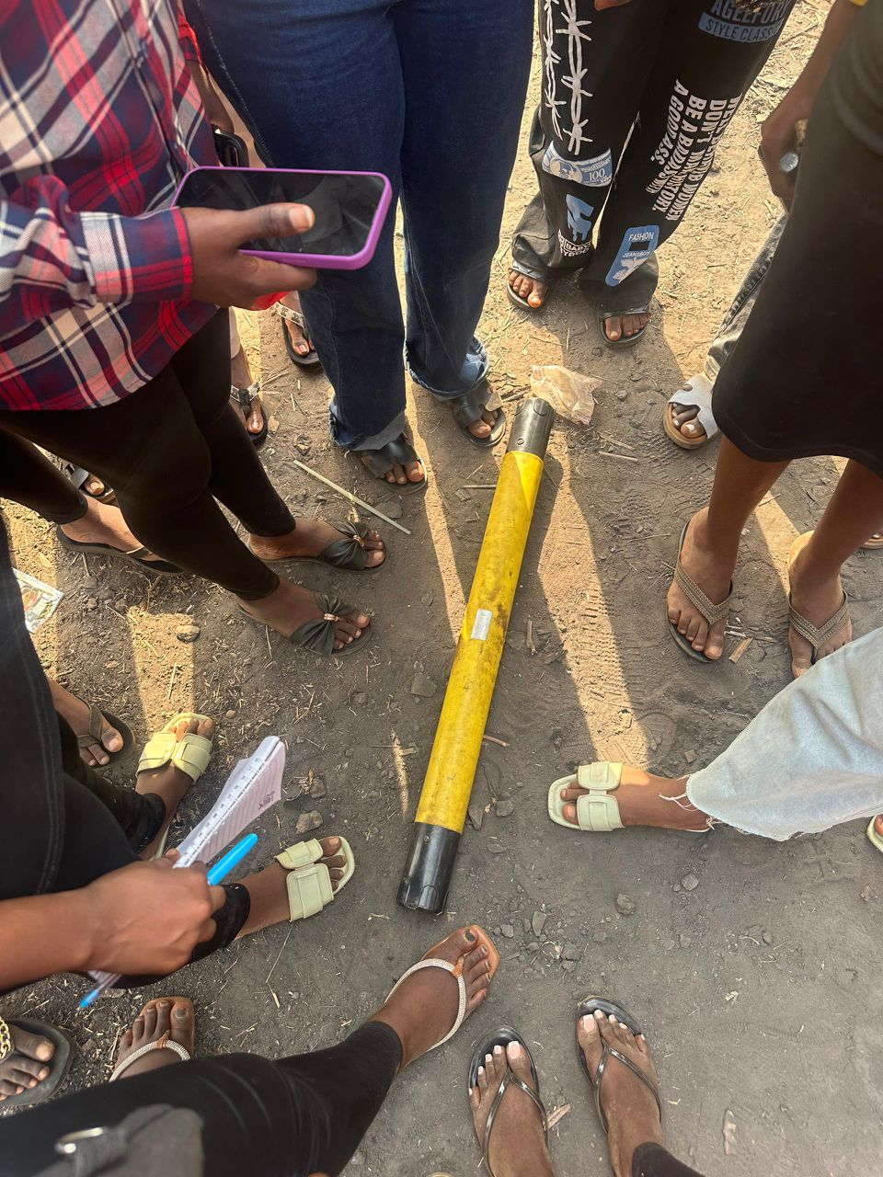
Fig: An HDMT-300 Equipment

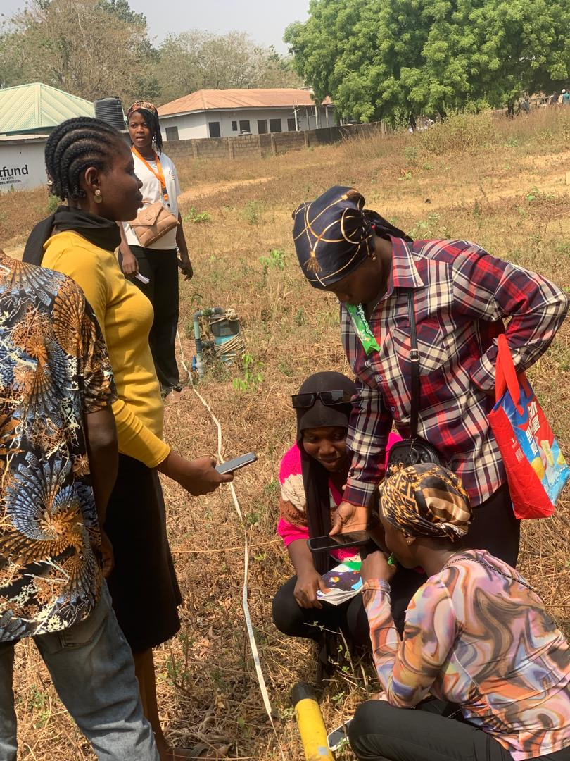
Fig: An HDMT-300 Equipment
3.5 Main Features
Accurate and efficient: Using 1-16, 1-32 channels to input measurement at the same time, to solve the defects of MT electrical field source changes, the accuracy rate is greatly improved, and the accuracy rate is 30-60% higher than that of the general single channel.
Smart and convenient: Standard 7/10 inch touch screen for real-time drawing, and intercommunication with mobile phone or tablet computer, PC computer for data processing and drawing.
Depth adjustable:Optional depth within the maximum depth range of different models.
Channel optional:1,1~16,1~32 Any channel selection.
Flexible input: It can input 1, 1-16, 1-32 channels of MN electrodes, and the MN spacing is flexibly variable from 1-5 meters. Electromagnetic sensor input can also be used to solve the measurement of special formations.
Advanced and stability:Multiple innovative designs obtained multiple invention patents.
Working Principle of the Instrument
The AIDU series instruments use natural electromagnetic field of the earth as the working field source to study the electrical structure inside the earth. According to the principle that different frequencies of electromagnetic waves have different skin depths in the conductive coal, the surface is measured from high frequency to The low-frequency Earth electromagnetic response sequence studies the difference in electrical variation of geological bodies at different depths in the subsurface and determines the occurrence of underground geological bodies.
Electromagnetic wave propagation theory, Helmholtz equation
Ground electromagnetic waves are sent to the ground, and the propagation of electromagnetic waves in the earth and soil follows the Maxwell equation. If it is assumed that most of the subterranean geotechnical soil is non-magnetic and is uniformly conductive macroscopically, there is no charge accumulation, then the Maxwell equation can be simplified to:
∇²H + k²H = 0 (1a)
∇²E + k²E = 0 (1b)
where k is called the wave number (or propagation coefficient)
k = [ω²με − iωσμ]^{1/2} (2)
Considering that the propagation coefficient k is a complex number, let k = b + ia, where: a is called the phase coefficient and b is called the absorption coefficient. In the electromagnetic frequency range measured by the ADMT series of natural electric field geophysical instruments (0.1 Hz to 5 kHz), the displacement current can usually be ignored, and K is further simplified as:
k = −iωμσ (3)
Wave group resistance and resistivity
A magnetic field with a change in the Helmholtz equation induces a changing electric field, and we have a magnetoelectric relationship:
E/H= −iωρ/k (4)
The surface impedance Z is defined as the ratio of the surface electric field and the horizontal component of the magnetic field. In the case of uniform earth, thisimpedance is independent of the polarization of the incident field and is related to the earth resistivity and the frequency of the electromagnetic field:
Z = E/H = √ωμρe^{iπ/4} (5)
The formula can be used to determine the resistivity of the earth:
ρ = 1/5f|E H|² (6)
Skin depth
In non-magnetic media, the skin depth formula is:
δ ≈ 503√ρ/f (7)
It can be seen from the above equation that the penetration depth of electromagnetic waves is related to frequency and resistivity. The frequency is certain, the higher the resistivity, the greater the penetration depth, the higher the resistivity, and the lower the frequency, the greater the penetration depth.

CHAPTER FOUR
RESULTS, DISCUSSION AND CONCLUSSION
4.1 Results
Five (5) profiles were probed to the depth of 100 meters each around the study area using ADMT. The purple colour represent very low resistivity (aquifer), blue colour represent low resistivity value indicating aquifer also, green colour represent intermediate resistivity value (likely fractured basement) and red colour represent high resistivity value indicating fresh basement (migmatites). In addition, the Scale on the Y axis represents the depth in meters at subsurface and x axis represent each VES point along the profile line.
4.2 Data Presentation and Interpretation
Resistivity modeling and inversion performed by Aidu 2D software in this work gave resistivity models. The resistivity models are presented as colour contour sections to reveal variation in subsurface resistivities. Geological materials have characteristic resistivity values that enable identification of boundaries between distinct lithologies on resistivity cross-sections. Consequently, the 2D electrical images along the profiles and their interpretations are discussed in this section.
The resistivity tomograms show the images of the resistivity pseudosections obtained from the processed data. Meanwhile, the profiles A to E inverted resistivity models are shown and discussed in this section (figures 4.1 - 4.5).
As shown in figures 4.1 to 4.5, the subsurface heterogeneous resistivity distribution and the resistivity values range from 30 to 560 Ωm.
Based on the resistivity signature and the geology of the area, three distinct lithology units were established that include topsoil, weathered/fractured basement and the crystalline basement (bedrock).
The inverted resistivity model section shows portions of different resistivity values that can be broadly classified as follow:
- The blue-coloured signature indicates low resistivity moisture contents (clay/leachate).
- The green-coloured resistivity signature occupying near shallow depth is interpreted as unconsolidated sediments (laterite/topsoil). The resistivity value ranges from 0.15 to 0.5 Ωm. The lateritic sands are in some places cemented by ferruginous and siliceous materials which reduced its porosity and water storage capacity.
- The orange-coloured resistivity structure is interpreted as weathered/fractured basement rock. Where the saturated weathered/fractured rocks are found to be sufficiently thick and located at depths below water table, it is delineated as groundwater aquifer. These saturated units have characteristic intermediate resistivity value that ranges from 21 to 1684 Ωm due to the absence of pore water.
- The purpled-coloured resistivity structure is interpreted as the fresh basements. This high resistivity value/structure is generally interpreted as the signature of unsaturated fresh rocks with resistivity value ranges from 87 to 3623 Ωm.
Meanwhile, all the available geological information on the project area was taken into consideration to constrain the interpretations.

4.3 Profile A – A’
The profile A is 50m long with coordinate point A (8⁰33’27”N, 4⁰38’12”E) to A’ (8⁰33’28”N, 4⁰38’11”E) comprises of ten measurements points separated by 5 m. It oriented in NW- SE direction across the existing boreholes with maximum depth penetration of 100.0 m. Figure 4.1 shows the resistivity tomogram of the profile A with vertical and horizontal axes of the model represent the depth and distance in meters respectively heterogeneity with resistivity values ranging from 80 to 560 Ω.m. The resistivity tomogram reveals likely topsoil of thickness around 20 m depth. Low resistivity zones (80 Ωm) between stations 20 to 100 laterally to depths around 35m, 55m, 65m and 95-100m can be explained as the likely aquifer zones (Weathered/Fractured) which enhance recharge of groundwater. It is characterized by low resistivity (130 Ωm) and high resistivity (560 Ωm).
The resistivity model indicates the presence of topsoil characterized by resistivity value that range from 130 to 170 Ωm with thickness generally less than 30 m. The topsoil is succeeded by weathered/fractured basement rock with resistivity value that range from 80 to 130 Ωm with depths of 40 m, 55m, 60 – 70 m and 95 m at stations 20 to 100. The stations 20, 30, 40, 50, 60 and 70 of the profile show multiple aquifer (weathered/fracture) zones are the recommended points for drilling to the depth of 90 m. The reddish color band with resistivity values greater than 480 Ωm at station 10 is the freshwater and not good for groundwater.
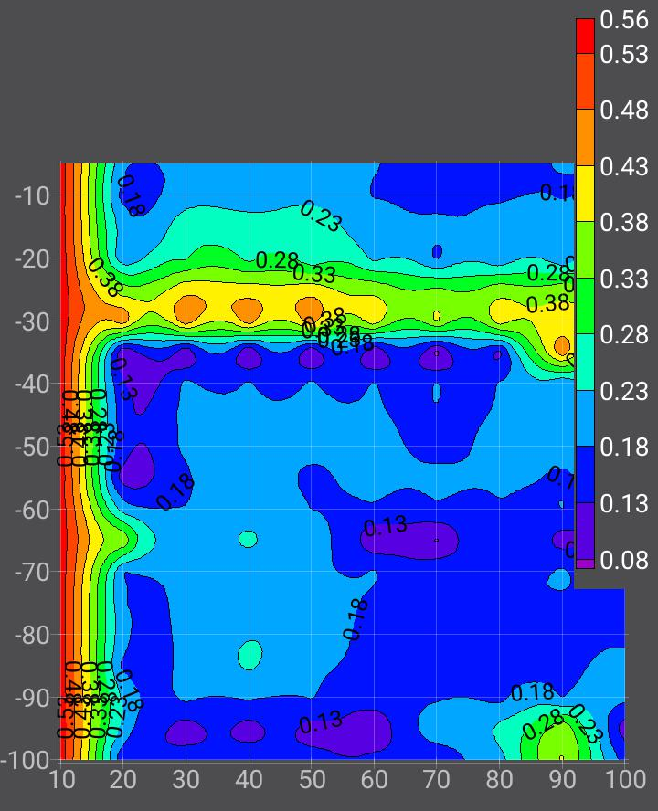
Figure 4.1:2D Resistivity Tomogram of Profile A

4.4 Profile B – B’
The profile B is 50 m long with coordinate point B (8⁰33’27”N, 4⁰38’13”E) to B’ (8⁰33’28”N, 4⁰38’12”E) comprises of ten measurements points separated by 5 m. It oriented in NW- SE direction with maximum depth penetration of 100 m. Figure 4.2 shows the resistivity tomogram of the profile B with vertical and horizontal axes of the model represent the depth and distance in meters respectively heterogeneity with resistivity values ranging from 40 Ω.m to 250 Ω.m. The resistivity tomogram reveals likely topsoil of thickness around 20 m depth. Low resistivity zones between stations 40 to 100 laterally to depths around 25m, 35m, 65m and 95-100m can be explained likely aquifer zones (Weathered/Fractured) layers which enhance recharge of groundwater. It is characterized by intermediate resistivity (eg. 120 Ωm) and high resistivity (eg. 250 Ωm).
The resistivity model indicates the presence of topsoil characterized by resistivity value that range from 40 to 180 Ωm with thickness generally less than 10 m. The topsoil is succeeded by weathered/fractured basement rock with resistivity value that range from 100 to 180 Ωm with depths of 25 m, 60 – 70 m, 80 m and 95 m at stations 40 to 100. The station 50 of the profile with multiple aquifer (weathered/fracture) zones is the recommended point for drilling to the depth of 100 m. The reddish color band with resistivity values greater than 100 ohm-m is the freshwater.
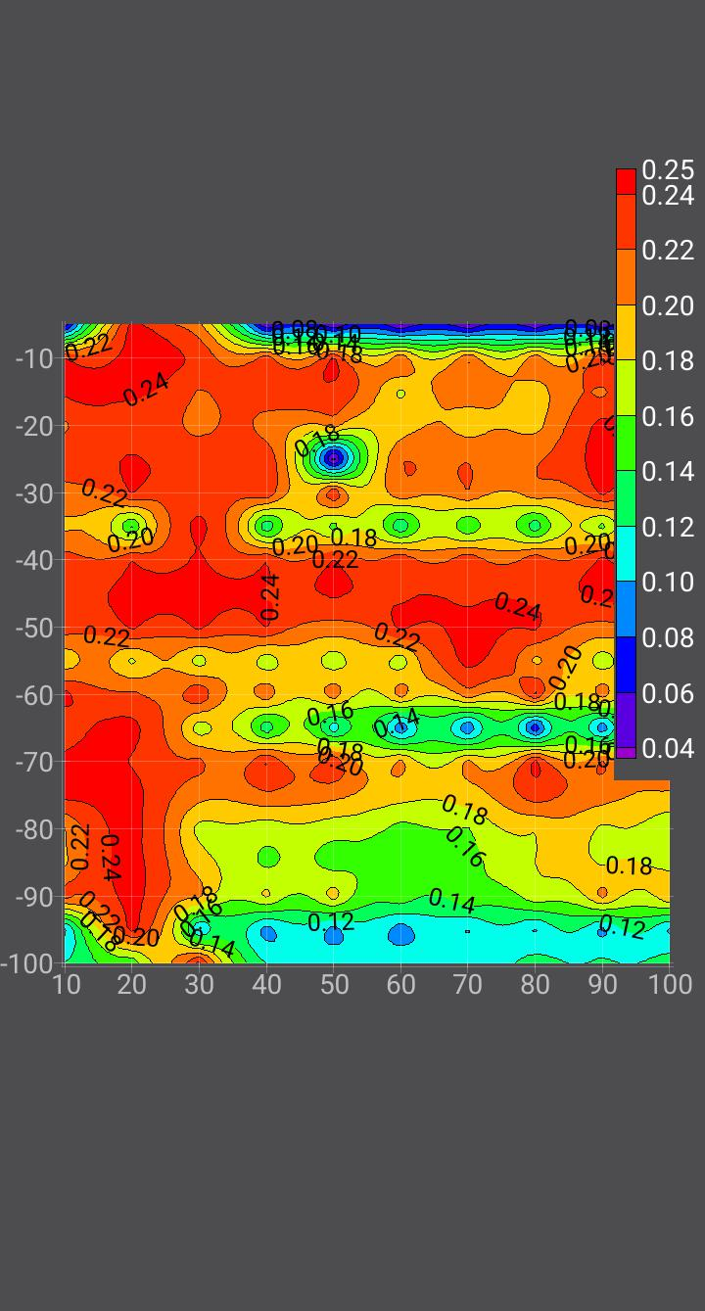
Figure 4.2: 2D Resistivity Tomogram of Profile B-B’
4.5 Profile C – C’
The profile C is 50 m long with coordinate point C(8⁰33’27”N, 4⁰38’13”E) to C’(8⁰33’29”N, 4⁰38’12”E) comprises of ten measurements points separated by 5 m. It oriented in NW-SE direction edge of the dumpsite with maximum depth penetration of 100 m. Figure 4.3 shows the resistivity tomogram of the profile C with vertical and horizontal axes of the model represent the depth and distance in meters respectively heterogeneity with resistivity values ranging from 60 to 420 Ω.m. The resistivity tomogram reveals likely topsoil of thickness around 20 m depth. Low resistivity zones (70 Ωm) between stations 10, 60 to 90 laterally to depths around 10, 40, 60, 70, 80 and 90 can be explained as the likely aquifer zones (Weathered/Fractured) which enhance recharge of groundwater. It is characterized by low resistivity (60-90 Ωm) and high resistivity (420 Ωm).
The resistivity model indicates the presence of topsoil characterized by resistivity value that range from 120 to 150 Ωm with thickness generally less than 20 m. The topsoil is succeeded by weathered/fractured basement rock with resistivity value that range from 60 to 110 Ωm with depths of 35 m, 75m and 95 m at stations 10, 40, 60, 70, 80 (existing borehole that is working) and 90. The stations 10, 40, 60, 70, 80 and 90 of the profile show multiple aquifer (weathered/fracture) zones are the recommended points for drilling to the depth of 90 m. The reddish color band with resistivity values greater than 480 Ωm at stations 20, 30, 50 (Existing Borehole not Functioning) and 100 are of high resistivity (fresh basement) and not good for groundwater.

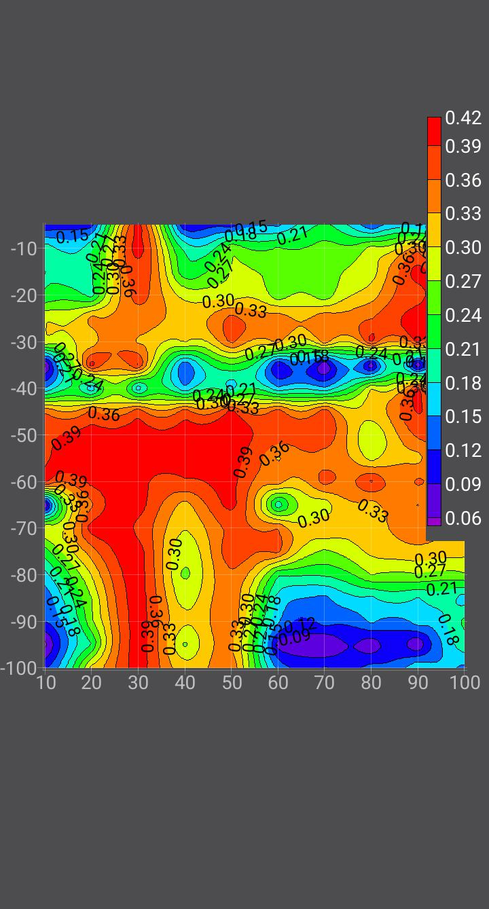
Figure 4.3:2D Resistivity Tomogram of Profile C-C’
4.6 Profile D – D’
The profile D is 50 m long with coordinate point D (8⁰33’28”N, 4⁰38’13”E) to D’ (8⁰33’29”N, 4⁰38’12”E) comprises of Ten measurements points separated by 5 m. It oriented in NW-SE direction edge of the dumpsite with maximum depth penetration of 100 m. Figure 4.4 shows the resistivity tomogram of the profile D with vertical and horizontal axes of the model represent the depth and distance in meters respectively heterogeneity with resistivity values ranging from 30 to 200 Ω.m. The resistivity tomogram reveals likely topsoil of thickness around 20 m depth. Low resistivity zones (30-50 Ωm) between stations 30 to 100 laterally to depths around 45m, 65m and 90-100m can be explained as the likely aquifer zones (Weathered/Fractured) which enhance recharge of groundwater. It is characterized by low resistivity (30-50 Ωm) and high resistivity (200 Ωm) is notice around station point 10 to 20.
The resistivity model indicates the presence of topsoil characterized by resistivity value that range from 160 to 200 Ωm with thickness generally less than 20 m. The topsoil is succeeded by weathered/fractured basement rock with resistivity value that range from 30 to 60 Ωm with depths of 35 m, 65m and 95 m at stations 30 to 100. The stations 30 to 70 and 90 of the profile show multiple aquifer (weathered/fracture) zones are the recommended points for drilling to the depth of 90 m. The reddish color band with resistivity values greater than 200 Ωm at stations 10 and 20 are of high resistivity (fresh basement) and not good for groundwater exploitation.

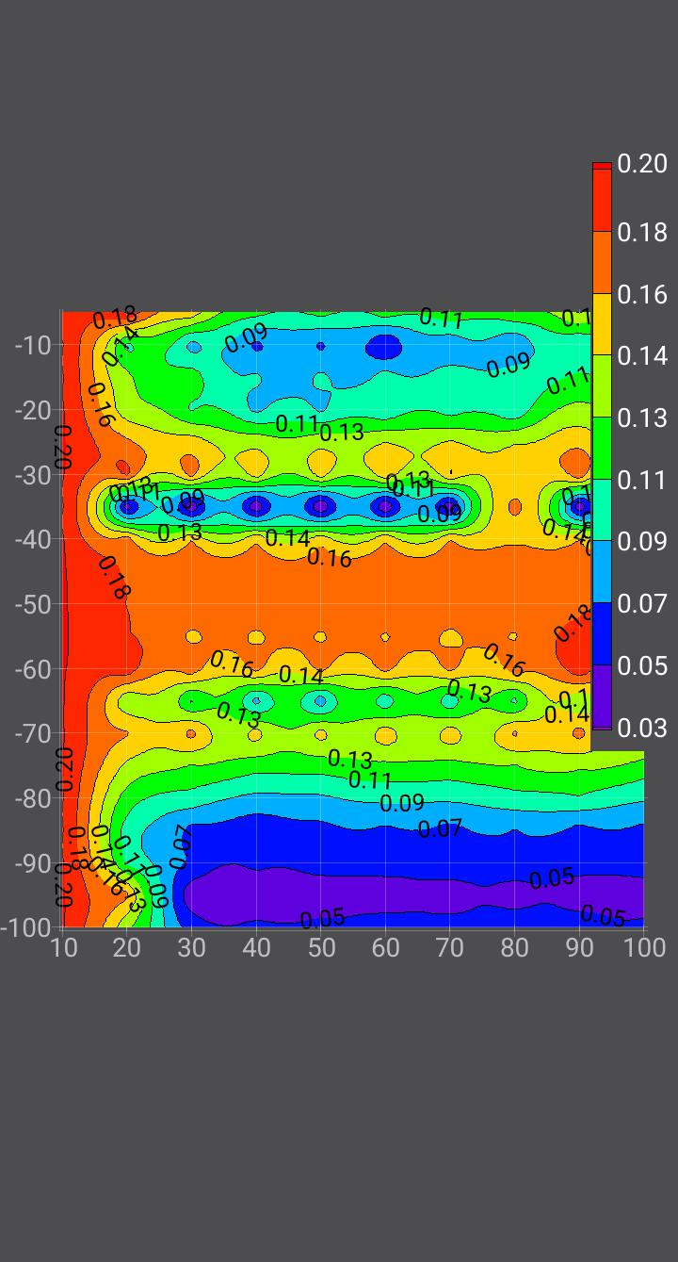
Figure 4.4:2D Resistivity Tomogram of Profile D - D’
4.7 Profile E – E’
The profile E is 50 m long with coordinate point E (8⁰33’27”N, 4⁰38’13”E) to E’ (8⁰33’28”N, 4⁰38’12”E) comprises of ten measurements points separated by 5 m. It oriented in NW-SE direction edge of the dumpsite with maximum depth penetration of 100 m. Figure 4.5 shows the resistivity tomogram of the profile E with vertical and horizontal axes of the model represent the depth and distance in meters respectively heterogeneity with resistivity values ranging from 30 to 210 Ω.m. The resistivity tomogram reveals likely topsoil of thickness around 20 m depth. Low resistivity zones (30-50 Ωm) at stations 10, 20 and 50 to 100 laterally to depths around 35m, 65m and 90-100m can be explained as the likely aquifer zones (Weathered/Fractured) which enhance recharge of groundwater. It is characterized by low resistivity (30-50 Ωm) and high resistivity (200 Ωm) is notice around station point 30 and 40.
The resistivity model indicates the presence of topsoil characterized by very low resistivity value that range from 30 to 50 Ωm with thickness generally less than 20 m. The topsoil is succeeded by weathered/fractured basement rock with resistivity value that ranges from 30 to 50 Ωm with depths of 35 m, 65m and 95 m at stations 10, 20 and 50 to 100. The stations 50 to 100 of the profile show multiple aquifer (weathered/fracture) zones are the recommended points for drilling to the depth of 90 m. The reddish color band with resistivity values greater than 210 Ωm at stations 30 and 40 are of high resistivity (fresh basement) and not good for groundwater exploitation.

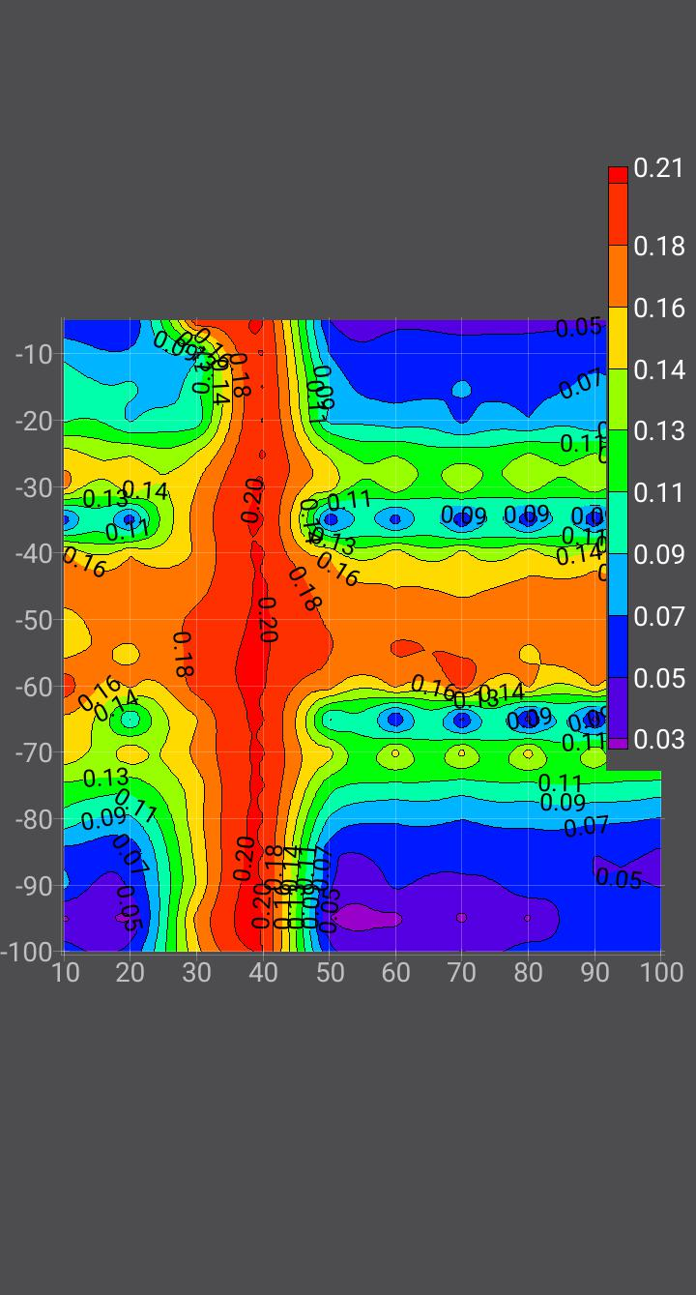
Figure 4.5:2D Resistivity Tomogram of Profile E - E’

Conclusion
The geophysical survey conducted around the Central Library of Kwara State Polytechnic, Ilorin, utilizing the Vertical Electrical Sounding (VES) method with the ADMT Resistivity Meter, successfully delineated the subsurface hydrogeological characteristics to assess groundwater potential. Five profiles (A to E) were probed to a depth of 100 meters, revealing a heterogeneous subsurface with resistivity values ranging from 30 to 560 Ωm. The resistivity tomograms identified three distinct lithological units: topsoil, weathered/fractured basement, and fresh crystalline basement. Low resistivity zones (30–130 Ωm) were interpreted as potential aquifer zones, primarily within the weathered and fractured basement rocks, which are conducive to groundwater recharge and storage. These zones were observed at varying depths (25–100 meters) across the profiles, with specific stations recommended for borehole drilling due to the presence of thick, saturated weathered/fractured layers. High resistivity zones (>200 Ωm) indicated fresh basement rocks, unsuitable for groundwater exploitation.
The study achieved its objectives by conducting VES at selected points, interpreting geoelectrical data to delineate subsurface layers, identifying potential aquifer zones, and recommending optimal borehole drilling locations. Profiles A, B, C, D, and E identified multiple stations (e.g., stations 20–70 in Profile A, station 50 in Profile B, and stations 10–90 in Profile C) with favorable aquifer characteristics, recommending drilling depths of approximately 90–100 meters. These findings address the water scarcity issues at the Central Library by providing a scientific basis for sustainable groundwater development, potentially improving water supply for sanitation, learning, and working conditions. The integration of geophysical data with geological knowledge ensured a robust interpretation, highlighting the efficacy of the VES method in basement complex terrains for groundwater exploration.

References
Adelusi, A. O., and Folami, S. L. (2020). Hydrogeological and hydrogeophysical investigations in basement complex terrains. Journal of African Earth Sciences, 162, 103-115.
Adepelumi, A. A., et al. (2013). Integrated geophysical studies for groundwater exploration in basement terrains. Geophysics Journal International, 195(2), 876-889.
Babu, H. V., et al. (2021). Mapping bedrock topography using magnetic techniques in hard-rock terrains. Journal of Geophysical Research, 126(3), 45-56.
Beeson, S., and Jones, C. (2016). Electrical resistivity methods for borehole siting in crystalline basement aquifers. Hydrogeology Journal, 24(5), 123-134.
Bienibuor, A. K., et al. (2016). Application of electrical resistivity methods in groundwater exploration. Environmental Earth Sciences, 75(8), 678-690.
Covel, M., et al. (2019). VLF methods for locating bedrock wells in fracture zones. Geophysical Prospecting, 67(4), 890-902.
Dan Hassan, M., and Olorunfemi, M. O. (2019). Geophysical investigation for groundwater in basement complex. Nigerian Journal of Technology, 38(2), 345-356.
Darracott, A., and McCann, D. (2017). Planning and designing geophysical surveys. Geophysical Journal International, 189(1), 23-34.
Fadele, S. I., et al. (2013). Groundwater occurrence in sedimentary and basement complex terrains. Journal of Nigerian Association of Hydrogeologists, 24, 56-67.
Fetter, C. W. (2010). Applied Hydrogeology (4th ed.). Prentice Hall.
Fitterman, D. V., and Stewart, M. T. (2016). Electrical and electromagnetic methods for groundwater studies. Geophysics, 81(4), WA123-WA134.
Hazell, J. R., et al. (2016). Electrical resistivity for groundwater exploration in sub-Saharan Africa. Journal of Applied Geophysics, 134, 178-189.
Hazell, J. R., et al. (2023). Resistivity variations in fractured basement rocks. Geophysical Prospecting, 71(2), 234-245.
Hinz, E. A. (2018). Magnetic methods in geophysical exploration. Geophysics Today, 45-67.
Kaufman, A. A., and Keller, G. V. (1989). Electromagnetic Methods in Applied Geophysics. Society of Exploration Geophysicists.
Kumar, D., et al. (2016). Electrical resistivity methods for groundwater exploration in hard rock terrains. Journal of Hydrology, 540, 102-115.
Loke, M. H. (2020). Tutorial: 2-D and 3-D Electrical Imaging Surveys. Geotomo Software.
MacDonald, A. M., et al. (2019). Designing successful geophysical surveys for groundwater exploration. Quarterly Journal of Engineering Geology and Hydrogeology, 52(3), 321-332.
MacDonald, A. M., et al. (2020). Groundwater exploration in complex geological settings. Hydrogeology Journal, 28(6), 1987-2001.
Marin, L., et al. (2020). Azimuthal resistivity surveys for hydraulic conductivity assessment. Journal of Environmental and Engineering Geophysics, 25(2), 167-178.
McNeill, J. D. (2018). Electromagnetic methods for groundwater exploration. Geophysics, 83(5), A45-A56.
McNeill, J. D., and Labson, V. F. (2017). Very low frequency (VLF) methods in geophysical exploration. Geophysical Prospecting, 65(4), 987-1001.
Nabighian, M. N. (2020). Electromagnetic Methods in Applied Geophysics. Society of Exploration Geophysicists.
Ogundana, A. K., and Talabi, A. O. (2014). Groundwater potential evaluation using electrical resistivity method. Journal of Emerging Trends in Engineering and Applied Sciences, 5(3), 201-207.
Olayinka, A. I. (2019). Resistivity characteristics of basement rocks in Nigeria. Nigerian Journal of Applied Sciences, 37(1), 45-56.
Olayinka, A. I., and Barker, R. D. (2018). Electrical resistivity methods for borehole siting. Geophysical Journal International, 175(2), 456-467.
Olayinka, A. I., et al. (2020). Geoelectrical characteristics of basement aquifers in southwestern Nigeria. Journal of African Earth Sciences, 171, 103-114.
Olorunfemi, M. O., and Fasuyi, S. A. (2018). Hydrogeological mapping using electrical resistivity surveys. Journal of Nigerian Association of Hydrogeologists, 29, 34-45.
Olorunfemi, M. O., and Olorunniwo, M. A. (2000). Geophysical investigation for groundwater in crystalline basement terrain. Journal of African Earth Sciences, 31(2), 345-356.
Omosuyi, G. O., et al. (2008). Integration of geophysical and geological data for groundwater exploration. Journal of Geology and Mining Research, 1(3), 67-75.
Oseji, J. O., et al. (2005). Groundwater exploration in basement complex using electrical resistivity method. Global Journal of Geological Sciences, 3(1), 45-52.
Otutu, O., and Oviri, J. O. (2010). Groundwater systems in basement and sedimentary terrains. Journal of Applied Sciences, 13(2), 123-134.
Parasnis, D. S. (2019). Principles of Applied Geophysics (5th ed.). Chapman and Hall.
Reynolds, J. M. (2017). An Introduction to Applied and Environmental Geophysics. Wiley.
Sauck, W. A., and Zabik, S. M. (2017). Azimuthal resistivity surveys for hydraulic conductivity. Environmental Geophysics, 22(3), 123-134.
Smith, R. (2021). Electrical techniques for groundwater exploration in crystalline basement. Journal of Applied Geophysics, 188, 104-115.
Solley, W. B., and Pierce, R. R. (2013). Estimated Use of Water in the United States. USGS Circular.
Telford, W. M., Geldart, L. P., and Sheriff, R. E. (2018). Applied Geophysics (2nd ed.). Cambridge University Press.
Todd, D. K. (2015). Groundwater Hydrology (3rd ed.). Wiley.
Todd, D. K., and Mays, L. W. (2022). Groundwater Hydrology (4th ed.). Wiley.
Van Dongen, P., and Woodhouse, M. (2017). Geophysical techniques for groundwater exploration. Hydrogeology Journal, 25(4), 987-1002.
Van Overmeeren, R. A. (2019). Electrical resistivity for aquifer boundary mapping. Geophysics, 84(3), A23-A34.
White, J. C., et al. (2020). Resistivity characteristics of basement rocks. Geophysical Journal International, 222(1), 567-578.
Wurmstich, B., et al. (2016). Electrical conductance for aquifer potential mapping. Journal of Hydrology, 535, 123-134.
Yuhr, L. B., et al. (2021). Microgravity and electromagnetic methods for karst mapping. Environmental Geology, 79(5), 234-245.

