ASSESSMENT OF PHYSICO-CHEMICAL PROPERTIES OF OYUN RIVER FOR IRRIGATED AGRICULTURE

BY
MUSA ROFIAT ORIYOMI
ND/23/WRE/PT/0005

A RESEACH PROJECT SUBMITTED TO DEPARTMENT OF WATER RESOURCES ENGINEERING, INSTITUTE OF TECHNOLOGY, KWARA STATE POLYTECHNIC, ILORIN.
IN PARTIAL FULFILLMENT OF THE REQUIREMENT FOR THE AWARD OF NATIONAL DIPLOMA IN WATER RESOURCES ENGINEERING, INSTITUTE OF TECHNOLOGY.
AUGUST, 2025

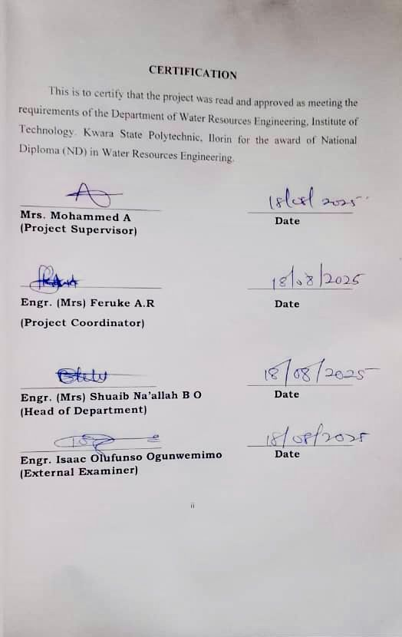
DEDICATION
This project is dedicated to Almighty Allah for the grace given to me to fulfill this academic program, and to my imperatives parents, Mr. and Mrs. Musa who are the architect of my academic pursuit.

ACKNOWLEDGMENT
All glory and honor is given to Almighty Allah, the most beneficent and most merciful for the accomplishment of my National Diploma (ND) in Kwara State Polytechnic.
My gratitude goes to my most able, diligent and distinguish and competent supervisor in person of Mrs. Mohammed A. for her motherly care, guidance, concern and for taking pains of going through the manuscript for constructive criticism. I acknowledge his extensive academic, professional and practical experience he used to complement my knowledge in making up this project.
My sincere appreciation also goes to all the lecturers both teaching and non-teaching staffs that are tolerant in putting me through the National Diploma (ND) program in this distinguish department of Public Administration especially egalitarian Head of Department (HOD) Engr. Mrs. Shuaib-Naallah,B.O and also my department lecturers Dr. Dauda Mr. Abdullahi Mrs. Mohammed Aisha Mrs. Feruke may God be with you all.
I will like to also appreciate my loving parents in person of Mr. and Mrs. Musa for their care, love and understanding they have shown to me all my life.
Lastly, I appreciate myself for the hard work I have put in since day one till this very moment, I pray Almighty Allah guide and protect me as I leave this great citadel of learning, and pinpoint my steps to greater heights Insha Allah.

ABSTRACT
The water quality assessment include an examination of the physical and chemical components of water in relation to natural facility, and human activities that can affect the health of people or human being. Three water samples were collected at up, middle and down stream of Oyun River using samples bottles for physiochemical analysis and compared with (FAO) standard food and agriculture. The results of the analysis indicated that all parameters were within the FAO standard limit except ca, mg, cL, Na and pH that are above the limit. It is therefore concluded that the River water is not of good quality for irrigation purpose.

TABLE OF CONTENTS
Title Page i
Certification ii
Dedication iii
Acknowledgment iv
Abstract vi
Table of Contents vii
CHAPTER ONE
1.0 Introduction 1-4

1.2 Statement Of The Problem 4

1.3 Aim And Objectives Of The Study 4-5

1.4 Scope Of Study 5

1.5 Significance Of The Study 5-6

CHAPTER TWO

Literature Review 7

2.1 Surface Water Physicochemistry, Microbiological and Metal Pollution

7

2.2 Surface Water Physicochemistry 7-9

2.2.1 Physiochemical Characteristics and Bacteriological Load in Surface Water

9

Heavy Metal Pollution of Surface Water 10-11

2.2.3 Physicochemical Properties and Heavy Metal Status of Surface Water

11

2.3 Sediment Physicochemistry and Metal Pollution 12

2.3.1 Physicochemical Properties of Sediment and Water 12
2.4 Physical Characteristics of Water 12-13
2.4.1 Temperature 13
2.4.2 Turbidity 13
2.4.3 Conductivity 13-14
2.5 Chemical Characteristics of Water 14-16
2.5.1 Inorganic Nutrients 16
CHAPTER THREE
Materials And Methods 17

3.1 Location Of The Study Area 18
3.2 Methodology 18
3.2.1 Water Sampling Procedure 18
3.2.2 Water Analysis 18
CHAPTER FOUR
4.0 Result and Discussions 21
4.1 Results of the Analysis 21
4.2 Discussion 21

4.2.1 Electrical Conductivity (ECW) 22

4.2.2 Total Dissolved Solids (TDS) 22
4.2.3 Calcium (Ca) 22
4.2.4 Magnesium (Mg++) 23

4.2.5 Sodium Absorption Ratio (SAR) 23

4.2.6 Chloride (Cl) 23
4.2.7 Sodium (Na) 23-24
4.2.8 pH 24
CHAPTER FIVE
5.0 Conclusions And Recommendations 25
5.1 Conclusions 25
5.2 Recommendations 25
References 26-30
CHAPTER ONE
1.0 INTRODUCTION
Water is an indispensable resource that sustains life, ecosystems, and numerous industrial and societal functions. Its quality is determined by its physico-chemical properties, which govern its suitability for consumption, agriculture, and various ecological processes. Parameters such as pH, temperature, electrical conductivity, total dissolved solids (TDS), turbidity, and concentrations of major ions and trace elements serve as key indicators of water quality
Water is a vital resource that can be replenished and is required for the existence of life, production of food, economic development, and general contentment.
Surface water is an important source of freshwater for human consumption, agriculture, and industrial usage in many parts of the world. However, anthropogenic activities such as residential, industrial, commercial, agricultural, and other anthropogenic activities, when combined with natural conditions, typically degrade Surface water quality, which is why a complete assessment of Surface water quality is vital for society (Abbasnia et al., 2019).
Surface waters from natural sources have a better quality than those from area that have been influenced by human activities. Most surface waters are subject to contamination from point and nonpoint sources through wastewaters from agricultural and industrial activities and runoff from rainfall.
The water quality assessment includes an examination of the physical, biological, and chemical components of water in relation to the natural quality, intended use, and human activities that can affect the health of aquatic systems. Freshwater makes up only 3% of the total amount of water on the planet, 2% stored taking the form of ice caps and glaciers the remaining 1% accounts for all available water supplies for the survival of all living creatures. Lakes, rivers, ponds, springs, and water wells are the most common sources of available freshwater/surface water (Akhter and Brraich, 2020).
Water quality has deteriorated as a result of the unrestricted and injudicious use of natural resources for economic development, industry, and agricultural operations. Scientists and social activists around the world are concerned about the deterioration of water quality. Surface water, which covers around 4–6% of the earth's surface, is one of the most productive and complicated aquatic ecosystems (Modrick and Georgakakos, 2015).
The quality of water, as a major ingredient of surface water, not only shows its fitness for human and industrial use but is also critical to its survival support Other ecosystem functions, such as biodiversity. Most of the surface water in agricultural catchments is saturated with excessive nutrients and other toxins as a result of significant anthropogenic pressure (Lemieux et al., 2015).
Surface water becomes a source rather than a sink as a result of the increasing pollution intake, and it is unable to tolerate changes in land-use practices and changes in hydrological balance. As a result, surface water is regarded as one of the world's most fragile ecosystems. However, surface water can purify water through reduced flow rates, organic matter decomposition, nutrient retention by bacteria, and plant uptake (Hemmings et al., 2015).
However, deforestation and conversion of wetland catchments into agricultural and industrial regions reduce the potential of these catchments to retain water in the environment, which increases water runoff with a high pollution load, causing water quality to worsen over time (Johnson and Belitz, 2015). Surface water loses its ecological activities due to poor water quality caused by an overabundance of fertilizers.
Surface water sources in the research locations (Jamwa-Ramgarh, Bassi, Virat-Nagar, and Amber Tehsil of Jaipur district); includes both man-made and natural sources. The water demand for water has risen dramatically over time as agricultural operations, industry, population, and urbanization have all expanded.
According to recent studies, the ecological quality of much surface water in the study areas has been gradually worsening. The majority of the surface water area in the research locations has been turned into agricultural fields where wheat, mustard, pearl millet, and other crops are grown as seasonal crops (Pistón et al., 2012).
The environment, which increases water runoff with a high pollution load, causing water quality to worsen over time. Surface water loses its ecological activities due to poor water quality caused by an overabundance of fertilizers. Surface water sources in the research locations Oyun River; include both man-made and natural sources. The water demand for water has risen dramatically over time as agricultural operations, industry, population, and urbanization have all expanded.
According to recent studies, the ecological quality of much surface water in the study areas has been gradually worsening. The majority of the surface water area in the research locations has been turned into agricultural fields where wheat, maize, millet, sugarcane and other crops are grown in recent years; water quality evaluation has become a crucial concern around the world, as the quality of life has been threatened by projections of future drinkable freshwater scarcity.
Monitoring water quality on a regular basis is required in order to establish strategies for improving ecological conditions and safeguarding the status of water bodies (Naubi et al., 2016).
Because environmental conditions change throughout the year, any water body's water chemistry is subject to geographical and temporal changes. Routine water sampling and analysis of a maximum number of the water body's physicochemical properties are essential for reliable monitoring of water quality conditions. The water body's regular spatial and temporal monitoring provides a vast, complex dataset that is required to convert information into a form that is easily predictable and effective to interpret. Around the world, the water quality index (WQI) is a widely used technique for monitoring the quality of both surface and groundwater (Soleimani et al., 2018). It's a way of combining various physical and chemical variables into a single, easily comprehendible number (Cebecauer and Buzna, 2018).
The purpose of this research has to determine the current water quality condition and spatiotemporal patterns of selected surface water in a selected region of Oyun River, as well as provide a mechanism for synthesizing all water quality conditions in a form that policymakers could understand.
We hope that this study will provide detailed, useful information that will aid policymakers and other interested parties in initiating restoration efforts to improve the water quality in the study region.

1.2 STATEMENT OF THE PROBLEM

Continuous use of Oyun river for irrigation practices by the farmers without proper quality monitoring as resulted into low crop yield in the year 2024 till date. This problem as led to the assessment physico-chemical properties of Oyun River.

1.3 AIM AND OBJECTIVES OF THE STUDY

The aim of this study is to access the physico-chemical properties of Oyun River in terms of its suitability for irrigated agriculture.

The specific objectives are as follows:

To locate water sampling point at upper, middle and down stream of Oyun River for sampling operation.

To investigate physical and chemical properties of water samples through laboratory analysis

To compare the result of analysis FAO standard

To suggest and improve practice for use of the river water for agriculture.

1.4 SCOPE OF STUDY
Upper stream, middle stream and down stream of Oyun River were consider for water sampling operation. The parameter for analysis include Electrical Conductivity (ECW), Total Dissolved Solids (TDS), Calcium (Ca++), Magnesium (Mg++), Sodium Absorption Ratio (SAR), Chloride (Cl-), Sodium (Na+), pH.

1.5 SIGNIFICANCE OF THE STUDY
The result of this work will be useful to:
- Maritime bodies in monitoring discharge processes and water pollutant.
- Environmental managers in comparing concentrations, occurrence and sources of heavy metal pollution and evaluating furthers effect in the study area and other Nigerian rivers.
- Residents and fishermen in understanding the consequences of direct defeacation into river water as one of the causes of their ailments.
- Kwara State Water Company in the assessment of all the surface water in the study area used for drinking and the setting of a water treatment plant in the study area.
- Moro Local Government council in providing waste disposal facilities, setting of waste management committee and enforcement of enabling environment laws of Kwara State.

CHAPTER TWO

LITERATURE REVIEW

Introduction
The biological assessment of water bodies has helped a lot in relating the presence and the concentration of certain minerals and ions to the condition of the water.
This research has been embarked upon by many researchers both corporate and individuals and has till date succeeded in providing the bases for acceptance and resulting of certain water sources. These works have all been polished and there is now a strong belief that the degree perfection of a particular water is relative, considering its context of purposes. These standards depends on the properties of the water which automatically affects mineral concentration. These properties or characteristics can be physical or chemical.
The review of literature that are related to this study are discussed under the following subheadings:

Surface Water Physicochemistry, Microbiological and Metal Pollution

Surface Water Physicochemistry
Reports on the physicochemical properties of rivers abound everywhere some of which are reported here. Mohammed and Caleb, (2014) determined some physicochemical parameters of water samples along River Galma in Zaria, Nigeria. In his report, only total suspended solids and total hardness were above permissible limits.
Ajiwe et al. (2014) analyzed the physicochemical components of three satellites rivers (Nworie, Otamiri and Oramirikwa) in Owerri Local Government Area of Imo State using World Health Organisation (FAO) standards to compare the results. The three rivers were to a large extent found to be safe for human consumption except PO43- in Nworie and Oramirika rivers and pH of the three rivers. Equally too, Maitera et al. (2011) had higher total hardness than total carbonate in wet season with the two parameters almost the same in dry season and higher conductivities than total dissolved solids.
Adamu et al., (2014) investigated into some physicochemical parameters of Watari reservoir Kano state, Nigeria. The mean values of TDS, conductivity, turbidity, total hardness suspended solids BOD, Cl⁻, NO⁻2, NO⁻3, COD and PO42- indicate the effectiveness of the treatment process. The high values for nitrates observed may be as a result of the use of nitrous based fertilizer in the locality.
Udo et al. (2013) investigated spatial variation in physicochemical parameters of Eastern Obolo estuary and the result reveal that TDS, BOD values from all station exceeded the recommended limits indicating Eastern Obolo estuary may not be efficient source of drinking water. The physicochemical measurements of water quality of Great Kwa river had been reported by Akpan et al., (2012). and the results showed water temperature, transperancy, salinity and DO values are significantly higher during the dry season than the wet season except BOD.
Okolo et al. (2014) reported average concentrations (mg/l) of anions of Nkisi River The concentration of these physicochemical characteristics where within World Health Organisation (FAO) acceptable standards of drinking water. According to Dibofori-Orji and Marcus, (2011), physicochemical analysis of Orashi River at Mbiama and Ogbema communities in River State recorded tempreature of 29.2$°$C for the two sampling points. The slight hardness of water samples observed is temporary and attributable to the presence of bicarbonates. Though the level of sulphate in the river water is an indication of some element of organic matter in the water. This could have its origin either from human waste and or industrial wastes.
Physicochemical parameter of the river Niger at Onitsha bank, Nigeria had been investigated by Egereonu and Ozuzu, (2005) to establish the levels of pollution of land and water on the river bank. The metallic and non- metallic ions, alkalinity, total solids, sulphate, chloride, hardness and other physicochemical parameters had been reported to a have adverse impacts on the water quality thus rendering the water unfit for human consumption.
The water quality of ponds at the university of Jos, Nigeria was also accessed by Jabbo et al. (2011). The values obtained fell within permissible units and the water was recommended to be good for irrigation.

Physiochemical Characteristics and Bacteriological Load in Surface Water
Ameen et al. (2011) had reported the mean physicochemical and bacteriological analysis of Asa treated water before and after refurbishment of the treatment plant. All samples were negative to E.coli. Similarly, Agwu et al. (2011) assessed the quality of drinking water sources from Aba South and Abayi areas of Abia State and reported all physicochemical parameters of water analyzed as within World Health Organisation (FAO) standard except for pH which ranged from (5.20 – 5.80) against FAO range of 6.5 – 8.5. All samples contained (staphylococcus sp. Streptococcus and E.coli, etc) to varying degrees. The three spring’s water in Bende LGA of Abia State assessed by Okolo et al. (2014) showed mean pH of 5, temperature of 28.3$°$C against 6.5 – 8.5 and temp (25°C) approved by FAO.

Heavy Metal Pollution of Surface Water
Previous cases of metal pollution of water bodies in Niger Delta are well documented. The levels of trace metals in drinking and ground water source in Ota, Nigeria had been assessed by Anako et al., (2004). Fe and Ni in some drinking and ground water sources were found in concentrations that exceeded the FAO guidelines while Pb levels were below detection in all the samples under investigation. Pollution indices evaluated indicated significant pollution by Pb, Fe and Ni and the mean metal levels in the sample water sources were of the under Fe>Cu>Zn>Ni>Pb>Mn.
Ebong et al. (2001) had earlier reported estuary waters of Qua River as having mean concentrations of Pb, Ni, V, Fe, Cu and Cd higher in wet season samples than in dry season samples and also the high mean metal concentrations of its associated creek co-related positively. However, mean concentrations later reported for surface water quality for the same Qua Iboe river system revealed indicating supersaturation which led to mineral precipitation condition of water (Umoren and Onianwa, 2012). Umoren et al., (2014) assessed the levels of environmentally toxic metals and their potential risk to the biota in surface and groundwater samples obtained from six different locations in Ibeno local government area of Akwa Ibom State. The predominant species in both surface and ground water were the free hydrated ions of Ni²⁺ (99.8%), Zn²⁺(99.4.4%), Cu²⁺ (72.7% - 96.4%), Pb²⁺(54.2% - 99.8%) as well as the hydroxyl complexed species of CrOH⁺ (24.5%).
Inyinbor et al., (2011) studied concentrations of Pb, Cu, Zn, Mn and Fe in Onyi river in Obajana community of Kogi State, Nigeria. The concentrations of these metals in water were however found to be higher than those of FAO standard for drinking water in certain location due to other anthropogenic activities. In Sokoto, Izuagie et al., (2011) examined heavy metals in running water sample from limestone mining site. Results of heavy metals concentration gave Zn (0.29 mg/L) while Pb, Mn, Ni, Cu and Fe were not detected. Sanyaolu et al., (2014) had investigated levels of Cd, Co, Cu, Cr, Fe, Mn, Pb and Zn in river Ogun, Nigeria and mean concentration of these metals and their ranges reported were within FAO tolerable limits.
Okorie, (2011) determined Cd, Co, Hg, Pb and Fe in Imo river from source to tributaries for dry and wet seasons and analysis showed Cd and Co occurred in trace amounts and so were not detected for the two seasons, but low levels of Hg were detected while the river contained high amount of Pb in the dry season with annual mean Pb level.

Physicochemical Properties and Heavy Metal Status of Surface Water
It had been reported that the pollution status of surface water around Yauri abattoir analysed by Ibrahim et al., (2013) recorded mean concentration values of TDS, TSS, DO, PO43-) and BOD as well as Cd, Ni and Pb higher than the national and international standard limits and control water sample where the pH values, SO43-, NO3- and COD, CO, Cu, Fe and Zn were above the control but below FAO, EU, SON, USEPA safe limits for physicochemical variables and metals in water. Comparative assessment of physicochemical and heavy metals analysis of river water samples from Ekpan, Ubeji and NPA environs of Warri, Delta State investigated by Ogbuagu et al., (2013) produced lower mean concentrations for pH, turbidity, NTU, TSS, COD, DO, TDS, conductivity, Cl⁻, HCO3-, SO42-, PO42- except turbidity at around NPA was slightly above FAO standard while Fe, Mn, Cd, Cr, Cu, Zn and Pb at all stations of the samples were mostly less.
The physicochemical characteristics and heavy metal levels in water samples from five rivers system in Delta State, Nigeria for 12 months (January to December, 2009) were also examined by Kaizer and Osakwe, (2010). On comparison with international guidelines, the rivers were not significantly contaminated but were suitable for domestic and industrial uses.

Sediment Physicochemistry and metal pollution
Sediments form a natural buffer in rivers and are important habitat as well as a main nutrient source of aquatic organisms.

Physicochemical properties of Sediment and Water
A much interesting work on the physicochemical properties of sediment is that of benthic sediments of Qua Iboe estuary. For this estuary Essien and Benson, (2007) reported monthly concentrations for NH3-, Cl⁻, CO32-, SO ³⁻ and NO3- in its benthic sediment during the wet season (June 2003 – Sept. 2003). Similarly, the mean monthly values for the dry season (Nov, 2003 – February 2004) also were reported.
4
2.4 Physical Characteristics of Water
pH: This is described as the general measure of the acidity or alkalinity of the water sample. The pH of water on a scale of 0 to 14, is a measure of the hydrogen ion concentration, water contains both ions and OH ins. Pure distilled water contains equal number of H and OH ions and is considered to be natural (pH7), neither basic nor acidic (Mitihell et al 2007). Acidity measures the amount of base required to neutralize a given sample to a specific point, this certainly changes the quality of the water (APHA, 1999).
Alkalinity is due to the presence of carbonates (CO32-) and bicarbonates (HCO3), (Frederic et al 2006). The level of alkalinity of water depends on the location of the sample sources. Rain water can be used to determine the solubility of chemical form of most substances, for example, hydroxides of many metals are insoluble, therefore the higher the pH, the less metal available in water (Frank, 2005). It has been noted that alkaline water are noted that alkaline water are not typical of Africa (Holden et al 2006).
The pH may be determined by either electronic or calorimetric methods. The glass electrode H, meter is the most widely used method and it is quick and accurate. The color of the solution does not affect results, but accurate figures cannot be obtained if the water is oily.
2.4.1 Temperature
Temperature is significant because biochemical reactions eg. uptake of oxygen by bacterial proceed more rapidly at a high temperature. Temperature also affect the solubility of oxygen in water, with less oxygen available for aquatic life at higher temperatures. This means that aquatic life is more vulnerable during the summer period when the flows are low and water temperature are high. Elevated temperatures can occur where thermal discharges form power stations and this can lead to thermal pollution.
2.4.2 Turbidity
Turbidity may be used as an estimate of undissolved substances in the sample. It may be measured by visual comparison with the standards or photo-metrically using spectrophotometer (standard methods for examination of waters and waste waters 1999). Water turbidity is as a result of the pressure of suspended) material which could be organic in that water. The materials include industrial waters, agricultural wastes, microbial growth, erosion products, presence of human organs inputs.
2.4.3 Conductivity
Conductivity is a measure of the amount of material dissolved in water. Conductivity generally increases over the length of a river but an unusual increase in conductivity can indicate the presence of polluting water. Conductivity is the reciprocal of the resistance offered by a solution with platinum electrode immersed in it each 1cm square, 11cm apart. It is usually denoted by the symbol K and defined by the geometry of the cell and RI the resistance in ohms. I is now a standard practice to express Nmho/cm. Sometimes the result will be shown as Ns. Conductivity varies with temperature and also with the nature of the ions and their concentration in the sample. Tests have shown that near neutrality, the effect of different ions at the same equivalent can give a raid and useful indication of the total ionic strength of water samples. Measurements are generally carried out using a conductivity meter at either 200$°$C or 2500$°$C. Values for natural water generally fall between the range of 85-120NSCM-1.
2.5 Chemical Characteristics of Water
Total Hardness: Total hardness in natural water are mainly due to the presence of calcium and magnesium salts and bicarbonate formed by reactions in the soil and rock through which the water percolates. Water with low alkalinity or hardness may be susceptible to pH reduction by “acid rain”, these can prevent the immediate formation of lather with soap and the formation of scale in pipes and fittings of hot water systems (Alpha 1999, Tebbutt 2002). Hard water can be softened on a larger scale by adding just enough line to precipitate the calcium as carbonate to remove the calcium salt.
2.5.1 Inorganic Nutrients
Nitrates: Nitrates is one of the inorganic nutrients in water it occurs as nitrate in water. Nitrate is known to be an important plant nutrient, thus it is used often as a fertilizer and is found in high concentration rare exceed 10mgll and are frequency less than 1mgll especially during periods of high primary production. Elevated concentrations in indicative of the influences of man such the use of nitrate fertilizer, septic tank failure and the vulnerability of the aquifer to infiltration be surface drainage. High level of nitrate greater than 20mglc may heat hazard to juvenile mammals (Lind, 2004). Nitrate level have been shown to be at the range of 0.4 – 0.55mglc in Africa water (Holden, 1960). Most sachet water in Nigeria, Aba to be precise have a nitrate range of 0.002 – 0.003mglc.
Nitrate is the reduced form of nitrite. This is common digestive systems. Nitrate is known to attack hemoglobin, producing methamoglobin this form of complex losses its oxygen carrying capacity in the red blood cell. The nitrate can come from nitrate drinking water or from food. Phosphorus is usually present in water as phosphate. They are usually formed when metallic atoms replace. Some or all of the hydrogen in phosphoric acid. This is usually in small amount, except when there has been human course enrichment of water. (Dugan et al, 2004). The main sources of phosphates in ground water and surface water include fertilizers, sewage, detergents and rain water which enter the centre mainly as a result of surface runoff and blank erosion. The amount of phosphates that water can hold without becoming polluted varies in a stream draining into a lake, the phosphates should not exceed 0.025mgll. A stream not flowing into a lake should not exceed 0.025mgll, excess phosphate concentration can lead to eutrophication process, by inner algal growth. Generally the water lower the total phosphates value of water, the better. Total phosphorus includes organic phosphates. While organic phosphates comprise the ions bonded to soil practices, and those present in laundry detergents (polyphosphates) (Parreira, 2005).
Rocks and many other geological land marks have also proved to be very good sources of some element that are of great marine and aquatic values. These rocks formed as a result of sedimentation of carcasses of organisms over a long period of time and through the deposition of molten margin which on its own house these elements. Calcium (Ca) is known to be present in water as a result of some runoff from these rocks. Such rock as limestone, gypsum and dolomite, provide a very high concentration of calcium, to water bodies. These concentration ranges from 40.00mgll (Lind, 2003). It known to have a very high aquatic productivity. Suort as bone tissues in fishes and nollus shells and also function in bone calcification in humans. It is very important in bone maintenance (David, et al, 2000) and also in regulation of nerve and muscle function (Robert, et al 2003).
Magnesium (Mg) which is mostly produced from runoff from igneous and carbonate rocks. It is very important in water hardness, just as calcium. It is important as a nutrient in plants where it aids growth and production of some porphyrings eg. Chlorophyll (Wetzel et al 2004, David et al 2005). It also has a very important function in humans where it is involved as constituents of bones, teeth; and also acts as an enzymes co-factor (Robert, et al 205).

CHAPTER THREE
Materials And Methods

3.1 Location Of The Study Area
Within Moro Local Government Area, Oyun river lies within is located in the South Eastern Part of Kwara State between longitudes 4°38'E -4°03'E and latitudes 9°50'N -8°24'N. . It runs through Moro Local Government Area longitudinally dividing it into two Oyun river and Basin River. The total area of Oyun River Basin is about 452.80km 2 while the total perimeter is 191.5/m 2. And Asa River Basin has the total area of 471.95km.
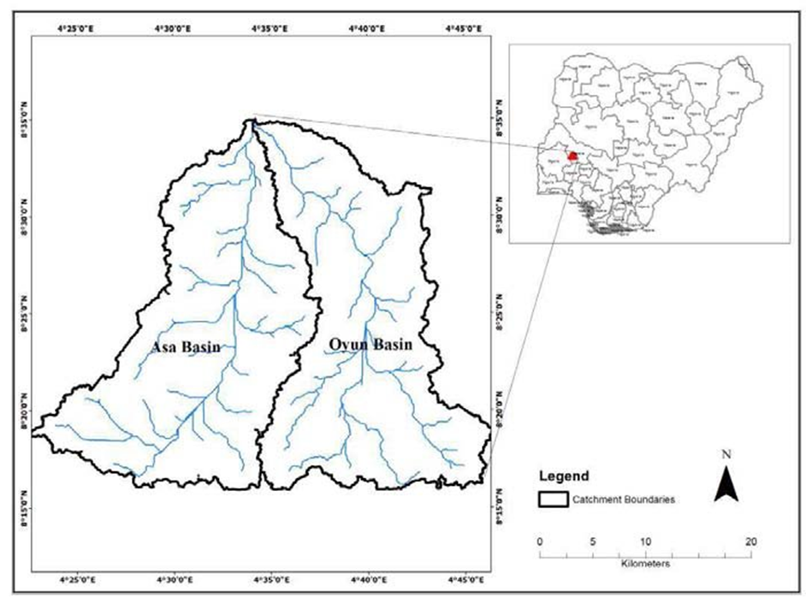
Figure 1: Map of the Study Area
3.2 Methodology
3.2.1 Water Sampling Procedure
A total of three (3) water samples were collected for analysis in May, 2025, before the beginning of the wet season to ensure that effluents from surface run- off did not contaminate the samples taken. One sample was collected from up-stream, one sample from middle-stream and one sample was collected from down-stream surface water bodies. The surface water was collected from Oyun River, Ilorin Kwara State.
The samples were collected in white plastic bottle water containers which were rinsed initially with the water to be sampled before proper sampling, labelling, storage and quality evaluation.
3.2.2 Water Analysis
In-situ test was carried out for the conductivity and pH, using conductivity and pH meters respectively; other parameters studied were total dissolved solids (TDS), and dissolved oxygen (DO). These parameters were measured directly by the use of HANA multi parameter ion specific metre (HI 83200). The concentrations of cations such as Fe²⁺, Cu²⁺, Zn²⁺, K⁺, Na⁺, Mg⁺, and Ca²⁺ were determined by the use of Atomic Absorption Spectrophotometer ( Bulk scientific model 210VGP) at the department of Water Engineering Technology, Kwara State Polytechnic, Ilorin.

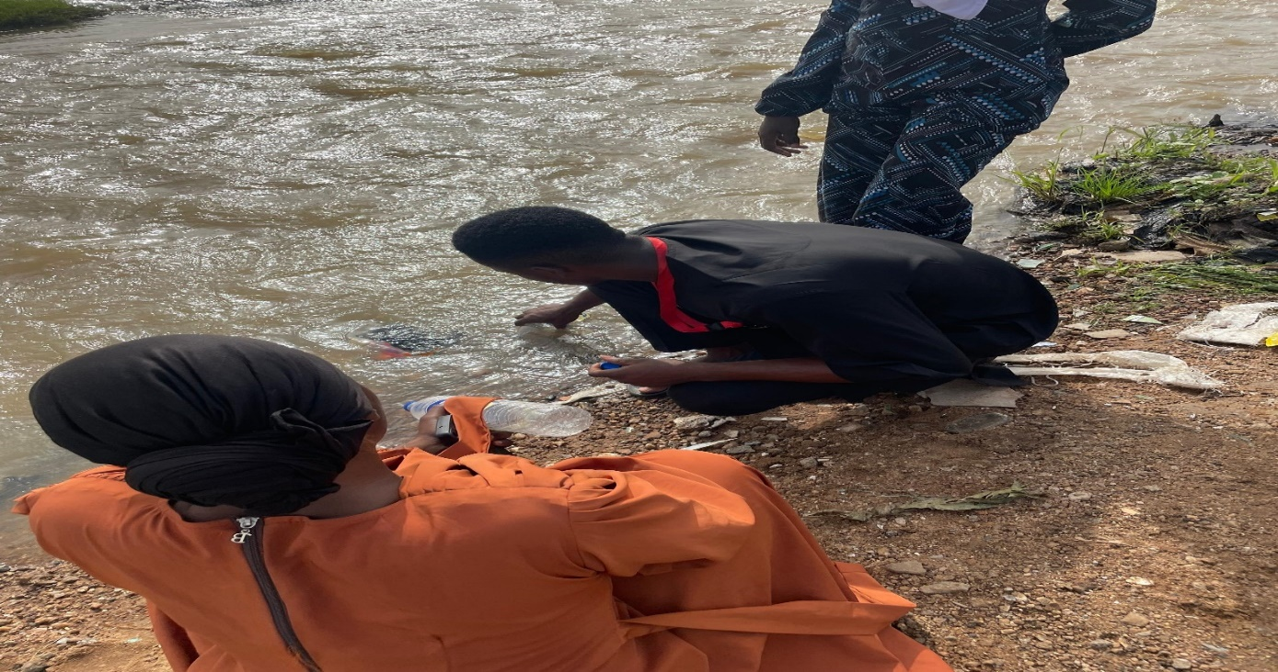
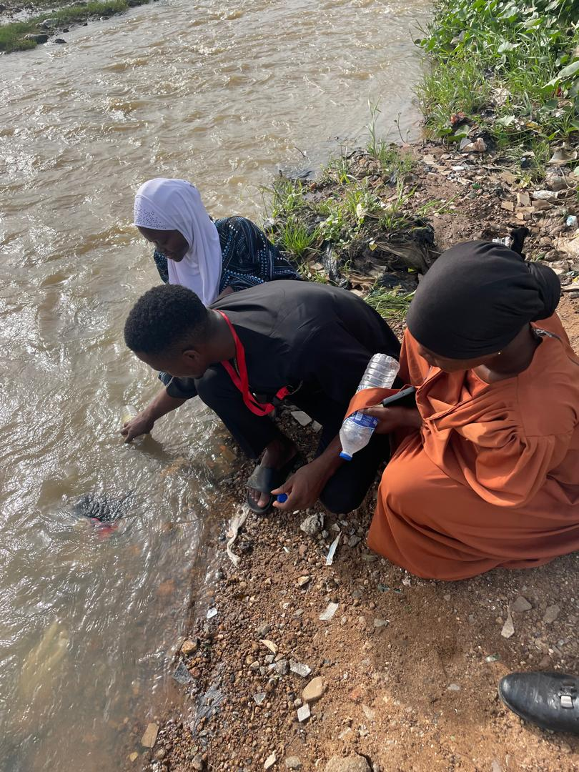
Plate 3.1: Water Sampling Operation at Upstream
Plate 3.2: Water Sampling Operation at Middle Stream
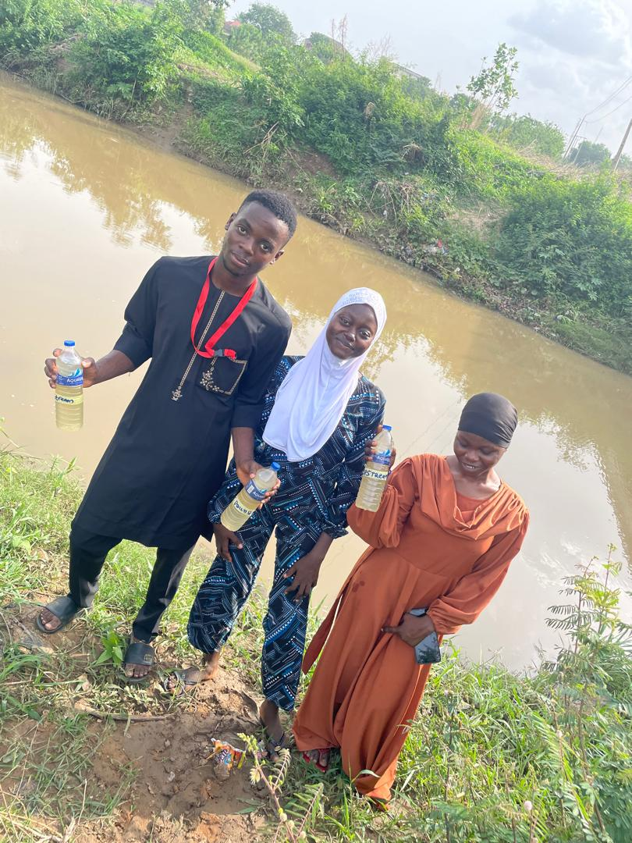
Plate 3.3: Water Sampling Operation at Down Stream
CHAPTER FOUR
RESULT AND DISCUSSIONS
4.1 Results Of The Analysis
Standard procedures were followed to determine the physicochemical parameters of the water samples in Oyun River, and calculations were done where necessary. The results of these procedures are presented in Table 4.1 below.
Table 1: Results of laboratory analysis
S/N Parameter Symbol Unit Upstream Middle Downstream
________________________________________________________________________
Electrical Conductivity ECW ds/m 0.09 0.06 0.07
Total Dissolved Solids TDS mg/l 120.0 180.0 330.0
Calcium Ca++ me/l 2.63 2.63 2.60
Magnesium Mg++ me/l 0.31 0.31 0.30
Sodium Adsorption Ratio SAR me/l 17.0 17.5 17.5
Chloride Cl- me/l 0.56 0.45 0.55
Boron B me/l 0.00 1.09 1.80
Sodium Na+ me/l 21.00 21.22 21.0
Acidity/Basicity pH 5.85 5.73 5.90
Bicarbonate HC03- 2.73 2.72 2.72
Nitrate-Nitrogen N03-N 3.79 4.06 3.92

4.2 Discussion
The analytic methods adopted were based on international acceptable methods and analytical application principles. Even though various kinds of instrument by different manufacturers were use in the course of analysis of the samples, the principles employed were all based on approved standard methods. The summary procedure used for testing each parameter is given below:

4.2.1 Electrical Conductivity (ECW)
Mean conductivity of water samples ranged between 0.09 ds/m and 0.07 ds/m with the lowest being recorded at middle stream and highest at down stream (Table 1). Oyun location recorded a value of 0.39 ds/m, although these values fell within the FAO acceptable limits of 2500μS/cm.

4.2.2 Total Dissolved Solids (TDS)
Mean total dissolved solids concentrations ranged from 120.0 to 330.0 mg/l with the highest values recorded at down-stream and the lowest at up-stream (Table 1). Oyun river recorded a TDS of 120.0 mg/l.The total dissolved solids were within the FAO acceptable limits of 1500 mg/l.
4.2.3 Calcium (Ca)
The most abundant alkaline earth in water is calcium. The analysis, it shows that the presence of calcium in surface water . Surprisingly, high Ca values (2.63 ca++ 2.63 me/l – 2.60 me/l) were recorded at Oyun river. High Ca in water at control than 50mg/L FAO allowable limit set.
4.2.4 Magnesium (Mg++)
The mean value of Mg ranged from (4.66 + 0.92 –5.70 + 0.96 mg/l) in Oyun river locations and (0.31, 0.31 mg/l – 0.30 mg/l) at Oyun river locations in up stream, down stream and middle stream respectively. These values as obtained in the present study are much higher than FAO permissible limit of 0.20 mg/l set for Mg in water.
Exchangeable bases values obtained in the present study were within FAO permissible limit except Mg and Ca with higher values due to natural clay formation from hills close to Oyun river.

4.2.5 Sodium Absorption Ratio (SAR)
The mean sodium levels in the study area ranged between 0.56 me/l recorded at Oyun river to 17.5 me/l recorded at downstream site. Site recorded a mean of me/l. The difference in the sodium levels in all sites were significant (p≤ 0.05) with those of the FAO standard. The sodium levels of the water were much lower as compared to those of FAO limit.
4.2.6 Chloride (Cl)
In Oyun river locations the mean levels of Cl- recorded 0.56, 0.45 and 0.55 mg/l in Oyun river locations recorded a mean Cl- concentration. The negative effect of too much chloride in surface water is that it breaks up organic matter thereby restrain algae growth, cause infertility in fish eggs, fasten corrosion of metal and also affect plant growth. This is the case of the results of the present study.
Chloride content in water from Oyun river locations were too high. This may be the reason for the difficulty in fetching water for domestic use. High chloride content in Oyun rivers may have come from dumping of refuse.
4.2.7 Sodium (Na)
Water normally contains various different broken-down inorganic constituents. Sodium is the world's 6th most plentiful component, tracked down in soils, plants, water, and food. Huge stores of sodium-containing minerals especially sodium chloride are available in the vast majority of the world.
Water normally contains various different broken-down inorganic constituents. Sodium is the world's 6th most plentiful component, tracked down in soils, plants, water, and food. Huge stores of sodium-containing minerals especially sodium chloride are available in the vast majority of the world.
Highest Na (21.00 mg/l) value was recorded at upstream in oyun river and the lowest value (21.0 mg/l) at oyun river. However, middle stream values obtained at oyun river (21.22 mg/l) respectively, were all above FAO permissible limit of
2.5 mg/l set for Na. This is not surprising being upstream. Middle stream and down stream and therefore naturally have salt in them such as NaCl and MgCl2.
4.2.8 pH
Acidity/basicity measures the presence of free CO₂ and dissolution of carbonate rocks found on the ground, produce high acidity which do not encourage the survival of life. Except the control at Oyun river, acidity level of Oyun river was just too high in both wet and dry seasons than the FAO permissible limit of 50 mg/l set for acidity in water.

Nitrate-Nitrogen
Nitrates are essential nutrition in sea-going biological systems; water bodies polluted by natural matter generally have more prominent nitrate levels (Shanthi, Ramasamy, and Lakshmanaperumalsamy,2002).
The mean concentration of nitrates in the surface water ranged between 3.79 mg/l and 3.92 mg/ml. The highest level was recorded at middle stream location while the lowest at downstream location with up stream recording a level of 3.9 mg/l. There was a significant different (p ≤ 0.05) between the mean concentration of nitrates in this area and those of FAO. The mean nitrate levels of the sampled water were above the 10.0 mg/L guideline value prescribed by FAO.
The high levels (as seen in the table 1) is an indication of contaminated water hence rendering it not suitable for human consumption. Elevated nitrate levels in the water may cause methaemoglobinaemia also referred to as ‘blue baby syndrome’ in infants and a cancer of the stomach in adults (FAO, 2011) The high concentration of nitrates-nitrogen in surface water may be due pollution by human and animal sewage through surface runoff into these waters. The use of pit latrines, poor solid waste management is the major sources of nitrates in these wells. High nitrate levels also stimulate algal growth play a role in eutrophication (Steffii et al., 2003).

CHAPTER FIVE
CONCLUSION AND RECOMMENDATIONS
5.1 Conclusions
This study was conducted to access the suitability of Oyun River to ascertain it suitability for irrigated agric culture. Three (3) water samples have been collectd at upper, middle and down stream of the Oyun River. Some physico-chemical properties were evaluated such as Electrical Conductivity (ECW), Total Dissolved Solids (TDS), Calcium (Ca++), Magnesium (Mg++), Sodium Absorption Ratio (SAR), Chloride (Cl-), Sodium (Na+), pH.
The study indicated that the river water is not of good quality for irrigation purpose.
5.2 Recommendations
The following recommendations were made from the result of this study.
  - The farmers should make use of gypsum or ash to improve the reduce the effect of high acidity in the soil caused by application of water during irrigation.
  - Application of manure or fertilizer to the soil is also recommended to improve crop yield.
  - An effective periodic monitoring of the river water quality is recommended.

REFERENCES
A. Abbasnia, M. Alimohammadi, A.H. Mahvi, R. Nabizadeh, M. Youseﬁ, A.A. Mohammadi, H. Pasalari H, M. Mirzabeigi, (2019). Assessment of groundwater quality and evaluation of scaling and corrosiveness potential of drinking water samples in villages of Chabahr city, Sistan and Baluchistan province in Iran, Data Brief 16 182–192.
Adamu M. Youseﬁ, A.A. Mohammadi, M. Yaseri, A.H. Mahvi, 2014: Epidemiology of drinking water ﬂuoride and its contribution to fertility, infertility, and abortion: an ecological study in West Azerbaijan Province, Poldasht County, Iran, Fluoride 50 343–353.

Agwu, P. O. and Orji, O. A., 2011. Morphological and physico-chemical properties of soils formed from diverse parent materials in Cross River State, Nigeria. Journal of Applied Geology and Geophysics, 7(1);1-7
Ajiwe M. Mirzabeygi, A. Abbasnia, M. Yunesian, R.N. Nodehi, N. Youseﬁ, M. Hadi,, (2014): Heavy metal contamination and health risk assessment in drinking water of Sistan and Baluchistan, Southeastern Iran, Human. Ecol. Risk Assess.: Int. J. 23 1893–1905.
Akhter and Brraich, 2020, Modiﬁcation of expected conﬂicts between drinking water quality index and irrigation water quality index in water quality ranking of shared extraction wells using multi criteria decision making techniques, Ecol. Indic. 83 368–379.
Alpha, R. (1999).Medical waste disposalIssue, Practice and Policy.An Indian and International perspective.Seminar on health and environment. Centre for Science and Environment. New Delhi, India.p.235

Ameen, OM, Usman, LA, Oladosu, IA, Olawore, NO, Ogunwande, IA (2011) Bioactivity of rhizome water from two river in Nigeria,. JMPR, 5(6): 1031-1033.
Anako, S. M., Olim, D. M., Akpa, E. A. and Nwangwu, B. C., 2004. Fertility status of selected soils developed on shale and sandstone parent materials in Odukpani LGA, Cross River State, Nigeria. Proceeding of the 44th conference of SSS N. 9-14
APHA. (1999)’ Standard Method for the examination of Water and Wastewater 18th edition, American Public Health Association, Washington, DC pp.45-60.
Cebecauer and Buzna, 2018: Association of hypertension, body mass index and waist circumference with ﬂuoride intake; water drinking in residents of ﬂuoride endemic areas, Iran, Biol. Trace Elem. Res. (2018).
Dibofori-Orji and Marcus, (2011),. Physical and Chemistry and Mineralogy of Soils Derived from Different Parent Materials in Southeastern Nigeria. International Journal of Plant and Soil Science, 25(3): 1-16
Ebong, T. E., Omueti, J. A. I. and Juo, A. S. R. 2001. Physicochemical, morphological and clay mineralogical properties of soils overlying basement complex rocks and Ogoja, Northern Cross River State. Soil Science and plant nutrition. 6(2), 203-214.
Egereonu and Ozuzu, 2005. Physicochemical properties of soils derived from sandstone parent materials under selected land use types at Agoi-Ibami in Central Cross River State, Nigeria. World News of Natural Sciences, 23:1- 12.
Essien O, K.N Benson (2007). Evaluation of groundwater quality of Mubi town in Adamawa State, Nigeria. African Journal of Biotechnology, Vol.7 (11), pp.1712- 1715.
Frank B.E. (2005). Analysis of water Quality of some Selected Open Wells in Zangon Kataf Local Government Area Kaduna State, Nigeria. An Unpublished Undergraduate project Geography Department Bayero University Kano.
Frederic, S., Blinkler, L, Erbe, T., Kummerer and Willmud, R. (2006). Contamination of Hospital Wastewater with hazardous Compounds ActaHydrochim. Hydrobiology, 2:90-97.
Hemmings A. Mohammadi, H. NajaﬁSaleh, A.H. Mahvi, M. Alimohammadi, R. Nabizadeh, M. Youseﬁ., 2015 Hydrologic Research Center – Georgia Water Resources Institute (HRC-GWRI), 2010. Implications of climatic changes for northern California water resources management for the later part of the 21st century. In: California Energy Commission PIER Energy-Related Environmental Research Report CEC-500-07-013. California Energy Commission, Sacramento, 117 pp.
Holden, A.E., Clesceri, L.S and Eaton, A.D. (2006). Standard Methods for the Examination of Water and Wastewater 18th Edition American Public Health Association, American water Works Association and Water Environment Federation , Washington, DC pp.4-89, 4-131.
Ibrahim T, Amadi A. N, (2014). Bacteriological Contamination of Groundwater from Zango Local Government Area, Katsina State, Northwestern Nigeria Journal of Geosciences and Geomatics 2.5 (2014): 186-195
Inyinbor, K. I., Asadu, C. L. A., Ezeaku, P. I., John, K., Eyong, M. O., Kateřina,V., Václav,T., Karel, N., Ondřej, D., and Vít, P. 2011. Genesis and Classification of Soils over Limestone Formations in a Tropical Humid Region. Asian Journal of Scientific Research, 13, 228-243.

Izuagie, Anthony A, Wilson Gitari, Jabulani Ray Gumbo Defluoridation of groundwater using diatomaceous earth: optimization of adsorption conditions, kinetics and leached metals risk assessment
Kaizer I.and Osakwe m.m (2010). Ground Water Quality Assessment inEti- Osa Lagos, Nigeria Using Multivariate Analysis: J. Environ.Manag. 15(1) 121-125.
Jabbo K., Solomon, O. L., Ayito, O. E., Kebonye, M. N., Ogeh, J. S. and Vít, P. 2011. Predictive Mapping of Soil Properties for Precision Agriculture Using Geographic Information System (GIS) Based Geostatistics Models. Modern Applied Science, 13(10), 60-77
Johnson S.M and Belitz P, (2015). Management and control salinity and irrigated agriculture water, Congresso Brasileiro de Engenharia setting.
Lemieux C., V. Koren, S. Reed, M. Smith, Z. Zhang, D.-J. Seo (2015): Hydrology Laboratory Research Modeling System (HL-RMS) of the US National Weather Service.
Mitihell, M., Uluozlu, O.D, Hasdemir, E, Tuzen, M, Sari, H and Suicmez, M. (2007). Determination of trace metal levels in seven fish species in lake in Tokat, Turkey, Food Chemistry, 90 (1-2): 175-179.
Modrick and Georgakakos, 2015, Standard Methods for the Examination of Water and Wastewater, American Public Health Association/American Water Works Association/Water Environment Federation, Washington DC, USA.
Mohammadi, and Caleb (2014): Data on corrosion and scaling potential of drinking water resources using stability indices in Jolfa, East Azerbaijan, Iran, Data Brief 16 724– 731.
Naubi., I. Naubi, N.H. Zardari, S.M. Shirazi, N.F.B. Ibrahim, L. BalooM (2016): Effectiveness of Water Quality Index for Monitoring Malaysian River Water Quality Pol. J. Environ. Stud., 25 (1) (2016), pp. 231-239
Okolo L, Nwachukwu, O. I., Olim, D. M., AFu, S. M., Akpa, E. A. and Adie, P. I., 2014. Comparative effect of organic amendments on heavy metals adsorption in soil and their chemical properties. Asian Journal of Applied Sciences. 9(1), 59-65
Okorie, 2011: Quality control assessment of five pathway water at University of Nigeria.
Pistón F.F, A.C.M. Meireles, E.Md Andrade, L.C.G. Chaves, H. Frischkorn, L.A. Crisostomo, 2012: A new proposal of the classiﬁcation of irrigation water, Rev. Cienc. Agronôm. 41 349–357.
Sanyaolu, P., Sormasekhar, S. A., Kanthi, G. K. and Raghu,B.K. 2013. Analysis of heavy metals by mearthhr
Soleimani, A. Abbasnia, M. Youseﬁ, A.A. Mohammadi, F.C. Khorasgani, (2018): Data on assessment of groundwater quality for drinking and irrigation in rural area Sarpol-e Zahab city, Kermanshah province, Iran, Data Brief 17 148–156.\
Udo, E. J., Ibia, T. O., Ogunwale, J. O., Ano, A. O. and Esu, I. 2013. Manual of soil, plant and water analysis. Lagos: Sibon Books Limited.
World Health Organization (WHO) (1999). Guideline for drinking water quality. In Recommendation, Vol. 1, 2nd ed.World Health Organization, Genevapp.30–113.
World Health Organization (WHO) (2011). WHO Guidelines for drinking water quality, 4th ed.World Health Organization, Geneva.pp. 219-229.

