INTERPRETATION OF AEROMAGNETIC DATA OF ILORIN USING EULER DECONVOLUTION METHOD

BY:

AYOADE ISLAMIYYAH OYENIKE
ND/23/SLT/PT/0637

BEING A PROJECT REPORT SUBMITTED TO THE DEPARTMENT OF SCIENCE LABORATORY TECHNOLOGY (PHYSICS/ELECTRONIC UNIT), INSTITUTE OF APPLIED SCIENCES, KWARA STATE POLYTECHNIC ILORIN

IN PARTIAL FULFILMENT OF THE REQUIREMENTS FOR THE AWARD OF NATIONAL DIPLOMA (ND) IN SCIENCE LABORATORY TECHNOLOGY (SLT), KWARA STATE POLYTECHNC, ILORIN, KWARA STATE

SUPERVISED BY:
Dr. A. J Sunday
JUNE, 2025


DEDICATION
I dedicate this project to the Almighty God, the source of all wisdom, strength, and inspiration. His grace and favor have carried me through the challenges and successes of this academic journey. Without His constant guidance, this work would not have been possible.
This project is also dedicated to my wonderful parents Mr and Mrs Adewale and family members, whose unwavering love, support, and prayers have been my strong foundation. Your encouragement and sacrifices gave me the strength to stay focused and determined.
Lastly, I dedicate this work to my supervisor, Dr. A. J Sunday, in appreciation of his guidance, expertise, patience and unwavering support throughout this project. May God continue to bless us all and make our efforts fruitful.

ACKNOWLEDGEMENT
First and foremost, I give all glory, honor, and thanks to the Almighty God, for His divine protection, wisdom, and strength throughout the course of this research work. His faithfulness and grace have been evident every step of the way, and I send blessings and peace to his beloved messenger, prophet Muhammad (SAW).
I wish to sincerely express my profound gratitude to my project supervisor, Dr. A. J Sunday, for his tireless guidance, patience, and constructive suggestions which helped shape this project into a meaningful and successful work. Your professionalism and mentorship have left a lasting impact on my academic growth, and I am truly grateful.
I extend my heartfelt appreciation to all the lecturers and staff of the Department of Science Laboratory Technology, Kwara State Polytechnic, Ilorin. Your contributions through teaching, mentorship, and encouragement have helped build the knowledge and skills that I now possess.
A special thank you to my parents Mr and Mrs Adewale and family, whose endless love, financial support, and prayers have been my backbone. You believed in me even when I doubted myself, and for that, I am eternally thankful.
To my colleagues, classmates, and friends who provided support, ideas, and motivation throughout this academic journey thank you. Your companionship made this experience not only bearable but memorable.
Lastly, I appreciate everyone who, in one way or another, contributed to the success of this project. May God bless us all abundantly and may he make our knowledge beneficial to us and humanity.
Ameen.

ABSTRACT
The Euler deconvolution of analytical signal of the magnetic field data over Ilorin, North central Nigeria has been carried out to determine the locations and depths of the iron ore bodies and other geologic sources in the area. The methodology adopted was obtaining solutions by inverting Euler homogeneity equation which relates the magnetic field and its gradient components to the location of the source of an anomaly and with the degree of homogeneity expressed as structural index. The Euler deconvolution process was carried out on the analytical grid of aeromagnetic data of the study area using a structural index of 1.0, 2.0 and 3.0 respectively. The Euler solutions for structural index of 1.0 have their depths ranges from 11 to 120m. For the Euler solutions S.I = 2.0, cluster solutions of relatively deep depth of between 234 to 242m are obtained. Their anomalous source location and pattern (Northeast – Southwest) coincides with the outcropped iron ore bodies at the central ore zone of the study area. The estimated depths and geometries provided by the Euler deconvolution result will aid the mine design and the economic exploitation of the iron ore deposit in the study area

TABLE OF CONTENTS
TITLE PAGE
CERTIFICATION
DEDICATION
ACKNOWLEDGMENT
ABSTRACT
TABLE OF CONTENT
CHAPTER ONE:
1.1 INTRODUCTION
1.2 AIM AND OBJECTIVES OF THE STUDY
1.3 LOCATION OF THE STUDY AREA
CHAPTER TWO
2.1 MAGNETIC SURVEYING
2.1.1 GROUND AND AIRBORNE SURVEYS
2.1.2 BOREHOLE MAGNETIC SURVEYS
2.1.3 MARINE MAGNETIC SURVEYS
2.2 MAGNETIC SURVEY INSTRUMENT
2.2.1 HISTORICAL DEVELOPMENT OF MAGNETIC INSTRUMENT
2.2.2 FLUXGATE MAGNETOMETER
2.2.3 PROTON PRECESSION MAGNETOMETER
2.2.4 ALKALI VAPOR MAGNETOMETERS
2.3 ROCK MAGNETIC PROPERTIES
2.4 MAGNETIC DATA PROCESSING
2.4.1 GLOBAL FIELD MODELS
2.4.2 EXTERNAL (TIME-VARYING) FIELD REMOVAL
2.4.3 DECULTURING
2.5 MAGNETIC DATA FILTERING
2.6 DEPTHS-TO-SOURCE ESTIMATION TECHNIQUES
2.6.1 EULER DECONVOLUTION
CHAPTER THREE: METHDOLOGY, DATA ACQUISITION AND ANALYSIS
3.1 DATA ACQUISITION
3.2 DATA PROCESSING
3.2.1 ANALYTICAL SIGNAL MAP
3.2.2 DEPTH TO MAGNETIC SOURCES
CHAPTER FOUR: RESULTS AND DISCUSSION
4.1 MAGNETIC DATA RESULTS
4.2 DISCUSSION
CHAPTER FIVE: CONCLUSION
5.1 CONCLUSION
REFERENCES

CHAPTER ONE
1.1 INTRODUCTION
Exploration of the subsurface requires innovative techniques and the magnetic method offers an excellent opportunity to map the structure and lithology of the subsurface (Okonkwoet al., 2012). The magnetic method involves the measurement of the earth’s magnetic field intensity. Typically, the total magnetic field and vertical magnetic gradient is measured. Measurements of the horizontal or vertical component or horizontal gradient of the magnetic field may also be made (Lowrie, 2007).
The aeromagnetic survey has applied in mapping the magnetic anomalies in the earth’s magnetic field and correlated with the underground geological structure (Bemsenet al., 2013). Generally, aeromagnetic maps reflect the variations in the magnetic field of the earth. These variations are related to changes of structures, magnetic susceptibilities and/or remnant magnetization (Vitaliset al., 2013). Linear features are clearly discernible on aeromagnetic maps and often indicate the form and position of individual folds, faults, joints, veins, lithologic contacts, and other geologic features that may lead to the location of individual mineral deposits. They often indicate the general geometry of subsurface structures of an area thereby providing a regional structural pattern (Oparaet al., 2012).While aeromagnetic surveys are extensively used as reconnaissance tools, there has been an increasing recognition of their value for evaluating prospective areas by virtue of the unique information they provide (Adetona and Abu, 2013).
In exploration, they historically have been employed chiefly in the search for minerals. Regional and detailed magnetic surveys continue to be a primary mineral exploration tool in the search for diverse commodities, such as iron, base and precious metals, diamonds, molybdenum, and titanium. Historically, ground surveys and today primarily airborne surveys are used for the direct detection of mineralization such as iron oxide–copper–gold (FeO-Cu-Au) deposits, skarns, massive sulfides, and heavy mineral sands; for locating favorable host rocks or environments such as carbonatites, kimberlites, porphyritic intrusions, faulting, and hydrothermal alteration; and for general geologic mapping of prospective areas (Nabighianet al., 2005).
The Euler deconvolution is an interpretation tool in potential field(magnetic data) for locating anomalous sources and the determination of their depths by deconvolution using Euler’s homogeneity relation (Reid et al., 1990).The Euler deconvolution has become a popular choice because the method assumes no particular geological model and has quick means of turning magnetic field measurements into estimates of magnetic source body location and depth. It is the method of depth estimation which is best suited for anomalies caused by isolating and multiple anomalous sources (Sunmonuet al., 2013).
1.2 AIM AND OBJECTIVES OF THE STUDY
The aim of this study is to use Euler deconvolution technique to estimate the depths to various magnetic rocks in the study area using high resolution aeromagnetic data. The objectives of this research include the following:
- To estimate the depth to the magnetic sources in the study area.
- To provide information about the geometry of the magnetic sources using different structural indicesin the study area.
1.3 LOCATION OF THE STUDY AREA
The study area, Ilorin, lies between Longitude 4.30E and 4.60E and Latitude 5.00$°$N and 5.30$°$N.
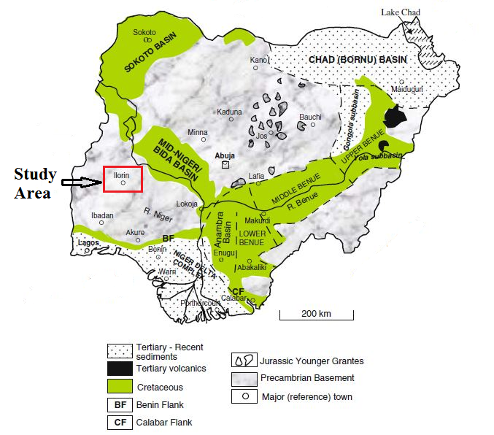
Figure 1.1: Map of Nigeria indicating the Study Area

CHAPTER TWO
2.1 MAGNETIC SURVEYING
Magnetic surveys can be carried out on land, in the air, on the ocean, in space, and down boreholes, covering a large range of scales and for a wide variety of purposes. Measurements acquired from all but the borehole platform focus on variations in the magnetic field produced by lateral variations in the magnetization of the crust. Borehole measurements focus on vertical variations in the vicinity of the borehole.
2.1.1 GROUND AND AIRBORNE SURVEYS
Ground and airborne magnetic surveys are used at just about every conceivable scale and for a wide range of purposes. Aeromagnetic surveys coupled with geologic insights were the primary tools in discovering the Far West Rand Goldfields gold system, one of the most productive systems in history (Roux, 1970). Kimberlites (the host rock for diamonds) are explored successfully using high-resolution aeromagnetic surveys (positive or negative anomalies, depending on magnetization contrasts) (Macnae, 1979; Keating, 1995; Power et al., 2004). Another economically important use of the magnetic method is the mapping of buried igneous bodies. These generally have higher susceptibilities than the rocks that they intrude, so it is often easy to map them in plain view. Commonly, the approximate 3D geometry of the body can also be determined. Because igneous bodies are frequently associated with mineralization, a magnetic interpretation can be the first step in finding areas favorable for the existence of a mineral deposit. In sedimentary basins, buried igneous bodies may have destroyed hydrocarbon deposits in their immediate vicinity, their seismic signature can be mistaken for a sedimentary structure (Chapin et al., 1998), or their orientation is important in understanding structural traps in an area (e.g., the Eocene Lethbridge dikes in southern Alberta, Canada).
2.1.2 BOREHOLE MAGNETIC SURVEYS
Borehole measurements of magnetic susceptibility and of the three orthogonal components of the magnetic field began in the early 1950s (Brodinget al., 1952). Both types of measurements can be used to determine rock magnetic properties, which aids in geologic correlation between wells. However, magnetic-field measurements in boreholes also can be used to determine both location and orientation of magnetic bodies missed by previous drilling. Levanto (1959) describes the use of three-component fluxgate magnetometers to determine the extension of magnetic ore bodies. Interpretation of borehole magnetic surveys was originally accomplished graphically by plotting the field lines along the borehole, extrapolating them outside the borehole, and looking for areas of field-line convergence. Least-square techniques were also employed to determine the parameters of the magnetic body (Silva and Hohmann, 1981). Today, acquisition of borehole magnetic surveys is not common practice, perhaps owing to the expense required in accurately determining borehole azimuth and dip.
2.1.3 MARINE MAGNETIC SURVEYS
Marine magnetic measurements began at Lamont in the late 1940s (Oreskes, 2001) and led to the development of the Vine-Matthews-Morley model of seafloor spreading (Dietz, 1961; Hess, 1962; Vine and Matthews, 1963; and Morley andLarochelle, 1964). The name of this model has been updated by consensus (Vine, 2001) to recognize Larry Morley of the Geological Survey of Canada as the independent developer of the theory of seafloor spreading (Morley’s original paper, which was rejected in early 1963, is reproduced in Morley, 2001). In fact, these marine magnetic measurements were a major factor in the acceptance of both the plate-tectonic theory and of the dynamo theory of generation of the earth’s core field. The seafloor spreading model is based on the concept that the seafloor is magnetized either positively or negatively, depending on the polarity epoch of the earth’s magnetic field. New seafloor is created at mid-ocean ridges and becomes part of oceanic plates moving away from the spreading center. Thus, magnetic anomalies along a section transverse to the spreading center show a regular pattern of highs and lows (stripes) — often symmetric about the spreading center — that can be calibrated in age to the geomagnetic timescale (this timescale was new and unproven in 1963; a more recent compilation accompanies the Geological Society of America’s 1999 geologic timescale). Leg 3 of the original Deep Sea Drilling Project (Maxwell and von Herzenet al., 1970) was designed to test the theory of sea-floor spreading by comparing the paleontological ages of the oldest sediments in the South Atlantic Ocean to the ages predicted by the seafloor spreading hypothesis. The two sets of ages matched very well, and the Vine-Matthews-Morley model was generally accepted; plate tectonics became a new paradigm in earth sciences. Marine magnetic measurements also are routinely used for normal exploration applications, although not in the volume of aeromagnetic work.
2.2 MAGNETIC SURVEY INSTRUMENT
2.2.1 HISTORICAL DEVELOPMENT OF MAGNETIC INSTRUMENT
The Swedish mining compass was one of the earliest magnetic prospecting instruments. Developed in the mid-nineteenth century, it consisted of a light needle suspended in such a way as to allow it to move in both horizontal and vertical directions. An improved version, the American mining compass, was developed around 1860. These were the first in a class of so-called dipping-needle instruments with automatic meridian adjustment. Although still in use these instruments were soon replaced by earth inductors, which could measure both the inclination and the various components of the earth’s magnetic field from the voltage induced in a rotating coil. In 1936, Logachev (1946) used such a device with a sensitivity of about 1000 nT over the Kursk iron-ore deposit (Reford and Sumner, 1964). Soon after, the Schmidt vertical magnetometer was developed, which could measure the vertical component of the earth’s magnetic field using a magnetic system (rhomb-shaped needle) oriented at a right angle to the magnetic meridian; it measured the system dip through a mirror attached to the needle and an auto-collimation telescope system. The vertical magnetometer was followed by the Schmidt horizontal magnetometer, which measured the horizontal component of the earth’s field. Both instruments had an accuracy of 10–20 nT.The Schmidt magnetometers came to be known as Askania- Schmidt magnetometers. In 1910, Edelman designed a vertical balance to be used in a balloon (Heiland, 1935). In 1946, a vertical-intensity magnetometer of the earth-inductor type was introduced by Lundberg (1947) for helicopter surveys, and a vibrating coil variety of the earth-inductor magnetometer was developed for bothairborne and ship-borne use (Frowe, 1948).A complete description of early magnetic prospecting instrumentsand their uses can be found in Heiland (1940),Jakosky (1950), and Reford and Sumner (1964).
2.2.2 FLUXGATE MAGNETOMETER
The fluxgate magnetometer was developed during World War II for airborne antisubmarine warfare applications; after the war, it was immediately adopted for exploration geophysics and remained the primary airborne instrument until the proton precession magnetometer was introduced in the 1960s. Fluxgate magnetometers today have two major applications. In airborne systems they are used in a strap-down (non-oriented) configuration to perform heading corrections by measuring the altitude of the aircraft in the earth’s field. They are also the dominant instrument in down-hole applications because of their small size, ruggedness, and ability to tolerate high temperatures. The basic elements of a fluxgate magnetometer are two matched cores of highly permeable material, typically ferrite, with primary and secondary windings around each core. The primary windings are connected in series but with opposite orientations and are driven by a 50–1000-Hz current which saturates the cores in opposite directions, twice per cycle. The secondary coils are connected to a differential amplifier to measure the difference between the magnetic fieldsproduced in the two cores. This signal is asymmetrical because of the ambient magnetic field along the core axis, producing a spike at twice the input frequency whose amplitude is proportional (for small imbalances) to the field along the core axis. A detailed discussion of the fluxgate magnetometer can be found in Telford et al. (1990). Typically, fluxgate elements are packaged into sets of threecore pairs with orthogonal axes, so all three components of the earth’s field can be measured. The resolution of a fluxgatesystem is dependent on the accuracy with which the cores andwindings can be matched, hysteresis in the cores, and relatedeffects; nevertheless, fluxgate units with better than 1 nT sensitivity are widely available. They are rugged, lightweight, and can be operated at relatively high measurement rates. Their major disadvantage for airborne applications is that because they are component instruments, they must be oriented. At least until recently, the accuracy of fluxgate measurements was limited by the stability of the gyro tables on which they were mounted.
2.2.3 PROTON PRECESSION MAGNETOMETER
Proton precession magnetometers were introduced in the mid-1950’s, and by themid-1960s had supplanted fluxgate magnetometers for almost all exploration applications. Proton precession magnetometers do not require orientation, a great advantage over earlier devices. The proton precession magnetometer is based on the splitting of nuclear spin states into sub-states in the presence of an ambient magnetic field by an amount proportional to the intensity of the field and a proportionality factor (the nuclear gyromagnetic ratio), which depends only on fundamental physical constants. The sensor consists of a quantity ofmaterial with odd nuclear spin, almost always hydrogen. The actual sensor filling is usually charcoal lighter fluid, decane, benzene, or, if necessary, even water. The sensor is surrounded by a coil through which a dc current is applied. This induces transitions to the higher energy of two nuclear spin sub-states. The current is then turned off and used to detect the fields associated with the transition back to the lower of the spin sub-states. This transition emits an electromagnetic field whose frequency is proportional to the earth’s field intensity, around 2 kHz. A frequency counter is then used to measure the field strength. The full treatment of the physics behind proton precession magnetometers (Hall, 1962) is usually explained intuitively in textbooks by envisioning the transition between nuclear sub-states as a precession ofthe nuclear magnetic moments around the earth’s field directionat an angular frequency proportional to the intensity ofthe field.The proton precession magnetometer has a number of advantages: it is rugged, simple, has essentially no intrinsic heading error, and does not require an orienting platform. However, to obtain reasonable signal strength, a fairly large quantity of sensor liquid and a large coil are required, making the instrument somewhat heavy, bulky, and power hungry. Furthermore, because a significant polarizing time is required and because the output signal is only around 2 kHz, the sample rate is somewhat limited if reasonable sensitivity is required. The best airborne units (now out of production) had a sensitivity of 0.05 nT at 2 Hz. More typical values would be 0.1nTat 0.2 Hz for portable instruments still in use. A variant (the Overhauser magnetometer) uses radiofrequency excitation and effectively displays continuous oscillation, which can be sampled at 5 Hz with resolution of 0.01 nT. The Overhauser variant also offers the lowest power drain of any modern magnetometer, a small sensor head, and minimal heading error. It is widely used in subsea magnetometers and is also used for airborne and ground survey work, often in gradient arrays.
2.2.4 ALKALI VAPOR MAGNETOMETERS
Alkali vapor magnetometers, with sensitivities around 0.01 nT and sample rates of 10 Hz, appeared in laboratories about the same time that proton precession magnetometers became popular field instruments. Because they were more fragile than proton precession magnetometers, and because the increased sensitivity was of marginal value,their use as field instruments was mostly restricted to gradiometers until the late 1970s. Today, alkali vapor magnetometers are the dominant instrument used for magneticsurveys, although some proton precession instruments are still in use for ground surveys, and fluxgates are used for borehole surveys. The operating principle and the actual construction of alkali vapor magnetometers are somewhat complex. However, since they have become the dominant type in current airborne, ship-borne, and ground exploration, a summary explanation of their operation is appropriate. The sensing medium is an alkali vapor consisting of atoms randomly distributed between two different atomic-energy levels, separated by energy equivalent to a visible frequency. In the presence of a magnetic field, the most stable energy level is split (Zeeman splitting) by an amount proportional to the magnitude of the field. For ambient fields of around 50 000 nT, the splitting energy will correspond to a frequency in the range of a few hundred kHz, i.e., the AM radio band. By shining light of the correct frequency through a vapor of a single-valence atom such as cesium or potassium, all of the electrons are forced into the higher-energy component of the split state (optical pumping). When this absorption is complete, the glass cell in which the vapor is contained becomes transparent because there are no further electrons to absorb the pumping radiation. Now, a radio-frequency field is applied to this cell. If the field is of exactly the right frequency, the electrons are redistributed back to the lower level, and the cell becomes opaque. The correct frequency depends on the ambient magnetic-field strength, so a swept-frequency field is applied, and the precise frequency at which opacity occurs is used to derive the ambient-field intensity. Alkali vapor instruments have excellent sensitivity, better than 0.01 nT. Because the frequency can be swept rapidly, 10-Hz sample rates are typical, and considerably higher ones are possible. These features account for the overwhelming popularity of this design. In addition, alkali vapor magnetometers are built to be lightweight and compact. The less desirable features are the fragility of the glass envelope and an intrinsic heading error. A good discussion of alkali vapor magnetometers can be found in Telford et al. (1990).
2.3 ROCK MAGNETIC PROPERTIES
In geologic interpretation of magnetic data, knowledge of rock-magnetic properties for a particular study area requires an understanding of both magnetic susceptibility and remanent magnetization. Seventy-five years ago, studies were already underway to explain the geologic factors influencing rock-magnetic properties that produce magnetic anomalies (Slichter, 1929; Stearn, 1929a). Factors influencing rock magnetic properties for various rock types are summarized by Haggerty (1979), McIntyre (1980), Clark (1983, 1997), Bath and Jahren (1984), Grant (1985), Reynolds et al. (1990a), and Clark and Emerson (1991). The Norwegian, Swedish, and Finnish surveys have been amassing large amounts of rock property information in conjunction with their national geophysical programs. Several studies have focused on developing classification schemes based on the statistical correlations between rock types and these petro-physical measurements (Korhonenet al., 2003). Less progress has been made in understanding how information on magnetic properties measured from hand samples can be transferred to scales more appropriate for aeromagnetic interpretation. Reford and Sumner (1964) and Clark (1983) discussed how the high variability of properties measured in hand samples contradicts the apparent homogeneity in the bulk effects of large bodies at the scale of aeromagnetic studies. Understanding this contradiction remains elusive, especially in understanding sedimentary sources. Improved understanding may result from case studies that directly investigate the relationship between magnetic anomalies, rock properties, and geology (Abaco and Lawton, 2003; Davies et al., 2004). The importance of sedimentary sources of magnetic anomalies was the subject of considerable discussion before the end of WorldWar II (e.g., Jenny, 1936; Wantland, 1944).Magnetic anomalies produced by glacial till were also widely known(summarized in Gay, 2004). However, experience with therelatively low resolution of the early aeromagnetic data allowed workers to effectively ignore their effects (Steenland, 1965; Nettleton, 1971), giving rise to the misconception that sediment are nonmagnetic. As data resolution increased, magnetic anomalies arising from sedimentary sources were again recognized (Grant, 1972). This recognition gained prominence in the 1980s, when studies were initiated to test for magnetic effects related to hydrocarbon seepage. These and subsequent studies demonstrated that magnetization capable of producing aeromagnetic anomalies in clastic sedimentary rocks and sediments arise from the abundance of detrital magnetite (Reynolds, Rosenbaum et al., 1990, 1991; Gay and Hawley, 1991; Gunn, 1997, 1998; Wilson et al., 1997; Grauchet al., 2001; Abaco and Lawton, 2003), remanence residing in iron sulfides that replaced the original detrital material (Reynolds, Rosenbaum et al., 1990, 1991), or possibly some other kind of remanence (Phillips et al., 1998). A recent study of the Edwards aquifer in central Texas has revealed, in a low-level helicopter survey, that carbonates may also contain enough detrital magnetite to produce magnetic anomalies at faults (Smith and Pratt, 2003). At local scales, magnetite can be produced by microbial activity (Machel and Burton, 1991) or destroyed by sulfidization(Goldhaber and Reynolds, 1991) in processes related to hydrocarbon migration, although it is still debated whether this effect can be detected from airborne surveys (Gay, 1992; Reynolds et al., 1990; Millegan, 1998; Stone et al., 2004). Morgan (1998) postulates that weak aeromagnetic lows in oil fields of the Irish Sea are caused by complex migration and mixing of fluids with hydrocarbons that reduced the magnetization of the host sandstones. The importance of remanent magnetization in magnetic interpretation has been recognized by many previous workers (see references in Zietz and Andreasen, 1967). To simplify analytical methods, remanent magnetization has beencommonly neglected or assumed to be collinear with the inducedcomponent. Bath (1968) considered remanent and induced components within 25◦ of each other to be collinear for practical purposes. Although valid in many geologic situations, a common misconception is that only mafic igneous rocks have high remanence. Several rock-magnetic and aeromagnetic studies have shown that remanence can be very high in felsic ash-flow tuffs (Bath, 1968; Rosenbaum and Snyder, 1985; Reynolds, Rosenbaum et al., 1990a; Grauchet al., 1999; Finn and Morgan, 2002).
2.4 MAGNETIC DATA PROCESSING
Data processing includes everything done to the data between acquisition and the creation of an interpretable profile, map, or digital data set. Standard steps in the reduction of aeromagnetic data, some of which also apply to marine and ground data, include removal of heading error and lag, compensation for errors caused by the magnetic field of the platform, the removal of the effects of time-varying external fields, removal of the International Geomagnetic Reference Field, leveling using tie-lines, micro-leveling, and gridding. One comprehensive reference that summarizes most aspects of magnetic data processing is Blakely (1995).
2.4.1 GLOBAL FIELD MODELS
The main component of the measured magnetic field originates from the magnetic dynamo in the earth’s outer core (Campbell, 1997). This field is primarily dipolar, with amplitude of around 50000 nT, but spherical harmonic terms up to about order 13 are significant. Since the core field is almost always much larger than that of the crustal geology, and since it has a significant gradient in many parts of the world, it is desirable to remove a model of the global field from the data before further processing; this can be done as soon as all positioning errors are corrected. The model most widely used today is the International Geomagnetic Reference Field (IGRF, Maus and Macmillan, 2005). It was established in 1968 and became widely used with the availability of digital data in the mid-1970s (Reford, 1980). In 1981 the IGRF was modified in order to be continuous for all dates after 1944 (Peddie, 1982, 1983; Paterson and Reeves, 1985; Langel, 1992). Today, the IGRF is updated every five years and includes coefficients for predicting the core field into the near future. Coefficients are available for the time period 1900 through 2005 (Barton, 1997; Macmillan et al., 2003). In practice today, the IGRF is calculated for every data point before any further processing. Prior to GPS navigation, however, it was common practice to level surveys first, and thenremovesa trend based on the best fit, either to the data or to a few IGRF values. For many of the earliest analog surveys, an arbitrary (sometimes unspecified) constant was subtracted from the measured data solely as a matter of convenience before contouring. In the future, the IGRF is likely to be supplanted by the Comprehensive Model (CM), which does a much better job of modeling time-varying fields from a variety of sources (Sabakaet al., 2002, 2004; Ravatet al., 2003).
2.4.2 EXTERNAL (TIME-VARYING) FIELD REMOVAL
Ground-based and airborne surveys generally include a stationary magnetometer that simultaneously measures the stationary,time-varying magnetic field for later subtraction from the survey data (Hoylman, 1961; Whitham and Niblett, 1961; Morley, 1963; Reford and Sumner, 1964; Paterson and Reeves, 1985). There is still considerable debate on how many base stations are needed to adequately sample the spatial variations of the external field for larger surveys or when the survey area is at a considerable distance from the base of operations. At sea, it is generally not possible to have a base-station magnetometer in the survey area, and the problem is either ignored or measurements are made in a gradient mode. The measurement of multi-sensor gradiometer data can reduce the need for a base station because the common external signal at the two sensors is removed by the differencing process, but recovery of the total field data from the gradiometer data can be difficult (Breiner, 1981; Hansen, 1984; Paterson and Reeves, 1985).
A method to fit distant base signals to the field signal in order to remove time-varying effects was proposed by O’Connel (2001) using a variable time-shift cross-correlator. The leveling of surveys using tie-lines was originally developed as an alternative to the use of base-station data (Whitham andNiblett, 1961; Reford and Sumner, 1964; Mittal, 1984; Paterson and Reeves, 1985) but is now a standard step after base-station correction. The purpose of leveling today is to minimize residual differences in level between adjacent lines and long-wavelength errors along lines that inevitably remain after compensation and correction for external field variations by base station subtraction. These residual long-wavelength effects, even if small, can be visually distracting, particularly on image displays. A set of tie-lines perpendicular to the main survey lines is normally acquired for leveling. The tie-line spacing is generally considerably greater than that of the main survey lines, although 1:1 ratios have been used where geologic features lack a dominant strike. The differences in field values at the intersections of the survey and tie-lines are calculated and corrections are applied to minimize these differences. A numberof different strategies for computing these corrections are in use. Perhaps the most common is to calculate a constant correction for all lines by least-squares methods, sometimes augmented to a low-order polynomial. Other algorithms regard the tie-lines as fixed and adjust only the survey lines. All of these strategies are empirical, and no one method performs best under all circumstances.
2.4.3 DECULTURING
Cultural anomalies are a serious problem in the geologic interpretation of airborne magnetic data, especially modernHRAM surveys that typically fly low above cultural sources. Many man-made structures (e.g., wells, pipelines, railroads,bridges, steel towers, and commercial buildings) are ferrousand so create sharp anomalies of tens to hundreds of nanoteslas.Cultural anomalies are often much larger in magnitude than the geologic anomalies of interest. Moreover, their shapes are effectively spikes with broadband frequency responses, making them difficult if not impossible to remove with linear filters. Several approaches have been developed for cultural editing. The utility of each approach depends on the magnitude and type of cultural anomalies present. One approach is to avoid flying low-level surveys to suppress the cultural signal (Balsley, 1952), but this may diminish useful geological signals from shallow sources and does not eliminate noise spikes.
2.5 MAGNETIC DATA FILTERING
The beginning stages of magnetic data interpretation generallyinvolve the application of mathematical filters to observed data. The specific goals of these filters vary, depending on the situation. The general purpose is to enhance anomalies of interest and/or to gain some preliminary information on source location or magnetization. Most of these methods have a long history, preceding the computer age. Modern computing power has increased their efficiency and applicability tremendously, especially in the face of the ever-increasing quantity of digital data associated with modern airborne surveys. Most filter and interpretation techniques are applicable to both gravity and magnetic data. As such, it is common, when applicable, to reference a paper describing a technique for filtering magnetic data when processing gravity data and vice versa.
2.6 DEPTHS-TO-SOURCE ESTIMATION TECHNIQUES
With the first aeromagnetic surveys came the recognition that the largest magnetic anomalies were produced by sources near the top of the crystalline basement, and that the wavelengths of these anomalies increased as the basement rocks became deeper. Techniques were devised to estimate the depths to the magnetic sources and, thus, the thickness of the overlying sedimentary basins. Mapping basement structure became an important application of the new aeromagnetic method. Early depth-to-source techniques were mostly of graphical nature and applicable only to single-source anomalies (Henderson and Zietz, 1948; Peters, 1949; Vacquieret al.,1951; Smellie, 1956; Hutchison, 1958; Grant and Martin, 1966; Koulomzineet al., 1970; Barongo, 1985). These techniques estimated target parameters by looking at various attributes of an anomaly (curve matching, straight-slope, half-width, amplitude, horizontal extent between various characteristic points, etc.). The straight-slope method in particular enjoyed immense popularity with interpreters working in petroleum exploration. Smith (1959) gave various rules for estimating the maximumpossible depth to various magnetic sources. Trial-and-error methods were also developed (Talwani, 1965), in which magnetic anomalies were calculated iteratively until a good fit with observed data was obtained. In the 1970s, automated depth analysis began to supplant the graphical and trial-and-error techniques. These new methods took advantage of the digital aeromagnetic data that began to appear at that time, and they typically generated large numbers of depth estimates along magnetic profiles based on simple but geologically reasonable 2D models such as sheets, contacts, or polygonal corners. Because validity of the models could not be assumed, the depth estimates still needed to be tested for reasonableness by appropriate forward modeling. In the 1990s, 3D automated depth-estimation methods began to appear. These were largely extensions of 2D methodsdesigned for application to gridded magnetic data. Most of the methods mentioned below still exist in commercial or public domain software. There is no best method, and it is wise to use a variety of methods to identify consistent results: forwardmodeling is still a good idea.
2.6.1 EULER DECONVOLUTION
The methodology as described by Reid, (1980) and Thompson, (1982) in obtaining solutions by inverting Euler homogeneity equation was adopted in this study. According toYaghoobianet al., (1992), the Euler’s homogeneity equation relates the magnetic field and its gradient components to the location of the source of an anomaly, with the degree of homogeneity expressed as a structural index. Euler’s homogeneity relationship can be written (Reid et al.,1990) for magnetic data in the form:
$$\left(x-x_{0}\right)\frac{∂T}{∂X}+\left(y-y_{0}\right)\frac{∂T}{∂Y}+\left(z-z_{0}\right)\frac{∂T}{∂Z}=N(B-T)$$
Where (x, y, z) are the coordinates of the observation point, N=-n, where n is degree of homogeneity, and N is a coefficient, called structural index (Thompson 1982). The structural index depends on the geometry of the source. For a homogeneous point source N = 3, a linear source (line of dipoles or poles, and for a homogeneous cylinder, rod, etc.) N = 2, for extrusive bodies (thin layer, dike, etc.) N = 1, for a contact, vertex of a block and a pyramid with a big height N = 0. The unknown coordinates ($x_{0},y_{0},z_{0}$) are estimated by solving a determined system of linear equations using a prescribed value for N with the least squares method. And a solution with aminimum standard deviation is found through usingdifferent tentative values for N. In the above equation, B denote the base level of the observed field i.e. background field.
The structural index is a measure of the fall-off rate of the field with distance from the source. The choice of a proper S.I is a function of the geometry of causative bodies. Estimation of the correct structural index is crucial for the successful application of the Euler deconvolution method (Reid et al., 1990). And this is achieved by using the index that produces the best clustering of solutions (Reid, 1995). Incorrect choice of structural index leads to errors in estimated source depths (Ravart, 1996). Euler deconvolutionused the magnetic field and its three orthogonal gradients (two horizontal and one vertical) to compute anomaly source locations (Keating and Pilkington, 2004). The three – dimensional (3D) analytical signal is calculated from the three orthogonal gradients of the magnetic field (Roestet al., 1992). (Amigun,et al.,2012).

CHAPTER THREE
METHDOLOGY, DATA ACQUISITION AND ANALYSIS
3.1 DATA ACQUISITION
Aeromagnetic datasheet/map with sheet number 223 was used for this study. The square map is about 55 X 55 km² covering an area of 3, 025km². The new high resolution aeromagnetic survey carried out for the Nigerian Geological Survey Agency by Furgo Airborne Services in 2009 which was flown at 500m line spacing and 80m terrace clearing using various survey parameters, softwares and errors which were corrected during surveys. This created a higher resolution data in digital form too as shown in Figure 3.1 and eliminated many errors associated with the old map.
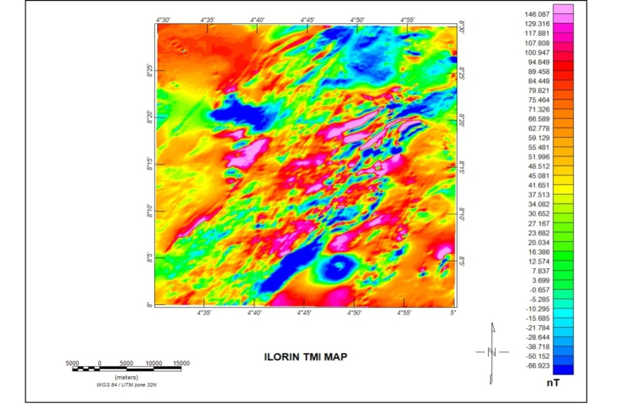
Figure 3.1: TMI of study area
3.2 DATA PROCESSING
Aeromagnetic data processing for this study involves the following: application of enhancement technique, the application of a gridding routine and removal of the Earth’s background magnetic field. Corrections such as background corrections (aircraft), stripping, micro-levelling, removing diurnal variation of the Earth’s magnetic field, aircraft heading, instrument variation, lag error between aircraft and the sensor and inconsistencies between flight lines and tie lines were done by the FurgoAirbone Services. Oasis Montaj Software was employed for the processing and enhancement of the aeromagnetic geophysical data.
3.2.1 ANALYTICAL SIGNAL MAP
The residual magnetic field which was separated from the Total Magnetic Intensity (TMI) map which was later used to obtain the analytical signal amplitude and used to visualize the distribution of the magnetic signature independent of the direction of magnetization. The analytical signal is formed through the combination of the horizontal and vertical gradients of the magnetic anomaly. Analytical signal amplitude is related to the amplitude of magnetization and however independent of the direction of magnetization and dependent on the location of the magnetic bodies.
3.2.2 DEPTH TO MAGNETIC SOURCES
In order to determine the depth to various or idealized magnetic bodies in the study area, Euler deconvolution technique was employed using the Oasis Montaj Software. For location and depth determination of causative anomalous bodies from gridded potential field datathe Euler deconvolution algorithm in Oasis Montaj was used. For the purpose of this method,we start by calculating the analytic signal grid then determine the peaks in the grid whose locations are later used for Euler deconvolution. Applying Eulerdeconvolution to each solution involves assigning values tostructural index (SI) and using least – squares inversion to solve the equation for an optimum$x_{0}, y_{0}, z_{0}$, and total magnetic field intensity (B). The window size and the respective number of the observation points, for which the system of linear equations is formed are also parameters in solving the inverse magnetic problem. Window of 10 x 10m data points prove most suitable in this study and were used. Solutions with depths to source above the error tolerance levels were rejected.
CHAPTER FOUR
RESULTS AND DISCUSSION
4.1 MAGNETIC DATA RESULTS
The depth estimation using Euler deconvolution technique is shown in figures 4.1.1 – 4.1.6. These figures shows the estimation source position and depth of structural indices, S.I = 1.0, S.I = 2.0, and S.I = 3.0 for each TMI sheet namely (Ilorin and Osi).
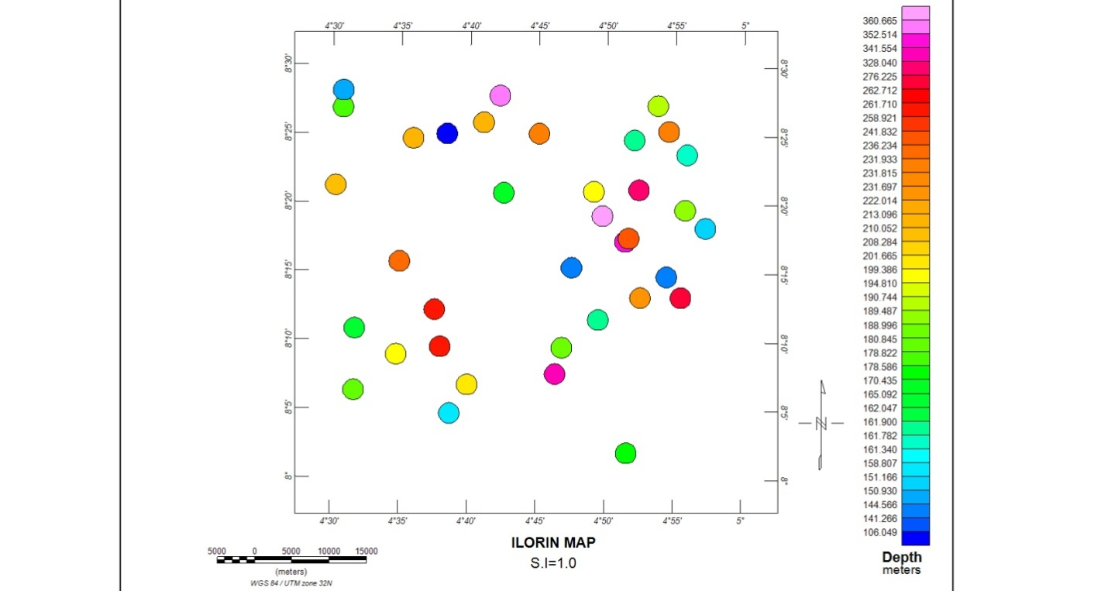
Figure 4.1.1: The Euler Deconvolution Depth Plot of the Study Area for S.I = 1.0
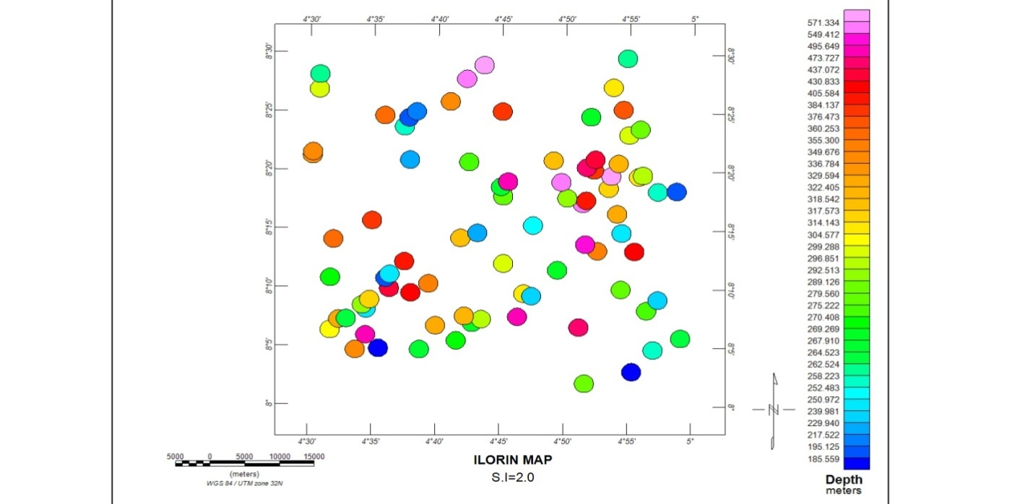
Figure 4.1.2: The Euler Deconvolution Depth Plot of the Study Area for S.I = 2.0

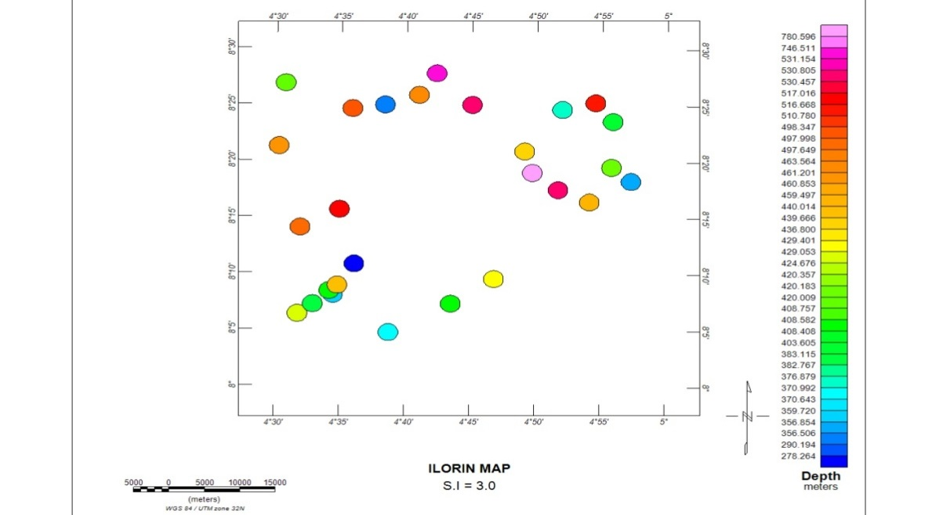
Figure 4.1.3: The Euler Deconvolution Depth Plot of the Study Area for S.I = 3.0

4.2 DISCUSSION
The Euler solutions for structural index of 1.0 of the magnetic anomalies shown in Figure 4.1.1 have their depths ranges from 106 to 360m. The clusters of solutions (circles) produced over anomalies for S.I = 1.0 as observed are spread out. The solutions for relatively deep depths i.e. from red (241m) to lilac (360m) are located in the northeastern part and coincide with the northern zone in the study area in Figure 3.1.The value of the structural index, 1.0 is typical for a sill or dyke (Yaghoobianet al., 1992).
Figure 4.1.2 shows the Euler solutions for structural index of 2.0 of the magnetic anomalies, having their depths range from 185 to 571m. The cluster of solutions (circles) produced over anomalies for S.I = 2.0 as observed are diffused. The solutions for relatively deep depth from 384m to 571m are located majorly in the northeastern part which coincides with the northern zone in the study area in Figure 3.1. The value of the structural index, 2.0 is typical for cylinder or rod (Yaghoobianet al., 1992).
Figure 4.1.3 shows the Euler solutions for structural index of 3.0 of the magnetic sources, having their depths ranges from 276 to 750m. The cluster solutions (circles) produced over anomalies for S.I = 3.0 are highly diffused with relatively deep depth from 510m to 750m which are located in the northeastern part which coincides with the northern zone in the study area in Figure 3.1. The value of the structural index, 3.0 is typical for spherical bodies (Yaghoobianet al., 1992).

CHAPTER FIVE
CONCLUSION
5.1 CONCLUSION
Euler deconvolution has been employed over Ilorin using different structural indices, and the results have shown features given below:
- The result of the analysis for structural index 1.0 for Ilorin has the depths ranges from 106 to 360m. Structural index 2.0 for Ilorinhas thedepths ranging from 185 to 571m. Structural index 3.0 for Ilorin has the depths ranges from 276 to 750m.
- For structural index 1.0 which are of magnetic sources such as sills or dykes are caused as a result of liquid igneous rocks also called molten magma that have intruded the sedimentary layers through cracks and later solidify thereby forming vertical and horizontal layers. While structural indices 2.0 which are of cylinders or pipes, and 3.0 which are of spherical bodies are caused by cultural or archaeological artifact that have been buried by sediments.
- Their magnetic source location and pattern (Northeast – Southwest) coincides with the Total Magnetic Intensity map of the study area.
- The estimated source depths and geometries provided by the Euler deconvolution technique can effectively serve as approximation for the construction of magnetic models of minerals in the studied area.

REFERENCES
Abaco, C. I., and D. C. Lawton. (2003). Magnetic anomalies in the Alberta foothills, Canada: SEG Expanded Abstracts, 22, 612– 615.
Adetona A. A. and Abu M. (2013). Estimating the Thickness of Sedimentation within Lower Benue Basin and Upper Anambra Basin, Nigeria, Using Both Spectral Depth Determination and Source Parameter Imaging. Geophysics.
Amigun, J. O., Afolabi, O. and Ako, B. D. (2012).Euler 3-D Deconvolution of Analytical Signal of Magnetic Anomalies over Iron Ore deposit in Okene, Nigeria. Journal of Emerging Trends in Engineering and Applied Sciences (JETEAS). 3. 711-717.
Balsley, J. R.(1952). Aeromagnetic surveying, in H. E. Landsberg, ed., Advances in Geophysics, 1: Academic Press, 313–350.
Barongo, J. O. (1985). Method for depth estimation and aeromagnetic vertical gradient anomalies: Geophysics, 50, 963–968.
Barton, C. E. (1997). International Geomagnetic Reference Field: The seventh generation: Journal of Geomagnetism and Geoelectricity,49, 123–148.
Bath, G. D. (1968). Aeromagnetic anomalies related to remanent magnetism in volcanic rock, Nevada Test Site: Geological Society of America Memoir 110, 135–146.
Bath, G.D. and C. E. Jahren.(1984). Interpretation of magnetic anomalies at a potential repository site located in the Yucca Mountain area, Nevada Test Site: U. S. Geological Survey Open File Report 84–120.
Blakely, R. J. (1995). Potential theory in gravity and magnetic applications: Cambridge University Press.
Breiner, S.(1981). Horizontal gradient methods for airborne and marine geophysical exploration: 51st Annual International Meeting, SEG, Expanded Abstracts, Geophysics, 441–442.
Broding, R. A., C. W. Zimmerman, E. V. Somers, E. S. Wilhelm, and A. A. Stripling. (1952). Magnetic well-logging: Geophysics, 17, 1–26.
Campbell, W. C. (1997). Introduction to geomagnetic fields: Cambridge University Press.
Chapin, D. A., S. V. Yalamanchili, and P. H. Daggett.(1998). The St. George Basin, Alaska, COST #1 well: An example of the need for integrated interpretation, in R. I. Gibson, and P. S. Millegan, eds., Geologic applications of gravity andmagnetics: Case histories: SEG and AAPG.
Clark, D. A., and D. W. Emerson.(1991). Notes on rock magnetization characteristics in applied geophysical studies: ExplorationGeophysics, 22, 547–555.
Clark, D. A. (1983). Comments on magneticpetrophysics: Bulletin of Australian Society of Exploration Geophysicists, 14, 49–62.
Clark, D. A. (1997). Magnetic petrophysicsand magnetic petrology; aids to geological interpretation of magnetic surveys: AGSO Journal of Australian Geology and Geophysics, 17, 83–103.
Dietz, R. S. (1961). Continent and ocean basin evolution by spreading of the sea floor: Nature, 190, 854–857.
Finn, C. A., and L. A. Morgan.(2002). High-resolution aeromagnetic mapping of volcanic terrain, Yellowstone National Park: Journal of Volcanology and Geothermal Research, 115, 207–231.
Frowe, E. (1948). A total field magnetometer for mobile operation: Geophysics, 13, 209–214.
Gay Jr., S. P.(1992). Epigenetic versus syngenetic magnetite as a cause of magnetic anomalies: Geophysics, 57, 60–68.
Gay Jr., S. P.(2004). Glacial till: A troublesome source of near-surface magnetic anomalies: The Leading Edge, 23, 542–547.
Gay, S. P., and B. W. Hawley. (1991).Syngenetic magnetic anomalysources: Three examples: Geophysics, 56, 902–913.
Goldhaber, M. B., and R. L. Reynolds.(1991). Relations among hydrocarbon reservoirs, epigenetic sulfidization, and rock magnetization: Examples from the south Texas coastal plain: Geophysics, 56, 748–757.
Grant, F. S. (1972). Review of data processing and interpretation methods in gravity and magnetics, 1964–71: Geophysics, 37, 647–661.
Grant, F. S. (1985).Aeromagnetics, geology and ore environments, in Magnetite in igneous, sedimentary and metamorphic rocks: An overview: Geoexploration, 23, 303–333.
Grant, F. S., and L. Martin.(1966). Interpretation of aeromagnetic anomalies by the use of characteristic curves: Geophysics, 31, 135–148.
Grauch, V. J. S., M. R. Hudson, and S. A.Minor.(2001). Aeromagnetic expression of faults that offset basin fill, Albuquerque basin, New Mexico: Geophysics, 66, 707–720.
Gunn, P. J. (1972). Application of Wiener filters to transformationsof gravity and magnetic fields: Geophysical Prospecting, 20, 860–871.
Gunn, P. J.(1997). Application of aeromagnetic surveys to sedimentary basin studies: AGSO Journal of Australian Geology and Geophysics, 17, 133–144.
Gunn, P. J. (1998).Aeromagnetics locates prospective areas and prospects: The Leading Edge, 17, 67–69.
Haggerty, S. E. (1979). The aeromagnetic mineralogy of igneous rocks: Canadian Journal of Earth Sciences, 16, 1281–1293.
Hall, S. H.(1962). The modulation of a proton magnetometer signal due to rotation: Geophysical Journal, 7, 131–142.
Hansen, R. O. (1984). Two approaches to total field reconstruction from gradiometer data: 54th Annual International Meeting, SEG Expanded Abstracts, 245.
Heiland, C. A. (1935). Geophysical mapping from the air: Its possibilities and advantages: Engineering and Mining Journal, 136, 609–610.
Hess, H. H. (1962). History of ocean basins, in A. E. J. Engel, H. L.James, and B. F. Leonard, eds., Petrologic studies: A volume to honor A. F. Buddington: Geological Society of America, 599–620.
Hoylman, H. W.(1961). How to determine and remove diurnal effects precisely: World Oil, December, 107–112.
Hutchison, R. D. (1958). Magnetic analysis by logarithmic curves: Geophysics, 23, 749–769.
Ikumbur, E. B., Onwuemesi, A. G., Anakwuba, E. K., Chinwuko, A. I., Usman, A. O. and Okonkwo, C. C. (2013). Spectral Analysis of Aeromagnetic Data over Part of the Southern Bida Basin, West-Central Nigeria.International Journal of Fundamental Physical Sciences. 3. 27-31.
Jenny,W.P. (1936).Micromagnetic surveys: Gulf Coast structures may be outlined by this new method: The Oil Weekly, April 27.
Keating, P. (1995). A simple technique to identify magnetic anomalies due to kimberlite pipes: Exploration Mining Geology, 4, 121–125.
Keating P. and Pilkington M.(2004).Euler deconvolution of the analytic signal and its application to magnetic interpretation. Geophysical Prospecting 52, 165-182.
Korhonen, J. V., H. S¨a¨ avuori, and T.Koistinen. (2003). Petrophysicalcorrelation of Fennoscandian magnetic and gravity anomalies: European Geophysical Society (EGS) –American Geophysical Union (AGU)–European Union of Geosciences (EUG) Joint Assembly, abstract #13230.
Koulomzine, T., Y. Lamontagne, and A. Nadeau. (1970).New methods for the direct interpretation of magnetic anomalies caused by inclined dikes of infinite length: Geophysics, 35, 812–830.
Langel, R. A. (1992). International Geomagnetic Reference Field: The sixth generation: Journal of Geomagnetism and Geoelectricity, 44, 679–707.
Levanto, A. E. (1959). A three-component magnetometer for small drill holes and its use in ore prospecting: Geophysical Prospecting, 7, 183–195
Logachev, A. A. (1946). The development and application of airborne magnetometers in the U.S.S.R.: Geophysics, 11, 135–147.
Lowrie, W. (2007). Fundamentals of Geophysics. Cambridge University Press, New York. P 43-844, 281-349.
Lundberg, H. (1947). Results obtained by a helicopter borne magnetometer: Transactions, Canadian Institute of Mining and Metallurgy, 50, 392–400.
Macmillan, S., S. Maus, T. Bondar, A. Chambodut, V. Golovkov, R. Holme, B. Langlaiset al. (2003). Ninth generation International Geomagnetic Reference Field released: EOS Transactions of the American Geophysical Union, 84, 503.
Machel, H. G., and E. A. Burton. (1991). Chemical and microbial processes causing anomalous magnetization in environments affected by hydrocarbon seepage: Geophysics, 56, 598–605.
Macnae, J. C. (1979).Kimberlites and exploration geophysics: Geophysics, 44, 1395–1416.
Maus, S., and S. Macmillan. (2005). 10th generation International Geomagnetic Reference Field: EOS Transactions of the American Geophysical Union, 86, 159.
Maxwell, A. E., R. P. von Herzen, et al. (1970). Initial Reports of the Deep Sea Drilling Project; covering Leg 3 of the cruises of the drilling vessel “Glomar Challenger,” Dakar, Senegal to Rio de Janeiro, Brazil, December 1968 to January 1969: Deep Sea Drilling Project: U. S. Government Printing Office.
McIntyre, J. I. (1980). Geological significance of magnetic patterns related to magnetite in sediments and metasediments — A review: Bulletin of the Australian Society of Exploration Geophysicists, 11, 19–33.
Millegan, P. S.(1998). High-resolution aeromagnetic surveying, in R. I. Gibson, and P. S.Millegan, eds., Geologic applications of gravity and magnetics: Case histories: SEG and AAPG.
Mittal, P. K.(1984). Algorithm for error adjustment of potential-field data along a survey network: Geophysics, 49, 467–469.
Morgan, R. (1998). Magnetic anomalies associated with the North and SouthMorecambe Fields, U. K., in R. I. Gibson, and P. R.Milligan, eds., Geologic applications of gravity and magnetics: Case histories: SEG and AAPG, 89–91.
Morley, L. W. (1963). The geophysics division of the Geological Survey of Canada: Bulletin of the Canadian Institute ofMiningMetallurgy, 5, 358–364.
Morley, L. W., and A. Larochelle. (1964).Paleomagnetism as a meansof dating geological events: Royal Society of Canada Special Publication8, 39–50.
Nabighian, M. N., Grauch, V. G. S., R., Hansen, R. O., LaFehr, T. R., Li, Y., Peirce, J. W., Phillips, J. D. and Ruder, M. E. (2005). The Historical Development of The Magnetic Method in Exploration. Geophysics. 70. 33-61.
Nettleton, L. L.(1971). Elementary gravity and magnetics for geologists and seismologists: SEG.
O’Connell, M. D. (2001). A heuristic method of removing micropulsationsfrom airborne magnetic data: The Leading Edge, 20, 1242– 1244.
Okonkwo, C.C., Onwuemesi, A. G., Anakwuba, E. K., Chinwuko, A. I., Ikumbur, B. E. and Usman, A. O. (2012). Aeromagnetic Interpretation over Maiduguri and Environs of Southern Chad Basin, Nigeria.Journal of Earth Sciences and Geotechnical Engineering. 2. 77-93.
Opara A. I., Ekwe, A. C., Okereke, C. N., Oha, I. A. and Nosiri, O. P. (2012). Integrating Airborne Magnetic and Landsat Data for Geologic Interpretation over part of the Benin Basin, Nigeria.The Pacific Journal of Science and Technology. 13.
Oreskes, N. (2001) Plate tectonics: An insider’s history of the modern theory of the Earth: Westview Press.
Phillips, J. D., R.W. Saltus, and R. L. Reynolds.(1998). Sources of magnetic anomalies over a sedimentary basin: Preliminary results from the Coastal Plain of the Arctic National Wildlife Refuge, Alaska, in R. I. Gibson and P. S. Millegan, eds., Geologic applications of gravity and magnetics: Case histories: SEG and AAPG, 130–134.
Peddie, N. W. (1982). International Geomagnetic Reference Field: The third generation: Journal of Geomagnetism and Geoelectricity, 34, 309–326.
Peddie, N. W. (1983) International Geomagnetic Reference Field — Its evolution and the difference in total field intensity between new and old models for 1965–1980: Geophysics, 48, 1691–1696.
Peters, L. J. (1949).The direct approach to magnetic interpretation and its practical application: Geophysics, 14, 290–320.
Power, M., G. Belcourt, and E. Rockel. (2004). Geophysical methods for kimberlite exploration in northern Canada: The Leading Edge, 23, 1124.
Ravat, D., T. G. Hildenbrand, and W. Roest.(2003). New way of processing near-surface magnetic data: The utility of the Comprehensive Model of the magnetic field: The Leading Edge, 22, 784–785.
Ravart, D. (1996). Analysis of the Euler method and its applicability environmental magnetic investigations. Journal of Environmental and Engineering Geophysics 1, 229-238.
Reford, M. S. (1980). History of geophysical exploration — Magnetic method: Geophysics, 45, 1640–1658.
Reford, M. S., and J. S. Sumner. (1964).Aeromagnetics: Geophysics,29, 482–516.
Reid, A. B.(1995). Euler deconvolution: Past, present and future – a review. 65th SEG meeting, Houston, USA, Expanded Abstract, 272-273.
Reid, A. B.,Allsop, I. M., Grasner, H, Millet, A. J. and Somerton, I. W. (1990). Magnetic interpretation in three dimensions using Euler deconvolution, Geophysics, 55, 80 – 91.
Reynolds, R. L., J. G. Rosenbaum, M. R. Hudson, and N. S. Fishman. (1990). Rock magnetism, the distribution of magnetic minerals in the Earth’s crust, and aeromagnetic anomalies: U. S. Geological Survey Bulletin1924, 24–45.
Reynolds, R. L., M. Webring, V. J. S. Grauch, and M. Tuttle. (1990). Magnetic forward models of Cement oil field, Oklahoma, based on rock magnetic, geochemical and petrologic constraints: Geophysics, 55, 344–353.
Reynolds, R. L., N. S. Fishman, and M. R. Hudson. (1991). Sources of aeromagnetic anomalies over Cement oil field (Oklahoma), Simpson oil field (Alaska), and the Wyoming-Idaho-Utah thrust belt: Geophysics, 56, 606–617
Roest, W., Verhoef, J., Pilkington, M. (1992).Magnetic interpretation using the 3-D analytic signal. Geophysics 57, 116-125.
Rosenbaum, J. G., and D. B. Snyder.(1985). Preliminary interpretationofpaleomagnetic and magnetic property data from drill holes USW G-1, G-2, GU-3, G-3, and VH-1 and surface localities in the vicinity of Yucca Mountain, Nye County, Nevada: U. S. Geological Survey Open File Report 85-49.
Roux, A. T.(1970). The application of geophysics to gold exploration in South Africa, in L. W. Morley, ed., Mining and groundwater geophysics, 1967: Geological Survey of Canada, Economic Geology Report No. 26, 425–438.
Sabaka, T. J., N. Olsen, and R. A. Langel.(2002). A comprehensive model of the quiet-time, near-the-earth magnetic field: Phase 3: Geophysical Journal International, 151, 32–68.
Sabaka, T. J., N. Olsen, and M. E. Purucke.(2004). Extendingcomprehensive models of the Earth’s magnetic field with Oerstedand Champ data: Geophysical Journal International, 159, 521–547.
Silva, J. B. C., and G. W. Hohmann. (1981). Interpretation of three component borehole magnetometer data: Geophysics, 46, 1721–1731.
Slichter, L. B.(1929). Certain aspects of magnetic surveying: AmericanInstitute of Mining and Metallurgical Engineers, Transactions, 81,238–260.
Smellie, D. W.(1956). Elementary approximations in aeromagnetic interpretation: Geophysics, 21, 1021–1040.
Smith, D. V., and D. Pratt. (2003).Advanced processing and interpretation of the high resolution aeromagnetic survey data over the Central Edwards Aquifer, Texas: Proceedings from the Symposium on the Application of Geophysics to Engineering and Environmental Problems, Environmental and Engineering Society.
Stearn, N. H. (1929a). A background for the application of geomagneticsto exploration: Transactions of the American Institute of Mining and Metallurgical Engineers, 81, 315–345.
Steenland, N. C.(1965). Oil fields and aeromagnetic anomalies: Geophysics, 30, 706–739.
Stone, V. C. A., J. D. Fairhead, and W. H. Oterdoom.(2004).Micromagneticseep detection in the Sudan: The Leading Edge, 23, 734–737.
Sunmonu, L. A., Olasunkanmi, N. K. and Alagbe, O. A. (2013).Aeromagnetic Data Interpretation for Geostructural Analysis of Ibadan, Southwestern Nigeria.International Journal of Engineering Research & Technology (IJERT). 2.
Thompson, D. T. (1982). EULDPH – A new technique for making computer – assisted depth estimates from magnetic data, Geophysics, 47, 31 – 37.
Talwani, M.(1965). Computation with the help of a digital computer of magnetic anomalies caused by bodies of arbitrary shape: Geophysics, 30, 797–817.
Vacquier, V., N C. Steenland, R. G. Henderson, and I. Zietz.(1951). Interpretation of aeromagnetic maps: Geological Society of America, Memoir 47.
Vine, F. J. (2001). Reversals of fortune, in N. Orestes, ed., Plate tectonics: An insider’s history of the modern theory of the Earth: Westview Press, 46–66.
Vine, F. J., and D. H. Matthews.(1963). Magnetic anomalies over oceanic ridges: Nature, 199, 947–949.
Vitalis, C. O., Charles, O. O., Victor, M. & Gideon O. L. (2013). Source Depth Determination from Aeromagnetic Data of Ilesha, Southwest Nigeria, Using the Peters’ Half Slope Method.Earth Science Research. 3.
Wantland, D. (1944). Magnetic interpretation: Geophysics, 9, 47–58.
Whitham, K., and E. R. Niblett.(1961).Thediurnal problem in aeromagnetic surveying in Canada: Geophysics, 26, 211–228.
Wilson, C. R., G. Tsoflias, and M. Bartelmann.(1997). A high-precision aeromagnetic survey near the Glen Hummel Field in Texas; Identification of cultural and sedimentary anomaly sources: The Leading Edge, 16, 37–44.
Yaghoobian, A., Boustead, G. A., Dobush, T. M. (1992). Object delineation using Euler’s Homogeneity Equation, Proceedings of SAGEEP ‘92, San Diego, California.
Zietz, I., and G. E. Andreasen.(1967). Remanent magnetization and aeromagnetic interpretation, Mining geophysics, vol. II: Theory: SEG, 569–590.

