INTERPRETATION OF GROUND MAGNETIC DATA TO ADDRESS BOREHOLE FAILURE IN BASEMENT COMPLEX OF CENTRAL NIGERIA

BY:

YAKUB RUKAYAT OPEYEMI
ND/23/SLT/PT/0101

BEING A PROJECT REPORT SUBMITTED TO THE DEPARTMENT OF SCIENCE LABORATORY TECHNOLOGY (PHYSICS/ELECTRONIC UNIT), INSTITUTE OF APPLIED SCIENCES, KWARA STATE POLYTECHNIC ILORIN

IN PARTIAL FULFILMENT OF THE REQUIREMENTS FOR THE AWARD OF NATIONAL DIPLOMA (ND) IN SCIENCE LABORATORY TECHNOLOGY (SLT), KWARA STATE POLYTECHNC, ILORIN, KWARA STATE

SUPERVISED BY:
DR. J.A. SUNDAY
JUNE, 2025

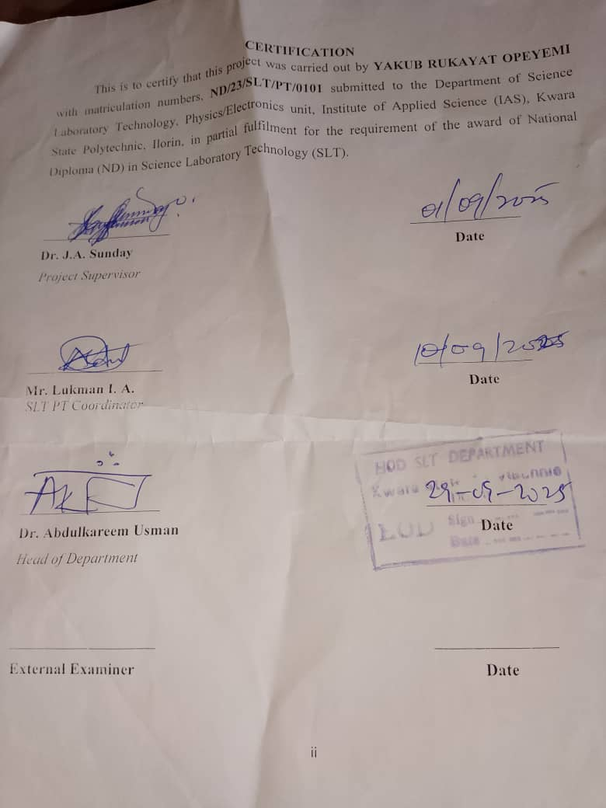
DEDICATION
This project is dedicated to Almighty God, the provider and sustainer of life, Whose grace has made this journey of my National Diploma (ND) possible, and also to my parents. May God continue to bless and protect you.

ACKNOWLEDGEMENT
I am indeed thankful and grateful to Almighty God for giving me the opportunity, courage, energy, grace, and assistance needed to successfully achieve one of my desired academic heights in life.
With humility and appreciation, my foremost acknowledgement goes to my amiable supervisor, DR SUNDAY JOHN ABAYOMI , who, despite his busy schedule, found time to guide and mentor me in my quest to achieve excellence. Hence, he has played a pivotal role in bringing this study to completion. I pray that Allah, in His boundless mercy, fulfil all his heart desires.
I extend my heartfelt gratitude to all my lecturers in the Department of Science laboratory technology, Kwara State Polytechnic, Ilorin, may God bless you all abundantly.
I would like to express my sincere appreciation to my parents, for their constant support and prayers, I pray you live long to eat the fruits of your labour (Amin).

TABLE OF CONTENTS
TITLE PAGE
CERTIFICATION
DEDICATION
ACKNOWLEDGMENT
TABLE OF CONTENT
CHAPTER ONE: INTRODUCTION
  - Preamble
1.2 Factors that Determine GroundwaterContaminationleachate
1.3 Justification
1.4 The Study Area
1.5 Aim and Objectives
CHAPTER TWO: LITERATURE REVIEW
2.1 Introduction
2.1 Overview of Geophysical Methods
2.1.1 Gravity Method
2.1.2 Electrical Methods
2.1.3 Radiometric Method
2.1.4 Seismic Method
2.2 Magnetic Method
2.2.1 The Earth’s Main Field
2.2.2 Magnetic Properties of Rocks
2.2.2.1 Susceptibilities of Rocks and Minerals
2.2.3 Magnetic Survey Methods
2.2.3.1 Ground Magnetic Survey
2.2.3.2 Marine (sea-borne) Magnetic survey
2.2.3.3 Aeromagnetic survey
2.2.4 Reduction/Correction of Magnetic Observations
2.2.4.1 The International Geomagnetic Reference Field (IGRF)
2.2.4.2 Correction of Diurnal Variation
2.2.4.3 Reduction to the Pole
2.2.4.4 Upward and Downward Continuation
2.2.4.5 Elevation and Terrain Corrections
2.2.5 Methods of Interpreting Magnetic Data
2.2.5.1 Qualitative Analysis
2.2.5.2 Quantitative Analysis
2.2.6 Magnetic Surveying Instruments
2.2.6.1 The Fluxgate Magnetometer
2.2.6.2 Proton Magnetometer
2.2.6.3 Magnetic Gradiometers
2.2.7 Advantages of Aeromagnetic Method
2.3 Previous Works on Interpretation Of Aeromagnetic Data
CHAPTER THREE: METHODOLOGY
3.0 Methods
CHAPTER FOUR: RESULTS, DISCUSSIONS AND CONCLUSSION
4.1 Magnetic Data Results
4.2 Discussion
CHAPTER FIVE: CONCLUSION
5.1 Conclusion
References

CHAPTER ONE
INTRODUCTION
  - Preamble
Geophysics is the application of physics to study the Earth, oceans, atmosphere and near-Earth space. It is a broad subject that encompasses many of the major sciences (Gadallah and Fisher, 2009). The science of geophysics applies the principles of physics to the study of the Earth. Geophysical investigations of the interior of the Earth involve taking measurements at or near the Earth’s surface that are influenced by the internal distribution of physical properties (Telford, et al., 1976). Analysis of these measurements can reveal how the physical properties of the Earth’s interior vary vertically and laterally (Keareyet al., 2002). Application of geophysics to the successful exploration of groundwater in sedimentary terrain requires a proper understanding of its hydro-geological characteristic. Evidence has shown that geophysical methods are the most reliable and the most accurate means of all surveying method of subsurface structural investigations and rock variation (Carruthers, 1985; Emenike, 2001).
The availability of quality water resources has always been the primary concern of societies in semi-arid and arid regions, even in areas of more abundant rainfall, the problem of obtaining adequate supply of quality water is generally becoming more acute due to ever increasing population and industrialization (Amarachi, and Ako, 2012). As a result of this, surface water cannot be dependable throughout the year, hence, the need to look for other alternatives to supplement surface water. This makes the world depend on the largest available source of quality fresh water which lies underground and this is referred to as Groundwater. It is the water held in the subsurface within the zone of saturation under hydrostatic pressure below water table (Ariyo and Banjo, 2008).
Groundwater forms a significant part of the water resources all over the World, particularly in the arid areas and favored for domestic purposes partly because groundwater is of high treatment before use since, according to(Sampat,2001)fungi,bacteria and other biological pollutants are naturally filtered and diluted as the water percolates through the soil and partly because the provision of portable water via the water supply scheme is grossly inadequate for the needs of the people. But as a result of careless management and/or disposal of hazardous materials, esh groundwater supplies would be greatly decreased. The problem of environmental contaminations, today, is one of the concerns of earth scientists and researchers from other related fields of science around the world. Fast industrial development and the uncontrolled growth of the urban population quality and requires little result in the production oftxic solid residues. Urban waste materials, mainly domestic garbage, are usually disposed off inadequately in land surface, shallow excavation, river and stream channels which place the under groundwater at high risk of being polluted. Pollution of groundwater happens mostly due to percolation of water and the infiltration of contaminants through the soil under waste disposal sites. '{The contaminant is a fluid that results from the decomposition of municipal solid wastes. Contamination takes place when this leaking aqueous liquid, called leachate reaches the groundwater table, thus affecting the quality ofthe groundwater.
1.2 Factors that Determine GroundwaterContaminationleachate
1. Depth to water table: If the water table is low (far below the ground surface), the leachate will be partially filtered as it percolates downward through the soil. If the water table is high( close to the ground surface ), the groundwater stands the risk of being contaminated by the leachate which has not been fully filtered by the time it gets in contact with the groundwater as shown in Figure I.

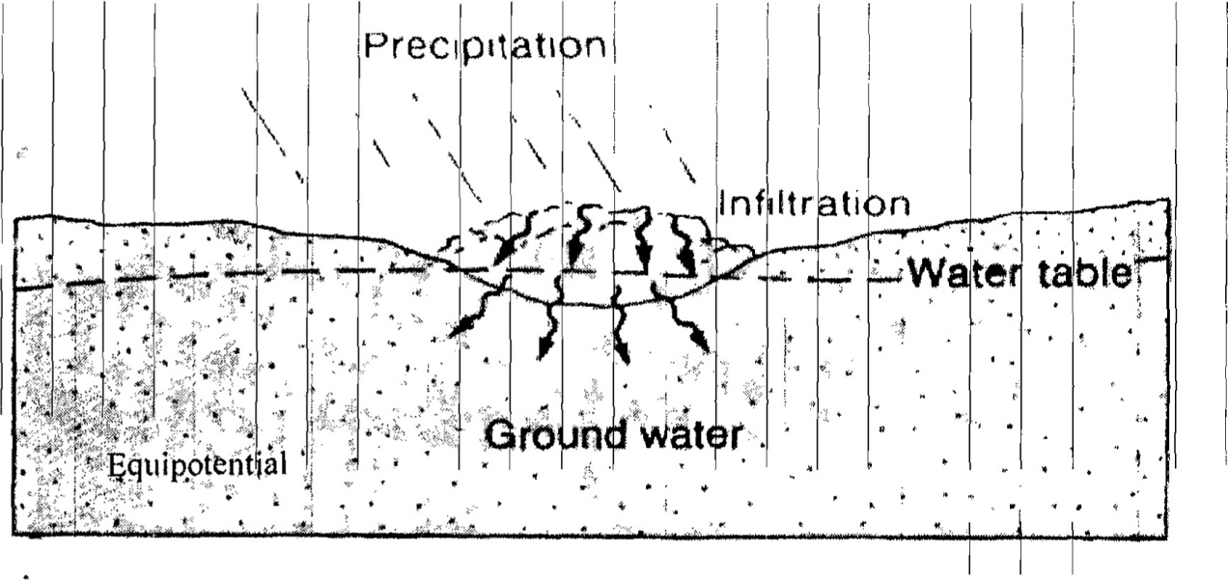
Fig. 1: water table intersect landfill (Montgpmery, 2000)
2.Concentration of contaminants: A high concentration of contaminants in leachate will make groundwater pollution more likely.
3. Permeability of geologic strata: Highly permeable geologic strata allow leachate to quickly percolate through, receiving little filtration along the way as shown in Figure 2
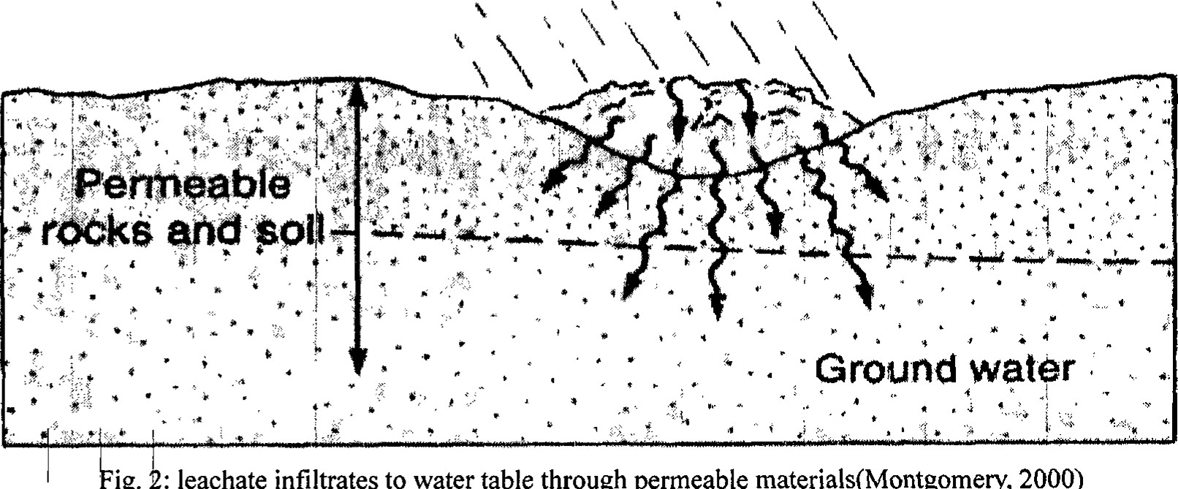
ig.
leachate
infiltrates
to
water
table
through
permeable
materials(Montgomery,
2000)

4. Hydrologic setting: Relative vulnerability to pollution by hydrologic setting becomes:
I. Extreme if (a) Bedrock aquifers crop out (especially in Karsts area); or bedrock aquifers are overlain by less than 3m of soil (b) Unconfined and gravel aquifers with unsaturated zone less than 3m thick Il. High if Bedrock aquifers are overlain by 3m sand and gravel, 3-10m sandy till, or 3-5m clay or clav-rich till.
Ill. Moderate if unconfined aquifers are overlain by 10m sandy clay till, or 5-10m clay rich till, clay or peat.
IV. Low if confined aquifers low permeable rock such as shale are overlain by 10m clay-rich till or (George, 1992).
1.3 Justification
The progressive population growth in Ilorin, the nearest major town to the study area, has led to severe shortage of portable drinking water for the area which poses a great challenge to both the citizens and the government. It is therefore obvious that the demand for reliable and consistent water supply is high. Certainly, the use of water is beyond mere domestic as virtually all the industries, companies and governmental establishments are in dare need of water. Such high demand can only be achieved through viable boreholes. The drilling of viable boreholes can be obtained by carrying out adequate geophysical studies to empirically ascertain areas or sites where long-term steady supply can be achieved.
Furthermore, rapid industrialization recently witnessed by the Ilorin metropolis has resulted in population increase and has led to the urbanization of satellite villages and settlements of which the ancient Eleko, Kwara Poly. (Permanent site), Ara and Akuo settlements, all of which fall in the study area. The people of these settlements depend solely on surface water from streams and hand dug wells for their domestic use. However, these sources of water are highly vulnerable to pollution thereby making the people to be susceptible to water borne diseases. Moreover, fast increase population growth of this region occasioned by the influx of people from nearly congested city of Ilorin, coupled with the location of government institutions such as Kwara State Polytechnic and University of Ilorin Teaching Hospital has also made these sources of water inadequate for its dwellers, and the need for good quality and readily available portable groundwater in this area forms the basis for this research (Sunday et al., 2019).

1.4 The Study Area
Kwara State in its entirety is located in the North-Central part of Nigeria. It lies between the Longitude 3⁰ and 6⁰ E and Latitude 8⁰ and 10⁰ N respectively (Figure 1). It covers an area of over 32,500 square kilometer and bounded by an international boundary with Benin Republic in the West, in the North by Niger, in the East by Kogi and to the south by Oyo, Ekiti and Osun.
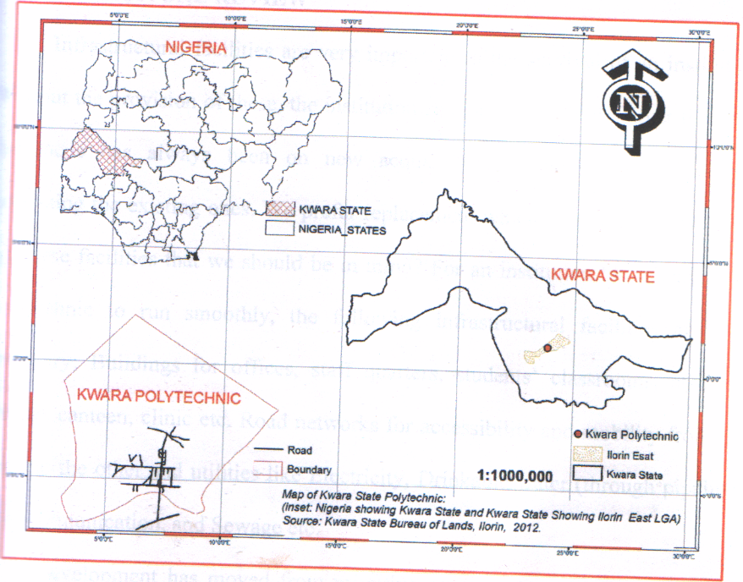
Figure 1: Merged geographical map of Nigeria, Kwara State and the study area, herein referred to as Kwara Polytechnic (source: Kwara State Bureau of Lands, Ilorin, 2012)
The area of study, falls in Ilorin, the capital city of Kwara State, with Kwara State Polytechnic (Figure 2) as the central point, lies within the crystalline basement rocks of western part of central Nigeria. The area is a semi-arid region of Nigeria with vegetation mainly guinea savannah, with shrubs and undergrowth (Nwankwo, 2011). The area is drained by rivers and streams such as Oyun River and river Ile-Apa as a tributary of river Niger (Nwankwoet al., 2004).
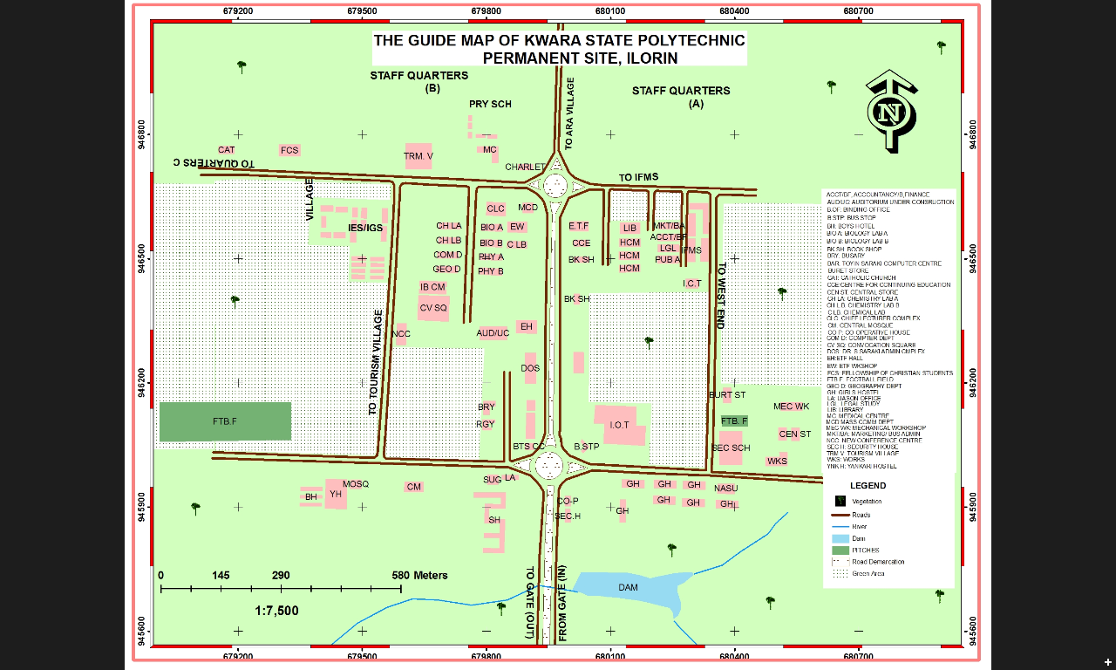
Figure 2: Guide map of the central point of the study area (Source: Sunday et al., 2019)
The progressive population growth in Ilorin, the nearest major town to the study area, has led to severe shortage of portable drinking water for the area which poses a great challenge to both the citizens and the government. It is therefore obvious that the demand for reliable and consistent water supply is high. Certainly, the use of water is beyond mere domestic as virtually all the industries, companies and governmental establishments are in dare need of water. Such high demand can only be achieved through viable boreholes. The drilling of viable boreholes can be obtained by carrying out adequate geophysical studies to empirically ascertain areas or sites where long-term steady supply can be achieved. A high population of the rural dwellers in the study area and neighboring villages depends on groundwater for day-to-day domestic, industrial and commercial water supply. The successful exploitation of basement terrain groundwater requires a proper understanding of its hydro-geophysical characteristics (Choudhury et al., 2001). This is particularly important in view of the discontinuous nature of basement aquifers (Satpathy and Kanungo, 1976).
Furthermore, rapid industrialization recently witnessed by the Ilorin metropolis has resulted in population increase and has led to the urbanization of satellite villages and settlements of which the ancient Eleko, Kwara Poly. (Permanent site), Ara and Akuo settlements, all of which fall in the study area. The people of these settlements depend solely on surface water from streams and hand dug wells for their domestic use. However, these sources of water are highly vulnerable to pollution thereby making the people to be susceptible to water borne diseases. Moreover, fast increase population growth of this region occasioned by the influx of people from nearly congested city of Ilorin, coupled with the location of government institutions such as Kwara State Polytechnic and University of Ilorin Teaching Hospital has also made these sources of water inadequate for its dwellers, and the need for good quality and readily available portable groundwater in this area forms the basis for this research (Sunday et al., 2019).
Regional and Geological Setting of the Study Area
The dominant lithologic units of the study area are gneisses of migmatite, biotite and granite which are regionally emplaced; the ferruginous quartzite is the source of the iron ore mineralization in the area (Olade, 1975). The area falls under the banded iron Formation of Nigeria, generally they occur in metamorphosed folded bands, associated with Precambrain basement complex rocks which included low metasediments, high grade schist, gneisses and migmatites(Chinwukoet al., 2014).The dominated lithologic units in the area are gneisses of migmatite, biotite and granite. Olade, (1975) pointed that the ferruginousquartzite is the source of the iron ore mineralization. The south eastern part of the study area is more sedimentary.
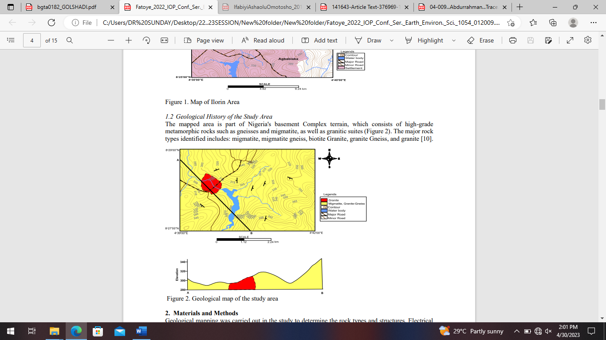
Figure 3: Geological Map of Ilorin (after Fatoyeet al., 2022).
1.5 Aim and Objectives
This study was carried out to have an insight into the subsurface geology of the study area with the following objectives:
- detect subsurface layers, their thicknesses, and their resistivities;
- investigate the hydrological conditions of the area with the view of delineating the potential area for groundwater development;
- map geological structures e.g., faults and fractures, which are conductive bodies, thus may accommodate groundwater, and
- locate possible and suitable site for productive boreholes in the study area.

CHAPTER TWO
LITERATURE REVIEW
2.1 Introduction
A quick look at magnetic field maps talks much about the location and shape of buried complicated features. However, a careful study of a map can provide extra details about the depth and edges of magnetic materials that are underground.
In magnetic surveying, by delineating lateral changes in magnetic susceptibilities, information about structural trends and lithological changes are provided. To distinguish between different sizes and different depths of the geological structures, edge detection techniques are used. To delineate structural features from magnetic data, many techniques have been developed. Also, estimation of the depth of magnetic sources using different methods can be applied to gridded magnetic data sets.
Nabighian (1972) used the concept of the analytic signal for magnetic interpretation, and showed that the analytic signal amplitude yields a Gaussian-shaped function over each corner of a 2D body with polygonal cross section. Roest et al. (1992) used the total magnetic intensity, which required the 3D analytic signal to approximately estimate the positions of magnetic contact corners and obtain depth estimates from gridded data. Reid et al. (1990) ushered in the
Euler deconvolution as an interpretive tool in the magnetic potential field for locating magnetic anomalies and the determination of their depths by deconvolution using Euler’s homogeneity relation. Cordell and Grauch (1985) proposed a method for locating the horizontal extents of the anomalous sources from the maxima of the horizontal gradient of the pseudogravity computed from the gridded magnetic data. Verduzco et al. (2004) developed tilt derivative from the potential magnetic field anomaly map and used the horizontal gradient of the tilt derivative as an edge detector for magnetic anomaly. Salem et al. (2007) have applied a new method for interpretation of gridded magnetic data based on the tilt derivative. The tilt derivative method,
by providing a means for estimating the depth to the basement, is a useful technique for interpreting magnetic data.

2.1 OVERVIEW OF GEOPHYSICAL METHODS
Various geophysical survey methods have been and are being used on land and offshore. Each of these methods measures something that is related to subsurface rocks and their geologic configurations. Rocks and minerals in the earth vary in several ways. According to (Gadallah, et al., 2009) these include:
• Density – mass per unit volume. The gravity method detects lateral variations in density. Both lateral and vertical density variations are important in the gravity method.
• Magnetic susceptibility – the amount of magnetization in a substance exposed to a magnetic field. The magnetic method detects horizontal variations in susceptibility.
• Propagation velocity – the rate at which sound or seismic waves are transmitted in the earth. It is these variations, horizontal and vertical, that make the seismic method applicable to petroleum exploration.
• Resistivity and Induced Polarization – Resistivity is a measure of the ability to conduct electricity and induced polarization is frequency-dependent variation in resistivity. Electrical methods detect variations of these over a surface area
• Self-Potential - ability to generate an electrical voltage. Electrical methods also measure this over a surface area.
• Electromagnetic wave reflectivity and transmissivity: reflection and transmission of electromagnetic radiation, such as radar, radio waves and infrared radiation, is the basis of electromagnetic methods etc.
2.1.1 Gravity Method
In gravity surveying, subsurface geology is investigated on the basis of variations in the Earth’s gravitational field arising from differences of density between subsurface rocks. An underlying concept is the idea of a causative body, which is a rock unit of different density from its surroundings. A causative body represents a subsurface zone of anomalous mass and causes a localized perturbation in the gravitational field known as a gravity anomaly. On a small scale, buried relief on a bedrock surface, such as a buried valley, can give rise to measurable anomalies. On a larger scale, small negative anomalies are associated with salt domes. Modern instruments capable of rapid gravity measurements are known as gravity meters or gravimeters (Al-Chalabi, 1972).
2.1.2 Electrical Methods
There are many methods of electrical surveying. Some makes use of fields within the Earth while others require the introduction of artificially-generated currents into the ground. These methods include;
• Direct current resistivity
• Electromagnetic
• Mise-a-la-masse
• Induced polarization
• Self-potential
The resistivity method is used in the study of horizontal and vertical discontinuities in the electrical properties of the ground, and also in the detection of three-dimensional bodies of anomalous electrical conductivity. It is routinely used in engineering and hydro geological investigations to investigate the shallow subsurface geology (Aspinall et al., 1975).
The Induced Polarization method makes use of the capacitive action of the subsurface to locate zones where conductive minerals are disseminated within their host rocks. When using a standard four-electrode resistivity spread in a DC mode, if the current is abruptly switched off, the voltage between the potential electrodes does not drop to zero immediately. After a large initial decrease, the voltage suffers a gradual decay and can take many seconds to reach a zero value (Aspinall et al., 1975).
The capacitive property of the ground causes both the transient decay of a residual voltage and the variation of apparent resistivity as a function of frequency. The two effects are representations of the same phenomenon in the time and frequency domains, and are linked by Fourier transformation.
The self-potential method makes use of natural currents flowing in the ground that are generated by electrochemical processes to locate shallow bodies of anomalous conductivity. The self-potential (or spontaneous polarization) method is based on the surface measurement of natural potential differences resulting from electrochemical reactions in the subsurface. Typical SP anomalies may have amplitude of several hundred millivolts with respect to barren ground. They invariably exhibit a central negative anomaly and are stable over long periods of time. They are usually associated with deposits of metallic sulphides, magnetite or graphite (Corry, 1985).
Electromagnetic (EM) surveying methods make use of the response of the ground to the propagation of electromagnetic fields, which are composed of an alternating electric intensity and magnetizing force. Primary electromagnetic fields may be generated by passing alternating current through a small coil made up of many turns of wire or through a large loop of wire. The response of the ground is the generation of secondary electromagnetic fields and the resultant fields may be detected by the alternating currents that they induce to flow in a receiver coil by the process of electromagnetic induction (Raab et al., 1984).
2.1.3 Radiometric Method
Radiometric surveying is employed in the search for deposits necessary for this application, and also for non-radioactive deposits associated with radioactive elements such as titanium and zirconium. Radiometric surveys are of use in geological mapping as different rock types can be recognized from their distinctive radioactive signature. The elements of principal interest in radiometric exploration are uranium (238U), thorium (232Th) and potassium (40K). Probably the most common application of radiometric techniques is in geophysical borehole logging (Gadallahet al., 2009).
2.1.4 Seismic Method
Reflection seismology (or seismic reflection) is a method of exploration geophysics that uses the principles of seismology to estimate the properties of the Earth's subsurface from reflected seismic waves (https://en.wikipedia.org/wiki/waste_management).
At its most basic, the seismic reflection technique consists of generating seismic waves and measuring the time taken for the waves to travel from the source, reflect off an interface and be detected by an array of receivers (or geophones) at the surface. By Knowing the travel time from the source to various receivers, and the velocity of the seismic waves, a geophysicist then attempts to reconstruct the pathways of the waves in order to build up an image of the subsurface (Sheriff et al., 1995).
2.2 MAGNETIC METHOD
The aim of a magnetic survey is to investigate subsurface geology on the basis of anomalies in the Earth’s magnetic field resulting from the magnetic properties of the underlying rocks. Although most rock-forming minerals are effectively non-magnetic, certain rock types contain sufficient magnetic minerals to produce significant magnetic anomalies (Horsfall, 1997).
2.2.1 The Earth’s Main Field
The Earth’s main magnetic field originates in electric currents circulating in the liquid outer core (geo-dynamo), but can be largely modeled by a dipole source at the Earth’s center. Distortions in the dipole field extending over regions thousands of kilometers across can be thought of as caused by a relatively small number of subsidiary dipoles at the core-mantle boundary (Milsom et al., 2011).
2.2.2 Magnetic Properties of Rocks
A rock may be regarded as a heterogeneous assemblage of minerals. The matrix minerals are mainly silicates or carbonates, which are diamagnetic in character. Interspersed in this matrix is a lesser quantity of secondary minerals (such as the clay minerals) that have paramagnetic properties. The bulk of the constituent minerals in a rock contribute to the magnetic susceptibility but are incapable of any contribution to the remanent magnetic properties, which are due to a dilute dispersion of ferrimagnetic minerals (e.g., commonly less than 0.01% in a limestone). The variable concentrations of ferrimagnetic and matrix minerals result in a wide range of susceptibilities in rocks (Lowrie, 2007).
2.2.2.1 Susceptibilities of Rocks and Minerals
The susceptibility of a rock usually depends on its magnetite content. Sediments and acid igneous rocks have small susceptibilities whereas basalts, dolerites, gabbros and serpentines are usually strongly magnetic. Weathering generally reduces susceptibility because magnetite is oxidized to hematite, but some laterites are magnetic because of the presence of maghemite and remanently magnetized hematite (Milsom et al., 2011).
The susceptibility, k, is small for most natural materials, and may be either negative (diamagnetism) or positive (paramagnetism). The fields produced by such materials are usually considered too small to affect survey magnetometers.
Modern high-sensitivity magnetometers are creating exceptions to this rule, but most useful magnetic anomalies are still due to the small number of ferro- or ferri-magnetic substances in which the molecular magnets are held parallel by intermolecular exchange forces. Below the Curie temperature, these forces are strong enough to overcome the effects of thermal agitation. Magnetite, pyrrhotite and maghemite, all of which have Curie temperatures of about 6000C, are the only important naturally occurring strongly magnetic minerals and, of the three, magnetite is by far the most common. Hematite, the most abundant iron mineral, normally has a very small susceptibility, and many iron ore deposits do not produce significant magnetic anomalies (Lowrie, 2007).
2.2.3 Magnetic Survey Methods
It is the induced and remanent fields that are of particular interest in a magnetics survey because the magnitudes of these fields are directly related to the magnetic susceptibility, spatial distribution and concentration of the local crustal materials. Furthermore only a few minerals occur abundantly enough in nature to make a significant contribution to the induced and remanent fields, the most important of these is magnetite and to a lesser extent ilmenite and pyrrhotite (Clarke, 1997). The three methods of acquiring magnetics data are discussed as follows.
2.2.3.1 Ground Magnetic Survey
Ground magnetic surveys are usually performed over relatively small areas on a previously defined target. Data is acquired close to ground level either via a person carrying a magnetometer or with a magnetometer mounted on a motor vehicle such as a quad motorcycle or four-wheel drive. Consequently, station spacing is commonly of the order of 10–100m, although smaller spacing may be employed where magnetic gradients are high. Readings should not be taken in the vicinity of metallic objects such as railway lines, cars, roads, fencing, houses, etc., which might perturb the local magnetic field. For similar reasons, operators of magnetometers should not carry metallic objects. Base station readings are not necessary for monitoring instrumental drift as fluxgate and proton magnetometers do not drift, but are important in monitoring diurnal variations (Ross, 2002).
2.2.3.2 Marine (sea-borne) Magnetic survey
Marine magnetic surveying techniques are similar to those of airborne surveying. The sensor is towed in a ‘fish’ at least two ships’ lengths behind the vessel to remove its magnetic effects. Marine surveying is obviously slower than aeromagnetic surveying, but is frequently carried out in conjunction with several other geophysical methods, such as gravity surveying and continuous seismic profiling, which cannot be employed in the air (Ross, 2002).
2.2.3.3 Aeromagnetic survey
Aeromagnetic surveying is rapid and cost-effective, typically costing some 40% less per line kilometer than a ground survey. Vast areas can be surveyed rapidly without the cost of sending a field party into the survey area and data can be obtained from areas inaccessible to ground survey. The vast majority of magnetic surveys are carried out in the air, with the sensor towed in a housing known as a ‘bird’ to remove the instrument from the magnetic effects of the aircraft or fixed in a ‘stinger’ in the tail of the aircraft, in which case inboard coil installations compensate for the aircraft’s magnetic field. The magnetic field is usually measured with a total field magnetometer. The most common instrument in use today is the caesium-vapour magnetometer.
Observations are made at regular intervals along a series of flight lines of constant azimuth and spacing. Observations are similarly made along tielines oriented perpendicular to the traverse lines. Tie lines are necessary to assist in the removal of temporal variations in the main field. Tie lines are usually spaced about ten times further apart than traverse lines (Ross, 2002).
Various corrections are necessary to be done on the acquired data for accurate geophysical extrapolations to be made, these corrections are discussed below.
2.2.4 Reduction/Correction of Magnetic Observations
The reduction of magnetic data is necessary to remove all causes of magnetic variation from the observations other than those arising from the magnetic effects of the subsurface.
2.2.4.1 The International Geomagnetic Reference Field (IGRF)
The Earth’s main field varies not only with latitude and longitude but also with time. Between 1980 and 2002 the field strength in the central Atlantic decreased by about 6%. These secular changes are described by the empirical International Geomagnetic Reference Field (IGRF) equations, which are defined to order N =10 by 120 spherical harmonic coefficients, supplemented to order N =8 by a predictive secular variation model. The shortest wavelength present is about 3000 km. IGRFs provide reasonable representations of the actual fields in well-surveyed areas, where they can be used to calculate regional corrections, but discrepancies of as much as 250 nT can occur in areas from which little information was available at the time of formulation. Since 2000, the accuracies of the IGRFs have been greatly improved by incorporating data from the Danish Oersted and German CHAMP satellites (Milsom et al., 2011).
Secular changes are adequately predicted by extrapolation from past observations for only a few years into the future, and IGRFs are updated every five years and are also revised retrospectively to give definitive models (DGRFs). These time-dependent corrections are vital for comparing airborne or marine surveys carried out years or even months apart but are less important in ground surveys, where base stations can be reoccupied (Milsom et al., 2011).
2.2.4.2 Correction of Diurnal Variation
The effects of diurnal variation may be removed in several ways. On land a method similar to gravimeter drift monitoring may be employed in which the magnetometer is read at a fixed base station periodically throughout the day. The differences observed in base readings are then distributed among the readings at stations occupied during the day according to the time of observation. It should be remembered that base readings taken during a gravity survey are made to correct for both the drift of the gravimeter and tidal effects; magnetometers do not drift and base readings are taken solely to correct for temporal variation in the measured field. Such a procedure is inefficient as the instrument has to be returned periodically to a base location and is not practical in marine or airborne surveys. These problems may be overcome by use of a base magnetometer continuous-reading instrument which records magnetic variations at a fixed location within or close to the survey area. This method is preferable on land as the survey proceeds faster and the diurnal variations are fully charted. Where the survey is of regional extent the records of a magnetic observatory may be used. Such observatories continuously record changes in all the geomagnetic elements. However, diurnal variations differ quite markedly from place to place and so the observatory used should not be more than about 100 km from the survey area (Milsom et al., 2011).
Diurnal variation during an aeromagnetic survey may alternatively be assessed by arranging numerous crossover points in the survey plan. Analysis of the differences in readings at each crossover, representing the field change over a series of different time periods, allows the whole survey to be corrected for diurnal variation by a process of network adjustment, without the necessity of a base instrument. An alternative method of removing the regional gradient over a relatively small survey area is by use of trend analysis. A trend line (for profile data) or trend surface (for a real data) is fitted to the observations using the least squares criterion, and subsequently subtracted from the observed data to leave the local anomalies as positive and negative residuals (Lowrie, 2007).
2.2.4.3 Reduction to the Pole
This simplifies the interpretation of anomalies by removing the asymmetry introduced due to its induction by the inclined main field. The main field is only vertical (and induced anomalies symmetric) at the north and south magnetic poles. As the name suggests reduction to the pole transforms the data to that which would have been measured at the magnetic poles. This simplifies the anomalies by centering anomalies over the causative magnetic body rather than being skewed and offset to one side (Ross, 2002).
2.2.4.4 Upward and Downward Continuation
Upward and downward continuation of magnetic data transforms the data to that which would be measured on different surfaces either above or below the actual observation surface. Upward continuation thus tends to attenuate the effect of near surface sources relative to deeper sources, while downward continuation has the opposite effect (Ross, 2002).
2.2.4.5 Elevation and Terrain Corrections
The vertical gradient of the geomagnetic field is only some 0.03nTm-1 at the poles and -0.015nTm-1 at the equator, so an elevation correction is not usually applied. The influence of topography can be significant in ground magnetic surveys but is not completely predictable as it depends upon the magnetic properties of the topographic features. Therefore, in magnetic surveying terrain corrections are rarely applied (Brodie C. Ross, 2002).
Having applied diurnal and geomagnetic corrections, all remaining magnetic field variations should be caused solely by spatial variations in the magnetic properties of the subsurface and are referred to as magnetic anomalies.
2.2.5 Methods of Interpreting Magnetic Data
There are basically two main methods of data interpretation in magnetic survey;
• Qualitative Interpretation
• Quantitative Interpretation
2.2.5.1 Qualitative Analysis
Much qualitative information may be derived from a magnetic contour map. This applies especially to aeromagnetic maps which often provide major clues as to the geology and structure of a broad region from an assessment of the shapes and trends of anomalies. Sediment covered areas with relatively deep basement are typically represented by smooth magnetic contours reflecting basement structures and magnetization contrasts. Igneous and metamorphic terrains generate far more complex magnetic anomalies, and the effects of deep geological features may be obscured by short wavelength anomalies of near-surface origin (Keary et al., 2002).
Qualitative interpretation could be done by visual inspection of the anomaly map to locate points of high or low intensity which may be interpreted as dyke or infiltration of material with different magnetic properties. Map of magnetic intensity in nanotesla (nT) could also be plot against distance (m) along selected profiles to visualize some structural trend.
2.2.5.2 Quantitative Analysis
There are various methods of interpreting magnetic data quantitatively amongst these methods are;
1. Euler deconvolution method
2. Wavelet method
3. Spectral method
4. Pal’s method
5. Centroid method and so on.
Spectral Analysis Method of Interpretation
Magnetic anomalies caused by shallow structures are more dominated by high wave number components than those resulting from deeper source. This effect may be quantified by computing the power spectrum of the anomaly since the long power spectrum has a linear gradient whose magnitude is dependent upon the depth of the source (Spector et al., 1970).
The major advantage of Spectral analysis method is its ability to filter almost all the noise from the data whilst still making sure no information is lost in the process of interpretation by overlapping data. Such techniques of spectral analysis provide rapid depth estimates from regularly-spaced digital field data; no geomagnetic or diurnal corrections are necessary as these remove only low-wavenumber components and do not affect the depth estimates which are controlled by the high-wavenumber components of the observed field (Spector et al., 1970).
Limiting depth is the most important parameter derived by direct interpretation, and this may be deduced from magnetic anomalies by making use of their property of decaying rapidly with distance from source. Magnetic anomalies caused by shallow structures are more dominated by short-wavelength components than those resulting from deeper sources. This effect may be quantified by computing the power spectrum of the anomaly as it can be shown, for certain types of source body, that the log-power spectrum has a linear gradient whose magnitude is dependent upon the depth of the source (Spector et al., 1970).
2.2.6 Magnetic Surveying Instruments
In early magnetic surveys the geomagnetic elements were measured using magnetic variometers. There were several types, including the torsion head magnetometer and the Schmidt vertical balance, but all consisted essentially of bar magnets suspended in the Earth’s field. Such devices required accurate levelling and a stable platform for measurement so that readings were time consuming and limited to sites on land (Keary et al., 2002).
2.2.6.1 The Fluxgate Magnetometer
The first such device to be developed was the fluxgate magnetometer, which found early application during the Second World War in the detection of submarines from the air. The instrument employs two identical ferromagnetic cores of such high permeability that the geomagnetic field can induce a magnetization that is a substantial proportion of their saturation value.
Identical primary and secondary coils are wound in opposite directions around the cores. An alternating current of 50–1000Hz is passed through the primary coils, generating an alternating magnetic field. In the absence of any external magnetic field, the cores are driven to saturation near the peak of each half-cycle of the current. The alternating magnetic field in the cores induces an alternating voltage in the secondary coils which is at a maximum when the field is changing most rapidly. Since the coils are wound in opposite directions, the instrument can be used to measure Z or H by aligning the cores in these directions, but the required accuracy of orientation is some eleven seconds of arc to achieve a reading accuracy of 0.1nT. Such accuracy is difficult to obtain on the ground and impossible when the instrument is mobile (Lowrie, 2007).
2.2.6.2 Proton Magnetometer
The most commonly used magnetometer for both survey work and observatory monitoring is currently the nuclear precession or proton magnetometer. The sensing device of the proton magnetometer is a container filled with liquid rich in hydrogen atoms, such as kerosene or water, surrounded by a coil. The hydrogen nuclei (protons) act as small dipoles and normally align parallel to the ambient geomagnetic field. A current is passed through the coil to generate a magnetic field 50–100 times larger than the geomagnetic field, and in a different direction, causing the protons to realign in this new direction. The current to the coil is then switched off so that the polarizing field is rapidly removed. The protons return to their original alignment by spiraling, or precessing, in phase around this direction with a period of about 0.5 ms, taking some 1–3 s to achieve their original orientation.
Field instruments provide absolute readings of the total magnetic field accurate to 0.1 nT although much greater precision can be attained if necessary. The sensor does not have to be accurately oriented, although it should ideally lie at an appreciable angle to the total field vector. Consequently, readings may be taken by sensors towed behind ships or aircraft without the necessity of orienting mechanisms. Aeromagnetic surveying with proton magnetometers may suffer from the slight disadvantage that readings are not continuous due to the finite cycle period. Small anomalies may be missed since an aircraft travels a significant distance between the discrete measurements, which may be spaced at intervals of a few seconds. Many modern proton magnetometers make use of the Overhauser Effect (Lowrie, 2007).
The protons are then polarized indirectly using radiofrequency energy near 60MHz. The power consumption of such instruments is only some 25% of classical proton magnetometers, so that the instruments are lighter and more compact. The signal generated by the fluid is about 100 times stronger, so there is much lower noise; gradient tolerance is some three times better; sampling rates are faster.
2.2.6.3 Magnetic Gradiometers
The sensing elements of fluxgate, proton and optically pumped magnetometers can be used in pairs to measure either horizontal or vertical magnetic field gradients. Magnetic gradiometers are differential magnetometers in which the spacing between the sensors is fixed and small with respect to the distance of the causative body whose magnetic field gradient is to be measured. Magnetic gradients can be measured, albeit less conveniently, with a magnetometer by taking two successive measurements at close vertical or horizontal spacing. Magnetic gradiometers are employed in surveys of shallow magnetic features as the gradient anomalies tend to resolve complex anomalies into their individual components, which can be used in the determination of the location, shape and depth of the causative bodies. The method has the further advantages that regional and temporal variations in the geomagnetic field are automatically removed. Marine and airborne versions of magnetometers and gradiometers are discussed by Woldand Cooper (1989) and Hood and Teskey (1989), respectively (Keary et al., 2002).
2.2.7 Advantages of Aeromagnetic Method
Aeromagnetic method is becoming more popular among geophysicists due to its high versatility, cost effectiveness and various other advantages over other geophysical techniques. The magnetic fields change when the physical properties like susceptibility and thickness of subterranean rocks change. The magnetic data finds wide applications and is able to provide very valuable subsurface information (Churchill et al., 2012).
Some of its other advantages are highlighted below;
• It covers large region in little time compared to land and sea borne surveys
• Airborne geophysics also contribute to tectonic reconstruction, groundwater resource management, petroleum and mineral exploration, mining and environmental protection application (Churchill et al., 2012)
• It covers areas of barrier that would not have been possible in land and sea borne
• Modern high-resolution magnetometers are able to collect data with an accuracy of 0.001nT (Rajaram et al., 2009)
• Data obtained could be interpreted in diverse ways like hydrocarbon prospecting, determination of curie depth, depth of magnetic basement, fractures amongst others.
2.3 PREVIOUS WORKS ON INTERPRETATION OF AEROMAGNETIC DATA
Numerous geophysical works have been and are being done around the globe using the various geophysical methods, some of the previous work that employed magnetic methods are reviewed here. (Olawuyi, 2015) Evaluated the fault and lineament structures within the Lafiagi Study area using geological, aeromagnetic and gravity data. (Anakwubaet al., 2011) Interpreted the aeromagnetic data over Maiduguri-Dikwa Depression using Fourier transform to deduce the magnetic source depth (both shallower and deeper) and also to delineate the fracture condition of the study area.
David and Mauritus concluded from the spectral analysis result obtained from aeromagnetic data of some part of Lower Benue Trough, that the area holds enough thickness for the accumulation of hydrocarbon. The magnetic basement surface plot of the area reveals that the basement surface presents a successive pattern of crests and troughs. It also indicates that the shape of the basement is irregular and associated with deep faults resulting from fractures (David et al., 2013).

CHAPTER THREE
METHODOLOGY
3.0 Methods
Ground magnetic data were acquired in the region every 15 m along lines in the north, spaced 10 m apart. An interpretation difficulty with total magnetic intensity anomalies is that they are dipolar (anomalies have positive and negative components), such that the shape of the anomaly depends to some extent on the presence of any residual magnetization and the magnetic inclination. Because the magnetic anomaly depends on the inclination and declination of the body magnetization, the inclination and declination of the local Earth’s magnetic field (Baranov, 1957) and total field are calculated. Baranov and Naudy (1964) proposed a mathematical approach called “reduction to pole” for simplifying anomaly shape estimates.
The ground total magnetic anomaly data was reduced to the pole (RTP) to center anomalies over their causative sources. The values of the parameters of the RTP filter included the magnetic inclination: -8.3 degrees and declination: -0.8 degrees. Addition, we adopted an amplitude correction inclination of 80 degrees to stabilize the results of this filter, which is unstable in regions of low magnetic latitudes.
The reduction to pole technique transforms total magnetic intensity anomalies into anomalies that would be measured if the field were vertical (meaning there is only an inducing field). This reduction to pole transformation makes the shape of the magnetic anomalies more closely related to the true location of the source structure and allows easier interpretation of the magnetic anomaly, as the location of the anomaly maxima will be centered over the body (assuming there is no residual magnetization).
Thus, the reduction to pole reduces the effect of the Earth’s ambient magnetic field and provides a more accurate interpretation for the position and shape of anomalous sources. Total magnetic field strength, as well as geomagnetic inclination and declination of the study area, which are prerequisite parameters in computing the apparent magnetic susceptibility, was derived for the study area (NOAA, 2013). Before applying the methods, the total field anomaly data were reduced to pole using a magnetic inclination of 53.149° and a declination of 4.497°
Horizontal gradient amplitude
The horizontal gradient amplitude (HGA) filter is used in computing the potential field data. It provides information on the lateral extent of magnetic bodies (Salawu et al., 2019). Unlike TGA technique, it is dependent on the magnetization direction i.e., it requires source magnetization direction. This enhancement tool improves the visibility shallow magnetic bodies (igneous intrusions, contacts, and sheet like features) that were covered by thedeeper ones. It is mathematically express in the equation below.
$$HGA =\sqrt{{\left(\frac{∂F}{∂x}\right)}^{2}+{\left(\frac{∂F}{∂y}\right)}^{2}}$$
F is the observed total field anomaly, $\frac{∂F}{∂x}$and$\frac{∂F}{∂y}$are the first-order partial derivatives of the potential field F in horizontal (y) and (x) directions respectively.
Total gradient magnitude
The total gradient amplitude (TGA) is among the edge detection and enhancement method used in the interpretation potential field data (Salem, 2005; Li, 2006; Adebiyi et al., 2023). It is applicable to low latitude regions like herein (Saleh et al., 2023). Unlike reduction to pole or equator, it requires no prior information of the magnetization direction for the interpreting two-dimensional structures (Salawu et al., 2020; 2023; Saada, 2016) as well as subdue the effects of low latitude as the case of reduction to pole or equator (Macleod et al., 1993). The total gradient amplitude (TGA) is given in the equation below.

$$TGA =\sqrt{{\left(\frac{∂F}{∂x}\right)}^{2}+{\left(\frac{∂F}{∂y}\right)}^{2}+{\left(\frac{∂F}{∂z}\right)}^{2}}$$
F is the observed total field anomaly, $\frac{∂F}{∂x}$and$\frac{∂F}{∂y}$are the first-order partial derivatives of the potential field F in horizontal (y) and (x) directions respectively. While $\frac{∂F}{∂z}$ is the first-order partial derivative of the potential fieldF in vertical (z) direction.

Analytic signal method
The analytic signal method is a well-known technique for locating the edges of magnetic anomalies. Nabighian (1972) developed the notion of 2-D AS of magnetic anomalies. In 2D, the amplitude of the analytic signal is independent of the direction of magnetization, and represents both the vertical and horizontal derivatives over all possible directions of the Earth’s field and source magnetization. In 3D, Roest et al. (1992) introduced the total gradient of magnetic data as an extension of the 2D case. The function used in the analytic signal method is the analytic signal amplitude (absolute value) of the observed magnetic field at the location (x, y), defined by three orthogonal gradients of the total magnetic field using the expression:
$$A\left(x, y\right)= \sqrt{{({δM}/{δx)}}^{2}+ {({δM}/{δy)}}^{2}+ {({δM}/{δz)}}^{2}}$$
where A (x, y) is the amplitude of the analytic signal at (x, y), and M is the observed magnetic field at (x, y).
Depth estimates
For the horizontal gradient and analytic signal methods, assuming thick sources, minimum depths to magnetic sources were obtained. Depth estimates were calculated along contact location obtained from the tilt derivative method and then compared with the Euler deconvolution depths. In magnetic surveys, upward continuation is particularly useful in tying together aeromagnetic surveys made from different flying altitudes (Allaby and Allaby, 1999). For calculating other depths apart from the edges of magnetic body to basement with Euler deconvolution technique, upward continuation was applied on reduction to pole field at heights of 10, 20, 30, and 40 m, and then the Euler deconvolution method with N=0.9 was performed on them.
The locations of the tilt derivative point that were selected for depth estimation were compared with the nearest points obtained from Euler deconvolution maps of upward continuation at heights of 10, 20, 30, and 40 m, and also the surface. The best approximations for depth of contact location are derived. Euler deconvolution is the basis for estimating depth to basement, and then those depths are corrected with tilt derivative depth estimations. Finally, a 3D map for the body that is shown in the results, in Chapter Four

CHAPTER FOUR
RESULTS, DISCUSSIONS AND CONCLUSSION
Interpretation of the elevation map
The visual inspection of Figure 4.1 reveals the low to high elevation with values varying between<322 to>362 m respectively. The elevation increases eastward and decreases northward, southward, and westward. The failed borehole lies in the relatively high elevation, while the corresponding good borehole is located at the edge of high elevation. Elevation sometimes influences groundwater availability as it affects water table. Theregions of low elevation mostly have higher water table as well as high elevation regions possibly have lower water table, potentially limiting groundwater availability. Elevation of the ground surface influences the depth of the water table and the pressure within aquifers. In general, regions of high elevation, water table is lower, and aquifers may have less pressure. Since, the good borehole is situated at the edge of a high elevation, it might benefit from factors like; high elevations which often contribute to increased aquifer pressure and the potential for reliable access to groundwater. In addition, geological formations at the edge of high elevation might be conductive to the storage and movement (permeable) of water leading to the productivity of the good borehole.
The failed borehole situated at the relatively high elevation may be hampered by factors such as impermeable geological layers, insufficient aquifer recharge or the presence of geological structure that impede groundwater flow. The productivity or failure of boreholes sometimes relies on elevation, but solely dependent on specific geological and hydrological characterization of the subsurface at every location of interest.
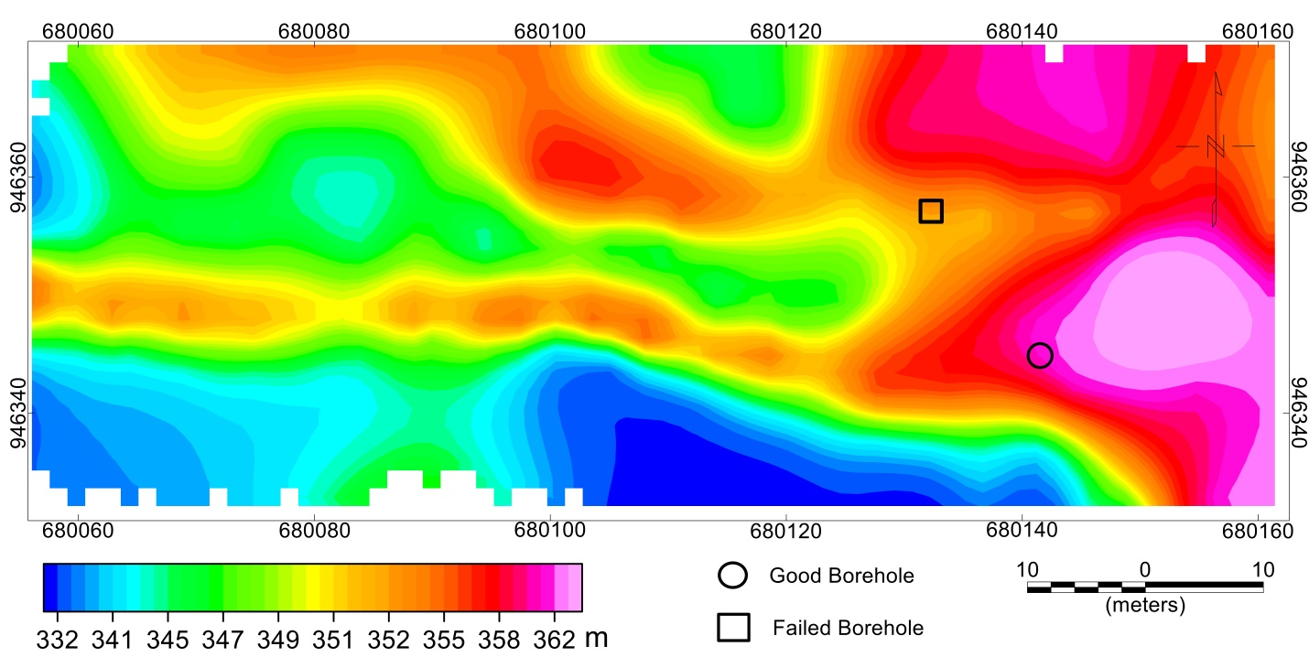
Fig. 1: Elevation map of the study area.
  - Interpretation of the total magnetic intensity and reduced to pole anomaly maps.
The direct interpretation of total magnetic intensity (TMI) data at low latitude regions (close to equator) like herein, requires a thorough understanding of the local geology and careful consideration of the unique magnetic field. The magnetic field lines are approximately parallel to the Earth's surface, resulting to a trivial magnetic inclination angle (Beard and Goitom, 2000). In a bid to mitigate these challenges and enhance the interpretation of the TMI anomaly data, the reduction to pole (RTP) and total gradient amplitude (TGA) techniques were employed to cautiously position the anomalies directly above their causative sources.
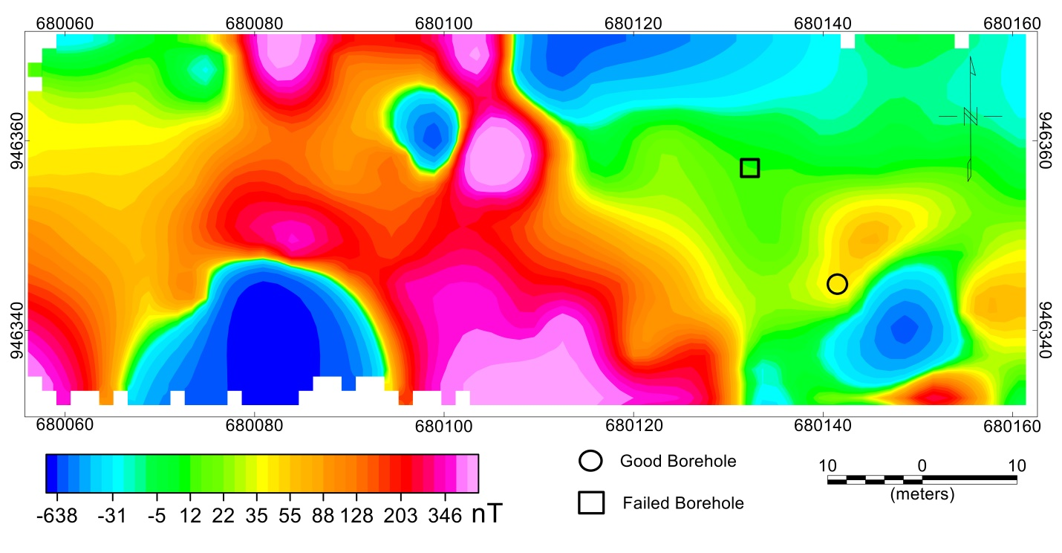
Fig. 2: The total magnetic intensity anomaly data of the survey area.
The regions of high TMI anomalies (figure 2) correspond to low RTP anomalies (Figure 3) and vice versa. The locations of low to high RTP anomalies as shown in Figure 3, vary from < -289 to >325 nT in blue to pink colors respectively. The observed strong negative RTP anomalies in the midsouth-central and a northern portion of the map could be attributed to deep seated metasedimentary formations. The strong positive RTP responses could be tied with metavolcanics formations of the basement complex terrain. The location of good borehole depicted in circular black shape lies within closely contoured RTP anomalies. These contours indicate subtle geological variation in relatively high RTP signatures, possibly ascribed to concealed fractured zone. The corresponding failed borehole denoted by black square falls within the margin of relatively low RTP anomalies. It is worth to mention that the interpretation of RTP anomaly map (figure 3) which consist of both deep and shallow seated magnetic structures is not sufficient to understand the concealed geometries of the good and failed boreholes. Since, groundwater sources are found within the shallow concealed (short wavelength amplitudes) structures. These necessitate the need to subject the RTP anomaly data (Figure 3) to shallow features enhancement filters like horizontal gradient magnitude (HGM).
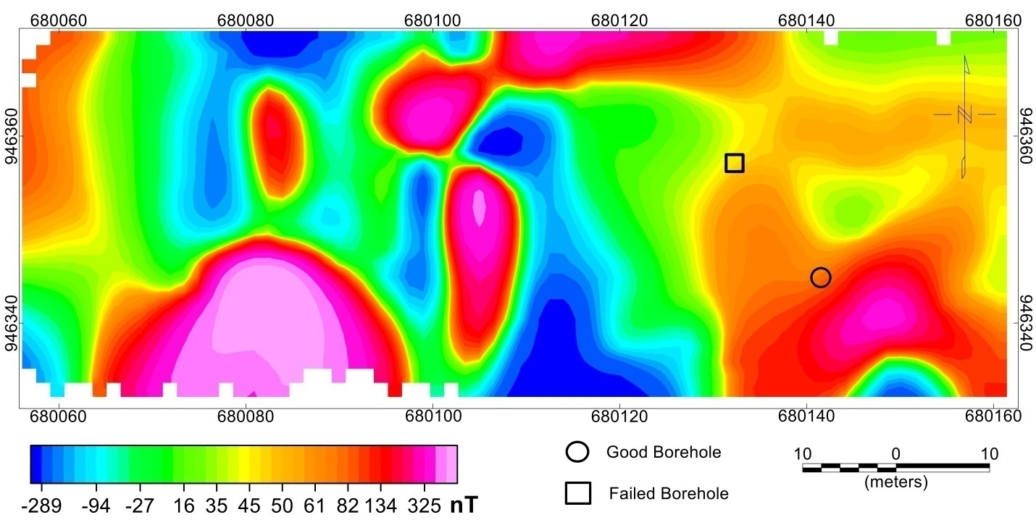
Fig. 3: The reduced-to-pole total magnetic intensity anomaly data of the survey area.
  - Interpretation of the RTP horizontal gradient amplitude map
The application of the RTP anomaly data to the horizontal gradient amplitude (HGA) filter (Figure 4), has revealed numerous concealed shallow magnetic structures which are relatively invisible in figure 3. The HGA map (figure 4) with values varying from < 1 to > 9 nT/m, distinguished the regions of shallow and deep-seated magnetic structures in pink and blue colors respectively. The location of good borehole which is observed at the edge of relatively high HGA anomaly, could be marked as a zone of structural weakness with high degree of faulting and fracturing. The high HGA anomaly at the southeastern corner could be an igneous intrusive body of short wavelengths amplitude within high elevation (Figure 1), adjoining the good borehole. The location of the failed borehole falls within the low HGA anomaly, depicting less magnetic materials of impermeable origin, thereby limiting aquifer’s connectivity or groundwater recharge.

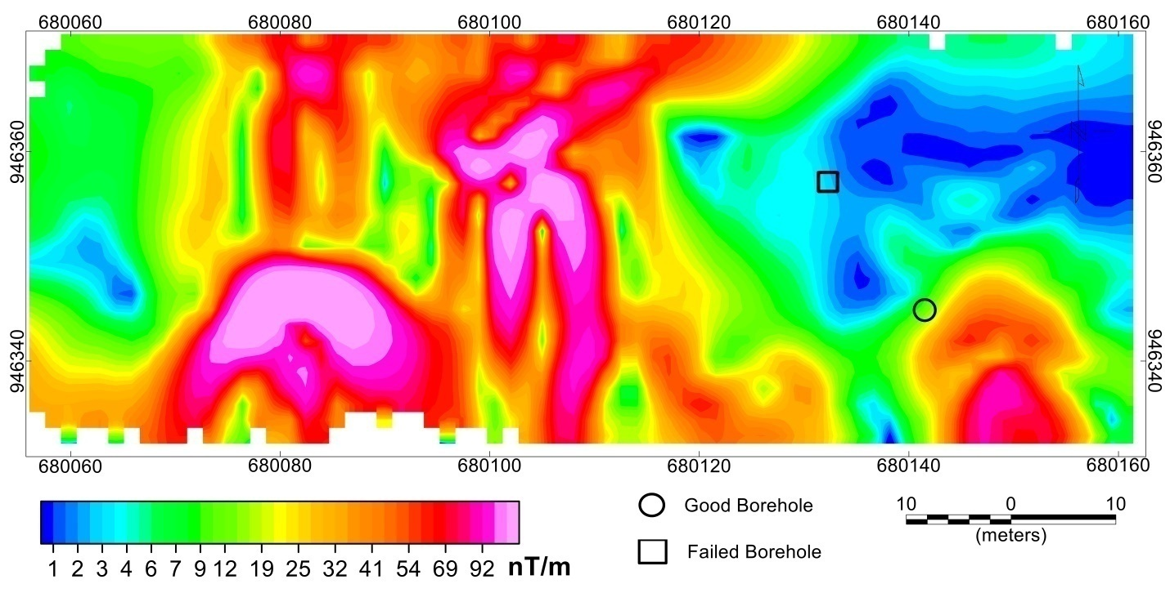
Fig. 4: The horizontal gradient amplitude map produced from the reduced-to-pole total magnetic intensity anomaly data of the survey area.
  - Interpretation of the TMI total gradient amplitude (TGA) map
The total gradient amplitude (TGA) anomaly map (Figure 5) has identified several structural geologic features primarily of two-dimensional sources. The TGA technique unlike RTP (Figure 3), is independent on the direction of magnetization, dip, strike among others, resulting from two-dimensional sources. Thus, making it as an outstanding tool for low latitude region like herein. Just like the HGA map (Figure 4), TGA depicts prominent shallow concealed structures with values varying from < 2 to > 244 nT/m. These high TGA values implies that the study predominantly falls within the crystalline basement complex. Though, the high and low TGA anomalies could be tied to the occurrence of different crystalline basement formations. The good borehole is also observed at the margin of relatively high TGA anomaly amplitude, which is in conformity with the relatively high elevation and high HGA, amplitudes (Figures 1, 4). The productivity of the failed borehole maybe be hindered by low TGA anomaly, probably resulting from the presence of confined (less permeable formations) or compacted unsaturated layers. This less porosity from these formations reduces the groundwater flow rates of the failed borehole. Hence, the productivity of the good borehole is tied with highs HGA and TGA amplitudes, which are associated with steeper slope in the water table, contributing to efficient groundwater movement towards the borehole. On the other hand, the locations with lows HGA and TGA amplitude represent less dynamic water table with flatter slope.
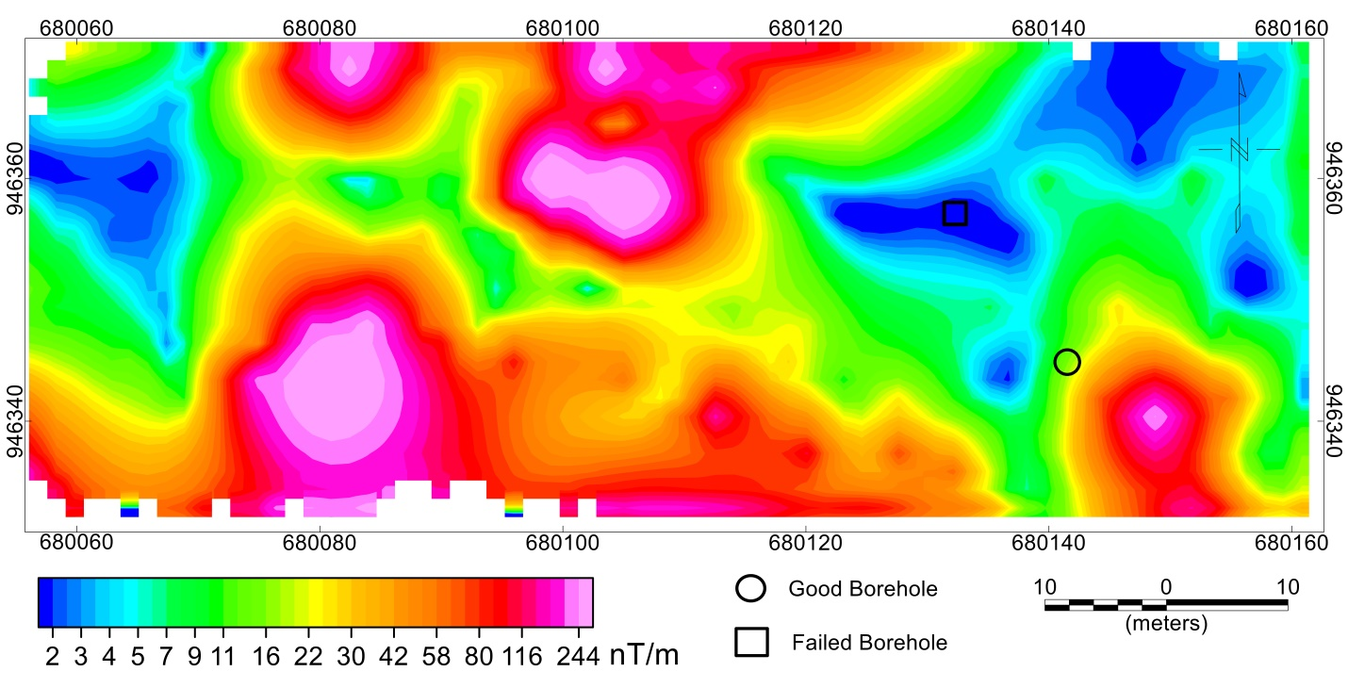
Fig. 5: The total gradient amplitude map produced from the total magnetic intensity anomaly data of the survey area.
  - Interpretation of the local wavenumber (LW) map
The interpretation of local wavenumber (LW) map (Figure 6), like the TGA map (Figure 5) is not dependent of the magnetization direction and thus requires no reduction to pole (RTP) data as prerequisite input. The LW depth estimate provide information on the subsurface characterization of the good and failed boreholes. The LW map reveals per meter depths to basement of deep to shallow sources with values varying from < 0.04 to > 0.43 1/m respectively. The locations with blue to pink colors represent the depths of deep to shallow-seated magnetic materials. The good borehole lies at the margin of the relatively low per meter depths. The good borehole reveals relatively low per meter wavenumber depth. Thus, suggesting that the subsurface around the good borehole exhibits a smoother change at local scale. Possibly, implying permeable formations or well-connected aquifers contributing to more accessible groundwater. Of these, the productivity of the good borehole could also be attributed to a linear NE-SW geologic feature such as fault or fracture, adjoining the region of high elevation (Figure 1). Along the dashed lines new boreholes could be produce, coupled with the occurrence of linear feature at the margin of highest elevation (see Figure 6) given rise to increase in pressure of the aquifer. On the contrary, the failed borehole is overlain on a NW-SE trend, within high per meter local wavenumber depth. This could imply a geological complexities or heterogeneities like the presence of impermeably layers or lithological changes that impede effective groundwater flow.
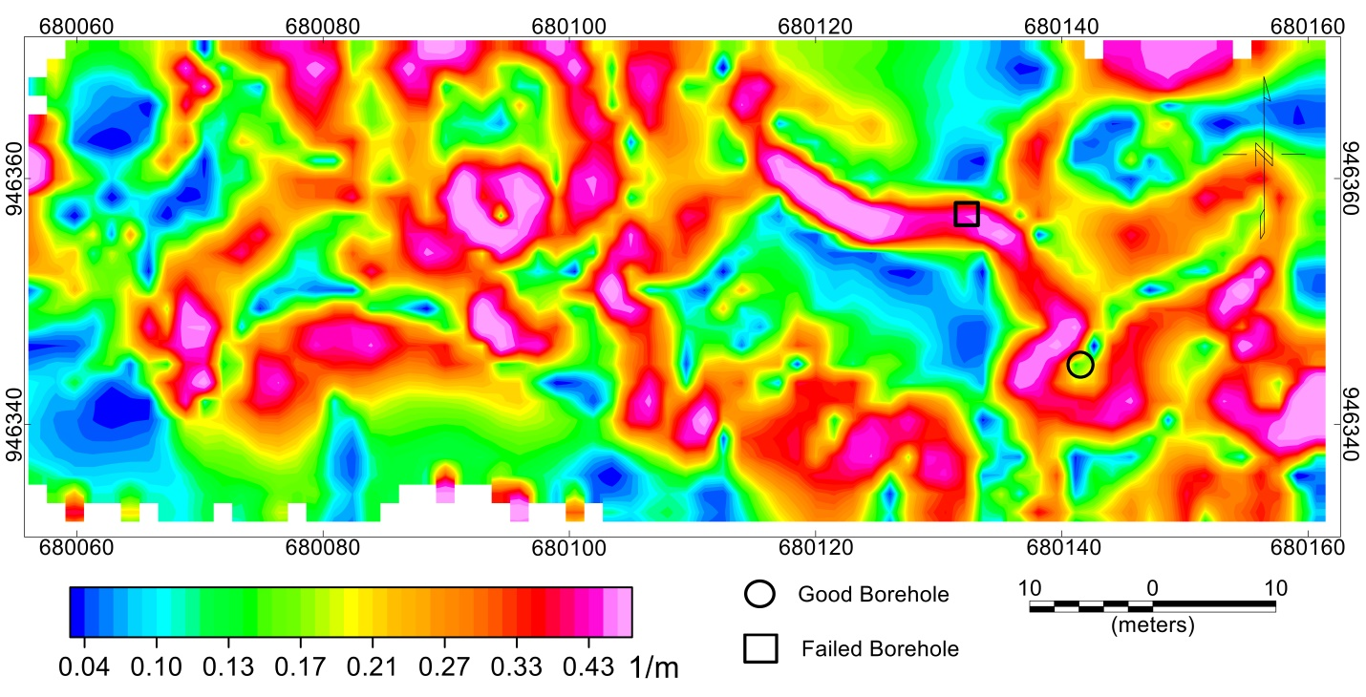
Fig. 6: The local wavenumber map produced from the total magnetic intensity anomaly data of the survey area.

CONCLUSION
An attempt has been made to interpret ground magnetic and elevation data with the purpose of addressing borehole failure in two locations at Kwara State Polyethnic, Northcentral Nigeria. This study has widened our understanding of groundwater borehole productivity and failure. The good borehole benefits from being strategically located at the edge of high elevation with highs horizontal and total gradient amplitudes and low local wavenumber depth estimates, indicating more favorable hydrogeological conditions. In comparison, the failed borehole, despite being located at relatively high elevation encountered problems related to less favorable geological settings, limiting the groundwater flow. Thus, the location of failed borehole revealed lows horizontal and total gradient amplitude and high local wavenumber depth estimates. Therefore, this study will serve as a paradigm in predicting newly target locations to be drilled for abundant and sustainable groundwater supply within the study area.

REFERENCES
Ajadi, B. S., Adaramola, M. A., Adeniyi, A. and Abubakar, M. I. (2016). Effect of effluents discharge on public health in Ilorin Metropolis, Nigeria. Ethiopian Journal of Environmental Studies & Management 9(4): Pp. 389 – 404.
Amarachi, R. A. and Ako, B. D (2012). Groundwater Investigation Using Combined Geophysical Methods. Adapted from extended abstract prepared in conjunction with poster presentation at AAPG Annual Convention and Exhibition, Long Beach, California, AAPG©2012.
Ariyo, S.O., and A.A. Banjo, 2008, Application of electrical resistivity method for groundwater exploration in a sedimentary terrain: A case study of Ilara-Remo, Southwest Nigeria: Continental Journal of Earth Sciences, v. 3, p 53 – 58.
Carruthers, R.M., 1985, Review of geophysical techniques for groundwater exploration in crystalline basement terrain: British Geological Survey, Regional Geophysics Research Group, Report 85/3, Pp.30.
Chinwuko, A. I., Usman, A. O., Onwuemesi, A. G, Anakwuba, E. K., Okonkwo, C. C. and Ikumbur, E. B., (2014); Interpretations of aeromagnetic data over Lokoja and environs, Nigeria; International Journal of Advanced Geosciences, 2 (2): Pp.66-71.
Choudhury, K., Saha, D. K. and Chakraborky, P. (2001). Geophysical study for saline water intrusion in acoastal alluvial terrain. J. Appl. Geophys. 46:189-200.
Emenike, E.A., 2001, Geophysical exploration for groundwater in a Sedimentary Environment: A case study from Nanka over Nanka Formation in Anambra Basin, Southeastern Nigeria: Global Journal of Pure and Applied Sciences, v. 7/1, p. 1-11.
Fatoye, O. V., Olasehinde, D. A., Olatunji, J. A., Olasehinde, O. D., Abioye, O. and Olasehinde, P. I. (2022). Structural Evaluation for Groundwater Within the Crystalline Basement of Ilorin, Nigeria, Using Multisensory. IOP Conf. Series: Earth and Environmental Science 1054. doi:10.1088/1755-1315/1054/1/012009.
Gadallah, M. R. and Fisher, R. (2009). Exploration Geophysics: Berlin Germany: Springer.
Keary, P., Micheal, B., and Hill, I. (2002). An Introduction to Geophysical Exploration (3rd Edition). Willey Blackwell Science.
Nwankwo, L. I (2011). 2D Resistivity Survey for Groundwater Exploration in a Hard Rock Terrain: A Case Study of MAGDAS Observatory, UNILORIN, Nigeria. Asian Journal of Earth Sciences; pp. 1-3.
Nwankwo, L. I., Olasehinde, O. I. and Babatunde, E. B. (2004). The use of electrical resistivity pseudo-section in elucidating the geology of an East-west profile in the basement complex terrain of Ilorin, West-central, Nigeria. Nig. J. Pure and Appl. Sci.; 1676-1682.
Olade, M. A. (1975). Evolution of Nigeria’s Benue Trough. African Lithosphere and their Geodynamic Significance. Journal of African Earth Science, Vol. 3, pp.437 – 442.
Satpathy, B. N. and Kanungo, D. N (1976). Water exploration on land terrain: A case history. Geophys. Prospect. 24: 725-736.
Sunday, J. A., Usman, A., Ologe, O. and Lawal, T. O. (2019). Detection of Fracture Zones for Groundwater Investigation from Interpretation of VLF-EM Anomalies of Kwara State Polytechnic Ilorin and its Environs. Global Journal of Human-Social Science; (19) 27-41.
Telford, W., Geldart, L., Sheriff, R., and Keys D. (1976). Applied Geophysics (2nd edition). New York. Cambridge University Press.
Li, X (2006). Understanding 3D analytic signal amplitude. Geophysics 71, L13–L16.
Salem, A (2005). Interpretation of magnetic data using analytic signal derivatives. Geophys. Prospect. 53, 75–82
Salawu NB, Omosanya KOL, Eluwole AB, Saleh A, Adebiyi LS (2023) Structurally-controlled gold mineralization in the Southern Zuru Schist Belt NW Nigeria: Application of Remote Sensing and Geophysical Methods. Journal of Applied Geophysics 211:10496
MacLeod TF, Jones I, Dai K (1993) 3-D analytic signal in the interpretation of total magnetic field data at low magnetic latitudes. Exploration Geophysics 24:679–8
Salawu, N. B., Olatunji, S., Adebiyi, S. L., Olasunkanmi, K. N., & Dada, S. S. (2019a). Edge Detection and Magnetic Basement Depth of Danko area, Northwestern Nigeria, from Low‑latitude Aeromagnetic Anomaly Data. Springer Nature Switzerland Applied Sciences, 1, 1056.
Saleh. A., Salako, K., Salawu, B., Orosun, M., Adebiyi, L.S., & Shehu, J. (2023). Airborne Magnetic and gamma-ray spectrometric prospecting to delineate structures associated With Gold mineralization-a case study in Yauri region, Northwestern, Nigeria. Arabian Journal of Geosciences, 16, 308.
Salawu, N. B., Fatoba, J. O., Adebiyi, L. S., Ajadi, J., Saleh, A., & Dada, S. S (2020). Aeromagnetic And Remote Sensing Evidence for Structural Framework of the Middle Niger and Sokoto Basins, Nigeria. Physics of the Earth and Planetary Interiors, 309.
Adebiyi, L. S., Eluwole, A. B., Fajana, A. O., Salawu, N. B., Saleh, A. (2023). Contrasting structures of the Southern Benue trough and the contiguous crystalline basement as observed from high‑resolution aeromagnetic data. Scientific Reports, 13:21516. https://doi.org/10.1038/s41598-023-48639-8.
Beard, L. P. & Goitom, B. (2000). Some problems in interpreting low latitude Magnetic Surveys.6th EAGE/EEGS Meeting.

