DEVELOPMENT OF IMAGE STEGANOGRAPHY APPLICATION SYSTEM USING SPATIALLY DESYNCHRONIZED STEGANOGRAPHIC ALGORITHM

By:
IBRAHIM ABDULWAHEED OLADIMEJI
ND/23/COM/PT/0143
CHAPTER ONE
GENERAL INTRODUCTION
1.1 BACKGROUND TO THE STUDY
The internet simply refers to a large collection of networked computers. Man has grown to depend on the internet on a continual basis and have incorporated it into their lives. Security, as of now, is the techniques developed to securely guard information and information systems on computers. Potential threats consist of the destruction of computer hardware, software, theft, unauthorized use, or disclosure (Sanjive, et al., 2022).
AL-Shaaby and Al-Kharobi (2021) described Computer and the information they contain are often considered confidential systems because their use is typically restricted to a limited number of users. This confidentiality can be exposed to danger in a variety of ways. For example, files, data and information can be exposed by hackers, viruses and worms. Therefore, security can be defined as the resistivity degree to, or protection from harm. It is also a statement of fact that security dynamics have evolved over the years (Alese, 2024).
Today, steganography is most often linked with the high-level technology variety, where data is hidden within other data in a file. For example, a word document might be hidden inside an image file. This is mostly done by replacing the most redundant or least important bits of data in the original with hidden data bits. Steganography is very different from cryptography, in the aspect that cryptography's chief aim is to protect the message from unauthorized attackers, whereas steganography strives to conceal the existence of the message itself while its transmission is taking place (Lee & Bell., 2022). When a message is encrypted, it is visible to the whole world and also vulnerable to malicious attacks, where as if the data is hidden in an image, apart from the entities involved in the communication process, no third party will be able to sense the transmission of data. Hence, being more secure, steganography finds a wider range of applications as compared to encryption. The type of data that can be hidden ranges from plain and cipher texts to images. A plethora of carrier file formats are available, however, images are used due to their high frequency and availability over the internet. However, every method has its own advantages as well as drawbacks. Different techniques can be used based on the varied requirements of different applications. One application may require containing and hiding really large data, whereas, on the other hand, some applications may need the process to be more discrete (Arron, 2022).
Steganography includes another level or layer of security by keeping data confidentially even the fact that secret communication takes place. The corresponding protection goal is called undetectability. Today, steganography is most often linked with the high-level technology variety, where data is hidden within other data in a file. For example, a word document might be hidden inside an image file, as in the preceding story. This is mostly done by replacing the most redundant or least important bits of data in the original file bits that are hardly missed by the human ear or eye with hidden data bits (Osuolale, 2022).

  - STATEMENT OF THE PROBLEM
Security has become one of the most significant problems in data communication over the internet (Saleh, 2021). So, it becomes an inseparable part of data communication. The establishment of a secure communication between two communicating parties is becoming a difficult problem due to the likelihood of attacks and other unintentional changes during an active communication over an unsecured network (Mustafa, et al., 2023). However, the security of secret information can be secured using either cryptography or steganography.
It is therefore against these background that this research presents a scheme on the data security techniques, this proposed scheme employs image steganography algorithm technique, to get a very highly secured system for data security over unsecure channel.
1.3 AIM AND OBJECTIVES
The aim of this research work on image steganography application system using spatially desynchronized steganographic algorithm. In other to achieve this aim, the following specific objectives were formulated:
- To develop a Security Application Techniques (SAT) that can hide data inside image
- To implement system develop in (i) using spatially desynchronized steganographic algorithm
- To evaluate the performance spatially desynchronized steganography system in data hiding
1.4 SIGNIFICANCE OF THE STUDY
The study on the Image Steganography Application System using a Spatially Desynchronized Steganographic Algorithm is of substantial significance in today’s digital age, where secure communication is a growing necessity. The research addresses the increasing need for advanced data hiding techniques that can ensure confidentiality, integrity, and robustness against modern steganalysis methods. This study is significant for several reasons: Enhanced Data Security: By implementing a spatially desynchronized algorithm, this system offers improved resistance to detection and extraction of hidden data. This provides a higher level of security compared to traditional steganographic techniques, especially in hostile environments where data privacy is at risk. Innovation in Steganographic Techniques: The integration of spatial desynchronization introduces a novel approach to steganography, potentially paving the way for more sophisticated and undetectable data hiding methods. This can contribute to academic research and technological development in the field of information security. Real-World Applications: The system has practical applications in military communication, digital rights management, confidential data transmission, and secure correspondence over public networks. It can be used to protect sensitive information in both governmental and private sectors.

1.5 SCOPE OF THE STUDY
This study is focused on the design and implementation of an Image Steganography Application System that utilizes a Spatially Desynchronized Steganographic Algorithm for secure data embedding and retrieval. The scope of the study is outlined as follows: Image-Based Steganography: The system is limited to steganographic techniques that operate on digital image files, particularly common formats such as PNG and JPEG. Other media types like audio, video, or text are outside the scope of this research. Spatial Domain Techniques: The study emphasizes spatial domain steganography, specifically using spatial desynchronization to improve imperceptibility and resistance to steganalysis. Frequency-domain methods such as DCT or DWT-based techniques are not covered in this implementation. Embedding and Extraction of Text Data: The application is designed to embed and extract text-based information within image files. It does not support embedding other file types (e.g., documents, executable files, or images within images). Security Through Obfuscation: The system focuses on security through data hiding and pattern desynchronization, rather than using encryption. While the technique enhances stealth, it does not substitute for cryptographic encryption mechanisms. User Interface and Functionality: A basic, user-friendly application interface is developed to allow users to upload images, embed secret messages, and retrieve them. The system does not include advanced functionalities such as batch processing or cloud-based deployment.

1.6 ORGANIZATION OF REPORT
Chapter one contains the background to the project, statement of the problem, the aim and objectives, significance of the study, scope of the study, and organization of the report. Chapter two entails the review of related past work, steganalysic techniques, spatially desynchronized steganographic, steganography techniques and steganography algorithm, different types of steganography, information security objectives and steganography goals.
More so, chapter three examines the method of the proposed system, the, the description and advantages of proposed system. Chapter Four, explains the implementation and documentation of the system which contains design, implementation techniques, documentation, hardware and software requirements.
Lastly, chapter five includes the summary, conclusions and recommendations.

CHAPTER TWO
LITERATURE REVIEW

2.1 REVIEW OF RELATED WORK
Sharma and Kumar (2023) proposed a steganographic algorithm based on least significant bit substitution to hide text file inside the digital image. All the three layers of an RGB image were used alternatively to embed data in the least two significant bits of selected pixel. In order to increase the storage capacity (i.e. length of message that can be embedded inside image), a compression algorithm was used that compresses the data to be embedded. The used compression algorithm works in a range of 1 bit to 8 bits per pixel ratio. And the developed system was able to maintain the accuracy and confidentiality of data. Furthermore, two cover images were used. Message was embedded in the first cover image which was then covered by second cover image. This hides the degradation of first cover image that were caused due to embedding of message.
Mishra et al. (2022) used a spatial domain LSB substitution for embedding a piece of information in an image. However, in order to achieve higher security of message as compared to basic LSB method, Arnold transformation was successively applied twice in two different phases. The system was tested and validated against a series of standard gray scale images and the results obtained were found to be highly promising.
Kaur et al. (2023) introduced a steganographic approach based on jump table with the identical matching concept. It is the Sami-blind embedding and extraction approach. The pixels of alternative RGB layers are used for embed the secret message. If no identical match found at any place of pixel than least significant bits are replaced with the secret message bits. The concept of secret key extraction and image blocking was also introduced in this approach. The results in terms of PSNR and CC were promising for this approach.
Cheng and Tseng (2022) proposed two hybrid least significant bit substitution methods. The first method coupled the optimal least significant bit substitution and optimal pixel adjustment process to improve the quality of steganographic image. The second method was the variation of the first one which replaces the optimal LSB substation with the worst LSB substitution. Based on these collaboration techniques, better steganographic quality was achieved. Experimental results presented in the paper showed that proposed method was superior to previous works.
Hayfaa, et., (2022), proposed a new method of embedded secret message into image; The proposed algorithm is designed based LSB (Least Significant Bit) method to hide encrypted message into image. Experimental tests performed on grayscale and true color images of size 256*256, same message used for all tests. The eighth bit is used to hide the secret message in each host image. Good and encouraged results are achieved, for grayscale and true color images. The study was designed the features of steganography, which will provide a higher level of security. Simple LSB method was used to embed the secret message into the image. The last bit in each pixel used to conceal the message binary code. The capital letter was used to perform the experiment and the future work will be on including the small letters, symbols, and numbers from 0 to 9
Sadaf, et al., (2020) proposed a technique for protection of image (data) in open wireless channel. The secret image was embedded in the cover image using LSB technique from spatial domain. Then the stego image is divided into 8*8 blocks. The divided stego image is encrypted by double random phase encoding. Double random phase encoding transforms the image into white stationary noise. In the first phase of double random phase the image is multiplied by first random phase mask. Then the, multiplied image is transferred from time domain to frequency domain by applying Fourier transform. In the final phase the image is convolved with the second random phase mask. The techniques has helped in protection of image with the LSB techniques.
2.2 STEGANALYSIC TECHNIQUES
Steganography leaves behind detectable traces (i.e., distortion) in the stego object and modifies the statistical properties. Detecting the presence of distorted statistical properties is called statistical steganalysis. Steganalysis is a relatively new research discipline with few articles appearing before the late-1990s. Steganalysis is "the process of detecting steganography by looking at variances between bit patterns and unusually large file sizes". It is the art of discovering and rendering useless covert messages (Diop et al., 2022). The goal of steganalysis is to identify suspected information streams, determine whether or not they have hidden messages encoded into them, and, if possible, recover the hidden information. The steganalysis techniques focus on detecting the presence/absence of a secret message in observed message, to our knowledge there seems to have been no attempt in extracting the secret message. In general, extraction of the secret message could be a harder problem than mere detection (Satenik et al., 2021). Therefore, based on the ultimate outcome of the effort we classify steganalysis into two categories:
- Passive steganalysis: Detect the presence or absence of a secret message in an observed message.
- Active steganalysis: Extract a (possibly approximate) version of the secret message from a stego message.
2.2.1 SPATIALLY DESYNCHRONIZED STEGANOGRAPHIC
The separation of the embedding domain from the staganalytic domain is used to prevent cover image prediction from the stego image. In other words, if the embedding domain is kept secret from the attacker then it is not possible to mount calibration attack by predicting the cover image statistics (Goel & Mukhopadhyay 2022). The spatial de-synchronization operation is used to hide the embedding domain from the attacker by randomizing the embedding domain. Here spatial de-synchronization implies the embedding grid is not synchronized with the JPEG compression grid of the stego image. Due to this spatial shifting (de synchronization), a noise (sometimes called de-synchronization noise) is added to the stego image. This noise masks the steganographic noise in such a way that the detection of steganographic embedding becomes difficult for the attackers. Thus spatial shifting operation resists calibration based attacks (Arijit et al., 2021).

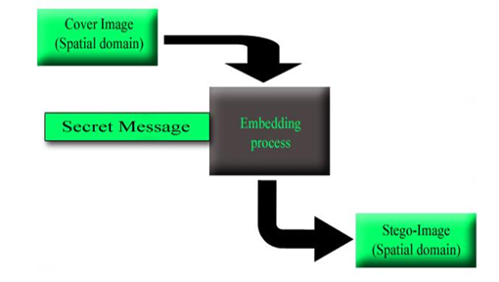
Figure 2.1: Steganography process in spatial domain

2.3 STEGANOGRAPHY TECHNIQUES AND STEGANOGRAPHY ALGORITHM
2.3.1 STEGANOGRAPHY TECHNIQUES
Steganography has three techniques which are Secret key, Public key and Pure steganography techniques, which are explained as follow:
Secret key steganography usual uses a well-known public algorithm, and relies on a secret key chosen by the two parties communicating beforehand. This key is needed to both embed and extract the hidden information, and if the right key is not used, it cannot be known if data is actually hidden in a given cover object.
- Public key steganography requires the sender using the recipient's public key to embed the information, which can only be recovered using the recipient's private key.
- This is analogous to how the public key architecture works in cryptography. The interesting characteristic with public key steganography is that even the sender should not be able to observe the secret message in the resulting stego object.
- Pure steganography does not require any prior exchange of information between the two parties communicating and relies on secret through obscurity. This means that the algorithms are not generally known, and therefore the level of testing is also unknown, making the tool unproven. One has to go on faith alone in those involved in the tool's creation to be assured covert communication. Numerous instances of the false sense of security through obscurity can be cited.
2.3.2 STEGANOGRAPHIC ALGORITHMS
There are algorithms implemented. Some of them filter the image before embedding data where as others don’t. The common factor among them is that all of them involve the Least Significant Bit (LSB) algorithm for embedding the data to be hidden into the pixels of the cover image. The Steganographic algorithms are as follows:
- BlindHide: Using a lossless image like a Bitmap image and then substituting its least significant bits with the data to be hidden is the easiest way of data embedding. This substitution takes place line by line. However, this techniques isn’t very secure as a malicious attacker might try to repeat this process multiple times to get access to the hidden data. This technique is called ‘BlindHide’ as it simply hides the data in a blind fashion, and hence isn’t very efficient at the same. It is possible that some part of the image gets totally distorted while remaining portion is as it is (Detecting LSB Steganography in Images (Lee, et al., 2021).
- FilterFirst: Now, only say x least significant bits are replaced, and the y most significant bits are used for filtering. The range for x is [1,7] and y is x less than 8 i.e. (8-x). The total recovery of the hidden message is assured as the bits used for filtering aren’t modified during embedding the data. No extra data is required, like the original picture, and still makes sure that embedding and retrieval are done with the same pixels (Lee et al., 2021).
- HideSeek: HideSeek algorithm involves the random distribution of message bits across the pixels of the cover image. HideSeek algorithm derives its name from a steganography tool of Windows 95, called “Hide and Seek” which uses a technique similar to our algorithm. A password generates a random seed, and this seed is used to select the first position to embed information in it. This random generation of positions keeps going on until the entire data is embedded. This algorithm is relatively difficult to crack, as every pixel combination needs to be tried in case the password isn’t known. There is still scope for improvement in this algorithm as the pixels aren’t evaluated if they’re good for hiding data. This can be dealt with by checking which regions of the image are better to embed the data within (Lee et al., 2021).
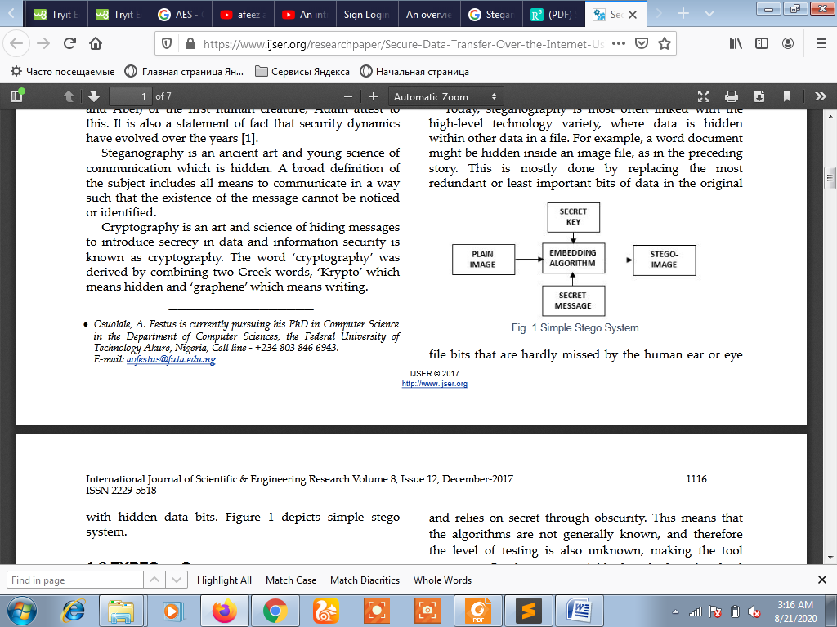
Figure. 2.2 Simple Stego System

  - DIFFERENT TYPES OF STEGANOGRAPHY
- Fragile Steganography: In Fragile Steganography, the file in which data is to be hidden is embedded, gets destroyed if it is modified. This technique isn’t used to record the copyright holder of files, as it is extremely easy to remove. However, in cases where proving that the file is in its original state is necessary, for example: for legal purposes or as an evidence, this method is employed as the watermark wouldn’t be present had the file been modified. It is generally observed that implementing Fragile Steganographic techniques is much simpler than implanting the robust ones.
- Robust Steganography: In Robust Steganographic technique, data is embedded into files which aren’t easy to detect or modify. Though no kind of mark is completely robust, a system is called robust if all efforts to remove the mark would modify the file to the extent that it no longer serves its original purpose or is of any use. Hence, it’s better to hide the mark where it’s easier to detect and remove. Robust marking is further divided into two more categories. The first one is watermarking. Watermarks are used to detect the owner or creator of the file leaked. They are generally hidden in a way that it’s extremely tedious to detect and eliminate them, and hence are termed as ‘imperceptible watermarks. But, this isn’t the case every time. At times, watermarks that are visible are used. They often form a kind of pattern on the original image. Such patterns are similar to use of watermarking in hard format. One such example is the watermarking found in the currency of Britain. Watermarking is used to identify the owner of the file, who has the copyright. On the other hand, fingerprinting makes use of a distinct mode of identification for every person who possesses the file and hence, is authorized to use it. This fingerprint can be used to detect the violation of agreements if the file is found with anyone else apart from the owner. The main difference between fingerprinting and watermarking is that, fingerprinting is used to identify the customer of a particular file whereas watermarking aims to find the owner who has the copyright. Fingerprints help in identifying those agents who have an illegal copy of the data, and hence prosecute them for violation of the terms of license agreement. Although fingerprinting should be used for production and distribution of objects in bulk, it is practically not possible to assign a unique fingerprint to every copy (Dharmesh et al., 2020).
    - INFORMATION SECURITY OBJECTIVES
Table 2.1: Some Information Security Objectives.
Information security objectives
Privacy or Conﬁdentiality | Keeping information secret from all but those who are authorized to see it.
Data integrity | Ensuring information has not been altered by unauthorized or unknown means.
Entity Authentication Or Identiﬁcation | Corroboration of the identity of an entity (e.g., a person, a computer terminal, a credit card, etc.).
Message Authentication | Corroborating the source of information; also known as data origin authentication.
Signature | A means to bind information to an entity.
Authorization | Conveyance, to another entity, of ofﬁcial sanction to do or be something.
Validation | A means to provide timeliness of authorization to use or manipulate information or resources.
Access control | Restricting access to resources to privileged entities.
Certiﬁcation | Endorsement of information by a trusted entity.
Time stamping | Recording the time of creation or existence of information.
Witnessing | Verifying the creation or existence of information by an entity other than the creator.
Receipt | Acknowledgement that information has been received.
Comﬁrmation | Acknowledgement that services has been provided.
Ownership | A means to provide an entity with the legal right to use or transfer a resource to others.
Anonymity | Concealing the identity of an entity involved in some process.
Non-repudiation | Preventing the denial of previous commitments or actions.
Revocation | Retraction of certiﬁcation or authorization.

2.4.2 STEGANOGRAPHY GOALS
Steganography goals of all the information security objectives listed in Table 2.2 above, the following four form a frame work upon which the others will be derived:
- Privacy or Conﬁdentiality
- Data integrity
- Authentication and
- Non-repudiation
- Conﬁdentiality is a service used to keep the content of information from all but those authorized to have it. Secrecy is a term synonymous with conﬁdentiality and privacy. There are numerous approaches to providing conﬁdentiality, ranging from physical protection to mathematical algorithms which render data unintelligible.
- Data integrity is a service which addresses the unauthorized alteration of data. To assure data integrity, one must have the ability to detect data manipulation by unauthorized parties. Data manipulation includes such things as insertion, deletion, and substitution.
- Authentication is a service related to identiﬁcation. This function applies to both entities and information itself. Two parties entering into a communication should identify each other. Information delivered, date of origin, data content, time sent, etc. For these reasons this aspect of cryptography is usually subdivided into two major classes: entity authentication and data origin authentication. Data origin authentication implicitly provides data integrity (for if a message is modiﬁed, the source has changed).
- Non-repudiation is a service which prevents an entity from denying previous commitments or actions. When disputes arise due to an entity denying that certain actions were taken, a means to resolve the situation is necessary.
CHAPTER THREE
RESEARCH METHODOLOGY AND ANALYSIS OF THE EXISTING SYSTEM
3.1 RESEARCH METHODOLOGY
In this section, the proposed algorithm of steganography and extraction of hidden message. The concept of spatial de-synchronization, encryption, and hashing to perform complete algorithm.
Steganography Algorithm
Let I is the cover image. It can describe the proposed steganography algorithm in following steps:
- Step 1: Desynchronize the cover image (I) is by the image cropping scheme, i.e by removing u topmost rows and v leftmost columns. Get cropped image (I_{c}) and remaining portion of image I_{cr} as output.
- Step 2: Apply Hash function to perform randomized cropping on cropped image (Ic). Get hashed cropped image (I_{ch}) and remaining portion of image I_{chr} as output.0
- Step 3: Encrypt the secret information (M). Get cipher text (M_{e}) as output.
- Step 4: Now the hashed cropped version of the image (I_{ch}) is used for embedding cipher text (M_{e}) using steganographic. Get stego image (Is1) as output.
- Step 5: Stitch the stego image (I_{s1}) with Ichr to obtain the embedded image I_{s2}.
- Step 6: Stitch the image (I_{s2}) with Icr to obtain another embedded image I_{s}.

Algorithm to Extraction of stego-bits
Let I_{s} is the stego image. The extraction of stego bits is rather simple, nearly reverse process of above algorithm. This algorithm can be described in following steps:
- Step 1: Extract the value of u & v (i.e. number of cropped rows and column) from stego image. Step 2: Desynchronize the stego image (I_{s}) is by the image cropping scheme, i.e by removing u topmost rows and v leftmost columns. Get cropped image (I_{sc}) and remaining portion of image I_{scr} as output.
- Step 3: Apply Hash function to perform randomized cropping on cropped image (I_{sc}). Get hashed cropped image (I_{sch}) and remaining portion of image I_{schr} as output.
- Step 4: Now the hashed cropped version of the image (I_{sch}) is used for bit extraction procedure. Get cipher text of secret information (M_{e}) as output.
- Step 5: Decrypt cipher text (M_{e}) to get the secret information (M) as output.
3.2 ANALYSIS OF THE EXISTING SYSTEM
Steganography provides sensitive information security through the embedding of the information in another information; thus, there is confidentiality. Such hidden information can only be revealed using a steganographic key. However, the technique and manner used to conceal the information could also serve as identity proofs. The technique for embedding the information, can become a shared secret if wrongly done, can be a mode of identification and authentication. The embedded information cannot be subjected to integrity check because the information may have been altered intentionally or unintentionally, and the changes made to the extracted information may not be observed.
3.3 PROBLEMS OF THE EXISTING SYSTEM
Computer scientists and security analysts have recently recognized the security threats posed by the illicit use of steganography techniques in the global information space. Terrorists can utilize steganography to communicate secretly without the knowledge of the law enforcement agencies. Owing to this, studies have been on going to find the problems of the existing steganography systems which can be exploited for hidden information detection, extraction, and/or destruction. There are two major techniques in steganalysis; visual analysis and statistical analysis. The aim of visual analysis is to reveal the presence of hidden information through a naked eye or computer-aided inspection. Statistical analysis tries to reveal small alterations in the carrier objects (it tries to unravel the statistical features associated with steganography processes). Furthermore, secret information can be removed by email firewall when filtering images and this is another threat to image steganography. However, most of the proposed image steganography techniques do not rely on e-mail as a communication channel, rather, on websites which can also distribute stego-images.
3.4 DESCRIPTION OF THE PROPOSED SYSTEM
Different steganography algorithms have been deployed to ensure data security. It should be noted that not all steganography systems operate with secret keys; however, the security of steganography systems can be enhanced by applying the Kerckhoff principle. The principle implies that even if an intruder knows the design and implementation of the steganography system, he must have the secret key to launch a successful attack on the system. Therefore, it may be wise to incorporate the secret keys (public or private) when implementing steganographic systems.
3.5 ADVANTAGES OF THE PROPOSED SYSTEM
- One-Way Hashing :- Used to ensure that a third party has not tampered with a sent message. This is accomplished by creating a hash of the message using a fixed character length for every item in the message, when the original items are in fact of variable character length. The hash is encrypted and sent with the message. When the recipient receives the message it is decoded. If the hash from the decoded message does not match the hash from the encrypted message, both the sender and recipient of the message know that it has been tampered with.
- Attaching Text to an Image:- Explanatory notes are attached to an image. In the medical profession this could be used when one medical office sends an image to another medical office. If the sending medical office needs to include explanatory notes of what the receiving medical office should be focusing on, this could be accomplished with steganography.
- Hiding Information:- Steganography can also be used to protect identities and valuable data from theft, unauthorized viewing, or potential sabotage by concealing the message within a unsuspicious image.

CHAPTER FOUR

DESIGN, IMPLEMENTATION AND DOCUMENTATION OF THE SYSTEM
4.1 DESIGN OF THE SYSTEM
  - DESIGN OF THE SYSTEM
The proposed system is designed in modules with each modules working together to perform the decision tree in order to enhance the performance of the existing system as earlier discussed in chapter three.
The ability to analyze and give focus to the system is explained in the following formats which are output design, input design, database design and procedure design.
    - OUTPUT DESIGN
Output design for the computerized system to go to the screen and the outputs are designed to present report in a meaningful way. The outputs of the system include import report and lying report.
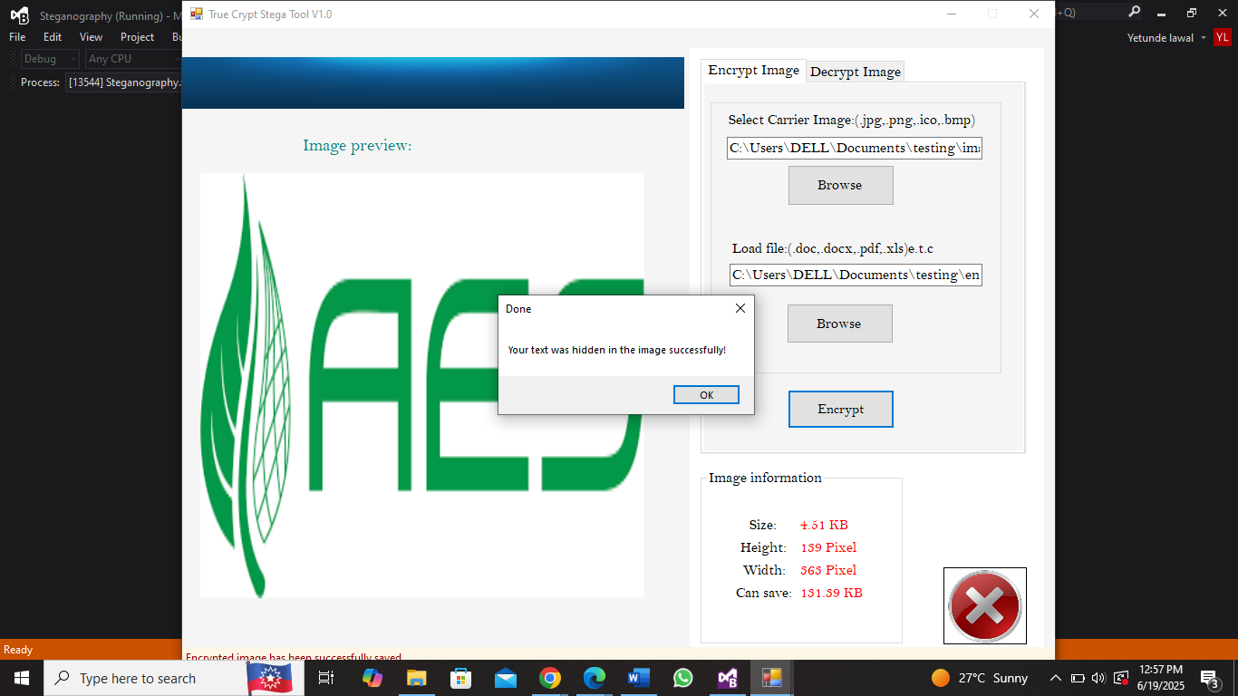
Figure 4.1: Interface for stego (saved successfully)
4.1.2 INPUT DESIGN
This is how data are fed into the system or the way data are to be organized so that the processing state could be successful that is what is explained under the input design.
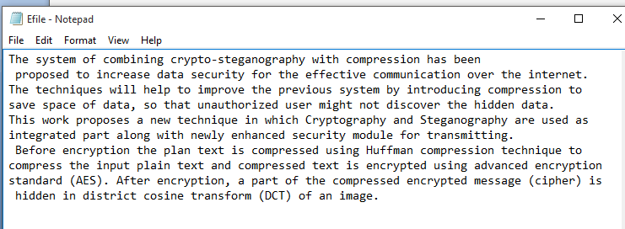
Figure 4.2: Txt. Data for Stego
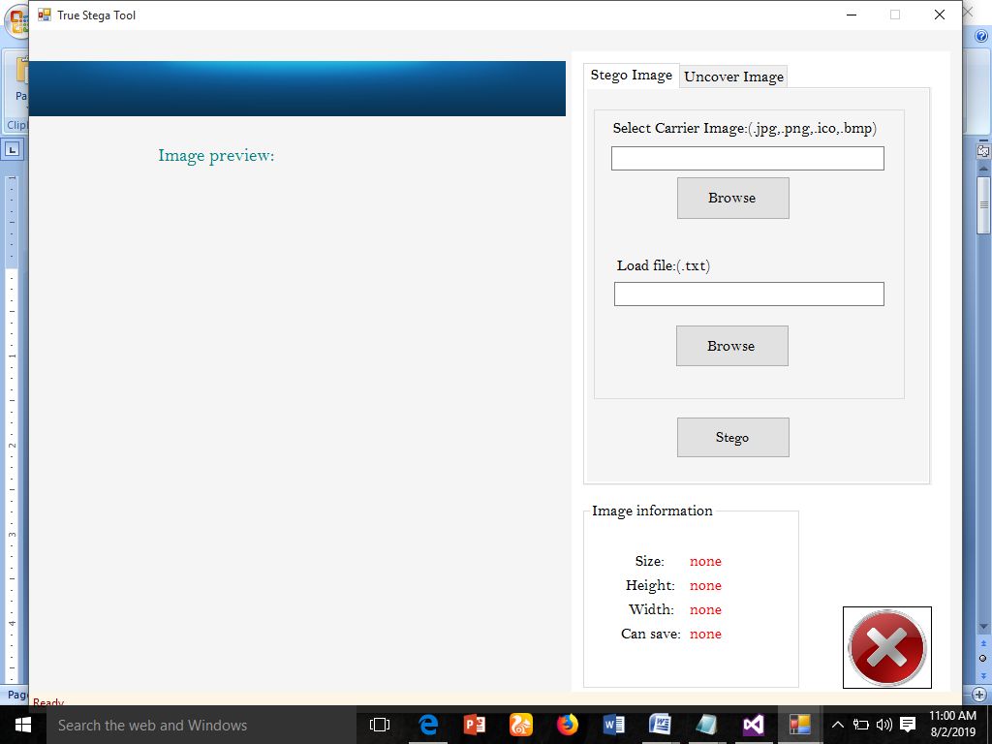
Figure 4.3: Input Interface for stego
AUTHENTICATE ATM TRANSACTION
WITH SMS OTP

4.1.3 PROCEDURE DESIGN
The procedure is the arrangement, steps and how the flow of a program with the arranging and structuring of the program. The methodology used for the program is an event driven programming language which makes program much more efficient in terms of execution, program write time, storage utilization and maintenance, since it is divided into modules.
4.2 SYSTEM IMPLEMENTATION
4.2.1 CHOICE OF PROGRAMING LANGUAGE USED WITH REASONS
The Programming language used for the design and implementation for operation is C Sharp (C#) and SQL serverwas used as a database server. The following were the reason for using the above program.
- It is compiled to an intermediate language (CIL) independently of the language it was developed or the target architecture and operating system.
- It is much more efficient and runs faster.
- The assembly concept solves the versioning control problem well.
- It is good support of distributed system.
- Ease-to-development. The rich class library makes many functions easy to be implemented.
- It is more type safe and pure object-oriented.
- It enhances the connection to the database program.
- Automatic garbage collection.
4.2.2 HARDWARE REQUIREMENTS
To install and run the program, the user needs a
- PC (Pentium IV),
- Dual-core, 2.70-GHz or faster processor,
- USB 2.0 bus dedicated to the Kinect,
- 480GB hard disk
- 8GB of RAM,
- Graphics card that supports DirectX 9.0c
- 10-100 MBPS of Network card

4.2.3 SOFTWARE REQUIREMENTS
- Windows 10 Professional or higher version
- SQL server 2010
- Microsoft word processor 2010
- Visual studio.Net setup tools
- HTML, Visual studio designer
4.2.4 IMPLEMENTATION TECHNIQUES USED
The implementation techniques used in the development of synchronous e-learning method is pilot implementation because it is easy to control; the pilot can be halted at any time. It is easy to evaluate because the new and old system are both running concurrently, it is also easy to train student and also at low risk.
4.3 SYSTEM DOCUMENTATION
4.3.1 PROGRAM DOCUMENTATION
The program is installed by clicking on the Wamp Server from the start menu, locate set up folder where the modules is saved on the www, double click then follow the instruction given on the screen. The program will be installed on Wamp Server folder.

4.3.2 OPERATING THE PROGRAM
Click on the start button on the windows start bar, move the mouse pointer to all program, click the Wamp Server to locate the folder of the application and then click on it. The Home page will be displayed and from where the user can click to check another page one after the other.
4.3.3 MAINTAINING THE SYSTEM
Maintaining of the system has to do with the modification of the system. It refers to the rate of making amendment to the system with ease under a condition. It also refers to the correction, addition or deletion of part or the whole program. Programs that have structure and a feature of maintainability are referring to be a good program. This Program is designed in such a way that it gives room for modification and expansion of the project.

CHAPTER FIVE
SUMMARY, CONCLUSION AND RECOMMENDATIONS
5.1 SUMMARY
The work accomplished during this project can be summarized with the following points:
- In this project the secured method has been developed for the Steganography which could be proven a highly secured method for data communication.
- Steganography is a powerful tools which enables people to communicate without possible eavesdroppers even knowing there is a form of communication in the first place.
- The main advantage of this Steganography System is that the method used for encryption is very secured.
5.2 CONCLUSION
Steganographic algorithm have been proposed to resist steganalytic attacks. The system is tested algorithm by taking nearly 50 different cover images of different image formats, specially JPEG and PNG image format. I found the correct working of proposed algorithm. It applied the spatial desynchronization scheme in two stages. At first stage cropping number of rows and columns is done. In second stage I performed randomized cropping. Incorporate the concepts of encryption of massage just before embedding it into cover image. The concepts of randomized cropping and encryption of massage seems a better concept against steganalytic attacks. It can also perform the proposed algorithm in grayscale as well as true color images. Even I have implemented the proposed algorithm correctly and it seems a better algorithm but proper testing of proposed algorithm is needed.
5.3 RECOMMENDATION
  - The proposed techniques can be used in military application for secure communication.
  - This system of image steganography techniques for information security is expected to provide high security and high performance mechanism for confidential data.
  - The secure image-steganograpgy for secure data over the internet is expected to add more value to information security as discipline.

REFERENCES
Alese, B.K (2024). Computer and Network Security. First Bank of Nigeria. Federal University of Technology, Akure.
AL-Shaaby, A. & Al-Kharobi T.(2021) Cryptography and Steganography: New Approach Transactions on Networks and Communications 5 No. 6.
Arijit Sur, Devadeep Shyam, Piyush Goel, and Jayanta Mukherjee, (2021) An image steganographic algorithm based on spatial desynchronization, Multimedia Tools Appl, Springer Science & Business Media New York.
Arron, M. (2022) Thesis on Steganography.
Chang C. C. and Tseng, H. W. (2022) “Data hiding in images by hybrid LSB substitution,” Third International Conference on multimedia and Ubiquitous Engineering, pp. 360-363.
Dharmesh, R., Richa, T., & Megh, H. (2022) “A New Parallel Messagedistribution Technique for Cost-based Steganography”. arXiv preprint arXiv:1705.08616.
Diop, I. Farssi, S .M Khouma, O. Diouf, H. B Tall, K .and Sylla, K . (2022) New Steganographic scheme based of Reed-Solomon codes, International Journal of Distributed and Parallel Systems (IJDPS) Vol.3, No.2.
Hayfaa, K, Robiah S, & Norliza L,. (2022), “LSB Based Image Steganography Using Dynamic Key Cryptography”, International Conference on Emerging Trends in Communication Technologies (ETCT).
Kumar P. & Sharma V. K., (2022)“Information security based on steganography & cryptography techniques: A review,” International Journal, vol. 4, no. 10, 2014.
Mishra, M. Kumar S. and Mishra, S. (2022), “Security enhanced digital image steganography baed on successive Arnold transformation”, Advances in Intelligent Systems and Computing, vol. 167, pp. 221-229.
Mustafa, S. T., Mohd, S., Mohd R., Sameer A. L., Mohammed M. H., & Hassanain M. A.; (2023): (Combination of Steganography and Cryptography: A short Survey) 2nd International Conference on Sustainable Engineering Techniques (ICSET 2019)IOP Conf. Series: Materials Science and Engineering 518 (2019) 052003, IOP Publishing doi:10.1088/1757-899X/518/5/052003
Osuolale, A. & Festus, K., (2022) Secure Data Transfer Over the Internet Using Image Crypto Steganography International Journal of Scientific & Engineering Research Volume 8, Issue 12, December-2017 1115ISSN 2229-5518IJSER © 2017http://www.ijser.org
Sadaf, B, Muhammad, S., Arif, Anjum, M. R. & Samia D, (2020) “Enhancing security of images by Steganography and Cryptography techniques”, IEEE Int. Conf. Innovative Computing Technology (INTECH).
Saleh, S., (2021) Secure Data Communication System Using Cryptography And Steganography International Journal of Computer Networks & Communications (IJCNC) Vol.5, No.3, May 2013DOI : 10.5121/ijcnc.2018.5310 125
Sanjive, T., Rakesh, K. D., and Ashendra, K. S. (2022) “A High Capacity PDF Text Steganography Technique Based on Hashing Using Quadratic Probing” International Journal of Intelligent Engineering and Systems, Vol.12, No.3, 2019 DOI: 10.22266/ijies2019.0630.20
Satenik Bagyan, Thomas Mair, Yuri Suchorski, Marcus J. B. Hauser and Ronny Straube, (2021) Spatial desynchronization of glycolytic waves as revealed by Karhunen–Loeve analysis.
Sharma V. and Kumar S. (2023) “A new approach to hide text in images using steganography,” International Journal of Advanced Research in Computer Science and Software Engineering, vol. 3.
Sur A., Goel P., and Mukhopadhyay J., (2022) Spatial Desynchronization: A Possible Way to Resist Calibration Attack, Dept. of Comput. Sci. & Eng., Indian Inst. of Technology, Guwahati, India.
Kaur P, Harchet S., Anupama G., and Akshay G., (2023) “An improved steganographic approach to diminish data modification for enhancing image quality”, IEEE.

