EVALUATION OF NURTRITIONAL COMPOSTION OF LETTUCE AS
AFFECTED BY DIFFERENT ORGANIC BIO-FERTILIZER: WITH PROXIMATE APPROACH

BY

OWOLABI OLUWASUEN AYOMIDE
ND/23/ABE/FT/0015

A RESEARCH PROJECT SUBMITTED TO THE DEPARTMENT OF
AGRICULTURAL AND BIO –ENVIRONMENTAL ENGINEERING
TECHNOLOGY, INSTITUTE OF TECHNOLOGY, KWARA STATE POLYTECHNIC, ILORIN

IN PARTIAL FULFILMENT OF THE REQUIREMENTS FOR THE
AWARD OF NATIONAL DIPLOMA IN AGRICULTURAL AND BIO-ENVIRONMENTAL ENGINEERING TECHNOLOGY

AUGUST, 2025



DEDICATION
This project is dedicated to Almighty Allah, the source of my strength and wisdom. I also dedicate it to my Loving Mother, whose unwavering support and love have been my guiding light. Thank you for believing in me.

ACKNOWLEDGMENT
I sincerely thank the Almighty Allah for His grace, strength, and guidance throughout the course of this project and my academic journey.
My deepest appreciation goes to my project supervisor, Engr. Muhammed Kawata Abdullahi,for his patience, invaluable guidance, constructive feedback, and support during the development of this project. Your mentorship has shaped not only this work but also my academic growth.
I am equally grateful to all the lecturers and staffs of theDepartment of Agricultural and Bio Environmental Engineering, Kwara State Polytechnic, for the knowledge, encouragement, and support throughout my time here.
To my beloved Mother, siblings, and friends, thank you for your prayers, love, and unwavering support. This accomplishment is as much yours as it is mine.
Finally, I appreciate my course mates and group members for the teamwork, shared experiences, and memories we created along the way.

TABLE OF CONTENTS
Title page i
Certification ii
Dedication iii
Acknowledgment iv
Table of Contents v
List of Tables viii
List of Plates ix
Abstract x

CHAPTER ONE: INTRODUCTION
- Introduction 1
  - Background of the Study 1
  - Problem Statement 3
  - Aim and Objectives of the Study 3
  - Scope of the Study 4

CHAPTER TWO:LITERATURE REVIEW

- Literature Review 5
  - Overview of Lettuce Cultivation and Nutritional Importance 6
  - Role of Fertilizers in Crop Nutrition 6
  - Organic Fertilizers 7
    - Ashoka Leaf Compost 7
    - Poultry Droppings 7
  - Inorganic Fertilizers (NPK) and Their Impact on Crop Nutrition 8
  - Comparative Studies on Organic vs. Inorganic Fertilizers 9
  - Proximate Analysis in Nutritional Evaluation 11

CHAPTER THREE: METHODOLOGY
3.Methodology 16
3.1 Study Area 16
3.2 Experimental Design 17
3.3 Materials and Equipment 18
3.4 Experimental Procedures 24
3.4.1 Soil Preparation and Potting 24
3.4.2 Nursery Establishment and Transplanting 24
3.4.3 Preparation and Application of Fertilizers 24
3.4.3.1 Ashoka Leaf Compost 24
3.4.3.2 Poultry Droppings 24
3.4.3.3 NPK Fertilizer 25
3.4.4 Cultural Practices 25
3.4.5 Harvesting 25
3.5 Sample Preparation for Proximate Analysis 26
3.6 Proximate Analysis 26
3.6.1 Moisture Content Determination 26
3.6.2 Crude Protein Determination (Kjeldahl Method) 27
3.6.3 Crude Fat Determination (Soxhlet Extraction Method) 28
3.6.4 Ash Content Determination 28
3.6.5 Crude Fiber Determination 29
3.6.6 Carbohydrate Determination (by Difference) 29
3.7 Data Collection 29 3.8 Statistical Analysis 30
CHAPTER FOUR: RESULT AND DISCUSSION
- Results and Discussions 31
  - Results 31
  - SPSS Statistical Analysis (ANOVA Summary) 31
  - Discussions 32

CHAPTER FIVE:CONCLUSION AND RECOMMENDATION
- Conclusions and Recommendations 34
  - Conclusions 34
  - Recommendations 34

REFERENCES 36

LIST OF TABLES

Table Page
3.1: The Treatment Applied 18
4.1: Result of Proximate Analysis of Lettuce 33
4.2: SPSS Statistical Analysis (ANOVA Summary) 34
LIST OF PLATES

Plate Page
3.1 Map of the Research location 18
3.3.1 Irrigation System 20
3.3.2 Greenhouse 21
3.3.3 Weighing Scale 21
3.3.4 Automatic Vernier Caliper 22
3.3.5 Planting Containers 22
3.3.6 Water Source 23
3.3.7 Moisture Oven 23

ABSTRACT
This study evaluates the nutritional composition of lettuce (Lactuca sativa) grown under different fertilizer treatments: Ashoka leaf compost, poultry droppings combined with Ashoka, and synthetic NPK fertilizer using proximate analysis. The main aim is to assess the impact of these fertilizers on the nutrient profile of lettuce, to characterize Ashoka leaves into powdered bio fertilizer, to assess the impact of Ashoka, poultry droppings plus Ashoka, and NPK on lettuce growth, to compare the nutritional values of lettuce under the three fertilizer treatments(moisture, crude protein, crude fiber, ash, crude fat, and carbohydrate), and to suggest appropriate measures for farmers to adopt Ashoka bio fertilizer as an alternative to NPK. The experiment was conducted in a greenhouse using a randomized complete design, and irrigation was managed with an IoT-based drip system. Proximate analysis followed standard AOAC methods. Results showed that the combination of Ashoka and poultry droppings significantly improved crude protein (5.95%), fat (1.089%), and ash content (3.356%) compared to NPK and Ashoka alone.NPK treatment recorded the highest carbohydrate content (16.23%), while Ashoka-only treatment retained the most moisture. ANOVA results confirmed significant differences (p < 0.05) across treatments, especially in protein, fat, and ash. The study concludes that Ashoka plus poultry droppings offer a more nutritionally beneficial and sustainable alternative to chemical fertilizers in lettuce production. It is recommended that local farmers adopt this organic mix to enhance crop quality and soil health.

CHAPTER ONE
INTRODUCTION

1.1 Background of the Study
Lettuce (Lactuca sativa L.) is a widely consumed leafy vegetable globally recognized for its nutritional benefits and economic significance. It is a rich source of essential nutrients, including vitamins A, C, and K, minerals such as iron, calcium, and potassium, dietary fiber, and various phytochemicals with antioxidant properties Kim et al. (2016). The increasing global demand for healthier and safer food has intensified interest in sustainable agricultural practices that not only enhance crop growth but also improve nutritional quality.
Agriculture plays a vital role in the economy of every nation. With a growing global population and the pervasive effects of climate change, there is an escalating need for increased food production using fewer resources like water, land, and labor. Controlled Environment Agriculture (CEA) offers a modern solution by enabling year-round crop cultivation in enclosed spaces with precise control over temperature, humidity, water, and light, leading to enhanced yields. Drip irrigation, an efficient water delivery system, supplies water directly to the plant root zone, minimizing wastage and promoting plant health, particularly in water-scarce regions.
Beyond irrigation, the type of fertilizer applied significantly influences crop growth and nutritional value. Organic bio-fertilizers are gaining prominence due to their environmental safety and ability to improve soil health. Lettuce, a fast-growing and nutrient-dense vegetable, can have its quality further enhanced through the judicious application of appropriate organic fertilizers.
Fertilizers are crucial for boosting crop yield and nutrient uptake. However, the excessive use of synthetic fertilizers, such as NPK (Nitrogen-Phosphorus-Potassium), has contributed to various environmental issues, including soil degradation, groundwater contamination, and nitrate accumulation in edible crops Sinha et al. (2021). These environmental concerns have prompted a shift towards organic fertilizers and bio-based soil amendments as more sustainable alternatives.
Organic bio-fertilizers, encompassing plant-based composts and animal manures, present a promising solution. They not only improve soil structure and microbial activity but also contribute to the nutritional enhancement of crops Mahanty et al. (2017). Among these, Ashoka leaf compost, derived from Polyalthia longifolia, is an underutilized organic amendment known for its high organic carbon content and potential for soil enrichment Kumawat et al. (2020). Similarly, poultry droppings are a nutrient-rich organic material that provides essential nitrogen, phosphorus, potassium, and other trace elements beneficial for plant development Adejumo et al. (2020).
Proximate analysis is a well-established scientific method used to assess the nutritional composition of crops by quantifying key components such as moisture, protein, ash, fat, fiber, and carbohydrates AOAC, (2019). Understanding how different fertilizer types influence these proximate parameters in lettuce is crucial for optimizing both agricultural productivity and the nutritional quality of the produce. This study aims to evaluate and compare the effects of Ashoka leaf compost, poultry droppings, and NPK fertilizer on the nutritional composition of lettuce using proximate analysis, thereby offering insights into which fertilizer type best supports nutrient-dense lettuce production under sustainable agricultural practices.

1.2 Problem Statement
Lettuce farming is expanding in developing countries like Nigeria due to rising demand and health awareness. However, most efforts focus on increasing yield, with little emphasis on the crop's nutritional quality. Synthetic fertilizers like NPK are commonly used, but they raise environmental and health concerns. Although organic fertilizers are eco-friendly, limited scientific data exist on their effect on crop nutrition in tropical regions. Ashoka leaf compost, though locally available and organic, is rarely used or studied for its agricultural benefits. Similarly, while poultry droppings are more commonly applied, their impact on lettuce's nutrient content lacks scientific validation. There is a critical gap in research comparing the proximate composition of lettuce grown with Ashoka compost, poultry droppings, and NPK
fertilizer.

1.3 Aim and Objectives of the Study
The aim of this study is to evaluate the nutritional composition of lettuce as affected by different organic bio-fertilizer with proximate approach
The specific objective are to;
i.characterize ashoka leaves to powdered bio fertilizer ii.assess impact of ashoka , poultry dropping plus Ashoka and NPK fertilizer on the growth of lettuce
- compare the nutritional values of lettuce on different three different fertilizer treatments (moisture content ,crude protein ,crude fiber ,ash content ,crude fat and carbohydrate)
- suggest appropriate measures to the local farmers in adopting Ashoka bio fertilizer instead of NPK

1.4 Scope of the Study
This study is specifically limited to evaluating the proximate nutritional composition of lettuce grown under three distinct fertilizer treatments: Ashoka leaf compost, poultry droppings plus ashoka , and NPK fertilizer. The lettuce was cultivated under controlled conditions, greenhouse and raised beds, and proximate analysis was conducted to measure moisture, ash, crude protein, crude fat, crude fiber, and carbohydrate content.

CHAPTER TWO
LITERATURE REVIEW

2.1 Overview of Lettuce Cultivation and Nutritional Importance
Lettuce (Lactuca sativa L.) is a cool-season, leafy vegetable belonging to the Asteraceae family, widely cultivated and consumed globally for its fresh, low-calorie leaves. It is a staple in various cuisines due to its culinary versatility and significant nutritional value. Lettuce contains substantial amounts of essential nutrients, including vitamins A, C, and K, folate, calcium, potassium, and dietary fiber, making it an important component of a healthy diet Kim et al. (2016) and Burgess et al. (2024).
Beyond its basic nutritional profile, lettuce is also rich in secondary metabolites such as phenolics and flavonoids, which contribute to its antioxidant and anti-inflammatory properties Raiola et al. (2012). However, the nutritional composition of lettuce is highly influenced by several factors, including its genetic variety, prevailing climatic conditions, and, critically, the type of soil amendments or fertilizers applied Singh et al. (2021). Burgess et al. (2024) further highlight lettuce's suitability for space farming due to its small size, quick life cycle, and large harvestable fraction, emphasizing the importance of maximizing nutrient content through biofortification strategies for astronaut dietary needs.
Adekiya et al. (2020) studied the impact of poultry manure and NPK fertilizer on lettuce yield and found that poultry manure significantly improved both growth and nutrient content of the crop, emphasizing its role in sustainable vegetable production.
Agbedeet al.(2017) examined composted organic materials like poultry droppings and sawdust, reporting that they enhanced soil fertility and lettuce nutrient uptake, particularly protein and fiber content.
Ojeniyiet al. (2012) reported improved proximate components (such as moisture, crude protein, and ash content) of lettuce when treated with organic fertilizers compared to inorganic NPK, suggesting organic inputs enhance food quality.
Adebayo and Akoun (2017) assessed the efficacy of neem-based organic fertilizers and poultry manure on lettuce and concluded that organic treatments produced crops with higher nutritional profiles, including increased carbohydrate and mineral contents.

2.2 Role of Fertilizers in Crop Nutrition
Fertilizers play a fundamental role in supplying essential nutrients to crops, which are vital for their growth, development, and overall productivity. The source of these nutrients, whether organic or inorganic, significantly influences the nutritional outcome of the plant. Inorganic fertilizers, such as NPK, provide readily available nutrients for rapid plant uptake, often leading to quick growth responses. However, their long-term application can negatively impact soil structure and potentially lead to the accumulation of chemical residues in crops Sinha et al. (2021). In contrast, organic fertilizers are known to enhance soil organic matter content, stimulate beneficial microbial activity, and improve overall soil fertility Mahanty et al. (2017).
Studies have indicated that lettuce grown with organic fertilizers often exhibits superior nutritional quality compared to that cultivated with solely chemical inputs Bhattacharyya and Jha, (2012). This is often attributed to the slower release of nutrients from organic sources, which allows for more balanced nutrient assimilation and optimized metabolic processes during plant growth. Hao et al. (2024) demonstrated that while synthetic fertilizers provide a rapid influx of nitrogen, organic fertilizers offer a more sustained release, leading to more consistent nutrient uptake by plants over time, especially when earthworms are present. Furthermore, Singh (2025) provides a comprehensive review of bio-based materials for controlled-release coated fertilizers, emphasizing their role in enhancing soil fertility and reducing environmental pollution by gradually releasing nutrients to match plant needs.

2.3 Organic Fertilizers

2.3.1 Ashoka leaf compost
Ashoka (Polyalthia longifolia) is a fast-growing, evergreen tree commonly found in tropical regions. Its leaves are rich in organic matter, making them suitable for composting to produce a bio-fertilizer that can significantly enhance soil fertility.
While Ashoka is more widely recognized for its medicinal applications, recent research suggests that composted Ashoka leaves contain moderate levels of macronutrients (N, P, K), various micronutrients, and a high content of organic carbon Kumawat et al. (2020). These components are instrumental in promoting microbial proliferation and efficient nutrient cycling within the soil. Furthermore, Ashoka compost has the potential to improve the organic content of soil and may contribute to increased protein and fiber content in leafy crops. Although empirical studies specifically on Ashoka compost as a fertilizer are currently limited, its inherent properties align well with the principles of sustainable agriculture.

2.3.2 Poultry droppings
Poultry droppings are a valuable, nutrient-rich organic waste product derived from poultry farms. This manure contains substantial amounts of essential plant nutrients, including nitrogen, phosphorus, potassium, calcium, and various trace elements Adejumo et al., (2020). When properly composted, poultry manure significantly enhances soil microbial life and supports vital plant processes, such as the synthesis of amino acids and chlorophyll.
Numerous studies have documented the beneficial effects of poultry manure on leafy vegetables. For instance, Igiehon and Babalola (2018) observed improvements in leaf biomass, protein content, and vitamin levels in lettuce treated with poultry droppings compared to synthetic fertilizers. Kouam et al. (2024) also found that poultry manure, when combined with other organic inputs, significantly influenced the growth, yield, and mineral quality of strawberries, highlighting its broad applicability and benefits. Poultry manure also plays a crucial role in balancing soil pH and improving moisture retention, thereby fostering healthier plant development. Desaulniers Brousseau et al. (2024) further explored animal waste-based organic liquid fertilizers, including chicken waste, for urban hydroponic farms, noting their potential to mitigate greenhouse gas emissions and support plant growth comparable to inorganic fertilizers. Sohn et al. (2024) also investigated anthroponics, the application of urinederived fertilizer, demonstrating its potential as a sustainable alternative to synthetic fertilizers for various crops, including basil, by providing comparable growth responses and nutritional composition.

2.4 Inorganic Fertilizers (NPK) and Impact on Crop Nutrition
NPK fertilizers are synthetic blends comprising three primary macronutrients: nitrogen (N), phosphorus (P), and potassium (K). These fertilizers are popular in conventional agriculture due to their immediate effects on crop growth and yield. They provide nutrients in a readily available form, allowing for rapid plant uptake and quick visual responses. However, several studies have raised concerns regarding the long-term dependency on chemical fertilizers, citing their potential negative impacts on soil health, water quality, and the creation of nutrient imbalances in crops Sinha et al. (2021).
NPK fertilizers can effectively increase the yield of lettuce, they do not necessarily enhance its nutritional content in the same manner as organic amendments. Excessive nitrogen application from chemical fertilizers, for example, may lead to increased nitrate accumulation in leafy greens, which is undesirable for human consumption Singh et al., (2021). Martínez-Moreno et al. (2024) demonstrated that reducing nutrient solution concentration in hydroponic lettuce could significantly decrease nitrate content without compromising yield. Kalivas et al. (2017) also investigated the impact of N-fertilizer on soil microbiota in lettuce cultivation, noting that while N-fertilizer can affect soil characteristics, it didn't significantly alter lettuce yield in their study. Therefore, a comparative evaluation of NPK's effects against those of organic alternatives like Ashoka compost and poultry droppings is essential for promoting sustainable and nutrition sensitive farming practices.

2.5 Comparative Studies on Organic vs. Inorganic Fertilizers
Research comparing the impact of organic and inorganic fertilizers on crop yield and nutritional quality is extensive. Many studies have focused on the proximate composition or similar nutritional parameters in leafy greens. For example, Arancon et al. (2006) found that vermin compost and manure treatments led to increased protein, fiber, and ash content in lettuce when compared to chemical fertilizers.
Other studies further support the benefits of organic amendments. Rathore et al. (2020) reported that organic inputs significantly improved the proximate content and antioxidant levels in lettuce. Similarly, Bhattacharyya and Jha (2012) highlighted that rhizobacterial bio-fertilizers enhanced mineral and protein accumulation in plants. Kim et al. (2016) also observed higher vitamin and fiber content in organically grown lettuce. Alkaabi et al. (2025) found that organic nutrient solutions for vertical hydroponic lettuce resulted in lower yields compared to inorganic ones but led to higher phenolic content and antioxidant activity, and lower nitrate levels. Tůmová et al. (2025) compared unfertilized and fertilized aquaponics with hydroponics for lettuce, noting that unfertilized aquaponics led to lower growth but higher antioxidant capacity, while fertilized aquaponics achieved comparable yields to hydroponics with significant nitrogen savings.
Massa et al. (2024) explored the use of cyano bacterial biomass as a sustainable resource for lettuce, finding it enhanced nutrient provision and plant yield, even with trace amounts of cyanotoxins, without exceeding safe human consumption limits. Kouam et al. (2024) also showed that combined organic and mineral fertilizers improved the yield and mineral quality of strawberries, emphasizing the synergistic effects.
Furthermore, recent advancements in nano fertilizers offer innovative solutions for sustainable agriculture. Rahman et al. (2021) investigated the effects of different nano fertilizers on strawberry fruits, finding that combined applications significantly improved growth, proximate composition, and antioxidant properties. Stojanova et al. (2025) provide a comprehensive review on nano fertilizers, highlighting their potential to improve nutrient efficiency, crop productivity, and food quality and safety by enhancing nutritional content and reducing pesticide residues.
Masengo et al. (2025) explored the use of nano-fertilizers in hydroponics for barley, demonstrating their effectiveness in improving plant greenness and biomass, which has implications for sustainable plant growth in controlled environments. Wang et al. (2025) conducted a systematic review of food-waste based hydroponic fertilizers, concluding that while no single methodology is consistently effective, these fertilizers hold potential for improving urban food security and sustainable horticulture. Zhao et al. (2025) demonstrated that water fertilizer regulation can improve yield, quality, and water-fertilizer use efficiency of greenhouse lettuce by altering the bacterial community in nutrient solutions, identifying beneficial bacterial genera associated with enhanced growth.
Despite these findings, there remains a limited body of research specifically comparing Ashoka leaf compost, poultry droppings, and NPK fertilizer in the context of lettuce cultivation. This study aims to contribute new knowledge to this specific research gap by directly comparing the effects of these three distinct fertilizer types on the proximate nutritional composition of lettuce.

2.6 Proximate Analysis in Nutritional Evaluation
Proximate analysis is a standard and widely accepted method used to evaluate the nutritional composition of plant materials. It systematically determines six major nutritional components, providing a comprehensive overview of the food's macronutrient profile:

a)Moisture Content:
This parameter reflects the water content in the sample and is crucial for understanding freshness, dry matter determination, and predicting shelf life. Mosii et al. (2023) highlight moisture content as a critical factor influencing the safe storage and stability of plant materials, emphasizing the need for controlled drying to prevent degradation. Similarly, Gani et al. (2023) observed a decrease in moisture content in corncob biomass after processing for biocoke fuel, indicating improved fuel properties. Park et al. (2022) also noted the importance of moisture content in biomass for predicting calorific value using thermo gravimetric analysis. Oke et al. (2022) characterized charcoal, reporting moisture content variations among wood species (e.g., Vitellaria paradoxum had the highest at 8.40%, Hevea brasiliensis the lowest at 3.26%) and its impact on fuel properties. Mekassa et al. (2024) analyzed moisture content in white sugar samples, finding variations (0.07% to 0.61%) that affect quality and shelf life. Dilebo et al. (2023) observed significant variations in moisture content among enset landraces (68.2% to 79.4% wet bases), comparable to other root and tuber crops. Berhanu et al. (2023) reported changes in moisture content of Tej (Ethiopian honey wine) with different maturity times, reflecting the accumulation of organic matter during fermentation. Moulick et al. (2023) found relatively low moisture content in indigenous spices (5.34% to 10.48%), which is favorable for longer shelf life. Racero-Galaraga et al. (2024) also emphasize that moisture content is a critical parameter in proximate analysis, directly affecting combustion efficiency and calorific value. Alemu et al. (2022) found moisture content in Yeheb nuts to range from 9.93% to 11%, which falls within recommended ranges for storage.

b)Crude Protein:
This component estimates the protein content based on the total nitrogen present in the sample, using a standard conversion factor. It indicates the level of amino acids and overall protein availability. Mohamed et al. (2023) showed that increasing the proportion of mechanically recovered poultry meat (MRPM) in luncheon formulations significantly reduced protein content (from 15.88% in control to 9.96% with 90% MRPM), reflecting the lower protein levels in MRPM itself. Berhanu et al. (2023) found that the crude protein content of Tej (Ethiopian honey wine) increased with longer maturity times (from 0.58 g/100mL at 10 days to 2.32 g/100mL at 30 days), suggesting microbial proliferation during fermentation contributes to protein accumulation. Moulick et al. (2023) also reported varying protein content in different indigenous spices (2.70% to 15.44%), with cumin and fennel seed showing the highest levels. Dilebo et al. (2023) observed significant variations in crude protein content among different enset landraces (2.43% to 11.90%), with Hayiwona exhibiting the highest value. Nandi et al. (2024) found high crude protein content in Cuchia eel (mean of 71.00 ± 0.86%), emphasizing its nutritional quality. Mekassa et al. (2024) analyzed protein content in white sugar (0.78% to 1.49%), noting variations between refined and plantation white sugars. Alemu et al. (2022) reported protein content in Yeheb nuts ranging from 10.98% to 11.96%, which they noted was comparable to most cereals but lower than other legumes. Zhong et al. (2023) found that largemouth bass fed formulated diets had significantly higher crude protein content in muscle tissues (19.52% vs. 18.76%) compared to those fed forage fish.

c)Crude Fat:
This analysis quantifies the lipid content by extracting fat-soluble components from the sample, representing the energy content. Mosii et al. (2023) reported no fat content in their herbal tea samples, which is expected for brewed teas. Mohamed et al. (2023) found that increasing MRPM in luncheon formulations led to a proportional increase in fat content (from 8.77% in control to 18.46% with 90% MRPM), reflecting the higher fat in MRPM. Berhanu et al. (2023) noted an increase in fat content in Tej samples with longer maturity times (from 0.25 g/100mL at 10 days to 0.63 g/100mL at 30 days). Moulick et al. (2023) identified red chili as having the highest fat content among the spices studied (19.04%). Dilebo et al. (2023) consistently found low crude fat content (below 1.0%, ranging from 0.61% to 0.89%) across all enset corm samples, typical for root and tuber crops. Nandi et al. (2024) reported crude lipid content in Cuchia eel (mean of 3.00% to 3.06%), indicating its nutritional profile. Mekassa et al. (2024) included fat content in their proximate analysis of white sugar (1.16% to 1.89%). Alemu et al. (2022) reported crude fat content in Yeheb nuts ranging from 10.07% to 10.34%, qualifying them as oil-rich. Zhong et al. (2023) found no significant difference in crude fat content between largemouth bass fed formulated diets and those fed forage fish (2.46% vs.
3.54%).

d)Ash Content:
The ash content represents the total mineral content of the sample after incineration. It serves as an indicator of the inorganic matter present. Mosii et al. (2023) found that the ash content of herbal tea samples (3.88%) was within recommended limits (4% to 8%), serving as a measure of overall mineral content. Mohamed et al. (2023) observed a significant increase in ash content (from 2.99% in control to 3.69% with 90% MRPM) with higher MRPM incorporation in luncheon, attributed to bone fragments in MRPM. Berhanu et al. (2023) noted an increase in ash content in Tej samples (from 0.36% at 10 days to 0.88% at 30 days) as maturity time increased, suggesting mineral leaching during fermentation. Moulick et al. (2023) reported significant differences in ash content among spices (2.25% to 9.16%), with cardamom showing the highest (9.16%). Dilebo et al. (2023) found varying ash content in enset landraces (2.01% to 4.60%), with higher ash indicating potential for increased mineral consumption. Oke et al. (2022) characterized charcoal from different wood species, noting that ash content varied (3.09% to 5.18%) and could indicate mineral matter and potential for slagging. RaceroGalaraga et al. (2024) describe ash as the inorganic residue after combustion, influencing process efficiency and environmental impact. Bidol et al. (2025) discuss the development of in-house quality control material for proximate analysis of solid fuels, including ash content, emphasizing its role in quality assessment. Lawal et al. (2024) characterized municipal solid waste, finding a significant organic content that contributes to energy potential, with ash being a component of the waste. Park et al. (2022) utilized thermogravimetric analysis for proximate analysis of agro-byproducts, including ash content, to predict calorific value. Güleç et al. (2022) used proximate analysis data, including ash, to predict the higher heating value of biomass feed stocks using artificial neural networks. Liu (2022) developed models to predict the elemental composition of coal using proximate analysis, which includes ash content, highlighting its importance in energy conversion systems. Seppelt et al. (2023) emphasize that ash content is a crucial parameter in proximate analysis for characterizing soil organic matter and its energy content. Mariyam et al. (2025) included ash content as a key parameter in their predictive model for biomass waste pyrolysis yield, noting its influence on char production. Gani et al. (2023) reported ash content in raw corncob biomass at 2.58% and in biocoke corncob at 2.78%. Zhong et al. (2023) found no significant difference in ash content between largemouth bass fed formulated diets and those fed forage fish
(1.28% vs. 1.24%).

e)Crude Fiber:
This component estimates the indigestible carbohydrate portion of the sample, primarily cellulose, hemicellulose, and lignin, which are important for digestive health. Mosii et al. (2023) found that their herbal tea samples contained crude fiber (7.59%) within WHO standards (less than 16%), indicating it as a good dietary source. Berhanu et al. (2023) observed a decrease in carbohydrate content in Tej with increased maturity time, implying its conversion during fermentation, but did not explicitly report fiber content. Moulick et al. (2023) reported varying fiber content in spices (4.70% to 9.37%), with clove having the highest. Dilebo et al. (2023) identified crude fiber as a significant component in enset corms (2.42% to 4.11%), comparable to other root and tuber crops, emphasizing its role in digestion and waste removal. Nandi et al. (2024) reported low crude fiber content in Cuchia eel (mean of 0.64%). Mekassa et al. (2024) included crude fiber in their proximate analysis of white sugar (0.06% to 0.24%). Alemu et al. (2022) reported crude fiber content in Yeheb nuts ranging from 10.1% to 10.4%. Zhong et al. (2023) reported a crude fiber content of 0.5% in formulated diets and 0.6% in forage fish for largemouth bass.

f)Carbohydrate:
This is calculated by subtracting the percentages of moisture, ash, crude protein, crude fat, and crude fiber from 100%. It represents the digestible carbohydrate and sugar content AOAC, (2019).
This analytical method is extensively employed in food and agricultural sciences to assess and compare the nutritional value of crops under different experimental treatments, providing robust data for nutritional assessment.
CHAPTER THREE
METHODOLOGY

3.1 Study Area
An experimental plot was set up in green house powered by Solar system at Maya village after school gate of Kwara State Polytechnic, Ilorin. during dry season in February 2025 to
Developed IoT-Based Solar-Powered Drip Irrigation and Characterization of Ashoka-Leaf as
Organic Fertilizer for Production of Lettuce. The study site lies approximately between latitude 080 31' North and longitude 04 38' East of Greenwich meridian. It is a transitional zone between the climate of southern Nigeria and semi-arid Sudan savannah of northern part of Nigeria. Green house has a height of 14 meters, a length of 75 meters, and a breadth of 26 meters. During the summer, the daytime temperature hovers around 45°C, while night time temperatures drop to approximately 33°C, with a relative humidity of approximately 45%.
The region experiences a tropical wet and dry climate, characterized by distinct rainy and dry seasons. The wet season typically extends from April to October, while the dry season occurs from November to March. The area receives moderate to high annual rainfall, which is favorable for the production of vegetables like lettuce. Average daily temperatures in the region range from 25°C to 34°C, and relative humidity levels generally vary between 40% and 85%, depending on the season.


Plate 3.1: Map of the Research location

3.2 Experimental Design
The experiment was laid out in a Randomized Complete Design (RCD) to minimize the effects of experimental variability, with four distinct treatments and three replicates for each treatment. Each replicate consisted of multiple experimental units (pots or designated plots) to ensure robust data collection.

The treatments applied were:

Treatment Fertilizer type
A Ashoka leaf compost
AP Ashoka + Poultry droppings
N NPK fertilizer
C Control (No fertilizer)
Each fertilizer treatment (Ashoka leaf compost, poultry droppings, and NPK fertilizer) was applied at three different dosage levels to assess dose-dependent effects:
- A1, AP1, N1 = 5 g
- A2, AP2, N2 = 7.5 g
- A3, AP3, N3 = 10 g

3.3 Materials and Equipment
The following materials and equipment were utilized for the experiment and subsequent laboratory analysis:
i. Planting Materials: Lettuce seeds (Lactuca sativa L.) of a suitable variety.

ii. Fertilizers:
- Ashoka leaf compost (prepared from Polyalthia longifolia leaves).
- Raw poultry droppings (collected from a local poultry farm).
- NPK fertilizer ( NPK ., 15:15:15).

- Soil: Loamy soil, sourced locally and prepared for planting.
- Irrigation System: Drip irrigation system, automated with IoT-based controls (sensors and microcontrollers) for precise water delivery.
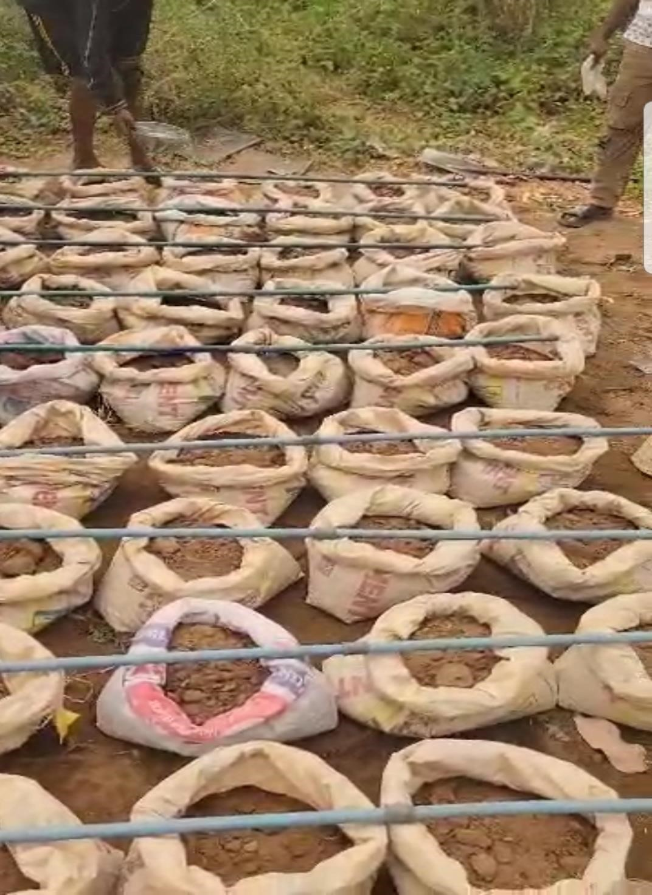
Plate 3.3.1: Irrigation System

- Greenhouse: A greenhouse facility to protect the crops from adverse environmental conditions and maintain controlled growing parameters.
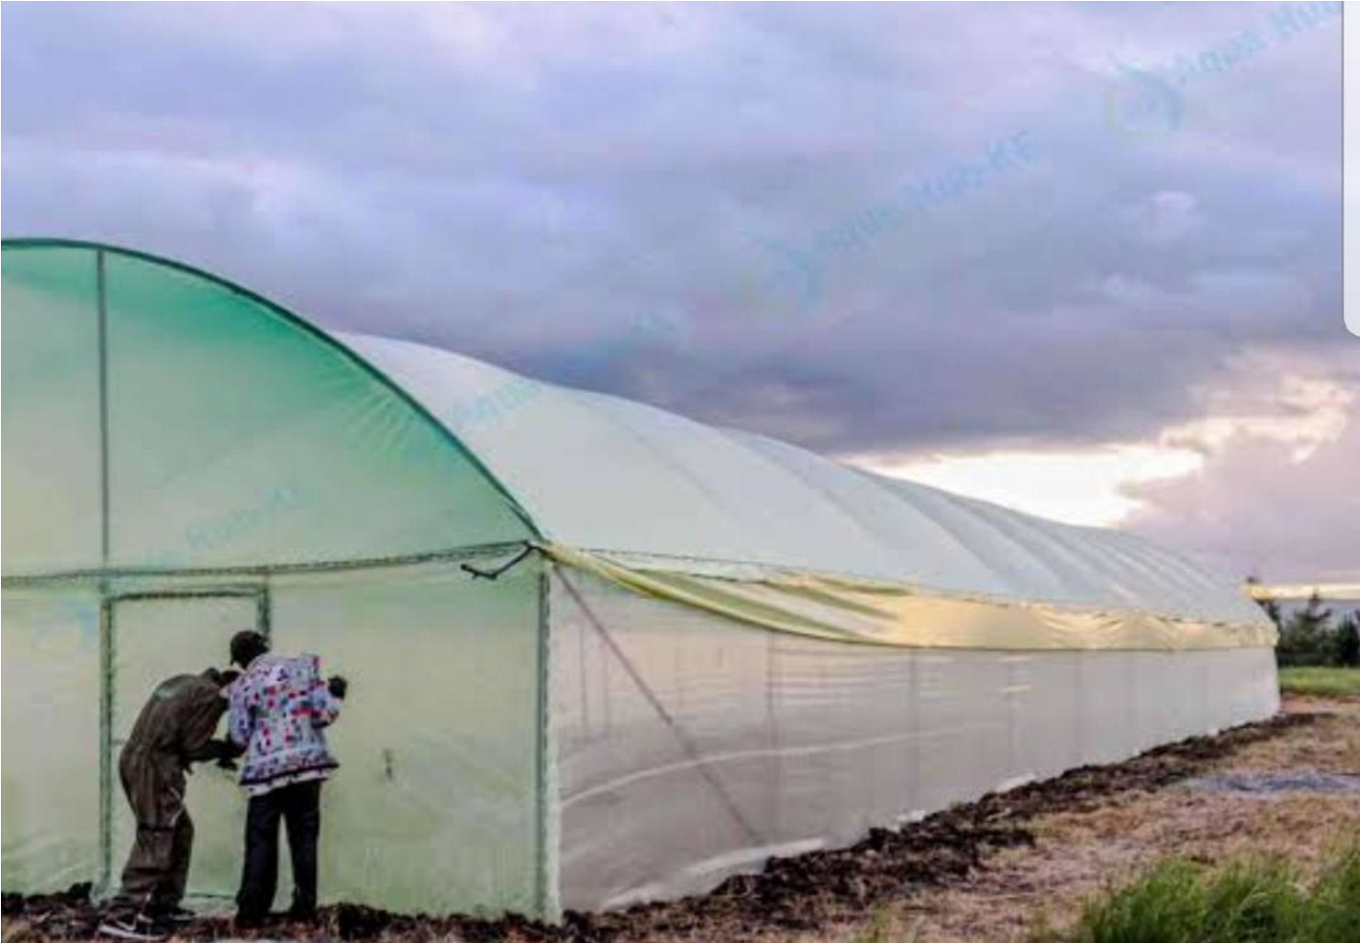

Plate3.3.2: Greenhousevi.Measuring Instruments: Meter rule, weighing scale, and an automatic vernier caliper for growth parameter measurements.

Plate3.3.3: Weighing Scale


Plate 3.3.4: Automatic Vernier Caliper
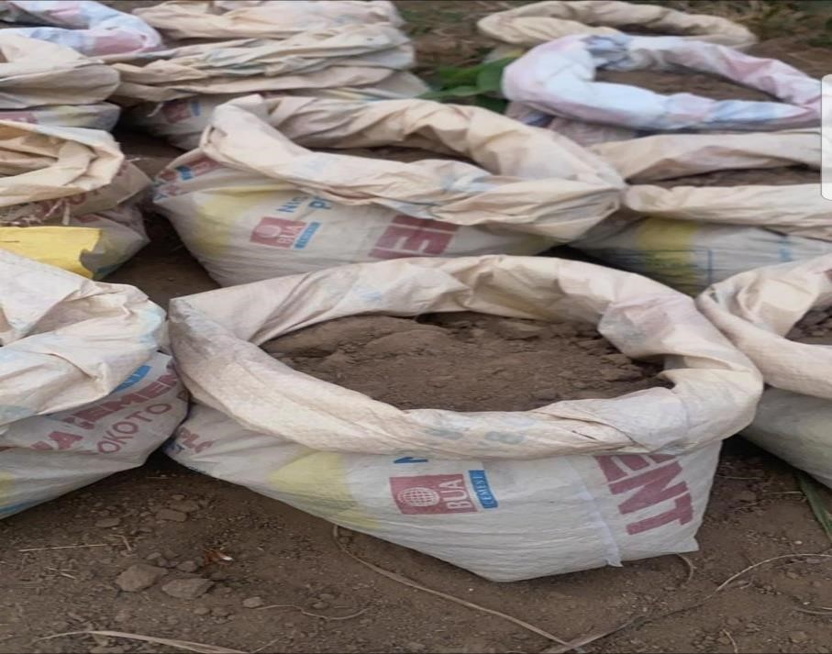
vii. Planting Containers: Individual planting bags for the establishment of each plant:

Plate 3.3.5: Planting Containers
viii. Water Source: Connected to the drip irrigation reservoir.


Plate 3.3.6: Water Source

ix. Proximate Analysis Equipment:
a)Moisture oven (for moisture content determination).


Plate 3.3.7: Moisture Oven
- Kjeldahl unit (for crude protein determination)
- Soxhlet extractor (for crude fat determination).
- Muffle furnace (for ash content determination).
- Other standard laboratory glassware and reagents required for acid-base digestion and filtering (for crude fiber).

3.4 Experimental Procedures

3.4.1 Soil preparation and potting
Loamy soil was collected and prepared by sieving to remove debris and ensure uniformity. The soil was then filled into individual planting bags, which served as the experimental units, according to the layout of the Randomized Complete Design.

3.4.2 Nursery establishment and transplanting
Lettuce seeds were initially sown in nursery trays filled with prepared loamy soil. The nursery trays were watered daily to ensure optimal germination and seedling development. After approximately three weeks, healthy and uniform lettuce seedlings were carefully selected from the nursery. These selected seedlings were then transplanted into the prepared planting bags, which had already been treated with the appropriate fertilizer type and dosage according to the experimental design. A consistent spacing of 25 cm × 25 cm was maintained between transplanted seedlings to ensure adequate growth area and minimize inter-plant competition.

3.4.3 Preparation and application of fertilizers

3.4.3.1 Ashoka leaf compost:
Fresh Ashoka leaves were collected and air-dried at room temperature for a period of two weeks. Following the drying process, the leaves were ground into a fine compost using bur mill.
This prepared Ashoka leaf compost was then applied to the designated planting bags at the specified dosage levels (5 g, 7.5 g, and 10 g) as per the experimental treatments.

3.4.3.2 Poultry droppings
Raw poultry droppings were collected from a local poultry farm. To reduce potential pathogenic load and mitigate ammonia toxicity, the raw droppings were subjected to a composting process for three weeks. After composting, the droppings were air dried to a suitable consistency and it was mixed with ashoka in the ratio before being applied to the soil in the respective planting bags according to the experimental treatment dosages (5 g, 7.5 g, and 10 g).

3.4.3.3 NPK fertilizer
The NPK fertilizer ( 15:15:15) was applied directly to the soil in the designated planting bags at the specified dosage levels (5 g, 7.5 g, and 10 g). The fertilizer was carefully incorporated into the topsoil to ensure even distribution and maximize nutrient availability to the lettuce plants.

3.4.4 Cultural practices
Throughout the experimental period, all experimental units (planting bags) received uniform amounts of water, which was applied consistently via the automated drip irrigation system to prevent water stress and ensure optimal moisture levels for plant growth. Weeding was performed manually as needed to minimize competition from weeds and ensure that the lettuce plants received adequate nutrients and light. No additional fertilizers or chemical inputs (e.g., pesticides, herbicides) were used at any stage of the experiment, ensuring that the observed effects were solely attributable to the applied fertilizer treatments.

3.4.5 Harvesting
Lettuce plants were harvested at physiological maturity, which occurred approximately 50 days after transplanting. At this stage, the leaves had reached their full size, and harvesting was carried out before any signs of bolting (premature flowering) appeared. Whole plants were carefully uprooted from the planting bags, cleaned to remove any adhering soil, and labeled according to their respective treatment group and replicate for subsequent laboratory analysis.

3.5 Sample Preparation for Proximate Analysis
After harvesting, the lettuce samples were thoroughly washed and cleaned to remove any dirt or foreign particles. The cleaned samples were then subjected to a drying process, typically by oven-drying at a controlled temperature (e.g., 60°C) until a constant weight was achieved, indicating complete moisture removal. The dried lettuce samples were then ground into a fine powder using a laboratory mill. The powdered samples were stored in airtight containers at a cool, dry place to prevent moisture reabsorption and degradation prior to proximate analysis.

3.6 Proximate Analysis
Proximate analysis of the harvested lettuce samples was conducted to determine their nutritional composition, adhering strictly to the standard methods outlined by the Association of Official Analytical Chemists AOAC, (2019). All values were reported on a dry weight basis (DWB), and results were recorded as percentages.

3.6.1 Moisture content determination
Dish was washed and placed in an oven till properly dried, after drying it was cooled in a desiccators, the empty dish and lid was then weighed on a weighing balance. 2.0g of sample was then weighed into the empty sterile dish and the sample was spread uniformly in the petri dish, the weight of the sample and the petri dish was taken. The sample was placed in the oven and dried at 105ºc for 3 hours. After 3 hours the sample was kept in the desiccator to cool and then weighed again using a weighing balance, after which it was put back into the oven and dried for another one hour and removed after an hour to reweigh, the process is continued until a constant weight is obtained. The dried sample and the petri dish were now re-weighed and recorded. It can be represented as:
% Moisture = 100
Where:
W1: Initial weight of petri dish
W2: Weight of sample and petri dish before drying
W3: Weight of sample and petri dish after drying

3.6.2 Crude protein determination (Kjeldahl Method)
Two grams of sample was measured into the digestive flask, 5g of kjedahl catalyst was weighed in the sample, 20ml of concentrated H₂SO₄ was added to the sample, and another tube containing the same constituents above was prepared as blank, the flask was placed in inclined position and heated gently until the solution was clear, this procedure was carried out in a fume cupboard. After digestion, the flask was removed from the heater and cooled and was later diluted with 60ml of distilled water, the flask was then placed in a micro kjedahl analyzer (distillation unit) where 40% NaOH was passed into it, it was heated then heated up to release ammonia which was distilled in a conical flask containing 25ml of 4% boric acid for 15 minutes to form ammonium borate solution which was titrated against 0.1M HCl until a purplish grey end point was obtained the same procedure was conducted for the blank solution. Protein content was calculated.
( ) .
% Nitrogen = 100
𝑋
Where: A = Volume of ml of 0.1M HCl used for sample
B = Volume of ml of 0.1M HCl used for blank titration
N = Normality of HCl
W = Weight of sample
14.007 = Atomic weight of Nitrogen
6.25 = Protein Nitrogen conversion factor
% Crude Protein = Nitrogen x conversion factor

3.6.3 Crude fat determination (Soxhlet Extraction Method)
Crude fat of the sample was determined using Soxhlet extractor with a reflux condenser and a distillation flask according to (AOAC, 2012). All glass wares were rinsed with petroleum spirit, they were drained and left to dry in the oven at 102ºC for 30 minutes and later cooled in
a
desiccator. 2.0g of sample was weighed into the fat extractor thimble which was plugged with cotton wool at the bottom and placed at an appropriate place at the chamber of the extractor. The distillation flask was filled into two-third capacities with n hexane, and boiled with a heating mantle, the distillate was collected until the extractor siphoned for 4 hours. Then the n hexane was recovered into a clean container and the remaining solvent in the container was vaporized in oven at 70ºc. The distillation flask was allowed to cool in a desiccator, after which the final weight of the flask was determined. The difference in the initial weight of the sample and the final weight determines the oil extracted from the sample (AOAC, 2012).
It can be represented as: % crude fat = x 100

Where W2= Weight of the receiver flask and fat
W1= Weight of empty receiver flask

3.6.4 Ash content determination
The crucible and lid were placed in the furnace and were heated at 550ºC for 2-3hrs to ensure that impurities on the crucible are burnt off, afterwards the crucible was cooled in the desiccator for 30 minutes, and the crucible and the lid were then weighed on a 3 decimal weighing balance. 5g of sample was weighed into the crucible and then heated on a heating mantle until it was totally charred. The sample was then transferred to the muffle furnace and heated at 550ºc for 4-5 hours or more until a whitish grey colour is formed. The crucible was not covered during heating but was later after heating it was covered to prevent loss of fluffy ash, after heating the sample is cooled in the desiccator and re-weighed.
The percentage Ash is calculated as: %Total Ash = x 100
Where w1= Weight of dish
W₂= weight of dish +sample before ashing
W₃= Weight of dish + sample after ashing

3.6.5 Crude fiber determination:
- Crude fiber was determined by sequential acid and alkali digestion of a known weight of the dried sample.
- The sample was boiled with dilute sulfuric acid, followed by dilute sodium hydroxide. iii. The residue was then filtered, washed, dried, and finally ignited in a muffle furnace. iv. The loss in weight after ignition represented the crude fiber content.

3.6.6 Carbohydrate determination (by Difference)
Total carbohydrate composition was determined by calculation of difference, the results of all other proximate analysis carried out are added up and subtracted from 100 to get the total carbohydrate present in the sample
% Carbohydrate = 100 – (% Ash+ % Fiber+ % Protein + % Fat+ % Moisture)

3.7 Data Collection
Data were recorded from three replicates per treatment for each of the following nutritional parameters determined through proximate analysis:
i. Moisture (%)ii. Crude Protein (%)iii. Crude Fat (%)iv. Ash (%)
v. Crude Fiber (%)vi. Carbohydrate (%)
Additionally, other relevant growth parameters, if collected (e.g., plant height, leaf number, fresh weight, dry weight), would also be recorded.

3.8 Statistical Analysis
Data obtained from the proximate analysis were subjected to Analysis of Variance (ANOVA) using SPSS Statistics software. This statistical test was employed to determine if there were significant differences in the nutritional parameters of lettuce among the different fertilizer treatments. When significant differences were identified by ANOVA, means were further compared using Duncan's Multiple Range Test (DMRT) at a 5% significance level (p<0.05) to pinpoint specific differences between treatment groups.

CHAPTER FOUR

4 RESULTS AND DISCUSSIONS

4.1 RESULTS
Table 4.1 below showed results of the proximate analysis of lettuce grown under three fertilizer treatments with the USDA Standard:The nutritional parameters analyzed were moisture, ash, crude protein, crude fat, crude fiber, and carbohydrate content. Data was analyzed using SPSS, and results were compared against USDA standard values.
Table 4.1:Result of Proximate Analysis of lettuce

Ashoka Ashoka + Poultry NPK USDA

Parameter
(A) (AP) Fertilizer Standard

Moisture (%) | 77.20 | 70.60 | 70.15 | 95.6
Ash (%)  Crude Protein | 2.949 | 3.356 | 2.55 | 1.00
(%) | 4.90 | 5.95 | 3.12 | 1.36
Crude Fat (%) | 0.542 | 1.089 | 0.321 | 0.15
Crude Fiber (%)  Carbohydrate | 5.027 | 5.061 | 4.11 | 1.1
 | 9.384 | 13.953 | 16.23 | 2.8
(%)

4.2 SPSS Statistical Analysis (ANOVA Summary)
Table 4.2 showed A one-way ANOVA was conducted using SPSS to determine whether there were statistically significant differences among the three treatments.
Table 4.2: SPSS Statistical Analysis (ANOVA Summary)

F- p-

Parameter Interpretation

value value

Significant difference; A > AP >
Moisture | 82.6 | 0.001 | NPK
Ash  Crude | 15.2 | 0.009 | Significant; AP > A > NPK
Protein | 28.4 | 0.003 | Highly significant; AP > A > NPK
Crude Fat | 56.3 | 0.000 | Highly significant; AP > A > NPK
Crude Fiber  Carbohydra | 3.12 | 0.087 | Not significant
 | 29.1 | 0.002 | Significant; NPK > AP > A
te
p < 0.01, *p < 0.05

4.3 Discussions
i. Moisture: The Ashoka-only treatment retained the highest moisture. However, all treatments were significantly below USDA moisture standards (~95.6%). ii. Crude Protein: Lettuce treated with Ashoka + Poultry (5.95%) showed a statistically significant increase compared to NPK (3.12%) and USDA (~1.36%) (p < 0.01).
iii. Ash Content: Ashoka + Poultry had the highest ash content (3.36%), indicating increased mineral accumulation. iv. Crude Fat: Though fat is generally low in lettuce, Ashoka + Poultry significantly raised its content above NPK.
v. Carbohydrate: NPK had the highest carbohydrate value (16.23%), indicating high dry matter accumulation, though protein and micronutrient values were lower.

CHAPTER FIVE

5 CONCLUSION AND RECOMMENDATION

5.1 Conclusion
This study compared the effects of three fertilization regimes Ashoka leaf compost, Ashoka + Poultry droppings, and inorganic NPK fertilizer on the proximate composition of lettuce.
The results show that:
- Ashoka + poultry droppings produced lettuce with significantly higher protein
(5.95%), fat (1.088%)), and fiber contents compared to NPK and Ashoka alone.
- NPK promoted higher carbohydrate accumulation (16.23%), which may benefit yield but not necessarily nutritional density. iii. The Ashoka-only treatment enhanced moisture and provided balanced results but was not the most optimal for nutrient content.
SPSS analysis confirmed statistically significant differences across treatments, particularly in crude protein, fat, and ash

5.2 Recommendations
- Adoption of Ashoka + Poultry dropping: This combination offers a balanced and superior nutritional profile for lettuce compared to chemical NPK.
- Limit Use of NPK: NPK increases carbohydrates and biomass, its impact on protein and micronutrients is lower.
- Organic Policy Promotion: Agricultural agencies in Nigeria should support the production and usage of bio-fertilizers like Ashoka leaf compost.
- Further Researchers should work on
    - Include micronutrient and heavy metal analysis.
    - Evaluate long-term soil health impacts of Ashoka compost.iii. Expand field trials in other leafy vegetables.

REFERENCES
A.C. Bidol et al., 2025. Development of coconut shell-based in-house quality control material for proximate analysis in solid fuels.
Adejumo, A. L., Olaleye, A. O., and Yusuf, A. K. (2020). Effects of organic fertilizers on growth and yield of vegetables. African Journal of Agricultural Research, 15(1), 90–98.
Adekiya, A. O., Agbede, T. M., and Ojeniyi, S. O. (2020). Comparative effects of poultry manure and NPK fertilizer on soil properties and performance of lettuce (Lactuca sativa). Journal of Organic Agriculture and Environment, 8(1), 45–52.
Agbede, T. M., and Ojeniyi, S. O. (2017). Use of compost and poultry manure for improving soil fertility and lettuce yield in tropical Alfisol. Nigerian Journal of Soil and Environmental Research, 15(1), 65–72.\
Alkaabi, A., Almansoori, E., Hebsi, M. A. L., Aldhaheri, S., Hassan, F. E., Ali, N. A. A., Al Shurafa, K. A., Tzortzakis, N., Di Gioia, F., and Ahmed, Z. F. R. (2025). Vertical hydroponic lettuce: Impact of organic nutrients on antioxidant phytochemicals. Annals of Agricultural Sciences, 70(1), 100386. https://doi.org/10.1016/j.aoas.2025.100386
Anika Seppelt, Juan Alberto Molina Valero, Cesar P´erez-Cruzado, Nieves Barros., 2023. Thermodynamic characterization of LF, H, and mineral soil layers from oak forest ecosystems: Exploring the role of proximate analysis.
AOAC. (2019). Official Methods of Analysis of AOAC International (21st ed.). Association of
Official Analytical Chemists, USA.

Arancon, N. Q., Edwards, C. A., Bierman, P., Welch, C., and Metzger, J. D. (2006).
Vermicompost influences on the growth and nutrient content of field crops. Bioresource Technology, 97(6), 831–840.
Bhattacharyya, P. N., and Jha, D. K. (2012). Plant growth-promoting rhizobacteria (PGPR): Emergence in agriculture. Scientia Horticulturae, 196, 34–48.
Birhanu Mekassa, Endalkachew Etana, Lemessa B. Merga., 2024. Proximate analysis, levels of trace heavy metals and associated human health risk assessments of Ethiopian white sugars.
Biru Alemu,0 Zhao Pu, Girma Debele, Abayneh Goshu, Mulisa Jida , Abdinasir Abdikadir,
Abdirisak Ahmed, Hailu Dadi, Kassahun Tesfaye, Algenash Tessema, Ma Chunhong., 2022. Proximate analysis of endangered evergreen leguminous shrub Yehebnut(Cordeauxia edulis Hemsl.) reveals high content of carbohydrate than protein.
Burgess, A. J., Pranggono, R., Escribà-Gelonch, M., and Hessel, V. (2024). Biofortification for space farming: Maximising nutrients using lettuce as a model plant. Future Foods, 9. https://doi.org/10.1016/j.fufo.2024.100317
Desaulniers Brousseau, V., Goldstein, B. P., Leroux, D., Giguère, T., MacPherson, S., and Lefsrud, M. (2024). Estimating the global warming potential of animal waste-based organic liquid fertilizer for urban hydroponic farms. Journal of Cleaner Production, 472. https://doi.org/10.1016/j.jclepro.2024.143434
Diego Racero-Galaraga, Jesús D. Rhenals-Julio, Stiven Sofan-German, Jorge M. Mendoza, Antonio Bula-Silvera., 2024. Proximate analysis in biomass: Standards, applications and key characteristics.
Fatih Güleç, Direnc Pekaslan, Orla Williams, Edward Lester ., 2022. Predictability of higher heating value of biomass feedstocks via proximate and ultimate analyses – A comprehensive study of artificial neural network applications.
Fuguo Liu., 2022. A comparison between multivariate linear model and maximum likelihood estimation for the prediction of elemental composition of coal using proximate analysi
Gani, A., Adisalamun, Arkan, D.M.R., et al., 2023a. Proximate and ultimate analysis of corncob biomass waste as raw material for biocoke fuel production. Case Stud. Chem. Environ. Eng. 8, 100525.
Hao, R., Wu, Y., Di, H., Chen, Y., Chen, W., Hu, R., and Tan, W. (2024). Elucidating the role of earthworms on the fate of fertilizer N with synthetic and organic fertilizer application. Geoderma, 452. https://doi.org/10.1016/j.geoderma.2024.117106
Igiehon, N. O., and Babalola, O. O. (2018). Biofertilizers and sustainable agriculture: Exploring arbuscular mycorrhizal fungi. Applied Microbiology and Biotechnology, 102(20), 8821–8833.
Kalivas, A., Ganopoulos, I., Psomopoulos, F., Grigoriadis, I., Xanthopoulou, A., Hatzigiannakis, E., Osathanunkul, M., Tsaftaris, A., and Madesis, P. (2017). Comparative metagenomics reveals alterations in the soil bacterial community driven by N-fertilizer and Amino 16® application in lettuce. Genomics Data, 14, 14–17. https://doi.org/10.1016/j.gdata.2017.07.013
Kim, M. J., Moon, Y., Tou, J. C., Mou, B., and Waterland, N. L. (2016). Nutritional value, bioactive compounds and health benefits of lettuce (Lactuca sativa L.). Journal of Food
Composition and Analysis, 49, 19–34.
Kouam, I. D., Moungang, S., Koulagna, H. I., Ntsoli, G. P., Titti, R. W., and Yaouba, A. (2024). Influence of organic and mineral fertilizers and a foliar biostimulant on the yield and nutritional quality of strawberries (Fragaria ×ananassa Duch.) under field conditions. Biochemical Systematics and Ecology, 117. https://doi.org/10.1016/j.bse.2024
Kumawat, P., Sharma, S., and Meena, R. S. (2020). Leaf litter compost of Polyalthia longifolia as nutrient source for sustainable agriculture. Journal of Environmental Biology, 41(3), 543–548.
Laone Thato Juddie Mosii, Tshepo Pheko-Ofitlhile, Rosemary Kobue-Lekalake, Ofentse Mazimba ., 2023. Terminalia Prunioides pods herbal tea: Antioxidant activity, proximate, and metal content analysis.
Mai A. Mohamed, Gehan M. Kassem, Dalia A. Zahran, Mohamed T. Emara, Nada.K. Mansour., 2023. Impact of mechanically recovered poultry meat (MRPM) on proximate analysis and mineral profile of traditional Egyptian luncheon.
Mahanty, T., Bhattacharjee, S., Goswami, M., Bhattacharyya, P., Das, B., and Ghosh, A. (2017).
Biofertilizers: Potential approach for sustainable agriculture development. Environmental Science and Pollution Research, 24(4), 3315–3335.
Massa, A., Santos, É., Martins, D., Azevedo, J., Reimão, M., Almeida, A., Azevedo, R., Pinto, E., Vasconcelos, V., Campos, A., and Freitas, M. (2024). Toxic and non-toxic cyanobacterial biomass as a resource for sustainable agriculture: A lettuce cultivation
experiment. Environmental Research, 262, 119942.
https://doi.org/10.1016/j.envres.2024.119942
Martínez-Moreno, A., Carmona, J., Martínez, V., Garcia-Sánchez, F., Mestre, T. C., Navarro
Pérez, V., and Cámara-Zapata, J. M. (2024). Reducing nitrate accumulation through the management of nutrient solution in a floating system lettuce (Lactuca sativa, L.). Scientia Horticulturae, 336. https://doi.org/10.1016/j.scienta.2024.113377
Meseret Berhanu, Asnake Desalegn, Dagim Jirata Birri, Mogessie Ashenafi, Fitsum Tigu., 2023. Microbial, physicochemical and proximate analysis of Tej collected from Amhara regional state of
Michael Abidemi Oke, Jacob Ademola Sonibare, Anthony Onakpohor, Olayemi Abosede Odunlami, Funsho Alaba Akeredolu, Francis Boluwaji Elehinafe ., Proximate analysis of some common charcoal in Southwestern Nigeria.
Ojeniyi, S. O. (2012). Integrated use of poultry manure and compost on growth and yield of lettuce. Nigerian Journal of Soil Science, 22, 92–98.
Rahman, M. H., Hasan, M. N., and Khan, M. Z. H. (2021). Study on different nano fertilizers influencing the growth, proximate composition and antioxidant properties of strawberry
fruits. Journal of Agriculture and Food Research, 6.
https://doi.org/10.1016/j.jafr.2021.100246
Raiola, A., Rigano, M. M., Calafiore, R., Frusciante, L., and Barone, A. (2012). Enhancing the health-promoting effects of lettuce. Mediators of Inflammation, 2012, 1–16.
Rathore, S. S., Kumar, R., and Singh, R. (2020). Organic amendments and lettuce growth: A comprehensive review. International Journal of Agricultural Sustainability, 18(2), 102– 114.
Sabah Mariyam, Mohammad Alherbawi, Gordon McKay, Tareq Al-Ansari., 2025. A predictive model for biomass waste pyrolysis yield: Exploring the correlation of proximate analysis and product composition.
Shishir Kumar Nandi, Md Abdullah Al Mamun, Afrina Yeasmin Suma, Zulhisyam Abdul Kari, Lee Seong Wei, Albaris B. Tahiluddin, Nesara Kadadakatte Manjappa, Shamima
Nasren, Shuva Saha, Guillermo T´ellez-Isaíasi, Walter G. Bottje, Muhammad Anamul Kabir ., 2024. Comparative analysis of biometrical and reproductive indices, proximate composition, and hemato-biochemical variables of cuchia eel Monopterus cuchia (Hamilton, 1822) from six different localities of Bangladesh.
Shyama Prosad Moulick, Farhana Jahan, Md. Zia Uddin Al Mamun, Md. Imam Sohel Hossain, Md. Waliullah, Rahima Akter Sathee., 2023. Analysis of indigenous spices widely consumed in Bangladesh: An assessment to explore its proximate contents, minerals, phytochemical compositions, and antioxidant activities.
Sinha, A. K., Patel, A. J., and Thakur, R. (2021). Environmental impact of excessive fertilizer use in vegetable cultivation. Journal of Soil Science and Plant Nutrition, 21(2), 589– 602.
Singh, A. K. (2025). Bio-based materials for fabrication of controlled-release coated fertilizers
to enhance soil fertility: A review. Next Materials, 8.
https://doi.org/10.1016/j.nxmate.2025.100701
Singh, R. K., Sharma, A., and Pant, D. (2021). Integrated nutrient management effects on lettuce
(Lactuca sativa). Journal of Plant Nutrition, 44(5), 675–685.
Sohn, W., El Saliby, I., Merenda, A., Phuntsho, S., Freguia, S., Guan, J., Gao, L., Lee, S., and Shon, H. K. (2024). Anthroponics: Application and effects on growth of parsley, rhipsalis, coriander, and basil fed with urine fertiliser. Desalination and Water
Treatment, 320. https://doi.org/10.1016/j.dwt.2024.100682
Stojanova, M., Demiri, S., Stojanova, M. T., Djukic, D. A., and Kaya, Y. (2025). From cultivation to consumption: Evaluating the effects of nano fertilizers on food quality and safety. Advanced Agrochem. https://doi.org/10.1016/j.aac.2025.07.001
Sunyong Park, Seok Jun Kim, Kwang Cheol Oh, LaHoon Cho, YoungKwang Jeon, Chunggeon Lee, DaeHyun Kim., 2022. Thermogravimetric analysis-based proximate analysis of agro-byproducts and prediction of calorific value.
Tesfaye Dilebo, Tileye Feyissa, Zemede Asfaw, Ashagire Zewdu ., 2023. Analysis of proximate composition, mineral contents, and anti-nutritional factors of enset (Ensete ventricosum) landraces commonly used for amicho preparation in Hadiya Zone, Southern Ethiopia:
Implications for food security and mineral bioavailability.
Tůmová, V., Benmansour, I., Langhansová, L., Petrtýl, M., Bureš, D., Petrová, Š., Haisel, D., Tejnecký, V., Pěchoučková, E., Laloučková, K., Malíková, L., Liška, M., Klouček, P., and Monsees, H. (2025). The impact of two aquaponic management strategies (unfertilized and fertilized aquaponics) on the quality and growth of green butterhead lettuce (Lactuca sativa, var. Salanova Aquino, Rijk Zwaan). Journal of Cleaner Production, 521. https://doi.org/10.1016/j.jclepro.2025.146202
USDA. (2020). FoodData Central. U.S. Department of Agriculture. Retrieved from
https://fdc.nal.usda.gov/
Wang, O., Deaker, R., and Van Ogtrop, F. (2025). A systematic review of food-waste based
hydroponic fertilisers. Agricultural Systems, 223.
https://doi.org/10.1016/j.agsy.2024.104179
Zaixuan Zhong, Jiajia Fan, Huanhuan Su, Huaping Zhu, Dongmei Ma ., 2023. Proximate compositions evaluation, histology and transcriptome analysis revealed the effects of formulated diets on muscle quality in Micropterus salmoides.
Zhao, Q., Feng, J., Guo, S., Yang, S., Jing, R., Zhang, X., Zhou, X., and Li, D. (2025). Waterfertilizer regulation improves yield, quality, and water-fertilizer use efficiency of greenhouse lettuce by altering the bacterial community in nutrient solutions. Journal of
Agriculture and Food Research, 21. https://doi.org/10.1016/j.jafr.2025.101976

