NUTRITIONAL ASSESMENT OF DRIED TOMATO (Solanium Lycopersicum) USING CABINET DRYING METHOD

BY
IBRAHIM TAOFEEKAT KEHINDE
ND/23/FST/PT/0013

BEING A PROJECT WORK SUBMITTED TO THE DETARTMENT OF FOOD SCIENCE AND TECHNOLOGY, INSTITUTE OF APPLIED SCIENCE, KWARA STATE POLYTECHNIC, ILORIN

IN PARTIAL FULFILMENT OF THE REQUIREMENT FOR THE AWARD OF NATIONAL DIPLOMA (ND) IN FOOD SCIENCE AND TECHNOLOGY

SEPTEMBER, 2025

CERTIFICATION
This is to certify that this project work was written and submitted by IBRAHIM TAOFEEKAT KEHINDE with matriculation Number ND/23/FST/PT/0013 to the Department of Food Science and Technology, Institute of Applied Science, Kwara State Polytechnic Ilorin.

_______________________ ________________
MRS NJOKU O.G DATE
(Project Supervisor)

_______________________ ________________
MR USMAN UTHMAN DATE
PT Coordinator

_______________________ ________________
MR. AGBAJE RAFIU DATE
Head of Department.

DEDICATION
This research work is dedicated to my Dad and mum for their unwavering support.

ACKNOWLEDGEMENT
All glory and thanks to the Almighty Allah for giving me the opportunity to complete dis project.
My deep gratitude goes to my supervisor, Mrs Njoku O.G, for her clear guidance and encouragement throughout the project. I also acknowledge my HOD Mr Agbaje Rafiu and all others lecturers and staff of Food Science and Technology Department.
Sincere Appreciation also goes to my parents. Thanks so much for your support, care, love and advice. May Almighty Allah continue to Bless them.

TABLE OF CONTENTS
Title page ………………………………………………………. i
Certification ……………………………………………………. ii
Dedication ……………………………………………………... iii
Acknowledgement …………………………………………… iv
Table of contents ………………………………………………. vi
List of Table...………………………………….……………. x
CHAPTER ONE
1.0 INTRODUCTION 1
1.2 STATEMENT OF THE PROBLEM 2
1.3 OBJECTIVES 2
CHAPTER TWO
2.0 LITERATURE REVIEW OF TOMATO 4
2.1 Taxonomy of Tomato 5
2.2 Tomato Quality 6
2.3 Cultivation of tomato 8
2.3.1 Temperature and light 8
2.3.2 Water and humidity 9
2.3.3 Soil 9
2.3.4 Land preparation 10
2.3.5 Seedlings 10
2.3.6 Sowing in seedbed 10
2.3.7 Seed production 11
2.4 Harvest and Post-harvest Practices 11
2.6.2 Nutritional Composition of Tomato 12
2.9 Uses of Tomato 12
CHAPTER THREE
3.0 Material and Methods 13
3.1 Sample collection of Tomato 13
3.2 Sample preparation 13
3.2.1 Treatments 13
3.2.2 Procedure for Dehydration 13
3.2.5 Cabinet dryer 14
3.4 Chemical analysis procedures (Triplicate values
were expressed on dry weight basis) 14
3.4.1 Proximate Composition 14
3.4.1.1 Determination of Moisture Content 14
3.4.1.2 Determination of Ash Content 15
3.4.1.3 Determination of Cruide Lipid Content 16

CHAPTER FOUR
4.0 Result and Discussion 18
4.1 TABLE OF RESULTS 18
4.2 DISCUSSION 18
4.2.1 Proximate Analysis 18
4.2.2 Vitamin A 19
4.2.2 Discussion on Crude Lipid Content 20
CHAPTER FIVE
5.0 Conclusion and Recommendation 22
REFERENCES
List of Table
Table 2.1 Nutritional Composition per 100g of Fresh Tomato 11
Table: 4.1 Cabinet Drying Sample 19
List of Figure
FIGURE1: Tomato plants and parts 22
FIGURE 2: Fruits Ripening Stage of Tomato 23

CHAPTER ONE
1.0 Introduction
Tomato (Solanum lycopersicum) is a major crop plant and a model system for fruit development. Globally, the tomato is one of the most important and recognized vegetable crop. It is comparatively a short duration crop and produces more output per unit area of cultivation, and it ultimately plays a significant role in promising a well-balanced diet (Van et al., 2005). It can be eaten raw in salads or as an ingredient in many dishes, drinks and consumed as tomato based products (Alam et al., 2007). Tomatoes and tomato-based foods provide a wide variety of nutrients and many health-related benefits to the body. It is a very good source of vitamins, minerals, sugars, essential amino acids, and dietary fibers (Ugonna et al., 2015). According to Food and Agriculture Organisation of the United Nation (FAOSTAT, 2014) global production of tomatoes is about 4.8 million hectares of land area and a yield of about 162 million tons. However, in Africa, Nigeria realized the lowest yield of production, which is about 4.0MT/Ha compared to South Africa and Egypt that recorded 78MT/Ha and 38.7MT/Ha respectively (FAOSTAT, 2014). Nevertheless, (Ugonna et al., 2015) attributed the reasons for such least yield to the lack of critical inputs, technological development, storage and processing facilities, poor marketing structure as well as high postharvest losses. Nigeria, with a population of above 170 million, it is apparent that the demand for tomatoes overshadows
the supply. The challenge is attributed to the seasonality, perishability, and inadequacies in post-harvest handling of the vegetable (Arah et al., 2015; Adenegan and Adeoye, 2011). Thus accounts for 40-50% loss annually (Adegbola et al., 2012). As a result, dried tomatoes provide an economical alternative to fresh ones; because dried tomato is more durable, and requires no additives, and is produced by direct sun-drying (Abdulmalik et al., 2014). Moreover, water removal prevents oxidative and enzymatic reactions, thus significantly increasing product shelf-life (Sagar and Kumar, 2010).
Worldwide, tomato plants are grown in several environments. There are specific zones in which it is impossible to grow the crop in open fields because of extreme climate conditions (Netherlands, northern Europe), and there are zones in which it is possible, but only in specific seasons (México). Currently, the trend is toward protected production in controlled greenhouse environments because this technique is highly efficient and has the potential to increase food production to meet market demands (Rico-García et al., 2009). According to the Food and Agriculture Organization of the United Nations (FAO), advantages of greenhouses include the following: protection against extreme climatic conditions; controlled heating, cooling, shading and CO₂ enrichment; out-of-season harvests; improvements in crop quality; ground structure preservation; ability to sow selected materials; considerable production increases; reduced production costs; more efficient use of the growing area and lowered use of pesticides. HA
2.3 Cultivation of Tomato
Tomato requires a relatively cool, dry climate for high yield and premium quality. However, it is adapted to a wide range of climatic conditions from temperate to hot and humid tropical. The optimum temperature for most varieties lies between 21 and 24 °C. The plants can survive a range of temperatures, but the plant tissues are damaged below 10 °C and above 38 °C.
Tomato plants react to temperature variation during the growth cycle (see Table 2.0), for seed germination, seedling growth, flower and fruit set and fruit quality. If cool or hot weather spells persist during flowering, pollen production will be low. This will influence fruit formation. Frost will kill the plants. To avoid frost damage, it is best to wait until the winter is definitely over before sowing. It is possible to sow indoors earlier (in pots or trays). Light intensity affects the colour of the leaves, fruit set and fruit colour. (Barbara van Dam, 2005). In tropical lowlands, the minimum temperature at night is also important. Temperatures below 21 °C can cause fruit abortion.
2.4 Harvest and Post-Harvest Practices
Depending on the variety, fruits become ready for first picking in about 60-80 days after transplanting. The stage of harvesting depends upon the purpose to which the fruits are to be used. Fruits are normally harvested early in the morning or evening. The fruits are harvested by twisting motion of hand to separate fruits from the stem. Harvested fruits should be kept in shade. Since all the fruits do not mature at the same time, they are harvested at an interval of 4 days. Generally, there will be 7-11 harvests in a crop life span. The average yield per hectare is 20-25 t/ha for normal varieties and 50-60 t/ha for hybrid varieties.

Table 2.1 Nutritional Composition per 100 g of Fresh Tomato
Element | Quantity
Water% | 93.5
Protein (g) | 0.9
Fat (g) | 0.1
Calories | 23
Carbohydrates (g) | 3.3
Fiber (g) | 0.8
Phosphorus (mg) | 19
Calcium(mg) | 7
Iron (mg) | 0.7
Vitamin A(UI) | 1.100
Vitamin B1(mg) | 0.05
Vitamin B2(mg) | 0.02
Vitamin C(mg) | 20
Niacin(mg) | 0.6
Source :(Jaramillo et al., 2007).

Antioxidants Nature of Tomato
Antioxidants are protective agents that inactivate Reactive Oxygen Species (ROS) and therefore significantly delay or prevent oxidative damage. In particular, superoxide dismutase (SOD), catalase and glutathione peroxidase (GSHPx) are endogenous naturally antioxidants present within human cells. In addition, antioxidants such as vitamin E, vitamin C, polyphenols and carotenoids are available from foods. Current dietary guidelines to combat chronic diseases, including cancer and Coronary Health Disease (CHD), recommend increased intake of plant foods, including fruits and vegetables, which are rich sources of antioxidants. The role of dietary antioxidants, including vitamin C, vitamin E, carotenoids and polyphenols, in disease prevention has received much attention recently and appears to have a wild range of anti atherogenic properties (Halliwell, 1995). These observations may explain the epidemiological data indicating that diets rich in fruits and vegetables are associated with a reduced risk of numerous chronic diseases (Gaziano, 1995).
2.9 Uses of Tomato
Tomato contains higher amounts of lycopene, a type of carotenoid with anti-oxidant properties (Arab l et al., 2000). which is beneficial in reducing the incidence of some chronic diseases (Basu et al., 2007). Like cancer and many other cardiovascular disorders (Freeman et al., 2010). This anti-oxidant property and its health benefit have raised the interest in tomato research and its consumption as a crop with medicinal properties (Mascio et al., 1989). Lycopene is believed to be the main contributing compound in tomatoes responsible for lower risk of prostate cancer (Pohar, 2003). Other studies have also shown that consumption of tomatoes and tomato-base foods can be linked to reduced incidence of a variety of cancers in general, including pancreatic, lung, stomach, colorectal, oral, bladder, breast and cervical cancers (Giovannucci et al., 1999). Lycopene in tomatoes enhance fertility by improving the quality and swimming speed of sperm whilst reducing the number of abnormal sperm in men (Innes, 2014). Arah et al. (2014) reported that tomatoes and tomato-based foods provide a wide variety of nutrients and many health-related benefits to the body.

CHAPTER THREE
3.0 Material and Methods
3.1 Sample Collection of Tomato
The tomato used for this study were obtained from Ipata market in Ilorin, Kwara state. The sample of tomato were selected from the lot based on firmness, color and size uniformity. The reagents were of analytical grade.
3.2 Sample Preparation
The sample were sorted, washed thoroughly with tap water, rinse with distilled water and then wipe with an absorbent paper (Owusu et al., 2012). It was divided into 2 different portions, the first batch was pretreated with 5% g/L Sodium metabishulfite (Na₂S₂O₅) solution for 5 min. The second portions was not pretreated (control) .
3.2.1 Treatments
Materials
- Tray.
- Bowl.
- Slicer.
- Siever.
- Heating source.
Reagent.
- Water.
- Sodium metabishulfite (Na₂S₂O₅).
- 3.2.2 Procedure for Dehydration
- An approximately 1kg of each of the sample were subjected cabinet drying.
3.2.5 Cabinet Dryer
Materials
- Foil paper
- Tray
- Sliced Tomato
- Cabinet Heating Equipment
Convective method of drying is employed to remove water from tomato through the application of heat in equipment meant for drying. Hot air is allowed to pass through the product in a manner to transfer the heat to the tomatoes and moisture is removed.
3.4 Chemical Analysis Procedures (Triplicate values were expressed on dry weight basis)
3.4.1 Proximate Composition
The chemical analysis of Ash, Fibre Carbohydrates and Protein contents were determined according to AOAC methods. Moisture content was determined using vacuum oven method. Crude protein was determined using the micro–Kjeldahl method (AOAC 1995). Fat content was estimated using Soxhlet extraction method . Ash was determined by incineration in muffle furnace at 550°C for 8 hours (AOAC, 2002). The available carbohydrate content was determined by subtracting 100 from the sum of moisture, protein, fat and ash contents (AOAC, 2005).
3.4.1.1 Determination of Moisture Content
Materials
- Grinded Tomato
- Weighing Machine
- Desiccators
- Oven
- Crucible
Moisture was determined by oven drying method. 1.5 g of well-mixed sample was accurately weighed in clean, dried crucible (W₁). The crucible was allowed in an oven at 100-105 ⁰C for 6-12 h until a constant weight was obtained. Then the crucible was placed in the desiccator for 30 min to cool. After cooling it was weighed again (W₂). The percent moisture was calculated by following formula:
Calculation
The percentage moisture was calculated as follow;
% Moisture =$\frac{W1-W2x100}{wt.ofsample }$
Where W1=initial weight of crucible + Sample
W2= Final weight of crucible + sample
Note: Moisture free samples were used for further analysis.
3.4.1.2 Determination of Ash Content
Materials
- Weighed Porcelein
- Crucible
- Ash
- Muffle Furnace
- Desiccator
- Blowpipe
For the determination of ash, clean empty crucible was placed in a muffle furnace at 600ºC for an hour, cooled in desiccator and then weight of empty crucible was noted (W₁). One gram of each of sample was taken in crucible (W₂). The sample was ignited over a burner with the help of blowpipe, until it is charred. Then the crucible was placed in muffle furnace 550ºC for 2 - 4 hours. The appearances of gray white ash indicate complete oxidation of all organic matter in the sample. After ashing furnace was switch off. The crucible was cooled and weighed (W₃). Percent ash was calculated by following formula:
Calculation
% Ash (dry basis) = $\frac{W3-W1}{ W2-W1 }X100\%$
Where: W1= weight of empty crucible.
3.4.1.3 Determination OF Cruide Lipid Content
Materials
- Sample
- Porous paper or filter paper
- Thimble
- Soxlhet refux flask
- Water
- Oven
- Desiccator
- Weighing machine
For determination of crude fat, Dry extraction method for fat the samples in desiccator and weighed again (W ). Determination was implied. It consisted of extracting dry sample with some organic solvent, since all the fat materials e.g. fats, phospholipids, sterols, fatty acids, carotenoids, pigments, chlorophyll etc. are extracted together therefore, the results are frequently referred to as crude fat. Fats were determined by intermittent soxhlet extraction apparatus. Crude fat was determined by ether extract method using Soxhlet apparatus. Approximately 1 g of moisture free sample was wrapped in filter paper, placed in fat free thimble and then introduced in the extraction tube. Weighed, cleaned and dried the receiving beaker was filled with petroleum ether and fitted into the apparatus. Turned on water and heater to start extraction. After 4-6 siphoning allow ether to evaporate and disconnect beaker before last siphoning. Transferred extract into clean glass dish with ether washing and evaporated ether on water bath. Then placed the dish in an oven at 105 ºC for 2 h and cooled it in a desiccator. The percent crude fat was determined by using the following formula:
Calculate
% crude fat = $\frac{w2-w1 }{weight of sample \left(2g\right)}X100\%$
Where : W1= weight of breaker
W2= weight of breaker (g) + fat extract (g)

CHAPTER FOUR
4.0 RESULT AND DISCUSSSION

Table: 4.1 Proximate Analysis
Samples | Moisture % | Vitamin A mg/100g | Ash % | Vitamin C mg/100g | Crude Lipids % | Protein %
FRESH | 93.5 | 1.000 | 12.60 g | 165.52 | 2.97 g | 1.1
CCD | 6.39 | 0.08 | 13.35 | 144.72 | 1.44 | 0.5
CDNa | 10.09 | 0.06 | 12.52 | 102.37 | 2.36 | 0.8

Key:
CCD= Control Cabinet Drying, CDNa = Cabinet Drying Na₂S₂O (Sodium Metabisulphate)

4.1 Proximate Analysis
From Table 4.1 comparing the flakes tomatoes and fresh one, indicates that the fresh tomato has the most highest moisture content (93.5±3.00) than the flakes tomatoes (CD Na: 10.09, CCD:6.39) respectively. However, Control Cabinet Drying (CCD:6.39) has the lowest moisture content, this may be due to the fact the CCD is not treated with any reagent out of all the treated sample and its subjected to the best drying method that aidded the removal of water. This phenomenon is in line with Mozumder et al. (2012) that work on pre-drying chemical treatment. However, several factors could account for such a difference. Since the main purpose of flakes is to preserve the quality content, then reducing the water reduces the risk of microbial growth which is not so in case of fresh tomato. Also, to increase the solid content so that consumers can buy more solid matter and extend it shelf life. The different in the value of the moisture content is due to the fact that the tomato samples were subjected to three different drying methods with different treatment. Out of all drying methods, cabinet drying shows the least value for moisture content while the air drying methods shows the highest value. The moisture content of the fresh tomato is in conformity with the finding of Romain (2001) and Harry (1994).
Fresh tomato was found to have the lowest ash content of (12.60) compared to the flakes tomatoes (CCD: 13.35 and CDNa: 12.95) respectively. CCD (13.35) shows the highest value of Ash content due to the treatment, the higher value of Ash content is in correlation to Ismail et al, (2012). Though it was not treated with any reagent but was blanched. Generally, this might result because the water content of the tomato has been reduced to its lowest minimal thereby making it mineral nutrient concentrated. The high water content might also contribute to the low level of ash.

Crude lipid content of flakes also reduced in value ranging from (CDNa: 2.22 CCD: 1.35) respectively, shows value close to the fresh one (2.97 g) when compared. This result is higher than Jaramillo et al., 2007, which gives the lipid content of tomato 0.100. Therefore, the lipid content of tomato should be very low in value.
The protein contents ranged from 0.5-1.1 %, the lowest value is the CCD 0.05 %, while the highest is the fresh 1.1. Generally tomato haa low protein contents.

4.2 Vitamins A
From Table 4.1 the Vitamin A contents of the flakes tomatoes were found to be closely related with a difference not exceeding 0.001mg/1000g according to United State Drugs Agency (USDA). However, the Vitamin A content of fresh tomato (1.000) was found to almost double that of flakes tomato except for the control that has the lowest value of 0.039mg/100g. The Value ranging from (CCD: 0.077, CD Na: 0.063,) respectively. (CCD: 0.032) sample shows the highest value of all the samples. This could be due to the high fat content of the fresh tomato which makes it stabilize the Vitamin A and C make it more available than the flakes tomato with the lower fat content. Cabinet drying method proof to be more efficient out of all other methods.
4.3 Vitamins C
Table 4.1 shows the range of vitamin C content from (CCD: 144.72, Na₂S₂O₅ CD: 102.37, respectively. The flakes tomatoes were found to have almost similar concentrations of vitamin C which is higher than that of the fresh tomato (39.20). Vitamins A and C are heat liable vitamins however, they tend to degrade at temperature of 65 ºC and above. This is reflected on the table of result as air drying method and solar drying method shows a considerable reduction in value of vitamin A and C. The increase in the concentration of vitamin C may be due to the fact that the tomato flakes were treated with vitamin C and its undisturbed by heat thereby causing increase in it concentration.

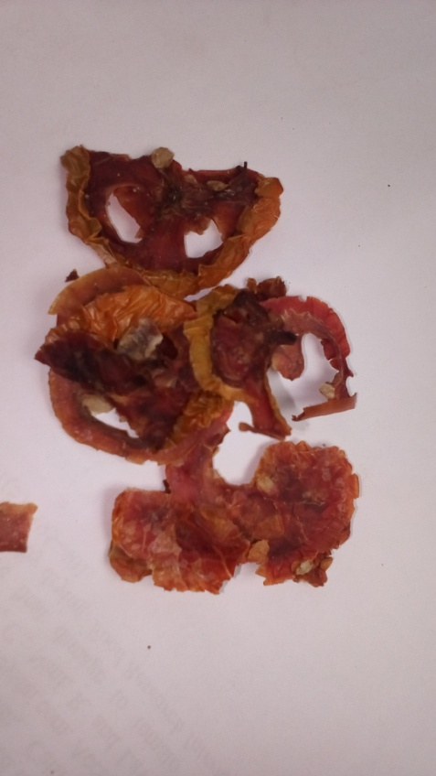

Figure 4.1: Sodium metabisulphite cabinet (NaCD) Dried tomato

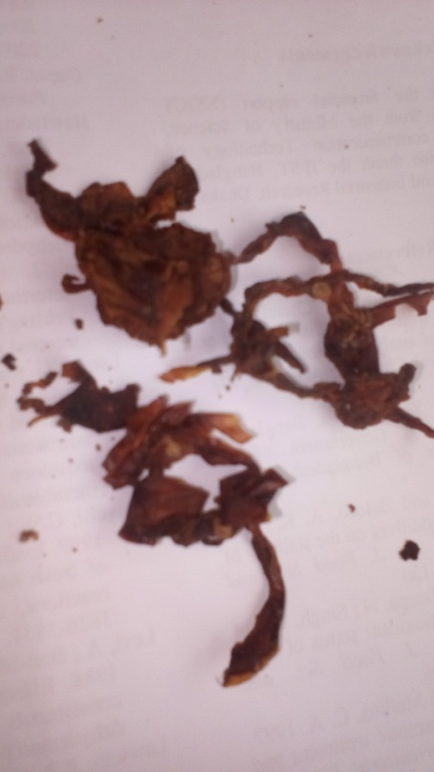
Figure 4.2: Control cabinet drying CCD

5.0 CONCLUSION
Tomato are rich in minerals and vitamin, the projects investigates the drying of tomato to preserves the nutrients using sodium metabisulphite and then drying through cabinet method.
The resut showed that the sodim metabisulphite was able to retain and enhance the nutrient. Additionally, the dried tomato shelf life will be extended and utilized more than the fresh tomato. The micro nutrients that are preserve are good for health and managing hidden hunger caused by micro deficiences.

REFERENCES
Abdulmalik, I. O., Amonye, M. C., Ambali, A. O., Umeanuka, P. O., Mahdi, M. (2014). Appropriate Technology for Tomato Powder Production. International Journal of Engineering Inventions, 3, 29-34.

Adegbola, J. A., Awagu, F., Adu, E. A., Anugwom, U. D., Ishola, D. T., &Bodunde, A. A. (2012). Investment Opportunities In Tomato Processing In Kano, Nothern Nigeria. Global AdvanceResearch Journal of Agricultural Science, 1(10), 288-297.

Adenegan, K. O., &Adeoye, I. B. (2011). Price Analysis Of Tomato In Rural and Urban Retail Markets of Oyo State. International Journal of Agricultural Economics & Rural Development, 4(2), 90-96.

AOAC . (2005). Association of Official Analytical Chemists. Official Methods of Analysis of the AOAC International. (18thed.). Gaithersburg (USA): AOAC International.

Association of Official Analytical Chemist (AOAC). ( 1995).Non-Enzymatic Methods of Crude Protein Contents Determination Official Methods of Analysis International. 16th Edition Method 4.6.01(962.09),International, Maryland, USA.

Freeman, B.B., Reimers, K.(2010), Tomato Consumption and Health: Emerging Benefits. American Journal of Lifestyle Medicine.

Gazian, J.M., Manson, J.E., Branch, L.G., Colditz, G.A.,Willett, W.C., Buring ,J.E.( 1995), A Prospective Study Of Consumption Of Carotenoids In Fruits And Vegetables And Decreased Cardiovascular Mortality In The Elderly. Ann Epidemiol; 5: 255-260.
Halliwell, B., Murcia, M.A., Chirico, S., Aruoma O.I. (1995). Free Radicals And Antioxidants In Food And In Vivo:What They Do And How They Work. Crit Rev Food Sci Nutr; 35: 7-20.

Harry, W.J.( 1994). Encyclopaedia of Agricultural Science, volume V S-W. Index; pp 337349.

Jaramillo, J., Rodriguez, V., Guzman, M., Zapata, M., Rengifo, T. (2007). Technical manual: Good Agricultural Practices In The Production Of Tomato Under Protected Conditions. FAO.

Mascio et al.,(1989).Di 142 American Journal Of Food Science and Technology.

Romain, H.R. (2001). Crop production in Tropical Africa. CIP Royal liberary Albert I, Brussseis; pp 467-475.

Sagar, V. R.., Kumar, P. S. (2010). Recent Advances in Drying and Dehydration of Fruits and Vegetables: a review. Journal of food science and technology, 47(1), 15-26.

Ugonna, C. U., Jolaoso., M. A., Onwualu, A. P. (2015). Tomato Value Chain in Nigeria: Issues, Challenges, and Strategies. J. Sci. Res. Rep, 7(7), 501-515.
Van Dam, B., Goffau, M. D., Van Lidt de Jeude, J., Naika, S. (2005). Cultivation of tomato: production, processing, and marketing.

