PHYTOCHEMICAL, IN VITRO ANTIOXIDANT POTENTIALS AND GC-MS ANALYSIS OF BIOACTIVE COMPOUND OF Curcuma longa

BY

SULAIMAN TITILAYO HAMEEDAH ND/23/SLT/PT/0457

SUBMITTEDTO

THE DEPARTMENT OF SCIENCE LABORATORY TECHNOLOGY , INSTITUTE OF APPLIED SCIENCES, KWARA STATE POLYTECHNIC, ILORIN.
IN PARTIAL FULFILLMENT OF THE REQUIREMENT FOR THE AWARD OF NATIONAL DIPLOMA (ND) IN SCIENCE LABORATORY TECHNOLOGY.

JUNE,2025

CERTIFICATION
This research project has been carefully supervised, examined, read and approved, as having satisfied one of the requirements for the award of National Diploma (ND) in Science Laboratory Technology, Institute of Applied Science (IAS) Kwara State Polytechnic, Ilorin.

….…………………………. ….………………………….

MRS.SALAUDEEN KAFAYAT A. DATE
(PROJECTSUPERVISOR)

….…………………………. ….………………………….

MR. LUKMAN. A DATE
SLT PT COORDINATOR

….…………………………. ….………………………….

DR. ABDULKAREEM USMAN DATE

HEAD OF DEPARTMENT (SLT)
DEDICATION

This project is dedicated to ALMIGHTY GOD, the giver of knowledge, wisdomand understanding and good health during the period of my course. And also to my parents, MR. & MRS. SULAIMAN

ACKNOWLEDGEMENTS

I give glory to Almighty God for His infinite Mercy and Protection over us for the completion of this seminar work.
. This stage of Academy pursuit wouldn’t 'have seen the light of the day without the support of my loving parent, Mr. & Mrs. SULAIMAN, thank you for the role you played in my life, may Almighty God blessings fill your life and forever remain blessed.
I also appreciate the Head of Department (HOD) DR. ABDULKAREEM USMAN for his support and love over all the student of department of Science laboratory Technology of Kwara State Polytechnic Ilorin, Kwara State.
I appreciate my able and ever dynamic supervisor MRS. SALAUDEEN KAFAYAT for his inspirational role in the Chord of this project topic and her constructive criticism may God Almighty bless you ma.

TABLE OF CONTENT
Title Page i
Certification ii
Dedication iii
Acknowledgement iv
Table of Content v
Abstract vi
List of Tables
List of Figures

ABSTRACT

This research investigated the phytochemical composition, in vitro antioxidant potential, and bioactive compound profile of Tumeric (Curcuma longa) extract using qualitative phytochemical screening, various antioxidant assays (DPPH, FRAP, ABTS), and Gas Chromatography-Mass Spectrometry (GC-MS) analysis. Fresh Tumeric rhizomes were extracted with ethanol, and the resulting crude extract was analyzed to identify key phytochemicals such as alkaloids, glycoside, steroids, tannins, phenolics , saponins, phlabotanin and flavonoids. The antioxidant assays demonstrated strong free radical scavenging and ferric reducing abilities in concentration dependant manner, highlighting tumeric’s potential as a natural antioxidant source. GC-MS profiling revealed a diverse array of bioactive compounds .A total of 14 major peaks were identified in the chromatogram. Each corresponds to different phytochemicals, with varying retention times (RT) and relative area percentages (Area%), indicating their abundance in the extract. Ar turmerone (RT 12.082, 59.88%) is the most abundant compound in the extract. It is a major sesquiterpene found in turmeric and has well-documented anti-inflammatory, antimicrobial, and neuroprotective activities. Curlone (RT 12.414, 17.80%) and Turmerone (RT 11.916, 2.91%) are other significant sesquiterpenes identified contribute to tumeric’s therapeutic properties. The findings from this study provide valuable insights into the chemical and functional properties of ginger extract, supporting its application in pharmaceutical, nutraceutical, and functional food industries as a potent natural antioxidant.

LIST OF TABLES PAGE NO

LIST OF FIGURES PAGE NO

CHAPTERONE

1.0 INTRODUCTION

Turmeric (Curcuma longa L. syn C.domestica Val.) belongs to family Zingiberaceae, which is extensively cultivated for its rhizomes. There are over 80 species of turmericand some species have multiple varieties and could be different in their chemical properties and biological activities. It is a perennial herb distributed throughout tropical and sub-tropical regions of the world including India, Pakistan, Bangladesh and Sri Lanka. In this study, we investigated the effect of processing steps (fresh turmeric)and extraction methodologies of turmeric essential on its chemical content (using GC-MS analysis), its antioxidant behavior(using in vitro assays such as DPPH, ABTS, FRAP and Nitric Oxide).Its rhizomes are harvested, washed and boiled in mild alkaline water to soften and dried in sun or in electric driers. This study aim of determing the phytochemical constituent of turmeric extract, invitro antioxidant potentials and GCMS analysis of bioactive compound on turmeric extract. The extract shows the presence of tannin, glycoside, steroid, phenolic, flavonoids and absence of saponin, terpenoid, alkaloids, amino acid and phlobatannin .In conclusion, phytochemical posses health benefit for humansuchas treatment and supportive careofdepression, arthritis, and even cancers.Antioxidants are an important part of our regular diet that prevents oxidative cell

damage by acting as free radical scavengers (Godic et al., 2014). Particularly, its active compound curcumin, demonstrates significant in vitro antioxidant potential. It scavenges free radicals, inhibits lipid peroxidation, and increases antioxidant enzyme activity. Specifically, turmeric can inhibit superoxide, hydroxyl radicals, and lipid peroxidation, and it possesses reducing power and DPPHradical scavenging abilities.
GCMSD (Gas Chromatography-Mass Selective Detector) is a technique used to analyze the volatile compounds in turmeric. It helps identify and quantify the different chemical components, including terpenes like ar-turmerone, turmerone, and curlone. GC-MS analysis reveals the presence of various compounds, including those with medicinal properties, and can be used for quality control and fingerprinting of turmeric samples.

BACKGROUND OF STUDY

Turmeric has a long history ofuse, dating back thousand of years, primarily in India and Southeast Asia.It hasbeenused intraditionalmedicine, including Ayurveda,andalso for dyeing textilesand in variousreligiousceremonies. Modernscientific interest inturmeric and its main active compound, curcumin, has grown significantly in recent decades dueto its potential health benefits, such as anti-inflammatory and antioxidant properties. Turmeric has beenused medicinally for over 4500 years. It wasa keycomponent used in treating ailments,including skin conditions, woundsand congestion. Scientific interest in turmeric has grown due to the potential of curcumin to modulate various signaling molecules and exhibit pleiotropic activities, meaning it can affect multiple processes in thebody.Amajorchallengeinusingturmerictherapeuticallyisitslowbioavailability,meaningthat the body doesn't absorb it very well from food. Researchers are exploring different methodsto extract curcuminoidsfromturmericandenhancetheir bioavailability, as well investigating their potential application in various industries, including food and pharmaceuticals.
JUSTIFICATION OF STUDY

Like other colorful plant-based foods, turmeric is rich in phytonutrients that may protect neutralizing free radicals(pollution,sunlight)and shielding the cells from damages. Diets rich plant-based foods are associated with prevention of medical conditions such as cancer and hearth diseases.
Aim of the Study
The main aim of this study is to evaluate the phytochemical composition, in vitro
antioxidant potential and identify the bioactive compounds of Tumeric (Curcuma longa)
using GC-MS analysis.

Objectives of the study
-To carry out extraction process
-To access the qualitative phytochemical, constitute of ginger extracts.
-To access the in vitro antioxidant of ginger extract
-To characterize and profile the bioactive compounds in ginger extract thro GC-MC (Chromatography-Mass Spectrometry) analysis

CHAPTERTWO

LITERATURE REVIEW

The yellow polyphenolic pigment known as curcumin, originating from the rhizome of the turmeric plant Curcuma longa L., has been utilized for ages in ancient medicine, as well as in cooking and food coloring. Recently, the biological activities of turmeric and curcumin have been thoroughly investigated. The studies mainly focused on their antioxidant, antitumor, anti-inflammatory, neuroprotective, hepatoprotective, and cardioprotective impacts. Thisreview seeksto provide an in-depth, detailed discussionof curcumin usage within the food processing industries and itseffect on health support and diseaseprevention.Curcumin’sbioavailability,bio-efficacy,andbio-safety
characteristics, aswellas itssideeffectsandqualitystandards, arealso discussed. Finally, curcumin’s multifaceted uses, food appeal enhancement, agro-industrial techniques counteracting its instability and low bioavailability, nanotechnology and focused drug delivery systems to increase its bioavailability, and prospective clinical use tactics are all discussed.

TAXONOMICALCLASSIFICATIONOFTURMERIC(CURCUMALONGA )
Kingdom : Plantae Clade : Tracheophytes Clade : Angiosperms Clade : Monocots Clade : Commelinids Order : Zingiberales Family:Zingiberaceae
Subfamily:Zingiberoideae Genus : Curcuma
Species:Curcumalonga

BOTANICALDESCRIPTIONOF TURMERIC
Turmeric is a perennial, herbaceous plant, part of the ginger family (Zingiberaceae), known for its rhizome (underground stem) which is used as a spice and in traditional medicine. The plant typically grows up to 3 feet tall, with broad, oblong, bright green leaves and pale yellow or whitish flowers on a spike-like stalk.

MEDICALIMPORTANCEOF TURMERIC

Manyhigh-qualitystudiesshowthatturmeric has major benefits for yourbodyand brain. Many of these benefits come from its main active ingredient, curcumin.
- Turmeric can increase the antioxidant capacity of the body : Oxidative damage is believed to be one of the mechanisms behind aging and many diseases. It involves free radicals, highly reactive molecules with unpaired electrons.
Freeradicalstendto react withimportant organicsubstances, suchas fattyacids, proteins, or DNA ( Kocaadam etal., 2017 ). Curcumin is a potent antioxidant that can
neutralizefreeradicalsduetoitschemicalstructure.

- Curcumin can boost brain-derived neurotrophic factor : Even in adulthood, brain neurons are capable of forming new connections, and in certain areas of the brain, they can multiply and increase in number.
One of the main drivers of this process is brain-derived neurotrophic factor (BDNF), which plays a role in memory and learning, and it can be found in areas of the brain responsible for eating, drinking, and body weight. Many common brain disorders have beenlinkedtodecreasedlevelsofBDNFproteinincludingdepressionandAlzheimer’s
disease (Ng etal.,2019). Both animal and human studies have found that curcumin may increase brain levels of BDNF (payam Sarraf etal., 2019). By doing this, it may be effective in delaying or even reversing many brain diseases and age-related decreases in brain function. It may also help improve memory and attention, which seems logical given its effects on BDNF levels. However, more studies are needed to confirm this.
- Curcumin may lower your risk of heart disease : Heart disease is the number one cause of death in the world. Research suggests that curcumin may help protect against many steps in the heart disease process (Shuai Jiang ., 2017). Specifically, it helps improve the function of the endothelium or the lining of your blood vessels. Endothelial dysfunctionisa major driver ofheart disease. This iswhenyour endotheliumisunableto regulate blood pressure, blood clotting, and various other factors. Several other studies
also suggest that curcumin can lead to improvements in heart health. In addition, curcumin can help reduce inflammation and oxidation (as discussed above), which can play a role in heart disease.
- Turmeric may help prevent cancer : Many different forms of cancer appear to be affectedbycurcuminsupplements. Infact, curcumin has beenstudiedasabeneficialherb in cancer treatment and has been found to affect cancer growthand development. Studies have shown that it can: -contribute to the death of cancerous cells -reduce angiogenesis (growth of new blood vessels in tumors) -reduce metastasis (spread of cancer)
There isalso evidence that curcumin mayprevent cancer fromoccurring inthe first place, especially cancers of the digestive system like colorectal cancer.

2.4.SIDE EFFECTS

Curcumin has a long established safety record. For example, according to JECFA (The Joint United Nations and World Health Organization Expert Committee on Food Additives) and EFSA (European Food Safety Authority) reports, the Allowable Daily Intake (ADI) value of curcumin is 0–3 mg/kg body weight ( Kocaadam etal ., 2017 ). Several trials on healthy subjects have supported the safety and -efficacy of curcumin. Despitethiswell-establishedsafety, some negative sideeffectshave beenreported.Seven subjects receiving 500–12,000 mg in a dose response study and followed for 72hrs experienced diarrhea, headache, rash, and yellow stool ( Lao etal ., 2006 ). In another study, some subjects receiving 0.45 to 3.6 g/day curcumin for one to four monthsreported nausea and diarrhea and an increase in serum alkaline phosphatase and lactate dehydrogenase contents ( Sharma etal., 2004 ).

CHAPTER THREE

MATERIALS AND METHODS
MATERIALS

CHEMICALS AND REAGENTS

Ethanol(CH3CH2OH),Wagner'sreagent, Potassiumhydroxide (KOH), Iron iii)chloride (FeCl3), Hydrogen tetraoxosulphate (iv) acid (H2SO4),Sodium hydroxide (NaOH), Hydrogen chloride (HCL).

APPARATUS/EQUIPMENTS
Conical flask,Testtube,Measuringcylinder,Beaker,Spatula, Weighingbalance, Funnel, Water bath, Rotary evaporator, microtiter plate, microliter pipette.

PLANT MATERIAL COLLECTION
Fresh Tumeric rhizomes (Curcuma longa) were purchased from a local Market, Ilorin, Kwara State, Nigeria. The plant material was thoroughly cleaned to remove dirt and extraneous materials prior to further processing.

METHODOLOGY

SAMPLEPREPARATIONANDEXTRACTION.

Tumeric (Curcum longa ) Rhizome wascleanedanddried inthesun for a week. It was peeled and grinded into a fine powder using an electric grinder. 200gofturmeric powder was measured ina beaker and soaked in1000mlofethanol for 48hrs. It was filtered and extracts were concentrated. to get crude extract which was used for further analysis.

3.2.2 Qualitative Phytochemical Screening
3.2.2.1. Alkaloids: 1cm³ of 1% HCl was added to 3cm³ of the extracts in a test tube. The mixture was heated for 20 minutes, cooled and filtered. The filtrate was used in the following tests: 2 drops of Wagner’s reagent was added to 1cm³ of the extracts. A reddish brown precipitate indicates the presence of alkaloids.
3.2.2.2. Tannins: 1cm³ of freshly prepared 10% KOH was added to 1cm³ of the extracts. A dirty white precipitate indicates the presence of tannins.
3.2.2.3. Phenolics: 2 drops of 5% FeCl₃ was added to 1cm³ of the extracts in a test tube. A greenish precipitate indicates the presence of phenolics.
3.2.2.4. Glycosides: 10cm³ of 50% H₂SO₄ was added to 1cm³ of the extracts, the mixture was heated in boiling water for 15 minutes. 10cm³ of Fehling’s solution was added and the mixture boiled. A brick red precipitate indicates the presence of glycosides.
3.2.2.5. Saponins (Frothing test): 2cm³ of the extract in a test tube was vigorously shaken for 2 minutes. Frothing indicates the presence of saponins.
3.2.2.6. Flavonoids: 1cm³ of 10% NaOH was added to 3cm³ of the extracts. A yellow colouration indicates the presence of flavonoids.
3.2.2.7. Steroids (Salakowsti test): 5 drops of concentrated H₂SO₄ was added to 1cm³ of the extracts. Red colouration indicates the presence of steroids.
3.2.2.8. Phlobatannins: 1cm³ of the extracts was added to 1% HCl. A red precipitate indicates the presence of phlobatannins.
3.2.2.9. Triterpenes: 5 drops of acetic anhydride was added 1cm³ of the extracts. A drop of concentrated H₂SO₄ was then added and the mixture was steamed for 1 hour and neutralized with NaOH followed by the addition of chloroform. A blue green colour indicates the presence of triterpenes.
3.2.2.10. Terpenoids: 5ml of aqueous extract of the sample is mixed with 2ml of CHCl₃ in a test tube. 3ml of con. H₂SO₄ is carefully added to the mixture to form a layer. An interface with a reddish brown coloration is formed if terpenoids constituent is present.
3.2.2.11. Amino acid (Yasuma and Ichikawa 1953): Two drops of ninhydrin solution (10mg of ninhydrin in 200ml of acetone) are added to two ml of aqueous filtrate. A characteristic purple colour indicates the presence of amino acids.
3.2.3 Invitro Antioxidant Assays
3.2.3.1 DPPH Free Radical Scavenging Activity
Free radical scavenging activity was determined according to the method of Mensor et al. Briefly, 500 μl of 0.3 mM alcoholic solution of DPPH (Himedia, India) was added to 2.5 ml of test samples at varying concentrations (250–1000 μg/ml). The samples were incubated in dark for 30 min, and absorbance was measured at 518 nm using UV-visible spectrophotometer (Systronics AU-2700, India). Synthetic antioxidant butylated hydroxytoluene (BHT) were used as positive control. The experiments were performed in triplicates, and scavenging activity was expressed as percentage inhibition, using the following formula:
% Scavenging =([Abs_{control} - Abs_{samples}]/ Abs_{control})×100
Hydroxyl Radical (OH.) Scavenging Assay
OH scavenging activity of the extract was determined as described by Smirnoff and Cumbes17 with slight modifications. Briefly, 2 mL of test compounds at 200 to 1000 mg/mL, 0.6 mL of 8 mM ferrous sulfate, 0.5 mL of 20 mM hydrogen peroxide, and 2 mL of 3 mM salicylic acid were mixed and incubated at 37°C for 30 minutes. Thereafter, 0.9 mL of distilled water was added to each vial, centrifuged at 4472 g for 10 minutes and absorbance was read at 510 nm. The percentage OH. scavenging activities of the extract was calculated using the following expression:
% Scavenging =([Abs_{control} - Abs_{samples}]/ Abs_{control})×100
Nitric Oxide Scavenging Activity
The nitric oxide scavenging activity was determined according to the method of Marcocci et al. Briefly, 2 ml of the test extracts with varying concentrations (250–1000 μg/ml) were incubated with 0.5 ml of sodium nitroprusside (5 mM) for 2 h at 27°C. Aliquot 1 ml of the incubated solution and mixed with 0.6 ml of Griess reagent (1.0 mL sulfanilic acid reagent [0.33%] in 20% glacial acetic acid at room temperature for 5 min with 1 ml of naphthyl ethylenediamine dichloride [0.1%]). The absorbance was measured immediately at 550 nm, and synthetic antioxidant BHT was used as positive control. The experiments were performed in triplicates, and scavenging activity was expressed as percentage scavenging, using the following formula:
% Scavenging =([Abs_{control} - Abs_{samples}]/ Abs_{control})×100

Hydrogen Peroxide Radical Scavenging Activity
H₂O₂ radical scavenging activity was determined according to the method of Ruch et al. A solution of H₂O₂ (40 mM) was prepared in phosphate buffer (50 mM, pH 7.4). Briefly, 1 ml of test samples of varying concentrations (250–1000 μg/ml) were added to the H₂O₂ solution and incubated for 10 min. Absorbance was measured at 230 nm against blank solution containing phosphate buffer without H₂O₂. Synthetic antioxidant ascorbic acid was used as positive control. The experiments were performed in triplicates, and scavenging activity was expressed as percentage scavenging, using the following formula:
% Scavenging =([Abs_{control} - Abs_{samples}]/ Abs_{control})×100
Superoxide Anion (O₂ .) Scavenging Assay
The scavenging effect of the extract and chalcone dimers on superoxide anion was evaluated using the procedure described by Yen and Chen.15 Briefly, superoxide anion was generated in a nonenzymatic system. The reaction mixture contained 1 mL of the test compound (0.2-1.0 mg/mL) in distilled water, 1 mL of 60 mM of phenazine methosulfate in phosphate buffer (0.1 M, pH 7.4), 1 mL of 468 mM of NADH in phosphate buffer, and 1 mL of 150 mM of NBT in phosphate buffer and was incubated at ambient temperature for 5 minutes, and the color was read at 560 nm against blank samples.
3.2.3.2FRAP Assay
Reagents:
a) Acetate buffer 300 mM pH 3.6: Weigh 3.1g sodium acetate trihydrate and add 16 ml of glacial acetic acid and make the volume to 1L with distilled water.
b) TPTZ (2, 4, 6-tripyridyl-s- triazine): (M.W. 312.34), 10 mM in HCl (M.W. 36.46).
c) FeCl₃. 6 H₂O: (M.W. 270.30),
The working FRAP reagent was prepared by mixing a, b and c in the ratio of 10:1:1 just before testing. Standard was FeSO₄. 7 H₂O: 0.1 - 1.5 mM in methanol. All the reagents were prepared from Merck (Germany) company.
Procedure:
FRAP solution (3.6 mL) add to distilled water (0.4 mL) and incubated at 37°C for 5 min. Then this solution mixed with certain concentration of the plant extract (80 mL) and incubated at 37°C for 10 min. The absorbance of the reaction mixture was measured at 593 nm. For construction of the calibration curve, five concentrations of FeSO₄, 7H₂O (0.1, 0.4, 0.8, 1, 1.12, 1.5 mM) were used and the absorbance values were measured as for sample solutions (Benzie and Strain, 1996).
3.2.3.3ABTS Radical Cation Decolorization Assay
2,2′-Azino-bis radical cation (ABTS- +) decolorization was measured as described by Pellegrini et al. with minor modifications. ABTS- + solution was prepared by mixing aqueous ABTS (7 mM) solution with 2.45 mM potassium persulfate (1:1 v/v) and incubating in darkness at room temperature for 16 h. The working solution was then obtained by diluting ABTS- + solution in methanol to an absorbance of 0.70 ± 0.05 at 734 nm. In each well of a 96 well-plate, 25 µL of TDB sample was added to 200 µL of the working solution. After a slight shake, the plate was covered by an aluminum foil and kept at room temperature for 30 min. Subsequently, the absorbance was recorded by a MultiskanTM Microplate Spectrophotometer (Thermo Fisher Scientific, Osaka, Japan). The ABTS radical decolorizing activity was calculated by the following formula:
ABTS radical decolorizing activity (%) = (1 − A_{sample}/A_{control}) × 100
3.2.4 GC-MS ANALYSIS
The ethanol extract of (put the botanical name of your plant) was subjected to GC- Ms analysis using the instrument GCMSD (Gas Chromatography-Mass Selective Detector) and PHYTOSCAN 2.M suggesting a general scan method for plant metabolites was also used. The oven temperature was programmed at 60 degrees celcius for 1.0 mins, and was gradually increased to 200 degrees celsius at 1.0/4 min and ending with 280 degrees celcius at 10 mins. A microvolume (1microlitre) of sample was injected tor anlaysis.
Helium gas of 99.95% purity was used as a carrier gas as well as eluent. The flow rate of helium gas was set to 1.58ml/min. The sample injector temperature was maintained at 280 degrees celsiusans split ratio was 1.0 throughout the experiment periods. The analysis was done with 70eV for ionization mass spectroscopy. The mass spectra was recorded for the mass range 50-600m/z for about 25 min. Based on comparison of their mass spectra, the components were identified. On elution through the colunmn, they were detected aselectronic signals as the compounds were separated. As individual compounds eluted from the Gas chromatographic column, they entered the detector (electron ionization detector) where they were bombarded with a stream of electrons causing them to be fragmentized. With a certain mass, the fragments were charged ions. From the mass spectrum graph which was the fingerprint of the molecule, the mass to charge (m/z) ratio was calibrated. GC-MS interpretation was carried out using the National

Institute of Standard and Technology (NIST) database, having over 62,000 patterns. The spectra of the known components stored in the NIST Library 2008 WILEY8, FAME were compared with the spectra of the unknown components. The components of the test materials were ascertained by noting their name, molecular weight and structure (Hussein et al., 2017).

CHAPTER FOUR

RESULTS
Phytochemical Analysis
Freshly prepared Cucuma Longa extract were subjected to preliminary phytochemical screening for various constituents.

Table 1: Phytochemical Analysis Of Cucuma Longa Rhizome EthanolExtract

Qualitative Analysis | Cucuma Longa Rhizome Extract
Tannin | +
Saponin | -
Terpenoid | +
Glycoside | +
Steriod | +
Alkaloid | +
Flavonoid | +
Phenolics | +
Amino. Acid | -
Phlabotanin | +
Note:
+ = Present
- = Absent

Table 2 : Invitro Antioxidant Potential of Cucuma Longa Rhizome Ethanol Extract to Scavenge free radical (% inhibition) of ABTS, DPPH & NO
Concentration ABTS DPPH NO
(µg/ml)

1000 92.98±0.06 84.07±0.80 86.49±1.03
500 84.69±0.48 73.61±0.43 79.51±0.38
250 77.0±0.06 65.93±0.42 73.74±0.66
125 67.22±0.34 58.82±0.31 71.19±4.22
62.5 55.06±0.72 51.37±0.22 58.61±0.20
31.25 43.56±0.44 44.16±0.09 50.92±0.52
15.6 33.89±0.67 39.05±0.50 42.51±0.27
7.8 28.47±0.61 31.06±0.34 34.36±0.21

Values are expressed as Mean ± SEM of three replicates.

Table 3: FRAP Antioxidant Potential of Extract
Samples | FRAP (Mmol Fe 2⁺ /g)
Cucuma Longa Extract | 2.855±0.05
BHT | 2.863±0.04
Values are expressed as Mean ± SEM of three replicates

GC-MS Analysis of Curcuma longa Ethanolic Rhizome extract
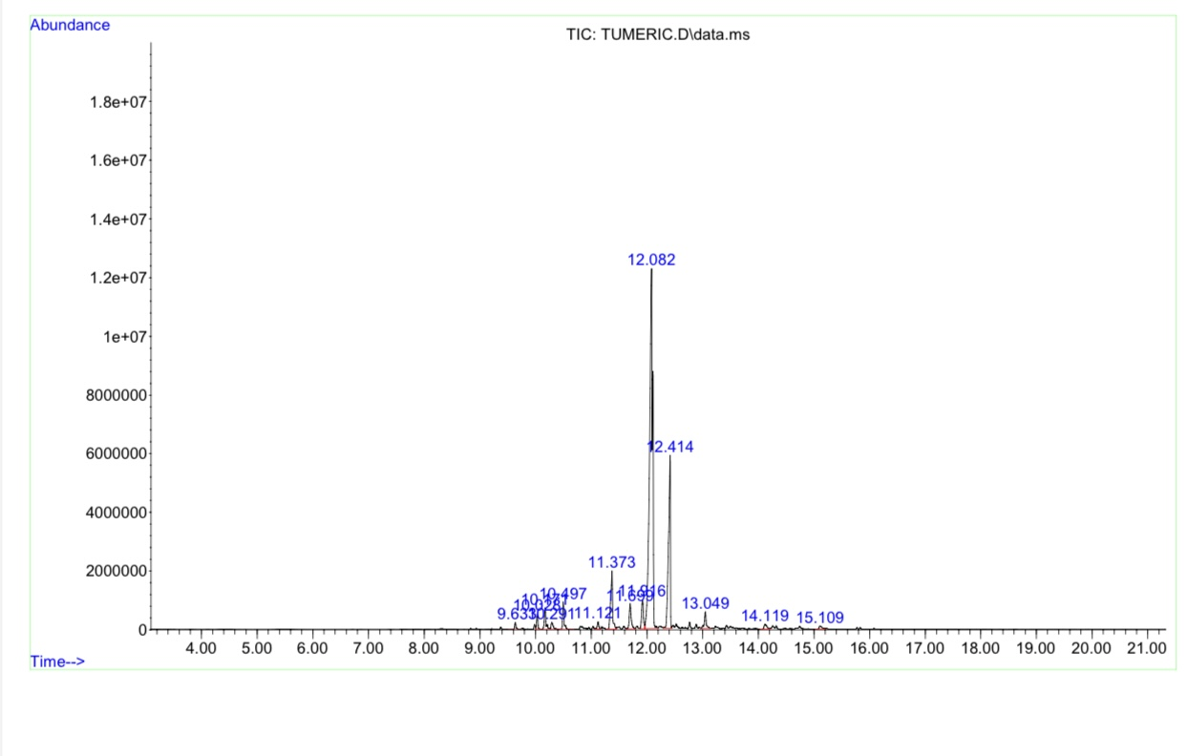
Figure 1 : GC-MS Analysis of Curcuma longa Ethanolic Rhizome extract
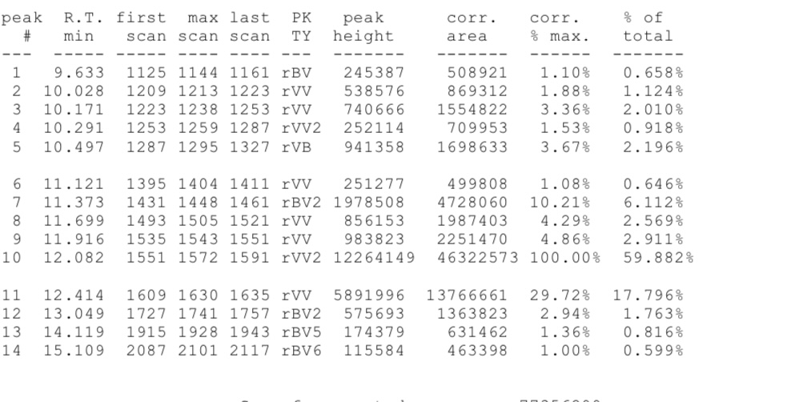

Table 4 :Bioactive compounds of Curcuma longa Ethanolic rhizome extract
Bioactivecompound | Molecular formula (Molecular weighting/mol) | Structure
Bicyclo[4.1.0]-3-heptene,2-isopropenyl- 5-isopropyl- 7,7-dimethyl- | C15H24(204.35) | 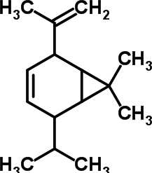

Xylopropamine | C11H17N (163.26) | 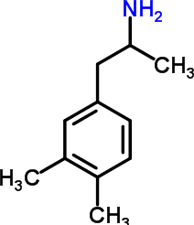
1-(3,3-dimethyl-but-1-ynyl)-1,2-dimethyl-3-methylene- cyclopropane | C12H18(162.27) | 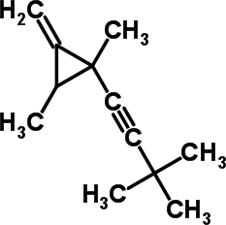
6-octen-1-yn-3-ol,3,7-dimethyl | C10H16O (152.23) | 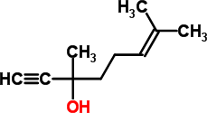
Ethyliso-allocholate | 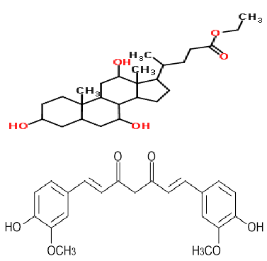C26H44O5(436.60)
Curcumin | C21H20O6(368.40)
α-curcumene | C15H22(202.33) | 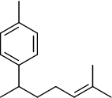
β-curcumene | C15H24(204.75) | 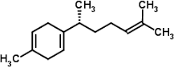
Isocurcumenol | C15H22O2(234.33) | 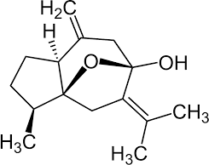
Curdione | C15H24O2(236.35) | 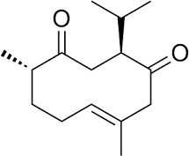

CHAPTER FIVE

DISCUSSION
The phytochemical analysis of the ethanolextractofcurcuma longa in Table 1 revealed thepresenceofseveralbioactivecompounds suchastannin, terpenoid, glycoside, steroid, alkaloid, flavonoid, phenolic and phlabotanin, while saponin and amino acid are absent. Tannins are polyphenolic compounds with antioxidant, antimicrobial, and astringent properties. In turmeric, they may contribute to its gut-protective and anti-inflammatory effects.
Saponins, known for anti-inflammatory and immunomodulatory effects, are not presentin this extract. Their absence may be due to the ethanol solvent, which less efficiently extracts polar saponins compared to water. Terpenoids are major bioactives in turmeric, including compounds like ar-turmerone, curlone, and atlantone, which were detected in your GC-MS profile. These have anti- inflammatory, neuroprotective, and anticancer potential. Glycosides often function as natural pro-drugs, becoming bioactive upon metabolism. Their presence may enhance therapeutic activity, such as antioxidant or anti- inflammatory effects. Plant steroids (phytosterols) such as stigmasterol or campesterol may be present. They possess anti-inflammatory and cholesterol-lowering properties.
Alkaloids are nitrogen-containing compounds known for antimicrobial, analgesic, and stimulant activity. Their presence adds pharmacological diversity. Flavonoids are strong antioxidants with anti-inflammatory, anti-aging, and cardioprotectiveroles. Turmeric isknowntocontainflavonoid-likepolyphenols, possibly co-extracted inethanol.

The presence of Phenolic is expected, as phenolic compounds like curcumin and related polyphenols are well-known turmeric components. These contribute significantly to antioxidant and anticancer activity.Proteins and free amino acids are typically not extracted in ethanol, hence their absence here. They are more effectively extracted with aqueous solvents. Phlobatannin is a class of condensed tannins. Their presence further supports the strong antioxidant and antimicrobial potential of the extract. The phytochemicalprofile suggests that the ethanolextract of Curcuma longa rhizome is a potent blend of bioactive compounds, mainly: phenolics, terpenoids, flavonoids and alkaloids. These constituents validate the traditional and pharmacological uses ofturmeric in inflammation, infections, oxidativestress,andgeneralwellness.

Table 2 shows the in vitro antioxidant potential of Curcuma longa (turmeric) rhizome ethanol extract measured by three standard assays: ABTS (2,2’- azino-bis(3- ethylbenzothiazoline-6-sulfonic acid)), DPPH
(2,2-diphenyl-1-picrylhydrazyl),andNO(NitricOxidescavenging).Eachassayevaluates the extract’s ability to scavenge free radicals, thus indicating antioxidant potential. All three assays demonstrate a clear dose-dependent trend — inhibition (%) increases with concentration. This confirms that antioxidant components in the extract areconcentration-sensitive and active. At the highest tested inhibition at 1000 µg/mL (92.98%). ABTS assay generally favors both hydrophilic and lipophilic antioxidants — indicating broad antioxidant capacity in the extract. Also high: 86.49% inhibition at 1000 µg/mL indicate that NO is linked to inflammation; scavenging suggests anti-inflammatory potential, aligning with traditional use and GC-MS results (turmerones are anti-inflammatory agents).
Also Peaks at 84.07% inhibition at 1000 µg/mL shows DPPH is specific for hydrogen- donating antioxidants, suggesting presence of phenolics, flavonoids, and terpenoids — confirmed in your phytochemical screening. The ethanol extract of Curcuma longa rhizomeshowsStrong,dose-dependent antioxidant activityacrossABTS,DPPH,andNO assays which is likely due to its rich content of phenolics, flavonoids, terpenoids, and curcuminoids, supporting its traditional use in managing oxidative stress, inflammation, and chronic diseases.
The FRAP assayfrom Table 3 measures the extract’s ability to reduce ferric ions (Fe³⁺) to ferrous ions (Fe²⁺), which reflects electron-donating antioxidant activity.
The Curcuma longa extract shows a FRAP value of 2.855 mmol Fe²⁺/g, which is almost identical to that of BHT (2.863 mmol/g), a well-known synthetic antioxidant commonly used as reference.
Turmeric extract is nearly as effective as BHT, which is a benchmark antioxidant in the food and pharmaceutical industries.
This suggests strong reducing potential, which complements the free radical scavenging activity seen in DPPH, ABTS, and NO assays. The FRAP value reflects the total antioxidant capacity, especially from phenolic compounds, flavonoids, and terpenoids, which donate electrons to neutralize free radicals. The Curcuma longa ethanol extract exhibits excellent antioxidantpotential, statistically comparable to BHT, as shown by the FRAP assay. This reinforces its potentialapplication in: Nutraceuticals, Functional foods and Pharmaceutical formulations.
The GC-MS chromatogrampresented inFigure 1reveals the complexchemicalprofile of the ethanolic extract of curcuma longa rhizome, highlighting the presence of multiple bioactive compounds. A total of 14 major peaks were identified in the chromatogram. Each corresponds to different phytochemicals, with varying retention times (RT) and relative area percentages (Area%), indicating their abundance in the extract. Ar- turmerone (RT 12.082, 59.88%) is the most abundant compound in the extract. It is a major sesquiterpene found in turmeric and has well-documented anti-inflammatory, antimicrobial, and neuroprotective activities. Curlone (RT 12.414, 17.80%) and Turmerone (RT 11.916, 2.91%) are other significant sesquiterpenes identified. These compounds contribute to the biological activity and characteristic aroma of turmeric oil. Several benzene derivatives such as benzeneacetaldehyde, ethyl-dimethyl benzenes, and p-Cymene were identified. These are typical of essential oils and may result from breakdown of larger curcuminoid structures during extraction or thermal degradation in GC-MS. Compoundslike(E)-Atlantone,2-tert-butylpyridine,andhexenylcyclohexadieneswere found in low abundance. Their contributions to therapeutic effects are not fully understood but may synergize with major sesquiterpenes. The extract shows a diverse profile of sesquiterpenes, aliphatic hydrocarbons, esters, aldehydes, and oxygenated aromatics. This diversity is consistent with turmeric’s ethnopharmacological uses, especially in inflammation and oxidative stress-related conditions. The GC-MS analysisof Curcumalongaextract revealed a phytochemical profile rich in sesquiterpenes, especially ar-turmerone and curlone, which together represent over 77% of the total volatile content. These findings confirm the extract’s therapeutic potential and match known chemical signatures ofturmeric oil. The presence of minor aromatic and aliphatic compounds further contributes to its pharmacological complexity.

CONCLUSION.
In conclusion, the phytochemical screening, antioxidant evaluation, and GC-MS profiling of Curcuma longa extract have collectively demonstrated that turmeric is a potent source of bioactive compounds with significant antioxidant activity. These findings support the continued exploration and utilization of turmeric in the formulation of natural health products and functional foods aimed at combating oxidative stress and enhancing overall well-being.

REFERENCES

Aleksandar Godic, Borut Poljsak, Metka Adamic, Raja Dahmane. The role of antioxidants in skin cancer prevention and treatment. Oxidative medicine and cellular longevity. 2014
Elias and M. N. Rao, “Inhibition of albumin denaturation and anti-inflammatory activity of
dehydrozingerone and its analogs,” Indian Journal of Experimental Biology, vol. 26, no. 10,
pp. 540–542, 1988.
Hussein HJ, Hameed IH, HadiMY (2017). Using gaschromatography-mass spectrometry (GC-MS)
techniquefor analysis of bioactive compounds of methanolic leaves extract of Lepidium sativum. Research Journal ofPharmacy and Technology 10(11): 3981-3989.
Kocaadam B., Şanlier N. Curcumin, an active component of turmeric (Curcuma longa), and its
effects on health. Crit. Rev. Food Sci. Nutr. 2017;57:2889–2895.
Lao C.D., Ruffin M.T., Normolle D., Heath D.D., MurrayS.I., Bailey J.M., Boggs M.E., Crowell J.,
Rock C.L., Brenner D.E. Dose escalation of a curcuminoid formulation. BMC Complement. Altern. Med. 2006;6:10.
Ng, T. K. S. et al. Decreased serum brain-derived neurotrophic factor (BDNF) levels in patients
with Alzheimer’s disease (AD): A Systematic Review and Meta- Analysis.Int. J. Mol. Sci. 20, 257 (2019).
P. Padmanabhan and S. N. Jangle, “Evaluation of in-vitro anti-inflammatory activity of herbal
preparation, a combination of four medicinal plants,” International Journal of Basic and cal Sciences, vol. 2, no. 1, pp. 109–116, 2012.

Sharma R.A., EudenS.A., PlattonS.L., Cooke D.N.,Shafayat A., Hewitt H.R., Marczylo T.H.,
Morgan B., Hemingway D., Plummer S.M. Phase I clinical trial of oral curcumin: Biomarkers of systemic activity and compliance. Clin. Cancer Res. 2004;10:6847–6854.
ShuaiJiangetal. PharmacolRes.2017May

