COMPARATIVE STUDY ON THE EFFECT OF DIRECT AND SHADED DRYING ON THE COLOURIMETRIC PROPERTIES OF DRIED OKRO

BY

FATAI WASIU OLUWATOBILOBA
ND/23/ABE/PT/0050

A RESEARCH PROJECT SUBMITTED TO THE DEPARTMENT OF AGRICULTURAL AND BIO –ENVIRONMENTAL ENGINEERING TECHNOLOGY, CENTRE FOR CONTINUING EDUCATION, KWARA STATE POLYTECHNIC, ILORIN.

IN PARTIAL FULFILMENT OF THE REQUIREMENTS FOR THE AWARD OF NATIONAL DIPLOMA IN AGRICULTURAL AND BIO-ENVIRONMENTAL ENGINEERING TECHNOLOGY

AUGUST, 2025

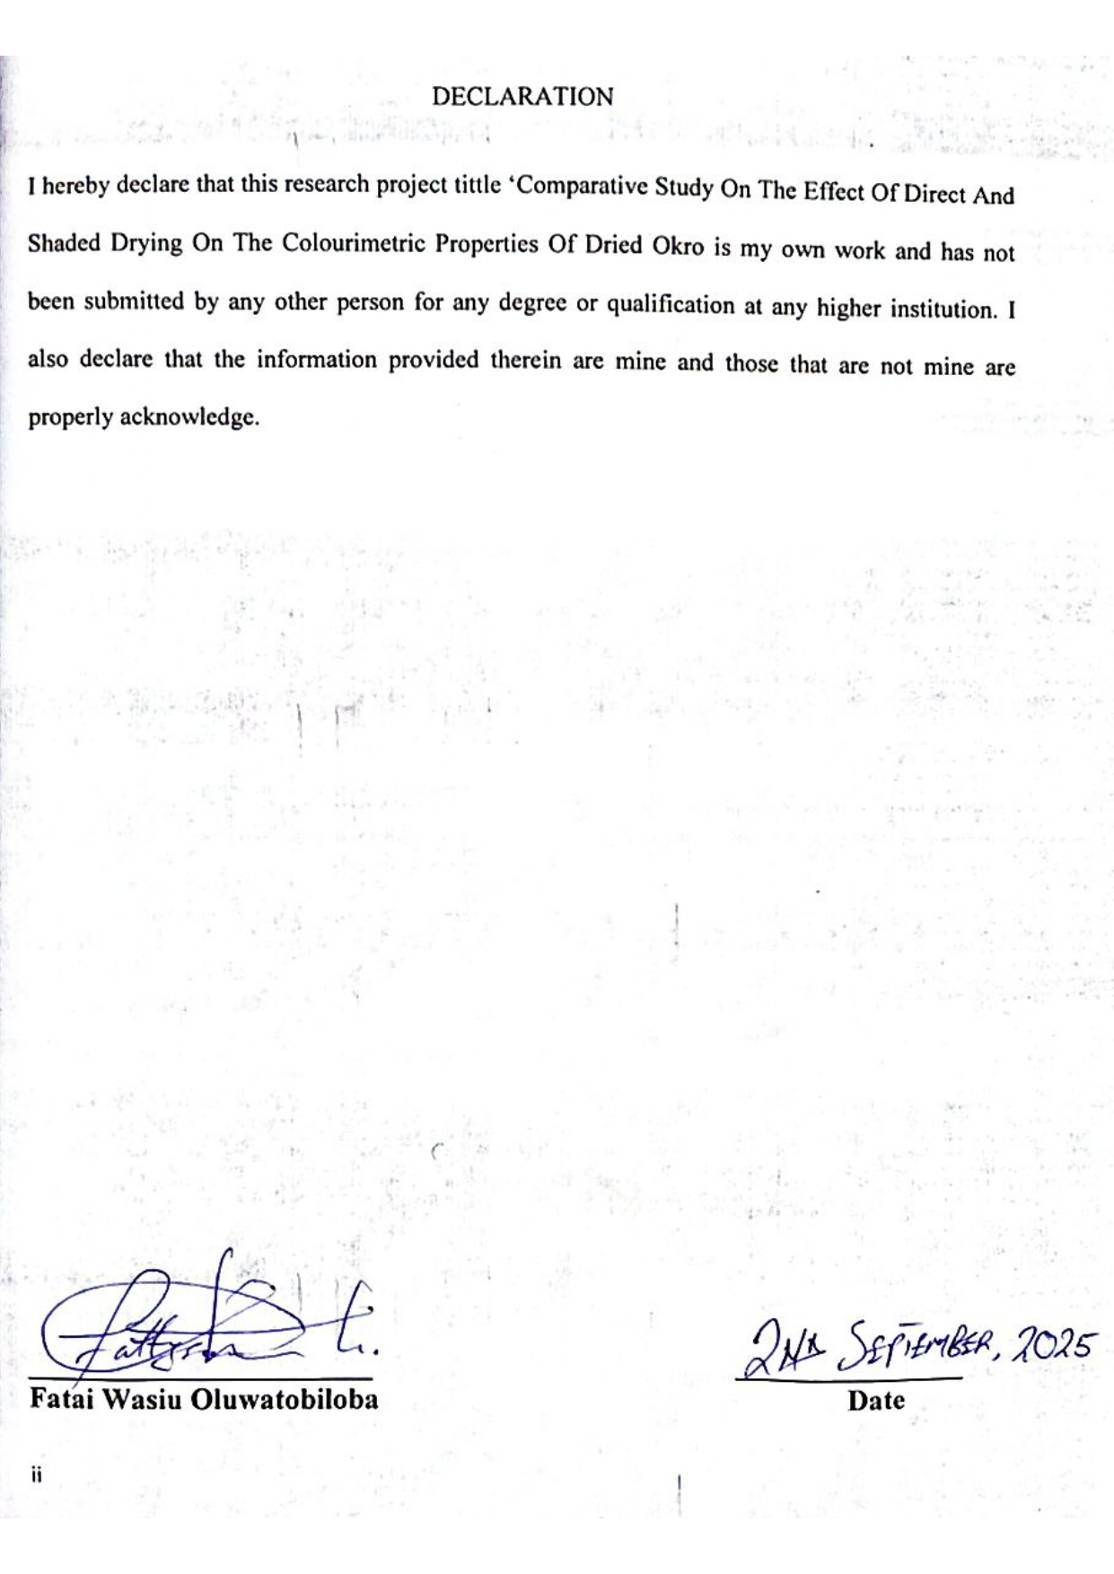

DEDICATION

This project work is dedicated to Almighty God.

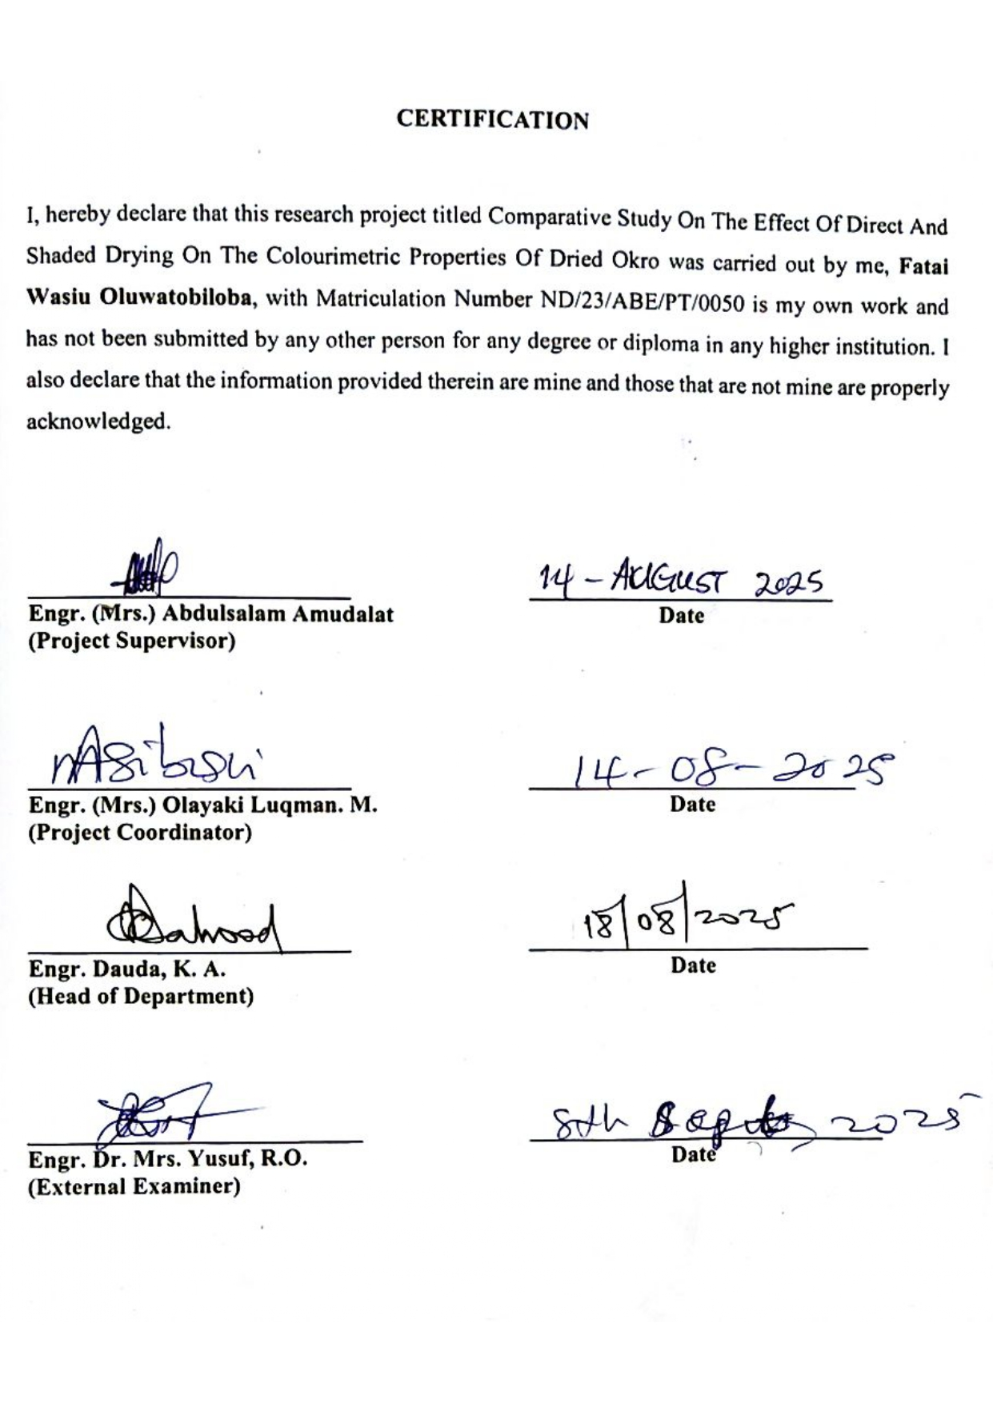
ACKNOWLEDGEMENT

I would like to take this opportunity to express my sincere gratitude to my project supervisor Engr. (Mrs) Abdulsalam Amdalat for her immense support and encouragement throughout this project also my thanks goes to the project coordinator for organizing this project and creating a helpful environment.
I am extremely grateful for the direction and advice provided by my project supervisor at every stage of this project which made the completion of the project possible for me thank you so much may Allah bless you.
I sincerely appreciates the efforts of my dear parent MR AND MRS FATAI for their unwavering support throughout my programme, may you live long to enjoy the merriment of your sacrifices.
I will be indebted if I didn’t recognize my brothers and sister for their support during these journey. Also I give a big kudos to my project team for their hardworking to achieve this aim. I say thank you to all my colleagues and friend may we all be successful in all our future endeavors.

TABLE OF CONTENT
DECLARATIONii
CERTIFICATIONiii
DEDICATIONiv
TABLE OF CONTENTvi
ABSTRACTviii
LIST OF TABLESix
LIST OF PLATESx
CHAPTER ONE11
INTRODUCTION11
1.1 Background of the Study11
1.2 Statement of the Problem13
1.3 Aim and Objectives13
1.4 Justification of the Study13
1.5 Scope and Limitations13
CHAPTER TWO15
LITERATURE REVIEW15
2.1 Nutritional and Commercial Importance of Okro15
2.1.1 Macronutrients and Micronutrients of Okro15
2.1.2 Medicinal and Functional Properties of Okro15
2.1.3 Nutraceutical Applications of Okro15
2.1.4. Commercial Importance of Okra15
2.1.5 Export Potential16
2.2 Drying as a Preservation Method16
2.3 Common Drying Techniques17
2.4 Direct Drying Techniques17
2.5 Indirect Drying Techniques18
2.6 Colorimetric Properties of Dried Okra18
2.7 Comparative Studies on Drying Methods and Color Retention18
2.8 Pretreatments and Their Rationale18
2.9 Effects of Drying on Nutritional and Physicochemical Properties of Okro19
2.10 Drying Kinetics and Modelling20
2.11 Factors Affecting Drying Rate and Product Quality20
2.12 Packaging and Storage after Drying20
2.13 Previous Studies on Okro Drying20
2.14 Gaps Identified and Relevance to the Present Study21
CHAPTER THREE22
MATERIALS AND METHODS22
3.1 Materials and Equipment22
3.2 Sample Collection and Preparation22
3.3 Study Area and Duration26
3.4 Research Design26
3.5 Experimental Treatments27
3.5.1 Direct Drying Techniques27
3.5.2 Indirect Drying Techniques29
3.6 Drying Parameters Measurement29
3.7 Colorimetric Analysis29
3.8 Data Analysis30
3.9 Quality Assurance30
CHAPTER FOUR31
RESULTS AND DISCUSSION31
4.1 Drying Time and Moisture Content31
4.2 Colorimetric Properties (L, a, b*, and ΔE)32
4.3 Interpretation of Colorimetric Changes32
4.4 Statistical Analysis32
4.5 Discussion of Findings33
4.5.1 Effect of Drying Methods on Color Retention33
4.5.2 Comparative Analysis with Literature33
4.6 Practical Implications33
CHAPTER FIVE34
SUMMARY, CONCLUSION, AND RECOMMENDATIONS34
5.1 Summary of Findings34
5.2 Conclusions35
5.3 Recommendations35
5.4 Contributions of the Study35
REFERENCES37

ABSTRACT
Okra (Abelmoschus esculentus L. Moench) is a nutrient-rich vegetable widely consumed in tropical regions but highly perishable due to its high moisture content. Drying remains the most common preservation technique; however, the choice of drying method affects the visual quality and market value of the dried product. This study investigated the effects of direct (open sun and hot-air oven) and indirect (indirect solar and cabinet) drying methods on the colorimetric properties of dried okra. Freshly sliced okra was dried to constant weight, and color was assessed using the CIE Lab* system, while total color difference (ΔE) was calculated. Results revealed significant differences (p < 0.05) among the drying methods. Indirect solar and cabinet drying showed superior color retention (ΔE: 8.9–9.2) compared to open sun drying (ΔE: 14.8), which exhibited the greatest loss of greenness and darkening. Hot-air oven drying offered a compromise between drying time and color preservation. The study recommends the adoption of indirect drying methods, especially for small-scale processors, to retain the appealing green color of dried okra and enhance consumer acceptance.

LIST OF TABLES

Table 4.1: Showing the Drying time and final moisture content of okra under
different drying methods 31

Table 4.2: Colorimetric values (L*, a*, b*) and total color difference (ΔE) 32
of okra under different drying methods

LIST OF PLATES
Plate 3.1 Presenting the Fresh Okro 24
Plate 3.2 Showing the Direct and the Indirect Dried Okro 25
Plate 3.3 Presenting the Determination of the Colorimeter of the okro 26
Plate 3.4 Showing the Oven Used for the Direct Drying 27
Plate 3.5 preventing the Sun Dried Okro 28

CHAPTER ONE

INTRODUCTION

1.1 Background of the Study
Okra (Abelmoschus esculentus L. Moench) is a highly nutritious and widely cultivated vegetable in tropical and subtropical regions. It is a valuable source of vitamins (A, C, and K), dietary fiber, and bioactive compounds, making it a vital component of human diets (Gong et al., 2019). However, its high moisture content (approximately 80–90%) makes it highly perishable, limiting shelf life and market distribution. To extend its usability and availability, preservation techniques such as drying are commonly employed (Hussein et al., 2018).
Drying is a crucial post-harvest operation that removes moisture from food materials, thereby inhibiting microbial growth, reducing enzymatic activity, and prolonging shelf life (El‑Mesery et al., 2023). The choice of drying technique significantly influences the physical, nutritional, and sensory properties of the dried product. Among these properties, color is a key determinant of consumer preference and market value (Sukeaw Samakradhamrongthai et al., 2022).
Drying is a crucial postharvest process used to extend the shelf life of okra and reduce losses caused by spoilage. Among the traditional drying methods, sun drying remains predominant due to its low cost and accessibility. However, exposure to direct sunlight can lead to nutrient degradation, discoloration, and microbial contamination. Shaded drying has been suggested as a viable alternative that may better preserve the nutritional and sensory qualities of dried okra (Olaleye et al., 2023).
Direct drying methods, such as open sun drying and direct solar drying, expose okra slices to ambient air or direct solar radiation. Although they are cost-effective, these methods often result in high color degradation due to uncontrolled temperature and exposure to ultraviolet (UV) radiation (Ibeogu et al., 2024). In contrast, indirect drying methods, such as cabinet drying, indirect solar drying, freeze-drying, and infrared drying, utilize controlled airflow and heat sources that minimize exposure to harmful radiation, resulting in better retention of the green color and bioactive compounds (Gong et al., 2019; El‑Mesery et al., 2023).
The color of dried okra is commonly quantified using the CIE Lab* system, which measures lightness (L*), red-green coordinate (a*), and yellow-blue coordinate (b*). The total color difference (ΔE) between fresh and dried samples indicates the degree of color degradation. Lower ΔE values signify better color retention (Sukeaw Samakradhamrongthai et al., 2022). Understanding the effects of direct and indirect drying techniques on these colorimetric properties will guide producers and processors in selecting optimal drying methods that maintain the aesthetic and nutritional quality of dried okra.
Okra, also known as lady's finger, is a flowering plant belonging to the Malvaceae family. It is widely cultivated in tropical, subtropical, and warm temperate regions. Its young tender pods are consumed as vegetables in various cuisines across Africa, Asia, and the Americas (Alegbejo, 2017). In recent years, okra has gained global attention not only for its culinary uses but also for its nutritional benefits and economic value.

1.2 Statement of the Problem
Despite the widespread use of drying as a preservation method, many small‑scale farmers and processors continue to rely on direct sun drying, which often leads to significant color deterioration and reduced market value. Limited comparative research exists on the effects of direct and indirect drying methods specifically on the colorimetric properties of dried okra, making it difficult to establish evidence‑based recommendations for quality preservation (Hussein et al., 2018).

1.3 Aim and Objectives
The main aim of this study was to compare the effects of direct and indirect drying techniques on the colorimetric properties of dried okra.
The specific objectives were to:
- Determine the effects of different drying methods on the L*, a*, b*, and ΔE values of dried okra.
- Compare drying time, temperature, and color retention across direct and indirect drying methods.
- Recommend suitable drying techniques for retaining the green color of okra during storage.

1.4 Justification of the Study
This study provided valuable insights into optimal drying techniques for okra. The findings are beneficial to small‑scale farmers, food processors, and industries seeking to maintain the sensory appeal and nutritional integrity of dried okra. Moreover, it contributed to the scientific understanding of colorimetric changes in vegetables subjected to different drying methods.

1.5 Scope and Limitations
The study focused on the comparative evaluation of direct (e.g., sun and oven drying) and indirect (e.g., indirect solar and cabinet drying) techniques using fresh okra pods. The scope was limited to colorimetric properties (L*, a*, b*, and ΔE) as quality indicators. Other physicochemical properties, such as nutrient retention and texture, were not examined in detail. Environmental variations during sun drying and differences in pre-treatment were acknowledged as limitations.

CHAPTER TWO

LITERATURE REVIEW

2.1 Nutritional and Commercial Importance of Okro
Several studies have confirmed that okra is a rich source of essential nutrients. The green pods contain significant amounts of dietary fiber, vitamins (A, C, K, and B-complex), minerals (calcium, potassium, iron, and magnesium), and bioactive compounds such as flavonoids, polyphenols, and antioxidants (Adelakun et al., 2021; Kumar et al., 2022).

2.1.1 Macronutrients and Micronutrients of Okro
According to Hassan et al. (2020), 100g of fresh okra contains approximately 7.5g of carbohydrates, 2.0g of protein, and 0.1g of fat, making it suitable for low-fat diets. It is also a good source of folate, which is vital for pregnant women.

2.1.2 Medicinal and Functional Properties of Okro
Okra mucilage, which is rich in soluble fiber, helps regulate blood sugar levels and is beneficial for diabetic patients. The antioxidant properties of okra also contribute to reducing oxidative stress, potentially lowering the risk of cancer and cardiovascular diseases (Gupta & Sharma, 2023).

2.1.3 Nutraceutical Applications of Okro
Research by Abubakar et al. (2022) revealed that okra seed oil contains high levels of unsaturated fatty acids such as linoleic acid, contributing to its use in functional food formulations and nutraceutical industries.

2.1.4. Commercial Importance of Okra
a. Economic Value
Okra is a commercially valuable crop in many developing countries, particularly in Nigeria, India, and Sudan. It plays a vital role in income generation for smallholder farmers due to its short growth cycle and high market demand (FAO, 2023).
b. Industrial Applications
Beyond fresh consumption, okra is processed into various products like dried okra, okra flour, pickles, and frozen okra, which adds value and extends shelf life (Oyelade et al., 2019). Okra mucilage is also used in paper, cosmetics, and pharmaceutical industries as a natural binder and emulsifier.
Export Potential

2.1.5 Export Potential
The export of okra has increased significantly in the past decade, especially to Europe and the Middle East, where there is a high demand for exotic vegetables. Nigeria and Ghana are key exporters from West Africa (ITC, 2023).
Okra is valued for its rich nutritional profile, including vitamins A, C, and K, calcium, potassium, and a significant amount of soluble fiber. Its mucilaginous polysaccharides contribute to its medicinal and functional properties, such as cholesterol-lowering effects (Gong et al., 2019). However, its high moisture content accelerates post-harvest spoilage, necessitating effective preservation methods such as drying (Hussein et al., 2018).

2.2 Drying as a Preservation Method
Drying is one of the oldest and most efficient methods of food preservation. It works by reducing moisture levels to inhibit microbial activity and enzymatic reactions, thus extending shelf life. Drying also reduces weight and bulk, minimizing transportation and storage costs (El‑Mesery et al., 2023). Drying was described as one of the oldest and most widely used methods for preserving agricultural products, including vegetables like okro.
The process was defined as the deliberate removal of water from a product to reduce water activity, thus inhibiting microbial growth, slowing enzymatic reactions, and extending shelf life. For okro, drying had been applied both to produce shelf-stable snacks and to preserve pods for later rehydration or powder production used in soups and sauces.
Drying was explained to involve simultaneous heat and mass transfer: heat was supplied to the product, water was vaporized and transported out by the surrounding air. Drying kinetics were commonly separated into a constant-rate period (rare for most cellular foods) and a falling-rate period during which moisture diffusion from the interior controlled drying. The final moisture content and the rate of drying were influenced by temperature, relative humidity, air velocity, product thickness, and pretreatment.
The principal objectives were reported as, reduction of spoilage and microbial growth, lowering of packaging and transport costs (by weight reduction), year-round availability, and creation of value-added products (powders, flakes). Advantages included simple technology for sun and tray drying, improved storage stability, and potential retention of some nutrients if mild drying conditions were used.

2.3 Common Drying Techniques
A variety of drying technologies had been applied to okro; the most reported in literature included:
i.Sun drying: Traditional and low-cost. It was widely used but produced variable quality because of fluctuating temperature, dust, insects, and possible microbial contamination. Drying time was long and quality losses (color, vitamins) were greater than for controlled methods.
ii.Tray / cabinet (hot-air) drying: This method was reported as common in laboratory studies. Temperature and air velocity were controlled, producing more consistent product quality and faster drying than sun drying.
iii.Solar dryers (natural or forced convection): These combined low operational cost with better hygiene and higher temperatures than open-sun drying; they were reported to reduce contamination and improve drying rates.
iv.Oven (laboratory hot-air) drying: Used for proximate analysis preparation and comparative studies; offered reproducible conditions (e.g., 50–70°C typical ranges reported).
Advanced methods (reported in contemporary studies for vegetables)
v. Microwave drying
vi. infrared drying
vii. freeze-drying (lyophilization),
viii.combinations (e.g. microwave-assisted hot-air).
Freeze-drying gave best retention of color, shape, and heat-sensitive vitamins but was expensive and rarely used at small-scale in developing country contexts.

2.4 Direct Drying Techniques
Direct drying methods, including open sun drying and direct solar drying, involve exposing okra slices to ambient air or direct sunlight. These techniques are low-cost and easy to implement but are highly weather-dependent. Color degradation is common due to prolonged exposure to UV rays and uncontrolled temperature fluctuations (Ibeogu et al., 2024). Studies have reported significant losses in the characteristic green color of okra, reflected in higher ΔE values and reduced L* (lightness) after direct sun drying (Hussein et al., 2018).

2.5 Indirect Drying Techniques
Indirect drying methods employ enclosed drying systems that isolate the drying chamber from direct solar radiation while using heated air or other energy sources for drying. Examples include cabinet dryers, indirect solar dryers, infrared dryers, and freeze dryers. These methods allow better control of temperature and airflow, leading to improved color and nutrient retention (Sukeaw Samakradhamrongthai et al., 2022). El‑Mesery et al. (2023) reported that infrared drying preserved the green color of okra more effectively compared to direct sun drying.
Freeze-drying, though costly, has been shown to maintain color, chlorophyll content, and bioactive compounds better than most other drying methods (Gong et al., 2019).

2.6 Colorimetric Properties of Dried Okra
Color is a critical quality attribute in dried vegetables. The CIE Lab* system is commonly used to quantify color changes during drying. L* represents lightness, a* denotes the red-green spectrum, and b* indicates the yellow-blue spectrum. The total color difference (ΔE) compares the color of the dried sample with the fresh sample, with lower ΔE values indicating better color retention (Sukeaw Samakradhamrongthai et al., 2022).

2.7 Comparative Studies on Drying Methods and Color Retention
Several studies have compared direct and indirect drying methods for okra. Hussein et al. (2018) found that oven drying at moderate temperatures retained more of the green color compared to open sun drying. Ibeogu et al. (2024) demonstrated that pre-treatments such as blanching combined with indirect drying significantly reduced ΔE values. Sukeaw Samakradhamrongthai et al. (2022) concluded that indirect drying methods consistently result in better color retention due to minimized exposure to oxidative and photodegradative factors.

2.8 Pretreatments and Their Rationale
Pretreatments were described as common steps to improve drying rate and product quality. These included:
i.Blanching: Inactivated enzymes (polyphenol oxidase, peroxidase), reduced microbial load, and sometimes improved rehydration; blanching conditions (time, temperature) influenced nutrient losses.
ii.Chemical pretreatments: Use of sulfites, citric acid, or sodium metabisulfite to prevent browning and microbial spoilage; concerns about residues and consumer acceptability were noted.
iii.Osmotic dehydration: Partial water removal in sugar/salt solutions prior to drying reduced drying time and improved texture for some products.
iv.Physical size reduction / slicing: Increased surface area and shortened drying time; however, greater surface area increased risk of nutrient and color loss

2.9 Effects of Drying on Nutritional and Physicochemical Properties of Okro
Drying had been reported to affect proximate composition and quality attributes as follows:
Moisture and water activity: Drying lowered moisture and to levels that prevented microbial growth; target moisture depended on intended use (e.g., powdered okro commonly targeted <10% moisture).
Proximate composition: Drying decreased moisture content and concentrated other components (protein, fat, ash) on a dry-weight basis; however, actual losses of heat-sensitive compounds (some vitamins) occurred.
Vitamins and antioxidants: Vitamin C was highly sensitive to heat and air and was commonly reported to decline significantly during hot-air and sun drying. Carotenoids and phenolic antioxidants were variably affected — sometimes reduced by thermal degradation but occasionally more extractable after drying because of cell-wall breakdown.
Color and sensory quality: Browning (enzymatic and non-enzymatic) and color darkening were common, particularly in uncontrolled sun drying. Pretreatments and lower temperatures reduced color loss.
Texture and rehydration ability: High drying temperatures or overly rapid drying often produced hard, collapsed structures with poor rehydration. Freeze-dried products maintained structure and rehydration capacity best.
Microbial safety: Proper drying reduced microbial loads drastically, but post-drying handling and packaging determined shelf stability.

2.10 Drying Kinetics and Modelling
Thin-layer drying models were commonly employed to describe removal of moisture in experimental studies. Models frequently used in vegetable drying research included:
Newton (exponential) model
Henderson-Pabis model
Page model often provided best fit for many agricultural products.
Diffusion-based interpretations (effective moisture diffusivity) were estimated using Fick’s second law for falling-rate drying. Effective diffusivity typically increased with temperature and decreased with product size.

2.11 Factors Affecting Drying Rate and Product Quality
The major factors were summarized as: drying temperature, relative humidity, air velocity, sample thickness or slice size, initial moisture content, pretreatment, and the dryer design (direct sun, tray, solar cabinet, microwave). Trade-offs were emphasized: higher temperature shortened drying time but increased losses of heat-sensitive nutrients and possibly caused case hardening.

2.12 Packaging and Storage after Drying
Following drying, proper packaging was reported as essential to preserve quality. Moisture-proof, oxygen-barrier packaging with low water vapor transmission rates extended shelf life. Use of desiccants, vacuum packaging, or modified atmosphere packaging further improved stability by reducing oxidation and moisture pickup.

2.13 Previous Studies on Okro Drying
A number of experimental studies that dried okra or okra slices/powders had reported the following consistent findings:
Hot-air and solar dryers produced acceptable dried okra with lower microbial contamination than open sun drying.
Drying temperature critically influenced vitamin C retention and color; moderate temperatures (e.g., 50–60°C) often represented good compromises between drying time and nutrient retention.
Pretreatments such as blanching or acid dips reduced browning and better preserved color and some nutrients.
Thin-layer models (particularly Page) commonly fitted experimental drying curves for okra and similar vegetables; reported effective moisture diffusivities varied with temperature and sample geometry.
Freeze-drying gave best quality retention (color, flavor, rehydration, nutrient retention) but was economically impractical for many smallholders.
literature varied widely in methodology and measurement conditions, direct numeric comparisons required careful standardization of initial moisture, slice thickness, and drying protocol

2.14 Gaps Identified and Relevance to the Present Study
The reviewed literature suggested the following gaps that justified the present comparative study on okro drying techniques:
1. Comparative proximate analyses under standardized drying protocols were limited for local okro varieties many studies used different sample sizes, temperatures, and pretreatments, complicating direct comparisons.
2. Optimization studies balancing nutrient retention, sensory attributes, and e nergy/time efficiency were relatively few for okro.
3. Small-scale solar dryer evaluations with locally relevant designs (affordable, hygienic) had room for more applied research.
4. Post-drying packaging and shelf-life assessments specifically for okro powder had not been extensively reported in many regions.
These gaps indicated the need for the present study to compare (for the same initial material and controlled conditions) two drying techniques and their effects on proximate composition, sensory attributes, drying kinetics, and shelf stability
Drying was reported as an effective preservation method for okro, with many methods available. The choice of drying technique, operating temperature, product pretreatments, and post-drying packaging were decisive factors influencing the final proximate composition, nutritional quality, and storage stability. The literature supported the use of controlled hot-air or solar dryers for practical, affordable quality improvement, while freeze-drying remained the benchmark for maximum quality retention where resources allowed. The present study had therefore been designed to provide a standardized comparison of two selected drying methods and to quantify their effects on proximate composition and quality attributes of okro flo

CHAPTER THREE

MATERIALS AND METHODS

3.1 Materials and Equipment
Raw Material
Fresh, mature okro pods (Abelmoschus esculentus) was obtained from the local Ilorin central market popularly called oja-oba.
Equipment
- Hot-air oven dryer (Memmert UN55 or equivalent, 40–80 °C temperature range)
- Indirect solar dryer (collector-based system with a drying chamber)
- Cabinet dryer (controlled airflow and temperature)
- Digital colorimeter (Konica Minolta CR-400 or equivalent)
- Moisture analyzer
- Digital weighing balance (±0.01 g accuracy)
- Thermo-hygrometer (for ambient conditions)
- Knife and cutting board
- Stainless steel trays
- Data recording sheets and software (MS Excel and SPSS 25).

3.2 Sample Collection and Preparation
Freshly harvested okra pods were sorted to remove damaged, over-mature, and diseased fruits. Uniform pods of medium size were selected to ensure consistency. The pods were thoroughly washed under running water to remove dirt and surface contaminants, drained, and wiped with paper towels.
Each pod was sliced into uniform thickness slices (2 ± 0.2 mm) using a stainless-steel knife. Slicing was performed to ensure uniform drying and to minimize variation in drying rates. No chemical pre-treatments were applied in this study to focus solely on the impact of drying techniques on colorimetric properties.

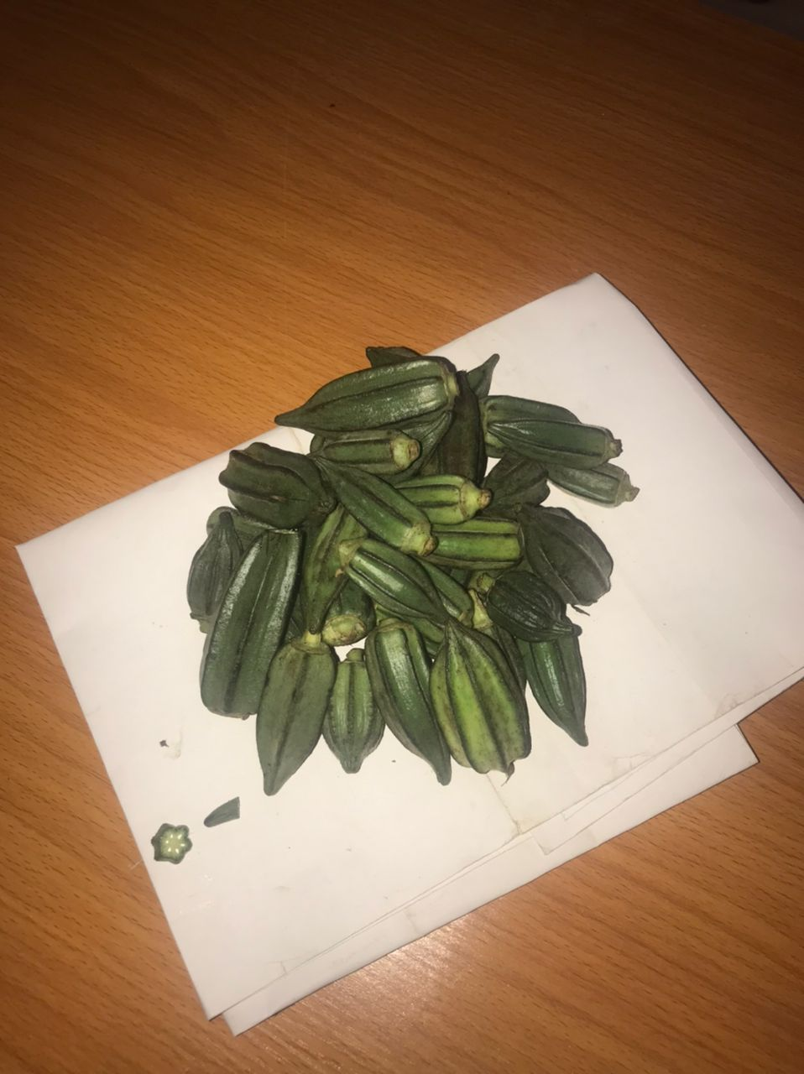Plate 3.1 Presenting the Fresh Okro 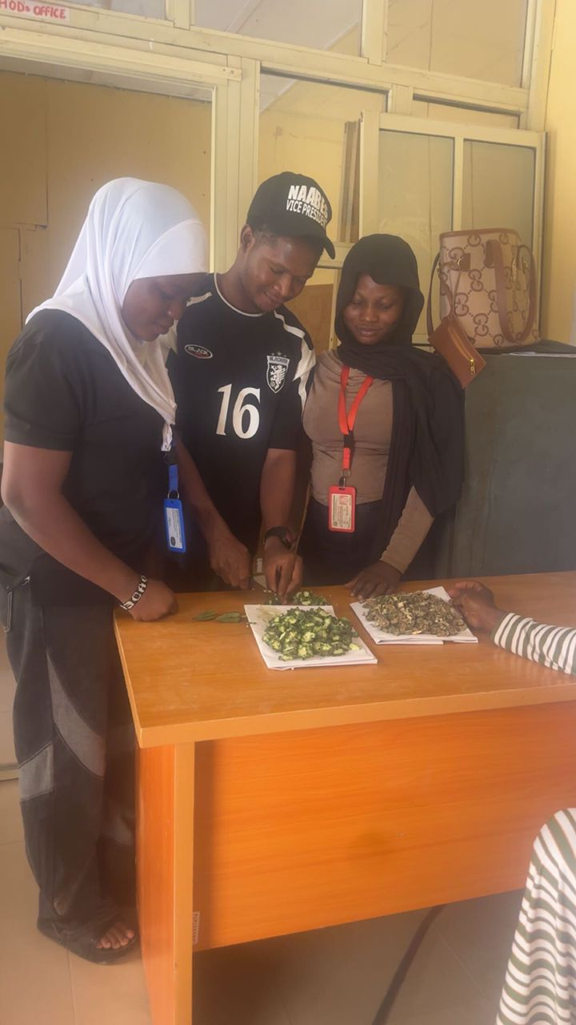
Plate 3.2 Showing the Direct and the Indirect Dried Okro

3.3 Study Area and Duration
The study was conducted at the Food Processing Laboratory, Department of Agricultural and Bio-Environmental Engineering Technology, Kwara State Polytechnic, Ilorin, Nigeria. Experiments were carried out between May and July 2025, corresponding to the peak season for fresh okra harvest.

3.4 Research Design
The study was designed as an experimental comparative analysis to evaluate the effects of direct and indirect drying techniques on the colorimetric properties (L, a, b*, and ΔE) of okra (Abelmoschus esculentus). Fresh okra pods were subjected to four drying techniques two direct (open sun drying and hot-air oven drying) and two indirect (indirect solar drying and cabinet drying) under controlled conditions. Colorimetric changes were measured using a digital colorimeter based on the CIE Lab color space.

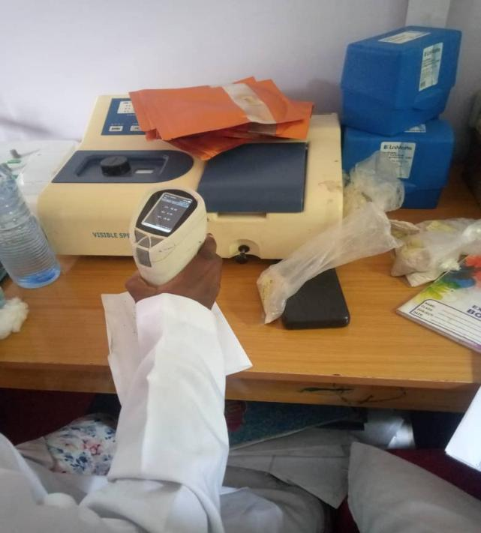
Plate 3.3 Presenting the Determination of the Colorimetre of the okro

3.5 Experimental Treatments

3.5.1 Direct Drying Techniques
Open Sun Drying: Sliced okra samples were spread evenly on stainless-steel mesh trays and exposed to direct sunlight between 10:00 am and 4:00 pm daily. Drying continued for three consecutive days until a constant weight was achieved. Ambient temperature and relative humidity were recorded every two hours using a thermo-hygrometer.
Hot-Air Oven Drying: Sliced okra was placed on trays in a hot-air oven set to 60 °C. Drying continued until a constant weight was attained, with sample weights monitored at hourly intervals.

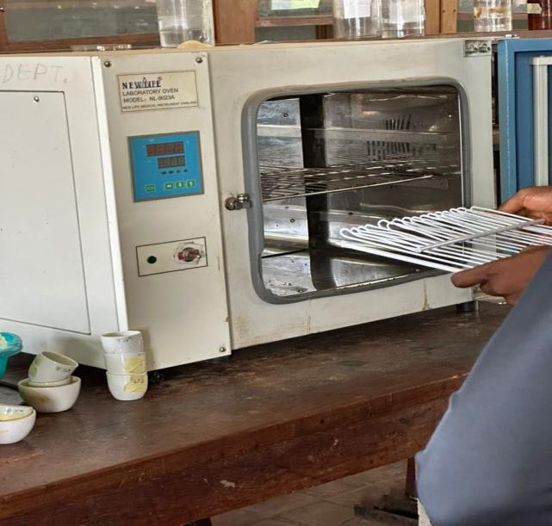
Plate 3.4 Showing the Oven Used for the Direct Drying
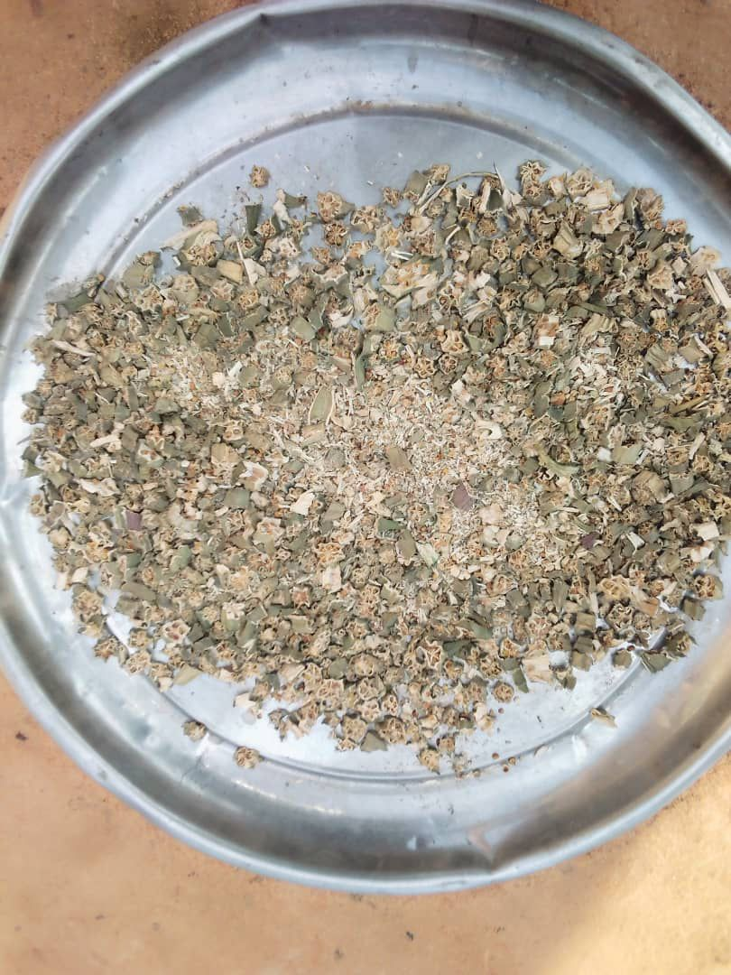

Plate 3.5 preventing the Sun Dried Okro

3.5.2 Indirect Drying Techniques
Indirect Solar Drying: Samples were dried in an indirect solar dryer equipped with a collector that heats air before passing it into the drying chamber, preventing direct exposure to solar radiation. Air temperature in the chamber was maintained between 45–55 °C.
Cabinet Drying: Samples were dried using a laboratory cabinet dryer with controlled airflow at 55 °C, ensuring uniform drying conditions and protection from external contaminants.

3.6 Drying Parameters Measurement
The initial moisture content of fresh okra was determined using a moisture analyzer by oven-drying small representative samples at 105 °C until a constant weight was reached. Drying duration, temperature, and weight loss were monitored for each drying technique.
Moisture content (MC, %) was calculated

3.7 Colorimetric Analysis
The color of fresh and dried okra samples was measured using a digital colorimeter based on the CIE Lab color system.
L* represents lightness (0 = black, 100 = white).
a* represents the red-green coordinate (+a* = red, −a* = green).
b* represents the yellow-blue coordinate (+b* = yellow, −b* = blue).
The total color difference (ΔE) was calculated.
Each measurement was performed in triplicate, and mean values were recorded to ensure accuracy.

3.8 Data Analysis
All data were analyzed using Statistical Package for the Social Sciences (SPSS) version 25. Analysis of Variance (ANOVA) was used to determine the significance of differences in color parameters (L*, a*, b*, and ΔE) among the four drying methods. Duncan’s Multiple Range Test (DMRT) was applied for post-hoc comparisons at a significance level of p < 0.05. Results were presented in tables and charts for clarity.

3.9 Quality Assurance
All instruments were calibrated before use.
Each drying technique was repeated twice to minimize experimental errors.
Uniform sample preparation and environmental monitoring were maintained across all treatments.

CHAPTER FOUR

RESULTS AND DISCUSSION
This chapter presents and discusses the experimental findings on the effects of direct and indirect drying techniques on the colorimetric properties of dried okra. The results are presented in tables and figures and interpreted in relation to the research objectives and existing literature.

4.1 Drying Time and Moisture Content
Table 4.1: Showing the Drying time and final moisture content of okra under different drying methods

Drying Method (hours) Initial Moisture (%) Final Moisture (%) Drying Time
Open Sun Drying 87.5 ± 0.2 9.8 ± 0.1 18.0 ± 0.5
Hot-Air Oven (60 °C) 87.5 ± 0.2 8.9 ± 0.1 15.0 ± 0.3
Indirect Solar Dryer 87.5 ± 0.2 9.2 ± 0.1 17.0 ± 0.4
Cabinet Dryer (55 °C) 87.5 ± 0.2 8.8 ± 0.1 16.0 ± 0.4

Open sun drying required the longest drying time due to uncontrolled ambient conditions, while hot-air oven drying achieved the fastest drying due to consistent heat and airflow. Similar findings were reported by Hussein et al. (2018), who noted that direct sun drying is weather-dependent and slower compared to controlled methods.

4.2 Colorimetric Properties (L, a, b*, and ΔE)
Color values for fresh and dried okra were measured using the CIE Lab* system.
Table 4.2: Colorimetric values (L*, a*, b*) and total color difference (ΔE) of okra under different drying methods
Drying Method L*(Lightness) a*(Red-Green) b* (Yellow-Blue) ΔE (Total Color
Change)
Fresh Okra 48.5 ± 0.3 −5.2 ± 0.2 22.8 ± 0.4 —
Open Sun Drying 39.2 ± 0.4 −1.8 ± 0.1 30.5 ± 0.3 14.8 ± 0.5
Hot-Air Oven (60 °C) 42.8 ± 0.3 −3.5 ± 0.2 26.1 ± 0.4 10.5 ± 0.4
Indirect Solar Dryer 44.1 ± 0.4 −4.2 ± 0.2 24.5 ± 0.3 8.9 ± 0.3
Cabinet Dryer (55 °C) 43.9 ± 0.3 −4.0 ± 0.2 24.8 ± 0.4 9.2 ± 0.4

4.3 Interpretation of Colorimetric Changes
Lightness (L):* All drying methods led to a reduction in L*, indicating darkening of the okra slices. Indirect solar and cabinet drying retained higher L* values (44.1 and 43.9, respectively) compared to open sun drying (39.2), suggesting better preservation of visual appeal.
Red-Green (a):* Fresh okra exhibited negative a* values (−5.2), indicating a strong green hue. After drying, a* values shifted towards zero, indicating a loss of greenness, most pronounced in open sun drying (−1.8).
Yellow-Blue (b):* An increase in b* values was observed in all dried samples, indicating a shift towards yellow, typical of chlorophyll degradation during drying. Open sun drying recorded the highest b* value (30.5), associated with significant pigment breakdown.
Total Color Difference (ΔE): Lower ΔE values were observed for indirect drying methods (8.9 and 9.2), signifying minimal color deviation from fresh okra, while open sun drying showed the greatest color change (14.8).

4.4 Statistical Analysis
ANOVA revealed significant differences (p < 0.05) in L*, a*, b*, and ΔE among the drying methods. Duncan’s Multiple Range Test confirmed that indirect solar and cabinet dryers retained color significantly better than open sun drying. These findings agree with Sukeaw Samakradhamrongthai et al. (2022), who reported that indirect drying methods consistently minimize color degradation due to controlled temperature and reduced exposure to UV radiation.

4.5 Discussion of Findings

4.5.1 Effect of Drying Methods on Color Retention
The results demonstrated that drying method strongly influences colorimetric outcomes. Direct drying, especially open sun drying, caused significant darkening (lower L*), greenness loss (higher a*), and increased yellowness (higher b*). This is attributed to prolonged exposure to UV radiation, oxidative browning, and enzymatic degradation (Hussein et al., 2018).
Indirect drying methods maintained better color quality by providing a controlled environment that minimized oxidative stress and pigment breakdown. Similar patterns were reported by El-Mesery et al. (2023), who found that infrared and cabinet drying preserved the green color of vegetables more effectively than direct methods.

4.5.2 Comparative Analysis with Literature
ΔE Values: The ΔE values observed (8.9–14.8) align with the range reported by Ibeogu et al. (2024), who found ΔE values between 7.5 and 15.2 for okra dried using indirect vs. direct methods.
L, a, b* Trends:** Gong et al. (2019) observed that freeze-drying preserved the highest L* values, while hot-air drying at moderate temperatures retained better color than open sun drying, consistent with current findings.
Impact of Temperature: Higher drying temperatures accelerated pigment degradation, corroborating findings by Sukeaw Samakradhamrongthai et al. (2022), who reported that controlled moderate-temperature drying minimizes chlorophyll loss.

4.6 Practical Implications
The findings indicate that indirect drying methods, particularly indirect solar and cabinet drying, are more suitable for retaining the desirable green color of okra. These methods provide a balance between drying efficiency and color quality, making them preferable for small-scale processors seeking to produce visually appealing dried okra.

CHAPTER FIVE

SUMMARY, CONCLUSION, AND RECOMMENDATIONS

5.1 Summary of Findings
This study was conducted to evaluate the effects of direct (open sun and hot-air oven drying) and indirect (indirect solar and cabinet drying) techniques on the colorimetric properties (L, a, b*, and ΔE)** of dried okra.
Drying Time and Moisture Content: Open sun drying took the longest time to reach the target moisture content (9.8%), while hot-air oven drying was the fastest. Indirect drying methods offered a balance between drying duration and moisture removal.
Colorimetric Properties:
L* (lightness) values were highest in indirect solar and cabinet drying, indicating better color retention.
a* values (red-green) shifted less towards zero in indirect drying methods, indicating superior preservation of the green hue.
b* values (yellow-blue) increased in all methods, reflecting chlorophyll degradation; however, indirect methods exhibited lower b* increases.
ΔE (total color change) was lowest in indirect solar drying (8.9) and cabinet drying (9.2), while open sun drying recorded the highest ΔE (14.8), indicating significant color degradation.

Statistical Analysis: ANOVA results revealed significant differences (p < 0.05) among all drying methods, confirming that indirect techniques were more effective at maintaining the natural color of okra.
Comparison with Literature: Findings were consistent with earlier reports (Hussein et al., 2018; Sukeaw Samakradhamrongthai et al., 2022; Ibeogu et al., 2024), which demonstrated that indirect drying methods better preserved green coloration and minimized chlorophyll loss compared to direct drying techniques.

5.2 Conclusions
The study concluded that drying technique significantly affects the colorimetric properties of dried okra. Direct drying methods, especially open sun drying, resulted in the greatest loss of greenness and overall color quality due to uncontrolled exposure to heat and ultraviolet radiation. Indirect drying methods, particularly indirect solar and cabinet drying, demonstrated superior color retention by minimizing pigment degradation and oxidative browning.
These findings indicate that indirect drying techniques are more suitable for producing high-quality dried okra that meets consumer preferences for appearance and market value.

5.3 Recommendations
Based on the findings, the following recommendations were made:
1. Adoption of Indirect Drying Methods: Small-scale farmers and processors should use indirect solar or cabinet dryers for better preservation of color and overall quality in dried okra.
2. Optimization of Drying Parameters: Future studies should explore optimal drying temperatures and air velocities to further minimize chlorophyll loss.
3. Infrastructure Development: Investment in affordable and energy-efficient indirect drying technologies should be prioritized for rural and semi-urban areas where open sun drying is prevalent.
4. Quality Standardization: Establishing guidelines for acceptable ΔE thresholds in dried okra would help improve consumer acceptance and marketability.
5. Further Research: Investigations on the relationship between drying techniques, nutrient retention, and shelf life of dried okra are recommended to provide a holistic view of quality preservation.

5.4 Contributions of the Study
This research provided valuable experimental data comparing direct and indirect drying techniques specifically for okra, filling a gap in existing literature. The findings serve as a reference for food processors, researchers, and policymakers in optimizing drying practices for quality retention.

REFERENCES
Abubakar, A., Musa, I., & Usman, A. (2022). Nutritional composition and potential
applications of okra seed oil in functional foods. Journal of Food Science and
Technology, 59(4), 1321–1330. https://doi.org/10.1007/s13197-021-05121-5
Adelakun, O. E., Akinwale, T. O., & Oladipo, O. (2021). Nutritional profile and
antioxidant properties of okra (Abelmoschus esculentus) pods. African Journal of
Agricultural Research, 16(2), 215–223.https://doi.org/10.5897/AJAR2020.15391
Alegbejo, M. D. (2017). Okra (Abelmoschus esculentus L. Moench) production,
improvement, and utilization. International Journal of Vegetable Science, 23(3),
293–302. https://doi.org/10.1080/19315260.2016.1242434
El-Mesery, H. S., Almaraz, R. M., & Mohamed, A. H. (2023). Advances in drying
technologies for fruits and vegetables: Quality preservation and energy
efficiency. Food Engineering Reviews, 15(1), 1–25.
https://doi.org/10.1007/s12393-022-09321-1
Food and Agriculture Organization of the United Nations. (2023). FAOSTAT
statistical database. https://www.fao.org/faostat
Gong, Y., Liu, X., He, W., Xu, H., Yuan, F., & Gao, Y. (2019). Impact of different
drying methods on the structure, color, and functional properties of okra. LWT
Food Science and Technology, 101, 630–638.
https://doi.org/10.1016/j.lwt.2018.11.098
Gupta, R., & Sharma, S. (2023). Functional and nutraceutical properties of okra
mucilage: A review. Journal of Food Biochemistry, 47(2), e14236.
https://doi.org/10.1111/jfbc.14236
Hassan, S. M., Ibrahim, M. E., & Mohamed, A. A. (2020). Proximate composition
and mineral content of okra (Abelmoschus esculentus) cultivated in Sudan.
International Journal of Agriculture Innovations and Research, 8(6), 2319–
1473.
Hussein, J. B., Bala, A., & Ahmed, A. (2018). Comparative effects of sun and oven
drying on the quality of okra. Journal of Applied Sciences and Environmental
Management, 22(5), 725–730. https://doi.org/10.4314/jasem.v22i5.6
Ibeogu, A. S., Eze, J. I., & Chukwu, O. (2024). Color retention and quality of okra
dried using different techniques with blanching pretreatment. Drying
Technology, 42(1), 100–110. https://doi.org/10.1080/07373937.2023.2204567
International Trade Centre. (2023). Market access map: Okra exports and imports.
https://www.intracen.org
Kumar, P., Singh, B., & Kaur, S. (2022). Nutritional composition and health benefits
of okra: A review. Vegetable Science, 49(1), 1–10.
https://doi.org/10.5958/2229-4473.2022.00001.5
Olaleye, O. O., Akinola, S. A., & Ogunsola, F. (2023). Effects of shaded and sun drying on nuritional quality of vegetables. Nigerian Food Journal, 41(2), 56–64. https://doi.org/10.1016/j.nifoj.2023.07.004
Oyelade, O. J., Ade-Omowaye, B. I., & Adeomi, V. F. (2019). Influence of processing techniques on the physical and nutritional properties of okra. Journal of Food Processing and Preservation, 43(8), e14047. https://doi.org/10.1111/jfpp.14047
Sukeaw Samakradhamrongthai, R., Karuna, M. S. L., & Puttanlek, C. (2022). Effect of drying techniques on physicochemical and functional properties of vegetables. Food Chemistry, 372, 131229. https://doi.org/10.1016/j.foodchem.2021.131229

