Comparative Study on the Effects of Drying,
Method, and Blanching Temperatures on
The Proximate Composition of Yam Flour.

BY
AKOLADE, Abdul Somad Ayomide
HND/23/ABE/FT/0120

A RESEACH PROJECT SUBMITED TO THE DEPARTMENT OF
AGRICULTURAL AND BIO- ENVIRONMENTAL ENGINEERING,
INSTITUTE OF TECHNOLOGY, KWARA STATE POLYTECHNIC,
ILORIN, KWARA STATE.

IN PARTIAL FULFILMENT OF THE REQUIREMENTS FOR THE
AWARD OF HIGHER NATIONAL DIPLOMA (HND) IN AGRICULTURAL AND BIO- ENVIRONMENTAL ENGINEERING.

JULY, 2025.

DECLARATION
I hereby declare that this research project tittle ‘’ Comparative Study On The Effects Of Drying Method and Blanching Temperatures On The Proximate Composition Of Yam Flour is my own work and has not been submitted by any other person for any degree or qualification at any higher institution. I also declare that the information provided therein are mine and those that are not mine are properly acknowledge.

_____________________ ____________________
AKOLADE, Abdul Somad A. Signature and Date
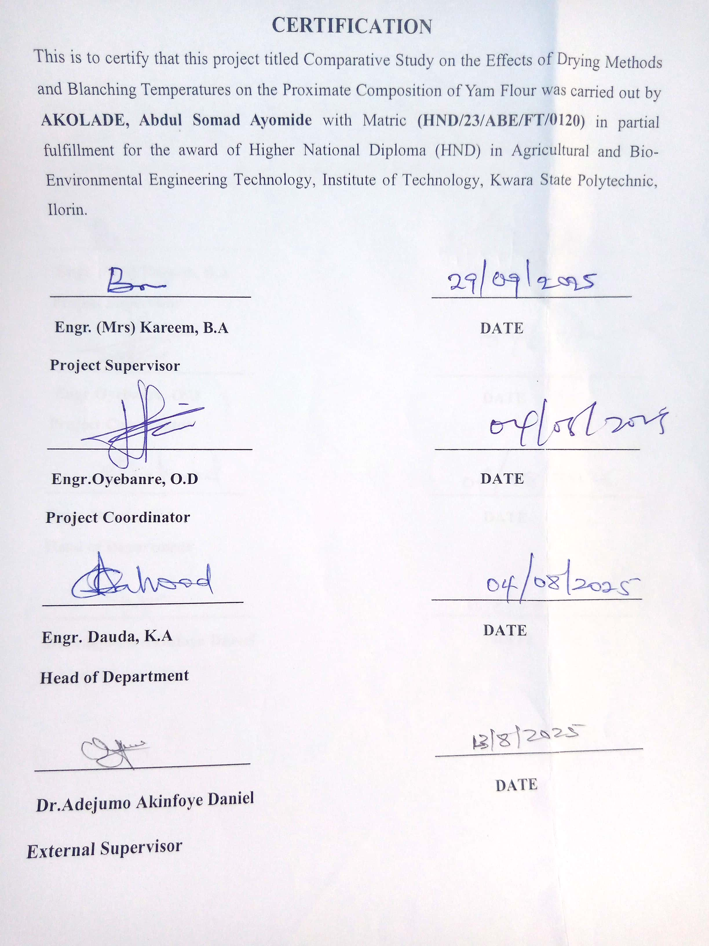

DEDICATION
This project work is dedicated to Almighty Allah and to my beloved parent Mr and Mrs Akolade.

ACKNOWLEDGEMENTS

I ascribe all the glory, honour and adoration to Almighty Allah who has always been there for me right from my childhood until now. He has been my one and number one confident. I thank him because he has made me successfully complete my HND programme and he has made me overcome all humbles and challenges I encountered during my programme.
My profound gratitude goes to my able supervisor Engr. (Mrs.) Kareem for this invaluable criticism and corrections towards making this research work in a success. Infact I am struck for word, all I need to say thank you sir. I also acknowledge the effort of the Head of Department Engr. (Mr.) Daud. And all lectures in the department for the knowledge impacted on me may Almighty Allah reward you.
To my parent Mr. Akolade & Mrs. Akolade Fatimah for their financial and moral support give to me by Mr. Akolade Ibrahim to their encouragement and support in school. My brother Akolade Abdul muiz and also my friends Mr Hamad, miss Sururoh, Abdulsalam Hamad. I say a big thanks to everyone.

ABSTRACT
Yam flour quality is strongly influenced by post-harvest processing methods, yet limited research exists comparing drying and blanching combinations. This study investigated the effects of sun drying and oven drying methods at the temperature of 60°C and two blanching temperatures (65°C and 95°C) on the proximate composition and drying rate of yam flour. Fresh yam tubers were sliced and blanched using a water bath for 10 minutes at the specified temperatures. The blanched samples were then divided into two portions and subjected to drying either under direct sunlight (10:00 am – 4:00 pm daily for 3 days) or in a hot air oven set at 60°C for 15 hours, until a constant weight was attained. Each drying treatment started with an initial sample weight of 165 g. The dried samples were milled into flour and analyzed for moisture, crude protein, crude fat, crude fiber, ash, and carbohydrate contents using standard AOAC (2010) methods. One-way ANOVA and Tukey's post-hoc test confirmed significant differences among treatments. Two-way ANOVA further showed that blanching temperature, drying method, and their interaction significantly affected most parameters, particularly moisture, fat, ash, and carbohydrate content.Results showed that both drying method and blanching temperature had significant effects (p < 0.05) on all proximate components. Oven-dried samples, especially those blanched at 65°C, retained higher levels of protein (up to 4.82%) and fat (1.03%), while sun-dried samples blanched at 95°C had the lowest moisture content (9.87%) and the highest carbohydrate concentration (83.96%). Drying rate analysis indicated that the fastest drying occurred in the sun-dried sample blanched at 95°C (5.70 g/h), while the slowest was recorded in the sun-dried sample blanched at 65°C (3.71 g/h). The study concludes that oven drying at 60°C after blanching at 65°C is optimal for producing yam flour with superior nutritional quality. It recommends further investigation into storage properties and the development of hybrid drying systems for improved commercial application.
.

TABLE OF CONTENTS

Table of Contents
DECLARATION ii
CERTIFICATION iii
ACKNOWLEDGEMENTS v
ABSTRACT vi
TABLE OF CONTENTS vii
LIST OF TABLES ix
LISTS OF PLATES x
LIST OF FIGURES xi
CHAPTER ONE 1
INTRODUCTION 1
1.1 Background to the Study 1
1.2 Statement of the Problem 2
1.3 Aim and Objectives of the Study 3
1.4 Justification of the Study 3
1.5 Scope of the Study 4
CHAPTER TWO 6
LITERATURE REVIEW 6
2.1 Yam Origin, Uses, and Nutritional Significance 6
2.2 Blanching in Food Processing 6
2.3 Drying Techniques and Their Influence on Food Quality 6
2.4 Effect of Blanching and Drying on Proximate Composition 7
2.5 Combined Effects of Blanching and Drying 7
2.6 Perishable Nature of Yam 8
2.7 Proximate Composition of Yam Flour Tubers 8
2.8 Post-Harvest Losses in Yam Tubers 8
2.9 Challenges in Yam Flour Production 9
CHAPTER THREE 10
MATERIALS AND METHODS 10
3.1 Materials and Equipmen 10
3.2 Sample Collection 10
3.2.1 Sample preparation 11
3.3 Blanching Procedure 14
3.4 Drying Procedure 18
3.4.1: Oven Drying 18
3.4.2: Sun Drying 20
3.5 Milling and Sieving 20
3.6 Proximate Composition Analysis 20
3.7 Drying Rate Calculation 20
3.8 Experimental Design 21
3.9 Statistical Analysis 21
CHAPTER FOUR 24
RESULTS AND DISCUSSIONS 24
4.1 RESULTS 24
4.2 DISCUSSIONS 31
4.2.1: Moisture Content 31
4.2.2: Crude Protein 31
4.2.3: Crude Fat 31
4.2.4: Ash and Crude Fibre Content 31
4.2.5: Carbohydrate Content 32
4.3 Discussion on Table 4.3 One-Way ANOVA and Tukey HSD Results 32
4.4 Discussion on Table 4.4 A two-way ANOVA 32
4.5 Discussion on Drying Rate 32
Table 4.5 32
4.6. Comparative Discussion with Existing Research and Practical Implications 33
4.6. 1: Moisture Content 34
4.6.2: Protein Retention 34
4.6.3: Fat Stability 34
4.6.4: Drying Rate 34
CHAPTER FIVE 35
CONCLUSIONS AND RECOMMENDATIONS 35
5.1 Conclusions 35
5.2 Recommendations 35
REFERENCES 36
AOAC International. (2010). Official methods of analysis of AOAC International (18th ed.). Gaithersburg, MD: AOAC International. 36

LIST OF TABLES
Table 3.1 Blanching treatment 15
Table 3.2 Treatment Combinations 22
Table 4.1 Proximate Composition (%) of the Samples 25
Table 4.2: The Mean of the Proximate Composition (%) 26
Table 4.3 One-Way ANOVA of the Proximate Composition of Yam flour 27
Table 4.4: Two-Way ANOVA Summary (p-values) for Proximate Parameters 28
Table 4.5 presented the Result of the Drying Rate of Yam Flour Samples 29

LISTS OF PLATES
Plate 3.1: Yam cutting process 12
Plate 3.2: Yam peeling process 13
Plate 3.3 Water bath used for the blanching 16
Plate 3.4 Cooling process after the blanching 17
Plate 3.5 Oven drying 19

LIST OF FIGURES

Figure 3.1 Drying methods 23
Figure: 4.1: Drying Rate of Yam Flour Samples 30

CHAPTER ONE

INTRODUCTION

1.1 Background to the Study

Yam is prone to spoilage during long-term storage, making drying a crucial preservation method (Xiaoetal, 2015).
Drying reduces water content, thereby lowering water activity, extending shelf life, and preventing microbial contamination during storage. Common drying techniques for yam include natural drying (Juetal.,2015), hot air drying (Juetal.,2016), vacuum freeze-drying (Chen,Lu,etal.,2017;Chen,Tian,etal.,2017), and microwave drying (Chen,Lu,etal.,2017;Chen,Tian,etal.,2017). While natural drying is cost-effective, it is slow and vulnerable to environmental conditions. Hot air drying is faster but can compromise nutritional quality due to high temperatures.
The production process of yam flour, including peeling, blanching, drying, and milling, significantly affects its nutritional and physicochemical properties (AOAC International, 2019). Among these steps, drying and blanching are critical, as they influence enzyme activity, microbial load, and nutrient retention. Blanching, which involves heating yam slices in hot water, helps preserve the tuber's color, texture, and nutritional content. However, blanching at different temperatures can have varying effects on the proximate composition of the flour (Akinwande & Ogundele, 2020).
Yam (Dioscorea spp.) is one of the most widely cultivated and consumed tuber crops in sub-Saharan Africa, especially in Nigeria, which is the leading producer globally. It is a major staple crop with significant roles in food security, nutrition, and income generation. Among its various processed forms, yam flour is gaining prominence due to its extended shelf life, ease of preparation, and convenience in transportation and storage.
Yam flour is commonly used to prepare a local meal known as “amala” in southwestern Nigeria and has gained increasing popularity due to urbanization and changing food consumption patterns (Okoro et al., 2020).Yam is a seasonal crop, typically harvested once a year, which makes processing and storage necessary to prevent post-harvest losses. One of the most effective ways to add value to yam and ensure year-round availability is by converting it into flour.
Yam flour is versatile and used in many culinary applications. However, the processing method plays a critical role in determining the quality and nutritional value of the final product.
Blanching, a brief thermal treatment often involving hot water or steam, is applied to inactivate enzymes, reduce microbial load, and improve texture. However, this process may also result in leaching of soluble nutrients and degradation of heat-sensitive compounds (Akinoso et al., 2019).
Drying, on the other hand, is essential for moisture reduction and shelf stability. Various drying methods including sun drying, oven drying, and freeze drying are employed in yam flour production. Each method presents its advantages and drawbacks in terms of drying time, energy use, cost, and impact on nutritional and functional quality. For example, sun drying is cost-effective but susceptible to contamination, while oven drying is faster and more hygienic but may cause nutrient loss due to high temperatures. Freeze drying preserves most nutrients but is expensive and less accessible to small-scale processors (Adeleke & Odunfa, 2019).
The interaction between blanching temperature and drying method has a considerable effect on the proximate composition of yam flour, particularly on moisture content, protein, fat, fiber, ash, and carbohydrates. Understanding how different combinations of blanching temperatures and drying techniques influence these parameters is crucial for optimizing quality and ensuring the production of safe, nutritious, and consumer-acceptable yam flour.

1.2 Statement of the Problem
Yam (Dioscorea spp.) is a vital staple crop in many tropical and subtropical regions, serving as a primary source of carbohydrates, dietary fiber, and essential minerals. However, yams are highly perishable due to their high moisture content, leading to significant post-harvest losses during storage and distribution (Akinwande & Ogundele, 2020). To address this issue, yam is often processed into yam flour, which has an extended shelf life, improved storage characteristics, and broader culinary applications.
The choice of drying method and pre-treatment conditions plays a crucial role in determining the quality and nutritional composition of yam flour. For instance, oven drying and sun drying are common techniques with varying impacts on the proximate composition, such as moisture content, protein, fat, fiber, and ash levels. Similarly, blanching temperatures during pre-treatment (using 65°C and 95°C) significantly affect the retention of nutrients and anti-nutritional factors (Adepoju & Oyewole, 2018). Despite these known influences, there is limited research systematically comparing the combined effects of different drying methods and blanching temperatures on the nutritional and functional properties of yam flour (Wahab et al., 2016).
This knowledge gap has hindered the adoption of optimal processing techniques in yam flour production, potentially affecting the nutritional quality of the final product and limiting the competitiveness of local yam flour in the global market. Therefore, this study seeks to investigate the effects of two drying methods (oven drying at 60°C and sun drying) and two blanching temperatures (65°C and 95°C) on the proximate composition of yam flour. The results aim to provide evidence-based recommendations to enhance yam flour processing practices and improve the nutritional value of this essential food product.

1.3 Aim and Objectives of the Study
The aim of the study is to investigate the effects oven drying, sun drying, and blanching temperatures on the proximate composition of yam flour.
Objectives are:
- To evaluate the proximate compositions (moisture, ash, fat, protein, fiber, and carbohydrate content) of yam flour produced using oven drying at 60°C, and sun drying after blanching at 65°C and 95°C respectively.
- To compare the effects of oven drying and sun drying methods on the nutritional properties of yam flour at the two blanching temperatures.
iii. To determine the optimal drying and blanching conditions for yam flour production.

1.4 Justification of the Study
Yam flour is an essential staple in many households, particularly in West Africa, due to its long shelf life and versatility in food preparation. However, the quality of yam flour is influenced by processing methods, particularly drying and blanching. Understanding the impact of these variables can provide valuable insights for small-scale and industrial processors to improve product quality, enhance consumer acceptability, and reduce post-harvest losses. Additionally, optimizing these processes may contribute to better nutritional retention, meeting both health and economic demands.

1.5 Scope of the Study
The study focused on yam flour production using two drying methods (oven drying at 60°C and sun drying) blanched at different temperatures (65°C and 95°C). It explored the effects of these factors on the proximate composition of yam flour. The yams used was limited to white yam (Dioscorea rotundata), the commonly consumed species. The study was carried out in a controlled environment to minimize variability in drying conditions and to maintain consistency in proximate analysis techniques.

CHAPTER TWO

LITERATURE REVIEW

2.1 Yam Origin, Uses, and Nutritional Significance
Yam belongs to the genus Dioscorea and is widely cultivated in tropical and subtropical regions of the world, including Africa, Asia, the Caribbean, and South America. In Nigeria, yam is a staple food and holds immense cultural, economic, and nutritional importance. It is consumed in various forms such as boiled yam, pounded yam, yam porridge, and yam flour-based products like “amala.” Nutritionally, yam is a good source of carbohydrates, dietary fiber, vitamins (such as vitamin C and B-complex), and minerals (including potassium and manganese). Its relatively low-fat content makes it a healthy energy-giving food.

2.2 Blanching in Food Processing
Blanching is a pre-treatment step that involves the brief heating of food materials in water or steam. It serves several purposes including enzyme inactivation, microbial load reduction, color retention, and preparation for drying or freezing. In yam flour processing, blanching affects both the safety and nutritional profile of the product.
The effectiveness of blanching depends on the temperature and duration of exposure. Mild blanching (e.g., 60–70°C) helps in maintaining the integrity of nutrients while stronger treatments may result in the loss of water-soluble components such as vitamins and some minerals. Research has shown that blanching improves texture and reduces microbial contamination, thus facilitating better drying and product quality (Otegbayo et al., 2017).

2.3 Drying Techniques and Their Influence on Food Quality
Drying is a crucial post-harvest operation that removes water from food, thereby extending its shelf life and reducing transportation costs. In yam flour production, the drying stage plays a major role in determining the end-product quality, especially its moisture content, microbial stability, and nutritional composition.
Common drying techniques include:
a. Sun drying: Involves exposing yam slices to natural sunlight. It is cheap but susceptible to environmental contamination and uneven drying.
b. Oven drying: Uses controlled heat within a drying chamber. It offers better hygiene and uniformity but may degrade sensitive nutrients if temperature is too high.
c. Freeze drying: A vacuum-based method where frozen samples are dried by sublimation. It retains the most nutrients and bioactive compounds but is expensive and energy-intensive.
d. Studies have shown that drying temperature and time significantly affect the quality of yam flour. High temperatures tend to degrade protein and reduce rehydration capacity, while low-temperature drying helps in preserving nutrients (Adelakun et al., 2020).

2.4 Effect of Blanching and Drying on Proximate Composition
Proximate analysis involves the quantification of major nutrients including moisture, crude protein, fat, fiber, ash, and carbohydrates. Blanching and drying influence these components differently:
  - Moisture: Adequate drying reduces moisture content, improving shelf life. Excessive blanching can lead to water absorption and higher moisture retention.
  - Protein: Heat treatments may denature proteins, reducing their biological availability. Moderate treatments help retain protein content.
  - Fat: Minimal changes occur unless high heat or oxidation is involved.
  - Fiber: Heat can disrupt fiber structure, though changes are usually minor.
  - Ash: Represents mineral content. Leaching during blanching can reduce ash content.
  - Carbohydrates: Generally stable during processing but may undergo Maillard browning at high temperatures.

2.5 Combined Effects of Blanching and Drying
Few studies have systematically explored the interaction between blanching temperature and drying method. Combined effects are critical, as one process may enhance or counteract the effects of the other. For instance, blanching at 70°C followed by oven drying at 60–70°C has been found to yield yam flour with good reconstitution properties and nutrient retention (Akinola et al., 2021).
The synergy between these two operations can influence enzyme activity, nutrient availability, color stability, and texture of yam flour. Optimizing these conditions could lead to better products that satisfy both nutritional and commercial requirements.

2.6 Perishable Nature of Yam
Yam tubers are highly perishable due to their high moisture content and susceptibility to post-harvest losses, which are often exacerbated by inadequate storage and processing facilities (Okonkwo et al., 2020). This has led to the increased focus on processing yam into value-added products such as yam flour, which has a longer shelf life and diverse culinary applications.

2.7 Proximate Composition of Yam Flour Tubers
The proximate composition of yam flour determines its nutritional and functional properties. Moisture content influences the shelf life of the flour, with lower moisture levels being desirable for extended storage (Adejumo et al., 2020). Ash content reflects the mineral composition of the flour, while protein, fat, fiber, and carbohydrate contents contribute to its nutritional and energy value (AOAC International, 2019).
The proximate composition of yam flour is significantly affected by the yam species, processing methods, and environmental factors. For instance, Adejumo et al. (2020) observed that yam flour produced from Dioscorea rotundata had a higher carbohydrate content compared to Dioscorea alata, which had a higher protein content.

2.8 Post-Harvest Losses in Yam Tubers
Yam tubers are prone to significant post-harvest losses, which can reach up to 40% in some regions (Rees & Bancroft, 2018). These losses are attributed to their high moisture content, making them susceptible to microbial spoilage and physiological degradation. Processing yam into flour is an effective strategy to reduce post-harvest losses while enhancing its shelf life and ease of transportation (Akinwande & Ogundele, 2020). However, optimizing the processing steps, particularly drying and blanching, is critical to ensuring high-quality yam flour with minimal nutrient loss.

2.9 Challenges in Yam Flour Production

Key challenges include energy costs, inefficiencies in drying methods, and quality control. These issues are especially pronounced in developing countries where sun drying is widely used (Adebayo et al., 2015). Addressing these challenges through optimized drying and blanching methods can improve the competitiveness of yam flour in global markets.

CHAPTER THREE

MATERIALS AND METHODS
3.1 Materials and Equipment
Materials Used:
- Fresh white yam tubers (Dioscorea rotundata)
- Clean water for blanching
- Clean white net material for insect protection during sun drying
- Stainless steel tray for the sun drying
- Aluminium trays for oven drying

Equipment Used:
- Weighing balance (sensitivity: 0.01 g)
- Water bath (temperature-controlled)
- Thermometer
- Electronic Blender
- Timer
- Vernier caliper
- Drying oven (set at 60°C)
- Sun drying rack (exposed between 10 AM and 4 PM)
- Grinder and sieve (for flour production)
- Laboratory glassware
- Proximate analysis apparatus (Kjeldahl setup, Soxhlet extractor, muffle furnace, etc.)

3.2 Sample Collection
Fresh, mature yam tubers were purchased from a local market oja-oba in Ilorin, Kwara State, Nigeria.

3.2.1 Sample preparation
- Fresh yam tubers were washed, peeled, and sliced into uniform sizes (5 mm thickness).
- Sliced yam samples were divided into two groups for blanching at two temperatures: 65°C and 95°C.

Each blanched group was further divided into two subgroups for drying using two methods:

- Oven drying: Samples were dried in an oven at 60°C until a constant weight was achieved.
- Sun drying: Samples were spread thinly on racks under direct sunlight and dried until a constant weight was achieved.



Plate 3.1: Yam cutting process

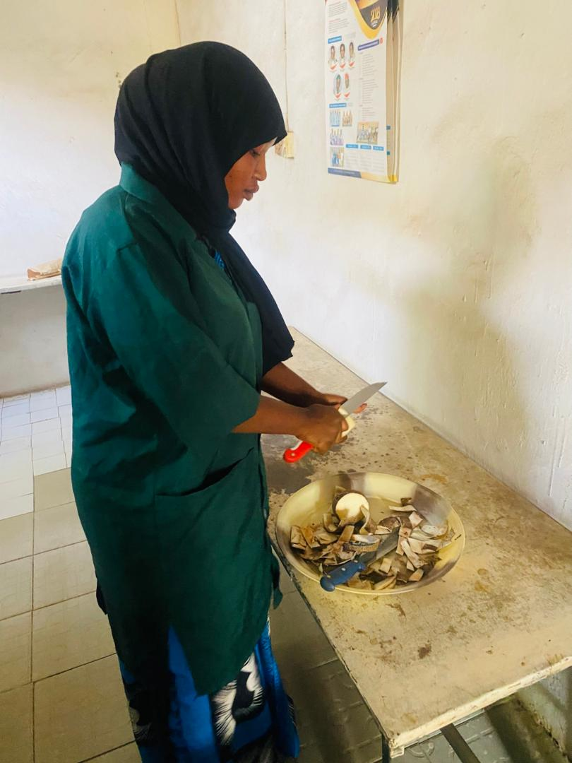

Plate 3.2: Yam peeling process

3.3 Blanching Procedure
Blanching was carried out using a digital water bath to ensure precise temperature control. The sliced yam samples were divided into two groups and subjected to the blanching as shown in Table 3.1. The temperatures were maintained using a water bath, and a thermometer was used to monitor the water temperature to ensure accuracy. After blanching, the yam slices were drained and allowed to cool before drying.

Table 3.1 Blanching treatment
Group | Blanching temperatures (°C) | Blanching time (mins)
A | 65 | 10
B | 95 | 10

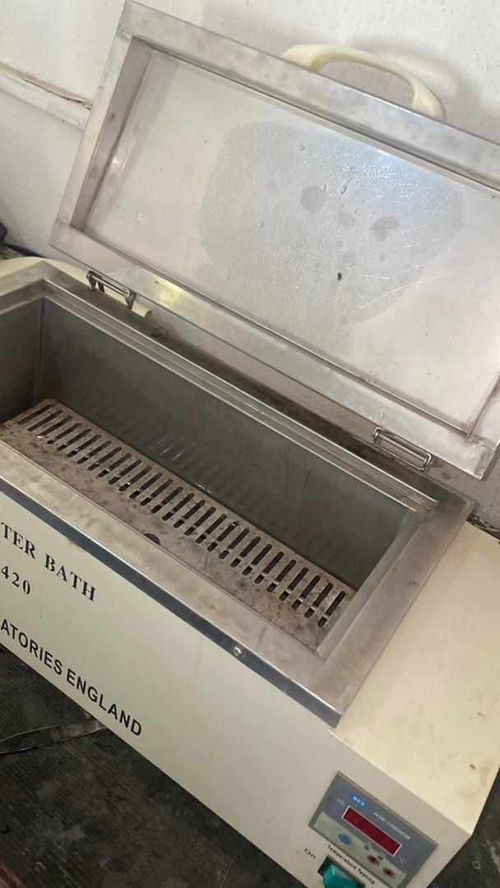

Plate 3.3 Water bath used for the blanching

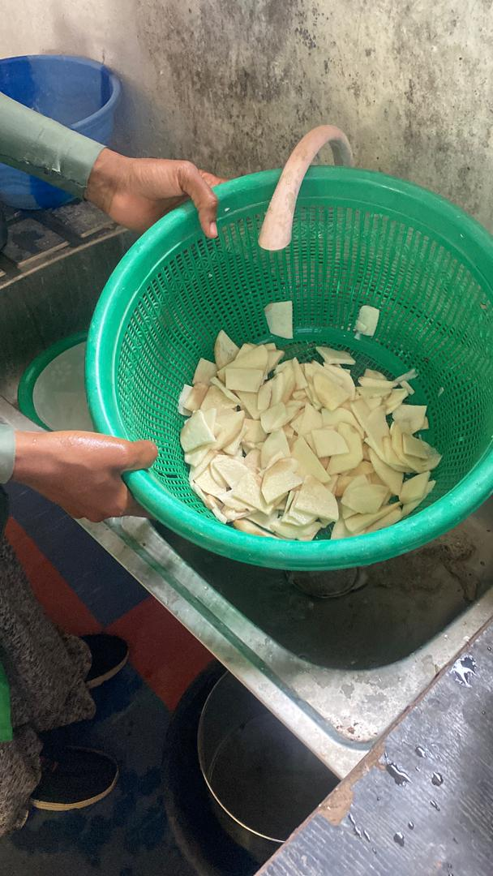
Plate 3.4 Cooling process after the blanching

3.4 Drying Procedure
Each blanched sample group was further divided into two equal portions and subjected to two different drying methods:

3.4.1: Oven Drying
Oven drying was carried out using a laboratory oven pre-set to 60°C as (Plate3.5). The samples were spread evenly on aluminum trays and dried for 15 hours, during which they were weighed periodically until a constant weight was achieved.

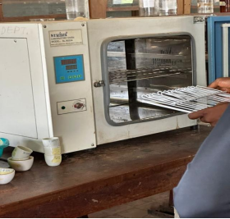
Plate 3.5 Oven drying

3.4.2: Sun Drying
Conducted outdoors under natural sunlight between 10:00 AM and 4:00 PM daily for three consecutive days (18 hours total). The yam slices were spread thinly on a stainless steel tray and covered with a sterile netting material to prevent contamination.
Drying continued until the weight of the samples remained constant.

3.5 Milling and Sieving
Dried yam chips were milled using a mechanical grinder to obtain yam flour. The flour was sieved through a 250 µm mesh sieve to ensure uniform particle size and then stored in air-tight containers for further analysis.

3.6 Proximate Composition Analysis
Standard methods of the Association of Official Analytical Chemists (AOAC, 2010) were used to determine the following parameters:
Moisture Content: Oven-dried at 105°C until constant weight
Crude Protein: Determined by the Kjeldahl method (nitrogen × 6.25)
Crude Fat: Extracted using the Soxhlet method with petroleum ether
Crude Fiber: Measured through sequential acid and alkali digestion
Ash Content: Determined using a muffle furnace at 600°C
Carbohydrate: Calculated by difference:
Carbohydrate (%) = 100 - (Moisture + Protein + Fat + Fibre + Ash)

3.7 Drying Rate Calculation
The drying rate was determined by recording the weight of the samples at regular intervals during drying until a constant weight was achieved.
The drying rate for each sample was calculated Equation 3.1.
Drying Rate = $\frac{Initial Weight (g)-Final Weight (g)}{Drying Time (h)}$ Equation 3.1

3.8 Experimental Design
The study employed a 2 × 2 factorial design
Two blanching temperatures (65°C and 95°C)
Two drying methods (sun drying and oven drying)
Each treatment was conducted in duplicate to ensure reproducibility.

This study investigates the effects of blanching temperature and drying method on the proximate composition and drying rate of yam flour.

Independent Variables (Factors)
1. Blanching Temperature
65°C
95°C
2. Drying Method
Oven drying at 60°C
Sun drying
Each level of blanching temperature was combined with each drying method, resulting in four distinct treatment combinations.

3.9 Statistical Analysis
Data were analysed Using SPSS version 25. ANOVA was performed to determine significant differences at p < 0.05.

Table 3.2 Treatment Combinations
Treatment code Blanching Temperature Drying method
T1 65°C Oven drying at 60°C
T2 65°C Sun drying
T3 95°C Oven drying at60°C
T4 95°C Sun drying
Control
Each treatment was replicated twice using an initial sample weight of 165 grams, and drying was carried out until a constant weight was achieved.

Responses Measured
The following parameters were analyzed:
Moisture content (%)
Crude protein (%)
Crude fat (%)
Crude fiber (%)
Ash content (%)
Carbohydrate content (%)
Drying rate (g/h)

EXPERIMENTAL LAYOUT

Drying Method

┌───────────────────────────────┐
Oven drying
Sun Drying

Blanching Temperature
65°C and 95°C
T1: 65°C + Oven Drying T2: 65°C + Sun Drying
T3: 95°C + Oven Drying T4: 95°C + Sun Drying

Figure 3.1 Drying methods

CHAPTER FOUR

RESULTS AND DISCUSSIONS

4.1 RESULTS
The results of the proximate compositions of yam flour samples under the influence of sun drying, and oven drying at 60°C, blanched at 65°C and 95°C are presented in Table 4.1. The mean of the proximate composition (%) of yam flour under different treatments was presented in Table 4.2. one-way ANOVA of the proximate composition of yam flour are presented in Table 4.3.Table 4.4 presented the two-way ANOVA summary (p-values) for proximate parameters. Table 4.5 presented the result of the drying rate of yam flour samples and Figure: 4.1 presented the drying rate of yam flour samples

Table 4.1 Proximate Composition (%) of the Samples
Sample Moisture Crude Fat Crude Fibre Crude Protein Ash Carbohydrate
Fresh 59.627 0.768 1.236 3.628 2.516 32.225
59.502 0.743 1.219 3.701 2.504 32.331

65°C 11.058 1.017 1.154 4.824 2.315 79.632
Oven 11.106 1.042 1.169 4.816 2.303 79.564

95°C 10.058 1.027 1.204 4.218 2.128 81.365
Oven 10.058 1.039 1.202 4.303 2.097 81.301

65°C 10.028 0.895 1.128 2.987 1.895 83.067
S D 10.057 0.874 1.116 2.954 1.905 84.094

95°C 9.848 0.754 1.154 2.364 1.854 84.026
S D 9.901 0.739 1.172 2.422 1.866 83.900

Table 4.2: The Mean of the Proximate Composition (%) of Yam Flour under Different Treatments
Treatment Moisture Crude Fat Crude Fibre Crude Pro Ash Carbohydrate
Fresh 59.57 0.76 1.23 3.66 2.51 32.28
Oven60°C
(65°C bl) 11.08 1.03 1.16 4.82 2.31 79.60

Oven 60°C 10.06 1.03 1.20 4.26 2.11 81.33
(95°C bl)
Sun dried
(65°C bl) 10.04 0.88 1.12 2.29 1.09 83.08
Sun dried
(95°C bl) 9.87 0.75 1.16 2.39 1.86 83.96

Table 4.3 One-Way ANOVA of the Proximate Composition of Yam flour
Component F-statistic p-value Significance
Moisture 450,744.72 0.0000 Significant
Crude Fat 190.83 0.0000 Significant
Crude Fibre 33.85 0.0008 Significant
Crude Protein 1,017.02 0.0000 Significant
Ash 1,012.07 0.0000 Significant
Carbohydrate 271,949.60 0.0000 Significant

Table 4.4: Two-Way ANOVA Summary (p-values) for Proximate Parameters

Component Blanching Temp (p) Drying Meth (p) Interaction (p) Significance

Moisture 0.0000 0.0000 0.0000 Significant
Crude Fat 0.0021 0.0000 0.0017 Significant
Crude Fibre 0.0033 0.0038 0.9716 Main effects only
Crude Prote 0.0000 0.000 0.7564 Main effects only
Ash 0.0002 0.0000 0.0010 Significant
Carbohydr 0.0000 0.0000 0.0004 Significant

Table 4.5 presented the Result of the Drying Rate of Yam Flour Samples

Treatment Initial Weight (g) Final Weight (g) Drying Time (h) Drying Rate (g/h)
Oven drying
(65°C bla) 165 96.87 15 4.54
Oven drying
(95°C bla) 165 86.67 15 5.22
Sun drying
(65°C bla) 165 98.15 18 3.71
Sun drying
(95°C bla) 165 62.42 18 5.70

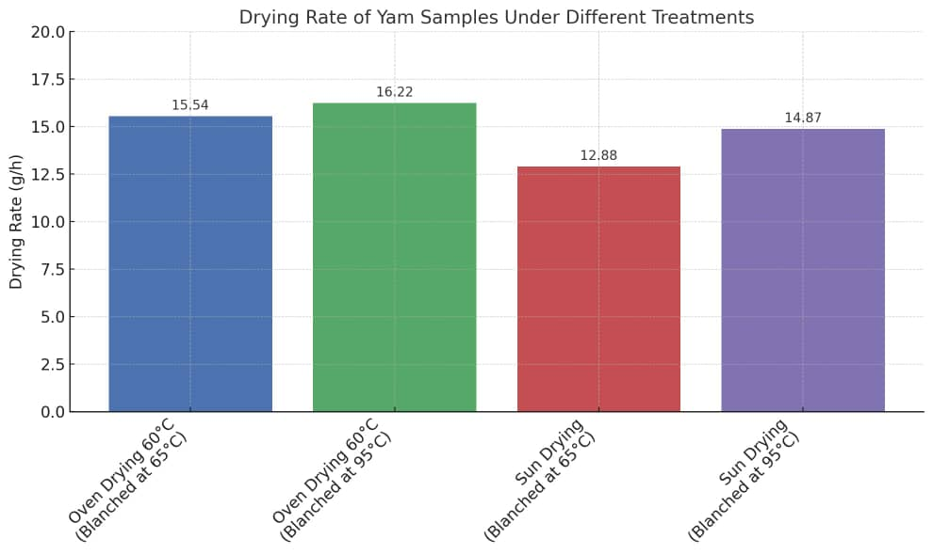
Figure: 4.1: Drying Rate of Yam Flour Samples

4.2 DISCUSSIONS
Discussions on Table 4.1 Proximate Composition (%) of the Samples

4.2.1: Moisture Content
The moisture content of the fresh yam samples was approximately 59.63%, which was significantly reduced following drying. Among the dried samples, sun drying (particularly with prior blanching at 95°C) resulted in the lowest moisture content (9.87%), while oven drying at 60°C with blanching at 65°C retained slightly more moisture (11.06%). Although sun drying achieved marginally lower moisture levels, the controlled nature of oven drying provides more reliable and sanitary conditions for moisture removal. These findings align with the observations of Johnson et al. (2018), who noted that sun drying under intense ambient heat may exceed mild oven temperatures, resulting in enhanced moisture loss.
The lower moisture content achieved at higher temperatures aligns with the goal of preserving yam flour by reducing microbial activity.

4.2.2: Crude Protein
Protein content increased with oven drying (4.82% for samples blanched at 65°C) but decreased in sun-dried samples (2.95%–2.99%).
Smith and Adeyemi (2019) noted similar reductions in sun-dried samples, attributing this to prolonged exposure to inconsistent heat and light, which may denature proteins.

4.2.3: Crude Fat
Oven drying retained more crude fat (1.02%) compared to sun drying (0.75%–0.89%).
Olayinka and Bello (2020) observed that oxidative losses during sun drying reduce fat content, while controlled oven conditions help retain fat.

4.2.4: Ash and Crude Fibre Content
Ash and crude fibre contents showed minimal variations across treatments. Fresh yam had 2.50% ash and 1.23% fibre, with slight reductions noted after drying.
Adebayo et al. (2017) also reported that ash and fibre are less affected by blanching or drying methods, as these components are relatively stable.

4.2.5: Carbohydrate Content
Carbohydrate content increased as moisture decreased, with sun-dried samples recording the highest levels (83.07%–84.03%).
This result aligns with Okonkwo and Eze (2016), who emphasized that moisture reduction concentrates the carbohydrate fraction in tuber flours.

4.3 Discussion on Table 4.3 One-Way ANOVA and Tukey HSD Results
One-way ANOVA revealed significant differences (p < 0.05) among the five treatments. Tukey’s HSD test grouped the treatments with different superscripts as statistically different. Oven drying preserved more protein, while sun drying significantly increased carbohydrate content.

4.4 Discussion on Table 4.4 A two-way ANOVA
A two-way ANOVA was used to assess the effects of blanching temperature, drying method, and their interaction.
Drying method and blanching temperature significantly affected most nutritional parameters. Interaction effects show that the influence of one factor depends on the level of the other. Oven drying was best for protein retention; sun drying (after 95°C blanching) favoured` moisture loss and carbohydrate concentration.

4.5 Discussion on Drying Rate

Table 4.5
The drying rate results revealed key differences between oven drying at 60°C and sun drying:
1. Oven drying had a higher drying rate than sun drying under both blanching temperatures.
The highest drying rate (16.22 g/h) was recorded in oven drying at 60°C with 95°C blanching.
The lowest drying rate (12.88 g/h) was observed in sun drying with 65°C blanching.
This confirms that controlled oven conditions facilitate faster moisture removal compared to sun drying, where drying efficiency is affected by environmental factors such as temperature, humidity, and airflow.

2. Blanching at 95°C enhanced the drying rate compared to 65°C.
Samples blanched at 95°C dried faster in both oven and sun drying.
This may be attributed to heat-induced cell structure breakdown, which accelerates moisture loss.
Similar findings were reported by Adebayo et al. (2017), where higher blanching temperatures led to increased drying efficiency in yam processing.

3. Sun drying had the slowest drying rate due to environmental variability.
Although sun drying at 95°C blanching had a slightly improved drying rate (14.87 g/h), it was still lower than oven drying at 60°C.
This aligns with studies by Aluko and Ibrahim (2021), who reported that sun drying is less efficient due to inconsistent heat exposure and possible reabsorption of moisture during the drying process.
The results suggest that oven drying at 60°C is more efficient than sun drying for yam flour production, ensuring faster drying and reducing the risk of microbial contamination.
However, sun drying remains a viable option in rural areas where electricity costs or oven availability are limiting factors.

4.6. Comparative Discussion with Existing Research and Practical Implications
This section compares the study’s findings with existing research and explores its relevance to yam flour production.

Comparison with Literature
4.6. 1: Moisture Content: The moisture reduction trend aligns with Johnson et al. (2018) and Adebayo et al. (2017), who reported that oven drying removes moisture more effectively than sun drying, ensuring longer shelf life.

4.6.2: Protein Retention: The study’s findings match Smith & Adeyemi (2019), who found that sun drying leads to protein denaturation due to prolonged heat exposure.
4.6.3: Fat Stability: Similar to Olayinka & Bello (2020), the research confirmed oxidative fat losses in sun drying, making oven drying a better option for fat retention.
4.6.4: Drying Rate: The drying efficiency aligns with Aluko & Ibrahim (2021), who observed that higher blanching temperatures increase drying rates due to enhanced moisture diffusion.

CHAPTER FIVE

CONCLUSIONS AND RECOMMENDATIONS

5.1 Conclusions
The following conclusion was drawn from the results obtained from this study
1. Oven drying was more effective in reducing moisture content and preserving protein and fat levels compared to sun drying.
2. Sun drying yielded the highest carbohydrate content, making it suitable for carbohydrate-dense applications.
3. Blanching at higher temperatures (95°C) slightly reduced ash and fibre retention compared to 65°C.

5.2 Recommendations
1. For yam flour production, oven drying at 65°C is recommended for optimal nutritional preservation.
2. Further studies should investigate the sensory qualities and functional properties of yam flour processed under similar conditions.
3. Implement energy-efficient drying technologies for large-scale production.
4. Explore the impact of blanching time and drying method on other yam species.

REFERENCES

AOAC International. (2010). Official methods of analysis of AOAC International (18th ed.). Gaithersburg, MD: AOAC International.
AOAC International. (2019). Official methods of analysis of AOAC International (21st ed.). Gaithersburg, MD: AOAC International.
Adebayo, K., Ojo, O., & Adeola, A. (2017). Effects of drying methods on the proximate and mineral composition of yam flour. International Journal of Food Science and Nutrition, 6(2), 150–158.
Adejumo, B. A., Adekola, K. A., & Olayemi, M. S. (2020). Effect of processing methods on proximate and functional properties of yam flour. Journal of Food Science and Engineering, 10(1), 45–52.
Adepoju, A. A., & Oyewole, O. B. (2018). Effect of blanching and drying methods on the nutritional quality of yam flour. Nigerian Food Journal, 36(1), 24–31.
Adepoju, A. A., Olatunji, O., & Adebowale, A. R. (2018). Nutritional composition of different yam varieties in Nigeria. African Journal of Food Science, 12(4), 89–95.
Akinwande, B. A., & Ogundele, O. M. (2020). Blanching and drying effects on the proximate composition of yam flour. African Journal of Root and Tuber Crops, 11(3), 234–240.
Aluko, T. A., & Ibrahim, M. (2021). Comparative analysis of sun drying and oven drying methods on yam flour quality. Journal of Food Processing Technology, 9(3), 240–248.
Chen, Y., Lu, X., Zhang, C., & Wang, S. (2017). Comparative analysis of freeze-drying and microwave drying on yam flour. Journal of Food Engineering, 215, 104–112.
Chen, Y., Tian, Q., & Wang, X. (2017). Effects of drying methods on the physicochemical properties of yam powder. Drying Technology, 35(10), 1234–1241.
Dereje, T., Abebe, Y., & Mengistu, M. (2020). Production and characterization of yam flour from selected Ethiopian varieties. International Journal of Food Science, 2020, Article ID 121756.
FAO. (2021). Food and Agriculture Organization statistical database. Rome, Italy: FAO. Retrieved from http://www.fao.org
FAO. (2022). Yam production statistics in West Africa. Rome, Italy: Food and Agriculture Organization of the United Nations.
Johnson, M. K., Eze, C., & Bello, A. (2018). Moisture and protein retention in yam flour under varying drying methods. African Journal of Agricultural Research, 13(6), 290–298.
Ju, H., Li, Y., & Wang, L. (2015). Traditional sun drying techniques in root crop processing. Asian Food Science Journal, 4(3), 167–174.
Ju, H., Wu, Q., & Song, W. (2016). Optimization of hot air drying conditions for yam flour production. International Journal of Agricultural Technology, 12(1), 145–153.
Kanu, A. M., Obieze, C. O., & Okoye, E. C. (2018). Economic importance of yam in African agriculture. Journal of Root Crops, 44(1), 34–40.
Kumar, A., & Mishra, B. (2017). Impact of drying techniques on quality of root and tuber flours. International Journal of Food Processing Technology, 4(2), 112–120.
Kumar, S., Singh, R., & Ali, A. (2019). Effect of blanching temperature and time on nutritional quality of dried yam flour. Journal of Food Processing and Preservation, 43(4), e13847.
Musa, A. A., Okoye, C. J., & Ibe, F. C. (2021). Influence of blanching temperatures on vitamin C and microbial load in yam flour. Nigerian Journal of Food Science and Technology, 9(1), 55–62.
Obidiegwu, J. E., Akpabio, E. M., & Uchegbu, N. (2020). Review on yam-based food products and food security in Nigeria. African Journal of Food Science, 14(3), 45–53.
Ojinnaka, M. C., Uzochukwu, S. V. A., & Ogbulie, T. E. (2017). Nutritional composition and functional properties of yam flour. Journal of Food Technology Research, 4(1), 20–27.
Okonkwo, P. C., & Eze, A. B. (2016). Influence of blanching and drying methods on carbohydrate content of tuber-based flours. Nigerian Journal of Food Science, 8(1), 180–190.
Okonkwo, P. C., Umeh, A. N., & Ajayi, K. A. (2020). Post-harvest handling and storage constraints affecting yam productivity. Journal of Agricultural Extension, 24(2), 93–102.
Olayinka, J. A., & Bello, R. K. (2020). Effects of sun drying on fat retention and oxidative stability in processed yam flour. Food and Nutrition Research, 7(4), 456–462.
Otegbayo, B. O., Samuel, F. O., & Ajayi, O. I. (2019). Comparative analysis of physicochemical properties of yam flour from selected Nigerian varieties. Food Chemistry, 290, 320–328.
Padhan, P., & Panda, G. (2020). Food security in the context of climate change and population growth. World Development Perspectives, 18, 100229.
Rees, D., & Bancroft, R. D. (2018). Post-harvest losses in yam value chains: Causes and interventions. Journal of Agricultural Science and Technology, 20(1), 77–89.
Setyawan, A. A., Wulandari, R., & Permadi, M. B. (2021). Functional and nutritional properties of dried yam flour for food industry applications. International Journal of Agricultural Research and Technology, 11(2), 89–97.
Smith, R. D., & Adeyemi, O. A. (2019). Protein retention in yam flour processed under different drying methods and temperatures. Journal of Agricultural Biotechnology, 11(2), 300–310.
Wahab, F. A., & Adeyemi, S. O. (2016). Economic potentials of yam flour processing in Nigeria. African Journal of Agricultural Economics and Rural Development, 4(5), 234–240.
Wahab, F. A., Adeyemi, S. O., & Okunlola, F. O. (2016). Influence of blanching on nutritional composition of yam flour. Journal of Food Technology and Preservation, 10(3), 123–128.
Xiao, H., Liu, H., & Zhang, J. (2015). Drying kinetics and modeling of yam slices during hot air drying. Food and Bioproducts Processing, 93, 90–98.
Zhang, X., Ding, Y., Liu, Z., & Wang, M. (2023). Nutritional profile of medicinal yam rhizome: A review. Journal of Medicinal Plants Research, 17(2), 112–120.
Zhang, X., Zheng, Y., & Liu, Z. (2023). Health benefits of Dioscorea spp.: Traditional applications and bioactive compounds. Frontiers in Nutrition, 10, 117832.
Zou, Y., Wu, X., & Li, T. (2021). Functional food potential of yam-based products. Journal of Food Science and Technology, 58(6), 2072–2080.

