Comparative Study on the Effects of Drying,
Method, and Blanching Temperatures on
The Proximate Composition of Yam Flour.

BY
ISMAIL, Hamza
HND/23/ABE/FT/0088

A RESEACH PROJECT SUBMITED TO THE DEPARTMENT OF
AGRICULTURAL AND BIO- ENVIRONMENTAL ENGINEERING,
INSTITUTE OF TECHNOLOGY, KWARA STATE POLYTECHNIC,
ILORIN, KWARA STATE.

IN PARTIAL FULFILMENT OF THE REQUIREMENTS FOR THE
AWARD OF HIGHER NATIONAL DIPLOMA (HND) IN
AGRICULTURAL AND BIO- ENVIRONMENTAL ENGINEERING.

JULY, 202
DECLARATION
I hereby declare that this research project tittle ‘’ Comparative Study On The Effects Of Drying Method, And Blanching Temperatures On The Proximate Composition Of Yam Flour is my own work and has not been submitted by any other person for any degree or qualification at any higher institution. I also declare that the information provided therein are mine and those that are not mine are properly acknowledge.

_____________________ ____________________
Ismail Hamza Signature and Date

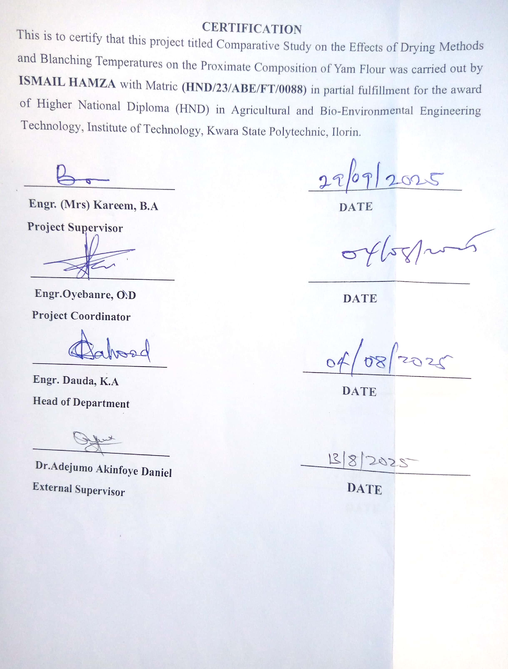

DEDICATION

This project work is dedicated to Almighty Allah for His protection throughout my academic journey.

ACKNOWLEDGEMENT
I would like to take this opportunity to express my sincere gratitude to my project supervisor Engr. Mrs. kareem, B.A for immense support and encouragement throughout this project also my thanks goes to the project coordinator for organizing this project and creating a helpful environment.
I am extremely grateful for the direction and advice provided by my project supervisor at every stage of this project which made the completion of the project possible for me thank you so much may Allah bless you.
I sincerely appreciates the efforts of my dear parent Mr and Mrs Ismail for their unwavering support throughout my programme, may you live long to enjoy the merriment of your sacrifices.
I will be indebted if I didn’t recognize my brothers and sister for their support during these journey. Also I give a big kudos to my project team for their hardworking to achieve this aim. I say thank you to all my colleagues and friend may we all be successful in all our future endeavors.

ABSTRACT
Yam flour quality is strongly influenced by post-harvest processing methods, yet limited research exists comparing drying and blanching combinations. This study investigated the effects of sun drying and oven drying methods at the temperature of 60°C and two blanching temperatures (65°C and 95°C) on the proximate composition and drying rate of yam flour. Fresh yam tubers were sliced and blanched using a water bath for 10 minutes at the specified temperatures. The blanched samples were then divided into two portions and subjected to drying either under direct sunlight (10:00 am – 4:00 pm daily for 3 days) or in a hot air oven set at 60°C for 15 hours, until a constant weight was attained. Each drying treatment started with an initial sample weight of 165 g. The dried samples were milled into flour and analyzed for moisture, crude protein, and crude fat, crude fiber, ash, and carbohydrate contents using standard AOAC (2010) methods. One-way ANOVA and Tukey's post-hoc test confirmed significant differences among treatments. Two-way ANOVA further showed that blanching temperature, drying method, and their interaction significantly affected most parameters, particularly moisture, fat, ash, and carbohydrate content. Results showed that both drying method and blanching temperature had significant effects (p < 0.05) on all proximate components. Oven-dried samples, especially those blanched at 65°C, retained higher levels of protein (up to 4.82%) and fat (1.03%), while sun-dried samples blanched at 95°C had the lowest moisture content (9.87%) and the highest carbohydrate concentration (83.96%). Drying rate analysis indicated that the fastest drying occurred in the sun-dried sample blanched at 95°C (5.70 g/h), while the slowest was recorded in the sun-dried sample blanched at 65°C (3.71 g/h). The study concludes that oven drying at 60°C after blanching at 65°C is optimal for producing yam flour with superior nutritional quality. It recommends further investigation into storage properties and the development of hybrid drying systems for improved commercial application.

TABLE OF CONTENTS

Table of Contents
DECLARATION ii
CERTIFICATION iii
DEDICATION iv
ABSTRACT vi
TABLE OF CONTENTS vii
LIST OF TABLES xi
LISTS OF PLATES xii
LIST OF FIGURES xiii
CHAPTER ONE 1
INTRODUCTION 1
1.1 Background to the Study 1
1.2 Statement of the Problem 3
1.3 Aim and Objectives of the Study 4
1.4 Justification of the Study 4
1.5 Scope of the Study 4
CHAPTER TWO 6
LITERATURE REVIEW 6
2.1 Influence of Yam Varieties on Flour Quality 6
2.2 Effect of Pretreatments on Yam Flour Attributes 6
2.3 Economic Analysis of Yam Flour Processing 6
2.4 Shelf Life and Storage of Yam Flour 7
2.5 Functional Properties of Yam Flour 7
2.6 Yam Production and Global Importance 7
2.7 Impact of Blanching on Nutritional and Anti-Nutritional Factors 8
2.8 Post-Harvest Losses in Yam Tubers 8
2.9 Proximate Composition of Yam Flour 8
2.10 Drying Techniques in Food Processing 9
2.11 Blanching in Food Processing 9
2.12 Combined Effects of Blanching and Drying on Proximate Composition 10
2.13 Methods of Drying in Yam Flour Production 10
2.13.1 Oven Drying 11
2.12.2 Sun Drying 11
CHAPTER THREE 12
MATERIALS AND METHODS 12
3.1 Materials and Equipmen 12
3.2 Sample Collection 12
3.2.1 Sample preparation 12
3.3 Blanching Procedure 16
3.4 Drying Procedure 20
3.4.1: Oven Drying 20
3.4.2: Sun Drying 22
3.5 Milling and Sieving 22
3.6 Proximate Composition Analysis 22
3.7 Drying Rate Calculation 22
3.8 Experimental Design 22
3.9 Statistical Analysis 23
CHAPTER FOUR 27
RESULTS AND DISCUSSIONS 27
4.1 RESULTS 27
4.2 DISCUSSIONS 34
4.2.1: Moisture Content 34
4.2.2: Crude Protein 34
4.2.3: Crude Fat 34
4.2.4: Ash and Crude Fibre Content 34
4.2.5: Carbohydrate Content 34
4.3 Discussion on Table 4.3 One-Way ANOVA and Tukey HSD Results 35
4.4 Discussion on Table 4.4 A two-way ANOVA 35
4.5 Discussion on Drying Rate Table 4.5 35
4.6. Comparative Discussion with Existing Research and Practical Implications 36
4.6. 1: Moisture Content 36
4.6.2: Protein Retention 36
4.6.3: Fat Stability 36
4.6.4: Drying Rate 36
CHAPTER FIVE 37
CONCLUSIONS AND RECOMMENDATIONS 37
5.1 Conclusions 37
5.2 Recommendations 37
References 38

LIST OF TABLES
Table 3.1 Blanching treatment 17
Table 3.2 Treatment Combinations 25
Table 4.1 Proximate Composition (%) of the Samples 29
Table 4.2: The Mean of the Proximate Composition (%) 30
Table 4.3 One-Way ANOVA of the Proximate Composition of Yam flour 31
Table 4.4: Two-Way ANOVA Summary (p-values) for Proximate Parameters 32
Table 4.5 presented the Result of the Drying Rate of Yam Flour Samples 33

LISTS OF PLATES

Plate 3.1: Yam cutting process 12
Plate 3.2: Yam peeling process 15
Plate 3.3 Water bath used for the blanching 18
Plate 3.4 Cooling process after the blanching 19
Plate 3.5 Oven drying 2

LIST OF FIGURES

Figure 3.1 Drying methods 26
Figure: 4.1: Drying Rate of Yam Flour Samples 33

CHAPTER ONE

INTRODUCTION

1.1 Background to the Study

The nutritional value of yam flour is often evaluated through its proximate composition, including moisture, protein, fat, fiber, ash, and carbohydrate content. However, these values are significantly affected by the drying method employed. Traditional methods such as sun drying are commonly used in rural areas due to their simplicity and cost-effectiveness but face limitations such as weather dependency and contamination risks. On the other hand, mechanical drying methods like oven drying offer better control over drying parameters but may result in nutrient losses due to high temperatures (Akanbi et al., 2017).

Moreover, the type of yam species and processing conditions also play vital roles in determining the flour's quality. Yam species such as Dioscorea rotundata (white yam) and Dioscorea alata (water yam) are commonly used due to their high starch content, but they exhibit different responses to drying and processing methods (Adebayo & Sobowale, 2018). With the growing demand for yam flour in both local and international markets, optimizing drying techniques has become essential to enhance product quality, minimize nutrient loss, and improve the economic viability of production (Falade & Olurin, 2020).

Yam (Dioscorea spp.) is a common crop consumed in many tropical regions due to its nutritional benefits and versatility in food applications. Yam flour, derived from processing yam tubers, is a popular product with a long shelf life and suitability for diverse food preparations. The processing of yam into flour involves peeling, slicing, drying, and milling, with drying being the most critical step. Drying techniques not only reduce the moisture content to prevent microbial growth but also influence the proximate composition and functional properties of the resulting flour (Adetunji et al., 2023).

As a starchy staple, it provides an affordable source of dietary energy, predominantly in the form of carbohydrates (Obidiegwuetal.,2020; Ojinnakaetal.,2017). Yam tubers are commonly consumed boiled, fried, or baked and play an essential role in traditional cuisine across various cultures

This study reviews the proximate composition of yam flour, examines various drying techniques and their effects, and explores factors influencing the quality and economic implications of yam flour production. Also, it addresses challenges and potential improvement in yam flour processing line.

1.2 Statement of the Problem
Yam (Dioscorea spp.) is a vital staple crop in many tropical and subtropical regions, serving as a primary source of carbohydrates, dietary fiber, and essential minerals. However, yams are highly perishable due to their high moisture content, leading to significant post-harvest losses during storage and distribution (Akinwande & Ogundele, 2020). To address this issue, yam is often processed into yam flour, which has an extended shelf life, improved storage characteristics, and broader culinary applications.
The choice of drying method and pre-treatment conditions plays a crucial role in determining the quality and nutritional composition of yam flour. For instance, oven drying and sun drying are common techniques with varying impacts on the proximate composition, such as moisture content, protein, fat, fiber, and ash levels. Similarly, blanching temperatures during pre-treatment (using 65°C and 95°C) significantly affect the retention of nutrients and anti-nutritional factors (Adepoju & Oyewole, 2018). Despite these known influences, there is limited research systematically comparing the combined effects of different drying methods and blanching temperatures on the nutritional and functional properties of yam flour (Wahab et al., 2016).
This knowledge gap has hindered the adoption of optimal processing techniques in yam flour production, potentially affecting the nutritional quality of the final product and limiting the competitiveness of local yam flour in the global market. Therefore, this study seeks to investigate the effects of two drying methods (oven drying at 60°C and sun drying) and two blanching temperatures (65°C and 95°C) on the proximate composition of yam flour. The results aim to provide evidence-based recommendations to enhance yam flour processing practices and improve the nutritional value of this essential food product.

1.3 Aim and Objectives of the Study
The aim of the study is to investigate the effects oven drying, sun drying, and blanching temperatures on the proximate composition of yam flour.
Specific Objectives are:
- To evaluate the proximate compositions (moisture, ash, fat, protein, fiber, and carbohydrate content) of yam flour produced using oven drying at 60°C, and sun drying after blanching at 65°C and 95°C respectively.
- To compare the effects of oven drying and sun drying methods on the nutritional properties of yam flour at the two blanching temperatures.
iii. To determine the optimal dry

1.4 Justification of the Study
Yam flour is an essential staple in many households, particularly in West Africa, due to its long shelf life and versatility in food preparation. However, the quality of yam flour is influenced by processing methods, particularly drying and blanching. Understanding the impact of these variables can provide valuable insights for small-scale and industrial processors to improve product quality, enhance consumer acceptability, and reduce post-harvest losses. Additionally, optimizing these processes may contribute to better nutritional retention, meeting both health and economic demands.

1.5 Scope of the Study
The study focused on yam flour production using two drying methods (oven drying at 60°C and sun drying) and varying blanching temperatures (65°C and 95°C). It explored the effects of these factors on the proximate composition of yam flour. The yams used was limited to white yam (Dioscorea rotundata) the commonly consumed species. The study was carried out in a controlled environment to minimize variability in drying conditions and to maintain consistency in proximate analysis techniques.
CHAPTER TWO

LITERATURE REVIEW

2.1 Influence of Yam Varieties on Flour Quality
The choice of yam variety significantly affects the physicochemical properties and overall quality of yam flour. A study by Otegbayo et al. (2022) evaluated different yam varieties and their suitability for instant pounded yam flour production. The findings indicated that specific varieties, such as TDr 10/00912 and TDr Meccakusa, exhibited favorable pasting and sensory attributes, making them suitable for high-quality fufu products.

2.2 Effect of Pretreatments on Yam Flour Attributes
Pretreatment methods, including blanching and precooking, play a crucial role in determining the quality attributes of yam flour. Adepoju et al. (2017) investigated the impact of various pretreatments and drying methods on the quality of yam flour. The study revealed that precooking significantly influenced the thermal and pasting properties of the flour, enhancing its colloidal stability.

2.3 Economic Analysis of Yam Flour Processing
Understanding the economic aspects of yam flour processing is vital for assessing its profitability and sustainability. Oluwalana et al. (2019) conducted an economic analysis of yam flour processing in Saki, Oyo State, Nigeria. The study found that yam flour processing is profitable, with a return on investment of 3.25 for every Naira invested. Factors such as labor cost, transportation, and storage significantly influenced profitability.

2.4 Shelf Life and Storage of Yam Flour
The shelf life of yam flour is influenced by processing methods, moisture content, and storage conditions. Proper drying and packaging are essential to extend shelf life and maintain quality. Studies have shown that yam flour can be stored for up to 12-18 months if adequately processed and kept moisture-free.

2.5 Functional Properties of Yam Flour
The functional properties of yam flour, such as water absorption capacity, swelling power, and solubility, are critical for its application in various food products. Adebowale et al. (2021) examined the variation in physical and functional properties of yam flours from different varieties. The study highlighted that processing methods, including drying techniques, significantly affect these functional properties, influencing the flour's suitability for different culinary uses.

2.6 Yam Production and Global Importance

Yam (Dioscorea spp.) plays a crucial role in ensuring food security in tropical and subtropical regions, particularly in West Africa, where over 90% of global yam production occurs. It serves as a major source of energy, providing carbohydrates, vitamins, and minerals essential for human health (FAO, 2021). Dioscorea rotundata (white yam) is particularly valued for its versatility in food preparation and its economic importance to smallholder farmers (Rees & Bancroft, 2018). Despite its importance, yam production faces challenges such as post-harvest losses and limited value addition, which necessitates improved preservation techniques, such as yam flour production.

2.7 Impact of Blanching on Nutritional and Anti-Nutritional Factors
Blanching is a critical pre-treatment step in food processing that aids in enzyme inactivation, color preservation, and microbial reduction. It also influences the nutritional and anti-nutritional factors of the final product. Studies have shown that blanching at higher temperatures can reduce anti-nutritional factors like oxalates and phytates, but prolonged blanching may lead to nutrient loss (Adepoju & Oyewole, 2018). The use of optimal blanching conditions, such as 65°C and 95°C, can help retain essential nutrients while improving the quality of yam flour.

2.8 Post-Harvest Losses in Yam Tubers

Yam tubers are prone to significant post-harvest losses, which can reach up to 40% in some regions (Rees & Bancroft, 2018). These losses are attributed to their high moisture content, making them susceptible to microbial spoilage and physiological degradation. Processing yam into flour is an effective strategy to reduce post-harvest losses while enhancing its shelf life and ease of transportation (Akinwande & Ogundele, 2020). However, optimizing the processing steps, particularly drying and blanching, is critical to ensuring high-quality yam flour with minimal nutrient loss.

2.9 Proximate Composition of Yam Flour

The proximate composition of yam flour includes moisture, protein, fat, ash, fiber, and carbohydrate contents. Nwafor et al. (2022) conducted a study on Dioscorea alata and Dioscorea rotundata yam varieties, revealing that sun-dried yam flour retained higher values in protein, ash, fiber, and carbohydrates compared to oven-dried samples. The moisture content ranged from 5.01% in sun-dried white yam to 8.25% in oven-dried white yam, while protein content varied from 0.79% in oven-dried water yam to 5.56% in sun-dried white yam.

2.10 Drying Techniques in Food Processing

Drying is a crucial preservation method in food processing, aiming to reduce moisture content to extend shelf life and maintain quality. Various drying techniques are employed, each with distinct advantages and challenges. Nainggolan et al. (2024) reviewed recent trends in drying processes for tuber crops, emphasizing the importance of optimizing drying methods to preserve nutritional content and enhance processing efficiency.

2.11 Blanching in Food Processing
Blanching, as a pre-treatment process, is essential for preserving the nutritional and sensory quality of processed foods. In yam flour production, blanching is critical for inactivating enzymes, such as polyphenol oxidase, that cause browning and spoilage (Kumar et al., 2019). Blanching also improves the texture and color of yam slices, making them more suitable for drying and milling into flour.
However, blanching at higher temperatures can lead to nutrient losses, particularly water-soluble vitamins and minerals. For instance, Musa et al. (2021) reported a significant reduction in vitamin C content in yams blanched at 95°C compared to those blanched at 65°C. Despite this, higher blanching temperatures are more effective in reducing microbial load and inactivating enzymes.

2.12 Combined Effects of Blanching and Drying on Proximate Composition
The interplay between blanching and drying significantly affects the nutritional and functional properties of yam flour. Studies have shown that blanching at 95°C before drying results in higher nutrient retention due to effective enzyme inactivation, which reduces nutrient degradation during drying (Musa et al., 2021).
Drying methods also play a crucial role in determining the proximate composition of yam flour. Oven drying at controlled temperatures is associated with better nutrient retention compared to sun drying, which may cause prolonged exposure to heat and oxidative damage (Adepoju & Oyewole, 2018). Combining optimal blanching and drying conditions can improve the quality of yam flour, ensuring its suitability for consumption and industrial applications.

2.13 Methods of Drying in Yam Flour Production
Drying is a fundamental step in yam flour production that directly affects the product's quality, nutritional composition, and storage stability. Oven drying and sun drying are two widely used methods. Oven drying is faster and more controlled, providing uniform drying, but it requires higher energy input. Sun drying, on the other hand, is cost-effective but dependent on weather conditions and prone to contamination (Kumar & Mishra, 2017). Comparing these methods under varying blanching conditions can provide insights into optimizing drying processes.

2.13.1 Oven Drying
Oven drying is a modern method that provides uniform and controlled drying conditions. It reduces moisture content quickly, preventing microbial growth and preserving the quality of the flour (Adepoju & Oyewole, 2018). However, excessive heat during oven drying can denature proteins and oxidize fats, leading to changes in the proximate composition. Kumar et al. (2019) found that oven drying at 60°C retained more protein and carbohydrate content compared to higher drying temperatures.

2.12.2 Sun Drying
Sun drying is a traditional and cost-effective method widely used in rural areas. It involves exposing yam slices to direct sunlight, which evaporates the moisture. However, sun drying is highly dependent on weather conditions and is prone to contamination by dust, insects, and microbial growth (Akinwande & Ogundele, 2020). Despite its limitations, sun drying remains a popular choice due to its low energy requirements and simplicity.

CHAPTER THREE

MATERIALS AND METHODS
3.1 Materials and Equipment
Materials Used:
- Fresh white yam tubers (Dioscorea rotundata)
- Clean water for blanching
- Clean white net material for insect protection during sun drying
- Stainless steel tray for the sun drying
- Aluminium trays for oven drying

Equipment Used:
- Weighing balance (sensitivity: 0.01 g)
- Water bath (temperature-controlled)
- Thermometer
- Electronic Blender
- Timer
- Vernier caliper
- Drying oven (set at 60°C)
- Sun drying rack (exposed between 10 AM and 4 PM)
- Grinder and sieve (for flour production)
- Laboratory glassware
- Proximate analysis apparatus (Kjeldahl setup, Soxhlet extractor, muffle furnace, etc.)

3.2 Sample Collection
Fresh, mature yam tubers were purchased from a local market oja-oba in Ilorin, Kwara State, Nigeria.

3.2.1 Sample preparation
- Fresh yam tubers were washed, peeled, and sliced into uniform sizes (5 mm thickness).
- Sliced yam samples were divided into two groups for blanching at two temperatures: 65°C and 95°C.

Each blanched group was further divided into two subgroups for drying using two methods:

- Oven drying: Samples were dried in an oven at 60°C until a constant weight was achieved.
- Sun drying: Samples were spread thinly on racks under direct sunlight and dried until a constant weight was achieved.



Plate 3.1: Yam cutting process

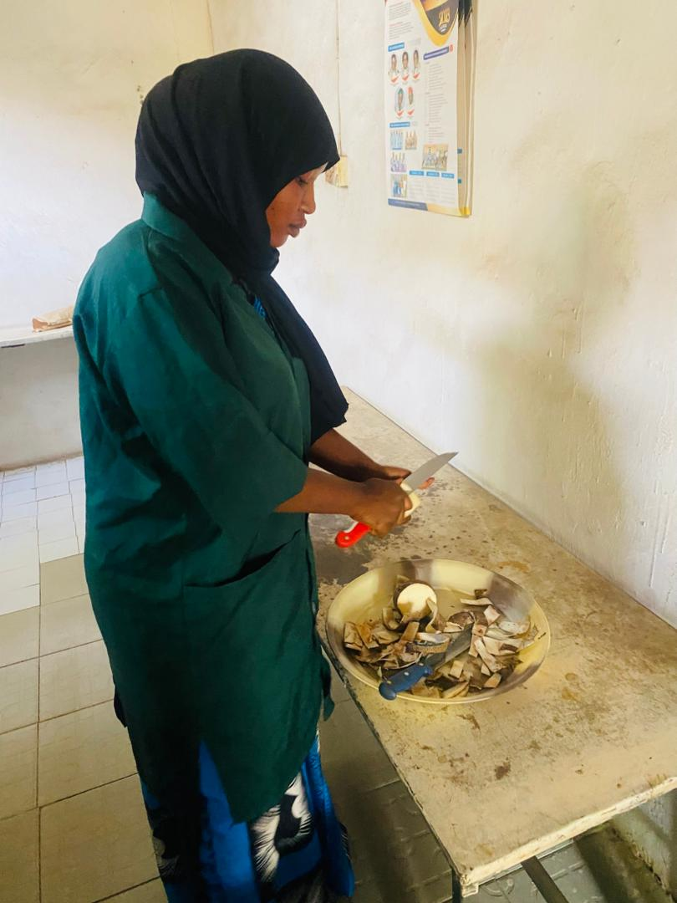
Plate 3.2: Yam peeling process

3.3 Blanching Procedure
Blanching was carried out using a digital water bath to ensure precise temperature control. The sliced yam samples were divided into two groups and subjected to the blanching as shown in Table 3.1. The temperatures were maintained using a water bath, and a thermometer was used to monitor the water temperature to ensure accuracy. After blanching, the yam slices were drained and allowed to cool before drying.

Table 3.1 Blanching treatment
Group | Blanching temperatures (°C) | Blanching time (mins)
A | 65 | 10
B | 95 | 10

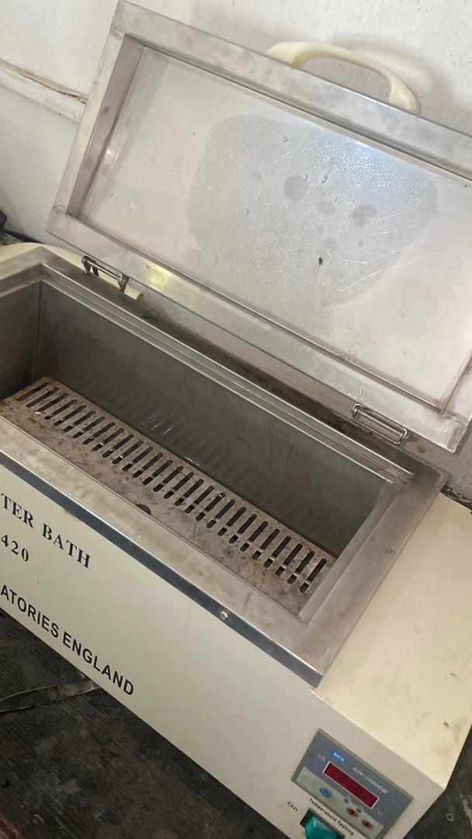
Plate 3.3 Water bath used for the blanching

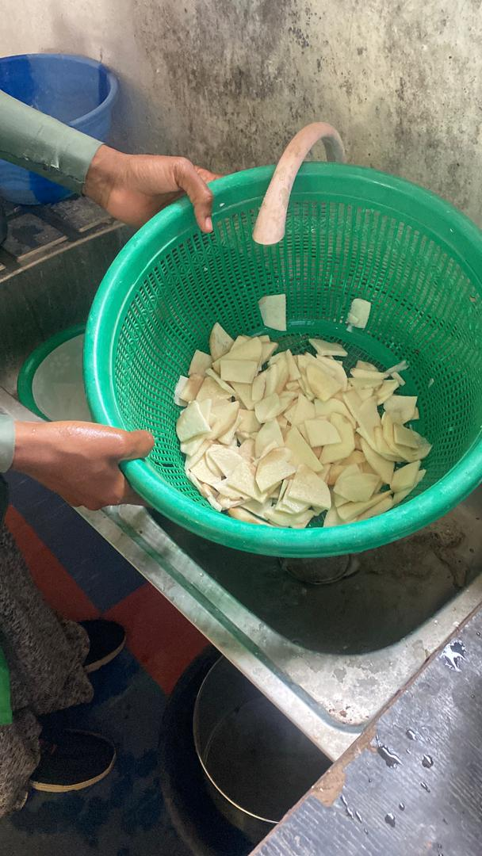
Plate 3.4 Cooling process after the blanching

3.4 Drying Procedure
Each blanched sample group was further divided into two equal portions and subjected to two different drying methods:

3.4.1: Oven Drying
Oven drying was carried out using a laboratory oven pre-set to 60°C as (Plate3.5). The samples were spread evenly on aluminum trays and dried for 15 hours, during which they were weighed periodically until a constant weight was achieved.

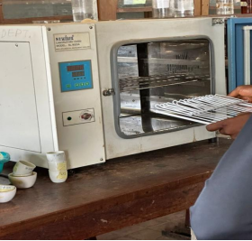
Plate 3.5 Oven drying

3.4.2: Sun Drying
Conducted outdoors under natural sunlight between 10:00 AM and 4:00 PM daily for three consecutive days (18 hours total). The yam slices were spread thinly on a stainless steel tray and covered with a sterile netting material to prevent contamination.
Drying continued until the weight of the samples remained constant.

3.5 Milling and Sieving
Dried yam chips were milled using a mechanical grinder to obtain yam flour. The flour was sieved through a 250 µm mesh sieve to ensure uniform particle size and then stored in air-tight containers for further analysis.

3.6 Proximate Composition Analysis
Standard methods of the Association of Official Analytical Chemists (AOAC, 2010) were used to determine the following parameters:
Moisture Content: Oven-dried at 105°C until constant weight
Crude Protein: Determined by the Kjeldahl method (nitrogen × 6.25)
Crude Fat: Extracted using the Soxhlet method with petroleum ether
Crude Fiber: Measured through sequential acid and alkali digestion
Ash Content: Determined using a muffle furnace at 600°C
Carbohydrate: Calculated by difference:
Carbohydrate (%) = 100 - (Moisture + Protein + Fat + Fibre + Ash)

3.7 Drying Rate Calculation
The drying rate was determined by recording the weight of the samples at regular intervals during drying until a constant weight was achieved.
The drying rate for each sample was calculated Equation 3.1.
Drying Rate = $\frac{Initial Weight (g)-Final Weight (g)}{Drying Time (h)}$ Equation 3.1

3.8 Experimental Design
The study employed a 2 × 2 factorial design
Two blanching temperatures (65°C and 95°C)
Two drying methods (sun drying and oven drying)
Each treatment was conducted in duplicate to ensure reproducibility.
This study investigates the effects of blanching temperature and drying method on the proximate composition and drying rate of yam flour.

Independent Variables (Factors)
1. Blanching Temperature
65°C
95°C
2. Drying Method
Oven drying at 60°C
Sun drying
Each level of blanching temperature was combined with each drying method, resulting in four distinct treatment combinations.

3.9 Statistical Analysis
Data were analysed Using SPSS version 25. ANOVA was performed to determine significant differences at p < 0.05.

Table 3.2 Treatment Combinations
Treatment code Blanching Temperature Drying method
T1 65°C Oven drying at 60°C
T2 65°C Sun drying
T3 95°C Oven drying at60°C
T4 95°C Sun drying
Control

Each treatment was replicated twice using an initial sample weight of 165 grams, and drying was carried out until a constant weight was achieved.

Responses Measured
The following parameters were analyzed:
Moisture content (%)
Crude protein (%)
Crude fat (%)
Crude fiber (%)
Ash content (%)
Carbohydrate content (%)
Drying rate (g/h)

EXPERIMENTAL LAYOUT

Drying Method

┌───────────────────────────────┐
Oven drying
Sun Drying

Blanching Temperature
65°C and 95°C
T1: 65°C + Oven Drying T2: 65°C + Sun Drying
T3: 95°C + Oven Drying T4: 95°C + Sun Drying

Figure 3.1 Drying methods

CHAPTER FOUR

RESULTS AND DISCUSSIONS

4.1 RESULTS
The results of the proximate compositions of yam flour samples under the influence of sun drying, and oven drying at 60°C, blanched at 65°C and 95°C are presented in Table 4.1. The mean of the proximate composition (%) of yam flour under different treatments was presented in Table 4.2. one-way ANOVA of the proximate composition of yam flour are presented in Table 4.3.Table 4.4 presented the two-way ANOVA summary (p-values) for proximate parameters. Table 4.5 presented the result of the drying rate of yam flour samples and Figure: 4.1 presented the drying rate of yam flour samples

Table 4.1 Proximate Composition (%) of the Samples
Sample Moisture Crude Fat Crude Fibre Crude Protein Ash Carbohydrate
Fresh 59.627 0.768 1.236 3.628 2.516 32.225
59.502 0.743 1.219 3.701 2.504 32.331

65°C 11.058 1.017 1.154 4.824 2.315 79.632
Oven 11.106 1.042 1.169 4.816 2.303 79.564

95°C 10.058 1.027 1.204 4.218 2.128 81.365
Oven 10.058 1.039 1.202 4.303 2.097 81.301

65°C 10.028 0.895 1.128 2.987 1.895 83.067
S D 10.057 0.874 1.116 2.954 1.905 84.094

95°C 9.848 0.754 1.154 2.364 1.854 84.026
S D 9.901 0.739 1.172 2.422 1.866 83.900

Table 4.2: The Mean of the Proximate Composition (%) of Yam Flour under Different Treatments
Treatment Moisture Crude Fat Crude Fibre Crude Pro Ash Carbohydrate
Fresh 59.57 0.76 1.23 3.66 2.51 32.28
Oven60°C
(65°C bl) 11.08 1.03 1.16 4.82 2.31 79.60

Oven 60°C 10.06 1.03 1.20 4.26 2.11 81.33
(95°C bl)
Sun dried
(65°C bl) 10.04 0.88 1.12 2.29 1.09 83.08
Sun dried
(95°C bl) 9.87 0.75 1.16 2.39 1.86 83.96

Table 4.3 One-Way ANOVA of the Proximate Composition of Yam flour
Component F-statistic p-value Significance
Moisture 450,744.72 0.0000 Significant
Crude Fat 190.83 0.0000 Significant
Crude Fibre 33.85 0.0008 Significant
Crude Protein 1,017.02 0.0000 Significant
Ash 1,012.07 0.0000 Significant
Carbohydrate 271,949.60 0.0000 Significant

Table 4.4: Two-Way ANOVA Summary (p-values) for Proximate Parameters

Component Blanching Temp (p) Drying Meth (p) Interaction (p) Significance

Moisture 0.0000 0.0000 0.0000 Significant
Crude Fat 0.0021 0.0000 0.0017 Significant
Crude Fibre 0.0033 0.0038 0.9716 Main effects only
Crude Prote 0.0000 0.000 0.7564 Main effects only
Ash 0.0002 0.0000 0.0010 Significant
Carbohydr 0.0000 0.0000 0.0004 Significant

Table 4.5 presented the Result of the Drying Rate of Yam Flour Samples

Treatment Initial Weight (g) Final Weight (g) Drying Time (h) Drying Rate (g/h)
Oven drying
(65°C bla) 165 96.87 15 4.54
Oven drying
(95°C bla) 165 86.67 15 5.22
Sun drying
(65°C bla) 165 98.15 18 3.71
Sun drying
(95°C bla) 165 62.42 18 5.70

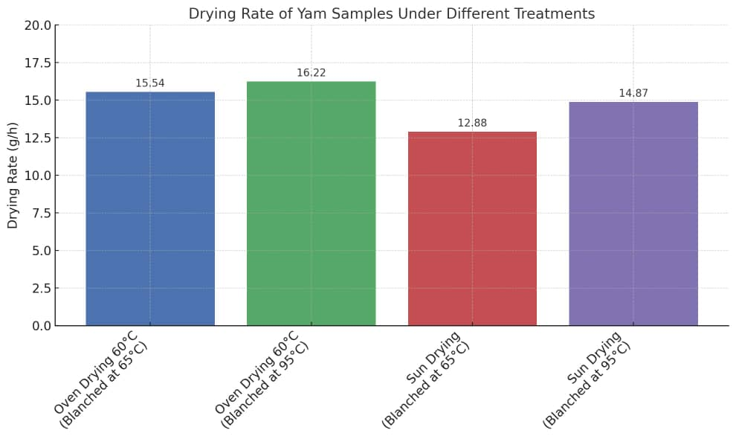
Figure: 4.1: Drying Rate of Yam Flour Samples

4.2 DISCUSSIONS
Discussions on Table 4.1 Proximate Composition (%) of the Samples

4.2.1: Moisture Content
The moisture content of the fresh yam samples was approximately 59.63%, which was significantly reduced following drying. Among the dried samples, sun drying (particularly with prior blanching at 95°C) resulted in the lowest moisture content (9.87%), while oven drying at 60°C with blanching at 65°C retained slightly more moisture (11.06%). Although sun drying achieved marginally lower moisture levels, the controlled nature of oven drying provides more reliable and sanitary conditions for moisture removal. These findings align with the observations of Johnson et al. (2018), who noted that sun drying under intense ambient heat may exceed mild oven temperatures, resulting in enhanced moisture loss.
The lower moisture content achieved at higher temperatures aligns with the goal of preserving yam flour by reducing microbial activity.

4.2.2: Crude Protein
Protein content increased with oven drying (4.82% for samples blanched at 65°C) but decreased in sun-dried samples (2.95%–2.99%).
Smith and Adeyemi (2019) noted similar reductions in sun-dried samples, attributing this to prolonged exposure to inconsistent heat and light, which may denature proteins.

4.2.3: Crude Fat
Oven drying retained more crude fat (1.02%) compared to sun drying (0.75%–0.89%).
Olayinka and Bello (2020) observed that oxidative losses during sun drying reduce fat content, while controlled oven conditions help retain fat.

4.2.4: Ash and Crude Fibre Content
Ash and crude fibre contents showed minimal variations across treatments. Fresh yam had 2.50% ash and 1.23% fibre, with slight reductions noted after drying.
Adebayo et al. (2017) also reported that ash and fibre are less affected by blanching or drying methods, as these components are relatively stable.

4.2.5: Carbohydrate Content
Carbohydrate content increased as moisture decreased, with sun-dried samples recording the highest levels (83.07%–84.03%).
This result aligns with Okonkwo and Eze (2016), who emphasized that moisture reduction concentrates the carbohydrate fraction in tuber flours.

4.3 Discussion on Table 4.3 One-Way ANOVA and Tukey HSD Results
One-way ANOVA revealed significant differences (p < 0.05) among the five treatments. Tukey’s HSD test grouped the treatments with different superscripts as statistically different. Oven drying preserved more protein, while sun drying significantly increased carbohydrate content.

4.4 Discussion on Table 4.4 A two-way ANOVA
A two-way ANOVA was used to assess the effects of blanching temperature, drying method, and their interaction.
Drying method and blanching temperature significantly affected most nutritional parameters. Interaction effects show that the influence of one factor depends on the level of the other. Oven drying was best for protein retention; sun drying (after 95°C blanching) favoured` moisture loss and carbohydrate concentration.

4.5 Discussion on Drying Rate Table 4.5
The drying rate results revealed key differences between oven drying at 60°C and sun drying:
1. Oven drying had a higher drying rate than sun drying under both blanching temperatures.
The highest drying rate (16.22 g/h) was recorded in oven drying at 60°C with 95°C blanching.

The lowest drying rate (12.88 g/h) was observed in sun drying with 65°C blanching.
This confirms that controlled oven conditions facilitate faster moisture removal compared to sun drying, where drying efficiency is affected by environmental factors such as temperature, humidity, and airflow.

2. Blanching at 95°C enhanced the drying rate compared to 65°C.
Samples blanched at 95°C dried faster in both oven and sun drying.
This may be attributed to heat-induced cell structure breakdown, which accelerates moisture loss.
Similar findings were reported by Adebayo et al. (2017), where higher blanching temperatures led to increased drying efficiency in yam processing.

3. Sun drying had the slowest drying rate due to environmental variability.
Although sun drying at 95°C blanching had a slightly improved drying rate (14.87 g/h), it was still lower than oven drying at 60°C.
This aligns with studies by Aluko and Ibrahim (2021), who reported that sun drying is less efficient due to inconsistent heat exposure and possible reabsorption of moisture during the drying process.
The results suggest that oven drying at 60°C is more efficient than sun drying for yam flour production, ensuring faster drying and reducing the risk of microbial contamination.
However, sun drying remains a viable option in rural areas where electricity costs or oven availability are limiting factors.

4.6. Comparative Discussion with Existing Research and Practical Implications
This section compares the study’s findings with existing research and explores its relevance to yam flour production.

Comparison with Literature
4.6. 1: Moisture Content: The moisture reduction trend aligns with Johnson et al. (2018) and Adebayo et al. (2017), who reported that oven drying removes moisture more effectively than sun drying, ensuring longer shelf life.

4.6.2: Protein Retention: The study’s findings match Smith & Adeyemi (2019), who found that sun drying leads to protein denaturation due to prolonged heat exposure.

4.6.3: Fat Stability: Similar to Olayinka & Bello (2020), the research confirmed oxidative fat losses in sun drying, making oven drying a better option for fat retention.

4.6.4: Drying Rate: The drying efficiency aligns with Aluko & Ibrahim (2021), who observed that higher blanching temperatures increase drying rates due to enhanced moisture diffusion.

CHAPTER FIVE

CONCLUSIONS AND RECOMMENDATIONS

5.1 Conclusions
The following conclusion was drawn from the results obtained from this study
1. Oven drying was more effective in reducing moisture content and preserving protein and fat levels compared to sun drying.
2. Sun drying yielded the highest carbohydrate content, making it suitable for carbohydrate-dense applications.
3. Blanching at higher temperatures (95°C) slightly reduced ash and fibre retention compared to 65°C.

5.2 Recommendations
1. For yam flour production, oven drying at 65°C is recommended for optimal nutritional preservation.
2. Further studies should investigate the sensory qualities and functional properties of yam flour processed under similar conditions.
3. Implement energy-efficient drying technologies for large-scale production.
4. Explore the impact of blanching time and drying method on other yam species.

References
Adebowale, A. A., Sanni, S. A., & Awonorin, S. O. (2021). Variation in physical and
functional properties of yam flours from different varieties. African Journal of Food Science, 15(3), 47–55.
Adebayo, A. S., & Sobowale, S. S. (2018). Effect of yam species and drying method on the
quality of yam flour. Nigerian Food Journal, 36(2), 49–58.
Adebayo, A. S., Ojo, O. J., & Adekunle, A. A. (2017). Effect of drying methods on proximate
composition and physicochemical properties of yam flour. International Journal of Food Science and Technology, 52(2), 456–463.
Adepoju, A. O., & Oyewole, O. B. (2018). Effects of blanching and drying methods on
nutritional and anti-nutritional contents of yam flour. Food Science & Nutrition, 6(3), 523–529.
Adepoju, A. O., Ojokoh, A. O., & Fagbemi, T. N. (2017). Influence of pretreatment methods
On functional and pasting properties of yam flour. Journal of Culinary Science & Technology, 15(1), 35–45.
Akanbi, W. B., Ojo, A. A., & Adeyeye, S. A. O. (2017). Influence of drying methods on the
quality of yam flour. Nigerian Journal of Agriculture, Food and Environment, 13(1), 59.
Akinwande, B. A., & Ogundele, O. A. (2020). Postharvest loss assessment of yam tubers and
the implications for food security. African Journal of Agricultural Research, 15(9), 12611269.
Aluko, A. A., & Ibrahim, Y. O. (2021). Performance of solar and sun drying methods on the
drying rate of yam chips. Agricultural Engineering International: CIGR Journal, 23(2), 213–222.
Falade, K. O., & Olurin, T. O. (2020). The effect of drying methods on the functional and
sensory characteristics of yam flour. Journal of Food Processing and Preservation, 44(2), e14344.
Food and Agriculture Organization (FAO). (2021). FAOSTAT statistical database. Retrieved
from https://www.fao.org/faostat
Johnson, A. A., Bamidele, O. P., & Agboola, O. J. (2018). Effects of drying temperature on
nutrient composition and sensory attributes of yam flour. Journal of Food Research, 7(1), 114–121.
Kumar, A., & Mishra, R. (2017). Advances in drying technologies for tuber crops: A review.
Journal of Food Process Engineering, 40(6), e12537.
Kumar, P., Saurabh, S., & Singh, A. (2019). Role of blanching in food processing: A review. Journal of
Food Science and Technology, 56(10), 4171–4181.
Musa, R. A., Adewuyi, B. A., & Alade, A. O. (2021). Effect of blanching on the nutrient retention and microbial load of yam slices. Scientific African, 13, e00933.
Nainggolan, J. C., Bangun, R. M. R., & Nasution, R. M. (2024). Review of drying processes for tuber
crops: Trends and innovations. Food Processing & Preservation Journal, 10(1), 23–31.
Nwafor, P. A., Eke, M. O., & Nwachukwu, O. C. (2022). Proximate and functional properties of yam
flours from two yam species: Effect of sun and oven drying. Journal of Root Crops Research, 19(1), 14–23.
Obidiegwu, J. E., Akpabio, E. M., & Aighewi, B. (2020). Nutritional composition of yams and
implications for their use as staple food in West Africa. African Journal of Biotechnology, 19(3), 112–122.
Ojinnaka, M. C., Oluka, S. I., & Okorie, I. (2017). Chemical and functional properties of yam flour from
different drying methods. African Journal of Food Science, 11(4), 94–100.
Okonkwo, J. C., & Eze, C. C. (2016). Effect of processing methods on the nutritional content of yam
flour. International Journal of Food Science and Nutrition, 7(2), 42–48.
Olayinka, A. A., & Bello, A. A. (2020). Effects of traditional and mechanical drying on fat and protein
content of yam flour. Nigerian Food Journal, 38(1), 59–65.
Oluwalana, I. B., Oduola, A. O., & Ogunwolu, S. A. (2019). Economic analysis of yam flour processing
in Saki, Oyo State, Nigeria. Journal of Agricultural Economics and Rural Development, 7(3), 234–240.
Otegbayo, B. O., Ogunlakin, G. O., & Oyedele, O. A. (2022). Evaluation of yam varieties for the
production of instant pounded yam flour. African Journal of Food Science and Technology, 13(2), 47–55.
Rees, D., & Bancroft, R. D. (2018). Yam production in West Africa: Post-harvest challenges and
interventions. International Journal of Agricultural Sustainability, 16(4), 352–360.
Smith, A. O., & Adeyemi, T. E. (2019). Impact of drying methods on proximate and functional
properties of yam flour. Journal of Food Quality, 2019, Article ID 3918940.
AOAC. (2010). Official methods of analysis (18th ed.). Association of Official Analytical Chemists.

