POTENCY OF FUSARIUM GRAMINEARUM TOXIN

BY

IZINREIN OLUBUNMI
ND/23/SLT/PT/0325
A PROJECT SUBMITTED TO THE DEPARTMENT OF SCIENCE LABORATORY TECHNOLOGY, INSTITUTE OF APPLIED SCIENCES, KWARA STATE POLYTECHNIC, ILORIN

IN PARTIAL FULFILMENT OF THE REQUIREMENTS OF THE AWARD OF NATIONAL DIPLOMA (ND) IN SCIENCE LABORATORY TECHNOLOGY (SLT)

JULY, 2025
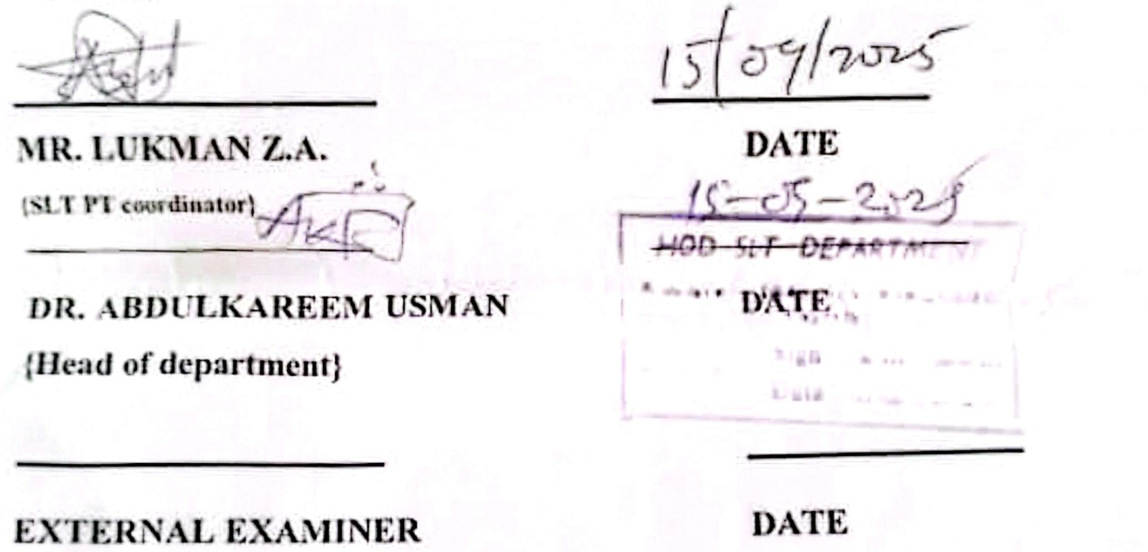
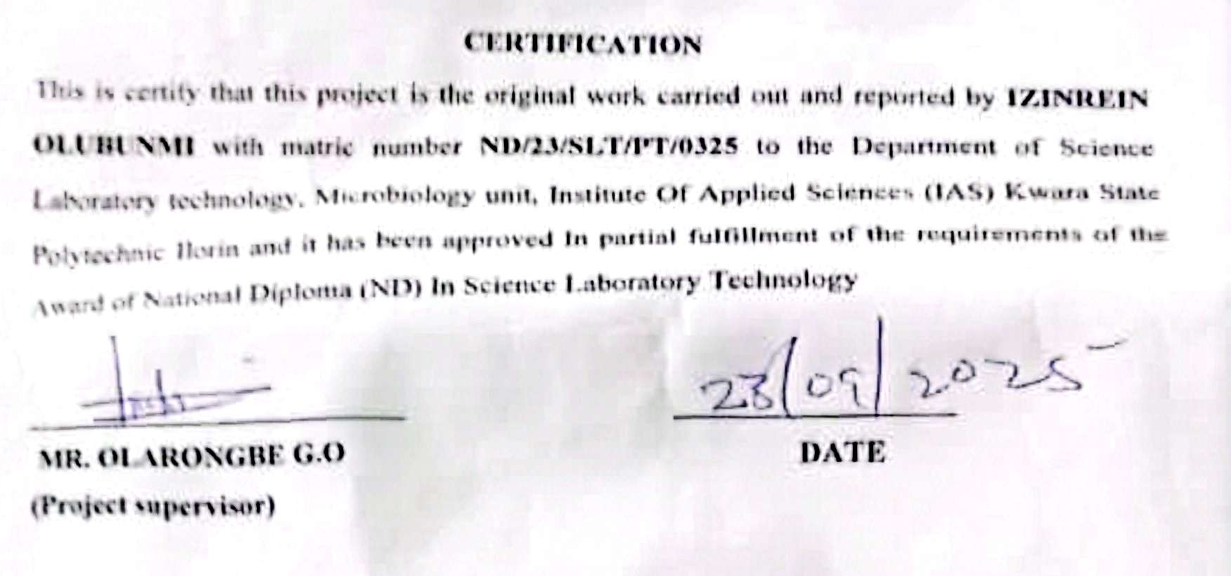

DEDICATION
This project is dedicated to Almighty God, whose grace and mercy have seen me through my academic journey.
It is also dedicated to my loving parents, for their unending support, sacrifices, and prayers, as well as to all students striving to achieve their dreams despite challenges.

ACKNOWLEDGEMENTS
I wish to express my profound gratitude to Almighty God for His guidance, protection, and strength throughout the duration of this project.
My sincere appreciation goes to my supervisor, Mr Olarongbe , for their invaluable guidance, encouragement, and constructive criticism, which greatly contributed to the success of this work.
I am also grateful to all my lecturers and the Department of Science Laboratory Technology, Kwara State Polytechnic, for the knowledge and support I have received.
Special thanks to my family, friends, and colleagues for their prayers, moral support, and encouragement during the course of this project.

TABLE OF CONTENTS

TITLE PAGE -------------------------------------------------------------------------- i
CERTIFICATION ---------------------------------------------------------------------ii
DEDICATION ------------------------------------------------------------------------iii
ACKNOWLEDGEMENTS ---------------------------------------------------------iv
TABLE OF CONTENTS ------------------------------------------------------------vii
LIST OF TABLES ---------------------------------------------------------------------viii
LIST OF FIGURES ---------------------------------------------------------------------viii
ABSTRACT ------------------------------------------------------------------------------ix
CHAPTER ONE
1.0 Introduction -------------------------------------------------------------------------6
1.1 Literature Review------------------------------------------------------------------8
1.2 Statement of Problem--------------------------------------------------------------9
1.3 Justification of Study--------------------------------------------------------------9
1.4 Aims and Objective----------------------------------------------------------------10

CHAPTER TWO
2.0 Materials and Methods -----------------------------------------------------------11
2.1 Material Used ---------------------------------------------------------------------11
2.2 Sterilization of Equipment and Environment ---------------------------------11
2.3 Samples Collection ----------------------------------------------------------------12
2.4 Media Preparation for fungal isolation -----------------------------------------12
2.4.1 Preparation of Potato Dextrose Agar -------------------------------------------12
2.4.2 Preparation of Potato Dextrose Broth-------------------------------------------13
25 Isolation of Fusarium gramenearium from maize------------------------------14
2.6 Characterization and Identification of Fusarium gramenearium --------------14
2.7 Sub-culturing and Extraction of Fusarium gramenearium----------------------15
2.8 Administration and Evaluation of the Potency of the Toxin in White Rats-15
CHAPTER THREE
3.0 Results
3.1 Characterization and Identification of Fungal Isolate ------------------------17
3.2 Weekly clinical Observation in Experimental rats -----------------------------19
3.3 Post-Mortem Gross Pathological Findings ------------------------------------- 20
CHAPTER FOUR
4.0 Discussion and Conclusion
4.1 Discussion -------------------------------------------------------------------- ---23
4.2 Conclusion ------------------------------------------------------------------------23
REFERENCES

LIST OF TABLES
Table 1: Characterization and Identification of Fusarium gramenarium Isolate after culturing

Table 2 Daily Observation for 100% Conc. Toxin Administration in Rats

Table 3 Daily Observation for 80% Conc. Toxin Administration in Rats

Table 4 Daily Observation for 60% Conc. Toxin Administration in Rats

Table 5 Daily Observation for 50% Conc. Toxin Administration in Rats
Table 6: Post-Mortem Findings in Experimental Rats

LIST OF FIGURES
Figure 1: Showing Microscopic view
Figure 2: Images of postmortem findings in experimental rats

ABSTRACT
Fusarium graminearum is a mycotoxigenic fungus that often infects cereal crops, generating strong toxins such deoxynivalenol (DON), zearalenone (ZEN), and fusarenon-X (FX). This study looked at how dangerous the F. graminearum toxin was when it was taken from infected maize samples and given to albino rats in controlled laboratory circumstances at different concentrations (100%, 80%, 60%, and 50%). Clinical investigations showed that the harmful effects got worse with higher doses. These symptoms included less movement, difficulty breathing, dullness of the eyes, and death at the greatest concentration. The investigation after death showed that important organs like the liver, kidney, and gut were getting worse, which confirmed systemic poisoning. Rats that were exposed to lesser amounts showed less severe but nonetheless noticeable physiological impairment. These results add to what we already know about the health consequences of F. graminearum toxins and show how important it is to keep an eye on and control mycotoxins in food systems to protect the health of people and animals.
Keyword: Fusarium graminearum, deoxynivalenol (DON), zearalenone (ZEN), mycotoxins, food safety, toxicology, organ damage.

