A TECHINCAL REPORT ON PROPORSED ON RESTAURANT AT JOURNALIST ESTATE GANIKI ROAD, ILORIN EAST

BY

IBRAHIM ABDULRASHEED OLASUNKANMI
ND/23/ARC/PT/0018

BEING A PROJECT REPORT SUBMITTED TO
THE DEPARTMENT OF ARCHITECTURAL TECHOLOGY, INSTITUTE OF
ENVIRONMENTAL STUDIES, KWARA STATE POLYTECHIC, ILORIN.

INPARTIAL FULFILMENT OF THE REQUIREMENT FOR THE AWARD OF NATIONAL DIPLOMA (ND) IN ARCHITECTURAL TECHNOLOGY.

SEPTEMBER, 2025

CERTIFICATION
I certify that this research project/Dissertation entitled A TECHINCAL REPORT ON PROPORSED ON RESTAURANT AT JOURNALIST ESTATE GANIKI ROAD, ILORIN EAST was carried out by IBRAHIM ABDULRASHEED OLASUNKANMI
under my supervision ARC Olanrewaju F.A has been approved. As meeting the requirement for the award of ND in Architectural Technology, Kwara State Polytechnic, Ilorin, Kwara State.


05/08/2025
DATE


05/08/2025
DATE


06/08/2025
DATE

_____________________ ____________
External Examiner DATE
DECLARATION
I declare that this Project/Dissertation is a project of my personal research works. It has not been
Presented for the award of any ND in any polytechnic. The ideas, Observations, Comments, and Suggestions here in represent my own convictions except quotations, which have been acknowledged.
In accordance with conventional academic traditions.

IBRAHIM ABDULRASHEED OLASUNKANMI
ND/23/ARC/PT/0018


________________________
SIGNATURE & DATE

TABLE OF CONTENT
Title page
Certification
Dedication
Acknowledgment
Abstract
TABLE OF CONTENTS
CHAPTER ONE
1.1 Background of Study/Historical Background or Brief Description of the Building Type
1.2 Statement of Design Problem
1.3 Aim and Objectives of the Project
1.4. Justification for the Project
1.5 Client’s Background, Philosophy, Operational Structure, and Goal of the Proposal
1.6 Scope of Study
1.7 Limitation of Study
1.8 Research Methodology (Approach to Tackling the Design Problem)
CHAPTER TWO
2.1 Literature Review
2.2 Historical Background of Restaurant Architecture
CHAPTER THREE CASE STUDIES
3.1 Introduction to Case Studies
3.2 Selected Case Studies
3.3 Case Study One: Iya Toyosi Restaurant, Sagamu, Ogun State
3.4 Case Study Two: Olla Food Restaurant, Osogbo, Osun State
3.5 Case Study Three: Bossy Food Restaurant, Sagamu, Ogun State
3.6 Online Case Studies
CHAPTER FOUR
4.1 Brief Historical Background
4.2 Location and Setting Out
4.3 Population
4.4 Site Inventory
Site Analysis
4.6 Site Selection and Justification
Location
Accessibility
Infrastructure Facilities
4.10 Topography
4.11 Soil Structure
4.12 General Climate Condition
elative Humidity
4.14 Wind
temperature
4.16 Vegetation
4.17 Road
4.18 Water and Electricity
Design Criteria
4.20 Design Brief
4.21 Design Analysis
4.22 Spatial Allocation
Planning Principles
CHAPTER FIVE
APPROACH TO THE DESIGN /DESIGN REALIZATION
5.1 Design Ideas and Concepts at Different Levels
5.1.1 Site-Level Design Concepts
5.1.2 Building-Level Design Concepts
5.2 Technological and Environmental Criteria
Construction Methodology and Material Finishes
5.2.2 Services Required
5.2.3 Environmental Conditions to be Achieved
5.2.4 Performance Standards
5.3 Legal Issues and Planning Regulations
5.4 Behavioral Pattern and Considerations
5.5 CONCLUSION AND RECOMMENDATIONS
5.5.1 Conclusion
5.5.2 Recommendations
REFERENCES

CHAPTER ONE

1.1 Background of Study/Historical Background or Brief Description of the Building Type
A restaurant is a purpose-built architectural facility designed to offer food and beverages for sale to customers who either consume them on the premises or take them away. It functions as both a commercial enterprise and a social gathering space, facilitating interaction, leisure, and cultural exchange. The concept of the restaurant has existed in various forms across civilizations, from communal dining halls in ancient China and Rome to European inns, alehouses, and Middle Eastern caravansaries that catered to travelers.
The modern restaurant, as we understand it today, emerged prominently in 18th-century Paris, where the word restaurant—originally meaning "to restore"—came to describe public dining places offering prepared meals at fixed prices (Spang, 2001). Since then, the restaurant industry has diversified into various types: fast-food chains, casual dining, fine dining, ethnic restaurants, buffets, cafés, and food courts, each with distinct architectural, operational, and service characteristics.
Architecturally, the design of a restaurant is influenced by a range of functional, aesthetic, and environmental considerations. These include spatial zoning (e.g., kitchen, service, dining, restroom, storage areas), customer flow, accessibility, acoustics, ventilation, lighting, and the ambiance created through materials, colors, and furnishings. According to Neufert (2012), efficient restaurant design should ensure comfort for both staff and customers, support high turnover without congestion, and reflect the theme or cultural identity of the establishment.
In the Nigerian context, particularly in urbanizing cities like Ilorin the capital of Kwara State the significance of restaurants has grown in tandem with urban expansion, increased population density, lifestyle changes, and rising demand for convenience. Ilorin is a historic city that serves as a socio-cultural melting pot, blending Yoruba, Fulani, and Hausa traditions. Over the past two decades, it has experienced rapid urbanization, spurred by educational growth, increased economic activity, and residential estate development.
One such emerging neighborhood is Journalist Estate in Ganiki, located within the expanding urban fringe of Ilorin. This estate has become increasingly populated due to its relative affordability, security, and access to major roads. However, despite its growing residential base, the area lacks standard food outlets and professionally designed restaurants. Most residents rely on informal food vendors, roadside kiosks, or must travel long distances to access quality dining facilities.
The absence of a structured, hygienic, and comfortable restaurant within Journalist Estate represents a significant service and infrastructure gap. It limits residents' access to convenient meals, reduces opportunities for social engagement, and undermines the estate's potential to attract visitors or support local economic development. A well-designed restaurant in this location would not only address residents' dining needs but also create employment opportunities, contribute to the estate’s commercial viability, and enhance the aesthetic value of the built environment.

1.2 Statement of Design Problem
- Provides efficient service through spatial planning;
- Meets local building codes and health standards;
- Incorporates environmental sustainability and energy efficiency; and
- Reflects the socio-cultural context of Ilorin while maintaining a modern outlook.
As noted by Neufert (2012), effective spatial organization and environmental responsiveness are crucial in restaurant design to enhance performance and customer satisfaction.

1.3 Aim and Objectives of the Project
Aim:
To design a culturally relevant, spatially efficient, and environmentally sustainable restaurant in Journalist Estate, Ganiki, Ilorin, that enhances the dining experience while serving as a landmark within the community.
Objectives:
- To analyze the physical, cultural, and socio-economic characteristics of the site.
- To propose a design that ensures functional zoning (kitchen, storage, dining, service areas) in line with best architectural practices.
- To incorporate climate-responsive strategies such as cross-ventilation, daylighting, and rainwater harvesting.
- To use materials that are durable, locally sourced, and sustainable.
- To ensure the design accommodates diverse user groups, including people with disabilities (as per the Nigeria Disability Act, 2018).

1.4. Justification for the Project
- Urbanization: As urban settlements expand, the need for social infrastructure such as eateries and gathering spaces becomes imperative (UN-Habitat, 2020).
- Employment Opportunities: Restaurants serve as employment generators, engaging chefs, waiters, cleaners, and managers.
- Cultural Importance: Restaurants are cultural assets that showcase regional cuisine and foster social integration.
- Public Health: Proper restaurant architecture can support hygiene and safety, reducing the risk of foodborne diseases (WHO, 2015).

1.5 Client’s Background, Philosophy, Operational Structure, and Goal of the Proposal
Client’s Background:
The client is an Ilorin-based hospitality entrepreneur with a vision to redefine the local dining experience. Having operated a small catering service, the client now seeks to expand into a full-service restaurant.
Philosophy:
The client's business philosophy centers on “Excellence in Taste and Space.” This entails high standards in food preparation, hygiene, and customer experience within a quality-built environment.
Operational Structure:
The restaurant will operate in a modular structure:
- Kitchen and food preparation zone
- Dining areas (indoor and semi-outdoor)
- Administrative office
- Staff restrooms and customer conveniences
- Outdoor relaxation spaces and parking
Goal:
To establish a well-branded, scalable restaurant outlet that offers affordable and nutritious meals within a safe, functional, and architecturally inspiring setting.

1.6 Scope of Study
The project covers:
- Site evaluation and environmental assessment
- Case studies of similar restaurant projects in Nigeria
- Development of architectural drawings: site plan, floor plan, elevations, and sections
- Material selection and energy analysis
- Landscape integration and service planning
- Conceptual and schematic design development
- 3D visualization of the proposed restaurant
The design will adhere to relevant codes including:
- Nigerian Building Code (NBC, 2006)
- ASHRAE standards for ventilation
- Nigerian Urban and Regional Planning Law

1.7 Limitation of Study
This project is limited to conceptual and architectural design phases only. The scope excludes:
- Detailed mechanical, electrical, and structural engineering designs
- Quantity surveying and budgeting for actual construction
- Land acquisition and governmental approvals
- Post-occupancy evaluation

1.8 Research Methodology (Approach to Tackling the Design Problem)
The approach adopted for this project is both qualitative and analytical, consisting of:
- Literature Review:
Review of academic journals, architectural handbooks, building codes, and restaurant design case studies (e.g., "Time-Saver Standards for Building Types" by DeChiara et al., 2011).
- Site Analysis:
Study of Journalist Estate’s topography, road network, sun path, wind direction, vegetation, and existing land use.
- User Need Survey:
Distribution of questionnaires and informal interviews with estate residents to gather data on eating habits, preferences, and expected restaurant features.
- Precedent Study:
Analysis of successful restaurant designs in similar urban settings, focusing on layout, material use, and climate adaptation.
- Design Development:
Creation of design concept through sketching, modeling, and simulation (using SketchUp and Revit).

CHAPTER TWO

2.1 Literature Review
Restaurant architecture is a distinctive typology within the commercial sector that fuses functionality, user experience, aesthetics, and service efficiency. The architectural approach to restaurant design goes beyond spatial arrangement — it encapsulates the atmosphere, cultural identity, environmental responsiveness, and the commercial branding of the space. Scholars and practitioners agree that the design of dining spaces directly influences user behavior, dwell time, and even customer satisfaction (Lawson, 2001; Piotrowski, 2011).
Building Typology and Classification:
Restaurant buildings are typically classified based on their service type (e.g., fine dining, casual dining, fast food), layout design (open plan, segmented, or modular), and spatial configuration (indoor, outdoor, drive-thru, or hybrid models). Each category dictates specific functional and spatial needs — for instance, fine-dining spaces emphasize ambiance, privacy, and acoustics, while fast-food restaurants prioritize circulation efficiency and high turnover (Cousins et al., 2014).
Functional Relationships Between Spaces:
Key functional areas in restaurant architecture include the dining area, kitchen, service zones, storage, restrooms, and administrative areas. The kitchen-to-dining flow is critical, influencing efficiency, hygiene, and safety. The "work triangle" — a concept borrowed from domestic kitchen design — has been adapted to commercial kitchens, with zones for preparation, cooking, and cleaning planned to minimize movement and improve workflow (Ching & Shapiro, 2014). The dining area itself is often organized to balance customer privacy with social interaction, with different seating zones (booths, communal tables, bar seating) designed for varied user preferences.
Technological and Environmental Considerations:
Modern restaurant architecture integrates energy-efficient systems, sustainable materials, and smart technologies. These include the use of LED lighting, solar panels, water-saving plumbing fixtures, natural ventilation, and locally sourced building materials. Contemporary restaurant designs also factor in noise control, thermal comfort, and air quality, which significantly affect customer comfort and health (Gissen, 2003). Open-kitchen designs have gained popularity, requiring architects to resolve issues of noise, odor control, and customer visibility.
Design Influences and Branding:
Restaurant buildings are not only spaces for eating but also serve as brand ambassadors. Design decisions—from façade treatments to signage, lighting, and interior finishes—create a unique identity that supports brand recognition and customer loyalty. According to Schlosser (2001), fast food chains such as McDonald's and KFC have used architecture as part of their marketing strategy, creating highly recognizable and reproducible building formats.
In the Nigerian context, restaurant architecture also reflects local customs, climate, and economic considerations. There is often a blending of indoor and outdoor dining areas to accommodate the tropical climate. In cities like Ilorin, design elements such as shaded verandas, the use of natural cross-ventilation, and incorporation of traditional materials (e.g., clay bricks, thatch, timber) remain relevant and effective (Falade, 2006).

2.2 Historical Background of Restaurant Architecture
The development of restaurant architecture can be traced back to ancient civilizations, each contributing to the evolution of dining spaces as social and commercial hubs.
Ancient Beginnings:
In Ancient Rome, thermopolia functioned as simple food stalls that served hot meals and drinks to working-class citizens who lacked private kitchens. These establishments, often open to the street, featured counters with built-in storage for hot food (Montanari, 1999). Similarly, Ancient China developed structured public dining facilities during the Tang and Song dynasties, where food halls and teahouses served both functional and social purposes (Anderson, 1988).
Islamic Hospitality Architecture:
In the Islamic world, caravansaries along trade routes served as hospitable spaces for travelers, offering food, rest, and security. These buildings were designed around large courtyards with peripheral rooms and communal dining halls, promoting both safety and social interaction. Their architecture emphasized symmetry, cultural ornamentation, and environmental response (Blair & Bloom, 1994).
The Birth of the Modern Restaurant – 18th Century Paris:
The modern restaurant originated in 18th-century Paris, differentiating itself from inns and taverns by offering individually ordered meals from printed menus, set dining hours, and a more refined environment (Spang, 2001). These early establishments focused on hygiene, customer comfort, and privacy—hallmarks of contemporary dining culture.
Industrial Revolution and Functionalism:
During the Industrial Revolution, urban populations surged, and with them came the need for canteens and cafeterias that could serve meals efficiently to workers. Architectural priorities shifted toward functionality, affordability, and mass service. Open floor plans, washable materials, and communal seating became common.
Mid-20th Century: Standardization and Branding:
The rise of fast food franchises in the mid-20th century introduced standardization in restaurant architecture. Companies like McDonald’s developed architectural prototypes to enhance brand visibility and operational consistency. The building became a symbol of the brand, with predictable layouts and materials (Schlosser, 2001).
21st-Century Innovations and Local Adaptation:
Today, restaurant design incorporates sustainability, digital integration, and experiential features. Key trends include:
- Open-kitchen layouts for transparency and engagement,
- Pop-up and mobile restaurants using modular or recycled structures,
- Green buildings utilizing passive cooling, solar energy, and natural lighting (Ching & Shapiro, 2014),
- Cultural fusion, particularly in multicultural regions like Nigeria, where traditional materials and forms are integrated with modern aesthetics and functional layouts.
In Ilorin, a growing urban center, restaurant architecture must address the tropical climate, cultural dining norms (e.g., group eating and outdoor dining), and the increasing demand for modern conveniences. A successful restaurant design in this context blends local identity with global best practices, ensuring both commercial viability and cultural relevance.

CHAPTER THREE

CASE STUDIES

3.1 Introduction to Case Studies
Case studies are critical in architectural design research, allowing the designer to evaluate how similar projects have responded to key functional, cultural, and environmental needs. In this chapter, three physical case studies and one online case study have been analyzed to inform the planning, spatial configuration, material selection, and sustainability strategies for the proposed restaurant in Journalist Estate, Ganiki, Ilorin.
Each case study is evaluated based on:
- Spatial planning and functional zoning
- Ventilation and lighting strategies
- Cultural and aesthetic relevance
- Accessibility and user comfort
- Environmental sustainability

3.2 Selected Case Studies
The following restaurants were selected due to their location in a similar climate zone (Southwest Nigeria), similarity in project scope (small- to medium-scale dining), and relevance to local architectural expression.

List of Selected Case Studies:
- Case Study One: Iya Toyosi Restaurant, Sagamu, Ogun State
- Case Study Two: Olla Food Restaurant, Osogbo, Osun State
- Case Study Three: Bossy Food Restaurant, Sagamu, Ogun State
- Online Case Study: Nando’s Restaurant, Johannesburg, South Africa

3.3 Case Study One: Iya Toyosi Restaurant, Sagamu, Ogun State

Overview
- Location: Sagamu, Ogun State
- Type: Medium-scale traditional and fast-food restaurant
- Design Features: Simple concrete block structure, covered front veranda, open-plan dining, traditional décor

Merits
- Cultural Relevance: Reflects Yoruba heritage in furniture, finishes, and food presentation
- Ventilation: Large window openings and high ceiling allow good natural airflow
- Low-Cost Construction: Use of local materials reduces construction costs
- Ease of Access: Flat terrain and open entrances allow all users easy access
- Adequate security
- Conducive environment

Demerits
- Inadequate Parking: Limited vehicle space causes congestion during peak hours
- Poor Lighting at Night: Relies heavily on natural lighting with minimal artificial lighting solutions
- Basic Sanitation Facilities: Restrooms are minimal and not up to modern standards
- Poor Spatial Definition: Kitchen and dining zones lack proper separation, affecting hygiene
- Lack of space
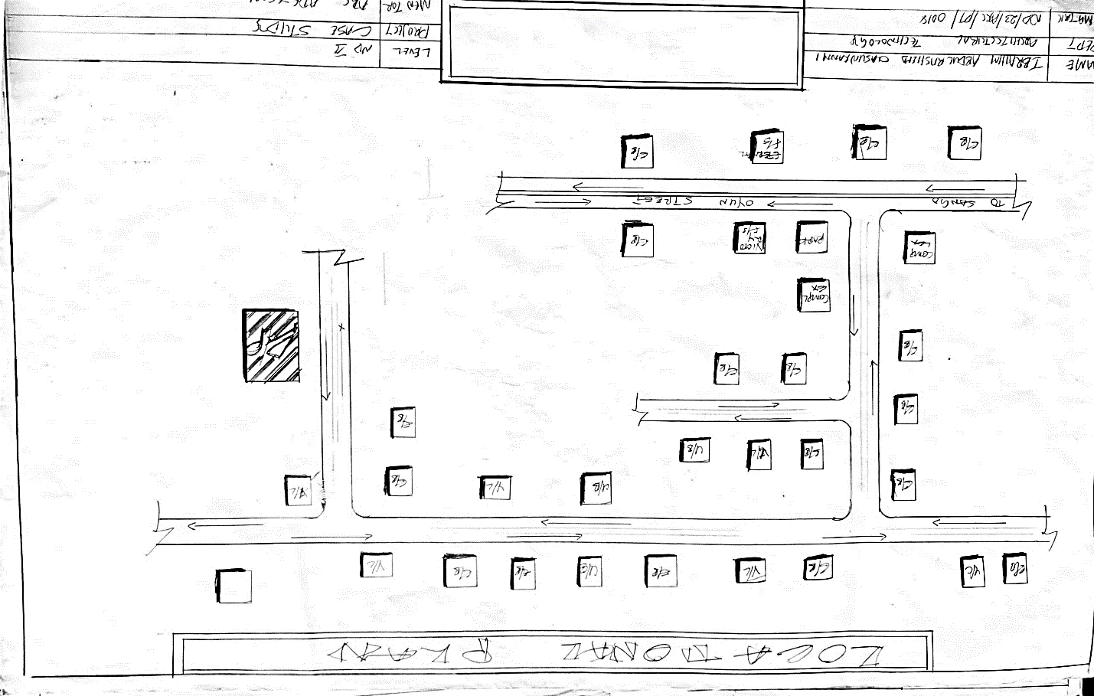

- FIG1;SHOWING LOCATION PLAN OFCASE STUDY ONE

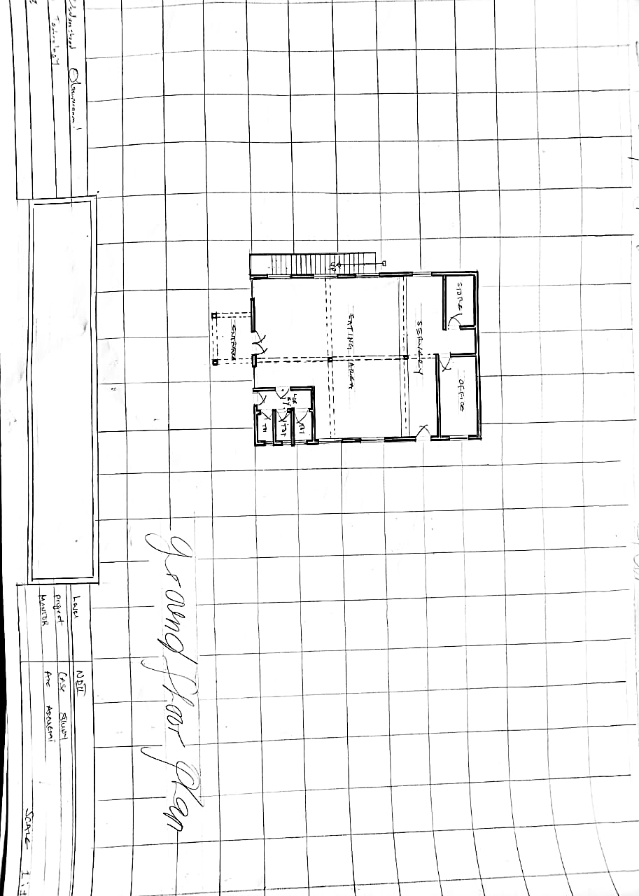
- FIG1;SHOWING floor PLAN OFCASE STUDY ONE

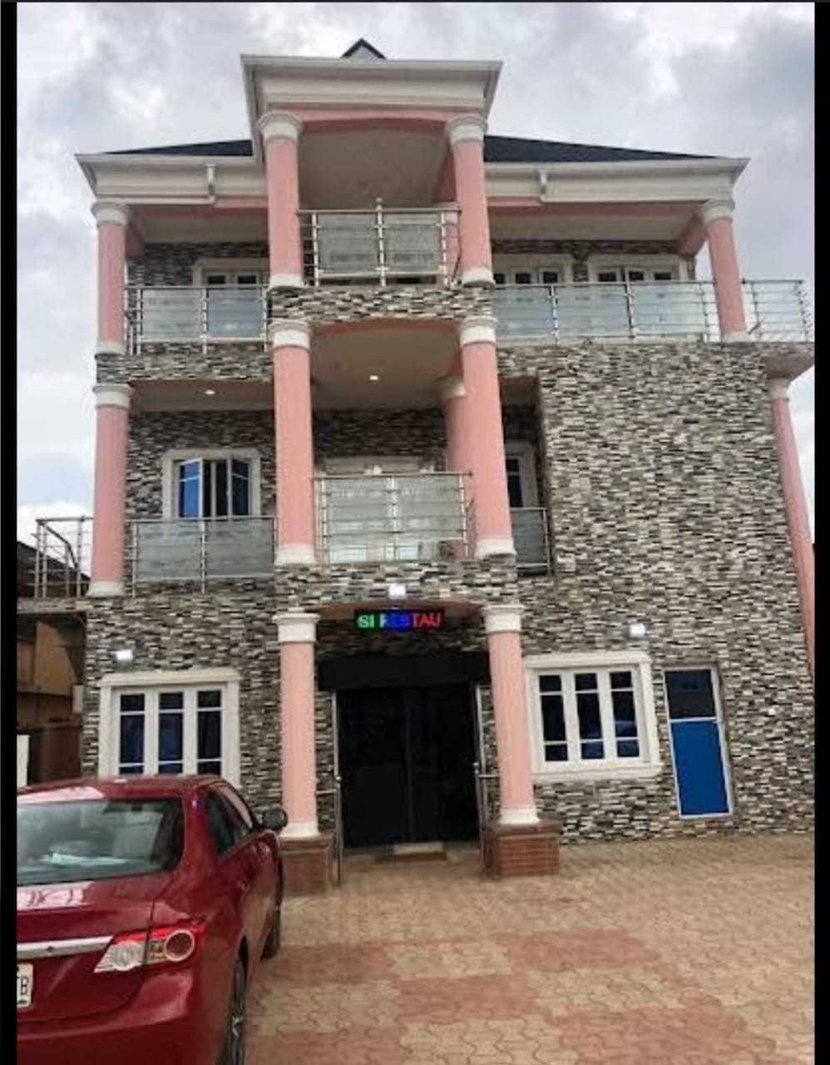

Plate 1: Front view of Iya Toyosi Restaurant, Sagamu, Ogun State

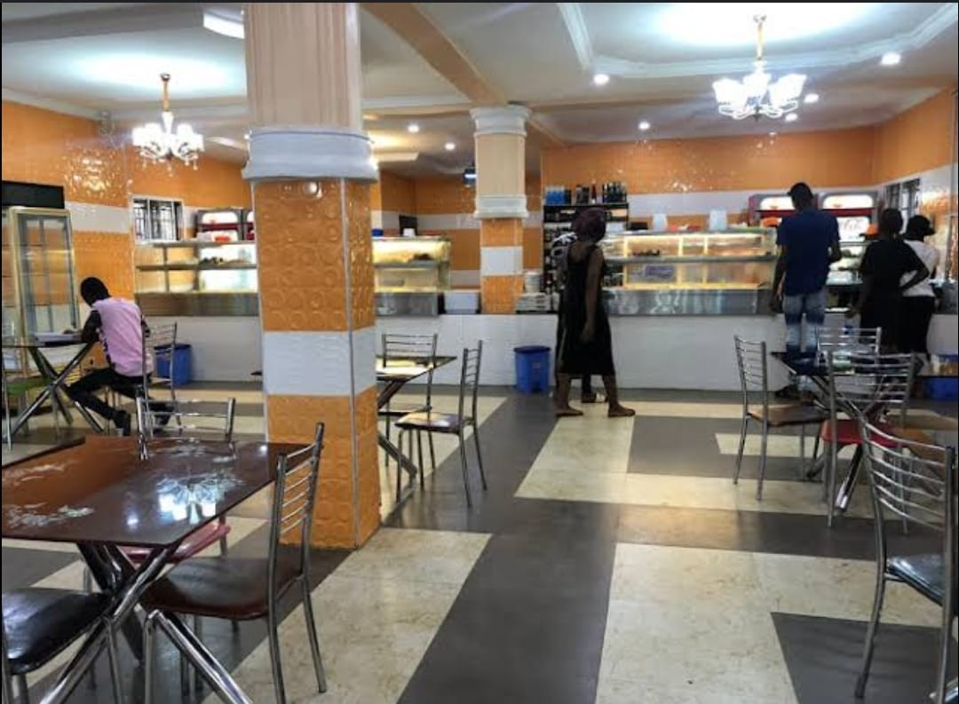
Plate 2 : Inside eating dinning of Iya Toyosi Restaurant, Sagamu, Ogun State

3.4 Case Study Two: Olla Food Restaurant, Osogbo, Osun State

Overview
- Location: Osogbo, Osun State
- Type: Casual dining and takeout restaurant
- Design Features: Brick façade, tiled interior, mechanical ventilation, counter-service layout

Merits
- Efficient Layout: Compact plan with functional kitchen, serving counter, and small seating area
- Modern Interior: Use of ceramic tiles, suspended ceilings, and bright lighting improves interior appeal
- Accessibility: Entrance ramp and wide interior paths accommodate people with disabilities
- Brand Identity: Color scheme and logo visible throughout interior for customer recall
- They have well furnish dinning
- There is natural lighting

Demerits
- Ventilation Dependence on A/C: Lack of cross-ventilation increases reliance on electrical cooling
- Limited Seating Capacity: Small size limits the number of customers that can dine-in simultaneously
- Noise Levels: Open-plan kitchen and hard surfaces create high reverberation during peak times
- Lack of Outdoor Dining: No provision for shaded external seating
- Insecurity
- Lack of cooking area
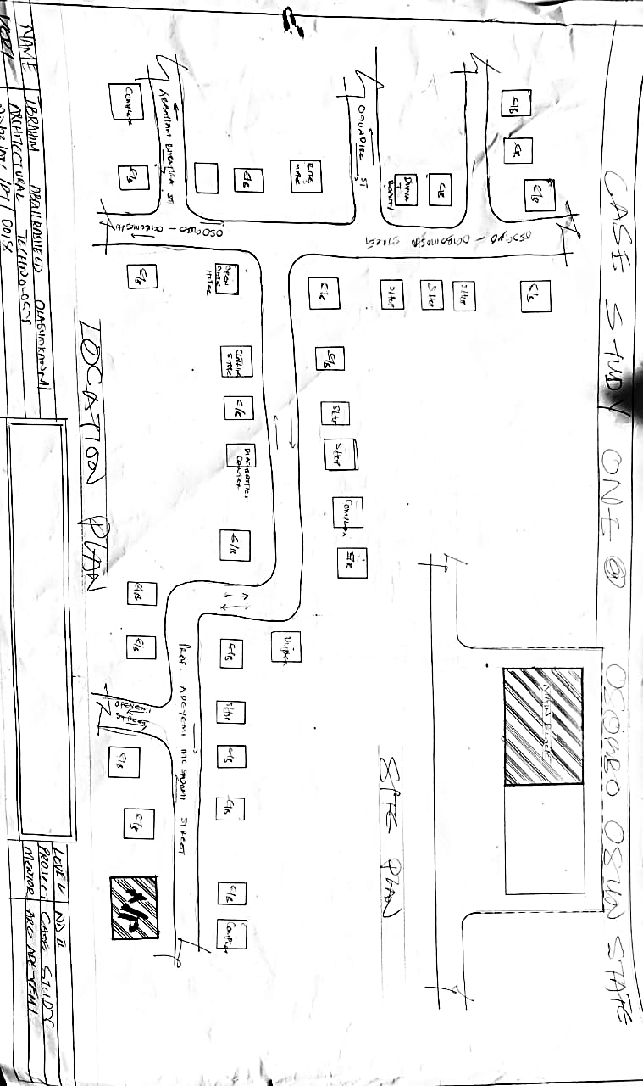

FIG 2; SHOWING LOCATION PLAN OFCASE STUDY TWO

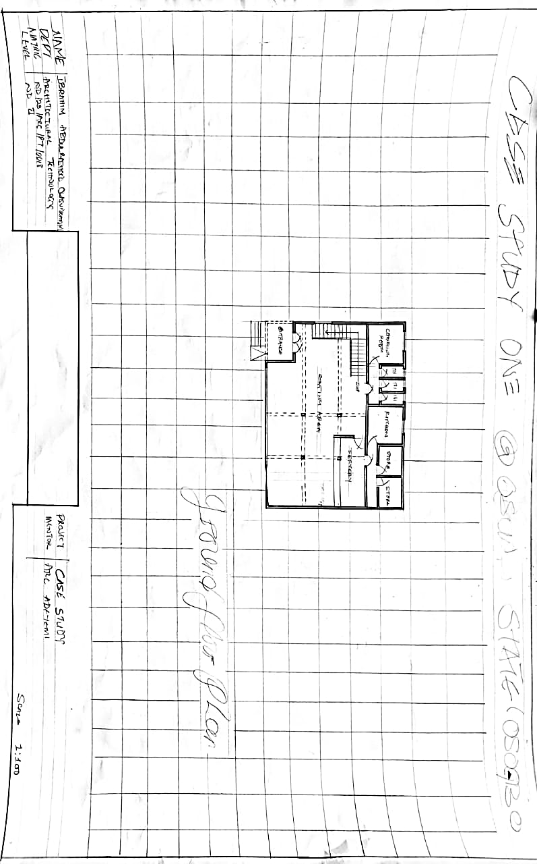
- FIG1;SHOWING floor PLAN OFCASE STUDY TWO

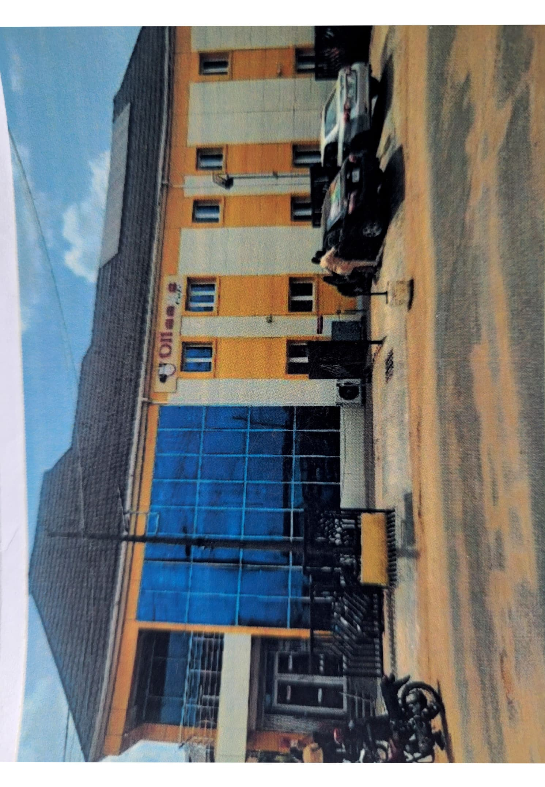
Plate3 : Front view of ollas food restaurant case study 2

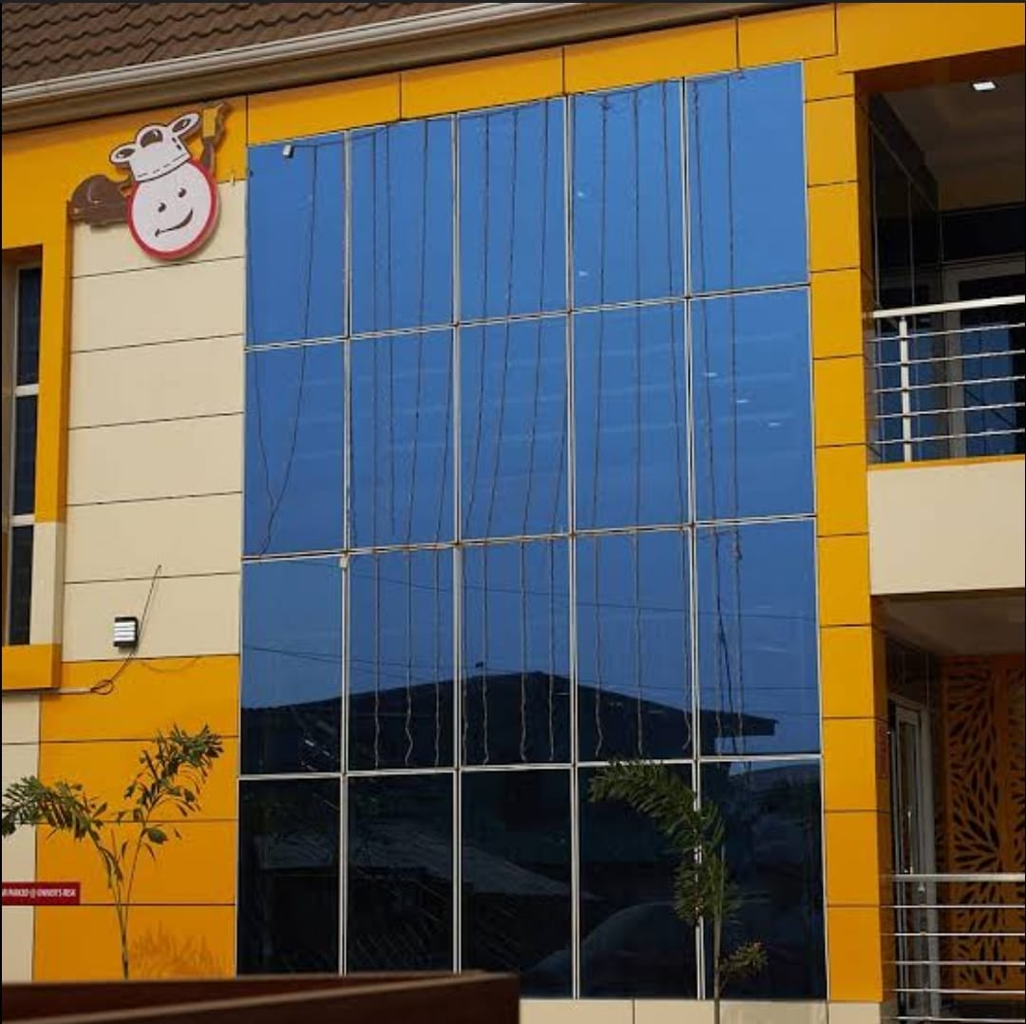

Plate 4 Side view of ollas food restaurant case study 2

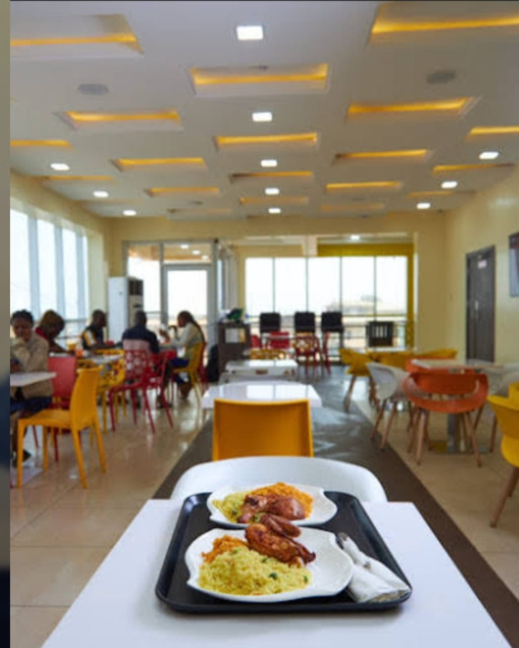

Plate 5 Inside and dinning of ollas food restaurant plate study 2

3.5 Case Study Three: Bossy Food Restaurant, Sagamu, Ogun State

Overview
- Location: Sagamu, Ogun State
- Type: Fast-food and event-friendly restaurant
- Design Features: Open dining hall, event stage, upstairs VIP section, mixed-use dining (indoor/outdoor)

Merits
- Multi-Functionality: Doubles as a restaurant and event space (birthdays, meetings, etc.)
- Spacious Layout: Multiple seating zones allow for varied user experiences
- Use of Local Materials: Polished concrete floors, clay bricks, and timber give the space warmth
- Ventilation Strategy: Combination of ceiling fans and natural ventilation
- Well furnish areas

Demerits
- Maintenance Issues: Larger space requires frequent cleaning and maintenance
- Acoustic Problems: Open ceilings and hard surfaces result in echo and noise buildup
- Inconsistent Branding: Interior design lacks a unified visual identity
- Accessibility Gaps: Upper floors lack elevator access for people with mobility challenges
- Lack of packing space
- Lack of security

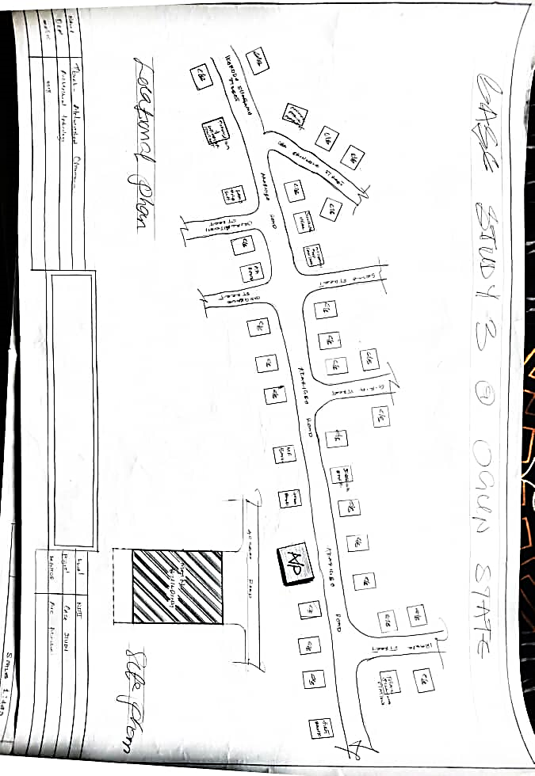
Plate 4 : showing location plan for case study 3

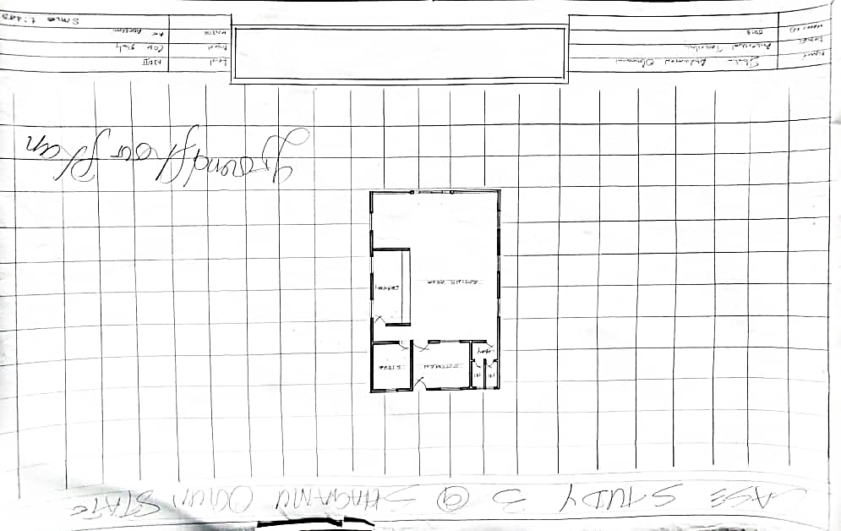
Plate 5 : showing floor plan of case study 3

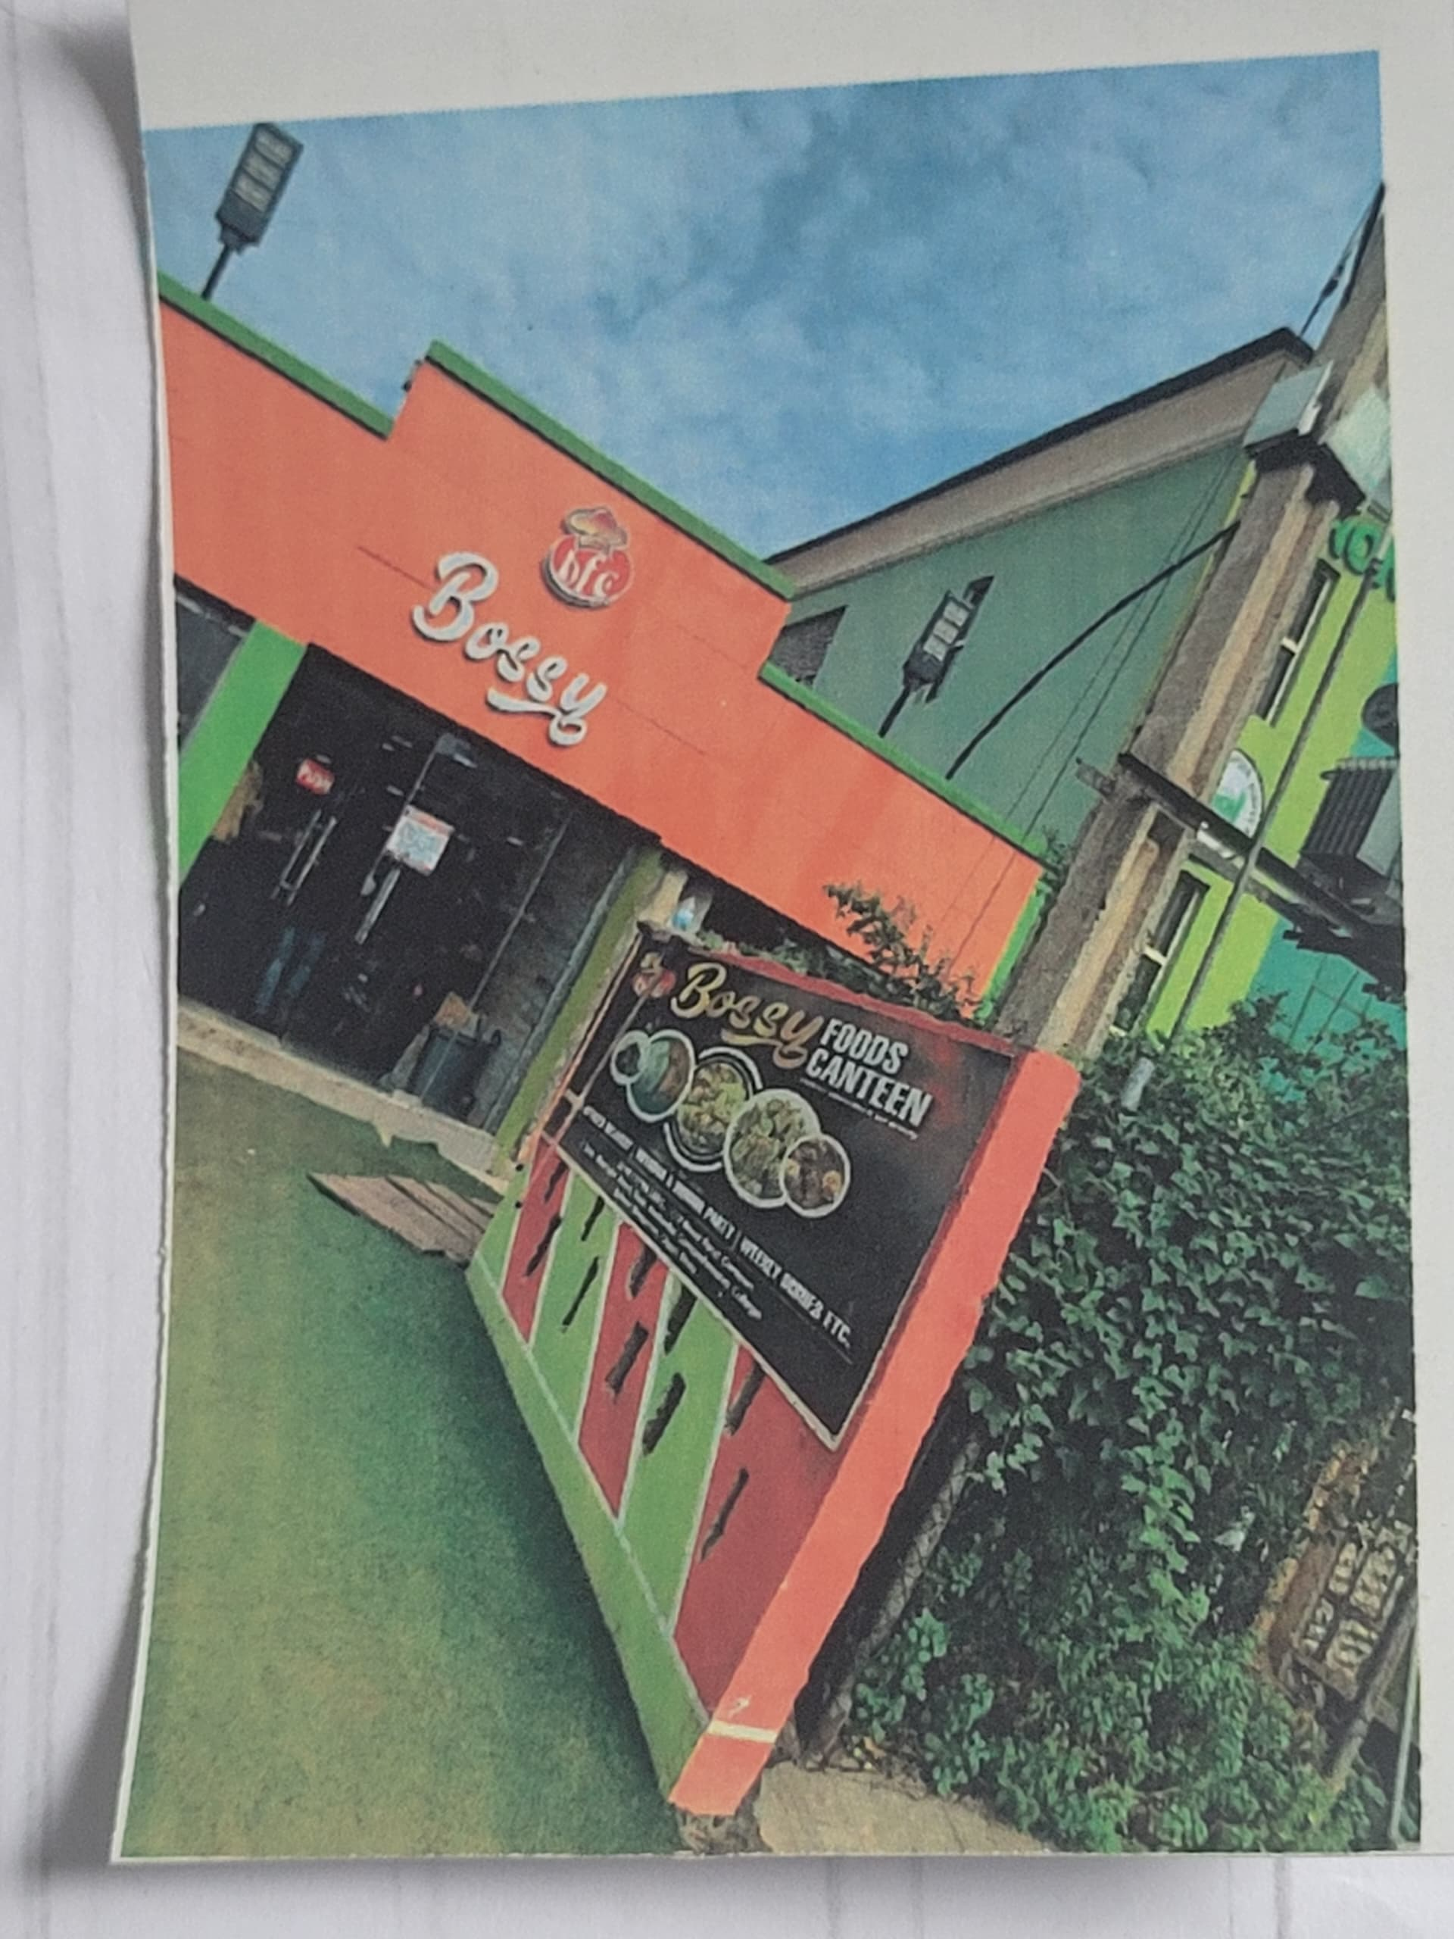

Plate:6 Showing Front View of Bossy Restaurant

3.6 Online Case Studies
Online case studies offer insight into global best practices, modern technologies, and contemporary architectural solutions. The following two online restaurants were studied due to their relevance in design innovation, spatial efficiency, and brand expression. They provide lessons applicable to the design of a restaurant in an urbanizing Nigerian context like Journalist Estate, Ilorin.

Online Case Study 1: International Restaurant – 4498 5th Ave, Brooklyn, NY 11220, USA

Overview
- Type: Full-service multicultural restaurant
- Location: 4498 5th Avenue, Brooklyn, New York
- Design Concept: Urban-modern with rustic influences
- Features: Mixed indoor and outdoor dining, glass façade, minimalist interiors, use of warm materials (timber, brick, pendant lighting)

Merits
- Efficient Use of Space: Despite being in a dense urban area, the restaurant uses vertical storage, built-in seating, and compact zoning.
- Visual Transparency: Glass façade creates openness and visual connection with the street.
- Natural and Artificial Lighting Blend: Large windows with task and ambient lighting create a warm dining atmosphere.
- Accessibility: ADA-compliant with ramps, wide entrances, and accessible restrooms.

Demerits
- Climate Dependence: Heavy use of glass requires HVAC systems year-round due to insulation issues.
- Limited Cultural Expression: Generic interior style lacks strong cultural identity.
- Noise Pollution: Street-facing design may lead to external noise infiltration.

Online Case Study 2: Modern Restaurant – Contemporary Fusion Restaurant, Beijing, China

Overview
- Type: High-end modern fusion restaurant
- Location: Beijing, China
- Design Theme: Futuristic minimalism with strong geometry and lighting design
- Features: Smart lighting systems, modular seating, concealed kitchen, dramatic ceiling design

Merits
- Innovative Spatial Experience: Creative use of space, lighting, and shapes makes the dining experience memorable.
- Technology Integration: Uses motion sensors, smart lighting, and automated ordering systems.
- Flexible Layout: Modular furniture allows the space to be reconfigured for events or group dining.
- Acoustic Design: Sound-absorbing ceiling panels and partitions improve comfort.

Demerits
- High Construction Cost: Finishes and technologies used are expensive and not cost-effective for developing contexts.
- Cultural Disconnection: Ultra-modern design can feel foreign or inaccessible in traditional communities.
- Maintenance Complexity: Technology systems require regular updates and skilled maintenance.

CHAPTER FOUR

SITE EVALUATION AND DESIGN CONSIDERATION

4.1 Brief Historical Background
Ilorin, the capital of Kwara State, was founded around 1450 and initially served as a frontier town under the Oyo Empire before becoming an emirate governed by the Fulani Caliphate in the 19th century. The city has evolved into a key administrative and commercial center, blending Islamic traditions with Yoruba heritage. Journalist Estate, located within the Ganiki axis of Ilorin South LGA, is a planned residential neighborhood designed to cater to media professionals and middle-income earners. The calm environment and reliable infrastructure present opportunities for sustainable commercial developments such as restaurants.
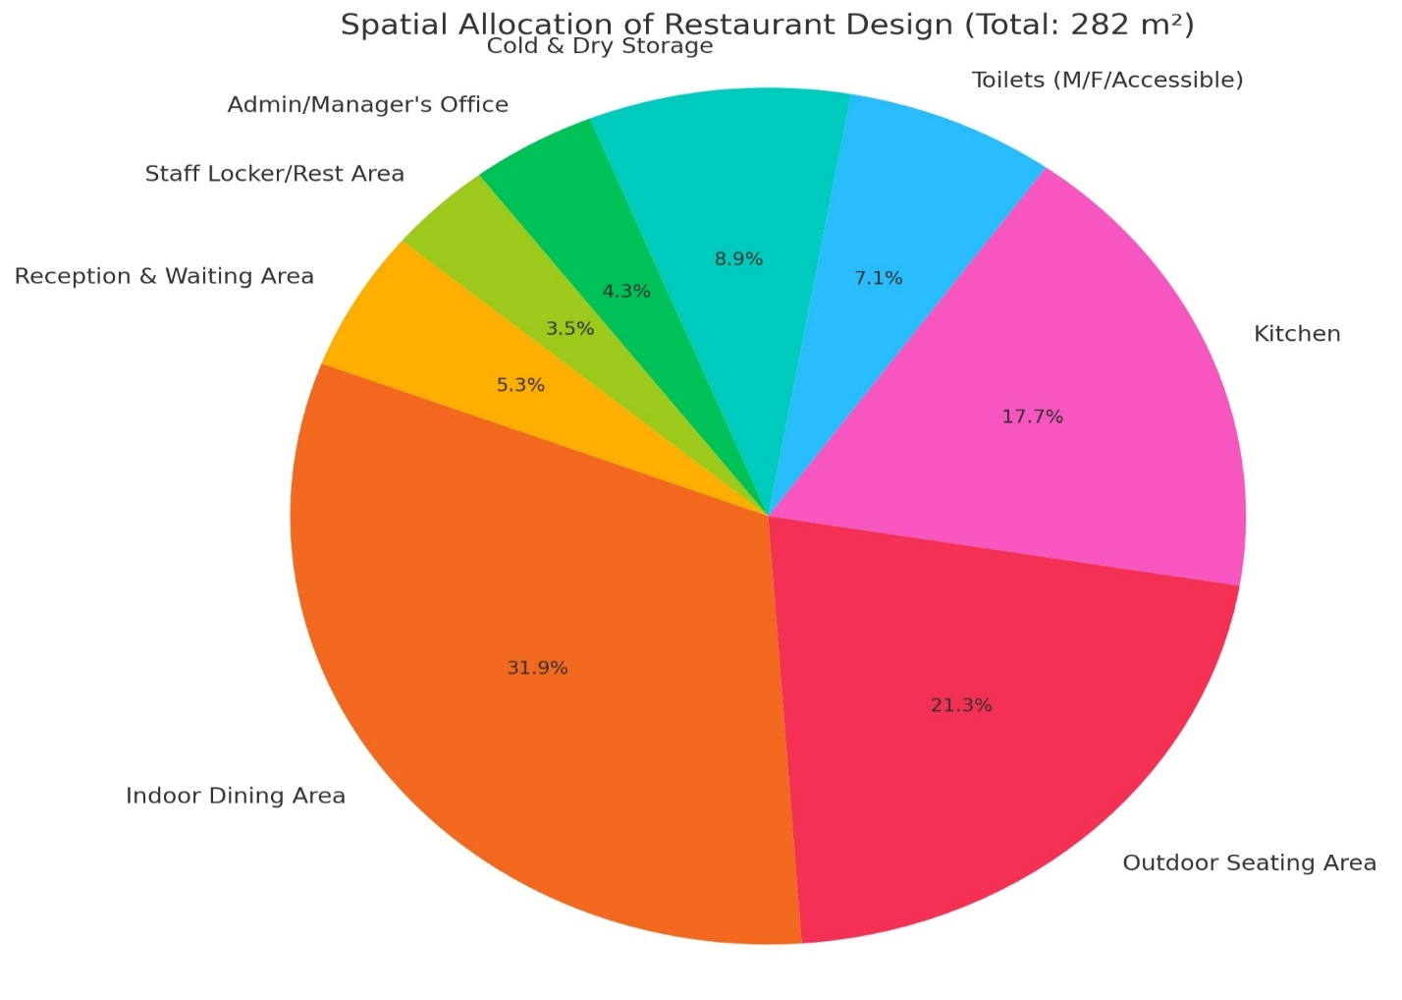

4.2 Location and Setting Out
The proposed restaurant site is situated along Offa Garage Road extension in Journalist Estate, Ganiki. Measuring approximately 1,200 square meters, the rectangular plot is bordered by residential plots and accessed via a tarred 9-meter-wide road. Its location ensures visibility and ease of design orientation for optimal land use.

4.3 Population
According to the 2006 National Population Commission (NPC) projections, Ilorin South LGA has a population of over 365,000. The estate is predominantly inhabited by professionals, including journalists, civil servants, and retirees. With an average household size of 5–6, there is a growing demand for quality leisure and dining facilities.

4.4 Site Inventory
- Current Use: Vacant, undeveloped plot
- Shape: Rectangular (approx. 30 m × 40 m)
- Vegetation: Sparse grasses and scattered shrubs
- Access: Via a 9-meter-wide asphalt road
- Utilities: Nearby electric poles and a public water supply line

Site Analysis
- Sun Path: Building fronts northeast, maximizing morning light and minimizing west heat
- Ventilation: Southeast prevailing wind direction supports natural ventilation
- Noise Level: Low ambient noise, conducive for dining atmosphere
- Drainage: Slight rearward slope aids natural stormwater runoff
- Visibility: Road-front location ensures commercial visibility

4.6 Site Selection and Justification
Reasons for selecting the site include:
- Accessibility via well-connected road networks
- Market Potential from nearby residents and institutions
- Compliance with zoning laws permitting mixed-use development
- Topography & Soil Suitability for shallow foundations
- Proximity to schools, offices, and public transportation routes

Location
- Coordinates: 8.4773° N, 4.5427° E
- Distances:
  - 3.2 km to Ilorin Mall
  - 1.5 km to Tanke Junction
  - 4 km to University of Ilorin Mini Campus

Accessibility
- Road Access: Tarred road connects to Offa Garage and Tanke routes
- Transport Options: Private vehicles, taxis, motorcycles, and pedestrian access
- Provision: Dedicated parking and access ramps for disabled patrons

Infrastructure Facilities
- Electricity: Supplied by the national grid with nearby transformers
- Water: Connected to public mains; provision for borehole backup
- Sewage: Soakaway and septic tank system
- Telecom: GSM and fiber network coverage for internet-enabled services

4.10 Topography
The site has a gentle 3% gradient sloping to the rear, enabling natural drainage with minimal grading.

4.11 Soil Structure
Geotechnical analysis indicates firm lateritic soil, ideal for strip or pad foundations. The bearing capacity supports low-rise development with minimal reinforcement.

4.12 General Climate Condition
Ilorin has a tropical savanna climate, featuring:
- Rainy Season: April to October
- Dry Season: November to March
- Annual Rainfall: 1,200–1,300 mm

elative Humidity
- 40–50% during dry season
- 80–90% during wet season
This necessitates materials that resist mold and condensation.

4.14 Wind
Prevailing southeast winds (8–15 km/h) offer opportunities for cross-ventilation and passive cooling strategies.

Temperature
- Average Range: 27°C–34°C
- Peak Heat: February–April (up to 38°C)
- Coolest Period: December–January (20–25°C)

4.16 Vegetation
The site’s natural vegetation is limited but will be enhanced through:
- Ornamental shade trees
- Green buffer zones
- Edible plants to complement outdoor dining

4.17 Road
The estate road is a 9-meter-wide asphalt surface. The design will include:
- Drive-through access
- 10–12 designated parking bays
- Loading/unloading zone for deliveries

ater and Electricity
- Water Supply: Borehole with 2,000-liter overhead storage
- Power Supply: 3-phase grid electricity; 5kVA solar inverter system as backup

Design Criteria
- Functionality: Efficient workflow from kitchen to service areas
- Sanitation: Use of water-resistant materials and non-slip floors
- Energy Use: Solar panels, LED lighting, cross-ventilation
- Accessibility: Inclusive design (ramps, wide doors, accessible restrooms)
- Safety: Emergency exits, fire extinguishers, CCTV, and signage

4.20 Design Brief
The restaurant will accommodate 60–100 customers per day, offering:
- Indoor and outdoor dining
- Reception and waiting area
- Full-service kitchen
- Administrative and staff rooms
- Parking and landscaped outdoor space

4.21 Design Analysis
Key planning elements include:
- Functional zoning for customer and service flows
- Strategic orientation to minimize heat gain
- Passive cooling with louvered windows and roof overhangs
- Space efficiency through linear circulation patterns

Planning Principles
- Zoning: Clear demarcation between service and public zones
- Circulation: Direct, non-intersecting movement paths
- Orientation: Northeast-facing to reduce heat gain
- Open Space: Outdoor seating integrated into green landscaping
- Sustainability: Solar energy, natural lighting, rainwater harvesting considered

CHAPTER FIVE

APPROACH TO THE DESIGN /DESIGN REALIZATION

5.1 Design Ideas and Concepts at Different Levels

5.1.1 Site-Level Design Concepts
The restaurant site was carefully analyzed and planned to respond to both functional requirements and environmental conditions. The building sits at the central axis of a rectangular plot to optimize space usage, create symmetry, and allow for circulation, parking, landscaping, and possible future expansion. Its orientation follows the east-west axis, minimizing direct sun penetration and promoting thermal comfort through natural shading.
Landscaping is used as a buffer to reduce road noise, create an inviting entry, and increase the site’s ecological value. Open-air seating is placed in the southern and eastern corners, where natural shading is optimized, while vehicular and pedestrian access points are clearly separated for safety.

5.1.2 Building-Level Design Concepts
The building is conceived with a modern architectural character, combining form and function. It features a rectilinear layout, where zones such as dining, kitchen, toilets, and services are arranged logically for ease of movement and efficient operations. The entrance opens into a central reception lobby, which serves as the distribution node to the indoor and outdoor dining zones.
The design emphasizes passive environmental strategies, including:
- Large fenestrations for natural daylight
- Clerestory windows for warm air escape
- Louvers and cross-ventilation pathways
- Biophilic elements like indoor plants, courtyards, and water features to enhance ambiance
These strategies reduce mechanical energy consumption and promote sustainability and user well-being.

5.2 Technological and Environmental Criteria

Construction Methodology and Material Finishes
- Structure: Reinforced concrete frame with sandcrete block infill for durability and local availability.
- Wall Finish: Internal surfaces are smooth-finished and painted with emulsion paint; external walls use cement render with waterproof coating for resilience.
- Roofing: Long-span aluminum sheets paired with heat-resistant insulation boards to improve thermal efficiency.
- Flooring: Public zones use non-slip ceramic tiles, while service and storage areas use polished concrete for ease of cleaning and maintenance.

5.2.2 Services Required
- Circulation: Paths are defined with wide corridors for free movement. Wheelchair-accessible ramps ensure inclusivity.
- Ventilation: Combination of cross-ventilation, ceiling fans, and high vents support natural cooling.
- Lighting: Ambient LED lighting throughout; focused lighting in the kitchen; skylights reduce reliance on artificial lighting.
- Plumbing: Water is sourced from a borehole; kitchen and sanitary zones are equipped with both cold and hot water outlets.
- Electrical Installation: Powered by both 3-phase public grid and solar hybrid backup system, including inverters and batteries.

Environmental Conditions to be Achieved
- Thermal Comfort: Controlled via shading, natural airflow, and insulated roofing.
- Air Quality: Ensured through fresh air circulation and non-toxic paints/adhesives.
- Noise Management: Landscaping buffers and sound-insulated partitions.
- Daylight: Achieves daylight factor of 60% in customer areas through windows and skylights.

5.2.4 Performance Standards
Parameter | Target
Daylight Factor | Minimum 60% in all dining areas
Indoor Noise Level | Below 40dB
Thermal Comfort | 24°C – 28°C
Energy Efficiency | At least 30% reduction compared to baseline
Accessibility Compliance | Full accessibility for disabled persons

5.3 Legal Issues and Planning Regulations
The restaurant design adheres strictly to both local and national regulatory frameworks:
- Zoning: Journalist Estate is zoned for mixed-use developments, including commercial activities like restaurants.
- National Building Code (NBC): The design complies with minimum standards for fire safety, structural integrity, sanitation, accessibility, and waste disposal.
- Setbacks: The site plan respects required 3m front and 2m rear/side setbacks to promote safety and air circulation.
- Environmental Approval: The project is registered for an Environmental Impact Assessment (EIA) under the Kwara State Environmental Protection Agency, with assessments on solid waste management, energy use, and public health.

5.4 Behavioral Pattern and Considerations
Design considerations were made to accommodate the behavioral patterns of users:
- Customer Comfort: Seating is organized into clusters for individuals, couples, and families. Outdoor seating zones support informal and leisure dining.
- Workflow for Staff: A linear kitchen layout ensures smooth food preparation and service flow. Storage and prep zones are kept away from customer paths.
- Cultural Sensitivity: Restrooms are designed to respect gender separation norms. Dining arrangements reflect both Western table seating and local communal dining practices.
- Wayfinding: Clear signage and intuitive movement paths guide users easily to various zones, reducing congestion.
- Inclusive Design: Provisions for wheelchair users, elderly patrons, and children are fully integrated.

CONCLUSION AND RECOMMENDATIONS

5.5 Conclusion
This research and design study on the Proposed Restaurant at Journalist Estate, Ganiki, Ilorin has explored, analyzed, and responded to the multifaceted needs of siting, designing, and realizing a modern restaurant in a growing residential estate within Ilorin metropolis. Drawing from a comprehensive review of the literature, historical precedents, and the site’s environmental and socio-economic context, the design was guided by sustainable, functional, and user-centered principles.
The final architectural proposal embodies the essence of comfort, efficiency, aesthetic appeal, and environmental responsiveness. Site planning considered accessibility, topography, vegetation, and noise buffers, while the building layout promotes optimal customer flow, kitchen operation, and thermal comfort. Material selection, ventilation strategies, and utility systems were designed to align with both client goals and performance standards, such as reduced energy consumption and improved air quality.
Furthermore, planning regulations from the Kwara State Physical Planning Authority and Nigerian Building Code were strictly adhered to in the zoning, setback, fire protection, and environmental compliance of the restaurant. Behavioral patterns, such as dining preferences, movement flow, and cultural relevance, were also integrated into the final design.
Thus, the project successfully meets its aim of creating a contemporary, functional, and contextually appropriate restaurant that enhances the social and economic life of the community while embracing sustainability and inclusivity.

5.6 Recommendations
- Implementation of Passive Design Strategies in Similar Projects
Future restaurant developments, especially in tropical regions like Ilorin, should continue to prioritize passive design principles such as cross ventilation, shading devices, and orientation-based planning to reduce reliance on mechanical cooling systems and minimize operational costs.
- Further Integration of Renewable Energy Systems
While a solar backup system was integrated in this design, it is recommended that future expansions or similar restaurant projects move toward fully off-grid solutions. Incorporating photovoltaic panels, solar water heating systems, and energy-efficient appliances will significantly enhance environmental performance.
- Digitally-Enhanced Customer Experience
It is advisable for future research and designs to explore the incorporation of digital technologies such as online ordering, automated billing, touchless restrooms, and mobile app integration for reservations and feedback collection to enhance customer satisfaction and streamline operations.
- Post-Occupancy Evaluation (POE)
After the restaurant is operational, a POE should be conducted to assess user satisfaction, energy consumption, waste management efficiency, and functional layout effectiveness. These findings can inform future architectural improvements and policy decisions.
- Research into Local Material Innovations
Future research should investigate the use of locally sourced, low-cost, and climate-resilient materials for construction to support sustainability and reduce dependence on imported finishes.

REFERENCES
- Akande, O. K. (2013). Environmental Design for Hot and Humid Regions: Principles and Practices. Lagos: College Press.
- Akinola, S. R. (2015). “Climate Responsive Architecture in Nigeria: Issues and Prospects.” Nigerian Journal of Environmental Design, 7(2), 110–120.
- Ayoola, M. B. (2018). Introduction to Building Design in Nigeria. Ilorin: Harmony Publishers.
- Bello, A. A. & Usman, M. A. (2020). “Site Planning and Land Use for Urban Commercial Facilities.” Journal of Environmental Management, 15(1), 23–35.
- Ede, A. N. (2014). “Building Collapse in Nigeria: Issues and Challenges.” Conference Proceedings of the Nigerian Institute of Building, 2(1), 25–32.
- Federal Republic of Nigeria. (2006). National Building Code. Lagos: Federal Ministry of Works and Housing.
- Hassan, M. T. & Salami, O. L. (2016). “Accessibility in Public Buildings for People with Disabilities in Nigeria.” Journal of Architecture and Built Environment, 4(3), 87–95.
- Kwara State Physical Planning Authority (2022). Zoning and Setback Guidelines for Residential Estates. Ilorin: KWSPPA.
- Nwokoro, I. & Onukwube, H. (2019). “Passive Design for Thermal Comfort in Restaurant Buildings in Nigeria.” International Journal of Sustainable Architecture, 3(4), 44–56.
- Olotuah, A. O. (2002). Design Principles in Architecture. Akure: Kayode Publishing.
- Olorunfemi, D. I. (2017). “Planning Regulations and Urban Development in Kwara State.” African Journal of Urban Studies, 8(2), 60–72.
- Oyenuga, A. & Ogunleye, O. (2015). “Design Considerations for Food Facilities in Tropical Environments.” Journal of Hospitality Architecture, 2(1), 34–45.
- Sanni, A. O. (2020). Landscape Architecture and Sustainable Urbanism in Nigeria. Abuja: Urban Trends Press.
- United Nations Habitat (2012). Designing for Sustainable Cities. Nairobi: UN-HABITAT.
- World Bank. (2021). Nigeria Climate Change Profile: Environmental Indicators and Trends. Washington D.C.: World Bank Publications.

