

PROJECT

ON
DESIGN AND CONSTRUCTION OF FEED HOPPER
BY

KAYODE ROLAKE OLUWASEUN

ND/23/ SLT/ PT /0408

SUBMITTED TO THE DEPARTMENT OF SCIENCE LABORATORY TECHNOLOGY

(PHYSICS UNIT), INSTITUTE OF APPLIED SCIENCE KWARA STATE POLYTECHNIC ILORIN IN PARTIAL FULFILLMENT OF THE REQUIREMENT FOR THE AWARD OF NATIONAL DIPLOMA (ND) IN SCIENCE LABORATORY TECHNOLOGY

SUPERVISOR BY: AGBOOLA A.O

2024/2025 SESSION

CERTIFICATION

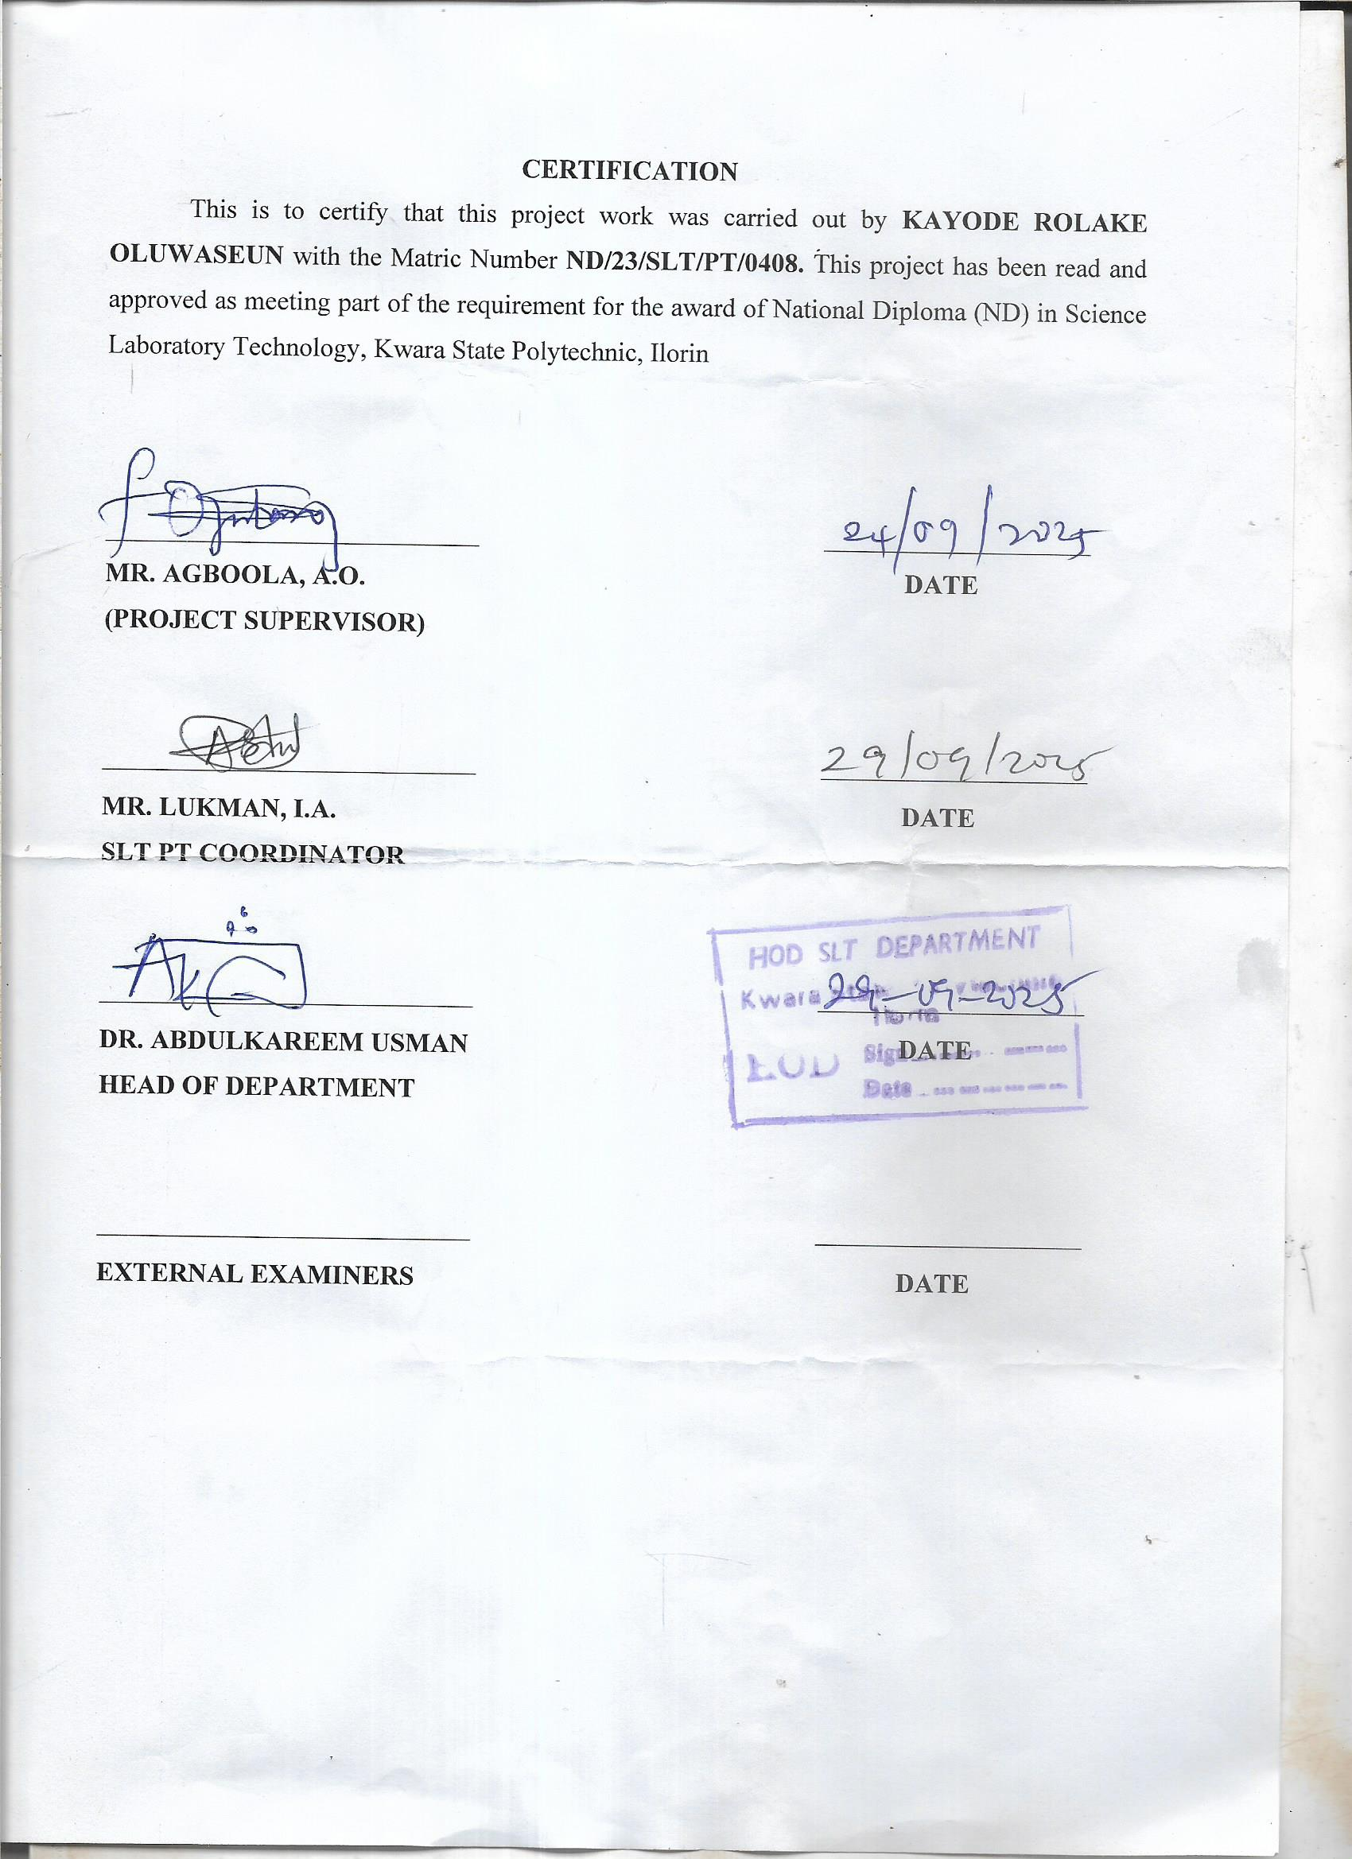
DEDICATION
this project is dedicated to almighty god whose supremacy in the knowledge of everything is absolute and to our entire family member

ACKNOWLEDGEMENT
Glory be to almighty god the lord of the world. who has been through his mercy for sparing our life till today this project would not. have been possible if not because of the invaivable input and assistance of some people whose in one way or the other made on immense contribution measuring a betterment of life.
Firstly. words are not enough or how we could express our profound and in depth love towards our supervisor.mr Agboola. A.O . who not only played the role of supervisor but also combine it with that of a father. We will forever be grateful to you may almighty god continue to bless you abundantly in all your endeavors in life
We will new direct our profound gratitude to our beloved parents whose have provided the needed financial assistance cover right from the day of birth to this stage. may the almighty god grant our parents long life and prosperity. so they could reap the fruit of their labor and crown their effort with success and continue to guide and protect them in their short comings(amen)

ABSTRACT
An abstract is a brief summary of a research paper, article, or document that highlights it's main points , methodology and conclusion. It provides readers, with a concise overview, helping them determine the relevance and significance of the work.

TABLE OF CONTENT
ABSTRACT i
ACKNOWLEDGE ii
TITTLE PAGE iii
CERTIFICATE iv
DEDICATIONS
CHAPTER ONE
1.0 ABSTRACT
I.1 INTRODUCTION TO FEED HOPPER
CHAPTER TWO
2:0 LITERATURE REVIEW
2:1 TYPE OF FEED HOPPER
2:2 USE OF FEED HOPPER
CHAPTER THREE
3:0 METHODOLOGY
3:1 EXAMPLE OF FEED HOPPER
3:2 MATERIAL
3:3 TOOLS USED
3:4 DESIGN
CHAPTER FOUR
4:1 DISCUSSION
4:2 PHYSICS PRINCIPLE OF WELDING IN METAL

CHAPTER FIVE
5:0 SUMMARY
5:1 CONCLUSION
5:3 REFERENCE

CHAPTER ONE
1:0 INTRODUCTION TO FEED HOPPER
Feed hopper is a device used to store and dispense material, often in industrial setting, providing a controlled flow of bulk material to subsequent processes it, essentially a holding tray designed to pour or feed large quantities of material, like waste, scrap metal, or raw materials, into a separate container or machine.
Hopper hold material and release them in a controlled manner, often using gravity or vibration. Mechanisms to control the flow of material
Feed hopper hold large quantities of material, allowing for efficient handing and release into the processing equipment. They are design to deliver material in a controlled and continuous manner, ensuring optimal
Performance of downstream machinery. Commonly used in recycling plants, scrap metal processing, and various industrial processes where bulk material need to be handled .
Feed hopper can handle a wide variety of materials, including scrap metal waste, shredded material and other bulk products

CHAPTER TWO
2:0 LITERATURE REVIEW
A literature review on feed hopper explore the critical role of animal feed in livestock production, examining it's impact on animal health, productivity, and resources utilization . It investigates the importance of feed quality. Alternative feed source, and the influence of feed management practices on animal
Performance. The review also delves into the economic and environmental implications of feed production and consumption
2:1 TYPE OF FEED HOPPER
- Gravity hopper
- Force feed hopper
- Vacuum hopper
- Tilted plane hopper
- Vibratory hopper
- Screw feeder
- Belt feeder
- Pneumatic feeder
- Rotary feeder
2:2 USES OF FEED HOPPER
Feed hoppers have various uses across industries, including:
- Livestock feedingFeed hoppers dispense animal feed, ensuring consistent and efficient feeding.
- Food processing Hoppers store and feed ingredients into processing lines, maintaining production flow.
- Pharmaceutical Feed hoppers handle powders and granules, ensuring accurate dosing and mixing.
- Agriculture Hoppers store and dispense seeds, fertilizers, and pesticides.
- ManufacturingFeed hoppers supply raw materials to production lines, such as plastics, chemicals, or powders.
Material handlingHoppers manage bulk materials like grains, powders, or pellets.
The benefits of using feed hoppers include:
Improved efficiency
- Consistent material flow
- Reduced waste
- Enhanced accuracy
- Increased productivity

CHAPTER THREE
3:0 METHODOLOGY
Methodology is the specific procedures or techniques used to identify, select, process, and analyze information about a topic. In a research paper, the methodology section allows the reader to critically evaluate a study's overall validity and reliability. Material and method can be made of steel for robustness and are used with various machinery like scrap metal balers or other processing equipment. Hopper feeders work by gravity or vibration to dispense materials at a controlled rate.
3:1 EXAMPLE OF FEED HOPPER
Material Analysis Determine the properties of the material being handled, such as flowability, density, and particle size.
- Hopper Design Calculate the optimal hopper shape, angle, and size based on material properties and flow requirements.
Flow Pattern Determine the desired flow pattern (mass flow or funnel flow) based on material characteristics and application needs.
Outlet Design Design the outlet to ensure smooth material discharge and prevent clogging.
- Structural Integrity Ensure the hopper's structural integrity to withstand material weight and flow forces.
Testing and Validation Test the hopper's performance and validate its design through experiments or simulations.
Some common design considerations include:
Hopper angle and shape
- Outlet size and shape
- Material of construction
- Liner materials (if applicable)
- Flow-promoting features (e.g., vibrators or aeration systems)
3:2. MATERIAL
Some common materials for feed hoppers include:
- Stainless Steel
- Mild Steel
- Galvanized Steel
- Aluminum
- Plastic (e.g., HDPE, PVC)
The choice of material depends on factors like:
- Corrosion resistance
- Durability
- Ease of cleaning
- Cost
- Compatibility with the material being handled

3:3 TOOLS USED

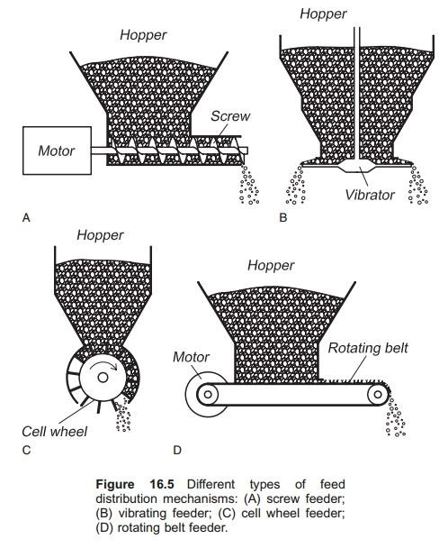
3:4 DESIGN
The design of a feed hopper involves several key considerations:
1. *Shape and Angle*: The hopper's shape and angle are critical to ensure smooth material flow and prevent clogging.
Outlet Design
The outlet size and shape determine the flow rate and material discharge.
- Material of Construction*: The material used for the hopper should be durable, corrosion-resistant, and compatible with the material being handled.
. Flow Pattern The hopper design should promote either mass flow or funnel flow, depending on the material's characteristics and application requirements.
Structural Integrity The hopper's structure should withstand the weight and flow forces of the material.

Some common design features include:
- Cynical or pyramidal shapeTo promote smooth material flow
- Vibrators or aeration systems*: To prevent clogging and promote flow
Liner materials To reduce friction and prevent material buildup Inspection and cleaning access To facilitate maintenance and troubleshooting

CHAPTER FOUR
4:1 DISCUSSION
Let's discuss feed hoppers!
Feed hoppers are crucial in various industries, including agriculture, food processing, and pharmaceuticals. They ensure a consistent and controlled flow of materials, improving efficiency and productivity.
4:2 PHYSICS PRINCIPLE OF WELDING IN METAL
Welding involves joining two metal pieces by applying heat, pressure, or both, to create a strong bond. The physical principles behind welding include:
Thermal Expansion Metals expand when heated, allowing them to fuse together.
Melting and Solidification The metal is melted and then solidifies, forming a strong bond.
- Diffusion Atoms from each metal piece diffuse into each other, creating a strong metallurgical bond.
- Heat TransferHeat is transferred from the welding source to the metal, melting and joining the pieces.
Some common welding processes include:
Shielded Metal Arc Welding (SMAW)
- Gas Metal Arc Welding (GMAW)
- Gas Tungsten Arc Welding (GTAW)
- Resistance Spot Welding (RSW)

CHAPTER FIVE
5:0 SUMMARY
Here's a summary on feed hoppers:
What is a Feed Hopper?
A feed hopper is a device used to store and dispense materials, such as grains, powders, or pellets, in a controlled manner.
5:1 CONCLUSION
In conclusion, feed hoppers are essential devices in various industries, providing a controlled and efficient way to store and dispense materials. Their design and functionality play a critical role in ensuring smooth material flow, reducing waste and improving productivity
5:2 REFERENCE
Here are some potential references on feed hoppers:
- Industry publications Journals like Powder Handling, Material Handling, or Feed & Grain magazines.
- Manufacturer websites. Companies like Buhler, Schenck Process, or Martin Sprocket & Gear.
- Technical papers Research articles on hopper design, material flow, and silo technology.
- Books*Bulk Solids Handling" by Colin R. Woodcock, "Powder Technology" by Fayed and Otten. Industry associations*: American Society of Agricultural and Biological Engineers (ASABE), International Society for Bulk Solids Handling (ISBSH).

