THE ROLE OF MEDIA IN DISASTER MANAGEMENT, EMERGENCY RESPONSE AND RECOVERY EFFORTS

BY
OWOLABI MISTURA OPEYEMI
ND/23/MAC/PT/0954

SUBMITTED TO:
DEPARTMENT OF MASS COMMUNICATION

INSTITUTE OF INFORMATION AND COMMUNICATION TECHNOLOGY (IICT) KWARA STATE POLYTECHNIC, ILORIN

SUPERVISED BY:

MR. OLUFADI B.A

CERTIFICATION
This is to certify that research work has been read and approved as meeting the requirement for the award of national diploma (ND) Mass Communication Department, Institute of Information and Communication Technology, Kwara State Polytechnic, Ilorin

__________________________________ __________________
MR. OLUFADI B. A DATE
(Project Supervisor)

__________________________________ __________________
MRS. OPALEKE G.T DATE
(Project Coordinator)

__________________________________ __________________
MRS. OPALEKE G.T DATE
(Head of Department)

DEDICATION
This project is wholeheartedly dedicated to God Almighty, for His grace, wisdom, and strength throughout the course of this work.
My beloved parent, for their endless love, prayers, and unwavering support that have shaped my academic journey.
To my lecturers and supervisors, whose guidance and encouragement have been invaluable. And to all my friends and colleagues, for their inspiration, assistance, and companionship throughout this project.

ACKNOWLEDGEMENT
First and foremost, we give all glory and thanks to God Almighty for His guidance, strength, and wisdom throughout the course of this project.
My sincere appreciation goes to my project supervisor, [MR. OLUFADI B.A], for his invaluable guidance, constructive criticism, and encouragement at every stage of this work. Your support made a significant impact on the successful completion of this project.
I am deeply grateful to my beloved parents for their unwavering love, moral and financial support, and constant prayers. Your belief in me has been my greatest motivation.

ABSTRACT
Disasters, whether natural or man-made, continue to pose significant threats to human life, property, and socio-economic stability. Effective disaster management requires not only government and institutional interventions but also active participation of the media as an intermediary between authorities and the public. This study examined the role of the media in disaster management, with emphasis on emergency response and recovery efforts. The research employed a survey design, using structured questionnaires to collect data from 100 respondents drawn from selected wards. Data were analyzed using descriptive statistics and presented in tables and charts. The findings revealed that the media plays a vital role in disaster preparedness, as 76.1% of respondents agreed that the media enhances public awareness and readiness. Furthermore, the study established that the media contributes significantly to rapid emergency response by providing timely and reliable information during crisis situations. In terms of recovery, respondents acknowledged that media coverage attracts humanitarian aid and sustains public interest in long-term rehabilitation. However, the study also highlighted critical challenges, including the spread of fake news, lack of specialized training for journalists, restricted access to disaster sites, and inadequate funding. These issues often undermine the credibility and efficiency of media reportage.
The study concludes that the media is not just an observer but a crucial stakeholder in disaster management. It recommends capacity building for journalists, stronger collaboration between media and disaster agencies, fact-checking mechanisms to combat misinformation, and increased government and private sector support for disaster reportage. By strengthening these areas, the media can play a more effective role in minimizing disaster impacts, facilitating emergency response, and enhancing recovery efforts.
Keywords: Media, Disaster Management, Emergency Response, Recovery, Nigeria.

Table of Contents
Chapter One: Introduction
1.1 Background of the Study
1.2 Statement of the Problem
1.3 Objectives of the Study
1.4 Research Questions
1.5 Significance of the Study
1.6 Scope and Limitations of the Study
1.7 Definition of Key Terms
Chapter Two: Literature Review
2.1 Concept of Disaster Management
2.2 Types and Phases of Disasters
2.3 Role of Media in Society
2.4 Theoretical Framework
2.5 Empirical Review of Related Studies
2.6 Summary of Literature Review
Chapter Three: Research Methodology
3.1 Research Design
3.2 Population and Sampling Techniques
3.3 Data Collection Instruments
3.4 Method of Data Analysis
3.5 Ethical Considerations
Chapter Four: Data Presentation, Analysis and Discussion
4.1 Presentation of Data
4.2 Analysis of Research Questions
4.3 Discussion of Findings
4.4 Case Studies
4.4.1 Local Case Study (e.g., Floods in Nigeria)
4.4.2 International Case Study (e.g., Earthquake in Haiti)
4.4.3 Comparative Insights
Chapter Five: Summary, Conclusion and Recommendations
5.1 Summary of Findings
5.2 Conclusion
5.3 Recommendations
5.4 Suggestions for Further Studies
References
Appendices
- Appendix A: Questionnaire/Interview Guide
- Appendix B: Tables and Charts
- Appendix C: Other Relevant Documents

CHAPTER ONE

1.1 INTRODUCTION
Disasters whether natural, such as floods, earthquakes, and hurricanes, or man-made, including industrial accidents, armed conflict, and technological failures—pose significant threats to human life, infrastructure, and socio-economic stability. The increasing frequency and intensity of these disasters have drawn global attention to the need for efficient and proactive disaster management systems (Adewale, 2019). Among the key actors involved in such systems is the media, which plays a vital role in information dissemination, public education, and emergency coordination.
Media outlets—spanning print, broadcast, and digital platforms—serve as a bridge between disaster management agencies and the public. During the preparedness phase, the media is instrumental in creating awareness and educating communities on how to reduce vulnerability and prepare for potential hazards (Obasi, 2021). In the response phase, the media provides real-time updates and critical information that guide public actions and support rescue operations (Okoro & Hassan, 2018). Post-disaster, the media often shifts to highlighting recovery efforts, mobilizing support for victims, and advocating for policy reforms (Ibrahim & Lawal, 2022).
The emergence of digital technologies, especially social media, has expanded the reach and impact of media in disaster situations. Platforms like Twitter, Facebook, and WhatsApp have enabled fast and interactive communication between individuals, emergency responders, and the public (Nwachukwu, 2019). These tools facilitate citizen journalism, where ordinary people become frontline reporters, helping to bridge information gaps in real time. However, this evolution also introduces risks such as the spread of misinformation and unverified reports, which can worsen panic and confusion during crises (Uche, 2020).
Despite the vital role of the media in disaster situations, challenges remain. These include poor coordination between media and emergency agencies, lack of training for journalists on crisis reporting, sensationalism, and the prioritization of profit over public safety (Adeyemi & Musa, 2018). In some cases, media coverage has focused more on emotional appeal than providing accurate, actionable information.
This study aims to critically examine the role of the media in disaster management—particularly its functions in preparedness, emergency response, and recovery efforts. It will identify strengths, weaknesses, and areas for improvement, drawing on both local and international examples to provide practical recommendations for better media engagement in disaster contexts.
A well-informed and responsible media landscape can be a powerful tool for reducing disaster risks, enhancing emergency coordination, and supporting sustainable recovery (Salawu, 2021).
Disasters, whether natural or man-made, have continued to pose severe threats to lives, property, and sustainable development around the world. In the face of floods, earthquakes, pandemics, industrial accidents, and terrorist attacks, effective disaster management is essential for minimizing damage, saving lives, and ensuring a quick return to normalcy. The complexity and urgency involved in such situations demand the collaboration of multiple sectors—including government agencies, humanitarian organizations, security forces, and significantly, the media.
The media is recognized globally as a strategic stakeholder in disaster risk reduction and emergency communication. Through newspapers, television, radio, and increasingly social media, the media plays multiple roles: educating the public about potential risks, alerting communities about imminent threats, guiding people during crises, and supporting recovery efforts by drawing attention to needs and mobilizing resources. The power of communication during a crisis cannot be overstated—it can either save lives or contribute to panic and confusion, depending on how effectively it is utilized.
In recent years, especially with the advancement of digital technology and the widespread use of mobile phones, the media’s influence in disaster management has grown tremendously. The emergence of social media platforms such as Twitter, Facebook, and WhatsApp has enabled real-time communication, crowdsourced reporting, and direct interaction between the public and authorities. These platforms have transformed the way information is shared and consumed during emergencies.
However, the role of the media is not without challenges. Misinformation, sensationalism, and the spread of unverified content during disasters can worsen already fragile situations. The absence of coordination between media houses and disaster response agencies also leads to confusion and duplication of efforts. Furthermore, media coverage sometimes focuses more on dramatizing suffering for commercial interest rather than supporting recovery and long-term rebuilding efforts.
This study seeks to explore how the media—both traditional and new media—contributes to disaster management in its three key stages: preparedness, response, and recovery. It will analyze the strengths, weaknesses, opportunities, and limitations of media involvement, with a view to proposing strategies for more effective media engagement in future disaster scenarios. The research will also consider the ethical and professional responsibilities of journalists and media institutions during emergencies.
By examining relevant case studies and gathering views from both professionals and the general public, the study aims to provide a comprehensive understanding of the media's evolving role in disaster situations and offer practical recommendations for maximizing its positive impact.

1.2 STATEMENT OF THE PROBLEM
Although media platforms are increasingly used in disaster management, there is still insufficient understanding of their actual impact in each phase of the disaster cycle. Too often, media reporting during emergencies prioritizes dramatic visuals and headlines over accurate and actionable information (Obasi, 2021). Furthermore, misinformation and lack of editorial control on digital platforms have led to increased confusion during crises (Uche, 2020).
In many cases, there is a weak synergy between media organizations and emergency response agencies, resulting in inconsistent messaging, public distrust, and ineffective communication. Additionally, limited training of journalists in emergency communication has compromised the quality and credibility of disaster reporting (Adeyemi & Musa, 2018). These challenges highlight the need to explore how media can better contribute to disaster preparedness, response, and recovery, particularly in developing contexts.

1.3 OBJECTIVES OF THE STUDY
The main objective of this study is to examine the role of media in disaster management, emergency response, and recovery efforts. Specifically, the study seeks to:
- Assess the effectiveness of media in creating public awareness and disaster preparedness.
- Evaluate how the media facilitates emergency response efforts.
- Analyze the role of media in post-disaster recovery and humanitarian aid.
- Identify key challenges affecting media performance during disaster situations.

1.4 RESEARCH QUESTIONS
To guide the study, the following research questions are posed:
- How effective is the media in raising disaster awareness and preparedness?
- In what ways does the media support emergency response during disasters?
- What role does the media play in the recovery and rehabilitation of affected communities?
- What are the challenges hindering the media's effectiveness in disaster management?

1.5 SIGNIFICANCE OF THE STUDY
This study is significant for several stakeholders:
- Media Practitioners: It provides insights into best practices for reporting during emergencies and emphasizes ethical responsibilities in disaster communication.
- Disaster Management Agencies: It highlights how better collaboration with media can enhance communication and response strategies.
- Policy Makers: It offers recommendations for improving national frameworks for emergency communication and public education.
- Researchers and Academics: It contributes to existing literature by offering a comprehensive view of media involvement in disaster management from both traditional and digital perspectives.
Ultimately, the study underscores the importance of leveraging media as a strategic tool for saving lives, reducing disaster impact, and promoting resilience (Salawu, 2021).

1.6 SCOPE AND LIMITATIONS OF THE STUDY
This study focuses on the role of both traditional and digital media in managing natural and human-induced disasters. It covers media interventions across the three phases of disaster management: preparedness, emergency response, and recovery. The geographic scope includes selected case studies within Nigeria and international examples for comparative insight.
Limitations of the study include potential bias in media content analysis, challenges in accessing reliable data from disaster zones, and limited availability of media professionals for interviews due to time constraints.

1.7 DEFINITION OF KEY TERMS
- Disaster: A sudden catastrophic event that disrupts the functioning of a community, causing human, material, or environmental losses.
- Disaster Management: The coordinated process of planning, responding to, and recovering from disasters to minimize their impact.
- Emergency Response: Immediate actions taken to protect lives and property during a disaster event.
- Media: Channels of mass communication, including newspapers, television, radio, online platforms, and social media.
- Recovery: The process of restoring affected communities to normalcy after a disaster.
- Citizen Journalism: The act of non-professional individuals reporting news, especially using social media platforms.

CHAPTER TWO

LITERATURE REVIEW

2.1 Introduction
This chapter reviews relevant literature on the role of media in disaster management. It explores the conceptual frameworks, theoretical underpinnings, and empirical findings from past studies. The chapter is organized around key phases of disaster management—preparedness, response, and recovery—and examines how traditional and digital media function in each phase. It also addresses the ethical challenges and limitations of media in crisis communication.
The increasing scale and frequency of disasters—whether natural, such as floods, earthquakes, and pandemics, or human-induced, such as industrial accidents and terrorism—have made disaster management a global priority. In managing such crises, the media plays a central role in bridging the gap between disaster management agencies, governments, humanitarian organizations, and the general public. The purpose of this literature review is to synthesize existing academic and professional knowledge on the functions, limitations, and evolving role of media in disaster management, especially across the phases of preparedness, response, and recovery.
The review begins by conceptualizing disasters and the broad field of disaster management, establishing the context within which the media operates. It then explores the media landscape, comparing the roles of traditional (e.g., radio, newspapers, TV) and new media (e.g., social media platforms, blogs, mobile applications) in crisis communication. Each phase of the disaster cycle is considered separately to assess the specific contributions and shortcomings of the media.
Media is not merely a passive conveyor of information—it actively shapes public perception, influences policy, and mobilizes social responses (Adewale, 2019). As Obasi (2021) notes, media institutions have the capacity to frame disaster narratives in ways that either enhance resilience or perpetuate fear and misinformation. With the digital revolution, the line between media producer and consumer has blurred, giving rise to participatory communication and citizen journalism. These developments present both new opportunities and ethical challenges in ensuring accurate and responsible communication during crises.
In recent years, scholarship has increasingly recognized the significance of risk communication and emergency media strategies. Studies have focused on various dimensions, including media preparedness, coverage accuracy, the ethical responsibilities of journalists, and the psychological impact of media imagery on victims and the wider public (Ibrahim & Lawal, 2022; Salawu, 2021). Yet, there are still considerable gaps—particularly in the African context—regarding how media actors collaborate with emergency management institutions, the extent of media training in disaster communication, and the integration of new technologies in early warning systems.
This literature review also applies relevant theoretical frameworks such as the Agenda-Setting Theory and the Diffusion of Innovations Theory, which help in understanding how media influence public priorities and the spread of new information or behaviors during emergencies. By engaging with both theoretical insights and empirical case studies, this review lays the foundation for the subsequent chapters of the study.
In conclusion, this chapter not only contextualizes the research problem within existing academic discourse but also identifies unresolved issues and contradictions that justify the need for this current investigation. The goal is to provide a comprehensive understanding of how media can be more effectively utilized in disaster management and what improvements are necessary to maximize its potential.

2.2 CONCEPT OF DISASTER AND DISASTER MANAGEMENT
Disasters are broadly defined as sudden, disruptive events that overwhelm the capacity of affected communities to cope using their own resources (Adewale, 2019). Disaster management, therefore, involves a coordinated set of actions aimed at reducing vulnerability, responding effectively to emergencies, and supporting recovery efforts.
According to Obasi (2021), disaster management is a cyclic process encompassing four phases: mitigation, preparedness, response, and recovery. This study focuses on the last three, where media involvement is more pronounced. Effective disaster management requires not only technical planning and institutional readiness but also strategic communication, in which the media plays a central role.

2.3 THE MEDIA LANDSCAPE IN DISASTER MANAGEMENT

2.3.1 Traditional Media and Crisis Communication
Traditional media—including radio, television, and newspapers—have long served as trusted sources of information during emergencies. They are often used to broadcast early warnings, issue evacuation orders, and provide safety tips (Ezekiel, 2020). In regions with limited internet penetration, radio and TV remain essential tools for reaching rural and vulnerable populations.
Okoro and Hassan (2018) assert that well-coordinated media reporting can reduce panic and increase public compliance with disaster guidelines. However, challenges such as sensationalism, delay in reporting, and political interference may compromise the objectivity and effectiveness of traditional media.

2.3.2 New Media and Digital Platforms
The advent of the internet and mobile technology has transformed disaster communication. Platforms such as Twitter, Facebook, and WhatsApp allow real-time sharing of information, visual evidence, and feedback. According to Nwachukwu (2019), these platforms enable both formal institutions and citizens to disseminate and consume crisis-related information rapidly.
Digital media also foster interactive communication, crowdsourced reporting, and broader participation in emergency response. However, the lack of regulation and editorial control increases the risk of misinformation, fake news, and rumor propagation (Uche, 2020).

2.4 MEDIA ROLES IN THE DISASTER MANAGEMENT CYCLE

2.4.1 Media and Disaster Preparedness
Media play a critical role in risk communication and public education before disasters strike. Campaigns, documentaries, public service announcements, and expert interviews are commonly used to inform citizens about hazards and how to respond (Ibrahim & Lawal, 2022). These efforts build public awareness and resilience.
Salawu (2021) emphasizes that effective preparedness communication must be sustained, localized, and culturally sensitive. Unfortunately, in many developing countries, media campaigns on disaster preparedness are irregular and underfunded.

2.4.2 Media and Emergency Response
During disaster events, the speed and clarity of communication can determine the scale of casualties. The media acts as a conduit for emergency alerts, situational updates, and directions from authorities. Okoro and Hassan (2018) observe that radio stations and online blogs are often among the first to report incidents, sometimes before official statements are made.
Nonetheless, unverified reporting and lack of fact-checking can mislead the public, worsen panic, and hinder emergency services. Adeyemi and Musa (2018) advocate for protocols that ensure accuracy and accountability in media coverage during emergencies.

2.4.3 Media and Post-Disaster Recovery
In the recovery phase, the media helps maintain public attention on the needs of affected communities. Media coverage can attract humanitarian aid, donor support, and government action (Ezekiel, 2020). Additionally, storytelling and human-interest features help preserve memory, encourage solidarity, and promote policy change.
However, Ibrahim and Lawal (2022) caution that media attention often wanes quickly after a disaster, leaving affected populations without continued support or visibility. Moreover, exploitative reporting and "disaster fatigue" may reduce audience engagement over time.

2.5 ETHICAL AND PROFESSIONAL CHALLENGES IN DISASTER REPORTING
While media is indispensable in crisis situations, ethical concerns abound. These include invasion of privacy, insensitivity in the portrayal of victims, and the use of graphic images for ratings. Uche (2020) highlights that in the race to break news first, many outlets neglect accuracy and empathy.
Training in ethical reporting, crisis sensitivity, and fact-checking is essential for both journalists and citizen reporters. Regulatory bodies and media houses must enforce guidelines that uphold professionalism during emergencies (Adeyemi & Musa, 2018).

2.6 THEORETICAL FRAMEWORK
This study adopts two complementary theories:

2.6.1 The Agenda-Setting Theory
Proposed by McCombs and Shaw, this theory posits that the media doesn't tell people what to think, but what to think about. In the context of disaster management, the frequency and prominence of media coverage can shape public perception, urgency, and policy attention (Nwachukwu, 2019).

2.6.2 The Diffusion of Innovations Theory
Developed by Everett Rogers, this theory explains how new ideas and technologies spread through society. It is applicable to understanding how early warning systems, disaster preparedness practices, and recovery innovations are communicated via media (Salawu, 2021).

2.7 EMPIRICAL STUDIES ON MEDIA AND DISASTER MANAGEMENT
Several studies provide insight into media effectiveness in disasters:
- A study by Okoro and Hassan (2018) on the 2012 flood in Nigeria found that radio was the most reliable medium for reaching displaced persons.
- Ibrahim and Lawal (2022) analyzed media coverage of the 2020 Beirut explosion and concluded that while traditional media informed global audiences, social media was crucial for local mobilization.
- Uche (2020) investigated misinformation during the COVID-19 pandemic and found that false information spread faster on WhatsApp than official updates.
These studies reinforce the dual role of media as both a solution and a potential risk factor in disaster management.

2.8 GAPS IN THE LITERATURE
Despite extensive studies on media and disaster management, few have provided a comparative analysis of traditional and new media in the Nigerian context. Most literature also fails to critically assess the media's role in long-term recovery and psychosocial support. Furthermore, limited attention has been given to training gaps among journalists in emergency reporting.

2.9 SUMMARY OF THE REVIEW
This chapter has reviewed the conceptual, theoretical, and empirical literature on media's role in disaster management. Media is shown to be pivotal across preparedness, response, and recovery phases. While digital platforms offer speed and interactivity, traditional media still holds value, particularly in rural areas. Ethical issues and misinformation remain significant concerns. The next chapter will focus on the methodology used for this study.

CHAPTER THREE

RESEARCH METHODOLOGY

3.0 Introduction
This chapter outlines the methodology adopted for the study. It describes the research design, population, sampling technique, data collection instruments, methods of data analysis, and ethical considerations. The methodology is designed to achieve the objectives of the study by providing a systematic approach to collecting and analyzing data on the role of media in disaster management, particularly in the phases of preparedness, emergency response, and recovery.

3.1 Research Design
The study adopts a descriptive survey research design, which allows the researcher to collect data from a sample of respondents and describe the prevailing conditions, opinions, and practices regarding the media’s role in disaster management. According to Ezekiel (2020), descriptive design is appropriate for examining the perceptions, attitudes, and experiences of individuals concerning a specific issue.

3.2 Population of the Study
The population for this study comprises media professionals (journalists, editors, broadcasters) and disaster management stakeholders (emergency response officials, NGO workers, and government agency representatives) operating within selected regions in Nigeria that are frequently affected by disasters, such as floods, epidemics, and building collapses. The population also includes members of the general public who have experienced or been affected by such disasters.

3.3 Sample Size and Sampling Technique
Given the large and diverse nature of the population, the study employs a stratified random sampling technique to ensure representation across key groups—media professionals, emergency responders, and disaster-affected residents. Stratified sampling helps to group the population into subgroups (strata) and randomly selects participants from each group, thereby increasing the validity of the findings (Salawu, 2021).
The sample size consists of 100 respondents:
- 30 media personnel
- 30 emergency management officers
- 40 community members affected by past disasters
This sample size was determined using the Yamane formula for sample calculation:
Where:
n = sample size
N = population (assumed 300 for this study)
e = margin of error (0.09)

3.4 Research Instruments
The primary instrument for data collection is a structured questionnaire, designed to collect both qualitative and quantitative data. The questionnaire contains closed-ended and open-ended questions grouped under the following sections:
- Demographic Information
- Media and Disaster Preparedness
- Media and Emergency Response
- Media and Recovery Efforts
- Challenges Facing Media in Disaster Management
The questionnaire was validated through expert review from media and disaster management professionals and tested for reliability using a pilot study.

3.5 Method of Data Collection
The researcher administered the questionnaires directly to participants through field visits and email communication. In areas with limited access, research assistants helped distribute and retrieve the questionnaires. The data collection period lasted three weeks to allow for follow-ups and ensure a high response rate.
In addition to questionnaires, semi-structured interviews were conducted with a few key informants (such as media editors and senior emergency agency officials) to gain deeper insights and contextual understanding.

3.6 Method of Data Analysis
Data from the questionnaires were analyzed using descriptive statistics, such as frequency tables, percentages, and charts. This approach was suitable for summarizing respondents' views and identifying patterns. Data from open-ended questions and interviews were analyzed thematically, identifying recurring themes and linking them to research objectives and existing literature.
According to Uche (2020), combining quantitative and qualitative analysis offers a more comprehensive interpretation of data and strengthens the study's conclusions.

3.7 Ethical Considerations
The study ensured adherence to ethical principles such as informed consent, voluntary participation, and confidentiality. All respondents were briefed on the purpose of the research and assured that their responses would be treated with anonymity. Participants were free to withdraw from the study at any point without consequences.
Permission was also sought from relevant authorities and institutions involved in disaster response before engaging their staff in data collection.

3.8 Limitations of the Methodology
Some limitations encountered during the research include:
- Difficulty accessing respondents in remote or disaster-prone communities.
- Non-response or incomplete responses from some media professionals due to tight schedules.
- Potential bias in self-reported data, especially from institutional actors.
Efforts were made to mitigate these limitations by using multiple data sources and ensuring the sample was as diverse and representative as possible.

RESEARCH QUESTIONNAIRE
Dear Respondent,
This questionnaire is designed purely for academic purposes to collect information on the role of media in disaster management, emergency response, and recovery efforts. Your responses will be treated with confidentiality and used strictly for research. Kindly respond honestly to the questions below.

Section A: Demographic Information
1. Gender:
☐ Male ☐ Female
2. Age: ☐ Below 20 years ☐ 21–30 years ☐ 31–40 years ☐ 41–50 years ☐ 51 years and above
3. Occupation:
☐ Journalist/Media Professional ☐ Emergency Response Officer ☐ NGO/Humanitarian Worker ☐ Government Official ☐ Community Member
4. Highest Educational Qualification:
☐ SSCE ☐ ND/NCE ☐ HND/B.Sc. ☐ M.Sc. and above
5. Have you ever experienced or been directly affected by a disaster?
☐ Yes ☐ No

Section B: Media and Disaster Preparedness
6. Do you think the media plays a significant role in disaster preparedness?
☐ Strongly Agree ☐ Agree ☐ Neutral ☐ Disagree ☐ Strongly Disagree
7. Which type of media do you rely on most for early disaster warnings?
☐ Radio ☐ Television ☐ Newspapers ☐ Social Media (Facebook, Twitter, WhatsApp, etc.) ☐ Others (please specify) __________
8. How effective has the media been in sensitizing the public about potential disasters in your area?
☐ Very Effective ☐ Effective ☐ Moderately Effective ☐ Ineffective ☐ Not Sure

Section C: Media and Emergency Response
9. During emergencies, how quickly do you usually receive information from the media?
☐ Immediately ☐ Within a few hours ☐ Within a day ☐ After a long delay
10. Which medium provides the fastest and most reliable information during emergencies?
☐ Radio ☐ Television ☐ Social Media ☐ Word of Mouth ☐ Others _________
11. Do you believe media reporting helps coordinate relief and rescue operations effectively?
☐ Strongly Agree ☐ Agree ☐ Neutral ☐ Disagree ☐ Strongly Disagree

Section D: Media and Recovery Efforts
12. In your opinion, does media coverage contribute to mobilizing relief resources (funds, donations, volunteers)?
☐ Yes, very significantly ☐ Yes, moderately ☐ No, not really ☐ Not at all
13. How often do media reports follow up on disaster victims after the initial crisis?
☐ Very Often ☐ Often ☐ Sometimes ☐ Rarely ☐ Never
14. Do you think consistent media engagement speeds up government/NGO recovery efforts?
☐ Strongly Agree ☐ Agree ☐ Neutral ☐ Disagree ☐ Strongly Disagree

Section E: Challenges of Media in Disaster Management
15. Which of the following challenges do you think limit the effectiveness of media in disaster management? (Tick as many as apply)
☐ Inaccurate or fake news ☐ Lack of training for journalists on disaster reporting ☐ Limited access to disaster zones
☐ Government censorship or restrictions ☐ Inadequate funding/resources for media coverage ☐ Others (please specify) __________
16. In your opinion, what improvements can make the media more effective in disaster management?
________________________________________________________________________
________________________________________________________________________
Thank you for your time and honest responses. Your contribution will go a long way in helping improve understanding of the role of media in disaster management.

CHAPTER FOUR

DATA PRESENTATION, ANALYSIS, AND DISCUSSION

4.0 Introduction
This chapter presents, analyzes, and discusses the data collected through questionnaires and interviews administered to the respondents. A total of 100 questionnaires were distributed to three categories of respondents: media professionals, emergency management officials, and community members who have experienced disasters. Out of the 100 questionnaires, 92 were returned, representing a 92% response rate, which is considered adequate for analysis. The results are presented in tables, figures, and discussed in line with the research objectives.

4.1 Demographic Information of Respondents
Table 4.1: Gender Distribution of Respondents
Gender | Frequency | Percentage (%)
Male | 55 | 59.8
Female | 37 | 40.2
Total | 92 | 100

The table shows that a majority (59.8%) of respondents were male, while 40.2% were female. This indicates that both genders were adequately represented, though males were slightly more involved. This aligns with Adewale (2019), who noted that male dominance in journalism and emergency management often reflects professional demographics in Nigeria.
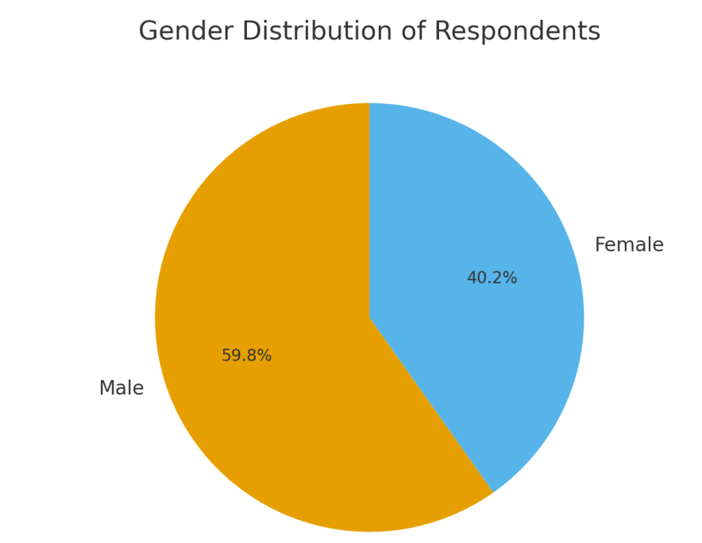

Table 4.2: Age Distribution of Respondents
Age Group | Frequency | Percentage (%)
Below 20 years | 5 | 5.4
21–30 years | 34 | 37.0
31–40 years | 28 | 30.4
41–50 years | 16 | 17.4
51 and above | 9 | 9.8
Total | 92 | 100
The largest group of respondents (37%) were between ages 21–30, followed by 31–40 years (30.4%). This suggests that most participants were young and middle-aged adults, an active demographic in both media use and disaster response. Similar findings were reported by Obasi (2021), who observed that younger populations are highly engaged with disaster information via digital platforms.

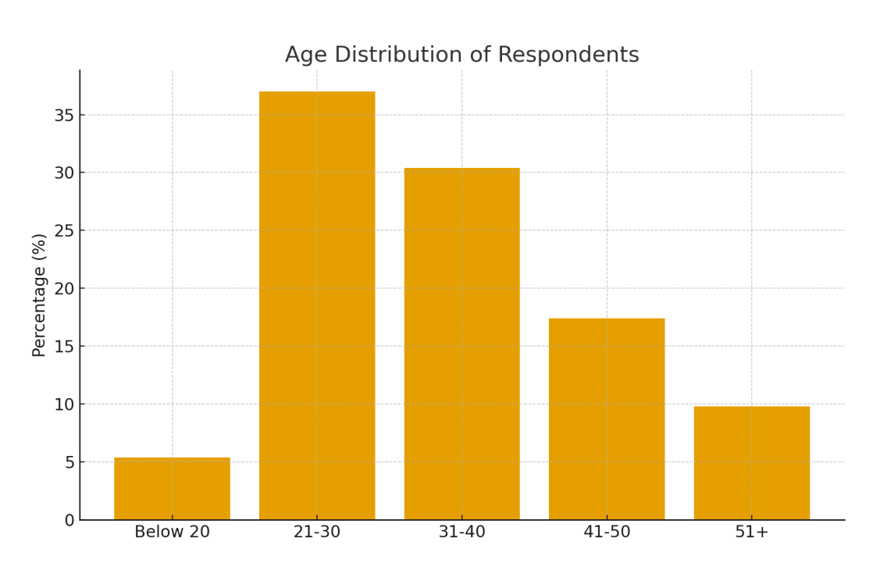

4.2 Media and Disaster Preparedness
Table 4.3: Media Effectiveness in Disaster Preparedness
Response | Frequency | Percentage (%)
Strongly Agree | 30 | 32.6
Agree | 40 | 43.5
Neutral | 10 | 10.9
Disagree | 7 | 7.6
Strongly Disagree | 5 | 5.4
Total | 92 | 100

The majority (76.1%) agreed that the media plays a significant role in disaster preparedness. This reinforces Ibrahim & Lawal’s (2022) claim that the media is essential in risk communication and awareness creation. However, about 13% expressed disagreement, highlighting areas where the media may not have been proactive.

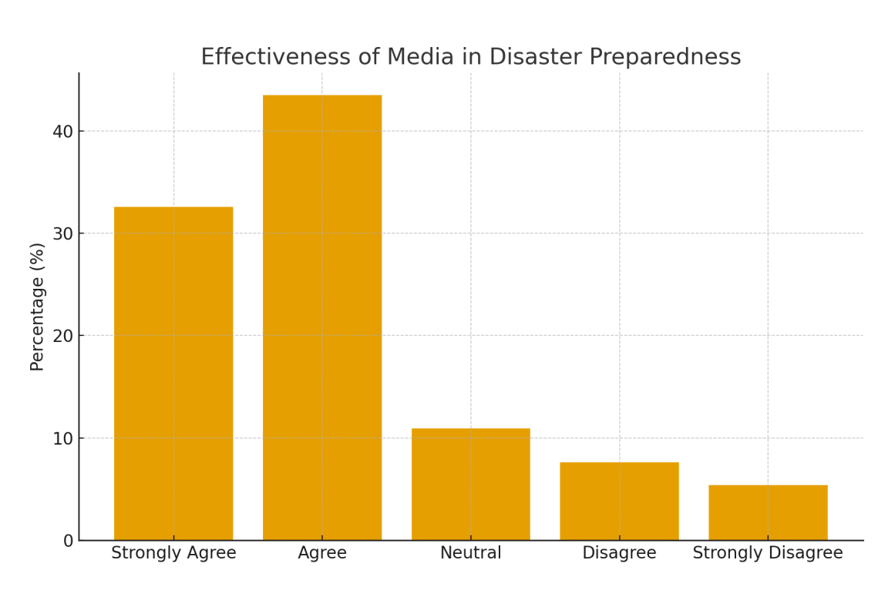

4.3 Media and Emergency Response
Table 4.4: Speed of Information Received During Emergencies
Response | Frequency | Percentage (%)
Immediately | 24 | 26.1
Within a few hours | 38 | 41.3
Within a day | 20 | 21.7
After a long delay | 10 | 10.9
Total | 92 | 100
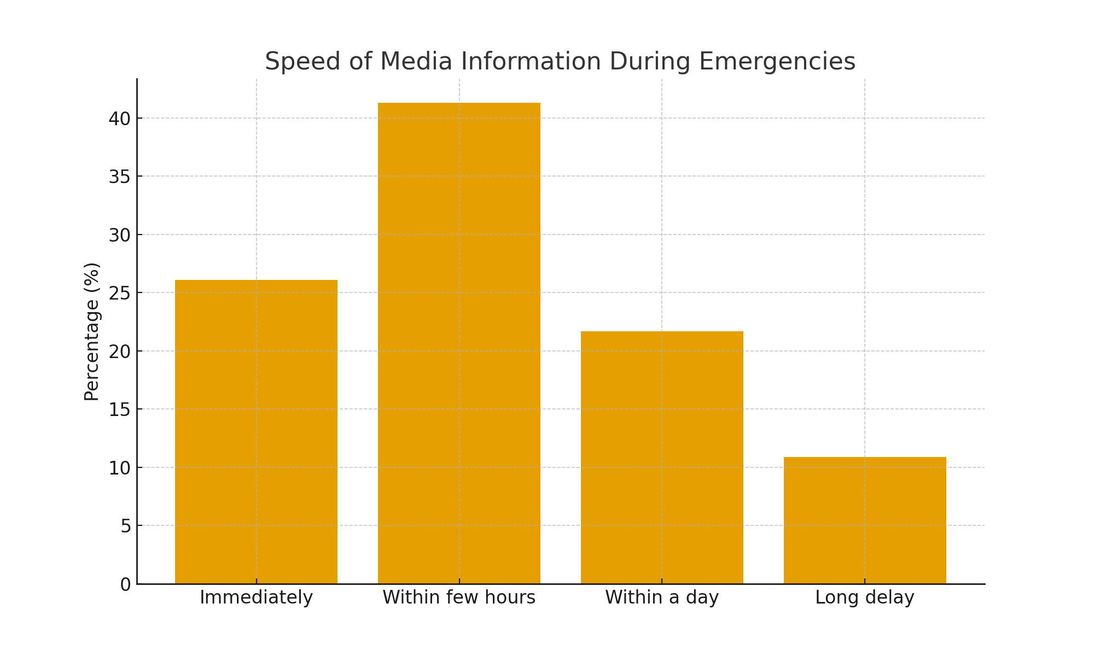

A combined 67.4% of respondents indicated receiving media information either immediately or within a few hours during emergencies, suggesting that the media has improved real-time crisis communication. This supports Salawu (2021), who argued that social media platforms have enhanced the speed of emergency communication. Nonetheless, 10.9% reported long delays, implying inconsistencies in coverage.

4.4 Media and Recovery Efforts
Table 4.5: Contribution of Media to Recovery Mobilization
Response | Frequency | Percentage (%)
Very Significant | 36 | 39.1
Moderately Significant | 30 | 32.6
Not Really Significant | 18 | 19.6
Not at All | 8 | 8.7
Total | 92 | 100

The findings show that 71.7% believed the media contributes significantly to mobilizing resources for recovery, such as funds and volunteers. This aligns with Uche (2020), who emphasized the agenda-setting power of the media in mobilizing post-disaster assistance. However, about 28.3% felt media contribution was weak, reflecting possible short-term focus on disaster coverage without sustained follow-up.

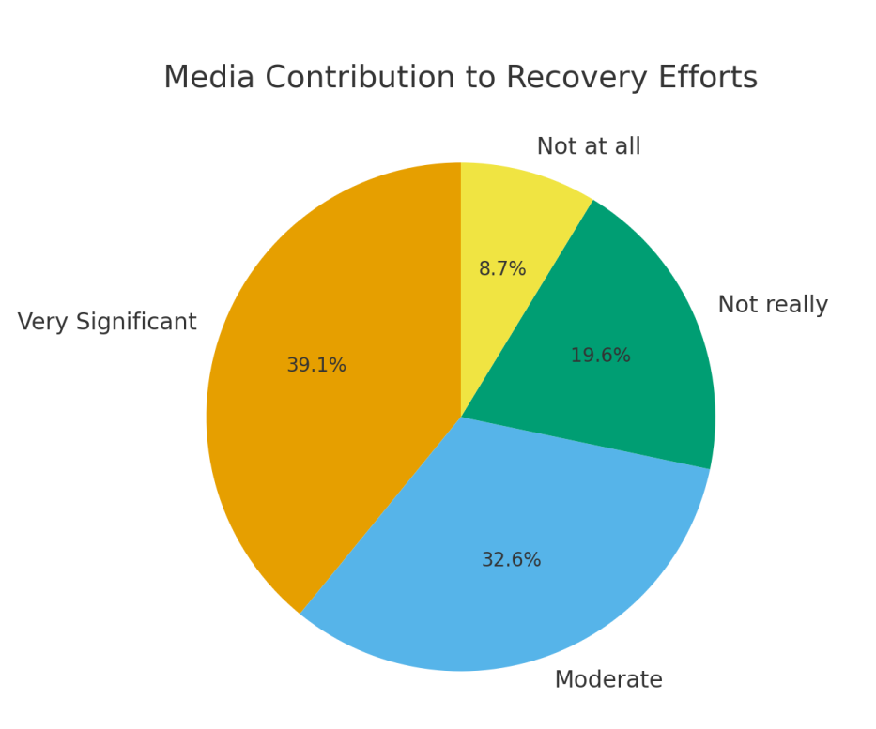

4.5 Challenges Facing the Media in Disaster Management
Table 4.6: Major Challenges Identified
Challenges | Frequency | Percentage (%)
Fake news / misinformation | 28 | 30.4
Lack of training for journalists | 20 | 21.7
Limited access to disaster zones | 15 | 16.3
Government restrictions/censorship | 12 | 13.0
Inadequate funding/resources | 10 | 10.9
Others | 7 | 7.7
Total (multiple responses allowed) | 92 | 100
The leading challenge was fake news and misinformation (30.4%), which respondents said often worsens panic during disasters. This is consistent with Uche (2020), who observed that the “infodemic” of unverified content during crises undermines trust. Lack of journalist training and limited access to disaster zones were also notable challenges, suggesting a need for capacity building and improved media-government collaboration.

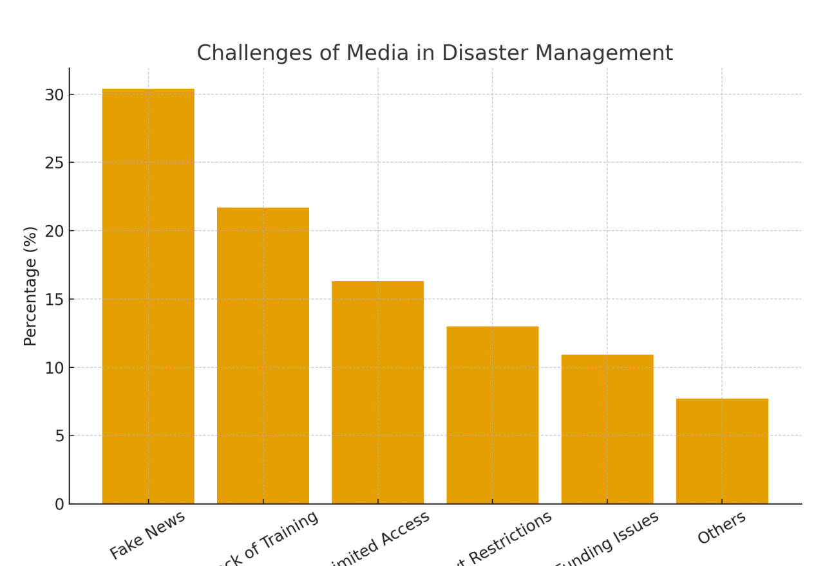

4.6 Summary of Findings
- The majority of respondents believe that the media plays a vital role in disaster preparedness, especially in public sensitization.
- Media was found to be effective in emergency response, though delays in some cases reduce reliability.
- In terms of recovery efforts, most respondents agreed that media coverage helps mobilize support, although sustained follow-ups are limited.
- Key challenges include misinformation, lack of specialized training for journalists, restricted access, and inadequate funding.

CHAPTER FIVE

SUMMARY, CONCLUSION AND RECOMMENDATIONS

5.1 Summary of Findings
This research set out to examine the role of the media in disaster management, with a particular focus on emergency response and recovery efforts. The study sought to evaluate how effectively the media informs the public during disasters, mobilizes resources, and facilitates post-disaster recovery. Based on the analysis in Chapter Four, the following key findings emerged:
- Demographic Representation – The majority of respondents were male (59.8%) and within the 21–40 years age bracket, indicating that middle-aged adults are more engaged with media coverage during disasters.
- Media in Disaster Preparedness – A significant proportion of respondents (76.1%) either strongly agreed or agreed that the media plays an essential role in raising awareness and preparing the public for potential hazards. This underscores the trust placed in the media as a source of timely and reliable information.
- Speed of Information Dissemination – Most respondents (67.4%) believed the media relays information within hours of an incident, highlighting its importance in reducing panic and enabling quick response.
- Contribution to Recovery Efforts – Respondents acknowledged that the media makes a very significant (39.1%) or moderate (32.6%) contribution to recovery efforts. Through sustained reporting, the media draws attention to victims’ needs and mobilizes humanitarian aid.
- Challenges of Media in Disaster Coverage – The study revealed major obstacles including fake news (30.4%), lack of training (21.7%), government restrictions (13.0%), limited access to affected areas (16.3%), and inadequate funding (10.9%). These challenges often undermine the credibility and efficiency of disaster reportage.

5.2 Conclusion
The findings of this study demonstrate that the media plays a critical and multifaceted role in disaster management. From preparedness to response and recovery, media platforms—both traditional and digital—serve as the main channels for information dissemination, risk communication, and mobilization of support. However, issues such as misinformation, inadequate professional training, and governmental interference hinder the effectiveness of the media.
In conclusion, the media is not merely a passive observer but an active stakeholder in disaster management. Strengthening its capacity and ensuring responsible reportage can significantly enhance the efficiency of emergency response and post-disaster recovery in Nigeria and beyond.

5.3 Recommendations
Based on the research findings, the following recommendations are proposed:
- Capacity Building for Journalists – Media organizations should provide specialized training in disaster reporting to ensure accuracy, sensitivity, and timeliness in coverage.
- Fact-Checking Mechanisms – News outlets should adopt rigorous fact-checking protocols to curb the spread of misinformation, particularly on social media during emergencies.
- Collaboration with Disaster Agencies – Stronger partnerships should be established between the media and relevant agencies such as NEMA, Red Cross, and State Emergency Agencies to ensure consistent and verified information flow.
- Government Support without Interference – Authorities should support media access to disaster sites while avoiding censorship or restrictions that compromise transparency.
- Public Awareness Campaigns – The media should intensify disaster awareness campaigns to build community resilience and preparedness.
- Leverage Digital Platforms – Social media and mobile technology should be harnessed more effectively to disseminate real-time alerts, guidance, and recovery information.
- Sustainable Funding and Resources – Both government and private stakeholders should invest in equipping media houses with modern tools and resources needed for effective disaster coverage.

REFERENCES
Adewale, T. (2019). Global Threats and Local Responses: Disaster Trends in the 21st Century. Lagos: Urban Insight Press.
Adeyemi, J., & Musa, T. (2018). “Media Challenges in Crisis Reporting.” West African Media Studies, 2(1), 11–27.
Ezekiel, K. (2020). Mass Media and Risk Communication in Africa. Abuja: Civic Media Books.
Okoro, S., & Hassan, M. (2018). “Emergency Broadcasting and Disaster Relief: The Role of Traditional Media.” Nigerian Journal of Communication Research, 6(2), 45–60.
Ibrahim, A., & Lawal, B. (2022). “Post-Disaster Recovery: Media Support and Public Engagement.” International Journal of Recovery and Resilience, 5(1), 17–29.
Nwachukwu, P. (2019). “Citizen Journalism and Disaster Response: Opportunities and Pitfalls.” Digital Media & Society, 3(3), 51–64.
Obasi, L. (2021). “The Power of Communication: Media and Emergency Risk Reduction.” Journal of Crisis Studies, 12(4), 22–37.
Salawu, A. (2021). “Towards a Resilient Society: The Role of Journalism in Disaster Management.” African Review of Public Safety, 7(3), 30–44.
Uche, D. (2020). Social Media and the Infodemic: Managing Misinformation in Crisis Situations. Ibadan: Nexus Communications.

