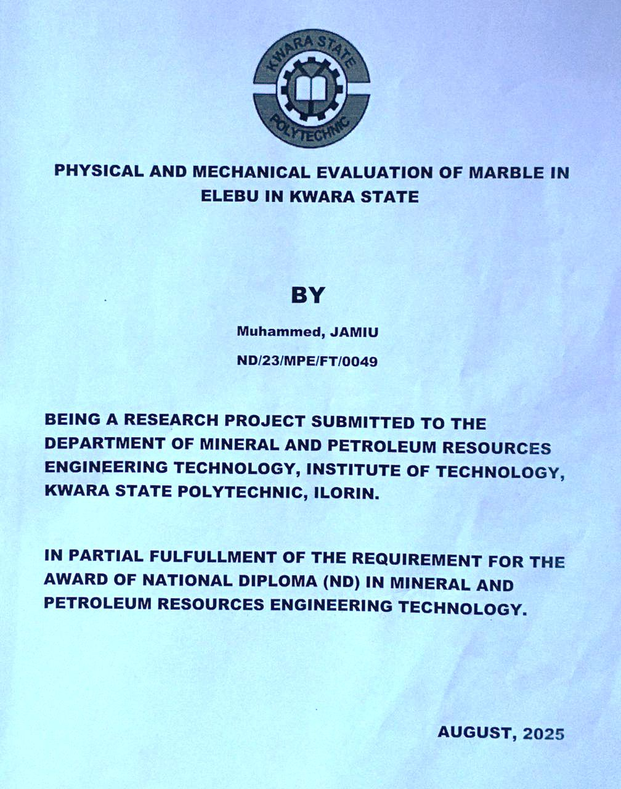

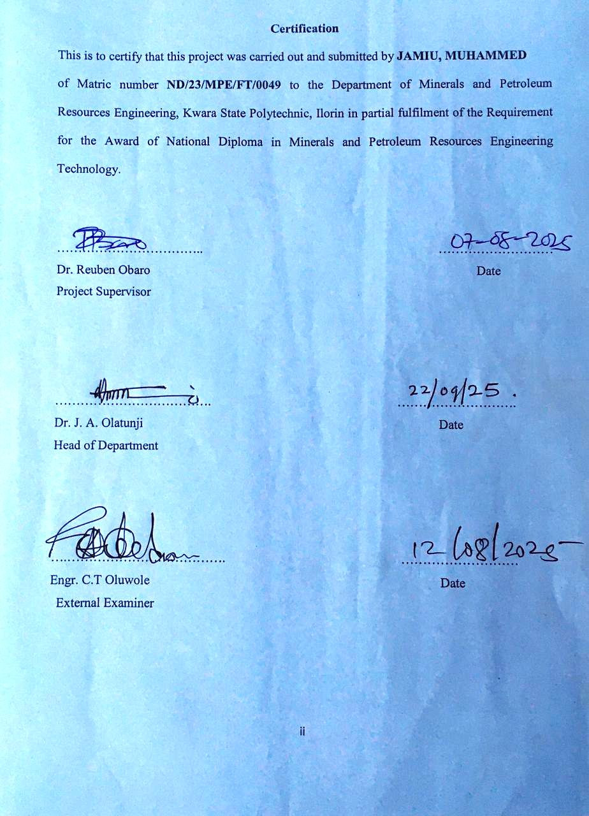
Dedication
I am delighted to dedicate this project to Almighty GOD, the creator of all universe who gave me the grace and opportunity to complete my ND program and this research, may His name be glorified.

Acknowledgements
I give all the glory and adoration to Almighty GOD, the beginning and the End, for his greatest protection and love given to me as a privilege to start and complete this research work.
I wholeheartedly extend my special thanks to my amiable supervisor Dr. Reuben Obaro for his professional guidance and support towards the success of this project.

Abstract
Physical and mechanical evaluation along with the economic potential of marble deposit from Elebu, in Moro Local Government Area of Kwara State were examined for their possible industrial applications. Five (5) samples were taken to laboratory for treatment and standard laboratory preparation prior to physical and mechanical analysis at Civil laboratory, University of Ilorin. The physical analysis include specific gravity, bulk density, porosity, compressive strength and aggregate abrasion value. It is evident for all the samples that the specific gravity may be credited to low degree of weathering and are suitable for heavy construction work. The lower density values can be attributed to the presence of impurities, especially in the country rocks. These factor contribute to a decrease in the overall density. Based on porosity, the marble is not prone to dissolubility, acid attacks and are less porous and dense along with the effect of weathering which have been of insignificant implication. The relatively lower values of water absorption can also be attributed to factors such as porosity and weathering or even high percentage of impurities including allied minerals. The UCS of all rock samples are not good in the production of floor tiles and cladding stone based on low Uniaxial Compressive Strength. The abrasion values of Elebu marble are compared to the minimum acceptable value specified in the ASTM C503 (2001) standard which suggest that all the samples are above the minimum required standard. Based on this, Elebu marble is not only suitable for fluxing steel but as chips which are crushed in pieces that are produced according to consumers’ size demand and needs. Chips give gardens or landscapes exquisite cool look. It can also be used as marble fittings of high strength materials that are fitted in places where hard substances impervious to moisture are demanded.

Table of Contents
Title page i
Certification ii
Dedication iii
Acknowledgement iv
Abstract v
Table of content vi
List of Figures ix
List of Tables x
CHAPTER ONE 1
1.0 Introduction 1
1.1 Background of the study 1
1.2 Aim of the study 2
1.3 Objectives of the study 2
1.4 Problem Statement 2
1.5 Scope of the study 2
1.6 Justification of the study 2
CHAPTER TWO 4
2.0 LITERATURE REVIEW 4
2.1 Review of Previous work 4
2.2 Geology of Nigeria 5
2.3 Geology of the study area 9
2.4 Strength of Marble 11
2.5 Uses of marble 11
CHAPTER THREE 12
3.0 MATERIALS AND METHOD 12
3.1 Sample collection 12
3.2 Laboratory analysis 12
3.2.1 Sample preparation 12
3.2.2 Procedures for Specific Gravity 12
3.2.3 Procedures for Density 13
3.2.4 Procedures for Porosity 13
3.2.5 Procedures for Water Absorption Test 13
3.2.6 Procedures for Uniaxial Compressive Strength 14
3.2.7 Procedures for Los Angeles (L.A) Abrasion Test 14
CHAPTER FOUR 15
4.0 RESULTS AND DISCUSSION 15
4.1 Results of specific gravity 15
4.2 Discussion on Specific Gravity 15
4.3 Results of Density (Kg/m³) 16
4.4 Discussion on Density 16
4.5 Results of Porosity (%) 17
4.6 Discussion of Porosity (%) 17
4.7 Results of Water Absorption Capacity 19
4.8 Discussion on Water Absorption 19
4.9 Results of Compressive Strength 21
4.10 Discussion of Compressive Strength 21
4.11 Results of Los Angeles Abrasion test (%) 24
4.12 Discussion on Los Angeles Abrasion 25
4.13 Economic Importance of Elebu Marble 26
CHAPTER FIVE 27
5.0 Conclusion and Recommendation 27
5.1 Conclusion 27
5.2 Recommendation 27
References 28

List of Figures
Figure 2.1. Geological Map of Nigeria (Obaje, 2009) 8
Figure 2.2. Location of the study area 10

List of Tables
Table 4.1. Result of Specific gravity 15
Table 4.2. Result of Density (Kg/m³) 16
Table 4.3. Results of Porosity test (%) 17
Table 4.4. Classification Scheme for porosity of rocks (Moos and De Quervain, 1948)18
Table 4.5. Result of Water Absorption Capacity 19
Table 4.6. Results of Compressive Strength of Marble 21
Table 4.7. Classification of Unconfined Compressive Strength (Mpa or Nmm²) 23
Table 4.8. Physico-mechanical Properties of Marble (ASTM C503 2001) 23
Table 4.9. Results of Los Angeles Abrasion test (%) 24

CHAPTER ONE
INTRODUCTION
1.1 Background of the study
Marble is one of the industrial rocks that is presently gaining prominence in the manufacturing sector of the Nigerian economy. The wide range of application of marble and associated lime-rich rocks especially in construction, recent upsurge in urban development and new opportunities in the solid minerals development has induced local as well as foreign entrepreneurs’ to show a keen interest in the exploitation of marble deposits in Nigeria and what determines the suitability of a marble deposit for the production of cement and construction purposes is largely its physical and chemical characteristics, hence the justification of this study. Elebu area lies within the Precambrian Basement Complex of Northcentral, Nigeria. The Basement rocks notably the migmatite gneiss complex, schist (metasediment), older granite and late intrusives. The schist occurs as a supracrustal cover on the Basement and consists of mica schist, metaconglomerate, calc-gneiss and marble and quartz biotite. The marble in Elebu area occurs in large deposit, yet very little data are available on its physical and mechanical properties. The exploration for marble started in the year 1970 (Alabiet al., 2013). The Occurrence and exploration of variety of marble deposits found within the Nigerian Basement terrain e.gBurum-Takalafia in the Federal Capital Territory (F.C.T), Abuja; kwakuti in Niger State; EtobeAjaokuta and Jakuti in Kogi State; Ukpilla in Edo State and Igbetti in Oyo State and Ukpilla in Edo State have been studied by many researchers and authors (Oluyide and Okunlola 1995). These deposits have various morphologies within the Schist belts and exhibit different physico-chemical characteristics that render them economically attractive. Marble also has numerous applications for structural and decorative purposes. It is utilized for outdoor sculpture, external walls, floor covering, decoration, stairs, and pavements. The majority of prehistoric monuments were made of marble. Marble has decorated the corridors of palaces and historical places e.gTajMahal Palace in India. This study therefore presents physical and mechanical properties of Elebu marble with the purpose of appraising its economic potentials and industrial applications.
1.2 Aim of the study
The aim of this study is to evaluate the physical and mechanical properties of marble for construction purposes.
1.3 Objectives of the study
The objectives of the study are as follows;
i. to determine the physical properties of marble in the study area.
ii. to determine the mechanical and strength of marble for construction purposes.
1.4 Problem Statement
Nowadays various engineering distress and concern have been observed due to the use of poor material for construction (i.e. material with less or poor engineering properties). It is very important to evaluate the physical and mechanical application of marble as it applies to construction purposes.
1.5 Scope of the study
This study is restricted to physical and mechanical characterization of marble. Samples collected from the study area was subjected into specific gravity, bulk density, porosity, water absorption while the mechanical properties includes uniaxial compressive strength and Los Abrasion analysis.
1.6 Justification of the study
Evaluation of marble deposits is vital for construction purposes and a keen interest in the exploitation of marble deposits in the study area is what determines the suitability of marble deposit for the production of cement and construction is largely its physical and mechanical characteristics.

CHAPTER TWO
LITERATURE REVIEW
2.1 Review of Previous work
Several authors has reported physio-mechanical properties of marble in Nigeria. Among these authors are Thuro and Scholz (2004) demonstrated that weathering in marble rock type has deep impacts on both physical and mechanical properties of the rocks as well as of the rock masses. The changes in mineral content and the increase of pore volume promote the action of mechanical disintegration and chemical decomposition.
Egesi and Tse, (2011) noted that understanding the mineralogy, grain size, texture and weathering states which could be related to the geological processes that form the rock also help in assessing the rock as dimension stone hence determining the rock’s suitability and availability for production
Daku et al. (2017) reported Engineering Properties of Jakura Marble and Its Suitability for Tiles Production and concluded exploitation of marble for tiles production will be a huge developmental growth for the Nigerian economy, considering their good engineering properties.
Ogunsola et al. (2019) reiterated the effect of petrographic and geochemical characteristics on rock strength and especially the relationships between the engineering properties and specific petrographic transformations which take place during weathering process which are very common in marble. This is very necessary, to enhance the understanding of the effect of the internal mechanism of rock structure and its engineering properties.
Akinola et al. (2020) studied physic-mechanical and compositional features of metamorphosed carbonate rock in Igue, Southwestern, Nigeria: Implication for Industrial Use as Dimension and noted that the marble deposit are pure to relatively pure deposits and the physio-mechanical characteristics satisfy the basic properties for dimension stones. However, it was also noted that the marble is affected by heat and the understanding these properties is quite essential when selecting and determining the maintenance requirements of these marble used as dimension stones.
2.2 Geology of Nigeria
The Pre-Cambrian basement complex of Nigeria lies between the West African Craton in the west and the Congo Craton in the east. The rocks of the basement complex of Nigeria are loosely categorized into three main groups which are;
The migmatite gneiss complex: The migmatite gneisses are the most abundant rocks of the basement complex. They are divided into two types. These are the biotite gneiss and banded gneiss (Falconer, 1911).
Petrogenetic and field evidences (De Swardt, 1953) show that the migmatite gneiss originated through silica potash metasomatism of ancient metagranulites mainly between 2.8-2.0 Ga. However older dates of about 3.0 Ga have been reported (Dada, Brique, and Birck, 1998) who believed that such relict signatures indicate that the Precambrian terrain was part of an Archean proto-shield affected by Proterozoic crustal activities. Field evidences and radiometric dating have shown that the Nigerian basement complex bears the imprints of the major Orogenies in the earth history dating back to 3000 Ma and it undergone its most pervasive deformation and remobilization during the Pan African (˂ 600 Ma).
The schist belt: The schist belt occurs prominently within the western half of the country. Though a few have been recently highlighted in central and southeastern parts (Elueze, 1992). They are mostly regarded to be of Proterozoic age (0.6-2.5Ga). Various types and grades of schists occur in the basement complex. They include mica schists, phyllite and biotite schist. They form lowland between quartzite ridges and are rare as continuous massive outcrops. The schist belts, which some author classified as metasediments shows distinctive petrological, structural and metallogenic features.
The schist belts in the southwestern part of Nigeria include Iseyin, igarra, Egbe-isanlu, ifewara-ilesha (Rahaman et.al. 1983, Elueze, 1992, Annor et.al, 1996). The lokoja- Jakura belt (Okunlola, 2001) and the southeastern belts (Ekwueme, 1987) are the recently highlighted belts. Although there seems to be some lack of consensus on locational delineation, geologic nomenclature, geodynamic setting and geochronological characteristics. The schist belt is of metamorphosed pelitic and sandy assemblages. The schist belt is of particular interest in that it is associated with a widespread occurrence of marble deposits in Nigeria. It is dominated by low-grade metasediments remnants of supracrustal cover during the Pan-African orogeny (Mc Curry 1976).
The Pan-African granitic series and associated minor rocks: According to Rahaman, Emofurieta, and Caenachet, (1983) the older granites are the most visible part of the Pan-African orogeny in Nigeria. The older Granites were first distinguished from the younger or plateau tin-bearing alkalic granite (Falconer, 1911). They range in size from plutons to the environment in which the granite is emplaced. Circular to elliptical bodies occurs in schist environment and more elongate bodies in migmatite Gneiss terrains.
The older granites are the most obvious manifestation of the pan African Orogeny and constitute about 40- 50% of the basement complex outcrop. They include rocks of a wide range of composition including tonalities, granites, granodiorites, adamallites, quartz Monzonites, syenites, and pegmatites, granitic – granodioritic compositions are the most common texturally, they vary from strongly foliated gneiss varieties to undeformed rocks. Under the granitic granodioritic rocks, (Jones, and Hockey, 1964) recognized three main groups of granites, an early phase comprising granodiorites and quartz diorites, a main phase comprising homogenous granites, syenites and coarse porphyritic biotite granite and a late phase comprising homogenous granites, dykes, pegmatites, and aplite.

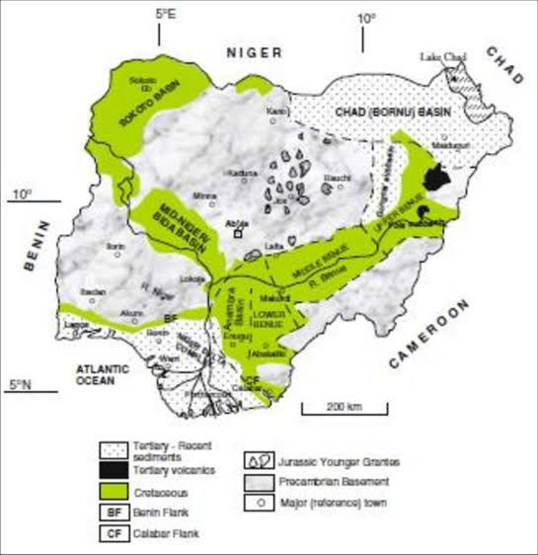

Figure 2.1: Geological Map of Nigeria (Obaje, 2009)

2.3 Geology of the study area
Elebu in Kwara State have been studied by many researchers and authors. These deposits have various morphologies within the Schist belts and exhibit different physical and mechanical characteristics that render them economically attractive. The Elebu area (Fig. 2.2) consist of fine to-medium grained granite and biotite-muscovite granite. It is underlain by migmatitic, augen and granitic gneiss along with quartzites and marble, (figure 2). Elebu marble occurs as low-lying outcrops along valley of River Abupata and is surrounded by quartzite ridges. The marble is grey in colour, medium grained in texture and occurs as two separate bands about 2 kilometers northwest of Elebu. According to Odewumi (2008) the exposure of the western band is approximately 3m x 30m in size while the eastern band which is about 800meters to the western band is approximately 5m x 200m in size while the modal estimates of the mineralogy are essentially dolomite 97%, tremolite 2% and quartz 1%. The dolomite is medium-grained and it occurs as irregular crystals with a variable shapes. Tremolite and quartz occur as accessory silicate minerals. The mean annual rainfall is 1500mm and the mean annual relative humidity is about 80%.The mean annual temperature is about 26.6ºC (Emofurieta, 1984).
Dendritic drainage pattern is prevalent in the area. The study area is also covered mainly by tall palm trees and grasses typical of rain forest vegetation. The vegetation is thick and has been greatly affected by human interference through farming, bush burning with the development of seasonal forests in some of the area.

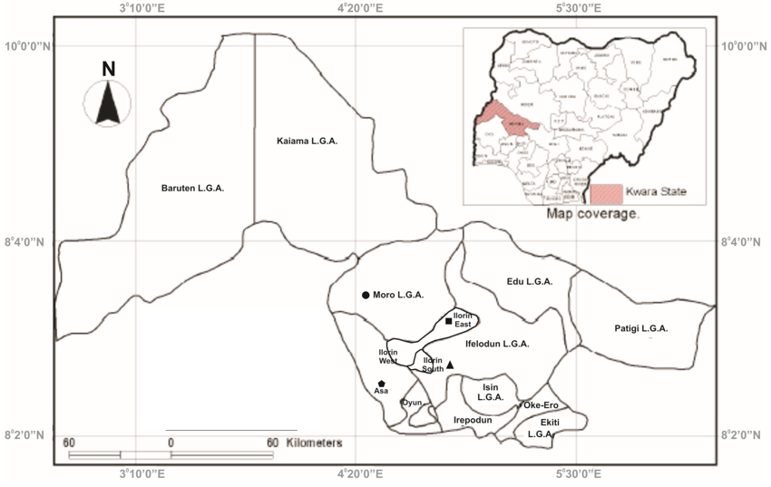
Figure 2.2. Location of the study area

2.4 Strength of Marble
The strength of marble is the measure of its capacity to resist stresses and it depends on the rift, hardness of grains, state of aggregation and degree of cohesion and interlocking of grains.
The surface of marble crumbles readily when exposed to a moist, acid atmosphere, but marble is durable in a dry atmosphere and when protected from rain (Fatoye and Gideon, 2013). The purest form of marble is statuary marble, which is white with visible crystalline structure. The distinctive luster of statuary marble is caused by light penetrating a short distance into the stone and then being reflected from the surfaces of inner crystals. Calcite (CaCO3) of which marble is composed is highly susceptible to attack by acid agents. Marble is readily dissolved by acids, even very dilute acid. However, dolomite marble is much more resistant to acid attack than calcite marble.
2.5 Uses of marble
Marble is used for interior or exterior design of a house or building. In addition, marble can also be used as raw material for crafts or sculpture. Marble has been used as a decorative building stone since ancient times and is widely appreciated for its beautiful colours, structure, and high gloss on polished surfaces. The Marble has been commonly used for different purposes like flooring, cladding etc., as a building material since the ancient times. Marble finds wide spread application as raw material in many industries depending mostly on their purity or chemical content. Therefore, prior and concise chemical characterizations are necessary before any industry application. Nigeria is a developing nation with abundant minerals resources, especially meta-carbonate which occur in an estimated proportion of 60% dolomite marble and 40% calcitic marble. These meta carbonate deposit usually occur within the Schist belt (Muotoh et al., 1998; Okunlola, 2001), marble is one of the industrial rocks that gain prominence in the manufacturing sector of the Nigerian economy.
CHAPTER THREE
MATERIALS AND METHOD
3.1 Sample collection
The methods used for this research work consist of field study and laboratory analyses. The field study exercise involved collection of six (6) fresh samples of marble. The marble was obtained from Elebu, Moro Local Government Area in Kwara State. The materials used in obtaining the samples include geologic hammer, chisel and sample bags while the compass-clinometer and global positioning system was used for direction. The Global positioning system (GPS) was used to take the coordinate of the study area.
3.2 Laboratory analysis
The laboratory analysis involved sample preparation for both physical and mechanical analysis. The laboratory analysis was undertaken at the Civil Engineering Laboratory, University of Ilorin
3.2.1 Sample preparation
The samples of marble obtained from the field were taken to Civil Engineering Laboratory, University of Ilorin for further analyses. The rock samples were carefully selected and processed at the laboratories in preparation for physical and mechanical analysis. The physical analysis that was carried out involves specific gravity, bulk density, porosity, water absorption while the mechanical properties includes uniaxial compressive strength and Los Abrasion analysis.
3.2.2 Procedures for Specific Gravity
The Bulk or Apparent specific gravity, Gb is the ratio of the dry weight, Wd of a rock to the weight, W of water equal to the total volume of rock including voids. The rock sample was dried for 24 hours in an oven at a temperature of 1050C to expel all water present in the rock sample. It was allowed to cool and the dry weight, Wd determined. The rock sample was completely immersed in water to enable it attained saturation for 48 hours and the saturated weight Ww was measured and recorded. The rock sample still in a soaked condition was weighed (Ws) while suspended in water. This can be mathematically represented as: G= Wd
Ww - WS
The essence of heating and then saturating is to determine the amount of water in the pore spaces of the sample.
3.2.3 Procedures for Density
The density of the rock sample was determined by multiplying the specific gravity, G with the density of water. Therefore, the rock sample density was calculated as follows: = 1000G (Kg/m3) Where is the density of water =1000Kg/m3
3.2.4 Procedures for Porosity
The sample was dried to a constant weight at a temperature of 105°C in an oven and cooled for 30 minutes in a desiccator. The porosity n, was determined by dividing the volume of water filling the pores (Ww-Wd) by the total volume of the rock sample, v. This is expressed in percentage as follows: n = %
3.2.5 Procedures for Water Absorption Test
The ASTM C97 procedure was adopted where the specimens were soaked in water for 48 hours, wiped dry, and weighed again. The difference in weights was divided by the dry weight and multiplied by 100 to give the percentage of water absorption. This is expressed mathematically as: Wsw = 100

3.2.6 Procedures for Uniaxial Compressive Strength
To determine the compressive strength, the sample was cut into a cube of 5cm and loaded gradually, one at a time, on the base of a Universal Testing Machine (UTM). The loading was continued till the first crack appears in the test specimen indicating beginning of failure. The load at failure (F) divided by the area of cross-section (A) of the sample gave the unconfined compressive strength of the sample:
Co = Where Co is crushing Strength F = Total load at failure A = Cross sectional area
3.2.7 Procedures for Los Angeles (L.A) Abrasion Test
The standard L.A. abrasion test subjects a coarse aggregate sample (retained on the No. 12 (1.70mm) sieve) to abrasion, impact, and grinding in a rotating steel drum containing a specified number of steel spheres. ASTM method C131-66 was used for the LA abrasion test. The samples were oven-dried at 105–110°C for 24hrs and then cooled to room temperature before they were tested. After drying, the samples were sieved into individual size fractions, and recombine to one of two specified grading that most nearly represents the aggregate gradation. The total sample mass was about 5000g. Six steel spheres were placed in a steel drum along with the 5000g of aggregate sample. The drum was rotated for 500 revolutions at a rate of 30–33 rev/min. After the revolution was completed, the sample was sieved through the 1.7 mm sieve (Sieve No 12). The amount of material passing the sieve is expressed as a percentage of the original weight. The LA abrasion loss or percentage loss was calculated as follows:
W = Where W is the abrasion loss (%) P1 is the initial weight (g) P2 is the weight passing through sieve no 12 (g).

CHAPTER FOUR
RESULTS AND DISCUSSION
4.1 Results of specific gravity
The results of specific gravity for Samples A is 2.50, Sample B is 2.53, Sample C is 2.62, and Sample D is 2.54 while Sample E is 2.65. It ranges from 2.50 to 2.65 with an average of 2.57.
Sample Number | Specific Gravity
Sample A | 2.50
Sample B | 2.53
Sample C | 2.62
Sample D | 2.54
Sample E | 2.65
Average | 2.57
Table 4.1. Result of Specific gravity

4.2 Discussion on Specific Gravity
The average specific gravity (SG) of Sample A, B, C, D and E (Table 4.1) suggest 2.57. Generally, the high Specific Gravity (SG) of marble may be credited to low degree of weathering and freshness of rocks (Akintolaet al., 2020). The slightly higher value in the marble may be attributed to the presence of ferromagnesian minerals. The relatively high specific gravity of some rocks in Nigeria has been associated to relatively high contents of iron – rich minerals present in rocks (Afolagboyeet al., 2016). However, the Specific Gravity is not usually consider as a primary means of determining the durability of rocks for construction purpose but Specific Gravity greater than 2.55 are generally considered to be suitable for heavy construction work (Blyth and De Freitas, 1974). Hence, the specific gravity of all the samples is suitable for construction works.
4.3 Results of Density (Kg/m³)
The result of density values is shown in table 4.3. The density for Sample A is 2510 Kg/m³, Sample B is 2586 Kg/m³, Sample C is 2520 Kg/m³ and Sample D is 2560 Kg/m³ while Sample E is 2570 Kg/m³. The density for all the samples ranges from 2510 Kg/m³ to 2586% with an average of 2549Kg/m³.
Sample Number | Density (Kg/m³)
Sample A | 2510
Sample B | 2586
Sample C | 2520
Sample D | 2560
Sample E | 2570
Average | 2549
Table 4.2. Result of Density (Kg/m³)

4.4 Discussion on Density
Generally, bulk density is influenced not only by porosity but also by mineral density of the components and the filling materials in the voids. Quick (2002) remarked that higher water absorption, porosity and lower density suggest less durable and less stain resistant and more susceptible to salt attack. According to the ASTM 503C (2008) standard, the minimum density required for marble to be used as a dimension stone is 2595 kg/m³. These values indicate that all density values are below the required standard (Table 4.2). The Elebu marble has significantly lower density values which can be attributed to the presence of impurities, especially in the country rocks. These factors contribute to a decrease in the overall density of Elebu marble.
4.5 Results of Porosity (%)
The results of percentage porosity is shown in table 4.3. The values for Sample A is 0.51%, Sample B is 0.54%, Sample C is 0.50% and Sample D is 0.59% while Sample E is 0.52%. The porosity test falls within 0.50% and 0.59% with an average of 0.53%.
Table 4.3. Results of Porosity test (%)
Sample Number | Porosity test (%)
Sample A | 0.51
Sample B | 0.54
Sample C | 0.50
Sample D | 0.59
Sample E | 0.52
Average (%) | 0.53

4.6 Discussion of Porosity (%)
Porosity has a direct and indirect impact on the physical properties of rocks, and is mostly measured as a vital rock parameter. An increasing porosity has an unfavourable influence on the weathering characteristics. The porosity values as shown in Table 4.5 suggest that the studied samples ranges between 0.51% and 0.54%. Studies based on Martins et al. (2016) have shown that higher porosity has resulted in lower durability compared to low – porosity rocks. Dearman (1981) stated that microporosity with percentage of pores with an effective diameter of less than of less than 0.005mm is a better indicator of carbonate rocks resistance to weathering than strength. Since porosity is known to control fluid flow, the Elebu marble is not prone to dissolubility and acid attacks, thus increasing its suitability as building stone. According to ISRM classification, the marbles are compact (Table 4.4) which suggest that all the samples are less porous and dense and the effect of weathering will be of little implication hence, it is compact (Moos and De Quervain, 1948)
Table 4.4. Classification Scheme for porosity of rocks (Moos and De Quervain, 1948)
S/n | Porosity | Classification
1. | < 1% | Compact
2. | 1 – 2.5% | Few pores
3. | 2.5 – 5% | Slightly porous
4. | 5 – 10% | Significantly porous
5. | 10 – 20% | Many pores
6. | < 20% | A lot of pore space

4.7 Results of Water Absorption Capacity
The water absorption for Sample A is 0.32%, Sample B is 0.29%, Sample C is 0.28% and Sample D is 0.25% while Sample E is 0.27%. The water absorption for all the samples (Table 4.5) ranges from 0.25% to 0.32% with an average of 0.28%.
Sample Number | Water Absorption (%)
Sample A | 0.32
Sample B | 0.29
Sample C | 0.28
Sample D | 0.25
Sample E | 0.27
Average | 0.28
Table 4.5. Result of Water Absorption Capacity

4.8 Discussion on Water Absorption
Water absorption is an important pointer of rock durability (Dakaet al., 2009). The water absorption values vary for different locations. These values are compared with the maximum value recommended by the ASTM 503C (2008) standard for the use of marble in dimension stone, which is 0.2%. Based on this comparison, it is clear that the average value of all the samples in the study area is relatively good for dimension stone. However, Samples A (0.32%) do not meet the recommended value for water absorption, making them unacceptable (Table 4.5). According to Mann (2006) the higher water absorption capacity allows for a higher stain holding capacity. The variation in water absorption values and the relatively lower values can also be attributed to factors such as porosity, fracturing, shearing, weathering or even high percentage of impurities including allied minerals like biotite which tend to increase the water absorption capacity of the marble.

4.9 Results of Compressive Strength
The results of compressive strength of marble is shown in table 4.6 below. The values for Sample A is 13.22N/mm², Sample B is 12.73N/mm², Sample C is 11.63N/mm² and Sample D is 12.98N/mm² while Sample E is 12.27N/mm², The porosity test falls within 11.63N/mm² and 13.22N/mm² with an average of 12.57N/mm²
Table 4.6. Results of Compressive Strength of Marble
S/N | Weight (kg) | Density (kg/m³) | Ultimate Future load (kN) | Area (mm²) | Compressive Strength (N/mm²)
A | 1.131 | 2953 | 68000 | 5130 | 13.22
B | 1.146 | 2690 | 68000 | 5342 | 12.73
C | 1.212 | 2746 | 68000 | 5843 | 11.63
D | 1.145 | 2543 | 68000 | 5237 | 12.98
E | 1.234 | 2854 | 68000 | 5543 | 12.27
 | Average |  |  |  | 12.57

4.10 Discussion of Compressive Strength
According to Moos and De Quervain, 1948 the International Society of Rock Mechanics (ISRM, 1978) classify rocks in the range of extremely strong to extremely weak depending on the compressive strength as shown in the table 4.8 below. ASTM 503C (Table 4.7) also reported 52MPa (52N/mm²) as the required standard value for marble. The results obtained from the crushing strength have a range of values between 11.63N/mm² and 13.22N/mm² with an average of 12.57 N/mm². This value does not meet the minimum required standard as specified by ASTM 503C (2008) as can be seen in Table 4.9. Therefore all rock samples are not good in the production of tiles and cladding stone because their UCS were below 100 Mpa (Waltham, 2009) only if only the compressive strength is to be considered. Although, the UCS of Elebu marble appears to be depending more on mineralogy than grain size or texture. This may be attributed to the presence of calcite, dolomite, tremolite and quartz (Odewumiet al., 2012).

Table 4.7. Classification of Unconfined Compressive Strength (Mpa or Nmm²)
S/n | Classification | Unconfined Compressive Strength (Mpa or Nmm²)
1. | Extremely Strong | > 250
2. | Very Strong | 100 – 250
3. | Strong | 50 – 100
4. | Medium Strong | 25 – 50
5. | Weak | 5 – 25
6. | Very Weak | 1 – 5
7. | Extremely Weak | < 1

Table 4.8. Physico-mechanical Properties of Marble (ASTM C503 2001)
Properties | Specification
Unconfined Compressive Strength (MPa) | 52
Abrasion Resistance | 10
Water Absorption Capacity (%) | 0.20
Bulk Density (g/m³) | 2.6
Apparent Porosity | -
Specific Gravity | 2.5

4.11 Results of Los Angeles Abrasion test (%)
The results of Los Angeles Abrasion test (%) is presented in table 4.9. Los Angeles Abrasion test for Sample A is 44.1%, Sample B is 42.2%, Sample C is 45.5% and Sample D is 43.7% while Sample E is 46.1%. The Los Angeles Abrasion test ranges from 33.7% to 38.2% with an average of 44.32%.
Table 4.9. Results of Los Angeles Abrasion test (%)
Sample Number | Los Angeles Abrasion test (%)
Sample A | 44.1
Sample B | 42.2
Sample C | 45.5
Sample D | 43.7
Sample E | 46.1
Average | 44.32

4.12 Discussion on Los Angeles Abrasion
Abrasion resistance represents the resistance of rock surface to wear as stated earlier, and are usually caused by pedestrian traffic, the wheels of trolleys and the legs of furniture. Therefore, a lower Los Angeles Abrasion values indicate rock samples that are tougher and more resistant to abrasion. The abrasion values of Elebu marble are compared to the minimum acceptable value specified in the ASTM C503 (2001) standard. However, all the samples are above the minimumrequired standard and the abrasion test range of values is also above the values of 28% and 40% which is acceptable standard based on the ASTM C1353.
This variation in abrasion resistance values is due to low or minimal of tectonic forces which could have resulted to minimal joints and shearing, which are not pronounced in the studied area. These factors positively affect the overall abrasion resistance of the marble resulting in higher values.
Nevertheless, the marble in the study area can be used for indoor/interior and outdoor/exterior use. The indoor use of Elebu marble includes tiles for walls, sculpture and pupits while the exterior use could include monuments and gravestone. Also, the physio-mechanical tests on Elebu marble deposit shows that these rocks may be suitable for dimension stone as the tests, generally, are not and above the recommended ASTM standard values for general building and structural purposes. However, marble suggest a higher water absorption than the ASTM recommended values. The major requirements for most interior use include adequate polishing quality, and strength and uniform colouration. Elebu marble suggest that the deposits is closed to these conditions and are likely to serve as indoor dimension stones. Nevertheless, the relatively low water absorption capacity and the presence of impurities in some of the marble variety may affect the long term performance of the marble as dimension stone.
Ozcelik and Ozguven (2014) reported that durability is a complex criterion determined by inherent strength, water absorption and pore space. Due to the relatively high-water absorption capacity, the deposits may be prone to strength deterioration and have less train resistance after a long exposure to unfavourable climatic condition. The durability of the marble deposit both as indoor or outdoor use could be enhanced through appropriate technology such as coating.
4.13 Economic Importance of Elebu Marble
Finely ground white calcite marble serves as good fillers, extenders and coating pigment. They stabilize the paint and act as a weather resistant (Obasi and Isife, 2012). As paper filler, it imparts high brightness to the sheets, surface smoothness and ink receptivity to printing. In plastic manufacturing, marble filler provides necessary reinforcements for greater impact strength, rigidity and stiffness. Physical tests indicate that the Elebu marble has high strength properties that could be applied in a variety of industries to produce tiles, chips and fittings. Marble chips are crushed pieces that are produced according to consumers’ size demand and needs. Chips give gardens or landscapes exquisite cool look. Marble fittings are high strength materials that are fitted in places where hard substances impervious to moisture are demanded. Results of physical and mechanical properties such as specific gravity, bulk density, porosity, compressive strength and abrasion value show that the marble bodies could be used for fluxing steel. They could also be useful in glass making, whiting and as fillers in papers and paints manufacture. In construction, it is widely used for road stabilization, aggregates, and as ornamental stones where it is polished into decorative slabs and masonry.

CHAPTER FIVE
Conclusion and Recommendation
5.1 Conclusion
The physical and mechanical data obtained from marble samples were compared to the standard criteria established by the ASTM standards. The specific gravity may be credited to low degree of weathering and are suitable for heavy construction work. The lower density values can be attributed to the presence of impurities, especially in the country rocks which however contribute to a decrease in the overall density. The porosity of the marble is not prone to dissolubility, acid attacks and are less porous and dense along with the effect of weathering which have been of insignificant implication. The relatively lower values of water absorption can also be attributed to factors such as porosity and weathering or even high percentage of impurities including allied minerals. The UCS of all rock samples are not good in the production of floor tiles and cladding stone based on low Uniaxial Compressive Strength. The abrasion values suggest that all the samples are above the minimum required standard. Based on this, Elebu marble is not only suitable for fluxing steel but as chips which are crushed in pieces that are produced according to consumers’ size demand and needs.
5.2 Recommendations
i. Further research should be conducted that will focus on the ornamental rock industry and demonstrate the optimum mining methods to save the raw materials.
ii. Adequate experimental works should be done on marble in Nigeria so as to ascertain their suitability of marble for different construction works.

References
Afolagboye, L. O., Talabi, A. O. and Akintola, O. O. (2016). Evaluation of Selected Basement Complex Rocks from Ado – Ekiti, SW Nigeria, As Source of Road Construction Aggregates. Bull Eng. Geol. Environ, 75: 853 – 865. 10. 1007/s10064-015-0766-1
Ajibade, A. C. (1976). Provisional Classification and Correlation of schist belts in Northwestern Nigeria. In Geology of Nigeria (C.A Kogbe, ed): Elizabethan Pub. Co, Lagos, Nigeria, 88- 90.
Akinola, O. O., Afolagboye, L. O. and Ola – Olaorun, O.A. (2020). Physio-mechanical and Compositional Features of Metamorphosed Carbonate Rock in Igue, Southwestern Nigeria: Implication for Industrial Use as Dimension Stones. Journal of Mining and Geology, 56 (2), 247 - 254
Alabi, A.B, Olatunji, S. Babalola, O.A, Nwankwo, L.I, Johnson, L.M, Odutayo, J.O and Alabi, A (2013): Structural and qualitative analysis of solid minerals (marble) in selected location in Nigeria. Nigeria Journal of Physics. 24, 68-76.
Annor, A. E., Olobaniyi, S. B. and Murke, A. (1996). A note on the Geology of Isanlu area, in the Egbe - Isanlu schist belt S.W Nigeria. Min. Geol. 32 (1), 47 - 52.
ASTM C503 / C503 M-10; Standard Specification for Marble Dimension Stone.
ASTM C97 / C97 M Test Methods for Absorption and bulk Specific Gravity of Dimension Stone.
ASTM C170 / C170 M Test Methods for Compressive Strength of Dimension Stone.
ASTM D3148 / D1348 M. Test Methods for Elastic Moduli of Intact Rocks.
ASTM D4644 / C4644 M. Test Methods for Slake – Durability Index.
ASTM (1976). Standard method of physical testing of quicklime, hydrated lime and Limestone, C110-76A, 15.
American Association for Solid Testing Materials (ASTM) C503/C503M-10. (2010). Standard Specification for Marble Dimension Stone. ASTM International. www.astm.org
American Standard for Testing Material -C- 97. (2015). Standard test methods for absorption and Bulk Specific Gravity of Dimension Stone.
Basu, S., Orr, S. A. and Aktas, Y. D. (2020). A Geological Perspective on Climate Change and Building Stone Deterioration in London: Implications for urban stone-built heritage research and Management. Atmosphere, 11(8), 788.
Boynton, S. (1980). Chemistry and Technology of Limestone, John Wiley and Sons Inc, New York, 300.
Dada, S. S., Brique, L. and Birck, J. L. (1998); Primordial Crystal Growth in Northern Nigeria. Preliminary Rb - Sr and Sm - Nd Constraint from Kaduna Migmatite Gneiss Complex, Journal of Min. Geol .34 (1), 1 - 6.
Daku, S. S., Wazoh, H. N and Ojo, O. A. (2017). Engineering Properties of Jakura Marble and Its Suitability for Tiles Production. Journal of Applied Geology and Geophysics, 5, 57 - 66
De Swardt, A. M .J. (1953). The Geology of the Country Rocks around Ilesha: Bulletin, Geological Survey of Nigeria, 23, 54.
Dowrie, D. G. and John, F (1982). Modern Lime Burning Plant at Sharpfell Quarry. Management and Products Report, 163 - 171.
Egesi, N. and Tse, C.A (2011): Dimension Stone: Exploration, Evaluation and Exploitation in South-West parts of Oban Masif South-Eastern Nigeria. Journal of Geology and Mining Research, 3(4), 115-120
Ekwueme, B.N (1987); structural orientations and Precambrian Deformational episode of Uwet area, Oban- massif, Nigeria. Precambrian, 34, 269 - 289.
Elueze, A. A. (1980). Geochemical Investigation of Proterozoic Amphibolites and Metal - Ultramafites in Nigeria, Schist belts, Implications for Precambrian Crustal Evolution. Ph.D. Thesis, University of Ibadan, (Unpublished).
Elueze, A.A (1992). Rift system for Proterozoic Schist belt in Nigeria, Tectonophysics, 209, 167- 169.
Elueze, A. A and Okunlola O. A (2003). Compositional Features and Industrial Appraisal of the Metamorphosed Carbonate Rocks of Burum and Jakura area, central Nigeria.
Emofurieta, W.O and Ekuajemi V.O. (1995). Lime products and economic aspects of Igbetti, Ososo and Jakura marble deposits in Southwest Nig: Journal of Min. and Geol. 31, 1, 89 - 97.
Emofurieta, W.O (1984); The geochemistry of Igbetti granite complex, Oyo state, Nigeria. Unpublished Ph.D. Thesis, University of Ife, Ile-Ife. Nigeria.
Fatoye, F. B. and Gideon, Y. B. (2013). Geology and Occurrences of Limestone and Marble in Nigeria, Journal of Natural Sciences Research, 3, 11, 60
Falconer, J. D. (1911). The Geology and geography of northern Nigeria. Macmillan, London, 295.
Grant, N. K. (1970). Geochronology of Precambrian Basement rocks from Ibadan, Southwestern Nigeria: Earth and planetary science letters 10, 29 - 38.
International Society for Rock Mechanics (ISRM), (1978). Suggested Methods for the Description of Discontinuities in Rock Masses. Int. J. Rock Mech. Min. Sci. and Geomech. Abstr. 15, 319 - 368.
Jones, H. A and Hockey, R.D (1964). The Geology of Parts of Southwestern Nigeria: Bulletin, GSN 31,101.
Lazzarini, L. (2004). Archaeometric Aspects of White and Coloured marbles used in antiquity: The state of the art. Periodico di Mineralogia, 73(3), 113-125.
Mann, J. (2006). The Four Basic Keys to Successful Stone Selection. Discovery Stone, 10: 34 - 38
McCurry, P. (1976). The geology of the Precambrian and Lower Paleozoic Rocks of Northern Nigeria. A Review in Geology of Nigeria. C.A Kogbe (ed). Elizabethan publications Lagos.
Moos A. V. and De Quervain F. (1948). TechnicheGestinkunde. Basel, Switzerland Verlag Birkhauser (in German).
Muotoh E. O. G., Oluyide P. O, Okoro A. U., Muogbo, O. E., (1988). The Muro Hills Banded Iron Formations, AC (eds). Precambrian Geology of Nigeria. GSN Kaduna. 1988; 219-220.
Obasi, R.A (2012). Geochemistry and Appraised of the Economic Potential of Calc-Gneiss and Marble from Igarra, Edo State South-West, Nigeria. ARPN Journal of Science and Technology, 2 (10), 1018 - 1021.
Obasi, R. and Isife, F. (2012). Geochemistry and Economic Potential of Marble from Ikpeshi, South-west, Nigeria, Journal of Engineering and Applied Sciences, 7, 6.
Odewumi, S. C., Ojo, O. J. and Adekeye, J. I. D. (2012). Geological Settings, Geochemical Characteristics and Signatures of Elebu, Okunrun and Okoloke Marble Deposits, Southwestern, Nigeria. African Journal of Natural Sciences, 15, 27 – 39
Ofulume, A. B. (1991). The Jakura Marble as Filler and Extender in Paints, Paper and Plastic Industries, Journal of Min. Geol. 27 (2), 187 - 193
Ogunsola, N. O., Lawal, A. I. and Saliu, M. A. (2019). Variations of Physico-Mechanical Mineralogical and Geochemical Properties of Marble under the Influence of Weathering, Mining of Mineral Deposits, 13, 1, 95-102
Okunlola, O. A (2001). Geological and Compositional Investigation of Precambrian Marble Bodies and associated Rocks in the Burum and Jakura areas, Nigeria. UnpublPh.D Thesis, University of Ibadan, 250.
Oluyide, P.O. and Okunlola, O.A, (1995): Litho-structural Controls of the Precambrian Carbonate Mineralization in BurumTakalafia Area, F.C.T. Abuja, Nigeria. Mining and Geosciences Society, 31st, Annual conference, abstracts. 1, 6 – 7.
Oyawoye, M.O. (1967). The Petrology of PotassicSyenites and its associated BiotitePyroxenite at Shaki Southwestern Nigeria: Contributions to Mineralogy and Petrology, 16, 115 - 138.
Ozcelik, Y. and Ozguven, A. (2014). Water Absorption and Drying Features of Different Natural Building Stones. Constr. Building Mater, 63: 257 – 270. Doi: 10.1016/j.conbuildmat.2014.04.030
Pathan, V. G. and Pathan, G. (2014). Feasibility and Need of use of Waste Marble Powder in Concrete Production. IOSR Journal of Mechanical and Civil Engineering (IOSR-JMCE), 23-26
Reedy, C. L. (2008). “Thin Section Petrography of Stone and Ceramic Cultural Materials.”
Archetype Publications, London.
Siegesmund, S. and Torok, A. (2010). Building stones. In Stone in Architecture: Properties,
Durability 11 – 95, Berlin, Heidelberg: Springer Berlin Heidelberg.
Toniolo, L., Poli, T., Castelvetro, V., Manariti, A., Chiantore, O. and Lazzari, M. (2002). Tailoring new fluorinated acrylic copolymers as protective coatings for marble. Journal of cultural Heritage, 3(4), 309-316.
Rahaman, M. A., Emofurieta, W. O. and Caenachet, O. (1983). The Pottasic Granites of Igbetti area. Further Evidence of the Polycyclic Evolution of the Pan African Belt in Southwestern Nigeria. Precambrian Research, 22, 75-92
Scott, P. W. and Dunham, A.C (1984); Problems in the evaluation of limestone for diver markets. 6th Indian Min. Intl Congress. Toronto.1 – 21

