
Modulatory Effect of Limestone Sample from Ogun State on Membrane Ca²⁺ ATPase of Rat

BY
DAUD IDRIS

ND/23/SLT/PT/0381
A PROJECT SUBMITTED TO THE DEPARTMENT OF SCIENCE LABORATORY
TECHNOLOGY (BIOCHEMISTRY UNIT), INSTITUTE OF APPLIED SCIENCES
(IAS), KWARA STATE POLYTECHNIC, ILORIN, KWARA STATE

IN PARTIAL FULFILMENT OF THE REQUIREMENTS FOR THE AWARD OF NATIONAL DIPLOMA (ND) IN SCIENCE LABORATORY TECHNOLOGY
SUPERVISED BY: MRS. MOHAMMED HAWAWU T
AUGUST 2025

DECLARATION
I, DAUD IDRIS hereby declare that this project report was carried out by me under the supervision of Mrs. Mohammed Hawawu T. All sources of information are specifically acknowledged by means of reference.
………………………………. | ………………………
DAUD IDRIS | Signature & Date
ND/23/SLT/PT/0381



DEDICATION
This project is dedicated foremost to Almighty God for his favor, mercy and grace upon our lives especially during this National Diploma programme in Kwara State Polytechnic Ilorin. We would also like to dedicate it to my parents Mr. and Mrs. DAUD , for their supports throughout this program.

ACKNOWLEDGEMENT
My gratitude is to God Almighty Allah who has made it possible for making this project a successful one.
My sincere appreciation goes to our amiable supervisor, Mrs. Mohammed H.T. , for her patience, guidance and motherly love in making this project research a reality, Thank you ma.
I also appreciate the Head of Department, the Head of Unit, and all the lecturers and staffs of the Department of Science Laboratory Technology for their supports throughout the National Diploma programme, God bless you all.
To my amazing parents Mr. and Mrs. DAUD, for their unrelenting supports in every aspect of my life, especially in my academic pursuit, may God bless you abundantly. To everyone who have shown me love and support in one way or the other, thank you and God bless you all.

TABLE OF CONTENTS
Title page i
Declaration ii
Certification iii
Dedication iv
Acknowledgement v
Table of Contents vi
Abstract viii
CHAPTER ONE: INTRODUCTION
1.1 Background of Study ………………………………………………………… 1 1.2 Statement of Problem …………………………………………………...…… 3
1.3 Justification of Study ………………………………………………………… 4
1.4 Aim ………………………………………………………………....………… 5
1.5 Specific Objectives …………………………………………………………… 5
CHAPTER TWO: LITERATURE REVIEW
2.1 Limestone Composition and Regional Variation …………………………….. 7
2.2 Membrane Calcium ATPase ………………………………………………..… 9
2.3 Calcium ATPase Structure and Mechanism ………………………………..… 11
2.4 Biochemical Processes Involving Ca²⁺-ATPase ……………………………… 13
2.5 Roles of Ca²⁺-ATPase ………………………………………………………… 15
2.6 Studies on Enzyme Activities and Modulation …………………………….… 17
2.7 Factors Affecting Ca²⁺-ATPase Activity ………………………………….… 19
2.8 Research Gaps and Rationale ……………………………………………..… 21 CHAPTER THREE: MATERIALS AND METHODS
3.1 Materials …………………………………………………………………..… 23
3.1.1 Sample Collection ……………………………………………….…… 23
3.1.2 Animals ……………………………………………………….……… 24
3.1.3 Chemicals/Reagents ………………………………………………..… 25
3.2 Methods ……………………………………………………………………… 26
3.2.1 Preparation of Limestone Samples …………………………………… 26
3.2.2 Characterization of Mineral Composition ………………………….… 27
3.2.3 Preparation of Homogenate ………………………………………...… 28
3.2.4 Determination of Ca²⁺-ATPase Activity ……………………………… 29 3.2.5 Kinetics of Ca²⁺-ATPase ……………………………………………… 30
3.3 Statistical Analysis …………………………………………………………… 31 CHAPTER FOUR: RESULTS
4.1 FTIR of Limestone Sample 1 ………………………………………………… 33
4.2 FTIR of Limestone Sample 2 ………………………………………………… 34
4.3 FTIR of Limestone Sample 3 ………………………………………………… 35
4.4 FTIR of Limestone Sample 4 ………………………………………………… 36
4.5 FTIR of Limestone Sample 5 ………………………………………………… 37
4.6 ATPase Activity in Brain …………………………………………………...… 38
4.7 ATPase Activity in Liver …………………………………………………...… 39
4.8 ATPase Activity in Muscle …………………………………………………… 40
4.9 Limestone-Dependent Activity in Brain ………………………………....… 42
4.10 Limestone-Dependent Activity in Liver ………………………….…….… 43
4.11 Limestone-Dependent Activity in Muscle ……………………………...… 44
CHAPTER FIVE: DISCUSSION AND CONCLUSION
5.1 Discussion ……………………………………………………………….… 46
5.2 Conclusion ………………………………………………………………… 50
References …………………………………………………………………..… 52
ABSTRACT

This study investigates the modulatory effects of limestone samples obtained from Ogun State, Nigeria, on membrane-bound calcium ATPase (Ca²⁺-ATPase) activity in rat tissues. Calcium ATPase is a critical enzyme responsible for regulating intracellular calcium homeostasis, which is essential for physiological processes such as muscle contraction, neurotransmission, and enzymatic regulation. Limestone, primarily composed of calcium carbonate (CaCO₃) with trace minerals and impurities, was collected, processed, and characterized using Fourier Transform Infrared Spectroscopy (FTIR). Enzyme assays were performed on brain, liver, and muscle homogenates of male Wistar rats to evaluate Ca²⁺-ATPase activity in the presence of different limestone samples. Results showed sample-dependent variations in enzymatic activity, with some limestone extracts enhancing Ca²⁺-ATPase function while others exhibited inhibitory effects. Differences were attributed to compositional variations, including calcite dominance, silicate content, and organic/metallic impurities. Tissue-specific responses indicated that brain, liver, and muscle enzymes reacted differently to the limestone extracts. These findings highlight the potential biochemical implications of environmental and dietary limestone exposure, emphasizing the need for further elemental and toxicological analysis.

CHAPTER ONE
1.0 INTRODUCTION

1.1 BACKGROUND OF STUDY
Calcium ions (Ca²⁺) play a central role in many physiological functions including muscle contraction, synaptic transmission, and enzymatic regulation. Intracellular calcium homeostasis is thus essential, and it is largely achieved through the activity of membrane-bound calcium ATPase (Ca²⁺-ATPase), an enzyme that actively pumps calcium out of the cytoplasm into the extracellular medium or secretes it into intracellular organelles such as the endoplasmic reticulum (Wang et al ., 2020).
The activity of Ca²⁺-ATPase is both internally and externally regulated by modulators like nutritional minerals as well as environmental toxins. There has also been growing interest among researchers in recent years towards the impact of such agents on enzyme function, particularly in pharmacological and toxicological processes (Nguyen et al ., 2021). These are mineral-rich natural resources like limestone, which may exert biochemical action due to the presence of calcium along with other trace elements.
Limestone, being predominantly calcium carbonate (CaCO₃), usually contains additional mineral elements such as magnesium, zinc, and even heavy metals depending on its geochemical origin. Nigeria's Ogun State abounds with rich limestone deposits, used extensively across construction, agriculture, and industry (Adebayo et al ., 2021). With the wide range of human and environmental exposure of limestone to this area, it is imperative to investigate its likely biological impact, particularly at the molecular level.
Empirical data show that mineral-containing materials can control enzymatic processes by either directly interacting with membrane proteins or altering membrane dynamics and ion channel function (Singh and Patel, 2020). High extracellular concentrations of divalent cations like calcium or magnesium, for example, could influence the structural organization and activity of ATPase enzymes.
Animal models, including rats, are systematically employed to explore biochemical responses to environmental compounds. The widespread employment of the rat Ca²⁺-ATPase model system is suitable for exploring the cell-based impact of exposure to minerals and could provide valuable clues about potential toxic or therapeutic effects (Zhang et al ., 2020). Despite its widely reported structural and industrial importance, limestone lacks significant data regarding its interaction with critical cell enzymes.
This study aims to evaluate the impact of Ogun State limestone on membrane-bound Ca²⁺-ATPase activity in rats. The findings are expected to shed light on the environmental mineral exposure health implications, especially among populations residing in or around areas with elevated limestone content. In addition, the study will contribute to the overall understanding of the ways natural mineral compounds may affect cellular physiology and enzyme kinetics, either favorably or unfavorably.

1.2 STATEMENT OF PROBLEM
There is increasing environmental exposure to limestone in Ogun State due to mining, quarrying, and use in agriculture. However, the biological and biochemical implications of such exposure have not been fully explored. Specifically, the impact of local limestone on vital enzymes such as membrane Ca²⁺-ATPase in animal models is yet to be established. Given the importance of this enzyme in calcium homeostasis, any potential modulatory effect could have profound physiological consequences.
1.3 JUSTIFICATION OF STUDY
There is need to understand the potential health implications of environmental exposure to limestone in Ogun State, Nigeria. The findings could help in assessing the risk or benefits associated with the use of local limestone in agriculture, food processing, and traditional medicine. Additionally, it will contribute to the growing body of knowledge in environmental toxicology and enzyme modulation.
1.4 AIM
To evaluate the modulatory effect of limestone sample from Ogun State on membrane Ca²⁺-ATPase activity in membrane of male wistar rats.
1.5 SPECIFIC OBJECTIVES
- To collect limestone samples and characterize the mineral composition of samples from selected locations in Ogun State;
- Evaluate the modulatory effects of limestone samples from selected locations in Ogun State on Ca ²⁺ -ATPase.
- determine the kinetics of Ca2+-ATPase and Na+/K+-ATPase with limestone samples from selected locations in Ogun State

CHAPTER TWO
2.0 Literature Review

2.1 Limestone Composition and Regional Variation
Limestone is a sedimentary rock primarily composed of calcium carbonate (CaCO₃), typically formed from the skeletal fragments of marine organisms such as coral and mollusks. However, its composition can vary significantly depending on geological origin, environmental conditions, and formation processes. Ogun State, Nigeria, is well known for its extensive limestone deposits, particularly in areas like Ewekoro and Shagamu, where limestone is mined extensively for use in cement production and agriculture.
According to Adebayo et al . (2021), limestone from Ogun State contains a high proportion of calcium carbonate (over 85%), along with trace elements like magnesium, iron, aluminum, silicon, and manganese. These additional elements may influence biological processes when organisms come into contact with or ingest limestone particles. The regional variation in limestone composition is influenced by the depositional environment, weathering, and associated mineral impurities.
These compositional differences are critical when considering the biological effects of limestone. For instance, magnesium and iron, when present in significant quantities, could modulate enzymatic activity either by serving as cofactors or competing with calcium for binding sites on enzymes like Ca²⁺-ATPase. Therefore, evaluating the precise chemical profile of limestone samples is essential before conducting biological assays or drawing conclusions about their effects on cellular mechanisms.

2.2 Membrane Calcium ATPase
Membrane calcium ATPases (Ca²⁺-ATPases) are vital transport proteins responsible for the extrusion of calcium ions from the cytoplasm into the extracellular space or into intracellular stores such as the endoplasmic reticulum (ER) or sarcoplasmic reticulum (SR). These enzymes help maintain a low intracellular calcium concentration, which is crucial for signal transduction, muscle contraction, and cellular metabolism.
There are `````````different isoforms of Ca²⁺-ATPase depending on the membrane in which they reside. For example, plasma membrane Ca²⁺-ATPase (PMCA) regulates calcium efflux across the cell membrane, while sarcoplasmic/endoplasmic reticulum Ca²⁺-ATPase (SERCA) facilitates calcium uptake into the ER or SR. Both rely on ATP hydrolysis to actively pump calcium ions against their concentration gradient, a process vital for cellular survival and function (Wang et al ., 2020).
Alterations in the activity of these enzymes due to chemical exposure or disease states can lead to pathological outcomes. For example, reduced SERCA function is linked to heart failure and neurodegeneration, while overactive PMCA has been associated with cell proliferation and cancer progression. Therefore, understanding how limestone components interact with these pumps may reveal their potential for physiological modulation or toxicity.

2.3 Calcium ATPase Structure and Mechanism of Ac on
Ca²⁺-ATPases are members of the P-type ATPase family, characterized by forming a phosphorylated intermediate during the catalytic cycle. The enzyme typically consists of three major cytoplasmic domains the actuator (A) domain, the phosphorylation (P) domain, and the nucleotide-binding (N) domain and several transmembrane helices that facilitate calcium translocation.
Mechanism of Action:
- In the E1 conformation, the enzyme has high affinity for calcium ions and binds two Ca²⁺ molecules from the cytoplasm.
- ATP binds to the N domain and is hydrolyzed, leading to phosphorylation of the P domain.
- The enzyme transitions to the E2 conformation , reducing calcium affinity and causing the release of Ca²⁺ into the extracellular space or into organelles.
- Dephosphorylation of the enzyme and return to the E1 conformation resets the system..
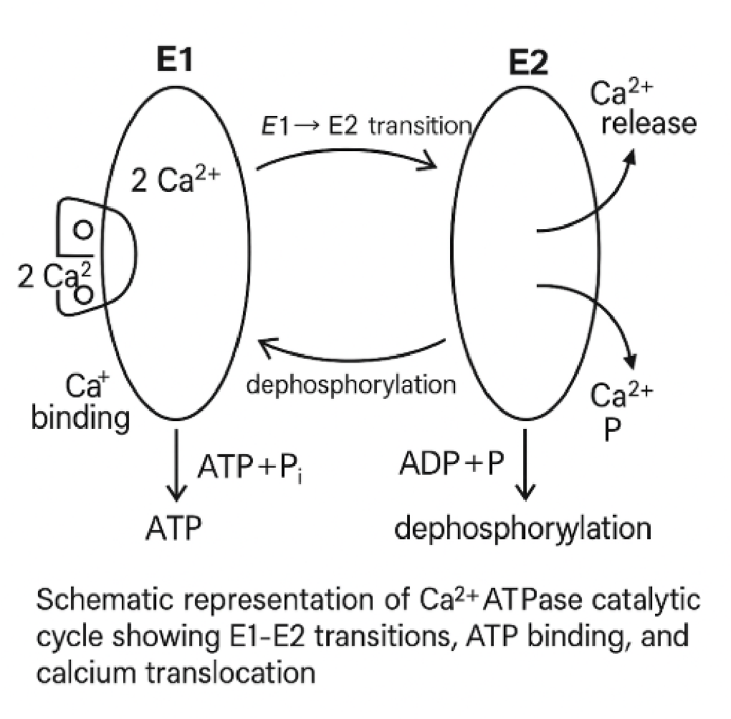
Figure .1 Schematic representation of Ca²⁺-ATPase catalytic cycle showing E1-E2 transitions, ATP binding, and calcium translocation.
Source:
This structural and functional complexity makes Ca²⁺-ATPase sensitive to chemical modulation. Mineral ions like magnesium are essential for ATP binding, while heavy metals or certain organic compounds may disrupt enzyme conformation or ATP hydrolysis, thereby altering calcium transport efficiency (Zhang et al ., 2020).

2.4 Biochemical Processes Involving Ca²⁺-ATPase
Ca²⁺-ATPases are involved in several biochemical processes vital for maintaining homeostasis and enabling signaling cascades. In muscle cells , particularly cardiac and skeletal muscle, SERCA pumps are critical for relaxation following contraction by sequestering cytosolic Ca²⁺ back into the sarcoplasmic reticulum. In neurons , PMCA helps terminate synaptic signals by clearing calcium from the cytoplasm, thus preventing excitotoxicity.
In secretory cells, such as those in the pancreas or salivary glands, Ca²⁺-ATPase regulates calcium-dependent exocytosis. Moreover, the enzyme plays a central role in apoptosis, where abnormal calcium handling can lead to mitochondrial dysfunction and activation of cell death pathways.
The activity of Ca²⁺-ATPase is finely regulated by calmodulin, phosphorylation status, and membrane lipid composition. Disruption by environmental substances such as limestone-derived minerals could either potentiate or inhibit these processes, depending on the mineral’s concentration and bioavailability.
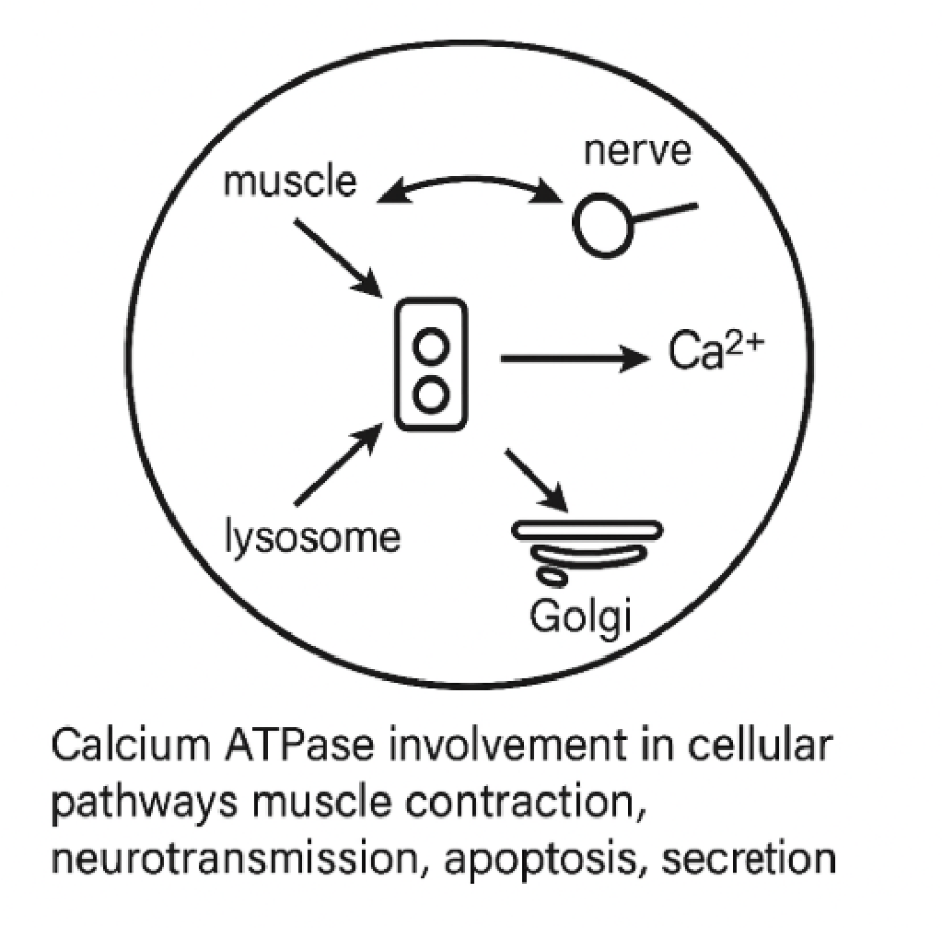
Figure.2: Calcium ATPase involvement in cellular pathways muscle contraction, neurotransmission, apoptosis, and secretion.
Source:
2.5 Roles of Ca²⁺-ATPase
The Ca²⁺-ATPase enzyme performs several essential physiological functions in both excitable and non-excitable cells. Below are its key roles:
- Calcium Homeostasis: Ca²⁺-ATPase maintains low intracellular calcium concentration by pumping Ca²⁺ out of the cytosol either into the extracellular space (PMCA) or into intracellular stores (SERCA). This is critical to avoid toxic calcium buildup in cells.
- Muscle Relaxation: In cardiac and skeletal muscle, SERCA pumps are responsible for removing Ca²⁺ from the sarcoplasm after contraction, allowing muscle fibers to relax. Dysfunction in this process is implicated in heart failure and muscular disorders (Wang et al ., 2020).
- Neuronal Signal Termination: PMCA plays a vital role in the termination of neurotransmission by removing excess Ca²⁺ from neurons after synaptic signaling. Proper functioning prevents neuronal overexcitation and cell death.
- Hormone and Enzyme Secretion: Ca² ⁺-ATPase regulates calcium-dependent secretion in exocrine and endocrine tissues. For example, pancreatic cells rely on tightly regulated calcium for insulin release.
- Cell Growth and Apoptosis: Calcium levels influence pathways for cell cycle progression and apoptosis. Ca²⁺-ATPase indirectly regulates these pathways by controlling cytosolic calcium concentrations.
- Sperm Motility and Fertility: Calcium signaling is essential for sperm activation and motility. Disruption in Ca²⁺-ATPase activity can impair fertility.
- Prevention of Calcium-Induced Cytotoxicity: by maintaining a steep gradient of calcium ions, Ca²⁺-ATPase prevents mitochondrial calcium overload and the initiation of apoptotic cascades (Nguyen et al ., 2021).
2.6 Studies on Enzyme Activities and Modulation
Various studies have explored how enzymes, particularly ion-transport ATPases, respond to environmental, nutritional, and synthetic modulators. One line of research focuses on how trace minerals such as magnesium, zinc, and iron affect ATPase activity by acting as cofactors or competitors. Singh and Patel (2020) demonstrated that exposure to elevated zinc levels significantly enhanced Ca²⁺-ATPase activity in hepatic membranes, whereas lead exposure inhibited it.
Another area of investigation is the use of animal models to examine enzyme modulation through dietary and environmental interventions. For example, Zhang et al . (2020) exposed rats to mineral-rich water and found dose-dependent changes in membrane ATPase activity. These studies suggest that environmental minerals can act either as enzyme stimulators or inhibitors depending on the form, dose, and bioavailability.
Similarly, bioavailable substances in natural mineral sources like limestone may modulate Ca²⁺-ATPase activity. Though not yet widely studied, limestone's elemental content (especially from industrial regions like Ogun State) is likely to influence cellular processes. Investigating this effect in rats provides a model to predict potential human and ecological impacts.
Modulation of enzyme activity is also used therapeutically. For instance, drugs such as thapsigargin inhibit SERCA to induce apoptosis in cancer therapy. On the other hand, compounds that enhance Ca²⁺-ATPase activity are being investigated for use in treating cardiac failure and neurodegenerative disorders.
2.7 Factors Affecting Ca²⁺-ATPase Activity
Several internal and external factors affect Ca²⁺-ATPase enzyme activity:
- pH and Temperature: Enzyme activity is highly pH-sensitive, with optimal activity occurring at physiological pH (around 7.4). Both low and high pH can denature the enzyme or affect binding sites. Temperature affects kinetic energy and can enhance or impair enzyme efficiency depending on the threshold.
- Availability of ATP and Mg²⁺: Ca² ⁺-ATPase is ATP-dependent, and ATP hydrolysis requires magnesium ions as cofactors. A deficiency in Mg²⁺ or ATP impairs enzyme activity.
- Lipid Composition of Membranes: The enzyme is embedded in the lipid bilayer, and membrane fluidity directly affects its function. Cholesterol content and fatty acid saturation can modulate activity.
- Presence of Inhibitors or Modulators: Certain drugs (e.g., vanadate), toxins, and environmental metals can inhibit Ca²⁺-ATPase. Conversely, calcium-mobilizing agents like calmodulin can enhance PMCA activity.
- Oxidative Stress: Oxidative stress resulting from reactive oxygen species (ROS) can cause enzyme denaturation or modify functional groups essential for calcium transport (Zhang et al ., 2020).
- Mineral Interactions from Environmental Sources: Minerals like those in limestone can bind to enzyme sites or influence membrane integrity, thereby modifying enzyme conformation and activity (Adebayo et al ., 2021).
2.8 Research Gaps and Rationale for Current Study
Despite the critical role of Ca²⁺-ATPase and the widespread exposure to natural minerals like limestone, there is limited research on the modulatory effects of such environmental materials on ATPase enzymes. Most existing studies focus on synthetic compounds or known heavy metal toxins, leaving a gap regarding naturally occurring mineral-rich substances.
Limestone from Ogun State is widely used in construction and agricultural applications, and its elemental composition varies with site-specific geology. The potential interaction of its components with biochemical pathways, especially calcium-regulating enzymes, has not been thoroughly investigated. Given the health implications of Ca²⁺ imbalance ranging from hypertension to neurodegeneration this study seeks to address this research gap.

CHAPTER THREE
3.0 MATERIALS AND METHODS
3.1 Materials
3.1.1 Sample collection
The materials required for this study included limestone samples collected from different locations in Ogun State. 3.1.2 Animals
- adult male Wistar rat was utilized for this study, with an average weight range of 150–200 g. The rat were procured from a certified animal breeding facility, and the brain, liver and muscles of the rats were excised to prevent tissue degradation. The organs were collected into ice-cold 0.25 M sucrose buffer (pH 7.4) to preserve enzymatic activity. This procedures were conducted in strict compliance with ethical guidelines, with approval obtained from the institutional Animal Care and Use Committee (ACUC).
3.1.3 Chemicals/Reagents
Reagents necessary for sample preparation and analysis included distilled water and standard laboratory-grade chemicals such as ammonium molybdate, sulfuric acid, L-ascorbic acid, sodium dihydrogen orthophosphate dihydrate, and sodium dodecyl sulfate (SDS). For buffer preparation, sodium chloride (NaCl), potassium chloride (KCl), magnesium chloride (MgCl ₂ ) , calcium chloride (CaCl ₂ ) , and Tris base were used. Enzymatic assays required ATP, sucrose buffer, and vanadate as the standard Ca²⁺ inhibitor. All reagents were of analytical grade, and distilled water was used throughout the experiments. Plastic containers and labelled glassware were utilized for reagent storage, ensuring compatibility with the chemicals involved.
  - Methods
    - Preparation of Limestone Samples
Limestone samples were collected from selected locations in Ogun State. These samples were cleaned to remove dirt, air-dried, and grounded into a fine powder using a mortal and pistol. The powdered samples was sieved to ensure uniform particle size. Two grams of each sample was dissolved in 100 mL of distilled water with constant stirring. The reaction mixture was filtered through Whatman No. 1 filter paper to remove insoluble residues. The resulting filtrates, referred to as limestone sample, were stored in labelled plastic containers at 4°C until further use (NLA, 2019).
    - Characterization of Mineral Composition
Fourier-transform infrared spectroscopy (FTIR) confirmation of carbonate content was performed using (FTIR) to detect characteristic carbonate peaks (Miller et al ., 2021).
    - Preparation of Homogenate/ Enzyme Source
Brain, liver and muscle tissues were quickly excised. The tissues were washed in ice-cold 0.25 M sucrose buffer (pH 7.4) and homogenized using a Potter-Elvehjem homogenizer. The homogenates were centrifuged at 10,000 × g for 15 minutes, and the supernatant served as the enzyme source.
    - Determination of Ca²⁺-ATPase Activity
Ca²⁺-ATPase activity were assayed in reaction mixtures containing 500 µL of Ca²⁺-ATPase buffer (240 mM KCl, 4 mM (MgCl ₂ ) , and 40 mM Tris, pH 7.4), 100 µL of 10 mM (CaCl ₂ ) , 10 µL homogenate, and varying volumes of 10 mM ATP. Reactions were conducted at 37°C for 30 minutes, the reaction was stopped with 0.2 ml of 5% (w/v) Sodium Dodecyl Sulphate (SDS) and the release of inorganic phosphate (P _{i} ) was measured colorimetrically using a molybdate-based assay at 820 nm (Bewaji et al ., 1985). All the assays were carried out in triplicate and individual experiment repeated three times to confirm the results.
    - Kinetics of Ca²⁺ATPases
To determine enzyme kinetics, assays was performed at varying ATP concentrations (10–100 µL of 10 mM ATP solution). The Michaelis-Menten parameters (V _{max} ) and (K _{m} ) was calculated by plotting initial velocity against substrate concentration and fitting the data to the Michaelis-Menten equation. Assays was conducted in the presence and absence of limestone extracts and standard inhibitors to assess their modulatory effects (bewaji et al., 1985).
  - Statistical Analysis
Comparative analyses was performed using one-way analysis of variance (ANOVA) followed by Tukey's post hoc test to determine significant differences among the samples. For experiments involving kinetic studies, non-linear regression analysis was employed to calculate enzyme kinetic parameters such as (V _{max} and K _{m} ). Statistical tests was conducted at a 95% confidence level (p < 0.05) to establish significance. All analyses was performed using GraphPad Prism (version 9.0 or later)

CHAPTER FOUR
4.0 RESULT
4.1: FOURIER TRANSFORM INFRARED SPECTUM (FTIR) OF LIMESTONE
SAMPLE 1
The Figure 4.1 shows the Fourier Transform Infrared Spectrum (FTIR) of limestone sample 1, the characteristic IR spectrum of sample 1 revealed most dominant peaks of calcite appearing at approximately 1415–1430 cm⁻¹, 874–878 cm⁻¹, and 712–715 cm⁻¹. The strong absorption near 1420 cm⁻¹ corresponds to the asymmetric stretching vibration (ν₃ mode) of the carbonate group. The band near 874 cm⁻¹ represents the out-of-plane bending vibration (ν₂ mode), while the absorption around 712 cm⁻¹ is attributed to the in-plane bending vibration (ν₄ mode). These data indicate that the studied limestone is mainly composed of calcium in the form of calcite as identified by its main absorption bands, together, these three bands confirm the presence of calcite as the dominant mineral in the sample. Two bands 1799 and 2513 are also observed compared to the standard bands of 1795–1800 cm⁻¹ and 2510–2520 cm⁻¹, arising from the ν₁ + ν₄ mode of the carbonate ion.) .and broad OH band at ~3400 also observed which indicates moisture or surface hydroxyl groups.
4.2: FOURIER TRANSFORM INFRARED SPECTUM (FTIR) OF LIMESTONE
SAMPLE 2
Figure 4.2 shows the FTIR spectrum of the limestone sample. 2 It shows the characteristic bands of calcite at 1,457,870 and 711. Cm-1. The spectrum peaks appearing at 1,790 and 2,500 cm-1 are also an indication of the presence of calcite. These data indicate that the studied limestone is mainly composed of calcium in the form of calcite as identified by its main absorption bands. The reference bands observed at 1,419, 874.08 and 712.20 cm-1 can be assigned to the asymmetric stretching, out-of-plane bending and in plane bending modes of CO32-, respectively . However, limestone sample has a splitting band at 874.71 cm-1 Moreover, the stretching vibrations of the surface hydroxyl groups (Si-Si-OH or Al-Al-OH) were found at 3,703cm and 3397.
4.3: FOURIER TRANSFORM INFRARED SPECTUM (FTIR) OF LIMESTONE
SAMPLE 3
Figure 4.3shows FTIR spectrum of Sample 3 revealed that the sample is attributed to the in-plane bending vibration (ν₄) band at ~722.6 cm⁻¹ is clearly present, and the ⁻ ¹. The absorption ~1376 cm⁻¹ corresponds to the asymmetric stretching vibration (ν₃) band the presence of the carbonate asymmetric stretch (even if slightly shifted), along with supporting combination bands, validates this identification. However, the spectrum also reveals notable impurities: 1541.3 cm⁻ ¹ Near but higher than the main carbonate asymmetric stretch v₃ of calcite (~1410–1470 however, the out of plain bending (ν₂) band near ~874 cm⁻¹ is not labelled, The presence of strong Si–O bands and OH/C–H stretches indicates that the sample is not pure limestone but contains silicate and organic impurities. 1019.4 cm⁻¹:
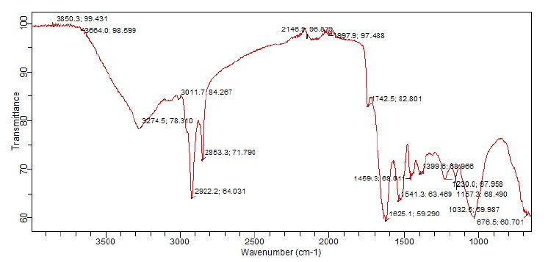
Figure 4.1: FOURIER TRANSFORM INFRARED SPECTUM (FTIR) OF LIMESTONE
SAMPLE 1
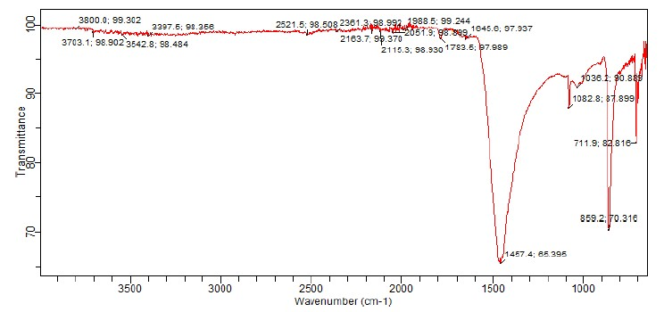
Figure 4.2: FOURIER TRANSFORM INFRARED SPECTUM (FTIR) OF LIMESTONE
SAMPLE 2
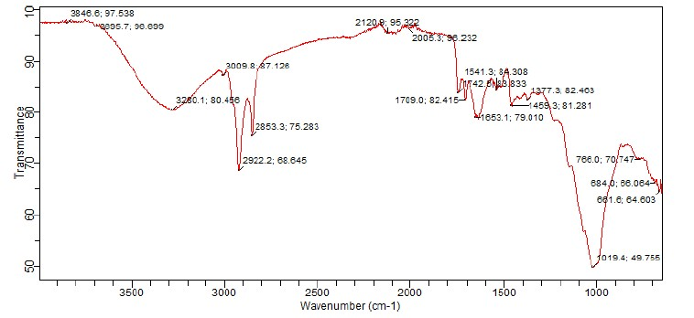
Figure 4.3: FOURIER TRANSFORM INFRARED SPECTUM (FTIR) OF LIMESTONE
SAMPLE 3
4.4: FOURIER TRANSFORM INFRARED SPECTUM (FTIR) OF LIMESTONE
SAMPLE 4
The figure 4.4 shows the Fourier Transform Infrared Spectrum (FTIR) of limestone sample 4, the characteristic IR spectrum of sample 4 Shows that the in-plane bending vibration (ν ₄) band at ~722.6 cm ⁻¹ is clearly present, and the asymmetric stretching (ν ₃) band appears shifted to ~1376.4 cm⁻¹. However, the ν₂ band near ~874 cm⁻¹ is not labelled, The presence of strong Si–O bands at 11073 cm⁻¹ and surface hydroxyl (OH/C–H) at 3319.8 cm ⁻¹) and Organic contamination (C–H stretch at 2916.8 cm⁻¹ and carbonyl stretch at 1718.3 cm⁻¹) stretches indicates that the sample is not pure limestone but contains silicate and organic impurities.
4.5: FOURIER TRANSFORM INFRARED SPECTUM ( FTIR) OF LIMESTONE SAMPLE 5
The figure 4.5 shows the Fourier Transform Infrared Spectrum (FTIR) of limestone sample 5, The characteristic IR spectrum of sample 5 revealed most dominant peaks of calcite appearing at approximately 1415–1430 cm⁻¹, 874–878 cm⁻¹, and 712–715 cm⁻¹. The clear band at 713.5 cm ⁻¹ is a strong indicator of calcite. The presence of a carbonate combination band at 1783.1 cm ⁻¹ further supports calcite. The out-of-plane bend appears at 857.3 cm⁻¹, the overall pattern still strongly supports a calcite-dominant limestone. A pronounced Si–O band at 1022.8 cm⁻¹ indicates meaningful silicate (quartz/clay) content. The broad O–H band at 3412.1 cm⁻¹ points to adsorbed moisture or hydroxylated silicate surfaces. The weak, scattered features around 2113–2180 cm ⁻¹ are non-diagnostic and likely reflect atmospheric/combination interferences rather than intrinsic carbonate chemistry.
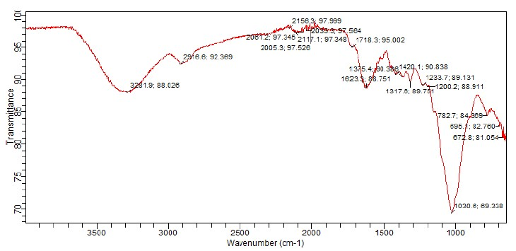
Figure 4.4: FOURIER TRANSFORM INFRARED SPECTUM (FTIR) OF LIMESTONE
SAMPLE 4
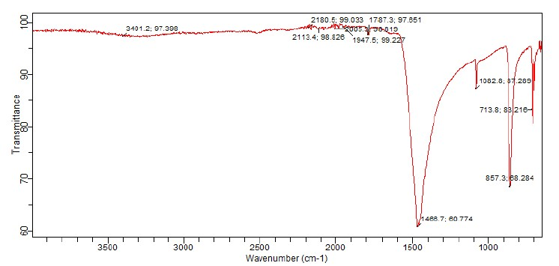
Figure 4.5: FOURIER TRANSFORM INFRARED SPECTUM (FTIR) OF LIMESTONE
SAMPLE 5
4.6: ATP-DEPENDENT ACTIVITY OF CALCIUM ATPase ACTIVITIES IN THE BRAIN IN THE PRESENCE OF LIMESTONE SAMPLES
Sample 3 has the highest ATP-dependent activity, showing a significantly higher specific activity at all easured concentrations compared to the other samples and the baseline Absence of LS control (p<0.05). Sample 2 also exhibits a pronounced increase in activity relative to the control (Figure 4.6). In contrast, Samples 1, 4, and 5 show activity levels that are comparable to or slightly lower than the control. The maximum reaction velocity ( V max) ranged from 0.7001 to 1.778, with the highest catalytic capacity observed in Sample 2 ( V max = 1.778). The Michaelis constant ( K m) values extended from 8.582 to 18.41. Notably, Sample 2 exhibited the lowest substrate affinity ( K m = 18.41), whereas Sample 1 demonstrated the highest affinity ( K m =
8.582).
4.7: ATP-DEPENDENT ACTIVITY OF CALCIUM ATPase ACTIVITIES IN THE LIVER IN THE PRESENCE OF LIMESTONE SAMPLES
Sample 3 has the highest specific activity at all measured concentrations compared to the other samples and the baseline Absence of LS control (p<0.05). Sample 2 also exhibits a pronounced increase in activity relative to the control (Figure 4.7). In contrast, Samples 1, 4, and 5 show activity levels that are comparable to or slightly lower than the control. The V max values spanned between 0.2559 and 0.7754, with the highest value recorded in Sample 2 ( V max =
0.7754). The K m values varied from 0.1824 to 19.47, where Sample 2 had the lowest affinity
( K m = 19.47) and Sample 1 showed the highest affinity ( K m = 0.1824).
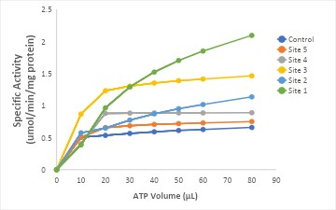
FIGURE 4.6: ATP-DEPENDENT ACTIVITY OF CALCIUM ATPASE ACTIVITY
WITHIN RAT BRAIN HOMOGENATES
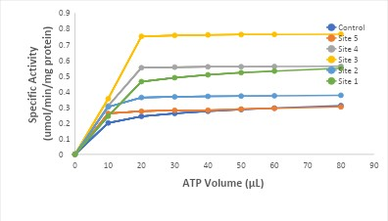
FIGURE 4.7: ATP-DEPENDENT ACTIVITY OF CALCIUM ATPase ACTIVITIES IN
THE LIVER IN THE PRESENCE OF LIMESTONE SAMPLES
4.8: ATP-DEPENDENT ACTIVITY OF CALCIUM ATPase ACTIVITIES IN THE MUSCLE IN THE PRESENCE OF LIMESTONE SAMPLES
Sample 3 has the highest ATP-dependent activity, showing a significantly higher specific activity at all measured concentrations compared to the other samples and the baseline Absence of LS control (p<0.05). Sample 2 also exhibits a pronounced increase in activity relative to the control. In contrast, Samples 1, 4, and 5 show activity levels that are comparable to or slightly lower than the control (Figure 4.8).
Within muscle samples, V max ranged from 0.5309 to 3.395, with Sample 2 showing the greatest catalytic capacity ( V max = 3.395). The K m values were distributed between 0.3273 and 66.95. The lowest substrate affinity was observed in Sample 2 ( K m = 66.95), while the highest affinity was seen in Sample 4 ( K m = 0.3273).
4.9: LIMESTONE-DEPENDENT ACTIVITY OF CALCIUM ACTIVITIES IN THE BRAIN IN THE PRESENCE OF LIMESTONE SAMPLES
Sample 3 has the highest specific activity, showing a significantly higher activity than the other samples (p<0.05). Samples 2 and 4 exhibit similar activity levels, while Samples 1 and 5 show the lowest specific activity (Figure 4.9).
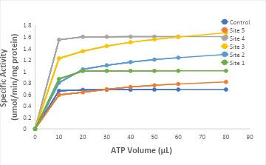
FIGURE 4.8: ATP-DEPENDENT ACTIVITY OF CALCIUM ATPASE ACTIVITY
WITHIN RAT MUSCLE HOMOGENATES
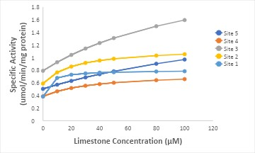
FIGURE 4.9: LIMESTONE-DEPENDENT ACTIVITY OF CALCIUM ATPase
ACTIVITIES IN THE BRAIN IN THE PRESENCE OF LIMESTONE SAMPLES
4.10: LIMESTONE-DEPENDENT ACTIVITY OF CALCIUM ATPase ACTIVITIES IN THE LIVER IN THE PRESENCE OF LIMESTONE SAMPLES
Sample 4 has the highest specific activity, showing a significantly higher activity than the other samples (p<0.05). Samples 1 , 2 , and 3 exhibit similar activity levels to each other, while Sample
- shows the lowest specific activity. (Figure 4.10)
4.11: LIMESTONE-DEPENDENT ACTIVITY OF CALCIUM ATPase ACTIVITIES IN THE muscle IN THE PRESENCE OF LIMESTONE SAMPLES
Sample 4 has the highest specific activity, showing a significantly higher activity than the other samples (p<0.05). Samples 2 and 3 exhibit similar activity levels, while Samples 1 and 5 show the lowest specific activity (Figure 4.11).
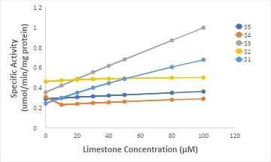
FIGURE 4.10: LIMESTONE-DEPENDENT ACTIVITY OF CALCIUM ATPase
ACTIVITIES IN THE LIVER IN THE PRESENCE OF LIMESTONE SAMPLES
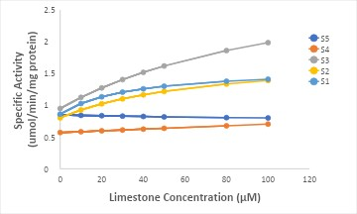
FIGURE 4.11: LIMESTONE-DEPENDENT ACTIVITY OF CALCIUM ATPase
ACTIVITIES IN THE MUSCLE IN THE PRESENCE OF LIMESTONE SAMPLES
CHAPTER FIVE
5.0 DISCUSSION AND CONCLUISON

5.1 DISCUSSION
In this study, it implies that limestone samples obtained from Ogun State possess variable modulatory effects on Ca²⁺-ATPase activity in rat brain, liver, and muscle homogenates. FTIR spectroscopy confirmed calcite ( CaCO₃) as the primary mineral phase across all samples, with site-dependent variations in silicate and organic content. These compositional differences are likely central to the differential effects on Ca²⁺-ATPase activity observed in this study.
Ca²⁺-ATPases, which include plasma membrane Ca²⁺-ATPases (PMCA) and sarco/endoplasmic reticulum Ca²⁺-ATPases (SERCA), are P-type ATPases responsible for maintaining intracellular Ca²⁺ homeostasis (Toyoshima and Inesi, 2004). Their function is critically dependent on both Ca²⁺ and Mg²⁺ availability. Mg²⁺ serves as an obligatory cofactor for ATP binding and hydrolysis, while Ca²⁺ is the transported substrate. Dissolution of calcite from limestone increases extracellular Ca²⁺ concentrations, which in turn can stimulate Ca²⁺-ATPase activity by enhancing substrate availability (Bers, 2002). Similarly, Mg²⁺ impurities within some samples may contribute to higher enzyme activity by optimizing ATP hydrolysis. This could explain the significantly elevated specific activities and Vmax values recorded for Samples 2 and 3. The accompanying rise in Km suggests a reduction in substrate affinity, consistent with allosteric modulation when excess ions are present in the assay environment (Feschenko et al ., 2022).
Trace elements and heavy metals, commonly found as impurities in natural limestone, further modulate ATPase activity. Beneficial metals such as Zn²⁺ and Mn²⁺ are known to stabilize membrane proteins and, in certain contexts, enhance Ca²⁺-ATPase activity (MacLennan and Kranias, 2003). In contrast, toxic metals such as Al³⁺, Pb²⁺, and Cd²⁺ can strongly inhibit the enzyme by binding to sulfhydryl groups, interfering with the phosphorylation-dephosphorylation cycle, or displacing essential cofactors (Stansfield and Bingham, 2013). This provides a biochemical rationale for the reduced or unchanged activity observed in tissues exposed to Samples 1, 4, and 5, which likely contain inhibitory contaminants. The FTIR detection of silicate and organic residues in these samples supports the possibility of co associated heavy metals and organic inhibitors.
Beyond ionic composition, Ca²⁺-ATPase activity is highly sensitive to the lipid environment. Being integral membrane proteins, their catalytic function depends on bilayer fluidity, cholesterol content, and surface charge distribution (Denning and MacLennan, 1986). Adsorption of mineral particles or organic residues from limestone extracts onto the membrane may disrupt lipid packing, alter electrostatic interactions, and thereby modify pump conformation. Such perturbations could underlie the inhibitory effects observed with certain samples, independent of direct metal interactions. Moreover, some trace elements, notably Fe²⁺ and Cu²⁺, may catalyze the generation of reactive oxygen species (ROS) via Fenton chemistry. Oxidative modification of thiol or tyrosine residues in ATPase proteins could reduce catalytic turnover, a mechanism consistent with the diminished activity observed in some assays (Bers, 2002).
Tissue-specific differences in response to the limestone extracts also highlight the distinct isoforms of Ca²⁺-ATPases expressed in brain, liver, and muscle. Neuronal tissue expresses high levels of PMCA isoforms crucial for synaptic signaling, whereas muscle tissue predominantly relies on SERCA for rapid contraction-relaxation cycles (Toyoshima and Inesi, 2004). The differential modulation of Vmax and Km values observed in this study may therefore reflect isoform-specific sensitivities to ionic and environmental changes induced by the mineral extracts. For instance, the stronger stimulation of Ca²⁺-ATPase activity in muscle homogenates by Sample 3 suggests that SERCA is particularly responsive to the ionic milieu provided by that extract, possibly through favourable Mg²⁺:Ca²⁺ ratios.
These research highlight that the biochemical impact of limestone on Ca²⁺-ATPases is complex, involving direct ionic effects on enzyme cofactors and substrates, trace-metal dependent activation or inhibition, perturbation of the lipid microenvironment, and potential oxidative modifications. The consistently higher activity observed with Sample 3 suggests a composition enriched in stimulatory cations (Ca²⁺, Mg²⁺, Zn²⁺) and relatively free from inhibitory heavy metals or organic contaminants. In contrast, the inhibitory effects of other samples may be attributable to heavy-metal toxicity, oxidative stress, or membrane disruption.
Future studies should aim to confirm these mechanisms through elemental analysis (e.g.,
ICP-MS or AAS) to quantify trace metal content, use of selective inhibitors such as vanadate (general P-type ATPase inhibitor) and thapsigargin (SERCA-specific inhibitor), and controlled assays with buffered free Ca²⁺ and Mg²⁺ concentrations. Additionally, measurement of oxidative stress biomarkers (e.g., protein carbonyls, lipid peroxidation) and membrane integrity assays would provide further insight into the indirect mechanisms of inhibition. Such approaches will strengthen causal links between limestone composition and its biochemical effects on
Ca²⁺-ATPase activity.

5.2 CONCLUISON
Our findings demonstrate that there was tissue specific responses of ATPases to limestone sample with the effects on the brain different from the liver and muscle tissue FTIR analysis confirmed calcite as the dominant mineral phase, with sample dependent variations in silicate and organic impurities that likely influenced enzymatic outcomes. More research is needed for better understanding of the activities of the ATPase.

REFERENCES
Adebayo, A. O., Adegbite, A. A., and Oladele, K. T. (2021). Geochemical and mineralogical characteristics of limestone in selected quarries of Ogun State, Nigeria. Journal of Mining and Geology, 57 (2), 123–132
Bers, D. M. (2002). Cardiac excitation contraction coupling. Nature, 415 (6868)
Denning, G. M., and MacLennan, D. H. (1986). Regulation of sarcoplasmic reticulum calcium transport by phospholipids. Journal of Biological Chemistry, 261 (8), 3384–3390.
Feschenko, M., Sweadner, K. J., and Penniston, J. T. (2022). Structure, function, and regulation of plasma membrane Ca²⁺-ATPases. Frontiers in Physiology, 13, 8835232.
MacLennan, D. H., and Kranias, E. G. (2003). Phospholamban: A crucial regulator of cardiac contractility. Nature Reviews Molecular Cell Biology, 4 (7), 566–577.
Nguyen, T. H., Lee, M. Y., and Kim, D. H. (2021). Environmental metals and modulation of iontransport enzymes: A biochemical perspective. Environmental Toxicology andPharmacology, 84, 103592.
Singh, R., and Patel, D. (2020). Mineral interactions with membrane-bound enzymes: Toxicological and therapeutic aspects. Toxicology Reports, 7, 1526–1535.
Stansfield, K., and Bingham, P. (2013). Metal toxicity at the synapse: Impacts on Ca²⁺-ATPase activity and neurotransmission. NeuroToxicology, 36, 1–12.
Toyoshima, C., and Inesi, G. (2004). Structural basis of ion pumping by Ca²⁺-ATPase of the sarcoplasmic reticulum. Annual Review of Biochemistry, 73, 269–292.
Wang, Y., Li, Y., and Zhang, H. (2020). Structure, function, and regulation of Ca²⁺-ATPase in health and disease. Frontiers in Physiology, 11, 583574.
Zhang, J., Chen, X., and Yu, Y. (2020). Modulation of ATPase enzymes in animal models exposed to environmental minerals. Journal of Biochemical Toxicology, 34 (5), e22467.
References

