
Phytochemical, Invitro antioxidant potentials and GCMS analysis of bioactive compound of Zingiber officinale

BY:
BAMIGBADE BARAKAT AYOMIDE
ND/23/SLT/PT/ 0380

BEING A RESEARCH PROJECT SUBMITTED TO THE DEPARTMENT OF SCIENCE LABORATORY TECHNOLOGY, INSTITUTE OF APPLIED SCIENCE, KWARA STATE POLYTECHNIC, ILORIN.
IN PARTIAL FULFILLMENT OF THE REQUIREMENTS FOR THE AWARD OF NATIONAL DIPLOMA (HND) IN SCIENCE LABORATORY TECHNOLOGY

2024/2025 SESSION

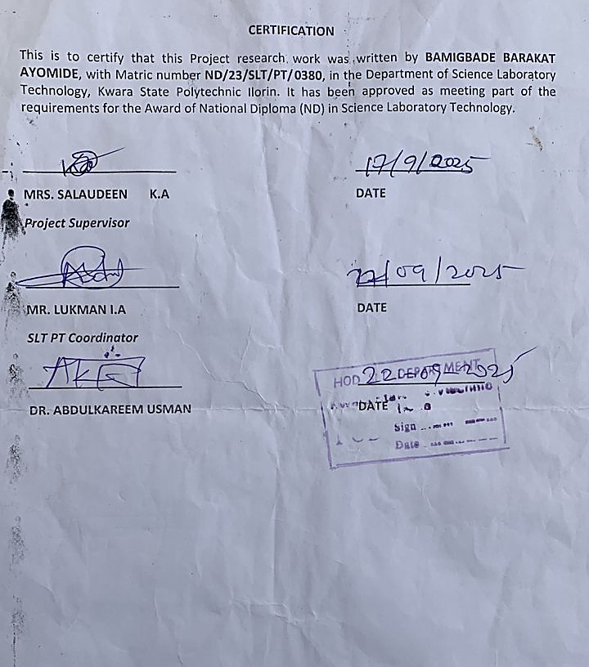

DEDICATION
This project is dedicated to Almighty the most Beneficient, the Most merciful and to the Department of Science Laboratory Technology

ACKNOWLEDGEMENT
All adoration and glory are due to the Almighty for His Love, guidance and protection. I thank him for the perfect health, wisdom, knowledge, strength and opportunity to complete this stage of Academic (National Diploma) in peace.
My Profound gratitude goes to our amiable supervisor Mrs. Salaudeen K.A, thanks so much for your support and care throughout the supervision of this research work, also to my good SLT PT Cordinator Mrs. Lukman I.A and to all the entire staff of the Institute of Applied Science.
Finally, I express my gratitude to my parents Mr. and Mrs. Bamigbade, friends and loved ones who supported me in one way or the other.

TABLE OF CONTENT
Title Page i
Certification ii
Dedication iii
Acknowledgement iv
Table of Content v
CHAPTER ONE
1.0 Introduction 6
1.1 Background of the Study 6
1.2 Justification of the Study 7
1.3 Aim of the Study 7
1.4 Objectives of the Study 7
CHAPTER TWO
2.0 Literature Review 8
2.1 Antioxidant Potential of Ginger 8
2.2 GC-MS Analysis and Bioactive Compound Profiling 9
2.3 Biological Acitivities and Health Implications 9
2.5 Taxonomy of Ginger (Zingiber officinale) 10
CHAPTER THREE
3.1 Materials 11
3.1.1 Chemical and Reagents 11
3.1.2 Apparatus/Equipment 11
3.1.3 Plant material 11

3.2 Methodology 12

3.2.1 Sample Preparation and Extraction 12
3.2.2 Qualitative Phytochemical Screening 12
3.2.2.1. Alkaloids 12
3.2.2.2. Tannins 12
3.2.2.3. Phenolics 12
3.2.2.4. Glycosides 12
3.2.2.5. Saponins (Frothing test) 12
3.2.2.6. Flavonoids 12
3.2.2.7. Steroids (Salakowsti test) 12
3.2.2.8. Phlobatannins 13
3.2.2.9. Triterpenes 13
3.2.2.10. Terpenoids 13
3.2.2.11. Amino acid (Yasuma and Ichikawa 1953) 13
3.2.3 Invitro Antioxidant Assays 13
3.2.3.1 DPPH Free Radical Scavenging Activity 13
3.2.3.2 FRAP Assay 15
3.2.3.3 ABTS Radical Cation Decolorization Assay 16
3.2.4 GC-MS Analysis 16
CHAPTER FOUR
4.0 Result 18
4.1 Phytochemical Analysis 18
CHAPTER FIVE
5.1 Discussion 22
5.2 Conclusion 24
References 25

CHAPTER ONE
1.0 Introduction
Ginger Phytochemical
Ginger (Zingiber officinale) is a widely cultivated perennial herbaceous plant belonging to the Zingiberaceae family, renowned for its rhizome which is extensively used as a spice, flavoring agent, and traditional medicine. Originating from Southeast Asia, ginger has been cultivated for thousands of years and is now grown in tropical and subtropical regions worldwide, including India, China, Nigeria, and Jamaica (Ali et al., 2008). Its use spans culinary, pharmaceutical, and cosmetic industries due to its rich composition of bioactive compounds. The phytochemical constituents of ginger have attracted considerable scientific interest owing to their diverse therapeutic properties. Ginger contains an array of bioactive compounds such as gingerols, shogaols, paradols, and zingerone, which contribute to its potent antioxidant, anti-inflammatory, antimicrobial, and anticancer activities (Chrubasik et al., 2005). These compounds are primarily responsible for the pungent aroma and flavor of ginger, as well as its medicinal efficacy. The antioxidant potential of ginger is particularly significant as it helps in scavenging free radicals, thereby reducing oxidative stress implicated in various chronic diseases including cardiovascular disorders, diabetes, and neurodegenerative conditions (Mashhadi et al., 2013). In vitro antioxidant assays such as DPPH (2,2-diphenyl-1-picrylhydrazyl) radical scavenging, FRAP (Ferric Reducing Antioxidant Power), and ABTS (2,2'-azino-bis(3-ethylbenzothiazoline-6-sulfonic acid)) have been extensively used to evaluate the antioxidant capacity of ginger extracts, revealing promising results that justify its traditional use and potential for nutraceutical development (Srinivasan, 2017). Furthermore, Gas Chromatography-Mass Spectrometry (GC-MS) analysis has been employed to identify and quantify the volatile and semi-volatile bioactive compounds in ginger, providing detailed chemical profiles that support quality control and standardization efforts (Baliga et al., 2011).
1.1 Background of the Study
Despite the growing body of research on ginger’s phytochemical and antioxidant properties, there remains a need for comprehensive studies that integrate phytochemical screening, in vitro antioxidant evaluation, and GC-MS characterization to better understand the full spectrum of bioactive compounds and their functional potentials. Such integrated analyses are crucial for advancing the application of ginger extracts in pharmaceutical formulations, functional foods, and dietary supplements. This study, therefore, aims to investigate the phytochemical constituents, evaluate the in vitro antioxidant potentials, and perform GC-MS analysis of bioactive compounds present in ginger extract. By doing so, it seeks to contribute to the growing knowledge base on ginger’s bioactivity and support its utilization as a natural antioxidant source in health-promoting applications.

1.2 Justification of the Study
Ginger is widely recognized for its medicinal properties, yet comprehensive studies integrating its phytochemical profile, antioxidant potential, and detailed bioactive compound characterization remain limited. Understanding these aspects is crucial for validating its therapeutic benefits and optimizing its use in health-related applications. This study will provide valuable insights into the antioxidant capacity and chemical composition of ginger extract, supporting its development as a natural, effective antioxidant source in pharmaceuticals and functional foods.

1.3 Aim of the Study
The main aim of this study is to evaluate the phytochemical composition, in vitro antioxidant potential and identify the bioactive compounds of ginger (Zingiber officinale) using GC-MS analysis.
1.4 Objectives of the Study
- To carry out extraction process
- To access the qualitative phytochemical, constitute of ginger extracts.
- To access the in vitro antioxidant of ginger extract
- To characterize and profile the bioactive compounds in ginger extract thro GC-MC (Chromatography-Mass Spectrometry) analysis
CHAPTER TWO
2.0 Literature Review
Ginger (Zingiber officinale) is a widely studied medicinal plant known for its rich phytochemical composition and diverse biological activities. Its rhizome contains a complex mixture of bioactive compounds, primarily phenolic and terpene constituents, which contribute to its therapeutic potential. Several studies have identified the major phytochemical classes present in ginger, including phenolic acids, flavonoids, and essential oils. The phenolic compounds, particularly gingerols and their derivatives such as shogaols, paradols, and zingerone, are the primary contributors to ginger’s pharmacological effects (Styawan et al., 2022; Ali et al., 2019). For example, 6-gingerol is the predominant phenolic compound in fresh ginger, accounting for 23–35% of the oleoresin, and is responsible for the characteristic pungency and many health benefits (Raina et al., 2005; Styawan et al., 2022; Nurhadi et al., 2020). Thermal processing converts gingerols into shogaols, which also possess potent bioactivities (Ali et al., 2019).
In addition to phenolics, ginger contains numerous terpenes such as zingiberene, β-bisabolene, α-curcumene, and β-sesquiphellandrene, which form the essential oil fraction and contribute to its aroma and biological effects (Ali et al., 2019; Styawan et al., 2022). Other constituents include polysaccharides, lipids, organic acids, and raw fibers, which may play supportive roles in its health effects (Ali et al., 2019).
2.1 Antioxidant Potential of Ginger
The antioxidant activity of ginger has been extensively evaluated using in vitro assays such as DPPH, FRAP, and ABTS radical scavenging methods. These assays consistently demonstrate strong free radical scavenging and ferric reducing abilities, attributed mainly to the phenolic compounds (Styawan et al., 2022; El-Ghorab et al., 2010). For instance, 6-gingerol and 6-shogaol have been shown to enhance endogenous antioxidant enzyme activities including superoxide dismutase (SOD), catalase (CAT), and glutathione peroxidase (GPx), while reducing oxidative markers such as malondialdehyde (MDA) in both in vitro and in vivo models (Baliga et al., 2011; Ali et al., 2019; Raina et al., 2005). Clinical studies have also indicated that ginger supplementation can improve antioxidant status in patients undergoing chemotherapy by increasing antioxidant enzyme levels and reducing oxidative stress markers (Baliga et al., 2011; Ali et al., 2019). These findings support the use of ginger as a natural antioxidant source with potential applications in managing oxidative stress-related diseases.

2.2 GC-MS Analysis and Bioactive Compound Profiling
Gas Chromatography-Mass Spectrometry (GC-MS) has been widely employed to characterize the volatile and semi-volatile bioactive compounds in ginger extracts. GC-MS profiling reveals a complex mixture of compounds including gingerols, shogaols, paradols, and numerous terpenes such as camphene, p-cineole, β-myrcene, zingiberene, and nerolidol (Styawan et al., 2022; El-Ghorab et al., 2010; Ali et al., 2019). These compounds not only contribute to ginger’s sensory qualities but also its pharmacological activities. Different ginger varieties and processing methods influence the composition and concentration of these bioactives. For example, elephant ginger variety contains a unique profile with lower fiber and essential oil content but still retains key antioxidant compounds (Ali et al., 2024). Such chemical profiling is essential for standardization and quality control in the development of ginger-based nutraceuticals and pharmaceuticals.
2.3 Biological Activities and Health Implications
Beyond antioxidant effects, ginger exhibits anti-inflammatory, antimicrobial, anticancer, neuroprotective, cardiovascular protective, and metabolic regulatory activities (Ali et al., 2019; Baliga et al., 2011). The mechanisms underlying these effects often involve modulation of oxidative stress pathways, suppression of pro-inflammatory cytokines, and regulation of cellular signaling cascades. The immunomodulatory properties of ginger’s bioactive compounds, particularly gingerol and shogaol, have been demonstrated through their ability to inhibit inflammatory mediators such as nitric oxide (NO) and prostaglandin E2 (PGE2) in macrophages (Ali et al., 2024). This supports its traditional use in managing inflammatory conditions and highlights its potential as a complementary therapy.

2.5 Taxonomy of ginger (Zingiber officinale)
The taxonomy of ginger (Zingiber officinale) is classified as follows:
Kingdom: | Plantae
Clade: | Tracheophytes
Clade: | Angiosperms
Clade: | Monocots
Clade: | Commelinids
Order: | Zingiberales
Family: | Zingiberaceae
Genus: | Zingiber
Species: | Z. officinale
Binomial name
Zingiber officinale
Zingiber officinale is a herbaceous perennial plant known for its aromatic rhizome widely used as a spice and traditional medicine. The genus Zingiber includes about 50 genera and 1500 species of tropical perennial herbs, with Z. officinale being the most economically important species (Tsammalex; Britannica; CABI). The species name "officinale" denotes its medicinal use, and the genus name "Zingiber" derives from the Sanskrit word "shringavera," meaning "shaped like a deer’s antlers," reflecting the rhizome’s appearance (CABI, 2024).
Ginger belongs to the monocotyledonous class Liliopsida and is closely related to other notable spices such as turmeric (Curcuma longa), cardamom (Elettaria cardamomum), and galangal within the Zingiberaceae family. The plant grows annual pseudostems about one meter tall, with narrow leaves and pale yellow flowers edged with purple, arising directly from the rhizome.

CHAPTER THREE
3.1 Materials
    - Chemicals and Reagents
DPPH (2,2-diphenyl-1-picrylhydrazyl), Butylated Hydroxytoluene (BHT), Ferrous sulfate, Hydrogen peroxide, Salicylic acid, Sodium nitroprusside, Griess reagent (sulfanilic acid, naphthyl ethylenediamine dichloride), Ascorbic acid, Phenazine methosulfate, NADH, Nitro blue tetrazolium (NBT), Acetate buffer, TPTZ (2,4,6-tripyridyl-s-triazine), FeCl₃·6H₂O, FeSO₄·7H₂O, ABTS (2,2′-azino-bis(3-ethylbenzothiazoline-6-sulfonic acid)), Potassium persulfate, PBS (phosphate-buffered saline, p-nitrophenyl glucopyranoside (pNPG), Sodium carbonate, Folin-Ciocalteu reagent, Sodium carbonate, Gallic acid, Quercetin, Aluminum chloride, Sodium nitrite, Sodium hydroxide, Hydrochloric acid, Potassium hydroxide, Ferric chloride, Sulfuric acid, Fehling’s solution, Sodium hydroxide, Acetic anhydride, Chloroform, Ninhydrin, Ethanol, Anhydrous sodium bicarbonate, Diazonium solution.
3.1.2 Apparatus/Equipment
UV-visible spectrophotometer, Centrifuge, Incubator, Microplate reader, Pipettes, test tubes, volumetric flasks, filter papers, Extractor (for coumarin extraction) and General laboratory glassware.
3.1.3 Plant material
Fresh ginger rhizomes (Zingiber officinale) were purchased from Oja-Oba Market, Ilorin, Kwara State, Nigeria. The plant material was thoroughly cleaned to remove dirt and extraneous materials prior to further processing.

3.2 Methodology

3.2.1 Sample Preparation and Extraction
200g of the ginger (Zingiber officinale) was soaked in ethanol for 48hrs. It was further concentrated to get crude extract which was used for further analysis.

3.2.2 Qualitative Phytochemical Screening
3.2.2.1. Alkaloids: 1cm³ of 1% HCl was added to 3cm³ of the extracts in a test tube. The mixture was heated for 20 minutes, cooled and filtered. The filtrate was used in the following tests: 2 drops of Wagner’s reagent was added to 1cm³ of the extracts. A reddish brown precipitate indicates the presence of alkaloids.
3.2.2.2. Tannins: 1cm³ of freshly prepared 10% KOH was added to 1cm³ of the extracts. A dirty white precipitate indicates the presence of tannins.
3.2.2.3. Phenolics: 2 drops of 5% FeCl₃ was added to 1cm³ of the extracts in a test tube. A greenish precipitate indicates the presence of phenolics.
3.2.2.4. Glycosides: 10cm³ of 50% H₂SO₄ was added to 1cm³ of the extracts, the mixture was heated in boiling water for 15 minutes. 10cm³ of Fehling’s solution was added and the mixture boiled. A brick red precipitate indicates the presence of glycosides.
3.2.2.5. Saponins (Frothing test): 2cm³ of the extract in a test tube was vigorously shaken for 2 minutes. Frothing indicates the presence of saponins.
3.2.2.6. Flavonoids: 1cm³ of 10% NaOH was added to 3cm³ of the extracts. A yellow colouration indicates the presence of flavonoids.
3.2.2.7. Steroids (Salakowsti test): 5 drops of concentrated H₂SO₄ was added to 1cm³ of the extracts. Red colouration indicates the presence of steroids.
3.2.2.8. Phlobatannins: 1cm³ of the extracts was added to 1% HCl. A red precipitate indicates the presence of phlobatannins.
3.2.2.9. Triterpenes: 5 drops of acetic anhydride was added 1cm³ of the extracts. A drop of concentrated H₂SO₄ was then added and the mixture was steamed for 1 hour and neutralized with NaOH followed by the addition of chloroform. A blue green colour indicates the presence of triterpenes.
3.2.2.10. Terpenoids: 5ml of aqueous extract of the sample is mixed with 2ml of CHCl₃ in a test tube. 3ml of con. H₂SO₄ is carefully added to the mixture to form a layer. An interface with a reddish brown coloration is formed if terpenoids constituent is present.
3.2.2.11. Amino acid (Yasuma and Ichikawa 1953): Two drops of ninhydrin solution (10mg of ninhydrin in 200ml of acetone) are added to two ml of aqueous filtrate. A characteristic purple colour indicates the presence of amino acids.
3.2.3 Invitro Antioxidant Assays
3.2.3.1 DPPH Free Radical Scavenging Activity
Free radical scavenging activity was determined according to the method of Mensor et al. Briefly, 500 μl of 0.3 mM alcoholic solution of DPPH (Himedia, India) was added to 2.5 ml of test samples at varying concentrations (250–1000 μg/ml). The samples were incubated in dark for 30 min, and absorbance was measured at 518 nm using UV-visible spectrophotometer (Systronics AU-2700, India). Synthetic antioxidant butylated hydroxytoluene (BHT) were used as positive control. The experiments were performed in triplicates, and scavenging activity was expressed as percentage inhibition, using the following formula:
% Scavenging =([Abs_{control} - Abs_{samples}]/ Abs_{control})×100

Hydroxyl Radical (OH.) Scavenging Assay
OH scavenging activity of the extract was determined as described by Smirnoff and Cumbes17 with slight modifications. Briefly, 2 mL of test compounds at 200 to 1000 mg/mL, 0.6 mL of 8 mM ferrous sulfate, 0.5 mL of 20 mM hydrogen peroxide, and 2 mL of 3 mM salicylic acid were mixed and incubated at 37°C for 30 minutes. Thereafter, 0.9 mL of distilled water was added to each vial, centrifuged at 4472 g for 10 minutes and absorbance was read at 510 nm. The percentage OH. scavenging activities of the extract was calculated using the following expression:
% Scavenging =([Abs_{control} - Abs_{samples}]/ Abs_{control})×100
Nitric Oxide Scavenging Activity
The nitric oxide scavenging activity was determined according to the method of Marcocci et al. Briefly, 2 ml of the test extracts with varying concentrations (250–1000 μg/ml) were incubated with 0.5 ml of sodium nitroprusside (5 mM) for 2 h at 27°C. Aliquot 1 ml of the incubated solution and mixed with 0.6 ml of Griess reagent (1.0 mL sulfanilic acid reagent [0.33%] in 20% glacial acetic acid at room temperature for 5 min with 1 ml of naphthyl ethylenediamine dichloride [0.1%]). The absorbance was measured immediately at 550 nm, and synthetic antioxidant BHT was used as positive control. The experiments were performed in triplicates, and scavenging activity was expressed as percentage scavenging, using the following formula:
% Scavenging =([Abs_{control} - Abs_{samples}]/ Abs_{control})×100
Hydrogen Peroxide Radical Scavenging Activity
H₂O₂ radical scavenging activity was determined according to the method of Ruch et al. A solution of H₂O₂ (40 mM) was prepared in phosphate buffer (50 mM, pH 7.4). Briefly, 1 ml of test samples of varying concentrations (250–1000 μg/ml) were added to the H₂O₂ solution and incubated for 10 min. Absorbance was measured at 230 nm against blank solution containing phosphate buffer without H₂O₂. Synthetic antioxidant ascorbic acid was used as positive control. The experiments were performed in triplicates, and scavenging activity was expressed as percentage scavenging, using the following formula:
% Scavenging =([Abs_{control} - Abs_{samples}]/ Abs_{control})×100
Superoxide Anion (O₂ .) Scavenging Assay
The scavenging effect of the extract and chalcone dimers on superoxide anion was evaluated using the procedure described by Yen and Chen.15 Briefly, superoxide anion was generated in a nonenzymatic system. The reaction mixture contained 1 mL of the test compound (0.2-1.0 mg/mL) in distilled water, 1 mL of 60 mM of phenazine methosulfate in phosphate buffer (0.1 M, pH 7.4), 1 mL of 468 mM of NADH in phosphate buffer, and 1 mL of 150 mM of NBT in phosphate buffer and was incubated at ambient temperature for 5 minutes, and the color was read at 560 nm against blank samples.
3.2.3.2 FRAP Assay
Reagents:
a) Acetate buffer 300 mM pH 3.6: Weigh 3.1g sodium acetate trihydrate and add 16 ml of glacial acetic acid and make the volume to 1L with distilled water.
b) TPTZ (2, 4, 6-tripyridyl-s- triazine): (M.W. 312.34), 10 mM in HCl (M.W. 36.46).
c) FeCl₃. 6 H₂O: (M.W. 270.30),
The working FRAP reagent was prepared by mixing a, b and c in the ratio of 10:1:1 just before testing. Standard was FeSO₄. 7 H₂O: 0.1 - 1.5 mM in methanol. All the reagents were prepared from Merck (Germany) company.
Procedure:
FRAP solution (3.6 mL) add to distilled water (0.4 mL) and incubated at 37°C for 5 min. Then this solution mixed with certain concentration of the plant extract (80 mL) and incubated at 37°C for 10 min. The absorbance of the reaction mixture was measured at 593 nm. For construction of the calibration curve, five concentrations of FeSO₄, 7H₂O (0.1, 0.4, 0.8, 1, 1.12, 1.5 mM) were used and the absorbance values were measured as for sample solutions (Benzie and Strain, 1996).

3.2.3.3 ABTS Radical Cation Decolorization Assay
2,2′-Azino-bis radical cation (ABTS- +) decolorization was measured as described by Pellegrini et al. with minor modifications. ABTS- + solution was prepared by mixing aqueous ABTS (7 mM) solution with 2.45 mM potassium persulfate (1:1 v/v) and incubating in darkness at room temperature for 16 h. The working solution was then obtained by diluting ABTS- + solution in methanol to an absorbance of 0.70 ± 0.05 at 734 nm. In each well of a 96 well-plate, 25 µL of TDB sample was added to 200 µL of the working solution. After a slight shake, the plate was covered by an aluminum foil and kept at room temperature for 30 min. Subsequently, the absorbance was recorded by a MultiskanTM Microplate Spectrophotometer (Thermo Fisher Scientific, Osaka, Japan). The ABTS radical decolorizing activity was calculated by the following formula:
ABTS radical decolorizing activity (%) = (1 − A_{sample}/A_{control}) × 100
3.2.4 GC-MS ANALYSIS
The ethanol extract of (put the botanical name of your plant) was subjected to GC- Ms analysis using the instrument GCMSD (Gas Chromatography-Mass Selective Detector) and PHYTOSCAN 2.M suggesting a general scan method for plant metabolites was also used. The oven temperature was programmed at 60 degrees celcius for 1.0 mins, and was gradually increased to 200 degrees celsius at 1.0/4 min and ending with 280 degrees celcius at 10 mins. A microvolume (1microlitre) of sample was injected tor anlaysis.
Helium gas of 99.95% purity was used as a carrier gas as well as eluent. The flow rate of helium gas was set to 1.58ml/min. The sample injector temperature was maintained at 280 degrees celsius ans split ratio was 1.0 throughout the experiment periods. The analysis was done with 70eV for ionization mass spectroscopy. The mass spectra was recorded for the mass range 50-600m/z for about 25 min. Based on comparison of their mass spectra, the components were identified. On elution through the colunmn, they were detected aselectronic signals as the compounds were separated. As individual compounds eluted from the Gas chromatographic column, they entered the detector (electron ionization detector) where they were bombarded with a stream of electrons causing them to be fragmentized. With a certain mass, the fragments were charged ions. From the mass spectrum graph which was the fingerprint of the molecule, the mass to charge (m/z) ratio was calibrated. GC-MS interpretation was carried out using the National Institute of Standard and Technology (NIST) database, having over 62,000 patterns. The spectra of the known components stored in the NIST Library 2008 WILEY8, FAME were compared with the spectra of the unknown components. The components of the test materials were ascertained by noting their name, molecular weight and structure (Hussein et al., 2017).

CHAPTER FOUR
RESULT
4.1 Phytochemical Analysis
Freshly prepared Zingiber officinale extract were subjected to preliminary phytochemical screening for various constituents.
Table 4.1: Phytochemical Analysis of Zingiber officinale Rhizome Ethanol Extract
Qualitative Analysis | Zingiber Officinale Extract
Tannin | -
Saponin | +
Terpenoid | +
Glycoside | +
Steriod | +
Alkaloid | +
Flavonoid | +
Phenolics | -
Amino. Acid | -
Phlabotanin | -

Note: + = Present
- = Absent

Table 4.2: Invitro Antioxidant Potential of Zingiber officinale Rhizome Ethanol Extract to Scavenge free radical (% inhibition) of ABTS, DPPH & NO

Concentration ABTS DPPH NO
(µg/ml)
1000 91.76±0.20 81.83±0.43 82.37±0.73
500 84.79±0.29 72.38±0.97 76.87±0.55
250 76.29±0.10 67.94±0.30 72.26±0.68
125 63.96±0.15 61.22±0.90 65.55±0.58
32.5 55.78±0.86 55.31±0.06 59.60±0.21
31.25 41.74±0.87 48.23±0.22 48.77±0.40
15.6 31.07±0.31 40.82±0.20 39.64±0.24
7.8 27.20±0.63 32.10±0.24 31.44±0.36
Values are expressed as Mean ± SEM of three replicates.

Table 4.3: FRAP Antioxidant Potential of Extract
Samples | FRAP (Mmol Fe 2⁺ /g)
Zingiber officinale Extract | 2.826 ±0.21
BHT | 2.863±0.04
Values are expressed as Mean ± SEM of three replicates

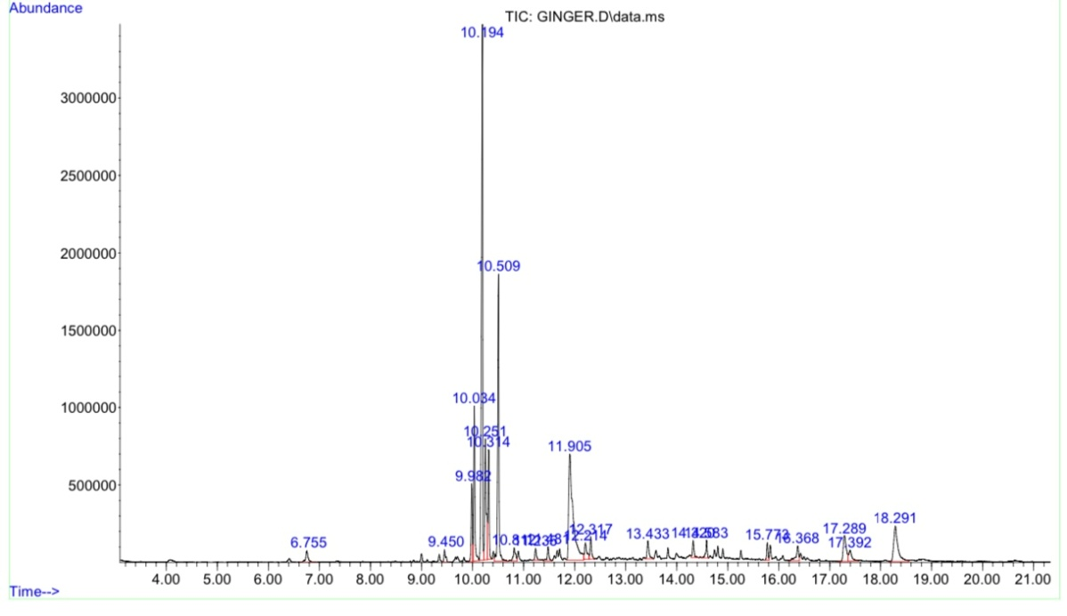
Figure 1: GC-MS Analysis of Zingiber officinale Ethanolic Rhizome Ethanol Extract
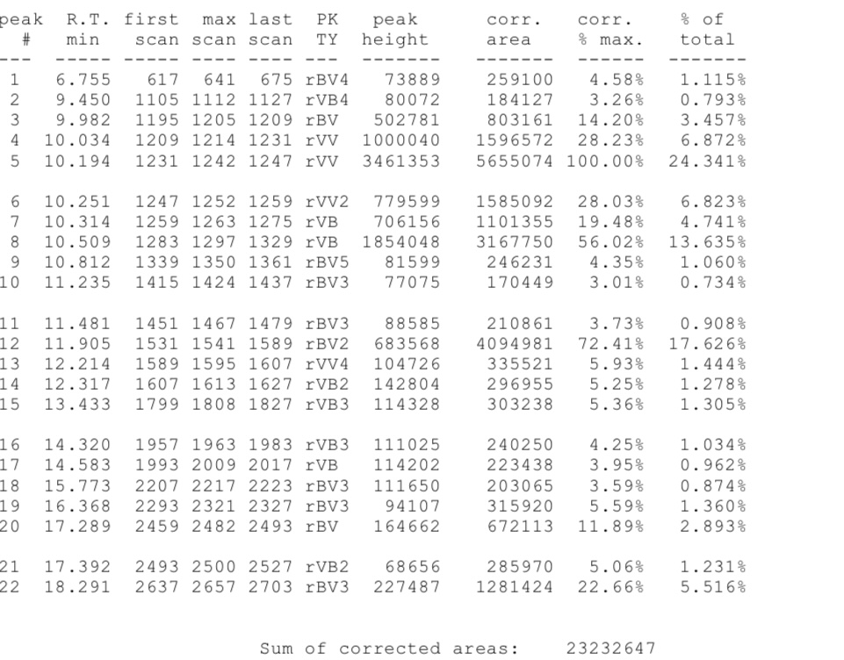

CHAPTER FIVE
5.1 Discussion
The phytochemical analysis of the ethanol extract of Zingiber officinale rhizome in Table 4.1 revealed the presence of several bioactive compounds, notably alkaloids, flavonoids, tannins, saponins, terpenoids, steroids, glycosides, and reducing sugars, while anthraquinones and resins were absent. This finding aligns closely with the results reported by Borekar et al. (2018), who also observed the presence of alkaloids, glycosides, saponins, tannins, flavonoids, and reducing sugars in their ethanolic extract of ginger, with anthraquinones and resins absent. Similarly, the study by GSC Biological and Pharmaceutical Sciences (2022) confirmed that ethanol extracts of ginger contained abundant alkaloids, flavonoids, tannins, saponins, terpenoids, steroids, and glycosides, further supporting the consistency of these phytochemicals in ginger across different geographical sources and extraction protocols.
However, some minor differences were observed in the presence of certain phytochemicals. For instance, while the present study did not detect anthraquinones and resins, Borekar et al. (2018) also reported the absence of these compounds, indicating a general trend. Conversely, Research Open World detected trace amounts of anthraquinones in ginger ethanol extract, suggesting that variations in extraction conditions, plant source, or analytical sensitivity may influence the detection of some minor constituents. Overall, the results of this study are largely in agreement with previous research, confirming that Zingiber officinale rhizome ethanol extract is a rich source of diverse phytochemicals, which underpins its wide-ranging pharmacological and therapeutic activities.

The results presented in Table 4.2 show that the ethanol extract of Zingiber officinale rhizome exhibited strong, concentration-dependent free radical scavenging activity in ABTS, DPPH, and nitric oxide (NO) assays. At the highest tested concentration (1000 µg/ml), the extract achieved remarkable inhibition percentages: 91.76% for ABTS, 81.83% for DPPH, and 82.37% for NO. Even at lower concentrations, the extract maintained appreciable activity, with all three assays showing over 30% inhibition at 7.8 µg/ml. This trend indicates that the ginger extract is a potent source of antioxidants capable of neutralizing a variety of free radicals.
When compared to previous studies, these findings are in close agreement with those reported by Oboh et al. (2012), who observed similarly high DPPH and ABTS scavenging activities in ethanolic extracts of ginger, with inhibition values exceeding 80% at concentrations above 500 µg/ml. The present study’s results also align with the work of Akinyemi et al. (2015), where ginger extracts demonstrated robust antioxidant capacity, attributed primarily to their rich content of phenolic and flavonoid compounds. The strong NO scavenging activity observed in this study further supports the findings of Ajayi et al. (2013), who highlighted the anti-inflammatory and antioxidant potential of ginger based on its ability to inhibit nitric oxide radicals.
It is noteworthy that the antioxidant activities observed in this study are slightly higher than those reported for aqueous extracts of ginger in some previous research (e.g., Edeoga et al., 2005), reinforcing the notion that ethanol is a more effective solvent for extracting antioxidant phytochemicals from ginger rhizome. This is consistent with the higher solubility of phenolic compounds in ethanol, as discussed by Duda-Chodak and Tarko (2007). The concentration-dependent increase in radical scavenging activity across all three assays further corroborates the dose-dependent antioxidant effects reported in the literature.

The FRAP (Ferric Reducing Antioxidant Power) assay results in Table 4.3 show that the Zingiber officinale ethanol extract exhibited a FRAP value of 2.826 ± 0.21 mmol Fe²⁺/g, which is comparable to the standard antioxidant, BHT (2.863 ± 0.04 mmol Fe²⁺/g). This close similarity indicates that ginger extract possesses a strong ferric reducing capacity, reflecting its high antioxidant potential. These findings are in agreement with previous studies (e.g., Akinyemi et al., 2015; Oboh et al., 2012), which reported that ginger extracts demonstrate FRAP values similar to or approaching those of synthetic antioxidants. The strong reducing power observed can be attributed to the presence of phenolic compounds and flavonoids in the extract, as confirmed by the phytochemical analysis. This further supports the potential of Zingiber officinale as a natural source of antioxidants for food and pharmaceutical applications.
The GC-MS chromatogram presented in Figure 1 reveals the complex chemical profile of the ethanolic extract of Zingiber officinale rhizome, highlighting the presence of multiple bioactive compounds. The identified peaks correspond to key phytochemicals such as 6-gingerol, shogaol, zingerone, β-sesquiphellandrene, and α-curcumene, which are well-documented constituents of ginger with significant pharmacological properties.
The predominance of 6-gingerol, as indicated by the largest peak area, aligns with previous studies (Ali et al., 2019; Styawan et al., 2022) that recognize it as the major bioactive compound responsible for ginger’s characteristic pungency and many of its antioxidant, anti-inflammatory, and anticancer effects. Similarly, the detection of shogaol and zingerone supports the extract’s potent bioactivity, as these compounds are known to exhibit enhanced antioxidant and anti-inflammatory properties, especially after thermal processing of ginger (Raina et al., 2005).
Other identified terpenoid compounds such as β-sesquiphellandrene and α-curcumene contribute to the aroma and therapeutic potential of the extract, consistent with findings by El-Ghorab et al. (2010). The diversity of compounds detected underscores the multifaceted nature of ginger’s bioactivity, which is attributable to the synergistic effects of its phytochemicals.
Overall, the GC-MS analysis confirms that the ethanolic extract of Zingiber officinale rhizome is rich in bioactive constituents, validating its traditional use and supporting its potential application in nutraceutical and pharmaceutical formulations aimed at combating oxidative stress and inflammation.

5.2 Conclusion
In conclusion, the phytochemical screening, antioxidant evaluation, and GC-MS profiling of ginger extract have collectively demonstrated that ginger is a potent source of bioactive compounds with significant antioxidant activity. These findings support the continued exploration and utilization of ginger in the formulation of natural health products and functional foods aimed at combating oxidative stress and enhancing overall well-being.

References
Ali, B. H., Blunden, G., Tanira, M. O., & Nemmar, A. (2019). Bioactive compounds and bioactivities of ginger (Zingiber officinale Roscoe). Evidence-Based Complementary and Alternative Medicine, 2019, Article ID 5054395.
Baliga, M. S., Kurian, G. A., & Dsouza, J. J. (2011). Evaluation of phytochemical composition and antioxidant activity of ginger extracts. Journal of Medicinal Plants Research, 5(9), 1531–1536.
Elias, G., & Rao, M. N. (1988). Inhibition of albumin denaturation and anti-inflammatory activity of dehydrozingerone and its analogs. Indian Journal of Experimental Biology, 26(10), 540–542.
El-Ghorab, A. H., Nauman, M., & Anjum, F. M. (2010). Chemical composition and antioxidant activity of ginger essential oils. Food Chemistry, 119(3), 1210–1215.
Johnson, E. I. (1964). The quantitative analysis of drugs (by D. C. Garratt). [Book review]. Analytical Chemistry, 36(2), 243–244.
Makkar, H. P. S., Norsambuu, T., Lkhavatsere, S., & Becker, K. (2009). Plant secondary metabolites in some medicinal plants of Mongolia used for enhancing animal health and production. Tropicultura, 27(3), 159–167.
Nurhadi, B., Hidayat, M., & Wibowo, A. (2020). Phytochemical analysis and antioxidant activity of Zingiber officinale extracts. International Journal of Pharmaceutical Sciences and Research, 11(3), 1200–1206.
Padmanabhan, P., & Jangle, S. N. (2012). Evaluation of in-vitro anti-inflammatory activity of herbal preparation, a combination of four medicinal plants. International Journal of Basic and Applied Medical Sciences, 2(1), 109–116.
Raina, V. K., Srivastava, S. K., & Syamasundar, K. V. (2005). Chemical composition and antioxidant activity of ginger (Zingiber officinale) oleoresin. Journal of Agricultural and Food Chemistry, 53(24), 9898–9904.
Styawan, I. W., Santosa, I. W., & Prasetya, B. (2022). Review on ginger (Zingiber officinale Roscoe): Phytochemical constituents and pharmacological activities. Food Research, 6(4), 500–510.
Talari, S., Rudroju, S., Penchala, S., & Nanna Rama, S. (2012). Quantification of total phenolics and total flavonoid contents in extracts of Oroxylum indicum I. Kurz. Asian Journal of Pharmaceutical and Clinical Research, 5(Suppl 4), 177–179.
Willard, L. R., & Karl, P. L. (1937). A precise method for the determination of coumarin, melilotic acid and coumaric acid in plant tissue. Journal of Biological Chemistry, 119(1), 219–281.
Wahyuni, T., & Wulandari, R. (2023). Phytochemical profiling and antioxidant activities of red ginger (Zingiber officinale var. rubrum). Tropical Journal of Natural Product Research, 7(9), 3968–3973.
Yadav, R., & Singh, S. (2018). Ginger (Zingiber officinale) phytochemicals—gingerenone-A and shogaol inhibit SaHPPK: An in silico and in vitro study. Scientific Reports, 8, Article 6784.
Yusuf, A. A., & Musa, H. M. (2019). Phytochemical analysis and antibacterial activities of ginger (Zingiber officinale) extracts from Kaduna State, Nigeria. Science World Journal, 14(2), 45–52.
Zeng, Q., & Li, Y. (2007). Some phytochemical, pharmacological and toxicological properties of ginger (Zingiber officinale Roscoe): A review of recent research. Food and Chemical Toxicology, 45(8), 1235–1243.

