EVALUATION OF NEEM LEAVE POWDER AS AN ALTERNATIVE PRESERVATION FOR COWPEA

BY

SAMUEL, DANIEL GBENGA
ND/23/ABE/PT/0032

A PROJECT SUBMITTED TO THE DEPARTMENT OF AGRICULTURAL AND BIO-ENVIRONMENTAL ENGINEERING TECHNOLOGY,
INSTITUTE OF TECHNOLOGY, KWARA STATE POLYTECHNIC, ILORIN
KWARA STATE, NIGERIA

IN PARTIAL FULFILMENT OF THE REQUIREMENTS FOR THE AWARD OF NATIONAL DIPLOMA (ND) IN AGRICULTURAL AND BIO-ENVIRONMENTAL ENGINEERING TECHNOLOGY.

AUGUST, 2025

DECLARATION
I hereby declared that this research project “Evaluation of Neem Leave Powder as an Alternative Preservation for cowpea” is my work and has not been submitted by any other person for any degree or qualification at any higher institution. I also declare that the information provided therein are mine and those that are not mine are properly acknowledged.

………………………….. …………………………
Name of Student Signature and Date

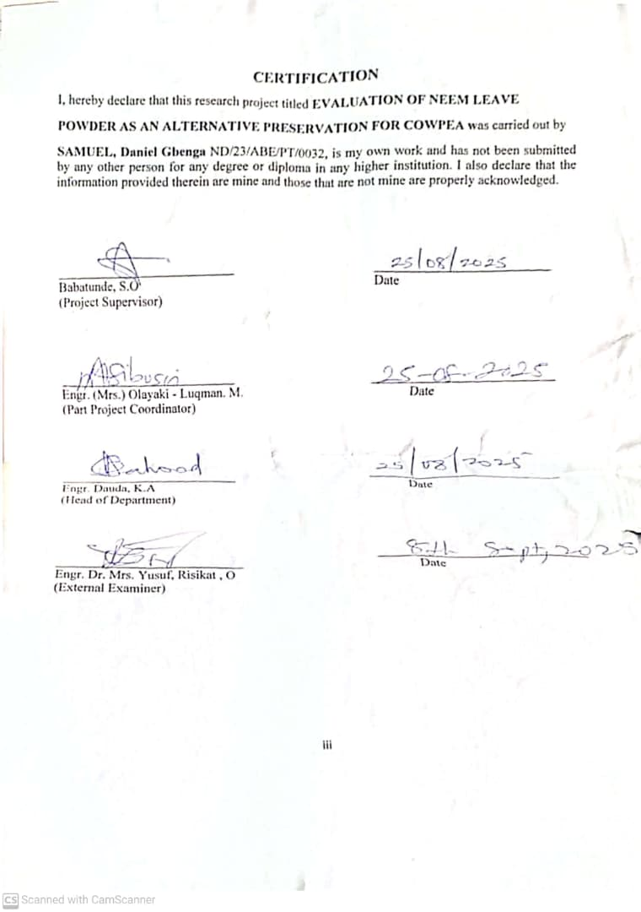
DEDICATION
This project is dedicated to Almighty Allah for his knowledge , protection and guidance and to my parent Mr and Mrs Samuel for their support throughout my days in school

Acknowledgement
All thanks and adoration are to God for making this program a success.
Making use of this great opportunity to thank and appreciate my humble supervisor Engr Babatunde, S.O for her guidance in leading me to the right path, Thank you for the care Ma, may you Excel in your entire endeavour (Amen). And to all my lecturers, I say a big thank you.
With heart of gratitude, I acknowledge the effort of my parents Mr and Mrs Samuel for their parental role in my life , and in making this project a successful one . May God continue to bless them.
Lastly, my gratitude goes to my family, friends and relatives and all my well wishers, thank you all for your invaluable instructions, financial support, words of encouragements during my stay in school.

TABLE OF CONTENTS
CHAPTER ONE - INTRODUCTION
1.1 Background to the Study 1
1.2 Problem Statement 1
1.3 Aims and Objectives 2
1.4 Significance of the project 2
1.5 Scope of the Study 3
CHAPTER TWO LITERATURE REVIEW
2.1 Cowpea production and storage challenges 4
2.2 insect pest in cowpea storage 4
2.3 Limitation of synthetic pesticides 4
2.4 botanical alternatives for pest control 5
2.5 Neem as bio-preservatives 5 2.6 efficacy of neem in controlling insect pest 6
2.7 Potential of neem leaves powder 6
2.8 Comparison with synthetic pesticides 6
2.9 Nutritional composition of cowpea 6
2.10 Constituent of cowpea 7
CHAPTER THREE - MATERIALS AND METHODS
3.1 Materials used in the stud 10
3.2 Methodology 13
3.3 Proximate composition of cowpea 14
CHAPTER FOUR - RESULTS AND DISCUSSION
4.1 Result 19
4.2 Discussion 23
CHAPTER FIVE - CONCLUSION AND RECOMMENDATION
5.1 Conclusion 28
5.2 Recommendation 28
References

CHAPTER ONE
INTRODUCTION
1.1 Background of the Study
Cowpea (Vigna unguiculata) is a vital legume crop in Nigeria, serving as a significant source of protein for both rural and urban populations. However, post-harvest losses due to insect pests, particularly the cowpea weevil (Callosobruchus maculatus), pose a substantial threat to food security. Traditional reliance on synthetic pesticides for storage pest control has raised concerns due to their environmental impact, cost, and potential health hazards.
Neem (Azadirachta indica), a tree indigenous to the Indian subcontinent and widely cultivated in Nigeria, possesses insecticidal properties attributed to compounds like azadirachtin. Utilizing neem leaf powder as a natural preservative offers a promising alternative to chemical pesticides, potentially reducing post-harvest losses in cowpea storage.
Cowpea is a crucial legume crop globally, but significant post-harvest losses occur due to insect pests like the cowpea weevil (Aslam et al., 2017; Kananji et al., 2018). Conventional preservation methods using synthetic insecticides pose health and environmental concerns (Isman, 2006).
Neem, with its proven insecticidal properties, offers a potential natural alternative for preserving cowpea (Isman, 2006). This study investigates neem leaves powder as a sustainable solution to reduce post-harvest losses.
1.2 Statement of the Problem
The prevalent use of synthetic pesticides in cowpea storage has led to issues such as pest resistance, environmental pollution, and health risks to consumers. Smallholder farmers often lack access to affordable and safe storage solutions. There is a pressing need to explore sustainable, cost-effective, and eco-friendly alternatives for cowpea preservation and Neem, with its proven insecticidal properties, offers a potential natural alternative for preserving cowpea
1.3 Aims and Objective
Aim
The aim of the study is to evaluate the effectiveness of neem leaf powder as a natural preservative in controlling callosobruchus maculatus infestation and maintaining the quality of stored cowpea seeds.
Objectives
The specific objectives of this study are:-
- To determine the efficacy of neem leaf powder in controlling callosobruchus maculatus infestation in stored cowpea seeds
- To identify the optimal dosage of neem leaf powder that minimize pest damage while maintaining seed quality.
- To assess the potential of neem leaf powder as sustainable and eco-friendly alternative to chemical insecticides in cowpea storage.
1.4 Significance of the Study
This study aims to provide insights into sustainable storage practices for cowpea, potentially offering smallholder farmers an accessible and eco-friendly alternative to chemical pesticides. The findings could contribute to reduced post-harvest losses, improved food security, and enhanced livelihoods.

1.5 Scope
The study focuses on evaluating the preservative effects of neem leaf powder on cowpea seeds during storage, specifically targeting its impact on Callosobruchus maculatus infestation and seed viability.

CHAPTER TWO
LITERATURE REVIEW
2.1 Cowpea Production and Storage Challenges
Cowpea (Vigna unguiculata) is a staple food crop in sub-Saharan Africa, particularly in Nigeria, where it plays a crucial role in food security due to its high protein content and adaptability to arid conditions (Singh et al., 2003). Despite its importance, cowpea production faces significant post-harvest challenges, especially during storage. Insect pests, primarily the cowpea weevil (Callosobruchus maculatus), cause extensive damage by boring holes in the seeds, leading to weight loss, reduced germination, and economic loss (Oparaeke, 2006).
2.2 Insect Pests in Cowpea Storage
The cowpea weevil is the most destructive pest of stored cowpea. Female weevils lay eggs on the surface of cowpea seeds, and the emerging larvae bore into the seeds to feed and develop, causing internal damage. If not controlled, an entire stockpile can be destroyed within three to four months (Jackai & Adesiyun, 1989).
Conventional methods for managing C. maculatus include synthetic insecticides like phosphine and permethrin. However, these chemicals have serious drawbacks such as pest resistance, chemical residues, and health risks to humans and animals (Ileke & Oni, 2011).
2.3 Limitations of Synthetic Pesticides
While synthetic pesticides are effective in the short term, their use has led to concerns about environmental contamination and human health hazards. Additionally, pests can develop resistance to chemicals over time, reducing effectiveness (Asawalam et al., 2006). Smallholder farmers often cannot afford consistent access to these pesticides or lack knowledge on proper usage, increasing the risk of misuse (Adedire & Ajayi, 1996).
2.4 Botanical Alternatives for Pest Control
Botanical pesticides have gained attention due to their biodegradability, low toxicity to humans, and local availability. Plants like neem (Azadirachta indica), pepper (Capsicum spp.), and garlic (Allium sativum) have shown effectiveness against storage pests (Ofuya & Dawodu, 2002). These botanicals work through various mechanisms, including repelling insects, disrupting growth, and acting as anti-feedants.
2.5 Neem (Azadirachta indica) as a Bio-Preservative
Neem is a tropical tree widely distributed in Africa and Asia, known for its bioactive compounds like azadirachtin, salannin, and nimbin. These compounds disrupt the hormonal systems of insects, deterring feeding, molting, and reproduction (Schmutterer, 1990). Neem leaf powder has been found effective in controlling bruchid pests like C. maculatus. Liamngee et al. (2020) showed that neem leaf powder significantly reduced cowpea weevil infestation and seed damage when applied at various concentrations. Similarly, Odeyemi and Daramola (2000) reported that neem powder achieved high insect mortality rates and preserved seed viability during storage. Furthermore, Asawalam et al. (2006) highlighted the insecticidal effects of various Nigerian plant species, with neem performing better than many others in terms of pest mortality and grain protection. Neem has also been reported to have no adverse effects on seed germination, making it suitable for storage where seed viability is important (Ileke & Oni, 2011).

2.6 Efficacy of Neem in Controlling Insect Pests
Numerous studies have demonstrated the efficacy of neem in controlling various insect pests, including C. maculatus. Neem treatments have been shown to:
1. Reduce Pest Populations*: Neem effectively reduces the populations of various insect pests.
2. Minimize Grain Damage*: Neem minimizes damage to stored grains, preserving their quality and market value.
3. Maintain Seed Viability*: Neem treatments maintain the viability of seeds, ensuring they remain suitable for planting.
2.7 Potential of Neem Leaves Powder
Neem leaves powder is a practical and accessible form of neem for smallholder farmers. The powder can be easily applied to stored grains, providing protection against insect pests.
2.8 Comparison with Synthetic Pesticides
Neem offers several advantages over synthetic pesticides, including:
1. Eco-Friendliness: Neem is biodegradable and non-toxic to humans and animals.
2. Cost-Effectiveness: Neem is often more affordable than synthetic pesticides.
3. Accessibility: Neem is widely available in many tropical regions.
2.9 Nutritional Composition of Cowpea
Most of the nutrient composition data is based on cowpea whole grain, although there is a limited amount of data for dehulled grains, sprouted grains and leaves. Whole grains include the seed coat which represents 6% of grain dry matter (Aremu, 1990).
The cowpea is morphologically variable and adapted to different environments, resulting in a wide range of local varieties (OECD, 2015). The nutritional composition of cowpea is impacted by genetic characteristics, agro-climatic conditions, biotic stresses and postharvest management (Goncalves et al., 2016; Murdock et al., 2003; Oluwatosin, 1998; Silveira et al., 2001). The cowpea is highly nutritious and has potential health benefits because of its high protein, high fibre and low glycaemic index, (OECD, 2018).

2.10 Constituents of Cowpea
The proximate composition of a large number of cowpea varieties is listed in Tables 2.2 and 2.3 below as reviewed by different researchers.

Carbohydrates and Fibres
The cowpea contains a high proportion of carbohydrates, representing the majority of the dry weight of the grain, leaves, and sprouts (Goncalves et al., 2016). Eight sugars (simple carbohydrates) have been reported in the cowpea, namely, sucrose (11-19 g/kg), glucose (4-5 g/kg), fructose (1-2 g/kg), galactose (≤ 15 g/kg), maltose (≤ 11 g/kg); and three carbohydrates considered to be anti-nutrients, stachyose (17-60 g/kg), verbascose (6-13 g/kg), and raffinose (5-10 g/kg) The crude fibre (complex carbohydrates) content of whole cowpeas ranges from 2.5% to 32% of total dry matter. The crude fibre content decreases when the seed coat is removed. The means for total, insoluble and soluble dietary fibre of dehulled cowpeas reported by Khan et al. (2007) are 18.2%, 14.8%, and 3.3% of dry matter respectively. Total dietary fibre includes cellulose (6%), hemicellulose (3.9%), lignin (2%), and pectin (1.8%) (Khan et al., 2007).

Protein
The cowpea provides a source of protein (Boukar, Massawe and Muranaka, 2011) with the whole grain containing levels ranging from 16% to 31%. The seed coat contains 12% protein (Aremu, 1990). Most of the cowpea grain proteins consist of globulins with lower levels of albumins, glutens, and protamine (Goncalves et al., 2016; Vasconcelos et al., 2010).
The amino acid composition of the cowpea is rich in lysine, leucine, arginine and other essential amino acids and can largely fulfill the essential amino acid requirements of a human diet. However, cowpeas are low in the sulphur amino acids (methionine and cysteine) compared to cereals and animal products and thus, for a balanced diet, cowpeas need to be supplemented with cereals or vegetables, meat and/or dairy products (Iqbal et al., 2006; Uzogara and Ofuya, 1992; Hussain and Basahy, 1998; FAO, 2004).

Lipids/fatty acids
According to (Goncalves et al., 2016) the lipid content of cowpea whole grain ranges from 0.5% to 3.9%. The lipid profile of cowpea indicates a predominance of triglycerides (41.2% of total fat), followed by phospholipids (25.1% of total fat), monoglycerides (10.6% of total fat), free fatty acids (7.9% of total fat), diglycerides (7.8% of total fat), sterols (5.5% of total fat) and hydrocarbons and sterol esters (2.6% of total fat) With respect to fatty acids, linoleic acid and palmitic acid predominate followed by oleic acid, stearic acid and linolenic acid (Thangadurai, 2005; Goncalves et al., 2016).

Minerals
Cowpeas are a source of essential minerals, calcium, magnesium, potassium, iron, zinc and phosphorus. Low availability of soil phosphorus is a primary constraint to cowpea production in developing countries (Burbidgeet al., 2016). Levels of grain phosphorous, potassium and manganese vary widely due to environmental conditions (Adebooye and Singh, 2007). Most minerals are at higher concentrations in leaves (Gerrano et al., 2015) and immature green pods (Gerrano, Jansen van Rensburg and Adebola, 2017) compared to grain (Belane and Dakora, 2012; Madodeet al., 2011). Some minerals are lost when the seed coats are removed, (Mamiroet al., 2011).

Vitamins
Cowpeas are a source of thiamin and niacin, and also contain reasonable amounts of other water-soluble vitamins such as riboflavin. Vegetative tissues including germinated grain tend to have higher levels of niacin, thiamin and riboflavin than grain (Nnanna and Phillips, 1989; Goncalves et al., 2016). Seed coat removal results in up to 30% loss in niacin content, while thiamin is reduced 41% by cooking (Nnanna and Phillips, 1989). Vitamin C values are higher in leaves than grains and increased by 4 to 38-fold after grains sprout (Devi, Kushwaha and Kumar, 2015. Cooking in an alkaline solution containing “kanwa” (naturally-occurring rock-salt) decreases thiamin, niacin and riboflavin levels compared to cooking without “kanwa” (Uzogaraet al., 1991). Fermentation results in a significant increase in the levels of thiamin and niacin (Akinyele and Akinlosotu, 1991).

CHAPTER THREE
MATERIALS AND METHODS
3.1 Materials Used in the Study
The following material, apparatus and equipment are used during the research work:
- Neem leaves
- Plastic container with lid
- Electronic weighing scale
- 10mm Sieve
- Thermometer
- Digital spoon scale
- Electric blender
- Neem powder
3.1.1 Neem Leaves and Neem Powder
The neem leaves also known as wonder leaves or holy leave was use to preserve the grain. It was pounded. Plate 3.1 shows the pictorial view of Neem Leave and neem powder. 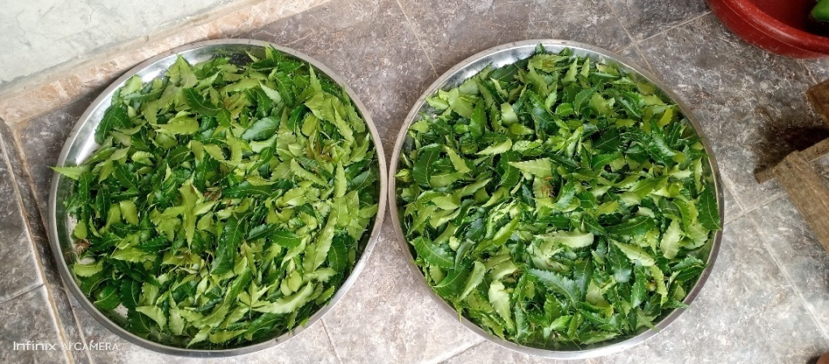
Plate 3.1 (a) Neem leaves
3.1.2 Electronic weighing Scale
This is used to measure the neem powder extracted from the neem leaves. Plate 3.2 shows the pictorial view of the electronic weighing scale.
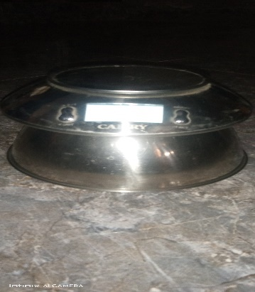
Plate 3.2 Electronic weighing Scale
3.1.3 Plastic container with lid
This was used for storing the grains (treated and un-treated) during the experiment. Plate 3.3 shows the pictorial view of the plastic container with lid.
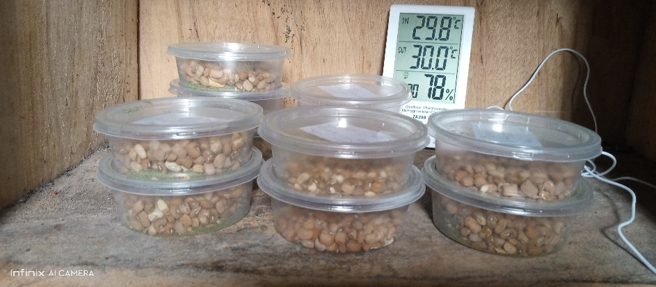
Plate 3.3: plastic container
3.1.4 Thermometer:
This is used to measure the amount of temperature in the room where the neem leaves were kept. Plate 3.5 shows the pictorial view of Thermometer
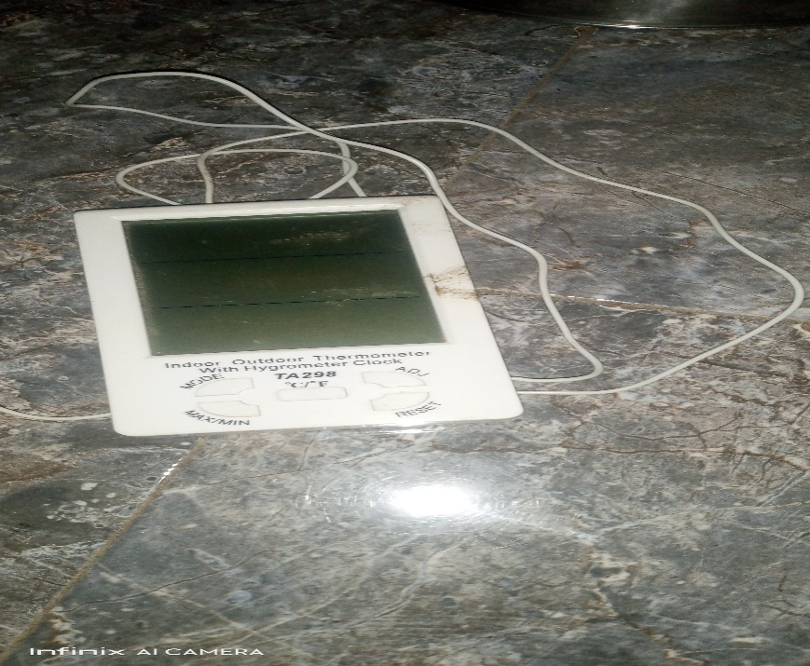
Plate 3.1.4: Thermometer
3.1.5 Digital spoon Scale
This was use to give us the correct amount of neem powder need in the jar as preservative
Plate 3.6 shows the pictorial view of Digital spoon scale
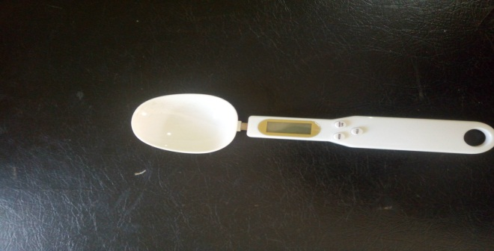
3.1.6 Electric Blender
This was use to blend the dry neem leaves into powder form. Plate 3.7 shows the pictorial view of the electric blender

3.2 METHODOLOGY
3.2.1 Sourcing of Experiment Materials
The cowpea was purchased from Mandate market in Ilorin West Local Government area of Kwara State. The neem leave was gotten from the back of Kwar State Polytechnic mini campus. The fresh neem leaves were dried under room temperature for nine days and the dried neem leaves were blended to neem powder.
3.2.2 Sample Preparation
The cowpeas were sorted to remove damage grains and unwanted particles. The wholesome grains were cleaned by manual winnowing. The grains were divided into potion by weighing them with electronic weighing scale into plastic containers. The neem was prepared in a room temperature (28ºC) and the dried neem leaves were blended into neem powder.
3.2.3 Experimental Procedure
The clean cowpea was divided into ten (10) portions of 100g for four samples each, 50g for four samples and two samples were used as control with the following descriptions into the plastic container.
- Two (2) containers of 50g each contains infected and non-infected cowpea with 5g neem powder
- Two (2) containers of 50g each contains infected and non-infected cowpea with 10g neem powder
- Two (2) containers of 100g each contains infected and non-infected cowpea with 5g neem powder
- Two (2) containers of 100g each contains infected and non-infected cowpea with 10g neem powder
- Two (2) jars of 100g each contain infected and non-infected cowpea with no preservation (no neem powder) which was used as control
3.2.4 Experimental Design
Proximate composition was done on the fresh cowpea before the addition of preservative and storage. The cowpea was preserved and stored for a period of twelve weeks. The proximate composition was conducted on the 4th and 6th , 8th, 10th and 12th weeks of storage in order to determine the effect of the preservatives on the stored cowpea
3.3 Proximate composition of Cowpea
This study aimed at determining the proximate composition, mineral constituents and tyrosine inhibitory activity of the cultivar. Cowpea presents (100g): 24.5 protein, 51.4 carbohydrates, 16.6 insoluble fibers and 2.7 soluble fibers, 2.6 ash; major mineral constituents.
3.3.1 Initial and Final Moisture Content Determination on Dry Basis (db)
Fresh beans sample of 100g were placed in pre-weighed electro weighing balances and mixed with neem powder, temperature of 70c for 6h at 26.1HG vacuum in a thelco 29 vacuum oven (precisions scientific, Chicago, IL) dishes were removed and placed immediately in desiccators to allow temperature to equilibrate before weighing.
The weighing used for the scale had an accuracy of 0.01g. All moisture measurement for each trial were replicated twice and moisture contents were calculated on dry basis using the following formula to obtain the initial moisture content of the samples.
MC (%db) = (W₁-W_{F}) x 100
W_{F}
W_{I} =initial weight of the sample 3.1
W_{F} =final weight of the sample
The final moisture of the dried samples was the determined using infrared moisture determination balance AD/4714A,(centurion scientist limited). Following manual recommendation, 5g of each sample was weighed into a cleaned dried dish. The sample was then placed in the infrared mixture determination balance. The temperature regulated to 105Oc. The mixture content was indicated automatically by the reading on the machine.
3.3.2 Determination of Fat Contents
About 5g of each of the sample weighted and wrapped in a filter paper and placed in an extraction thimble. The thimble weighed before the additional of the sample, (W₁), the thimble with sample (W₂) was then inserted in soxhlet apparatus. Extraction under reflux was carried out with petroleum ether (30-60⁰C boiling range) for 5hrs. At the end of the extraction thimble was dried in an oven for about 180s at 100⁰c for the evaporation of the solvent and the thimble was allowed to cool in a desiccators and later weighed (W₃) (AOAC,2005)
%Fat = (weight loss of a sample {extracted fat})– (original weight of sample) x 100 (W₂ – W₃) – (W₂ –W₁) x 100
3.3.3 Determination of Carbohydrate Contents
The carbohydrate contents were determined by the subtraction of the summation of crude protein, crude fiber, and ash, fat contents in percentage from 100 percent.
3.3.4 Determination of Ash Contents
The ash content was determined as described in association of official analytical chemists (AOAC) official standard and methods (2005). A know weigh of the beans was charred in a low flame. Thereafter, the sample was transferred to the furnace regulated at 600_{o}c for about 30min. the sample was then cooled and reweighed the procedure was respected until gray ash was resulted. The ash content was calculated as shown in equation developed by AOAC (2005).
C_{ASH} = W_{ASH} x 100
W_{AS}
Where,
C_{ash} = the ash content in %
_{ASH} = ash weigh, kg
W_{as} = sample weigh, kg
3.3.5 Determination of Crude Fibre Contents
The fibre content was determined by the method described in AOAC, (2005). Two grams of the samples were accurately weighed into fibre flask and 100 ml of 0.255 N H₂SO₄ was added. The mixture was then heated under reflux for one hour with the heating mantle and the hot mixture was filtered through fibre sleeve cloth. The filtrate was thrown of while the residue was returned to the fibre flask to which 100ml of 0.313 NNAOH was added and heated under reflux for another 1hr. The mixture was filtered through a fibre sleeve cloth and 100ml of acetone was added to dissolve ant organic constituent. The residue was washed with some hot water twice on the sleeve cloth before it was finally transferred into a crucible. The crucible containing the residue was cooled in the desiccators and later weighed to obtain weight W₂
The different W₁-W₂ gives the weight of fibre and the percentage fibre was obtained as
% Fibre = W₁-W₂ x 100
Weight of sample 3.4
3.3.6 Determination of Crude Protein Content
Protein content of the test sample was determined using micro kjedhel method as described by AOAC (2005). One gram of test sample was weighed into digestion tube, 15ml of concentrated H₂SO₄ and one tablet of selenium catalyst was added. The mixture was digested on an electro-thermal heater until clear solution is obtained. The flask was allowed to cool after which the solution was diluted with distilled water to 50ml, 5ml of this was transferred into the distillation apparatus, 5ml of 2% boric acid was pipette into a 100ml conical flask (the receiving flask) and 4 drop of screened methyl red indicator was added 50% N_{a}OH was continually added to the digested sample until the solution turned cloudy and this indicates the alkalinity of the solution. The distillation was carried out the acid solution in the receiving flask with the delivery tube below the acid level. As the distillation is going on, the pink color solution of the receiving flask turned blue. Distillation was continued was continued until the content of the round bottom flask is about 50ml. The resulting solution in the conical flask was titrated with 0.1 M HCI.
% Nitrogen = Titre value x 0.1 HCI x 0.014 x 100 x ⁵⁰/₅
Original weight of sample
% Protein = %Nitrogen x protein conversion factor.

CHAPTER FOUR
RESULTS AND DISCUSSION
4.1 RESULTS
The average results of a proximate composition of the cowpea before storage and preservation is presented in table 4.1 while that of freshly prepared neem powder is presented in table 4.2.
Table 4.3-4.6 shows the average results of the proximate composition of the treatment applied to the cowpea after eight (6) weeks of the experiment for the different quantities of neem powder applied.
Table 4.7 shows the average result of the proximate composition of cowpea before storage and preservation, the freshly prepared neem powder and when different treatment were applied to the cowpea are present in the appendix A-L
Table 4.1 Average Proximate Composition of Cowpea before Storage

Proximate Composition (%)
SAMPLE MC ASH FAT FIBREPROTEIN CHO
COWPEA 14.02 3.3 3.2 3.1 5.1 71.3

Table 4.2 Average Proximate Composition of Neem Powder

Proximate Composition (%)
NEEM
POWDER MC ASH FAT FIBRE PROTEIN CHO

14.12 1.06 3.8 3.07 1.02 76.95

Table 4.3 Average Proximate Composition of Cowpea with Neem Treatment under Ambient Storage

Proximate Treatment Applied Preserved
Composition (%) Infested with Insect
MC 14.32 15.16
PROTEIN 5.71 5.10
CARBONHYDRATE 76.14 71.48

Table 4.4 Average Proximate Composition of Cowpea (50g) with Neem Powder (5g) under Ambient Storage

Proximate Composition (%)
SAMPLE MC PROTEIN CHO
COWPEA 14.21 5.90 76.23
Table 4.5 Average Proximate Composition of Cowpea (50g) with Neem Powder (10g) under Ambient Storage

Proximate Composition (%)
SAMPLE MC PROTEIN CHO
COWPEA 15.10 5.40 74.28

Table 4.6 Average Proximate Composition of Cowpea (100g) with Neem Powder (5g) under Ambient Storage
Proximate Composition (%)
SAMPLE MC PROTEIN CHO
COWPEA 15.03 5.62 75.06

Table 4.7 Average Proximate Composition of Cowpea with no Neem Powder
Proximate Composition (%)
Cleaned Cowpea Cowpea with Insect
MC 14.52 15.32
PROTEIN 5.94 5.42
CARBOHYDRATE 76.11 70.03

4.2 Discussions
4.2.1 Effect of Neem powder on cowpea
Tables 4.3-4.6 revealed the effect of different quantities of neem powder added to preserve the cowpea. In all the results presented the moisture content increases as well as the protein. It was also observed that there was no emergence of insects which are responsible for feeding on the carbohydrate. Therefore, the decrease on the carbohydrate was negligible when compared with the fresh cowpea before storage and preservation.
4.2.2 Effect of Carbohydrate on Cowpea
Table 4.3-4.6 show the result of the carbohydrate of the cowpea when neem powder was applied and when insect was introduced.
The carbohydrate ranged between 70.03 to 76.28% when neem powder was applied. The highest value recorded was when 10g neem powder was applied to the cowpea while the lowest carbohydrate was recorded when no treatment was applied to the cowpea with infested insects.
The value recorded for the cowpea which treated with 5g of neem powder is still higher with the value recommended for carbohydrate in cowpea by (Mainaet al., 2000) which ranged between 68-73%.
4.2.3 Effect of Moisture Content on Cowpea
The moisture content recorded in this study ranged between 14.08 to 15.32%. The highest recorded was when no treatment was applied to the cowpea (control). The lowest moisture content was when 5g of neem powder was added to the cowpea. This implies that increase in moisture content will reduce the storage life of cowpea. This will cause insect multiplication in the cowpea under study. The reverse is the case when there is decrease in the moisture content,
4.2.4 Effect of protein on Cowpea
The protein content on the non-infested cowpea ranged between 5.71 to 6.10% and the protein content in the infested cowpea ranged between 5.10 to 5.62%. The protein content with 5g of neem powder was the highest recorded and the least was when 2g of neem powder was applied. The infested cowpea when 2g of neem powder was the lowest and 5g of neem powder was the highest. The protein content when 5g of neem powder favors the infested and non-infested cowpea.
4.2.5. Effect of neem powder on Cowpea
It was also observed that the cowpea infested with insect and preserved with various quantity of neem powder were found dead and there were no multiplication of insect. Also the cleaned and healthy cowpea preserved with various quantity of neem powder remains clean and fresh without any emergency of insect. Thus, the neem powder had persevered the shelf life of the cowpea throughout the experiment thereby prohibiting insect multiplication and no detection of life insect during the period of study.
4.2.1 Effect of Neem powder on cowpea
Tables 4.3-4.6 revealed the effect of different quantities of neem powder added to preserve the cowpea. In all the results presented the moisture content increases as well as the protein. It was also observed that there was no emergence of insects which are responsible for feeding on the carbohydrate. Therefore, the decrease on the carbohydrate was negligible when compared with the fresh cowpea before storage and preservation.
4.2.2 Effect of Carbohydrate on Cowpea
Table 4.3-4.6 show the result of the carbohydrate of the cowpea when neem powder was applied and when insect was introduced.
The carbohydrate ranged between 70.03 to 76.28% when neem powder was applied. The highest value recorded was when 3g neem powder was applied to the cowpea while the lowest carbohydrate was recorded when no treatment was applied to the cowpea with infested insects.
The value recorded for the cowpea which treated with 5g of neem powder is still higher with the value recommended for carbohydrate in cowpea by (Maina et al., 2000) which ranged between 68-73%.
4.2.3 Effect of Moisture Content on Cowpea
The moisture content recorded in this study ranged between 14.08 to 15.32%. the highest recorded was when no treatment was applied to the cowpea (control). The lowest moisture content was when 5g of neem powder was added to the cowpea. This implies that increase in moisture content will reduce the storage life of cowpea. This will cause insect multiplication in the cowpea under study. The reverse is the case when there is decrease in the moisture content,
4.2.4 Effect of protein on Cowpea
The protein content on the non-infested cowpea ranged between 5.71 to 6.10% and the protein content in the infested cowpea ranged between 5.10 to 5.62%. The protein content with 5g of neem powder was the highest recorded and the least was when 2g of neem powder was applied. The infested cowpea when 2g of neem powder was the lowest and 5g of neem powder was the highest. The protein content when 5g of neem powder favors the infested and non-infested cowpea.
4.2.5. Effect of neem powder on Cowpea
It was also observed that the cowpea infested with insect and preserved with various quantity of neem powder were found dead and there were no multiplication of insect. Also the cleaned and healthy cowpea preserved with various quantity of neem powder remains clean and fresh without any emergency of insect. Thus, the neem powder had persevered the shelf life of the cowpea throughout the experiment thereby prohibiting insect multiplication and no detection of life insect during the period of study.

CHAPTER FIVE
CONCLUSIONS AND RECOMMENDATIONS
5.1 CONCLUSIONS
The effect of organic preservatives for the treatment of insects and pest in agricultural crops was investigated, based on the experiment conducted, the following conclusion was drawn:
- Neem powder in different quantity of 2g, 3g, 4g, and 5g were applied to cowpea under ambient storage of 28ºc using infested and non-infested cowpea.
- Neem powder favors the non-infested cowpea when 5g of neem powder is applied and also showed no emergence of life insect throughout the experiment.
- The infested cowpea showed no further emergence of insect and confirmed death of the entire insect introduced when 5g of neem powder was used.
- Neem powder can be used as an alternative preservative for cowpea.
5.2 RECOMMENDATIONS
The following recommendation were made at the end of the study for further work
- Famers should be encourage and educated on the effectiveness of use of neem powder.
- The awareness of the use of neem powder as an alternative to chemical should be advocated.
- Other agricultural crop can be tested and treated with the neem powder.

Adedire, C. O., & Ajayi, F. A. (1996). Assessment of the insecticidal properties of some plant
extracts as grain protectants against the cowpea bruchid Callosobruchus maculatus (F.). Journal of Plant Protection in the Tropics, 13(3), 177–185.

