DESIGN AND IMPLEMENTATION OF TEXT TO SPEECH/AUDIO SYSTEM USING DAILOGFLOW

BY
AMAO HALIMAH WURAOLA
ND/23/COM/PT/0121

A Project Submitted to the Department of Computer Science, Institute of Information and Communication Technology, Kwara State Polytechnic, Ilorin

In Partial Fulfillment of the Requirements for the Award of National Diploma (ND) in Computer Science

June, 2025

CERTIFICATION
This is to certify that this project was carried out by AMAO HALIMAH WURAOLA Matric Number ND/23/COM/PT/0121 as been read and approved as meeting part of the requirements for the award of National Diploma (ND) in Computer Science.

………………………………. ……………………………….
MR. OLAJIDE A.T Date
(Project Supervisor)

………………………………. ……………………………….
MR, OYEDEPO F. S. Date
(Head of Department)

………………………………. ……………………………….
External Examiner Date

DEDICATION
This project is dedicated to the creator of the earth and the universe, the Almighty God. It is also dedicated to my parents for their moral and financial support.

ACKNOWLEDGEMENT
All praise is due to the Almighty God, the Lord of the universe. I praise Him and thank Him for giving me the strength and knowledge to complete my ND programme and also for my continued existence on earth.
I appreciate the utmost effort of my supervisor,( MR OLAJIDE A.T) whose patience support and encouragement were the driving force behind the success of this research work. She gave useful corrections, constructive criticisms, comments, recommendations, advice and always ensures that an excellent research is done. My sincere gratitude goes to the Head of the Department, (Mr. Oyedepo, F. S.) and other members of staff of the Department of Computer Science, Kwara State Polytechnic, Ilorin, for their constant cooperation, constructive criticisms and encouragements throughout the programme.
Special gratitude goes to my parents MR&MRS AMAO who exhibited immeasurable financial, patience, support, prayers and understanding during the periods in which I was busy tirelessly in my studies. Special thanks go to all my lovely siblings.
My sincere appreciation goes to my friends and classmates

TABLE OF CONTENTS
Title page. i Certification ii Dedication. iii Acknowledgement iv Abstract. V Table of contents Vi CHAPTER ONE: GENERAL INTRODUCTION. 1.1 Background to the study 1 1.2. Statement of the problem 3 1.3. Aim and Objective of the study 3 1.4. Significance of the study 4 1.5. Scope of the study 4 1.6. Organization of the Report 5 CHAPTER TWO LITERATURE REVIEW 2.1. Review of Related works 7 2.2 . Review of general Text CHAPTER THREE: RESEARCH METHODOLOGY AND ANALYSIS 3.1 Research Methodology 14 3.2. Analysis of the Existing System 16 3.3 Problem of the Existing System 16 3.4. Description of the Proposed System 17 3.5 Advantages of the Proposed System 17 CHAPTER FOUR: DESIGN, IMPLEMENTATION AND DOCUMENTATION OF THE SYSTEM 4.1. Design of the System 18 4.1.1 Output Design 18 4.1.2 Input Design 19 4.1.3 Procedure Design 21 4.2 Implementation of the System 21 4.2.1 Choice of Programming Language 22 4.2.2 Hardware Support 22 4.3 Documentation of the System 22 4.3.1 Maintaining the System 22 CHAPTER FIVE: SUMMARY, CONCLUSION AND RECOMMENDATION 5.1 Summary 23 5.2 CONCLUSION 23 5.3. Recommendation 24 Reference 25 Appendices Flowchart Source Program Listings

Abstract
Design and implementation of a test to speech audio system HD generalation of synthesized speech from test. The purpose of this work is to make synthesized speech as intelligible, natural and pleasant to listen as woman speech. Speech is the primary means of communication between people. During synthesis very small segment of recorded woman speech are concatenated together to produce the synthesized speech. The quality of a speech synthesizer is judged by its similarity to the human voice and by its ability to be understood.A text to speech synthesizer allows people with visual impairments and reading this disabilities to listen to written work on a Microsoft visual studio version 2010 with integrated development environment (net.ide). the Microsoft C# is chosen following the fact that extracted information needs to be presented in an enhanced pictorial/graphical format and easy communication with the database for program flexibility in Windows platform.therefore C# is the programming language using for the scripting of the design and MySQL database was use for the database management in the implementation.

CHAPTER ONE
GENERAL INTRODUCTION
1.1 BACKGROUND TO THE STUDY
speech is the medium of communication between people. An acoustic speech signal contain a variety of information. It contain testual message as well as information from which we can identify whether the person is male or female adult or children. So speech place play in vital role in speaker recognization system. Text-to-speech synthesis (TTS) is the automatic conversion of a text into speech/voice that resembles, as closely as possible a native speaker of the language reading that text. Text to speech/audio system is the technology which lets computer speak to you. The TTS system gets the text as the input and then a computer algorithms which called TTS engine analyses the text pre- processess the text and synthesize the speech with some mathematical modesls.the TTS engine usually generate sound data in an audio format as output( pradeep, 2015).
Eniola 2018 claim that speech recognition extract the word for a speech signal by analyzing the signal and compare it to the world stored in the Data Base Factor such as the pitch and tone of the speaker as well as ambient noise affect a program's performance biometric differences in voice models which are influenced by geography location can also affect the performance of the 2 system. Codes have been designed that can perform a speech recognition task with which 75% accurate, but this area is study require further development to address factors such as database management as well as performance under noise.
The -text-to-speech (TTS) synthesis procedure consists of two main phases.the first is text analysis where the input text is transcribed into a phonetic or some other linguistic representation , and the second one is the generation of speech waveforms ,where the output is produced from this phonetic and prosodic information. These two phases are usually called high and low levels synthesis.The input text might be for example data from a word processor, standard ASCII from e-mail, a mobile text message,or scanned text from a newspaper. The character strings is then pre processed and analyzed isto phonetic representation which is a String of phonemes with some additional information for correct intonation, duration and stress. Speech sound is finally generated with the low level synthesizer by the information from high level one. The artificial production of speech like sound has a long history, with documented mechanical attempts dating to the eighteenth century (Vandana, 2019).
Speech synthesis can be described as artificial production of human speech. A computer system used for this purpose is called a speech synthesizer, and can be implemented in software or hardware. A text- to speech (TTS) system converts normal language text into speech. Synthesized speech can be created by concatenating pieces of recorded that are stored in a data base, systems differ in the size of the stored speech units, a system that are stores phones or diaphones provides the largest output range but many lack clarity. For specific usage domains, the storay of entire words or sentences allow for high quality output (dhulipalla,2013).
Mel -frequency cepstral coefficient (MFCCs) are coefficients that collectively make up an MFC. They are derived from a type of cepstral representation of the audio clip (a nonlinear ‘spectrum-of -a-spectrum’). Digital processing of speech signal and voice recognition algorithm is very important for fast and accurate automatic voice recognition technology. The voice is a signal of infinite information.
A direct analysis and synthesizing the complex voice signal is due to too much information contain in the signal. Therefore the digital signal process such as feature Extraction and feature matching are introduced to represent the voice signal. Several methods such as liner predictive coding (LPC) Hidden markov model (HMM), Artifical neural network (ANN) and etc are evaluated with a view to identify a straight forward and effective method for voice signal. The extraction and matching process is implemented right after the pre processing or filtering signal is performed. The non-parametric method for modelling the human auditory perception system, Mel frequency cepstral coefficient (MFCCs) are utilize as extraction techniques. The non liner sequence alignment known as dynamic time warping (DTW)introduced by sakoe chiba has been used as feature matching techiques. Since it’s obvious that the voice signal tends to have different temporal rate the alignment is important to produce the better performance (Anjolaluwa,2021).
The purpose of this research is to show the accuracy and time result of a text independent automatic speech recognition (ASR) System based on Mel frequency cepstrum coefficients (MFCC). In this project the author proposed a new method using the MFCC technique to improve the speaker recognition process. The voice is the most common method between humans for communication ,current the speaker recognition algorithm are not 100% reliable since they do not have the truly capacity to determine a speaker amonge other the use of a better system for speaker recognition can have application in the daily life opening doors and windows or control different devices. If we can trust in the precision of the speaker recognition algorithm, the voice can turn into an essential tool to activate and operate appliances, and even we can think about driving a car with the voice.
1.2 STATEMENT OF THE PROBLEM
There are people who are visually impaired, or not able to speak and hear properly. These people will be facing difficulty in conveying information with normal persons. If they meet an individual who do not know the sign language than it will be difficult to communicate. This prompted the new idea of the new system of speech to text that is, the person who cannot talk will be able to type a message that they want to share and the listener can hear the speech as the output or can see the message on display. If the person is visually impaired, they need to get trained with typing text on keyboard and can analyse the typed text as they hear the speech.
1.3 AIM AND OBJECTIVES
This aim of this research is to design and implement a text to speech automated system using Mel frequency cepstral coefficient (MFCC)algorithm. The objective are as follows:
- Design a model system that will enhance computer to use speech synthesis to read text and screen contents giving visually impaired and blind users access
- Simulate the model that dedicated computer system designed for a specific function
- Develop a system that will enhance effective means of communication by bridging the gap among the visually impaired people
1.4 SIGNIFICANCE OF THE STUDY
The significance of this study is enhancing computer to use speech synthesis to read text and screen content giving Visually impaired and blind user asses this include reading aid for the blind talking aif for the vocally handicapped and training aids and other commercial applications. All these applications demand the real time embedded platform to meet the real time specifications such as speed power space requirements etc.
1.5. SCOPE OF THE STUDY
The project works cover implementation a text to voice automated system using Mel Frequency cepstral coefficient (MFCC) algorithm. This work goes for reading out information to user though the speech synthesis by designing a cost effective and more flexible embedded system.
1.6 ORGANIZATION OF REPORT.
This report is organized as stated below chapter one discuss the general introduction and overview of the whole project. It also discuss the statement of the problem, aim and objective of the proposed system, significance of the study scope and limitations of the project, organization of the report and the definition of technical term used chapter two deals with the literature review the review of related writing of the project topic it gives the details information of all writing related to the topic which helps to know for information on the project topic. Chapter three deals with analysis of the system which includes the data collection method employed, the description of the existing system and it's problem and the description of the proposed system and possible advantage it will provide the will solve problems encountered in the existing manual system. While chapter four deal with the design , implementation and the description of the proposed system. It covers description of the output design, input design, database design and procedures design. The implementation techniques used the programming language used in developing the new system and system requirements for running the system. And also talks about the program documentation as well user documentation. Lastly chapter five present a brief summary of the work done, experience gained and problems encountered in the course of the project, conclusion and recommendations.

CHAPTER TWO
LITERATURE REVIEW
2.1 REVIEW OF RELATED WORKS
Nisha in the year 2017 in a research discussed speaker identification and speaker verification techniques. The identification of voice falls under the category of speaker identification where the given voice is compared with a set of already existing similar sample voice present in the database and then a match is done. However, speaker verification is the process of authenticating a speaker based on some parameter or in other words the speaker is identified. Text dependent and text independent voice recognition systems have also been discussed. Along with this, various features recognitions techniques like linear predictive coding (LPC), perceptual linear prediction (PLP) , relative spectral filtering (RASTA) and mel-frequency ceptral coefficient (MFCC) along with their merit and demerit have been discussed. The merits and demerits can easily give a trade-off to choose the features extraction technique best suited to the current situation and time. Some classification techniques like hidden Markov model (HMM) neutral network modeling approach (NN) bracket dynamic time wraping (DTW) and vector quantization (VQ) as also been discussed.
Ayushi, (2018) Highlighted the use of technology in the field of communication. Application have been created that can take part in this communication. The function used in establishing such a link include acoustic and articulatory speech recognition, converting speech signal to text and then again to a signal, language translation etc. The techniques for achieving system can be classified in to various parameters like speaker, vocal sound vocabulary etc. The general prerequisite for any feature extraction technique involves some preprocessing followed by feature extraction by any of the methods be it LPC, MFCC or Dynamic Time Warping It also brings forth the acoustic models and a basic ideal about the phonemes. The pattern classification approach includes template based, knowledge based statistics and neural network based approach. The speech to text conversion method includes Hidden model HMM,
Artificial Neural Nextwork Classifier based on cuckoo search optimization. The text to speech conversation phases include text processing articulate synthesis , formant synthesis and concatenative synthesis. The language translation technique includes rule based machine translation, statistical machine translation examples based machine translation and hybrid machine translation. The finding and issues of each functionality has been clearly mentioned and explained. In speech to text HMM has been classified as the best technique despite of the drawback that are present in it and in text to speech formant synthesis has been concluded as the best approach for conversation. Hybrid translation finds itself to be popular because of it's fast learning ability and data acquisition.
Ayushi (2017) explained various speech recognition algorithms along with the techniques and challenges involved in the system. The issue with recognition involves the utterance approach because no two people can speak in the same way, there is always a difference it maybe because of their age gender geographical location or any other reason. Some styles of speaking are very quiet and some of them are really slow, the same word pronounced in the American accent might sound different in the British accent. All these issues have to be analyzed before developing an algorithm. There are various types of speaker models which may either be text dependent or text independent. The size of vocabulary also has an uttered. Different speech recognition techniques like MFCC, PLC etc have also been briefly discussed. There are various types of speaker models which may either be text dependent or text independent. The size of vocabulary also has impact on speech recognition along with the background in which the world or sentence is uttered. Different speech recognition techniques like MFCC,PLC etc have also been briefly discussed the approach to classification include acoustic phonetic approach, pattern recognition approach and artificial intelligence approach. Pattern matching approach for speech recognition have also been discussed. The future scope regarding large vocabulary system and speaker independent continuous system have also been discourse in this paper.
Riyaz and sheikh (2019) in their research used speaker recognition for Urdu language. The dataset use is doing so consist of 250 different Urdu words which are spoken by 20 different speaker which comprises of 8 make speaker and 12 female speaker The reason for using HMM and MFCC for accomplishing the same has been fund to have the highest accuracy has compared to other future extraction technique and models. The dataset contains varied speaker whose accent in Urdu language varies from kannada accent to uttar Pradesh accent.Vector Quantization is used to compress the size of the feature vector and improve accuracy for the classification, Hidden Markov model has been. The performance is based on the accuracy of the the Urdu words spoken with turns out to be 96.4% even after using minimum no of features as mentioned in the paper.
According to shantinath (2015) stated that for the last 35 years research on TTS(Abdul 2015). Generating synthetic speech has been somewhat unusual in the past looking at the recent research tends data gloves is discussed in the system design for hand gestures recognition where the system consider the only the single gestures.
The real time hardware implementation of text to speech has been drawing attention of the research community due to its various real time applications. These include reading aids for the blind blind talking aid for vocally handicapped and training aids and other commercial applications. All there application demands the real time embedded platform to meet the real time specifications such as speed power space requirements etc in this context the embedded processor ARM has been chosen As hardware platforms to implement text to speech conversion. this conversion needs algorithms to perform various operations like part of speech tagging phrase marking, words to phoneme conversion and clustergem synthesis we are using ARM 7 processor for the implementation (Naresh (2017).
An embedded system is a dedicated computer system designed for one or two specific function, This system is embedded as a part of a complete device system that include hardware such as electrical and mechanical components. The embedded system is unlike in the general purpose computer which is engineered to manage a wide range of processing pass optimize size cost power consumption iliability and performance in vented system are particularly produced on board scale and share function across a variety of environment and applications is TTS system and arbitrary test is converted into speech which can be heard out loud (Endarapu 2015)
Peissner 2016, presented a simulation tools which help to execute applications in virtual environment. The purpose of the tools is to find speech recognition error by performing consecutive simulations. Each and every action performed by the application will be considered as an event. The errors related to particular events will be displayed i.e.whether it is due to recognition problem or no this is specific event is linked to that action etc.
Speech signals are represented as a sequence of sound which contain several information in it speech signal result is multiple variation arising at multiple levels:semantic, linguistic,articulatory and acoustic . Variation occurring due to these levels results in difference in the auditory properties of uttered signal. Utterer related fluctuations are seen because of anatomical variance inherent in the human vocal system and common individuals learned speaking routine Capbell (2017).

2.2. REVIEW OF RELATED CONCEPTS
2.2.1. Speech Recognition
Speech recognition application are becoming more and more useful now a days. Various interactive speech aware applications are available in the market but they are usually meant for and executed on the traditional general purpose computer with growth in the needs for embedded computing and the demand for emerging embedded platforms, it is required that the speech recognition system (SRS) are telephone handheld devices which becoming more and more powerful an affordable as well.it has become possible to run multimedia on there devices. Speech recognition system emerge as effective alternatives for such devices where typing because difficult attributed to their small screen limitations.
2.2.2Voice Recognition
Voice recognition is an ability of a computer, computer software program, or hardware device to decode the human voice into digitized speech that can be interpreted by the computer or hardware device. Voice recognition is commonly used to operate a device, perform commands, or write without having to operate to a keyboard, mouse,or press any buttons. Today, this is done on a computer with automatic speech recognition (ASR) software programs. Many ASR programs require the user to "train" the ASR program to recognize their voice so that it can more accurately convert the speech to text.
2.2.3. Mel Frequency Cepstral Coefficient (MFCC) Method.
This is a technique based on human hearing behavior that can not recognize frequencies over 1Khz. MFCC are base on the difference of frequencies that the human ear can distinguish. The signal is expressed in the MEL scale is based on the perception of the pitches in an equally spaced intervals judged by observers. This scale uses a filter that is spaced linearly at frequencies below 1000Hz and logarithmic spacing above 1000Hz,in the next paragraphs we will explain the MFCC process.
2.2.3.1. Pre-emphasis.
In this process we emphasize the higher frequencies, this will increase the energy in the signal at higher frequencies.

2.2.3.2. Framing.
This is the segmentation of the speech samples in boxes within the range of 20 Ms to 40 Ms. The voice signal is divided in frames of N sample. Adjacent frame are separated by M(M<N). Distinctive values used are M =100 and N=256.
2.2.3.3. Hamming windowing.
In signal processing a window is used when a signal we are interested has a limited length.
Indeed a real signal has to be finite in time, in addition a calculation is only possible from a finite number of points. To observe a signal in a finite time, we multiply it by a window function. We decide to used Hamming window after doing tests with Trianguler window, Rectangular window and Hamming window with value of N is = 128, 256, and 512 and M =50, 100 and 200, the combination of N =256 and M =100 gives the best performance. Nis equal to the size of the window and M the overlap 5.4 fast courier Transform in order to convert every frame of N sample from time domain in frequency domain in frequency domain we have to apply the Fourier Transform to covert the convolutions of the glottal pulse and the vocal impulse response in the time domain.
2.2.4. Voice Recognition and visually Impaired.
According to survey done, India is now home to the world,s largest number of blind people. Of the 37 million people across the globe who are blind over 15 million are from India. So in India blindness is the biggest problem. The leading causes of blindness are cataract, uncorrected refractive error, glaucoma, and macular degeneration . India' current population is 1.22 billion. Due to this huge population there is a lot of traffic in the road and in today 's world on one has time even to talk each other especially in metro cities. So the blind people or vision impaired person feels alone in this environment. People who have impaired vision regularly use white canes and/ or guide dogs to assist in obstacle avoidance.
Guide dogs can also be of limited assistance for finding the way to a remote location, known as "way finding" so our goal is to create a portable, self-contained system that will allow visually impaired individuals to travel through familiar and unfamiliar environments with out the assistance of guides. Several electronic devices are currently available for providing guidance to a remote location but there tends to be expensive, or make use of a Braille interface (Moulton, 2019).
Text to Speech (TTS) is a technology that convert a written test into human understandable voice. ATTS synthesizer is a computer based system that can be able to read any test aloud that is given through standard input device.IN general,a TTS system can be broken Down into three main parts: a linguistics,a phonetic and an acoustic part. First an ordinary text is input to the system.
A linguistic module converter this text into a phonetic representation. From this representation, the phonetic processing module calculates the speech parameters. Finally, an acoustic module uses these parameters to generate a systemic speech signal. The objective of a text to speech system is to convert an arbitrary given text into a corresponding spoken waveform. Text processing and speech generation are two main components of a text to speech system. The objective of the text processing component is to process the given input text and product appropriate sequence of phonemic units.
These phonemic units are realized by the speech generation components either by synthesis from parameters or by selection of a unit from a larger speech corpus. For natural sounding speech synthesis, it is essential that the text processing component produce an appropriate sequence of phonemic units corresponding to an arbitrary input text.
The main function of text to speech (TTS) system is to convert an arbitrary text to a spoken waveform. This task generally consist of steps i.e., text analysis text normalization, text processing, acoustic processing and speech generation. Text analysis part is preprocessing which analyze the input and organize into manageable list of words, Text normalization is the transformation of text to pronounceable form. The main objective of this process is to identify punctuation marks and pauses between words, Text process is the conversation of the given text into a sequence of synthesis units, Acoustic processing the speech will be spoken out the voice characteristics of a person like three types such as concatenation synthesis, Formanant synthesis, Articultory synthesis where as speech generation of an acoustic wave from corresponding to each of there until in the sequence.

CHAPTER THREE
RESEARCH METHODOLOGY AND ANALYSIS OF THE EXISTING SYSTEM
3.1. RESEARCH METHODOLOHY
Text to speech sentences takes place in several steps. The TTS systems get a text as input, which it first must analyze and then transform into a phonetics description. Then in a further step it's generates the prosody. From the information now available, it can produce a speech signal. The structure of the text-to-speech synthesizer can be broken down into major modules.
Natural language processing (NLP) module: It produce a phonetic transcription of the text read, together with prosody.
Digital signal processing (DSP) module: it transforms the symbolic information it receives from NLP into audible and Intelligible speech
The major operations of the NLP module are as follows:
Text analysis: first the text is segmented into tokens. The token-to- word conversion created the orthographic form of the token. From the token "Mr" the orthographic form "Mister" is formed by the expansion, the token "12" guess the autographic from "twelve" and "1997" is transformed into "nineteen ninety seven".
Application of pronunciation rules: After the test analysis has been completed, pronunciation rules can be applied. Letters cannot be transformed 1.1 into the phonemes because correspondence is not always parallel. In certain environments, a single letter can correspond to either no phonemes ( for example, "h" in "caught" ) or several phonemes ( "m" in "maximum").
3.2 Analysis of the existing system:
The existing approach used was synthesized speech which can be created by concatenating part of recorded speech which is stored in a database. The mainly significant qualities of a speech synthesis system are naturalness and intelligibility. Naturalness Expresses how intimately the output sound like human speech, whereas intelligibility is the easiness with which the output is understood.
Character to voice is not a reading big task. This is because there are only 26 characters in English and each character has a unique pronunciation. When we have to read lengthy text, character to voice is not recommended at the user level, as it is difficult to make out a word from the character's read. As we have played the wave files corresponding to every character read, in character to voice conversion, we can also play The Wave file for every word read. But practically it is impossible to record all the words of a dictionary. Hence there is a need to think of some other alternative. In the first attempt to play a word as a whole we can think of playing syllables of a word.
3.3 PROBLEMS OF THE EXISTING SYSTEM
The problem with the existing system is limited database; The system can store limited voices which hindered the conveying of full information and this serve as a road block to effective communication. So, this prompted to come up with a new idea, here whatever we are giving input from any keyboard corresponding output will get in the form of voice means speech.
1. Visual impaired and not able to speak and hear properly
2. Use sign language to communicate.
3. By using hand gesture movements can be developed, but we get very few outputs, since the movement we can make by hand, are less and we cannot share all the words with limited signs and the communication barrier will occur with people who do not understand sign languages.
3.4 DESCRIPTION OF THE PROPOSED SYSTEM
The proposed approach is the use of embedded processor to implement text- to- speech conversion. Microprocessor has been choosing as the hardware platform which is an advanced RISC machine, message is displayed on LCD and transmitted using radio frequency modulator. Two module are built for the prospective of transmitter and receiver the real-time capability of transmission of text from the keyboard is buffered and displayed in the source or Base station and simultaneously transmitted over air media. The system can deliver the message up to 50 m. However, it can be extended up to 100 m with the app of RF module. At the receiver side the system has the accuracy in receiving input message, which will be buffered and displayed at the receiver station. It can simultaneously provide clear voice and display output. People can easily understand the received voice message.
3.5 ADVANTAGES OF PROPOSED SYSTEM
It is expected that the new system will reduce an improve on the problems encountered in the old system. The system is expected to be among other things to do the following;
*The new system can do text structuring and annotation.
*The new systems speech's rate can be adjusted
*It has a user friendly interface so that people with less computer knowledge can easily use it.
*It will compatible with all the vocal engines.
*It helps visually impaired people in their daily life.
*The proposed method is the better system compared to gesture recognition
*It enhances effective communication.

CHAPTER FOUR
DESIGN AND IMPLEMENTATION OF THE SYSTEM
4.1 Design of the System
System design has been the most creative and dynamic phase of system development. However, system design provides full information about the new system and the sequence of operation from the input to the output. The system is designed in graphic user interface (GUI) for effectiveness and better usability goals.
4.1.1 Output Design
The output is referred to as report, processing results, message etc that relates directly to input files which are stored and being processed which letter turn to generate output. The outputs of this project work are the introduction page and the main page. The outputs are as presented below:
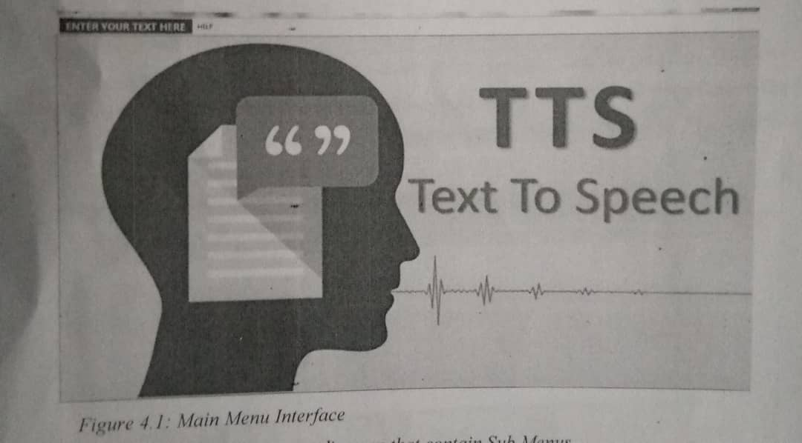
Figure 4.1: main interface
This diagram is a main menu diagram that contain sub menus
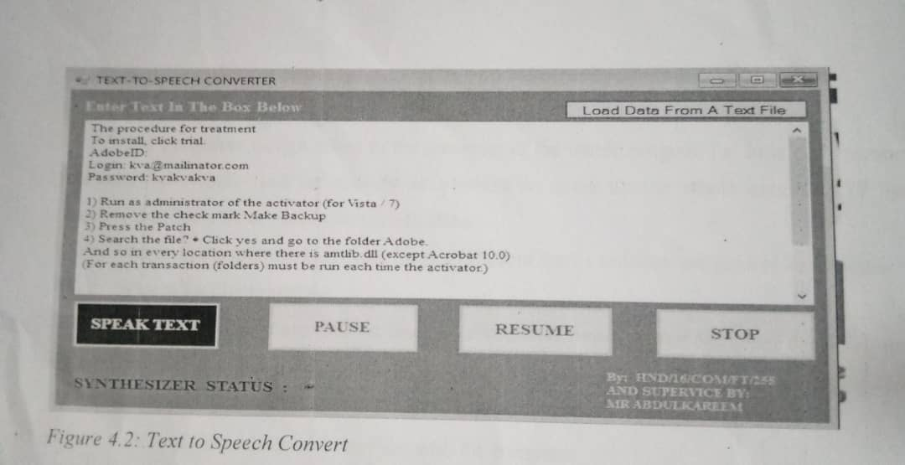
4.2: text to speech convert
This is a page where user input or type the text
4.1.2 Input Design
The input design describes the input interface for data entry into the program. Data entry interfaces needs to be considered in developing a new system to ensure users friendliness. Data entry is done through the keyboard and in some cases typing in textbox. The interface descriptions are as shown below:
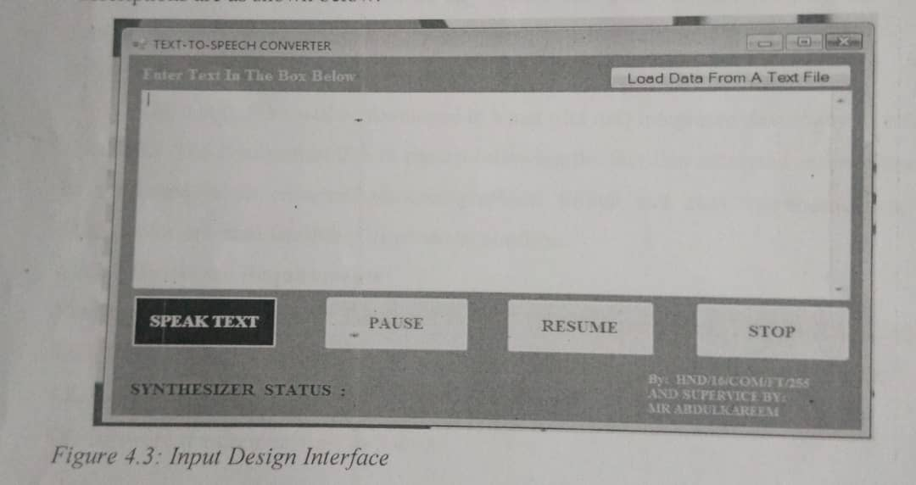

4.3: input design interface
This interface is the page where the user enter text;
4.1.4 Procedure Design
The procedure design refers to the construct of the whole program i.e. how each section functions individually and collectively as a role to make up the room execution of the program work/operate according to his specification.
4.2 system implementation
The design system depends on the capabilities and power of the computer on which the application system is installed. However, selecting a choice of application support (hardware and software) depends much on;
- how readily the user is to interfere with the computer
- cost and benefits
- management support for changes
Hence, choosing the appropriate hardware and software will enhance the performance of the system.
The most important requirements on which the running of the program basically depends on is the provision of Internet facility. So any system that must run this program must be internet ready.
4.2.1 choice of programming language
The application will be developed in a net (dot net) integrated development environment (net IDE). The application IDE is chosen following the fact that extracted information needs to be presented in an enhanced pictorial/graphical format and easy communication with the database for program flexibility in Windows platform.
4.2.2. hardware requirements
Minimum of microcomputer Pentium IV Intel 1.5 GHZ processor comma 1.0 GB RAM, 40 GB hard disk, 14 VGA monitor windows XP or higher, enhanced keyboard, mouse and pad.
4.2.3. software requirements
The software requirements are as follow:
Windows operating system e.g. win7
Microsoft visual studio
4.2.4. implementation technique
These deals with the processes and steps taking to put the system into use, before the system can be fully employed into the system some training might have been done by the user of the application if he or she is a computer illiterate, because the user might be a computer illiterate, so also the system might have also been use. Since the work of an expert can not be eliminated from the system the computerized system will have to work hand in hand with the expert in the field.
4.3. system documentation
After the program has been well tested with input that the output has already been known, the next is to install the software in to the computer system for use.
The processes of installing are been stated below
- Insert the CD into the system through the CD ROM after the computer is switch on
- Locate the CD derive directory in my computer and click it to open
- After open locate setup.exe, and then click to install the program by following the necessary step in installing the program
- Ensure full installing of the software for effective operation of the system .
After the program has been fully install The next thing is to locate the package install to put it into operation to locate the package for expiration purpose the following step are to be taking
- Click on start menu from task bar then select all program
- From the display sub option select by locating the software installed named information to load the software.
3.3.1. PROGRAM DOCUMENTATION
Proper and adequate. You click on start button then locate all programs and click on Text to voice, wait till it load the welcome page will be displayed, which is as well the main menu. So you can select any menu from the list provided in other to perform any operation you desired to perform.
3.3.2. SYSTEM MAINTENANCE
Built in safeguards of the system to prevent illegal or accidental alteration of the data files.
Provisions to store completed encrypted files, safely and to restore this information if necessary, ability of the software to accurately recover from an accidental or improper shutdown.
Software is considered flexibility when the system is easily altered to meet a new or different business requirement . Flexibility also refers to how adaptable an application is to different organizational or business situations. The adaptation or alteration can be in the form of changes to the program its if (e.g., code) or parameters used to set up the information system.

CHAPTER FIVE
SUMMARY, CONCLUSION AND RECOMMENDATIONS
5.1 SUMMARY
Text-to-speech is an application that converts text into spoken word, by analyzing and processing the text using natural language processing (NLP) and then using digital signal representation of the text. Here, we developed a useful text-to-speech synthesized speech and reads out to the user which can then be saved. The development of a text to speech synthesizer will be of great help to people with visual impairment and making through large volume of text easier
5.2 CONCLUSION
The Mel-Frequency cepstral coefficient algorithm is a good choice for speech recognition where multiple speakers exist. The algorithm supports multiple languages, multiple speakers and a high vocabulary size. Moreover, the implementation of this algorithm is quite easy as it successfully extract features from the voice sample. In computational context MFCC is far more expensive because of the use of fast Fourier transform when measuring its range. However, the noise present in the background environment does affect the recognition and impacts the performance of the algorithm. The change from a environment to a noise free location can help in improving the results and performance.
Text-to-speech is the automatic conversion of a text into speech that resemble, as closely as possible, a native speaker of the language reading that text. Converting of text to speech is done with the aid of text-to-speech synthesizer (TTS) which is the technology that lets computer speak to you. The TTS system gets the text as the input and the na computer algorithm which called TTS engine analyses the text, pre-processes the text and synthesizes the speech with some mathematical models. The TTS engine usually generates sound data in an audio format as the output. The text to speech conversation may seem effective and efficient to its users if it produces natural speech and by making several modification to it. This system is useful for deaf and dumb people to interact with the peoples from society and equally beneficial for visually impaired as well as normal audience.

5.3 RECOMMENDATIONS
Base on findings of this research, the following are hereby recommended
i Since language is the ability to express one’s thoughts by means of a set of signs (text) gestures, and sounds, implementation of text to speech is strongly recommended to aid effective communication of the dumb , deaf and visually impaired person.
ii Organizing of computer training to the visually impaired on how to input text to be converted to speech on the system, to ease their communication effectiveness
iii Development of independent voice enabled applications, which can work on speech input and output.
iv More research should be undertaken on other talking aids for the blind and speaking aids for the deaf and dumb

REFERENCE
Abudul, R., Kulesh, M. & Kailash, C., R. (2016). ARM Based Implementation of Text-To- Speech (TTS) for Real Time Embedded System, Department of Electrical. Engineering, Indian institute of Technology Patna, India. Pp. 23-24.
Abutalebi, H.,R.,Bijankhan, M. (2022). Implementation of a Text-To-Speech For Farsi Language, In Sixth International Conference On Spoken Language Processing. Pp.
Anjaoluwa, T. (2016). A Speech Synthesis Corpus for Norwegian, IOP Conference Series: Earth and Environment science.Pp. 7-9. doi:10.1088/1755-1315/730/1/012005
Ayushi, T.,Navya, P.,Pinal, P. Simran, S. & Supriya, A. (2018). Speech to Text and ext to Speech Recognition Systems: A Review, IOSR Journal OG Computer Engineering (IOSR-JCE).Vol. 20, Issues:2. Pp.1233-1234.
Ayushi,Y., Vadwala, M., Krishna, A., Suthar, R., Yeshi, A., Karmakar, D., Pandya, N. (2017). Survey Paper On Different Speech Recognition Algorithm: Challenges and Techiques, International Journal Of Computer Applications. Vol.5, Issue : 4. Pp. 123-124
Barkhoda, W., Daneshfar, F., Azami, B., Z. (2018). Design and Implementation of a Kurdish TTS System Based on Allophones Using Network, In: ISCEE 2008,Zanjan,Iran.Pp.12-13.
Beutnagel. M., Connie, A., Syrdal, A., K. (2019).Diphone Synthesis using Unit Selection, The Third ESCA/COCOSDA Workshop (ETRW) on Speech Synthesis, ISCA.Pp. 19-20.
Daneshfar, F., Barkhoda, W. & Azami, B., Z. (2019). Implementation of a Text- to-Speech System for Kurdish language. ICDT Colmar , France. Pp.23-24
Deller, R. J. (2020). Discrete Time Processing of Speech Signals. John Wiley and Sons, Chichester. Pp. 7-8.
Dhulipppalla, A. (2013). Implementation of Text to Speech Reader, Computers and Operations Research Journal. Pp.7-8
Dutoit, T. (2019).High Quality Text-To-Speech Synthesis of the French Language Ph. D. Dissertation, submitted at the Faculte Polytechnique de Mons. Pp .7-8.
Eniola , J., H. (2018). Speech Activated Telephony Email Reader (SATER)
Based on Speaker Verfication and Text-To-Speech Conversation, IEEE Trans. Consumer Electronics. Vol. 43,Issue: 3. Pp. 707-716
Farrohki, A., Ghaemmaghami, S., Sheikham, M. (2014). Estimation Of Prosodic Information For Persian Text-To-Speech System Using a Recurrent Neural Network. Speech Prosody, International Conference. Pp.23-24
Moulton, J., Wang, M., F. & Henderson, M., A. K. (2017). Implementation of Voice to Text System, Innovative Systems Design and Engineering. Vol.8, Issue: 5. Pp.202-203.
Naresh, M., Noor, N. & Endaru K. (2017). Text-To-Speech Synthesis System, IOP Conference Series: Earth and Environmental Science. Pp. 7-9.
Nisha, A. (2017). A Generic Speech Synthesis, System Documentation, Interpreting Telecommunications Laboratories, Kyoto, Japan, Vol. 5. Issue: 8.
Pp.67-68
Peissner ,M., Abdulhamid, M. & Murungi, M (2016). System Design Speech
Recognition System,Research and Information Technologies. Vol. 1. Issue: 2. Pp. 4-5. Dol. 10.20535/SRIT.2308-8893.2019.4.05
Pradeep, W. (2015). Arabic Speech Synthesis Using Large Speech Database; PhD. thesis, Cairo University,Electronics And Communications Engineering Department. Pp. 6-7.
Riyaz A. & Sheikh, M. (2019). Speech Synthesis Recognition For Urdu Language, IOSR Journal of computer Engineering (IOSR-JCR). Vol. 20, Issue: 2. Pp. 1233-1234.
Shantinath, A., Wayudi, S., Sheikhan, M. (2015). Prosodic Information For
Persian Text-To-Speech System using Neural Network International Journal
Of Creative Research Throughts (IJCRT). Vol 1, Issue: 1. Pp.4-5.
Vandana, E., (2019). Text-To-Speech Recognition System Using Raspberry
Processor, International Journal Science & Technology. Vol.1. Issue: 1 . Pp. 4-5.
Vanitha ,E., Kumar , P. Kasarla, M. & Kumaraswamy, E. (2015).Implementation of Text-To-Speech for Real Time Embadded System UsingRaspberry Processor, International
Journal & magazine of engineering technology management and research. Vol.2. Issue,:3.pp.3435.
Yoon k. (2016). A Prosodic phrasing model for a Korean text to speech synthesis system.computer speech & Language elsevier, Amsterdam.pp.4-6.

