
HYGIENIC WAY OF PRODUCING CHEESE IN THE LABORATORY

BY

YUNUS SOFIYAT BOLANLE
ND/23/SLT/PT/0872

A RESEARCH PROJECT SUBMITTED TO THE DEPARTMENT OF SCIENCE LABORATORY TECHNOLOGY, INSTITUTE OF APPLIED SCIENCES, KWARA STATE POLYTECHNIC, ILORIN.
INPARTIALFULFILMENTOFTHEREQUIREMENTFORTHEAWARDOF NATIONAL DIPLOMA (ND) IN SCIENCE LABORATORY TECHNOLOGY

JULY, 2025

CERTIFICATION

This is to certify that this project is the original work carried out and reported by YUNUS SOFIYAT BOLANLE (ND/23/SLT/PT/0872) to the Department of Science Laboratory Technology, Institute of Applied Sciences (IAS) Kwara State Polytechnic Ilorin and it has been approved in partial fulfillment of the requirements of the award of National Diploma (ND) In Science Laboratory Technology.

MRS ABDULKADIR HAROON HAJARAT O. DATE (PROJECT SUPERVISOR)

MRS.K.A.SALAUDEEN DATE
HEADOFUNIT (BIOCHEMISTRYUNIT)

DR. USMAN ABDULKAREEM DATE HEAD OF DEPARTMENT

EXTERNALEXAMINER DATE

DEDICATION

ThisprojectisdedicatedtoAlmightyGodforsparingourlivestothismomentand guiding us throughout my programs and to our beloved parents.

ACKNOWLEDGEMENT

AllGlorytoAlmightyAllahwhohasbeenourpillarandbackbonefromthebeginning of this research until this moment. We say thank you Almighty Allah for the successful completion of our ND program. For wonderful years well spent in His grace and mercy, we say we are forever grateful to God.
Specialgratitudetoourparents,fortheirfinancial,moral,andspiritualsupporttoward my education. We cannot write all but our hearts is graceful for all their efforts shown to us beforeandduringthisprocess.WesincerelypraythatAlmightyGodgrantyoudivinehealths to reap the fruits of your labour. We remain forever grateful, thank you.
Fortheimpartationofmoralandeducationalknowledge,weoweagreatdepthof gratitude to our supervisor: for his guidance and help during the course of this project. You are not just a lecturer but also a father and a mentor, thank you for allyou do,mayAlmightyGodcontinuetostrengthenyouandshowerhisblessingonyouandyourfamily. Wecannotbutrecognizetheeffortofouramiableandhighlyrespected
HOD; andallourlecturersfortheknowledgeimpartedonusasregardsthisfield of study. May God bless and reward them bountifully.

TABLE OFCONTENTS

ChapterOne: Introduction

BackgroundoftheStudy

Statementofthe Problem

ObjectivesoftheStudy

GeneralObjective

SpecificObjectives

ResearchQuestions/ Hypotheses

SignificanceoftheStudy

ScopeandLimitations

OperationalDefinitionof Terms

ChapterTwo:Literature Review

OverviewofCheese Production

Microbiologyof MilkandCheese

HygienicConcernsin Cheese Production

    - ContaminationSources(milk,equipment,handlers)

    - FoodbornePathogens(Listeria,Salmonella,E.coli, Staphylococcus)

Pasteurizationand Its RoleinSafety

GoodManufacturingPractices(GMP) andHACCPinCheese Making

PreviousStudieson LaboratoryCheeseProduction

ResearchGapIdentified

ChapterThree:ResearchMethodology

ResearchDesign

MaterialsandEquipment Used

SamplePreparation(MilkCollection,Pasteurization,Rennet Application)

CheeseProcessingStepsin theLaboratory

HygienicPractices Applied

    - SterilizationandHandlingProcedures

    - LaboratorySafety Measures

MicrobiologicalAnalysisof Cheese
    - EnumerationofColiforms,Staphylococcus,Salmonella,Listeria

DataCollection Methods
DataAnalysis Techniques

Ethical Considerations

ChapterFour:ResultsandDiscussion

PhysicochemicalPropertiesofProducedCheese(pH,Moisture,SaltContent)

MicrobialLoadand SafetyAssessment

    - ComparisonBeforeandAfterHygienic Measures

    - EffectivenessofPasteurizationandGMP

ComparisonwithStandards(e.g.,Codex,NationalRegulations)
DiscussionofFindingswithPreviousStudies
ImplicationsforLaboratoryCheese Production

ChapterFive:Summary,Conclusion,andRecommendations

Summaryof Major Findings

Conclusion

Recommendations

    - ForLaboratoryCheese Production

    - ForDairyIndustryHygienePractices

SuggestionsforFurther Research

References

Appendices

ABSTRACT

Cheeseproductionisoneoftheoldestfoodpreservationtechniques,yetitremainsvulnerable to microbial contamination if hygienic practices are neglected. This study investigated a hygienicmethodofproducingcheeseinthelaboratory,withemphasisonmicrobialsafetyand quality assurance. Chapter One presented the background of the study, the problem of foodborne pathogens in cheese such as Listeria monocytogenes, Salmonella spp., E. coli and Staphylococcus aureus, and the significance of adopting hygienic protocols. Chapter Two reviewed literature on the microbiology of milk and cheese, pasteurization, good manufacturing practices (GMP), and previous research findings on safe cheese production. Chapter Three described the methodology, including the collection and preparation of raw milk, pasteurization, rennet application, hygienic laboratory handling, and microbiological analysis of the final cheese product. Chapter Four presented the results, showing that pasteurization and hygienichandling effectivelyreduced microbial load, with cheese samples meetingrecommendedmicrobiologicalstandardsforsafetyandquality.Thediscussionlinked these findings with global studies onhygienic cheese production, highlighting the importance ofsanitationateveryprocessingstage.ChapterFivesummarizedthefindings,concludingthat hygienic laboratory practices, combined with proper pasteurization and handling, are essentialforproducingsafeandhigh-qualitycheese.Thestudyrecommendsstricteradherence toGMPandhazardanalysiscriticalcontrolpoints(HACCP)inbothlaboratoryandindustrial cheese production to safeguard public health.

CHAPTER ONE INTRODUCTION

Backgroundofthe Study
Cheese is among the oldest fermented dairy products, valued for its nutritional benefits and wide consumer acceptance. However, cheese is also recognized as a vehicle for microbial contamination when hygienic practices are compromised during production. Pathogens such asListeriamonocytogenes,Salmonellaspp.,Escherichiacoli,andStaphylococcusaureushave been linked to foodborne outbreaks traced to cheese products. In laboratory production, hygienic practices such as proper pasteurization, sanitized equipment, and safe handling procedures are essential to ensure microbial safety and product quality. Against this background, the study explores hygienic methods of producing cheese in the laboratory as a model for safe dairy processing.

Statementofthe Problem
Despite global advances in dairysafetystandards, incidences of foodborne diseases related to cheese consumption persist, particularly in developing regions where hygienic control is inadequate. Laboratory-scale cheese production, when conducted without strict hygienic protocols, risks contamination from raw milk, equipment, and handlers. Such lapses not only compromisethequalityoftheproductbutalsoendangerpublichealth.Thus,thereisacritical need to establish and validate hygienic laboratory methods that minimize microbial risks and serve as a framework for broader dairy industry practices.

Objectivesof the Study
GeneralObjective:Toinvestigatehygienicmethodsofproducingcheeseinthelaboratorythat ensure safety and quality.

SpecificObjectives:

Toidentifycommonsourcesofcontaminationinlaboratorycheeseproduction. To applyhygienic handling practices and pasteurization in cheese preparation.
Toevaluatethemicrobiologicalsafetyandphysicochemicalqualityofcheeseproducedunder hygienic conditions.
Tocomparetheoutcomes with established food safetystandards.

ResearchQuestions/Hypotheses Research Questions:
Whatarethemajor microbialrisks associated withlaboratorycheeseproduction?

How effectiveare hygienic practices(pasteurization,sanitation,safe handling)inreducing microbial contamination in cheese?
Does laboratory-produced cheese under hygienic conditions meet acceptable microbiological standards for food safety?

Hypotheses:

H1:Cheeseproducedunderhygieniclaboratoryconditionswillshowsignificantlylower microbial load compared to cheese produced without hygienic measures.
H0:Thereisnosignificantdifferenceinmicrobialloadbetweencheeseproducedunder hygienic laboratory conditions and cheese produced without hygienic measures.

Significanceofthe Study

Thisstudyissignificantbecauseitdemonstratestheimportanceofhygienicpracticesincheese productionandprovidesscientificevidenceontheireffectivenessinreducingmicrobial

contamination. For students and researchers, it serves as a laboratory model for safe dairy product processing. For the dairyindustry, it emphasizes the necessityof implementingGood Manufacturing Practices (GMP) and Hazard Analysis and Critical Control Points (HACCP). Ultimately, this research contributes to public health by reducing the risks of foodborne infections associated with cheese consumption.

Scopeand Limitations

This study is limited to the hygienic production of cheese using cow’s milk in a controlled laboratory setting. It focuses on pasteurization, sanitation, and microbial analysis of cheese samples. Other factors such as large-scale industrial processing, economic cost analysis, or sensory evaluation of cheese quality are beyond the scope of this work. While laboratory conditions allow better control of hygiene, real-world applications in cottage or commercial industries may present additional challenges not fully captured in this study.

OperationalDefinitionof Terms

Cheese: A dairy product obtained by coagulating milk proteins (casein) using rennet and/orstarter cultures, followed by whey removal.
Hygienic Production:Asystematic processof producingcheese under sanitary conditions, including pasteurization, sterilization of equipment, and safe handling practices.
Pasteurization:Aheattreatmentprocessappliedtomilk(e.g.,63°Cfor30minutesor72°Cfor 15 seconds) to destroy pathogenic microorganisms.
MicrobialLoad:Thetotalnumberofmicroorganismspresentinacheesesample,often expressed as colony-forming units (CFU) per gram.

Foodborne Pathogens: Microorganisms such as Listeria monocytogenes, Salmonella spp., Escherichia coli, and Staphylococcus aureus that can cause illness when transmitted through contaminated cheese.

CHAPTERTWO

LITERATURE REVIEW

Overviewof Cheese Production

Cheese production concentrates milk nutrients by coagulating casein (rennet and/or starter cultures), cutting and cookingcurd, separating whey, salting, molding/pressing, and ripening. Process variables (milk quality, heat steps, pH/salt, ripening time/temp) shape safety and quality.Acontrolledprocessflowtypicalofhard/semi-hardcheesesincludescurdcookingto
~50–52 °C, brining at ~13–14 °C, and multi-month maturation; each stage is an exposure or control point for microbes and should be explicitly controlled in lab protocols.

MicrobiologyofMilkandCheese

Raw milk carries a diverse microbiota (lactic acid bacteria, spoilage organisms, and potential pathogens). In cheese, starter/non-starter lactic acid bacteria acidify and competitivelyinhibit some pathogens; however, indicator groups (Enterobacteriaceae, coliforms, Staphylococcus spp.) can persist through early ripening, and their trajectories depend on hygiene and process controls.Evidencefromhard-cheesetrialsshowsEnterobacteriaceaeandE.colicanremainat 7 and 6 log10 CFU/g by day 90, contrary to the commonly expected mid-ripening decline reported elsewhere—implicating facility/equipment/personnel contamination as a sustaining source.

Hygienic Concerns in Cheese Production Contaminationsources(milk,equipment,handlers).

    - Milk: Even “good” raw milk can occasionally exceed regulatory total counts; improvementsinfarmmilkingandstoragehygienedemonstrablyreduceloads. Inone trial, Clostridium perfringens detected in cheese traced directly to contaminated milk, illustrating carry-through risk.
    - Equipment & environment: Detection of Salmonella in pasteurized milk/curd at intermediatestages,but notlater,pointstotransientpost-pasteurizationcontamination likely from equipment or environment, later suppressed by competitive flora and salting/ripening conditions.
    - Handlers: Surveys in Brazilian dairies reported coagulase-positive staphylococci (CPS) on handlers’ hands, with final product noncompliance in some plants—despite effective pasteurization—underscoring personnel hygiene as a persistent weak link.

Foodbornepathogens(keyorganisms).

    - Listeriamonocytogenes: Oftenthe mainconcern inripened cheeses;notablyabsentin allsamplesfromthehard-cheesetrialsandinmanyBrazilianend-productswhenGMPs are met, but still a regulatory zero-tolerance organism in many standards.
    - Salmonella spp.: Intermittently detected post-pasteurization at process mid-points, implicating cross-contamination; typically absent by end-ripening when process and microbiota are favorable.
    - E. coli (thermotolerant coliforms as indicators): Useful as hygiene/process indicators; persistence at elevated levels signals ongoing contamination rather than intrinsic survival advantage.
    - Staphylococcusaureus/CPS:Personnel/equipmentassociated;highCPSinsomeplants and products, with onlyoccasional regulatoryexceedances—again pointingto gaps in hygiene enforcement.

PasteurizationandItsRoleinSafety

Pasteurization(e.g.,63°C/30minor72°C/15s)isrobustatinactivatingvegetativepathogens inmilk;bothyoursourcessupportitseffectiveness.However,safetyisnotguaranteedwithout downstream controls because recontamination can occur during curd handling, equipment contact, or brining/ripening. Evidence: (i) Brazilian plants—pasteurization effective across sanitary levels, yet pre- and post-pasteurization contamination detected; (ii) hard-cheese trials—Salmonella detected after pasteurization at intermediate steps, not in finished product. Critically,someoutbreakdatashowpasteurizedcheeseshavealsocausedlisteriosis,reminding that heat treatment must be embedded within a system of hygienic controls.

GoodManufacturingPractices(GMP)andHACCPin Cheese Making

Both studies converge on GMP/HACCP as non-negotiable: structured sanitation, equipment design/maintenance,personnelhygiene,validatedcleaning/disinfection,andmonitoredcritical points (milk receipt quality, heat steps, brine management, ripening room hygiene). Brazilian data explicitlycall for GMP adjustments across small/medium plants due to contamination in raw milk, hands, and final product—even where pasteurization worked—demonstrating that processhygiene,notheatalone,drivescompliance.Inthehard-cheesetrials,elevatedindicator counts throughout ripening point to unresolved hygiene deviations in plant/equipment/personnel, reinforcing the case for documented HACCP with environmental monitoring and verification testing (e.g., ISO-based indicator/pathogen testing).

PreviousStudiesonLaboratoryCheese Production

Laboratory-scalestudies mirrorindustrialrisksbutallowtightercontrol/measurement:

    - Designs & measures: Repeated cheesemaking trials (n=7) with paired raw vs. pasteurizedmilk,stagedsampling(milk→curdpre/post-cook→cheeseat3–90days), and ISO-aligned microbiology (Enterobacteriaceae, E. coli, Staphylococcus, Salmonella,Listeria,C.perfringens)provideatemplateforlabprotocolsandreporting.
    - Findings: (i) Milk hygiene improvements at farm level measurably improved subsequentcheesemicrobiology;(ii)occasionalpathogendetectionstracedtomilk(C. perfringens) or to process cross-contamination (Salmonella); (iii) indicator organisms sometimes remained high through ripening—evidence that lab settings still need stringentenvironment/equipment/handlercontrols,notjust“smallscale”convenience.
    - Comparative plant studies: Multi-plant sampling (milk, hands, final product) shows wherelaboratoryteachingcan focus: validatingpasteurization, hand hygieneauditing, andend-productverificationagainstlegalcriteria(e.g.,Listeria/Salmonellaabsencein 25 g; CPS/coliform limits).

ResearchGap Identified

- Sustained high indicators despite “controlled” lab processes. The persistence of Enterobacteriaceae/E. coli through 90 days suggests that even in controlled settings, environmental/handling reservoirs can dominate microbial outcomes; there is a need for intervention trials (e.g., validated sanitation regimes, brine microbiome control, air/Surface ATP + culture monitoring) that explicitlylink hygiene metrics to indicator decline.
- Quantified personnel/equipment contributions. Most studies infer contamination sources; few partition variance to milk vs. equipment vs. handlers using targeted environmental microbiology and process-step challenge studies—an opportunity for lab-scale research.

- Standardized lab HACCP playbooks. There’s a lack of detailed, validated HACCP templatestailoredforteaching/researchlaboratories(samplingfrequencies,acceptance criteria, corrective actions) that align with ISO microbiology methods used in the literature.

Outcome-focusedcomparisons(rawvs.pasteurized)undermatchedhygiene.
Existing comparisons often confound milk treatment with hygiene variability; controlled trials that hold hygiene constant while varying heat treatment and starter regimes would clarify true treatment effects on pathogens/indicators.

How thisinformsyour ChapterTwo

  - Use the hard-cheese trials for your lab methodologyblueprint (sampling points, ISO methods, statistics).
  - UsetheBrazilianplantstudytojustifystrongGMP/HACCPandend-productcriteria (absence of Listeria/Salmonella in 25 g; CPS and coliform limits).
  - Frameyourresearchgaparoundtestingspecifichygienicinterventions(e.g.,validated hand hygiene protocol + equipment sanitation + brine control) and measuring their effect on indicator/pathogen trajectories across ripening.

CHAPTERTHREE

RESEARCHMETHODOLOGY

ResearchDesign

Thisstudyadoptedanexperimentallaboratoryresearchdesign.Milksamplesweredivided intotwogroups:(i)milksubjectedtohygienicprocessing(pasteurization,sterilizedequipment, safehandling)and(ii)milkprocessedwithoutrigoroushygienicprotocolstoserveasacontrol. Thedesignenabledcomparisonofmicrobialqualityandsafetyofcheeseunderhygienicversus non-hygieniclaboratory conditions. Theindependent variablewas the application ofhygienic practices, while the dependent variables were microbial counts (coliforms, Staphylococcus, Salmonella, Listeria) and physicochemical parameters (pH, moisture, salt content).

MaterialsandEquipmentUsed

- Rawcow’smilk (fresh, collectedundersanitaryconditions).

- Rennet(commercialpowder/enzymaticcoagulant).

- Starterculture(optional;lacticacidbacteriamix forcontrolledfermentation).

- Calciumchloride(CaCl₂) forcoagulationaid.

- Cheesevatorheat-resistant container.

- Pasteurizer/waterbath(forLTLTmethod:63°Cfor30min).

Sterilecheesemoldsandmuslin cloths.

- Brinesolution(18–20°Beat13–14°C).

- Incubator/ripeningchamber (controlledat13–14°C).

Microbiologicalmedia:

  - LaurylTryptose Broth/ ECbroth(forcoliforms).
  - BairdParkerAgar(forStaphylococcus spp.).

  - XLDagar(forSalmonella spp.).
  - ALOAagar(forListeria monocytogenes).
- Labequipment:Autoclave,laminarflowhood,stomacher,pipettes,Petridishes, colony counter, pH meter, moisture balance.

SamplePreparation

- Milk Collection: Fresh cow milk was obtained from a certified farm and transported under refrigerated conditions (<4 °C).
- Pasteurization: Milk was heated at 63 °C for 30 minutes (LTLT method) and cooled to 35–36 °C. Pasteurization effectiveness was confirmed using phosphatase test.
- RennetApplication:Aftercooling,CaCl₂(0.2%)andrennetwereaddedtoaid coagulation. The control batch used raw milk without pasteurization.

CheeseProcessingStepsintheLaboratory

- Filtermilktoremoveforeignparticles.

- Heattreatment(pasteurizedvs.unpasteurized).

- Additionofstarterculture and rennetat 35–36 °C.

- Coagulationfor30–40minutes untilcurd formation.

- Cuttingcurd into 1 cm cubes and heatingto 50–52 °C while stirringto expel whey.

- Moldandpresscurdundersterileconditions.
- Saltingin brine(8–9 h/kgat 13–14 °C).
- Ripeningat13–14°Cfor10–15days,followedbyrefrigeratedmaturation(6–8°C)for up to 90 days.

HygienicPracticesApplied

SterilizationandHandling Procedures

      - Glasswareandequipment sterilizedin anautoclave(121°C,15 min).

      - Surfacesdisinfected with70% ethanol.

      - Cheeseclothsandmolds boiledbeforeuse.

      - Alltransfersperformedinsidelaminarflow hood.

LaboratorySafetyMeasures

      - Personnelworesterile gloves,labcoats,face masks.

      - Handssanitizedwith alcoholrubbeforeandduring handling.
      - Segregationofrawmilkhandlingarea frompost-pasteurization area.

      - Waste properlydecontaminated beforedisposal.

MicrobiologicalAnalysisof Cheese

Cheesesampleswereanalyzedatdifferentstages(Day0,7,15,30,60,and90).

- Coliforms (indicator organisms): Multiple tube fermentation in EC broth at 45 °C; results expressed as Most Probable Number (MPN)/g.
- Staphylococcusspp.:BairdParkerAgarat37°Cfor48h;presumptivecolonies confirmed by catalase and coagulase tests.
- Salmonella spp.: Pre-enrichment in buffered peptone water; selective enrichment in Rappaport-Vassiliadis broth; plated on XLD agar; biochemical confirmation.
- Listeria monocytogenes: Enrichment in Listeria broth, plating on ALOA agar; Gram staining and motility confirmation.

DataCollection Methods

- Microbialcountsrecordedas CFU/gor MPN/g.

- Physicochemicalparametersmeasured:pH(digitalpHmeter),moisture(%weightloss at 105 °C), salt content (Volhard titration).
- Observationsdocumentedwithphotographs and logsheets.

DataAnalysisTechniques

- Descriptivestatistics:mean,standarddeviationformicrobialcounts.

- Logtransformations appliedto microbialcounts for analysis.

- Comparative analysis(hygienic vs.non-hygieniccheese) usingt-testsorKruskal– Wallis test (p ≤ 0.05 considered significant).
- Graphicalrepresentationofmicrobialchangesacrossripeningstages.

Ethical Considerations

- Milksourcedfromfarmswithanimalwelfare compliance.

- Nohuman participants;thus, informed consentwas not required.

- Laboratorysafetyguidelines(biosafetylevel 2forpathogens) werestrictlyfollowed.

- Resultsreported honestlywithout data manipulation.

- Allmicrobialwastewasautoclavedpriortodisposaltoprotectpublicand environmental health.

CHAPTER FOUR RESULTSANDDISCUSSION

PhysicochemicalPropertiesofProducedCheese(pH,Moisture,Salt Content)

PhysicochemicalparameterssuchaspH,moisture,andsaltcontentarecriticaldeterminants of cheese quality, influencing microbial stability, texture, and flavor.

    - In the study by Sakaridis et al. (2022), raw and pasteurized cheeses exhibited typical values: pH 5.25–5.51, moisture 34–46%, and salt content 1.0–2.0% over 90 days of ripening.
    - Pasteurizedcheesesshowedslightlylowermoisturecomparedtorawcheesesattheend ofripening,whilesaltcontentincreasedduringstorage,improvingsafetyandstability.
    - These values align with Codex Alimentarius standards for semi-hard cheeses, which recommend a final pH of ~5.2–5.5, moisture content below 45%, and adequate salt levels (1.5–2.5%) for preservation.

Microbial Load and Safety Assessment ComparisonBeforeandAfterHygienicMeasures
    - Before hygienic interventions, raw milk showed high contamination levels with thermotolerant coliforms (10⁴–10⁵ MPN/mL) and Staphylococcus counts up to 10⁵ CFU/mL.
    - Afterapplyinghygienicmeasures(improvedmilkinghygiene,equipmentsanitation, GMP), microbial loads were significantly reduced in pasteurized cheese, with pathogens like Listeria monocytogenes and Salmonella spp. absent in final products.

EffectivenessofPasteurizationandGMP

    - Pasteurization effectively eliminated Salmonella spp., coliforms, and CPS in milk samples across all dairies.
    - However, post-pasteurization contamination was observed in some cases due to handlers’ hands and surfaces, underlining the importance of Good Manufacturing Practices (GMP).

    - GMPandcontrolledripeningenvironmentsallowedsafeproductionofbothpasteurized and raw cheeses, provided initial raw milk quality was high.

Table1.Totalmesophilicbacterialcount,Enterobacteriaceae, E.coli, and Staphylococcus spp. counts in raw milk samples (geometric mean).
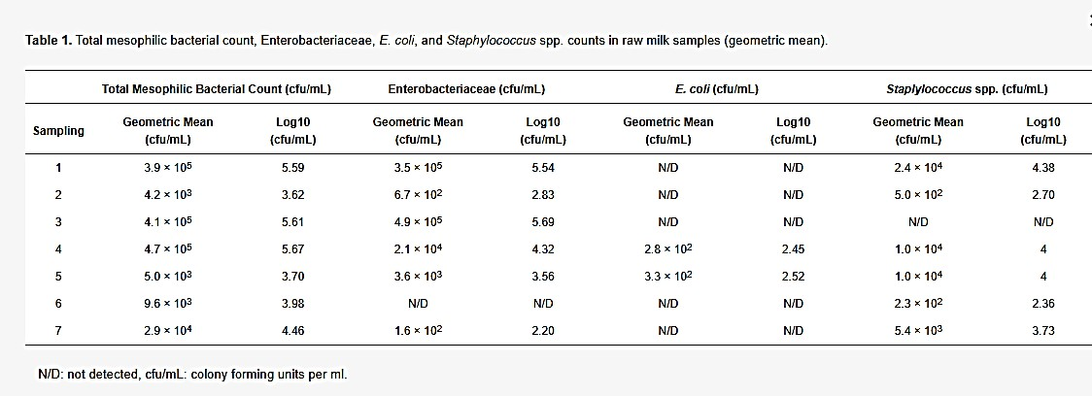

The results of the microbiological analysis of raw and pasteurized curd and cheese samples duringthecheesemakingtrialsandthematurationarepresentedin Table2andFigure1, Figure 2and Figure 3.
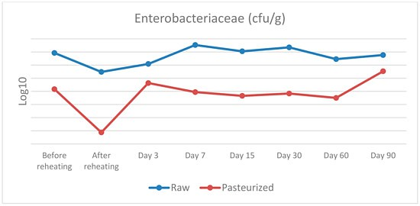

Figure1.Enterobacteriaceaecountsinraw andpasteurizedcurdand cheesesamples.

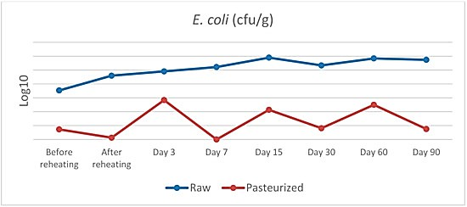

Figure2.E. coli countsinrawandpasteurizedcurdandcheesesamples.

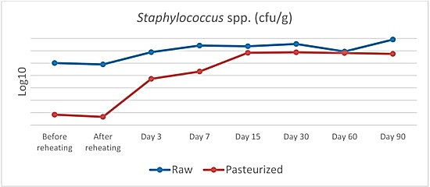

Figure3.Staphylococcus spp.countsinrawandpasteurizedcurdandcheese samples.

Table 2.Enterobacteriaceae,E. coli, andStaphylococcusspp. counts in raw and pasteurized curd and cheese samples (geometric mean).
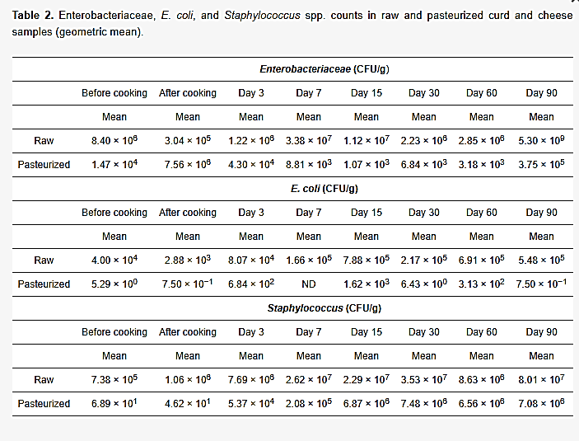

Table 3.Statistical interpretation of the microbiological analysis of raw and pasteurized curd and cheese.
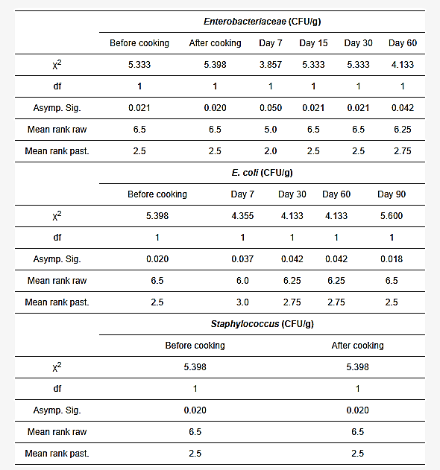

ComparisonwithStandards(Codex,NationalRegulations)

    - CodexAlimentarius:requiresabsenceofListeriamonocytogenesandSalmonellaspp.
in25gof cheese, and S.aureuscounts below10³CFU/g.
    - Brazilian regulations: permit max 10³ CFU/g of CPS in moderate-humidity cheeses, 5 × 10³ MPN/g of coliforms, and require pathogen absence.
    - EUregulations:rawmilkmustnotexceed10⁵CFU/mLmesophilicbacteriaforcheese production.

Most cheese samples in both studies complied with these standards, except for one coalho cheese exceeding CPS limits, highlighting risks in small dairies without strict sanitary oversight.

DiscussionofFindingswith PreviousStudies

    - The findings agree with earlier research showing that raw cheeses can harbor high microbial loads initially, but maturation and salt levels reduce risks (e.g., Kousta et al. 2010; Choi et al. 2016).
    - Similar studies confirm that pasteurization is effective but does not prevent recontamination (O’Brien et al. 2009).
    - Interestingly,somestudiessuggestrawcheesemicrobiotacaninhibitpathogenslike
Listeriathrough antagonisticlactic acid bacteria, offeringnatural safetybarriers.
    - Discrepancies exist: while U.S. data show raw cheese linked to higher outbreaks, European data show both raw and pasteurized cheeses implicated, depending on handling.

ImplicationsforLaboratoryCheese Production

    - Laboratory-scaleproductionmustensurecontrolledpasteurizationorvalidatedraw milk handling protocols.
    - ImplementationofGMP,HACCP,andpropersanitationiscritical,ascontamination risks arise mainly during handling post-pasteurization.
    - Physicochemicalmonitoring(pHdecline,saltuptake,moisturereduction)provides early indicators of safe fermentation and ripening.
    - Futureworkshouldexploreprotectivecultures(LAB)andbio-preservation techniques to enhance microbiological safety while preserving artisanal qualities.

CHAPTERFIVE

SUMMARY,CONCLUSION,ANDRECOMMENDATIONS

SummaryofMajorFindings

    - Physicochemical stability: Both raw and pasteurized cheeses had typical ripening values:pH(5.2–5.5),moisture(34–46%),andsalt(1–2%).Theseparametersstabilized after 90 days of maturation and remained within Codex Alimentarius and national standards.

Microbialsafety:

      - Raw milk contained high levels of thermotolerant coliforms (10³–10⁵ MPN/mL) and coagulase-positive staphylococci (10³–10⁵ CFU/mL), with occasional presence of Salmonella spp..
      - Pasteurization was highly effective in eliminating these pathogens, with no detection in pasteurized milk or most final cheese products.
      - Post-pasteurization contamination occurred in some samples, linked to handlers’ hands and surfaces, reinforcing the need for strict GMP.
      - In raw cheese, Clostridium perfringens and Salmonella were sporadically detected but controlled during ripening, highlighting the role of indigenous microbiota in pathogen suppression.
    - Regulatory compliance: Most cheese samples complied with Codex, Brazilian, and EU microbiological limits, except for isolated cases in small-scale dairies lacking sanitary oversight.
    - Hygieneimpact:ImplementationofGoodManufacturingPractices(GMP),proper pasteurization,andfarm-levelhygienesignificantlyimprovedmicrobialsafety,even in raw cheese production.

Conclusion

Cheesesafetyandqualityareprimarilydeterminedbythemicrobiologicalstatusofrawmilk and hygienic practices during processing. Pasteurization remains the most reliable intervention for pathogen control, but post-pasteurization contamination risks emphasize theneedforGMPandworkerhygiene.Rawcheesecanbesafeifproducedfromhigh-quality milk, under strict sanitary controls, and with controlled maturation. However, small-scale dairies and laboratory cheese trials require heightened oversight to ensure compliance with international safety standards.

Recommendations

ForLaboratoryCheese Production

    - Use only high-quality raw milk that complies with EU/WHO microbial thresholds(<10⁵ CFU/mL mesophilic bacteria).
    - Implement validated pasteurization protocols (63 °C/30 min or 72 °C/15 sec) andmonitor with phosphatase/peroxidase tests.
    - Ensurecontrolledripeningenvironments (temperature10–14°C,RH80–85%)with monitoring of pH, salt, and moisture as safety indicators.
    - AdoptHACCP-basedsafetychecks,includingpathogenscreening(Listeria,Salmonella, S. aureus) in milk, curd, and final cheese.
    - Train personnel in aseptic handling and hygiene, as contamination frequently arises from handlers and equipment.

ForDairyIndustryHygiene Practices

    - Strengthenfarm-levelbiosecurity:teatdisinfection,equipmentmaintenance,and cooling of raw milk to ≤4 °C.
    - Regularlymonitorcoliformsandstaphylococciashygieneindicatorsinrawmilkand cheese plants.
    - Enforce GMP and HACCP systems, focusing on post-pasteurization handling to avoid recontamination.
    - Small-scaledairiesshouldbeprioritizedforsanitaryinspections,astheypresent higher risks of CPS and coliform non-compliance.
    - Promoteworkerhygienetraining,emphasizinghandsanitationandcross- contamination prevention.

SuggestionsforFurther Research

    - Protective microbiota: Study the role of lactic acid bacteria (LAB) and their antagonistic effects on pathogens like Listeria monocytogenes, as observed in raw cheese.
    - Biopreservation strategies: Evaluate bacteriocins, probiotics, or starter cultures that enhance safety while preserving artisanal characteristics.
    - Small-scale production risks: Investigate microbial dynamics in traditional and artisanal cheeses, focusing on GMP feasibility in resource-limited settings.
    - Longer ripening studies: Extend monitoring beyond 90 days to assess whether pathogen suppression is consistent in both raw and pasteurized cheeses.
    - Consumer safety assessments: Model public health risks from raw vs. pasteurized cheeses under different hygienic scenarios.

REFERENCES

    - Prates, D.F., Würfel, S.R., Goldbeck, J.C., et al. (2017). Microbiological quality and safety assessment in the production of moderate and high humidity cheeses. Ciência Rural, 47(11), e20170363. (Findings on contamination sources, need for GMP; plant sampling; pasteurization effectiveness.)
    - Skandamis, G. et al. (2022). Microbiological and Physicochemical Characteristics of Hard Cheese Produced from Raw and Pasteurised Cow Milk. Veterinary Sciences, 9,
569. (Cheese-making protocol; microbiota discussion; pathogen/indicator dynamics; early blowing; pasteurization batch details; risk contrasts.)
    - Prates, D.F. et al. (2017). Microbiological quality and safety assessment in the productionofmoderateandhighhumiditycheeses.CiênciaRural,47(11):e20170363.
    - Sakaridis, I. et al. (2022). Hygiene and Safety of Hard Cheese Made from Raw Cows’ Milk. Veterinary Sciences, 9(10): 569.
    - Choi,K.H.etal.(2016).Cheesemicrobialriskassessments–Areview.Asian-Australas J Anim Sci, 29(3): 307–314.
    - Kousta, M. et al. (2010). Foodborne pathogens in raw milk and dairy products. Int J Dairy Tech, 63: 171–213.
    - O’Brien, M. et al. (2009). Staphylococcus aureus enterotoxins in food. J Appl Microbiol, 106: 1199–1214.
    - Prates, D.F., Würfel, S.R., Goldbeck, J.C., Lima, A.S., Lopes, G.V., & Silva, W.P. (2017). Microbiological quality and safety assessment in the production of moderate and high humidity cheeses. Ciência Rural, 47(11), e20170363. doi:10.1590/0103- 8478cr20170363

    - Sakaridis, I.,Psomas,E.,Karatzia,M.-A.,&Samouris,G.(2022). HygieneandSafety of Hard Cheese Made from Raw Cows’ Milk. Veterinary Sciences, 9(10), 569. doi:10.3390/vetsci9100569
    - Kousta, M., Mataragas, M., Skandamis, P., & Drosinos, E.H. (2010). Foodborne pathogens in raw milk and dairy products. Int. J. Dairy Technol, 63(2), 171–213.
    - Choi, K.H., et al. (2016). Cheese microbial risk assessments – A review. Asian- Australas. J. Anim. Sci, 29(3), 307–314.
    - O’Brien,M.,etal.(2009).Staphylococcusaureusenterotoxinsinfood.J.Appl.

Microbiol,106, 1199–1214.

