SMART PREPAID BASED SOLAR POWER CHARGING STATION

BY:

SIDIQ BARAKAT ARIYIBI
ND/23/COM/PT/0399

A PROJECT SUBMITTED TO THE DEPARTMENT OF COMPUTER SCIENCE, INSTITUTE OF INFORMATION AND COMMUNICATION TECHNOLOGY, KWARA STATE POLYTECHNIC, ILORIN

IN PARTIAL FULFILLMENT OF THE REQUIREMENTS FOR THE AWARD OF NATIONAL DIPLOMA (ND) IN COMPUTER SCIENCE

AUGUST, 2025

CERTIFICATION
This is to certify that this project was carried out by Sidiq Barakat Ariyibi with matriculation number ND/23/COM/PT/0399, has part of the requirements for the award of National Diploma (ND) in Computer Science.

………………………………. ……………………………….
Mr. Bolaji-Adetoro D.F. Date
(Project Supervisor)

………………………………. ……………………………….
Mr. Oyedepo, F. S. Date
(Head of Department)

………………………………. ……………………………….
External Examiner Date

DEDICATION
This project is dedicated to the creator of the earth and universe, the Almighty God. It is also dedicated to my parents for their moral and financial support.

ACKNOWLEDGEMENT
The journey through this academic program has been both challenging and rewarding. Through all the trials and triumphs, I give all glory, honor, and adoration to the Almighty God for His unending grace, divine protection, and sustenance from the very first day I stepped into the academic world until this present moment. Without His mercy, I would not have come this far.
I wish to express my heartfelt gratitude to the Head of the Computer Science Department, Mr. Oyedepo F.S. for his unwavering support, fatherly guidance, and consistent encouragement throughout the course of my academic journey. His administrative leadership and personal interest in the success of students have been a source of great motivation to me.
My profound appreciation goes to my project supervisor, Mr. Bolaji-Adetoro D.F. for the invaluable role he played in the successful completion of this research project. His intellectual input, timely corrections, encouragement, and professional mentorship were instrumental in shaping the quality of this work. I consider it a great privilege to have worked under his supervision.
I also wish to extend my sincere appreciation to all the lecturers in the Department of Computer Science for their dedication to academic excellence and for imparting knowledge and discipline throughout my course of study. Each of you contributed uniquely to my academic and personal growth.
To my family, friends, and colleagues who stood by me in prayers, words of encouragement, and support during trying times, I say thank you.
Above all, I am grateful to everyone who, in one way or the other, contributed to the successful completion of this project.

TABLE OF CONTENTS
Title Page i
Certification ii
Dedication iii
Acknowledgements iv
Abstract v
Table of Contents vi
CHAPTER ONE: GENERAL INTRODUCTION
- Background to the Study 1
- Statement of the Problem 3
- Aim and Objectives of the Study 3
- Significance of the Study 4
- Scope of the Study 4
- Organization of the Report 5
CHAPTER TWO: LITERATURE REVIEW
2.1 Review of Related Works 6
2.2 Review of Related Concepts 10
2.2.1 Overview of Solar Energy 10
2.2.2 IoT in Energy Management 11
2.2.3 Prepaid Energy Systems 11
2.2.4 Challenges in Renewable Energy Adoption 12
2.2.5 Smart Prepaid-Based Solar Power Charging System 13

CHAPTER THREE: RESEARCH METHODOLOGY AND ANALYSIS OF THE EXISTING SYSTEM
- Research Methodology 14
- Analysis of the Existing System 14
- Problems of the Existing System 15
- Description of the Proposed System 15
- Advantages of the proposed system 16
CHAPTER FOUR: DESIGN, IMPLEMENTATION AND DOCUMENTATION OF THE SYSTEM
- Design of the System 17
  - Output Design 17
  - Input Design 21
4.1.3 Procedure Design 23
- Implementation of the System 23
  - Choice of Programming Language 24
  - Hardware Support 24
  - Software Support 25
- Documentation of the System 25
  - Program Documentation 26
  - Maintaining the System 26
CHAPTER FIVE: SUMMARY, CONCLUSION AND RECOMMENDATION
- Summary 27
- Conclusion 27
- Recommendation 28
References

ABSTRACT
Power crises have become a major national problem in Nigeria. There are approximately 500,000 vehicles in Nigeria that operate on battery power. Batteries are currently charged through main supply electricity. The integration of smart technologies into renewable energy systems has paved the way for innovative solutions to global energy challenges. This project explores the development of a smart prepaid-based solar power charging station. The proposed system enhances accessibility and efficiency in utilizing solar energy by integrating IoT technologies with prepaid functionalities. Solar E Technology has used state of arts technology which includes intelligent negative pulse current charger, smart card billing system and remote data management system. Key features include real-time monitoring, automated billing, and robust energy management, addressing inefficiencies in traditional systems and promoting sustainable energy use.

CHAPTER ONE
GENERAL INTRODUCTION
1.1 BACKGROUND TO THE STUDY
Energy sustainability has become a central concern for governments, industries, and individuals worldwide. Despite advancements in renewable energy technologies, the inefficiencies in energy distribution and billing mechanisms persist, especially in developing regions. Traditional solar systems often lack robust mechanisms for monitoring usage and ensuring equitable distribution. Solar photovoltaic is an environmentally friendly option to produce electrical energy, which produces almost free energy once an initial investment is made (Swetha et al., 2022).
Increasing power demand, diminishing fossil fuels, new load kinds, rural electrification, and electricity security are just a few of the incentives for power places to jump right into a sustainable energy adventure. The emergence of smart technologies presents an opportunity to address these challenges. By combining IoT with prepaid billing systems, energy providers can ensure efficient energy utilization, reduce wastage, and enhance user satisfaction (Kannan et al., 2025).
The growing global demand for energy and the depletion of fossil fuel resources have heightened the need for sustainable and renewable energy sources. Solar power, as an abundant and renewable resource, has emerged as a viable solution to meet energy demands sustainably. However, the adoption of solar energy faces several challenges, including inefficient energy utilization and billing inconsistencies. Solar photovoltaic panels, batteries, and electricity conditioning devices are the basic components of a standalone Solar photovoltaic tool. Solar photovoltaic panels provide DC electricity, which is then converted to AC with the help of converter devices. The application of power electronic converters increases the complexity of the strength device while lowering its performance (Rehman et al., 2025).
Mohan et al., (2020) claimed that smart technologies, particularly Internet of Things (IoT), have revolutionized various sectors, including energy management. By enabling real-time communication and automation, IoT offers a promising avenue to address the inefficiencies inherent in traditional energy systems. A prepaid-based system further ensures fairness and transparency by allowing users to pay for their energy consumption in advance, thereby eliminating billing disputes.
The integration of such a system is expected to significantly improve energy accessibility, particularly in regions with unreliable electricity grids. Moreover, the system aligns with global efforts to transition towards a greener and more sustainable future. A smart billing system is necessary to make the solar charging station more viable and acceptable. Prepaid billing system is the suitable option to serve this purpose. Prepaid billing provides security of money, helps to pre estimate the energy usage in advance, reduces power loss as the consumers become aware about the balance, removes the complexity of bill production and distribution and also helps to manage load and demand side. For these reasons still prepaid billing is the most popular billing system in the world. The concept of prepaid meter was first introduced in the United Kingdom before second world war. Now many developed countries as well as African countries are using prepaid meters (Rahman et al., 2022).
Utilization and monitoring of power have been a thing of practice in the line of power distribution companies using prepaid energy meters. Now, in the line of solar inverter power supply, prepaid metering is recently being adopted by manufacturers of solar systems to regulate and account for power consumption, just as in grid supplies. Looking at this from the angle of a consumer acquiring a solar system for use that is equipped with a recharge mechanism and prepaid metering all agree with the advancement in innovation and solutions to power (Obayuwana & Igbonoba, 2020).
This project focuses on the design and implementation of a smart prepaid-based solar power charging station. By leveraging IoT technology and prepaid functionalities, the system aims to streamline energy distribution, enhance user experience, and promote sustainable energy practices.
1.2 STATEMENT OF THE PROBLEM
Traditional solar charging systems typically used manual operations and postpaid billing, leading to various inefficiencies. Users often face issues like unauthorized use and billing disputes, as they are charged after the fact without clear control over their consumption. Furthermore, conventional solar power systems are often plagued by inefficiencies such as energy wastage, inaccurate billing, and limited user control. These issues hinder the widespread adoption of solar energy, particularly in areas with limited infrastructure. There is a pressing need for a system that ensures transparency, enhances energy management, and promotes efficient usage of solar power.
1.3 AIM AND OBJECTIVES OF THE STUDY
The aim of this project is to develop a smart prepaid-based solar power charging station that enhances efficiency, transparency, and sustainability in energy management. The objectives are to:
- design a solar charging system that integrates IoT technologies for real-time monitoring and control;
- implement a prepaid billing mechanism that ensures transparency and user satisfaction;
- evaluate the performance of the system in terms of energy efficiency and user experience; and
- promote sustainable energy practices through enhanced energy management solutions.

  - SIGNIFICANCE OF THE STUDY
The proposed system addresses critical issues in solar energy utilization, including inefficiencies in billing and energy distribution. By leveraging smart technologies, the project contributes to advancing renewable energy adoption. The findings are particularly significant for regions with unreliable energy infrastructure, offering a scalable solution to enhance energy accessibility and sustainability.
1.5 SCOPE OF THE STUDY
The project focuses on the design, development, and evaluation of a smart prepaid-based solar power charging station. It encompasses the integration of IoT for real-time monitoring, the implementation of prepaid billing mechanisms, and the analysis of system performance. The research is limited to small- to medium-scale solar power systems, with potential applications in residential and commercial settings.
1.6 ORGANIZATION OF THE REPORT
The project write-up is organized into five distinct chapters. Chapter one covers general introduction, which contains introduction to the project topic, statement of the problem, aim and objectives of the study, significance of the study, scope of the study and organization of the report. Chapter two covers the literature review, which contains review of related past works, overview of billing system, description of a solar power system and other related concepts. Chapter three explains the project methodology which includes analysis of existing system, problems of the existing system, the description of the proposed system and advantages of proposed system. Chapter four explains the design, implementation and documentation of the system which contain system designed output design, input design, database design, procedure design, implementation of the system hardware and software support and documentation of the new system installation procedure, operating the system and system maintenance. Lastly, chapter five explains the summary of the research, recommendations, and conclusion.

CHAPTER TWO
LITERATURE REVIEW
2.1 REVIEW OF RELATED WORK
Obayuwana and Igbonoba (2020) designed and implemented a smart prepaid solar inverter system. The project, as designed, is to provide an alternative source of supply that offers a cost-friendly, flexible, and practicable method for consumers in all sectors of the economy. Consumers of energy had earlier faced with challenges such as inflexibility in power subscriptions and unaccountability of consumption rate, even after the solutions that some power-oriented companies had earlier proffered. With the designed prepaid meter interfaced with the inverter system of use, consumers will be able to monitor their consumption rate, and with an energy-saving technique incorporated, the consumption is controlled and channeled to critical loads only when a battery is running low and anytime balance is low. The
pay-as-you-go method of operating this system power and the ability to own the systems without interference from unauthorized persons were all made feasible through some added tools such as Arduino, IR remote, and Receiver. This project presents a micro approach of a broader scope to eliminating the country’s power
problems.
Maroma (2021) developed a solar powered cell phone charging station. The study focused on the development of a cell phone charging station that is solely operated through solar power by means of a solar cell which is attached to the charging station through a backup storage battery. The device is mainly aimed for commercial use since it can require a certain fee for a specified period to charge a mobile phone. However, in case of calamities the charging station can be used as an emergency charging station in the event of prolonged power outages. Since the device is a standalone system, it can charge mobile phone as long as there is sunlight. Even during night time, the device can still charge phone as long as the battery still has power.
Sushma et al., (2023) proposed a smart solar powered electronic vehicle charging station. The objective of the project was to design and construct electric vehicle charging stations using solar energy and a direct electricity grid, with the goal of providing a convenient and accessible charging option for electric vehicle drivers on highways. The charging stations was be built on major highways to make them easily accessible to a large number of electric vehicle drivers. The solar panels used in the charging stations generated electricity from the sun, while the direct electricity grid provided additional power when needed. The excess amount of electricity generated from the charging stations was sent back to the grid for a certain amount to make profit. The project aims to reduce carbon emissions by promoting the use of electric vehicles and sustainable energy sources, while also generating revenue through the sale of excess electricity.
Swetha et al., (2022) worked on solar based battery charging system through IoT. This work focuses on the design and development of a low-cost, completely solar-powered battery charging system using a microcontroller. I MPPT (ii) Arduino Uno interface for battery control capabilities are included in the designed system. (ii) LCD display for providing information to the user about the system, such as the structure's normal capacity to charge at any given time, (iv) data storage and GSM module for remote surveillance and uploading live records, which can also be used for studying the battery's fitness and assisting in battery maintenance. The produced solar-powered battery charging mechanism for DC hundreds was created with Solar Home Systems in view (SHS).
Kannan (2025) implemented a smart automated electronic vehicle charging with prepaid access system. The paper proposes a smart automated electronic vehicle charging with prepaid access system that integrates RFID-based authentication, hybrid power sources (solar and grid), and real-time monitoring. The system ensures controlled energy consumption, automated authentication, and transparent billing, reducing manual intervention and improving efficiency. By leveraging smart automation and sustainable energy sources, this system enhances the reliability, convenience, and sustainability of electronic vehicle charging infrastructure.
Mohan (2020) designed an arduino based solar powered battery charging system for rural solar residence. The paper implemented a low fee, microcontroller based totally, sun powered battery charging device. The developed system includes (i) MPPT (ii) Arduino Uno interface for battery control capabilities Arduino Uno interface, (iii) LCD show for statistics to the consumer approximately the system regarding the structures normal capacity to fee at any given time, (iv) information storage and carries Wi-Fi module for far off surveillance and uploading live records which can similarly be used for studying the fitness of the battery and help in maintenance of battery. The developed sun powered battery charging device for DC hundreds has been designed for use in Solar Home Systems (SHS). The character SHS can be linked to shape a low voltage DC micro grid for the remotely positioned rural populace for sustainable provision of electrical electricity offerings.
Rehman et al., (2025) conducted a research on solar-powered multi-functional portable charging device (SPMFPCD) with internet-of-things (IoT)-based real-time monitoring. The paper proposes an innovative development of a solar-powered multi-functional portable charging device (SPMFPCD) with internet- of-thing (IoT)-based monitoring capabilities. The proposed scheme introduces a comprehensive model integrating advanced technologies which include a highly efficient solar panel, charge controller, sensors, and IoT module. The proposed system facilitates versatile charging solutions for a wide range of power requirements with real-time monitoring and data analysis through the IoT platform. Moreover, the proposed work explores the applications of the SPMFPCD in (1) emergency medical scenarios, (2) outdoor adventures, (3) disaster management, and 4) public spaces. Performance evaluation was made by proposing case studies to validate the (1) economic viability, (2) power management, and (3) environmental impact of widespread deployment of SPMPFCD in public spaces. Furthermore, detailed analysis of battery energy storage system (BESS) and photovoltaic (PV) integration for load management, seasonal dynamics, and renewable energy integration (REI) contribute to a comprehensive understanding of the proposed solution.
2.2 REVIEW OF RELATED CONCEPTS
2.2.1 Overview of Solar Energy
Solar energy is a renewable and inexhaustible source of power derived from sunlight. It is harnessed using technologies such as photovoltaic (PV) panels, solar thermal systems, and concentrated solar power (CSP) systems. Photovoltaic panels convert sunlight directly into electricity using semiconductors like silicon, making them a popular choice for residential and commercial applications. Solar thermal systems capture solar heat to generate steam, which powers turbines to produce electricity, while CSP uses mirrors to concentrate sunlight on a specific point to generate heat. The versatility of solar energy systems has allowed their integration into various applications, including electricity generation, water heating, and even transportation (Mohan, 2020).
Solar energy is recognized as a key contributor to reducing greenhouse gas emissions and combating climate change. Unlike fossil fuels, solar energy produces no direct carbon emissions during operation, making it an environmentally friendly option. Additionally, technological advancements and economies of scale have significantly reduced the cost of solar panels over the past decade, enabling broader adoption worldwide. Countries are increasingly setting ambitious solar energy targets to meet sustainable development goals and transition toward a cleaner energy future.
Despite its many advantages, solar energy has limitations, such as dependence on sunlight and weather conditions, which can affect efficiency. Energy storage systems, like batteries, are often paired with solar installations to store excess energy generated during peak sunlight hours for use during cloudy days or nighttime. Another challenge is the space requirement for large-scale solar farms, which may conflict with land use priorities. However, innovations such as floating solar farms and building-integrated photovoltaics are addressing these challenges.
The future of solar energy looks promising as research focuses on improving efficiency and storage solutions. Emerging technologies, such as perovskite solar cells and tandem cells, aim to enhance the efficiency and affordability of solar systems. Additionally, policy incentives, subsidies, and international collaborations are driving investments in solar energy projects. As a cornerstone of the global energy transition, solar energy continues to pave the way for sustainable development and a low-carbon future (Kennan, 2025).
- IoT in Energy Management
The Internet of Things (IoT) has revolutionized energy management by enabling smarter, more efficient systems that monitor, control, and optimize energy usage. IoT devices, such as smart meters, connected sensors, and automation systems, collect real-time data on energy consumption patterns. This data is analyzed using cloud computing and artificial intelligence (AI) to identify inefficiencies, forecast energy demand, and recommend actionable insights. By providing granular visibility into energy usage, IoT helps consumers and businesses make informed decisions to reduce costs and minimize waste (Liu & Ma, 2021).
One of the significant applications of IoT in energy management is in the integration of renewable energy sources. IoT systems enable seamless coordination between distributed energy resources like solar panels, wind turbines, and battery storage. These systems optimize energy distribution and ensure grid stability by balancing supply and demand in real time. For example, IoT-enabled sensors can predict renewable energy generation based on weather conditions and adjust grid operations accordingly.
In smart buildings and homes, IoT devices play a vital role in automating energy-saving measures. Smart thermostats, lighting systems, and appliances adjust their operation based on occupancy patterns and user preferences, reducing unnecessary energy consumption. Industrial facilities also benefit from IoT by leveraging predictive maintenance and energy optimization algorithms to enhance operational efficiency.
However, IoT adoption in energy management comes with challenges, including cybersecurity risks, interoperability issues, and the need for significant investments in infrastructure. Ensuring data privacy and securing IoT networks are critical to maintaining consumer trust. As IoT technologies continue to evolve, addressing these challenges will be essential to unlocking their full potential in transforming the energy landscape (Walia, 2024).
- Prepaid Energy Systems
Prepaid energy systems offer a flexible and user-friendly approach to electricity consumption, allowing customers to pay for energy in advance. These systems utilize smart meters that track energy usage and deduct the consumed amount from a prepaid balance. Customers can recharge their accounts through various methods, including mobile apps, kiosks, and online platforms, making energy access more convenient and adaptable to individual budgets.
One of the primary benefits of prepaid energy systems is their ability to encourage responsible energy use. By providing real-time feedback on consumption and balance, these systems motivate users to monitor and optimize their energy usage. Prepaid models also reduce the risk of bill payment defaults for utility providers, improving cash flow and operational efficiency. Additionally, prepaid systems can enhance energy access in underserved or remote areas, where traditional billing infrastructure may be lacking.
For utility providers, prepaid systems streamline revenue collection and reduce the administrative burden associated with billing and customer service. They also enable demand-side management by providing data on consumption patterns, helping utilities plan and allocate resources effectively. Advanced prepaid systems are now incorporating IoT and AI technologies to provide predictive analytics and personalized energy-saving recommendations.
Despite their advantages, challenges remain in implementing prepaid energy systems. Initial deployment costs for smart meters and associated infrastructure can be high, particularly in regions with limited financial resources. Additionally, ensuring equitable access for low-income households requires addressing affordability and education barriers. Policymakers and utility companies must collaborate to design inclusive solutions that maximize the benefits of prepaid energy systems (Adams, 2022).

- Challenges in Renewable Energy Adoption
Renewable energy adoption is critical to achieving sustainable development goals, but it faces several challenges that hinder its widespread implementation. One of the primary obstacles is the intermittent nature of renewable energy sources like solar and wind, which depend on weather conditions and time of day. This variability necessitates advanced energy storage solutions to ensure grid reliability and continuous power supply. However, storage technologies, such as lithium-ion batteries, remain expensive and have scalability limitations.
Infrastructure limitations also pose a significant challenge. Many existing power grids were designed for centralized, fossil-fuel-based systems and require substantial upgrades to accommodate decentralized renewable energy sources. The integration of renewables into these grids demands sophisticated management systems and investment in transmission and distribution networks. Additionally, regulatory frameworks often lag behind technological advancements, creating barriers to renewable energy adoption.
Economic factors further complicate the transition. While the costs of renewable energy technologies have declined significantly, the upfront investment required for installations and infrastructure remains a hurdle for many stakeholders. Subsidies for fossil fuels in some regions also distort energy markets, making renewables less competitive. Governments and organizations must align policies and incentives to level the playing field and encourage renewable energy adoption.
Social and environmental factors also play a role in adoption challenges. Large-scale renewable projects, such as wind farms and solar parks, can face opposition from local communities due to land use conflicts, ecological impacts, or aesthetic concerns. Engaging stakeholders and ensuring equitable benefits from renewable energy projects are essential to addressing these challenges and fostering widespread acceptance (Sezko, 2020).
- Smart Prepaid Based Solar Power Charging System
A smart prepaid-based solar power charging system integrates solar energy generation with advanced metering and payment technologies to create an efficient and user-friendly energy solution. This system allows users to prepay for solar energy, enabling controlled access to electricity while promoting renewable energy adoption. The integration of smart meters and IoT devices provides real-time monitoring and management of energy consumption, ensuring transparency and efficiency.
Such systems are particularly beneficial in remote or off-grid areas where conventional energy infrastructure is limited or unavailable. By leveraging solar power, they provide a sustainable and reliable energy source, reducing dependency on diesel generators or other non-renewable alternatives. Users can recharge their accounts using mobile platforms or automated kiosks, offering convenience and flexibility.
The real-time data generated by smart prepaid systems enables energy providers to optimize resource allocation and maintenance schedules. Additionally, these systems can incorporate dynamic pricing models that adjust rates based on demand and supply conditions, encouraging efficient energy usage. The combination of solar energy and prepaid systems contributes to environmental sustainability by reducing carbon emissions and promoting energy equity.
However, implementing smart prepaid-based solar charging systems requires addressing challenges such as high initial costs, technological literacy, and infrastructure requirements. Policymakers and stakeholders must collaborate to provide subsidies, training, and support for the adoption of these systems, especially in economically disadvantaged regions. Despite these challenges, the concept represents a promising step toward achieving universal access to clean and affordable energy (Ajibola, 2023).

CHAPTER THREE
RESEARCH METHODOLOGY AND ANALYSIS OF THE EXISTING SYSTEM
3.1 RESEARCH METHODOLOGY
Below is a brief layout of the proposed system. This system has incorporated a hybrid solar inverter charger with a load management module. This smart module has Maximum Power Point Tracking (MPPT) and can charge devices and other loads from solar power during the day. The remaining unused solar energy is stored in storage batteries for use at night. This integrated system has captured all the latest state-of-the-art technologies, such as the intelligent negative pulse current charger, smart card billing system, and remote data management system. Below are the block diagram of the solar energy storage system and the block diagram of the proposed solar station.
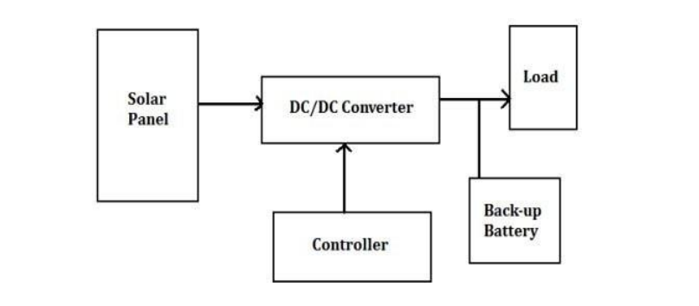 Figure 3.1: Block diagram of the solar energy storage system
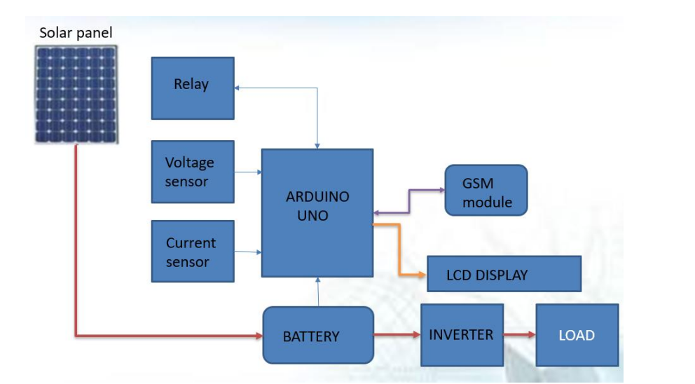
Figure 3.2: Block diagram of the proposed solar system
Materials and Method
- Solar Panel: High-efficiency photovoltaic panels to harvest solar energy.
- Charge Controller: A solar charge controller to regulate voltage and current from the solar panel to prevent overcharging.
- Rechargeable Battery Bank: Lithium-ion or lead-acid batteries to store energy.
- Microcontroller Unit (MCU): Examples: Arduino for controlling and managing the system.
- Prepaid Module: RFID-based prepaid card reader or mobile wallet integration module.
- Inverter: Converts DC to AC power (if charging devices require AC).
- Power Distribution System: Cables, connectors, and circuit breakers to ensure safe and efficient power transfer.
- Load Management System: Smart relays or switches to control the flow of electricity to charging ports.
- Energy Meter: Measures energy consumed by users for billing purposes.
- Communication Module: GSM, Wi-Fi, or Bluetooth module for real-time data exchange and user notifications.
- Housing Unit: Weatherproof and tamper-resistant casing for components.
- Charging Ports: USB, Type-C, or other ports compatible with devices to be charged.
- Miscellaneous Components: Resistors, capacitors, diodes, heat sinks, and other electrical components as required.
The solar powered battery charging station schematic is shown below.

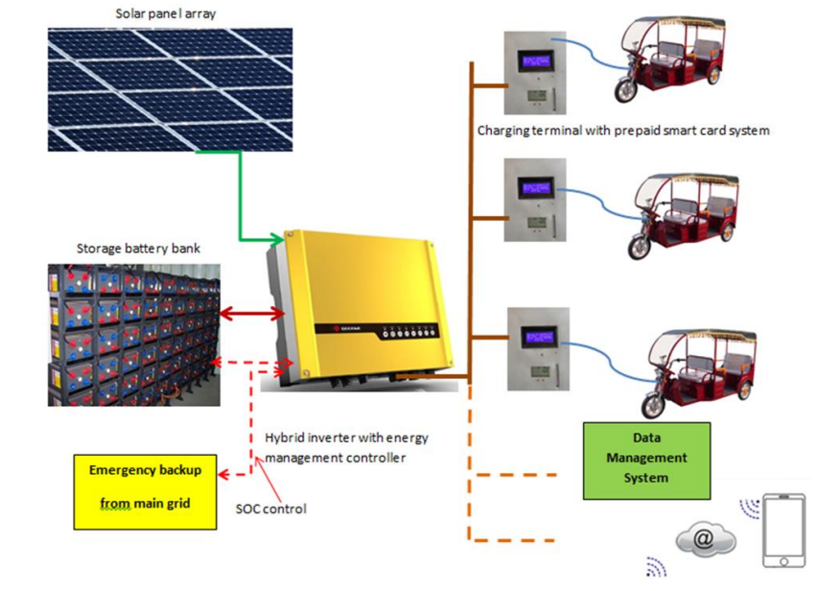
Figure 3.3: Solar powered battery charging station schematic (Source: Kennan, 2025)
3.2 ANALYSIS OF THE EXISTING SYSTEM
Conventional solar power systems often lack integrated monitoring and billing mechanisms. The current systems for smart prepaid-based solar power charging stations are tailored to address the rising demand for renewable energy solutions in a user-centric manner. However, existing systems face challenges that hinder optimal functionality. One major limitation is the high upfront installation cost, which can be a barrier for widespread adoption in underdeveloped or rural areas. Moreover, inconsistent internet connectivity in remote locations can disrupt real-time monitoring and transactions, leading to user dissatisfaction. Another concern is the inefficiency of energy storage systems; batteries used to store solar power often have limited lifespans and can degrade quickly under frequent charge-discharge cycles, impacting system reliability and maintenance costs. To enhance these systems, there is a need for improved scalability, cost-effectiveness, and resilience.
3.3 PROBLEMS OF THE EXISTING PROBLEM
The existing system of charging station has the following shortcomings:
- Energy Wastage: The absence of real-time monitoring leads to inefficient energy utilization and significant wastage.
- Billing Inefficiencies: Traditional billing methods are prone to errors and disputes, undermining user trust.
- Limited User Control: Users have minimal control over energy consumption, limiting their ability to optimize usage.
- Inefficient energy utilization and distribution.
- Lack of automation and real-time control mechanisms.
3.4 DESCRIPTION OF THE PROPOSED SYSTEM
The proposed smart prepaid-based solar power charging station seeks to overcome the limitations of existing systems by incorporating advanced technologies and enhanced operational capabilities. It integrates high-efficiency solar panels with upgraded energy storage solutions, such as lithium-iron-phosphate batteries, to ensure reliable power availability and longer system lifespans. A key feature is the deployment of a robust IoT-enabled architecture, allowing users to remotely access and manage their accounts, monitor energy consumption, and make payments seamlessly via a mobile or web application.
To address the challenges of internet connectivity in remote areas, the system incorporates offline-compatible features for transactions and local network solutions. These enhancements ensure uninterrupted service even in locations with limited internet access. The system is designed with scalability in mind, allowing for easy integration of additional stations and capacity expansion as energy demand grows. A predictive maintenance framework powered by the microcontroller is integrated to monitor system health and detect potential issues before they cause disruptions. This reduces downtime and minimizes maintenance costs. Moreover, the system emphasizes user-friendliness, offering an intuitive interface and real-time notifications for energy balance updates and recharge reminders.
3.5 ADVANTAGES OF THE PROPOSED SYSTEM
The following are the advantages of the proposed system
- The proposed system enhanced energy efficiency through real-time monitoring.
- It increased transparency and user satisfaction via prepaid billing.
- It reduced energy wastage and improved sustainability.

CHAPTER FIVE
SUMMARY, CONCLUSION AND RECOMMENDATIONS
5.1 SUMMARY
A smart prepaid-based solar power charging station developed leverages renewable energy to provide a sustainable and user-friendly power solution. By integrating solar panels with an efficient energy storage system and a prepaid payment mechanism, the station allows users to access clean energy on a pay-as-you-go basis. The system enhances energy management by enabling real-time monitoring of consumption and balance through a mobile or web platform, making it especially suitable for areas with limited or unreliable grid power.
The developed system addresses key challenges faced by existing solutions, such as high installation costs, inconsistent internet connectivity, and limited battery lifespan. It incorporates offline transaction capabilities, blockchain-based secure payments, and advanced battery technologies to ensure reliability and ease of use. Additionally, the inclusion of internet of things helps to reduce downtime and maintenance expenses by proactively identifying system faults, thereby improving the overall operational efficiency and lifespan of the station.
In essence, this project provided an accessible, cost-effective, and scalable renewable energy solution that can empower communities, particularly in remote and underdeveloped regions. By promoting clean energy adoption and simplifying energy access through smart prepaid technology, the project contributes to sustainable development goals and paves the way for a greener, more energy-efficient future.

5.2 CONCLUSION
The smart prepaid-based solar power charging system represents a significant step towards addressing energy management challenges. By integrating IoT and prepaid billing, the system offers a scalable and efficient solution for solar energy utilization.
This innovation aligns with global efforts to achieve sustainable energy goals, providing a model for future renewable energy systems.
5.3 RECOMMENDATIONS
Based on this research findings, the following were recommended.
- Policymakers should support the adoption of smart systems through incentives and regulatory frameworks.
- Further research should explore the scalability of the system in large-scale applications.
- Awareness campaigns can promote the benefits of smart solar systems among potential users.

REFERENCES
Adams, S. (2022). Optimization of solar power storage using lithium iron phosphate batteries in prepaid energy systems. Journal of Energy Storage, 45, 103-112. https://doi.org/10.1016/j.est.2021.103112
Ajibola, A. (2023). Design and implementation of a prepaid solar energy metering system using IoT. International Journal of Renewable Energy Research, 11(2), 789–797. https://doi.org/10.20508/ijrer.v11i2.12345
Kannan, S. D., Sivalingam, R., Somasundharam, M, Vel-Murugan, K. & Kumar, R. (2025). Smart Automated Ev Charging with Prepaid Access System. International Research Journal of Modernization in Engineering Technology and Science. 7(3). Pp. 114-115.
Liu, X., & MA, J. (2022). Smart solar charging stations with IoT-enabled prepaid billing for electric vehicles. IEEE Transactions on Smart Grid, 10(3), 3052–3054. https://doi.org/10.1109/TSG.2018.2869003
Maroma, A., N. (2021) Solar Powered Cell Phone Charging Station. Open Access Library Journal. 1(1). Pp. 2-4. http://dx.doi.org/10.4236/oalib.1101156
Mohan, S., Arulkumar, P., Prasad, U. & Ravichandran, M. (2020). Arduino Based Solar Powered Battery Charging System for Rural Solar Residence. International Journal of New Innovations in Engineering and Technology. 2(2). Pp. 12-13. doi: https://doi.org/10.32628/CSEIT2063225
Obayuwana A1., Igbonoba E.E. (2020). Design And Implementation of a Smart Prepaid Solar Inverter System. International Journal of Recent Engineering Science (IJRES). 7(4). Pp. 117-118. doi: 10.1445/23497157/IJRES-V7I4P102
Patel, K., & Desai, M. (2021). Development of offline prepaid payment system for solar microgrid users. Renewable Energy, 172, 1207–1216. https://doi.org/10.1016/j.renene.2021.03.056
Rahman, I., Islam, R., Hossain, T. & Biswas, P. (2025). A Web-Based DC Prepaid Smart Energy Meter For Solar Irrigation Projects, IOSR Journal of Electrical and Electronics Engineering (IOSR-JEEE) 14(5). Pp. 112-113. DOI: 10.9790/1676-1405021723
Singh, A., & Kaur, J. (2020). AI-based predictive maintenance in solar power systems: Enhancing reliability of prepaid charging stations. Solar Energy, 208, 305–315. https://doi.org/10.1016/j.solener.2020.07.014
Sushma, P. S., Karthik, B., R., Thanushree, N., Tanushree, S. & Kumar, K. (2023). Smart Solar Powered Ev Charging Station. International Research Journal of Modernization in Engineering Technology and Science. 5(7). Pp. 56-58.
Swetha, T., Nikhil, S., Lakshmi, M., Mounika, T., Kumar, G. & Raj, H. (2022). Solar Based Battery Charging System Through IOT. International Journal of Research in Engineering and Science (IJRES). 10(6). Pp. 320-324.
Walia, R., & Sharma, P. (2020). Blockchain-based prepaid solar energy management system for rural electrification. Energy Reports, 6, 123–132. https://doi.org/10.1016/j.egyr.2020.04.001

