
KWARA STATE POLYTECHNIC, ILORIN.
BASE STATION SYSTEM.

BY:
YUSUF AHMED
(ND/23/SLT/PT/333)

BEING A PROJECT SUBMITTED TO THE DEPARTMENT OF
SCIENCE LABORATORY TECHNOLOGY INSTITUTE OF APPLIED SCIENCES,
KWARA STATE POLYTECHNIC, ILORIN.

IN PARTIAL FULFILLMENT OF THE REQUIREMENTS FOR THE AWARD OF ORDINARY NATIONAL DIPLOMA
(OND) IN SCIENCE LABORATORY TECHNOLOGY (SLT).

JULY, 2025

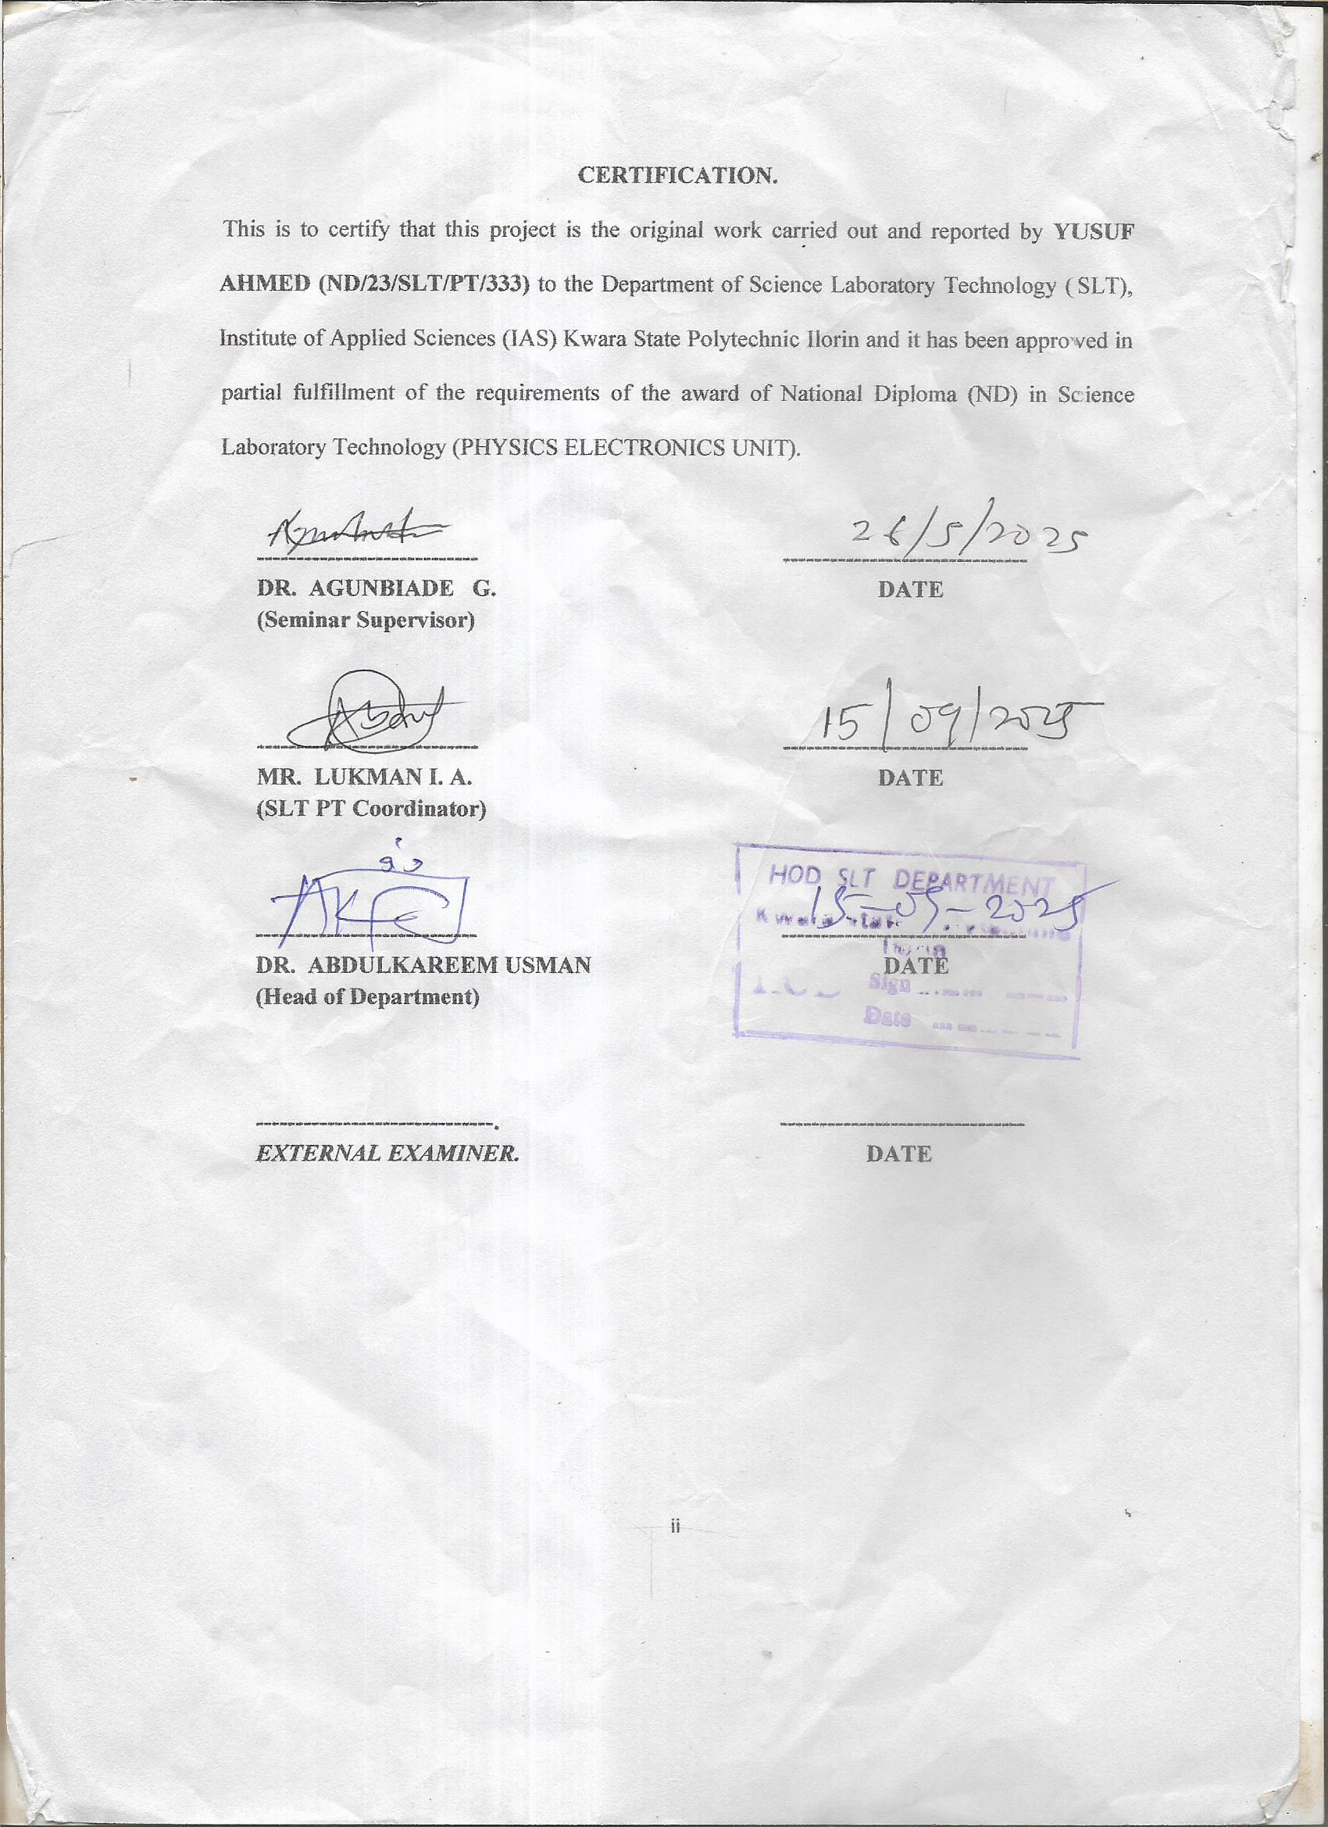

DEDICATION
To Almighty GOD who is kind and merciful to me.
To my father Mr. YUSUF and my mother Mrs. YUSUF by whose encouragement, sacrifices,
support and prayers I attained this level of success.

ACKNOWLEDGEMENT
I acknowledge the most-high God who has always been kind and merciful to me. I thank the Lord Almighty for the gift of life, sound health, and journey mercies and for providing all the needed resources throughout my period of studies. My profound gratitude goes to my beloved Supervisor, Dr. G. Agunbiade for his scholarly guidance and mentoring during the entire period of this work. I acknowledge and I appreciate the efforts of Dr. B. B. Ibrahim for his contributions as the Head of Department. I appreciate, greatly, the current H.O.U. Dr. O. K. Olaore who worked tirelessly to ensure that the needful is done. God bless you Sir.
Other members of academic and non-academic staff of Physics Department, Kwara State Polytechnic Ilorin are highly appreciated. You are all unique and wonderful.
I am also indebted to my sibling. Your encouragement and voice of wisdom to me most especially when I share my challenges with you, are highly appreciated. I specially appreciate my beloved parents for their support and encouragement in the course of my education.
I love you all.

TABLE OF CONTENTS.
Contents
CERTIFICATION PAGE ........................................................................... Error! Bookmark not defined.
DEDICATION .......................................................................................................................................... iii
ACKNOWLEDGEMENT ........................................................................................................................ iv
TABLE OF CONTENTS. .......................................................................................................................... v
LIST OF ACRONYMS ........................................................................................................................... vii
ABSTRACT ............................................................................................................................................ xiv
CHAPTER ONE: INTRODUCTION/LITERATURE REVIEW. ............................................................................. 1
1.1. INTRODUCTION ..........................................................................................................1
1.2. OBJECTIVES: ...............................................................................................................2
1.3. BASE STATION CONTROLLER AND TRANSCODER CONTROLLER. ..............2
1.4. RADIO BASE STATIONS ............................................................................................3
1.5. OTHER ACCESS NETWORK EQUIPMENT .............................................................4
1.6. TRANSCODER CONTROLLER (TRC) ......................................................................4
1.6.1. TRC FUNCTIONS ..................................................................................................................... 4
1.7. TRC IMPLEMENTATION. ..........................................................................................5
1.8. BASE STATION CONTROLLER (BSC) .....................................................................6
1.8.1. BSC FUNCTIONS. .................................................................................................................... 6
1.9. BSC IMPLEMENTATION............................................................................................9
1.10. BSC/TRC ..............................................................................................................10
1.11. RADIO BASE STATION (RBS). ........................................................................10
1.11.1. RBS FUNCTIONS ................................................................................................................... 11
1.12. RBS 2000 IMPLEMENTATION .........................................................................13
Distribution switch Unit (DXU) ......................................................................................................... 14
1.13. Transceiver Unit (TRU) ........................................................................................14
1.13.1. Combining and Distribution Unit (CDU) ............................................................................... 15
1.13.2. Power Supply Unit (PSU) ...................................................................................................... 15
1.13.3. Energy Control Unit (ECU) .................................................................................................... 16
1.14. RBS 2000 IN A NETWORK ................................................................................16 1.15. RBS 2000 SERIES DESCRIPTIONS. .................................................................17
CHAPTER TWO: MATERIALS AND METHODS. ............................................................................. 23
2.1. CELL PLANNING PROCESS ....................................................................................23
2.2. STEP 1: THE CELLPLANNING PROCESS TRAFFIC AND COVERAGE
ANALYSIS (SYSTEM REQUIREMENTS) ..........................................................................23
2.3. STEP 2: NOMINAL CELL PLAN ..............................................................................24
2.4. STEP 3: SURVEYS (AND RADIO MEASUREMENTS) .........................................24
2.5. STEP 4: (FINAL CELL PLAN) SYSTEM DESIGN ..................................................24
2.6. STEP 5: IMPLEMENTATION ..................................................................................25
2.7. STEP 6: SYSTEM TUNING .......................................................................................25
2.8. DESCRIPTION OF REPLACEABLE UNITS (RUS) AND BUSES IN RBS 2000
MACRO. .................................................................................................................................25
2.9. OPERATION AND MAINTENANCE TERMINAL (OMT) .....................................28
2.10. RADIO BASE STATION (RBS) CONFIGURATION .......................................31
2.11. CONFIGURATION RBS 2207 2+2+2 900Mhz. .................................................31 2.12. CONFIGURATION RBS 2206 4+4+2 1800 Mhz. ..............................................37
CHAPTER TREE: DISCUSSION OF RESULT. ................................................................................................ 42
SECOND GENERATION (2G): .........................................................................................42
FEATURES: ........................................................................................................................................ 43
LIMITATIONS: ................................................................................................................................... 43
CHAPTER FOUR: SUMMARY, CONCLUSION AND RECOMMENDATION. .................................................. 46
REFERENCE: .............................................................................................................................................. 48

LIST OF ACRONYMS
ADC
American Digital Cellular
AMPS
advanced mobile phone service AoC
advice of charge
AUC
authentication center bps
bits per second
BSC
base station controller
BSS
base station system BTS
base transceiver station CGI
cell global identity
CUG
closed user group
DCS
digital cellular system
DTMF
dual-tone multifrequency EIR equipment identity register
GIWU
GSM interworking unit
GMSC
gateway mobile services switching center
GMSK
Gaussian minimum shift keying
GSM
global system for mobile communication HLR
home location register Hz
hertz ISDN
integrated services digital network k
kilo
kbps
kilobits per second
LA
location area
LAI location-area identity
LPC
linear predictive coding
MHz
megahertz MSC
mobile services switching center
MSN
mobile service node
MXE
message center NMT
Nordic Mobile Telephone
OMC
operations and maintenance center OSS
operation and support system PCS
personal communications services PDC
personal digital cellular
PLMN
public land mobile network SS
switching system TACS
total access communication system
TDMA
time division multiple access

VLR
visitor location register
A3 Authentication algorithm
A5 Ciphering algorithm
A8 Ciphering key computation
A Interface between MSC and BSC
Abis Interface between BSC and BTS
ACK Acknowledgement protocol
ADM Adaptive delta modulation
ADPCM Adaptive differential pulse-code modulation
ADSL Asymmetric Digital Subscriber Line. A technique for dramatically increasing the data rates available on copper wiring.
AMPS Analog Mobile Phone System. The US analogue cellular standard.
ARFCN Absolute Radio Frequency Channel Number
ARQ Automatic repeat request
ATM Asynchronous Transfer Mode
AuC: Authentication Centre. The part of the GSM system responsible for authenticating the mobiles and providing ciphering keys.

BCCH Broadcast Control Channel. A GSM logical control channel providing information to the mobile as to the channel configuration in the cell.
BER Bit error rate
BP Burst Period. The duration of a single burst, when one mobile transmits within the GSM framing structure.
BS Base station. The part of the radio system which transmits the signal to the mobile.
BSC Base Station Controller. The part of the GSM system responsible for controlling the base stations.
BSS Base Station Sub-system. The combination of the BTS and BSC.
BSSMAP BSS Management Part. The protocol used for BSS management on the Abis interface.
BT Bandwidth-Time product. A means of measuring the amount of filtering applied to the pulse during the modulation process.
BTS Base Transceiver Station. Another name for BS.
CAI Common air interface – as in CT2 standard.
CDMA Code Division Multiple Access. The use of different codes to allow users to access the same spectrum at the same time.
CC Call Control. The protocol layer within GSM responsible for overall control of the call.
CELP Code-excited linear prediction, vocoder.
CEPT European Committee for Post and Telecommunications. The European body Responsible for radio spectrum management.
COST Co-operation in Science and Technology programme (Europe).
COST 231 COST committee dealing with future mobile system.
CT-0 The original analogue VHF/LF cordless phone technology as used in UK, France and elsewhere.
CT-1 Cordless Telephone Generation One – 900MHz analogue FM cordless Technology standardized by CEPT.
CT-2 Cordless Telephone Generation 2. An early UK digital cordless standard. CT-3 Early Swedish (Ericsson) digital cordless standard.
CTM Cordless terminal mobility – an application concept and an ETSI project. DCS Digital cellular system (eg DCS1800).
DECT Digital European Cordless Telephone. The European cordless telephone standard.
Downlink Transmission path from radio fixed part to portable part.
Duplex Simultaneous two-way conversation.
DTAP Direct Transfer Application Part. The protocol used on the Abis interface to Distinguish between messages for mobiles and for BTSs.
DTX Discontinuous transmission
EDGE Enhanced Data rates for GSM Evolution. Method of increasing data rates in GSM by using 8PSK modulation
8PSK Eight Phase Shift Keying. Modulation techniques encoding 3 bits to each symbol.
EIR Equipment Identity Register. Part of the GSM system responsible for keeping details of the mobile units and their status.
ETR ETSI technical report.
ETS ETSI technical standard.
ETSI European Telecommunications Standards Institute.
FACCH Fast Associated Control Channel. A logical channel used for sending emergency information to the mobile by suppressing traffic information.
FCCH Frequency Control Channel. A logical control channel within GSM used to allow the mobile to lock onto the transmitted signal.
FDMA Frequency Division Multiple Access. The division of the radio frequency into narrow slots, each one being given to a different user.
FEC Forward error correction.
FH Frequency Hopping. Changing rapidly from frequency to frequency to avoid problematic propagation effects.
FPLMTS Future Public Land Mobile Telecommunications Service. The US name for third generation radio systems.
FSK Frequency-shift keying.
FT Fixed termination.
GAP Generic access profile of DECT.
GFSK Gaussian-filtered FSK modulation.
GIP GSM interworking profile of DECT.
G-MSC Gateway Mobile Switching Centre. The part of the GSM system providing the link into the PSTN.
GMSK Gaussian Minimum Shift Keying. The modulation technique used in GSM, a form of phase modulation.
GoS Grade of service.
GPRS General Packet Radio Service.
GSM Global System for Mobile telecommunications. also Groupe Speciale Mobile
Handoff Procedure whereby communications between a mobile handset and a base station is automatically routed via an alternative base station when necessary to maintain or improve communications.
Handover Another term for handoff.
HLR Home Location Register. The part of the GSM system responsible for holding records about mobiles and for keeping track of the parent MSC area.
HSCSD High Speed Circuit Switched Data. 2.5 G enhancement to GSM giving higher data rates
IAP ISDN access profile for DECT.
ISI Inter-Symbol Interference. A radio propagation effect whereby echoes of received signals cause previous symbols transmitted to interference with current symbols.
IMEI International Mobile Equipment Identity. The GSM number given to each mobile. IMSI International Mobile Subscriber Identity. The phone numbering system used within GSM.
IMT2000 International Mobile Telecommunications system for the year 2000.
IN Intelligent Network.
IP Internet Protocol, a layer 3 network protocol IS54 US digital AMPS standard.
IS95 US CDMA digital cellular standard.
ISDN Integrated Services Digital Network. A protocol for sending digital information over copper landlines.
ITU International Telecommunications Union. The international body responsible for spectrum management.
IWP Inter-working profile.
IWU Inter-working unit.
LA Location Area
LAC Location Area Code
LAI Location Area Identity
LAPD Link Access Protocol on interface D. Part of the ISDN protocol stack also used in GSM.
LEO Low Earth Orbiting satellite system. A proposed communications system based on up to 66 satellites.
LLME Lower layer management entity (DECT).
LNA low noise amplifier.
LOS Line-Of-Sight
LPC Linear Predictive Coding.
MAC Medium Access Control. The means whereby mobiles access radio channels which are not permanently reserved for their own particular use.
MAP Mobile Application Part. Part of the SS7 protocol dealing with mobile services. MM Mobility Management. The protocol layer within GSM responsible for keeping track of mobiles and performing security functions. MoU Memorandum of Understanding MS Mobile Station.
MSC Mobile Switching Centre. The part of the GSM system responsible for switching calls. MSISDN Mobile Subscriber Integrated Services Digital Number. The numbering system used to contact GSM mobiles from other networks.
MSK Minimum shift keying modulation.
MTP Message Transfer Part. Part of the SS7 protocol stack.
NADC North American Digital Cellular
NCC National Colour Code
NMT Nordic Mobile Telephone system. The Nordic analog cellular standard.
O&M Operations and maintenance
OAM Operations, administration and maintenance.
OMC Operations and Maintenance Centre. The part of the GSM system responsible for monitoring network function.
PABX private automatic branch exchange.
PAGCH Paging and Access Grant Channel. A GSM logical control channel providing paging information and allowing mobiles to make access attempts.
PBX Private Branch Exchange (today has same meaning as PABX).
PCM Pulse Code Modulation. A simple form of speech coding.
PCN Personal communications network.
PCS1900 Personal Communications System at 1900 MHz. A variant of GSM working at 1900MHz designed for the US.
PDC Personal Digital Cellular. The Japanese cellular standard.
PHL Physical layer – lowest protocol layer.
PHS Personal Handiphone System. The Japanese cordless telephone standard.
PLMN Public Land Mobile Network.
PMR Private (or Professional) Mobile Radio. A radio system owned by the users ` typically large companies.
POTS Plain old telephone service.
PSK Phase shift keying modulation.
PSTN Public Switched Telephone Network.
PT Portable termination.
QPSK Quadrature Phase Shift Keying. A form of modulation whereby orthogonal carriers are used to gain the maximum information from the channel.
Quantization: A process of representing samples of an analogue waveform by the nearest whole number of predefined voltage steps.
RACH Random Access Channel. A GSM logical control channel used for making uplink access attempts.
RAP Radio access profile for DECT. RAN Radio Access Network RFP Radio fixed part.
RIL Radio Interface Layer. The protocol within GSM responsible for maintenance of the radio interface.
RLAN Radio local area network.
RLL Radio local loop.
RPE-LTP Regular pulse excitation – long term predictor – speech coder user in GSM.
RR Radio Resource. The protocol layer within GSM responsible for providing a service over the air interface.
RSSI: Received signal strength indication.
SACCH Slow Associated Control Channel. A logical channel used alongside a traffic channel to send signalling information to and from the mobile.
SCCH Synchronisation Control Channel. A GSM logical control channel providing synchronisation to the mobile.
SCCP Signalling Control and Connection Part. Part of the SS7 protocol stack.
SID Silence Descriptor
SIM Subscriber Identity Module. A small card within GSM mobiles which contains the subscriber identity.
Simplex One-way communication.
SMS Short Message Service. A feature within GSM whereby messages of up to 160 characters can be transmitted to mobiles.
SMS-SC SMS Service Centre. The part of the GSM system which handles short messages. SRES Signed Results Produced by authentication algorithm.
TA Timing Advance
TACS Total Access Communications System. The UK (and other European countries) analogue cellular standard.
TBR Technical basis for regulation – ETSI standards.
TCH Traffic Channel. The channel used in GSM to send subscriber information.
TCAP Transaction Capability Application Part. Part of the SS7 protocol stack.
TDD time division duplex.
TDM Time division multiplex.
TDMA Time Division Multiple Access. A system where users access all the frequency but only for a limited time.
TETRA TErrestrial Trunk RAdio
TMN Telecommunications Management Network. The concept of managing the network from a single point using a networked operations and maintenance system.
TMSI Temporary Mobile Subscriber Identity. A GSM number given to the mobile during an encrypted call to prevent eavesdroppers being able to located the mobile.
TRAU Transcoder Rate Adapter Unit
TRX Transmit/Receiver module. The GSM term for a single carrier card within a BTS. UMTS Universal Mobile Telecommunications Service. One name for the third generation mobile radio system.
Uplink Communications path from portable part to fixed part.
UPT Universal Personal Telecommunications. The fixed network equivalent of third generation systems.
VAD Voice Activity Detection
VLR Visitors Location Register. The part of the GSM system responsible for keeping track of a mobile’s position to the nearest location area.
VSAT Very Small Aperture Terminal. A satellite communication system based on dishes around 1m across.
WAP Wireless Application Protocol
WLL Wireless Local Loop. The use of radio to replace copper wiring as a means of connecting the home to the PSTN.
WPABX Wireless PABX.

ABSTRACT
Each Generation is defined as a set of telephone network standards, which detail the technological implementation of a particular mobile phone system. The number generation of cellular communications networks is 1G, 2G, 3G, 4G, and 5G. The five generations of mobile networks are 1G, 2G, 3G, 4G, and 5G, where G stands for 'Generation' and the numerals 1, 2, 3, 4, and 5 signify the generation number. Since the early 1980s, a new generation of mobile networks" has emerged every ten years or so.
The handover mechanism guarantees that whenever the mobile is moving from one base station area/cell to another, radio connection is handed over to the target base station without interruption. Intra and inter MSC handover, Inter-MSC and intra-MSC handover from WCDMA to GSM were discussed. Handover scenarios in 2G, 3G, 4G, and 5G were addressed. Interfrequency handover, hard handover, soft and softer handover were treated with the aid of diagrams to illustrate them, Uplink and Downlink power control in soft handover were explained. Handover procedure and parameters in the handover algorithm were not left out.
Useful Glossary of Terms were added to this work.
Cell planning process step1: traffic and coverage analysis (system requirement). Step2, nominal cell plan, step 3 surveys and radio requirement, step4 system design (the final plan), step5 implementation and step 6 system tuning were carefully discussed and practically done. The descriptions of the replaceable units(RUs) and Buses in RBS 2000 macro were not left out. The use of Operation and Maintenance Terminal (OMT) to design Radio Base Station(RBS) were carried out. Configuration of RBS 2207 2+2+2 900MHz and RBS 2206 4+4+2 1800MHz were designed, configured and loaded and ready for integration.

CHAPTER ONE: INTRODUCTION/LITERATURE REVIEW.

This chapter is designed to provide the student with an overview of the base station system. It addresses base station system components, their functions, features, and required specifications.

1.1. INTRODUCTION
The Base Station System (BSS) is responsible for all the radio related functions in the system, such as:
- Radio communication with the mobile units
- Handover of calls in progress between cells
- Management of all radio network resources and cell configuration data. Ericsson’s BSS consists of three components:
- Base Station Controller (BSC): the BSC is the central node within a BSS and co-ordinates the actions of TRCs and RBSs.
- Transcoder Controller (TRC): the TRC provides the BSS with rate adaptation capabilities. This is necessary because the rate used over the air interface and that used by MSC/VLRs are different - 33.8 kbits/s and 64 kbits/s respectively. A device which performs rate adaptation is called a transcoder.
- Radio Base Station (RBS): an RBS acts as the interface between MSs and the network, by providing radio coverage functions from their antennae.

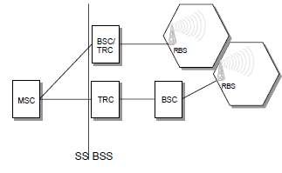
Figure 1 BSS in Ericsson’s GSM systems.

1.2. OBJECTIVES:
Upon completion of this chapter the student will be able to:
- Describe the basic base station system structure
- Describe the functions of the Transcoder Controller
- Describe the implementation of the Transcoder Controller
- Describe the functions of the Base Station Controller
- Describe the implementation of the Base Station Controller
- Describe the functions of the Radio Base Station
- Describe the implementation of the Radio Base Station

1.3. BASE STATION CONTROLLER AND TRANSCODER CONTROLLER.
There two main options available for implementing the TRC and BSC in Ericsson’s BSS: BSC/TRC: a combined BSC and TRC on the same AXE. This is suitable for medium and high capacity applications, e.g. urban and suburban area networks. The node can handle up to 1,020 transceivers (TRXs). 15 remote BSCs can be supported from one BSC/TRC.

Stand-alone BSC and stand-alone TRC: the stand-alone BSC (without transcoders) is optimized for low and medium capacity applications and is a complement to the BSC/TRC, especially in rural and suburban areas. It caters for up to 300 TRXs. The stand-alone TRC is located at the MSC/VLR to increase transmission efficiency. A stand-alone TRC can support 16 remote BSCs.

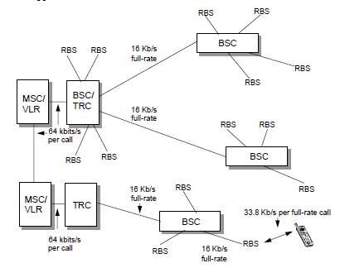
Figure 2 TRC utilization and transmission rates in BSS.

1.4. RADIO BASE STATIONS
Ericsson’s Radio Base Station (RBS) 2000 series of base stations implement the GSM-defined BTS. This includes the following RBSs:
- RBS 2101
- RBS 2102
- RBS 2103
- RBS 2202
- RBS 2301
- RBS 2302 •  RBS 2302 MAXITE

In Sweden, all three of the mobile network operators is working with the national rail company to ensure coverage for travelers. This involves placing an antenna on top of the train and a leaky cable running within the length of the train.

1.5. OTHER ACCESS NETWORK EQUIPMENT
Many mobile networks include additional equipment to provide improved coverage. Examples of such equipment includes:
- Repeaters: these are placed in locations throughout the access network to repeat the digital signal from the MS and BTS. This helps to reduce the BER and thus provide better quality calls to subscribers. A typical location for a repeater may be on top of a building.

- Leaky cable: this is simply a cable carrying the electromagnetic energy which has “holes” in it to leak out this radio signal at regular intervals. This may be suitable in areas which are difficult to cover using traditional base station equipment. For example, a leaky cable could be used to provide coverage within an underground train system.

1.6. TRANSCODER CONTROLLER (TRC)
1.6.1. TRC FUNCTIONS
The primary functions of a TRC are to perform transcoding and to perform rate adaptation.

Transcoding
As previously explained, the function of converting from the PCM coder information (following A/D conversion) to the GSM speech coder information is called transcoding. This function is present in both the MS and the BSS.

Rate Adaptation
Rate adaptation involves the conversion of information arriving from the MSC/VLR at a rate of 64 kbits/s to a rate of 16 kbits/s for transmission to a BSC (for a full rate call). This 16 kbits/s contains 13 kbits/s of traffic and 3 kbits/s of inband signaling information.

This is an important function. Without rate adaptation the links to BSCs would require four times the data rate capabilities. Such transmission capabilities form an expensive part of the network. By reducing the rate to 16 kbits/s, it is possible to use one quarter of the transmission links and equipment.

In Ericsson’s GSM systems, the TRC contains units which perform transcoding and rate adaptation. These hardware units are called Transcoder and Rate Adaptation Units (TRAUs).

All TRAUs are pooled, meaning that any BSC connected to the TRC can request the use of one of the TRAUs for a particular call.

The TRC also supports discontinuous transmission. If pauses in speech are detected, comfort noise is generated by the TRAU in the direction of the MSC/VLR.

1.7. TRC IMPLEMENTATION.
In previous versions of Ericsson’s GSM systems, the TRC did not exist. Its functions were included as part of the BSC. This has been changed to reduce the data rate between the MSC and BSC sites, thus reducing transmission network costs.

The TRC is implemented on the AXE platform consisting of standard APZ and APT subsystems and the following APT subsystems:

Table 1 BSC Subsystems
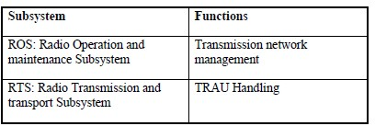

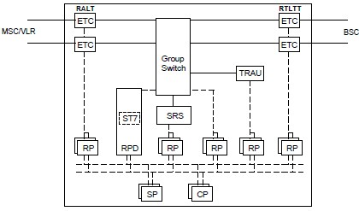
Figure 3 TRC hardware configuration.

The hardware which is specific to the TRC is: •  Transcoder and Rate Adapter Unit (TRAU)

1.8. BASE STATION CONTROLLER (BSC)
During the initial specification of GSM, the radio-related functions were intended to be included in the MSC. However, the increasing complexity of the GSM radio system led to the requirement for more dedicated radio.

1.8.1. BSC FUNCTIONS.
The BSC controls a major part of the radio network. Its most important task is to ensure the highest possible utilization of the radio resources. The main functional areas of the BSC are: •  Radio Network Management
- RBS Management
- TRC Handling
- Transmission Network Management
- Internal BSC Operation and Maintenance
- Handling of MS connections

1.8.1.1. Radio Network Management Radio network management includes the following tasks:
- Administration of radio network data including:
- Cell Description Data (e.g. cell identity, BCCH channel number, maximum and minimum output powers in the cell, RBS type, etc.)
- System information data (e.g. information about whether or not the cell is barred from access, maximum output power allowed in the cell, BCCH channel identities in neighboring cells)
- Locating data (e.g. cell rank used in HCS and high traffic load situations)
- Cell load sharing data, i.e. parameters for forcing early handovers from congested cells
- Traffic and event measurements: (e.g. number of call attempts, congestion, traffic levels for a cell, traffic levels for an MS, number of handovers, number of dropped connections, etc.).
- Idle channel measurement: the RBS collects statistics from the MSs about signal strength and quality. These statistics are then used during the channel allocation process, so that a channel with low interference is allocated for a call.

1.8.1.2. RBS Management
Ericsson’s RBS implementation is transceiver-orientated, ensuring good redundancy features. This means that as little as possible of the equipment is common to several transceivers.

This philosophy inevitably leads to a master slave relationship between the BSC and the transceivers in the RBS. A logical model of the RBS is built up within the BSC and RBS equipment can be logically defined, connected and disconnected.

The main tasks of RBS management are:

- RBS configuration: this involves the allocation of frequencies to channel combinations and power levels for each cell according to available equipment. If equipment becomes faulty causing the loss of important channels, reconfiguration of the remaining equipment is activated, sacrificing less important channels.
- RBS software handling: this involves the control of program loads.
- RBS equipment maintenance: RBS faults and disturbances are recorded and logged continuously.

1.8.1.3. TRC Handling
Although TRAUs are located in a TRC, the BSC, as controller of the radio resources of a GSM network, actually co-ordinates the sourcing of a TRAU for a call.

During call set-up, the BSC instructs the TRC to allocate a TRA device to the call. If one is available, the TRC confirms the allocation of a TRA device. The TRA device is considered to be under the control of the BSC for the duration of the call.

1.8.1.4. Transmission Network Management
The transmission network for a BSC includes the links to and from MSC/VLRs and RBSs. This involves the following tasks:
- Transmission interface handling: this provides functions for administration, supervision, test and fault localization of the links to RBSs. The BSC configures, allocates and supervises the 64 kbits/s circuits of the PCM links to the RBS. It also directly controls a remote switch in the RBS which enables efficient utilization of the 64 kbits/s circuits.

1.8.1.5. Internal BSC Operation and Maintenance
Operation and maintenance tasks can be performed locally in the BSC or remotely from the OSS. Internal BSC operation and maintenance involves the following features:

- TRH maintenance: administration, supervision and test of the TRansceiver Handler (TRH) is carried out in the BSC. The TRH consists of both hardware and software. A TRH is located on a Regional Processor for the Group switch (RPG). One RPG thus serves several transceivers. There can be several RPGs in the BSC.

- Processor load control in the BSC: this function ensures that during processor overload situations, a large number of calls can still be handled by the BSC. If too many calls are accepted, real time requirements such as call set-up times cannot be fulfilled. To prevent this, some calls need to be rejected in situations of high load. Calls already accepted by the system are given full service and are not affected by the overload situation.

1.8.1.6. Handling of MS Connections
Call Set Up
Call set up involves the following processes:
- Paging: the BSC sends paging messages to the RBSs defined within the desired LA. The load situation in the BSC is checked before the paging command is sent to the RBS.
- Signaling set-up: during call set-up, the MS connection is transferred to an SDCCH allocated by the BSC. If the MS initiated the connection, the BSC checks its processor load before the request is further processed.
- Assignment of traffic channel: after SDCCH assignment, the call set-up procedure continues with the assignment of a TCH by the BSC. As this takes place, the radio channel supervision functions in the BSC are informed that the MS has been ordered to change channels. If all TCHs in the cell are occupied an attempt can be made to utilize a TCH in a neighboring cell.

During a Call
The main BSC functions during a call are:
- Dynamic power control in MS and RBS: the BSC calculates adequate MS and BTS output power based on the received measurements of the uplink and downlink. This is sent to the BTS and the MS every 480 ms to maintain good connection quality.
- Locating: the locating function continuously evaluates the radio connection to the MS, and, if necessary, suggests a handover to another cell. This suggestion includes a list of handover candidate cells. The decision is based on measurement results from the MS and BTS. The locating process is being executed in the TRC.
- Handover: if the locating function proposes that a handover take place, the BSC then decides which cell to handover to and begins the handover process.   If the cell belongs to another BSC, the MSC/VLR must be involved in the handover. However, in a handover, the MSC/VLR is controlled by the BSC. No decision making is performed in the MSC because it has no real time information about the connection.
- Frequency Hopping: two types of hopping are supported by the BSC:
  Baseband hopping: this involves hopping between frequencies on different transceivers in a cell   Synthesizer hopping: this involves hopping from frequency to frequency on the same transceiver in a cell

1.9. BSC IMPLEMENTATION
The BSC is implemented on a non-AM-based AXE platform consisting of standard APZ and APT subsystems and the following APT subsystems:

Table -2 BSC Subsystems.
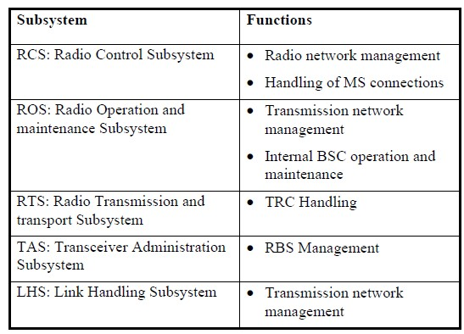

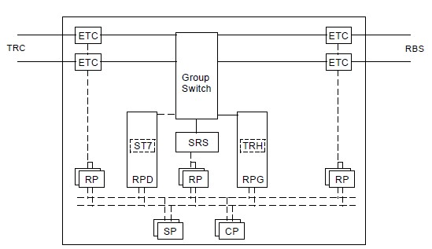
Figure 4 BSC hardware configuration.

The hardware which is specific to the BSC is:
•  Regional Processor for the Group switch (RPG)/Transceiver Handler (TRH)

1.10. BSC/TRC
It is possible to combine the functions of the TRC and BSC in one AXE-based node. The subsystems in a BSC/TRC are the same as those used in a stand-alone BSC.

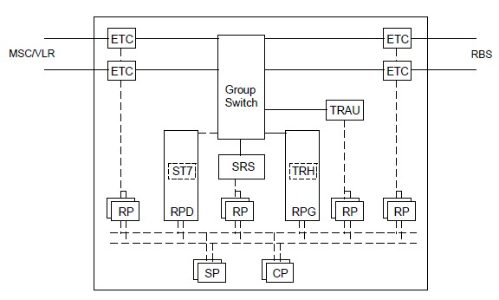
Figure 5 BSC/TRC hardware configuration. The hardware which is specific to the BSC/TRC is:
- RPG/TRH
- TRAU

1.11. RADIO BASE STATION (RBS).

RBS INTRODUCTION
An RBS includes all radio and transmission interface equipment needed on site to provide radio transmission for one or several cells.

The RBS 2000 family is Ericsson’s second generation of RBS offering products with a low total lifetime cost1. This is achieved by functions including long Mean Time Between Failure (MTBF) performance and short Mean Time To Repair (MTTR). In addition, this product line is quick and easy to install thus giving the possibility to achieve a rapid network roll out.

RBS 2000 provides products for both indoor and outdoor installations and is available for GSM 900, GSM 1800 and GSM 1900.

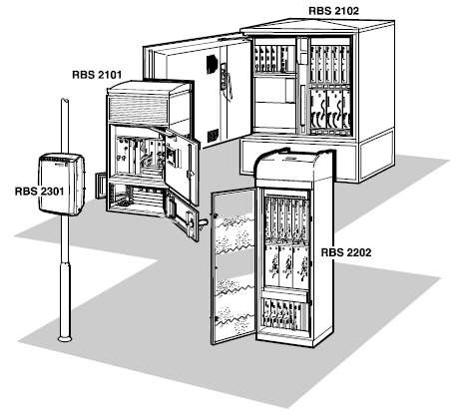
Figure 6 Examples of the RBS 2000 series.

1.11.1. RBS FUNCTIONS
RBS functionality can be divided into the following areas:
- Radio resources
- Signal processing
- Signaling link management
- Synchronization
- Local maintenance handling •  Functional supervision and testing

RADIO RESOURCES
An RBS’s main function is to provide connection with the MSs over the air interface. This includes the following tasks:
- Configuration and system start: site configuration involves loading of software from the BSC and setting parameters prior to system startup, including:
- Transmitter and receiver frequencies
- Maximum output power
- Base Station Identity Code (BSIC)
- Radio transmission: to transmit several frequencies using the same antenna, a combiner or a set of combiners are needed. Transmission power is controlled from the BSC.
- Radio reception: in addition to reception of traffic on the physical channels, a primary RBS function the detection of channel requests from MSs (e.g. when a call is being made).

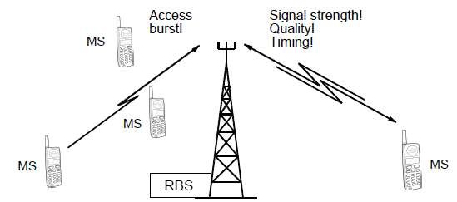
Figure 7 The RBS listening for channel requests and measuring the uplink on an established connection

SIGNAL PROCESSING
An RBS is responsible for the processing of signals before transmission and after reception. This includes:
- Ciphering using the ciphering key
- Channel coding and interleaving
- Adaptive equalization •  Realization of diversity
- Demodulation

SIGNALING LINK MANAGEMENT
An RBS manages the signaling link between the BSC and MS, applying the appropriate protocols to the information being sent.

SYNCHRONIZATION.
Timing information is extracted from the PCM-links from the BSC and is sent to a timing module within the RBS. This enables the RBS to synchronize with the correct frequency reference and TDMA frame number.
LOCAL MAINTENANCE HANDLING.
An RBS enables operation and maintenance functions to be carried out locally at the RBS site, without BSC connection. In this way, field technicians can maintain RBS equipment and software on site.

FUNCTIONAL SUPERVISION AND TESTING.
Supervision and testing of RBS functions is supported, using either built-in tests during normal operation or tests executed by command.

1.12. RBS 2000 IMPLEMENTATION
All types of RBS within the RBS 2000 series have the following characteristics:
- Support for user flexibility by providing modular hardware and software designs.
- Transceiver oriented design, which stresses using as little common equipment as possible ensuring dependable performance.
- Design and use are aimed at keeping system life cycle costs low.

The RBS 2000 series is based on standardized hardware units called Replaceable Units (RU). The major RUs are:
- Distribution switch Unit (DXU)
- TRansceiver Unit (TRU)
- Combining and Distribution Unit (CDU)
- Power Supply Unit (PSU) •  Energy Control Unit (ECU).

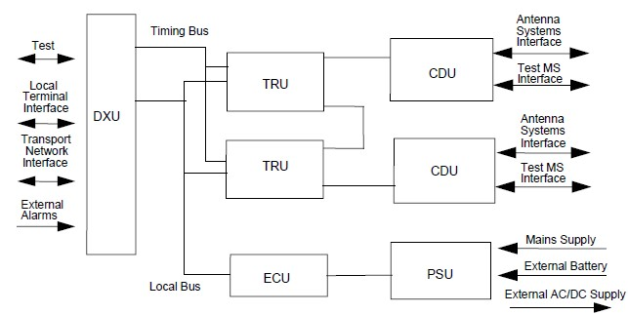
Figure 8 Replaceable units in RBS 2000.
Distribution switch Unit (DXU) The DXU performs the following tasks:
- Provides an interface to the BSC
- Manages the link resources and connects the traffic time slots from the BSC link to the TRUs
- Controls signaling to the BSC and performs concentration
- Extracts synchronization information from the link and generates a timing reference for the RBS.

In addition, the DXU has a database which stores information about installed hardware.

1.13. Transceiver Unit (TRU)
One TRU includes all functionality needed for handling one radio carrier (i.e. the 8 time slots in one TDMA frame). It is responsible for radio transmitting, radio receiving, power amplification and signal processing.

The TRU contains a radio frequency test loop between the transmitter and the receiver. This facilitates TRU testing by generating signals and looping them back.

TRUs are connected by a bus to enable frequency hopping. Some RBS products can contain up to 6 TRUs.

1.13.1. Combining and Distribution Unit (CDU)
The CDU is the interface between the TRUs and the 2-way antenna system. The task of the CDU is to combine signals to be transmitted from various transceivers and to distribute received signals to the receivers. All signals are filtered before transmission and after reception using bandpass filters.

A range of CDU types have been developed to support different configurations within the RBS 2000 family. They consist of different types of CDUs, including:

- Without combiners
- With hybrid combiners
- With filter combiners to support large configurations CDUs with duplex filters make it possible to transmit and receive using the same antenna.

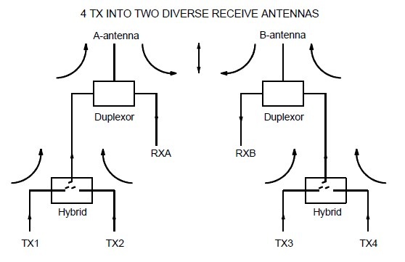
Figure 9 Example of a CDU type C

1.13.2. Power Supply Unit (PSU)
The PSU rectifies the power supply voltage to the +24 VDC necessary for RBS operation.

1.13.3. Energy Control Unit (ECU)
The ECU controls and supervises the power equipment and regulates the environmental conditions inside the cabinet.

The RBS 2000 is pre-assembled at the factory including program load and parameter settings making a quick startup possible.

Assembly can also be carried out on site. The RBS software is downloaded from the BSC and stored in a non-volatile (flash memory) program store. In a working RBS, this flash memory keeps cell down time low because traffic does not need to be interrupted. Power failure recovery can also be done quickly.

1.14. RBS 2000 IN A NETWORK
The Transmission Drop and Insert (TDI) function makes it possible to connect RBSs together. This is an important cost saving feature of Ericsson’s RBSs, as an RBS need not be connected to the BSC directly via a dedicated link. Instead it may be more economic to connect that RBS to another RBS in the region, thus saving on expensive transmission costs. The following network topologies are supported:

- Star: this is the traditional architecture, where each RBS is connected directly to a BSC •  Cascade: a cascade architecture includes RBSs connected to each other without a loop, thus using transmission resources efficiently
- Loop: this architecture includes RBSs connected to each other with a loop, ensuring that even if one link fails, another path is available

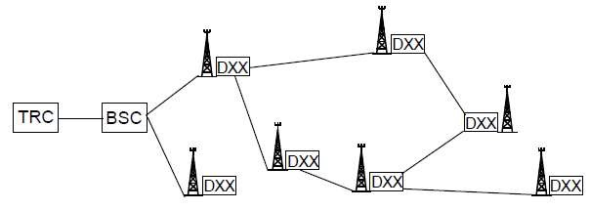

Figure 10 Ericsson’s RBS 2000 Network Configurations.

1.15. RBS 2000 SERIES DESCRIPTIONS.

Table 3 RBS 2000 Series.
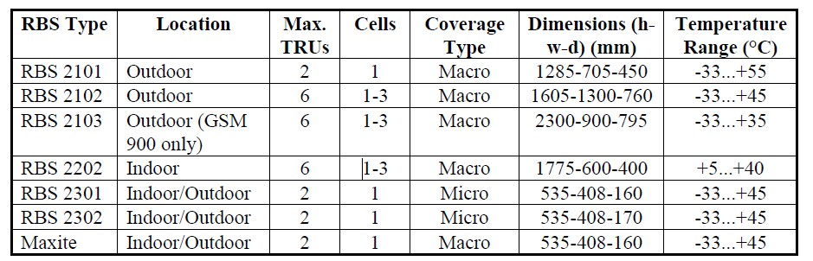

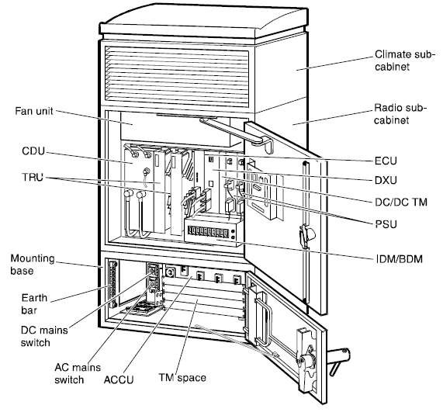
Figure 11 RBS 2101
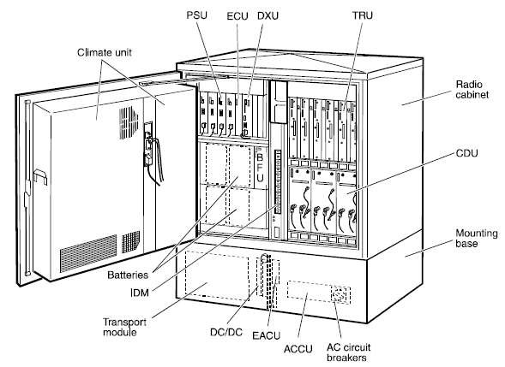
Figure 12 RBS 2102.

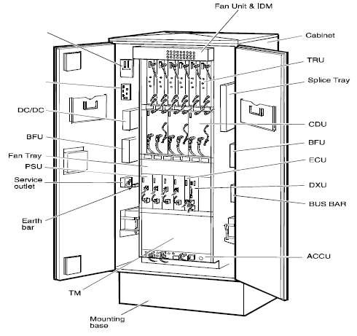
Figure 13 RBS 2103.

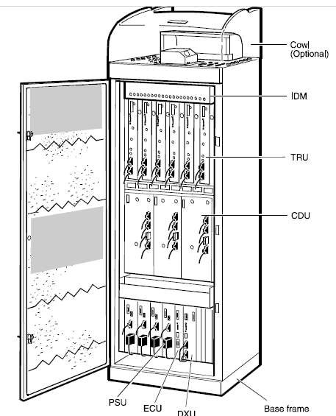
Figure 14 RBS 2202.

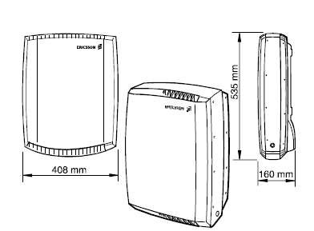
Figure 15 RBS 2301. RBS 2302 is almost identical.

CHAPTER TWO: MATERIALS AND METHODS.

2.1. CELL PLANNING PROCESS
Cell planning can be described briefly as all the activities involved in determining which sites will be used for the radio equipment, which equipment will be used, and how the equipment will be configured. In order to ensure coverage and to avoid interference, every cellular network needs planning. The major activities involved in the cell planning process are depicted in Figure 3.1.

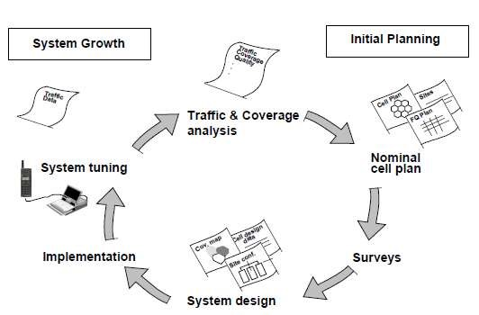

Figure 3.1 The cell planning process.

2.2. STEP 1: THE CELLPLANNING PROCESS TRAFFIC AND COVERAGE ANALYSIS (SYSTEM REQUIREMENTS)
The cell planning process starts with traffic and coverage analysis. The analysis should produce information about the geographical area and the expected need of capacity. The types of data collected are:
- Cost
- Capacity
- Coverage
- Grade of Service (GoS)
- Available frequencies
- Speech Quality Index • System growth capability
The traffic demand (i.e. how many subscribers will join the system and how much traffic will be generated) provides the basis for cellular network engineering. Geographical distribution of traffic demand can be calculated by using demographic data such as:
- Population distribution
- Car usage distribution
- Income level distribution
- Land usage data
- Telephone usage statistics
- Other factors such as subscription charges, call charges, and price of mobile stations.

2.3. STEP 2: NOMINAL CELL PLAN
Upon compilation of the data received from the traffic and coverage analysis, a nominal cell plan is produced. The nominal cell plan is a graphical representation of the network and simply looks like a cell pattern on a map. However, a lot of work lies behind it (as described previously). Nominal cell plans are the first cell plans produced and form the basis for further planning. Quite often a nominal cell plan, together with one or two examples of coverage predictions, is included in tenders.

At this stage, coverage and interference predictions are usually started. Such planning needs computer-aided analysis tools for radio propagation studies, e.g. Ericsson’s planning tool known as the Ericsson Engineering Tool (EET).

2.4. STEP 3: SURVEYS (AND RADIO MEASUREMENTS)
The nominal cell plan has been produced and the coverage and interference predictions have been roughly verified. Now it is time to visit the sites where the radio equipment will be placed and perform radio measurements. The former is important because it is necessary to assess the real environment to determine whether it is a suitable site location when planning a cellular network. The latter is very important because even better predictions can be obtained by using field measurements of the signal strengths in the actual terrain where the mobile station will be located.

2.5. STEP 4: (FINAL CELL PLAN) SYSTEM DESIGN
Once we optimize and can trust the predictions generated by the planning tool, the dimensioning of the RBS equipment, BSC, and MSC is performed. The final cell plan is then produced. As the name implies, this plan is later used during system installation. In addition, a document called Cell Design Data (CDD) containing all cell parameters for each cell is completed.

2.6. STEP 5: IMPLEMENTATION
System installation, commissioning, and testing are performed following final cell planning and system design. This step will be further explained later in this chapter.

2.7. STEP 6: SYSTEM TUNING
After the system has been installed, it is continually evaluated to determine how well it meets the demand. This is called system tuning.
It involves:
- Checking that the final cell plan was implemented successfully
- Evaluating customer complaints
- Checking that the network performance is acceptable
- Changing parameters and performing other measures (if needed)

The system needs constant re-tuning because the traffic and number of subscribers increases continuously. Eventually, the system reaches a point where it must be expanded so that it can manage the increasing load and new traffic. At this point, a coverage analysis is performed and the cell planning process cycle begins again.

2.8. DESCRIPTION OF REPLACEABLE UNITS (RUS) AND BUSES IN RBS 2000 MACRO.
The hardware consists of a number of Replacable Units (RUs) and buses, which are briefly described in the following sections. The RU is the smallest hardware part that can be swapped when doing repair at the site. This can be e.g. a Tranceiver Unit (TRU), cable, fan etc.

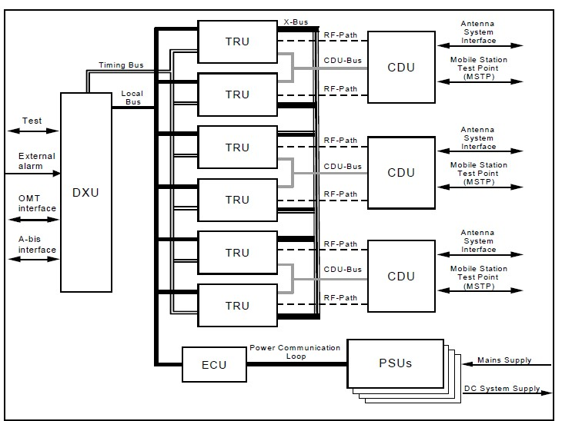
Figure XX Replaceable Units (RUs) and buses in RBS 2000.
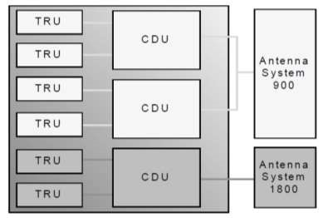

DISTRIBUTION SWITCH UNIT (DXU)
The Distribution Switch Unit (DXU) is the RBS central control unit. There is one DXU per RBS. It provides a system interface by cross connecting either a 2Mbit/s or 1.5 Mbit/s transport network and individual time slots to their associated transceivers.

TRANSCEIVER UNIT (TRU)
It is a transmitter/receiver and signal processing unit which broadcasts and receives the radio frequency signals that are passed to and from the mobile station. Each TRU handles 8 air time slots.

COMBINING AND DISTRIBUTION UNIT (CDU)
A combiner is a device, at the base station, that allows connection of several transmitters to one antenna. It allows each transmitters RF energy out to the antenna, while blocking the RF energy from the other transmitters utilizing the same antenna. There are two types of combiners: • Hybrid
• Filter

ENERGY CONTROL UNIT (ECU)
The ECU controls and supervises the power and climate equipment to regulate the power and the environmental conditions inside the cabinet to maintain system operation. It communicates with the DXU over the Local Bus. The main units in the power and climate system are:
- Power Supply Units (PSU)
- Battery and Fuse Unit (BFU) with batteries
- AC Connection Unit (ACCU)
- Climate subcabinet with Climate Control Unit (CCU), heater, active cooler and heat exchanger (outdoor cabinets only)
- Fans controlled by Fan Control Units (FCU)
- Climate sensors, i.e. temperature and humidity sensors.

LOCAL BUS
The local bus offers internal communication between the DXU, TRUs and ECU. Examples of information sent on this bus are TRX Signaling, speech and data.

TIMING BUS
The timing bus carries air timing information from the DXU to the TRUs.

X-BUS
The X-bus carries speech/data on a time slot basis between the TRUs. This is used for base band frequency hopping.

CDU BUS
The CDU Bus connects the CDU to the TRUs and facilitates interface and O&M functions e.g. transfers alarms and RU specific information.

POWER COMMUNICATION LOOP
The power communication loop consists of optical-fiber cables and carries control and supervision information between the ECU, PSUs, and the BFU. E.g., the output current is regulated due to the traffic load of the RBS.

2.9. OPERATION AND MAINTENANCE TERMINAL (OMT)
Operation and Maintenance Terminal (OMT) is a software tool specifically designed for the RBS 2000 family of base stations. It is used to perform a number of Operation and Maintenance tasks on site or remotely from the BSC. OMT is a PC program that runs under Microsoft Windows 95 or Windows NT.

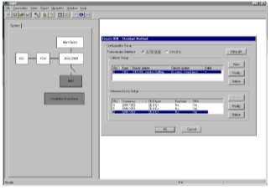
Figure XXX Operation and Maintenance Terminal (OMT).

OMT is used during the Radio Base Station (RBS) testing process, both in the warehouse and onsite. It is used for updating and maintaining the RBS Installation DataBase (IDB), defining RBS external alarms, and during the performance of preventive and corrective maintenance functions on the RBS 2000. The primary functions that OMT will be used to perform are; Monitoring the cabinets Internal Alarms in the troubleshooting process, performing IDB operations, defining the External Alarms and Antenna Related Auxiliary Equipment (ARAE), and monitor the hardware and configuration status of the RUs in the cabinet.

Internal Alarms
During the base station repair process, the Monitor function can be used to collect information about the fault status of the RBS. This will provide the RBS technician the ability to check for faults when no MMI indications are present, and to confirm repair actions after an RU has been replaced.

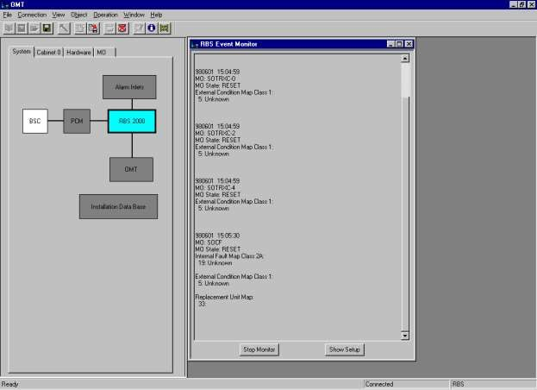
Figure 3-23 Internal Alarms

External Alarms/Antenna Related Auxiliary Equipment (ARAE)
The OMT is used to define external alarms for the base station. It is also used to define Antenna Related Auxiliary Equipment (AREA) alarms, e.g the active antenna in the Maxite. Even though they are binary alarms these alarms will be handled more like an internal alarm in the BSC. It is important to note that during the alarm definition process the OMT must be disconnected. In order to load the newly defined alarms, the base station needs to be placed in the local mode, precluding any traffic while the new IDB is being.

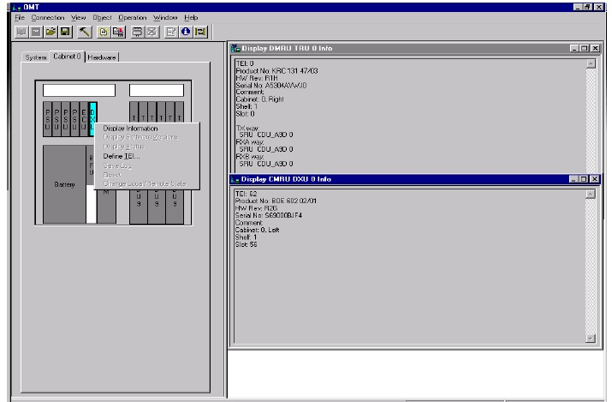
Figure 3-25 Installation Data Base (IDB).

Monitor functions
The monitor function in the OMT makes it possible to check the configuration of RUs and MOs, read sensor outputs and read fault status on RUs. This function belonged to OMT2 in the old SW-releases, but has now been implemented in the new OMT version.

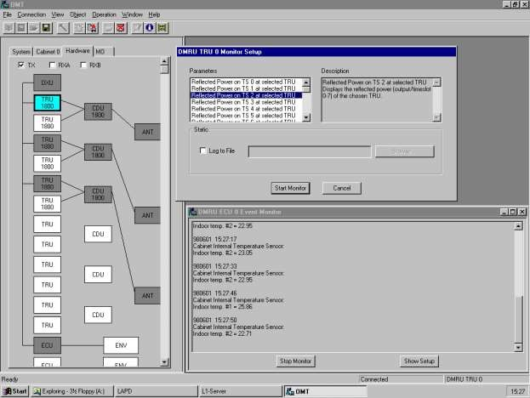
Figure 3-26 Monitor functions.

2.10. RADIO BASE STATION (RBS) CONFIGURATION
- RBS configuration: This involves the allocation of frequencies to channel combinations and power levels for each cell according to available equipment. If equipment becomes faulty causing the loss of important channels, reconfiguration of the remaining equipment is activated, sacrificing less important channels.
- RBS software handling: this involves the control of program loads.
- RBS equipment maintenance: RBS faults and disturbances are recorded and logged continuously.

  - CONFIGURATION RBS 2207 2+2+2 900Mhz.

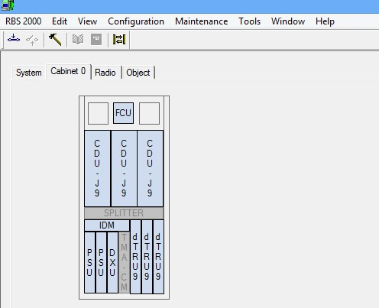
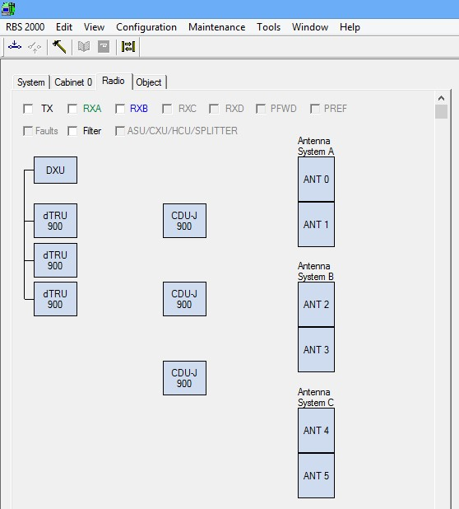

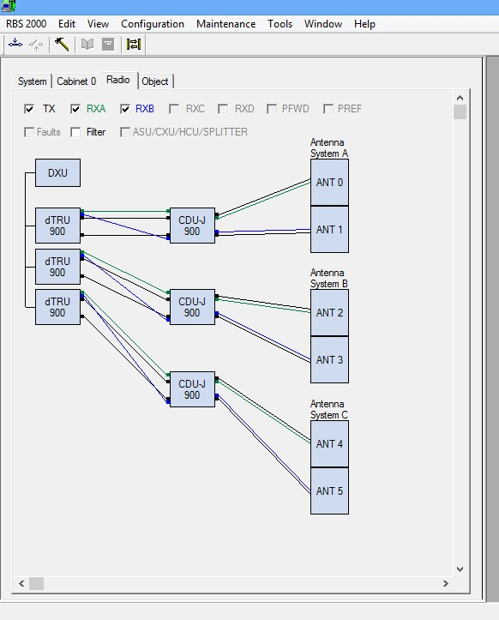

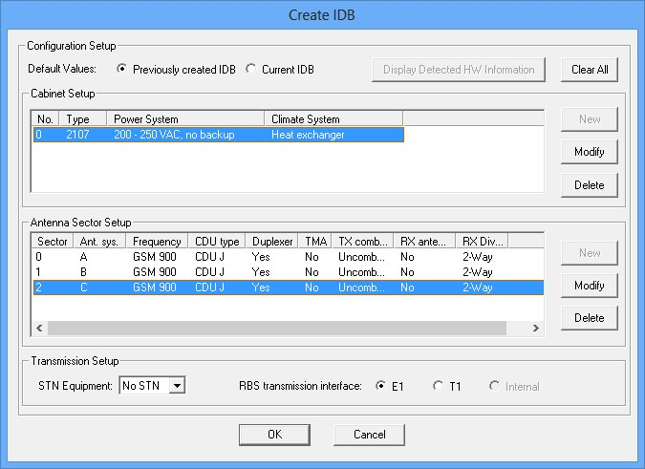

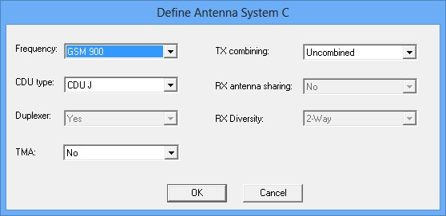

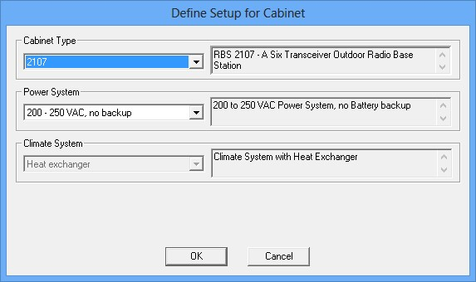

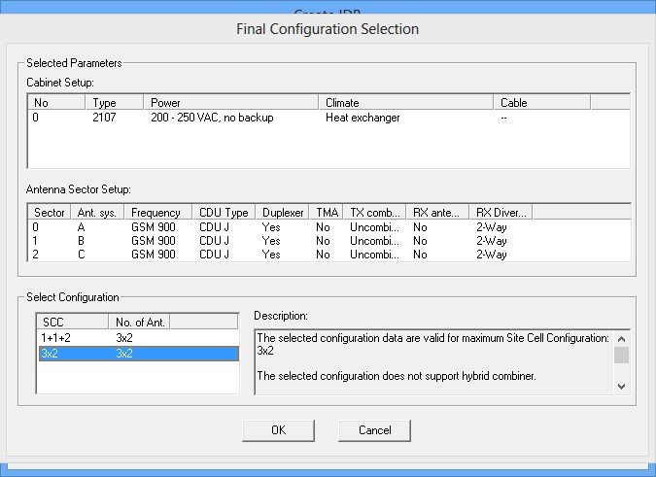

  - CONFIGURATION RBS 2206 4+4+2 1800 Mhz.
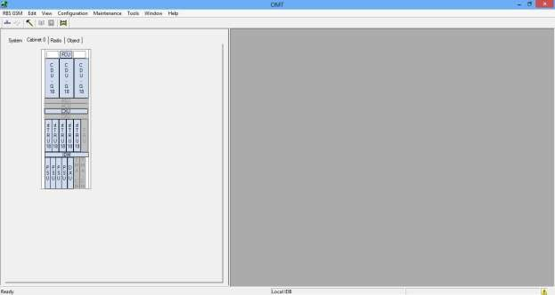

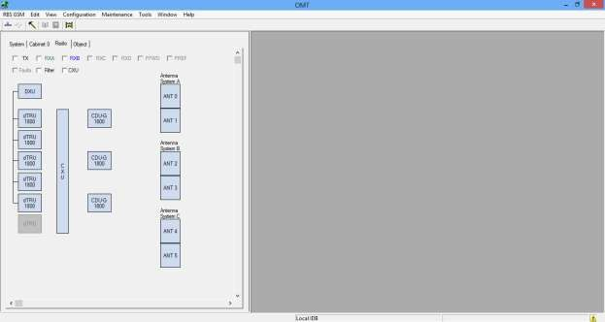

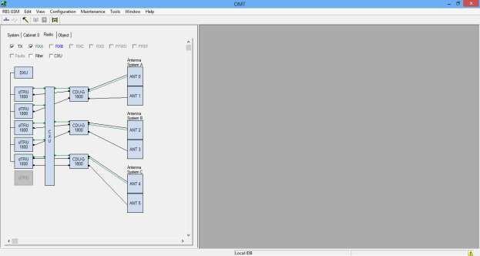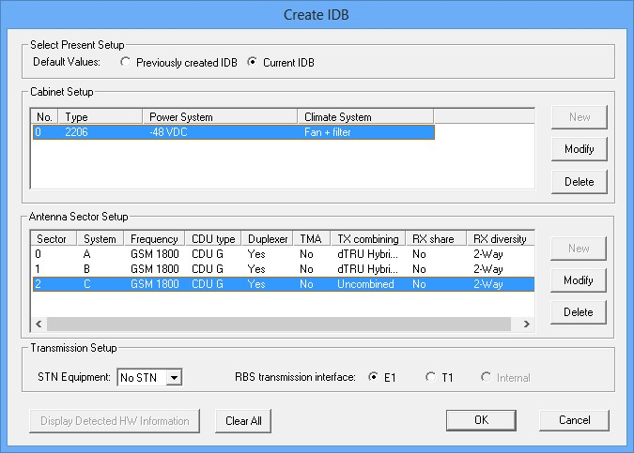
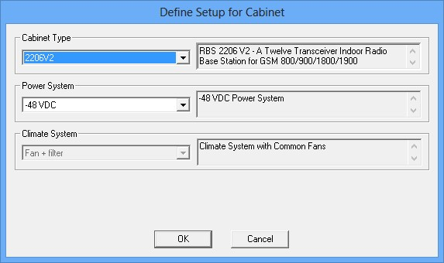
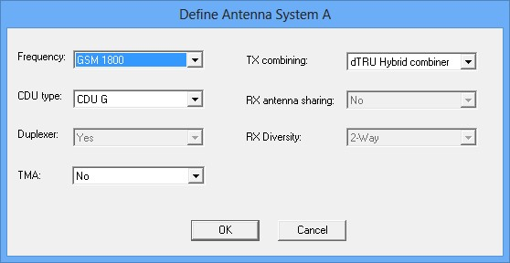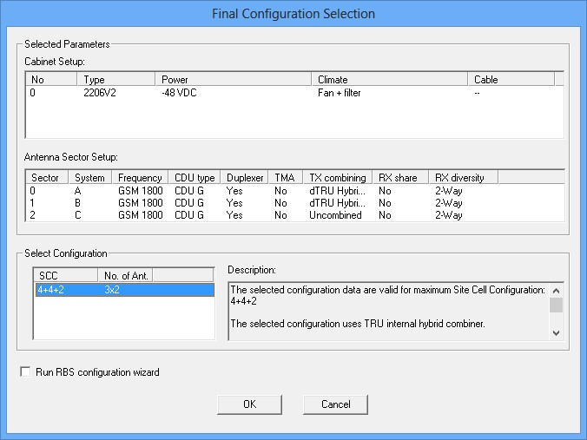

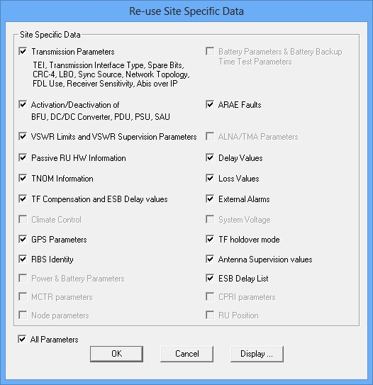

CHAPTER TREE: DISCUSSION OF RESULT.

The BSC manages all the radio-related functions of a GSM network. It is a high-capacity switch that provides functions such as MS handover, radio channel assignment and the collection of cell configuration data. A number of BSCs may be controlled by each MSC.

GSM 900
The original frequency band specified for GSM was 900 MHz. Most GSM networks worldwide use this band. In some countries and extended version of GSM 900 can be used, which provides extra network capacity. This extended version of GSM is called E-GSM, while the primary version is called P-GSM.

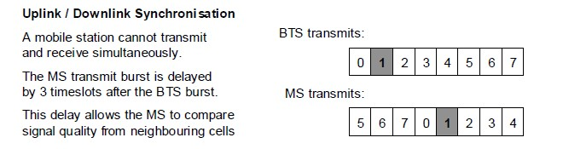
Half rate TCH is not generally implemented. The delay between uplink and downlink is generally less than 3 timeslots due to Timing Advance.

SECOND GENERATION (2G):
In 1991, a second-generation mobile network was launched by Radiolinja based on the GSM. It’s a digital network, and providing a reliable & secure communication channel was the 2G network’s primary motive. Because of transmitting wireless transmission of 2G mobile network was known as the Global System for Mobile Communication. 2G network also has some features and
limitations.
Cell phones received their first major upgrade when they went from 1G to 2G. The main difference between the two mobile telephone systems (1G and 2G), is that the radio signals used by 1G network are analog, while 2G networks are digital . Main motive of this generation was to provide secure and reliable communication channel. It implemented the concept of CDMA and GSM. Provided small data service like SMS and MMS. Second generation 2G cellular telecom networks were commercially launched on the GSM standard in Finland by Radiolinja (now part of Elisa Oyj) in 1991. 2G capabilities are achieved by allowing multiple users on a single channel via multiplexing. During 2G Cellular phones are used for data also along with voice. The advance in technology from 1G to 2G introduced many of the fundamental services that we still use today, such as SMS, internal roaming, conference calls, call hold and billing based on services e.g. charges based on long distance calls and real time billing. The max speed of 2G with General Packet Radio Service (GPRS) is 50 Kbps or 1 Mbps with Enhanced Data Rates for GSM Evolution (EDGE). Before making the major leap from 2G to 3G wireless networks, the lesser-known 2.5G and 2.75G was an interim standard that bridged the gap
FEATURES:
- Digital technology.
- Small data services like SMS and MMS (Multimedia Message System).
- Roaming was possible.
- First internet system with poor data rate.
- Better voice call.
- Conference calls are allowed.
- Comparatively enhanced security.
- Data speed up to 64 Kbps.
- 30 to 200 kHz bandwidth.
LIMITATIONS:
- Restricted mobility.
- Data rate low.
- Fewer features.
- Less hardware capability.
- User numbers are limited.
Features | 1G | 2G
Evolution | 1970 | 1980
Introduced/deployment | 1979 | 1991
Technology | AMPS,  TACS | GSM
Technology Behind | Analog cellular tech | Digital cellular tech
Frequency | 800-900  MHz | 1.8 GHz
Internet Service |  | Narrow band
Net Speed | 2.4 Kbps | 64 Kbps
Application/service | Voice call | Voice call, short message
Bandwidth | NA | 25Mhz
Channel bandwidth |  | 200 kHz
Core network | PSTN | PSTN
Data rate | 2kbps | 14.4.-64 kbps
Handoff | Horizontal | Horizontal
Enhancements: |  | GPRS and EDGE
Peak data rate: |  | 384 kbps with  EDGE
Multiplexing | FDMA | TDMA,CDMA
Access system |  | TDMA,CDMA
Advantage |  | Multimedia features (SMS  & MMS)  Internet access and SIM introduced
Types of switching | circuit | 2G: circuit  2.5G circuit & packet.

GSM 1800 CHANNELS
GSM-900 and GSM-1800 are used in most parts of the world: Europe, Middle East, Africa,
Australia and most of Asia. In South Americas it is in Costa Rica (GSM-1800), Brazil (GSM850, 900 and 1800), Guatemala (GSM-850, GSM-900 and 1900), El Salvador (GSM-850, GSM900 and 1900).
GSM-900 uses 890–915 MHz to send information from the mobile station to the base station
(uplink) and 935–960 MHz for the other direction (downlink), providing 124 RF channels (channel numbers 1 to 124) spaced at 200 kHz. Duplex spacing of 45 MHz is used. Guard bands 100 kHz wide are placed at either end of the range of frequencies.

In some countries the GSM-900 band has been extended to cover a larger frequency range. This 'extended GSM', E-GSM, uses 880–915 MHz (uplink) and 925–960 MHz (downlink), adding 50 channels (channel numbers 975 to 1023 and 0) to the original GSM-900 band. The GSM specifications also describe 'railways GSM', GSM-R, which uses 876–915 MHz (uplink) and 921–960 MHz (downlink). Channel numbers 955 to 1023. GSM-R provides additional channels and specialized services for use by railway personnel.

All these variants are included in the GSM-900 specification. GSM-1800 uses 1710–1785 MHz to send information from the mobile station to the base tranceiver station (uplink) and 1805– 1880 MHz for the other direction (downlink), providing 374 channels (channel numbers 512 to
885). Duplex spacing is 95 MHz.GSM-1800 is also called DCS (Digital Cellular Service) in the United Kingdom, while being called PCS in Hong Kong (not to mix up with GSM-1900 which is commonly called PCS in the rest of the world.)

CHAPTER FOUR: SUMMARY, CONCLUSION AND RECOMMENDATION.

The handover mechanism guarantees that whenever the mobile is moving from one base station area/cell to another, radio connection is handed over to the target base station without interruption. Intra and inter MSC handover, Inter-MSC and intra-MSC handover from WCDMA to GSM were discussed. Handover scenarios in 2G, 3G, 4G, and 5G were addressed. Inter-frequency handover, hard handover, soft and softer handover were treated with the aid of diagrams to illustrate them, Uplink and Downlink power control in soft handover were explained. Handover procedure and parameters in the handover algorithm were not left out. Useful Glossary of Terms were added to this work.
Cell planning process step1: traffic and coverage analysis (system requirement). Step2, nominal cell plan, step 3 surveys and radio requirement, step4 system design (the final plan), step5 implementation and step 6 system tuning were carefully discussed and practically done. The descriptions of the replaceable units(RUs) and Buses in RBS 2000 macro were not left out. The use of Operation and Maintenance Terminal (OMT) to design Radio Base Station(RBS) were carried out. Configuration of RBS 2207 2+2+2 900MHz and RBS 2206 4+4+2 1800MHz were designed, configured and loaded and ready for integration.
The difference between GSM-900 and GSM 1800?
It has been proven that 900 Mhz band has 30-40 per cent better coverage than 1800 Mhz band. The two types of cellular telephony radiation use different carrier frequencies and give different frequency spectra, but they usually also differ in intensity, as GSM 900 MHz antennas operate at about double the power output than the corresponding DCS 1800 MHz ones.
The use of 900 MHz frequency.
Overview. 3GPP Band 8 (900 MHz) is used globally for 2G GSM voice and basic data mobile communications. Technology-neutral licensing enabled 900 MHz to become a mainstream spectrum choice for mobile broadband using 3G HSPA / HSPA+ / DC-HSPA+, particularly due to the limited bandwidth required by previous 2G GSM systems.

The advantages of 900 MHz.
Better range & building penetration: The 900MHz wavelength is 70% shorter than 300MHz products, allowing the signal to "squeeze" through narrow opening in both commercial and residential environments. The FCC allows higher transmit powers for 900MHz spread spectrum systems.

How far can 900 MHz go?
In an ideal, obstacle-free environment, 900 MHz signals can travel several kilometers. However, in urban areas with buildings and other structures, the range is typically reduced to a few hundred meters.

REFERENCE:

- GSM SYSTEM SURVEY STUDENT TEXT EN/LZT 123 3321 R2C
- https://www.academia.edu/24399074/GSM_SYSTEM_SURVEY?auto=do wnload&email_work_card=download-paper
- Air Interface Dimensioning, Dimensioning Guideline – RL20:
https://sharenet-ims.inside.nokiasiemensnetworks.com/Overview/D380538151
- Serna, L.; Chris, J; Novosad, T: LTE RPESS Training https://sharenet-ims.inside.nokiasiemensnetworks.com/Open/424371939
- 3GPP TS 36.214 Physical Layer – Measurements www.3gpp.org
- Guideline for Propagation Modelling with NetAct Planner, Ver. 1.0, 28.9.2007 https://sharenet-ims.inside.nokiasiemensnetworks.com/Open/407812263
- Jussi Reunanen: HSDPA dim material, Nokia, ver 29.6.2005:
https://sharenet-ims.inside.nokiasiemensnetworks.com/Open/407818402
- Holma, H; Toskala, A: HSDPA/HSUPA for UMTS, Wiley 2006
- Laiho, J; Wacker, A; Novosad, T: Radio Network Planning and Optimisation for UMTS, Second Edition, Wiley 2006
- Chris J: 3G Radio Network Planning Guidelines https://sharenet-
ims.inside.nokiasiemensnetworks.com/livelink/livelink?func=ll&objId=364981390&obj Action=Browse&viewType=1
- Novosad, T: Atoll for LTE, NSN Test Report https://sharenet-ims.inside.nokiasiemensnetworks.com/Download/397837410
- Djupsund, M Performance Indicator Definition Document, Guideline document for all Radio technology performance indicator definitions, Version 3.0.0 https://inside.nokiasiemensnetworks.com/global/Company/Organisation/COO/RA_index/
Multiradio_RD/System_architecture/Organization_structure/Performance-Capacity-
Management/Pages/Performance_and_Capacity_Management.aspx?redirected=true
- Khiem, L; Zanier, P; Arjoma, A; Novosad, T: LOS project, NSN, April 2009 deliverable: https://sharenet-ims.inside.nokiasiemensnetworks.com/Open/402659684
- 3GPPdoc. R4-080625, Reporting Range of RSRP, TSG-RAN Working Group 4 (Radio) meeting #46bis, Shenzhen, China, 31 March – 4 April, 2008.
- 3GPPdoc. R4-081419, RSRQ Reporting Range, TSG-RAN Working Group 4 (Radio) meeting #47bis , Munich, Germany, June 16 – 20, 2008.
- Makelainen, K: ,LTE workaround with NetAct Planner :
https://sharenet-ims.inside.nokiasiemensnetworks.com/Open/372999100
- Szervinsk. A; Sanchez, R: LTE Reuse 1 vs. Reuse 1/3: Planning Analysis, System Performance, CMO NAM, June 2008 :
https://sharenet-ims.inside.nokiasiemensnetworks.com/Overview/407814112
- Bajon, M., Wojciech B., Marcin, G.: Migration towards LTE (v0.4) 02.11.2009: https://sharenet-ims.inside.nokiasiemensnetworks.com/Open/409022864
- Peng Juan Ming, Su Yefei: TD LTE Planning Guidelines: https://sharenet-ims.inside.nokiasiemensnetworks.com/Overview/D419261006
- Lamminmaki, J.: SINR vs. RSRP and RSRQ for Field Measurements https://sharenet-ims.inside.nokiasiemensnetworks.com/Open/410878443
- Wan, Tao: Atoll WI: https://sharenet-ims.inside.nokiasiemensnetworks.com/Open/409512031
- Novosad, T.: LTE planning study for Sydney cluster with Atoll and Atoll ACP module. https://sharenet-ims.inside.nokiasiemensnetworks.com/Overview/D409093376
- Atoll Ordering Instructions, https://sharenet-ims.inside.nokiasiemensnetworks.com/Open/416797696
- Planet Evaluation by NSN: https://sharenet-ims.inside.nokiasiemensnetworks.com/Open/417095435
- Wan, Tao: Planet WI:
https://sharenet-
ims.inside.nokiasiemensnetworks.com/livelink/livelink?func=ll&objId=402670437&obj Action=Browse&viewType=1
- Wan, Tao: Comparison of Planet and Atoll for LTE: https://sharenet-ims.inside.nokiasiemensnetworks.com/Open/402670437
- LTE dimensioning tool by NE:
https://sharenet-ims.inside.nokiasiemensnetworks.com/Open/D380069775
- Serna, Lorena, Hathiranami, Navin: LTE Optimization Guidelines: https://sharenet-ims.inside.nokiasiemensnetworks.com/Overview/D415266561
- Golden eNB Parameter Configuration: https://bts.inside.nokiasiemensnetworks.com/labstorage/Current_Configuration/Inc22_Go lden_Configuration/
- NE Parameter Knowledge Database: http://10.151.18.141
- RL10 eNB Parameter Course : https://sharenetims.inside.nokiasiemensnetworks.com/livelink/livelink?func=ll&objId=419966762&obj Action=Browse
- Balazs, A: KPI Definitions for: RL20 https://sharenet-
ims.inside.nokiasiemensnetworks.com/livelink/livelink/overview/423964880

- Balazs, A: KPI Targets for RL20:
https://sharenet-ims.inside.nokiasiemensnetworks.com/Overview/D424009366

- Serna, L: e-UTRAN Field and Network KPI List (RL10) – https://sharenet-ims.inside.nokiasiemensnetworks.com/Overview/D411459148
- Novosad, T: LTE Performance Estimation Based on HSPA Field Measurements slideset: https://sharenet-ims.inside.nokiasiemensnetworks.com/Overview/D419155036
- Salo, Jari: eNodeB Databuild Templates (RL10): https://sharenet-ims.inside.nokiasiemensnetworks.com/Open/420186968
- Green, M: AT&T Trial Report: https://sharenet-ims.inside.nokiasiemensnetworks.com/Guest/Open/416124709
- Reference Signal Coverage Comparison in LTE and UMTS: https://sharenet-ims.inside.nokiasiemensnetworks.com/Overview/D421544601
- LTE Project Material Uploads – CoDe IMS: https://sharenet-ims.inside.nokiasiemensnetworks.com/Open/416686784
- LTE Delta Enabling by Network Engineering related to RL10 P7, RL20 P3 and RL15TD P3 (July 2010): https://sharenet-ims.inside.nokiasiemensnetworks.com/Open/420011455
- LTE Delta Enabling by Network Engineering related to RL20 P7 and RL15TD P7 (December 2010):
https://sharenet-ims.inside.nokiasiemensnetworks.com/Open/425105301
- Parameter Knowledge Database (PKDB): http://10.151.18.141

