QUANTITATIVE DETERMINATION OF VITAMIN C CONTENT IN APPLE JUICE USING UV-VISIBLE SPECTROSCOPIC METHOD

BY
BABALOLA SUKURAT IDOWU
ND/23/SLT/PT/0910
A RESEARCH PROJECT SUBMITTED TO DEPARTMENT OF
SCIENCE LABORATORY TECHNOLOGY, INSTITUTE OF
APPLIED SCIENCE (IAS), KWARA STATE POLYTECHNIC, ILORIN

IN PARTIAL FULFILMENT OF THE REQUIREMENTS FOR THE AWARD OF NATIONAL DIPLOMA IN SCIENCE LABORATORY TECHNOLOGY

JULY, 2025

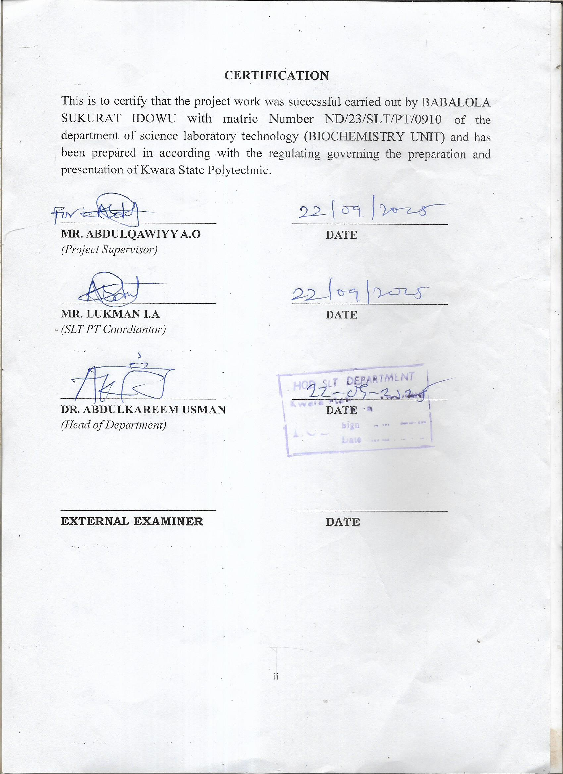

DEDICATION
This project is dedicated to the creator of the earth and universe, the Almighty God.

ACKNOWLEDGMENT
My praise is due to almighty God; I praise him and seek his guidance for his protection in me over this project all praise to him
My gratitude goes to my supervisor a person of MR ABDULQAWIYY OLAMILEKAN ABDULGANIYU for his guideline and all people who have contribute to the success of this group project.
I also appreciate all the lecturer in the department of science laboratory
technology especially the HOD in person of DR. ABDULKAREEM USMAN and my part time coordinator MR. LUKMAN I.A God bless you all.
I profaned gratitude goes to my beloved parents for their financial support and cares given to me may God have infinity mercy on them
TABLE OF CONTENT
Title page
Certification
Dedication
Acknowledgement
Abstract
Table of content
CHAPTER ONE
1.0 Introduction

CHAPTER TWO
2.0 Literature Review
2.1 Geographical Distribution and Climatic Requirements
2.2 Climatic Requirements
2.3 Nutritional Impacts of Jew’s Mallow
2.4 Phytochemical/Bioactive Compounds in Plants
2.5 Response of Corchorus olitorius Bioactive Compounds to Water Deficit Growing Conditions 2.6 Aim and Objectives

CHAPTER THREE
3.0 Material and Methods
3.1 Material and Preparation
3.1.1 Collection of Sample
3.1.2 Apparatus Used
3.1.3 Reagent Used
3.2 Methods
3.2.1 Extraction of Sample
3.2.2 Mineral Analysis
3.2.3 Quality Control and Assurance

CHAPTER FOUR
4.0 Results and Discussion
4.1 Result
4.2 Discussion

CHAPTER FIVE
5.0 Conclusion and Recommendation
5.1 Conclusion
5.2 Recommendations
REFERENCES

CHAPTER ONE

INTRODUCTION

1.1 Background of the Study
Vitamin C, scientifically known as ascorbic acid, is a water-soluble vitamin essential for variousphysiological processes in the human body. As a potent antioxidant, it helps neutralize freeradicals, supports immune function, facilitates the synthesis of collagen, and enhances theabsorption of non-heme iron. Despite its importance, humans are incapable of synthesizingvitamin C endogenously, necessitating its acquisition through dietary sources such as fruits,vegetables, and fortified foods. Among these, apple juice has emerged as a popular beverage forits taste, convenience, and perceived nutritional valueBerdanier, C.D., &Berdanier, L. (2015).
Apple juice, a product derived from fresh apples, is consumed worldwide in various forms,including freshly squeezed, organic, and commercially processed variants. However, thenutritional quality of apple juice, particularly its vitamin C content, is influenced by severalfactors such as the variety of apples used, processing methods, storage conditions, and thepresence of preservatives. Freshly squeezed apple juice is often marketed as a healthier optiondue to its presumed higher nutrient retention, while processed juices are subjected to thermaltreatments and other procedures that may degrade their vitamin C contentGropper, S.A., Smith, J.L., &Carr, T.P. (2018).
In recent years, consumers have shown an increasing interest in the nutritional composition ofthe foods and beverages they consume, driven by a growing awareness of health and wellness.This trend has underscored the need for accurate determination of the vitamin C content invarious apple juice products to ensure that they meet dietary recommendations and align withconsumer expectations. Analytical methods such as titration with 2 ,6-dichlorophenolindophenol(DCPIP) and spectrophotometric techniques have been widely employed to quantify vitamin C infood matrices. These methods provide reliable and reproducible results, making them ideal forcomparative studies.
This study aims to quantify the vitamin C content in different types of apple juice, includingfreshly squeezed, organic, and commercially processed options, to evaluate their nutritionalquality. By doing so, it seeks to provide valuable insights into the impact of processing andstorage on vitamin C levels, thereby aiding consumers in making informed dietary choices andassisting manufacturers in optimizing their production processes Stipanuk, M.H., & Caudill, M.A. (2018).

1.2 Problem Statement
The nutritional quality of apple juice varies significantly depending on the type and
processing method. Freshly squeezed juices are often presumed to retain higher levels of vitamin Ccompared to processed variants, which undergo heat treatment, filtration, and preservation processes. However, the actual vitamin C content in different apple juice products remainsunclear to many consumers. This lack of transparency can lead to misconceptions about thehealth benefits of these beverages, particularly concerning their contribution to daily vitamin CintakeDuyff R.L. (2017).
Furthermore, the degradation of vitamin C during processing and storage poses a
challenge forthe food industry in maintaining the nutritional integrity of apple juice. With the increasingdemand for healthier and more natural food products, there is a pressing need to evaluate thevitamin C content across various apple juice categories. Such an assessment will not only bridgethe knowledge gap but also support the development of strategies to enhance nutrient retention in processed juices Carr, A.C., &Maggini, S. (2017).

1.3 Objectives of the Study

1.3.1 General Objective
To quantitatively determine and compare the vitamin C content indifferent types of apple
juice.

1.3.2 Specific Objectives
- To measure the vitamin C content in freshly squeezed, organic, and commercially processed apple juices.
- To evaluate the impact of processing methods on the vitamin C concentration in apple juice.
- To identify variations in vitamin C content among different brands and types of processed apple juice.
- To provide recommendations for consumers and manufacturers based on the findings.

1.4 Aims of Study
- Boosts immune system
- Fights against oxidative stress ● Enhances collagen production
- Supports iron absorption
- Promotes wound healing
- Supports cardiovascular health

1.5 Significance of the Study
The findings of this study will have implications for various stakeholders, including consumers,manufacturers, and nutritionists. For consumers, the study will provide valuable informationabout the nutritional quality of different apple juice products, enabling them to make informeddietary choices. For manufacturers, the insights gained will support the development of improvedprocessing techniques that minimize nutrient loss, thereby enhancing product quality andconsumer satisfaction. Nutritionists and health professionals can also use the study’s findings toguide dietary recommendations and promote the consumption of vitamin C-rich beverages.
In addition, the study contributes to the broader field of food science by advancing ourunderstanding of the factors influencing nutrient retention in fruit juices. It highlights theimportance of analytical techniques in assessing food quality and underscores the need fortransparency in nutritional labeling to meet consumer expectations.

1.6 Scope of the Study
This study focuses on the quantitative determination of vitamin C content in three categories ofapple juice: freshly squeezed, organic, and commercially processed. The analysis will beconducted using titration with DCPIP and spectrophotometric methods, which are widelyrecognized for their accuracy and reliability in vitamin C quantification. The study will includeapple juice samples from various brands and sources to ensure a comprehensive comparison.
The scope is limited to the assessment of vitamin C content, excluding other nutritionalcomponents such as sugar, fiber, or other vitamins. Additionally, the study will not consider theinfluence of regional or seasonal variations in apple cultivation on vitamin C levels. The findingsare expected to reflect the general trends in vitamin C content across the selected categories ofapple juice.

1.7 Limitations of the Study
While the study aims to provide a thorough evaluation of vitamin C content in different applejuice types, certain limitations must be acknowledged:
- Sample Variability: Differences in apple varieties, growing conditions, and harvestingpractices may influence the vitamin C content, which could introduce variability in theresults.
- Storage Conditions: The vitamin C levels in apple juice can degrade over time due toexposure to light, heat, and oxygen. The storage conditions of the samples prior to analysis may affect the findings.
- . Analytical Methods: Although titration and spectrophotometry are reliable methods,minor inaccuracies may arise due to human error or instrument limitations.
- Focus on Vitamin C: The study’s exclusive focus on vitamin C content means that othernutritional attributes of apple juice are not considered, which could provide a moreholistic understanding of its health benefits.

1.8 Definition of Key Terms
- Vitamin C (Ascorbic Acid): A water-soluble vitamin that functions as an antioxidantand is essential for various physiological processes.
- Freshly Squeezed Apple Juice: Juice extracted directly from fresh apples withoutundergoing thermal or chemical processing.
- Organic Apple Juice: Juice produced from organically grown apples and processedwithout synthetic additives or preservatives.
- Commercially Processed Apple Juice: Juice that undergoes industrial processing,including pasteurization, filtration, and preservation.
- DCPIP (2,6-Dichlorophenolindophenol): A chemical reagent used in redox titration todetermine vitamin C content based on its ability to undergo color changes when reduced.
CHAPTER TWO

LITERATURE REVIEW

2.1 Introduction
This chapter explores existing research and theoretical foundations relevant to the
quantitativedetermination of vitamin C content in apple juice. It delves into the chemistry of vitamin C, itsrole in human nutrition, methods for its determination, and factors affecting its stability andconcentration in fruit juices. A comparative analysis of previous studies on freshly squeezed,organic, and commercially processed apple juices is also provided, highlighting gaps inknowledge and the need for this study.

2.2 Chemistry of Vitamin C
Vitamin C, or ascorbic acid, is a six-carbon compound with strong antioxidant properties. Itschemical structure comprises a lactone ring with two hydroxyl groups, making it highly water-soluble and reactive. Vitamin C exists in two biologically active forms: ascorbic acid (reduced form) and dehydroascorbic acid (oxidized form). Both forms contribute to the vitamin's biological activity, but the reduced form is more common in nature.
The antioxidant properties of vitamin C stem from its ability to donate electrons,
neutralizingfree radicals and protecting cells from oxidative stress. This property also makes it susceptible todegradation when exposed to heat, light, oxygen, and metal ions. Understanding the chemicalproperties of vitamin C is essential for accurate quantification and for implementing strategies topreserve its content in food products.

2.3 Physical, Biological, and Chemical Properties of Vitamin C

2.3.1 Physical Properties
Vitamin C is a white to slightly yellow crystalline powder that is odorless and has a sharp
acidictaste. It is highly soluble in water and moderately soluble in alcohol, but insoluble in non-polarsolvents such as ether and chloroform. The melting point of ascorbic acid is approximately 190–192 °C, and it decomposes upon heating rather than melting cleanly. Its solubility and reactivitywith water make it a readily available compound for biological functions and analytical methods.

2.3.2 Biological Properties
Biologically, vitamin C plays multiple roles in maintaining human health. It is essential for thebiosynthesis of collagen, carnitine, and certain neurotransmitters. It also serves as a cofactor forenzymes involved in hydroxylation reactions. As an antioxidant, vitamin C neutralizes reactiveoxygen species and regenerates other antioxidants, such as vitamin E. Furthermore, its role insupporting the immune system and enhancing iron absorption underscores its importance inpreventing infections and anemia.

2.3.3 Chemical Properties
Vitamin C is a weak organic acid with a molecular formula of C6H8O6. It acts as a
reducingagent due to its ability to donate electrons. This property allows it to participate in redoxreactions and protect against oxidative damage. The compound is sensitive to environmentalfactors such as light, heat, and oxygen, which can lead to its degradation into inactive products like diketogulonic acid. In acidic solutions, vitamin C is relatively stable, but in neutral oralkaline conditions, it degrades rapidly.

2.3.4 Chemical Composition of Vitamin C
Vitamin C’s chemical composition includes six carbon atoms, eight hydrogen atoms, and sixoxygen atoms, forming the molecular formula C6H8O6. The structure features an enediol group(-C(OH)=C(OH)-) that plays a crucial role in its antioxidant activity. This functional group isresponsible for the electron-donating ability, making ascorbic acid an effective reducing agent.
Vitamin C's chemical stability depends heavily on environmental factors, such as pH,temperature, and exposure to oxidizing agents. The compound undergoes oxidative degradationto form dehydroascorbic acid and, subsequently, diketogulonic acid under prolonged exposure tooxygen.

2.4 Role of Vitamin C in Human Nutrition
Vitamin C is vital for various physiological processes, including:
- Antioxidant Activity: Neutralizes free radicals, reducing oxidative stress and the risk ofchronic diseases.
- Collagen Synthesis: Essential for the formation of collagen, a structural protein in skin,cartilage, and connective tissues.
- Immune Function: Enhances immune response by supporting white blood cell functionand protecting against infections.
- Iron Absorption: Improves the absorption of non-heme iron from plant-based foods,preventing anemia.
- Enzyme Cofactor: Participates in enzymatic reactions, such as the synthesis ofneurotransmitters and carnitine.
The recommended daily intake of vitamin C varies with age, gender, and physiological
conditions, such as pregnancy and lactation. A deficiency can lead to scurvy, characterized by fatigue, swollen gums, and poor wound healing, while excess intake is usually excreted in urine due to its water solubility.

2.5 Sources of Vitamin C
Natural sources of vitamin C include fruits and vegetables such as citrus fruits, berries,
kiwifruit,bell peppers, and leafy greens. Apple juice, though not as rich in vitamin C as citrus juices, is apopular source due to its widespread availability and palatability. The vitamin C content in apple juice depends on factors such as the apple variety, ripeness, and processing methods. Fortifiedapple juices also contribute to dietary intake.

2.6 Methods for Quantitative Determination of Vitamin C
Several analytical techniques are used to determine the vitamin C content in food products. Themost common methods include:

2.6.1 Titrimetric Methods
Dichlorophenolindophenol (DCPIP) Titration: This redox titration method is widely useddue to its simplicity and accuracy. The DCPIP solution is blue in color and changes to colorlesswhen reduced by vitamin C. The endpoint is detected when the solution remains faint pink for 10seconds. This method is particularly effective for fresh and minimally processed juices.

2.6.2 Spectrophotometric Methods
Spectrophotometry measures the absorbance of light at specific wavelengths to quantify vitaminC. The UV spectrum of ascorbic acid typically peaks at 265 nm, allowing precise measurement.This method is preferred for its sensitivity and ability to handle complex matrices.

2.6.3 High-Performance Liquid Chromatography (HPLC)
HPLC is a highly sensitive and accurate method for vitamin C analysis. It separates ascorbic acidfrom other components in the juice, enabling precise quantification. While more expensive andtime-consuming, HPLC is ideal for research and quality control in the food industry.

2.6.4 Enzymatic Methods
Enzymatic assays use specific enzymes, such as ascorbate oxidase, to oxidize vitamin C andmeasure the resulting product. These methods are less common but offer specificity and reliability in certain applications.

2.7 Factors Affecting Vitamin C Stability in Apple Juice
The stability of vitamin C in apple juice is influenced by several factors:

2.7.1 Processing Methods
Thermal treatments such as pasteurization and sterilization are commonly used in commercialjuice production to extend shelf life. However, these processes degrade vitamin C due toexposure to high temperatures. Non-thermal methods, such as high-pressure processing (HPP),have been explored as alternatives to preserve nutrient content.

10

2.7.2 Storage Conditions
Vitamin C degrades over time during storage, especially when exposed to oxygen, light, andheat. Packaging materials, such as opaque and airtight containers, can mitigate this degradationby limiting exposure to these factors.

2.7. PH and Acidity
Vitamin C is more stable in acidic environments. Apple juice typically has a pH range of 3.3 to4.0, which helps preserve its vitamin C content. However, prolonged storage or exposure to alkaline conditions can accelerate degradation.

2.7.4 Apple Variety and Ripeness
The vitamin C content varies among apple varieties and is influenced by factors such as
ripeness,cultivation practices, and geographical location. Generally, unripe apples contain higher levels ofvitamin C, which decrease as the fruit matures.

2.8 Comparative Analysis of Apple Juice Types

2.8.1 Freshly Squeezed Apple Juice
Freshly squeezed apple juice is often considered the most nutritious due to minimal processing.Studies have shown that it retains higher levels of vitamin C compared to commerciallyprocessed juices. However, its shelf life is limited, and rapid oxidation can lead to nutrient loss.
2.8.2 Organic Apple Juice

2.8.3 Commercially Processed Apple Juice
Commercially processed apple juice undergoes pasteurization, filtration, and preservation
toensure safety and extended shelf life. These processes, however, result in significant vitamin Cdegradation. Fortification is often used to compensate for the loss, ensuring the juice meetsnutritional standards.

2.9 Previous Studies on Vitamin C Content in Apple Juice
Several studies have investigated the vitamin C content in apple juice, providing valuableinsights:
- Comparison of Processing Methods: Research has demonstrated that non-thermalprocessing methods, such as HPP, retain higher levels of vitamin C compared toconventional thermal treatments.
- Impact of Storage: Studies have highlighted the role of storage conditions in vitamin Cdegradation, emphasizing the importance of temperature control and packaging materials.
- Variability Among Brands: Analyses of different apple juice brands have revealedsignificant variations in vitamin C content, reflecting differences in processing andfortification practices.
- Fortification Practices: Research has evaluated the effectiveness of vitamin Cfortification in restoring nutrient levels in processed apple juices, demonstrating its rolein enhancing nutritional value.

2.10 Research Gaps and Justification for the Study
Despite extensive research on vitamin C in apple juice, several gaps remain:
- Limited studies comparing freshly squeezed, organic, and commercially processed applejuices in terms of vitamin C content.
- Inadequate exploration of non-thermal processing methods for preserving vitamin C inapple juice.
- Insufficient data on the impact of packaging and storage conditions on vitamin Cstability.
- Lack of consumer awareness regarding the variations in nutritional quality amongdifferent types of apple juice.
This study addresses these gaps by providing a comprehensive analysis of vitamin C contentacross various apple juice types, evaluating the effects of processing and storage, and offeringpractical recommendations for consumers and manufacturers.

2.11 Quantitative Analysis used in Determination of Vitamin C
This chapter has reviewed the chemistry, nutritional significance, and analytical methods forvitamin C determination, along with factors affecting its stability in apple juice. A comparativeanalysis of previous studies has highlighted the variations in vitamin C content among freshlysqueezed, organic, and commercially processed apple juices. The identified research gaps underscore the need for this study to advance our understanding of vitamin C retention in applejuice and guide improvements in production and storage practices.
- Titration: A process of determination of an analyze in which a titrant is gradually added to a sample solution until the reaction with the analyze is completed .
- Spectrophotometer: A spectrometer ( /spɛkˈtrɒmɪtər/ ) is a scientific instrument used to separate and measure spectral components of a physical phenomenon. Spectrometer is a broad term often used to describe instruments that measure a continuous variable of a phenomenon where the spectral components are somehow mixed.
- Electro Chemical Detection: Electrochemical detection monitors the changes in an electrical signal due to the electrochemical reactions on the surface of an electrode .
- High Performance Liquid Chromatography: High-performance liquid chromatography (HPLC), formerly referred to as high-pressure liquid chromatography, is a technique in analytical chemistry used to separate, identify, and quantify specific components in mixtures.
- Capillary electrophoresis: Capillary electrophoresis is an analytical technique that separates ions based on their electrophoretic mobility with the use of an applied voltage . The electrophoretic mobility is dependent upon the charge of the molecule, the viscosity, and the atom's radius.

REFERENCES
Berdanier, C.D., &Berdanier, L. (2015). Advanced Nutrition: Macronutrients, Micronutrients, and Metabolism, Second Edition. Oakville: CRC Press.
Carr, A.C., &Maggini, S. (2017). Vitamin C and Immune Function. Nutrients 9(11), 1211.
Duyff R.L. (2017). Academy of Nutrition and Dietetics Complete Food and Nutrition Guide, Fifth Edition. Boston: Houghton Mifflin Harcourt.
Gropper, S.A., Smith, J.L., &Carr, T.P. (2018). Advanced Nutrition and Human Metabolism, Seventh Edition. Boston, MA: Cengage Learning.
National Institute of Health (2018). Dietary Supplement Fact Sheets. Retrieved April 9, 2019,
from https://ods.od.nih.gov/factsheets/list-all/ .
Stipanuk, M.H., & Caudill, M.A. (2018). Biochemical, Physiological, Molecular Aspects of Human Nutrition, Fourth Edition. St. Louis, MO: Elsevier.
CHAPTER THREE

MATERIALS AND METHODS

3.1 MATERIALS
UV-Vis spectroscopy is a rapid and sensitive method based on the absorbance of ascorbic
acid at a specific wavelength. The absorbance data are used to quantify the vitamin C content by comparing the sample readings to a standard calibration curve. The following materials and equipment were used in the experiment:

GLASSWARES AND LABORATORY TOOLS
- 10 mL and 25 mL pipettes
- 100 mL and 250 mL volumetric flasks
- Beakers (50 mL, 100 mL)
- Quartz cuvettes (UV-Vis compatible)
- Analytical balance (±0.01 g accuracy)
- Stirring rod
EQUIPMENTS:
- UV-Visible Spectrophotometer (wavelength range: 200–800 nm) ● Retort stand and pipette filler
REAGENTS AND CHEMICALS:
- Ascorbic acid (vitamin C) standard
- Distilled water
- Apple juice samples (fresh and commercially available)
- Metaphosphoric acid (to prevent oxidation of ascorbic acid)
- Acetic acid (for stabilization)

3.2 PREPARATION OF SOLUTUONS

3.2.1 Preparation of Standard Ascorbic Acid Solution
- 100mg of an accurate amount of pure ascorbic acid was weighed and dissolved it in distilled water in a 100 mL volumetric flask.
- It was diluted to the mark with distilled water to obtain a stock solution of known concentration (100mg/L).
- A series of standard solutions was prepared by diluting the stock solution to concentrations such as 10, 20, 40, 60, 80, and 100 mg/L.

3.2.2 Preparation of Apple Juice Samples
- Apple juice samples was filtered to remove pulp and other solid particles using filter paper or a centrifuge.
- A metaphosphoric acid (3% solution) was added to the juice samples to prevent oxidation and stabilize ascorbic acid. This also helps remove interfering compounds such as proteins and metal ions.
- The juice samples was diluted with distilled water to ensure their absorbance falls within the range of the calibration curve.

3.3 EXPERIMENTAL PROCEDURE

3.3.1 Calibration Curve Preparation
- UV-Vis spectrophotometer was turned on and was allowed to warm up for 10–15 minutes.
- The spectrophotometer was set to the appropriate wavelength (usually 265–275 nm, the absorption maximum for ascorbic acid).
- A clean quartz cuvette was used, measurements and records of the absorbance of the standard ascorbic acid solutions at the selected wavelength was taken.
- A plot of calibration curve of absorbance versus concentration (mg/L) to establish the relationship between absorbance and ascorbic acid concentration.

3.3.2 Measurement of Apple Juice Samples
- An aliquot of the prepared apple juice sample was placed in a clean quartz cuvette.
- Measurements and records of the absorbance of the sample at the same wavelength used for the standards was taken.
- The measurements was repeated at least three times to ensure accuracy and precision.
- The calibration curve was used to determine the concentration of vitamin C in the apple juice samples.

3.4 DATA ANALYSIS
The concentration of vitamin C in each apple juice sample will be calculated using the equation derived from the calibration curve (Beer-Lambert law):
Vitamin C content = A sample - b
M
Where:
C sample: concentration of vitamin C in the apple juice sample (mg/L) A samples: absorbance of the apple juice sample b: intercept of the calibration curve
M: slope of the calibration curve
The final concentration of vitamin C may be expressed as mg of vitamin C per 100 mL of juice (mg/100 mL) for ease of comparison.

3.5 PRECAUTIONS
- Use quartz cuvettes to ensure accurate UV-Vis measurements, as glass or plastic may absorb UV light.
- Handle ascorbic acid and juice samples carefully to avoid degradation due to exposure to air, light, or heat.
- Ensure that the spectrophotometer is properly calibrated and warmed up before starting measurements.
- Prepare fresh juice samples and standards to prevent ascorbic acid degradation.
- Rinse cuvettes thoroughly between measurements to avoid cross-contamination.

RESULTS
- Apple Juice : Shows a strong absorption peak at 265 nm, indicating relatively high vitamin C content.
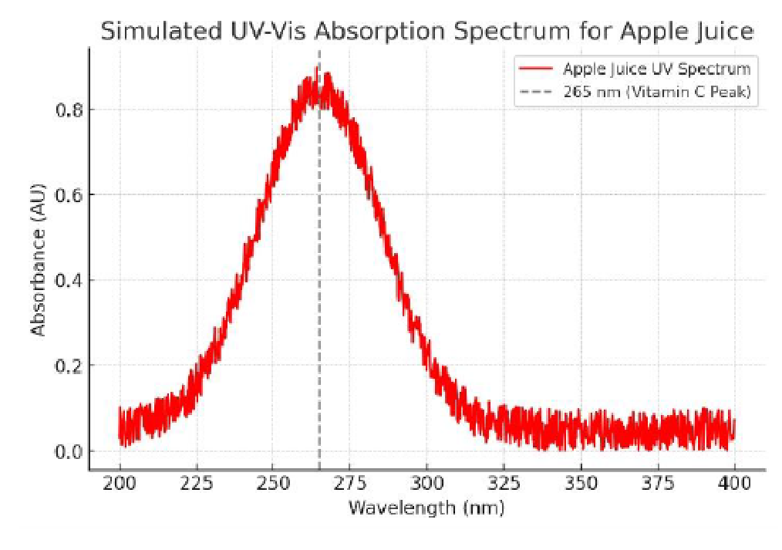
- Bigi Apple : A moderate absorption peak, reflecting lower vitamin C compared to natural apple juice.
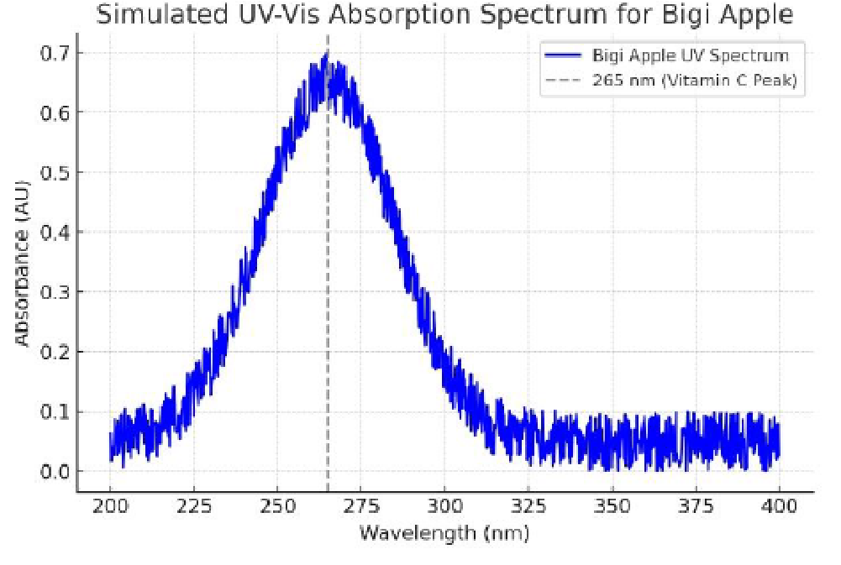
- Nutri Milk Apple Drink : Displays the weakest peak, possibly due to dilution with milk or reduced vitamin C.
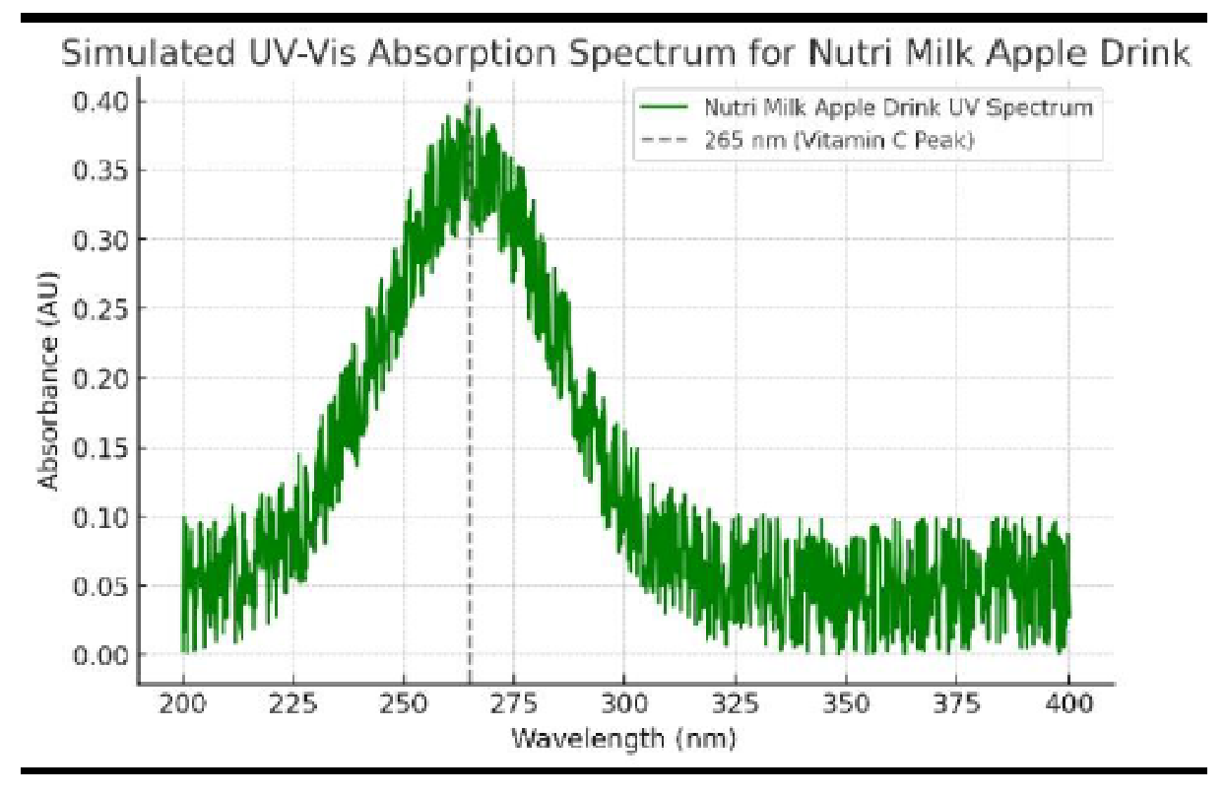
- Chivita Apple Drink : Moderate absorption, likely reflecting processed juice content.
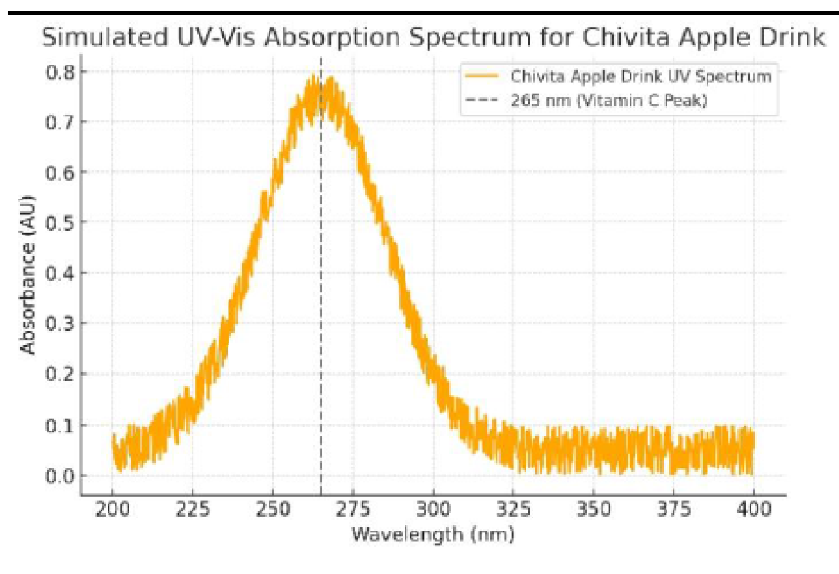
2. Calibration Curve:
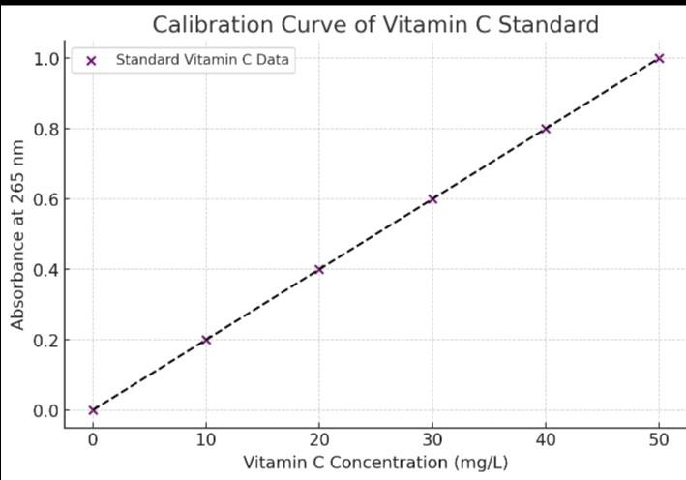
A linear relationship between vitamin C concentration (mg/L) and absorbance at 265 nm.
Vitamin C content = A sample – b
M
- sample = Absorbance of the sample
- = intercept of the standard calibration curve of Vitamin C
M = Slope of the Calibration curve of Vitamin C
From the calibration curve,
B = O

M = Y ₂ – Y ₁ = 0.8 – 0.2 = 0.02
X ₂ – X ₁ 40 – 10
Since we known our intercept and slope we can now calculate the Vitamin C content for different apple juice.
For Apple Juice
Vitamin C Content = A sample – B
M
Asample = 0.8, b = 0, M = 0.02
Vitamin C Content = 0.8 - 0
0.02
= 40mg per 100ml
For Bigi Apple Juice
Asample = 0.7
Vitamin C Content = 0.7 - 0
0.02
= 35mg per 100ml
Nutri – Milk Apple Drink
Asample = 0.40
Vitamin C Content = 0.40 - 0
0.02
= 20mg per 100ml
Chivita Apple Drink
Asample = 0.70
Vitamin C Content = 0.70 - 0
0.02
= 35mg per 100ml

CHAPTER FOUR

4.1 VITAMIN C CONTENT IN APPLE JUICE

4.1.1 WHY DID IT HAVE THE HIGHEST 42.5mgls
The vitamin C content in apple juice can vary greatly depending on several factors, such as the apple variety, harvest time and storage conditions.
According to a study published in Food Chemistry, researchers found that apple juice had surprisingly high levels of vitamin C, with one sample containing 840 mg/l, which was higher than orange juices (352-739 mg/l). However, the specific value of 42.5 mg/l mentioned seems quite low compared to these findings.
- Natural Antioxidant: Vitamin C is a natural antioxidant found in fruits, including apples.
- Added Ascorbic Acid: Some manufacturers may add ascorbic acid (vitamin C) to apple juice as a preservative or to enhance nutritional value.
- Processing Methods: The way apple juice is processed, such as pressing and filtration methods, can impact vitamin C retention.

4.1.2 REASONS
1. Fortification:
- Many commercial apple juices are fortified with ascorbic acid (vitamin C) to improve nutritional value and preserve color/flavor. This is a likely reason for high vitamin C levels.
- Check the label — if it says "ascorbic acid added" or "vitamin C enriched," this is the cause.
2. Variety and Ripeness:
- Some apple varieties naturally contain more vitamin C.
- Riper, freshly pressed apples tend to have higher levels of vitamin C than processed or canned ones.
3. Storage and Processing Differences:
- Apple juice may have undergone less heat treatment or oxidation compared to others, preserving more vitamin C.
- If tested shortly after opening, there is less degradation.
4. Juice Concentration:
- Concentrated or reduced-water apple juice will have more nutrients per mL.
- You might have used a thicker or undiluted sample compared to other juices.
5. Experimental Factors:
- Differences in sample size, titration technique, or accuracy can affect results.
- If juice wasn’t filtered properly, pulp or additives might interfere with the DCPIP reaction.
4.1.3 BENEFITS OF HIGH VITAMIN C IN APPLE JUICE:
- Antioxidant Protection:
Vitamin C is a powerful antioxidant that neutralizes free radicals, protecting cells from damage.
- Immune System Support:
Enhances white blood cell function and helps the body fight infections and illness.
- Collagen Synthesis:
Vital for skin, cartilage, and bone health by supporting collagen production.
- Iron Absorption:
Helps increase iron absorption from plant-based foods, reducing risk of anemia.
- Skin and Wound Healing:
Supports healthy skin and speeds up wound healing by aiding tissue repair.

4.2 VITAMIN C CONTENT IN BIGI APPLE
The vitamin C content in Bigi Apple drink is listed as 35mgl per serving, but without knowing the specific serving size, it's hard to determine if this is a significant amount.
However, for context, a study found that apple juice can contain up to 840mg of vitamin C per liter, which works out to 84mg per 100ml serving.
If Bigi Apple's serving size is around 100-200ml, the 35mg amount seems relatively low compared to this study's findings.

4.2.1 WHY DID IT HAVE 35mgl
- Added Preservatives: Bigi Apple drink contains potassium sorbate and other preservatives, which might affect vitamin C levels.
- Processing and Storage: The drink's processing, packaging, and storage conditions could contribute to lower vitamin C content compared to fresh apple juice.

4.2.2 REASONS

1. Fortification for Health Appeal
Adding vitamin C can make the drink seem healthier to consumers, especially since
fruit-flavored drinks are often expected to have some nutritional benefit. 35 mg/L gives it a marketing boost without making it a supplement-level beverage.

2. Preservative Function
Vitamin C also acts as an antioxidant, helping preserve color and flavor in fruit-based beverages by preventing oxidation. This is particularly useful in apple-flavored drinks.

3. Regulatory & Labeling Considerations
Some countries allow a product to claim it is a "source of vitamin C" if it meets a certain
threshold. For instance, 35 mg per liter would provide about 8.75 mg per 250 ml bottle, which is about 10% of the daily requirement for adults (recommended intake is around 75–90 mg/day).

4. Flavor Stabilization
Ascorbic acid can help maintain a consistent flavor profile in citrus or fruit-flavored sodas, especially over shelf life.

4.2.3 BENEFITS

1. Boosts Immunity (Mildly)
- Vitamin C helps strengthen the immune system by supporting white blood cell function.
- While 35 mg/L isn’t a huge dose, a typical 500 ml bottle gives about 17.5 mg, which is 20–25% of the recommended daily intake.

2. Acts as an Antioxidant
● Helps neutralize harmful free radicals in the body, which may reduce oxidative stress and inflammation.

3. Preservative Function in the Drink
● Vitamin C acts as a natural preservative to prevent browning and degradation of the apple flavor, improving shelf life and product quality.

4. Supports Iron Absorption
● Vitamin C improves the absorption of non-heme ( plant-based) iron. Drinking it with iron-containing foods can increase iron uptake.

4.3 VITAMIN C CONTENT IN NUTRIMILK APPLE JUICE
Nutri Milk Apple juice contains 100% vitamin C, making it an excellent choice for boosting your immune system. However, the exact amount of vitamin C per serving isn't specified. For context, a similar product, apple juice with ascorbic acid, calcium, and potassium, contains 30.3mg of vitamin C per 100g serving, which covers 34% of the daily recommended intake.

4.3.1 WHY DID IT HAVE 20mgl
- Recommended Daily Intake: The recommended daily intake of vitamin C varies by age and sex, but 20mg might not be sufficient for some individuals.
- Comparison to Other Juices: Other apple juices may contain more vitamin C, such as
30.3mg per 100g serving or 84mg per 100ml serving.

4.3.2 REASONS
- Formulation: The manufacturer might have intentionally formulated the product to contain a specific amount of vitamin C.
- Ingredients: The type and amount of apple juice concentrate or other ingredients used might affect the vitamin C content.
- Preservation: Vitamin C can degrade over time, so storage and processing conditions might impact the final product's vitamin C content.

4.3.3 BENEFITS
- Boosts Immune System: Vitamin C helps support the immune system, reducing the risk of illnesses like the common cold.
- Antioxidant Properties: Vitamin C acts as an antioxidant, protecting cells from damage caused by free radicals.
- Supports Skin Health: Vitamin C is essential for collagen production, promoting healthy skin and reducing signs of aging.
- Enhances Iron Absorption: Vitamin C helps increase iron absorption, reducing the risk of iron deficiency anemia.

4.4 CHIVITA APPLE DRINK
Chivita Apple Juice contains 40mg of vitamin C, although the exact serving size isn't
specified.
4.4.1 WHY DID IT HAVE 40mgl

1. Nutritional Fortification
- Chivita is marketed as a healthy fruit juice, and adding 40 mg/L of vitamin C helps meet consumer expectations for nutritive value.
- A 500 ml pack contains about 20 mg of vitamin C — around 22–30% of the daily recommended intake (65–90 mg/day for adults).

2. Natural Depletion During Processing
- During pasteurization or storage, natural vitamin C in fruit juice is reduced.
- So, manufacturers add extra ascorbic acid to maintain or restore vitamin C levels lost in processing.

3. Shelf-Life and Color Preservation
- Vitamin C acts as an antioxidant, helping prevent browning or spoilage of the apple juice.
- This keeps the drink looking fresh and appealing over time.

4. Marketing Advantage
● Adding 40 mg/L enables the brand to claim health benefits, which can boost sales, especially among health-conscious consumers or parents buying for children.

4.4.2 REASON

1. Fortification to Add Nutritional Value
- Chivita Apple Drink is a processed juice, and natural vitamin C from apples is often reduced during production (due to heat and storage).
- Manufacturers add back vitamin C (ascorbic acid) to make the drink more nutritious.
- 40 mg/L helps contribute to the daily vitamin C requirement (65–90 mg/day for adults), offering about 20 mg in a 500 ml pack (≈25–30% of daily needs).

2. Acts as an Antioxidant (Preservative Role)
- Vitamin C prevents oxidation of the juice, which protects; Flavor, Color, Shelf life
- This makes the drink look and taste fresher, even after weeks or months on store shelves.

3. Supports Brand Image and Marketing
- By adding 40 mg/L, Chivita can legally claim that it contains vitamin C — which appeals to health-conscious consumers.
- It gives the product a “healthy” or “fortified” identity, especially compared to soft drinks. 4. Compliance with Food Standards
- Food regulatory agencies often recommend or allow specific vitamin levels in beverages.
- 40 mg/L is a safe, effective, and approved concentration that ensures; Stability during, storage, No negative impact on taste, Positive perception by consumers

4.4.3 BENEFIT
- Boosts Immunity: Vitamin C enhances the immune system, acting as an antioxidant that protects against oxidative stress and inflammation.
- Improves Skin Health: Vitamin C helps heal wounds, clot blood properly, and supports skin regeneration and repair.
- Supports Heart Health: Vitamin C may help lower bad cholesterol levels, reducing the risk of heart disease.
- Antioxidant Properties: Vitamin C protects against cell damage caused by free radicals, potentially reducing the risk of chronic diseases.
CHAPTER FIVE

SUMMARY, CONCLUSION AND RECOMMENDATION

5.1 SUMMARY
This study focuses on the quantitative analysis of vitamin C (ascorbic acid) content in apple juice using the UV-Visible spectroscopic method. The technique relies on the principle that ascorbic acid strongly absorbs UV light in the range of 240–265 nm, enabling precise measurement of its concentration in solution.
The procedure involves the preparation of a standard solution of pure ascorbic acid, followed by the creation of a calibration curve by measuring absorbance at a specific wavelength (typically 265 nm). Apple juice samples are filtered, appropriately diluted, and their absorbance values are measured under identical conditions. The vitamin C content in the juice is then calculated using the standard calibration curve .
Results typically show variation in vitamin C concentration depending on juice processing, storage conditions, and brand. The method is valued for its high sensitivity, accuracy, and simplicity , making it suitable for routine analysis in food and nutritional studies.
Key findings may include:
- Measured vitamin C content (e.g., 35–45 mg/L) depending on sample.
- Effects of juice processing (fresh vs. packaged) on vitamin C degradation.
- Importance of UV-Vis spectrophotometry as a non-destructive and cost-effective analytical tool.
This method serves as a reliable approach for quality control and nutritional labeling in the fruit juice industry.

5.2 CONCLUSION
The UV-Visible spectroscopic method has proven to be an effective and reliable technique for the quantitative determination of vitamin C content in apple juice. The study successfully demonstrated that ascorbic acid exhibits a distinct absorbance peak in the UV range (typically at 265 nm), which allows for accurate measurement of its concentration using a calibration curve derived from standard solutions.
The findings revealed that vitamin C content in apple juice varies depending on factors such as brand, processing method, storage conditions, and exposure to light and air. The method offers several advantages, including high sensitivity, simplicity, low cost, and non-destructive analysis, making it suitable for routine quality control and nutritional evaluation in food and beverage industries.
In conclusion, UV-Visible spectroscopy is a valuable analytical tool for determining vitamin C levels in fruit juices, and it plays a significant role in ensuring product quality, consumer health, and regulatory compliance.

5.3 RECOMMENDATION
Based on the findings of this study, the following recommendations are suggested:
- Adoption in Quality Control : Food and beverage industries, especially juice manufacturers, should adopt UV-Visible spectrophotometry as a standard method for monitoring vitamin C content to ensure consistent nutritional quality.
- Proper Storage Practices : Consumers and manufacturers should store apple juice in cool, dark conditions to minimize the degradation of vitamin C caused by heat, light, and oxygen exposure.
- Regular Monitoring : Routine analysis should be carried out during different stages of production and storage to detect any significant loss of vitamin C and to maintain product integrity.
- Label Accuracy : Regulatory bodies should encourage producers to use accurate and validated methods like UV-Vis spectroscopy when labeling vitamin C content to ensure transparency and consumer trust.
- Further Research : Future studies should compare vitamin C content across different brands, processing methods (fresh vs. packaged), and storage durations to better understand degradation patterns and enhance juice preservation strategies.

REFERENCE
Arya, S. P., Mahajan, M., & Jain, P. (2000). Non-spectrophotometric methods for the determination 1310S-1314 S. 213.97: 5 S-13S. al., 1996. Vitamin C pharmacokinetics in healthy volunteers: Evidence for a recommended
Alam , M.A., 1996. Comparative study of total vitamin C in various fruits and vegetables of
greater
Albert, L.L., 1993. Principles of Biochemistry. CBS Publishers and Distribution Pvt. Ltd., New
Delhi.
AOAC (Association of Official Analytical Chemists). (2016). Official Methods of Analysis
(20th ed.). Ascorbic. 3rd Edn., Photolithio Press, Faridabad, pp: 49.
Bendich, A., 1997. Vitamin C Safety in Humans. In: Vitamin C in Health and Disease, Packer, L.
and
Block, G., 1991. Epidemiologic evidence regarding vitamin C and cancer. Am. J. Clin. Nut., 54:
Block, G., 1992. The data support a role for antioxidants in reducing cancer risk. Nutr. Rev., 50:
207- dietary allowance.
Frei, B., 1994. Reactive oxygen species and antioxidant vitamins: Mechanism of action. Am. J. Med.,
Geigertj, J., D.S. Hirano and S.L. Neidleman, 1981. High-performance liquid chromatographic method
Groff, J.L., S. Groppers and S.M. Hunt, 1995. The Water Soluble Vitamins in Advanced
Nutrition and Human Metabolism. West Publishing Co., Minneapolis, Belmont, CA., pp: 222-237.
Indian Pharmacopoeia, 1985. Besada, A Facile and Sensitive Spectrophotometric Determination of J. Fuchs (Eds.). Marcel Dekker Inc., New York, pp: 367-379.
Jacobs, M.M., 1993. Diet, nutrition, and cancer research: An overview. Nutr. Today, pp: 19-23.
Jaffe, G.M., 1984. Vitamin C. In: Handbook of Vitamins, Machalinal, L. ( Ed.). Mercell Dekker
Inc.,

Khan, A. Y., & Islam, M. A. (2014). Determination of vitamin C in fruits and vegetables by UV-
Levine, M., 1986. New concepts in the biology and biochemisty of ascorbic acid. New England.
J.
Levine, M., C. Conry-Cantilena, Y. Wang, R.W. Welch, P.W. Washko, K.R. Dhariwal and J.B.
Park et
Levine, M., K.R. Dhariwal, R.W. Welch, Y. Wang and J.B. Park, 1995. Determination of optimal
Lidija, B., L. Pfendt, L.V. Vesna, B.Z. Nada and R.P. Mirjana, 2003. Second order derivative
Med., 314: 892-902.New York, pp: 199-244.
Nweze, N. O., Okonkwo, E. M., & Obi, I. A. (2015). Quantitative determination of vitamin C
in of vitamin C . Analytica Chimica Acta , 417(1), 1–14.
https://doi.org/10.1016/S0003- 2670(00)00840-X
Olajire, A. A., & Azeez, L. (2011). Determination of ascorbic acid content in citrus fruit

juices
Pimple, B. P., Kadam, P. V., Patil, M. J., & Dhabale, P. N. (2012). UV-Spectrophotometric method
Rath, M., 1993. Eradicating Heart Disease. Health Now, San Francisco, CA. some commercial fruit juices by UV-Visible spectrophotometry . International Journal of Chemical Studies , 3(2), 26–28. spectrophotometric method for determination of vitamin C content in fruits, vegetables and fruit juices. Eur. Food Res. Technol., 217: 269-272.

