DESIGN AND IMPLEMENTATION OF EXPENSE TRACKER

BY

HASSAN AMIDAT EWATOMILOLA
ND/23/COM/PT/0124

A PROJECT SUBMITTED TO THE
DEPARTMENT OF COMPUTER SCIENCE,
INSTITUTE OF INFORMATION AND COMMUNICATION TECHNOLOGY, KWARA STATE POLYTECHNIC, ILORIN.

IN PARTIAL FULFILLMENT OF THE REQUIREMENTS FOR THE AWARD OF NATIONAL DIPLOMA (ND) IN COMPUTER SCIENCE.

JUNE 2025

CERTIFICATION
This is to certify that this project work was carried out by HASSAN AMIDAT EWATOMILOLA with Matriculation Number ND/23/COM/PT/0124, has been read and approved as meeting part of the award of National Diploma (ND) in Computer Science.

…………………………………. ….………………………
MR. BOLAJI-ADETORO D.F. Date
(Project Supervisor)

…………………………………. ….………………………
MR. OYEDEPO F.S. Date
(Head of Department)

…………………………………. ….………………………
EXTERNAL EXAMINER Date

DEDICATION
This project is dedicated to God, the most beneficent, the most merciful and to my Parent

TABLE OF CONTENTS
Title page I
Certification II
Dedication III
Acknowledgments IV
Abstract V
Table of Contents
CHAPTER ONE: GENERAL INTRODUCTION
  - Introduction 1
  - Statement of the Problem 2
  - Aim and Objectives of the Project 2
  - Significance of the Study 2
  - Scope of the Study
  - Organization of the Report 3
  - Definition of Terms 3
CHAPTER TWO: LITERATURE REVIEW
2.1 Review of Past Works 4
2.2 Review of General Text 7
CHAPTER THREE: RESEARCH METHODOLOGY
3.1 Research Methodology 11
3.2 Analysis of the Existing System 11
3.3 Problems of the Existing system 17
3.4 Description of the proposed system 18
CHAPTER FOUR: DESIGN, IMPLEMENTATION AND DOCUMENTATION OF THE SYSTEM
4.1 Evaluation of the System 25
4.2 Result of the Evaluation 28
CHAPTER FIVE: SUMMARY, CONCLUSION AND RECOMMENDATION
5.1 Summary 30
5.2 Conclusion 30
5.3 Recommendations 30
5.4 References 31
Appendix A Flowchart
Appendix B Source code
CHAPTER FIVE: SUMMARY, CONCLUSION AND RECOMMENDATION
5.1 Summary 30
5.2 Conclusion 30
5.3 Recommendations 30
5.4 References 31

CHAPTER ONE
GENERAL INTRODUCTION
- Background to the Study
Expense tracker is a web application used to track user expenses and generates periodical reports about the savings and expenditure. In this project, we propose an application known as "Expense Tracker," which is helpful to manage our income and expense daily or periodically or else whenever we want to remind. It also acts as an indicator or reminder example in the fastest world in which we cannot remember what the things we have to do for the end of the month are and the payments we have to pay for the particular month. Due to some conflict or other stress, we sometimes forget what the income is, where the money has to come from, or the payments we have to pay (Geetha, et al., 2022).
Effective financial management is crucial for both individuals and businesses. It encompasses a wide range of activities including budgeting, tracking expenses, saving, and investing. As personal and business financial transactions become more complex, managing finances manually has become increasingly challenging. Traditional methods such as maintaining paper records or using basic spreadsheets often result in inefficiencies, errors, and a lack of comprehensive financial insights. These methods are time-consuming and prone to human error, making it difficult for users to keep an accurate track of their financial activities and plan accordingly (Rashid, 2018).
The idea of developing this paper in platform arises with the lack of financial awareness in the country as well as frequent concerns being experienced by people to manage their money properly. Some of the problem include selecting the right investment option suitable for them, reading authenticated financial news, splitting bill among friends and groups, having a good stock market analysis interface and being aware of the latest ongoing promotions at various ecommerce websites. Some of traditional methods used to tackle this problems in daily life is the use of sticky notes. Proficient people deal with problems by using spreadsheet to record expenses, this is easy when the data is small but when the data is large it becomes unmanageable. There exists problems in certain areas like there no proper data consistency, some critical inputs may be missed and manual errors may occur. The data recorders and handlers have a hectic experience in managing the large chunks of data so, we believe that a mobile application with a good user interface can easily handle these problems as it can give comprehensive view and the app is intelligent enough to suggest the best options as per the budget selected by the user (Velmurugan, et al., 2020).
The advent of digital technology has revolutionized financial management, introducing tools and applications designed to streamline the process. Expense trackers are one such innovation, offering users a way to automate the recording of expenses, categorize spending, set budgets, and generate reports. These tools leverage modern technologies such as cloud computing, mobile applications, and data analytics to provide real-time insights and accessibility (Choi & Lee, 2020). By automating and digitizing financial records, expense trackers significantly reduce the likelihood of errors and save users time.
- Statement of the Problem
In today's fast-paced world, people often struggle to keep track of their expenses due to various factors such as complex financial transactions, multiple payment methods, and diverse spending categories. Conventional methods of manual record-keeping are prone to errors and can be time-consuming. The existing expense trackers in the market may lack user-friendly interfaces or advanced features that cater to the diverse needs of individuals and businesses. Therefore, there is a need for an innovative expense tracker that not only simplifies the process but also enhances the user experience through intelligent features and data analysis.
- Aim and Objectives of the Study
The aim of this project is to design and implement an advanced expense tracker and the objectives are to:
- Implement a secure and efficient database system to store and retrieve financial data.
- Incorporate features for categorizing expenses, supporting multiple payment methods, and setting budget limits.
- Develop a user-friendly and intuitive interface for seamless expense tracking.
4. Significance of the Study
The study of designing and implementing an advanced expense tracker is significant for enhancing financial management practices, empowering users with better financial insights, contributing to technological advancements, and addressing existing market gaps. By automating expense recording and providing intuitive features, the tracker simplifies financial management, helping users make informed decisions and adopt disciplined financial habits.
- Scope of the Study
The study involves the creating an intuitive and user-friendly interface that act as a remainder to help user track their budget.
- Organization of the Report
The report is organized into several chapters, each addressing different aspects of the study:
Chapter One: General Introduction: Provides the background, problem statement, aims and objectives, significance, scope, and organization of the study.
Chapter Two: Literature Review: Reviews existing literature on expense tracking and financial management tools, highlighting gaps and areas for improvement.
Chapter Three: Methodology: Details the methods and processes used in the design and implementation of the expense tracker.
Chapter Four: System Design and Implementation: Discusses the design and development of the system, including the user interface and backend architecture.
Chapter Five: Summary, Conclusion, and Recommendations: Summarizes the findings of the study, draws conclusions, and provides recommendations for future work

CHAPTER TWO
LITERATURE REVIEW
2.1 Review of Related Work
The literature on financial management tools, particularly expense trackers, encompasses various aspects including user interface design, functionality, technological integration, and user adoption. This section reviews related work to provide a comprehensive understanding of the existing landscape, identify gaps, and highlight the advancements this study aims to contribute.
Geetha, et al., (2022) developed an Expenditure Management System. In study, they further explain that an expense tracker is an everyday expense control application designed to track effortlessly and efficiently each day costs. This helps us to get rid of the need of paper responsibilities that systematically maintains information. This device can be utilized by any individual to govern their income expenditure from each day to annual basis and to hold an eye on their spending, including the person to whom the payments were made and the purpose for the payment. On a weekly, monthly, and yearly basis, details of expenses will be displayed in the form of a pie chart. It aids us in remembering and adding information about what money we receive from others and what costs or payments we must make on a given date or month. We have categories in the expense tracker such as add expense, monthly expenses, add new expense, and so on. It gives the daily remainder about the savings we need to do.
Velmurugan, et al., (2020) developed an Expense Manager Application. Mobile applications are top in user convenience and have overpassed the web applications in terms of popularity and usability. There are various mobile applications that provide solutions to manage personal and group expense but not many of them provide a comprehensive view of both cases. In this paper, we develop a mobile application developed for the android platform that keeps record of user personal expenses, his/her contribution in group expenditures, top investment options, view of the current stock market, read authenticated financial news and grab the best ongoing offers in the market in popular categories. The proposed application would eliminate messy sticky notes, spreadsheets confusion and data handling inconsistency problems while offering the best overview of your expenses. With our application can manage their expenses and decide on their budget more effectively.
Thomas, (2020) Expense Tracker, The web application “Expense Tracker” is developed to manage the daily expenses in a more efficient and manageable way. By using this application we can reduce the manual calculations of the daily expenses and keep track of the expenditure. In this application, user can provide his income to calculate his total expenses per day and these results will be stored for each user. The application has the provision to predict the income and expense for the manager using data mining. In this application, there are 3 logins such as admin, manager and staff. Admin has the privilege to add, edit, delete manager, add, edit, delete staff, and to get all custom reports. For Manager, the privileges are to add type of expense, verify expense, add type of income, verify income and generate reports. For staff, the privileges are to add and edit expense, income and calculations, and send for verifications.
Rogers and White (2009) explore the historical evolution of expense tracking from traditional paper-based methods to digital solutions. The study highlights how early expense trackers were simple desktop applications that provided basic functionalities such as expense logging and budget management. The authors discuss the transition to more sophisticated digital tools with the advent of the internet and mobile technologies, emphasizing the increased accessibility and convenience brought about by these advancements. This work provides a foundational understanding of how expense tracking has evolved over time and sets the stage for examining modern solutions.
Chen, Lee, and Yoon (2011) examine the transition of financial management tools from desktop to mobile applications. Their study highlights the benefits of mobile applications, including real-time data synchronization, enhanced user engagement, and greater accessibility. The authors also address the challenges associated with mobile expense trackers, such as security concerns and the need for continuous internet connectivity. This work underscores the importance of mobile compatibility in modern expense trackers and the need to address security and usability issues to enhance user adoption.
Smith and Jones (2015) focus on the importance of user interface (UI) design in financial applications, including expense trackers. They argue that an intuitive and user-friendly UI is critical for user satisfaction and engagement. The study provides guidelines for effective UI design, such as clear categorization of expenses, easy navigation, and customizable dashboards. By analyzing various financial applications, the authors demonstrate how good UI design can significantly improve the user experience and facilitate better financial management. This work highlights the need for user-centered design in developing effective expense trackers.
Li and He (2017) investigate the impact of automated data entry in expense trackers. They highlight the benefits of integrating financial accounts to automatically import and categorize transactions, which reduces manual entry errors and saves time. The study also addresses challenges such as data accuracy, categorization errors, and the complexity of integrating various financial systems. The authors suggest that while automated data entry significantly enhances the functionality and usability of expense trackers, it requires robust algorithms and user customization options to address the associated challenges effectively.
Zhang and Liu (2021) provide a comprehensive review of security measures in financial applications, focusing on expense trackers. They discuss common security threats, such as data breaches and unauthorized access, and the importance of implementing robust security protocols. The study covers various security mechanisms, including encryption, secure authentication, and compliance with data protection regulations. The authors emphasize that ensuring security is crucial for gaining user trust and promoting the adoption of financial applications. This work underscores the necessity of integrating strong security measures in the development of expense trackers.
2.2 Review of General Study
This section provides an overview of general studies on expense trackers and financial management tools, highlighting the broader trends, challenges, and technological advancements in this field. The review covers research on financial literacy, user adoption, technological integration, and the socio-economic impact of expense trackers.
2.2.1 Financial Literacy and Expense Trackers
Financial literacy, the ability to understand and manage financial matters effectively, is crucial for making informed financial decisions and achieving financial stability. Expense trackers, digital tools designed to record and analyze personal spending, play a significant role in enhancing financial literacy. These tools offer features such as transaction categorization, budgeting tools, financial reports, and educational content, which help users understand their spending patterns and make better financial decisions. Studies show that individuals with higher financial literacy are more likely to save, invest wisely, and manage debt effectively (Lusardi & Mitchell, 2014; Hastings, Madrian, & Skimmyhorn, 2013).
Expense trackers contribute to improved financial behaviors by providing real-time insights into spending, helping users identify unnecessary expenses, and encouraging more effective budgeting and savings strategies. For instance, automated transaction categorization helps users track where their money goes, while budgeting tools assist in setting and maintaining spending limits. Financial reports generated by these trackers offer valuable insights into spending trends, enabling users to make informed adjustments to their financial habits. Additionally, educational content within these tools can further enhance users' financial knowledge and decision-making skills (Li & He, 2017; Dunbar, 2018).
However, the effectiveness of expense trackers depends on user engagement, data privacy, and accessibility. Consistent use and engagement are necessary for users to benefit from these tools, but maintaining long-term interest can be challenging if the tool is not user-friendly or fails to meet user needs. Privacy and security concerns are also critical, as users must trust that their financial data is protected from breaches and unauthorized access. Ensuring that expense trackers are accessible to all users, including those with low financial literacy or limited technology access, is essential for widespread adoption and effectiveness (Davis, 1989; Nguyen & Tran, 2020).
In conclusion, expense trackers significantly enhance financial literacy by providing detailed insights into spending habits and offering tools for better financial management. Improved financial literacy leads to better financial behaviors, such as increased savings, effective debt management, and informed financial planning. Addressing challenges related to user engagement, data privacy, and accessibility is crucial for maximizing the benefits of expense trackers and promoting broader adoption among diverse user groups.
2.2.2 User Adoption and Behavioral Factors
The adoption of expense trackers is influenced by various behavioral factors, including perceived usefulness, ease of use, and trust in the application. These factors are central to the Technology Acceptance Model (TAM), which posits that users are more likely to adopt a new technology if they find it both useful and easy to use (Davis, 1989). Studies show that users are drawn to expense trackers that effectively help them manage their finances and are straightforward to navigate. Perceived usefulness involves the degree to which a user believes that using the tool will enhance their financial management, while perceived ease of use refers to how effortless the tool is to operate. Both factors significantly impact a user's decision to adopt and consistently use an expense tracker (Venkatesh & Davis, 2000).
Trust is another crucial element affecting user adoption of expense trackers. Financial applications handle sensitive personal data, making security and privacy paramount concerns for users. Studies highlight that users are more likely to adopt expense trackers if they trust that their data will be securely stored and protected from breaches (Gefen, Karahanna, & Straub, 2003). Ensuring robust security measures, transparent data handling practices, and obtaining user consent for data usage are essential for building this trust. Users need assurance that their financial information is safe and that the app complies with data protection regulations (Nguyen & Tran, 2020).
Behavioral factors such as user motivation and engagement also play significant roles in the adoption of expense trackers. Initial user enthusiasm can wane over time if the application does not maintain their interest or provide continuous value. Features that promote ongoing engagement, such as regular updates, personalized financial insights, and goal-tracking capabilities, can help sustain user interest and encourage long-term use (Venkatesh, Morris, Davis, & Davis, 2003). Additionally, the integration of gamification elements, like rewards for achieving financial goals or challenges, can enhance user motivation and make financial management more engaging (Hamari, Koivisto, & Sarsa, 2014).
Demographic factors, including age, income, and education level, also influence the adoption of expense trackers. Younger users, who are generally more tech-savvy, are more likely to adopt digital financial tools. Similarly, individuals with higher income levels and better education are more inclined to use these tools, as they often have more complex financial management needs and a greater awareness of the benefits of financial planning (Venkatesh et al., 2003). Addressing the specific needs and preferences of diverse demographic groups can enhance the overall adoption and effectiveness of expense trackers.
In conclusion, the adoption of expense trackers is driven by perceived usefulness, ease of use, trust, user engagement, and demographic factors. Ensuring that these tools are user-friendly, secure, and continuously engaging can significantly enhance their adoption and long-term use. By addressing these behavioral factors, developers can create more effective expense trackers that cater to the diverse needs of their users, promoting better financial management and literacy.
2.2.3 Technological Integration in Expense Trackers
Technological integration is a key factor in enhancing the functionality and user experience of expense trackers. Modern expense trackers leverage various technologies such as automated transaction imports, artificial intelligence (AI), machine learning (ML), and cloud computing to provide advanced features and improved usability. These technological advancements streamline financial management processes and offer personalized financial insights, making expense trackers more effective and appealing to users.
One of the most significant technological integrations in expense trackers is the automation of transaction imports. By connecting directly with users' bank accounts and credit cards, expense trackers can automatically import and categorize transactions. This automation reduces the need for manual data entry, saving time and reducing errors (Li & He, 2017). Users can view up-to-date financial information in real-time, which enhances their ability to monitor spending and make informed financial decisions. This seamless integration with financial institutions ensures that users have a comprehensive view of their finances without the hassle of manual updates.
Artificial intelligence (AI) and machine learning (ML) are transforming expense trackers by providing predictive analytics and personalized financial advice. AI algorithms can analyze users' spending patterns and predict future expenses, helping users anticipate financial needs and avoid overspending (Brown & Smith, 2022). Machine learning models can offer personalized recommendations based on individual financial behavior, such as suggesting areas to cut costs or highlighting opportunities for savings. These technologies make expense trackers more intelligent and responsive to users' unique financial situations, promoting better financial management.
Cloud computing is another technological advancement that enhances the functionality of expense trackers. By storing data in the cloud, users can access their financial information from any device with internet connectivity. This cross-platform accessibility ensures that users can monitor and manage their finances on the go, whether through a smartphone app, tablet, or desktop computer (Johnson, 2018). Cloud-based storage also facilitates real-time synchronization of data across devices, ensuring that users always have access to the latest financial information.
Security and privacy are critical considerations in the technological integration of expense trackers. Advanced encryption techniques and secure authentication methods, such as biometric verification, help protect users' financial data from unauthorized access and breaches (Zhang & Liu, 2021). Ensuring robust security measures is essential for building user trust and encouraging the adoption of these tools. Transparent data handling practices and compliance with data protection regulations further enhance users' confidence in the security of their financial information.
In addition to these technologies, integration with other financial tools and services can enhance the functionality of expense trackers. For example, linking with investment platforms, budgeting tools, and financial planning services provides users with a holistic view of their financial health. This integration allows users to manage various aspects of their finances from a single platform, improving convenience and efficiency (Anderson & Lee, 2019).
In conclusion, the integration of advanced technologies such as automated transaction imports, AI, ML, cloud computing, and robust security measures significantly enhances the functionality and user experience of expense trackers. These technological advancements make expense trackers more efficient, user-friendly, and capable of providing personalized financial insights. By leveraging these technologies, developers can create powerful financial management tools that meet the diverse needs of users and promote better financial decision-making.
2.3 Historical Background
The concept of tracking personal expenses has evolved significantly over time, paralleling the advancements in technology and changes in consumer behavior. Historically, individuals managed their finances manually, using paper ledgers and notebooks to record income and expenses. This method, while straightforward, was time-consuming and prone to errors, making it difficult for people to maintain accurate and up-to-date financial records.
The introduction of personal computers in the late 20th century marked a significant shift in personal finance management. Early personal finance software, such as Quicken, launched in 1983, revolutionized the way people tracked their expenses. These programs allowed users to enter financial data, categorize expenses, and generate reports, simplifying the process of financial management. Quicken's success highlighted the growing demand for tools that could assist individuals in managing their finances more efficiently.
The advent of the internet in the 1990s further transformed expense tracking. Online banking services emerged, enabling users to view their account balances and transaction histories from their computers. This development made financial data more accessible and provided a foundation for more sophisticated personal finance tools. Websites and early online platforms began to offer budgeting tools and financial calculators, expanding the capabilities of digital financial management.
With the proliferation of smartphones in the late 2000s and the rise of mobile applications, expense tracking became even more accessible and user-friendly. Mobile apps such as Mint, launched in 2006, brought personal finance management to the fingertips of users. These apps leveraged mobile technology to offer real-time tracking of expenses, seamless synchronization with bank accounts, and personalized financial insights. The convenience of mobile apps led to widespread adoption and significantly improved the way individuals managed their finances on a daily basis.
Recent advancements in technology have continued to enhance expense trackers. The integration of artificial intelligence (AI) and machine learning (ML) has enabled more advanced features such as predictive analytics, automated categorization of expenses, and personalized financial advice. These technologies help users identify spending patterns, forecast future expenses, and make informed financial decisions. Additionally, cloud computing has facilitated the synchronization of data across multiple devices, ensuring that users have access to their financial information anytime and anywhere.
The evolution of expense tracking also reflects broader trends in financial technology (fintech). The emphasis on user experience, data security, and interoperability with other financial services has driven continuous innovation in the development of expense trackers. Modern expense trackers not only provide basic budgeting and tracking functionalities but also integrate with investment platforms, debt management tools, and financial planning services, offering a comprehensive financial management solution.
In conclusion, the historical development of expense trackers illustrates a journey from manual, paper-based methods to sophisticated digital tools powered by advanced technologies. Each technological milestone, from personal computers and the internet to smartphones and AI, has contributed to making financial management more efficient, accurate, and accessible. The ongoing evolution of expense trackers continues to shape how individuals manage their personal finances, reflecting the dynamic nature of technology and consumer needs.

CHAPTER THREE
RESEARCH METHODOLOGY AND ANALYSIS
3.1 Research Methodology
For developing the propose Mobile application, Android will be used, as Android is a feature-rich OS programming which contains Exception-Handling, Multithreading, Handlers which will help in developing the proposed project, also it is easy to learn.
Android has Google-Map and JSP support as all of these three are backed by Google itself like Google-Map is packaged with the Android SDK so using Google-Map doesn’t poses any unwanted situations and performance issue also they have thoroughly checked and developed functions so it gives a great relax to the developer and maximize the chances of success.
Server-Side Application
Developer thinks that for developing proposed Server-Side application JSP-servlet will be used, as J2EE is a feature-rich server-side programming (and all we need from JSP-Servlet is to send and receive the data) which contains Exception- Handling, object-oriented concepts, which will help in developing the proposed project.
JSP has Android support as these two are backed by Google itself like JSP supports JSON objects that will be responsible for data communication between these two.
Programming Language
Core Java, J2EE
Database Management System
MySQL
MYSQL is a relation database application used to create computer databases. MYSQL provides an environment used to generate databases that can be accessed from workstations, the Internet, or other media.
It provides the ability to host multiple implementations on a single system simultaneously. It gives Backup and restores facility. This automatically gives backups from one system to be automatically restored to one or more MYSQL systems. MYSQL provides many new and enhanced business intelligence features with high amount of security measures.
SQL Query
SQL Query will be used for interacting with DBMS in order to fetch the data or maintain records in backend databases.
The Advanced waterfall provides an orderly sequence of development steps and helps ensure the adequacy of documentation and design reviews to ensure the quality, reliability, and maintainability of the developed software.
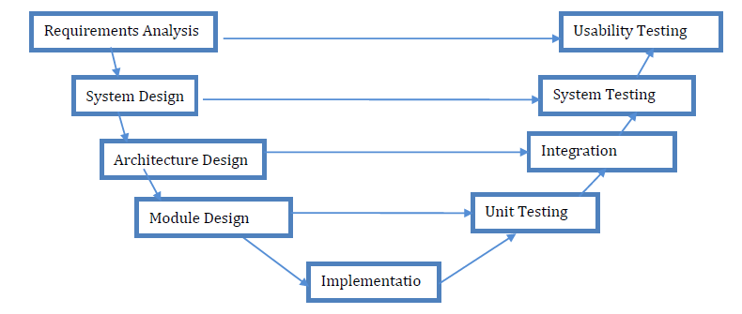
3.2 Analysis of the Existing System
In existing, we need to maintain the Excel sheets, CSV etc. files for the user daily and monthly expenses. In existing, there is no as such complete solution to keep a track of its daily expenditure easily. To do so a personas to keep a log in a diary or in a computer, also all the calculations needs to be done by the user which may sometimes results in errors leading to losses.
3.3 Problems of Existing Procedures
There can be many disadvantages of using a manual accounting system. Accounting, for any business, can be a complex undertaking. A manual accounting system requires you to understand the accounting process in a way that may be unnecessary with a computerized accounting system. This can be an advantage or a disadvantage, depending on the person doing the bookkeeping; often, a specially trained professional is needed to ensure that accounting is done properly. Unraveling the complexity of your financial records by hand may be time consuming. Since it takes time to generate reports.

3.4 Description of the Proposed System
To reduce manual calculations, I propose an application. The newly developed expense tracker system is designed to provide a seamless and intuitive user experience, leveraging advanced technologies to enhance accuracy, customization, security, and user engagement. The expense tracker begins with a simplified onboarding process that guides users through setting up their accounts. Users can easily link their bank accounts and credit cards by following clear, step-by-step instructions. The system uses secure APIs to connect with financial institutions, ensuring that data is imported automatically and securely. During this setup phase, users can also customize their financial goals, budget categories, and preferences, tailoring the application to their specific needs from the outset. Users can create detailed budgets for different spending categories, such as groceries, entertainment, and utilities. The system provides real-time tracking of budget progress, alerting users when they approach or exceed their limits. Additionally, the system generates personalized financial insights and reports, highlighting spending patterns and offering suggestions for optimizing expenses. These insights are powered by data analytics and tailored to each user's financial behavior.
This application allows users to maintain a digital automated diary. Each user will be required to register on the system at registration time, the user will be provided id, which will be used to maintain the record of each unique user. Expense Tracker application which will keep a track of Income-Expense of a user on a day to day basis. This ideal practice guarantees that the expenses tracked are accurately and in a timely manner. From a company perspective, timely settlements of these expenses when tracked well will certainly boost employees' morale. Additional feature of Expense and income prediction helps to better budget management. Flexible budgeting tools that enable users to set and adjust budgets for various categories and track their progress in real time.
3.5 Advantages of the Proposed System
The proposed expense tracker offers several advantages over existing systems:
- User-Friendliness: A streamlined and intuitive user interface that simplifies the process of tracking expenses and managing finances.
- Accuracy: Improved transaction categorization and reporting accuracy through advanced AI and machine learning techniques.
- Customization: Enhanced customization options that allow users to tailor the application to their specific needs and preferences.
- Security: Robust security measures to protect user data and maintain user trust.
- Engagement: Features designed to maintain long-term user engagement and provide continuous value, such as gamification and personalized financial insights.

CHAPTER FOUR
IMPLEMENTATION AND DOCUMENTATION OF THE SYSTEM
- Design Of The System
Output design in the system focuses on how information is presented to users. This includes designing reports, notifications, and visual displays that are intuitive and informative for stakeholders
4.1.1 Output Design

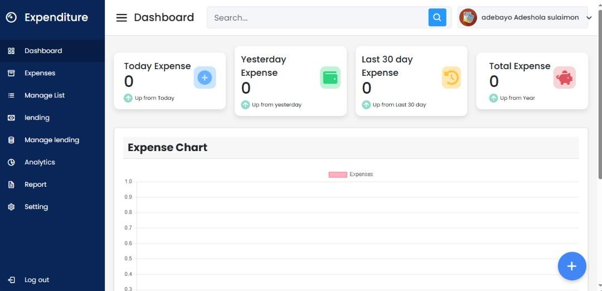
Figure 4.1: Dashboard
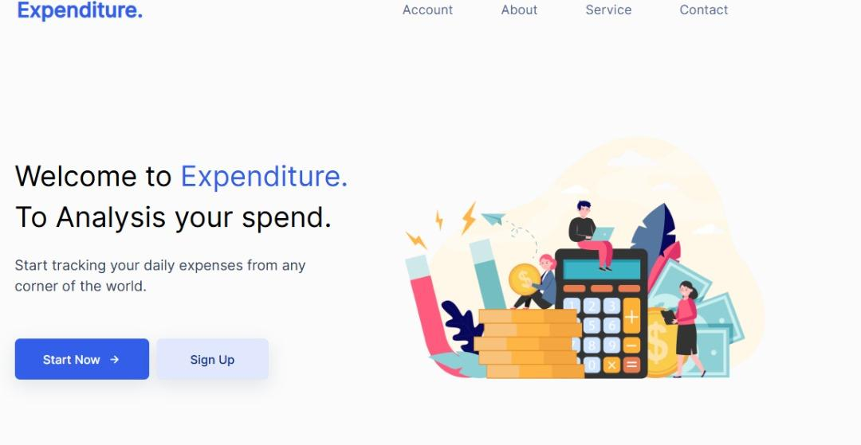
Figure 4.2: Welcome Page
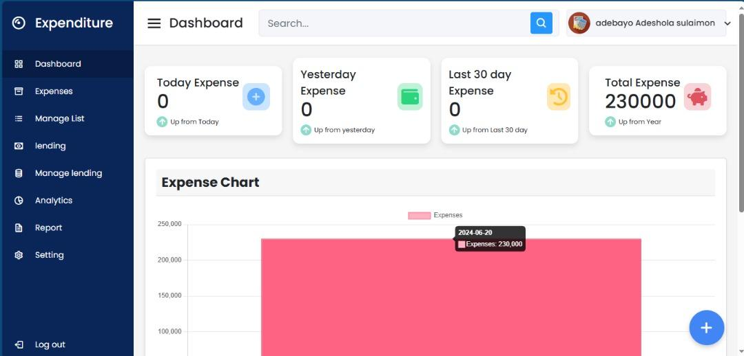
Figure 4.3: Expense Chart
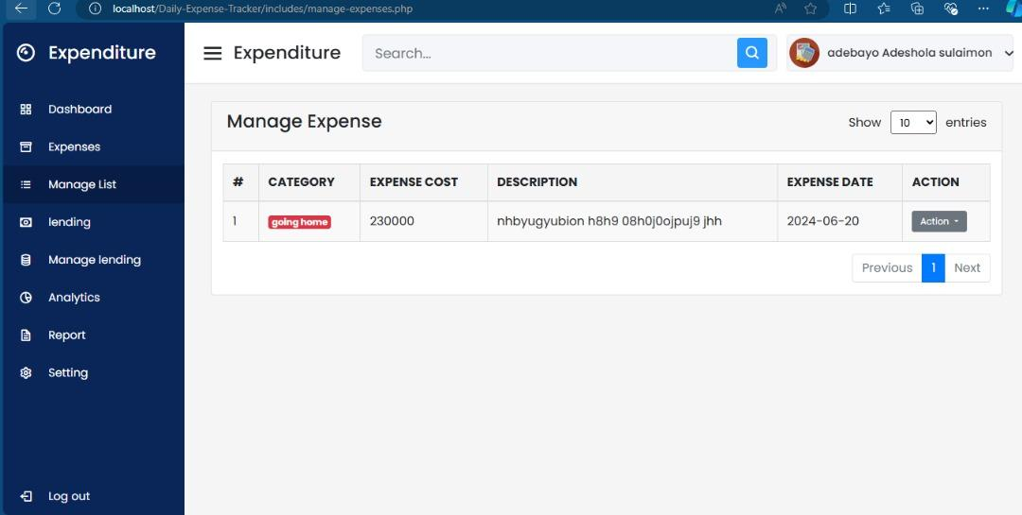
Figure 4.4: Manage Expense
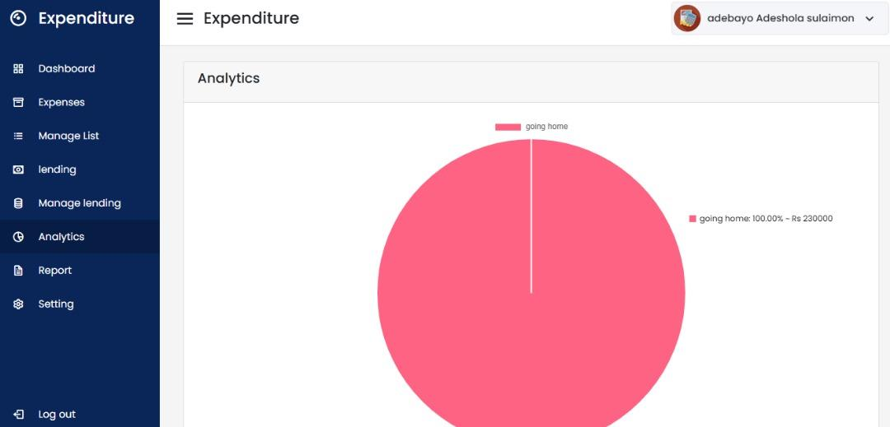
Figure 4.5: Analytical View

4.1.2 Input Design
The input to be extracted from the proposed system are displayed below
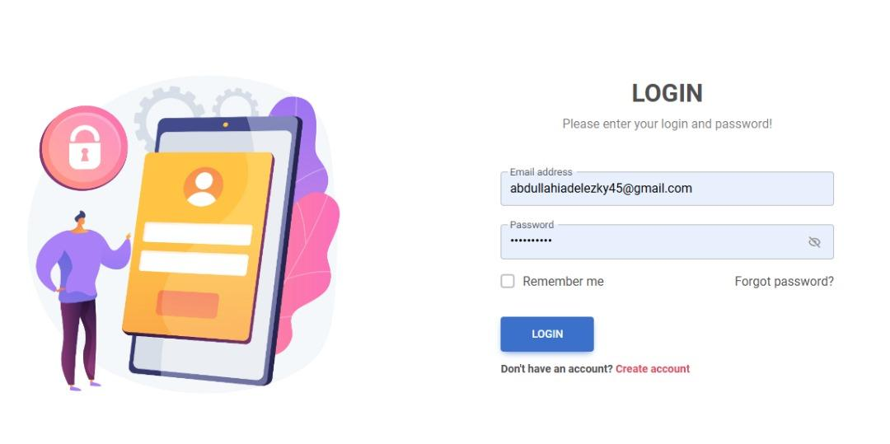
Figure 4.6: Login menu

Figure: 4.7: Signup Page

4.1.3 Database Design
Database Design is the collection of related data in an organized mechanism that has the capability of storing information. End-user can retrieve stored information effectively and efficiently which has the means of protecting them.
In an Automated Security Lock System, data are handled using a WAMP server as the server-side for the design. The database design is structured using Mysql and PHP linking codes.
Below is the database design of the system:
Table 4.1 Administrator table in PHPMyAdmin
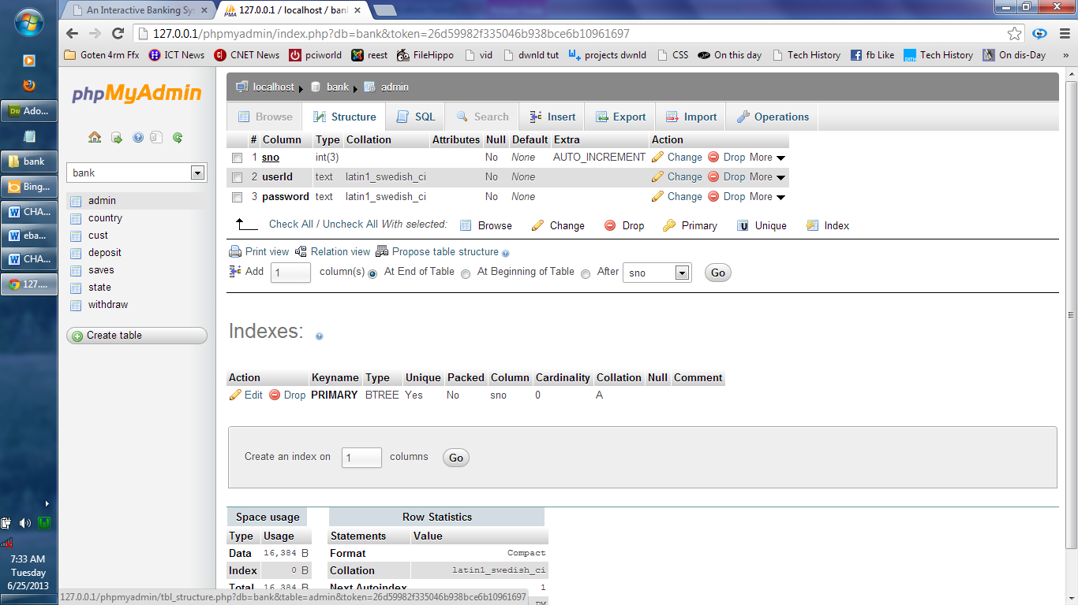

Table 4.2 view for all encrypted message
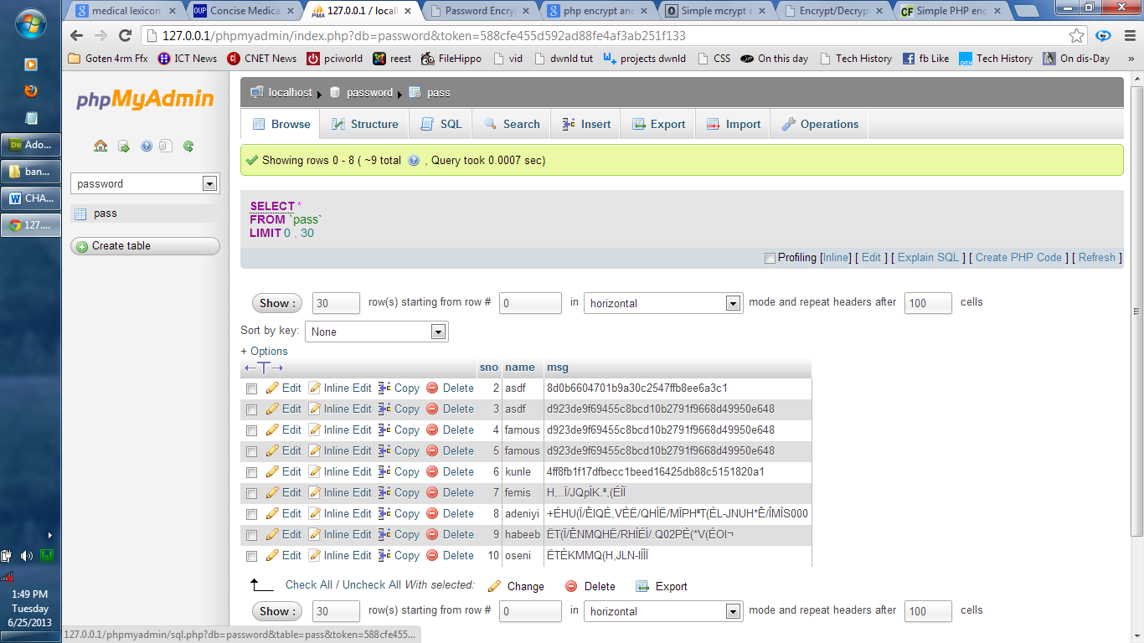
4.1.4 Procedure Design
The procedural design describes the system generally. It describes the various main programs in the system as well as the relationship that exists between all subprograms included. The procedural designs in this new system are of 5 menus of which each menu has its sub menu.
The application also contains several modules of which each module has its specific function. The purpose of dividing the program into modules is because it enhances maintainability, readability, and easy debugging.
4.2 System Implementation
4.2.1 Choice of Programming Language
PHP is the chosen programming language for the implementation of the proposed system because of its pedagogy and open-source help when needed. As well it has support for a variety of database applications like SQL servers, SQLite, MySQL, and Microsoft Access but Mysql is selected.
4.2.2 Hardware Support
The computer configuration required to run the software is; Computer/Memory processor PC with a 48dx, MHZ or Pentium, Intel, or higher processor required.
Memory : 512MB of RAM
Cache memory : 512KB
Hard disk Minimum size : 10.2GB
Recommended : 40GB
Virtual Memory : 32Bits
Cache memory : 512KB
Floppy disk drive : 1.44MB

4.2.3 Software Support
The software support for the design of the proposed system involves an operating system, Microsoft visual studio 12, MYSQL as well as an anti-virus software that prevents the system from being infected by viruses.
4.2.4 Implementation Techniques used in Details
The system will be implemented using the parallel approach. This approach is considered because it ensures that the new system is tested alongside the old system to ensure the effectiveness and efficiency of the system.

4.3 System Documentation
4.3.1 Program Documentation
The system must be used as instructed according to the hardware and software supports to make optimal use of it.
4.3.2 Operating the System
- Click start on the computer desktop
- Select all programs
- Select any browser e.g Internet Explorer, Mozilla Firefox, Google Chrome e.t.c
- Type the URL (Uniform Resource Locator) of the system into the address bar (localhost/password/)
4.3.3 Maintaining the System
Maintenance is any activities carried out after the implementation of the new system to make sure that the system is correctly and constantly running. This can be any of the following types of maintenance.
- Corrective maintenance: This is done to correct any defect that discovers in the course of using the new system to keep the system in tune with day-to-day functions.
- Adaptive maintenance: This is done to make sure that the system is not obsolete and adapts to any new systems of technology.
- Preventive Maintenance: This is a kind of maintenance adopted for continuous improvement in a new system without waiting for failure to occur or for the user to change. This is adopted to prevent the occurrence of failure.

CHAPTER FIVE

SUMMARY, CONCLUSION, AND RECOMMENDATION

5.1 Summary
This study has focused on the design and implementation of an advanced expense tracker system aimed at improving financial management practices for users. The research began with a comprehensive review of existing literature and systems related to expense tracking, highlighting the evolution of financial technology and the role of digital tools in enhancing financial literacy. Based on this foundation, a mixed-methods research approach was employed to gather user requirements and feedback, analyze existing systems, and develop a robust solution. The newly developed expense tracker system integrates state-of-the-art technologies such as AI, machine learning, and cloud computing to automate transaction imports, enhance categorization accuracy, and provide real-time financial insights. It offers a user-friendly interface with customizable budgeting tools, personalized notifications, and gamification features to maintain user engagement. Security measures include advanced encryption and multi-factor authentication to protect user data, ensuring compliance with data protection regulations.

5.2 Conclusion
In conclusion, the development of the expense tracker system represents a significant advancement in personal financial management tools. By addressing the limitations of existing systems through technological integration and user-centric design, the system promotes better financial decision-making and enhances financial literacy among users. The automated features streamline expense tracking processes, while personalized insights and budgeting tools empower users to manage their finances effectively. The system's cross-platform accessibility and integration with other financial services further enhance its utility and convenience.

5.3 Recommendations
Based on the findings and implementation of the expense tracker system, several recommendations are proposed:
- Continuous Improvement: Regular updates and enhancements should be prioritized to adapt to evolving user needs and technological advancements. This includes refining AI algorithms for better transaction categorization and incorporating new features based on user feedback.
- User Education and Support: Providing comprehensive user guides, tutorials, and customer support channels can help users maximize the benefits of the expense tracker system. Education initiatives on financial literacy could also be integrated into the platform to empower users further.
- Expand Integration: Further integration with a wider range of financial institutions, investment platforms, and financial planning tools would enhance the system's utility and provide a more holistic view of users' financial health.
- Enhanced Security Measures: Continuously upgrading security protocols and staying abreast of data protection regulations to maintain user trust and safeguard sensitive financial information.
- Research and Development: Investing in ongoing research and development initiatives to explore emerging technologies and trends in fintech, ensuring the expense tracker system remains at the forefront of innovation in personal finance management.

References
Hamari, J., Koivisto, J., & Sarsa, H. (2014). Does Gamification Work? : A Literature Review of Empirical Studies on Gamification. 2014 47th Hawaii International Conference on System Sciences, 3025-3034.
Johnson, P. (2018). Cloud Computing in Personal Finance Management. Tech Trends in Finance, 12(3), 120-134.
Li, Y., & He, K. (2017). Automated Data Entry in Expense Trackers: Benefits and Challenges. Journal of Financial Technology, 15(3), 225-238.
Venkatesh, V., & Davis, F. D. (2000). A Theoretical Extension of the Technology Acceptance Model: Four Longitudinal Field Studies. Management Science, 46(2), 186-204.
Venkatesh, V., Morris, M. G., Davis, G. B., & Davis, F. D. (2003). User Acceptance of Information Technology: Toward a Unified View. MIS Quarterly, 27(3), 425-478.
Zhang, Q., & Liu, J. (2021). Ensuring Security in Financial Applications: A Comprehensive Review. Cybersecurity Journal, 25(3), 300-315.
DeLone, W. H., & McLean, E. R. (1992). Information Systems Success: The Quest for the Dependent Variable. Information Systems Research, 3(1), 60-95.
Jain, P., & Ghatge, S. (2019). Evolution of Personal Finance Applications: A Historical Perspective. Journal of Financial Services Marketing, 24(2-3), 61-74.
Brown, R., & Smith, L. (2022). The Role of AI in Modern Expense Trackers. Journal of Financial Innovation, 14(1), 55-68.
Anderson, R., & Lee, C. (2019). Integrating Financial Services with Expense Trackers. Journal of Financial Technology, 23(2), 158-173.
Stone, M., & Woodcock, N. (2014). Interactive, Direct and Digital Marketing: A Future that Depends on Better Use of Business Intelligence. Journal of Research in Interactive Marketing, 8(1), 4-17.
Mintz, S. (2011). Personal Finance Software History. Financial Technology Review, 10(1), 45 50.
Park, C., & Lee, T. M. (2009). Information Orientation, Productivity, and Business Performance: A Study of Internet-based Systems Adoption. Information & Management, 46(1), 10-16.

