Sensory evaluation of cookies produced from blend of Wheat flour, fonio flour and bambara GROUNDNUT FLOUR

BY:

KAZEEM KAOSARA TOLANI
ND/23/FST/PT/0003
BEING A PROJECT WORK SUBMITTED TO THE
THE DEPARTMENT OF FOOD AND SCIENCE TECHNOLOGY, INSTITUTE OF APPLIED SCIENCES, KWARA STATE POLYTECHNIC ILORIN, KWARA STATE

IN PARTIAL FULFILLMENT OF THE REQUIREMENT FOR THE AWARD OF NATIONAL DIPLOMA (ND) IN FOOD AND SCIENCE TECHNOLOGY

SEPTEMBER, 2025
CERTIFICATION
This is to certify that this project work presented by KAZEEM KAOSARA TOLANI (ND/23/FST/PT/0003) has been read, approved and submitted to the Department of Food and Science Technology, Institute of Applied Sciences, Kwara State Polytechnic, Ilorin.

_____________________________ ___________________
MRS. ZAKARIYA I.M DATE
(Project Supervisor)

_____________________________ ___________________
MRS. MAIYAKI T.D DATE
(Project Coordinator)

_____________________________ ___________________
MR. AGBAJE RAFIU DATE
(Head of Department)

_____________________________ ___________________
(External Examiner) DATE

DEDICATION
This project work is dedicated to Almighty God and my darling parents, MR. and MRS. KAZEEM May you reap the fruit of your labour, Ameen.

ACKNOWLEGDEMENT
My profound gratitude goes to the almighty God, the creator of all things. I thank Him for His faithfulness, favor, grace and mercies towards me from the beginning of my programme to the end, and for a successful project.
My immense appreciation goes to my honorable supervisor, a great mother, a great and wonderful lecturer and a friend indeed, MRS. ZAKARIYA I.M for her immense support. Despite all the stress and tight schedules, she still found time to go through my work correcting mistakes therein. I pray that may Almighty God richly reward her in double fold. Ameen.
To all lecturers in the Department of Food and Science Technology, I appreciate you all for your guidance and professional advice towards my educational pursuit in this great school. May God bless you all.
My sincere gratitude goes to my head of department (HOD), MR. AGBAJE RAFIU for his fatherly advice, I pray God increase his knowledge and understanding. To other lecturers, for your immeasurable impacts in my life I say thank you to you all.
Also, to my lovely parents, MR. and MRS. KAZEEM, for their support on my educational pursuit. Thank you for all the support.
My special gratitude goes to all my friends and families. Thank you all for your support.

TABLE OF CONTENTS
Title Page
Certification
Dedication
Acknowledgement
Table of Content
Abstract
CHAPTER ONE: INTRODUCTION
1.1 General Background of the Study
1.2 Statement of the Problem
1.3 Justification of the Study
1.4 Aim and Objectives
1.4.1 Specific Objectives
1.5 Research Questions
1.6 Significance of the Study
1.7 Scope and Limitations
1.7.1 Scope of the Study
1.7.2 Limitation of the Study
1.8 Definition of Terms
CHAPTER TWO: LITERATURE REVIEW
2.1 Origin of Wheat
2.1.1 Wheat Description and Cultivation
2.1.2 Contribution of Wheat to Dietary Intake of Nutrients
2.1.3 Chemical Composition of Wheat
2.1.4 The Nutritional Composition of Wheat
2.1.5 Uses of Wheat
2.2 Acha (Digitaria exilis and Digitaria iburua)
2.2.1 Food Uses of Acha
2.2.2 Nutritive Value and Health Benefits of Acha
2.3 Bambara Nut
2.3.1 Nutritional Values and Health Benefits of Bambara Groundnut
2.3.2 Numerous Health and Nutritional Benefits of Bambara Nut
CHAPTER THREE: MATERIALS AND METHODS
3.1 Source of Materials
3.2 Methods
3.2.1 Sample Preparations
3.2.2 Production of Fonio Flour
3.2.3 Production of Bambara Groundnut Flour
3.2.4 Formulation of Cookies Composite Flour
3.2.5 Production of Cookies
3.2.6 Sensory Evaluation
CHAPTER FOUR: RESULT AND DISCUSSION
4.1 Data Analysis and Results on Sensory Evaluation of Cookies Produced from Blend of Wheat, Fonio, and Bambara Groundnut Flour
4.1.1 Descriptive Statistics
4.2.1 The Colour
4.2.2 The Taste
4.2.3 The Flavor
4.2.4 The Texture
4.2.5 Overall Acceptability
4.2.6 Analysis of Variance (ANOVA)
CHAPTER FIVE: SUMMARY, CONCLUSION AND RECOMMENDATION
5.1 Summary
5.2 Conclusion
5.3 Recommendations
REFERENCES

ABSTRACT
This study investigates the feasibility of producing cookies using composite flour blends of wheat, fonio, and Bambara groundnut to enhance nutritional value and reduce reliance on imported wheat flour in Nigeria. The research focuses on processing these grains into flour, assessing their suitability for cookie production, and evaluating consumer acceptability through sensory analysis. Fonio and Bambara groundnut flours were prepared using established methods, and cookies were produced with varying proportions of the composite flour, with 100% wheat flour cookies serving as the control. Sensory evaluation, conducted with a 9-point Hedonic scale by 10 panelists, assessed color, taste, flavor, texture, and overall acceptability. Sample F received the highest ratings for color (8.6) and taste (8.2), while Sample A was rated highest for overall acceptability (7.5). Analysis of Variance (ANOVA) revealed significant differences in taste, flavor, texture, and overall acceptability (p < 0.05), with Sample E consistently scoring the lowest. The study demonstrates that wheat-fonio-Bambara groundnut composite flour is a viable alternative for producing nutritious and acceptable cookies, offering potential economic benefits by utilizing underutilized local crops and reducing wheat importation. Recommendations include developing mechanized harvesting and processing technologies to enhance Bambara groundnut utilization and support its large-scale production.

CHAPTER ONE
INTRODUCTION
- General Background of the Study
Cookies are nutritive snacks produced from unpalatable dough that is transformed into appetizing product through the application of heat in an oven (Oguntoyinbo et al., 2020). They are ready-to-eat, conveniences and inexpensive food product, containing digestive and dietary principle of vital importance. Cookies are bakery products consumed worldwide due to their affordability, convenience, palatability, and long shelf life (Durojaye et al., 2023).
Cookies contribute valuable quantities of iron, calcium, protein, calorie, fibre and some of the B-vitamins to our diet and daily food requirement. Soft wheat flour has been the major ingredient used in the production of cookies and other pastry products, but they can also be made with non-wheat flours such as sorghum, maize, pearl millet, plantain, acha grain or more suitably bambara-nuts flour. Cookies based on rye, barley, rice, maize, acha, amaranth and oat flour have been reported by several researchers. Protein enrichment studies on cookies have been carried out using brewer’s spent grain and some legumes, which are generally good source of proteins.
Wheat is the most popular cereal grain used for the production of confectionary products, because of its high protein (gluten) which combines strength and elasticity required in producing pastries and confectionaries for desirable texture and flavour (Potter and Hotchkiss, 2006;). Wheat flour, is considered as a major ingredient used in the production of cookies and other pastry products, is mostly imported by countries with unfavorable climates for wheat cultivation Local raw materials substitution for wheat flour known as composite flour is increasing due to the growing market for confectioneries Okolie, et al., (2018) Composite flour can be defined as a mixture of several flours obtained from roots and tubers, cereal, legumes, etc., with or without the addition of wheat flour (Adewole et al., 2018).Wheat flour has been composited with other non-wheat flours such as maize, sorghum, plantain, acha grain, pears, millet, bambara-nuts, oat, mushroom, et cetera, to produce snacks such as cookies.(Oguntoyinbo et al., 2020). Production of composite flour is to get a product that is better than the individual components (i.e. improved properties or performances, or in some cases, improved economies). The nutritional composition of flours from cereals is poor in lysine but rich in sulphur-containing amino acids; this can be improved by flours milled from other non-cereal flours.
Wheat is the third most important cereal crop after maize and rice, with world production of 695 million metric tons annually (FAO, 2018). Among the cereal flours, wheat is extensively used for baking products such as bread, cake and dough nut making among other uses. Wheat flour comprises of 8 to 13% protein, 72% carbohydrates, 1.5% fat, 2.5% sugar, 0.5% minerals and 12 to 13% moisture Wheat is low in protein and nutritionally not balanced because it is low in lysine, an essential amino acid (Adeomowaye et al., 2019). Hence, there is need for supplementation of wheat with high protein materials such as Bambara groundnut to improve the protein and essential amino acid as well as the functional properties of the wheat flour. Fortification of wheat flour with high protein materials from plant sources has been recognized (Akubor & Nwawi, 2019). Supplementation of wheat flour with Bambara groundnut flour could therefore enhance the nutritional quality of cookies. The need for strategic development in the use of inexpensive local resources in the production of staple foods has been promoted by organizations, such as; Food and Agricultural Organization (FAO) .
However, this resulted to the initiation of the composite flour program, the aim of which was to seek ways of substituting flours, starches and protein concentrates from indigenous crops, for as much wheat as possible in cookies. In Nigeria, reliance on wheat flour in the baking industries has over the years restricted the use of other cereals and legumes available for domestic use.
In recent years, government has through intensive collaboration with research institutes encouraged the use of composite wheat flours this initiative enhanced the use of flours from roots and tubers, legumes. The consumption of baked products by humans coupled with the escalation of wheat importation and difficulty in cultivating wheat in the tropics has focused attention on the need to explore the use of alternative local flours as supplements or substitutes for wheat flour in the baking industry. Many researchers have worked extensively on composite flour for the production of biscuits, buns, cakes and bread. According to Adewole et al., (2018) composite flour refers to the mixture of different concentrations of non-wheat flours from cereals, legumes, roots and tubers or mixture of flours other than wheat flour.
Composite flours are advantageous, owing to the fact that the inherent deficiencies of essential amino acids in wheat flour (lysine, tryptophan and threonine) are supplemented from other sources. Composite flour is better utilized for cookies production rather than for bread because of their ready-to eat form, relatively prolonged shelf-life, wide consumption and good eating quality.
The first cookies are thought to be test cakes bakers used to test the oven temperature. They date back as early as 7th Century A.D. Persia which is now Iran. They were one of the first countries to grow and harvest sugar cane. With war and exploration eventually sugar was introduced to the Mediterranean area and European countries and so were cookies and by the end of the 14th century, cookies were common place in European cities. The earliest cooking books from the Renaissance were chockfull of cookie recipes.
One popular type of cookie in Elizabethan England was a square short-cookie made with egg yolks and spices and baked on parchment paper. After the Industrial Revolution, improvements in technology led to more variety of cookies be available commercially. The base for all cookies was the same though: wheat flour, sugar and fats like butter and oil.

1.2 Statement of the Problem
Wheat is a major raw material in the baking industry, and fluctuating government policies as well as the current war between Russia and Ukraine have led to a skyrocketed price of the product vis-à-vis the health challenges encountered by gluten-intolerant consumers
Rapid population growth, climate change, intensive monoculture farming, and resource depletion are among the challenges that threaten the increasingly vulnerable global agricultural food system. Heavy reliance on a few major crops is also linked to a monotonous diet, poor dietary habits, and micronutrient deficiencies, which are often associated with diet-related diseases. Diversification of both agricultural production systems and diet is a practical and sustainable approach to address these challenges and to improve global food and nutritional security. This strategy is aligned with the recommendations from the EAT-Lancet report, which highlighted the urgent need for increased consumption of plant-based foods to sustain population and planetary health.
  - Justification of the Study
The demand for highly nutritious and healthy foods as well high cost of wheat importation necessitated the need to explore the use of composite flour for some food products). The nutritional composition of flours from cereals is poor in lysine but rich in sulphur-containing amino acids; this can be improved by flours milled from other non-cereal flours.
Bambara groundnut is a legume indigenous to Africa and is cultivated across the semi-arid sub-Saharan Africa region. It is a hardy crop and has been recognized as an important nutritious food source when food is scarce. This could be attributed to its climate-smart features, including its ability to fix nitrogen, and to grow under adverse environmental conditions such as poor soils and drought. This nutrient-dense legume is sometimes termed a “complete food” due to its balanced macronutrient composition.
Bambara groundnut contains ~64.4% carbohydrate, 23.6% protein, 6.5% fat, and 5.5% fiber and is rich in minerals. It is relatively underutilized compared with major cash crops and has often been associated with small-scale, subsistence farming, with women being the major producers and processors. The utilization constraints of Bambara groundnut include the knowledge gap in improved seed system, agronomic practices, processing, and utilization. Genetics, agronomy, and nutritional aspects of Bambara groundnut and its food uses have recently been reviewed by other authors. This explain the study of the potential role of Bambara groundnut in closing the gaps in the production of cookies. The modern model of using underutilized crop species regarding productivity, processing, consumption and research will to broaden uniformly in the prevailing global diet that is useful for the current world solution.
  - Aim and Objectives
To produced cookies from composite flour with the blend wheat, Fonio and Bambara groundnut flour at different proportion.
1.4.1 Specific Objectives
- To process the grain into flour for the production of cookies
- To assess the suitability of the flour for the production of cookies
- To carry out sensory evaluation on the product to determine the most preference.
1.5 Research Questions
- What’s the feasibility of processing wheat, fonio and Bamabara groundnut flour blend?
- Does wheat fonio and Bamabara groundnut blend flour suitable for production of cookies?
- What is the sensory acceptability level of wheat, fonio and Bamabara groundnut cookies?
1.6 Significance of the Study
- To educate the people on the quality, nutritional value, and benefit attached to the baked product, especially cookie produced from both wheat fonio and bamabara groundnut
- To educate the local populace about the economic importance of using this underutilized cereal and legumes in terms of cost, local availability, and production for small income holders and live hood
- It will contribute more knowledge and also make materials available for further research on the subject matter.
1.7 SCOPE AND LIMITATIONS
Scope of the Study
The study focuses on developing a protocol for producing cookies, evaluating its sensory properties, and comparing the best product with the control in term of consumer acceptability.
Limitation of the Study
The following are some of the constraints encountered during the course of this research.
- Time constraint: The research simultaneously collides with other academic work of the researcher, thus limiting the time devoted to the research.
- Financial constraint: insufficient funds tend to impede the efficiency ofthe researcher in sourcing for the relevant materials, literature or information and in the process of data collection.
1.8 DEFINITION OF TERMS
- Cookie- is a conventional wheat flour-based food product produced from unpalatable dough with the application of heat and transformed into an appetizing product.
- Composite flour-Composite flour can be defined as a mixture of several flours obtained from roots and tubers, cereal, legumes, etc., with or without the addition of wheat flour
- Cereal-Cereals are cultivated grasses, and their grains are used as food

CHAPTER TWO
LITERATURE REVIEW
2.1 Origin of Wheat
The first cultivation of wheat occurred about 10 000 years ago, as part of the ‘Neolithic Revolution’, which saw a transition from hunting and gathering of food to settled agriculture. These earliest cultivated forms were diploid (genome AA) (einkorn) and tetraploid (genome AABB) (emmer) wheats and their genetic relationships indicate that they originated from the south-eastern part of Turkey (Dvorak, 2007). Cultivation spread to the Near East by about 9000 years ago when hexaploid bread wheat made its first appearance (Feldman, 2001). The earliest cultivated forms of wheat were essentially landraces selected by farmers from wild populations, presumably because of their superior yield and other characteristics, an early and clearly non-scientific form of plant breeding. Wheat today currently, about 95% of the wheat grown worldwide is hexaploid bread wheat, with most of the remaining 5% being tetraploid durum wheat.
The latter is more adapted to the dry Mediterranean climate than bread wheat and is often called pasta wheat to reflect its major end-use. However, it may also be used to bake bread and is used to make regional foods such as couscous and bulgur in North Africa. Small amounts of other wheat species (einkorn, emmer, spelt) are still grown in some regions including Spain, Turkey, the Balkans, and the Indian subcontinent. In Italy, these hulled wheats are together called faro while spelt continues to be grown in Europe, particularly in Alpine areas (Fossati and Ingold, 2001). The recent interest in spelt and other ancient wheat (including kamut, a tetraploid wheat of uncertain taxonomy, related to durum wheat) as healthy alternatives to bread wheat.Wheat is one of the world’s most commonly consumed cereal grains. It comes from a type of grass (Triticum) that is grown in countless varieties worldwide. Bread wheat, or common wheat, is the primary species. Several other closely related species include durum, spelt, emmer, einkorn, and Khorasan wheat. White and whole-wheat flour are key ingredients in baked goods, such as bread. Other wheat-based foods include pasta, noodles, semolina, bulgur, and couscous. Wheat is highly controversial because it contains a protein called gluten, which can trigger a harmful immune response in predisposed individuals.
However, for people who tolerate it, whole-grain wheat can be a rich source of various antioxidants, vitamins, minerals, and fiber wheat, any of several species of cereal grasses of the genus Triticum (family Poaceae) and their edible grains. Wheat is one of the oldest and most important of the cereal crops. Of the thousands of varieties known, the most important are common wheat (Triticumaestivum), used to make bread; durum wheat (T. durum), used in making pasta (alimentary pastes) such as spaghetti and macaroni; and club wheat (T. compactum), a softer type, used for cake, crackers, cookies, pastries, and flours. Additionally, some wheat is used by industry for the production of starch, paste, malt, dextrose, gluten, alcohol, and other products.
2.1.1 Wheat description and Cultivation
The wheat plant has long slender leaves and stems that are hollow in most varieties. The inflorescences are composed of varying numbers of minute flowers ranging from 20 to 100. The flowers are borne in groups of two to six in structures known as spikelet’s, which later serve to house the subsequent two or three grains produced by the flowers. Though grown under a wide range of climates and soils, wheat is best adapted to temperate regions with rainfall between 30 and 90 cm (12 and 36 inches). Winter and spring wheat are the two major types of the crop, with the severity of the winter determining whether a winter or spring type is cultivated. Winter wheat is always sown in the fall; spring wheat is generally sown in the spring but can be sown in the fall where winters are mild.
Wheat is one of the oldest and most important of the cereal crops of the thousands of varieties known, the most important are common wheat (Triticumaestivum), used to make bread durum wheat (T. durum), used in making pasta (alimentary pastes) such as spaghetti and macaroni; and club wheat (T. compactum), a softer type, used for cake, crackers, cookies, pastries, and flours. Additionally, some wheat is used by industry for the production of starch, paste, malt, dextrose, and other products. (Encyclopedia Britannica 2022).
The major wheat species grown throughout the world is Triticumaestivum, a hexaploid species usually called “common” or “bread” wheat. However, the total world production includes about 35–40 mt of T. turgidum var. durum, a tetraploid species which is adapted to the hot dry conditions surrounding the Mediterranean Sea and similar climates in other regions. This is used for making pasta and is often referred to either as “pasta wheat” or “durum wheat”. Wheat is a global commodity, with about 150 mt being traded annually (World Agricultural Outlook Board, 2014). Hence, the pattern of production does not necessarily reflect the pattern of consumption. This is particularly significant for wheat, with increased consumption being associated with the adoption of a “western lifestyle” in countries undergoing urbanization and industrialization.

2.1.2 Contribution of wheat to dietary intake of nutrients

Wheat is often considered primarily as a source of energy (carbohydrate) and it is certainly important in this respect. However, it also contains significant amounts of other important nutrients including proteins, fiber, and minor components including lipids, vitamins, minerals, and phytochemicals which may contribute to a healthy diet.Wheat is widely consumed by humans, in the countries of primary production (Shewry and Hey 20015) and in other countries where wheat cannot be grown. For example, imported wheat is used to meet consumer demands for bread and other food products in the humid tropics, particularly those with a culinary tradition dating back to colonial occupation. Globally there is no doubt that the number of people who rely on wheat for a substantial part of their diet amounts to several billions. The high content of starch, about 60–70% of the whole grain and 65–75% of white flour, means that wheat is often considered to be little more than a source of calories, and this is certainly true for animal feed production, with high-yielding, low-protein feed varieties being supplemented by other protein-rich crops (notably soybeans and oilseed residues). However, despite its relatively low protein content (usually 8–15%) wheat still provides as much protein for human and livestock nutrition as the total soybean crop, estimated at about 60 m tonnes per annum (Shewry, 2000). Therefore, the nutritional importance of wheat proteins should not be underestimated, particularly in less developed countries where bread, noodles and other products (e.g. bulgur, couscous) may provide a substantial proportion of the diet. Nutritional composition of the wheat grain varies with differences in climate and soil. On average, a kernel of wheat contains 12 percent water, 70 percent carbohydrates, 12 percent protein, 2 percent fat, 1.8 percent minerals, and 2.2 percent crude fibers. Thiamin, riboflavin, niacin, and small amounts of vitamin A are also present
2.1.3 Chemical Composition of Wheat
Chemical composition refers to the arrangement type and ratio atoms in molecules of chemical substances. Chemical composition varies when chemicals are added or subtracted from a substance, when the ratio of subtracted changes, or when other chemical changes occur in chemicals.
MINERAL COMPOSITION OF WHEAT TABLE 2.1
Mineral | composition %
Carbon dioxide, CO₂ | 0.10
Silicon dioxide, S₁O₂ | 64.90
Potassium, K₂O | 7.87
Iron oxide, Fe₂O₃ | 6.78
Calcium oxide, C₉O | 5.64
Phosphenes oxide,P₂O₅ | 3.04
Magnesium oxide, M₅O | 1.74
Sulphur oxide, ₅O₃ | 0.83
Titanium oxide, T₁O₂
Chlorine, CL | 0.250
Zichronium, ZR | 0 <LLD
Loss on ignition (LOT) | -
S1o2+a1₂O₃+Fe₂O₃ | 79.64
Aluminiumdioxode, A1₂O₃ | 7.96

2.1.4 The Nutritional Composition of the Wheat
The nutritional composition of the wheat grain varies somewhat with differences in climate and soil. On an average, the kernel contains 12 percent water, 70 percent carbohydrates, 12 percent protein, 2 percent fat, 1.8 percent minerals, and 2.2 percent crude fibres. Thiamin, riboflavin, niacin, and small amounts of vitamin A are present, but the milling processes removes most of those nutrients with the bran and germ. Most wheat used for food requires processing. The grain is cleaned and then conditioned by the addition of water so that the kernel breaks up properly. In milling, the grain is cracked and then passed through a series of rollers. As the smaller particles are sifted out, the coarser particles pass to other rollers for further reduction. About 72 percent of the milled grain is recovered as white flour. Flour made from the whole kernel is called graham flour and becomes rancid with prolonged storage because of the germ-oil content retained. White flour, which does not contain the germ, preserves longer. Inferior and surplus wheats and various milling by-products are used for livestock feeds.
The greatest portion of the wheat flour produced is used for bread making. Wheats grown in dry climates are generally hard types, having protein content of 11–15 percent and strong gluten (elastic protein). The hard type produces flour best suited for bread making. The wheats of humid areas are softer, with protein content of about 8–10 percent and weak gluten. The softer type of wheat produces flour suitable for cakes, crackers, cookies, and pastries and household flours. Durum wheat semolina (from the endosperm) is used for making pastas, or alimentary pastes.

2.1.5 Uses of Wheat
- Wheat is milled to produce flour which is used to make a variety of products around the world including bread across the world. Wheat contains a protein called gluten which is necessary for the basic structure in forming the dough system for bread, rolls and other baked goods. Many of the foods we consume on a daily basis such as bread, cookies, cakes, pies, pastries, cereals, crackers, pasta, flour tortillas and noodles are all made from wheat flour.
- Wheat is used for cattle, poultry, and other livestock feed. Wheat is a raw material used for feed and animal production worldwide for its nutritional and economic value
- Wheat also forms the base for three extremely popular alcoholic drinks - whiskey, vodka, and beer.
- Young wheatgrass is becoming increasingly popular as a nutritional supplement offering vitamin A, B-complex, C, E, l and K
It is also extremely rich in protein, and contains 17 amino acids, which are the building blocks of protein.
- Since 2010, wheat has been substituted for corn and used to produce bioethanol in the UK and U.S.
- Some strains of wheat are grown to produce starch in South Asia used in textile manufacturing.
- In many countries, rural houses still use wheat straw to thatch their houses as well as mattresses and pillows.
- Wheat is also being used for plastics manufacturing and aquaculture feed purposes for both fish and shrimp.
2.2.0 Acha(Digitariaexilis and Digitariaiburua)
Acha (Digitariaexilis and Digitariaiburua) commonly, known as fonio or hungry rice is a cereal grain in the family of Gramineae. (Adekunle and Abiodun, 2018). Fonio species belong to the Poaceae family, sub-family of Panicoideae, a tribe of Paniceae, and the genus (Digitaria Halle). The genus Digitaria Haller comprises 230-325 annual and perennial grass species with a wide geographic distribution in the tropics and subtropics. (Balloguoet al. 2013) It is also a unique size of 0.4 - 0.5 mm.
Acha is considered the oldest West African cereal with cultivation dating back to 5000 BC. (Malomo and Abiose 2019). The plant is characterized by a height of 0.5–3 feet and many of them are small long grains usually yellow and dark in colour which makes its production tedious, coupled with the fact that its mechanization is virtually non-existence. The plant is known by different names in various communities in Africa: such as Acha in Nigeria, Findi in Senegal, Findo in Gambia, Folio in Serria loan, Founde in Mali, Fonio in Burkina Faso, Kpendo in Guinea, Podgi in Benin Republic and Pom-Polin in Cote Devior. Acha production has the potential to play an important role in the improvement of food security (Suleiman et al., 2015). It is widely grown in Nigeria in the cool region of Plateau, part of Bauchi, Kebbi, Taraba, Kaduna, and Niger States. According to (Gyang and Wuyep 2005), the English name hungry rice, believed to have been coined, by Europeans is considered misleading by some authors (Ibrahim and Saidu, 2017). Acha (Digitariaexilis and Digitariaiburua) are similar in shape, size, and nutritional composition, except for the differences in the morphological characteristics of the kernel. They are an annual cereal crop indigenous to West Africa where it is unique, in that it has greater methionine content than cultivated for its straw and edible grains. (Chukwu and Abdulkadir 2008).
In West Africa, the common species cultivated are Digitaria exilis (white acha), and Digitariaiburua (blackacha). Acha is now being gradually "rediscovered" and considered for improvement as cultivated species. (Okemoet al., 2017) Acha or Fonio is a great crop of antiquity and the most ancient indigenous cereal of West Africa with a cultivation history dating back to 7000 years Cruz, (2004) but has a low yield of 931 kgha⁻¹. Acha is a low-input demanding crop which tolerates a wide range of soils, including loamy, sandy, stony, and shallow but not waterlogged clayed soils indexes Philip and Itodo (2006).
Acha is a very handy crop and can grow well on poor soils, it can even produce seed on soils with Aluminum levels that are toxic to other crops and can be relied on in dry savannah lands, where rains are brief and unreliable. The tiny grains are gluten-free and are rich in protein; consumers outside Africa are beginning to recognize its flavour and nutritional quality. Folio is sometimes regarded as the “grain of life” as it provides food early in the farming season when other crops are yet to mature for harvest (Ibrahim, 2001). Among the native crop of Africa, it is selected as a target for biotechnology because of its exceptional culinary and nutritional properties. In Nigeria, fonio products are currently recommended as a choice of carbohydrate for diabetic patients today.
2.2.1 Food Uses of Acha
Some varieties of traditional food prepared from acha include thick porridge (tuwo), thin porridge(kunu), steamed products (brabusco or couscous), gwote, and alcoholic beverages. The grains of acha can also be boiled like rice and eaten with stew. Flour can be prepared from acha which may be fortified with other cereals flour for the production of porridge or pudding cooked in various forms with fish, meat, legumes, or vegetables. In some parts of Nigerian states such as plateau, Bauchi, and Kaduna, acha grain is not only consumed as food but the straws are burnt to produce ash of which its filtrate is used for cooking indigenous delicacies. The grains could be used for cookies, crackers, and popcorn. Whole meal acha (Digitariaiburua) flours can be used in the preparation of some biscuits and snacks that could be useful for individuals with gluten intolerance (Adekunle and Nkama, 2003).
2.2.2 Nutritive value and health benefits of acha
According to Adekunle and Gidado (2017), acha contains low glycemic content of about 40% and low free sugar which makes it a good diet for diabetic patients as there is an increase in the rate of diabetes among teenagers and people have been advised to avoid refined grain products. (Jideani and Podgorski 2009) reported that in-vitro, starch digestibility and glycemic property of achaiburu and maize porridge analyzed contain high crude protein content of about 8.7% while in some black acha samples it is up to 11.8% which is high in leucine (19.8%), methionine and cysteine of about 7% and valine (5.5%) of essential amino acid.
Black acha contains essential amino acids with higher values in leucine, methionine, and cystine (Adekunle and Gidado 2017). According to Sadiqet al. (2015), black and white foniowere analyzed and the black species had the highest nutrient value. Black fonio contains crude fibre 1.3%, carbohydrate 79.72%, ash 2.31%, crude protein 8.75%, and moisture 7.0%. On the other hand, white fonio contains 7.11% crude protein, 3.0% crude fats, 0.79% crude fiber, 79.72% carbohydrate and moisture 7.9%. Table 2.8 show the essential amino acid composition and table 2.9 shows the anti-nutritional factor composition of Acha(Digitaria Exilis)
2.3 Bambara Nut
Bambara nut is considered the third common major legume after groundnuts. Bambara groundnut or nuts is regards as a false nut, rather it is alegume and contains lots of protein as well. It is mainlyused in cooking especially in the making of Okpa which can be taken along with pap (Akamu or Ogi), drinks, soaked garri flakes and others. It can also be eaten fresh or boiled after drinks, and can be ground either fresh or dry to make puddings. Bambara nit is a sustainable low-cost source of complex carbohydrate, plant-based proteins, unsaturated fatly acids, and essential minerals (masnesium, iron, zinc, and potassium) especially for those living in arid and semi-arid regions. Scientific name: Vigna subterranean Family: FabaceaeSubfamily: FaboideaeOrder: FabalesKingdom: Plantae.
Bambara groundnut is indigenous to sub-Saharan Africa where it is widely cultivated. The centre of origin is most likely North-Eastern Nigeria and Northern Cameroon, in West Africa. The species is also grown to a lesser extent in some Asian countries such as India, Malaysia, Philippines and Thailand.
2.3.1 Nutritional Values and Health Benefits of Bambara Groundnut
This type of food crop, also known as Bambara nuts is predominately cultivated in West Africa, it is a type of groundnut and also is one of the common food sources in Nigeria as it used in the production of various food delicacies. It might be surprising to say that most people in Nigeria may not be conversant with this name as the local name is commonly used but it forms most parts of some families' daily meal. Locally, it is called Okpa (Igbo), Epa- Roro (Yoruba), Kwaruru or Gurjiya (Hausa).Just like groundnuts, Bambara groundnut or nuts is regarded as a false nut, rather it is a legume and contains lots of protein as well. It is mainly used in cooking especially in the making of Okpa which can be taken along with Pap (Akamu or ogi), drinks, soaked garri flakes, and others.
The method of cooking the nut (Okpa) is by steaming which after grounded into flour is used in the preparation, and this makes all the ingredients to remain intact, thus making it highly nutritive. It can as well be roasted, properly salted and then eaten as a snack or used in the making of probiotic beverages.
Most times, the Bambara groundnut is consumed because it gives energy and tastes great when prepared well but it has other great health benefits which make it a must-eat for everyone.
Its nutrients consist of carbohydrates, protein, fat, fiber content, vitamins, minerals such as manganese, potassium, fluoride, magnesium, calcium, phosphorus, zinc, selenium, sodium, iron, copper, etc., and just like milk, it too is regarded as a complete food.
2.3.2 The NumerousHealth and Nutritional Benefits of Bambara Nut Includes;
- It has all the essential nutrients that food needs and because of this, it helps in the prevention of malnutrition and other health problems such as kwashiorkor, rickets, etc., which are triggered or caused by poor and inadequate dieting.
- It helps in reducing the effects of various health conditions such as anemia as it contains iron and other essential nutrients which boost the body's blood level.
- It also helps in reducing the chances of getting cancer and other health issues because of the presence of antioxidants that protects the body from harmful food chemicals.
- The minerals contained in the Bambara nuts such as calcium protects the body from arthritis, osteoporosis and other related bone diseases.
In as much as Bambara nuts or groundnuts is well known for its food source, it is also good to know that its health benefits are almost second to none, as it is used for various medicinal and therapeutic purposes, and contains all the nutrients that our body needs to function well.

CHAPTER THREE
3.0 MATERIALS AND METHODS
3.1 Source of Materials
Bamabara groundnut and fonio was procured at kofarmata market in kano state wheat flour, sugar, cocoa powder baking powder, butter baking soda nutmeg powder vanilla essence used for this study were purchased from Oja Oba market, Ilorin,
3.2 Methods
3.2.1 Sample preparations
3.2.2 Production of fonio flour
Fonio flour was produced using the method described by Nkirukaet al., 2020
- Cleaning (Manually) fonio cereal cleaning was done by hand-picking to remove stones, husks, broken grains, and other physical impurities. This ensures hygienic processing and improves the quality of the flour.
- Washing the grain was washed to remove dust, surface dirt, and microbial contaminants from the grains which also contributes to better flour color and hygiene.
- The grain was boiled in water for 5 minute and drained
- It was then steeped in water for 24 hours
- Oven drying (110°C for 1hrMinutes)
- The dried fonio grain was dry mill using hammer Mill into fonio flour
- Sieve (Using 212 µm Sieve Size)

Fonio
Cleaning
Washing
Boiling for 5minutes
Draining
Steeping 24hrs
Cabinet drying 110°C for 1hr
Dry milling
Sieving (0.6mm)
Fonio flour
Figure 3.1: Flow chart of fonio flour
Source: Nkiruka et al., 2020
3.2.3 Production of Bambara Groundnut flour
Bambara groundnut flour was produced using the method descried by
- Cleaning (Manually) by hand sorting was done by hand-picking to remove stones, husks, broken grains, and other physical impurities. This ensures hygienic processing and improves the quality of the flour.
- The Bambara groundnut was soaked for 24hours and dehulled manually oven dried at 60°C for 18hours
- Milling into flour then sieve using 0.25 um sieve and package

Production of Bambara groundnut flour
Bambara groundnut grain
Sorted
Soaked (24 hours)
Dehulled (manually)
Oven dried (60 0c for 18 hours)
Milled (Hammer mill)
Sieved (0.25 um sieve)
Bambara groundnut flour
Figure 3.2: Flow chart of Bambara flour
Source: Eke-ejiofor
Table 3.1 Formulation of Cookies Composite Flour
 |  | WF  g | BGF  g | ACF | Butter  G | Nutmeg | Egg | sugar  g | Cocopowder g | Baking soda | Baking powder
1 | Sample A | 180 | 10 | 10 | 100 | 1/8 tsp | 1unit | 68 | 5 | ½ tsp | ½ tsp
2 | Sample B | 170 | 10 | 20 | 100 | 1/8 tsp | 1unit | 68 | 5 | ½ tsp | ½ tsp
3 | Sample C | 160 | 20 | 20 | 50 | 1/8 tsp | 1unit | 68 | 5 | ½ tsp | ½ tsp
4 | Sample D | 150 | 30 | 20 | 45 | 1/8 tsp | 1unit | 68 | 5 | ½ tsp | ½ tsp
5 | Sample E | 50 | 25 | 25 | 40 | 1/8 tsp | 1unit | 68 | 5 | ½ tsp | ½ tsp
6 | Sample F | 100 | - | - | 35 | 1/8 tsp | 1unit | 68 | 5 | ½ tsp | ½ tsp

Production of Cookies
The cookies were prepared following the procedure used by (Chauhan et al., 2016) with some modifications. The recipe that was used has the following ingredients: flour at different composition blend for wheat flour, Bambara groundnut flour and fonio flour to form the composite flour. Butter, sugar, egg, salt, baking soda, nutmeg powder vanilla essence, baking powder and water were mixed at different proportion as shown in table 3.1. The margarine and sugar were mixed using a Kenwood hand-mixer until a fluffy mixture was formed followed by the addition of eggs and mixing at a constant speed until foaming appears in about 3 min. The flour and all other ingredients including water were added and mixed until a homogenous dough was formed in about 2 min. The dough was kneaded to a uniform sheet of 6 mm thickness and cut into round shapes using a 45-mm-diameter stainless steel cookie cutter and baked at 170 °C for 11 min. The baked cookies were allowed to cool at room temperature (25±2 °C) for 1 h and were packed in airtight zip lock bags for further uses. Cookies prepared from 100% wheat flour served as the control sample
Sensory evaluation
Sensory evaluation was done with 10 panelists in the sensory laboratory. Panelists were required to evaluate taste, texture, color, flavour and overall acceptability using a 9-point Hedonic scale with corresponding descriptive terms that ranged from 9 - like extremely to 1 - dislike extremely.
IMAGES OF COOKIES SAMPLES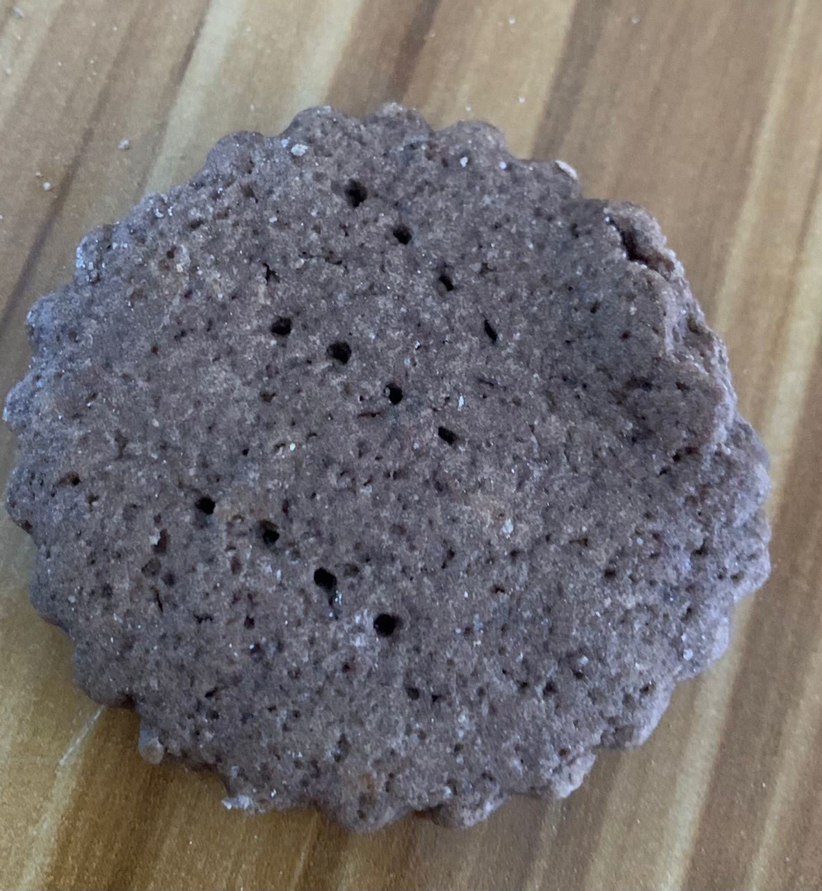
A

B

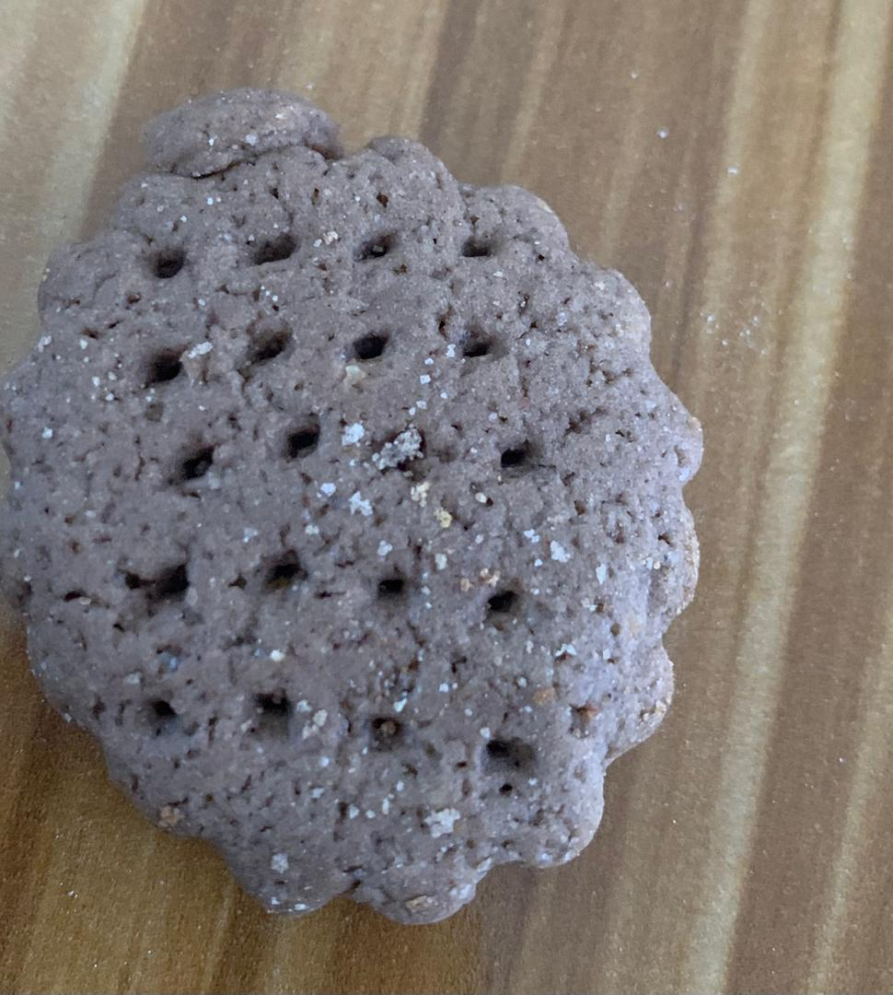
IMAGES OF COOKIES SAMPLES
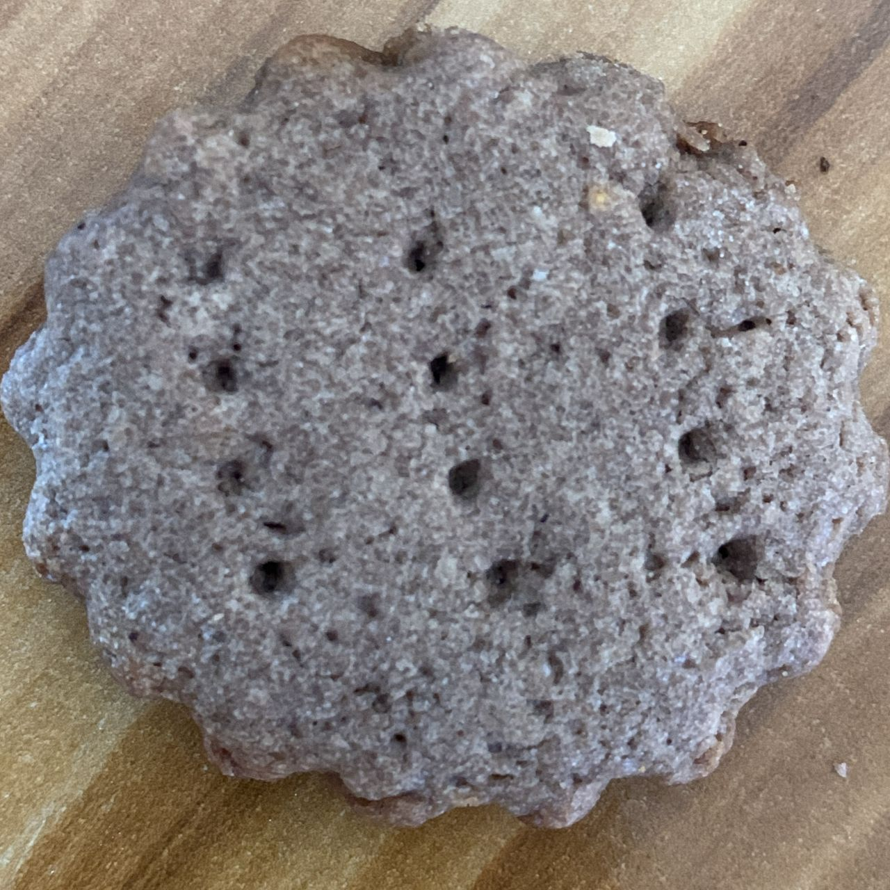
C

D

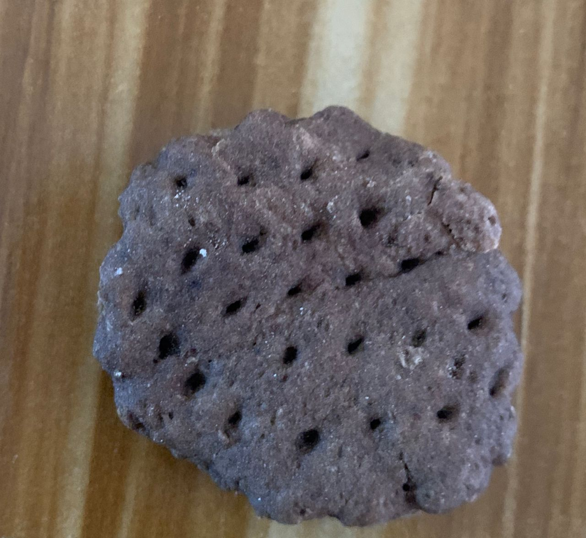

IMAGES OF COOKIES SAMPLES
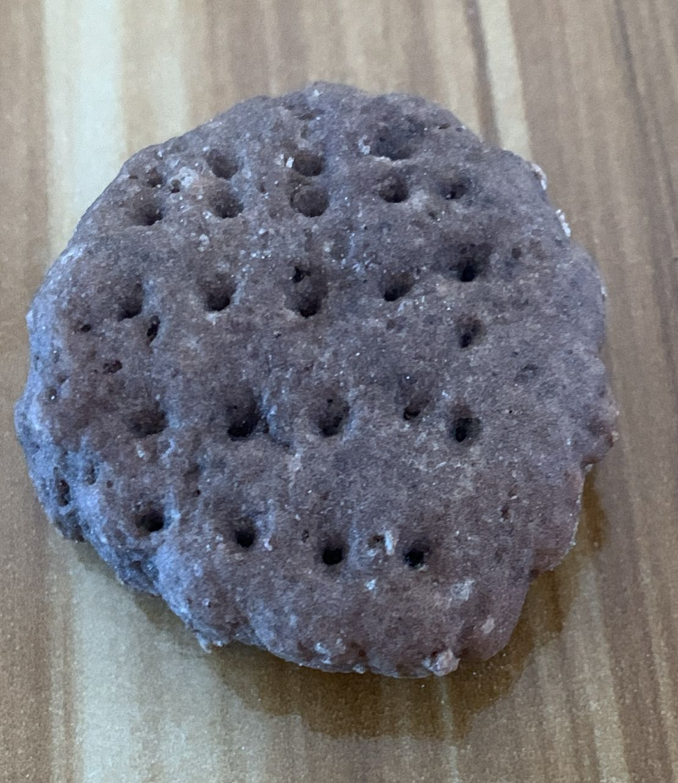
E

F

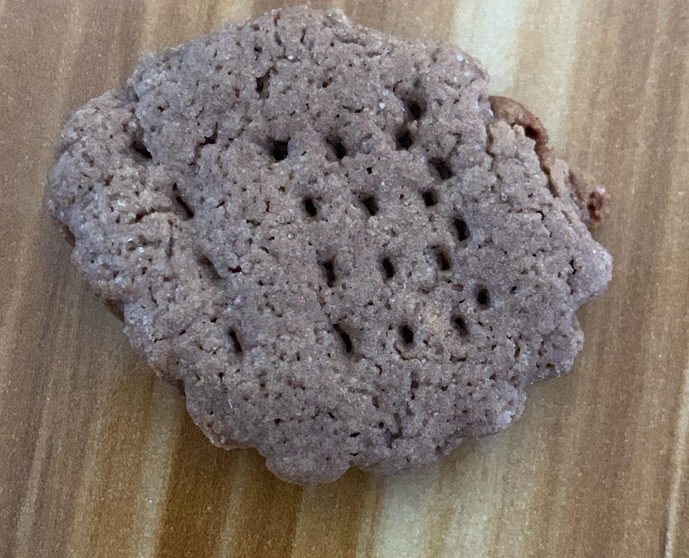
PACKAGE COOKIES

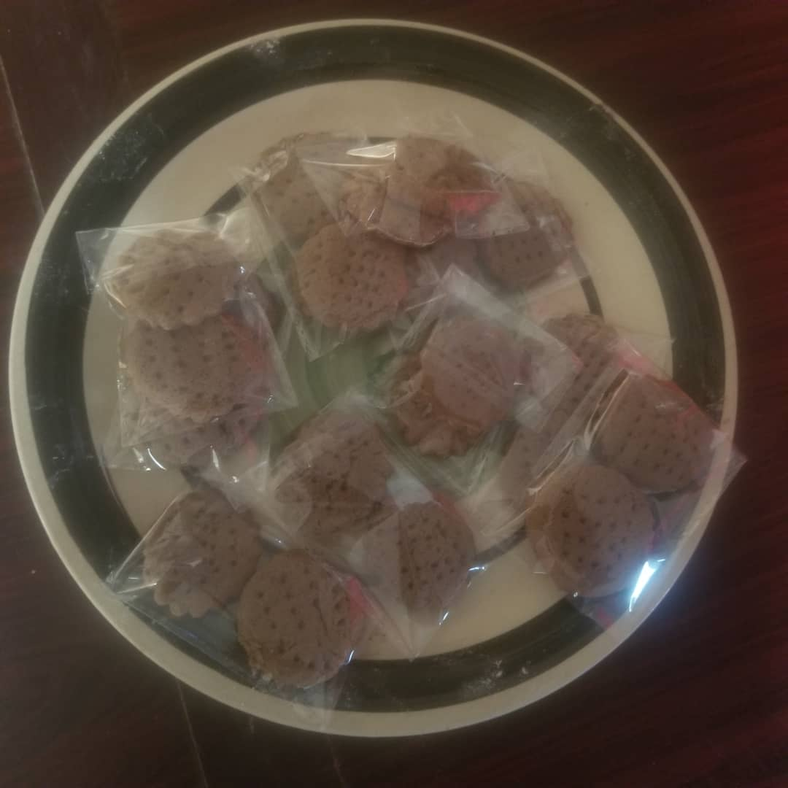
SAMPLE A TO F
CHAPTER FOUR
4.0 RESULT AND DISCUSSION
4.1 Data Analysis and Results on Sensory Evaluation of Cookies Produced from Blend with of Wheat, Fonio and Bambara Groundnut Flour
(i) Descriptive statistics
The descriptive statistics of the average rating of respondents on samples cookies produced from blend with Wheat flour, Fonio flour and Bambara ground nut flour based on different characteristics are shown in the figure 1 below;
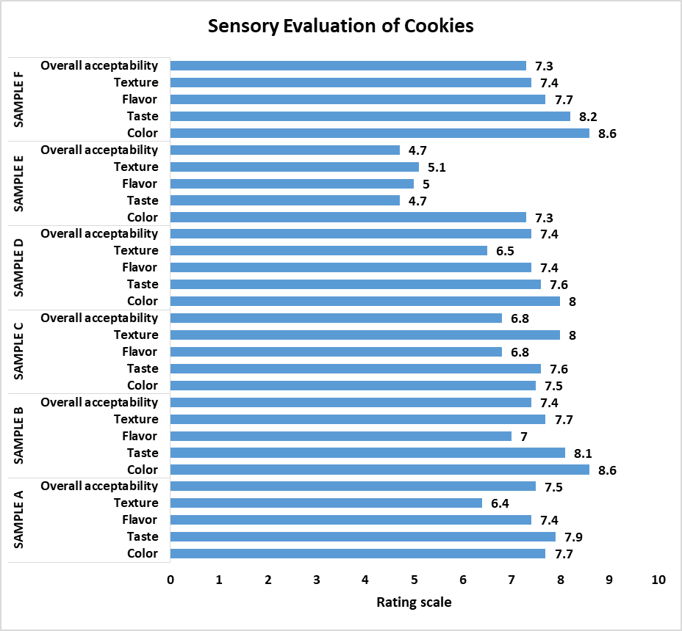
Figure 1. Bar diagram of average rating scale of samples sensory evaluation of cookies

From Figure 1,
4.2 .1 The colour
The color for sample B and F has the highest average rating scale of 8.6, i.e. like extremely/very much, while the sample E has the least average rating scale of 7.3, i.e. like moderately which implies that all the color of the cookie’s samples can be considered liked by the respondents.
4.2.2 The taste
For the taste, sample F (8.2) has the highest average rating scale i.e. like very much, then follow by sample B (8.1), also rated like very much and the samples (A, C & D) average rating were approximately 8 (i.e. like very much) while the sample E (4.7≈ 5), has the least average rating scale, i.e. Neither like nor dislike. This indicates that the taste of all the samples except sample E cookies samples can be considered liked by the respondents.
4.2.3 The flavor
For the flavor, sample F (7.7≈ 8) has the highest average rating scale i.e. like very much, follow by sample A and D (7.4) i.e. like moderately, then samples B and C with approximate average rating 7 (i.e. like moderately) while the sample E (5), has the least average rating scale, i.e. Neither like nor dislike. This indicates that the flavor of all the samples except sample E cookies samples can be considered liked by the respondents.
4.2.4 The texture
In term of texture, sample C (8) has the highest average rating scale i.e. like very much, follow by sample B (7.7≈8) i.e. like very much, then samples F (7.4), i.e. like moderately and sample D (6.5) and sample C (6.4), respectively considered like slightly while the sample E (5.1), has the least average rating scale, i.e. Neither like nor dislike. The results also implies that the texture of all the samples except sample E cookies samples can be considered liked by the respondents.
4.2.5 Overall acceptability
Lastly, sample A (7.5≈8, i.e. like very much) has the highest average rating scale for the overall acceptability, follow by sample B & D (7.4, i.e. like moderately), then samples F (7.3, i.e. like moderately) and sample C (6.5≈7, i.e. like moderately) while the sample E (4.7≈5, i.e. neither like nor dislike), has the least average rating scale. Also, the results implies that there is overall acceptability of all the cookies samples except the sample E cookies which is neither like nor dislike.
(ii) Analysis of Variance (ANOVA)
Hypotheses
H₀: µ₁ = µ₂ = … = µ₆ i.e. Samples have equal average scale rating
Ha: at least one sample mean scale rating differs from others
Significance Level: α = 0.05
Critical Value(s) and Rejection Region(s); Reject the null hypothesis if p-value ≤ 0.05.
The ANOVA was performed using SPSS to identify the variability among the Samples (A-F) scale ratingand results are displayed in the Table 1 below.
Table 1. ANOVA Table
 |  | Sum of Squares | df | Mean Square | F | Sig.(p-value)
Color | Between Sample | 15.35 | 5 | 3.07 | 1.57 | 0.18
Color | Within Sample | 105.50 | 54 | 1.95 | 1.57 | 0.18
Color | Total | 120.85 | 59 |  | 1.57 | 0.18
Taste | Between Sample | 87.35 | 5 | 17.47 | 7.59 | 0.00
Taste | Within Sample | 124.30 | 54 | 2.30 | 7.59 | 0.00
Taste | Total | 211.65 | 59 |  | 7.59 | 0.00
Flavor | Between Sample | 47.68 | 5 | 9.54 | 4.93 | 0.00
Flavor | Within Sample | 104.50 | 54 | 1.94 | 4.93 | 0.00
Flavor | Total | 152.18 | 59 |  | 4.93 | 0.00
Texture | Between Sample | 57.35 | 5 | 11.47 | 2.47 | 0.04
Texture | Within Sample | 250.30 | 54 | 4.64 | 2.47 | 0.04
Texture | Total | 307.65 | 59 |  | 2.47 | 0.04
Overall acceptability | Between Sample | 58.55 | 5 | 11.71 | 2.76 | 0.03
Overall acceptability | Within Sample | 229.10 | 54 | 4.24 | 2.76 | 0.03
Overall acceptability | Total | 287.65 | 59 |  | 2.76 | 0.03
From the Table 1, the results shows that the null hypothesis (H₀) for the color of cookies samples cannot be rejected since the p-value = 0.18 (F=1.57) > 0.05. This indicates that there is no strong evidence to conclude that there is significant differences in average scale rating of cookies color even when the average scale rating for scale differs. However, the results shows that the taste (p-value=0.00, F=7.59), flavor (p-value=0.00, F=4.93), texture (p-value=0.04, F=2.47) and overall acceptability (p-value=0.03, F=2.76), respectively have the p-value < 0.05. Therefore, the null hypotheses (H₀) for the taste, flavor, texture and overall acceptability for cookies samples were rejected and conclude that there is significant differences in average scale rating for cookies taste, flavor, texture as well as overall acceptability. This implies that there is strong evidence to suggest that the average scale rating differs for the samples based on the cookies taste, flavor, texture and overall acceptability. Hence, further test is required which is multiple comparison to determine the most significant cookies sample.
Table 2. Multiple Comparisons test for color
Color Multiple Comparisons test |  |  |  |  |  | 95% Confidence Interval
Variable | (I) Sample | (J) Sample | Mean Difference (I-J) | Std. Error | Sig. | Lower Bound | Upper Bound
Color | SAMPLE A | SAMPLE B | -0.90 | 0.63 | 0.16 | -2.15 | 0.35
Color | SAMPLE A | SAMPLE C | 0.20 | 0.63 | 0.75 | -1.05 | 1.45
Color | SAMPLE A | SAMPLE D | -0.30 | 0.63 | 0.63 | -1.55 | 0.95
Color | SAMPLE A | SAMPLE E | 0.40 | 0.63 | 0.52 | -0.85 | 1.65
Color | SAMPLE A | SAMPLE F | -0.90 | 0.63 | 0.16 | -2.15 | 0.35
Color | SAMPLE B | SAMPLE A | 0.90 | 0.63 | 0.16 | -0.35 | 2.15
Color | SAMPLE B | SAMPLE C | 1.10 | 0.63 | 0.08 | -0.15 | 2.35
Color | SAMPLE B | SAMPLE D | 0.60 | 0.63 | 0.34 | -0.65 | 1.85
Color | SAMPLE B | SAMPLE E | 1.30 | 0.63 | 0.04* | 0.05 | 2.55
Color | SAMPLE B | SAMPLE F | 0.00 | 0.63 | 1.00 | -1.25 | 1.25
Color | SAMPLE C | SAMPLE A | -0.20 | 0.63 | 0.75 | -1.45 | 1.05
Color | SAMPLE C | SAMPLE B | -1.10 | 0.63 | 0.08 | -2.35 | 0.15
Color | SAMPLE C | SAMPLE D | -0.50 | 0.63 | 0.43 | -1.75 | 0.75
Color | SAMPLE C | SAMPLE E | 0.20 | 0.63 | 0.75 | -1.05 | 1.45
Color | SAMPLE C | SAMPLE F | -1.10 | 0.63 | 0.08 | -2.35 | 0.15
Color | SAMPLE D | SAMPLE A | 0.30 | 0.63 | 0.63 | -0.95 | 1.55
Color | SAMPLE D | SAMPLE B | -0.60 | 0.63 | 0.34 | -1.85 | 0.65
Color | SAMPLE D | SAMPLE C | 0.50 | 0.63 | 0.43 | -0.75 | 1.75
Color | SAMPLE D | SAMPLE E | 0.70 | 0.63 | 0.27 | -0.55 | 1.95
Color | SAMPLE D | SAMPLE F | -0.60 | 0.63 | 0.34 | -1.85 | 0.65
Color | SAMPLE E | SAMPLE A | -0.40 | 0.63 | 0.52 | -1.65 | 0.85
Color | SAMPLE E | SAMPLE B | -1.30 | 0.63 | 0.04* | -2.55 | -0.05
Color | SAMPLE E | SAMPLE C | -0.20 | 0.63 | 0.75 | -1.45 | 1.05
Color | SAMPLE E | SAMPLE D | -0.70 | 0.63 | 0.27 | -1.95 | 0.55
Color | SAMPLE E | SAMPLE F | -1.30 | 0.63 | 0.04* | -2.55 | -0.05
Color | SAMPLE F | SAMPLE A | 0.90 | 0.63 | 0.16 | -0.35 | 2.15
Color | SAMPLE F | SAMPLE B | 0.00 | 0.63 | 1.00 | -1.25 | 1.25
Color | SAMPLE F | SAMPLE C | 1.10 | 0.63 | 0.08 | -0.15 | 2.35
Color | SAMPLE F | SAMPLE D | 0.60 | 0.63 | 0.34 | -0.65 | 1.85
Color | SAMPLE F | SAMPLE E | 1.30 | 0.63 | 0.04* | 0.05 | 2.55
*. The mean difference is significant at the 0.05 level.
From Table 2, the results show that there is significant difference between the cookies color sample B-E and sample E-F since the p-value (0.04) < 0.05 (level of significance). This implies that the cookies color sample differs in appearance when compared between sample E and B &F only but not significantly differs between the other samples. Hence, sample E color is most significant.
Table 3. Multiple Comparisons test for taste
Taste Multiple Comparisons test |  |  |  |  |  | 95% Confidence Interval
Variable | (I) Sample | (J) Sample | Mean Difference (I-J) | Std. Error | Sig. | Lower Bound | Upper Bound
Taste | SAMPLE A | SAMPLE B | -0.20 | 0.68 | 0.77 | -1.56 | 1.16
Taste | SAMPLE A | SAMPLE C | 0.30 | 0.68 | 0.66 | -1.06 | 1.66
Taste | SAMPLE A | SAMPLE D | 0.30 | 0.68 | 0.66 | -1.06 | 1.66
Taste | SAMPLE A | SAMPLE E | 3.20 | 0.68 | 0.00* | 1.84 | 4.56
Taste | SAMPLE A | SAMPLE F | -0.30 | 0.68 | 0.66 | -1.66 | 1.06
Taste | SAMPLE B | SAMPLE A | 0.20 | 0.68 | 0.77 | -1.16 | 1.56
Taste | SAMPLE B | SAMPLE C | 0.50 | 0.68 | 0.46 | -0.86 | 1.86
Taste | SAMPLE B | SAMPLE D | 0.50 | 0.68 | 0.46 | -0.86 | 1.86
Taste | SAMPLE B | SAMPLE E | 3.40 | 0.68 | 0.00* | 2.04 | 4.76
Taste | SAMPLE B | SAMPLE F | -0.10 | 0.68 | 0.88 | -1.46 | 1.26
Taste | SAMPLE C | SAMPLE A | -0.30 | 0.68 | 0.66 | -1.66 | 1.06
Taste | SAMPLE C | SAMPLE B | -0.50 | 0.68 | 0.46 | -1.86 | 0.86
Taste | SAMPLE C | SAMPLE D | 0.00 | 0.68 | 1.00 | -1.36 | 1.36
Taste | SAMPLE C | SAMPLE E | 2.90 | 0.68 | 0.00* | 1.54 | 4.26
Taste | SAMPLE C | SAMPLE F | -0.60 | 0.68 | 0.38 | -1.96 | 0.76
Taste | SAMPLE D | SAMPLE A | -0.30 | 0.68 | 0.66 | -1.66 | 1.06
Taste | SAMPLE D | SAMPLE B | -0.50 | 0.68 | 0.46 | -1.86 | 0.86
Taste | SAMPLE D | SAMPLE C | 0.00 | 0.68 | 1.00 | -1.36 | 1.36
Taste | SAMPLE D | SAMPLE E | 2.90 | 0.68 | 0.00* | 1.54 | 4.26
Taste | SAMPLE D | SAMPLE F | -0.60 | 0.68 | 0.38 | -1.96 | 0.76
Taste | SAMPLE E | SAMPLE A | -3.20 | 0.68 | 0.00* | -4.56 | -1.84
Taste | SAMPLE E | SAMPLE B | -3.40 | 0.68 | 0.00* | -4.76 | -2.04
Taste | SAMPLE E | SAMPLE C | -2.90 | 0.68 | 0.00* | -4.26 | -1.54
Taste | SAMPLE E | SAMPLE D | -2.90 | 0.68 | 0.00* | -4.26 | -1.54
Taste | SAMPLE E | SAMPLE F | -3.50 | 0.68 | 0.00* | -4.86 | -2.14
Taste | SAMPLE F | SAMPLE A | 0.30 | 0.68 | 0.66 | -1.06 | 1.66
Taste | SAMPLE F | SAMPLE B | 0.10 | 0.68 | 0.88 | -1.26 | 1.46
Taste | SAMPLE F | SAMPLE C | 0.60 | 0.68 | 0.38 | -0.76 | 1.96
Taste | SAMPLE F | SAMPLE D | 0.60 | 0.68 | 0.38 | -0.76 | 1.96
Taste | SAMPLE F | SAMPLE E | 3.50 | 0.68 | 0.00* | 2.14 | 4.86
*. The mean difference is significant at the 0.05 level.
From Table 3, the results show that there is significant difference between the cookies tastesample E and sample A, B, C, D & F since the p-value (0.00) < 0.05 (level of significance). This implies that the cookies tastefor sample E differs when compared other samples without any other samples paired significant. Also, the results indicates that sample E cookies taste is mostly significant.

Table 4. Multiple Comparisons test for flavor
Flavor Multiple Comparisons test |  |  |  |  |  | 95% Confidence Interval
Variable | (I) Sample | (J) Sample | Mean Difference (I-J) | Std. Error | Sig. | Lower Bound | Upper Bound
Flavor | SAMPLE A | SAMPLE B | 0.40 | 0.62 | 0.52 | -0.85 | 1.65
Flavor | SAMPLE A | SAMPLE C | 0.60 | 0.62 | 0.34 | -0.65 | 1.85
Flavor | SAMPLE A | SAMPLE D | 0.00 | 0.62 | 1.00 | -1.25 | 1.25
Flavor | SAMPLE A | SAMPLE E | 2.40 | 0.62 | 0.00* | 1.15 | 3.65
Flavor | SAMPLE A | SAMPLE F | -0.30 | 0.62 | 0.63 | -1.55 | 0.95
Flavor | SAMPLE B | SAMPLE A | -0.40 | 0.62 | 0.52 | -1.65 | 0.85
Flavor | SAMPLE B | SAMPLE C | 0.20 | 0.62 | 0.75 | -1.05 | 1.45
Flavor | SAMPLE B | SAMPLE D | -0.40 | 0.62 | 0.52 | -1.65 | 0.85
Flavor | SAMPLE B | SAMPLE E | 2.00 | 0.62 | 0.00* | 0.75 | 3.25
Flavor | SAMPLE B | SAMPLE F | -0.70 | 0.62 | 0.27 | -1.95 | 0.55
Flavor | SAMPLE C | SAMPLE A | -0.60 | 0.62 | 0.34 | -1.85 | 0.65
Flavor | SAMPLE C | SAMPLE B | -0.20 | 0.62 | 0.75 | -1.45 | 1.05
Flavor | SAMPLE C | SAMPLE D | -0.60 | 0.62 | 0.34 | -1.85 | 0.65
Flavor | SAMPLE C | SAMPLE E | 1.80 | 0.62 | 0.01* | 0.55 | 3.05
Flavor | SAMPLE C | SAMPLE F | -0.90 | 0.62 | 0.15 | -2.15 | 0.35
Flavor | SAMPLE D | SAMPLE A | 0.00 | 0.62 | 1.00 | -1.25 | 1.25
Flavor | SAMPLE D | SAMPLE B | 0.40 | 0.62 | 0.52 | -0.85 | 1.65
Flavor | SAMPLE D | SAMPLE C | 0.60 | 0.62 | 0.34 | -0.65 | 1.85
Flavor | SAMPLE D | SAMPLE E | 2.40 | 0.62 | 0.00* | 1.15 | 3.65
Flavor | SAMPLE D | SAMPLE F | -0.30 | 0.62 | 0.63 | -1.55 | 0.95
Flavor | SAMPLE E | SAMPLE A | -2.40 | 0.62 | 0.00* | -3.65 | -1.15
Flavor | SAMPLE E | SAMPLE B | -2.00 | 0.62 | 0.00* | -3.25 | -0.75
Flavor | SAMPLE E | SAMPLE C | -1.80 | 0.62 | 0.01* | -3.05 | -0.55
Flavor | SAMPLE E | SAMPLE D | -2.40 | 0.62 | 0.00* | -3.65 | -1.15
Flavor | SAMPLE E | SAMPLE F | -2.70 | 0.62 | 0.00* | -3.95 | -1.45
Flavor | SAMPLE F | SAMPLE A | 0.30 | 0.62 | 0.63 | -0.95 | 1.55
Flavor | SAMPLE F | SAMPLE B | 0.70 | 0.62 | 0.27 | -0.55 | 1.95
Flavor | SAMPLE F | SAMPLE C | 0.90 | 0.62 | 0.15 | -0.35 | 2.15
Flavor | SAMPLE F | SAMPLE D | 0.30 | 0.62 | 0.63 | -0.95 | 1.55
Flavor | SAMPLE F | SAMPLE E | 2.70 | 0.62 | 0.00* | 1.45 | 3.95
*. The mean difference is significant at the 0.05 level.
From Table 4, the results show that there is significant difference between the cookies sample E flavor and sample A, B, C, D & F since the p-value (0.00 and 0.01) < 0.05 (level of significance). This implies that the cookies flavorfor sample E differs when compared other samples without any other samples paired significant. Also, the results indicates that sample E cookies flavor is mostly significant.
Table 5. Multiple Comparisons test for texture
Texture Multiple Comparisons test |  |  |  |  |  | 95% Confidence Interval
Variable | (I) Sample | (J) Sample | Mean Difference (I-J) | Std. Error | Sig. | Lower Bound | Upper Bound
Texture | SAMPLE A | SAMPLE B | -1.30 | 0.96 | 0.18 | -3.23 | 0.63
Texture | SAMPLE A | SAMPLE C | -1.60 | 0.96 | 0.10 | -3.53 | 0.33
Texture | SAMPLE A | SAMPLE D | -0.10 | 0.96 | 0.92 | -2.03 | 1.83
Texture | SAMPLE A | SAMPLE E | 1.30 | 0.96 | 0.18 | -0.63 | 3.23
Texture | SAMPLE A | SAMPLE F | -1.00 | 0.96 | 0.30 | -2.93 | 0.93
Texture | SAMPLE B | SAMPLE A | 1.30 | 0.96 | 0.18 | -0.63 | 3.23
Texture | SAMPLE B | SAMPLE C | -0.30 | 0.96 | 0.76 | -2.23 | 1.63
Texture | SAMPLE B | SAMPLE D | 1.20 | 0.96 | 0.22 | -0.73 | 3.13
Texture | SAMPLE B | SAMPLE E | 2.60 | 0.96 | 0.01* | 0.67 | 4.53
Texture | SAMPLE B | SAMPLE F | 0.30 | 0.96 | 0.76 | -1.63 | 2.23
Texture | SAMPLE C | SAMPLE A | 1.60 | 0.96 | 0.10 | -0.33 | 3.53
Texture | SAMPLE C | SAMPLE B | 0.30 | 0.96 | 0.76 | -1.63 | 2.23
Texture | SAMPLE C | SAMPLE D | 1.50 | 0.96 | 0.13 | -0.43 | 3.43
Texture | SAMPLE C | SAMPLE E | 2.90 | 0.96 | 0.00* | 0.97 | 4.83
Texture | SAMPLE C | SAMPLE F | 0.60 | 0.96 | 0.54 | -1.33 | 2.53
Texture | SAMPLE D | SAMPLE A | 0.10 | 0.96 | 0.92 | -1.83 | 2.03
Texture | SAMPLE D | SAMPLE B | -1.20 | 0.96 | 0.22 | -3.13 | 0.73
Texture | SAMPLE D | SAMPLE C | -1.50 | 0.96 | 0.13 | -3.43 | 0.43
Texture | SAMPLE D | SAMPLE E | 1.40 | 0.96 | 0.15 | -0.53 | 3.33
Texture | SAMPLE D | SAMPLE F | -0.90 | 0.96 | 0.35 | -2.83 | 1.03
Texture | SAMPLE E | SAMPLE A | -1.30 | 0.96 | 0.18 | -3.23 | 0.63
Texture | SAMPLE E | SAMPLE B | -2.60 | 0.96 | 0.01* | -4.53 | -0.67
Texture | SAMPLE E | SAMPLE C | -2.90 | 0.96 | 0.00* | -4.83 | -0.97
Texture | SAMPLE E | SAMPLE D | -1.40 | 0.96 | 0.15 | -3.33 | 0.53
Texture | SAMPLE E | SAMPLE F | -2.30 | 0.96 | 0.02* | -4.23 | -0.37
Texture | SAMPLE F | SAMPLE A | 1.00 | 0.96 | 0.30 | -0.93 | 2.93
Texture | SAMPLE F | SAMPLE B | -0.30 | 0.96 | 0.76 | -2.23 | 1.63
Texture | SAMPLE F | SAMPLE C | -0.60 | 0.96 | 0.54 | -2.53 | 1.33
Texture | SAMPLE F | SAMPLE D | 0.90 | 0.96 | 0.35 | -1.03 | 2.83
Texture | SAMPLE F | SAMPLE E | 2.30 | 0.96 | 0.02* | 0.37 | 4.23
*. The mean difference is significant at the 0.05 level.
From Table 5, the results show that there is significant difference between the cookies sample E texture and sample B, C, & F since the p-value (0.00, 0.01 & 0.02), respectively< 0.05 (level of significance). This implies that the cookies flavorfor sample E differs when compared samples B, C, & F only but not significant with sample A & D and without any other significant paired samples. This shows that the sample E cookies texture is also considered mostly significant.

Table 6. Multiple Comparisons test for overall acceptability
Overall acceptability Multiple Comparisons test |  |  |  |  |  | 95% Confidence Interval
Variable | (I) Sample | (J) Sample | Mean Difference (I-J) | Std. Error | Sig. | Lower Bound | Upper Bound
Overall acceptability | SAMPLE A | SAMPLE B | 0.10 | 0.92 | 0.91 | -1.75 | 1.95
Overall acceptability | SAMPLE A | SAMPLE C | 0.70 | 0.92 | 0.45 | -1.15 | 2.55
Overall acceptability | SAMPLE A | SAMPLE D | 0.10 | 0.92 | 0.91 | -1.75 | 1.95
Overall acceptability | SAMPLE A | SAMPLE E | 2.80 | 0.92 | 0.00* | 0.95 | 4.65
Overall acceptability | SAMPLE A | SAMPLE F | 0.20 | 0.92 | 0.83 | -1.65 | 2.05
Overall acceptability | SAMPLE B | SAMPLE A | -0.10 | 0.92 | 0.91 | -1.95 | 1.75
Overall acceptability | SAMPLE B | SAMPLE C | 0.60 | 0.92 | 0.52 | -1.25 | 2.45
Overall acceptability | SAMPLE B | SAMPLE D | 0.00 | 0.92 | 1.00 | -1.85 | 1.85
Overall acceptability | SAMPLE B | SAMPLE E | 2.70 | 0.92 | 0.00* | 0.85 | 4.55
Overall acceptability | SAMPLE B | SAMPLE F | 0.10 | 0.92 | 0.91 | -1.75 | 1.95
Overall acceptability | SAMPLE C | SAMPLE A | -0.70 | 0.92 | 0.45 | -2.55 | 1.15
Overall acceptability | SAMPLE C | SAMPLE B | -0.60 | 0.92 | 0.52 | -2.45 | 1.25
Overall acceptability | SAMPLE C | SAMPLE D | -0.60 | 0.92 | 0.52 | -2.45 | 1.25
Overall acceptability | SAMPLE C | SAMPLE E | 2.10 | 0.92 | 0.03* | 0.25 | 3.95
Overall acceptability | SAMPLE C | SAMPLE F | -0.50 | 0.92 | 0.59 | -2.35 | 1.35
Overall acceptability | SAMPLE D | SAMPLE A | -0.10 | 0.92 | 0.91 | -1.95 | 1.75
Overall acceptability | SAMPLE D | SAMPLE B | 0.00 | 0.92 | 1.00 | -1.85 | 1.85
Overall acceptability | SAMPLE D | SAMPLE C | 0.60 | 0.92 | 0.52 | -1.25 | 2.45
Overall acceptability | SAMPLE D | SAMPLE E | 2.70 | 0.92 | 0.00* | 0.85 | 4.55
Overall acceptability | SAMPLE D | SAMPLE F | 0.10 | 0.92 | 0.91 | -1.75 | 1.95
Overall acceptability | SAMPLE E | SAMPLE A | -2.80 | 0.92 | 0.00* | -4.65 | -0.95
Overall acceptability | SAMPLE E | SAMPLE B | -2.70 | 0.92 | 0.00* | -4.55 | -0.85
Overall acceptability | SAMPLE E | SAMPLE C | -2.10 | 0.92 | 0.03* | -3.95 | -0.25
Overall acceptability | SAMPLE E | SAMPLE D | -2.70 | 0.92 | 0.00* | -4.55 | -0.85
Overall acceptability | SAMPLE E | SAMPLE F | -2.60 | 0.92 | 0.01* | -4.45 | -0.75
Overall acceptability | SAMPLE F | SAMPLE A | -0.20 | 0.92 | 0.83 | -2.05 | 1.65
Overall acceptability | SAMPLE F | SAMPLE B | -0.10 | 0.92 | 0.91 | -1.95 | 1.75
Overall acceptability | SAMPLE F | SAMPLE C | 0.50 | 0.92 | 0.59 | -1.35 | 2.35
Overall acceptability | SAMPLE F | SAMPLE D | -0.10 | 0.92 | 0.91 | -1.95 | 1.75
Overall acceptability | SAMPLE F | SAMPLE E | 2.60 | 0.92 | 0.01* | 0.75 | 4.45
*. The mean difference is significant at the 0.05 level.

CHAPTER FIVE
5.0 SUMMARY, CONCLUSION AND RECOMMENDATION
5.1 SUMMARY
Wheat is one of the most widely produced cereals worldwide. This food belongs to the genus Triticum spp. and constitutes a source of food for humans and production animals. Wheat is recognized for its nutritional properties where it has a high energy and protein value, low fat, and lignin values. It is also an important source of minerals and vitamins for human.
The results vividly showed that it could be possible to produce nutritious and acceptable cookies through the substitution of wheat flour. The high protein, ash and fibre contents of cookies made from bambara nut substitution as well as the acceptability of the composite cookies attested to this fact. The results also showed that substitution with bambara nut did not alter the physical characteristics and consumer acceptability of the cookie samples especially at 5% substitution level. In conclusion, therefore, 5% MBB incorporation in cookies production could help to substantially reduce foreign exchange on wheat importation and reduce wastage of the by-product, while improving the nutritional status of consumers.
5.2 CONCLUSION
Wheat and Bambara flour can be combined to produce cookies with appreciable improved protein content, which can be use in the management of protein energy malnutrition. The use of this flour blends will reduce the pressure on wheat Flour and help to improve the utilization of Bambara groundnut flour, and prevent it from going into extinction. This is an advantage in a non-traditionally wheat producing country like Nigeria.
It is also of interest in child feeding programs and food for the low-income groups.

5.3 RECOMMENDATIONS
The following recommendations would contribute to the improvement of planting and usage of Bambara nut in Nigeria and encourage the large scale production of this important crop.
- A mechanical harvester for Bambara nut should be developed and introduced into Nigeria. This will eliminate the rigours of the present harvesting methods and reduce the magnitude of losses.
- A Bambara nut Sheller should be developed for use in the country. This will relieve the processors of the tedium of the present methods, reduce seed damage und check the attack of mould, afflatoxin and other microorganisms.
- Appropriate technology storage facilities should be developed for the crop and the proper treatment and environment needed for its storage should be determined.
- Research efforts should be geared toward the breeding of pest and disease resistant as well as high yielding varieties
- Solar drying facilities should be introduced to replace the present sun drying method.
- Nigeria Government should also support and encourage the farmers planting the Bambara Nut.

REFERENCES
Adekunle, O. A., and Abiodun, O. A. (2018). Fonio: Acha (Digitaria exilis and Digitariaiburua). Journal of Food Science and Technology, 55(3), 1-5.
Adekunle, O. A., and Gidado, G. I. (2017). Nutritional value and health benefits of acha. African Journal of Food Science, 11(5), 123-130.
Adekunle, O. A., and Nkama, I. (2003). Whole meal acha (Digitariaiburua) flours can be used in the preparation of some biscuits and snacks that could be useful for individuals with gluten intolerance. Journal of Food Science and Technology, 40(2), 156-162.
Adeomowaye, O. R., Ogunlakin, G. O., Oloyede, A. B., and Amure, E. A. (2019). Optimization of process variables for the production of cookies from wheat, fonio, and pigeon pea flour blends. Annals of Faculty Engineering Hunedoara, 20(4), 101-106.
Adewole, K. O., Oluwalana, I. B., and deyoju, A. A. (2018). Optimization of the production of composite flour from wheat, cocoyam and bambara groundnut flours using optimal mixture design of response surface methodology. International Journal of Food Science and Nutrition Engineering, 8(1), 1-7.
Akubor, P. I., and Nwavi, D. O. (2019). Fortification of wheat flour with high protein materials from plant sources has been recognized. Journal of Food Science and Technology, 56(4), 789-795.
Ballogou, V. Y., Soumanou, M. M., Toukourou, F., and Hounhouigan, J. D. (2013). Structure and nutritional composition of fonio (Digitaria exilis) grains: A review. International Research Journal of Biological Sciences, 2(1), 73-79.
Chauhan, S. K., Kokane, S. R., and Shukla, A. K. (2016). Production of cookies from wheat flour and bambara groundnut flour blends. Journal of Food Science and Technology, 53(2), 1234-1240.
Chukwu, O. (2008). Physicochemical properties of acha (Digitaria exilis and Digitariaiburua) grains. Journal of Food Technology, 6(5), 214-216.
Cruz, J. F. (2004). Fonio: A small grain with potential. LEISA Magazine, 20(1), 16-17.
Durojaye, S., Sammond, N., and Moosavi, R. (2023). Diabetic Striatopathy; A Differential Worth Considering in Diabetic Patients with Acute Onset Hyperkinetic Movements or Basal Ganglia (Striatal) Abnormalities on Imaging.(P8-4.007). Neurology, 100(17_supplement_2), 3685.
Dvorak, J. (2007). The first cultivation of wheat occurred about 10,000 years ago, as part of the ‘Neolithic Revolution’. Theoretical and Applied Genetics, 114(6), 947-959.
Eke-Ejiofor, J. (2019). Production of Bambara groundnut flour. Journal of Food Processing and Preservation, 43(3), e13845.
Feldman, M. (2001). The origin of cultivated wheat. In The World Wheat Book: A History of Wheat Breeding (pp. 3-56). Lavoisier Publishing.
Fossati, D., and Ingold, R. (2001). Spelt continues to be grown in Europe, particularly in Alpine areas. Agronomy, 21(5), 456-462.
Gyang, J. F., and Wuyep, P. A. (2005). The English name hungry rice, believed to have been coined by Europeans. Journal of Agricultural Science, 47(2), 123-130.
Ibrahim, A. (2001). Fonio is sometimes regarded as the “grain of life”. African Journal of Food Science, 2(4), 56-62.
Jideani, I. A., and Podgorski, S. C. (2009). In-vitro starch digestibility and glycemic property of acha (Digitaria exilis) porridge. Cereal Foods World, 54, A48.
Malomo, S. A., and Abiose, S. H. (2019). Acha (Digitaria exilis and Digitariaiburua). Journal of Food Science and Technology, 56(3), 789-795.
Nkiru, O. E., Francis, O. A., Adanma, O. I., Ezidimma, U. A., Oluchi, A. L., and Nwaobiara, E. C. Nutrients and Sensory Qualities of Moi Moi Developed from Flours of Broad Bean (Vicia faba) Seeds Grown in South Eastern Nigeria as Affected by Different Processing Treatments.
Oguntoyinbo, O., Olumurewa, J. A. V., and Omoba, O. S. (2020). Chemical composition, dietary fiber and antioxidant activity of fermented ripe banana peel flour. J. Food. Stab, 3(2), 27-42.
Okemo, P. O., Kago, E. K., Kinyua, Z. M., and Maingi, J. M. (2017). Diversity of Ralstonia solanacerum strains in Solanaceous crops production regions of Central Kenya. vol, 16, 1-12..
Okolie, C. L., Mason, B., & Critchley, A. T. (2018). Seaweeds as a source of proteins for use in pharmaceuticals and high‐value applications. Novel proteins for food, pharmaceuticals and agriculture: sources, applications and advances, 217-238.
Philip, T., and Itodo, I. N. (2006). Acha is a low-input demanding crop. Agricultural Engineering International, 8(1), 1-10.
Potter, N. N., and Hotchkiss, J. H. (2006). Wheat is the most popular cereal grain used for the production of confectionary products. Food Science, 5th ed., Chapman and Hall.
Sadiq, M. S., Singh, I. P., Suleiman, A., Isah, M. A., Umar, S. M., Maude, A. M., and Sallawu, H. (2015). Application of Data Envelopment Analysis (DEA) to determine GHG emission and carbon sequestration in small-scale maize production in Niger State, Nigeria. Agricultural and Bionutritional Research, 1(1), 1-19.
Shewry, P. R. (2000). Wheat protein for human and livestock nutrition. Food Control, 11(3), 117-123.
Shewry, P. R., & Hey, S. J. (2015). The contribution of wheat to human diet and health. Food and Energy Security, 4(3), 178-202.
Suleiman, A., Abba, A. M., Ojo, O. F., Murtala, U. M., Badaru, U. A., and Alasinrin, G. O. (2015) Occurrence of Toxigenic Fungi and Mycotoxins in Refined Wheat Flour from Retail Outlets in Nasarawa State, Nigeria.
World Agricultural Outlook Board. (2014). Wheat is a global commodity, with about 150 mt being traded annually. USDA Agricultural Projections to 2023.

