Comparative Study on the Effects of Drying, Method, and Blanching Temperatures on The Proximate Composition of Yam Flour.

BY
ADIAMA, Adeola Nafisat
ND/23/ABE/FT/0025

A RESEACH PROJECT SUBMITED TO THE
DEPARTMENT OF AGRICULTURAL AND BIO- ENVIRONMENTAL ENGINEERING,
INSTITUTE OF TECHNOLOGY,
KWARA STATE POLYTECHNIC, ILORIN, KWARA STATE.

IN PARTIAL FULFILMENT OF THE REQUIREMENTS FOR THE
AWARD OF NATIONAL DIPLOMA (ND) IN
AGRICULTURAL AND BIO- ENVIRONMENTAL ENGINEERING.

JULY, 2025

DECLARATION

I hereby declare that this research project title ‘’ Comparative Study On The Effects Of Drying, Methods, And Blanching Temperatures On The Proximate Composition Of Yam Flour is my own work and has not been submitted by any other person for any degree or qualification at any higher institution. I also declare that the information provided therein are mine and those that are not mine are properly acknowledge.

_____________________ ____________________
Adiama Adeola Nafisat Signature and Date

CERTIFICATION

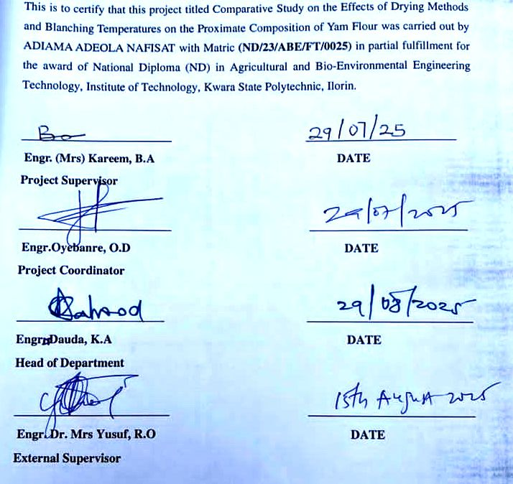

DEDICATION

This project work is dedicated to Almighty Allah.

ACKNOWLEDGEMENT
In the name of Almighty Allah, the Most Gracious and Most Merciful. All praise and gratitude to Allah for granting me the strength, wisdom, and opportunity to complete this project.
I would like to express my heartfelt appreciation to the following people
Firstly toMy project supervisor, Engr. Mrs. Kareem, B.A, for her expert guidance, patience, and valuable feedback throughout this project. Your supervision has been instrumental in shaping this work.
My precious and beloved parents, Mr. and Mrs. Adiama Adeshina, for their unwavering support, love, and prayers. Your sacrifices and encouragement have been my driving force.
Lastly, to my dear siblings, for their encouragement, care, and understanding. Your presence has made this journey more meaningful.
I also appreciate my lectuer in person of Engr Abdullah Kawata and all the departmentental lecturers for their contributions towards my success

Thank you all

ABSTRACT
Yam flour quality is strongly influenced by post-harvest processing methods, yet limited research exists comparing drying and blanching combinations. This study investigated the effects of sun drying and oven drying methods at the temperature of 60°C and two blanching temperatures (65°C and 95°C) on the proximate composition and drying rate of yam flour. Fresh yam tubers were sliced and blanched using a water bath for 10 minutes at the specified temperatures. The blanched samples were then divided into two portions and subjected to drying either under direct sunlight (10:00 am – 4:00 pm daily for 3 days) or in a hot air oven set at 60°C for 15 hours, until a constant weight was attained. Each drying treatment started with an initial sample weight of 165 g. The dried samples were milled into flour and analyzed for moisture, crude protein, crude fat, crude fiber, ash, and carbohydrate contents using standard AOAC (2010) methods. One-way ANOVA and Tukey's post-hoc test confirmed significant differences among treatments. Two-way ANOVA further showed that blanching temperature, drying method, and their interaction significantly affected most parameters, particularly moisture, fat, ash, and carbohydrate content. Results showed that both drying method and blanching temperature had significant effects (p < 0.05) on all proximate components. Oven-dried samples, especially those blanched at 65°C, retained higher levels of protein (up to 4.82%) and fat (1.03%), while sun-dried samples blanched at 95°C had the lowest moisture content (9.87%) and the highest carbohydrate concentration (83.96%). Drying rate analysis indicated that the fastest drying occurred in the sun-dried sample blanched at 95°C (5.70 g/h), while the slowest was recorded in the sun-dried sample blanched at 65°C (3.71 g/h). The study concludes that oven drying at 60°C after blanching at 65°C is optimal for producing yam flour with superior nutritional quality. It recommends further investigation into storage properties and the development of hybrid drying systems for improved commercial application.

TABLE OF CONTENTS
Table of Contents
DECLARATION ii
CERTIFICATION iii
DEDICATION iv
This project work is dedicated to Almighty Allah. iv
ABSTRACT vi
TABLE OF CONTENTS vii
LIST OF TABLES ix
LISTS OF PLATES x
LIST OF FIGURE x
INTRODUCTION 1
1.1 Background to the Study 1
1.2 Statement of the Problem 3
1.3 Aim and Objectives of the Study 4
1.4 Justification of the Study 4
1.5 Scope of the Study 4
CHAPTER TWO 6
LITERATURE REVIEW 6
2.2 Proximate Composition of Yam Flour 7
2.3 Drying Techniques in Food Processing 7
2.4 Sun Drying, Advantages and Challenges 8
2.5 Mechanical Drying: Advantages and Challenges 8
2.6 Comparison of Sun Drying and Mechanical Drying 8
2.7 Impact of Drying Methods on Nutritional Composition 9
2.8 Challenges in Yam Flour Production 9
2.9 Economic Implications of Drying Techniques 9
2.10 Factors Affecting Drying Efficiency 10
2.11 Combined Effects of Blanching and Drying on Proximate Composition 10
CHAPTER THREE 11
MATERIALS AND METHODS 11
3.1 Materials and Equipmen 11
3.2 Sample Collection 11
3.2.1 Sample preparation 11
3.3 Blanching Procedure 15
3.4 Drying Procedure 19
3.4.1: Oven Drying 19
3.4.2: Sun Drying 21
3.5 Milling and Sieving 21
3.6 Proximate Composition Analysis 21
3.7 Drying Rate Calculation 21
3.8 Experimental Design 21
3.9 Statistical Analysis 22
CHAPTER FOUR 26
RESULTS AND DISCUSSIONS 26
4.1 RESULTS 26
4.2 DISCUSSIONS 33
4.2.1: Moisture Content 33
4.2.2: Crude Protein 33
4.2.3: Crude Fat 33
4.2.4: Ash and Crude Fibre Content 33
4.2.5: Carbohydrate Content 33
4.3 Discussion on Table 4.3 One-Way ANOVA and Tukey HSD Results 34
4.4 Discussion on Table 4.4 A two-way ANOVA 34
4.5 Discussion on Drying Rate Table 4.5 34
4.6. Comparative Discussion with Existing Research and Practical Implications 35
4.6. 1: Moisture Content 35
4.6.2: Protein Retention 35
4.6.3: Fat Stability 35
4.6.4: Drying Rate 35
CHAPTER FIVE 36
CONCLUSIONS AND RECOMMENDATIONS 36
5.1 Conclusions 36
5.2 Recommendations 36
REFERENCES 37

LIST OF TABLES
Table 3.1 Blanching treatment 16
Table 3.2 Treatment Combinations 23
Table 4.1 Proximate Composition (%) of the Samples 27
Table 4.2: The Mean of the Proximate Composition (%) 28
Table 4.3 One-Way ANOVA of the Proximate Composition of Yam flour 29
Table 4.4: Two-Way ANOVA Summary (p-values) for Proximate Parameters 30
Table 4.5 presented the Result of the Drying Rate of Yam Flour Samples 31

LISTS OF PLATES
Plate 3.1: Yam cutting process 12
Plate 3.2: Yam peeling process 13
Plate 3.3 Water bath used for the blanching 16
Plate 3.4 Cooling process after the blanching 17
Plate 3.5 Oven drying 19

LIST OF FIGURE
Figure 3.1 Drying methods 25
Figure: 4.1: Drying Rate of Yam Flour Samples 32

CHAPTER ONE

INTRODUCTION

1.1 Background to the Study
Yam (Dioscorea spp.) is a staple crop consumed in many tropical regions due to its nutritional benefits and versatility in food applications. Yam flour, derived from processing yam tubers, is a popular product with a long shelf life and suitability for diverse food preparations. The processing of yam into flour involves peeling, slicing, drying, and milling, with drying being the most critical step. Drying techniques not only reduce the moisture content to prevent microbial growth but also influence the proximate composition and functional properties of the resulting flour (Adetunji et al., 2023).
The nutritional value of yam flour is often evaluated through its proximate composition, including moisture, protein, fat, fiber, ash, and carbohydrate content. However, these values are significantly affected by the drying method employed. Traditional methods such as sun drying are commonly used in rural areas due to their simplicity and cost-effectiveness but face limitations such as weather dependency and contamination risks. On the other hand, mechanical drying methods like oven drying offer better control over drying parameters but may result in nutrient losses due to high temperatures (Akanbi et al., 2017).
In addition, yams are often processed into flour, which has significant culinary applications and serves as a staple food in many countries (Derejeetal.,2020). Yam flour is particularly valued for its long shelf life and compact form, making it an ideal raw material for storage and transportation (Setyawanetal.,2021; Zouetal.,2021).
Beyond direct consumption, yams hold considerable potential for industrial applications, contributing to local livelihoods, particularly in densely populated regions of southern, southwestern, and western parts of various countries.
Moreover, the type of yam species and processing conditions also play vital roles in determining the flour's quality. Yam species such as Dioscorea rotundata (white yam) and Dioscorea alata (water yam) are commonly used due to their high starch content, but they exhibit different responses to drying and processing methods (Adebayo & Sobowale, 2018). With the growing demand for yam flour in both local and international markets, optimizing drying techniques has become essential to enhance product quality, minimize nutrient loss, and improve the economic viability of production (Falade & Olurin, 2020).
This chapter reviews the proximate composition of yam flour, examines various drying techniques and their effects, and explores factors influencing the quality and economic implications of yam flour production. Additionally, it addresses challenges and potential advancements in yam flour processing.

1.2 Statement of the Problem
Yam (Dioscorea spp.) is a vital staple crop in many tropical and subtropical regions, serving as a primary source of carbohydrates, dietary fiber, and essential minerals. However, yams are highly perishable due to their high moisture content, leading to significant post-harvest losses during storage and distribution (Akinwande & Ogundele, 2020). To address this issue, yam is often processed into yam flour, which has an extended shelf life, improved storage characteristics, and broader culinary applications.
The choice of drying method and pre-treatment conditions plays a crucial role in determining the quality and nutritional composition of yam flour. For instance, oven drying and sun drying are common techniques with varying impacts on the proximate composition, such as moisture content, protein, fat, fiber, and ash levels. Similarly, blanching temperatures during pre-treatment (using 65°C and 95°C) significantly affect the retention of nutrients and anti-nutritional factors (Adepoju & Oyewole, 2018). Despite these known influences, there is limited research systematically comparing the combined effects of different drying methods and blanching temperatures on the nutritional and functional properties of yam flour (Wahab et al., 2016).
This knowledge gap has hindered the adoption of optimal processing techniques in yam flour production, potentially affecting the nutritional quality of the final product and limiting the competitiveness of local yam flour in the global market. Therefore, this study seeks to investigate the effects of two drying methods (oven drying at 60°C and sun drying) and two blanching temperatures (65°C and 95°C) on the proximate composition of yam flour. The results aim to provide evidence-based recommendations to enhance yam flour processing practices and improve the nutritional value of this essential food product.

1.3 Aim and Objectives of the Study
The aim of the study is to investigate the effects oven drying, sun drying, and blanching temperatures on the proximate composition of yam flour.
Objectives are:
- To evaluate the proximate compositions (moisture, ash, fat, protein, fiber, and carbohydrate content) of yam flour produced using oven drying at 60°C, and sun drying after blanching at 65°C and 95°C respectively.
- To compare the effects of oven drying and sun drying methods on the nutritional properties of yam flour at the two blanching temperatures.
iii. To determine the optimal drying and blanching conditions for yam flour production.

1.4 Justification of the Study
Yam flour is an essential staple in many households, particularly in West Africa, due to its long shelf life and versatility in food preparation. However, the quality of yam flour is influenced by processing methods, particularly drying and blanching. Understanding the impact of these variables can provide valuable insights for small-scale and industrial processors to improve product quality, enhance consumer acceptability, and reduce post-harvest losses. Additionally, optimizing these processes may contribute to better nutritional retention, meeting both health and economic demands.

1.5 Scope of the Study
The study focused on yam flour production using two drying methods (oven drying at 60°C and sun drying) and varying blanching temperatures (65°C and 95°C). It explored the effects of these factors on the proximate composition of yam flour. The yams used was limited to white yam (Dioscorea rotundata) the commonly consumed species. The study was carried out in a controlled environment to minimize variability in drying conditions and to maintain consistency in proximate analysis techniques.

CHAPTER TWO

LITERATURE REVIEW
2.1 Yam Agronomy
Yam (Dioscorea spp.), a tropical tuber crop, is a vital source of food and income for millions of people, particularly in West Africa, which accounts for over 90% of global yam production. Nigeria remains the leading producer, contributing significantly to food security and export markets (IITA, 2023). While yams are botanically classified as perennial plants because they can regrow from their tubers across multiple growing seasons, they are typically cultivated as annual crops. Farmers harvest the tubers at the end of a single growing season, Usually lasting 6–12 months, to optimize yields and land use (Onwueme & Charles, 2021).
Yam cultivation requires specific agronomic practices, including site selection, proper land preparation, and staking in some cases, to support the plant's climbing habit. Yams grow best in well-drained sandy loam soils with a pH range of 5.5 to 6.5 and an annual rainfall of 1,200–2,000 mm. Propagated using seed yams or cut tuber setts, the crop benefits from good organic matter levels to enhance tuber development. However, yam farming faces challenges such as declining soil fertility, high labor demands, and pest infestations, all of which can affect tuber yield and quality (Adebayo & Sobowale, 2018).
Post-harvest, yam tubers are processed into various value-added products, including yam flour, to extend shelf life, reduce post-harvest losses, and enhance marketability. Yam flour production involves several steps, including peeling, slicing, drying, and milling, with drying being the most critical process. Drying reduces the moisture content of the tubers, preventing microbial growth and spoilage. The drying method significantly influences the proximate composition, functional properties, and sensory attributes of the flour (Falade & Olurin, 2020).
Moreover, the type of yam species used, such as Dioscorea rotundata (white yam) and Dioscorea alata (water yam), greatly affects the quality of the flour. These species differ in their responses to agronomic practices and processing methods, which ultimately influence the physicochemical and nutritional properties of the final product. The growing demand for yam flour in local and international markets emphasizes the need for sustainable agricultural practices and optimized processing methods to enhance productivity and profitability.
Yam flour, derived from various yam species, is a staple in many tropical regions. The quality of yam flour is influenced by its proximate composition and the drying techniques employed during its production. This chapter delves into the proximate composition of yam flour, examines different drying methods—particularly sun drying and mechanical drying—and their impact on nutritional composition, discusses challenges in yam flour production, and explores the economic implications of these drying techniques.

2.2 Proximate Composition of Yam Flour
The proximate composition of yam flour includes moisture, protein, fat, ash, fiber, and carbohydrate contents. Nwafor et al. (2022) conducted a study on Dioscorea alata and Dioscorea rotundata yam varieties, revealing that sun-dried yam flour retained higher values in protein, ash, fiber, and carbohydrates compared to oven-dried samples. The moisture content ranged from 5.01% in sun-dried white yam to 8.25% in oven-dried white yam, while protein content varied from 0.79% in oven-dried water yam to 5.56% in sun-dried white yam.

2.3 Drying Techniques in Food Processing
Drying is a crucial preservation method in food processing, aiming to reduce moisture content to extend shelf life and maintain quality. Various drying techniques are employed, each with distinct advantages and challenges. Nainggolan et al. (2024) reviewed recent trends in drying processes for tuber crops, emphasizing the importance of optimizing drying methods to preserve nutritional content and enhance processing efficiency.

2.4 Sun Drying, Advantages and Challenges
Sun drying is a traditional and cost-effective method widely used in tropical regions. Its advantages include low operational costs and simplicity. However, challenges such as dependence on weather conditions, longer drying times, and potential contamination pose significant drawbacks. Nwafor et al. (2022) noted that while sun drying retained higher nutritional values in yam flour, it required extended drying periods to achieve desired moisture reduction.

2.5 Mechanical Drying: Advantages and Challenges
Mechanical drying methods, such as oven drying, offer controlled environments, leading to uniform drying and reduced drying times. These methods are less dependent on weather conditions and can enhance product safety by minimizing contamination risks. However, they involve higher energy consumption and operational costs. Nwafor et al. (2022) observed that oven-dried yam samples had higher moisture content and lower nutritional values compared to sun-dried counterparts, indicating potential nutrient degradation due to higher drying temperatures.

2.6 Comparison of Sun Drying and Mechanical Drying
Comparative studies between sun drying and mechanical drying highlight significant differences in the quality and nutritional composition of dried products. Nwafor et al. (2022) reported that sun-dried yam flour retained better nutritional profiles than oven-dried samples. Similarly, Nainggolan et al. (2024) emphasized the need for optimizing drying methods to balance efficiency and nutrient preservation in tuber processing.

2.7 Impact of Drying Methods on Nutritional Composition
Drying methods significantly influence the nutritional composition of yam flour. Nwafor et al. (2022) found that sun drying preserved higher levels of protein, ash, fiber, and carbohydrates, while oven drying resulted in higher moisture content. This suggests that lower drying temperatures in sun drying may better preserve heat-sensitive nutrients.

2.8 Challenges in Yam Flour Production
Yam flour production faces challenges such as selecting appropriate drying methods to preserve nutritional quality, ensuring product safety by preventing contamination during drying, and addressing economic constraints related to energy consumption in mechanical drying methods. Nainggolan et al. (2024) highlighted the need for efficient drying technologies to overcome these challenges in tuber processing.

2.9 Economic Implications of Drying Techniques
The choice of drying technique has economic implications in yam flour production. Sun drying offers cost savings due to minimal energy requirements but may result in longer processing times and potential quality issues. Mechanical drying provides faster processing and consistent quality but incurs higher energy costs. Nainggolan et al. (2024) discussed the importance of balancing cost and efficiency in selecting appropriate drying methods for tuber crops.

2.10 Factors Affecting Drying Efficiency
Several factors influence drying efficiency, including the type of drying method, temperature control, slice thickness of the yams, and environmental conditions. Nwafor et al. (2022) noted that sun drying required extended periods to achieve desired moisture reduction, while oven drying provided more controlled and faster drying but affected nutritional quality.

2.11 Combined Effects of Blanching and Drying on Proximate Composition
The interplay between blanching and drying significantly affects the nutritional and functional properties of yam flour. Studies have shown that blanching at 95°C before drying results in higher nutrient retention due to effective enzyme inactivation, which reduces nutrient degradation during drying (Musa et al., 2021).

CHAPTER THREE

MATERIALS AND METHODS
3.1 Materials and Equipment
Materials Used:
- Fresh white yam tubers (Dioscorea rotundata)
- Clean water for blanching
- Clean white net material for insect protection during sun drying
- Stainless steel tray for the sun drying
- Aluminium trays for oven drying
Equipment Used:
- Weighing balance (sensitivity: 0.01 g)
- Water bath (temperature-controlled)
- Thermometer
- Electronic Blender
- Timer
- Vernier caliper
- Drying oven (set at 60°C)
- Sun drying rack (exposed between 10 AM and 4 PM)
- Grinder and sieve (for flour production)
- Laboratory glassware
- Proximate analysis apparatus (Kjeldahl setup, Soxhlet extractor, muffle furnace, etc.)

3.2 Sample Collection
Fresh, mature yam tubers were purchased from a local market oja-oba in Ilorin, Kwara State, Nigeria.

3.2.1 Sample preparation
- Fresh yam tubers were washed, peeled, and sliced into uniform sizes (5 mm thickness).
- Sliced yam samples were divided into two groups for blanching at two temperatures: 65°C and 95°C.
Each blanched group was further divided into two subgroups for drying using two methods:
- Oven drying: Samples were dried in an oven at 60°C until a constant weight was achieved.
- Sun drying: Samples were spread thinly on racks under direct sunlight and dried until a constant weight was achieved.


Plate 3.1: Yam cutting process

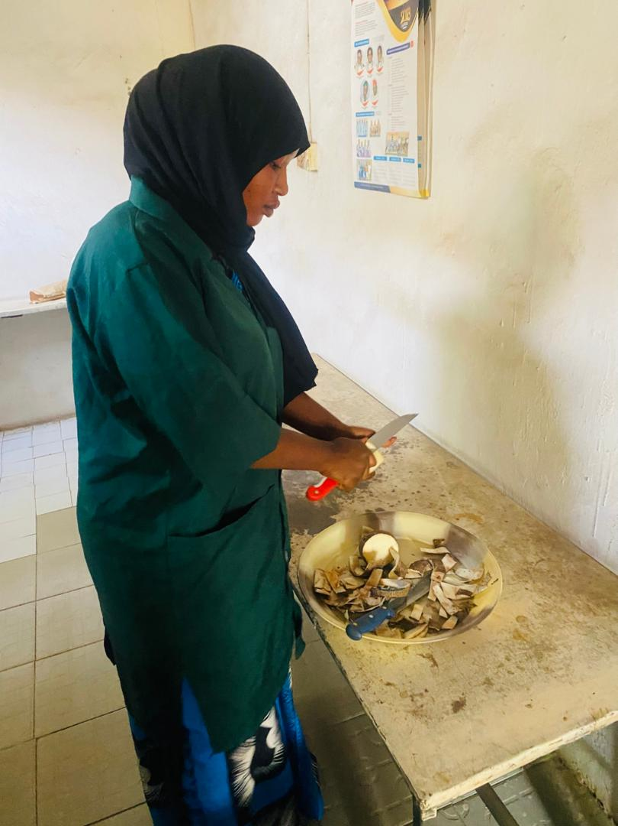
Plate 3.2: Yam peeling process

3.3 Blanching Procedure
Blanching was carried out using a digital water bath to ensure precise temperature control. The sliced yam samples were divided into two groups and subjected to the blanching as shown in Table 3.1. The temperatures were maintained using a water bath, and a thermometer was used to monitor the water temperature to ensure accuracy. After blanching, the yam slices were drained and allowed to cool before drying.

Table 3.1 Blanching treatment
Group | Blanching temperatures (°C) | Blanching time (mins)
A | 65 | 10
B | 95 | 10

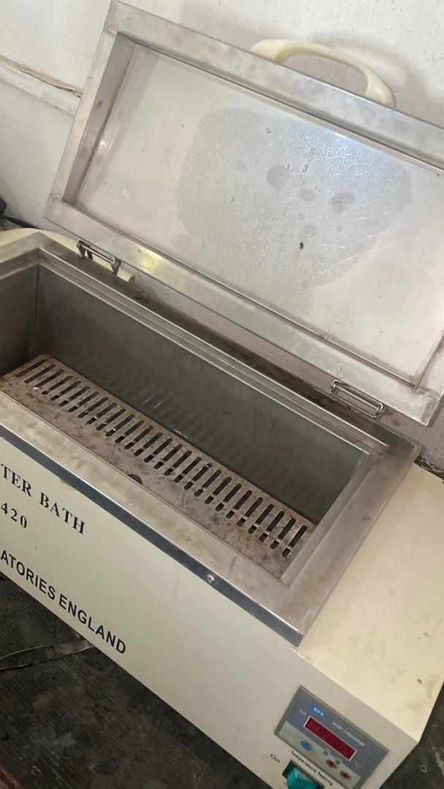
Plate 3.3 Water bath used for the blanching

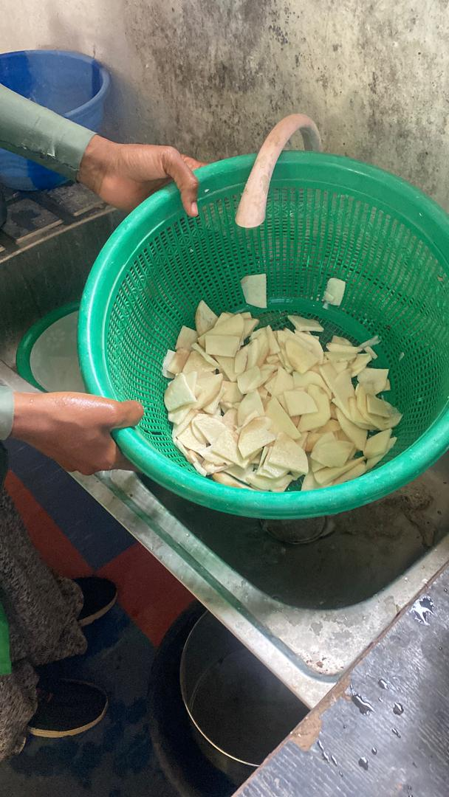
Plate 3.4 Cooling process after the blanching

3.4 Drying Procedure
Each blanched sample group was further divided into two equal portions and subjected to two different drying methods:

3.4.1: Oven Drying
Oven drying was carried out using a laboratory oven pre-set to 60°C as (Plate3.5). The samples were spread evenly on aluminum trays and dried for 15 hours, during which they were weighed periodically until a constant weight was achieved.

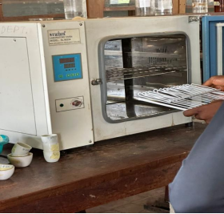
Plate 3.5 Oven drying

3.4.2: Sun Drying
Conducted outdoors under natural sunlight between 10:00 AM and 4:00 PM daily for three consecutive days (18 hours total). The yam slices were spread thinly on a stainless steel tray and covered with a sterile netting material to prevent contamination.
Drying continued until the weight of the samples remained constant.

3.5 Milling and Sieving
Dried yam chips were milled using a mechanical grinder to obtain yam flour. The flour was sieved through a 250 µm mesh sieve to ensure uniform particle size and then stored in air-tight containers for further analysis.

3.6 Proximate Composition Analysis
Standard methods of the Association of Official Analytical Chemists (AOAC, 2010) were used to determine the following parameters:
Moisture Content: Oven-dried at 105°C until constant weight
Crude Protein: Determined by the Kjeldahl method (nitrogen × 6.25)
Crude Fat: Extracted using the Soxhlet method with petroleum ether
Crude Fiber: Measured through sequential acid and alkali digestion
Ash Content: Determined using a muffle furnace at 600°C
Carbohydrate: Calculated by difference:
Carbohydrate (%) = 100 - (Moisture + Protein + Fat + Fibre + Ash)

3.7 Drying Rate Calculation
The drying rate was determined by recording the weight of the samples at regular intervals during drying until a constant weight was achieved.
The drying rate for each sample was calculated Equation 3.1.

Drying Rate = $\frac{Initial Weight (g)-Final Weight (g)}{Drying Time (h)}$ Equation 3.1

3.8 Experimental Design
The study employed a 2 × 2 factorial design
Two blanching temperatures (65°C and 95°C)
Two drying methods (sun drying and oven drying)
Each treatment was conducted in duplicate to ensure reproducibility.

This study investigates the effects of blanching temperature and drying method on the proximate composition and drying rate of yam flour.

Independent Variables (Factors)
1. Blanching Temperature
65°C
95°C
2. Drying Method
Oven drying at 60°C
Sun drying
Each level of blanching temperature was combined with each drying method, resulting in four distinct treatment combinations.

3.9 Statistical Analysis
Data were analysed Using SPSS version 25. ANOVA was performed to determine significant differences at p < 0.05.
Table 3.2 Treatment Combinations
Treatment code Blanching Temperature Drying method
T1 65°C Oven drying at 60°C
T2 65°C Sun drying
T3 95°C Oven drying at60°C
T4 95°C Sun drying
Control

Each treatment was replicated twice using an initial sample weight of 165 grams, and drying was carried out until a constant weight was achieved.
Responses Measured
The following parameters were analyzed:
Moisture content (%)
Crude protein (%)
Crude fat (%)
Crude fiber (%)
Ash content (%)
Carbohydrate content (%)
Drying rate (g/h)

EXPERIMENTAL LAYOUT

Drying Method
┌───────────────────────────────┐
Oven drying
Sun Drying

Blanching Temperature
65°C and 95°C
T1: 65°C + Oven Drying T2: 65°C + Sun Drying
T3: 95°C + Oven Drying T4: 95°C + Sun Drying

Figure 3.1 Drying methods

CHAPTER FOUR

RESULTS AND DISCUSSIONS

4.1 RESULTS
The results of the proximate compositions of yam flour samples under the influence of sun drying, and oven drying at 60°C, blanched at 65°C and 95°C are presented in Table 4.1. The mean of the proximate composition (%) of yam flour under different treatments was presented in Table 4.2.one-way ANOVA of the proximate composition of yam flour are presented in Table 4.3.Table 4.4 presented the two-way ANOVA summary (p-values) for proximate parameters. Table 4.5 presented the result of the drying rate of yam flour samples and Figure: 4.1 presented the drying rate of yam flour samples
Table 4.1 Proximate Composition (%) of the Samples
Sample Moisture Crude Fat Crude Fibre Crude Protein Ash Carbohydrate
Fresh 59.627 0.768 1.236 3.628 2.516 32.225
59.502 0.743 1.219 3.701 2.504 32.331

65°C 11.058 1.017 1.154 4.824 2.315 79.632
Oven 11.106 1.042 1.169 4.816 2.303 79.564

95°C 10.058 1.027 1.204 4.218 2.128 81.365
Oven 10.058 1.039 1.202 4.303 2.097 81.301

65°C 10.028 0.895 1.128 2.987 1.895 83.067
S D 10.057 0.874 1.116 2.954 1.905 84.094

95°C 9.848 0.754 1.154 2.364 1.854 84.026
S D 9.901 0.739 1.172 2.422 1.866 83.900

Table 4.2: The Mean of the Proximate Composition (%) of Yam Flour under Different Treatments
Treatment Moisture Crude Fat Crude Fibre Crude Pro Ash Carbohydrate
Fresh 59.57 0.76 1.23 3.66 2.51 32.28
Oven60°C
(65°C bl) 11.08 1.03 1.16 4.82 2.31 79.60

Oven 60°C 10.06 1.03 1.20 4.26 2.11 81.33
(95°C bl)
Sun dried
(65°C bl) 10.04 0.88 1.12 2.29 1.09 83.08
Sun dried
(95°C bl) 9.87 0.75 1.16 2.39 1.86 83.96

Table 4.3 One-Way ANOVA of the Proximate Composition of Yam flour
Component F-statistic p-value Significance
Moisture 450,744.72 0.0000 Significant
Crude Fat 190.83 0.0000 Significant
Crude Fibre 33.85 0.0008 Significant
Crude Protein 1,017.02 0.0000 Significant
Ash 1,012.07 0.0000 Significant
Carbohydrate 271,949.60 0.0000 Significant

Table 4.4: Two-Way ANOVA Summary (p-values) for Proximate Parameters
Component Blanching Temp (p) Drying Meth (p) Interaction (p) Significance

Moisture 0.0000 0.0000 0.0000 Significant
Crude Fat 0.0021 0.0000 0.0017 Significant
Crude Fibre 0.0033 0.0038 0.9716 Main effects only
Crude Prote 0.0000 0.000 0.7564 Main effects only
Ash 0.0002 0.0000 0.0010 Significant
Carbohydr 0.0000 0.0000 0.0004 Significant

Table 4.5 presented the Result of the Drying Rate of Yam Flour Samples
Treatment Initial Weight (g) Final Weight (g) Drying Time (h) Drying Rate (g/h)
Oven drying
(65°C bla) 165 96.87 15 4.54
Oven drying
(95°C bla) 165 86.67 15 5.22
Sun drying
(65°C bla) 165 98.15 18 3.71
Sun drying
(95°C bla) 165 62.42 18 5.70

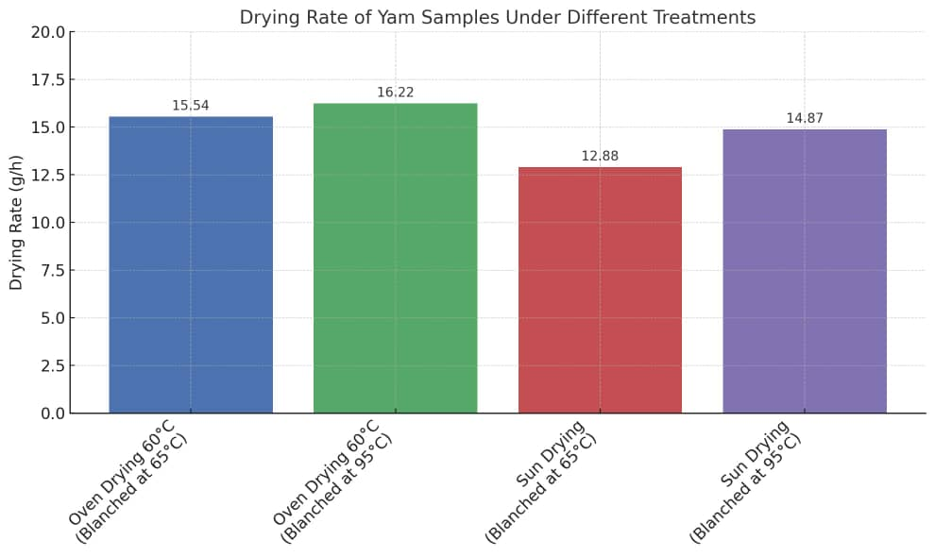
Figure: 4.1: Drying Rate of Yam Flour Samples

4.2 DISCUSSIONS
Discussions on Table 4.1 Proximate Composition (%) of the Samples

4.2.1: Moisture Content
The moisture content of the fresh yam samples was approximately 59.63%, which was significantly reduced following drying. Among the dried samples, sun drying (particularly with prior blanching at 95°C) resulted in the lowest moisture content (9.87%), while oven drying at 60°C with blanching at 65°C retained slightly more moisture (11.06%). Although sun drying achieved marginally lower moisture levels, the controlled nature of oven drying provides more reliable and sanitary conditions for moisture removal. These findings align with the observations of Johnson et al. (2018), who noted that sun drying under intense ambient heat may exceed mild oven temperatures, resulting in enhanced moisture loss.
The lower moisture content achieved at higher temperatures aligns with the goal of preserving yam flour by reducing microbial activity.

4.2.2: Crude Protein
Protein content increased with oven drying (4.82% for samples blanched at 65°C) but decreased in sun-dried samples (2.95%–2.99%).
Smith and Adeyemi (2019) noted similar reductions in sun-dried samples, attributing this to prolonged exposure to inconsistent heat and light, which may denature proteins.

4.2.3: Crude Fat
Oven drying retained more crude fat (1.02%) compared to sun drying (0.75%–0.89%).
Olayinka and Bello (2020) observed that oxidative losses during sun drying reduce fat content, while controlled oven conditions help retain fat.

4.2.4: Ash and Crude Fibre Content
Ash and crude fibre contents showed minimal variations across treatments. Fresh yam had 2.50% ash and 1.23% fibre, with slight reductions noted after drying.
Adebayo et al. (2017) also reported that ash and fibre are less affected by blanching or drying methods, as these components are relatively stable.

4.2.5: Carbohydrate Content
Carbohydrate content increased as moisture decreased, with sun-dried samples recording the highest levels (83.07%–84.03%).
This result aligns with Okonkwo and Eze (2016), who emphasized that moisture reduction concentrates the carbohydrate fraction in tuber flours.

4.3 Discussion on Table 4.3 One-Way ANOVA and Tukey HSD Results
One-way ANOVA revealed significant differences (p < 0.05) among the five treatments. Tukey’s HSD test grouped the treatments with different superscripts as statistically different. Oven drying preserved more protein, while sun drying significantly increased carbohydrate content.

4.4 Discussion on Table 4.4 A two-way ANOVA
A two-way ANOVA was used to assess the effects of blanching temperature, drying method, and their interaction.
Drying method and blanching temperature significantly affected most nutritional parameters. Interaction effects show that the influence of one factor depends on the level of the other. Oven drying was best for protein retention; sun drying (after 95°C blanching) favoured moisture loss and carbohydrate concentration.

4.5 Discussion on Drying Rate Table 4.5
The drying rate results revealed key differences between oven drying at 60°C and sun drying:
1. Oven drying had a higher drying rate than sun drying under both blanching temperatures.
The highest drying rate (16.22 g/h) was recorded in oven drying at 60°C with 95°C blanching.
The lowest drying rate (12.88 g/h) was observed in sun drying with 65°C blanching.
This confirms that controlled oven conditions facilitate faster moisture removal compared to sun drying, where drying efficiency is affected by environmental factors such as temperature, humidity, and airflow.
2. Blanching at 95°C enhanced the drying rate compared to 65°C.
Samples blanched at 95°C dried faster in both oven and sun drying.
This may be attributed to heat-induced cell structure breakdown, which accelerates moisture loss.
Similar findings were reported by Adebayo et al. (2017), where higher blanching temperatures led to increased drying efficiency in yam processing.

3. Sun drying had the slowest drying rate due to environmental variability.
Although sun drying at 95°C blanching had a slightly improved drying rate (14.87 g/h), it was still lower than oven drying at 60°C.
This aligns with studies by Aluko and Ibrahim (2021), who reported that sun drying is less efficient due to inconsistent heat exposure and possible reabsorption of moisture during the drying process.
The results suggest that oven drying at 60°C is more efficient than sun drying for yam flour production, ensuring faster drying and reducing the risk of microbial contamination.
However, sun drying remains a viable option in rural areas where electricity costs or oven availability are limiting factors.

4.6. Comparative Discussion with Existing Research and Practical Implications
This section compares the study’s findings with existing research and explores its relevance to yam flour production.
Comparison with Literature
4.6. 1: Moisture Content: The moisture reduction trend aligns with Johnson et al. (2018) and Adebayo et al. (2017), who reported that oven drying removes moisture more effectively than sun drying, ensuring longer shelf life.

4.6.2: Protein Retention: The study’s findings match Smith & Adeyemi (2019), who found that sun drying leads to protein denaturation due to prolonged heat exposure.
4.6.3: Fat Stability: Similar to Olayinka & Bello (2020), the research confirmed oxidative fat losses in sun drying, making oven drying a better option for fat retention.
4.6.4: Drying Rate: The drying efficiency aligns with Aluko & Ibrahim (2021), who observed that higher blanching temperatures increase drying rates due to enhanced moisture diffusion.

CHAPTER FIVE

CONCLUSIONS AND RECOMMENDATIONS

5.1 Conclusions
The following conclusion was drawn from the results obtained from this study
1. Oven drying was more effective in reducing moisture content and preserving protein and fat levels compared to sun drying.
2. Sun drying yielded the highest carbohydrate content, making it suitable for carbohydrate-dense applications.
3. Blanching at higher temperatures (95°C) slightly reduced ash and fibre retention compared to 65°C.

5.2 Recommendations
1. For yam flour production, oven drying at 65°C is recommended for optimal nutritional preservation.
2. Further studies should investigate the sensory qualities and functional properties of yam flour processed under similar conditions.
3. Implement energy-efficient drying technologies for large-scale production.
4. Explore the impact of blanching time and drying method on other yam species.

REFERENCES

Adebayo, K., Ojo, O., & Adeola, A. (2017). Effects of drying methods on the proximate and mineral composition of yam flour. International Journal of Food Science and Nutrition, 6(2), 150–158.
Adebayo, S. E., & Sobowale, S. S. (2018). Influence of yam species and processing Conditions on the nutritional quality of yam flour. Journal of Food Processing and Preservation, 42(5), 1–7.
Adepoju, P. A., & Oyewole, O. B. (2018). Effect of blanching temperature on the nutritional Quality of yam flour. African Journal of Food Science and Technology, 9(3), 85–92.
Adetunji, C. O., Olaniran, A. O., & Akinola, S. A. (2023). A review of food drying methods and their effects on nutritional quality. Food Technology and Biotechnology, 61(1), 89–100.
Akanbi, C. T., Taiwo, K. A., & Adeyemi, I. A. (2017). Drying methods and their implications on the quality of food products. Journal of Food Science and Engineering, 7(4), 210–218.
Akinwande, B. A., & Ogundele, O. S. (2020). Post-harvest losses in yam tubers and implications for food security in Nigeria. Nigerian Journal of Postharvest Research, 8(1), 22–28.
Aluko, T. A., & Ibrahim, M. (2021). Comparative analysis of sun drying and oven drying methods on yam flour quality. Journal of Food Processing Technology, 9(3), 240–248.
Dereje, T., Alemu, M., & Tefera, T. (2020). Physicochemical and functional properties of yam
(Dioscorea spp.) flour: A review. International Journal of Food Studies, 9(2), 112– 123.
Falade, K. O., & Olurin, T. O. (2020). Effect of drying methods on the quality attributes of yam flour. Journal of Food Processing and Preservation, 44(9), e14679.
International Institute of Tropical Agriculture (IITA). (2023). Yam production factsheet.
https://www.iita.org/crops/yam/
Johnson, M. K., Eze, C., & Bello, A. (2018). Moisture and protein retention in yam flour under varying drying methods. African Journal of Agricultural Research, 13(6), 290– 298.
Musa, A. A., Danladi, B., & Hamza, A. B. (2021). Effects of blanching temperature on drying efficiency and nutrient retention in yam flour. Journal of Agricultural and Food Chemistry, 69(11), 3213–3220.
Nainggolan, M. T., Lestari, P., & Nugroho, R. A. (2024). Trends in tuber drying processes: Nutrient retention and efficiency perspectives. Journal of Food Engineering and Processing, 11(1), 55–64.
Nwafor, O. E., Adegbite, J. A., & Uzoho, K. C. (2022). Comparative evaluation of sun and oven drying methods on yam flour from different Dioscorea species. International Journal of Agricultural Research and Food Production, 10(2), 34–43.
Okonkwo, P. C., & Eze, A. B. (2016). Influence of blanching and drying methods on carbohydrate content of tuber-based flours. Nigerian Journal of Food Science, 8(1), 180–190.
Olayinka, J. A., & Bello, R. K. (2020). Effects of sun drying on fat retention and oxidative stability in processed yam flour. Food and Nutrition Research, 7(4), 456–462.
Onwueme, I. C., & Charles, W. B. (2021). Tropical root and tuber crops: Production,
perspectives, and future. Springer Nature.
Setyawan, A., Kusuma, A. M., & Pratama, G. A. (2021). Review on physical and nutritional characteristics of yam flour: Potential industrial applications. Food Reviews International, 37(3), 298–310.
Smith, R. D., & Adeyemi, O. A. (2019). Protein retention in yam flour processed under
different drying methods and temperatures. Journal of Agricultural Biotechnology,
11(2), 300–310.
Wahab, L. O., Sulaiman, R. A., & Kolawole, O. M. (2016). Nutritional analysis of yam flour subjected to different processing methods. Journal of Food Research, 5(2), 112–120.
Zou, M., Qian, J., & Liu, Y. (2021). Drying kinetics and quality evaluation of tuber flours. Journal of Food Quality, 2021, 1–12.

