
DEPARTMENT OF SCIENCE LABORATORY TECHNOLOGY
FABRICATION OF LABORATORY EQUIPMENT; INOCULATION LOOP, NEEDLE AND SPIRIT LAMP
BY

ALEEM MARIAM ADEOLA
ND/23/SLT/PT/0532

BEING PROJECT SUBMITTED TO
THE DEPARTMENT OF SCIENCE LABORATORY TECHNOLOGY, INSTITUTE OF APPLIED SCIENCES,
KWARA STATE POLYTECHNIC ILORIN, KWARA STATE

IN PARTIAL FULFILLMENT OF THE REQUIREMENT FOR THE AWARD OF NATIONAL DIPLOMA (ND) IN SCIENCE LABORATORY TECHNOLOGY (MICROBIOLOGY OPTION), KWARA STATE POLYTECHNIC ILORIN, KWARA STATE

SUPERVISED BY: MRS. ABDULLAHI HAJARAT J.

2024/2025 SESSION

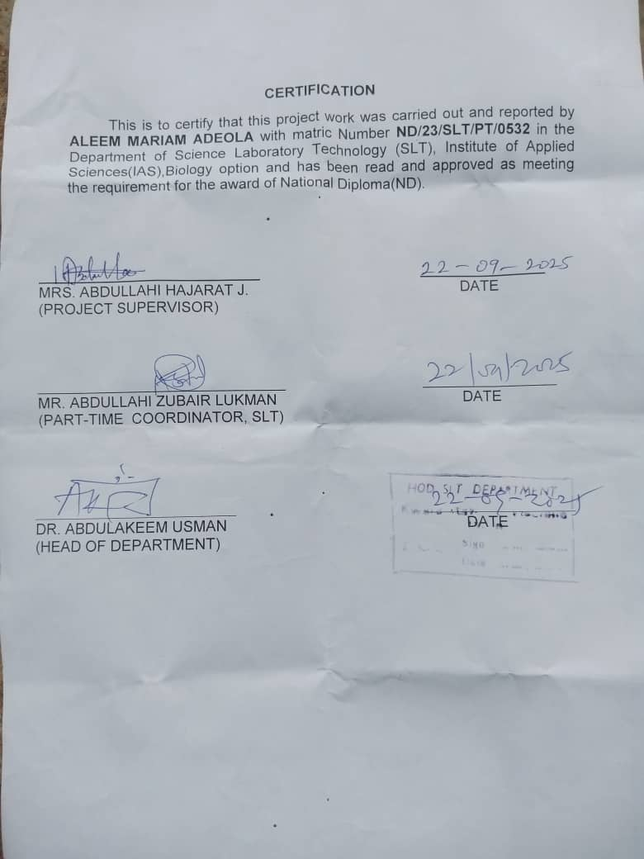
DEDICATION
This project is dedicated to Almighty Allah, the provider and sustainer of life, Whose grace has made this journey of my National Diploma (ND) possible.
To my loving family, who’ve been my rock throughout this journey. To my parents MR & MRS ALEEM, whose love , support, prayers and sacrifices have shaped me into who I am today. To my beloved brothers ISIAQ & ABEEB who’ve stood by me through thick and thin your support means the world to me and to everyone who’s played a part in my journey, thank you for the love, encourage and contributions. This project is dedicated to you all with gratitude and love. May Almighty Allah continue to bless and protect you.

ACKNOWLEDGEMENT
I am indeed thankful and grateful to Almighty Allah for giving me the opportunity, courage, energy, grace, and protection over me throughout the period of my programme.
With thankful acknowledgement goes to my amiable supervisor, Mrs. Abdullahi H.J with despite her busy schedule, found time to guide and mentor me in my quest to achieve excellence. Hence, She has played a pivotal role in bringing this study to completion. I pray Allah grant her wisdom, patience and clarity of thought as she oversees my work. May her efforts be fruitful and may she be rewarded for her commitment to excellence Amen.
I extend my heartfelt gratitude to the head of my department, Dr. Usman Abdulkareem, the head of unit, Miss. Ahmed Tawakalitul,my coordinator Mr Lukman and lecturers in the Department of Science Laboratory Technology , Kwara State Polytechnic, Ilorin, may Allah bless you all abundantly.
I would like to also appreciate myself, the little soul in me for not getting tired and relent through this journey I’m supper proud of myself and I thank God almighty for not leaving my side, I pray almighty Allah continue to guide and protect me in everything I lay my hands on.
My appreciation also goes to my sister's and brother's thanks you all for your support and guidance, to make this journey successful i pray almighty Allah will always be with u and reward u for all your efforts on me. And to everyone that sees me through this journey, God bless you all.
I extend my heartfelt thanks to my amazing fellow students for creating unforgettable memories together, I am deeply grateful. May Allah bless us abundantly on our individual journeys.
Contents
Title page
Certification
Dedication
Acknowledgements
Table of Content
Abstract
CHAPTER 1: INTRODUCTION AND LITERATURE REVIEW
  - INTRODUCTION
1.2 AIMS AND OBJECTIVES
1.3 STATEMENT OF THE PROBLEM
1.4 LIMITATIONS OF THE STUDY

CHAPTER TWO

2.0 HISTORY AND EVOLUTION

2.1 BRIEF HISTORY OF INOCULATING LOOPS IN MICROBIOLOGY
2.2 PRINCIPLE OF INOCULATING LOOPS AND NEEDLES
2.3 PARTS OF INOCULATING LOOPS AND NEEDLES
2.4 TYPES OF INOCULATING LOOPS AND NEEDLES
2.5 INOCULATING LOOPS AND NEEDLES OPERATING PROCEDURE
2.6 APPLICATIONS OF INOCULATING LOOPS AND NEEDLES
2.7 ADVANTAGES OF INOCULATING LOOPS AND NEEDLES
2.8 LIMITATIONS OF INOCULATING LOOPS AND NEEDLES
2.9 PRECAUTIONS

2.10 INOCULATING LOOPS AND NEEDLES EXAMPLES
CHAPTER THREE
3.0 INOCULATING LOOPS FOR PETRI DISH

3.1 ACCURACY AND PRECISION IN SAMPLE TRANSFER WITH INOCULATING LOOPS

3.2 INOCULATING LOOPS IN DIFFERENT MICROBIOLOGICAL TECHNIQUES

3.3 INNOVATION AND FUTURE TRENDS IN INOCULATING LOOP DESIGN

3.4 FUTURE PROSPECTS AND POTENTIAL IMPACT

CHAPTER FOUR

4.0 MATERIALS, DISCUSSION AND CONCLUSION

4.1 MATERIALS

4.2 DISCUSSION

4.3 CONCLUSION
REFERENCE

ABSTRACT
This project aimed to fabricate laboratory equipment, specifically an inoculation needle and a spirit lamp, using locally sourced materials. The inoculation needle was made from stainless steel wire, while the spirit lamp was constructed using borosilicate glass and brass components. The fabricated equipment was tested for performance, durability, and safety. The results showed that the inoculation needle and spirit lamp met the required standards for laboratory use, providing a cost-effective and reliable alternative to commercial products.
CHAPTER ONE
1.0 INTRODUCTION
An inoculation loop (also called a smear loop, inoculation wand or micro streaker) is a simple tool used mainly by microbiologists to pick up and transfer a small sample of microorganisms called inoculum from a microbial culture, e.g. for streaking on a culture plate. This process is called inoculation.
In microbiology, inoculation is the process of adding bacteria to a culture media so they can reproduce there. To increase immunity against a certain disease, it is frequently used to introduce vaccines, serum, or other antigenic substances into the body (Ashraful, M., et al., 2018).
Inoculating loops and needles are hand-held and compact appliances that introduce microorganisms like bacteria or yeast into plated or tubed growth media before incubation, multiplication, or growth. The inoculum is commonly delivered and disseminated into liquid media, streaked onto or stabbed into a solid agar-based medium, or both (Danilcenko, H. et. al., 2013).
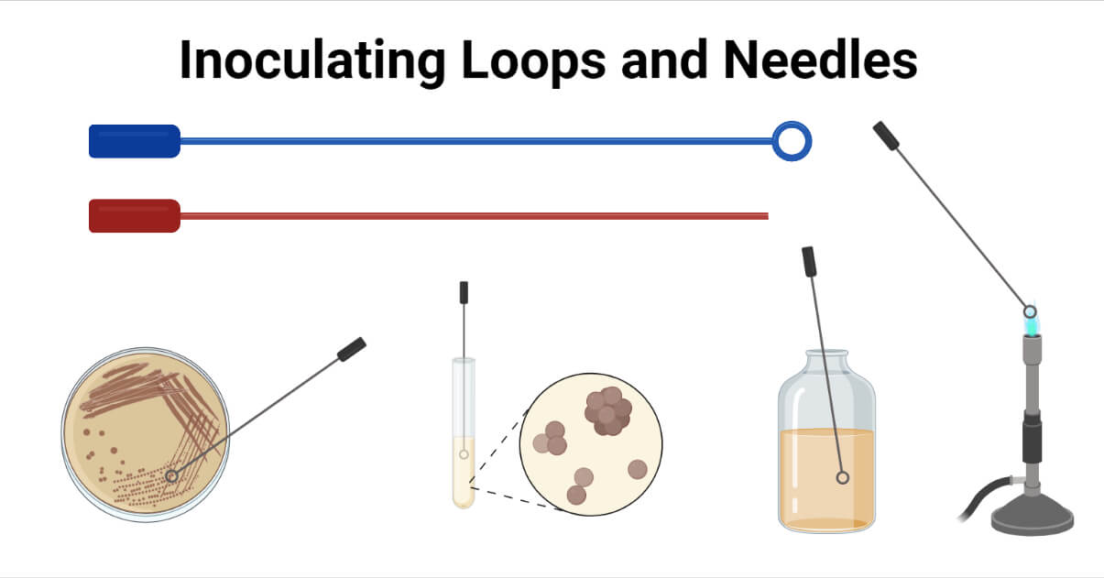

Figure 1.0: Inoculating loops and needles
An inoculation loop often referred to as a smear loop, inoculation wand, or microstreaker, is a basic instrument used largely by microbiologists to take and transfer a small sample (inoculum) of a microbe culture, for instance, to strip on a culture plate. It is a tool often constructed of nichrome or platinum wire, with a tip with a tiny loop with a diameter of around 2 mm to 5 mm. Transferring liquid media between Petri plates or liquid media requires loops. The liquid media are retrieved via an inoculation loop. Loop wires can also extract larger samples (Borokini, T. I., & Omotayo, F. O. (2012).
Needles transfer solid media between Petri plates or other solid media. When removing solid or dense material, an inoculation needle is employed. These work well for removing samples of small colonies of microscopic organisms.
These are employed for sampling and transmitting small amounts of microorganisms before additional investigation, microscopic examination, or serial dilution.
The tool consists of a thin handle with a loop about 5 mm wide or smaller at the end. It was originally made of twisted metal wire (such as platinum, tungsten or nichrome), but disposable molded plastic versions are now common. The size of the loop determines the volume of liquid an inoculation loop can transfer, (Khan, M. A. 2016).. An early report of the use of an inoculation loop as an analytical tool was by O’Sullivan et al. in a 1960 published protocol developed to improve methods for culturing urine samples. A 3mm diameter loop was used to deliver a consistent volume of urine for analysis. Loops can now be purchased to transfer volumes ranging from 1-10 microliters, though pipettes have replaced inoculation loops as more reliable tools to deliver small volumes of liquid, (Bako, S. P., et. al., 2015)
1.2 AIMS AND OBJECTIVES
AIMS
The aim of this project is to scientifically explore and document the procedures involved in the fabrication of laboratory equipment; inoculation needle and spirit lamp, exploring the principles of inoculating loops and needles, knowing the types and applications of inoculating loops and needles.
OBJECTIVES
- Improving the design and fabrication process for enhanced performance and durability.
- Exploring the use of alternative materials and techniques for laboratory equipment fabrication.
- Developing a comprehensive guide for local fabrication of laboratory equipment.
1.3 STATEMENT OF THE PROBLEM
The fabrication of laboratory equipment, specifically inoculation needles and spirit lamps, faces challenges in ensuring:
Precision and accuracy: Meeting exacting standards for inoculation needles.
Material durability: Selecting materials resistant to corrosion and sterilization.
Safety and control: Designing spirit lamps with safe and controllable flames.
Quality consistency: Maintaining consistent quality across fabricated equipment.
These challenges impact the reliability, safety, and effectiveness of laboratory equipment.
1.4 LIMITATIONS OF THE STUDY
- Limited availability of certain materials or equipment.
- Potential variability in quality and performance of fabricated equipment.

CHAPTER TWO

2.0 HISTORY AND EVOLUTION

In the realm of microbiology, inoculating loops stand as an indispensable tool, bridging past methodologies with modern scientific practices. Their journey from rudimentary instruments to precision tools reflects the evolution of microbiological research itself. This article delves into the history, types, and practical applications of inoculating loops, a vital component in any microbiology laboratory.

2.1 BRIEF HISTORY OF INOCULATING LOOPS IN MICROBIOLOGY
The story of inoculating loops begins in the late 19th century, a period marked by groundbreaking discoveries in microbiology. Early researchers, striving to cultivate and study microorganisms, fashioned simple loops from wire or other materials available at the time. These primitive tools were pivotal in handling cultures, albeit with limited precision and efficiency, (Gupta, D.Chaturvedi, N.(2020).
As the field of microbiology expanded, so did the need for more refined instruments. The transition from these early versions to today’s sophisticated designs mirrors the advancements in material sciences and our understanding of microbial cultures. Modern inoculating loops, crafted from materials like nichrome, platinum, and plastic, offer enhanced precision, durability, sterility, and ease of use, catering to the diverse needs of contemporary microbiological studies.
2.2 PRINCIPLE OF INOCULATING LOOPS AND NEEDLES
Flaming of the loops and needles till they become red hot facilitates their sterilization such that it prevents cross-contamination of samples. Following this, when they are cooled, they are ready to pick up, transfer and inoculate the microbial sample into the media or prepare a smear.
2.3 PARTS OF INOCULATING LOOPS AND NEEDLES
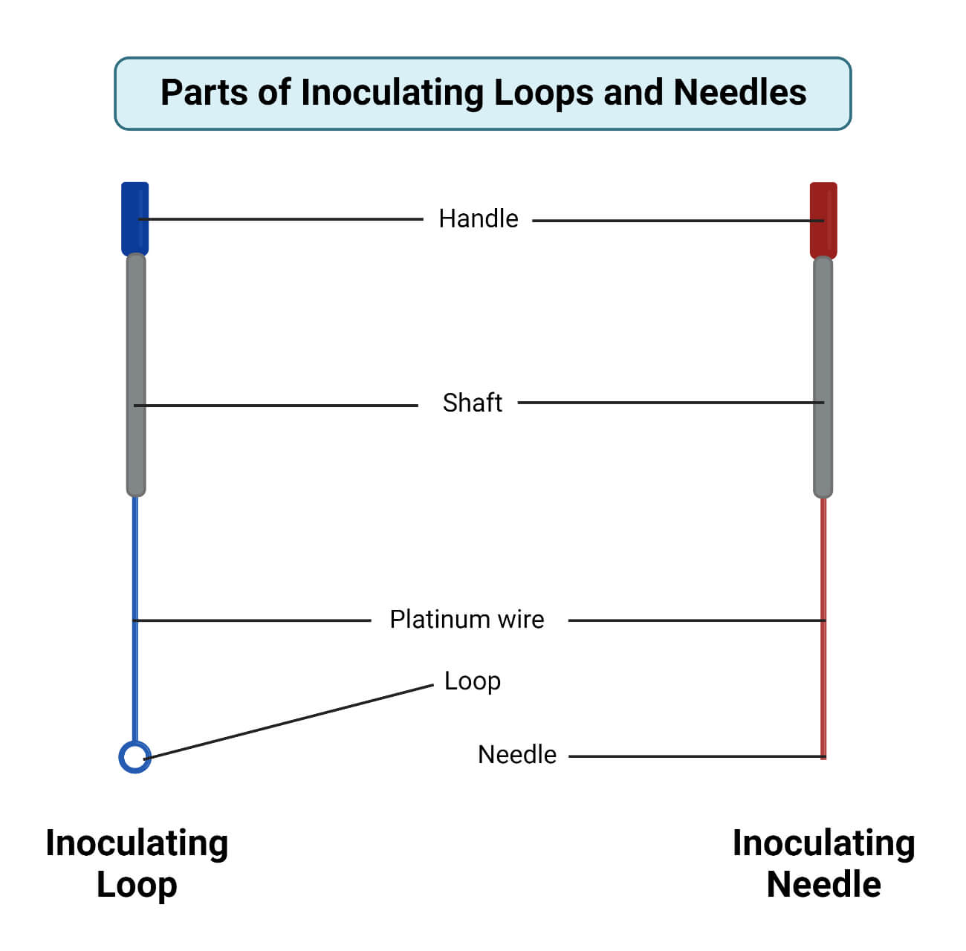

Figure 1.1: Parts of inoculating loops and needles
- Handle: The inoculating loop or needles are handled by holding the handle part of the loop or needle and facilitating fatigue-free application. It is made of aluminum and brass in either an insulated or non-insulated format. The handle is 8 inches long.
- Shaft: Nickel-plated brass is used to make the loop shaft. For added heat protection for the user, PVC is used to insulate the shaft of the loop handle.
- Turret: It holds nickel-chromium or platinum wire.
- Loop: The nichrome or platinum wire affixed to the turret is twisted into a loop structure at the end. The wire is resistant to high temperatures and oxidation. The loop is 2mm to 5 mm in diameter.
- Needle: It is substantially identical to the loop but uses a straight wire instead.
2.4 TYPES OF INOCULATING LOOPS AND NEEDLES
There are mainly two types of inoculation loops, namely:
- With calibrated inoculation loop (Calibrated)
- It is employed for quantitative specimen cultures.
- It is available in sizes of 1µL and 10µL.
- Licensed calibration.
- Without calibrated inoculation loop (Noncalibrated)
- Various sizes are available with an internal diameter (Ø) of 2, 3, 4, or 5 mm.
- It is simple to use and dispose of.
- Inoculation loops are ready to use.
- It has undergone gamma radiation sterilization.
Inoculation needles are categorized as reusable and disposable based on their durability.
- Reusable inoculation needle: A metallic handle and nichrome or platinum wire are attached to form the common reusable inoculation needle.
Disposable inoculation needle: It is usually composed of plastic resin. A blunted end is formed by the dulling of the needle’s base. These are employed in environments where the flame is impractical, such as under hoods and in anaerobic chambers, thereby removing the risk of infection from pathogens spread via aerosol generation, cross-contamination, spattering, and risks associated with open flames, and are color coded for easy identification. It is rigid enough to permeate the media for subsurface inoculation.
2.5 INOCULATING LOOPS AND NEEDLES OPERATING PROCEDURE
- Sterilize the wire inoculating loop by angling through the heat source until the full length of the wire begins to glow red/orange from the heat.
- Cool the loop or needle before selecting the bacterial sample to be transferred.
- The loop/needle is reheated after use to sterilize it.
- Disinfect a 12-inch diameter ring around the base of the heating device to eliminate any bacteria that survived the heating process.
2.6 APPLICATIONS OF INOCULATING LOOPS AND NEEDLES
- Inoculating needles are used in microbiology to investigate bacteria and fungi on semi-solid media.
- Needle-oriented culture techniques are also used in biotechnology, cell biology, and immunology.
- The inoculation loop/ needle is used for streak plate streaking, fishtail inoculating slant cultures, and inoculating stab cultures.
- Stab cultures are used to research cell motility, microbial oxygen requirements utilizing thioglycolate cultures, and the gelatin liquefaction of bacteria. Stab cultures especially call for the inoculation needle.
- Inoculating loops and needles are employed for inoculation, serial dilution, sterile sampling, transfer, and spreading microbiological samples.

2.7 ADVANTAGES OF INOCULATING LOOPS AND NEEDLES
- The use of platinum wire in inoculating loops and needles facilitates their rapid heating and rapid cooling such that it saves time as well as increases the efficiency of work.
- Likewise, nickel-chrome loops possess durability and rapid cooling following heat sterilization.
- Disposable inoculating loops and needles do not require flaming and thus eliminate the risk of infection due to the aerosol formation of pathogenic microorganisms.
2.8 LIMITATIONS OF INOCULATING LOOPS AND NEEDLES
- Platinum wires are costlier. Disposable plastic loops and needles are also quite expensive.
- This process of inoculating is time-consuming, and the integrity of samples can be damaged if mistakes are made.
- There is a high potential for human error and contamination while working with multiple samples.
2.9 PRECAUTIONS
- The region around the heating device should be disinfected after the completion of the heating process to eradicate the microorganisms that survived following flaming.
- The heated loop or needle should not be touched with the hand after flaming, and let it cool down for some time before use. Hot loops and needles kill the sample microorganisms to be transferred.
- The wire loops and needles should be flamed before and after use.
- Streaking should be performed gently with smooth and rapid movements to prevent gouging the agar plate.
- Proper handling and sterilization of inoculating loops are crucial to ensure laboratory safety.
- Users must be aware of the risks associated with improper sterilization, such as cross-contamination and erroneous results. Adhering to recommended sterilization techniques, as discussed earlier, and staying informed about safety practices is essential.
- Regular inspection of reusable loops for any signs of wear or damage is crucial.
- For labs using disposable loops, implementing a proper disposal and recycling strategy is key to maintaining an efficient and environmentally responsible workspace.
- For labs using disposable loops: before opening the pouch that contains the lopos, make sure that the pouch is 100% closed so that the loops are kept sterile and there is no risk of contamination

2.10 INOCULATING LOOPS AND NEEDLES EXAMPLES

Laboratory inoculating loop Nunc™ (Thermo Scientific)
- Nunc loops and needles from Thermo Scientific are disposable.
- They are constructed from non-toxic polystyrene.
- Due to liquid adherence characteristics, accidental discharges are avoided.
- Precision-molded, these items can be applied to a wide range of fields, including biotechnology, pharmaceuticals, research labs, and the manufacture of diagnostic kits and vaccines.

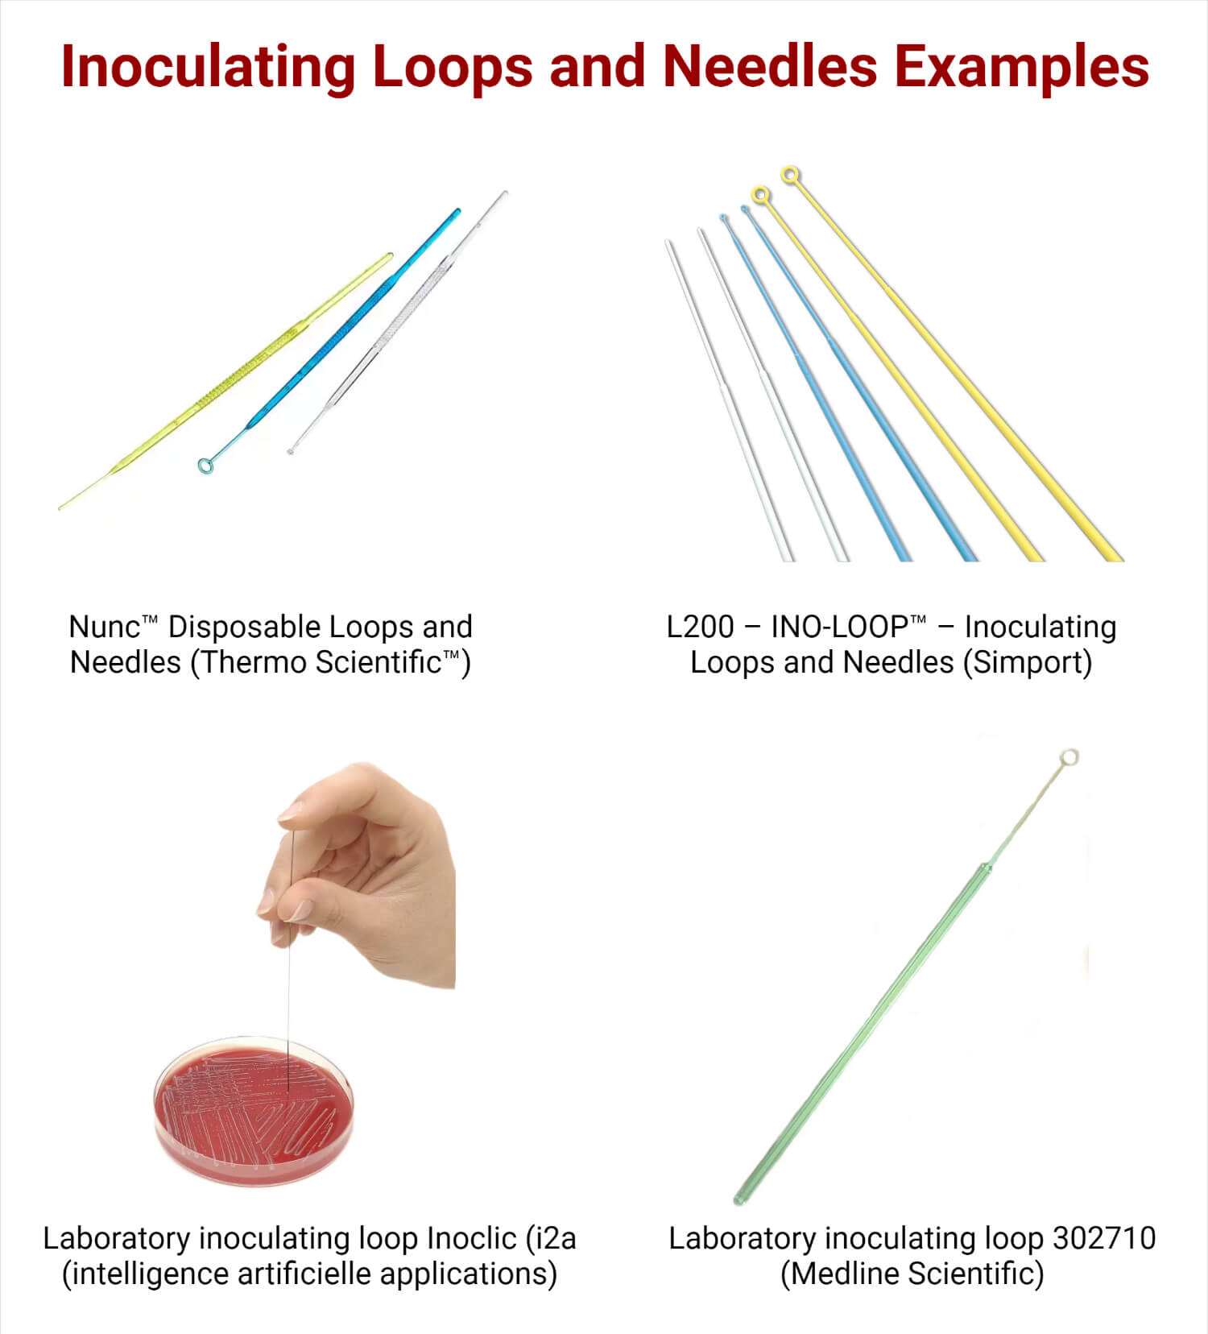

Figure 1.2: Inoculating Loops and Needles Examples
Source: Respective Company Website

Laboratory inoculating loop L200 Ino-Loop™ (Simport Scientific)
- Smooth and flexible loops and needles allow uniform streaking without harming the gel’s surface.
- Sterilized and contained in secure, tamper-evident zip-lock resealable bags.
- Cross-contamination brought on by insufficient sterilization is eradicated.

Laboratory inoculating loop Inoclic (i2a (intelligence artificielle applications) S.A.)
- INOCLIC is advised for the suspension of bacteria in a liquid medium or the inoculation of agar or tubed maintenance media.
- INOCLIC can launch identification using the same agar plate by using mass spectrometry and AST on agar media.

Laboratory inoculating loop 302715 (Medline Scientific)
- They provide uniform and clean streaking while protecting the gel surface because they are smooth and flexible.
- They come in handy sterile peel pouch packs marked with the batch and expiration date.

CHAPTER THREE
3.0 INOCULATING LOOPS FOR PETRI DISH
Evolution of Design and Materials Used in Inoculating Loops
The evolution of inoculating loops is a testament to the ever-changing landscape of microbiological tools. Initially, metal wires were bent into loops and manually sterilized via flaming. This method, while effective, had its limitations in terms of precision, durability and consistent quality.
The introduction of nichrome, a nickel-chromium alloy, marked a significant advancement. Renowned for its high melting point and resistance to corrosion, nichrome became a preferred material for reusable loops. Its ability to withstand repeated sterilization by flaming made it a mainstay in many labs.
However, the quest for improved sterility and convenience led to the development of disposable plastic loops. These loops, always pre-sterilized, offered a solution to contamination risks associated with reusable loops. Their one-time use nature also eliminated the need for time-consuming sterilization processes, thus increasing efficiency in fast-paced laboratory environments. Moreover, plastic loops are produced by injection molding, which is the most accurate technology in plastic production. Thus, plastic loops, if produced on accurate injection molding machine in a high-quality mold, are very precise. If purchased from a reliable producer, plastic loops offer accurate dose of 1 or 10 microliter (µl), (Kang, Y.,et. al.,. 2018).
Today, the choice between nichrome, platinum, and plastic loops largely depends on the specific needs of a microbiological task. Platinum loops, though more expensive, provide exceptional durability and heat resistance, making them a valuable investment for labs performing high-precision work. On the other hand, disposable plastic loops are increasingly popular in settings where rapid turnover and convenience are prioritized.

Best Practices for Ensuring Loop Sterility
Ensuring the sterility of inoculating loops is paramount in microbiological work. For more detailed insights into the variety and usage of these tools, refer to Inoculating loops & needles. This resource provides a comprehensive overview of different types of loops and needles, aiding in the selection of the appropriate tool for specific laboratory applications.

3.1 ACCURACY AND PRECISION IN SAMPLE TRANSFER WITH INOCULATING LOOPS
Accurate and precise sample transfer is crucial in microbiology. Inoculating loops, when used correctly, provide a high degree of control over the amount and placement of microbial samples. For example, in techniques like streaking for isolation, the loop’s ability to gently and precisely deposit microbes is essential. However, it’s vital to avoid common mistakes, such as improper sterilization or incorrect handling, which can lead to sample contamination or inaccurate results. Addressing these concerns is not only essential for sample handling but also for broader lab safety, including minimizing air contamination. For a deeper understanding of this aspect, the article Preventing Air Contamination During Inoculating Loop Use offers valuable information.

3.2 INOCULATING LOOPS IN DIFFERENT MICROBIOLOGICAL TECHNIQUES
Inoculating loops play a versatile role in various microbiological techniques. Whether it’s streaking for isolation or inoculating broths, their importance cannot be overstated. In each application, the precision and safety of the loop directly impact the experiment’s success. It’s also essential to consider the ancillary equipment used in these processes. A helpful resource in this regard is the Guide to Centrifuge Tubes, which provides essential information on selecting the right centrifuge tubes, a critical component in many laboratory procedures involving inoculating loops.

3.3 INNOVATION AND FUTURE TRENDS IN INOCULATING LOOP DESIGN
The field of microbiology is continually evolving, and with it, the tools of the trade are also advancing. Innovation in inoculating loop design is driven by the need for greater precision, efficiency, and safety in microbial culturing.

Emerging Technologies and Designs
- Recent advancements have introduced loops with more ergonomic designs, reducing hand fatigue during repetitive tasks. For example, Miniplast Quadloops are a patented product due to their quadruple profile, that enables the user to use the same loop, 4 different times. After each stroke, the end user turns the loop 90° with the fingers to get a new surface of the loops ball end. If you are curious to hear more about our cost effective and ergonomic loops, please refer to our product page: Miniplast Inoculating Loops
- Another recent advancement, is the individually packed loop. Miniplast offers all types of loops that are packed each one in a sealed plastic pouch. These sterilized loops can be used one by one, as opposed to a pouch of 10 or 20 loops, where the researcher opens the pouch to use 2 or 3 loops but has the risk that all the other loops would be contaminated. Our individually loops save mony to the laboratory and ensure that each loop used is absolutely sterile.
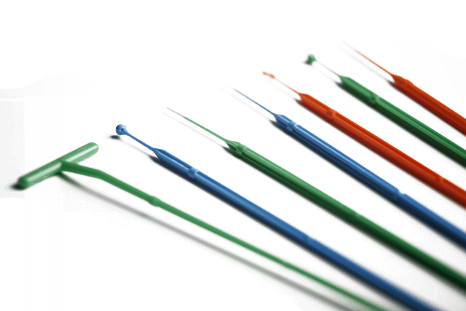
- Smart inoculating loops, equipped with sensors, are being developed to provide real-time data on parameters like temperature and sterility, enhancing the accuracy and reliability of microbiological procedures.

Figure 1.3: Miniplast Inoculating Loops

3.4 Future Prospects and Potential Impact
- Anticipated future trends include the development of more sustainable, biodegradable materials for disposable loops, addressing environmental concerns.
- The integration of AI and automation in loop design is on the horizon, potentially revolutionizing sample handling and streaking techniques.

CHAPTER FOUR

4.0 MATERIALS, DISCUSSION AND CONCLUSION

4.1 MATERIALS

Inoculation Needle:

Materials: Stainless steel wire (0.5-1.5 mm diameter), wire cutters, pliers, and a sharpening stone.

Fabrication process:

1. Cut the stainless-steel wire to the desired length.

2. Shape the wire into a needle point using the sharpening stone.

3. Bend the needle to the required angle.

4. Sterilize the needle using autoclaving or dry heat sterilization.

Spirit Lamp:

Materials: Borosilicate glass, brass components (wick holder and base), ethanol or methanol, and a wick.

Fabrication process:

1. Cut and shape the borosilicate glass to the desired shape.

2. Assemble the brass components, including the wick holder and base.

3. Attach the wick to the wick holder.

4. Fill the lamp with ethanol or methanol.

4.2 DISCUSSION

The fabricated inoculation needle and spirit lamp were tested for performance, durability, and safety. The results showed that:

The inoculation needle was able to withstand sterilization processes and maintained its shape and sharpness.

The spirit lamp provided a consistent and controlled flame, suitable for laboratory use.

Both equipment showed excellent durability and resistance to corrosion.

The fabricated equipment was compared to commercial products, and the results showed that they met the required standards for laboratory use. The cost analysis revealed that the fabricated equipment was significantly cheaper than commercial products, making it a cost-effective solution for laboratory settings.

4.3 CONCLUSION
Inoculating loops, with their rich history and continuous innovation, remain an indispensable tool in microbiology labs. From their humble beginnings to their current sophisticated forms, these tools have significantly contributed to advances in microbiological research and diagnostics.
In conclusion, understanding and utilizing inoculating loops effectively is crucial for any microbiological work. By embracing best practices, staying abreast of new technologies, and continually striving for precision and safety, laboratory professionals can ensure that these essential tools contribute to the groundbreaking discoveries and advancements in the field of microbiology.

REFERENCE
Ashraful, M., RaushanaraAkter, NusratSubhan, MostafizurRahman, M., Muntasir, M.,LutfunNahar, et al. (2018).Antidiarrhoeal property of the hydroethanolic extract of the flowering tops of Anthocephaluscadamba. Brazilian Journal of Pharmacognosy. 18(2):155-159.
Bako, S. P., Bakfur, M. J., John, I., &Bala, E. I. (2015).Ethnomedicinal and phytochemical profile of some savanna plant species in Nigeria. International Journal of Botany.
Boopathi, T.,Gopalasatheeskumar, K., Parthiban, S., Sangeetha, G., ThangaKokila, M. &Manimaran T. (2017).Evaluation of Antimicrobial Activity of TecomaStans and MuntingiaCalabura.6(3): 617-627.
Borokini, T. I., &Omotayo, F. O. (2012).Comparative phytochemical analysis of selected medicinal plants in Nigeria. Inter J AdvChem Res, 1, 011 - 018.
Danilcenko, H., Jariene, E., Gajewski, M., Sawicka, B., Kulaitiene, J. &Cerniauskiene, J. (2013).Changes in amino acids content in tubers of Jerusalem artichoke (Helianthus tuberosus L.) cultivars during storage. Acta Sci. Pol.-HortorumCultus 2013, 12, 97–105.
Das, K., Tiwari, R.K.S. &Shrivastava, D,K. (2010).Techniques for evaluation of medicinal plant products as antimicrobial agent: Current methods and future trends. Journal of Medicinal Plants Research, 4(2):104-111.
Durling, N.E., Catchpole, O.J., Grey, J.B., Webby, R.F., Mitchell, K.A., Foo, L.Y. & Perry, N.B. (2007).Extraction of phenolics and essential oil from dried sage (Salvia officinalis) using ethanol- water mixtures. Food Chem. 10(1): 1417 – 1424.
Flora of North America Editorial Committee.(2006). Helianthus tuberosus L. Flora of North America, 21.
Gupta, D.Chaturvedi, N.(2020).Impact of Processing on Inulin and sugars content of Jerusalem Artichoke Tuber.Res. I. Pharm. Technol. 13, 3143-3146.
Gupta, K., Talwar, G., Jain, V., Dhawan, K. & Jain, S. (2003).Salad crops: Root, bulb and tuber crops. In Encyclopedia of Food Sciences and Nutrition, 2nd ed.; Academic Press: Cambridge, MA, USA, pp. 5060–5073.
Halliwell, B. (1905).How to characterize an antioxidant.BiochSocSym 61: 85-91.
Kang, Y., Lee, K. &An, H. (2018).Inhibitory effects of Helianthus tuberosus ethanol extract on Dermatophagoides farina body-induced atopic dermatitis mouse model and human keratinocytes. Nutrients, 10, 1657.
Kaufmann, B. & Christen P. (2002).Recent extraction techniques for natural products: microwave assisted extraction and pressurized solvent extraction. Phytochem.Anal. 13:105-113.
Kays, S. J., Nottingham, S. F., (2008). Biology and Chemistry of Jerusalem Artichoke Helianthus tuberosus L.CRC Press, Taylor and Francis Group, Boca Raton, USA.
Khan, M. A. (2016). Introduction and importance of medicinal plants and herbs.Unani.Zahid, India.

