PRODUCTION OF AN ESTABLISHING THE NUTRITIONAL BENEFIT OF CASTOR OIL IN THE HOSPITALITY INDUSTRY

AFOLAYON RASHEEDAT AJOKE
ND/23/HMT/PT/0050

SUBMITTED TO:

DEPARTMENT OF HOSPITALITY MANAGEMENT TECHNOLOGY

INSTITUTE OF APPLIED SCIENCES (IAS)

KWARA STATE POLYTECHNIC, ILORIN NIGERIA.

IN PARTIAL FULFILLMENT OF THE REQUIREMENT FOR THE AWARD OF NATIONAL DIPLOMA (ND) IN HOSPITALITY MANAGEMENT
IN PARTIAL FULFILLMENT OF THE REQUIREMENT FOR THE AWARD OF NATIONAL DIPLOMA (ND) IN HOSPITALITY MANAGEMENT

SEPTEMBER, 2025.

CERTIFICATION
This is to certify that this Project work is carried out by AFOLAYAN RASHEEDAT AJOKE with Matric no. ND/23/HMT/PT/0050 and has been completed, read through and approved as meeting part of the requirements of the department of Hospitality Management, Institute of Applied Sciences (IAS), Kwara State Polytechnic for the award of National Diploma in Hospitality Management.

__________________ _________________
OWOLABI, ROSALINE MODUPE (MRS.) DATE
Project Supervisor

_________________ _________________
MRS. ADEBAYO S.M. DATE
Project Coordinator

____________________ __________________
MRS. AREMU O.O. DATE
(H.O.D)

DEDICATION
This project is dedicated to Almighty God the creator of heaven and earth the one who created all human kind who gave me knowledge to achieve this Seminar work also my parent MR. AND MRS. AFOLAYAN who are supportive both spiritually and financial I say God bless you more.

ACKNOWLEDGEMENTS
All praise to Almighty God whose protection and favour was supreme in the course of my education.
I am highly indebted to my parents MR. and MRS. AFOLAYAN for their financially, morally and spiritual support towards the achievement of my National Diploma (ND).
My appreciation goes to my able and amiable Supervisor the person of OWOLABI ROSALINE MODUPE (MRS.) who toke her time in guiding and support me in writing this project may almighty God always be with you and Special gratitude goes to our able Coordinator in person of MRS. ADEBAYO SHERIFAT M. and all Hospitality Management department lecturers.
Lastly my sincere appreciation goes to all my family and friends who support me in one way or others I say God bless you more.

TABLE OF CONTENTS
Title page i
Certification ii
Dedication iii
Acknowledgement iv
Table of contents v
Chapter One
1.1 background of the study 1
1.2 Statement of the Problems 2
1.3 Research Question 2
1.4 Objective of the study 3
1.5 Significance of the Study 3
1.7 Scope of the Study 3
1.6 Delimitation of the study 5
1.8 Definition of the Key Terms 5
Chapter Two
Literature Review 7
2.0 Literature Review 7
2.1 Overview of castor oil 7
Chapter Three
3.0 Research Methodology 10
3.1 Research Design 16
3.2 Population of the study 17
3.3 Sample size and Sampling Technique 17
3.4 Validity and Reliability 18
3.5 Data Collection method 18
3.6 Data Analysis 18
Chapter Four
4.1 Material and Methods 21
Chapter Five
Summary, Conclusion and Recommendation 23
5.1 Summary 24
5.2 Conclusion 24
5.3 Recommendation 25
References 26

CHAPTER ONE
1.0 INTRODUCTION
1.1 BACKGROUND OF THE STUDY
The hospitality industry is continually evolving, with increasing emphasis on nutrition, wellness, and the use of natural products in food and personal care services. As health-conscious consumers demand more functional and nutritious ingredients, there is a growing interest in exploring alternative oils with unique health benefits. One such underutilized resource is castor oil, extracted from the seeds of the Ricinus communis plant. Traditionally known for its medicinal and industrial applications, castor oil is rich in ricinoleic acid, a monounsaturated fatty acid with potential health-promoting properties.
Despite its widespread use in pharmaceuticals, cosmetics, and lubricants, castor oil remains largely absent in mainstream culinary and hospitality practices due to safety concerns—primarily the presence of ricin, a highly toxic compound found in raw castor seeds. However, advances in oil extraction and detoxification techniques have made it possible to produce refined castor oil that is free from harmful toxins and potentially safe for various applications.
This project aims to explore the production process of castor oil and evaluate its nutritional composition, with a focus on assessing its potential applications in the hospitality industry. This includes not only culinary uses, where permitted and safe, but also integration into spa treatments, wellness programs, and cosmetic formulations used in hotels, resorts, and restaurants.
Understanding the nutritional benefits of refined castor oil, such as its fatty acid profile, antioxidant properties, and potential digestive benefits, could open new avenues for innovation within the hospitality sector. Additionally, the study will explore the perceptions and readiness of hospitality professionals to incorporate castor oil into their service offerings, considering both nutritional value and consumer safety.

By evaluating castor oil from both a scientific and industry perspective, this project seeks to promote sustainable and health-oriented alternatives within the hospitality space, contributing to a broader goal of enhancing guest experiences through natural and functional products.
1.2 STATEMENT OF THE PROBLEM
The hospitality industry is constantly seeking innovative, health-oriented, and sustainable ingredients to meet the growing demands of nutrition-conscious consumers. Natural oils have become increasingly important in food preparation, skincare treatments, and wellness offerings in hotels, restaurants, and spas. However, despite its rich nutritional profile and long-standing medicinal history, castor oil remains significantly underutilized in the hospitality industry.
One of the primary barriers to the use of castor oil is the toxicity of raw castor seeds, which contain ricin, a harmful compound that must be effectively removed during processing. While scientific advancements have enabled the safe production of refined castor oil, limited awareness, safety concerns, and lack of research on its nutritional applications in hospitality settings have restricted its adoption.
Moreover, there is insufficient scientific data and industry-specific knowledge regarding the nutritional composition and safe uses of castor oil in culinary and non-culinary aspects of hospitality services. As a result, hospitality professionals remain hesitant to incorporate it into menus, spa treatments, or wellness routines—despite its potential benefits such as anti-inflammatory properties, digestive support, and skin nourishment.
1.3 RESEARCH QUESTIONS
1. What is the process involved in the safe production and refinement of castor oil from castor seeds?
2. What are the nutritional components of refined castor oil, and what potential health benefits do they offer?
3. To what extent is refined castor oil safe for human use, particularly in culinary and wellness applications?
4. How can castor oil be effectively utilized in the hospitality industry, particularly in food preparation, spa treatments, or wellness services?
1.4 OBJECTIVES OF THE STUDY
General Objective:
To produce refined castor oil, evaluate its nutritional benefits, and assess its potential applications in the hospitality industry.
Specific Objectives:
1. To extract and refine castor oil from castor seeds using standard production methods.
2. To analyze the nutritional composition of refined castor oil, including its fatty acid profile and other health-related components.
3. To evaluate the safety of refined castor oil for human use, particularly in food and wellness applications.
4. To investigate possible applications of castor oil in the hospitality industry, including culinary uses, spa treatments, and wellness programs.
1.5 SIGNIFICANCE OF THE STUDY
This study is significant in several ways, as it contributes to both academic knowledge and practical advancement in the hospitality industry. It seeks to bridge the gap between scientific research on castor oil and its real-world application in food service and wellness settings.

Contribution to Nutritional Science: The study will provide detailed information on the nutritional composition of refined castor oil, including its fatty acid profile, potential antioxidant properties, and health benefits. This will add to the growing body of literature on natural oils and their functional roles in human nutrition.
Innovation in Hospitality Practices: By exploring the safe and effective use of castor oil in culinary and wellness services, the research may help introduce new products or enhance existing offerings in the hospitality industry. This could include applications in food preparation, massage therapy, skin care, or health-focused menus, supporting guest wellness.
Awareness and Education:The study will promote awareness among hospitality professionals about the potential of castor oil as a nutritional and therapeutic product. It can also guide chefs, spa managers, and nutritionists in making informed decisions about incorporating alternative natural oils into their services.
Economic and Agricultural Relevance: In regions where castor plants are widely cultivated, such as parts of Africa and Asia, the study may encourage the commercial utilization of castor seeds for safe oil production, thereby adding economic value to local agriculture and supporting sustainable resource use.
1.6 SCOPE OF THE STUDY
This study focuses on the production, nutritional analysis, and potential applications of castor oil within the hospitality industry. It covers both scientific aspects (such as oil extraction and nutrient composition) and practical applications (including culinary and wellness uses in hospitality establishments).
Specifically, the study includes:
1. Extraction and Refinement
• The study will involve the extraction of castor oil from castor seeds using standard methods such as cold pressing or solvent extraction.
• The oil will be refined and detoxified to ensure it is free from ricin and safe for use.
2. Nutritional Analysis
• The refined oil will be analyzed to determine its nutritional content, including fatty acids, vitamins, and other bioactive compounds.
• The study will also investigate any potential health benefits based on its composition.
3. Application in the Hospitality Industry
• The research will explore how castor oil can be used in culinary services, spa treatments, and wellness offerings in hotels, restaurants, and resorts.
• It will also assess the perceptions of hospitality professionals regarding its use.
1.7 DELIMITATION OF THE STUDY
• The study does not involve direct consumption trials or human testing of castor oil products.
• It focuses only on refined (detoxified) castor oil, not raw or industrial-grade oil.
• The research will be limited to laboratory analysis, expert opinions, and industry perception, rather than full-scale implementation in hospitality businesses.
1.8 DEFINITION OF TERMS
Castor Oil A pale yellow, thick vegetable oil extracted from the seeds of the Ricinus communis plant. It is commonly used in pharmaceuticals, cosmetics, and industrial applications, and is being explored for potential nutritional and hospitality uses.
Ricin: A naturally occurring toxic protein found in castor seeds. It must be removed during the refining process to make castor oil safe for human use.
Refined Oil: Oil that has been processed to remove impurities, toxins, or unwanted substances such as ricin. Refined castor oil is considered safe for non-medicinal, wellness, and in some cases, food applications.
Nutritional Composition: The breakdown of nutrients present in a substance, such as fats, vitamins, minerals, and other bioactive compounds that contribute to health.
Hospitality Industry: A broad category of fields within the service industry, including hotels, restaurants, spas, resorts, and other businesses focused on customer care, food service, and wellness.
Wellness Application: The use of products or treatments that promote physical, mental, or emotional well-being, commonly found in spas or wellness centers in the hospitality industry.
Food-grade Oil: Oil that is processed and certified safe for consumption. Not all castor oils are food-grade due to the presence of toxins in raw form.
Extraction: The process of obtaining oil from seeds or plants using methods such as cold pressing or solvent extraction.

CHAPTER TWO
LITERATURE REVIEW
2.1 Overview of Castor Oil
Castor oil is a vegetable oil extracted from the seeds of the castor plant (Ricinus communis), which is native to tropical regions of Africa and Asia but now widely cultivated around the world. The oil has been used for centuries in traditional medicine, cosmetics, and industry, known primarily for its laxative, anti-inflammatory, and lubricating properties.
Physical and Chemical Properties
Castor oil is a thick, pale yellow liquid with a slightly pungent odor. It is unique among vegetable oils in that it contains a high concentration—about 85–90%—of ricinoleic acid, a rare hydroxylated fatty acid. This gives the oil exceptional viscosity, stability, and biological activity, making it useful in pharmaceuticals, cosmetics, and various industrial applications.
Nutritional Profile
Though not commonly used in mainstream diets, castor oil contains:
• Ricinoleic acid – known for anti-inflammatory and antimicrobial properties
• Oleic and linoleic acids – which are heart-healthy unsaturated fats
• Vitamin E and other trace antioxidants
When properly refined and detoxified, these nutrients may offer digestive, skin-nourishing, and immune-supporting benefits, making castor oil a candidate for inclusion in wellness-based hospitality services such as spa treatments and health retreats.

Safety Concerns and Detoxification
Raw castor seeds contain ricin, a highly toxic protein that can be fatal if ingested. Therefore, castor oil must be refined to remove ricin and other harmful compounds before it is considered safe for any human use. Various detoxification methods, such as heat treatment and chemical processing, have proven effective in producing safe, pharmaceutical-grade castor oil.
Applications Beyond Industry
Although its most common uses are in lubricants, paints, soaps, and pharmaceuticals, castor oil is gaining attention in:
• Spa and massage therapy (due to its moisturizing and anti-inflammatory properties)
• Cosmetics and skincare products
• Health and wellness programs in the hospitality industry
• Functional food research in controlled or medicinal contexts
Relevance to the Hospitality Industry
In recent years, the hospitality industry has seen rising demand for natural, organic, and wellness-focused products. Castor oil, when safely processed, aligns with this trend and may be integrated into:
• Spa and wellness treatments
• Natural cosmetic amenities
• Specialized dietary offerings under professional supervision
Despite its potential, limited awareness, safety concerns, and lack of culinary application studies have hindered its broader adoption.

:
Nutritional Composition of Castor Oil
Castor oil is distinguished from other vegetable oils by its unique fatty acid profile and bioactive components. Its nutritional value is largely derived from its high content of ricinoleic acid, a rare hydroxylated fatty acid that accounts for approximately 85–90% of its total fatty acids (Anjani, 2012).
Components
Ricinoleic Acid: The dominant fatty acid in castor oil, ricinoleic acid (12-hydroxy-9-octadecenoic acid) is responsible for most of the oil’s distinctive properties. This monounsaturated fatty acid has been studied for its anti-inflammatory, antimicrobial, and analgesic effects. It is also believed to support digestive health by promoting smooth muscle contractions (Vieira et al., 2001).
Other Fatty Acids: Besides ricinoleic acid, castor oil contains smaller amounts of other fatty acids such as:
• Oleic acid (C18:1): A heart-healthy monounsaturated fat known for reducing inflammation and improving cardiovascular health.
• Linoleic acid (C18:2): An essential polyunsaturated fatty acid important for skin health, immune function, and cell membrane integrity.
• Stearic acid (C18:0) and Palmitic acid (C16:0): Saturated fats present in minor quantities.
Vitamins and Antioxidants: Castor oil contains Vitamin E (tocopherols), a natural antioxidant that helps protect cells from oxidative damage. This contributes to the oil’s reputed skin-nourishing and anti-aging properties.
Other Bioactive Compounds: Trace amounts of phytosterols and phenolic compounds have been identified in castor oil, which may contribute to its antioxidant and anti-inflammatory benefits.
Nutritional Benefits
• Anti-inflammatory Effects: The high ricinoleic acid content contributes to reducing inflammation and pain, supporting its use in topical applications and potentially in functional foods.
• Skin Health: The oil’s fatty acid profile and antioxidant components nourish and hydrate the skin, making it valuable for cosmetic and therapeutic uses in hospitality wellness services.
• Digestive Aid: Traditionally, castor oil has been used as a laxative, stimulating intestinal contractions, though this requires careful dosing and safety considerations.
• Antimicrobial Activity: Some studies suggest that castor oil may help inhibit certain bacteria and fungi, enhancing its value in hygiene and wellness applications.
Safety and Consumption
Raw castor oil contains ricin, a potent toxin, which is removed during the refining process. Only properly refined and detoxified castor oil is considered safe for external and, in some cases, limited internal use. Because of its laxative potency and potential side effects, its use in culinary or food-grade applications remains limited and requires further scientific validation (Audi et al., 2005).
Extraction and Detoxification Techniques
The quality, safety, and usability of castor oil, especially in food, cosmetic, and wellness applications, depend significantly on the methods used for its extraction and detoxification. Due to the presence of ricin, a highly toxic protein in castor seeds, careful processing is essential to render the oil safe for human use.

Extraction Techniques: The extraction of castor oil can be performed using several methods, each with varying efficiency and impact on oil quality:
Mechanical (Cold or Hot) Pressing
• Cold Pressing: This method involves pressing the castor seeds at low temperatures without heat. It produces high-quality oil with better preservation of nutrients, but the yield is typically lower.
• Hot Pressing: This involves heating the seeds before pressing, which increases oil yield but may degrade some nutrients.
• Application: Cold-pressed oil is preferred for cosmetic and wellness uses due to its purity and nutrient retention.
Solvent Extraction
• Uses solvents like hexane to extract oil from crushed castor seeds.
• Yields a higher volume of oil, making it suitable for industrial-scale production.
• The solvent is later evaporated and recovered.
• Limitation: Requires further refining to remove residual solvents and toxins.
Supercritical Fluid Extraction (SCFE)
• Uses supercritical CO₂ as the extracting agent under high pressure.
• Produces high-purity oil with minimal chemical residues.
• Highly efficient but expensive, and not commonly used in developing regions.
Detoxification Techniques
After extraction, detoxification is essential to eliminate ricin, ricinine, and other anti-nutritional compounds present in castor oil.
a. Heat Treatment
• Ricin is heat-labile and can be denatured by heating the oil to temperatures above 80°C.
• Heat treatment is widely used in combination with filtration and is effective in inactivating ricin.
• Must be carefully monitored to avoid degrading beneficial nutrients.
b. Chemical Neutralization
• Involves the addition of alkaline substances (e.g., sodium hydroxide) to neutralize free fatty acids and remove toxins.
• Often followed by washing, drying, and deodorization.
• Common in industrial production of pharmaceutical- and cosmetic-grade castor oil.
c. Filtration and Clarification
• Physical removal of solid impurities and residue proteins (e.g., ricin) through activated carbon, clay, or membrane filters.
• Enhances oil clarity and safety for topical or culinary application.
d. Steam Distillation
• Sometimes used to purify the oil and separate volatile toxic substances.
• More effective for aromatic or essential oil fractions, not always sufficient for complete ricin removal.
3. Safety Standards and Quality Control
For castor oil to be considered safe for human use, it must meet international standards such as:
• Codex Alimentarius (for food-grade oils)
• United States Pharmacopeia (USP)
• British Pharmacopoeia (BP)
Regular chemical analysis is required to confirm the absence of ricin and other hazardous compounds.
Perception and Acceptance in the Hospitality Sector
The hospitality industry is increasingly evolving to embrace natural, organic, and wellness-focused products, driven by global trends in health-conscious living, sustainable practices, and holistic wellness. Within this context, castor oil—despite its long history in traditional medicine and cosmetics—has had limited acceptance and visibility, especially in hospitality operations such as spas, resorts, wellness centers, and food service.
General Perception of Castor Oil
Castor oil is often perceived with caution due to its historical associations with:
• Laxative use and digestive cleansing
• Unpleasant taste and odor
• Toxicity concerns, particularly related to ricin
• Medicinal or industrial use, rather than nutritional or luxury service use
These associations have made hospitality professionals hesitant to adopt castor oil in guest services without clear evidence of its safety, benefits, and consumer acceptance.
2. Awareness Among Hospitality Professionals
Anecdotal evidence and limited surveys suggest that many hospitality practitioners are:
• Unaware of the full range of benefits of detoxified or refined castor oil
• Uncertain about regulatory status for human consumption or therapeutic use
• Concerned about guest safety, allergic reactions, and potential liability
However, professionals in spa and wellness sub-sectors are more familiar with castor oil, particularly for:
• Massage therapy (as a carrier oil)
• Detox wraps and lymphatic drainage treatments
• Natural skincare formulations (e.g., lip balms, soaps, moisturizers)
Consumer Demand and Trends
There is a growing consumer demand for:
• Natural and plant-based wellness products
• Clean beauty and skincare
• Traditional and herbal treatments
• Functional foods and holistic detox options
This trend creates an opportunity for castor oil to be rebranded and repositioned as a premium wellness product, provided its detoxified form is safe and well-regulated.
Barriers to Acceptance: Despite the potential, several barriers still limit the widespread acceptance of castor oil in the hospitality sector:
• Limited scientific awareness among stakeholders
• Concerns over toxicity and food safety
• Lack of clear regulatory guidelines on its internal use in food or dietary services
• Insufficient marketing and product innovation in hospitality formats
Opportunities for Integration
With proper education, training, and quality assurance, castor oil could be introduced in hospitality in the following ways:
• Spa menus: As part of deep tissue massage oils, detox therapies, or skin treatments
• Guest amenities: In herbal soap bars, bath oils, and cosmetic kits
• Functional wellness services: Detox plans and holistic wellness packages (under professional supervision)
• Boutique product offerings: In gift shops as part of organic beauty or wellness kits
The Way Forward: To improve perception and drive adoption in the hospitality industry, there is a need for:
• Awareness campaigns showcasing the benefits of detoxified castor oil
• Training workshops for spa and wellness practitioners
• Product certifications to assure safety and quality
• Scientific validation of its nutritional and wellness effects
• Brand repositioning to shift from its laxative/medicinal reputation to a luxury natural product

CHAPTER THREE
RESEARCH METHODOLOGY
3.0 INTRODUCTION
Research methodology refers to the process of conducting research, including the techniques, procedures, and tools used to collect and analyze data (Saunders et al., 2019). A research methodology outlines the steps and procedures that will be used to achieve the research objectives and answer research questions. The research instruments that will be used in this study are self-designed questionnaires, personal interviews and observations. Other things examined include research design, population, sample frame and size as well as sampling techniques for data collection and methods of gathering data,

3.1 Research Design
Research design refers to the overall plan or blueprint of a research study that guides the collection and analysis of data (Creswell & Creswell, 2018). A well-designed research study is crucial to ensure that the research questions are answered accurately and that the results are reliable and valid. The study will utilized survey research design which is a research method that involves collecting data from a sample of individuals through the use of standardized questionnaires or surveys. The goal of survey research is to gather information about a population by collecting data from a representative sample. Survey research design, scientifically samples and interviews people to analyze and report what they said. Ohaja (2003) avers that survey is usually employed in studies of attitudinal and behavioral trends with the researcher seeking to uncover their demographic psychological underpinnings.
This study will adopt a mixed-methods research design, combining both experimental (laboratory-based) and descriptive survey approaches. The experimental component will focus on the production and nutritional analysis of castor oil. The descriptive component will involve surveys and interviews with hospitality professionals to explore the current and potential uses of castor oil in the industry

3.2 POPULATION OF THE STUDY
The population of this research of this research works consists of all students of Kwara State polytechnic. Questionnaire would be administered within the school premises which consist of 100%necessary information.
According to Wimmer and Dominick (2006) population is a group or class of subjects, variables, concepts or phenomenon in a given study.
This implies that every element, subject, object among others is capable of providing useful and relevant data In explaining a certain phenomenon of a given study.
Population is a list of collection of subject, objects, concepts or variables in a defined environment.
Population: Hospitality industry professionals (e.g. chefs, spa managers, nutritionists), food technologists, and health experts.
3.3 SAMPLE SIZE AND SAMPLING TECHNIQUE
Sample size refers to the number of observations or participants included in a sample, which is a subset of the larger population (Babbie, 2002). Random Sampling technique will be used to sample the target population as an element selected. The researcher assigns a number to each clement in the list and then uses a table of random numbers which is normally constructed in a way that each entry has an equal probability of being selected.
Sample Size: Laboratory Analysis: 1–3 samples of castor oil (cold-pressed, commercial, and locally made). Survey/Interviews: 30–50 respondents from selected hotels, restaurants, and wellness centers.
Sampling Techniques: Purposive sampling for industry professionals with relevant experience. Convenience sampling for castor oil samples available in local markets.
3.4 VALIDITY AND RELIABILITY
Laboratory tests will be conducted using standardized procedures.
Survey tools will be reviewed by experts for face and content validity.
A pilot study will be conducted to test the reliability of the questionnaire.
3.5 DATA COLLECTION METHODS
Laboratory Analysis
Objective: To determine the nutritional components of castor oil.
Tests Conducted: Fatty acid composition
Vitamin content (especially Vitamin E) Toxicological screening for ricin
Caloric value
Questionnaires
Objective: To understand the perception, awareness, and usage of castor oil in hospitality settings.
Format: Semi-structured questionnaires and interviews with open and closed-ended questions.
Observations
Observing castor oil use in culinary or spa services, if any, in selected establishments.
3.6 DATA ANALYSIS
Quantitative Data (from lab tests and questionnaires): Analyzed using descriptive statistics (mean, percentage, frequency) and presented in charts/tables using SPSS or Excel.
Qualitative Data (from interviews): Analyzed using thematic analysis to identify patterns, themes, and insights.
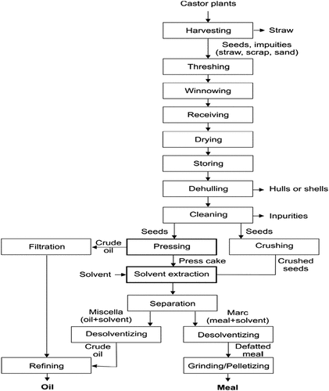
FIG 1: FLOW CHAT OF CASTOR OIL PRODUCTION

CHAPTER FOUR
MATERIAL AND MATETHOD
MATERIAL USED
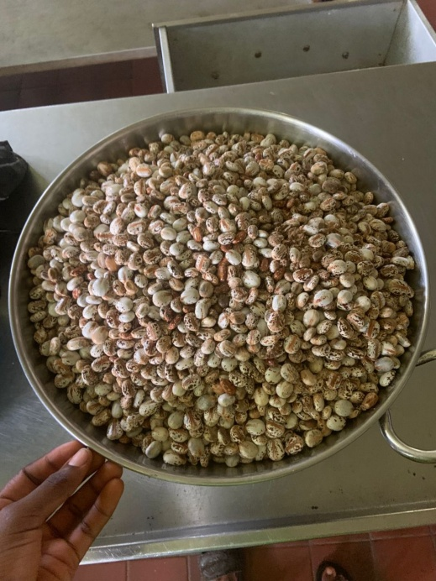
FIG: 4.1 CASTOR SEED

FIG 4.2: STEP 1
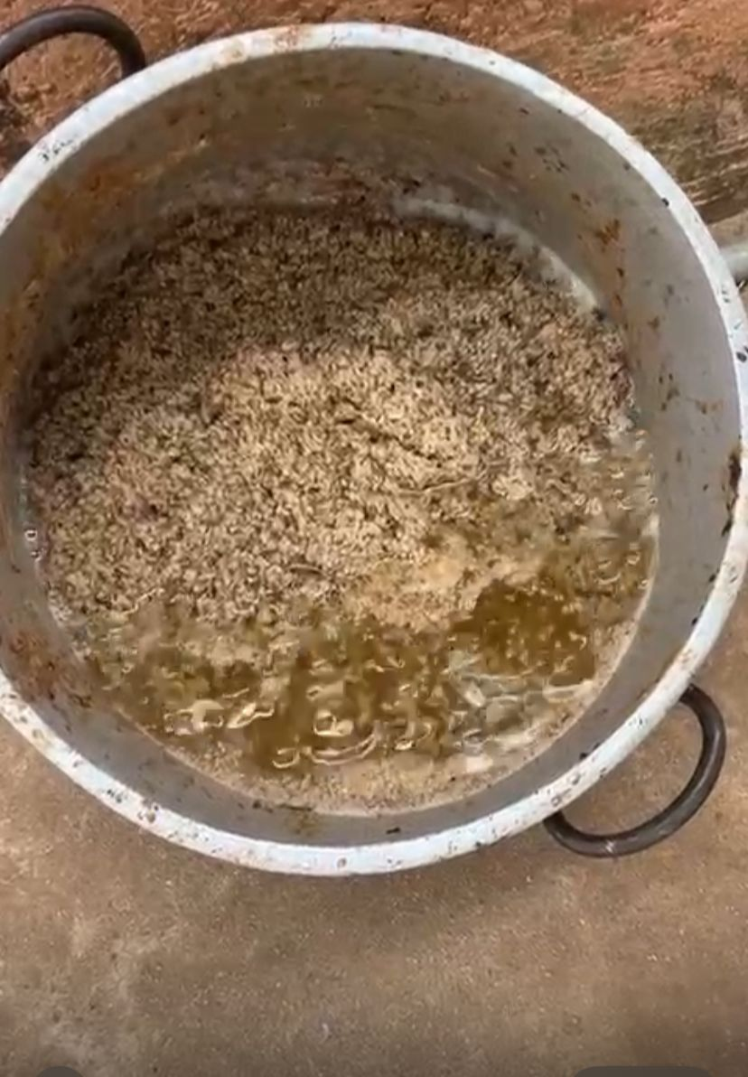
FIG 4.3: STEP 2

FIG: 4.4 STEP 3
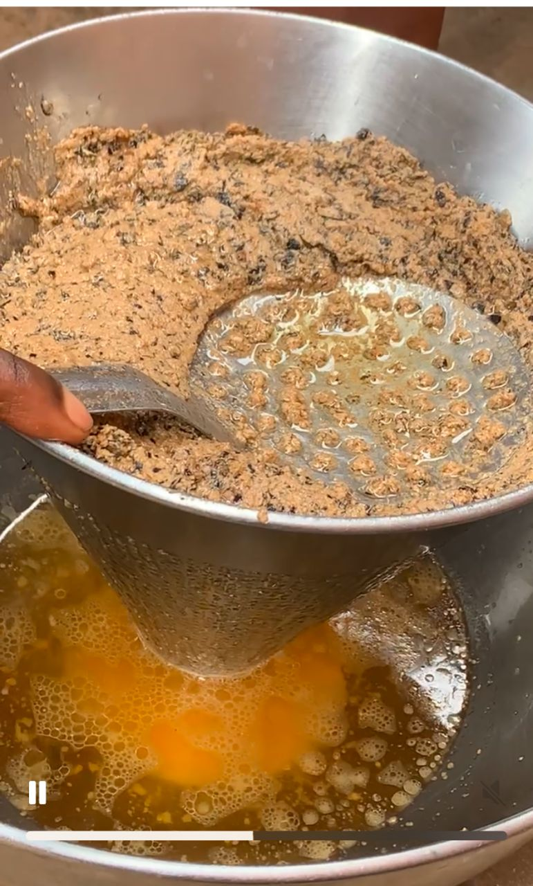
FIG 4.5: STEP 4
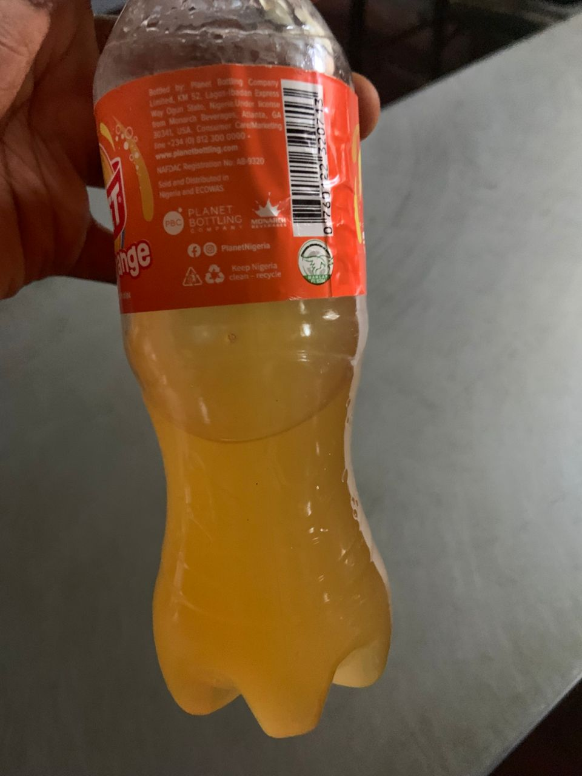
FIG 4.5 FINAL PRODUCT OF CASTOR OIL
Threshing:- The dried capsules are threshed to release the castor beans
cleaning the beans are cleaned to remove impurities and debris oil extraction
oil Extraction
Mechanical Pressing: Castor beans are pressed to extract the oil solvent extract the oil
Solvent Extraction: A solvent is used to extract oil from the seed
Refining: the extracted oil is refined to remove impurities and improve its quality. this may involved the following:
Degumming: Removing impurities like phospholipids
Neutralization: Removing free fatty acids
Bleaching: Removing color and impurities
Deodoraization: Removing unpleasant
Quality control: The final product is tested for quality, purity and consistency. castor oil is used in various
Application, Including
Pharmaceuticals: Laxatives and medicinal products
Cosmetics: Skincare products haircare products, and lip balms
Industrial: Lubricants, Paints and coatings

Castor Oil Processing: Extraction and Uses
Castor Oil Extraction Methods
1. Cold Pressing: Seeds are pressed to extract oil without heat.
2. Solvent Extraction: Seeds are treated with solvents to extract oil.
Castor Oil Processing Steps
1. Seed Preparation: Castor seeds are cleaned and dried.
2. Extraction: Oil is extracted using cold pressing or solvent extraction.
3. Refining: Extracted oil is refined to remove impurities.
4. Filtering: Refined oil is filtered to improve clarity and quality.
Uses of Castor Oil
1. Medicinal: Used for its anti-inflammatory and antimicrobial properties.
2. Skincare: Used in skincare products for its moisturizing and soothing properties.
3. Haircare: Used to promote hair growth and improve scalp health.
4. Industrial: Used in the production of lubricants, soaps, and other products.
Precautions
1. Allergic Reactions: Some people may be allergic to castor oil.
2. Skin Irritation: Castor oil can cause skin irritation in some individuals.
3. Internal Use: Consult a healthcare professional before using castor oil internally.

CHAPTER FIVE
5.0 Summary, Conclusion and Recommendation
5.1 Summary
This study investigated the production and nutritional benefit of castor oil (Ricinus communis) and its possible application in the hospitality industry. The research was motivated by the need to explore alternative oils that could provide nutritional and functional value, while also assessing their safety and acceptability.
The study began with a background discussion on castor oil as a non-conventional oil source, its known industrial and medicinal uses, and the challenges posed by its toxic component (ricin). The problem statement highlighted the lack of sufficient empirical evidence on the nutritional composition and potential hospitality applications of properly processed castor oil.
A mixed-methods research design was employed. Castor oil was extracted from mature castor seeds using standardized procedures, after which laboratory analysis was carried out to determine its proximate composition (moisture, protein, fat, ash, fiber), fatty acid profile, and the presence of toxic or anti-nutritional factors. In addition, a structured questionnaire and interviews were administered to chefs, food and beverage managers, nutritionists, and food safety officers in selected hospitality establishments to assess awareness, perceptions, and willingness to adopt castor oil in practice.
Findings from the laboratory analysis revealed that castor oil is rich in lipids, with ricinoleic acid as the dominant fatty acid, and contains essential micronutrients. However, the presence of anti-nutritional factors and toxicity risks means that safe processing and strict regulation are necessary before culinary application. The survey findings indicated that although a majority of hospitality practitioners were aware of castor oil, many were uncertain about its safety for direct culinary use. Concerns raised included toxicity, taste/odor, cost, and regulatory approval. Nevertheless, respondents expressed interest in non-culinary applications of castor oil, such as in food preservation, polishing, and lubrication.
5.2 Conclusion
The study concluded that castor oil, though nutritionally rich, cannot be freely recommended for direct culinary use in the hospitality industry without thorough detoxification and safety validation. Its high lipid content and unique fatty acid composition highlight its nutritional potential, but the associated risks of ricin toxicity make cautious adoption necessary.
From the perception survey, hospitality practitioners demonstrated cautious awareness of castor oil, showing low willingness to use it in cooking but recognizing possible value in non-food applications within hospitality operations. This highlights a knowledge and safety gap that needs to be addressed through education, regulation, and further scientific research.
Overall, castor oil remains a valuable resource that could contribute to the hospitality industry if production methods and regulatory frameworks ensure complete removal of toxins and certification for safe use.
5.3 Recommendations
Based on the findings of this study, the following recommendations are made:
Safe Processing
Castor oil intended for hospitality use must undergo proper detoxification and refinement processes to eliminate ricin and other anti-nutritional factors.
Collaboration with food science laboratories and regulatory agencies is essential to standardize processing methods.
Regulatory Oversight
Government food safety agencies (e.g., NAFDAC in Nigeria) should develop guidelines for testing, certification, and approval of castor oil for food-related applications.
Clear labeling and consumer education should accompany any commercial production of edible-grade castor oil.
Awareness and Training
Hospitality practitioners (chefs, food and beverage managers) should be sensitized on the nutritional properties, potential benefits, and risks of castor oil.
Training programs can help build confidence in evaluating and adopting non-conventional oils.
Top of Form
Bottom of Form

REFERENCES
Bekele, B. A., Ourgessa, A. W., Terefe, A. A. & Hailu S. S. (2018). Studies on Ethiopian Castor Seed (Ricinuscommunis L.): Extraction and Characterization of Seed Oil, Journal of Natural Products and Resources, 4(2), 188-190
Mubofu, E. B. (2016). Castor oil as a potential renewable resource for the production of functional materials. Sustainable Chemical Process, 4:11 Pp 1-12
Galhiane, M. S., Rissato, S. R. & Santos, L. S. (2012). Evaluation of the Performance of a Castor-Oil Based Formulation in Limiting Pesticide Residues in Strawberry Crops, Quim. Nova, 35(2), 341-347
Kandola, A. (2018). Benefits of castor oil for the face and skin. Medical News Today, Newsletter. Available @ https://www.medicalnewstoday.com
Baker, B. P. & Grant, J. A. (Accessed 05/12/2018). Castor Oil Profile: Active Ingredient Eligible for Minimum Risk Pesticide Use. Integrated Pest Management Program. Available at: http://hdl.handle.net/1813/56115
Patel, V. R., Dumancas, G. G., Viswanath, L. C. K., Maples, R. & Subong, B. J. J. (2016). Castor Oil: Properties, Uses, and Optimization of Processing Parameters in Commercial Production. Lipid Insights 2016:9 1–12 doi:10.4137/LPI.S40233.
Daugherty, C. M. (Accessed, 05/12/2018). The uses of Castor Oil. The Castor oil Industry, Pp 287-298
Nautiyal, O. H. (2017). Castor Oil and its Derivatives’ with Market Growth, Commercial Perspective: Review. Research & Reviews: Journal of Chemistry
Cangemi, J. M., dos Santos, A. M., Neto, S. C. & Chierice, G. O. (2008). Biodegradation of polyurethane derived from castor oil. Polímeros: Ciência e Tecnologia, 18 (3), 201-206,
Kubala, J. (2018). 7 Benefits and Uses of Castor. Healthline, available at: http://www.heathline.com
Grant, B. L. (2018). Castor Oil for Garden Use: Tips On Treating Pests With Castor Oil on Animals. Available @ https://www.gardeningknowhow.com
Sania, K. G., Jafaria, M. & Shams, S. (2010). A Comparison of the Efficacy, Adverse Effects, and Patient Compliance of the Sena-Graph Syrup and Castor Oil Regimens for Bowel Preparation, Iranian Journal of Pharmaceutical Research, 9 (2), 193-198
Tunaru, S., Althoff, T. F., Nüsing, R. M., Diener, M., & Offermanns, S. (2012). Castor oil induces laxation and uterus contraction via ricinoleic acid activating prostaglandin EP3 receptors. Pp 9179-9184, Available @ www.pnas.org/cgi/doi/10.1073/pnas.1201627109
Haq, M. I., Rasheed, A., Adnan, A., Qureshi, F. A. & Saleem, R. (2016). Synthesis, Characterization and Application of Sulphited Castor Maleic Adduct as an Effective Leather, Journal- Society of Leather Technologists and Chemists, 263-270
Olawole, K. (2019). Castor Farming Will Reduce Unemployment By 50%, Leadership Newspaper 10/04/2019
Imran-ulhaq, M., Rasheed, 1 A., Adnan, A., Qureshi, F. A. & Saleem, R. (2016). Synthesis, Characterization and Application of Sulphited Castor Maleic Adduct as an Effective Leather Fatliquor, Journal- Society of Leather Technologists and Chemists, 263-270
Olawole, K. (2019). Castor Farming Will Reduce Unemployment By 50%, Leadership Newspaper 10/04/2019
Ruparao, T. Gahukar (2017). A review of castor-derived products used in crop and seed protection. Phytoparasitica, 45 (5), 655–666.

