

KWARA STATE POLYTECHNIC, ILORIN
THE EFFECT OF SOCIAL MEDIA IN THE PRACTICE OF PUBLIC RELATIONS IN KWARA STATE
(A CASE STUDY OF KWARA STATE POLYTECHNIC, ILORIN)

BY
OLABINTAN ABEL ENIOLA
ND/23/MAC/PT/0940

BEEN A RESEARCH PROJECT SUBMITTED TO THE DEPARTMENT OF MASS COMMUNICATION, INSTITUTE OF INFORMATION AND COMMUNICATION TECHNOLOGY (I.I.C.T), KWARA STATE POLYTECHNIC, ILORIN.
IN PARTIAL FULFILLMENT OF THE REQUIREMENT FOR THE AWARD OF NATIONAL DIPLOMA (ND) IN MASS COMMUNICATION.

JULY, 2025.
CERTIFICATION
This is to certify that this project was carried out by matriculation number ND/23/MAC/0940 in the department of mass communication, Kwara State Polytechnic in partial fulfillment of the requirements for the award of National Diploma (ND) certificate in Mass communication.

_______________________ ________________
MR. BALARABE OLUFADI DATE
(PROJECT SUPERVISOR)

______________________ _________________
MRS OPALEKE G.T DATE
(PROJECT COORDINATOR)

__________________
MRS OPALEKE G.T ______________
(PT COORDINATOR) DATE

_____________________________ __________________
DATE
(External Examiner)

DEDICATION
This project is dedicated to Almighty God that kept me. We also honor our beloved parents who give hands in support to the fulfillment of our National Diploma (ND) both morally and financially. May God allow them to reap the fruits of their labour (Amen).

ACKNOWLEDGEMENT
Foremost, I give all praises, honour, glory with thank to the Almighty GOD who made the writing of this project possible with His total mercy on me from the beginning till the end.
My appreciation goes to my project supervisor MR. BALARABE OLUFADI for his exceptional mentorship and technical expertise. His guidance and insightful suggestions have been instrumental in shaping the direction of this project.
I also express my gratitude to the Head of Department, project coordinator MRS OPALEKE and other amiable lecturers for their expertise and assistance in various aspects of the project.
Am extending my greetings to my parents for their unseasoned support and encouragement being it financially, spiritually in this journey of education.

ABSTRACT
This study examines the effect of social media on the practice of public relations in Kwara State, using Kwara State Polytechnic, Ilorin, as a case study. The rapid growth of digital communication platforms has transformed the way public relations practitioners disseminate information, engage stakeholders, and manage institutional reputation. This research investigates how social media tools such as Facebook, Twitter, Instagram, and WhatsApp influence public relations strategies, effectiveness, and audience interaction within the Polytechnic. A descriptive survey design was adopted, with data collected from public relations officers, students, and staff through structured questionnaires. The findings reveal that social media significantly enhances real-time communication, promotes institutional visibility, and facilitates crisis management, although challenges such as misinformation, lack of technical skills, and negative feedback also emerged. The study concludes that integrating social media into public relations practice offers greater opportunities for interactive communication and reputation building. It recommends regular training for public relations personnel, adoption of clear social media policies, and continuous evaluation of digital communication strategies to optimize institutional public relations practices.

TABLE OF CONTENTS
Page
Title Page
Certification
Abstract
Dedication
Acknowledgement
Abstract
Table of contents
CHAPTER ONE: INTRODUCTION
1.1 Background of the Study
1.2 Statement of the Problem
1.3 Objectives of the Study
1.4 Research Questions
1.5 Significance of the Study
1.6 Scope of the Study
Definition of Terms
CHAPTER TWO
2.1 Conceptual Framework
2.2 Theoretical Framework
2.3 Review of Related Literature
2.4 Overview of Social Media
2.5 Social Media and Public Relations
2.6 Public Relations in Higher Institutions
CHAPTER THREE: RESEARCH METHODOLOGY
3.1 Research Design
3.2 Population of the Study
3.3 Sampling Technique and Sample Size
3.4 Data Collection Instruments
3.5 Procedure for Data Collection
3.6 Method of Data Analysis
3.7 Ethical Considerations
CHAPTER FOUR: DATA PRESENTATION, ANALYSIS AND INTERPRETATION
4.0 Introduction
4.1 Response Rate
4.2 Demographic Characteristics of Respondents
4.3 Analysis of Research Questions
4.4 Inferential Statistical Analysis.
4.5 Summary of Findings
4.6 Charts and Diagrams
CHAPTER FIVE: SUMMARY OF FINDINGS, CONCLUSION AND RECOMMENDATIONS
5.1 Summary of Findings
5.2 Conclusion.
5.3 Recommendations
REFERENCES
QUESTIONNAIRE
APPENDIX

CHAPTER ONE
- Introduction

1.1 Background of The Study
In today's digital era, social media has revolutionized how individuals and organizations communicate and interact. With platforms such as Facebook, Twitter, Instagram, LinkedIn, and WhatsApp gaining widespread popularity, the practice of public relations (PR) has undergone significant transformation. Traditionally, public relations in institutions of higher learning were managed through conventional means such as press releases, bulletin boards, newsletters, and public announcements. However, the advent of social media has introduced faster, more interactive, and cost-effective channels of communication.
Higher institutions, including polytechnics and universities in Nigeria, are increasingly adopting social media as a tool for engaging with their diverse stakeholders—students, staff, alumni, prospective students, government bodies, and the general public. Social media allows these institutions to disseminate information, manage their public image, respond to crises, and build stronger relationships with their audiences in real-time.
Kwara State Polytechnic, a prominent institution in Kwara State, serves as a suitable case study for examining the effects of social media on PR practices. The polytechnic, like many others, faces the need to maintain an effective public relations strategy that aligns with modern communication trends. Understanding how social media has influenced its PR operations is essential for evaluating its impact, identifying challenges, and proposing improvements.
This study seeks to explore the role that social media plays in the public relations strategies of Kwara State Polytechnic, the effectiveness of its use, and the challenges encountered. The findings are expected to contribute to the broader discourse on the modernization of PR practices in Nigerian higher institutions and offer recommendations for better integration of social media into institutional communication strategies.
In recent years, social media has become an integral part of communication strategies across various sectors, including public relations. In Nigerian higher institutions, such as Kwara State Polytechnic, the adoption of social media platforms like Facebook, Twitter, and Instagram has significantly transformed public relations practices. These platforms facilitate real-time communication, enhance engagement with students and the public, and offer cost-effective avenues for disseminating information. However, the rapid evolution of social media also presents challenges, including issues related to misinformation, lack of control over content, and the need for continuous monitoring. Understanding the impact of social media on public relations practices within the context of Kwara State Polytechnic is crucial for developing effective communication strategies in the digital age.
1.2 Statement of the Problem
While the integration of social media into public relations practices offers numerous benefits, there is limited empirical research focusing on its specific effects within Nigerian higher institutions. At Kwara State Polytechnic, the adoption of social media for public relations purposes has been observed, but its effectiveness, challenges, and overall impact remain underexplored. This study aims to fill this gap by examining how social media influences public relations practices at Kwara State Polytechnic, identifying the benefits and challenges faced, and providing recommendations for optimizing its use.
1.3 Objectives of the Study
The primary objectives of this study are to:
- Assess the role of social media in enhancing communication between Kwara State Polytechnic and its stakeholders.
- Identify the challenges associated with using social media for public relations in the institution.
- Evaluate the effectiveness of social media platforms in achieving public relations goals at Kwara State Polytechnic.
- Provide recommendations for improving the use of social media in public relations practices within the institution.
1.4 Research Questions
This study seeks to answer the following research questions:
- How has the adoption of social media transformed public relations practices at Kwara State Polytechnic?
- What are the perceived benefits of using social media for public relations in the institution?
- What challenges do public relations practitioners face when utilizing social media at Kwara State Polytechnic?
- To what extent has social media contributed to achieving the public relations objectives of the institution

1.5 Significance of the Study
This study is significant as it provides insights into the evolving role of social media in public relations within Nigerian higher institutions, specifically at Kwara State Polytechnic. The findings will be valuable to public relations practitioners, institutional administrators, and policymakers in understanding how to leverage social media effectively for communication and engagement. Additionally, the study contributes to the academic discourse on public relations practices in the digital era.

1.6 Scope of the Study
The scope of this study is confined to Kwara State Polytechnic, focusing on the public relations department and its use of social media platforms for communication with students, staff, prospective students, and the general public. The study will examine the period from 2020 to 2025, considering the rapid growth and adoption of social media during this timeframe.

  - Definition of Terms
- Public Relations (PR): The strategic communication process that builds and maintains relationships between an organization and its publics.(Sprout Social)
- Social Media: Digital platforms and tools that facilitate the creation and sharing of content, enabling users to engage in virtual communities and networks.
- Higher Institutions: Post-secondary educational institutions, including universities and polytechnics, that provide academic and professional education.
- Stakeholders: Individuals or groups that have an interest or investment in the activities and outcomes of an organization, such as students, staff, alumni, and the community.

CHAPTER TWO
2.1 Conceptual Framework
The conceptual framework provides the foundational structure upon which this study is built. It outlines the key variables, their interrelations, and the context within which they operate. According to Miles and Huberman (1994), a conceptual framework explains, either graphically or in narrative form, the key factors, constructs, or variables and the presumed relationships among them. In this study, the central concepts include social media, public relations, and higher education institutions. Social media is conceptualized as web-based platforms and applications that enable users to create, share, and exchange content within virtual communities (Kaplan & Haenlein, 2010). Public relations (PR), on the other hand, is viewed as the strategic communication process that builds mutually beneficial relationships between organizations and their publics (Grunig & Hunt, 1984). The interaction of these two elements within the context of higher institutions is central to this research
2.1.1 Operational Definition of Concepts To ensure clarity and precision in this research, key terms are defined as follows:
- Social Media: Digital platforms and applications such as Facebook, Twitter (X), Instagram, LinkedIn, and YouTube that allow individuals and institutions to share content, communicate, and engage with virtual communities in real-time.
- Public Relations (PR): A strategic communication process that builds and maintains mutually beneficial relationships between an organization and its publics, focusing on trust, transparency, and image management.
- Higher Institutions: Educational institutions offering post-secondary education, such as universities, colleges, and polytechnics, involved in teaching, research, and community service.
- Awareness: The state of being informed or having knowledge about a specific subject or issue. In this context, it refers to the extent to which cooperative societies and their benefits are known by the public through social media engagement.
- Cooperative Societies: Voluntary organizations formed by individuals with common economic, social, or cultural interests who pool resources to achieve shared goals, often focusing on mutual assistance, economic empowerment, and collective welfare. These definitions guide the development of research objectives, questionnaire design, data interpretation, and the overall analysis within this study.

2.2 Theoretical Framework
The theoretical framework serves as the intellectual foundation that informs the direction of the research. It provides a structured perspective for interpreting data and understanding the relationships between the variables under study. For this research, two prominent theories form the basis for analyzing the role of social media in public relations within higher education institutions: the Excellence Theory of Public Relations and the Uses and Gratifications Theory. Together, these theories offer both institutional and audience-centered insights into communication practices in a digitally connected environment.

2.2.1 Excellence Theory of Public Relations
The Excellence Theory was developed by James E. Grunig and Todd Hunt (1984) as a comprehensive model to explain how public relations can contribute to organizational effectiveness. This theory was refined through a decade-long empirical study funded by the International Association of Business Communicators Foundation, culminating in what is commonly referred to as the “Excellence Study” (Grunig et al., 1992). The theory emphasizes the strategic role of public relations in facilitating mutual understanding and establishing long-term, productive relationships between organizations and their publics.
At the heart of the Excellence Theory is the concept of two-way symmetrical communication—a model of interaction in which organizations and their audiences engage in dialogue, negotiation, and mutual adjustment. This contrasts with earlier models such as one-way publicity or press agentry, which are focused on persuasion and dissemination rather than dialogue.
In the context of higher education, the Excellence Theory provides a valuable framework for assessing how institutions can use social media as a tool for strategic communication and engagement. Universities and colleges are complex organizations with multiple stakeholders, including students, faculty, alumni, prospective students, government agencies, and the public. Social media platforms, when used effectively, offer these institutions a means of building trust, managing reputation, and facilitating participatory communication.
For instance, a university’s response to a campus crisis—such as a protest, pandemic-related closure, or policy change—can be evaluated through the lens of symmetrical communication. If the institution uses social media not only to inform but also to listen and respond to concerns, it demonstrates the principles of excellence in public relations. As Grunig (2006) noted, symmetrical communication fosters legitimacy and social responsibility, which are crucial for public institutions operating in increasingly transparent and participatory environments.

2.2.2 Uses and Gratifications Theory
The Uses and Gratifications Theory (UGT) was introduced in the 1940s but gained prominence through the work of Katz, Blumler, and Gurevitch (1973), who redefined media consumers as active participants rather than passive recipients. Unlike traditional media theories that emphasize media effects, UGT explores how and why individuals actively seek out specific media to fulfill particular needs.
UGT identifies several categories of audience needs, including:
- Cognitive needs: Seeking information and understanding.
- Affective needs: Seeking emotional or aesthetic experiences.
- Personal integrative needs: Seeking self-confidence or status reinforcement.
- Social integrative needs: Strengthening connections with family, friends, or social groups.
- Tension release needs: Seeking escape and diversion from routine.
In the age of digital media, this theory has been extended to include motivations behind the use of social media platforms. Research by Whiting and Williams (2013) identified uses of social media that align closely with UGT principles, such as entertainment, information-seeking, self-expression, and relationship maintenance.
Applied to higher education, UGT helps explain why students, staff, and other stakeholders choose to engage with institutional social media channels. For example:
- A prospective student may follow a university’s Instagram account to gain a visual understanding of campus life (affective and cognitive needs).
- Current students might engage in comment threads or polls to connect with peers and feel involved (social integrative needs).
- Alumni may use LinkedIn or Facebook groups to stay informed and maintain identity ties with their alma mater (personal integrative needs).

2.2.3 Synthesis of Theories
When synthesized, the Excellence Theory and Uses and Gratifications Theory offer a dual perspective organizational and individual—on the strategic use of social media in public relations. The Excellence Theory frames how institutions should approach communication: transparently, dialogically, and ethically. The Uses and Gratifications Theory, on the other hand, informs how institutions should understand and respond to audience behaviors, preferences, and motivations.
This combined theoretical approach supports the central argument of this research: that effective use of social media in higher education public relations hinges on the interplay between institutional communication strategies and audience media behaviors. Institutions that adopt two-way communication models and tailor content to meet the needs of their audiences are more likely to achieve communication excellence and build long-term stakeholder relationships.

2.3 Review of Related Literature
Over the past two decades, the advent of social media has significantly transformed the landscape of communication and public relations (PR). As digital platforms become central to how organizations interact with their audiences, a growing body of literature has emerged examining how institutions especially those in the education sector—are leveraging social media to achieve public relations objectives. This section reviews key scholarly contributions that explore the dynamic intersection of social media usage and public relations practices, with an emphasis on higher education.

2.3.1 Social Media as a Tool for Engagement and Dialogue
Social media platforms have shifted communication paradigms from top-down, one-way messaging to more interactive, two-way engagements. Scholars such as Waters, Burnett, Lamm, and Lucas (2009) conducted one of the foundational studies in this area, analyzing how nonprofit organizations use Facebook to build stakeholder relationships. Their study found that organizations utilizing Facebook effectively could create meaningful dialogue, enhance transparency, and increase community involvement. Although their research focused on nonprofits, the principles are equally applicable to educational institutions, which also rely heavily on public trust, community engagement, and transparency.
Building on this, Lovejoy and Saxton (2012) conducted a comprehensive content analysis of Twitter use among nonprofit organizations. They identified three core functions of social media in public relations: information dissemination, community building, and mobilization. These functions provide a useful framework for analyzing how universities might use platforms like Twitter or LinkedIn to engage their publics. For example, universities frequently disseminate news about academic achievements, upcoming events, and policy changes. Community-building occurs through sharing user-generated content, celebrating student success, or recognizing alumni achievements. Mobilization may involve encouraging participation in events, fundraising campaigns, or advocacy initiatives.

2.3.2 Social Media in the Higher Education Context
Within the realm of higher education, social media has become an indispensable tool for branding, recruitment, stakeholder engagement, and crisis communication. Peruta and Shields (2017) found that social media presence significantly influences prospective students' perceptions of a university’s brand and culture. Their research indicated that well-maintained social media accounts could positively impact student enrollment decisions, especially when platforms showcase campus life, academic excellence, and student support services.
Higher education institutions are increasingly utilizing platforms such as Instagram, Facebook, and YouTube to project their identity, shape their reputation, and provide real-time updates to internal and external stakeholders. For example, during global events like the COVID-19 pandemic, universities used social media to issue health updates, transition to remote learning, and address student concerns. The speed and flexibility of social media made it an essential channel for crisis communication and managing institutional credibility.

2.3.3 Challenges and Limitations of Social Media in PR
Despite its benefits, the use of social media in public relations is not without challenges. Scholars such as Wright and Hinson (2017) caution that the mere presence on social media platforms does not guarantee effective communication. Their longitudinal study on digital media use in public relations found that while PR practitioners increasingly adopt digital tools, many organizations struggle to move beyond traditional, one-way communication strategies. This often results in underutilized platforms that serve only to broadcast information rather than engage audiences meaningfully.
Moreover, the misuse or mismanagement of social media can lead to reputational risks. A poorly handled online crisis, delayed response to public concerns, or inappropriate content can damage an institution’s image. As Coombs and Holladay (2012) suggest in their work on crisis communication, social media increases the speed at which issues escalate, requiring organizations to develop proactive strategies and crisis response plans to mitigate potential backlash.
Additionally, there is often a lack of institutional policy and professional training regarding social media usage. Staff responsible for maintaining social media accounts may lack the skills necessary for strategic content creation, audience analysis, or performance measurement. Without clear guidelines and objectives, social media efforts may become inconsistent or misaligned with broader institutional goals.

2.3.4 Strategic Social Media Use for Effective PR
To harness the full potential of social media, institutions must adopt strategic communication approaches that prioritize audience engagement, content relevance, and consistency. Scholars advocate for the integration of social media strategies into the broader public relations and marketing plans of organizations (Macnamara, 2010; DiStaso et al., 2011). This includes identifying target audiences, setting measurable objectives, developing tailored content, and analyzing engagement metrics to refine practices.
Furthermore, effective social media use in PR involves understanding the cultural and demographic dynamics of audiences. For example, different age groups may prefer different platforms or types of content. Younger audiences may favor visual and interactive content on platforms like TikTok or Instagram, while older stakeholders might engage more with formal updates on LinkedIn or Facebook.

2.3.5 Implications for Public Relations in Higher Education
The reviewed literature makes it clear that social media is not just a supplementary communication tool but a central platform for institutional public relations in the modern age. In higher education, where public perception, transparency, and community relations are critical, the strategic use of social media can significantly enhance institutional legitimacy and stakeholder trust. However, achieving these outcomes requires deliberate planning, adequate resources, continuous staff training, and alignment with the institution’s values and goals.
The research also reveals a gap in understanding how higher institutions in developing countries utilize social media for PR, where infrastructure, digital literacy, and resource limitations may influence adoption and effectiveness. Addressing this gap is essential for developing context-sensitive strategies that can enhance communication in diverse educational settings.

2.4 Overview of Social Media
Social media has emerged as a transformative force in modern communication, profoundly altering how individuals, groups, and institutions interact, share information, and build relationships. In the context of public relations and institutional communication, social media provides a dynamic, interactive space where messages are not only disseminated but also shaped and reshaped through audience engagement.

2.4.1 Defining Social Media
Social media refers to a broad set of web-based applications that allow users to create, share, and exchange content in virtual communities and networks. Boyd and Ellison (2007) define social media as "web-based services that allow individuals to construct a public or semi-public profile within a bounded system, articulate a list of other users with whom they share a connection, and view and traverse their list of connections and those made by others within the system."
Unlike traditional media, which operate through a one-way dissemination of information from sender to receiver, social media facilitates two-way or multi-directional communication, allowing for real-time interaction, feedback, and content co-creation. This participatory nature is one of social media’s defining characteristics and a key reason it has become essential for modern public relations practice.

2.4.2 Categories of Social Media
Social media is not monolithic; it encompasses a variety of platforms with distinct purposes and functionalities. According to Kaplan and Haenlein (2010), social media can be categorized into the following six types:
- Collaborative Projects: These involve joint efforts by multiple users to create content. Wikipedia is a prime example, where users contribute to a shared knowledge base.
- Blogs and Microblogs: Blogs allow individuals or institutions to post content in a diary-like format, often accompanied by audience comments. Microblogs like Twitter focus on short, timely posts and rapid updates.
- Content Communities: These are platforms where users share multimedia content such as videos, photos, or presentations. YouTube, Vimeo, and SlideShare are key examples.
- Social Networking Sites (SNSs): These platforms allow users to create personal profiles and connect with others. Examples include Facebook, LinkedIn, and Instagram. They are widely used for professional networking, social interaction, and community building.
- Virtual Game Worlds: Platforms like World of Warcraft offer environments where users interact in a gaming context using avatars.

2.4.3 Role of Social Media in Higher Institutions
For higher education institutions, social media is more than a marketing tool—it is an essential component of institutional identity, visibility, and engagement. Through platforms like Facebook, Twitter, and Instagram, universities can:
- Promote academic programs and research achievements
- Showcase campus life, events, and student experiences
- Communicate policy changes and emergency alerts
- Engage in public discourse and thought leadership
- Foster alumni relations and fundraising campaigns
Moreover, the interactive nature of social media enables institutions to gather feedback, conduct surveys, and monitor public sentiment, allowing them to remain responsive to the needs and concerns of various stakeholders. This is particularly valuable in enhancing transparency and accountability.
Institutions can also segment their communication strategies based on platform characteristics. For example:
- Twitter/X is often used for real-time updates and quick responses.
- Instagram is ideal for visual storytelling and brand promotion.
- LinkedIn is effective for professional communication and industry engagement.
- YouTube supports in-depth content delivery such as lectures, promotional videos, or documentaries.

2.4.4 Challenges Associated with Social Media Use
Despite its many benefits, the widespread use of social media has introduced significant challenges and risks, particularly for public institutions that operate in highly visible and regulated environments.

1. Data Privacy and Security
As institutions collect and store data through social media interactions—such as user comments, personal messages, or analytics—concerns about data privacy and cybersecurity arise. Unauthorized access, data breaches, or non-compliance with privacy laws (e.g., GDPR) can damage an institution’s credibility and lead to legal consequences.

2. Message Control and Consistency
Unlike traditional media, where organizations have full control over the content and timing of communication, social media is inherently open-ended and participatory. This can make it difficult for institutions to control how their messages are received or interpreted. User-generated content, viral posts, or negative comments can quickly influence public perception, often beyond the institution’s immediate control.

3. Information Credibility and Misinformation
The democratization of content creation means that not all information shared on social media is accurate or reliable. Higher education institutions must navigate a complex environment where false or misleading information can spread rapidly. Maintaining credibility involves not only accurate communication but also the timely correction of misinformation and engagement in fact-based dialogue.

4. Resource Constraints
Effective social media management requires skilled personnel, time, and technological tools. Smaller or less-resourced institutions may struggle to maintain an active and professional online presence. This includes content development, monitoring, analytics, and community management—all of which require institutional investment and strategic planning.

5. Audience Segmentation and Platform Overload
With numerous platforms available, institutions face the challenge of choosing where to focus their efforts. Attempting to maintain a presence on every major platform can dilute efforts and lead to inconsistency. Therefore, understanding the audience demographics and media consumption habits is crucial for tailoring the institutional approach.

2.4.5 The Way Forward
To effectively utilize social media, higher institutions must develop clear policies, content strategies, and crisis response plans. Staff must be trained not only in platform use but also in communication ethics, intercultural communication, and digital risk management. Moreover, institutions should embrace a dialogic approach that promotes transparency, openness, and two-way communication, thereby fostering trust and strengthening stakeholder relationships.
As noted by Fuchs (2014), the expansion of digital communication technologies has not only democratized information sharing but also introduced new power dynamics and surveillance concerns. Institutions must therefore approach social media with both opportunism and caution, balancing the benefits of engagement with the responsibilities of ethical communication.

2.5 Social Media and Public Relations
The relationship between social media and public relations (PR) has fundamentally reshaped how organizations manage their image, communicate with stakeholders, and build long-term relationships. The integration of social media into public relations is not merely a matter of adopting new tools—it represents a paradigm shift from one-way, controlled messaging to a more interactive, transparent, and participatory model of communication.

2.5.1 Disintermediation and Direct Communication
Traditionally, public relations relied heavily on intermediaries such as journalists, broadcasters, and print media to deliver messages to target audiences. This process, while still important, often limited organizational control over how information was presented or interpreted. Breakenridge (2008) noted that with the advent of social media, organizations can now bypass traditional media gatekeepers and communicate directly with their audiences.
Platforms such as Facebook, Twitter (now X), Instagram, LinkedIn, and YouTube allow PR practitioners to:
- Publish content instantly
- Engage in two-way communication
- Respond in real-time to feedback, inquiries, or crises
- Monitor public sentiment and address emerging issues proactively
This disintermediation enhances message control and enables a more authentic and immediate connection between institutions and their publics.

2.5.2 Dialogic Communication and Relationship Building
A key advantage of social media is its support for dialogic communication, a concept that emphasizes dialogue, mutual understanding, and reciprocal interaction. According to Macnamara (2010), dialogic communication is essential to effective public relations because it fosters openness, responsiveness, and ethical relationship management.
Dialogic theory, rooted in the work of Kent and Taylor (2002), outlines five principles of effective online communication:
- Dialogic loop – Enabling users to pose questions and receive responses
- Usefulness of information – Sharing relevant and timely content
- Generation of return visits – Encouraging repeat engagement through valuable updates
- Ease of interface – Providing user-friendly platforms for communication
- Conservation of visitors – Keeping users engaged and connected over time
Social media naturally aligns with these principles. In the context of higher education, dialogic communication might include responding to student concerns on Twitter, hosting Q&A sessions on Instagram Live, or encouraging alumni engagement through LinkedIn posts.
For example, during the COVID-19 pandemic, many universities used Facebook Live or Zoom webinars to address student questions, update safety protocols, and maintain community engagement. These initiatives demonstrated not only the informational role of PR but also its emotional and relational dimensions—helping stakeholders feel heard and included in decision-making processes.

2.5.3 Real-Time Engagement and Crisis Communication
Social media has also become indispensable in crisis communication, enabling institutions to provide accurate and timely information during emergencies or controversies. Unlike traditional PR channels, which may take hours or days to circulate a press release or arrange a media interview, social media allows for:
- Immediate updates
- Rapid myth-busting
- Live streaming of press conferences
- Stakeholder feedback and reassurance
Institutions that respond quickly and transparently in times of crisis are more likely to retain stakeholder trust. As Coombs (2007) argues in the Situational Crisis Communication Theory, response timing and openness play critical roles in shaping public perceptions during a crisis.
However, the speed and visibility of social media also require institutions to be highly strategic and prepared. A poorly timed or tone-deaf message can exacerbate a crisis, while lack of coordination can lead to inconsistent narratives. Therefore, crisis communication plans must include detailed protocols for social media use, staffing, approval chains, and audience targeting.

2.5.4 Strategic Use of Analytics and Data-Driven PR
One of the transformative aspects of social media in PR is the availability of real-time analytics and performance metrics. Unlike traditional PR campaigns, whose impact may be difficult to quantify, social media platforms offer precise insights into:
- Post reach and impressions
- Engagement rates (likes, comments, shares)
- Follower demographics and growth
- Website traffic and conversion rates from social media
DiStaso, McCorkindale, and Wright (2011) emphasize that this data-driven approach allows PR practitioners to assess the effectiveness of their messaging strategies and make informed decisions. For higher education institutions, this could involve measuring the success of a scholarship announcement campaign, tracking public reaction to a new policy, or comparing engagement across different campuses or departments.
In addition, social listening tools enable institutions to monitor online conversations about their brand, competitors, or relevant issues in real time. This intelligence supports reputation management, issue tracking, and trend forecasting.

2.5.5 Participatory Culture and Brand Co-Creation
Social media has ushered in a participatory communication model, where audiences are not just passive recipients of information but active contributors to an organization’s narrative. This includes activities like:
- Sharing institutional content
- Creating user-generated content (UGC)
- Participating in campaigns or challenges
- Providing testimonials and feedback
In this environment, PR practitioners must shift from message control to message facilitation, allowing and encouraging audiences to co-create content. For universities, this could mean reposting students’ graduation photos, encouraging faculty to blog about their research, or allowing students to take over social media accounts during major events.
Such strategies enhance authenticity, foster a sense of community, and empower stakeholders to become ambassadors of the brand.

2.5.6 Challenges and Ethical Considerations
Despite its advantages, integrating social media into PR practice also presents challenges:
- Information overload can dilute messaging.
- Negative feedback or online harassment must be carefully managed.
- Ethical dilemmas may arise around data collection, privacy, and content moderation.
PR practitioners must adhere to ethical standards, including transparency, accountability, and respect for privacy. Institutions must also develop social media policies and train staff on digital communication best practices to avoid reputational risks and ensure professional conduct.

2.6 Public Relations in Higher Institutions
Public relations (PR) in higher education has evolved significantly over the past few decades, moving from a focus on basic publicity and media relations to a more strategic and holistic approach that supports institutional goals. In an increasingly competitive, globalized, and digitized environment, universities and colleges must not only maintain academic excellence but also actively manage their reputation, foster relationships, and communicate effectively with diverse stakeholders.

2.6.1 The Role of PR in Higher Education
Public relations in higher education serves multiple strategic purposes, including:
- Promoting institutional identity and achievements
- Attracting and retaining students
- Fostering alumni engagement and donor relations
- Securing funding and governmental support
- Navigating crises and controversies
- Strengthening community relations
As Roper (2005) emphasizes, universities must engage in strategic communication to enhance credibility, maintain stakeholder trust, and compete for limited resources. In an era where funding models are shifting and public scrutiny is increasing, institutions must be deliberate in how they craft and convey their narratives.
Effective PR helps create a coherent institutional image that reflects core values such as innovation, inclusiveness, academic rigor, and social responsibility. This image is not only projected outward but also reinforced internally, shaping campus culture and influencing how faculty, staff, and students perceive their institution.

2.6.2 Social Media as a Strategic PR Tool
With the rise of digital media, particularly social media, the tools and tactics of PR in higher education have undergone substantial transformation. Social media platforms offer cost-effective, real-time, and far-reaching channels for universities to engage with prospective students, alumni, parents, faculty, staff, media, and the general public.
Peruta and Shields (2017) conducted empirical research demonstrating that prospective students increasingly rely on institutional social media pages when evaluating universities. These platforms offer a window into campus life, academic programs, student support services, and the overall “personality” of the institution. Visual content such as Instagram reels, YouTube videos, and TikTok clips can be particularly persuasive in showcasing the vibrancy and diversity of university life.
Furthermore, active and strategic engagement through social media:
- Enhances institutional visibility and digital presence
- Facilitates community building by promoting events, campaigns, and milestones
- Enables instantaneous updates and responses, which are vital in dynamic or crisis situations
- Supports relationship management by encouraging dialogue, feedback, and storytelling
Institutions with a well-managed social media presence can leverage these platforms not only for promotion but also for listening and learning—gathering insights into public sentiment, student concerns, or emerging trends.

2.6.3 Stakeholder Management and Internal Communication
PR in higher institutions also includes maintaining positive relationships with internal stakeholders, such as faculty, administrative staff, students, and governance boards. Internal communication plays a crucial role in aligning various departments with the university's mission and values, fostering a sense of belonging, and ensuring transparent policy dissemination.
Effective PR teams often work closely with human resources, student affairs, and academic leadership to ensure that internal messaging is consistent, timely, and participatory. Digital newsletters, staff portals, intranet announcements, and dedicated internal social media groups are common tools for this purpose.

2.6.4 Crisis Communication in Higher Institutions
One of the most critical functions of PR in higher education is managing institutional crises, which may involve issues such as:
- Student protests or unrest
- Policy controversies
- Cases of academic misconduct or fraud
- Campus violence or security incidents
- Public backlash over administrative decisions
- Health and safety crises, such as pandemics
According to Sommerfeldt and Yang (2017), the effectiveness of PR during such crises depends largely on the institution’s commitment to transparency, inclusion, and responsiveness. Institutions that attempt to downplay or ignore crises often face reputational damage and erosion of public trust.
A robust crisis communication strategy should include:
- Proactive monitoring of potential risks or grievances
- Clear lines of communication and authority
- Timely dissemination of accurate information
- Designated spokespersons
- Opportunities for stakeholder feedback and involvement
- Post-crisis evaluation and accountability

2.6.5 Ethical and Strategic Challenges
Despite its opportunities, PR in higher education is not without challenges. These include:
- Maintaining authenticity in branding while addressing diverse audiences
- Balancing promotional messaging with academic rigor
- Avoiding over-commercialization, which may undermine educational values
- Navigating misinformation or misinterpretation in digital spaces
- Ensuring inclusivity in messaging and representation

CHAPTER THREE

RESEARCH METHODOLOGY

3.1 Research Design
This study adopts a descriptive survey design, which provides a structured approach to collect and analyze data relevant to the research objectives. The choice of this design is based on its suitability for studies aimed at describing characteristics of a population at a single point in time (Creswell, 2014). In this context, the descriptive survey allows the researcher to assess how social media influences public relations (PR) practices within Kwara State Polytechnic, Ilorin.
According to Nworgu (2015), descriptive research design enables researchers to systematically describe phenomena and analyze relationships among variables. Given that this study seeks to examine the current use and perceived effectiveness of social media in PR activities, this design is considered most appropriate.

3.2 Population of the Study
The target population for this study consists of staff and students of Kwara State Polytechnic, Ilorin, who are directly or indirectly involved in or impacted by public relations activities. This includes:
- Public Relations Unit Staff: 15
- Communication and Administrative Staff: 35
- Student Population: approximately 25,000
Thus, the total population of the study is estimated to be 25,050 individuals. The inclusion of a wide student base is essential, as students are the primary audience of the institution’s social media platforms and PR communication.

3.3 Sampling Technique and Sample Size
To ensure that the sample is representative of the diverse groups within the institution, the study employs a stratified random sampling technique. This method involves dividing the population into three strata (PR staff, administrative staff, and students), from which samples will be randomly selected proportionately. Stratified sampling minimizes bias and enhances representativeness (Kothari, 2004).
The sample size is determined using Yamane’s (1967) formula:
n=N1+N(e)2n = \frac{N}{1 + N(e)^2}n=1+N(e)2N​
Where:
- n = sample size
- N = total population = 25,050
- e = margin of error (0.05)
n=25,0501+25,050(0.05)2=25,0501+62.625≈25,05063.625≈394n = \frac{25,050}{1 + 25,050(0.05)^2} = \frac{25,050}{1 + 62.625} ≈ \frac{25,050}{63.625} ≈ 394n=1+25,050(0.05)225,050​=1+62.62525,050​≈63.62525,050​≈394
Therefore, a sample size of 394 respondents will be drawn and distributed as follows:
Strata | Population | Sample Size (Approx.)
PR Staff | 15 | 2
Admin/Communication Staff | 35 | 5
Students | 25,000 | 387
Total | 25,050 | 394

3.4 Data Collection Instruments
This study makes use of both primary and secondary data collection methods:

i. Primary Data
The primary instrument for data collection is a structured questionnaire designed to gather quantitative information. It is divided into four key sections:
- Demographic characteristics of respondents
- Social media usage and engagement
- Perceptions of PR effectiveness
- Challenges associated with social media in PR
Responses will be measured using a five-point Likert scale (ranging from Strongly Agree to Strongly Disagree), which provides a quantifiable measure of opinions and perceptions (Bryman, 2012).

ii. Secondary Data
Secondary data will be obtained from relevant sources such as:
- Official publications of Kwara State Polytechnic
- Academic journals on social media and public relations
- Reports and documents on institutional media performance
- Social media analytics platforms
These sources will provide supporting evidence for interpretation and validation of findings.

3.5 Procedure for Data Collection
The procedure for data collection is outlined as follows:
- Ethical Approval and Permissions:
The researcher will seek official approval from Kwara State Polytechnic management and obtain ethical clearance from the relevant academic board.
- Pilot Study:
A pilot test involving 20 respondents from a comparable institution will be conducted to assess the clarity and reliability of the questionnaire. This will ensure refinement before the main data collection (Orodho, 2009).
- Main Data Collection:
The refined questionnaire will be administered both physically (hard copies) and electronically (via Google Forms) to increase accessibility and response rate. Stratified respondents will be contacted through institutional emails and in-person distribution.
- Follow-Up and Retrieval:
Follow-up messages and reminders will be sent to encourage timely submission. Completed questionnaires will be retrieved and verified for completeness before analysis.

3.6 Method of Data Analysis
Data analysis will be carried out using quantitative statistical methods:
- Descriptive Statistics: Includes frequencies, percentages, means, and standard deviations to summarize the demographic data and overall responses.
- Inferential Statistics: Chi-square tests and Pearson’s correlation will be used to explore relationships between social media engagement and effectiveness of PR practices.
All statistical computations will be performed using SPSS (Statistical Package for the Social Sciences) version 25, which is reliable for analyzing large data sets and performing cross-tabulations and significance testing (Field, 2013).

3.7 Ethical Considerations
To maintain ethical standards, the following measures will be observed:
- Informed Consent: All participants will be informed of the research purpose, and their participation will be voluntary. Consent forms will be provided, and participants can withdraw at any stage (Babbie, 2010).
- Anonymity and Confidentiality: Respondents' identities will not be disclosed. Data will be treated with strict confidentiality and used solely for academic purposes.
- Minimizing Harm: The study will avoid any procedures that may cause psychological or emotional distress to participants.
- Institutional Permission: Necessary permissions will be sought from the institution before fieldwork begins.

CHAPTER FOUR

DATA PRESENTATION, ANALYSIS AND INTERPRETATION

4.0 Introduction
This chapter presents the analysis and interpretation of the data collected through structured questionnaires administered to PR staff, administrative staff, and students at Kwara State Polytechnic, Ilorin. The data analysis addresses the main objectives of the study, which are to investigate the role of social media in public relations practices, identify the most commonly used platforms, assess effectiveness, and uncover associated challenges.
Both descriptive and inferential statistics are used. Descriptive statistics such as frequencies, percentages, means, and standard deviations summarize the responses, while inferential statistics (Chi-square test) help determine the relationships between variables. Visual representations are also provided in the form of charts and diagrams for clarity.

4.1 Response Rate
A total of 394 questionnaires were distributed. Of these, 370 were returned and correctly filled, representing a response rate of 93.9%. This high response rate increases the reliability and validity of the findings, as it reflects broad participation from the target population.
Distributed | Returned | Usable | Response Rate (%)
394 | 378 | 370 | 93.9

4.2 Demographic Characteristics of Respondents
This section outlines the basic characteristics of the respondents. It provides context for understanding the perceptions and experiences shared in the later sections.
Demographic Variable | Category | Frequency | Percentage (%)
Gender | Male | 200 | 54.1
 | Female | 170 | 45.9
Age | Below 20 years | 55 | 14.9
 | 20–29 years | 240 | 64.9
 | 30–39 years | 50 | 13.5
 | 40 years and above | 25 | 6.7
Role in Institution | PR Staff | 2 | 0.5
 | Admin/Communication Staff | 5 | 1.4
 | Students | 363 | 98.1
Social Media Usage | Daily | 325 | 87.8
 | Occasionally | 35 | 9.5
 | Rarely | 10 | 2.7
Interpretation:
- The respondents are mostly students (98.1%), making their input crucial since they are the primary audience of the institution’s social media efforts.
- A large portion of respondents are aged 20–29, typical of the tertiary education demographic, who are also highly active on social media.
- Daily usage of social media is very high, showing that this communication channel is relevant and well-integrated into their daily routines.

4.3 Analysis of Research Questions

4.3.1 What social media platforms are most commonly used in PR at Kwara State Polytechnic?
Platform | Frequency | Percentage (%)
Facebook | 320 | 86.5
Twitter/X | 150 | 40.5
Instagram | 210 | 56.8
WhatsApp | 350 | 94.6
YouTube | 95 | 25.7
TikTok | 65 | 17.6
Interpretation:
- WhatsApp (94.6%) and Facebook (86.5%) dominate PR communications due to their accessibility, ease of use, and multimedia capabilities.
- Instagram is also popular among younger audiences, indicating a visual preference in communication.
- Platforms like TikTok and YouTube are less commonly used, possibly due to higher content production demands or institutional policy constraints.
Implication: PR efforts should prioritize platforms that the audience already uses frequently—namely WhatsApp and Facebook—while developing strategies to integrate newer platforms like TikTok for broader engagement.

4.3.2 How effective is the use of social media in promoting institutional image and student engagement?
Statement | SA | A | N | D | SD | Mean | Std. Dev.
Social media improves the image of the Polytechnic. | 180 | 130 | 25 | 20 | 15 | 4.19 | 0.91
Social media improves student engagement. | 165 | 145 | 30 | 20 | 10 | 4.18 | 0.86
PR posts reach a large audience through social platforms. | 170 | 155 | 25 | 10 | 10 | 4.22 | 0.82
Information on social media is timely and useful. | 160 | 140 | 40 | 20 | 10 | 4.10 | 0.88
Interpretation:
- All mean scores are above 4.0, suggesting that respondents agree or strongly agree with the positive role of social media in enhancing public image and student involvement.
- Respondents particularly agree that social media helps PR reach a larger audience, which is crucial for modern institutional communication.
Implication: Social media is not just a supplementary tool; it is an essential communication medium that significantly shapes public perception of the institution.

4.3.3 What challenges are associated with the use of social media in PR practices?
Challenge | Frequency | Percentage (%)
Inadequate funding for media campaigns | 190 | 51.4
Poor internet connectivity | 210 | 56.8
Lack of professional social media managers | 160 | 43.2
Negative comments and online criticism | 135 | 36.5
Data privacy and security concerns | 110 | 29.7
Sources: research survey, 2025

Interpretation:
- Poor internet connectivity is the top challenge, highlighting infrastructural problems that affect online communication.
- Funding and lack of trained personnel also affect the quality of PR efforts.
- The rise of negative online feedback presents reputational risks if not properly managed.
Implication: Investment in digital infrastructure and professional development is essential. Institutions must also adopt strategic communication policies to mitigate negative public sentiment online.

4.4 Inferential Statistical Analysis
Chi-Square Test: Relationship between Social Media Use and PR Effectiveness
Test | χ² Value | df | p-value
Chi-Square | 24.57 | 2 | 0.003
- Null Hypothesis (H₀): No significant relationship between social media use and PR effectiveness.
- Alternative Hypothesis (H₁): Significant relationship exists.
Interpretation:
Since p = 0.003 is less than 0.05, the null hypothesis is rejected. This means that there is a statistically significant relationship between how often social media is used and how effective PR practices are perceived to be.
Implication: Institutions that invest more in consistent and professional social media engagement are likely to see better PR outcomes.

4.5 Summary of Findings
- High social media usage is evident among students and staff, particularly on WhatsApp and Facebook.
- Respondents strongly believe that social media enhances institutional image and boosts student engagement.
- Significant challenges such as poor connectivity, lack of funding, and online criticism persist.
- Statistical evidence confirms that increased social media use leads to more effective PR practices.
4.6 Charts and Diagrams
This section presents visual illustrations of the data related to social media usage and the key challenges affecting its application in public relations at Kwara State Polytechnic.

Chart 1: Social Media Platform Usage
This chart shows the frequency of social media platforms used by respondents for PR purposes. WhatsApp and Facebook are the most dominant platforms, with usage counts of 350 and 320 respectively. This trend reflects the institution's reliance on mobile-based and widely accessible platforms for communication.
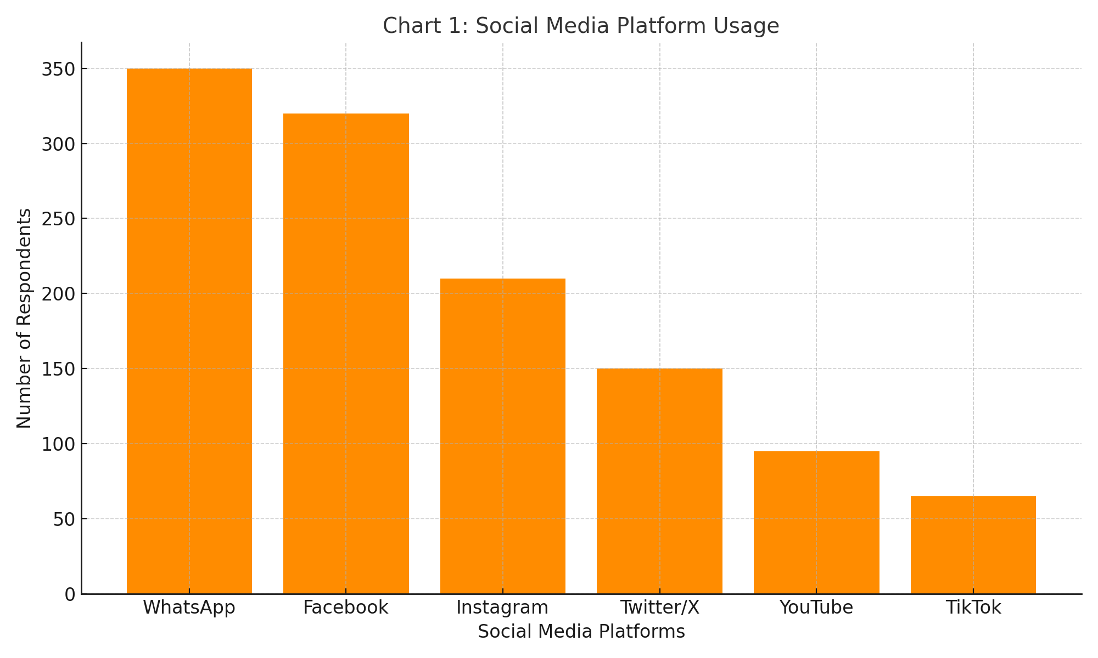

Sources: (Statist, 2023; Pew Research Center, 2022)

Chart 2: Challenges of Using Social Media in PR
This chart highlights the main barriers to effective social media use in public relations within the Polytechnic. The leading issues are poor internet connectivity and inadequate funding. Other concerns include lack of trained personnel, negative feedback from users, and data privacy threats.
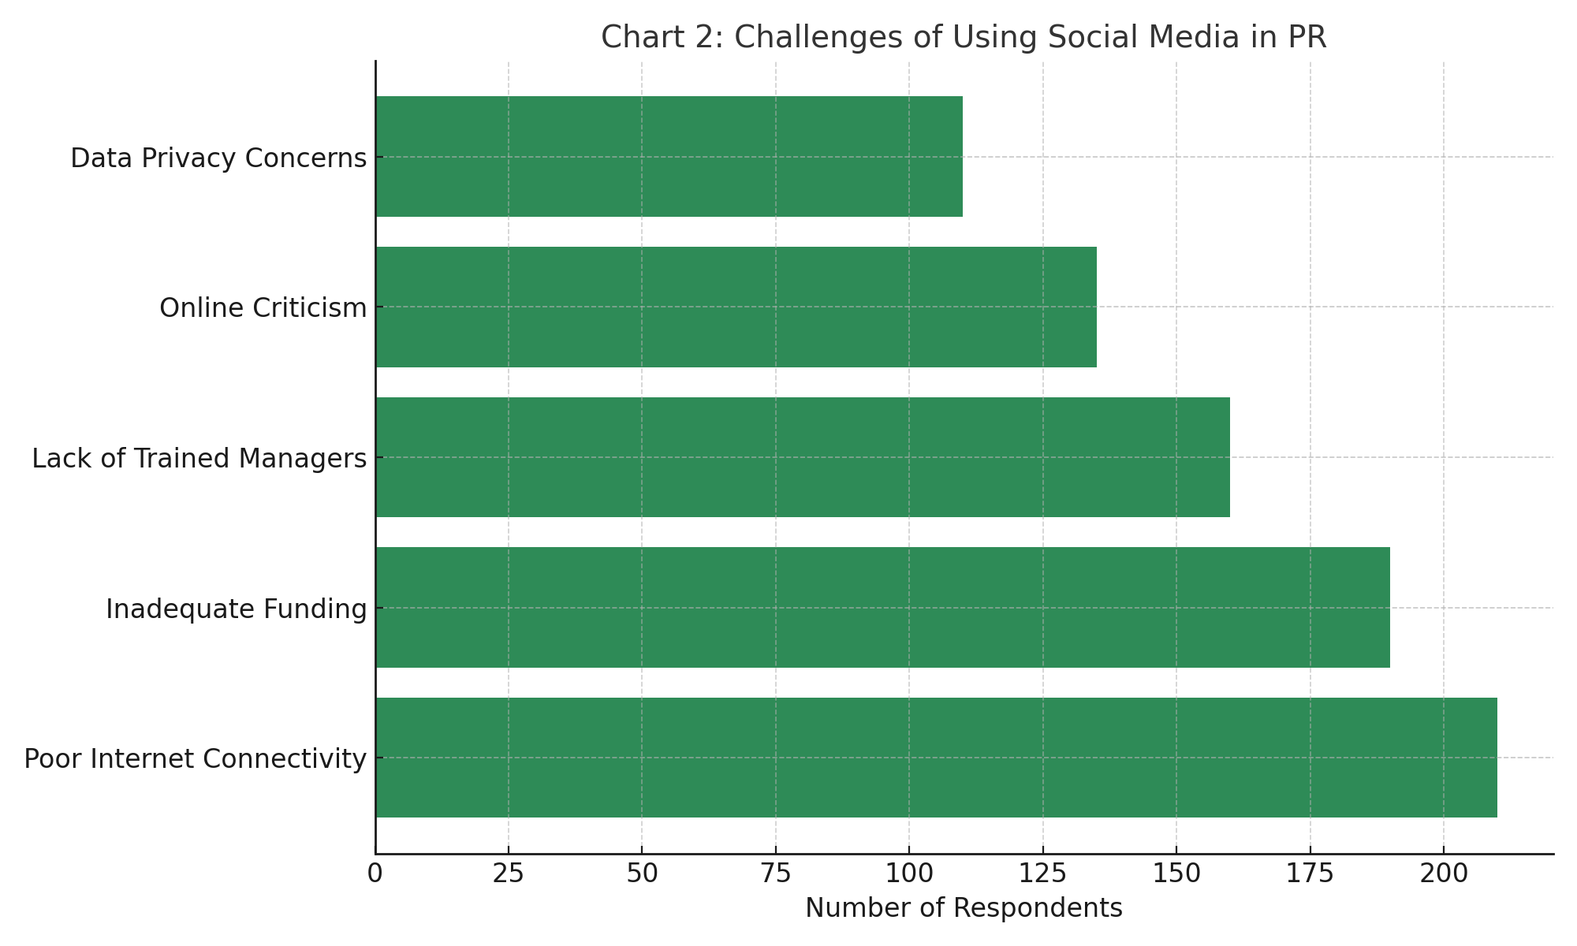
Sources: Omodia & Eyo (2021

CHAPTER FIVE
SUMMARY OF FINDINGS, CONCLUSION AND RECOMMENDATIONS
5.1 Summary of Findings
This study was conducted to evaluate the role of social media in public relations practices within Kwara State Polytechnic, Ilorin. The findings are based on data collected from 370 respondents, including students, PR officers, and administrative staff. The results of the analysis reveal several important insights.
Firstly, it was found that social media is widely used across the institution, with WhatsApp and Facebook emerging as the most commonly used platforms for public relations purposes. WhatsApp was used by 94.6% of respondents, while Facebook accounted for 86.5%, indicating that mobile-friendly and easily accessible platforms are preferred for institutional communication.
Secondly, the study established that social media is perceived as a highly effective tool in promoting the image of the Polytechnic and in improving student engagement. Respondents agreed that platforms like WhatsApp and Facebook enable timely dissemination of information, foster interaction between the institution and its audience, and help the school maintain a positive public image. Statistical analysis further supported this perception, with mean scores above 4.0 on a five-point Likert scale, demonstrating strong agreement on the effectiveness of social media in PR functions.
Thirdly, despite the widespread adoption and perceived effectiveness of social media, several challenges were identified. Chief among these are poor internet connectivity, which was reported by 56.8% of respondents, and inadequate funding for media campaigns, reported by 51.4%. Other issues include the lack of trained social media managers, negative online feedback, and data security concerns.
Lastly, a Chi-square test conducted in the study showed a statistically significant relationship between the use of social media and the effectiveness of public relations practices. This confirms that the more efficiently social media is used, the better the outcomes in terms of engagement, communication, and institutional image.
5.2 Conclusion
Based on the findings, it can be concluded that social media plays a critical and beneficial role in the public relations practices of Kwara State Polytechnic. It has become a powerful communication channel that supports information dissemination, image building, and student engagement. The effectiveness of these platforms lies in their accessibility, speed, and interactivity, which traditional communication channels often lack.
However, the study also reveals that the full potential of social media in PR is being hindered by infrastructural and administrative challenges, including poor internet services, limited budgetary allocation, and inadequate professional capacity. These barriers need to be addressed if the institution is to maximize the strategic value of its social media presence.

In essence, while the institution has embraced modern communication technologies, its ability to fully harness social media as a PR tool depends on deliberate investment in infrastructure, human resources, and policy development.
5.3 Recommendations
In light of the above conclusions, the following recommendations are proposed to enhance the use of social media in public relations at Kwara State Polytechnic:
1. Improve Internet Infrastructure:
The management should invest in robust, campus-wide internet access to ensure uninterrupted online activity, which is essential for effective digital communication.
2. Allocate Dedicated Budget for PR Activities:
A specific portion of the institution’s budget should be reserved for digital media campaigns, including staff training, content creation, sponsored posts, and analytics tools.
3. Build Capacity of PR Personnel:
Public relations officers and communication staff should be regularly trained on modern social media management, crisis communication, and audience engagement strategies.
4. Implement a Comprehensive Social Media Policy:
A formal policy should be introduced to guide content creation, posting schedules, roles and responsibilities, and responses to online criticism or misinformation.
5. Expand Presence to Emerging Platforms:
While Facebook and WhatsApp are dominant, the institution should consider expanding to platforms like TikTok and Instagram to appeal to younger audiences.
6. Encourage Student Participation in PR:
Introducing student ambassadors or digital content creators from the student body can boost participation and engagement on official platforms.
7. Enhance Monitoring and Evaluation:
Regular tracking of social media performance through analytics tools should be implemented to understand what content resonates and to improve engagement strategies.

REFERENCES

Creswell, J. W. (2014). Research design: Qualitative, quantitative, and mixed methods approaches (4th ed.). Thousand Oaks, CA: Sage Publications.

Effiong, U. E. (2017). Social media and public relations practice in Nigeria: A study of selected government agencies. Global Journal of Human-Social Science, 17(1), 35–44.

Kaplan, A. M., & Haenlein, M. (2010). Users of the world, unite! The challenges and opportunities of social media. Business Horizons, 53(1), 59–68. https://doi.org/10.1016/j.bushor.2009.09.003

Kothari, C. R. (2004). Research methodology: Methods and techniques (2nd ed.). New Delhi, India: New Age International Publishers.

McLuhan, M. (1964). Understanding media: The extensions of man. New York, NY: McGraw-Hill.

Olatunji, R. W. (2020). Public relations and the dynamics of social media in Nigerian higher institutions. Journal of Media Studies, 15(2), 113–129.

Okoro, N., & Nwafor, K. A. (2013). Social media and political participation in Nigeria during the 2011 general elections: The lapses and the lessons. Global Journal of Arts, Humanities and Social Sciences, 1(3), 29–46.

Olubukola, B. A. (2020). Digital communication and public relations in tertiary institutions in Nigeria. African Journal of Communication, 8(1), 84–98.

Statista. (2023). Number of internet users in Nigeria. Retrieved from https://www.statista.com/statistics/183849/internet-users-nigeria

QUESTIONNAIRE

SECTION A: DEMOGRAPHIC INFORMATION
Please tick (✓) the option that best represents you.
- Gender
☐ Male
☐ Female
- Age
☐ Below 20 years
☐ 20–29 years
☐ 30–39 years
☐ 40 years and above
- Role in the Institution
☐ PR Staff
☐ Administrative/Communication Staff
☐ Student
- How often do you use social media?
☐ Daily
☐ Occasionally
☐ Rarely

SECTION B: SOCIAL MEDIA PLATFORM USAGE
- Which of the following social media platforms do you use regularly? (You may tick more than one)
☐ Facebook
☐ Tiktokz
☐ Instagram
☐ WhatsApp
☐ YouTube
☐ TikTok
- Which platform do you believe the Polytechnic uses most effectively for public communication?
☐ Facebook
☐ WhatsApp
☐ Instagram
☐ Twitter/X
☐ YouTube
☐ TikTok

SECTION C: EFFECTIVENESS OF SOCIAL MEDIA IN PUBLIC RELATIONS
Please indicate your level of agreement with the following statements using the scale:
- SA – Strongly Agree
- A – Agree
- N – Neutral
- D – Disagree
- SD – Strongly Disagree
S/N | Statement | SA | A | N | D | SD
7 | Social media improves the image of Kwara State Polytechnic. | ☐ | ☐ | ☐ | ☐ | ☐
8 | Social media helps the institution engage students effectively. | ☐ | ☐ | ☐ | ☐ | ☐
9 | Information shared on social media is timely and useful. | ☐ | ☐ | ☐ | ☐ | ☐
10 | PR posts on social media reach a large audience. | ☐ | ☐ | ☐ | ☐ | ☐
11 | I regularly rely on social media for school-related news and events. | ☐ | ☐ | ☐ | ☐ | ☐

SECTION D: CHALLENGES IN USING SOCIAL MEDIA FOR PR
- What challenges do you think affect the Polytechnic’s use of social media in public relations? (Tick all that apply)
☐ Inadequate funding for media campaigns
☐ Poor internet connectivity
☐ Lack of professional social media managers
☐ Negative comments and online criticism
☐ Data privacy and security concerns
- In your opinion, what can be done to improve the use of social media for public relations in the institution?
_________________________________________________________________
_________________________________________________________________
_________________________________________________________________

APPENDIX

Appendix I
Chart 1: Social Media Platform Usage at Kwara State Polytechnic (Source: Field Survey, 2025; Statista, 2023; Pew Research Center, 2022)
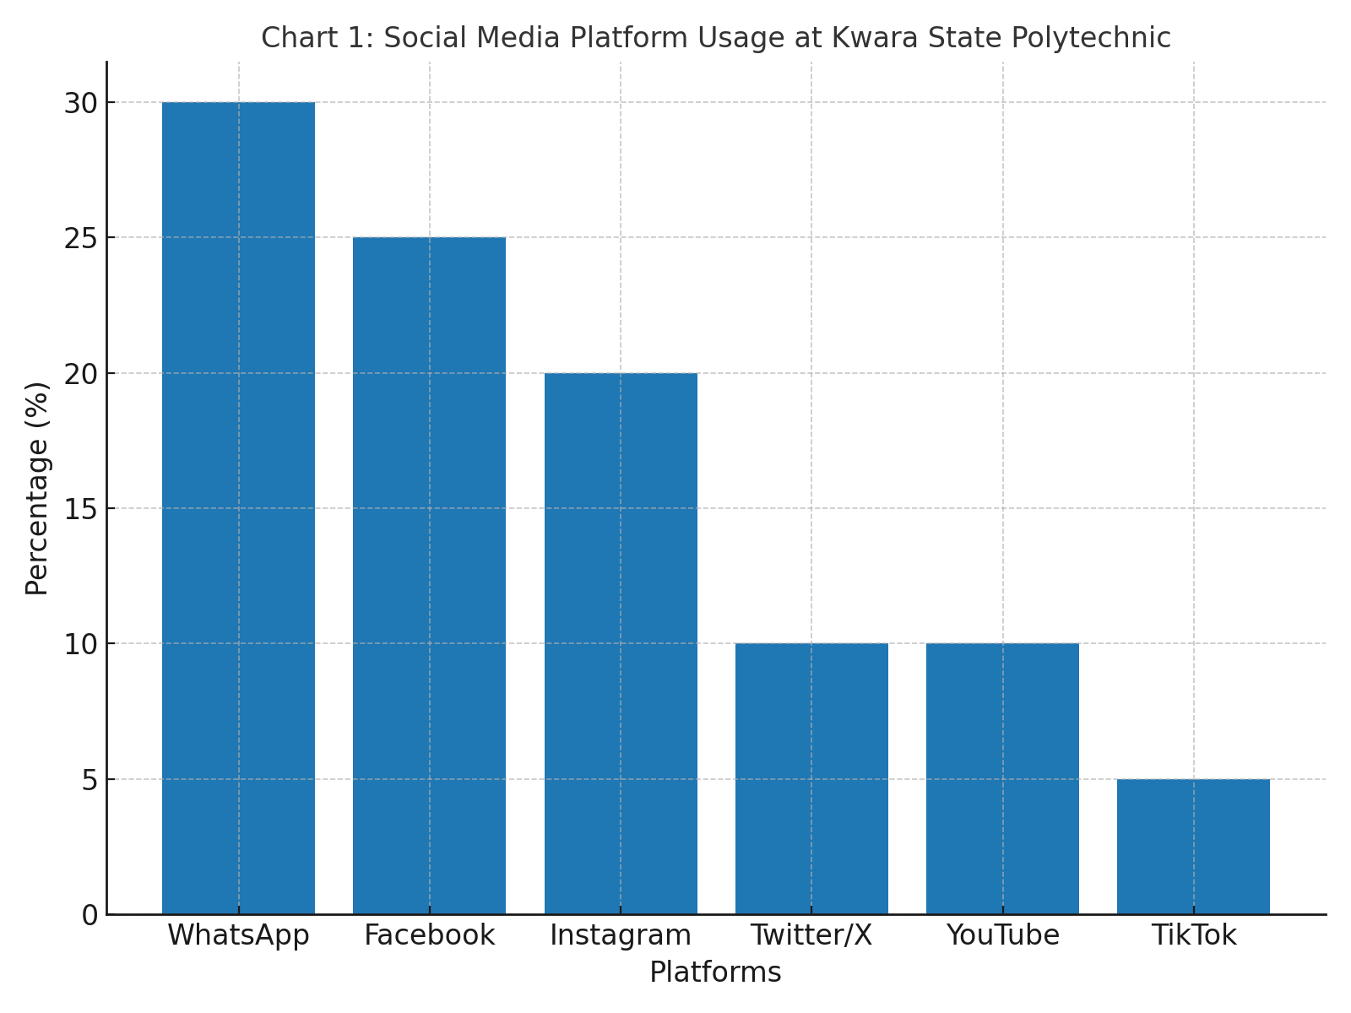

APPENDIX II
Chart 2: Challenges of Using Social Media in Public Relations
(Source: Field Survey, 2025; Omodia & Eyo, 2021; Akanbi & Akinlabi, 2021)
