CHARACTERISTICS VARIATION OF VISIBLE LIGHT AND OUTDOOR TEMPERATURE MEASUREMENT IN ILORIN, KWARA STATE, NIGERIA.

A PROJECT REPORT SUBMITTED

BY

ODEBIYI BARAKAT ABIDEMI
ND/23/SLT/PT/0298
BEING A PROJECT SUBMITTED TO THE DEPARTMENT OF SCIENCE LABORATORY TECHNOLOGY , INSTITUTE OF APPLIED SCIENCE, KWARA STATE POLYTECHNIC, ILORIN.
IN PARTIAL FULFILLMENT OF THE REQUIREMENTS FOR THE AWARD OF NATIONAL DIPLOMA (ND) IN SCIENCE LABORATORY TECHNOLOGY
JUNE, 2025
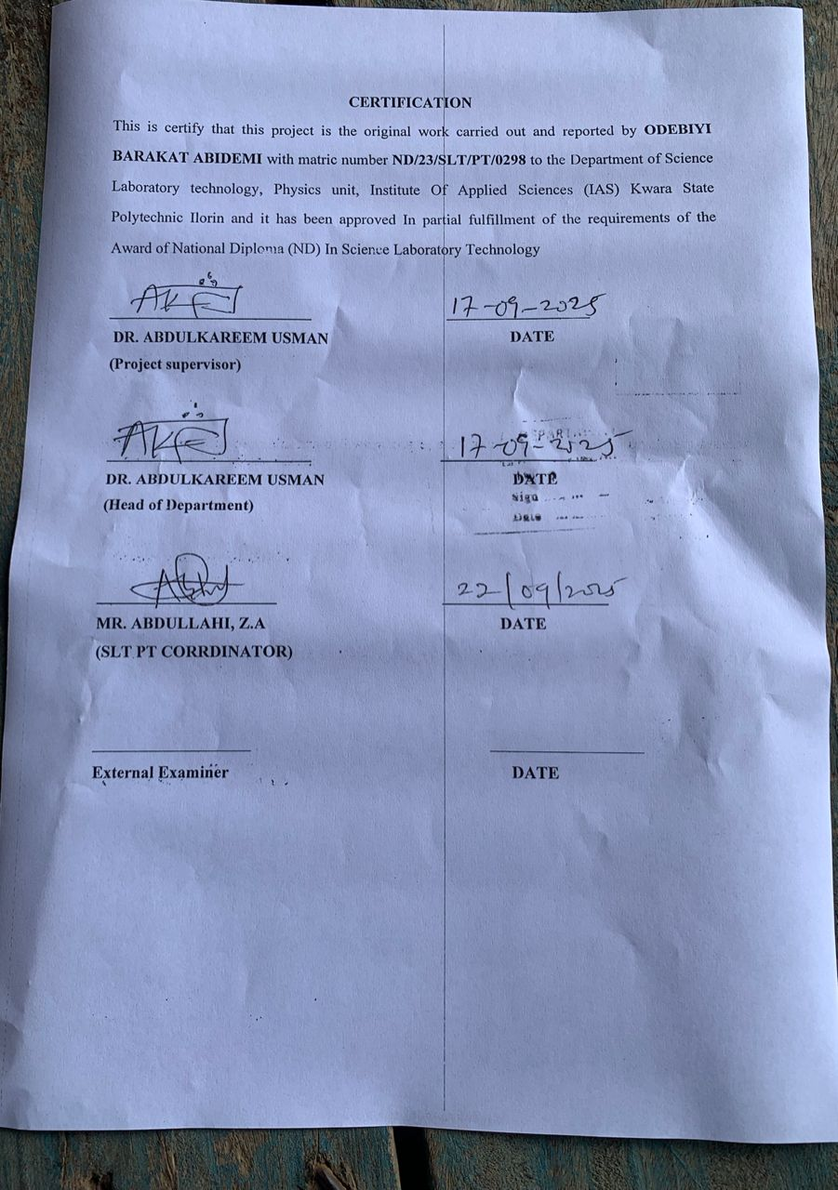

DEDICATION
This project is dedicated to Almighty God, the giver of life and wisdom for his grace, blessings and mercies throughout my course of study.
And also to my precious and loving parent Mr. and Mrs. Odebiyi. May Almighty God reward you with blessings and crown your efforts. May you reap the fruit of your labour and also to my siblings and families at large. May Almighty God fulfill your heart desires (Amen)

ACKNOWLEDGEMENT
My sincere heart of gratitude goes to the Almighty Allah, the all in all and most high for the knowledge given to me for the successful completion of my national diploma program.
This project would not have been possible without the cooperation of a very number of people. My debt in this regard, however, is to my supervisor in person of DR. ABDULKAREEM, USMAN whose patience, criticisms and comments extends to fully in time as they did in details. I am extremely grateful and I hope that the final result will not be a disappointment to him.

TABLE OF CONTENTS

Title Page …………………………………………………………………………
Certification ………………………………………………………………………
Dedication …………………………………………………………………………
Acknowledgement ……………………………………………………………...…
Table of Contents …………………………………………………………………
List of Figures ……………………………………………………………………..
List of Tables ……………………………………………………………………..
Abstract ……………………………………………………………………………
CHAPTER ONE: INTRODUCTION

1.1 General Background………………………………………………………

1.2 Relevance of visible light in micrometeorology

and related sciences………………………………………………………

1.3 Outdoor Temperature……………………………………………………

1.4 Statement of the Research Problem………………………………………

1.5 Objectives of this Research ………………………………………………

1.6 Justification for the Research ……………………………………………..

1.7 Expected Contribution to Knowledge …………………………………….

CHAPTER TWO: LITERATURE REVIEW
CHAPTER THREE: THEORETICAL BACKGROUND

3.1 Visible Light ………………………………………………………………

3.2 Outdoor Temperature …………………………………………………….

CHAPTER FOUR: METHODOLOGY

4.1 Pre-Field Experimental Work ……………………………………………..

4.2 Site Description ……………………………………………………………

4.3 Field Measurements ……………………………………………………….

4.4 Photometer and Thermometer probe ……………………………………...

4.5 Data Acquisition and Reduction …………………………………………..

4.5.1 Data logging of the sample data …………………………………………..

4.5.2 Pre-processing of the raw data …………………………………………….
CHAPTER FIVE: RESULTS AND DISCUSSION

5.1 Characteristics variation of visible light and outdoor temperature …….....

CHAPTER SIX: SUMMARY AND CONCLUSIONS

6.1 Summary and Conclusions ……………………………………………......
References

ABSTRACT

Visible light is the small part of the electromagnetic spectrum that human eyes can detect. When visible light travels through a prism or diffraction grating, it becomes separated into the colors of the rainbow. Each color of visible light has a different wavelength. Outdoor Temperature is a physical quantity expressing hot or cold. It is measured with a thermometer calibrated in one or more temperature scales. This research work was carried out at a tropical location (Kwara state polytechnic) in Ilorin, Kwara state. The instruments used for this research are photometer and thermometer. The measurements were taken for a period of one week (18th May – 1st June, 2025). The data were recorded at every 30 minutes and were reduced to hourly measurement. For the period under consideration, the highest value of visible light for this research is 80Wm⁻²Lx.

CHAPTER ONE

INTRODUCTION
  - GENERAL BACKGROUND
Sunlight is different than the light from a light bulb. The sun gives off many different wavelengths of light. Some of these wavelengths we can see with our eyes as “visible” light. However, only about 2% of the wavelengths the Sun gives off are detectable with human eyes (AMNH, 2002).
Visible light is the small part of the electromagnetic spectrum that human eyes can detect. When visible light travels through a prism or diffraction grating, it becomes separated into the colors of the rainbow. Each color of visible light has a different wavelength. All wavelengths of light move at the same speed, but different wavelengths have different energy. Within the visible spectrum, red light has the longest wavelength and is the least energetic while violet light has the shortest wave-length and is the most energetic. The study of light is extremely important to astronomy because it is the means by which we learn about the Universe (Regan and Parrish, 2018).
Light is so much a part of our everyday existence contributing to our quality of life, as well as a key enabler in photonics, solar power, and new lighting technologies, that the year 2015 has been declared by the UNESCO as the International Year of Light and Lighting Technologies. Light has many different meanings depending upon the application (Regan and Parrish, 2018).
When it is used to broadly describe optical radiation, it is deﬁned as electromagnetic radiation with wavelengths between approximately10 nm and 1 mm, i.e., a term that is used to describe the ultraviolet, visible, and infrared regions of the electromagnetic spectrum. Electromagnetic radiation is the emission or transfer of energy in the form of electromagnetic waves and in the form of photons. Photon is a quantum of electromagnetic radiation that is usually associated with radiation that is characterized by one wavelength or frequency (monochromatic radiation) (Regan and Parrish, 2018).
1.2 RELEVANCE OF VISIBLE LIGHT IN MICROMETEOROLOGY AND RELATED SCIENCE
In ancient times, appearances in the air were called meteors. In the first half of the 20th century, the upper soil layers were considered part of meteorology (Hann and Süring, 1939). Today meteorology is understood in a very general sense to be the science of the atmosphere (Dutton, 2014), and includes also the mean states (climatology). Sometimes the definition of meteorology is very narrow, and only related to the physics of the atmosphere or weather prediction. To understand atmospheric processes, many other sciences such as physics, chemistry, biology and all geosciences are necessary, and it is not easy to find the boundaries of these disciplines (Bradt, 2004).
In a pragmatic way, meteorology is related only to processes that take place in-situ in the atmosphere, while other sciences can investigate processes and reactions in the laboratory. This underlines the specific character of meteorology, i.e., a science that investigates an open system with a great number of atmospheric influences operating at all times but with changing intensity (Bradt, 2004).

1.3 OUTDOOR TEMPERATURE
Temperature symbolizes the thermodynamic condition of a body. The direction of the net flow of heat between two bodies determines the value of temperature. For meteorological purposes, temperatures are measured for a number of media. The most common variable measured is air temperature (at various heights), ground, soil, grass minimum and seawater temperature (Ohannesianet al., 2013).
The outdoor temperature is usually not the same as the one desired indoors, and hence, it is necessary to heat or cool by one technique or another—in order to create a comfortable climate inside a building. Good thermal insulation is demanded so that excessive amounts of energy are not wasted for this heating and cooling. Therefore, we now contemplate the thermal properties of glazings (Bradt, 2004).
Measuring the temperature outdoors is one of the most basic aspects of weather observation. The outdoor temperature can affect many things about your day; it can even determine whether you'll spend your day indoors or out. Having a thermometer outside can also help determine when plants should be covered or brought inside in the winter. Thermometers are simple to use and come in a wide range of prices, with the more expensive ones offering more functions than simple temperature reading (Ohannesian et al., 2013).

1.4 STATEMENT OF RESEARCH PROBLEM
Visible light Electromagnetic radiation in this range of wavelengths is called visible light or simply light. A typical human eye will respond to wavelengths from about 380 to 740 nanometers. It is however necessary to observe the characteristics variation of the visible light and outdoor temperature in Ilorin, Kwara State.
1.5 OBJECTIVES OF THE STUDY
The specific of the objective of this research are to:
- Measure visible light
- Measure outdoor temperature
- Observe the diurnal variation of visible light and outdoor temperature
1.6 JUSTIFICATION FOR THE RESEARCH
Characteristics variation of visible light and outdoor temperature such as we have in this study is very useful as it gives us the actual amount of visible light received in Ilorin.
1.7 EXPECTED CONTRIBUTION TO KNOWLEDGE:
The results of this study will provide empirical relationships that can be useful to the visible light and outdoor temperature variation. This directly affects evapotranspiration and will be useful to agro-meteorologist, climate modeling and water resources management.

CHAPTER TWO
LITERATURE REVIEW
Light or "visible light" refers to the visible region of the electromagnetic spectrum – that is, the range of wavelengths that trigger brightness and colour perception in humans. It lies between UV and infrared radiation (wikipedia.com).
Visible light, which travels at a dizzying 186,282 miles per second through space, is just one part of light's broad spectrum, which encompasses all electromagnetic radiation. We can detect visible light because of cone-shaped cells in our eyes that are sensitive to the wavelengths of some forms of light. Other forms of light are invisible to humans because their wavelengths are either too small or too large to be detected by our eyes.
White light and all the colors of the rainbow represent a small part of the electromagnetic spectrum, but they are the only forms of light we can see because of their wavelengths. Humans can only detect wavelengths between 380 and 700 nanometers. Violet has the shortest wavelength we can see, while red has the largest (wikipedia.com).
While we don't normally call other forms of electromagnetic radiation light, there is little difference between them. Infrared light is just outside our vision with a wavelength bigger than red light. Only with instruments like night-vision goggles can we detect the infrared light generated by our skin and other heat-emitting objects. On the other side of the visible spectrum, smaller than violet light waves are ultraviolet light, X-rays and gamma rays.
Visible light is a form of electromagnetic (EM) radiation, as are radio waves, infrared radiation, ultraviolet radiation, X-rays and microwaves. Generally, visible light is defined as the wavelengths that are visible to most human eyes.
EM radiation is transmitted in waves or particles at different wavelengths and frequencies. This broad range of wavelengths is known as the electromagnetic spectrum. That spectrum is typically divided into seven regions in order of decreasing wavelength and increasing energy and frequency. The common designations are radio waves, microwaves, infrared (IR), visible light, ultraviolet (UV), X-rays and gamma-rays (wikipedia.com).
Visible light falls in the range of the EM spectrum between infrared (IR) and ultraviolet (UV). It has frequencies of about 4 × 10¹⁴ to 8 × 10¹⁴ cycles per second, or hertz (Hz) and wavelengths of about 740 nanometers (nm) or 2.9 × 10⁻⁵ inches, to 380 nm (1.5 × 10⁻⁵ inches).
Light color is usually determined by the energy being produced by the source that emits it. The hotter an object is, the more energy it radiates, resulting in light with shorter wavelengths. Cooler objects create light with longer wavelengths. For example, if you fire up a blowtorch, you will find its flame is red at first, but as you turn it up, the color becomes blue.
Similarly, stars emit different colors of light because of their temperatures. The surface of the sun has a temperature around 5,500 degrees Celsius, causing it to emit a yellowish light. A star with a cooler temperature of 3,000 C, like Betelgeuse, emits red light. Hotter stars like Rigel, with a surface temperature of 12,000 C, emit blue light (Steeger et al., 2001).
In 1801, he was experimenting with silver chloride, a chemical which turned black when exposed to sunlight. He had heard that exposure to blue light caused a greater reaction in silver chloride than exposure to red light. Ritter decided to measure the rate at which silver chloride reacted when exposed to the different colors of light. To do this, he directed sunlight through a glass prism to create a spectrum. He then placed silver chloride in each color of the spectrum. Ritter noticed that the silver chloride showed little change in the red part of the spectrum, but increasingly darkened toward the violet end of the spectrum. This proved that exposure to blue light did cause silver chloride to turn black much more efficiently than exposure to red light (Steeger et al., 2001).
Ultraviolet (UV) is electromagnetic radiation with a wavelength from 10 nm to 400 nm, shorter than that of visible light but longer than X-rays. UV radiation is present in sunlight constituting about 10% of the total light output of the Sun. It is also produced by electric arcs and specialized lights, such as mercury-vapor lamps, tanning lamps, and black lights. Although long-wavelength ultraviolet is not considered an ionizing radiation because its photons lack the energy to ionize atoms, it can cause chemical reactions and causes many substances to glow or fluoresce. Consequently, the chemical and biological effects of UV are greater than simple heating effects, and many practical applications of UV radiation derive from its interactions with organic molecules (wikipedia.com).
Ultraviolet (UV), one of the components of solar radiation, is divided into UV-A (320-400 nm), UV-B (280-320 nm), and UV-C (200-280 nm). Normally, stratospheric ozone reflects UV-C and most of the UV-B, so only UV-A, and a little of the UV-B reach the Earth (Steeger et al., 2001). Organisms on Earth are therefore evolutionarily adapted to UV-A, but might not be adapted to UV-B.
Jordan and Kurtz (2013),later observations and studies appeared in the mid-1990s, although at this time the agent responsible for EVA browning had not been identified. It is interesting that even in 1994 Jordan and Kurtz, (2013)noted that Cerium Oxide-containing glass (which blocks UV radiation below 350 nm) prevented EVA discoloration in indoor tests.
Kempe et al. (2007)Formulations of EVA that undergo yellowing/browning has also been shown to produce acetic acid, with UV exposure which corrodes solder bonds and electrical contacts. This also corresponds to increased leakage current through the encapsulant.
King et al., (1999)Performance Losses initially attributed optical losses at the from EVA browning at the Carrisa Planes Site have later attributed to Fill Factor Losses due to solder-bond degradation and inadequate use of bypass diodes.
In 2003 Jorgensen et al. measured the “Peel Strength” of EVA layers vacuum laminated to various backsheet materials after exposure to a Xenon UV source at intensities of ~1 sun.
At least one study has examined the decrease in light transmittance and PV module efficiency for silicone-encapsulated PV modules with UV light exposure under an AM0 spectrum. The authors found a ~15% decrease in PV module efficiency after a ~15 year UV dose.
In 2003, Osterwald et al., published the results of a 5-year study of commercial c-Si PV modules in which the authors found a linear relationship between slow Isc degradation rates (-0.2%/year tob-0.5% year) and UV radiation dose. The authors did not attribute the decrease in Isc to EVA browning, noting an example of one module with an 8% drop in Isc and no obvious change in encapsulant appearance.
Johann Ritter (1801) is best known for his discovery of ultraviolet light in 1801. A year earlier, in 1800, William Herschel discovered infrared light. This was the first time that a form of light beyond visible light had been detected. After hearing about Herschel's discovery of an invisible form of light beyond the red portion of the spectrum, Ritter decided to conduct experiments to determine if invisible light existed beyond the violet end of the spectrum as well.
Johann Ritter then decided to place silver chloride in the area just beyond the violet end of the spectrum, in a region where no sunlight was visible. To his amazement, he saw that the silver chloride displayed an intense reaction well beyond the violet end of the spectrum, where no visible light could be seen. This showed for the first time that an invisible form of light existed beyond the violet end of the spectrum.

CHAPTER THREE
3.0 THEORITICAL BACKGROUND
3.1 VISIBLE LIGHT
Light is a type of energy made of electromagnetic waves, a blend of magnetism and electricity. Visible light is only one kind of light or electromagnetic radiation. Certain animals like bees can see other forms of light, such as ultraviolet light. Radio waves are another type of light, as is infrared light. Humans can only see a small section of electromagnetic radiation, and this band is called the visible light spectrum. Visible light is made both of waves and of particles. This idea is called “wave-particle duality” and is one of the basic tenets of the revolutionary physics discoveries in quantum theory (Dianne, 2018).When atoms are excited, they can emit a photon particle if another photon with the same energy passes by it.
Visible light is the light humans see with their eyes. Visible light comes primarily from the sun, but also from other natural and manmade light sources. The visible light spectrum is the range of wavelengths that make up visible light (Dianne, 2018).

3.1.1 PROPERTIES OF VISIBLE LIGHT
The light that humans see with eyes is called visible light. Visible light contains every color that humans can see. There are distinct properties of visible light that set it apart from other types of electromagnetic radiation (Ohannesian et al., 2013).
If the visible light spectrum passes through a prism, the resulting rainbow reveals all the colors in the spectrum. These range from red, with a wavelength of 700 nanometers (which is incredibly small), through orange, yellow, green, blue and finally violet, with a wavelength of 380 nanometers (which is even smaller!). Radio wavelengths, in contrast, are quite long, greater than a meter. Gamma ray wavelengths are even smaller than visible light wavelengths, at the picometer level (Oldford and MacKay, 2000).
One of the properties of visible light is the presence of dark absorption lines in the visible light spectrum. These lines serve as markers for missing wavelengths. Scientists use these patterns to study the makeup of stars, as missing wavelengths correspond to certain elements.
An interesting characteristic of visible light is that exists as both a wave and a particle. This may sound strange, but consider first the wave aspect of visible light. Like any other wave, including waves in the ocean, light waves can travel in every direction, interact with other waves and even bend (Oldford and MacKay, 2000).
These waves travel at 186,000 miles per second in a vacuum, which is referred to as one light second. Visible light does slow down when passing through denser material such as air or human eyes.
Visible light cannot pass through any opaque walls, like radio waves can(Dianne, 2018).

3.1.2 USES OF LIGHT ON EARTH
Sunlight provides the energy that green plants use to create sugars mostly in the form of starches, which release energy into the living things that digest them. This process of photosynthesis provides virtually all the energy used by living things. Some species of animals generate their own light, a process called bioluminescence. For example, fireflies use light to locate mates and vampire squid use it to hide themselves from prey (wikipedia.com).
3.1.3 SOURCES OF VISIBLE LIGHT
Visible light can be emitted from a number of sources. The most influential visible light source on Earth is the sun. Other sources of visible light include stars, planets and moons (which display light reflected from the sun), auroras, meteors, volcanoes, lightning, fire and bioluminescent organisms such as fireflies, certain jellyfish, fish and even certain microbes (wikipedia.com).
Can you imagine living in an era without light bulbs or lamps? The technology of human light sources has evolved a great deal since early humans had to rely only on the light in their environment. Artificial sources of visible light include candles, oil lamps, gas lighting and light bulbs. Today, a broad range of light bulbs and lamps exist, from the early types of incandescent light bulbs to fluorescent lights, to light-emitting diode (LED) lights. More energy-efficient light bulbs are being made every year (Oldford and MacKay, 2000).
Another powerful source of light is the LASER, or Light Amplification by the Stimulated Emission of Radiation. At this point in time, lasers do not resemble the weapons seen in science fiction movies and television shows. But they are still very useful. Laser beams are single-wavelength light beams that are used in many modern technologies, from bar codes and music storage to surgery and microscopy. Laser altimeters are also being used by satellites used to study the Earth’s polar ice sheets, to see how much water they store. Light is constantly being used in new, efficient ways to help humanity, and indeed the entire world (NASA, 1958).

LIGHT AND THE EYE
The wavelengths of light penetrate as far as the retina in the eye and the dermis in the skin. Most people can perceive wavelengths of between about 400 nanometres (nm) and 780 nm visually. Rather than being clear cut, the boundaries of the visible region of the spectrum for humans exhibit fluid transitions. Moreover, a person's eyesight and sensitivity to light vary over their lifetime due to ageing processes in the eye. Especially for the short-wavelength section of the visible spectrum (blue light), the transparency of the lens decreases with age.

THE SIGNIFICANCE OF LIGHT
Light is not only responsible for allowing us to see our surroundings but also has other biological effects and influences the sleep/wake cycle, among other things. Light has long been used for medical and cosmetic purposes. Many lasers and IPL devices ("flash lamps") operate with different wavelengths of light. For example, light with a relatively high proportion of blue light is used in light therapy devices or daylight lamps to treat "winter depression" or to set the "body clock" when everyday life involves little natural light.

THE ELECTROMAGNETIC SPECTRUM
If all light, visible or not, is technically the same thing electromagnetic radiation what distinguishes one type from another, its wave properties.
Electromagnetic waves exist in a spectrum of different wavelengths and frequencies. As a wave, light's speed follows the wave speed equation, where the speed is equal to the product of wavelength and frequency.
In this equation,​v​is wave velocity in meters per second (m/s), ​λ​ is wavelength in meters (m) and ​f​ is frequency in hertz (Hz).
In the case of light, this can be rewritten with the variable ​C​ for the speed of light in a vacuum.
3.2 OUTDOOR TEMPERATURE
The outdoor temperature is usually not the same as the one desired indoors, and hence, it is necessary to heat or cool—by one technique or another—in order to create a comfortable climate inside a building. Good thermal insulation is demanded so that excessive amounts of energy are not wasted for this heating and cooling. Therefore, we now contemplate the thermal properties of glazings (Cassidy, 2002).
Measuring the temperature outdoors is one of the most basic aspects of weather observation. The outdoor temperature can affect many things about your day; it can even determine whether you'll spend your day indoors or out. Having a thermometer outside can also help determine when plants should be covered or brought inside in the winter. Thermometers are simple to use and come in a wide range of prices, with the more expensive ones offering more functions than simple temperature reading (Cassidy, 2002).
Purchase a thermometer. Depending on the price you want to spend, you can get a simple thermometer or a "weather station" that will tell you various other aspects of the weather (such as wind speed, rainfall amount, and humidity and barometer readings). Some digital thermometers have a remote display that allows you to read the outside temperature from the comfort of inside your home.
UNITS OF TEMPERATURE
The temperature is usually given in degrees Celsius (°C) or degrees Fahrenheit (°F).The SI unit of temperature is Kelvin (K) (wikipedia.com).
MEASUREMENT OF AIR TEMPERATURE
Liquid-in-glass thermometers are commonly used for routine observations of air temperature, including maximum, minimum, dry bulb and wet-bulb temperatures. The liquid used in a thermometer depends on the required temperature range; mercury is generally used for temperatures above its freezing point (−38.3 °C), while ethyl alcohol or other pure organic liquids are used for lower temperatures (wikipedia.com).

CHAPTER FOUR

METHODOLOGY

This research work was carried out at a tropical location (Kwara state polytechnic) in Ilorin, Kwara State. The instruments used for this research are photometer and thermosensor probe. The measurements were taken for a period of two weeks (18thMay-1stJune, 2025). The data were recorded at every 30 minutes and were reduced to hourly measurement.

The reduced data (hourly) was plotted against local standard time to show the diurnal variation of the measured data.

4.1 PRE-FIELD EXPERIMENTAL WORK

INSTALLATION OF THE PHOTOMETER AND THERMOMETER

We installed photometer and thermosensor probe, we adhere to the instructions below to test the photometer and thermosensor probe function
- We inserted the battery
- We connected the photometer and thermosensor probe to the appropriate connector on the junction box.
- We checked their altitude usage, to make sure it works perfectly in the location.
- We mounted it with the photometer and thermosensor probe having a solar panel in it.
- We used an iron rod to mount it, the rod is of 5meter length.
- We mounted the photometer and thermosensor probe which consist of solar panel at the top mounting stage.
- Then we connected the data Weather Smart Data logger to the personal computer (PC).

CHOOSING THE BEST PHOTOMETER AND THERMOMETER LOCATION

We used the following guideline to determine the best location for photometer and thermosensor probe.
- We installed the photometer and thermosensor probe in a location where wind flow is unobstructed by tress and nearby buildings.
- For the most accurate readings the photometer and thermosensor probe should be mounted at least 4 feet (1.2m) above the roof line.
- We did this by mounting the photometer and thermo sensor probe on a metal rod of shout 4feet (1.2) above the roof line.
- We make sure the metal rod is properly grounded.

4.2 SITE DESCRIPTION

This research was carried out inside physics laboratory, Kwara State Polytechnic, Ilorin, Kwara State.
Kwara State Polytechnic has been in operation since 1973 with focus on technological and entrepreneurship skills. It is located in Ilorin, the capital of Kwara state. Kwara state polytechnic started with 110 pioneering students and it offer National Diploma and Higher National Diploma in courses at undergraduate levels.
Kwara state polytechnic is a Nigeria Tertiary Institution that was established in 1973 by the military Governor of Kwara state col. (David Bamigboye) after the decision of establishing a polytechnic in Kwara state was announced in 1971.
The latitude of kwara state is 8.9848⁰N while the longitude is 4.5624⁰E. The latitude and longitude can be mapped to closest address of kwara, Nigeria.
Kwara state is located in sub-locality, locality, district, kwara state of Nigeria country (Federal Republic of Nigeria Population census, 2006).

4.3 FIELD MEASUREMENTS

The photometer and thermosensor probewas mounted. We used measuring tape to measured 5.2m pole above ground levelin Kwara state polytechnic, Ilorin, Kwara state.

4.4 PHOTOMETER AND THERMO SENSOR PROBE

The probe or instruments used for this research for are photometer and themosensor probe. The below image represents the probe.

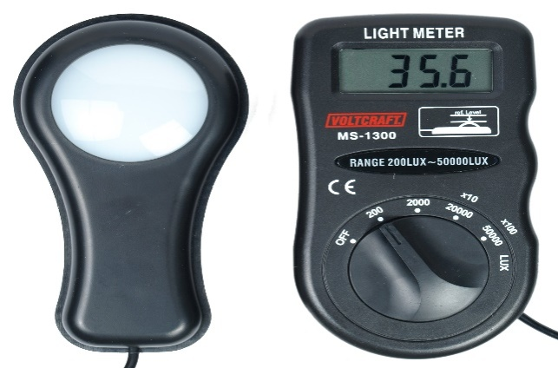

Figure 4.1: Diagram illustration Photometer (wikipedia.com).
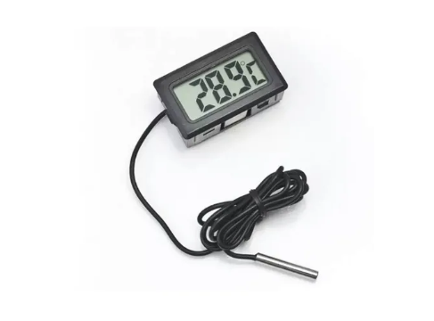
Figure 4.2: Themosensor probe (wikipedia.com).

4.5 DATA ACQUISITION AND REDUCTION

This research work was carried out at a tropical location (Kwara state polytechnic) in Ilorin, Kwara state. The instruments used for this research are photometer and thermometer. The measurements were taken for a period of one week (18thMay – 1stJune, 2025). The data were recorded at every 30 minutes and were reduced to hourly measurement.

Custom-built software for the operation, acquisition and pre-processing of the raw data was used (WeatherSmart, 2017). In this software, the following parameters were configured: sampling time, average time and data storage.

4.5.1 DATA LOGGING OF THE SAMPLE DATA
In this project, the acquisition of the data was achieved by using Weather Smart data logger systems (measurement and control module). An RS232 connection to the computer for communication purposes was achieved by using a USB cable. The data logger is wirelessly connected to all the sensing elements thereby accepting their respective signals.
The transducers signals were then sampled, digitized and stored in the internal/expanded memory. The data which were collated in ASCII format were then reduced using a data reduction program, MicroCal Origin 7.1 Version. All the sensors used was sampled every 30 minutes but later reduced to hourly data. The radiation measuring instruments were sampled at 10 Hz, and subsequently averaged to produce hourly data statistics for the surface radiation fluxes.

4.5.2 PRE-PROCESSING OF THE RAW DATA

The data processing and presentation package, MicroCal Origin 7.1 Version has been used for necessary computations and data reduction. After elimination of spurious data values and the data to 30 minutes, data were then reduced to hourly data averages. The data thereafter were imported into the MicroCal origin version 7.1 new worksheet and a graphical presentation of the diurnal variability of the measured parameters was produced.

CHAPTER FIVE:
RESULTS AND DISCUSSION
This study is aimed at estimating visible light from outdoor temperature. The estimations of visible light and outdoor temperature at a tropical location were obtained as datasets from the field experimental measurement at Ilorin, the Kwara State capital. The field experiment was carried out from 18th May –1stJune, 2025.

5.1 CHARACTERISTICS VARIATIONOFVISIBLE LIGHT AND OUTDOOR TEMPERATURE

For day 1, the result shows increase in the reading of visible light about 0 to 200 hours which is the highest value or reading for visible light for the day (80mW/m²). It then falls sharply from 600 to 850 hours. There was a constant reading from about 850 to 2200 hours, before it finally increases at about 2400 hour with the value 40mW/m². The diurnal variation of both the visible light and outdoor temperature on this day was depicted in Figure 5.1.

For day 2, the result shows increase in the reading of visible light about 0 to 250 hours which is the highest value or reading for visible light for the day (80mW/m²). It then falls sharply from 600 to 900 hours. There was a constant reading from about 900 to 2000 hours, before it finally increases at about 2200 hour with the value 40mW/m². The diurnal variation of both the visible light and outdoor temperature on this day was depicted in Figure 5.2.

For day 3, the result shows increase in the reading of visible light about 0 to 250 hours which is the highest value or reading for visible light for the day (75mW/m²). It then falls sharply from 500 to 900 hours. There was a constant reading from about 900 to 2100 hours, before it finally increases at about 2200 hour with the value 55mW/m². The diurnal variation of both the visible light and outdoor temperature on this day was depicted in Figure 5.3.

For day 4, the result shows increase in the reading of Visible light measured and Visible Light predicted about 0 to 400 hours which is the highest value or reading for Visible Light measured for the day (80mW/m²). It then falls sharply from 500 to 800 hours. There was a constant reading from about 850 to 2200 hours, before it finally increases at about 2300 hour. The diurnal variation of both the Visible Light measured and Visible Light predicted on this day was depicted in Figure 5.4.

For day 5, the result shows increase in the reading of Visible light measured and Visible Light predicted about 0 to 400 hours which is the highest value or reading for Visible Light measured for the day (78mW/m²). It then falls sharply from 600 to 800 hours. There was a constant reading from about 800 to 2100 hours, before it finally increases at about 2200 hour. The diurnal variation of both the Visible Light measured and Visible Light predicted on this day was depicted in Figure 5.5.

For day 6, the result shows increase in the reading of Visible light measured and Visible Light predicted about 0 to 500 hours which is the highest value or reading for Visible Light measured for the day (77mW/m²). It then falls sharply from 500 to 800 hours. There was a constant reading from about 850 to 2100 hours, before it finally increases at about 2200 hour. The diurnal variation of both the Visible Light measured and Visible Light predicted on this day was depicted in Figure 5.6.

For day 7, the result shows increase in the reading of Visible light measured and Visible Light predicted about 0 to 400 hours which is the highest value or reading for Visible Light measured for the day (75mW/m²). It then falls sharply from 500 to 800 hours. There was a constant reading from about 850 to 2200 hours, before it finally increases at about 2300 hour. The diurnal variation of both the Visible Light measured and Visible Light predicted on this day was depicted in Figure 5.7.

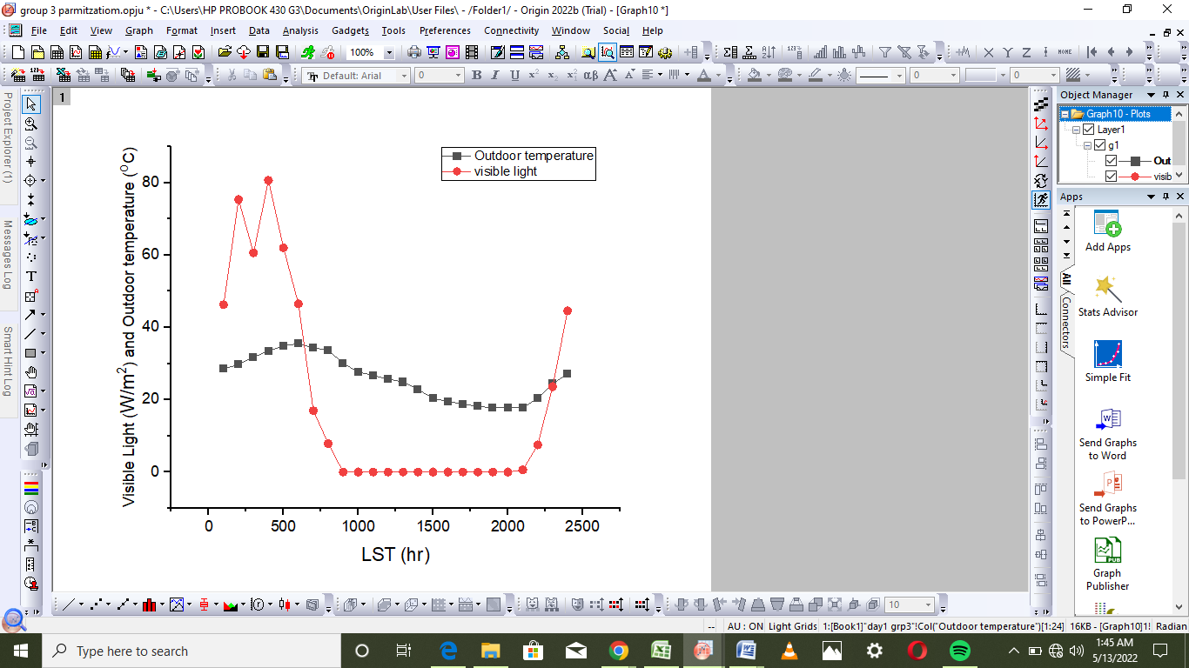
Figure 5. 1: Diurnal variation of Visible Light and Outdoor Temperature for(DOY 115).

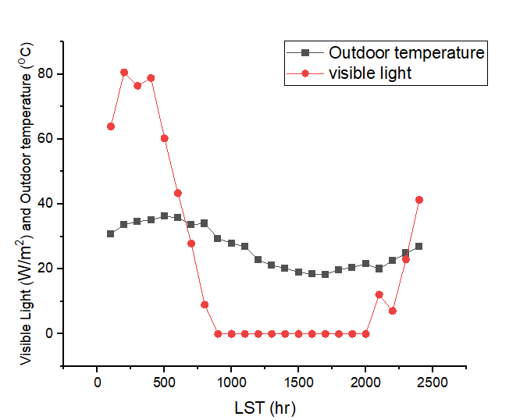
Figure 5. 2: Diurnal variation of visible light and outdoor temperature for (DOY 116).

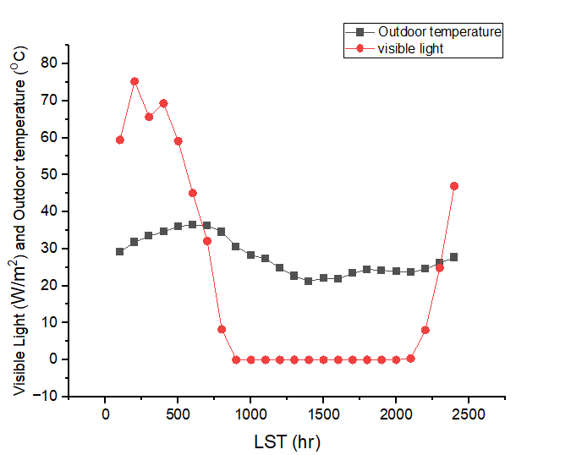
Figure 5.3: Diurnal variation of visible light and outdoor temperature for (DOY 117).

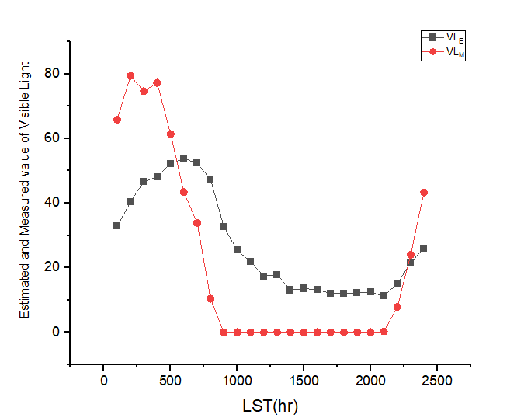
Figure 5.4: Diurnal variation of estimated and measured value for (DOY 118).

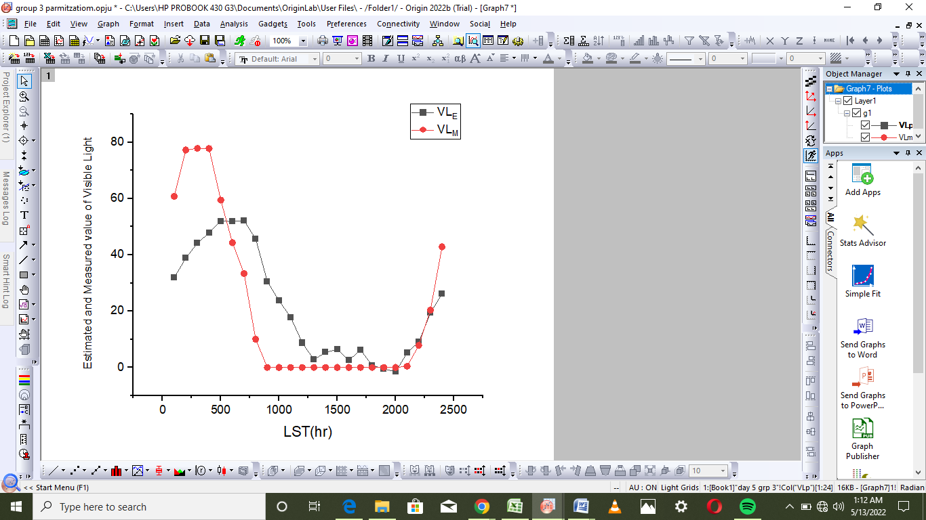
Figure 5.5:Diurnal variation of estimated and measured value for(DOY 119).

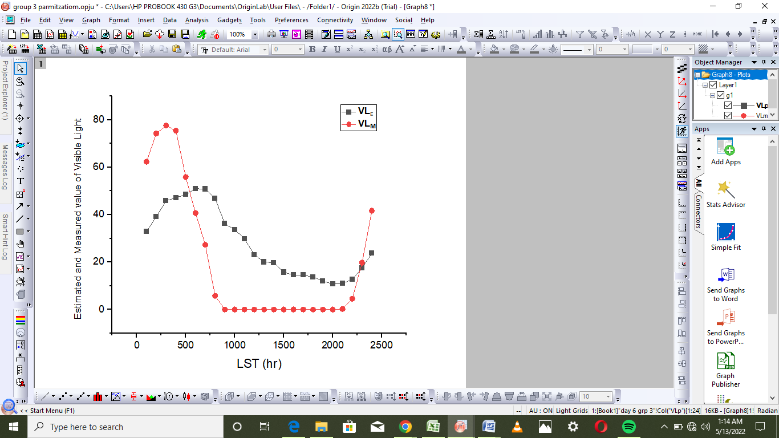
Figure 5.6:Diurnal variation of estimated and measured value for (DOY 120).

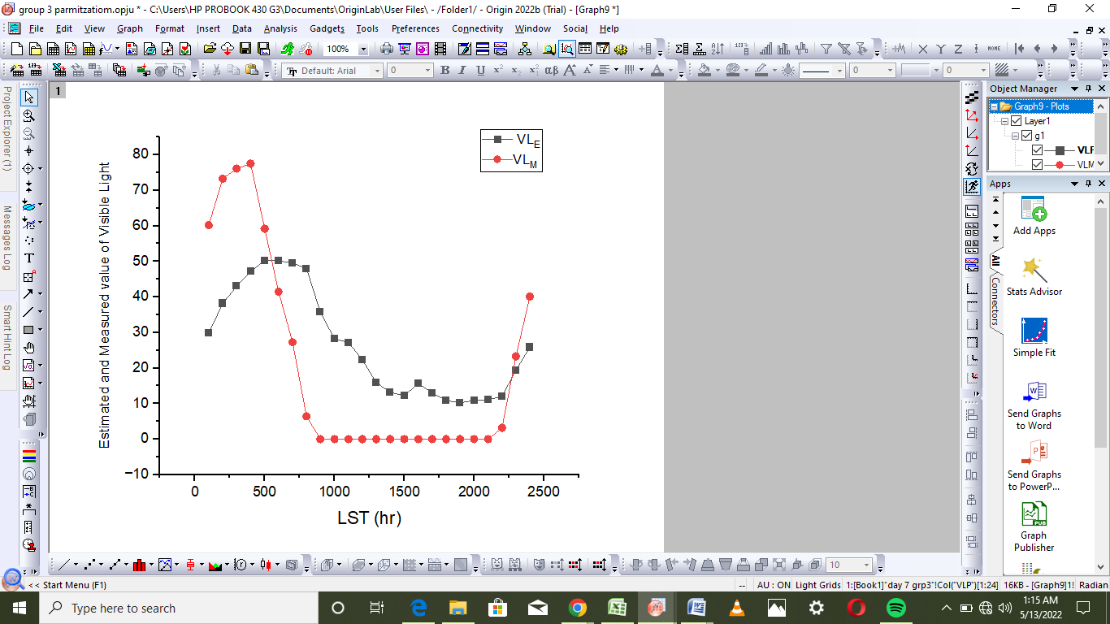
Figure 5.7: Diurnal variation of estimated and measured value for (DOY 121).

CHAPTER SIX:

SUMMARY AND CONCLUSIONS

Continuous measurements of Visible Light and Outdoor temperature at an experimental site (08⁰ 9’21⁰N, 04⁰30’.50⁰E) located at the Kwara State Polytechnic Ilorin, Nigeria, was carried out between 18thMay –1stJune, 2025. Using the direct measurement technique, these datasets were used to investigate the characteristics variation of the visible light and outdoor temperature in Ilorin, Kwara State.

The results showed that for the period under consideration, the highest value of visible light for this research is 80Wm⁻²Lx.

REFERENCES

Dianne, H. J. (2018). "The Sun and the Earth's Climate: Absorption of solar
spectral radiation by the atmosphere". Living Reviews in Solar Physics. 4 (2): 2.
Dutton, M. (2014). "Risks, especially for the eye, emanating from the rise of solar

UV-radiation in the Arctic and Antarctic regions". International Journal of Circumpolar Health. 59 (1): 38–51

Hann, A.J and Suring, K.J. (1939). "Removal of ethylene from air and low oxygen

atmospheres with ultra violet radiation". Lebensm-Wiss U Technology. 19: 176–9
Johann, R. (1801). "Ultraviolet B irradiation-induced G2 cell cycle arrest in
human keratinocytes by inhibitory phosphorylation of the cdc2 cell cycle kinase". Oncogene. 11 (10): 2151–6

Jordan, K.J and Kurtz, R.H. (2013). "Atmospheric pollutants destroyed in an ultra

violet scrubber". Laboratory Practice. 22 (2): 103–6

King, T.J; Herndon, J.H; Colón, L.E and Gottschalk, R.W. (1999). "The impact

of natural sunlight exposure on the UVB-sun protection factor (UVB-SPF) and UVA protection factor (UVA-PF) of a UVA/UVB SPF 50 sunscreen". J Drugs Dermatol. 10 (2): 150–155.
NASA (1958). The Warmest Year in Modern Record.

Steeger, E; Almog, J; Frank, A; Ziv, Z; Bergman, P and GuiQuang, W. (2001).

"Detection of dry bodily fluids by inherent short wavelength UV luminescence: Preliminary results". Forensic Sci Int. 66 (2): 89–94.
Osterwald, A; Tucker, M. A andHou-Jensen, K. (2003). The Danish case-control study
ofcutaneousmalignant melanoma. I. Importanceof host factors. Int J Cancer;42:200-6.

