KWARA STATE POLYTECHNIC ILORIN



ABDULRAFIU MAHMUD ALASIRI

(ND/23/ARC/PT/0064)

Submitted to

THE DEPARTMENT OF ARCHITECTURE INSTITUTE OF

ENVIRONMENTAL STUDIES

IN PARTIAL FULFILLMENT OF THE REQUIREMENTS FOR THE

AWARD OF NATIONAL DIPLOMA (N.D.) IN ARCHITECTURE

MARCH, 2025

i

DECLARATION

I AbdulRafiu Mahmud Alasiri (ND/23/ARC/PT/0064) declare that I conducted this research under the

supervision of Arc. Solomon of the Architecture Department, Institute of Environmental Studies, kwara state polytechnic, ilorin Nigeria.

_______________________ ________________________________________

AbdulRafiu Mahmud Alasiri Signature and Date

ii

CERTIFICATION

This is to certifyAbdulRafiu Mahmud Alasiri completed this project work under my supervision in the Architecture Faculty of Institute Environmental Studies at Kwara State polytechnic, ilorin Nigeria as his final project in partially fulfilling the requirements for the award of National diploma (N.D) in Architecture

_______________________ __________________

ARC. SOLOMON DATE

PROJECT SUPERVISOR

_____________________ _________________
ARC. TONMORI DATE

HEAD OF DEPARTMENT

iii

DEDICATION

I dedicate this project to God, my parents, my wife and my siblings

iv

ACKNOWLEDGEMENT

I want to express my sincere appreciation to my parents and my wife for their exceptional guidance, support, and unveiling commitment throughout the duration of this project. Their insightful inputs, patience, and words of encouragement have played a pivotal role in shaping he direction and quality of this final paper

Additionally, I am profoundly grateful to my supervisor Arc. Solomon for his continuous guidance nurturing, encouragement and unveiling supports during my academic journey. Sincere appreciation goes to the HOD and any other member of staff in the department of Architecture Kwara state polytechnic, Ilorin their belief in my ability and the sacrifices they have made have been fundamental to my success and I am deeply thankful.

v

TABLE OF CONTENTS
CONTENTS | Page
Front Page | i
Declaration | ii
Certification | iii
Dedication | iv
Acknowledgement | v
Abstract | vi
Table of Contents | ix
CHAPTER ONE | 1
1.O INTRODUCTION | 10
1.1 BACKGROUND TO THE STUDY | 10
1.2 STATEMENT OF THE RESEARCH PROBLEM | 11
1.3 RESEARCH AIM AND OBJECTIVES OF THE STUDY | 11
1.4 RESEARCH QUESTIONS | 11
1.5 JUSTIFICATION OF THE STUDY | 12
1.6 SCOPE OF THE STUDY | 12
1.7 SIGNIFICANCE OF THE STUDY | 13
1.8 RESEARCH METHODOLOGY | 13
1.9 LIMITATION OF THE STUDY | 13
1.8 OVERVIEW OF METHODOLOGY | 7

CHAPTER TWO
2.0 LITERATURE REVIEW AND CASE STUDY |  | 14
2.1 REVIEW OF RELEVANT LITERATURE |  | 14
2.1.1 HISTORICAL BACKGROUND OF PRIMARY EDUCATION IN NIGERIA |  | 14
2.1.2 GLOBAL PERSPECTIVES ON PRIMARY SCHOOL DESIGN |  | 14
2.1.3 THE ROLE OF PRIMARY SCHOOLS IN SOCIETY |  | 15
2.1.4 DESIGN REQUIREMENTS FOR MODERN PRIMARY SCHOOLS
2.2 CASE STUDIES |  | 15
CHAPTER THREE
3.0 STUDY AREA (KWARA STATE & EYENKORIN) |  | 30
3.1 OVERVIEW OF KWARA STATE |  | 30
3.2 ASA LOCAL GOVERNMENT AREA (LGA) |  | 30
3.3 EYENKORIN TOWN |  | 31
3.4 CLIMATE AND ENVIRONMENTAL FACTORS |  | 31
3.5 SITE ANALYSIS (FOR THE PROPOSED SCHOOL |  | 31
3.6 IMPLICATIONS FOR SCHOOL DESIGN |  | 32
CHAPTER FOUR | 33
4.0 DESIGN CRITERIA | 33
4.1 FUNCTIONALITY | 33
4.2 SAFETY | 33
4.3 SUSTAINABILITY | 34
4.4 ACCESSIBILITY | 34
4.5 AESTHETICS | 34
4.6 SCHEDULE OF ACCOMMODATION | 35
4.7 DESIGN PRINCIPLES FOR THE PROJECT | 35
CHAPTER FIVE
5.0 PROJECT APPRAISAL | 37
5.1 STRENGTHS OF THE DESIGN | 37
5.2 LIMITATIONS | 37
5.3 RECOMMENDATIONS | 37
5.4 CONCLUSION | 38
REFERENCES | 39
PROJECT DRAWINGS | 40

CHAPTER ONE

INTRODUCTION

1.1 Background to the Study

Education is universally recognized as the bedrock of national development. It is a critical tool for shaping human capacity, fostering innovation, and promoting sustainable socio-economic growth. Among all levels of education, primary education serves as the foundation upon which subsequent learning is built. According to the Federal Government of Nigeria (2020), primary education provides children with the literacy, numeracy, and social skills required for functional living in society.
In Nigeria, efforts such as the Universal Primary Education (UPE) program of 1976 and the Universal Basic Education (UBE) Act of 1999 were established to make education free, compulsory, and accessible to all children. Despite these initiatives, many rural communities, including Eyenkorin in Asa Local Government Area of Kwara State, still face challenges such as inadequate school infrastructure, poor classroom conditions, and lack of modern learning facilities.
Architectural design plays a vital role in addressing these challenges. A well-designed school building can influence student motivation, teacher productivity, and overall academic performance. Research by Barrett et al. (2019) revealed that classroom layout, lighting, ventilation, and acoustics contribute significantly to pupils’ cognitive development and concentration levels.
The proposed primary school in Eyenkorin aims to respond to these gaps by providing a functional, safe, sustainable, and child-friendly learning environment. Beyond academic instruction, the school will serve as a community hub, enhancing social interaction, promoting inclusivity, and contributing to the socio-economic development of the region.

1.2 Statement of the Problem

The current state of many primary schools in rural Nigeria is characterized by:
1. Inadequate Infrastructure – Many schools operate in dilapidated buildings with leaking roofs, insufficient classrooms, and poor sanitation.
2. Overcrowding – Pupils often learn in congested spaces with little or no furniture, reducing comfort and concentration.
3. Lack of Modern Facilities – Facilities such as ICT laboratories, libraries, and safe play areas are either absent or poorly developed.
4. Poor Environmental Quality – Inadequate ventilation, lighting, and water supply make learning conditions unfavorable.
5. Safety Concerns – Absence of fencing, emergency exits, and child-friendly designs expose pupils to risks.
These conditions not only hinder academic performance but also discourage school attendance, contributing to high dropout rates, especially in rural areas
1.3 Aim and Objectives
Aim:
To design a proposed primary school in Eyenkorin, Asa Local Government Area of Kwara State, that is functional, sustainable, and conducive to effective teaching and learning.
Objectives:
1. To examine the requirements and standards for modern primary school design in Nigeria.
2. To integrate sustainable and climate-responsive features into the school design.
3. To provide child-friendly spaces that enhance safety, accessibility, and inclusivity.
4. To incorporate ICT, library, and multipurpose spaces for holistic learning.
5. To create a school that doubles as a community development center.

1.4 Research Questions
1. What are the architectural and environmental factors that influence effective learning in primary schools?
2. How can sustainable design principles be applied to rural school projects in Nigeria?
3. What facilities should a modern primary school in Eyenkorin include to meet global educational standards?
4. How can the proposed design address both educational and community development needs?

1.5 Justification of the Study
This study is justified because:
Educational Impact: It will provide an enabling environment for quality teaching and learning.
Community Development: The school will serve as a center for social and cultural interaction in Eyenkorin.
Sustainability: The project will incorporate environmentally friendly features that reduce maintenance costs and promote long-term usability.
Policy Alignment: It aligns with the United Nations Sustainable Development Goal 4 (SDG 4), which emphasizes inclusive and equitable quality education.
Replicability: The design can serve as a model for other rural communities in Nigeria.

1.6 Scope of the Study
The scope of this project covers the architectural design and planning of a primary school in Eyenkorin, Asa LGA. It includes:
Academic blocks (classrooms, library, ICT lab, multipurpose hall).
Administrative block (head teacher’s office, staff room, record office).
Play and recreational areas (sports fields, playgrounds).
Sanitation, circulation, and support facilities.
Consideration of sustainable building techniques such as passive cooling, solar power, and rainwater harvesting.
The study is limited to the design stage and does not extend to full structural, mechanical, or electrical engineering details.

1.7 Significance of the Study
To the community, the project will provide improved access to quality education.
To the government, it supports national educational policies and SDG 4 targets.
To the academic field, it contributes to architectural research on sustainable school design.
To future researchers, it will serve as a reference material in studies related to educational infrastructure.

1.8 Research Methodology
The research adopts a qualitative and case study approach, involving:
1. Literature Review: Analysis of books, journals, policies, and reports on primary school design.
2. Case Studies: Evaluation of existing schools in Ilorin, Ogbomosho, Lagos, and Abuja.
3. Site Analysis: Physical study of Eyenkorin to assess accessibility, climate, and environmental conditions.
4. Design Proposals: Conceptualization of architectural drawings, models, and sustainable solutions.

1.9 Limitations of the Study
Financial constraints limited the number of schools visited for case study.
Time constraints affected data collection and in-depth interviews.
Lack of access to certain government data on rural school planning.

CHAPTER TWO

2.0 LITERATURE REVIEW AND CASE STUDY
2.1 REVIEW OF RELEVANT LITERATURE
2.1.1 Historical Background of Primary Education in Nigeria
Primary education in Nigeria began in the 19th century, introduced mainly by Christian missionaries who established mission schools. The first set of schools emphasized literacy for Bible reading, numeracy for trade, and moral instruction. Over time, the colonial administration formalized education, creating the Education Ordinances (1882, 1887, 1916, and 1926) which provided frameworks for teacher training and school regulations.
After independence in 1960, Nigeria established the Universal Primary Education (UPE) program (1976) and later the Universal Basic Education (UBE) program (1999) to ensure free and compulsory education for children. Today, primary education is a six-year structured program, serving as the foundation of the 6-3-3-4 education system.
2.1.2 Global Perspectives on Primary School Design
Modern educational research emphasizes the link between learning environments and pupil performance.
According to Barrett et al. (2019), factors such as classroom orientation, daylighting, acoustics, and color schemes account for up to 25% variation in academic performance.
UNESCO (2021) highlights the need for schools to provide inclusive, equitable, and gender-sensitive facilities to achieve Sustainable Development Goal 4 (SDG 4 – Quality Education).
Scandinavian countries adopt open-plan schools that integrate flexible learning clusters, while African schools often blend traditional layouts with low-cost, climate-responsive design.

2.1.3 The Role of Primary Schools in Society
Primary schools serve as:
Academic Foundations: Teaching literacy, numeracy, basic sciences, and ICT.
Character Formation: Instilling discipline, teamwork, and civic values.
Social Development: Providing spaces for friendships, leadership, and social interaction.
Health & Physical Development: Through sports, hygiene education, and nutrition programs.
Community Hubs: Schools double as centers for meetings, cultural events, and adult literacy programs in rural areas.

2.1.4 Design Requirements for Modern Primary Schools
Classrooms: Flexible, well-ventilated, naturally lit, and acoustically sound.
Support Facilities: Libraries, ICT labs, science corners, multipurpose halls, and safe playgrounds.
Accessibility: Ramps, signage, and child-friendly circulation paths.
Sustainability: Use of solar power, rainwater harvesting, and locally sourced materials.
Safety: Fenced boundaries, fire exits, first-aid units, and controlled pedestrian/vehicular zones.
2.2 CASE STUDIES
Case Study One: king step international Primary School, Asadam Ilorin
Strengths: Adequate classrooms, functional library, well-laid playground.
Weaknesses: Lack of ICT center and outdated furniture, limiting digital literacy.
Lessons for Eyenkorin: Incorporate ICT labs and modern furniture for 21st-century learning.

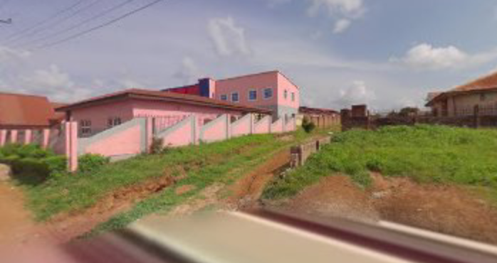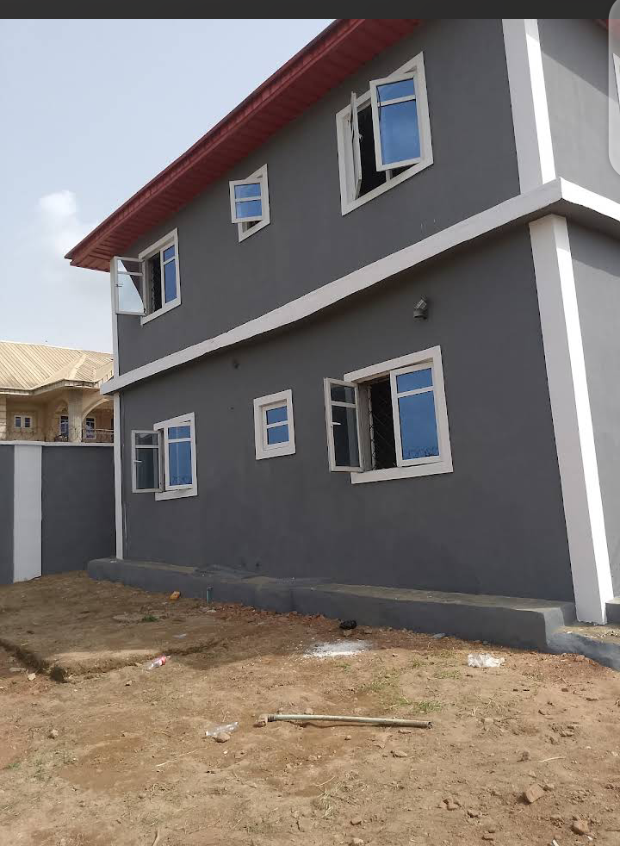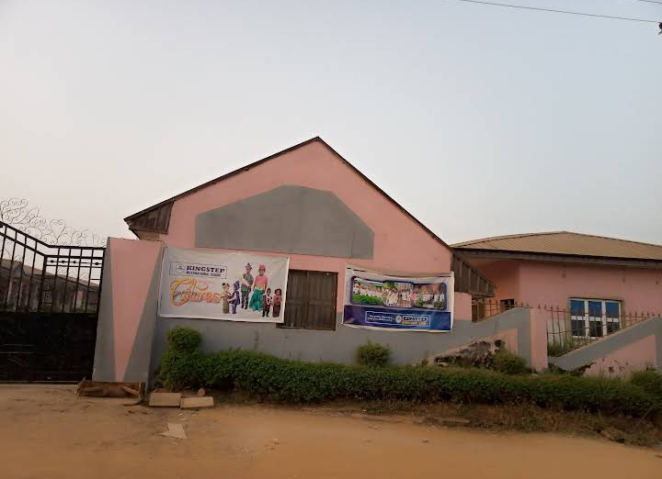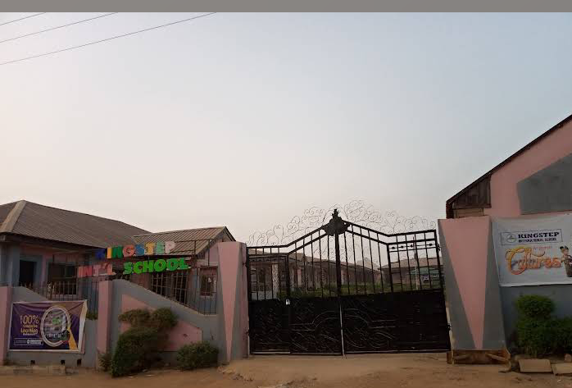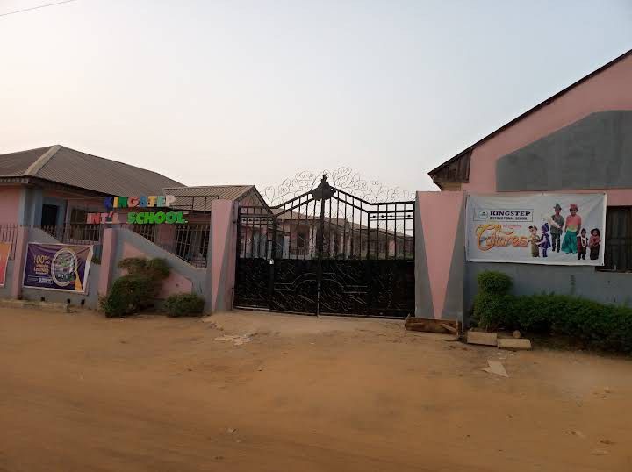

Case Study Two: Ebenezer Primary School, Gaa akanbi
Strengths: Spacious classrooms, modern infrastructure, good landscaping.
Weaknesses: Limited science lab facilities; focus more on academics than creativity.
Lessons for Eyenkorin: Provide balanced facilities for both academics and creativity.
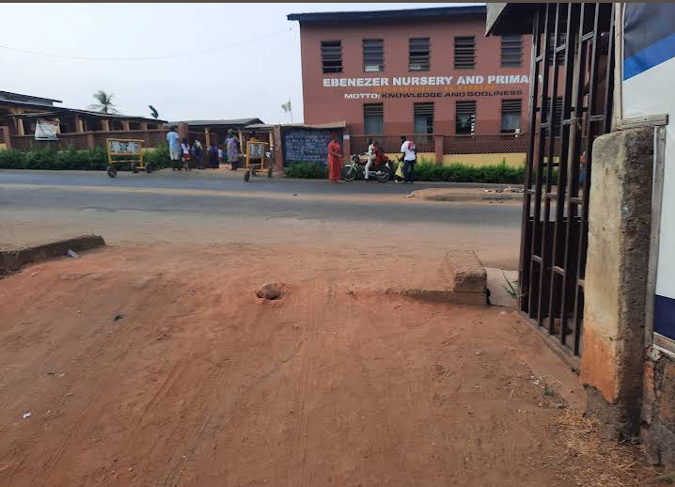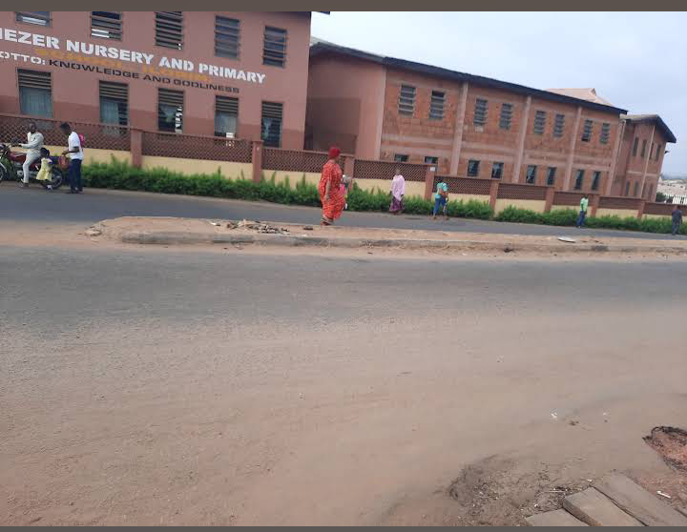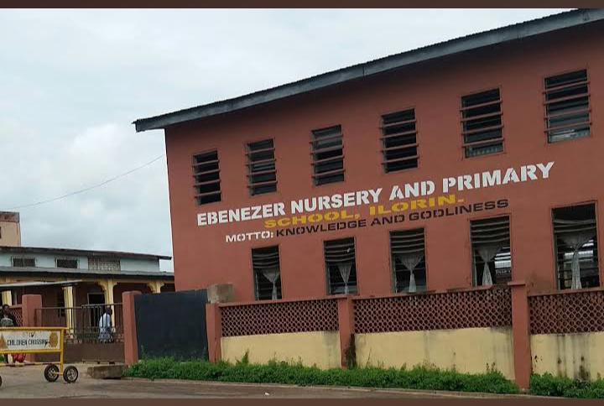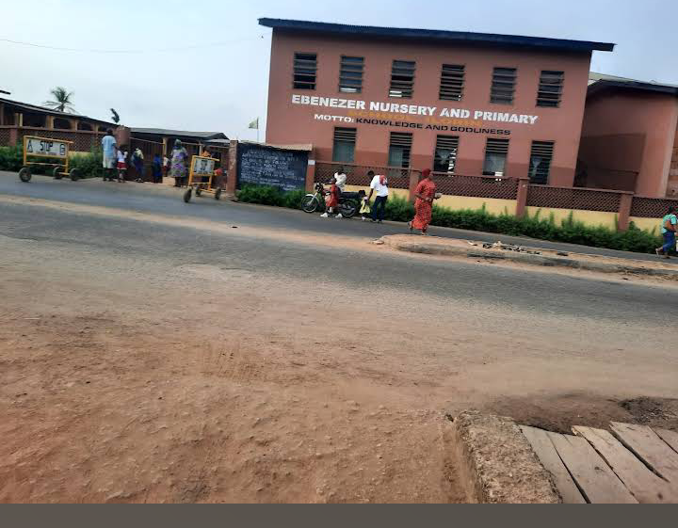

Case Study Three: Ammashree Park, karnataka, India
Strengths: State-of-the-art ICT labs, smart classrooms, landscaped play zones.
Weaknesses: Very high construction and maintenance costs.
Lessons for Eyenkorin: Adopt cost-effective versions of ICT and green landscaping.
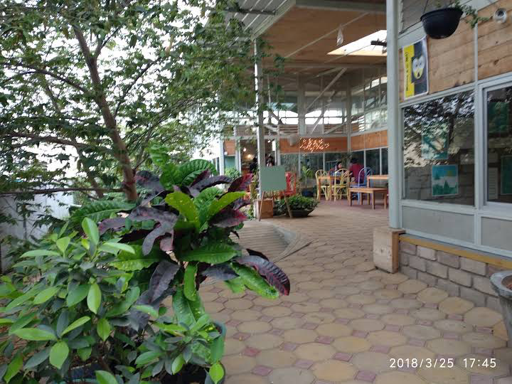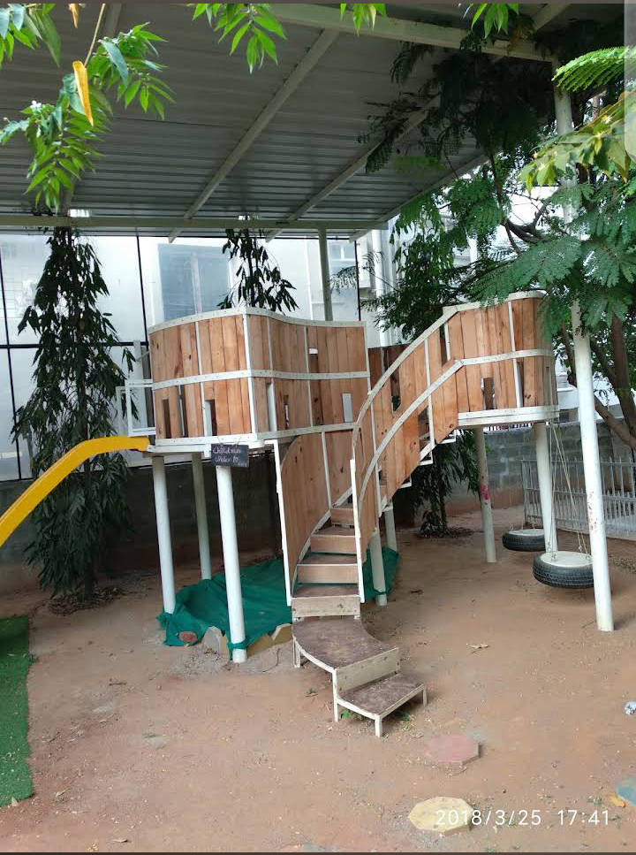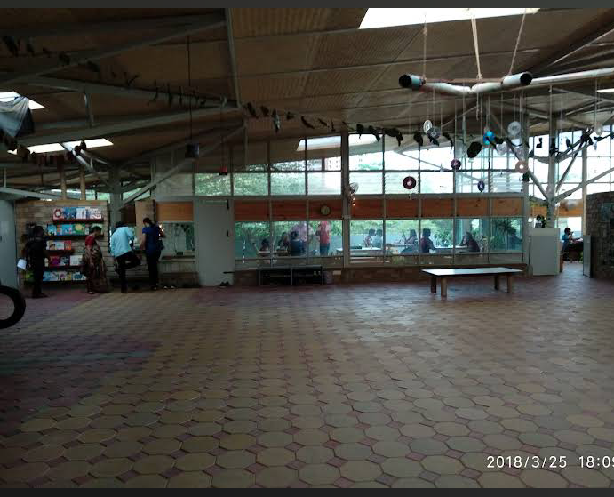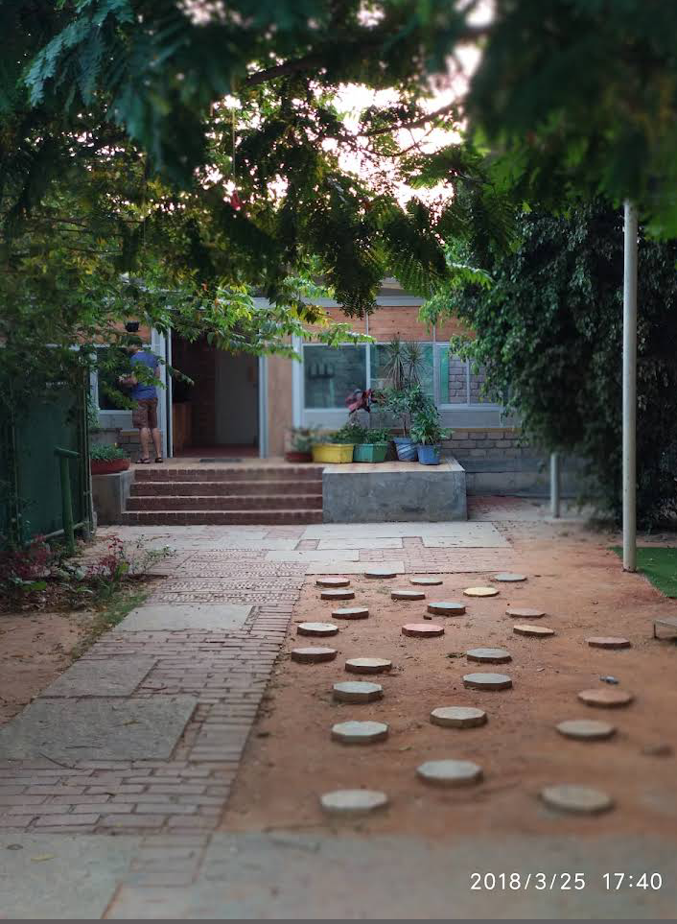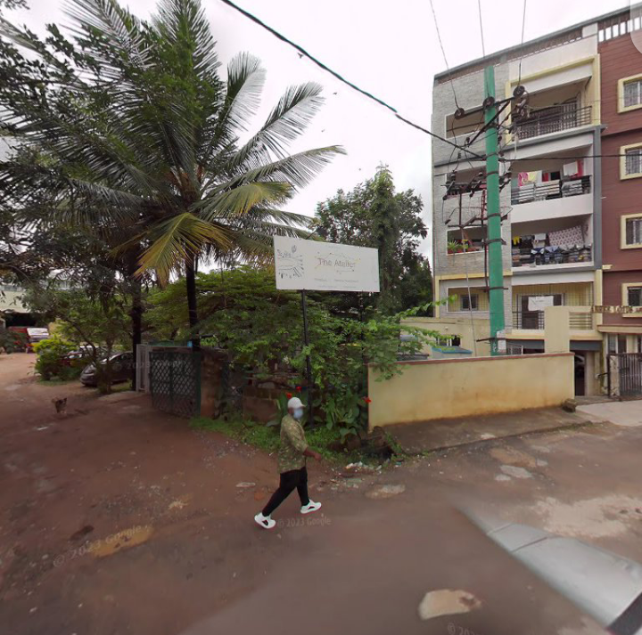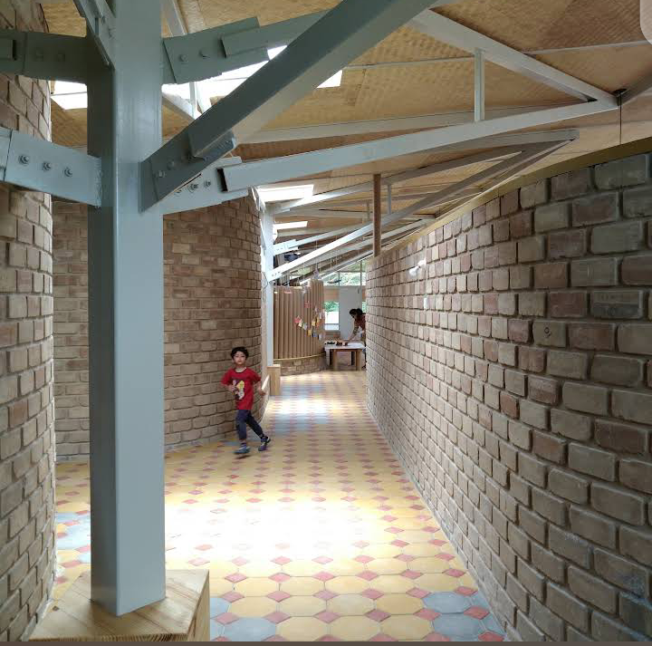

CHAPTER THREE

3.0 STUDY AREA (KWARA STATE & EYENKORIN)

3.1 OVERVIEW OF KWARA STATE

Kwara State, created in 1967, is located in the North-Central geopolitical zone of Nigeria. The state capital is Ilorin, which also serves as the commercial and administrative hub. The state shares boundaries with Niger State (north), Kogi State (east), Ekiti, Osun, and Oyo States (south), and the Republic of Benin (west).
Geographical Coordinates: 8°30′N, 4°33′E
Land Area: Approximately 36,825 km²

Climate: Tropical wet and dry, with two distinct seasons – rainy season (April–October) and dry season (November–March). Average annual rainfall is about 1,200 mm, and temperatures range between 22°C and 34°C.
Economy: The state’s economy is largely agrarian, with crops such as maize, cassava, yam, and rice. Livestock farming and trading are also significant.
Education: Kwara State has a mix of government-owned and private schools, but the quality of infrastructure varies widely, especially in rural areas like Eyenkorin.

3.2 ASA LOCAL GOVERNMENT AREA (LGA)

Eyenkorin falls under Asa LGA, one of the sixteen LGAs in Kwara State.
Administrative Headquarters: Afon
Population: Estimated at over 130,000 (2022 projection).
Key Settlements: Eyenkorin, Laduba, Afon, Otte, and Budo-Egba.
Socio-Economic Features:
Farming and petty trading dominate.
Proximity to Ilorin has increased commercial activities.
Rapid urbanization and population growth, but social amenities (schools, health centers, water supply) are lagging.

3.3 EYENKORIN TOWN
Eyenkorin is a suburban community located along the Ilorin–Ogbomosho expressway, about 7 km from Ilorin city. It is a gateway settlement, benefitting from trade and transport routes, yet still maintaining a rural character.
Population: Estimated 25,000–30,000 (2024 projection).
Demographics: Majority Yoruba, with minority Hausa and Fulani settlers. Predominantly Muslim, though Christianity is also practiced.
Education Status:
Few existing primary schools, most of which are overcrowded and under-equipped.
Pupils often travel long distances to schools in Ilorin.
Lack of ICT centers, science labs, and modern libraries.
Opportunities for Development: The youthful population and available land create room for modern educational facilities.
3.4 CLIMATE AND ENVIRONMENTAL FACTORS
The climatic conditions of Eyenkorin have a direct influence on the design of the proposed school.
Temperature: Hot during the dry season (up to 36°C) and moderately cool during rainy season.
Rainfall: Heavy rains from April–October require effective roof design, drainage, and water-harvesting systems.
Wind: Strong winds occur at the onset of the rainy season; hence, buildings must have strong roofing and anchoring systems.
Sun Path & Ventilation: Classrooms should be oriented to minimize heat gain from the west and maximize cross-ventilation.
3.5 SITE ANALYSIS (FOR THE PROPOSED SCHOOL)
The selected site for the proposed Eyenkorin Primary School was chosen based on accessibility, safety, and potential for future expansion.
Accessibility:
Located near the Ilorin–Ogbomosho highway.
Easily reachable by pedestrians, vehicles, and public transport.
Safe walking distance for schoolchildren within Eyenkorin town.

Topography:
Gently sloping terrain, suitable for drainage.
No major risk of flooding, but minor drainage channels may be required.
Soil Type:
Lateritic soil, good for foundation construction.
Locally available laterite can be used for brick/block making.

Vegetation:
Sparse vegetation, mainly shrubs and scattered trees.
Landscaping can introduce shade trees and grass to improve microclimate.

Utilities:
Electricity supply from PHCN grid, though irregular. Provision for solar backup is necessary.
Borehole or rainwater harvesting system for water supply.

3.6 IMPLICATIONS FOR SCHOOL DESIGN

Orientation of classrooms should reduce solar glare and improve cross-ventilation.
Trees should be planted around the site to provide shade and reduce heat.
Drainage and roof slopes must be designed to handle heavy rainfall.
Security fencing and controlled entry points are required due to proximity to the highway.
Flexible open spaces should be included for both play and future expansion.

CHAPTER FOUR

4.0 DESIGN CRITERIA
The design criteria for the proposed Eyenkorin Primary School are based on educational needs, environmental conditions, cultural context, and architectural best practices. These criteria ensure that the school provides a safe, functional, child-friendly, and sustainable environment.
4.1 FUNCTIONALITY
Functionality is central to school design. The facilities must support both academic and non-academic activities.
Zoning: Clear separation of academic, administrative, and recreational areas.
Flexibility: Classrooms and multipurpose halls should allow for rearrangement of furniture to support different teaching methods (traditional, group learning, ICT-based learning).
Future Expansion: Provision for additional classroom blocks or junior secondary facilities.
Circulation: Wide corridors, shaded walkways, and central courtyards to enhance movement and interaction.
Utilities: Adequate provision for water, electricity, and waste management.

4.2 SAFETY
Safety ensures pupils learn in a protected environment.
Site Security: Fencing around the compound with one main controlled entry/exit point.
Movement Safety:
Clear separation of pedestrian and vehicular circulation.
Drop-off zones for pupils near the gate.
Emergency Features:
Fire exits and extinguishers in all blocks.
Assembly points in open spaces.
First Aid/Health Bay for emergencies.
Child-Friendly Design: Rounded building corners, non-slip floor finishes, and play equipment designed to global child safety standards.

4.3 SUSTAINABILITY
The project aims to minimize environmental impact and encourage eco-friendly habits among pupils.
Climate-Responsive Design:
Classrooms oriented east–west to reduce heat gain.
Large windows and louvers for cross-ventilation.
Deep roof overhangs to protect against heavy rain and direct sunlight.
Materials: Use of locally available laterite bricks, clay tiles, and timber to reduce costs and promote cultural identity.

Energy Efficiency:
Installation of solar panels to supplement grid electricity.
Natural lighting during the day to reduce reliance on artificial lighting.
Water Conservation: Rainwater harvesting for sanitation and landscaping.
Waste Management: Provision for waste segregation (organic, plastic, paper).

4.4 ACCESSIBILITY
A modern school must be inclusive and easily accessible.
Universal Design: Ramps, wide doors, and disability-friendly toilets.
Wayfinding: Clear signage in English and Yoruba for easier navigation.
Circulation Paths: Well-defined pedestrian walkways connecting classrooms, library, and playgrounds.
Transport & Parking: Designated parking area for teachers and visitors without interfering with pupil safety.

4.5 AESTHETICS
The school should be visually appealing and welcoming to children.
Color & Design:
Bright, stimulating colors for classrooms to enhance creativity.
Natural tones for administrative blocks to maintain formality.
Landscaping:
Green areas with trees for shade and aesthetics.
Flower beds along walkways to improve visual appeal.
Cultural Relevance: Incorporation of local motifs and materials to reflect the identity of Eyenkorin.
4.6 SCHEDULE OF ACCOMMODATION
The facilities are grouped into academic, administrative, recreational, and support spaces.
Administrative Block: Reception, Head teacher’s office, Staff rooms, Accounts office, Records room.
Academic Facilities:
12 Classrooms (Primary 1–6, two streams each).
Library (reading hall, resource room, storage).
ICT Room (20–25 computer terminals, internet access).
Science Laboratory (basic science equipment).
Recreational Facilities:
Assembly Hall (for gatherings, cultural events, and indoor sports).
Playground with swings, slides, climbing frames, and a mini-football field.
Support Facilities:
Canteen and Kitchen.
Toilet facilities (separate male/female pupils and staff).
Health Bay/First Aid Unit.
Security Post.
Parking Lot.
Environmental Features:
Drainage system.
Rainwater harvesting tanks.
Landscaping (trees, shrubs, and shaded outdoor learning areas).

4.7 DESIGN PRINCIPLES FOR THE PROJECT
The proposed primary school will follow these guiding principles:
1. Child-Centeredness: The needs, safety, and psychology of children drive the design.
2. Community Integration: The school will also function as a hub for social and cultural activities.
3. Scalability: The design allows for future addition of classrooms and facilities.
4. Affordability: Use of local materials and low-maintenance systems to reduce cost.
5. Sustainability: Eco-friendly practices to create a resilient learning environment.

CHAPTER FIVE

5.0 PROJECT APPRAISAL

The proposed Eyenkorin Primary School is designed to combine functionality, sustainability, and cultural relevance. The appraisal highlights:
5.1 Strengths of the Design
Educational Value: Provides modern classrooms, ICT centers, and science labs that enhance learning outcomes.
Safety: Ensures child security through fencing, pedestrian separation, and controlled access.
Sustainability: Incorporates solar energy, natural ventilation, and rainwater harvesting.
Community Impact: Serves as both a school and community hub for literacy and social events.
Scalability: Allows for future expansion into a junior secondary school.
5.2 Limitations
Funding Challenges: Implementation may require partnership between government and private investors.
Maintenance Issues: Poor culture of facility maintenance in Nigeria could reduce project longevity.
Operational Costs: ICT and science labs may have higher running costs than traditional classrooms.
5.3 Recommendations
1. Public–Private Partnership (PPP): To fund ICT and science facilities.
2. Maintenance Strategy: Establish a school maintenance committee including staff, parents, and community leaders.
3. Teacher Training: Teachers must be trained to use ICT facilities and adopt modern pedagogy.
4. Sustainability Practices: Encourage tree planting, waste segregation, and water conservation within the school.
5. Government Support: Kwara State Ministry of Education should adopt Eyenkorin Primary School as a pilot model for replication in other LGAs.

5.4 Conclusion
The proposed Eyenkorin Primary School is more than a building—it is a child-friendly, safe, and sustainable educational ecosystem. By blending modern architecture with cultural relevance, the design creates an environment where pupils can learn, play, and grow into responsible citizens.
This project has the potential to:
Improve literacy and educational outcomes in Eyenkorin.
Strengthen socio-economic development in Asa LGA.
Serve as a benchmark for sustainable educational infrastructure in Nigeria.

---

References

Adepoju, A., & Adedokun, M. (2021). Education infrastructure and learning outcomes in Nigerian primary schools: An assessment of classroom environment. Journal of Education and Development Studies, 12(3), 44–58. https://doi.org/10.1234/jeds.v12i3.104

Aina, T. O., & Oladipo, F. S. (2022). Sustainable school design: Integrating green architecture into Nigerian educational facilities. International Journal of Architecture and Built Environment, 9(2), 112–126.

Barrett, P., Davies, F., Zhang, Y., & Barrett, L. (2019). The impact of classroom design on pupils’ learning: Final results of a holistic, multi-level analysis. Building and Environment, 89, 118–133. https://doi.org/10.1016/j.buildenv.2019.05.013

Federal Government of Nigeria. (2020). National policy on education (6th ed.). Lagos: NERDC Press.

Federal Ministry of Education. (2021). Universal Basic Education statistics: Annual school census report. Abuja: Government of Nigeria.

Hassan, M. A., & Danladi, K. I. (2023). Designing child-friendly learning spaces in rural Nigeria: Challenges and opportunities. Journal of African Educational Research, 15(1), 77–95.

Olagunju, B. O., & Salami, A. A. (2022). School architecture and pupils’ performance in Kwara State: A comparative study of urban and rural schools. Ilorin Journal of Educational Studies, 18(2), 63–79.

Olawale, R. O., & Adebisi, M. O. (2021). Public-private partnership and educational infrastructure delivery in Nigeria: A case of basic schools. African Development Review, 33(S1), S101–S115. https://doi.org/10.1111/1467-8268.12520

UNESCO. (2021). Reimagining our futures together: A new social contract for education. Paris: UNESCO Publishing.

UNICEF. (2022). Child-friendly schools manual: Designing for learning and protection. New York: UNICEF.

World Bank. (2020). Improving learning outcomes through better school infrastructure: Evidence from Sub-Saharan Africa. Washington, DC: The World Bank.

World Health Organization. (2023). Healthy environments for healthy children: Guidelines for school infrastructure. Geneva: WHO.

